**(這只是整理前面做過的實驗內容 不4考古QQ)**

嵌入式實驗-各實驗內容

Lab01

4.4七段顯示器(腳位、十六進位編碼、BusOut)

Lab02

4.4使用AnalogOut (DAC)

AnalogOut Aout(DAC0_OUT)

Aout = 0.25 //輸出值=3.3V*0.25=0.825V

Picoscope:接收輸出並用波形呈現

4.5 smooth waveform

4.6 sine waveform

4.7 PwmOut Pout(D3~D10)

Pout.period(週期)

Pout=振福

Lab03

4.3 AnalogIn Ain(A0~A5)

picoscope 產生analog訊號給Ain

Aout=Ain

Aout傳給picoscope讀並顯示

4.4 picoscope傳給Ain Pout=Ain 用PWM傳給picoscope

4.5 用螢幕顯示Ain讀進的值

Serial pc( USBTX, USBRX ) //板子與電腦間傳輸

float ADCdata //紀錄Ain

pc.printf("%1.3f\r\n", ADCdata) // 從screen印出來

4.6 FFT

numpy.arange(0,1,Ts) // (start,stop,steps) return array of evenly spaced value

//default: start=0,step=1,可只寫stop

Q:看不懂FFT的計算部分QQ

Lab04

3.3 自寫library(customize)&引入textLCD library

sudo apt install mercurial

mbed add <https://os.mbed.com/users/wim/code/TextLCD/>

TextLCD lcd(D2, D3, D4, D5, D6, D7)

lcd.locate(5,1) //locate(行/列)

LCD.printf來顯示

3.4 uLCD

Add "4DGL-uLCD-SE" library

mbed add <https://os.mbed.com/users/4180_1/code/4DGL-uLCD-SE/>

uLCD.printf來顯示

其他uLCD功能介紹可查

Demo 範例code中有的:

uLCD.text_width(4); //4X size text

uLCD.text_height(4);

uLCD.color(RED);

Lab05 Interrupts, timers and tasks

4.3 InterruptIn 功能

|  |
| --- |
| **rise** Attach a function to call when a rising edge occurs on the input |
| **fall** Attach a function to call when a falling edge occurs on the input |
| **mode** Set the input pin mode: PullUp, PullDown, PullNone, PullDefault |

例code: InterruptIn button(SW2); button.rise(&ISR1);//括號放&attachFunction

4.4 Timer 功能

|  |  |
| --- | --- |
| **start** | Start the timer |
| **stop** | Stop the timer |
| **reset** | Reset the timer to 0 |
| **read** | Get the time in seconds |
| **read_ms** | Get the time in milli-seconds |
| **read_us** | Get the time in micro-seconds |

4.5 Timer用在設定週期/頻率

if(timer_fast.read() > 2){ redLED = !redLED; timer_fast.reset(); } // 2秒閃一次

if(timer_slow.read() > 0.2){ greenLED = !greenLED; timer_slow.reset(); } //0.2 “

4.6 Timeout 用在time-triggered 功能

|  |  |
| --- | --- |
| **attach** | Attach a function to be called by the Timeout, specifying the delay in seconds |
| **attach_us** | Attach a function to be called by the Timeout, specifying the delay in microseconds |
| **detach** | Detach the function |

tout.attach( &blink, 2.0) // attach blink這個function, 在2秒後執行

4.7 Ticker 用在periodic event

|  |  |
| --- | --- |
| **attach** | Attach a function to be called by the Timeout, specifying the **interval** in seconds |
| **attach_us** | Attach a function to be called by the Timeout, specifying the **interval** in microseconds |
| **detach** | Detach the function |

time_up.attach( &blink, 0.2 ); //每0.2執行一次blink

4.8 用Timer做debounce:用interrupt attach按鈕 判斷離上次做完超過一秒才做。做完reset timer。

Lab06 Serial Communication

Serial(UART) used by computers to send and receive control information and data with two uni-directional asynchronous channels. Must be configured with the same settings (packet format and baud rate, etc.).

I2C provides synchronous channels between masters and slaves.

4.3 兩塊板子間的UART控制LED(看tx, rx怎接)

4.4 用Serial傳十個字元給picoscope，讓picoscope解讀

用迴圈來連續putc十次，要設定鮑率device.baud(9600);

4.5 I2C 連結板子&感溫器TMP102

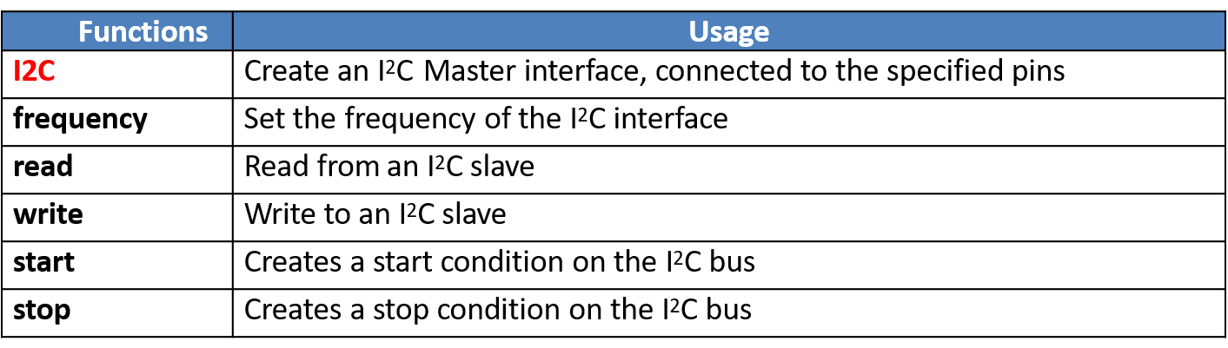

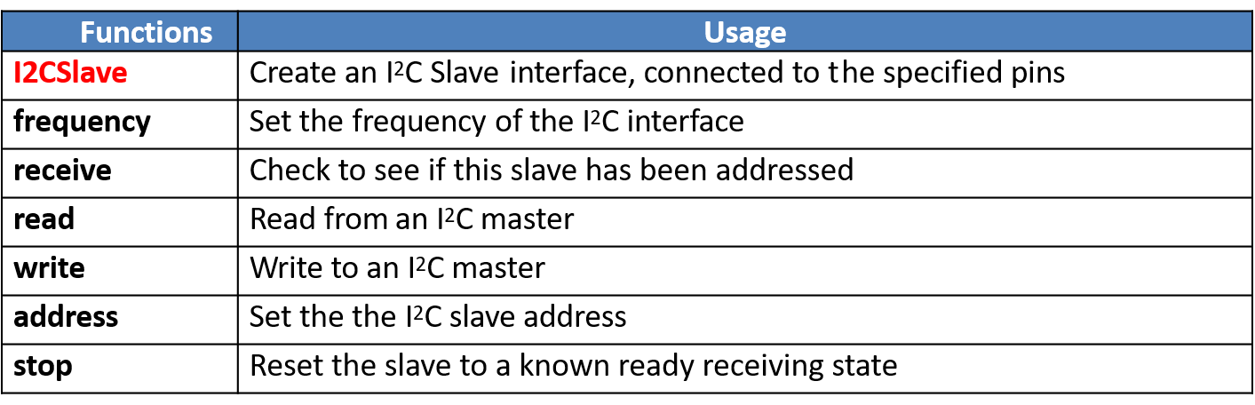

4.7 I2C讀取內建三軸加速計測值，印在電腦上

Lab07 Audio Synthesis

4.2 while不斷讀是否有button訊號(BusIn),用bitwise判斷是哪顆被按

4.3