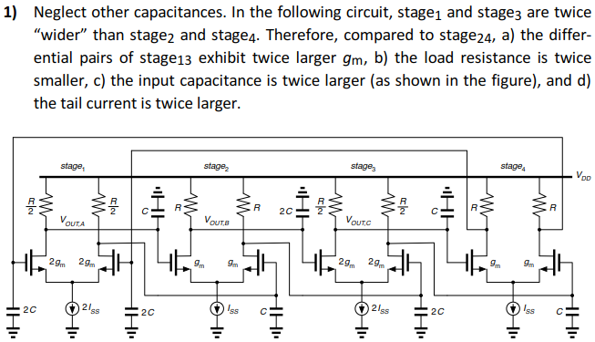
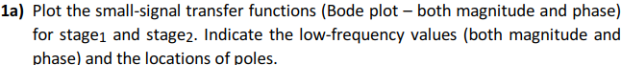
  - stage1: $H_{1}\left(s\right)=\frac{-(2g_{m})(R/2)}{1+s(R/2)(C)}=\frac{-g_{m}R}{1+s/ω_{10}}, ω_{10}=\frac{2}{RC}$
stage2: $H_{2}\left(s\right)=\frac{-(g_{m})(R)}{1+s(R)(2C)}=\frac{-g_{m}R}{1+s/ω_{20}}, ω_{20}=\frac{1}{2RC}$
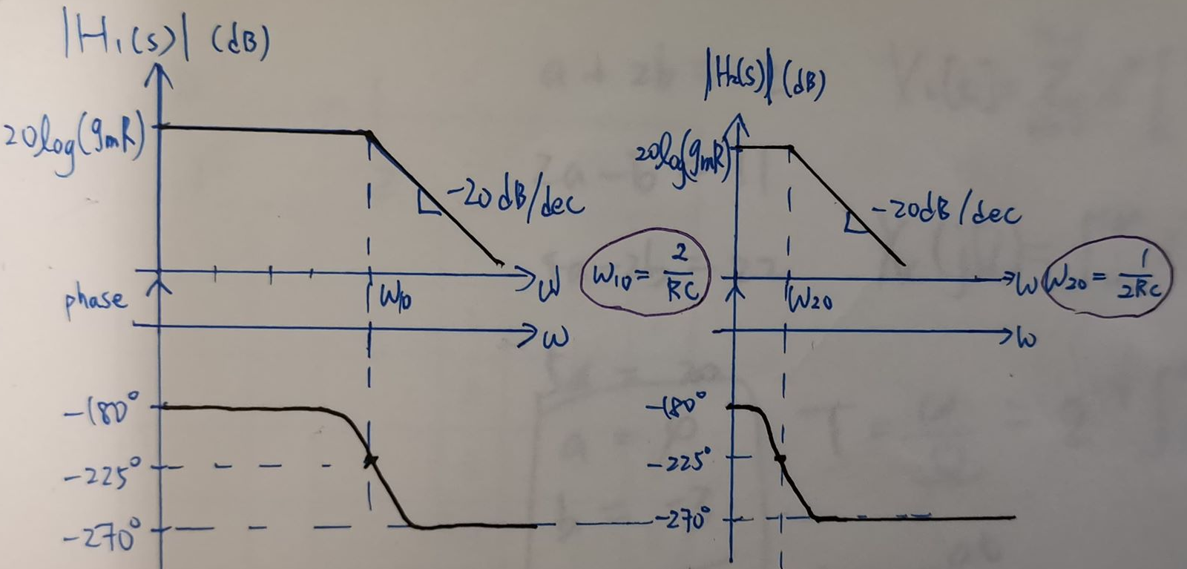
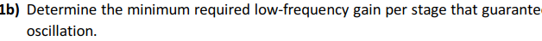
  - $H\left(s\right)=\left(\frac{-g_{m}R}{1+s\frac{RC}{2}}\right)\left(\frac{-g_{m}R}{1+s2RC}\right)\left(\frac{-g_{m}R}{1+s\frac{RC}{2}}\right)\left(\frac{-g_{m}R}{1+s2RC}\right)={-\left(g_{m}R\right)}^{4}{\left(\frac{1}{1+s\frac{RC}{2}}\right)}^{2}{\left(\frac{1}{1+s2RC}\right)}^{2}$
$∠H{\left(ω_{OSC}\right)}_{open}=-180°×5-2\operatorname{atan}\left(ω_{OSC}\frac{RC}{2}\right)-2\operatorname{atan}\left(ω_{OSC}2RC\right)=0°$
$⇒\operatorname{atan}\left(ω_{OSC}\frac{RC}{2}\right)+\operatorname{atan}\left(ω_{OSC}2RC\right)=90°⇒ω_{OSC}=\frac{1}{RC}$
$\left|H\left(ω_{OSC}\right)\right|={\left(g_{m}R\right)}^{4}{\left(\sqrt{1+2^{2}}\right)}^{-2}{\left(\sqrt{1+{0.5}^{2}}\right)}^{-2}=\frac{4}{25}{\left(g_{m}R\right)}^{4}=1$
$⇒g_{m}R=1.58$
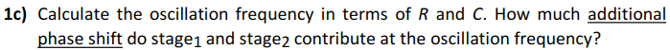
  - Oscillation frequency ($ω_{OSC}$) is $1/RC$.
Additional phase shift of stage1 is $\operatorname{atan}\left(ω_{OSC}\frac{RC}{2}\right)=26.56°$
Additional phase shift of stage2 is $\operatorname{atan}\left(ω_{OSC}2RC\right)=63.44°$
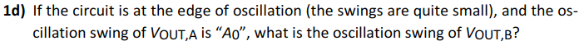
  - $V_{OUT,A}=A_{0}→V_{OUT,B}=A_{0}\left|H_{2}\left(ω_{OSC}\right)\right|=A_{0}\left(\frac{g_{m}R}{\sqrt{1+{0.5}^{2}}}\right)=0.89A_{0}g_{m}R$

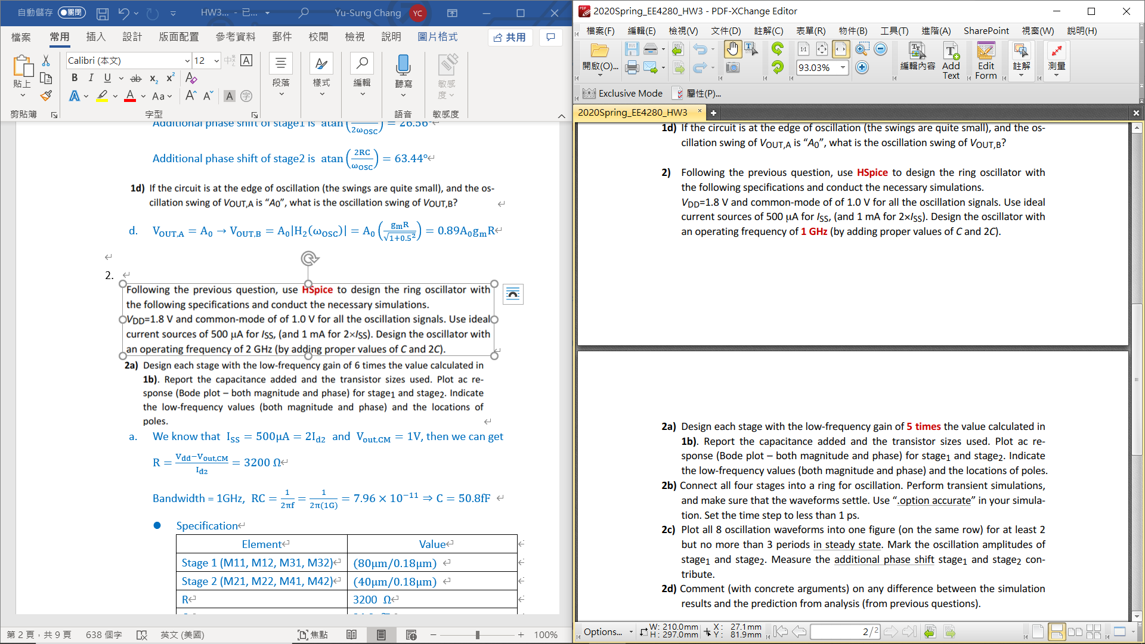
  - We know that $I_{SS}=500μA=2I_{d2}$ and $V_{out,CM}=1V$, then we can get $R=\frac{V_{dd}-V_{out,CM}}{I_{d2}}=3200 Ω$
Bandwidth = 1GHz, $RC=\frac{1}{2πf}=\frac{1}{2π(1G)}=7.96×{10}^{-11}⇒C=50.8fF$
- Specification
Element | Value
Stage 1 (M11, M12, M31, M32) | $(60μm/0.18μm)$
Stage 2 (M21, M22, M41, M42) | $(30μm/0.18μm)$
R | 3200 $Ω$
C | 50.8 $fF$
$I_{SS}$ | 500 $μA$
Gain of each stage | 7.99 (18.1dB)
Input Common-mode | 1 V
$V_{out}$ | 1 V

- Stage 1
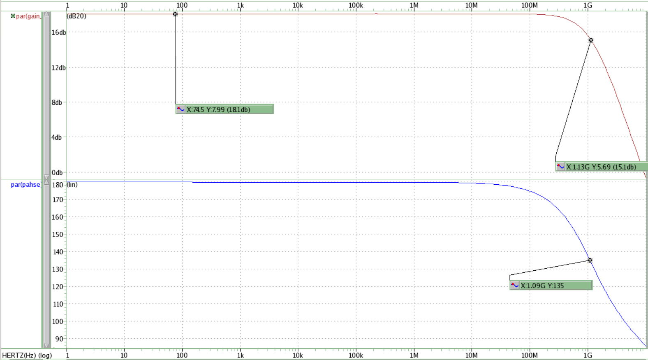
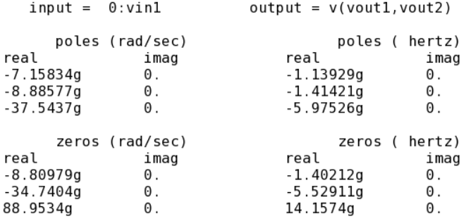
- Stage 2
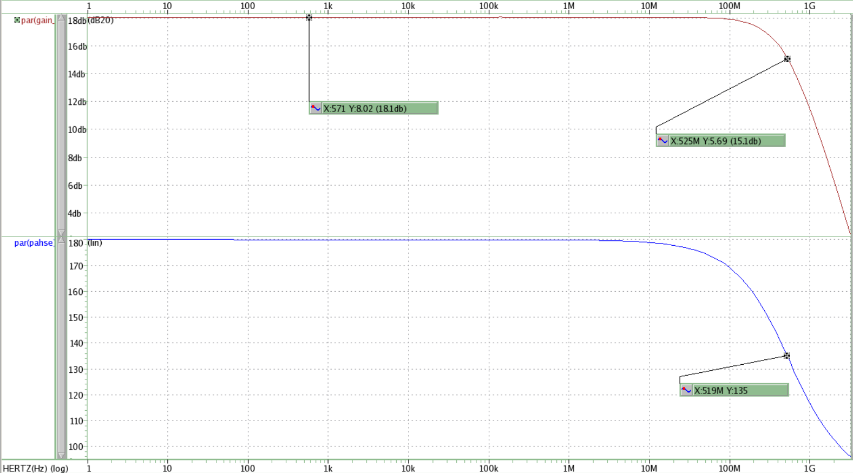
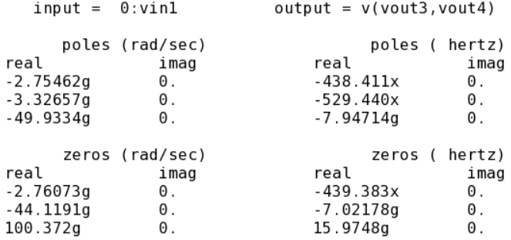
- The gain I designed is 7.99, which is close to 5 times value of minimum required low-frequency gain.
- For Stage 1, we expect that the -3dB gain would locate at 2GHz, and it shows up at 1.13GHz in the simulation. For Stage 2, we expect that the -3dB gain would locate at 500MHz, and it shows up at 525MHz in the simulation.
  - This is because we ignore the parasitic capacitance and channel-length modulation in calculation.
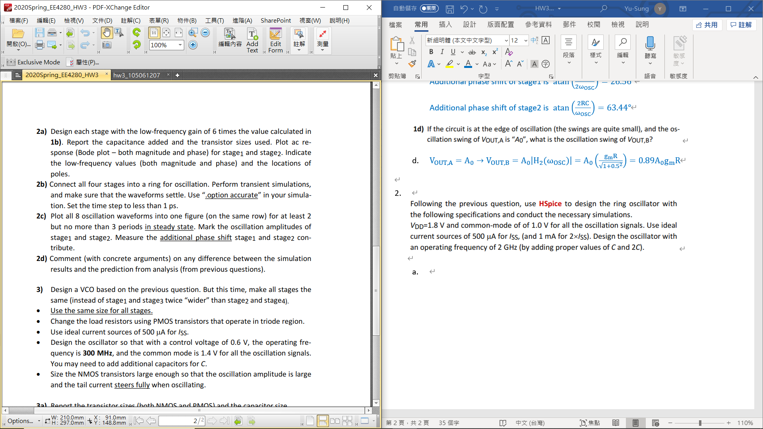
  - Use “.option DELMAX” to set the time step to less than 1 ps.
  - Simulation
- All 8 oscillation waveforms
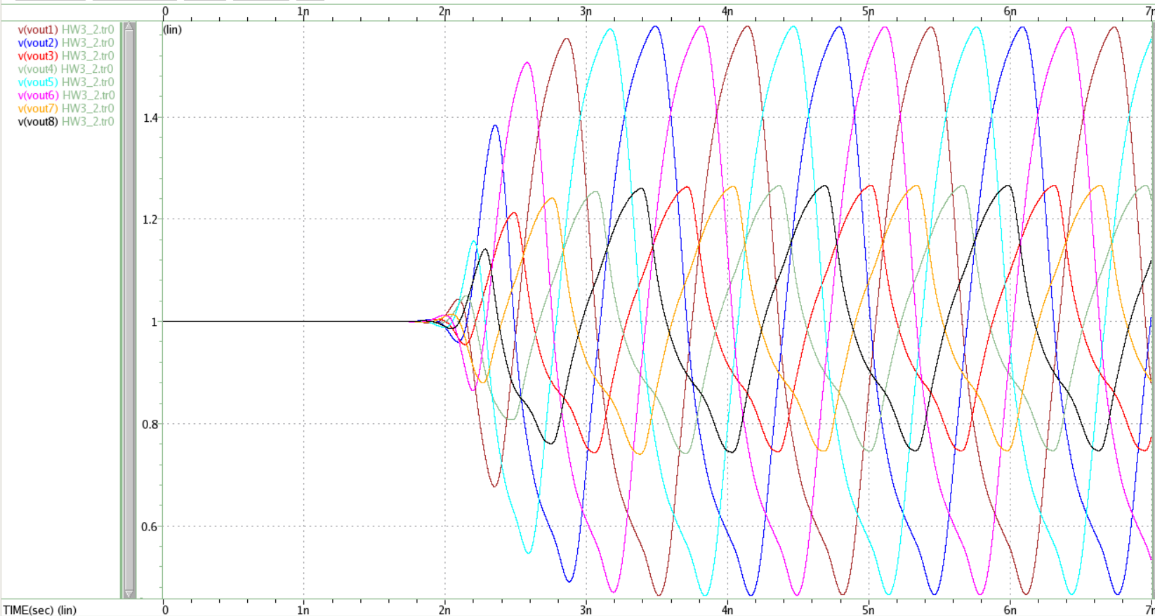
- Stage 1
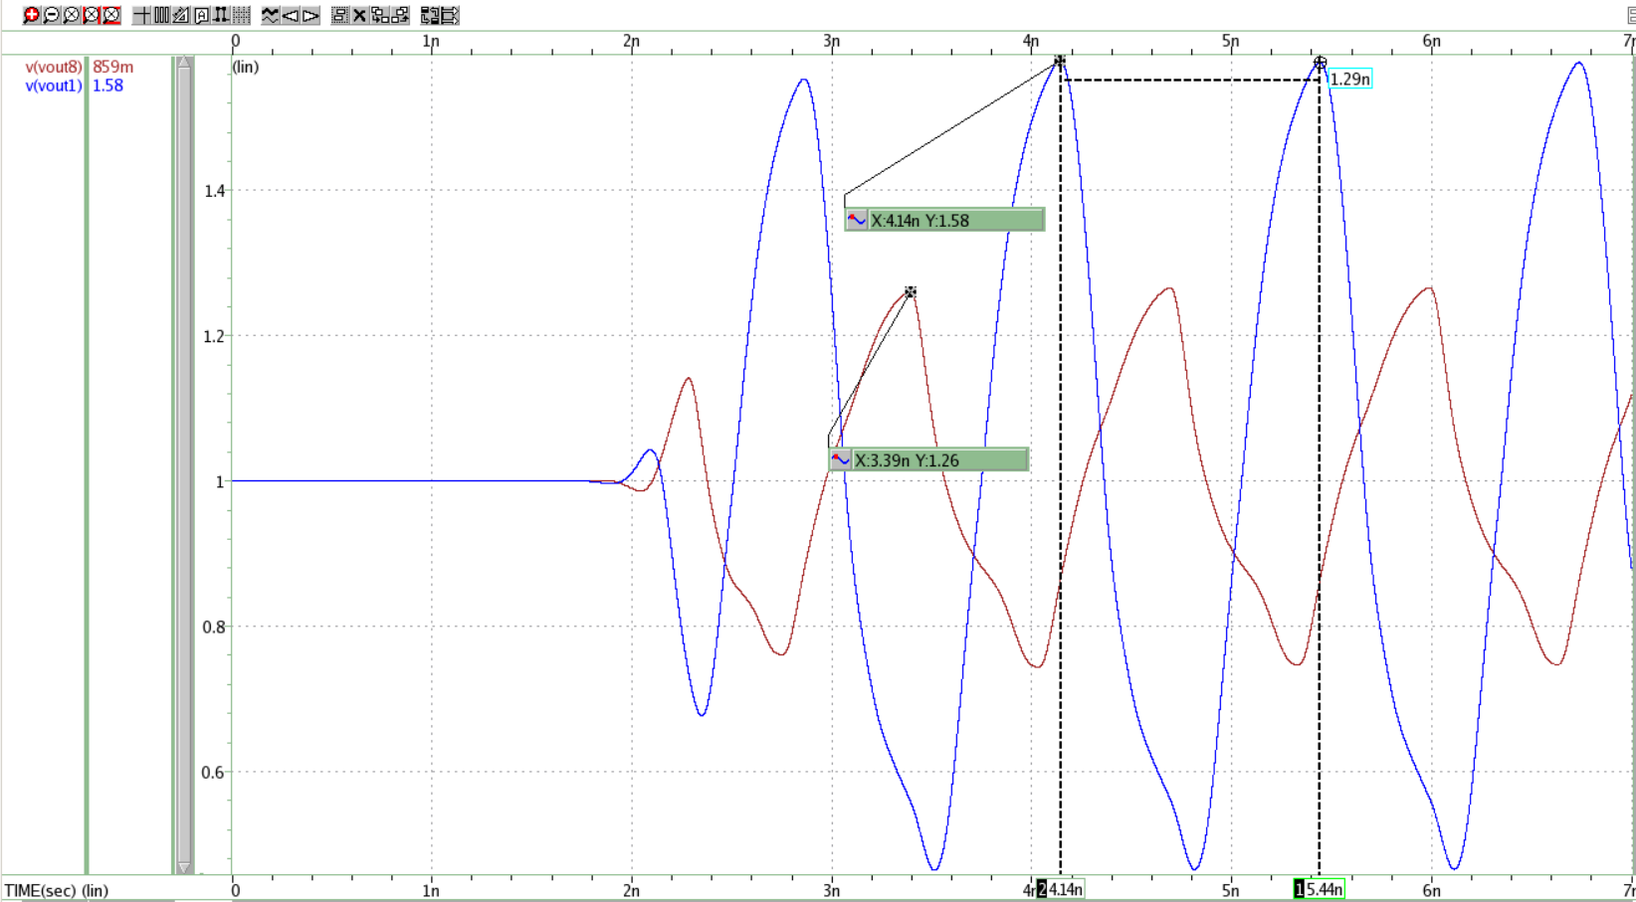
  - Input: vout8, Output: vout1
  - Amplitude of stage 1 (|vout1|): 580 mV
  - Period of each signal = (5.44n – 4.14n) = 1.29n
total phase shift = $\frac{Δt}{T}×360°=\frac{4.14n-3.39n}{1.29n}×360°=209.30°$
  - Additional phase shift = 180$°$- total phase shift in one period
Then, we can get the additional phase shift is $29.30°$.
- Stage 2
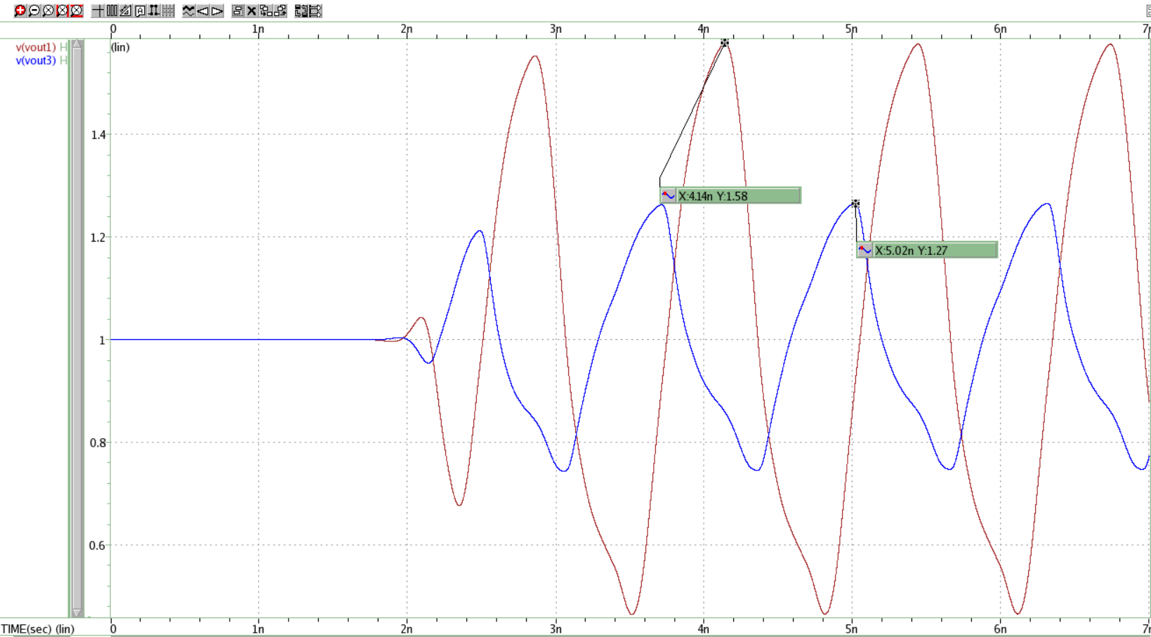
  - Input: vout1, Output: vout3
  - Amplitude of stage 2 (|vout3|): 270 mV
  - Period of each signal = 1.29n
total phase shift = $\frac{Δt}{T}×360°=\frac{5.02n-4.14n}{1.29n}×360°=245.58°$
  - Additional phase shift = 180$°$- total phase shift in one period
Then, we can get the additional phase shift is $65.58°$.
  - Comment
    - Hand-calculation
Additional phase shift of stage1 is $26.56°$
Additional phase shift of stage2 is $63.44°$
    - Simulation
Additional phase shift of stage1 is $29.30°$
Additional phase shift of stage2 is $65.58°$
    - Comment
      - The simulated values of -3dB gain both in stage 1 and stage 2 are lower than the expected values. This is because we ignore the parasitic capacitance and channel-length modulation in calculation.
      - Due to ignoring the parasitic capacitance and channel-length modulation in calculation, we got the larger values of additional phase shift in each stage in the simulation.

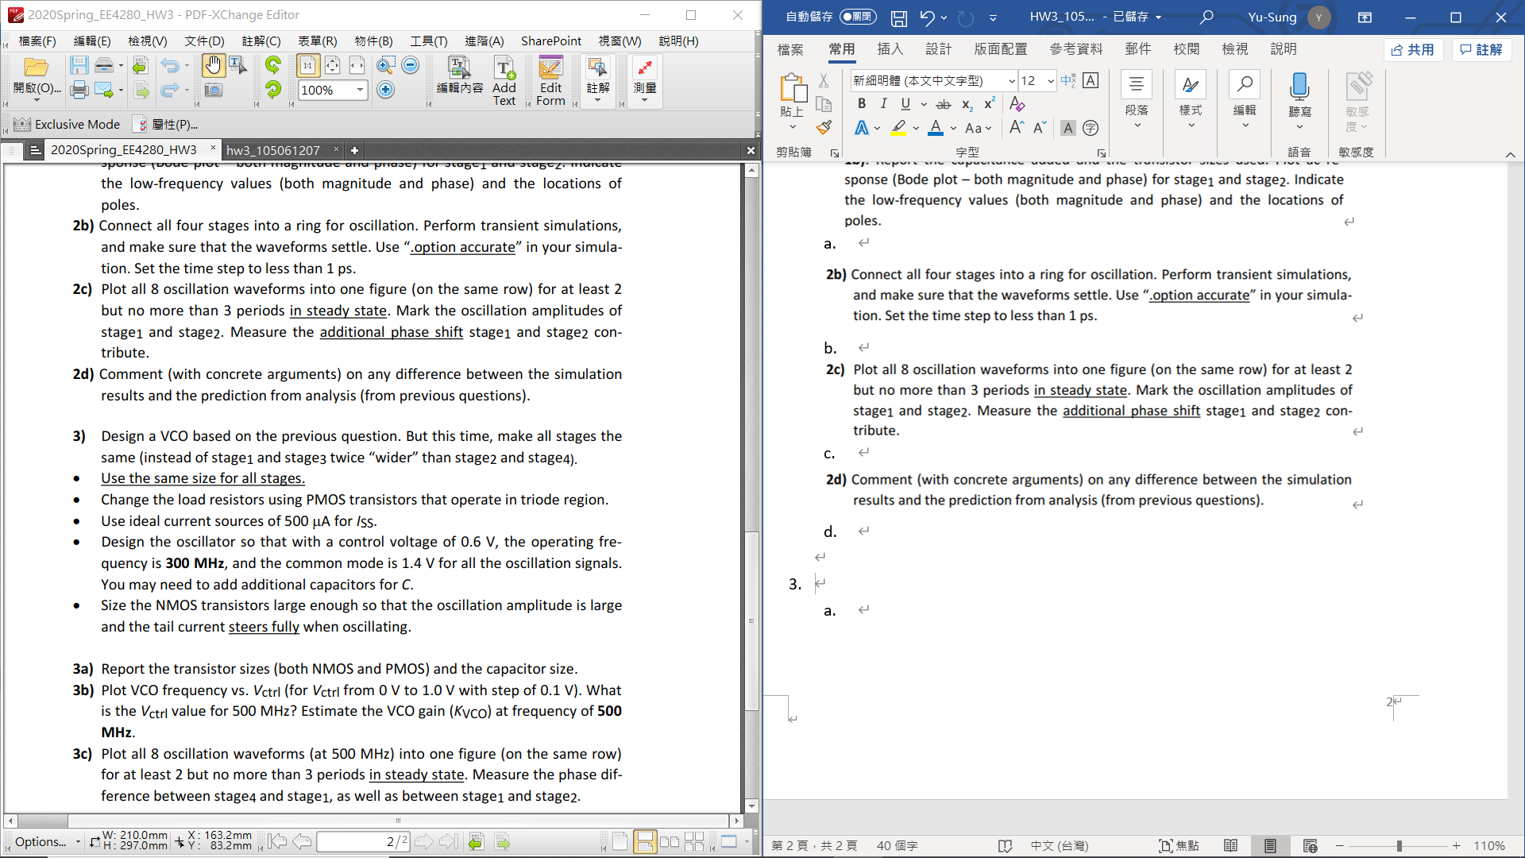

    - Specification
Element | Value
Stage NMOS (M11n, M12n) | $(50μm/0.18μm)$
Stage PMOS (M11p, M12p) | $(3.4μm/0.18μm)$
C | 200 $fF$
$I_{SS}$ | 500 $μA$
Gain of each stage | 8.15 (18.5dB)
Frequency of -3dB Gain | 300 MHz
Input Common-mode | 1.4 V
Output Common-mode | 1.398 V
    - Waveview of each stage
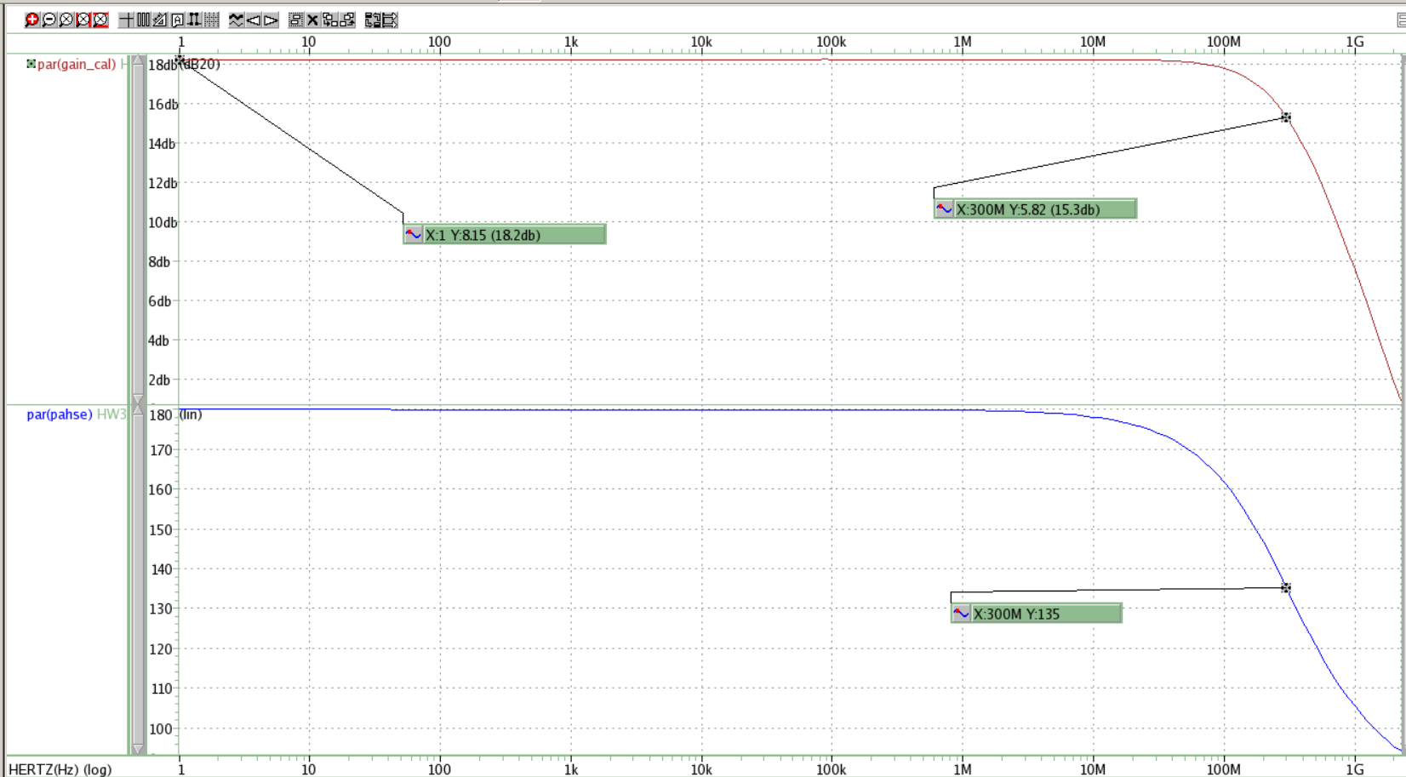
    - Pole-Zero
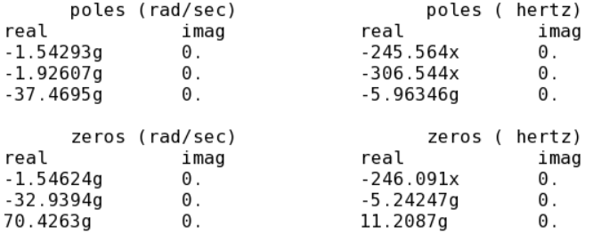
    - Prove “the tail current steers fully when oscillating”
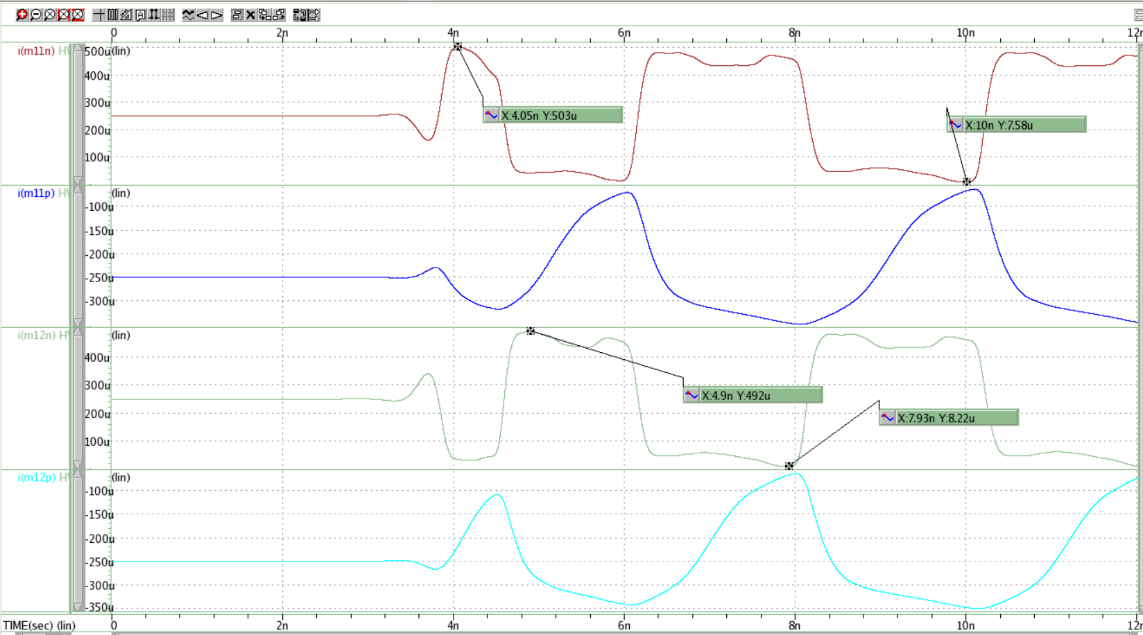
      - This result shows that the maximum current flows into M11n and M12n (NMOS) are 503$μA$and 492$μA$, and the minimum current flows into M11n and M12n (NMOS) are 7.58$μA$and 8.22$μA$. This also shows that the tail current steers fully when oscillating.
  - VCO frequency vs.$Vctrl$
    - VCO frequency vs.$Vctrl$
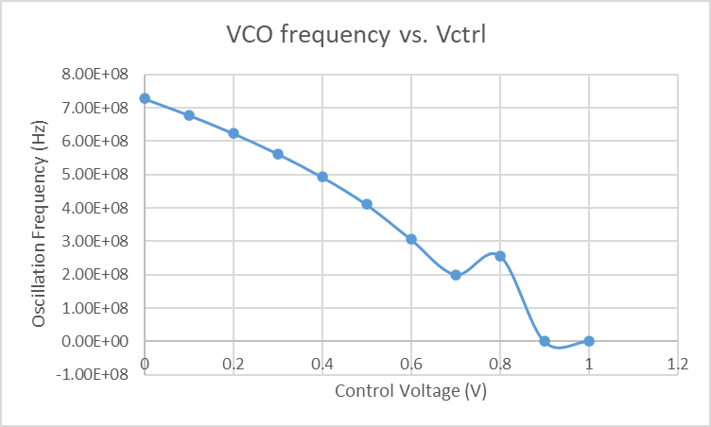
      - We can estimate the VCO gain at frequency 500 MHz is 0.37 V.
    - AC response vs.$Vctrl$
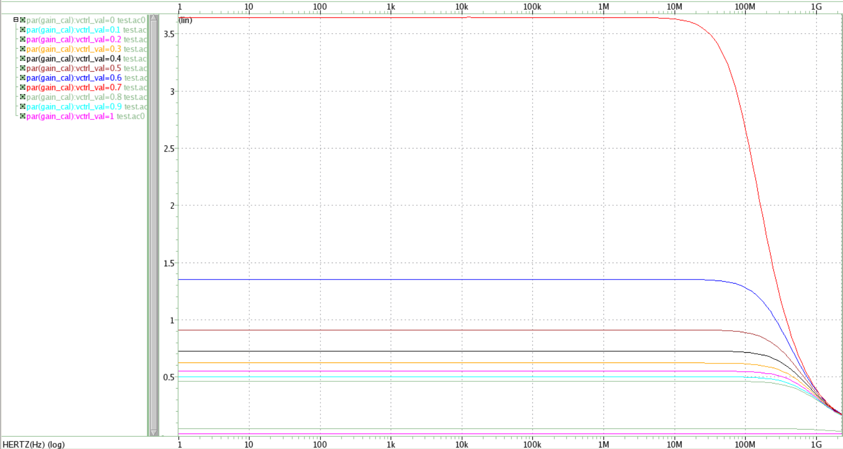
  - Simulation
    - All 8 oscillation waveforms
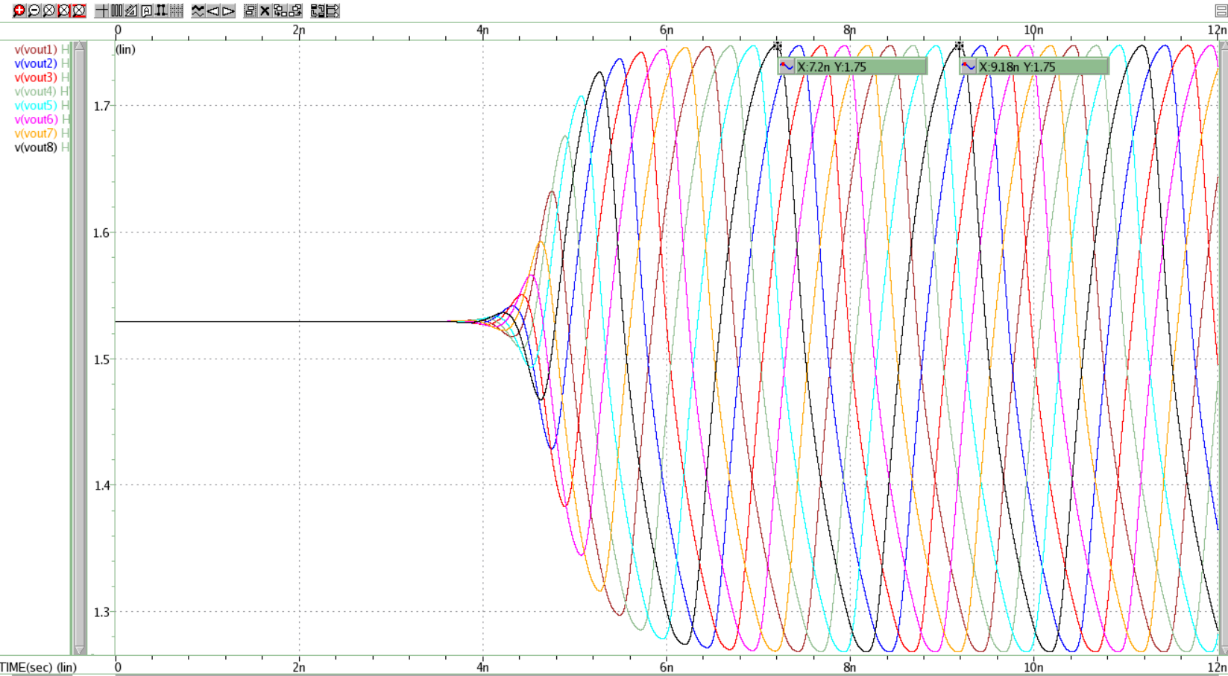
      - $V_{ctrl}=0.37 V$
      - Operating frequency = 1/(9.18n-7.2n) = 505 MHz

    - Stage 4 (input) and Stage 1 (output)
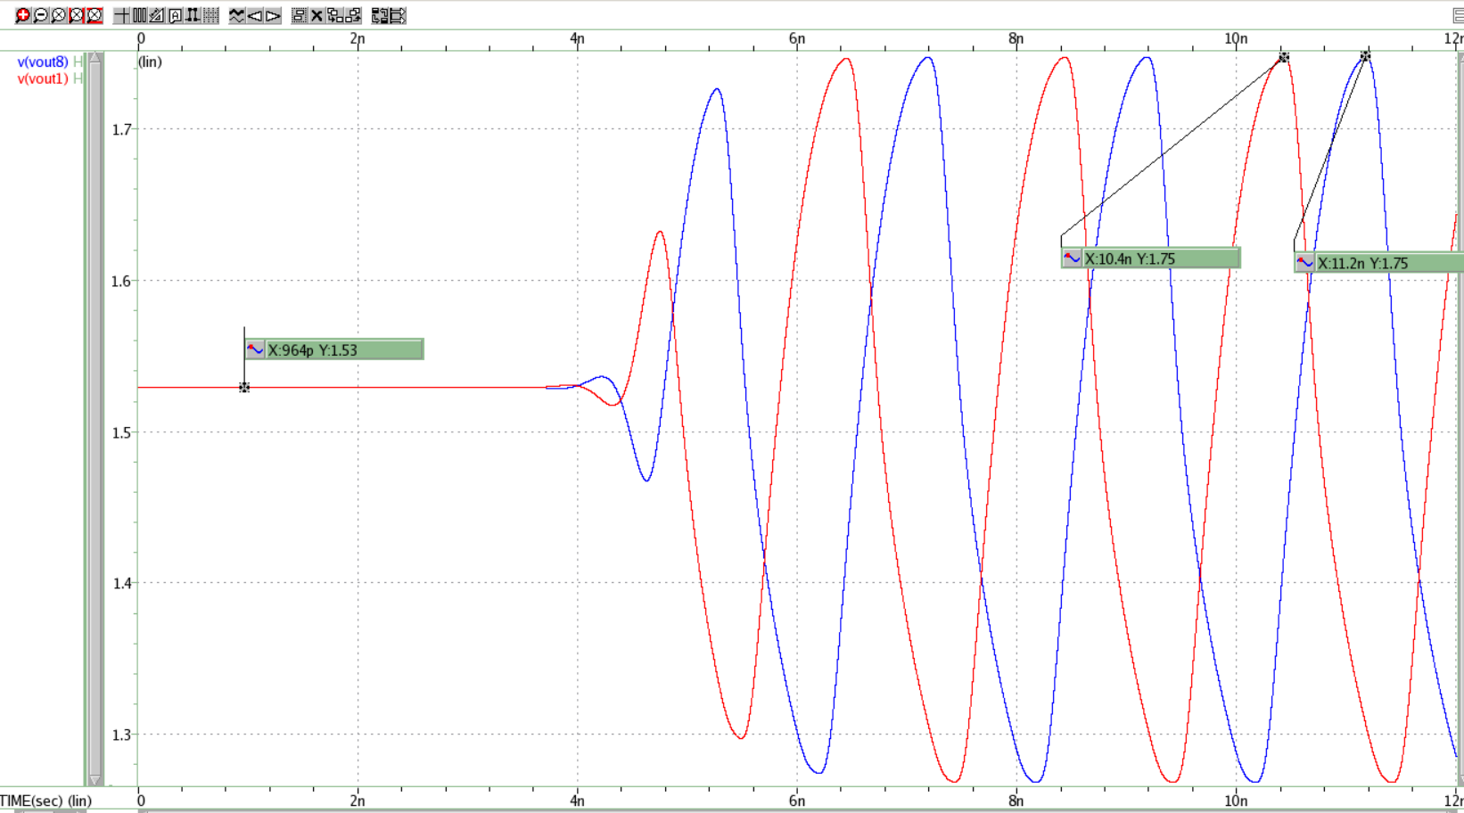
  - Input: vout8, Output: vout1
  - Amplitude: 22 mV (1.75mV – 1.53mV)
  - Period of each signal = 505 MHz
total phase shift = $Δt×f×360°=219.98°$
  - Additional phase shift = 180$°$- total phase shift in one period
Then, we can get the additional phase shift is $39.98°$.
    - Stage 1 (input) and Stage 2 (output)
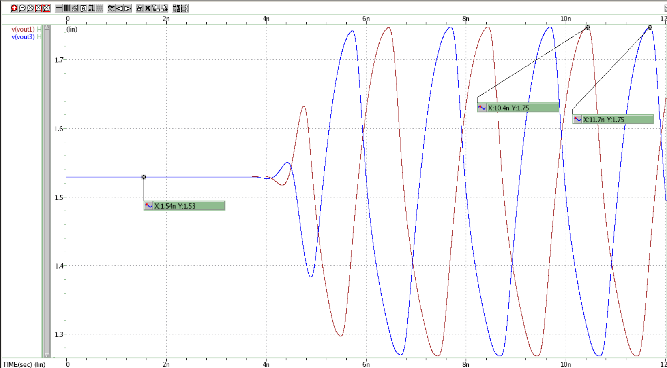
      - Input: vout1, Output: vout3
      - Amplitude: 255 mV
      - Frequency of each signal = 505 MHz
total phase shift = $Δt×f×360°=236.34°$
      - Additional phase shift = 180$°$- total phase shift in one period
Then, we can get the additional phase shift is $56.34°$.
    - Comment
      - Changing the value of Wn doesn’t affect the value of output common mode.
      - This design doesn’t work when control voltage ($Vctrl$) larger than 0.8 V.

