1. Consider a common-source amplifier like the following

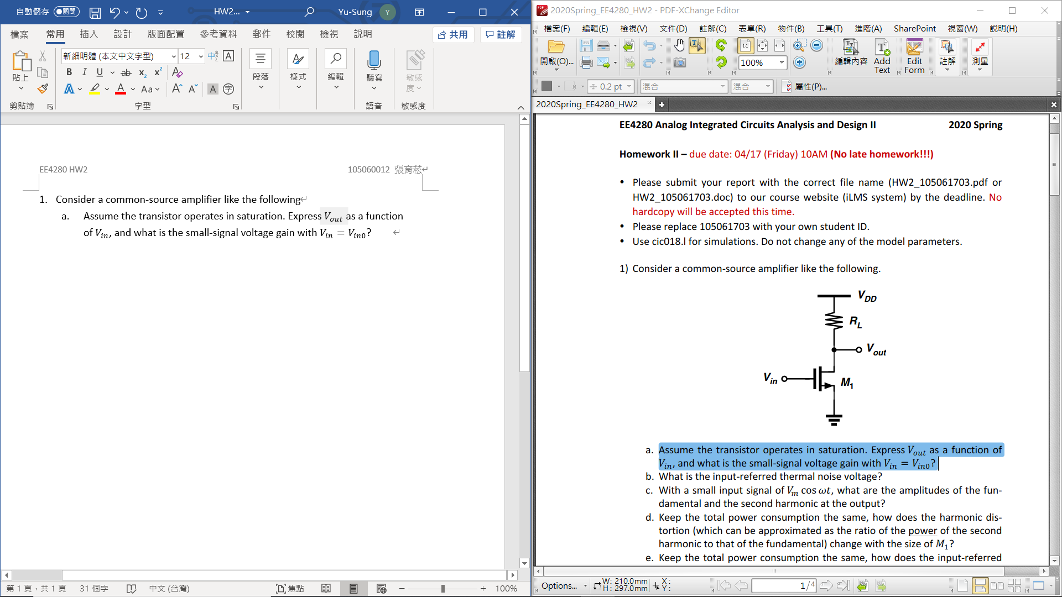

* 1. The small-signal voltage gain with $V_{in}=V_{in0}$ is $μ_{n}C_{ox}\left(W/L\right)(V_{in0}-V_{TH})(r_{o1}||R_{L})$.
  2. Input-referred thermal noise voltage?

* 1. Input signal $V_{m}\cos{ωt}$, what is the amplitudes of the fundamental and the second harmonic at the output?

$V_{DD}-V_{out}=0.5μ_{n}C_{ox}\left(W/L\right){\left(V_{in}-V_{TH}\right)}^{2}R_{L}=f(V_{in})$

$f\left(V_{in}\right)=f\left(V_{in0}\right)+f^{'}\left(V_{in0}\right)\left(V_{in}-V_{in0}\right)+\left(1/2!\right)f^{''}\left(V_{in0}\right){\left(V_{in}-V_{in0}\right)}^{2}…$

$=f\left(V_{in0}\right)+\left[μ_{n}C_{ox}\left(W/L\right)\left(V_{in0}-V_{TH}\right)R_{L}\right]\left[V_{m}\cos{ωt}\right]+ \left[0.5μ_{n}C_{ox}\left(W/L\right)R_{L}\right]\left[{\left(V_{m}\cos{ωt}\right)}^{2}\right]+…$

$\cos^{2}{ωt}=0.5(1+\cos{2ωt})$

* The amplitude of the fundamental harmonic is $μ_{n}C_{ox}\left(W/L\right)V_{ov}R_{L}V_{m}$
* The amplitude of the second harmonic is $0.25μ_{n}C_{ox}\left(W/L\right)R_{L}V_{m}^{2}$
  1. Keep the total power consumption the same. The relationship between the harmonic distortion and the size of $M1$.

Keeping the power consumption same means that drain current remains the same. $I_{D}=0.5μ_{n}C_{ox}\left(W/L\right)V_{ov}$, $\frac{A_{HD2}}{A_{F}}=\frac{V_{m}}{4(V_{in0}-V_{TH})}$

$⇒$ If we increase the width of $M1,$ the overdrive voltage will be decreased, then the ratio of harmonic distortion will be increased at the same time.

* 1. The relationship between the input-referred thermal noise voltage and the size of $M1$.

$S_{v,out}=4kT\left(γ/g_{m1}^{-1}+1/R_{L}\right)R_{L}^{2}, S_{v,out}=S_{v,in}A_{v}^{2}, A_{v}=g_{m1}R_{L}$

$S_{v,in}=4kT\left(\frac{γ}{g_{m1}}+\frac{1}{g_{m1}^{2}R_{L}}\right), g_{m1}=μ_{n}C_{ox}\left(W/L\right)V_{ov}⇒$ the input-referred thermal noise voltage would decrease with increasing the width of.

* 1. (Hspice)

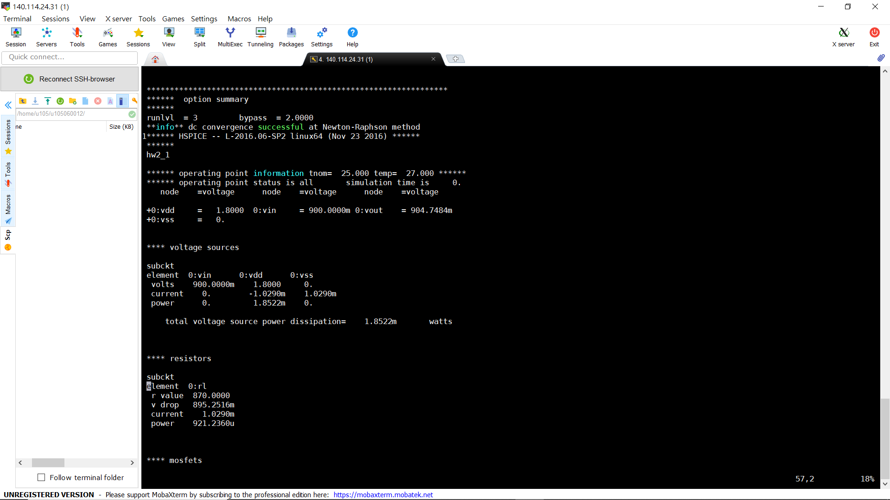

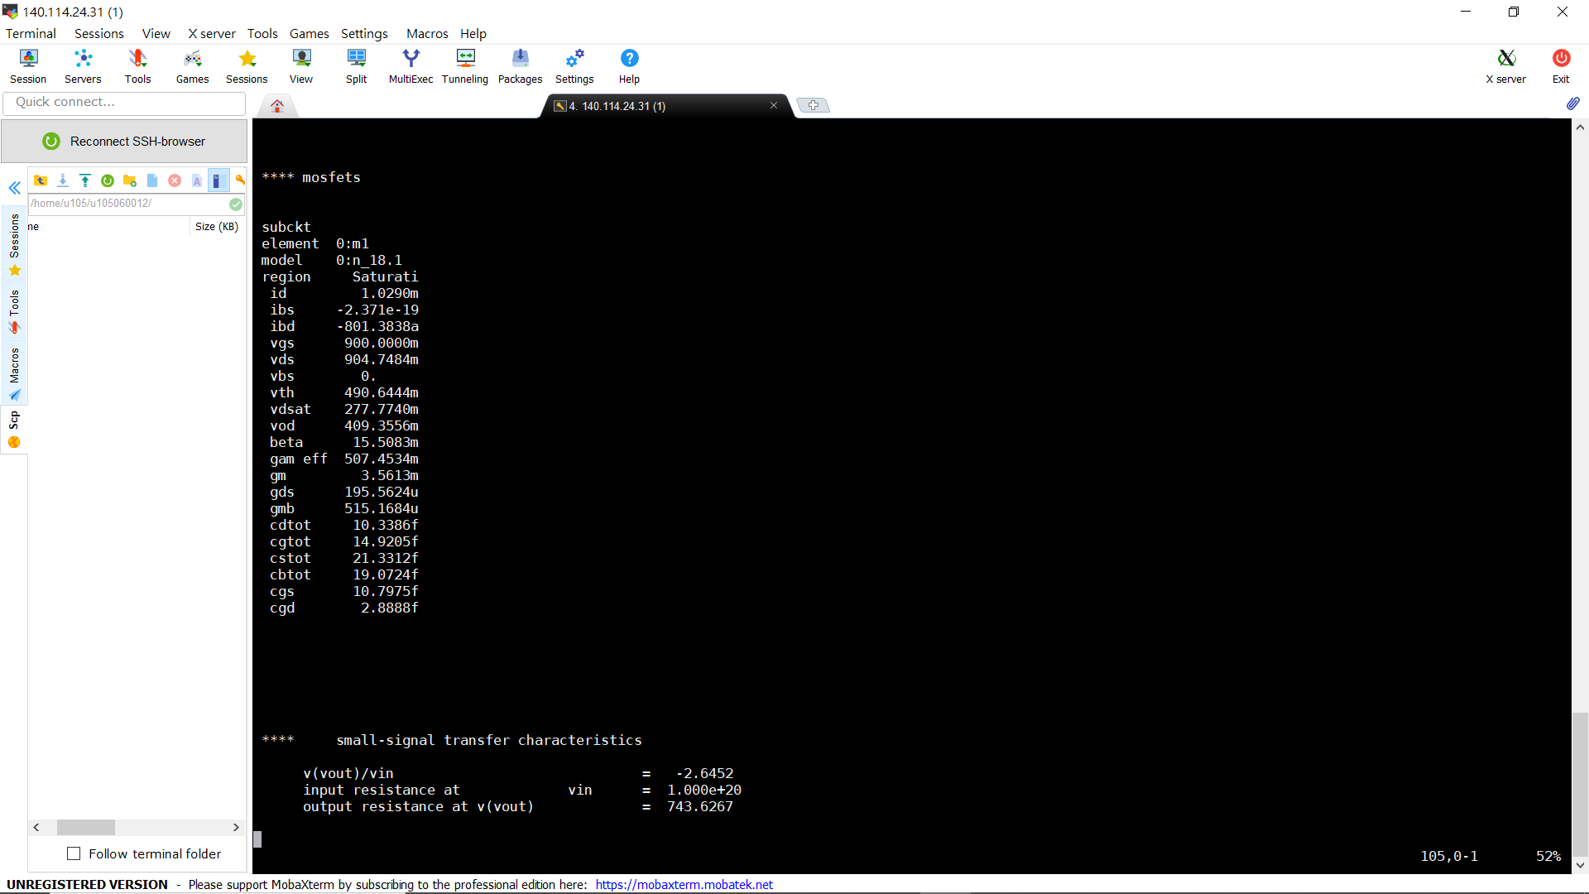

* 1. With minimum channel length ($L=0.18μm$), the overdrive voltage of M1 is 410mV, and the small-signal gain is -2.65.
  2. With dc analysis, the plot of the transfer function from $V_{in}$ to $V_{out}$ by changing $V_{in}$ from 0V to 1.8V is

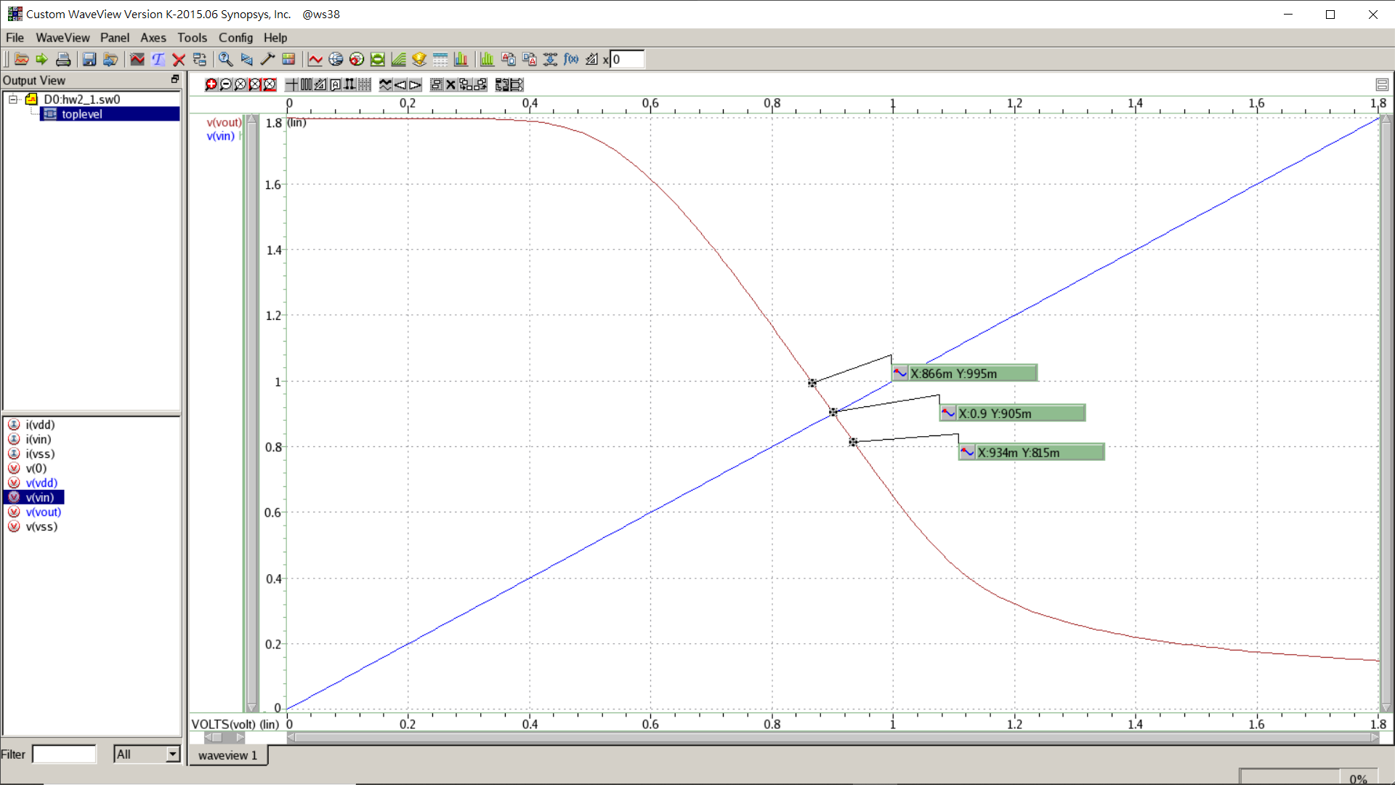

* 1. The input voltage range that the small-signal voltage gain is within +/–10% of that at the operating point is 274mV.

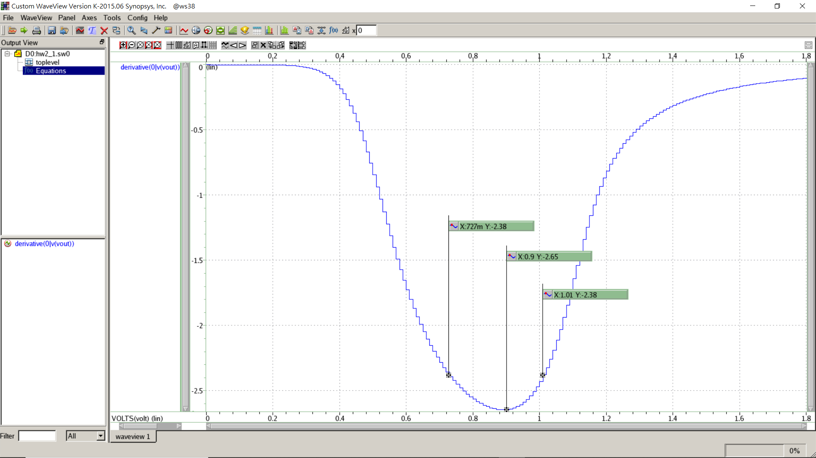

* 1. The small-signal gain decreases at the lower and upper bounds of this range because the gain at lower bound follows the equation that $gain=μ_{n}C_{ox}\left(W/L\right)V_{ov}R_{out}$, which means that the gain will be increase with increasing the value of input voltage. However, when the input voltage larger than the upper bound of this range, the drain current ($I_{D}$) increasing leads to the voltage cross $R_{out}$ increase, and this would lower the voltage between drain and source ($V_{DS}$). By the equation that $gain=μ_{n}C_{ox}\left(W/L\right)V_{ov}(1+λV_{DS})R_{out}$, the gain will be decreased when $V_{DS}$ decrease. That is the reason why the small-signal gain decreases at the lower and upper bounds of this range.
  2. $V_{ov}=410mV$ (from 1g), $A_{F}=g_{m}R_{L}V_{m}, V_{HD2}=0.25g_{m}R_{L}V_{m}^{2}$ (from 1c), $V_{m}=25mV$. The expected power ratio of the second harmonic to the fundamental signal is ${\left(\frac{V_{m}}{4\left(V_{in0}-V_{TH}\right)}\right)}^{2}=2.32×{10}^{-4}$
  3. (Hspice) Input signal is $0.025sin⁡(2π×1M×t)$

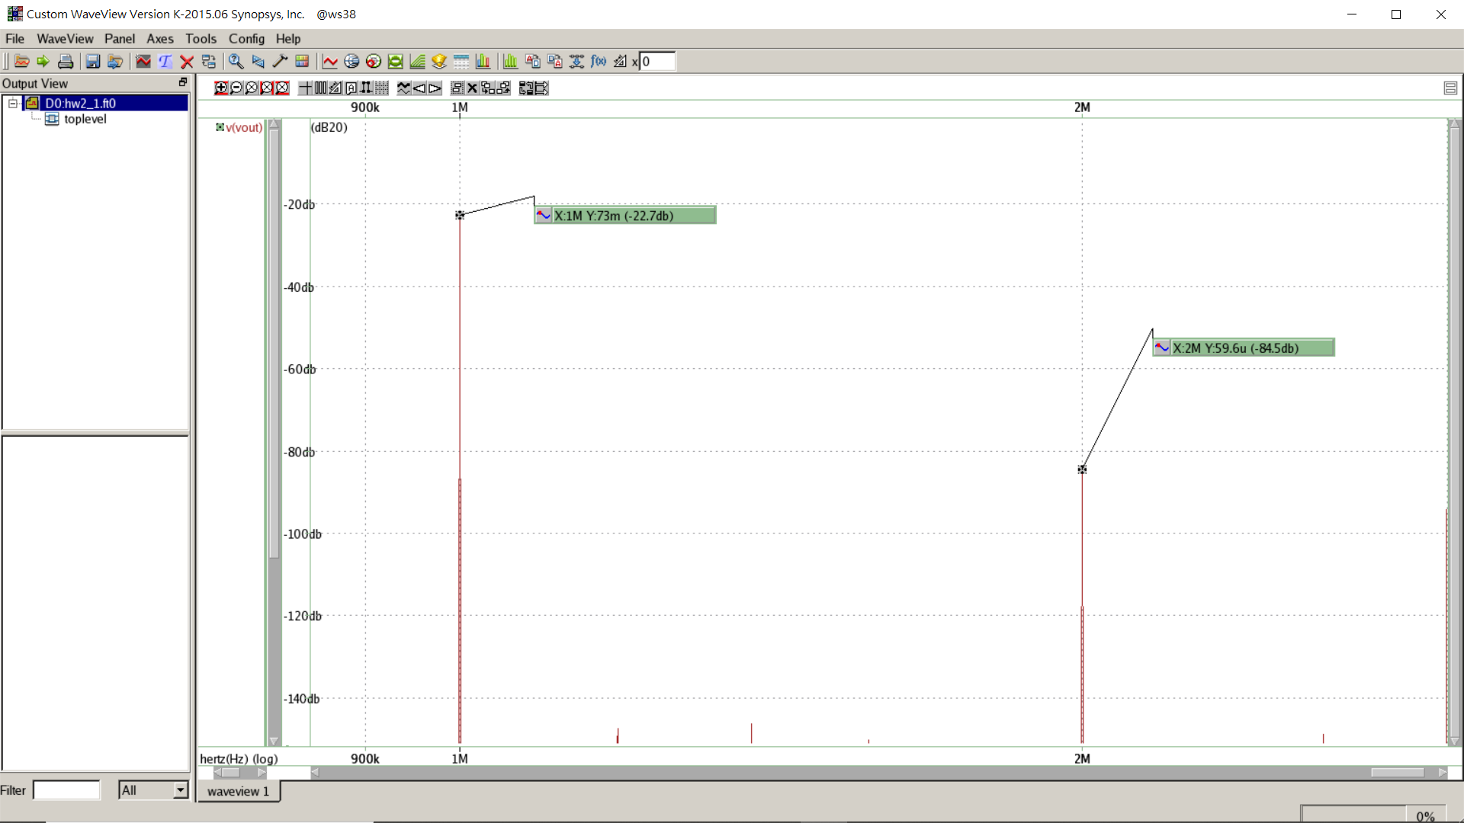

* The coefficient of harmonic distortion at 1Meg Hz is -22.7dB.
* The coefficient of harmonic distortion at 2Meg Hz is -84.5dB.
  1. What is the simulated ratio between the power of the second harmonic to that of the fundamental?

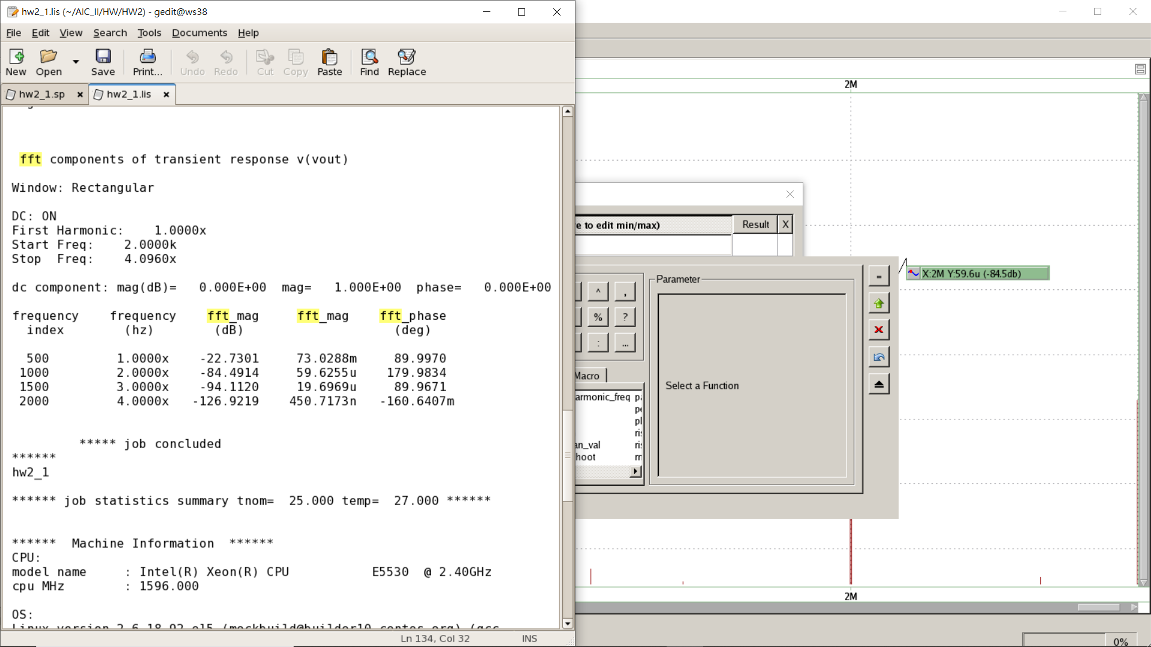

* Power ratio $={\left(\frac{A_{HD2}}{A_{F}}\right)}^{2}=\frac{{\left(59.6255u\right)}^{2}}{{\left(73.2088m\right)}^{2}}=6.67×{10}^{-7}$
  1. How is this number compared to the prediction in question 1)-k? What are the possible reasons for this discrepancy?
     + Hand-calculation: $2.32×{10}^{-4}$, Simulation: $6.67×{10}^{-7}$
     + Suppose that $f\left(V_{in}\right)=f\left(V_{in0}\right)+α_{1}\cos{ωt}+α_{2}\cos{2ωt}$, $ω=1MHz$

By hand-calculation,

* + - The possible reason for this discrepancy is that we have the different coefficient by hand-calculation and simulation. In addition, we only consider the first two terms of the Taylor expansion, so the results must be very different.
  1. Change the size of 𝑀1 from the width in question 1)-g to 30μm with step size of 2μm, adjust $V_{in,CM}$ accordingly so that the power consumption stays constant. Repeat the previous simulations with a sinusoidal input amplitude of 25mV at frequency of 1MHz. Plot the ratio between the power of the second harmonic to that of the fundamental vs. transistor width.

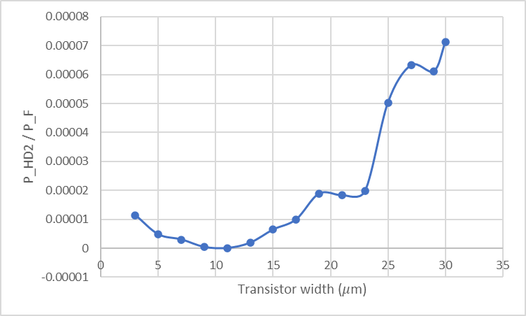

* 1. How is the result compared to that in question 1)-d? Explain the possible reasons for this discrepancy and elaborate your arguments.

In question 1)-d, we need to keep the power consumption same, which means that drain current remains the same. Therefore, we concluded that the ratio of harmonic distortion would be increased with increasing the transistor width in the condition that the power consumption stays constant.

In this plot, we can find the same result compare to the conclusion made in question 1)-d.

* 1. What is the simulated output noise voltage and input-referred noise (both in terms of $V^{2}/Hz$) voltage at low frequencies? What is the total output noise voltage and total input-referred noise voltage (both in terms of $V_{rms}$) if a noise bandwidth of 1GHz is assumed?

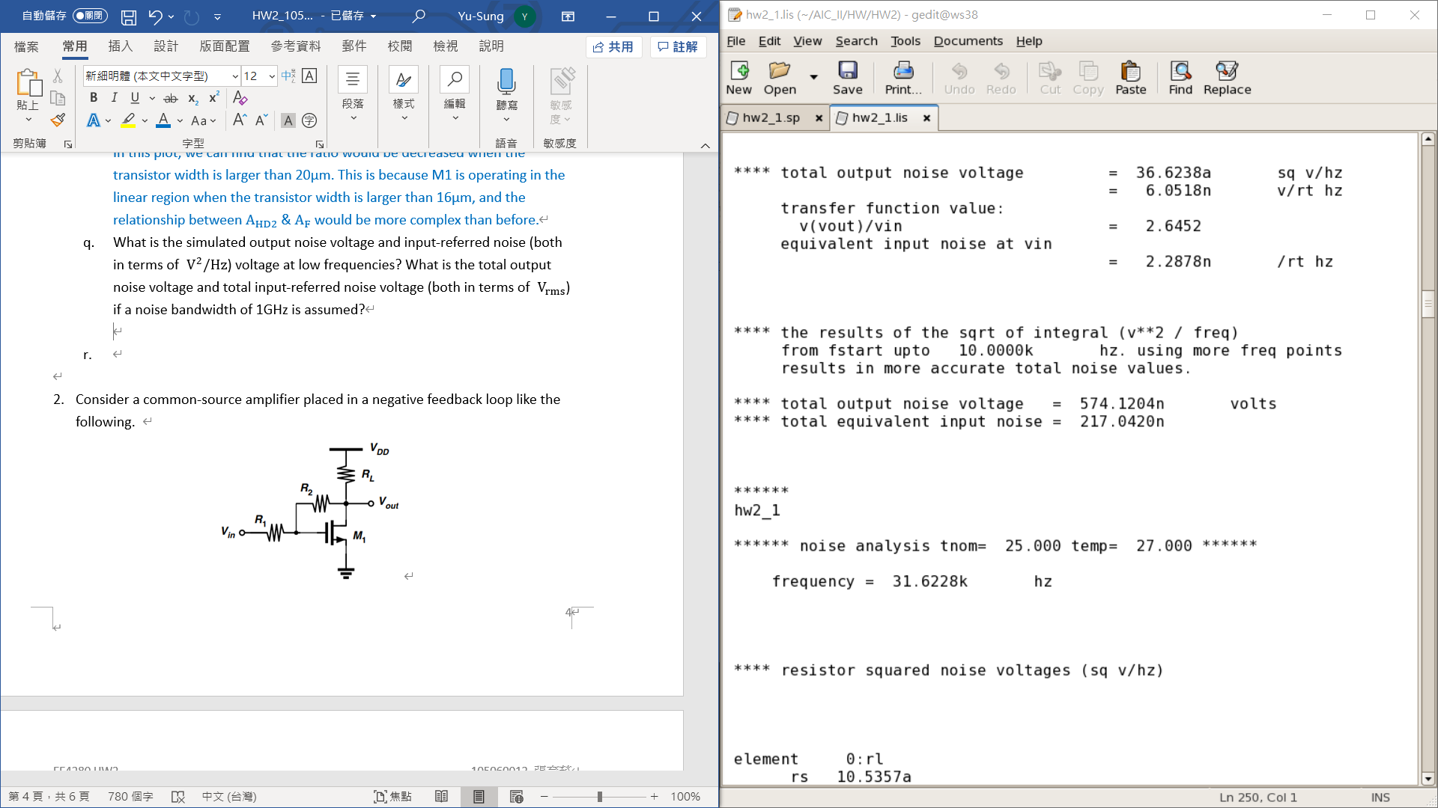

* + - Output noise voltage $=36.6×{10}^{-18} (V^{2}/Hz)$
    - Input-referred noise voltage $=5.23×{10}^{-18} (V^{2}/Hz)$
    - Total output noise voltage $=\sqrt{V_{n,out}^{2}×1G}=0.1913m V_{rms}$
    - Total input-referred noise voltage $=\sqrt{V_{n,in}^{2}×1G}=72.32μ V_{rms}$
  1. Change the size of 𝑀1 from the width in question 1)-g to 30μm with step size of 2μm, adjust $V_{in,CM}$ accordingly so that the power consumption stays constant. Repeat the noise simulations and plot the total output noise voltage and total input-referred noise voltage (both in terms of $V_{rms}$) vs. transistor width.

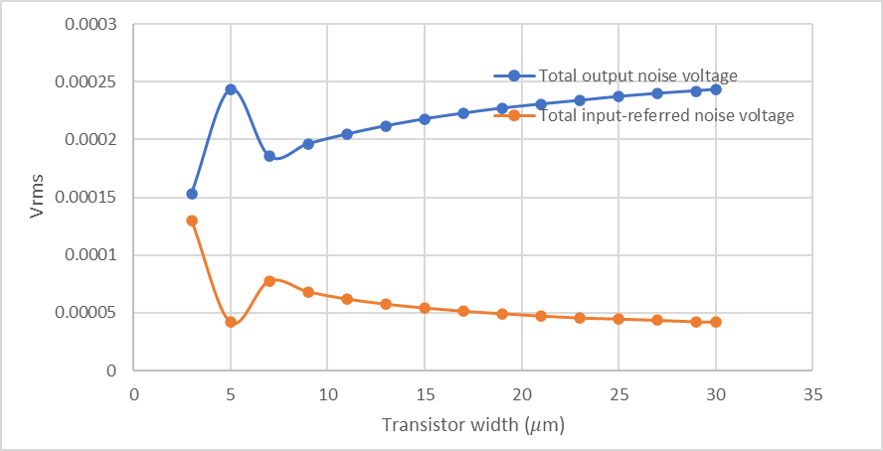

* 1. How is the result compared to that in question 1)-e? Explain the possible reasons for this discrepancy and elaborate your arguments.

* + - By the equation of $S_{v,in}$, we can find that $S_{v,in}$ decrease with increasing the transistor width (since power consumption is constant also means that drain current is constant). And the result of simulation also meets this analysis.
    - By the equation of $S_{v,out}$, we can find that $S_{v,out}$ increase with increasing the transistor width. And the result of simulation also meets this analysis.
  1. Based on the results of the previous two question sets, what is the optimal size for 𝑀1 that gives the minimum THD+N ratio? Notice that the noise power should be calculated at output node in this case.

$$THD+N=\frac{\sum_{n=2}^{∞}{harmonic powers+noise power}}{fundamental power}≈\frac{second harmonic powers+noise power}{fundamental power}$$

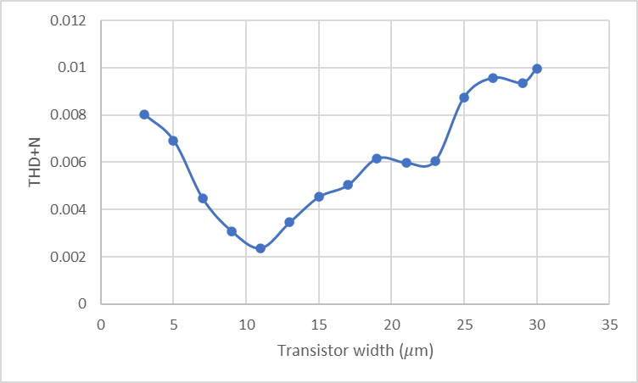

The optimal size of M1 is $\left(W/L\right)=(12μm/0.18μm)$.

1. Consider a common-source amplifier placed in a negative feedback loop like the following.

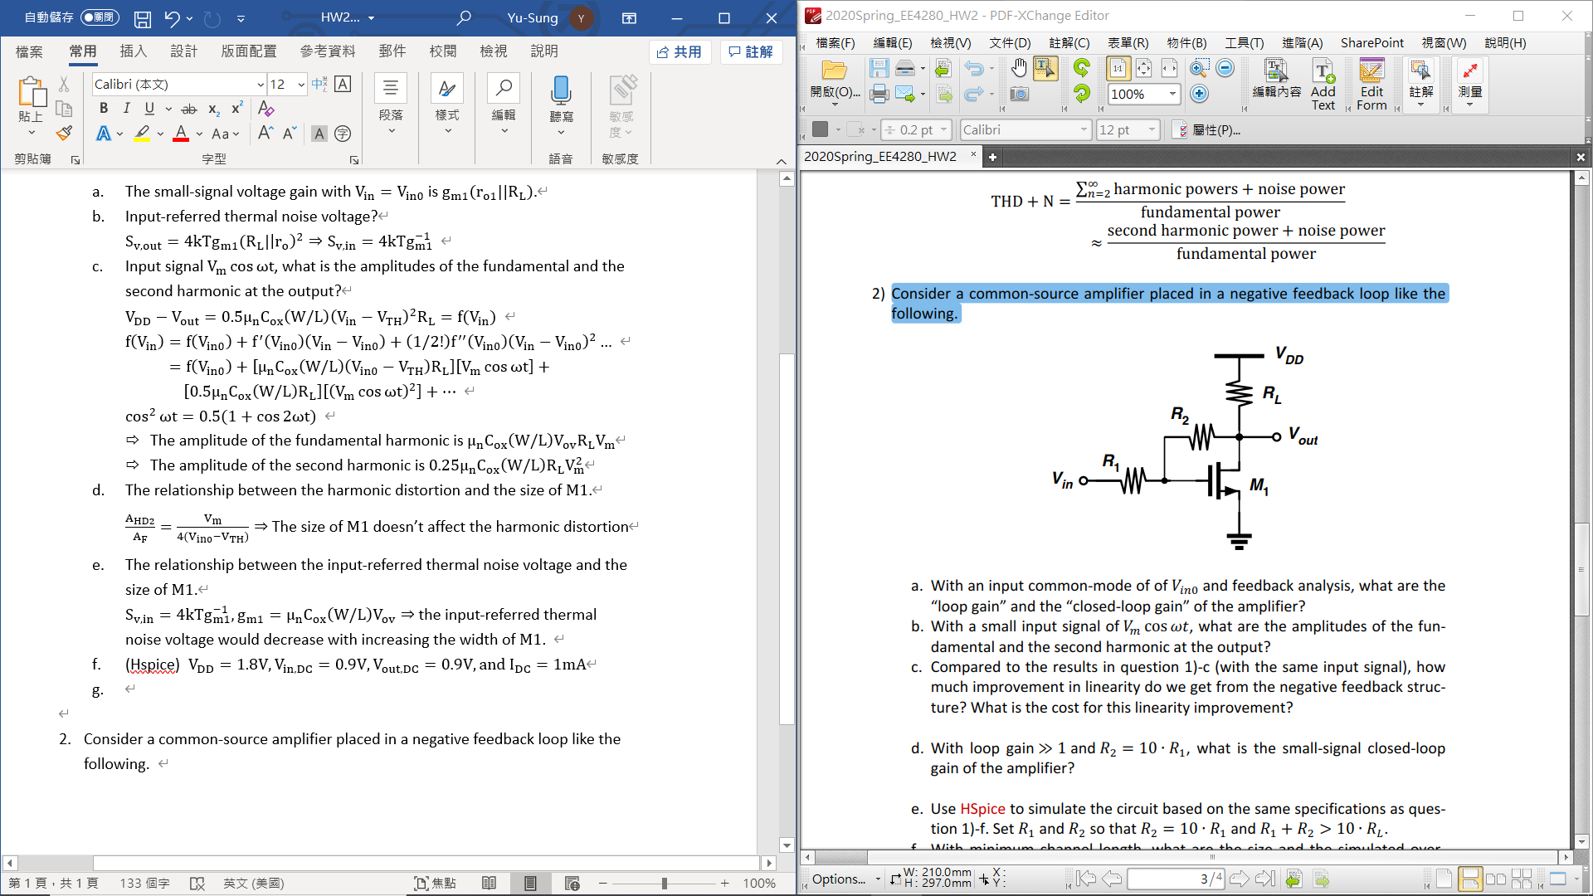

* 1. Loop gain ($βA$)? Closed-loop gain ($A/(1+Aβ)$)?

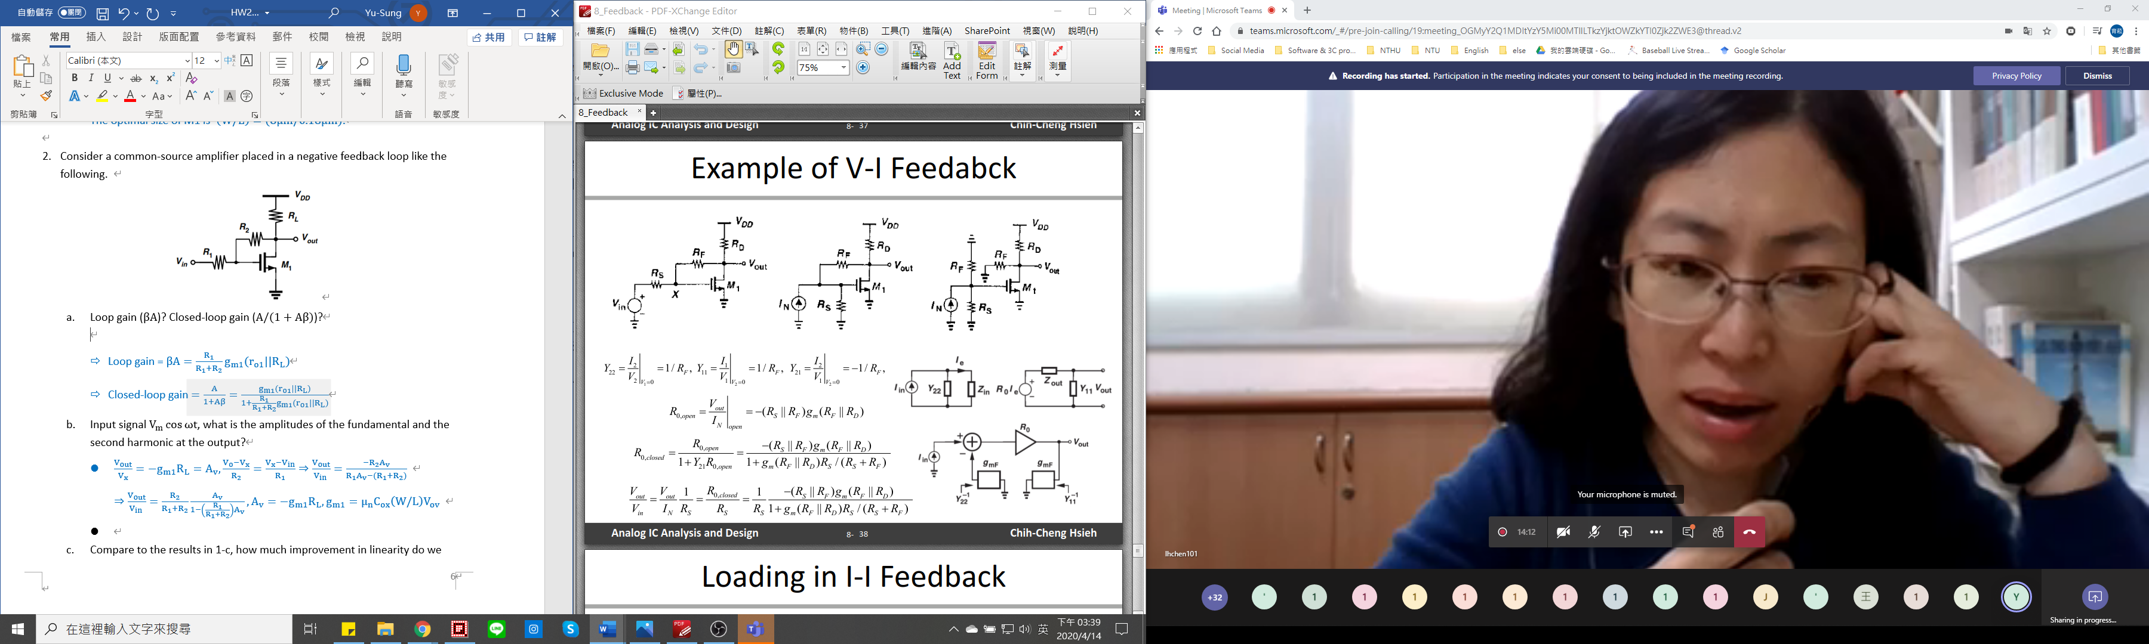

$A=-(R_{1}||R_{2})g_{m1}(R_{2}|\left|R_{L}\right), β=-1/R_{2}, g_{m1}=μ_{n}C_{ox}\left(W/L\right)V_{ov}$

$Loop gain (βA)=\frac{R_{1}}{R_{1}+R_{2}}g_{m1}(R_{2}|\left|R_{L}\right)$

* Closed-loop gain $\left(R\right)=\frac{V_{out}}{I_{N}}=\frac{A}{1+Aβ}=\frac{-(R_{1}||R_{2})g_{m1}(R_{2}|\left|R_{L}\right)}{1+\frac{R_{1}}{R_{1}+R_{2}}g_{m1}(R_{2}|\left|R_{L}\right)}$
  1. Input signal $V_{m}\cos{ωt}$, what is the amplitudes of the fundamental and the second harmonic at the output?
$\frac{V_{out}}{V_{in}}=\frac{V_{out}}{I_{N}}\frac{1}{R_{1}}=\frac{1}{R_{1}}\frac{-(R_{1}||R_{2})g_{m1}(R_{2}|\left|R_{L}\right)}{1+\frac{R_{1}}{R_{1}+R_{2}}g_{m1}(R_{2}|\left|R_{L}\right)}$

* For input-output characteristic, $A=α_{1}E+α_{2}E^{2}$, and $y\left(t\right)=a\cos{ωt}+b\cos{2ωt}$ (fundamental and second harmonic)

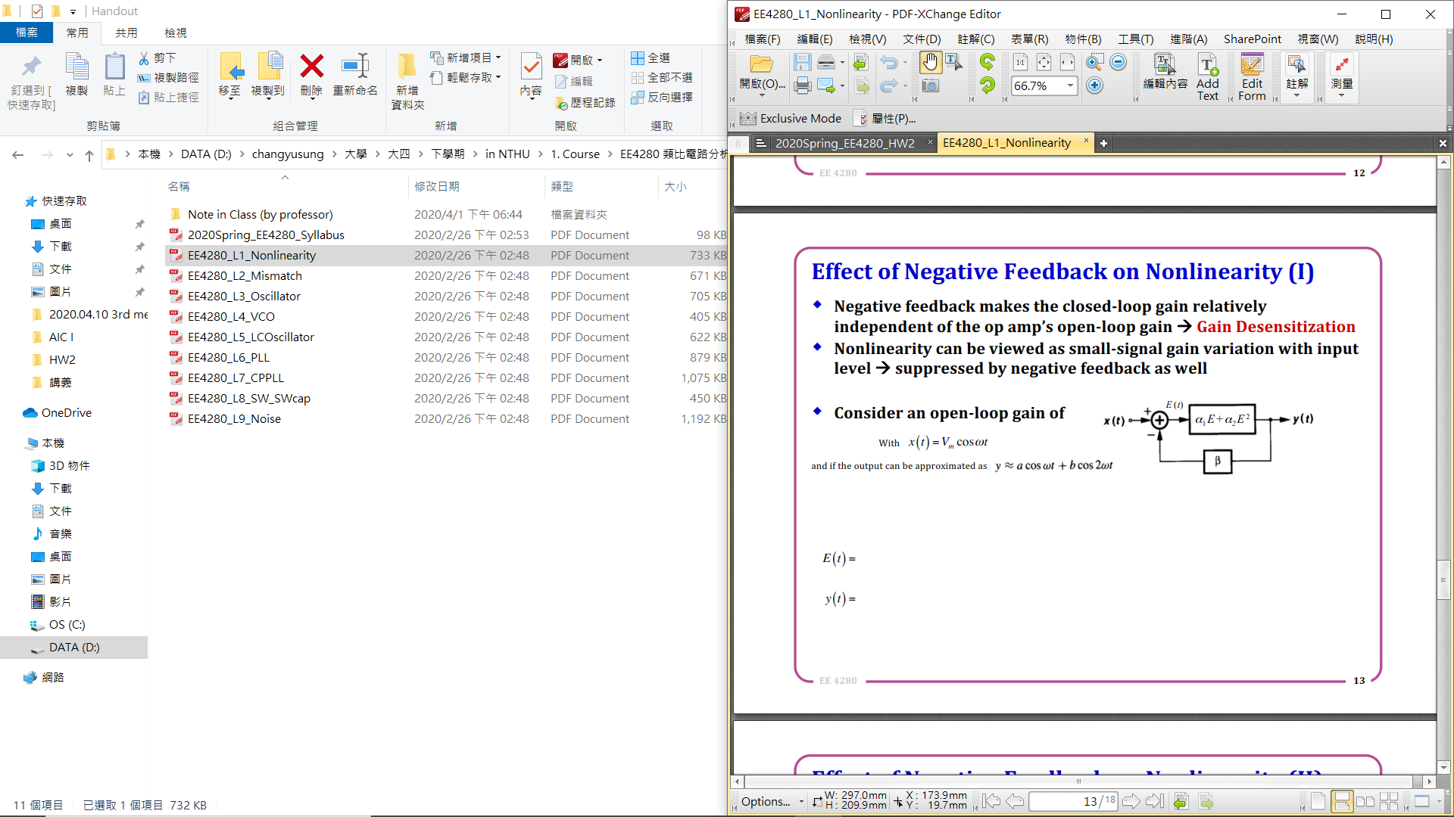



* 1. Compare to the results in 1-c, how much improvement in linearity do we get from the negative feedback structure? What is the cost for this linearity improvement?
* Not only fundamental harmonic distortion but also second harmonic distortion are improved by the negative feedback structure.
* For fundamental harmonic distortion, this term is pretty similar to gain, such as $A_{F,CS}=μ_{n}C_{ox}\left(W/L\right)V_{ov}R_{L}V_{m}=gain_{CS}V_{m}$ and $A_{F,FB}=\frac{α_{1}}{1+α_{1}β}V_{m}=gain_{FB}V_{m}$. We can find that $A_{F,CS}$ is larger than $A_{F,FB}$ due to the gain difference.
* For the amplitudes of the fundamental and the second harmonic at the output, the feedback one is smaller than the CS one since the dominator of the one in feedback in much larger than numerator compared to that in CS.
* However, the cost for this improvement is that the power dissipation would be higher, and the closed-loop gain is lower than the origin.
  1. With loop gain >> 1 and $R_{2}=10R_{1}$, what is the small-signal closed-loop gain of the amplifier?
* Closed-loop gain $\frac{V_{out}}{V_{in}}=\frac{V_{out}}{I_{N}}\frac{1}{R_{1}}=\frac{1}{R_{1}}\frac{-(R_{1}||R_{2})g_{m1}(R_{2}|\left|R_{L}\right)}{1+\frac{R_{1}}{R_{1}+R_{2}}g_{m1}(R_{2}|\left|R_{L}\right)}≈10$
  1. (Hspice)

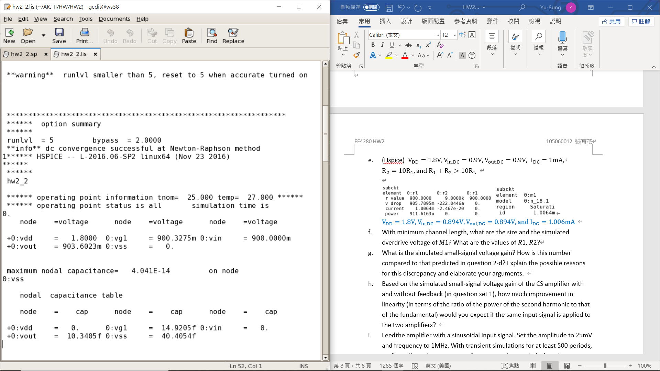

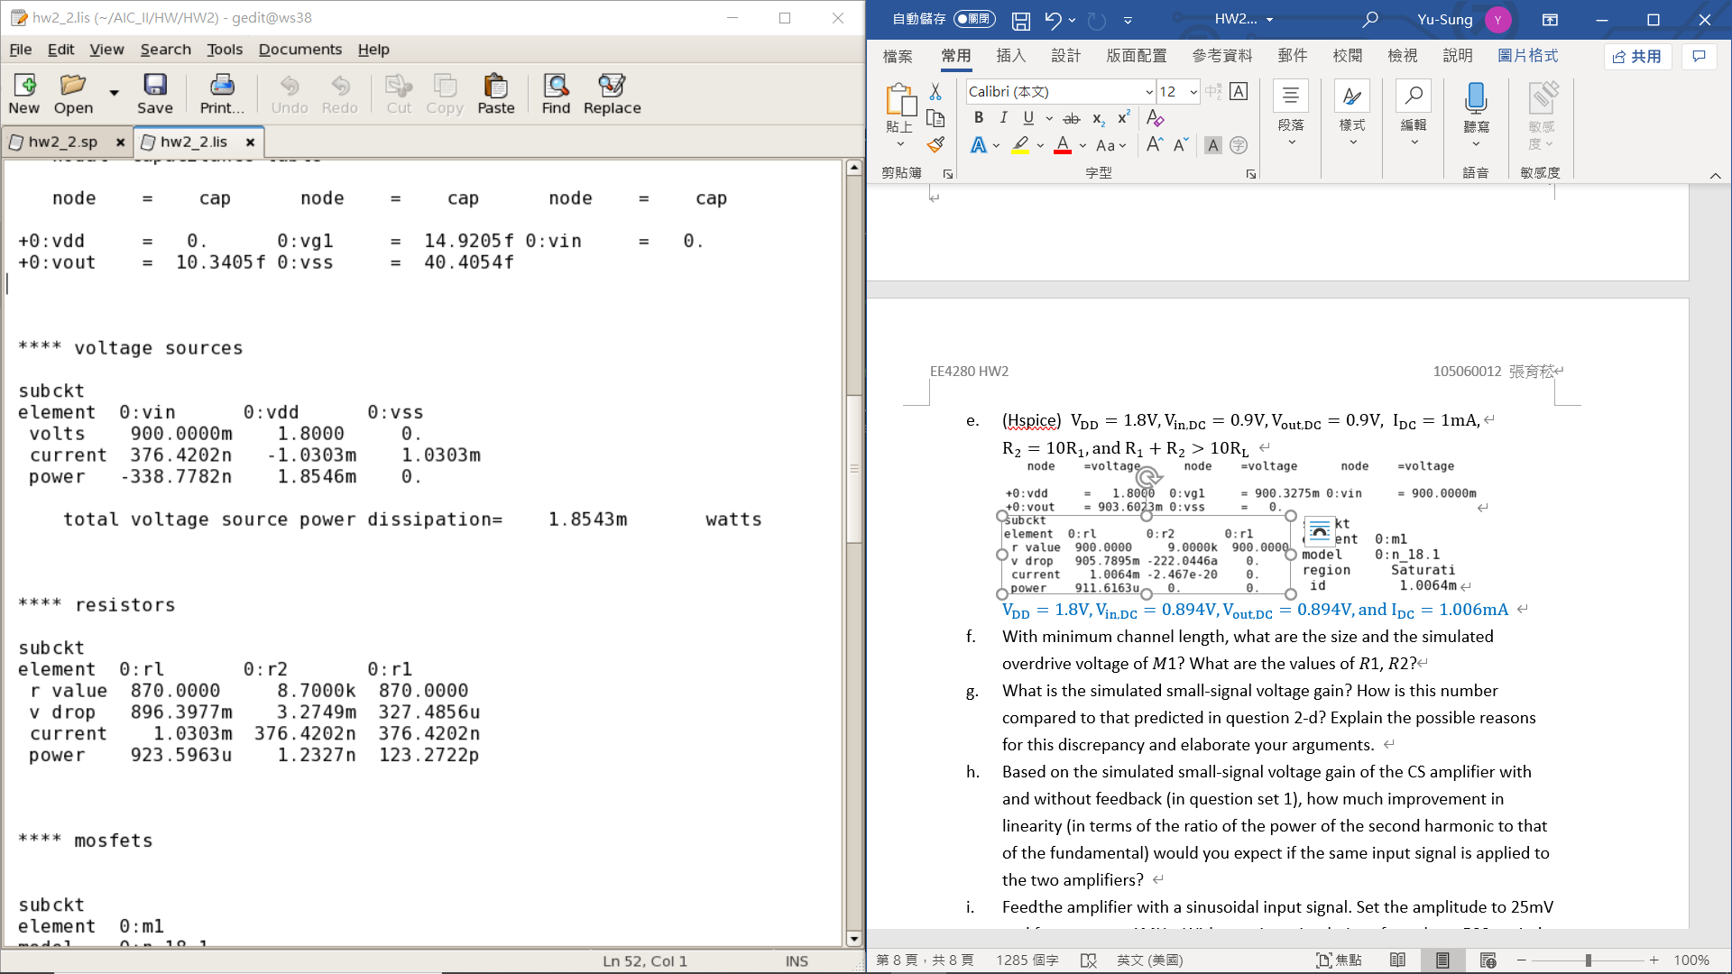 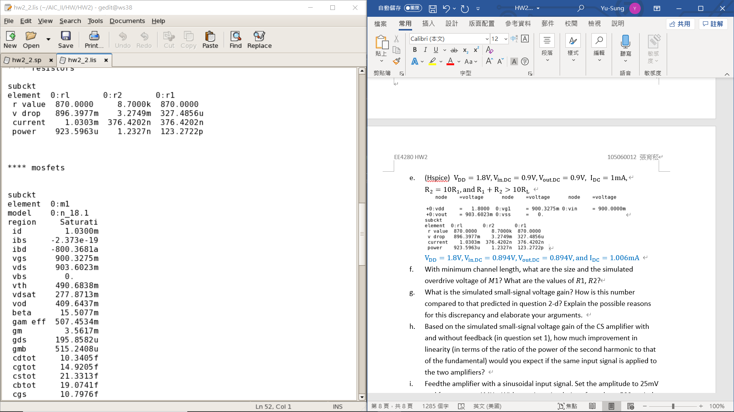

* 1. With minimum channel length, what are the size and the simulated overdrive voltage of 𝑀1? What are the values of 𝑅1, 𝑅2?

With minimum channel length ($L=0.18μm$), the overdrive voltage of M1 is 409mV, the small-signal gain is -1.76,and.

* 1. What is the simulated small-signal voltage gain? How is this number compared to that predicted in question 2-d? Explain the possible reasons for this discrepancy and elaborate your arguments.
* For hand-calculation, closed-loop gain $=\frac{1}{R_{1}}\frac{-(R_{1}||R_{2})g_{m1}(R_{2}|\left|R_{L}\right)}{1+\frac{R_{1}}{R_{1}+R_{2}}g_{m1}(R_{2}|\left|R_{L}\right)}=2.03$ with gm = 3.56m ($Ω^{-1}$), and the value of gm is given by the simulation.
* The results of gain obtained by hand-calculation and simulation are very similar, but the result is far from the result in 2-d because we assume loop gain is much larger than 1 in 2-d.
* However, the loop gain in this circuit is 0.26. Therefore, this is the reason for this discrepancy.
  1. Based on the simulated small-signal voltage gain of the CS amplifier with and without feedback (in question set 1), how much improvement in linearity (in terms of the ratio of the power of the second harmonic to that of the fundamental) would you expect if the same input signal is applied to the two amplifiers?
* For CS, $α_{1}=μ_{n}C_{ox}\left(\frac{W}{L}\right)V_{ov}R_{L}, α_{2}=0.5μ_{n}C_{ox}\left(\frac{W}{L}\right)R_{L}$

$⟹\frac{A_{HD2}}{A_{F}}{\left.​\right|}_{CS}=\frac{α_{2}}{2α_{1}}V_{m}=\frac{V_{m}}{4\left(V_{in0}-V_{TH}\right)}$.

$\frac{A_{HD2}}{A_{F}}{\left.​\right|}_{FB}=\frac{α_{2}}{2α_{1}{\left(1+α_{1}β\right)}^{2}R_{1}}V_{m}, α_{1}=2V_{ov}α_{2}$

* The expected improvement in linearity of power is ${\left(\frac{1}{{\left(1+α_{1}β\right)}^{2}R_{1}}\right)}^{2}$.
 $α_{1}β=[(R_{1}||R_{2})(μ_{n}C_{ox}\left(\frac{W}{L}\right)(V_{in}-V_{TH}))(R_{2}|\left|R_{L}\right)]×\frac{1}{R_{2}}=0.36$

 + The expected linear improvement is ${\left(\frac{1}{{\left(1+α_{1}β\right)}^{2}R_{1}}\right)}^{2}=3.84×{10}^{-7}$
  1. Feed the amplifier with a sinusoidal input signal. Set the amplitude to 25mV and frequency to 1MHz. With transient simulations for at least 500 periods, perform dft on the output waveform over a time period when the wave-form becomes steady (after at least 100 periods) and plot the result with y-axis in dB20 scale. Place markers at 1MHz and 2MHz. Use “.option accurate” in your simulation. Set time step to less than 1ns. Zoom in to [0 3] MHz for x-axis and [−150 0] dB for y-axis.

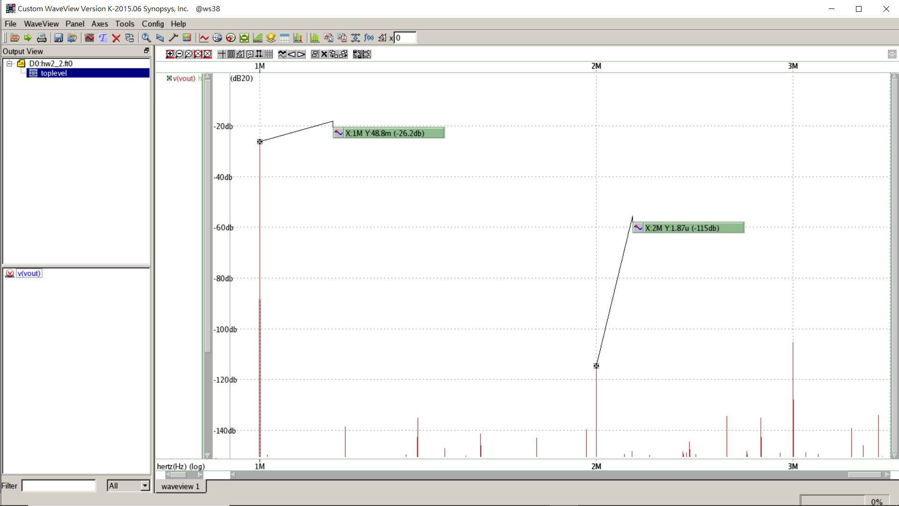

* The coefficient of harmonic distortion at 1Meg Hz is -22.7dB.
* The coefficient of harmonic distortion at 2Meg Hz is -84.5dB.
  1. What is the simulated ratio between the power of the second harmonic to that of the fundamental?

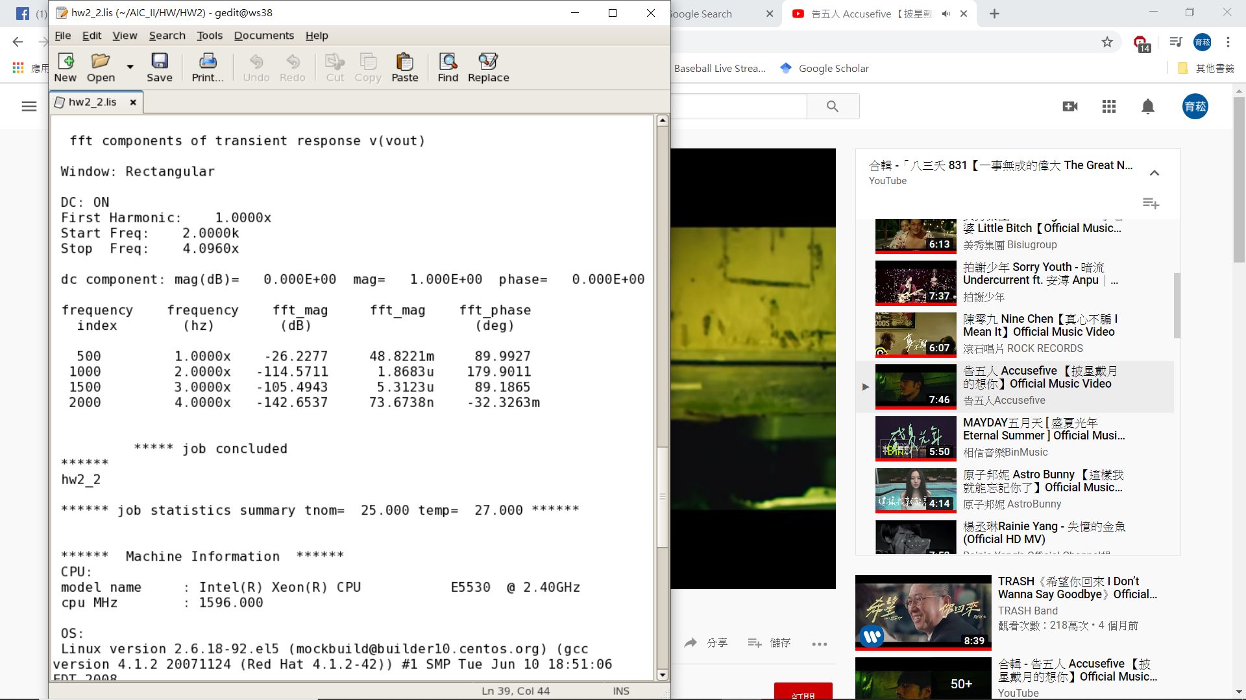

* Power Ratio $={\left(\frac{A_{HD2}}{A_{F}}\right)}^{2}=\frac{{\left(1.8683u\right)}^{2}}{{\left(48.8221m\right)}^{2}}=1.464×{10}^{-9}$
  1. How is this result compared to that in question 2)-b? How is this improve-ment over a CS amplifier without feedback compared to that predicted in question 2)-h? What are the possible reasons for this discrepancy?
* By hand-calculation (in power),

* + Linear improvement of power by hand-calculation is $3.89×{10}^{-7}$
* By simulation (in power),
  + With feedback: ${\left(\frac{A_{HD2}}{A_{F}}{\left.​\right|}_{FB}\right)}^{2}=1.464×{10}^{-9}$
  + Without feedback: ${\left(\frac{A_{HD2}}{A_{F}}{\left.​\right|}_{CS}\right)}^{2}=6.67×{10}^{-7}$
  + Linear improvement of power by simulation is $2.2×{10}^{-3}$
* We can find that the results of linear improvement by hand-calculation and simulation are totally difference. The result from simulation is much better than hand-calculation.
* The reason I think is that we use some approximations to get the hand-calculation result. Furthermore, in the simulation, I didn’t keep drain current in 1mV precisely, and this could lead to the error of the equation.