2018 AIC Midterm Exam Solution

1. Answer definitions of the following terms and explain the physical mechanisms. (10%)

(a) Chemical Vapor Deposition. (2%)

講義1-62~1-65

(b) Drain Induced Barrier Lowering. (2%)

講義2-61

(c) Ion implementation and anneal. (2%)

講義1-59~1-61

(d)  effecteffecteffect effecteffect. (2%)

講義2-36

(e) Mobility degradation. (2%)

講義2-62

2. A NMOS is biased with a gate voltage VG and a drain voltage VD as shown in Fig. 2. (10%)

(a) Sketch the small signal model. (2.5%)

Simple:

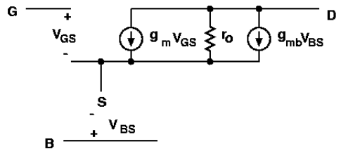

Complete:

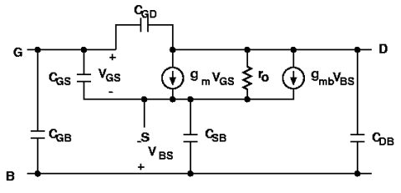

(b) Write down the ID–VG equation in saturation region. (2.5%)

$I_{D}=\frac{1}{2}{μC}_{ox}\frac{W}{L}{(V_{GS}-V_{TH})}^{2}$

(c) Derive two types of gm equation. (2.5%)

$g_{m}={μC}_{ox}\frac{W}{L}V_{OV}=\sqrt{2{μC}_{ox}\frac{W}{L}I_{D}}=\frac{2I_{D}}{V_{OV}}$

(d) Sketch the two types of gm transfer curve in (c). (2.5%)

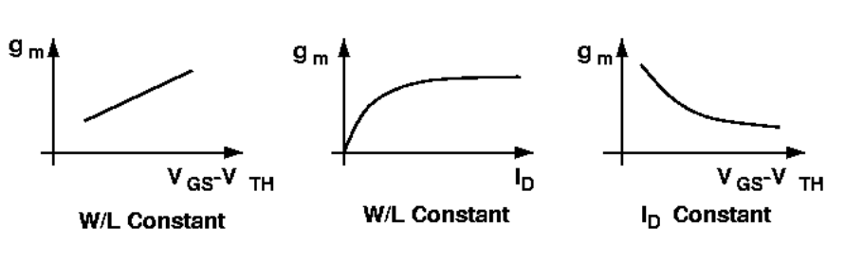

3. Fig. 3 is a layout of CMOS inverter. (10%)

(a) Draw the cross section from A-A’. (2.5%)

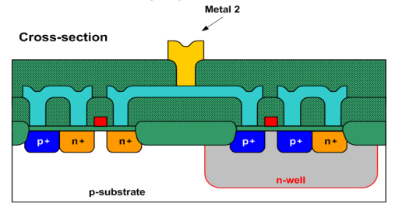

(b) Sketch and name all the parasitic capacitance of nMOS. (2.5%)

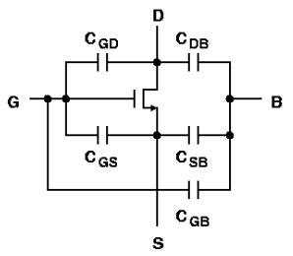

(c) Sketch the transfer curve of gate-to-source and gate-to-drain capacitances versus gate-to-source voltage. (2.5%) 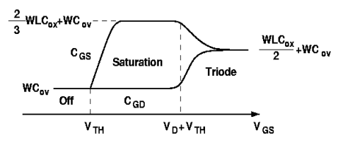

(d) Sketch the operation region in the figure of (c) (2.5%): 同上

4.

(a)

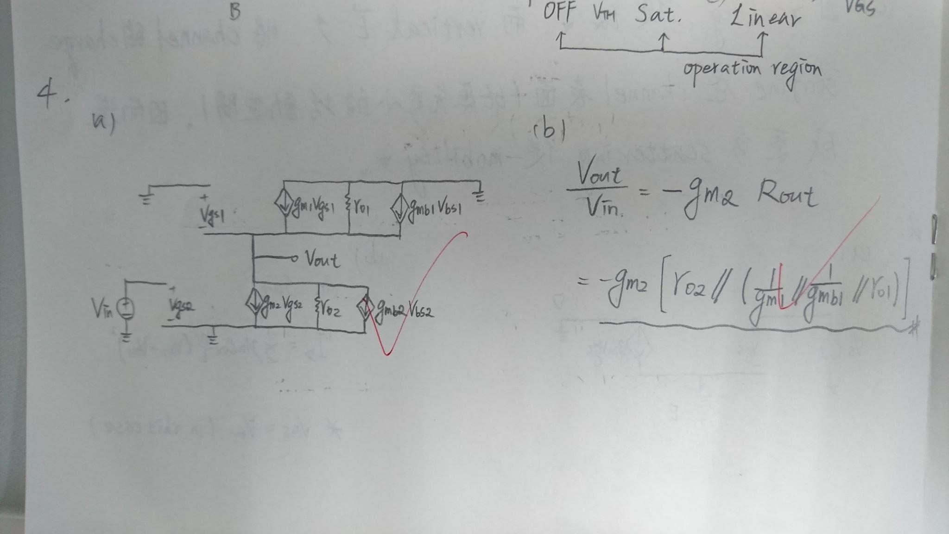

(b)

5. The ro vs. VDS characteristic of MOSFET is shown in Fig. 5. Please identify and explain the corresponding effects at region I ~ III. (5%)

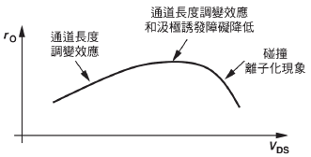

I: Channel-length modulation

II: Channel-length modulation + DIBL

III: Impact ionization

6.

(a)

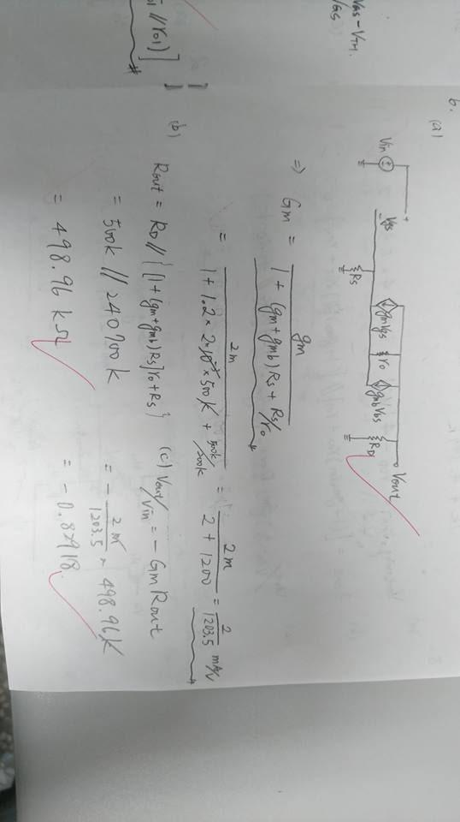

$G_{m}=\frac{g_{m1}}{1+\left(g_{m1}+g_{mb1}\right)R_{s}+\frac{R_{s}}{r_{o1}}}=1.66 uA/V$

(b)

$R_{out}=\left\{[1+(g_{m1}+g_{mb1})r_{o1}]R_{s}+r_{o1}\right\}||R_{D}≅498.96 kOhm$

(c)

$A_{V}=-G_{m}R_{out}=-0.828 V/V$

7.

(a)

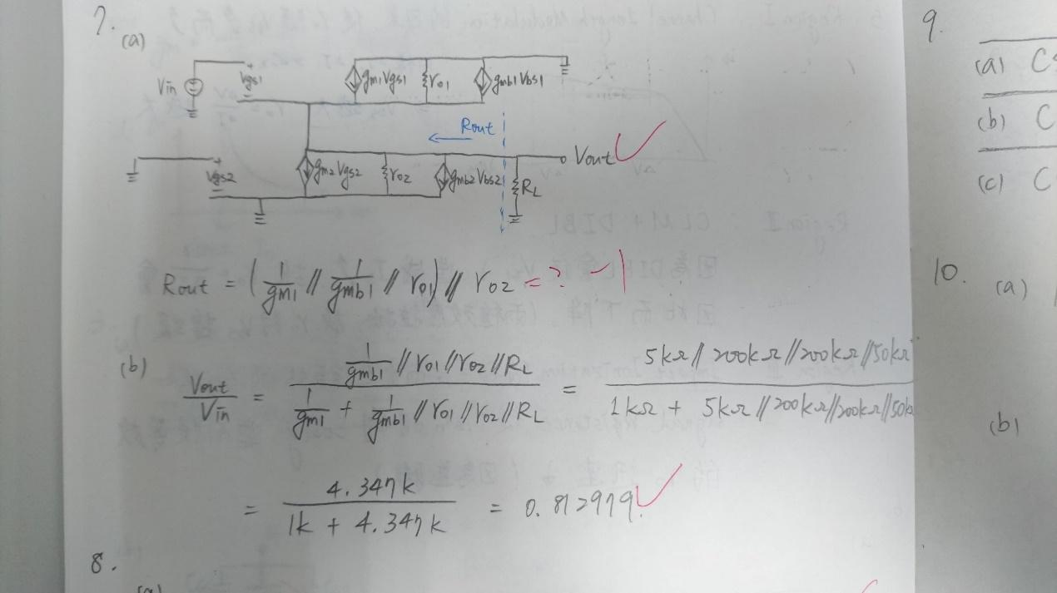

$R_{out}=\frac{1}{\left(g_{m1}+g_{mb1}\right)}\left|\left|r_{o1}\right|\right|r_{o2}=833 Ohm$

(b)

$\frac{V_{out}}{V_{in}}=-g_{m1}\left(r_{o1}\left|\left|r_{o2}\right|\right|\frac{1}{g_{m1}+g_{mb1}}||R_{L}\right)=0.8125 V/V$

8.

(a)

$V_{out-swing}=V_{DD}-V_{ov1}-V_{ov2}-V_{ov3}-V_{ov4}=3.3-0.3×4=2.1 V$

(b)

$R_{out}≅(g_{m2}r_{o2}r_{o1})||\left(g_{m3}r_{o3}r_{o4}\right)=20 MOhm$

(c)

$\frac{V_{out}}{V_{in}}=-g_{m1}R_{out}=20000 V/V$

(d)

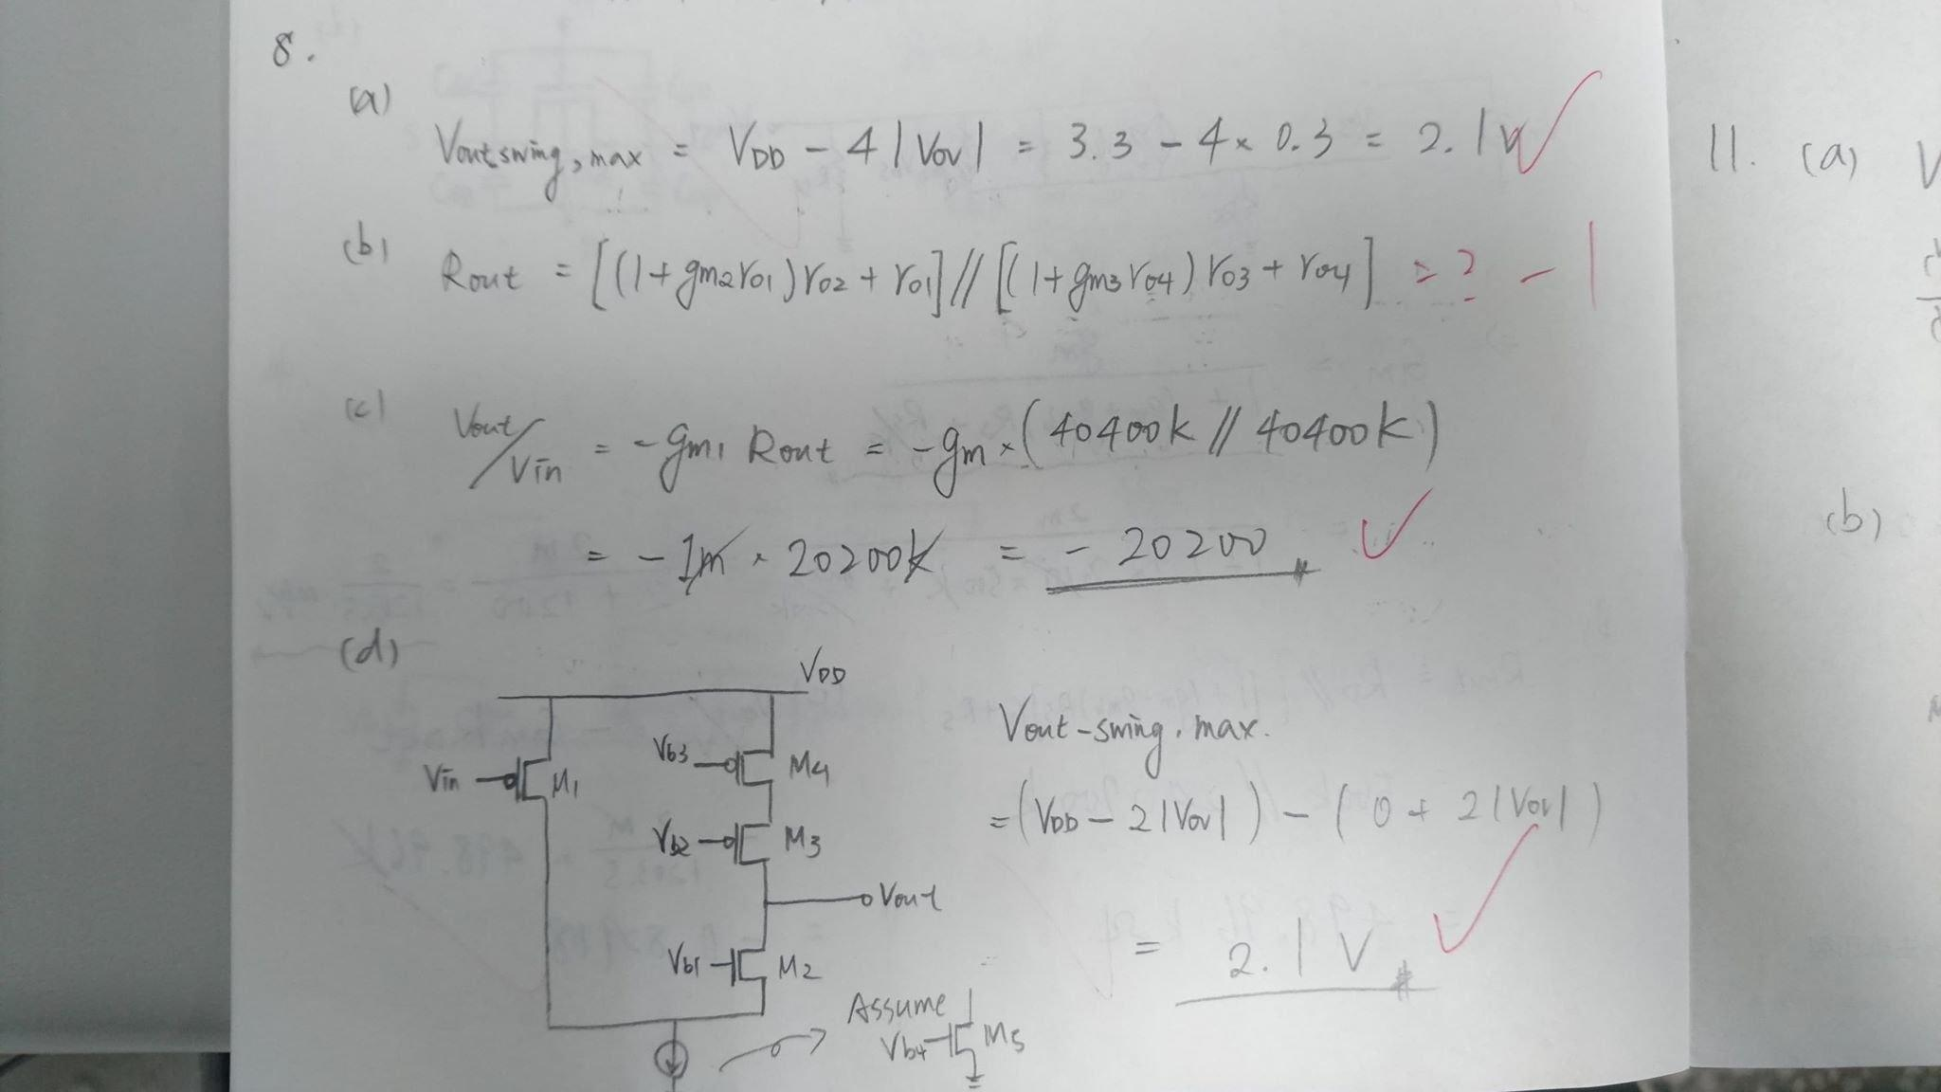

9.

|  | CS | CD | CG |
| --- | --- | --- | --- |
| Rin | Large | Large | Small |
| Rout | Large | Small | large |
| Characteristic | (iv)  trans-conductance | (i)  Voltage amp. | (ii)(iii)  Current amp  Trans-impedance |

10.

(a) M0: 4u/1u, M2: 16u/1u (4u/1u m=4), M3: 16u/1u (4u/1u m=4)

(b) VGS1+VGS0-VTH=0.8+0.8-0.5=1.1V

11.

(a) Vb=Vov1+VGS2=0.3+1=1.3V, (W/L)4/ (W/L)2=4, Vout,min=Vov3+Vov4=0.6V

(b)

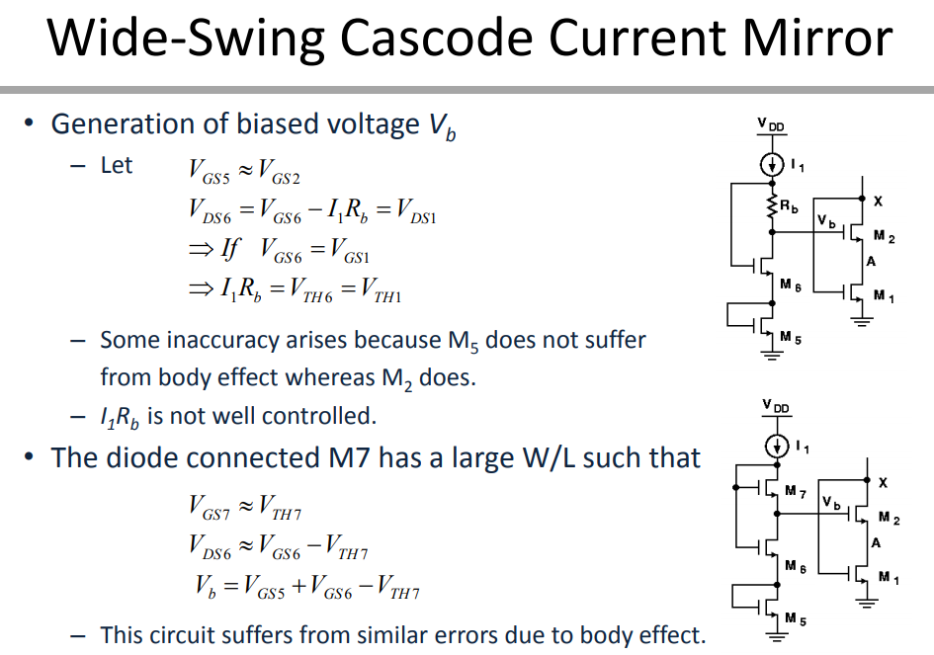

12.

(a) Differential gain = - gm(RD||ro)=-1m*(200k||200k)=-100(V/V)

(b) Common gain = -(RD/2)/(1/2gm)+Rss=-200/401 (V/V)

(c) Max differential input range==0.2V

(d) 0.9V<Vin,cm<1.3V

(e) for M2 operate in saturation, Vout2.min=Vin,cm-Vth=1-0.5=0.5V

🡪 ID2=(1.8-0.5)/200k=6.5uA🡪ID1=10u-6.5u=3.5u🡪Vout1=1.8-(3.5u*200k)=1.1

🡪Vout1-Vout2=1.1-0.5=0.6V

13.

FFFFT

TFFTT