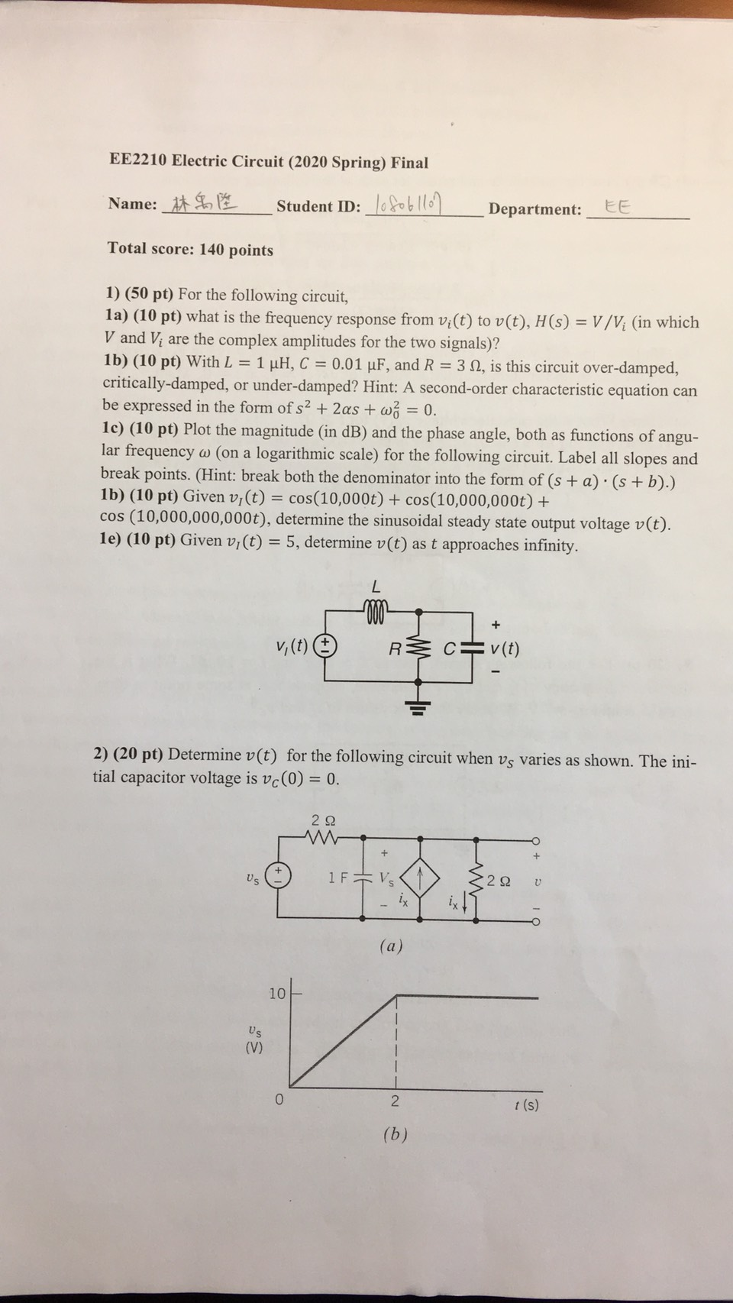

**EE2210 Electric Circuit (2020 Spring) Final**

**Name: 林禹陞**

**Student ID: oblo**

**Department:**

EE

**Total score: 140 points**

1) (50 pt) For the following circuit,

1a) (10 pt) what is the frequency response from v;(t) to v(t), H(s) = V/V; (in which V and V, are the complex amplitudes for the two signals)?

1b) (10 pt) With L = 1 μH, C = 0.01 μF, and R = 32, is this circuit over-damped, critically-damped, or under-damped? Hint: A second-order characteristic equation can be expressed in the form of s2 + 2as + w2 = 0.

1c) (10 pt) Plot the magnitude (in dB) and the phase angle, both as functions of angu- lar frequency @ (on a logarithmic scale) for the following circuit. Label all slopes and break points. (Hint: break both the denominator into the form of (s + a) (s+b).) 1b) (10 pt) Given v,(t) = cos(10,000t) + cos(10,000,000t) +

cos (10,000,000,000t), determine the sinusoidal steady state output voltage v(t). 1e) (10 pt) Given v,(t) = 5, determine v(t) as t approaches infinity.

**+**

*v,(t) (*

R

*C= v(t)*

2) (20 pt) Determine v(t) for the following circuit when vs varies as shown. The ini- tial capacitor voltage is vc(0) = 0.

US

2 Ω w

1F Vs lx

(a)

2 Ω

O

US

(V)

10

0

2

*t(s)*

*(b)*