Design

* NMOS： $I_{D}=\frac{1}{2}μC_{ox}\frac{W}{L}{\left(V_{GS}-V_{T}\right)}^{2}(1+λV_{DS})$, with $μC_{ox}=k_{n}$ W/L=3

1. For $V_{DS}=4V, V_{GS}=3V$ 🡪 $1.36m=0.5×k_{n}×3{\left(3-V_{T}\right)}^{2}(1+4λ)$
2. For $V_{DS}=3V, V_{GS}=3V$ 🡪 $1.35m=0.5×k_{n}×3{\left(3-V_{T}\right)}^{2}(1+3λ)$
3. For $V_{DS}=3.3V, V_{GS}=3.3V$ 🡪 $1.86m=0.5×k_{n}×3{\left(3.3-V_{T}\right)}^{2}(1+3.3λ)$
4. For $V_{DS}=3.3V, V_{GS}=3.2V$ 🡪 $1.68m=0.5×k_{n}×3{\left(3.2-V_{T}\right)}^{2}(1+3.3λ)$
5. Calculate $V_{T}$： $\frac{1.86}{1.68}={\left(\frac{3.3-V_{T}}{3.2-V_{T}}\right)}^{2}$ 🡪 $V_{T}=1.2846V$
6. Calculate $λ$： $\frac{1.36}{1.35}=\frac{1+4λ}{1+3λ}$ 🡪 $λ=0.00758$
7. Calculate $k_{n}$ 🡪 $k_{n}=299.057μ$ (Using 1.)

* PMOS： $I_{D}=\frac{1}{2}μC_{ox}\frac{W}{L}{\left(V_{SG}+V_{T}\right)}^{2}(1+λV_{SD})$, with $μC_{ox}=k_{p}$ W/L=3

1. For $V_{SD}=4V, V_{SG}=3V$ 🡪 $1.397m=0.5×k_{p}×3{\left(3-V_{T}\right)}^{2}(1+4λ)$
2. For $V_{SD}=3V, V_{SG}=3V$ 🡪 $1.3328m=0.5×k_{p}×3{\left(3-V_{T}\right)}^{2}(1+3λ)$
3. For $V_{SD}=3.3V, V_{SG}=3.3V$ 🡪 $1.8m=0.5×k_{p}×3{\left(3.3-V_{T}\right)}^{2}(1+3.3λ)$
4. For $V_{SD}=3.3V, V_{SG}=3.2V$ 🡪 $1.64m=0.5×k_{p}×3{\left(3.2-V_{T}\right)}^{2}(1+3.3λ)$
5. Calculate $V_{T}$： $\frac{1.8}{1.64}={\left(\frac{3.3-V_{T}}{3.2-V_{T}}\right)}^{2}$ 🡪 的蛋糕 $=-1.1012V$
6. Calculate $λ$： $\frac{1.397}{1.3328}=\frac{1+4λ}{1+3λ}$ 🡪 $λ=0.0563$
7. Calculate $k_{p}$ 🡪 $k_{p}=210.821μ$ (Using. 1)

Table1

Comment:

當 $V_{GS}$ 小的時候，實驗數據與hspice模擬結果相近。當 $V_{GS}$ 變得越來越大的時候，實驗數據與模擬結果偏差越來越多。推測是計算 $V_{th}, λ, k_{n}$ 等值時只用了一組數據去計算，但是在不同 $V_{GS}$ 情況之下會有稍微不同 $V_{th}, λ, k_{n}$ 數值，例如當 $V_{GS}$ 上升時， $V_{th}$ 也會稍微的上升，因此模擬的結果才會與實驗數據有誤差。

Table2

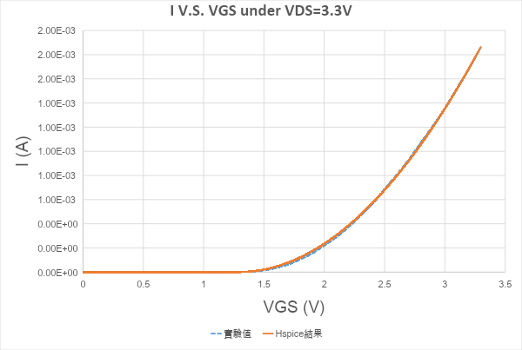

Comment:

實驗結果與hspice模擬的結果相近。根據Table1，當 $V_{GS}$ 小的時候hspice模擬結果跟實驗結果會相當吻合。

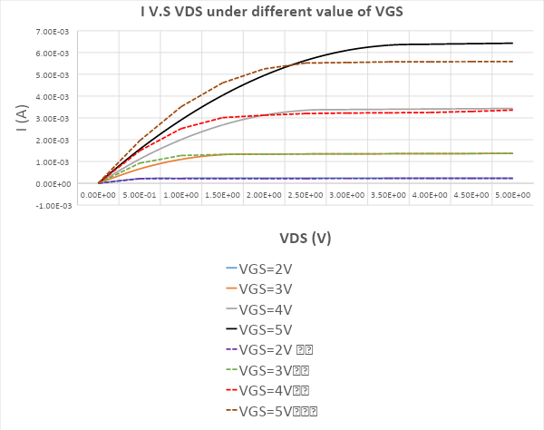

Table3

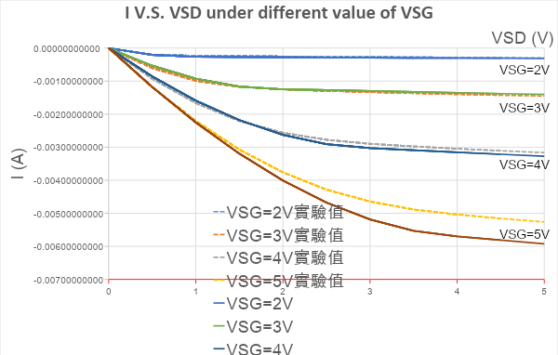

4

Comment:

PMOS與NMOS有類似的現象， $V_{GS}$ 變得越來越大的時候，實驗數據與模擬結果偏差越來越多。不過跟模擬結果的差距比NMOS還小。誤差仍可能來自於手算只取了一組數據來去算 $V_{th}, λ, k_{n}$，因此產生誤差。

Table 4

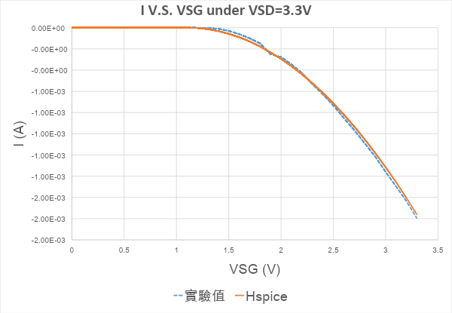

Comment:

實驗結果與hspice模擬的結果相近。根據Table3，當 $V_{GS}$ 小的時候hspice模擬結果跟實驗結果會相當吻合。

2.

Vary $V_{th}$ from 0.8V to 1.5 (0.2V/step)

Comment:

$I_{D}=\frac{1}{2}μC_{ox}\frac{W}{L}{\left(V_{GS}-V_{T}\right)}^{2}(1+λV_{DS})$, with $μC_{ox}=k_{p}$ W/L=3. When $V_{GS}$ is fixed, $if V_{T}$ is higher, $V_{od} (overdrive voltage, V_{GS}-V_{T})$ is lower, which means mosfets is more easily to enter saturation region ( $V_{DS}$ > $V_{od})$. The figure above is consistent what I analyzed. When $V_{T}$ is higher, it enters saturation early (when $V_{DS}$ is smaller compared to smaller $V_{T}$). And according to the current formula, as long as mosfets stay in saturation region, the smaller $V_{T}$ is, the larger $I_{D}$ is, which is also consistent with the figure above.

Vary $K_{p}$ from 50u to 250u (50u/step)











Comment:

$I_{D}=\frac{1}{2}μC_{ox}\frac{W}{L}{\left(V_{GS}-V_{T}\right)}^{2}(1+λV_{DS})$, with $μC_{ox}=k_{p}$ W/L=3. According to current formula, the larger $K_{p}$ is, the larger is when other parameters are fixed.

Vary $Lambda$ from 0.02 to 0.06 (0.01/step)



Comment:

$I_{D}=\frac{1}{2}μC_{ox}\frac{W}{L}{\left(V_{GS}-V_{T}\right)}^{2}(1+λV_{DS})$, with $μC_{ox}=k_{p}$ W/L=3. The different current curve caused by different value of $λ$ will be seen after the mosfet enter saturation region. And according to the foumela, the larger $λ$ is, the larger current is and slope of of curve ($\frac{dI_{D}}{dV_{DS}}= λ$) is larger as well when other parameters are fixed, which is consisten to the figure above.

Hspice code:

NMOS:

lab6 nmos

.param Vtn=0.8949

+ kn=217.44u

+ lam=0.0065562

+ toxn=100n

+ cbd0=2p

+ cgso=0.1p

.model N_MOS nmos level=1 vto=vtn kp=kn

+ lambda=lam tox=toxn cgso=cgso

+ cgdo=cgso cbd=cbd0

******************************************** $Table1

M1 d1 g1 gnd! gnd! N_MOS W=30u L=10u

Vds1 d1 gnd! 3.3

Vgs1 g1 gnd! 3.3

.DC Vds1 0 5 0.5 sweep Vgs1 2 5 1

.probe dc I(M1)

******************************************** $Table2

M2 d2 g2 gnd! gnd! N_MOS W=30u L=10u

Vds2 d2 gnd! 3.3

Vgs2 g2 gnd! 3.3

.DC Vgs2 0 3.3 0.1

.probe dc I(M2)

******************************************** $Vary the parameters

M3 d3 g3 gnd! gnd! N_MOS W=30u L=10u

Vds3 d3 gnd! 3.3

Vgs3 g3 gnd! 2

.DC Vds3 0 5 0.5 sweep Vtn 0.8 1.6 0.2

.alter

.DC Vds3 0 5 0.5 sweep kn 50u 250u 50u

.alter

.DC Vds3 0 5 0.5 sweep lam 0.02 0.06 0.01

.probe dc I(M3)

********************************************

.option post probe

.end

PMOS:

lab6 pmos

.param Vtn=-1.1012

+ kn=210.821u

+ lam=0.0563

+ toxn=100n

+ cbd0=2p

+ cgso=0.1p

.model P_MOS pmos level=1 vto=vtn kp=kn

+ lambda=lam tox=toxn cgso=cgso

+ cgdo=cgso cbd=cbd0 cbs=cbd0

******************************************** $Table1

M1 d1 g1 gnd! gnd! P_MOS W=30u L=10u

Vds1 gnd! d1 3.3

Vgs1 gnd! g1 3.3

.DC Vds1 0 5 0.5 sweep Vgs1 2 5 1

.probe dc I(M1)

******************************************** $Table2

M2 d2 g2 gnd! gnd! P_MOS W=30u L=10u

Vds2 gnd! d2 3.3

Vgs2 gnd! g2 3.3

.DC Vgs2 0 3.3 0.1

.probe dc I(M2)

********************************************

.option post probe

.end