1.

1.1

Block diagram:

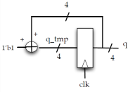

Logic diagram:

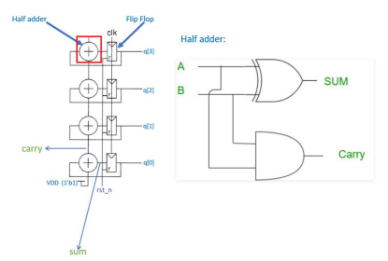1.2

Input: clk, rst_n

Output: [3:0]q;

waveform:

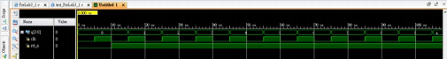

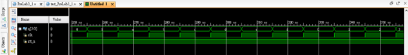As the simulation waveform shows, q is increasing from 0, 1, 2, 3…15, then back to 0,

1… etc.

2.

Input: clk, rst_n

Output: [7:0]q;

Logic diagram:

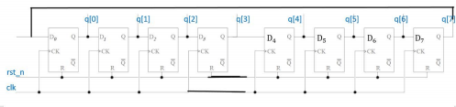

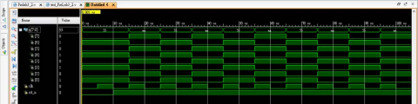As the initial value is 8’b0101_0101, and it’s also ring counter, there is only two

possible value for output ([7:0]q), which is 8’b0101_0101 and 8’b1010_1010.