邏輯設計實驗preLab4

105060012張育菘

**1 Cascade eight DFFs together as a shift register. Connect the output of the last DFF to the input of the first DFF as a ringer counter. Let the initial value of DFF output after reset be 01010101. Construct the Verilog RTL representation for the logics with verification.**

* 1. **Draw the logic diagram**

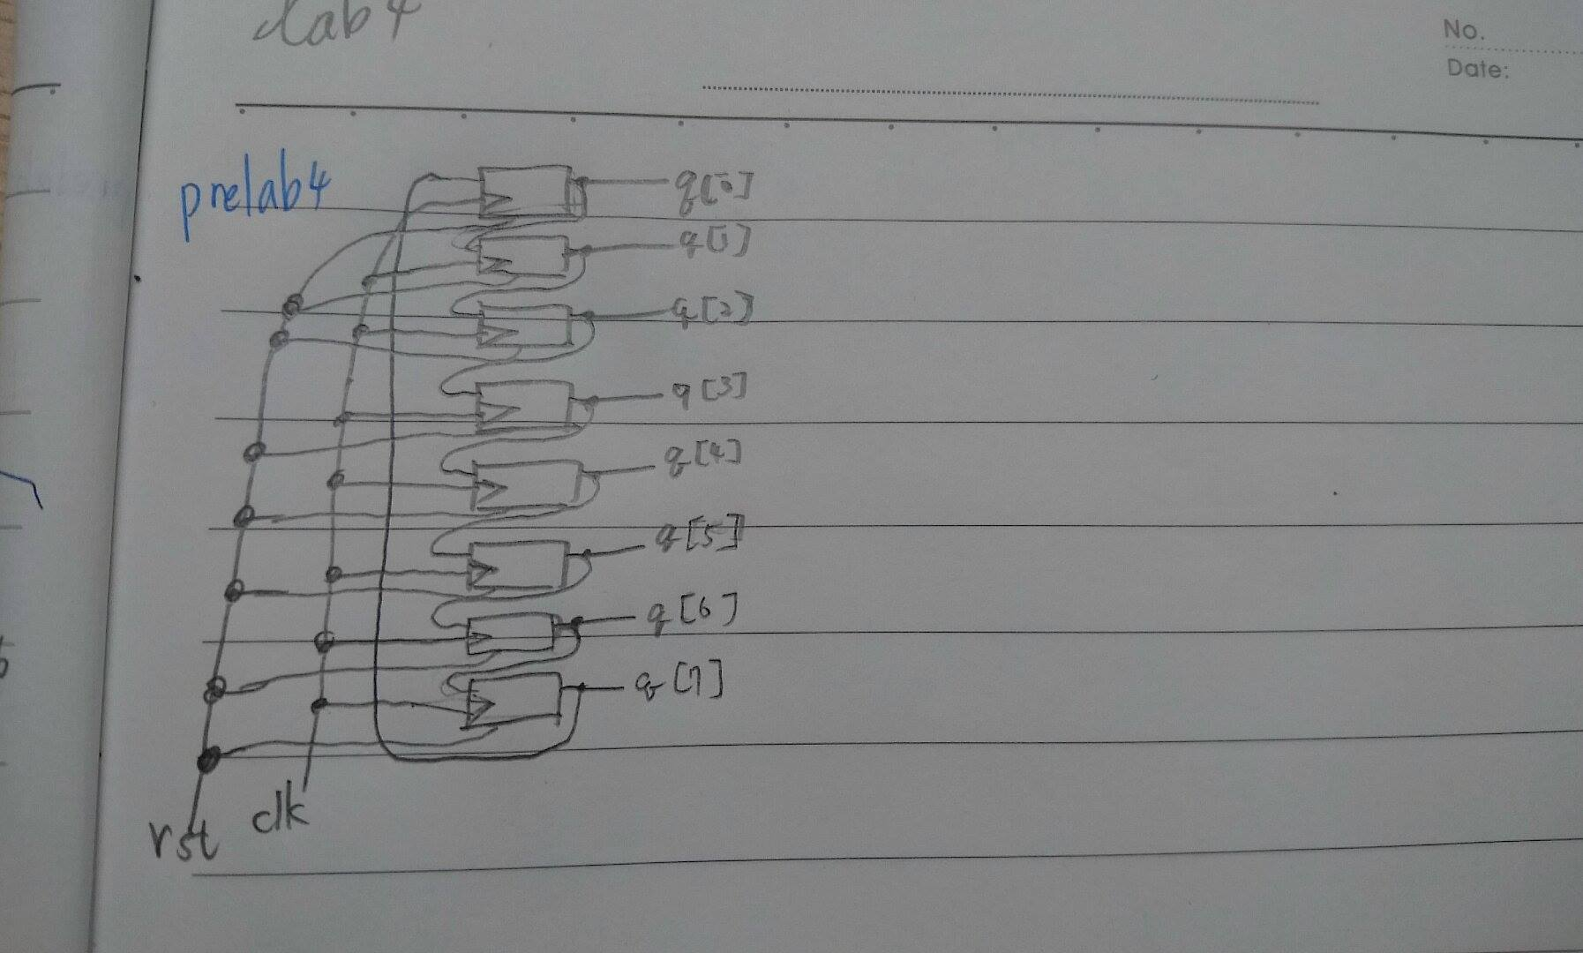

**1.2 Construct Verilog RTL representation for the logics with verification.**

output [7:0]q;

input rst,clk;

reg [7:0]q;

always@(posedge clk or negedge rst) //此功能為shifter，每次移一個bit

if(~rst) q<=8'b01010101;

else begin

q[0]<=q[7];

q[1]<=q[0];

q[2]<=q[1];

q[3]<=q[2];

q[4]<=q[3];

q[5]<=q[4];

q[6]<=q[5];

q[7]<=q[6];

end

Result

q每次往右移1個bit，因此從初始值01010101🡪10101010🡪10101010🡪…

