邏輯設計實驗preLab3

105060012張育菘

**1 Consider a 4-bit synchronous binary up counter.**

* 1. **Draw the logic diagram**

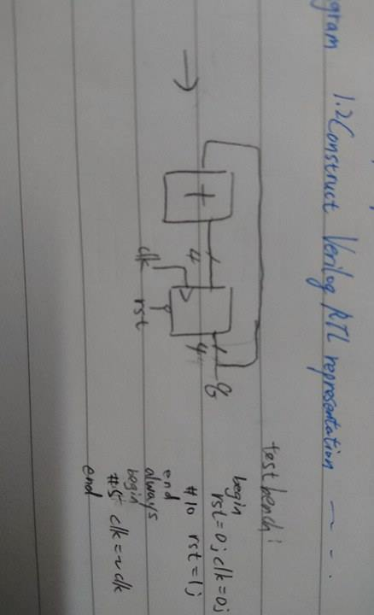

**1.2 Construct Verilog RTL representation for the logics with verification.**

input rst, clk;

output reg [3:0]q; //q為一4-bit的數

always@(posedge clk or negedge rst) //clk=1時加法&讀值

if(~rst) //rst = 0時reset

q<=4'b0000;

else

q<=q+4'd1;

