邏輯設計實驗Lab2結報

105060012張育菘

**1 Emulate exp1 in lab1 (a full adder s+cout=x+y+cin) with the following parameters.**  Design Specification

input : x, y, cin;

output : count, s;

block diagram :

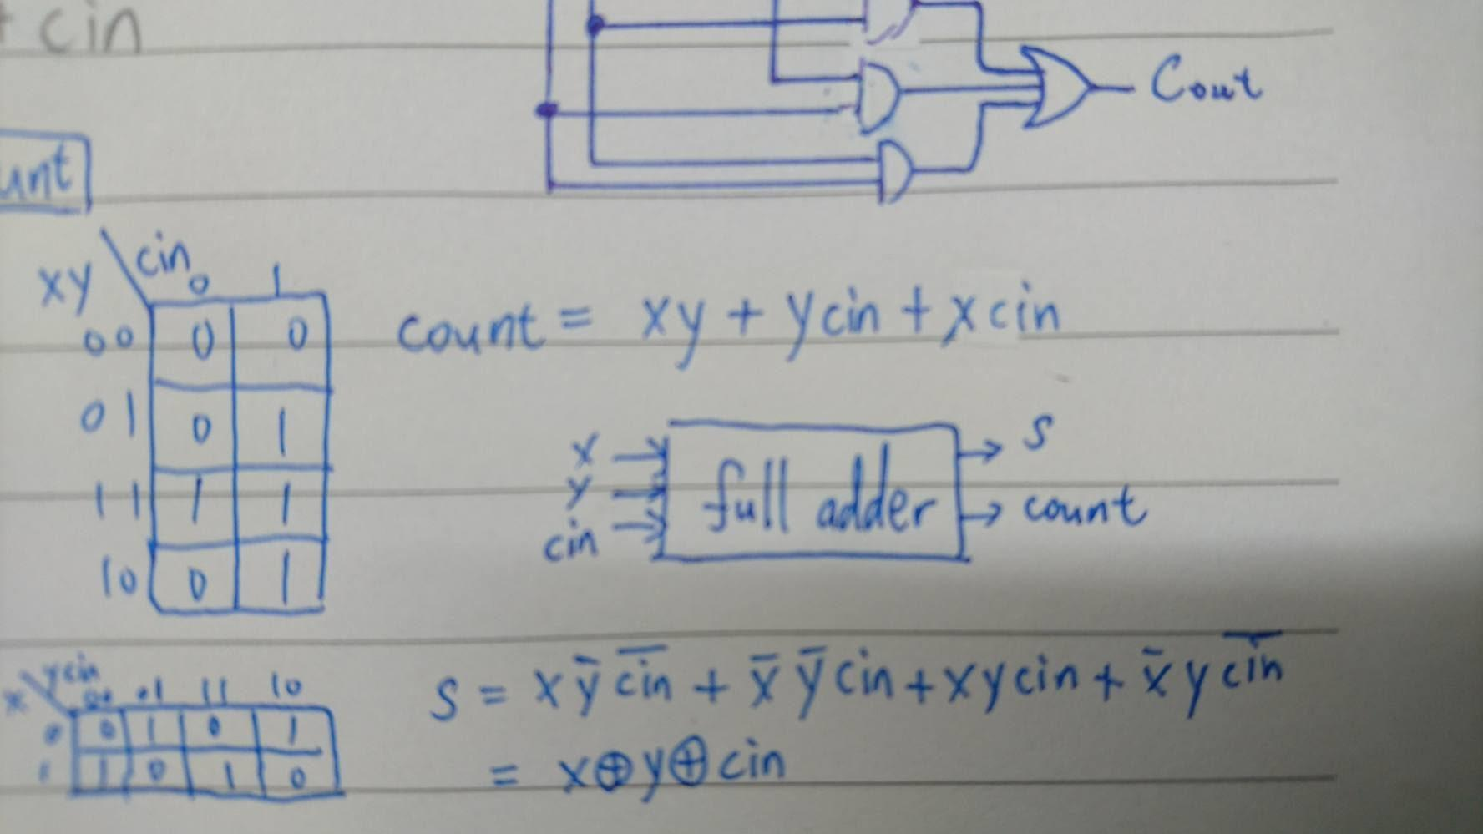

Design Implementation

Logic function :

s = x^y^cin

count = (x&y)|(x&cin)|(y&cin)

Logic diagram :

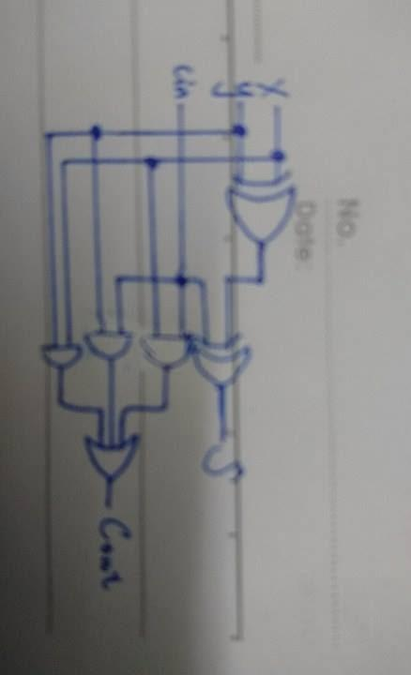

Result

1. cin=1,y=1,z=1 → count=1,s=1
2. cin=1,y=0,z=1 → count=1,s=0

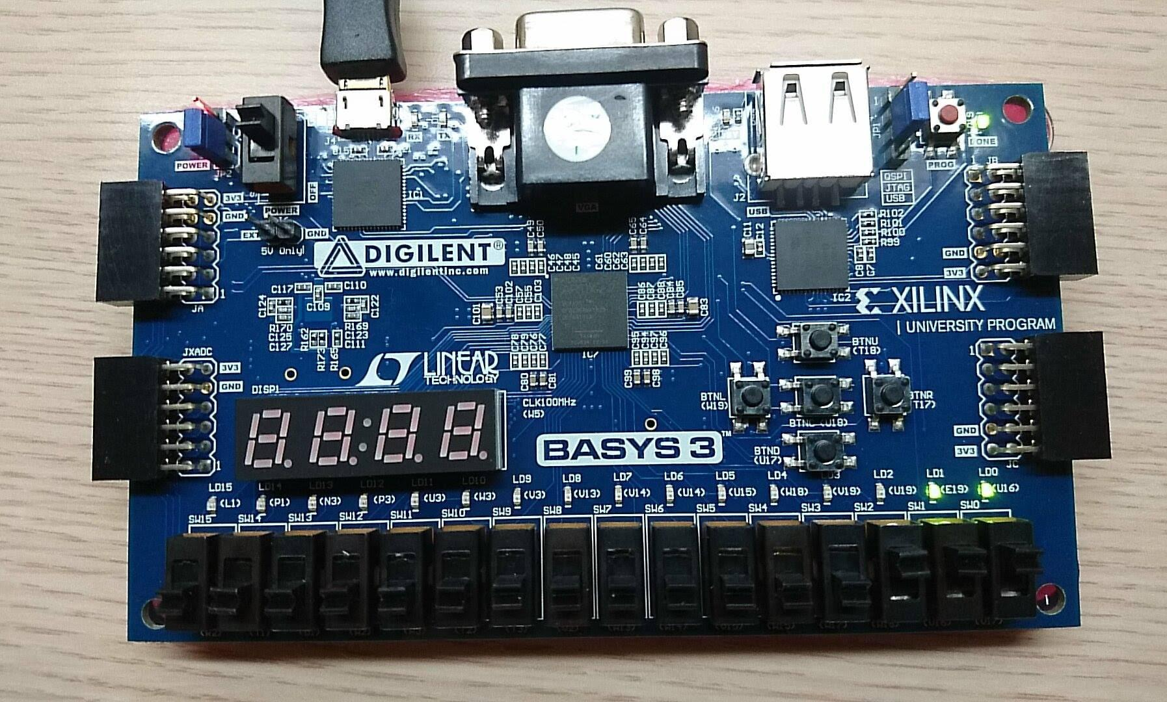 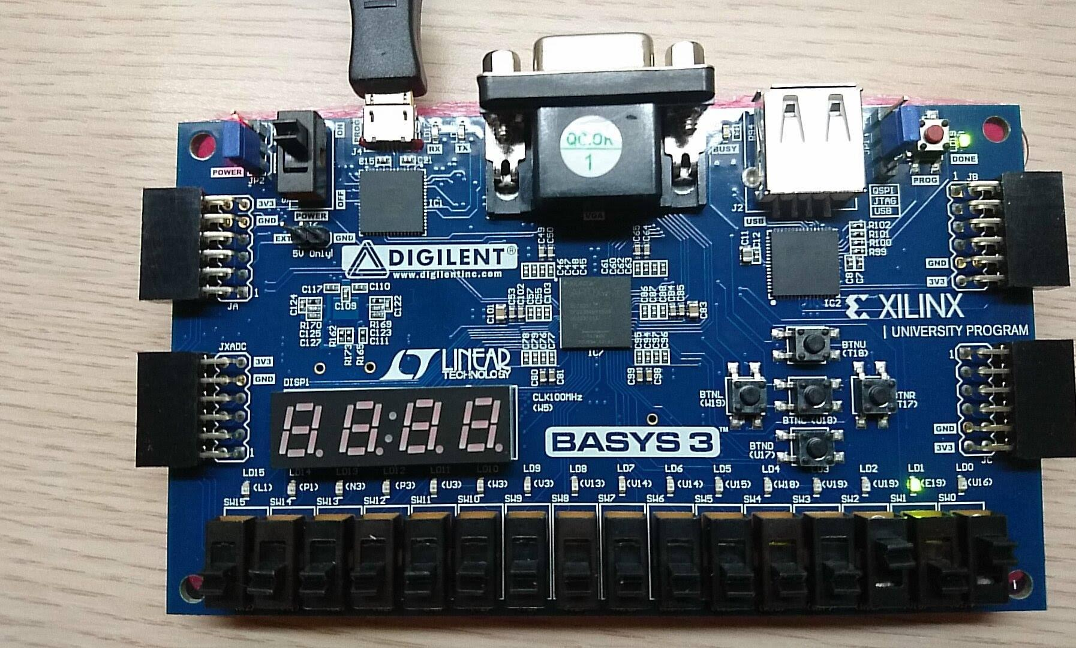

**2. Derive a BCD (i[3:0]) to 7-segment display decoder (D_ssd[7:0]), and also use four LEDs (d[3:0]) to monitor the 4-bit BCD number. (Other values of i outside the range will show F).**

Design Specification

input : i[3:0]

output :d[3:0], D_ssd[7:0];

block diagram :

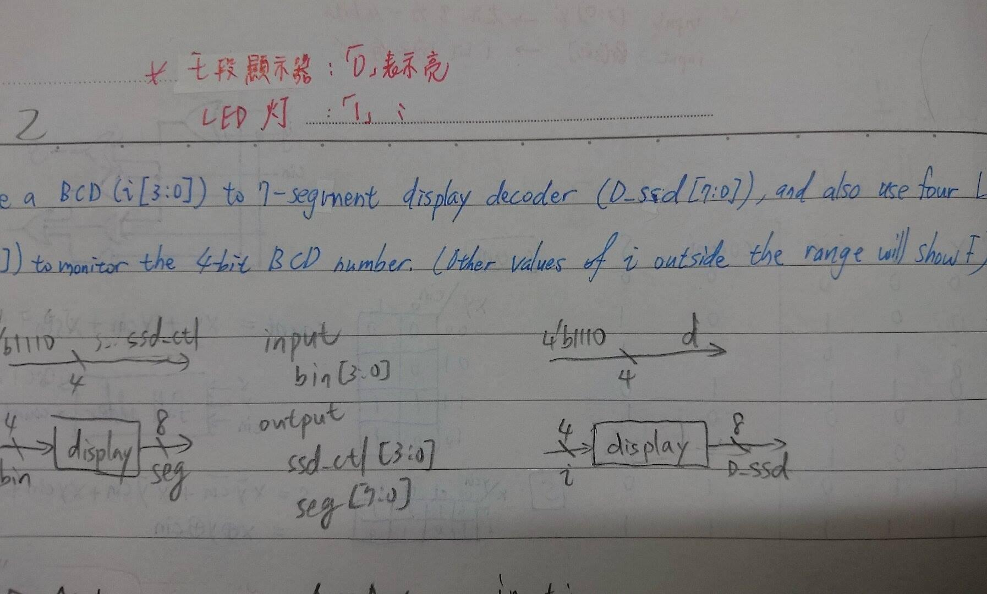

Design Implementation

Logic function :

d = 4'b1110; //使monitor只有最右邊的顯示器有功能

當i為4'd0: D_ssd = 8'b00000011; //0

當i為4'd1: D_ssd = 8'b10011111; //1

當i為4'd2: D_ssd = 8'b00100101; //2

當i為4'd3: D_ssd = 8'b00001101; //3

當i為4'd4: D_ssd = 8'b10011001; //4

當i為4'd5: D_ssd = 8'b01001001; //5

當i為4'd6: D_ssd = 8'b01000001; //6

當i為4'd7: D_ssd = 8'b00011111; //7

當i為4'd8: D_ssd = 8'b00000001; //8

當i為4'd9: D_ssd = 8'b00001001; //9

default: D_ssd = 8'b01110001; //F

Result

1. i=1010 → 顯示5 3. i=0101 → 10(>9) → 顯示F
2. i=1001 → 顯示9 4. I=1011 → 13(>9) → 顯示F

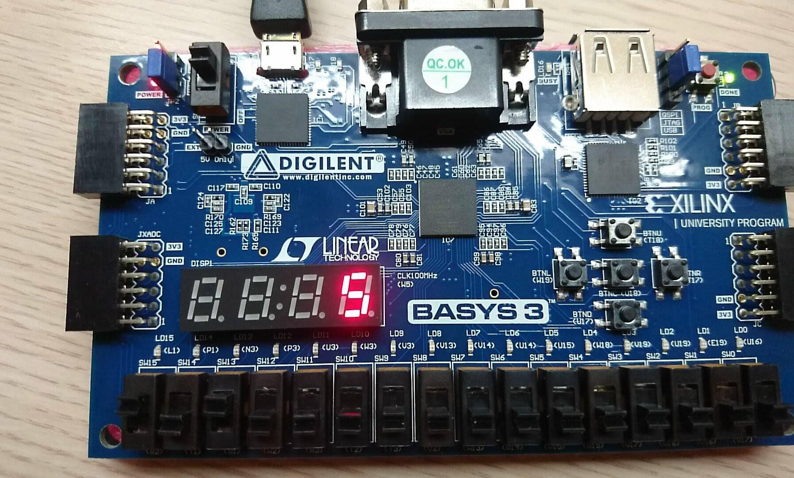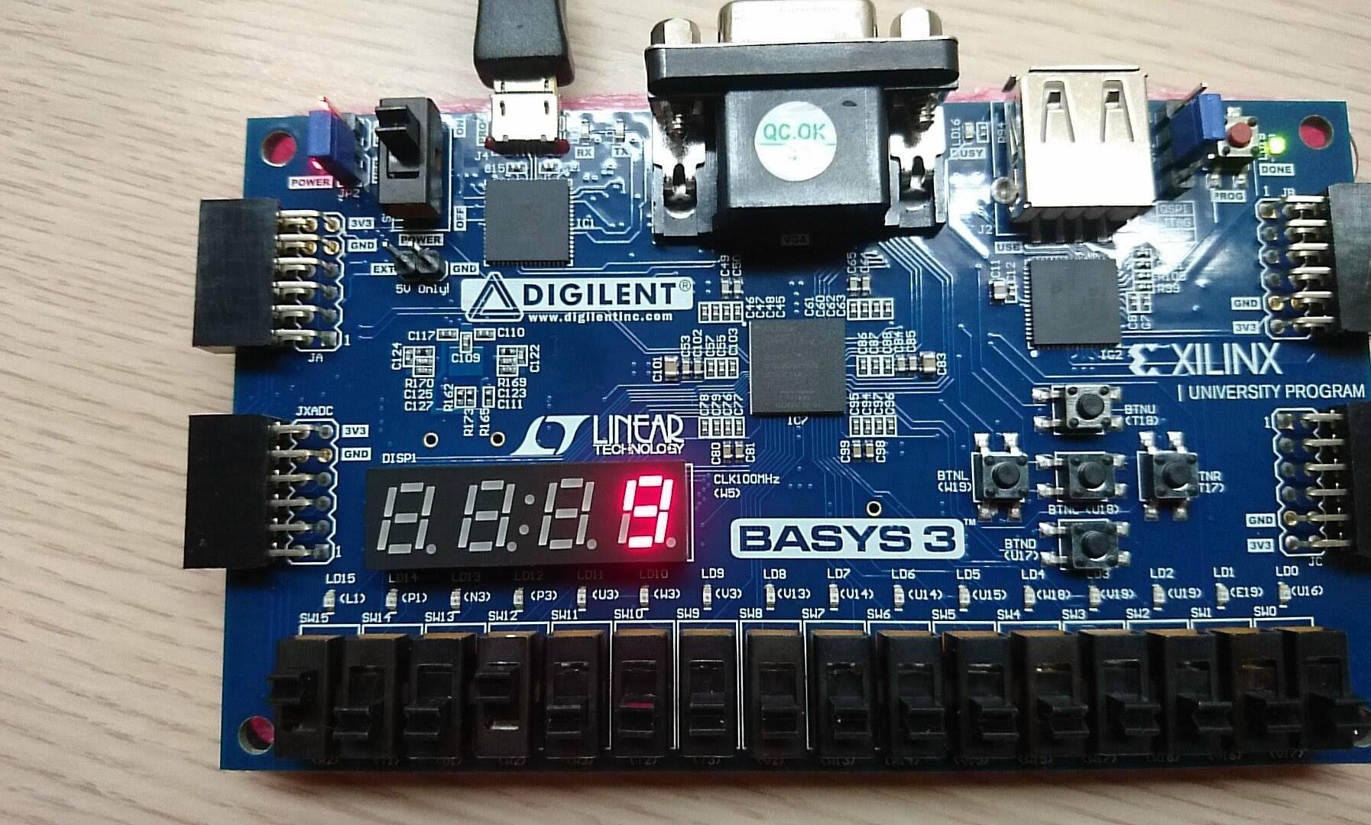

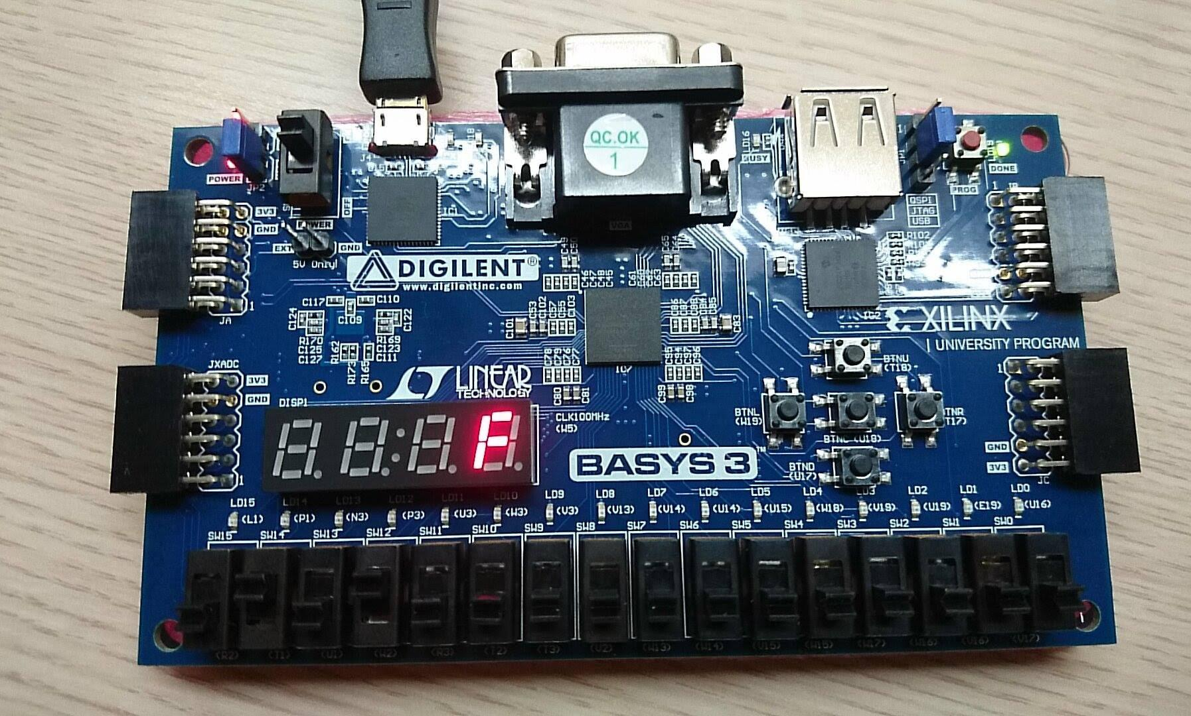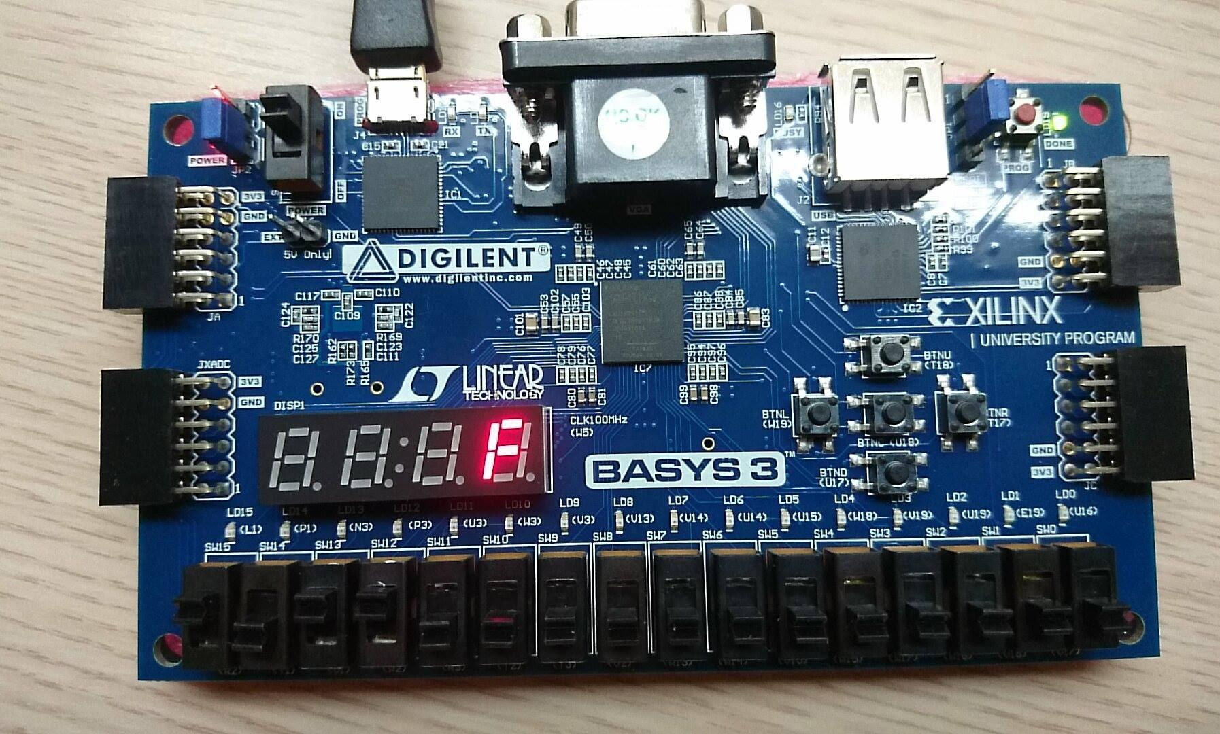

Discussion

1. 在打verilog時，若用到”case”時，一定要有”default”不然實驗可能會跑不出來。
2. 在使用七段顯示器時”0”表示”亮”；”1”表示”暗”。
3. 在使用LED時”1”表示”亮”；”0”表示”暗”。

**3 (Bonus) Design a combinational circuit that compares two 4-bit unsigned numbers A and B to see whether A is greater than B. The circuit has one output X such that X = 0 if A ≤ B and X = 1 if A > B. (let A[3:0], B[3:0] be controlled by 8 DIP switches, the binary numbers are displayed on 8 LEDs. The result X is on another LED.)**

Design Specification

input : [2:0]A, [2:0]B;

output : [2:0]Aout, [2:0]Bout, X;

block diagram :

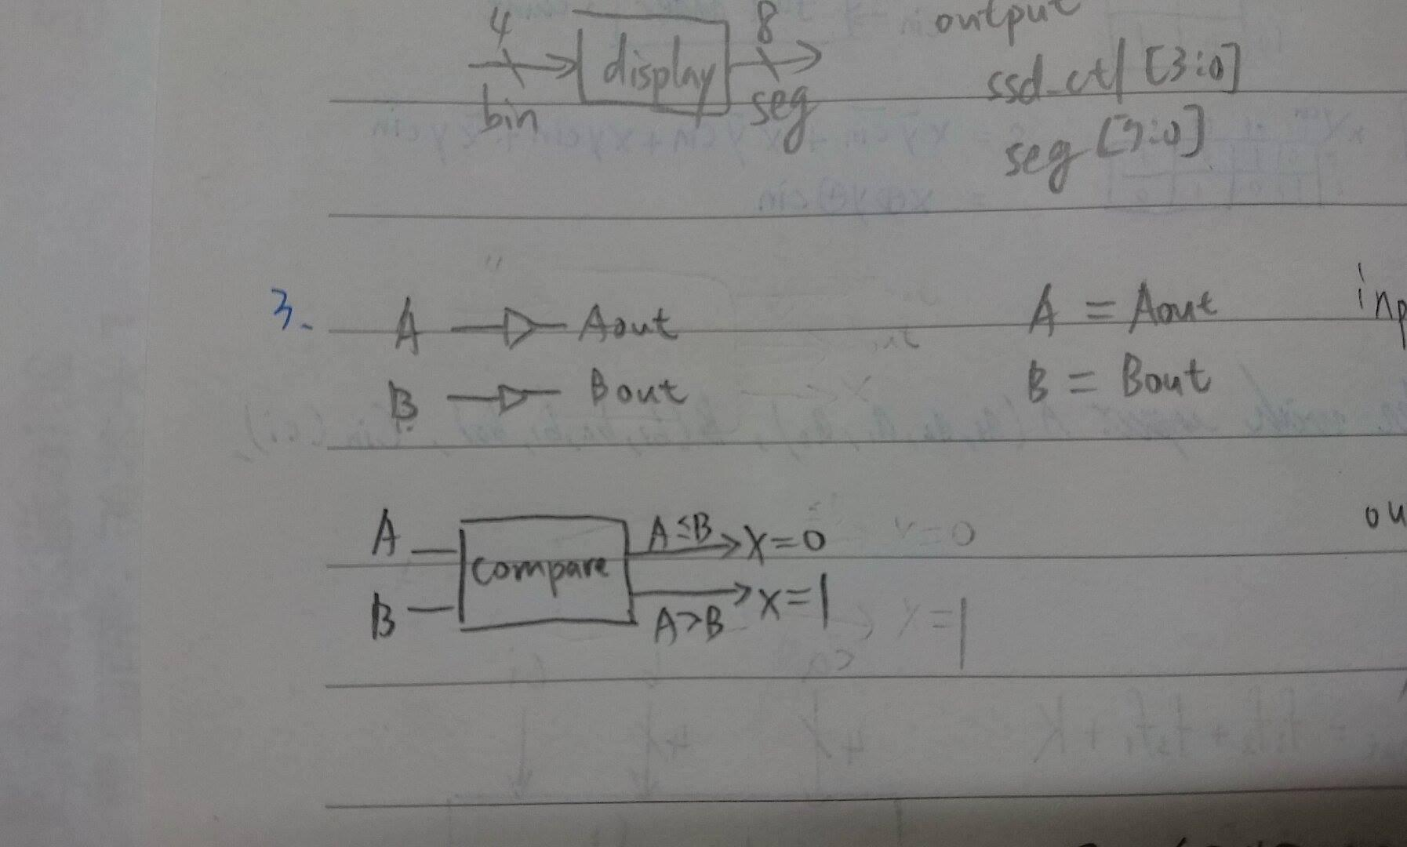

Design Implementation

Logic function :

A = Aout ; //此動作是為了能使pin上面的LED燈能跟著一起亮暗

B = Bout ;

X = (A>B) ? 1:0 ; //若A>B是對的→ X=1；相對的，若不成立→ X=0

Result

*U16 {Aout[3]}、E19 {Aout[2]}、U19 {Aout[1]}、V19 {Aout[0]}

*W18 {Bout[3]}、U15 {Bout[2]}、U14 {Bout[1]}、V14 {Bout[0]}

*L1 {X}

1. A=1100, B=0011 → B>A → X=0 →L1(最左邊的燈)”不亮”
2. A=1101, B=1010 → B<A → X=1 →L1(最左邊的燈)”亮”
3. A=1100, B=1100 → B=A → X=0 →L1(最左邊的燈)”不亮”

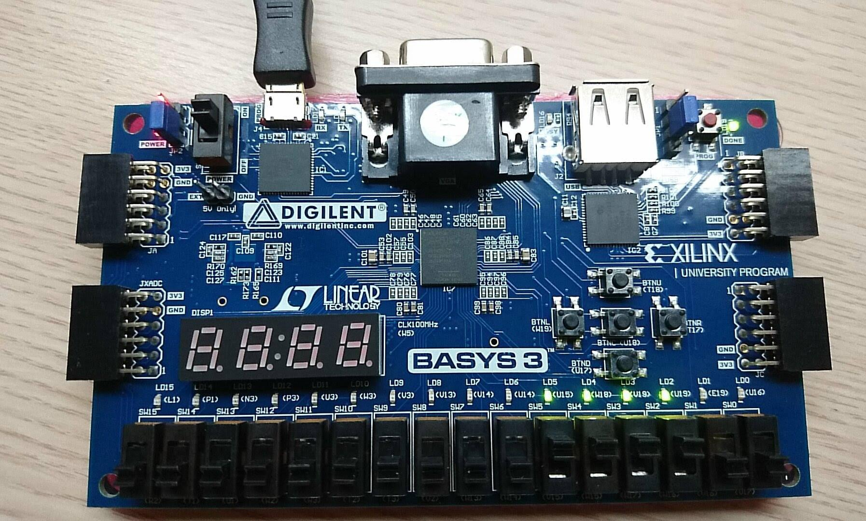

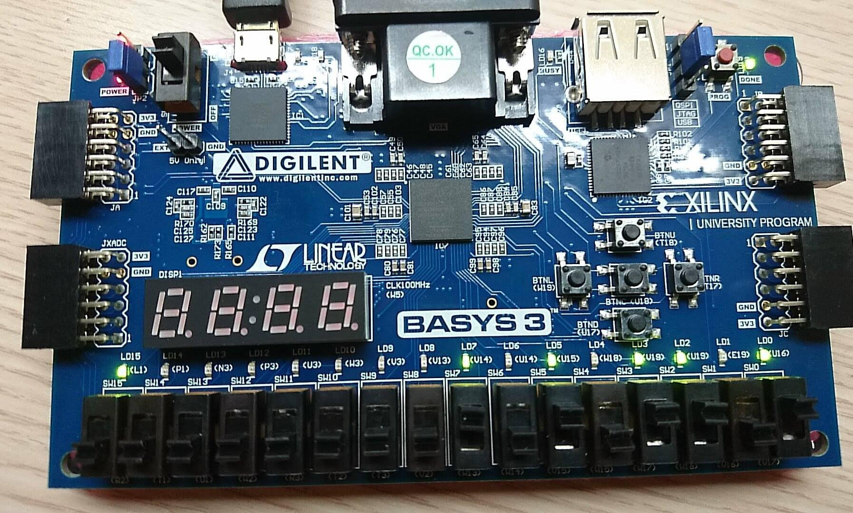

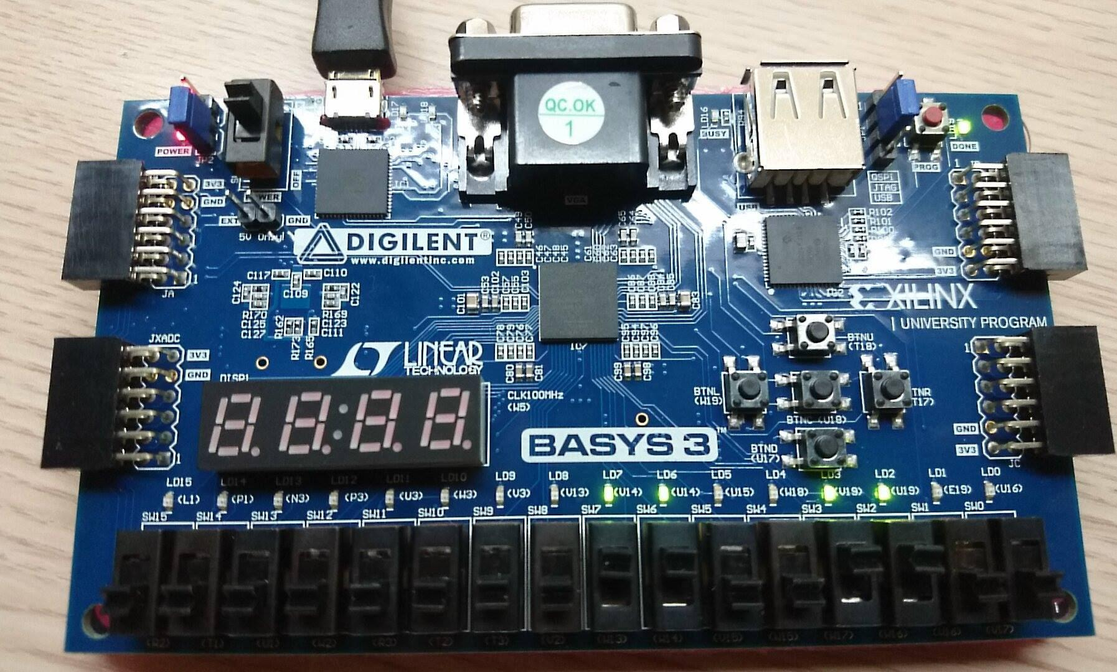

Discussion

1. 在使用LED時”1”表示”亮”；”0”表示”暗”。

**Conclusion**：

這是第一次用板子做實驗的lab，這次讓我稍稍了解到板子的運作，以及如何讓七段顯示器顯示出我要的圖形，真的是很棒的實驗，讓我受益良多。