**邏輯設計實驗Lab12結報**

**104060012邱怡庭**

**1 For the time delay of electronic clock in lab7. Instead using 14-segment displays to show the time, use LCD to present all the functions in lab7.**

**Design Specification**

**input** clk,

**input** rst_n,

**output** LCD_rst**,**

**output wire** [1:0]LCD_cs,

**output** LCD_rw,

**output** LCD_di,

**output wire**  [7:0] LCD_data,

**output** LCD_en

**wire** [3:0]second1,second0,minute1,minute0,hour1,hour0,day1,day0,month1,

month0,year1,year0;

**wire** en,out_valid;

**wire** [7:0] data_out;

**wire** clk_div;

**wire** clk_d;

**block diagram:**

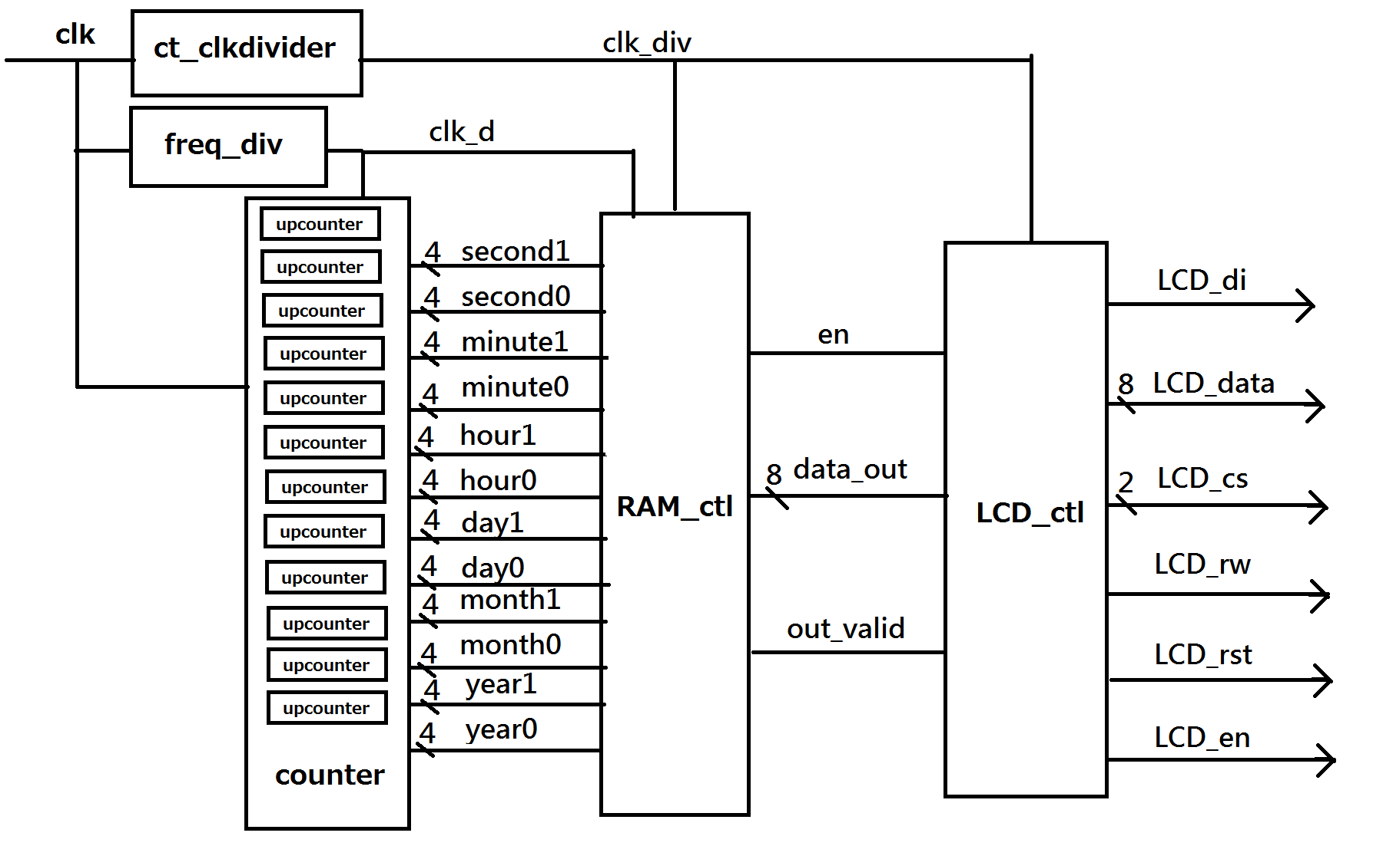

**Design Implementation**

**logic function / logic diagram**:

***upcounter***

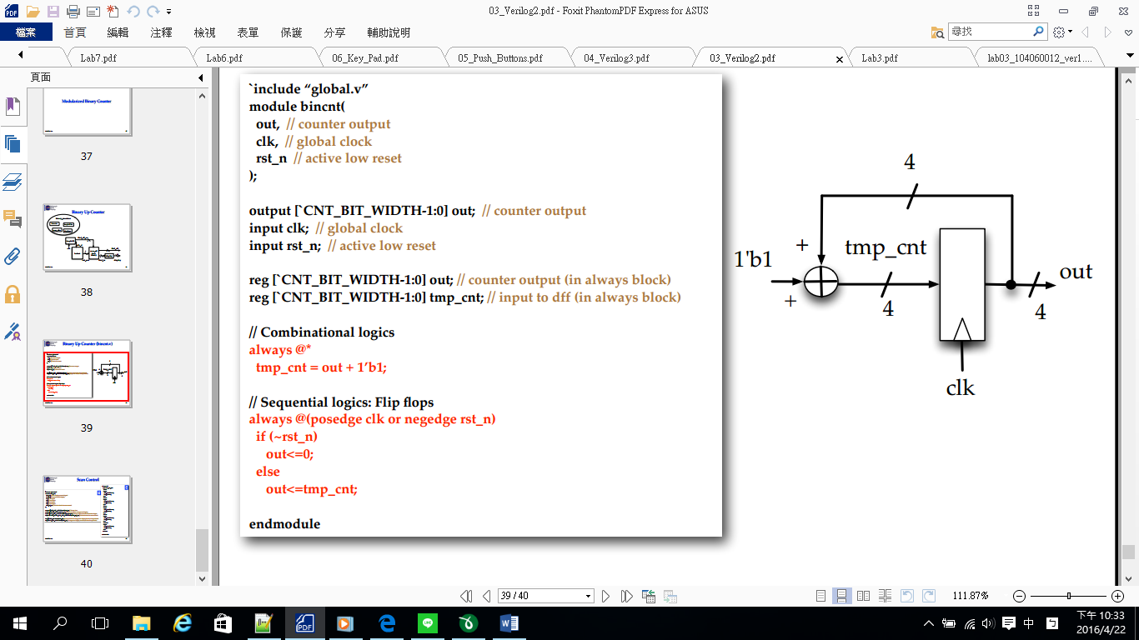

***freq_div:***

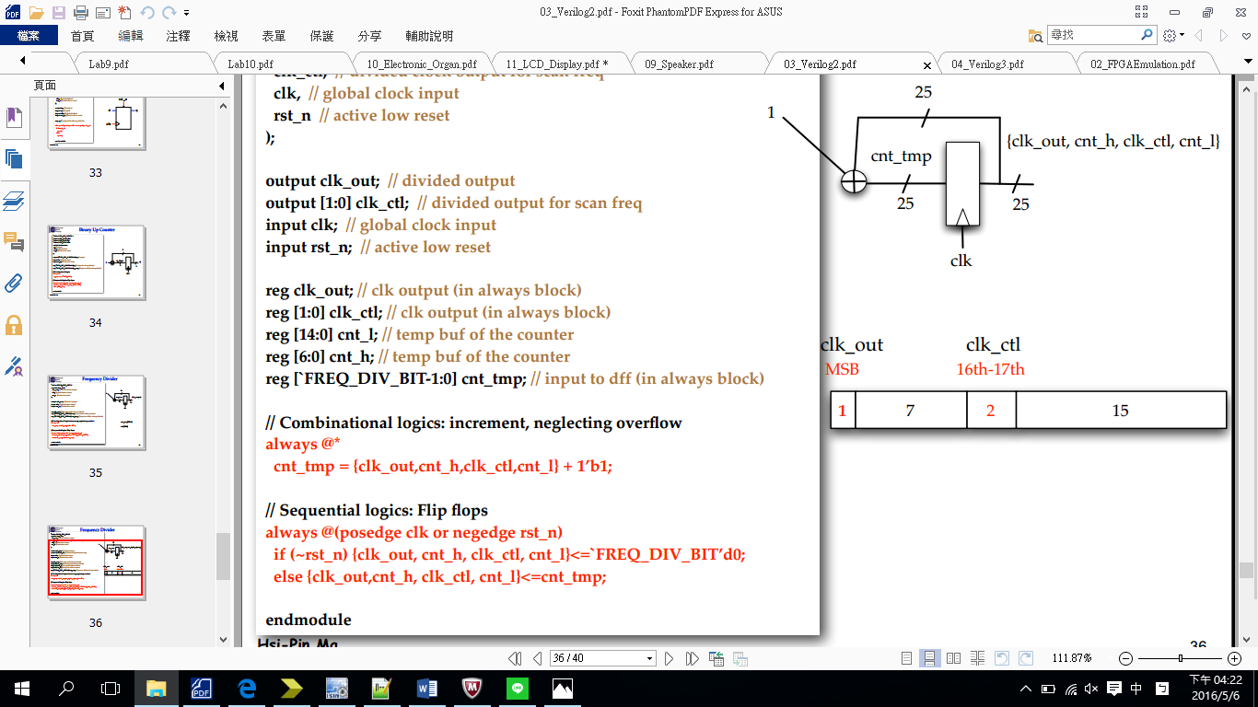

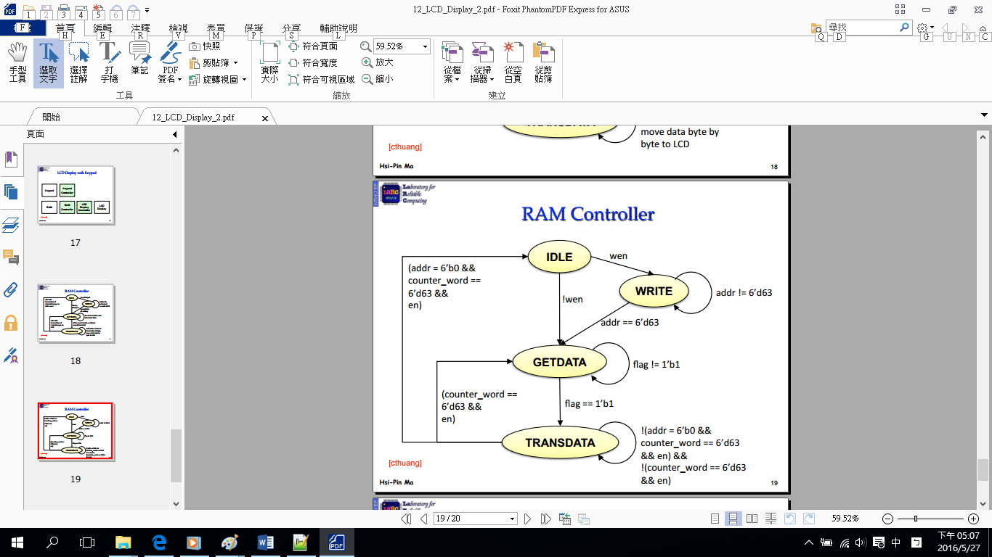

**RAM_ctl**

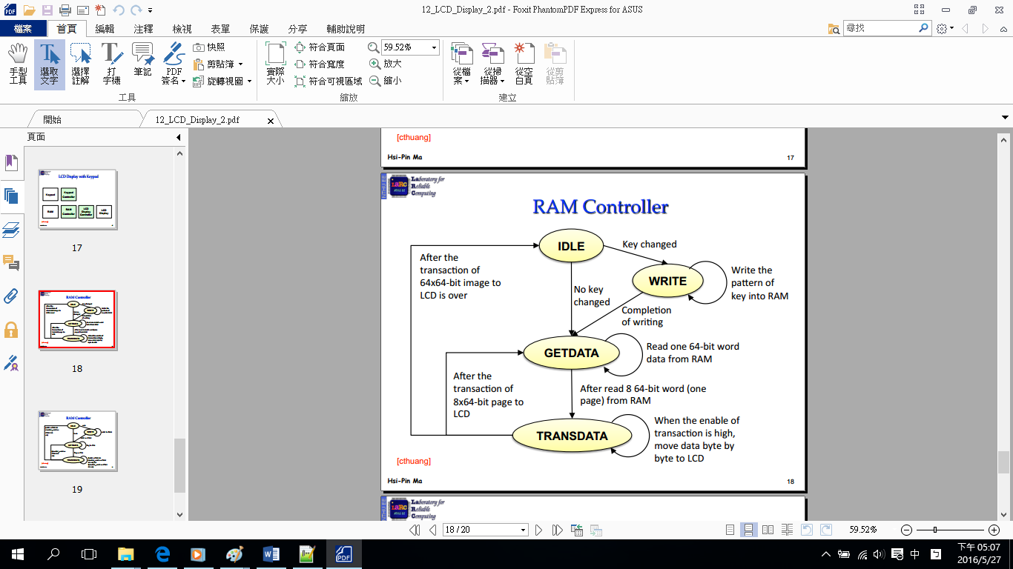

**LCD_ctl**

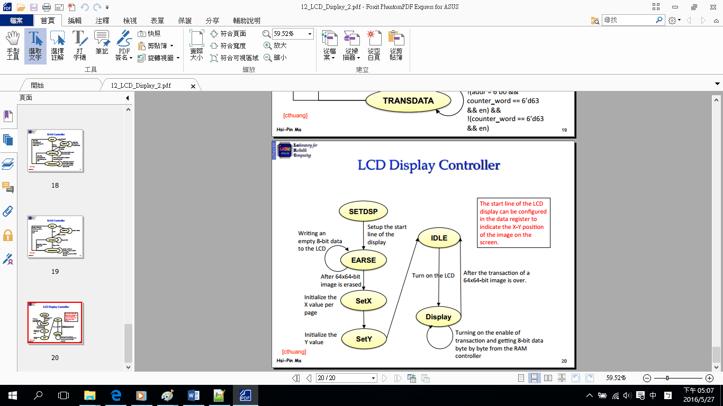

***counter***

*連接second, minute, hour, day, month, year的counter, 設定second從0數到59進位至minute，minute從0數到59進位至hour，hour從day0數到23進位至day，day從1數到monthday(28or30or31)進位至month，month從1數到12進位至year，year從0數到99。*

**I/O pin assignment:**

## pin mapping

NET "clk" LOC = "R10";

NET "rst_n" LOC = "N3";

## LCD control signals

NET "LCD_rst" LOC = "E3";

NET "LCD_cs[1]" LOC = "E1";

NET "LCD_cs[0]" LOC = "F4";

NET "LCD_data[7]" LOC = "F3";

NET "LCD_data[6]" LOC = "D2";

NET "LCD_data[5]" LOC = "D1";

NET "LCD_data[4]" LOC = "H7";

NET "LCD_data[3]" LOC = "G6";

NET "LCD_data[2]" LOC = "E4";

NET "LCD_data[1]" LOC = "D3";

NET "LCD_data[0]" LOC = "F6";

NET "LCD_en" LOC = "F5";

NET "LCD_rw" LOC = "C2";

NET "LCD_di" LOC = "C1";

**Discussion:**

利用RAM自counter讀取資料並輸出在LCD上。

**Conclusion:**

只要結合lab07的counter與RAM便可製作簡易的電子鐘。