**邏輯設計實驗Lab11結報**

**104060012邱怡庭**

**1 LCD display example.**

**1.1 Follow the lecture. Create the ROM block to store the graphs given in the example file “picture.coe”. There are 16 64x64 pictures but the last 7 are empty. Study the file.**

**1.2 Integrate the given example files “ct_clkdivider.v”, “rom_ctrl.v”, “lcd_ctrl.v”, lcd_display.v”, and use the given pin assignment file “lcd_display.ucf” to build the whole LCD display example.**

**1.3 The animation displays 10 pictures repeatedly. Among them, the 10th picture is an empty one. Fix the design to show 9 pictures repeatedly and ignore the 10th picture. Therefore, the result animation will be smoother.**

**1.4 Modify the design by inserting an additional 2-second delay after showing the last (9th ) picture. You should do that by adding one extra state with a pause counter.**

**Design Specification**

**output** : lcd_rst; // LCD reset

[1:0] lcd_cs; // LCD frame selection

lcd_rw; // LCD read/write control

lcd_di; // LCD data/instruction

[7:0] lcd_d; // LCD data

lcd_e; // LCD enable

data_ack; //data re-arrangement buffer ready indicator

data_request; // request for the memory data

**input** : clk, // clock from crystal

rst_n, // active low reset

**wire** : clk_50k; // Divided 50k clock

clk_d;

[7:0] data; // byte data transfer from buffer

[6:0] addr; // Address for each picture

**block diagram:**

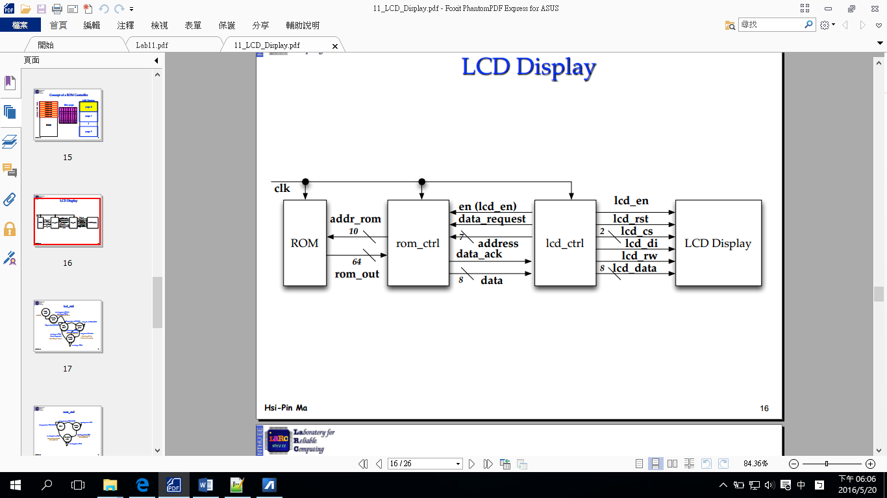

**Design Implementation**

**logic function / logic diagram**:

***rom_ctl:***

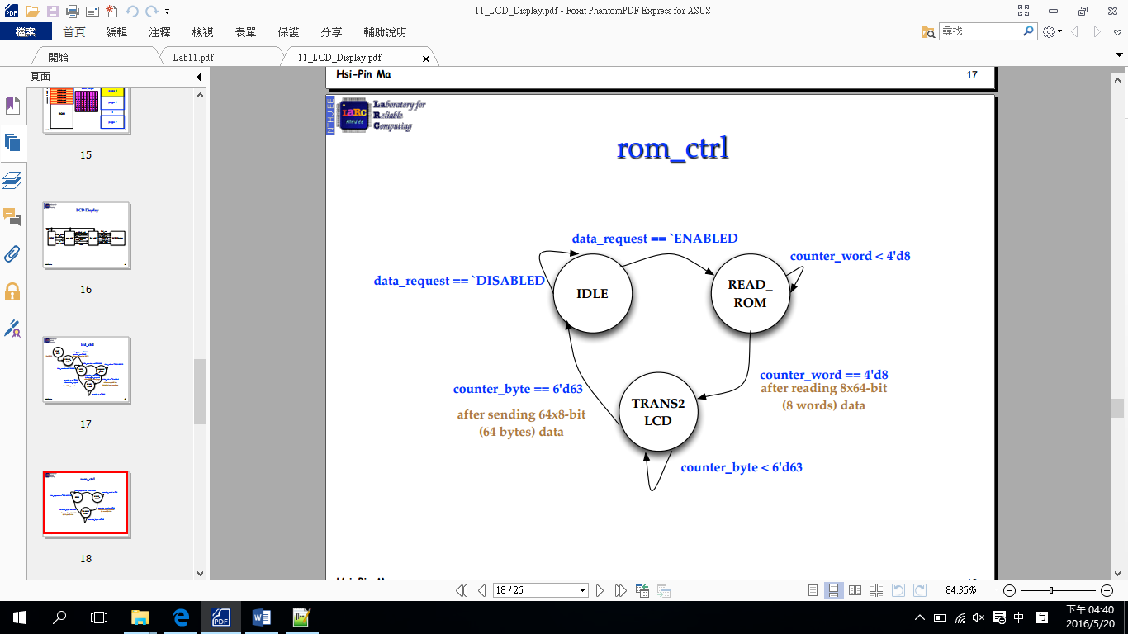

***lcd_ctl:***

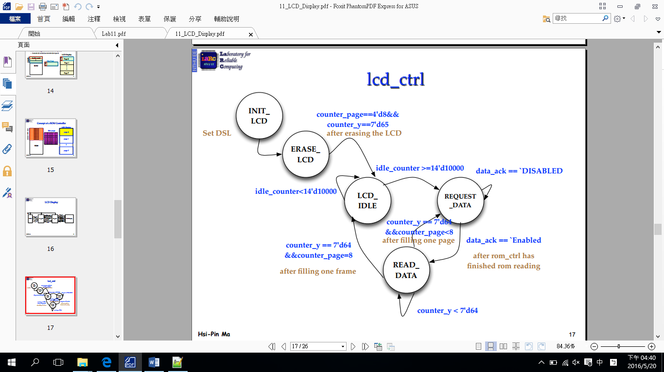

***clock_divider:***

*將40MHz的clk divide成50kHz*

***freq_div:***

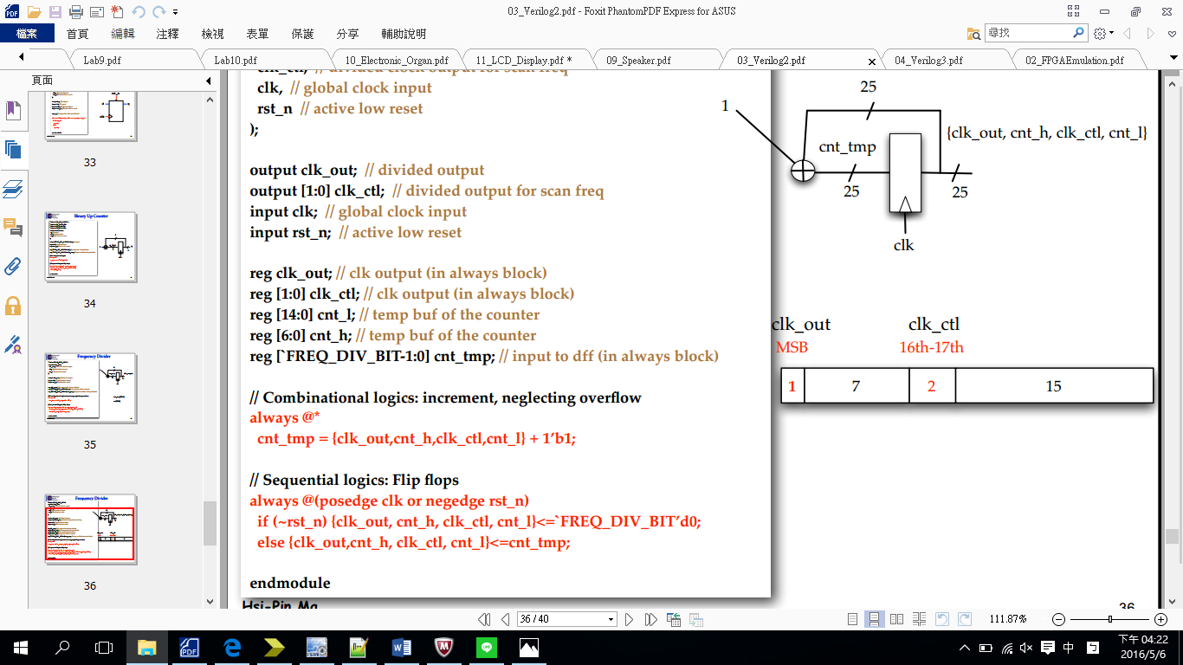

用1Hz控制lcd_ctl中LCD_PAUSE state的cnt，使當LCD顯示第8張圖時，停留兩秒後再返回第一張。

**I/O pin assignment:**

## pin mapping

NET "clk" LOC = "R10";

NET "rst_n" LOC = "N3";

## LCD control signals

NET "LCD_RST" LOC = "E3";

NET "LCD_CS[1]" LOC = "E1";

NET "LCD_CS[0]" LOC = "F4";

NET "LCD_D[7]" LOC = "F3";

NET "LCD_D[6]" LOC = "D2";

NET "LCD_D[5]" LOC = "D1";

NET "LCD_D[4]" LOC = "H7";

NET "LCD_D[3]" LOC = "G6";

NET "LCD_D[2]" LOC = "E4";

NET "LCD_D[1]" LOC = "D3";

NET "LCD_D[0]" LOC = "F6";

NET "LCD_E" LOC = "F5";

NET "LCD_RW" LOC = "C2";

NET "LCD_DI" LOC = "C1";

NET "data_request" LOC = "H5";

NET "data_ack" LOC = "H6";

**Discussion:**

設置一counter使其自動改變音高並結合speaker_ctl和buzzer_ctl產生一段旋律。

**2 (Bonus) Modify the pictures and put your signature on top of the given animation. You can use the space around. You name can be either English or Chinese.**

**Design Specification**

**output** : lcd_rst; // LCD reset

[1:0] lcd_cs; // LCD frame selection

lcd_rw; // LCD read/write control

lcd_di; // LCD data/instruction

[7:0] lcd_d; // LCD data

lcd_e; // LCD enable

data_ack; //data re-arrangement buffer ready indicator

data_request; // request for the memory data

**input** : clk, // clock from crystal

rst_n, // active low reset

**wire** : clk_50k; // Divided 50k clock

clk_d;

[7:0] data; // byte data transfer from buffer

[6:0] addr; // Address for each picture

**block diagram:**



**Design Implementation**

**logic function / logic diagram**:

***rom_ctl:***



***lcd_ctl:***

**

***clock_divider:***

*將40MHz的clk divide成50kHz*

***freq_div:***

**

用1Hz控制lcd_ctl中LCD_PAUSE state的cnt，使當LCD顯示第8張圖時，停留兩秒後再返回第一張。

**I/O pin assignment:**

## pin mapping

NET "clk" LOC = "R10";

NET "rst_n" LOC = "N3";

## LCD control signals

NET "LCD_RST" LOC = "E3";

NET "LCD_CS[1]" LOC = "E1";

NET "LCD_CS[0]" LOC = "F4";

NET "LCD_D[7]" LOC = "F3";

NET "LCD_D[6]" LOC = "D2";

NET "LCD_D[5]" LOC = "D1";

NET "LCD_D[4]" LOC = "H7";

NET "LCD_D[3]" LOC = "G6";

NET "LCD_D[2]" LOC = "E4";

NET "LCD_D[1]" LOC = "D3";

NET "LCD_D[0]" LOC = "F6";

NET "LCD_E" LOC = "F5";

NET "LCD_RW" LOC = "C2";

NET "LCD_DI" LOC = "C1";

NET "data_request" LOC = "H5";

NET "data_ack" LOC = "H6";

**Discussion:**

同lab11_1，利用notepad更改coe檔的圖。

**Conclusion:**

利用ROM去讀取圖片以顯示在LCD上。