**邏輯設計實驗Lab05預報**

**104060012邱怡庭**

**Construct a 30-second down counter with pause function. When the counter goes to 0, all the LEDs will be lighted up. You can use one push button for reset and one other for pause/start function.**

* 1. **Write the spec (inputs, outputs, and function table) of the design.**

**output** [14:0] display; // 14 segment display control

**output** [3:0] ftsd_ctl; // scan control for ftsd

**output** [15:0] led; //led display control

**input** clk; // clock

**input** rst_n; // low active reset

**input** in; // input control for FSM

**wire** [1:0] ftsd_ctl_en; // divided output for ftsd ctl

**wire** clk_d; // divided clock

**wire** count_enable; // if count is enabled

**wire** [3:0] dig0,dig1; // second counter output

| **rst_n** | **in** | **clk** | **count_enable** | **function** |
| --- | --- | --- | --- | --- |
| 0 | ⅹ | ⅹ | ⅹ | Return to 30 |
| 1 | 0 | ↑ | ⅹ | Present state |
| 1 | 1 | ↑ | 0 | Next state(pause) |
| 1 | 1 | ↑ | 1 | Next state(count) |

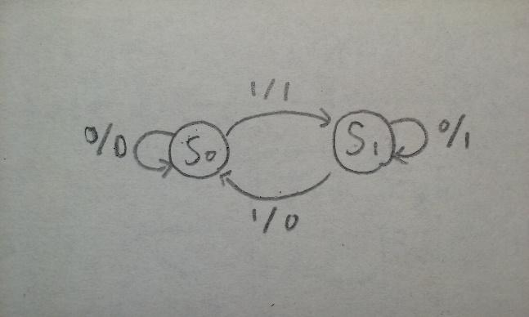

* 1. **Draw the related block/logic diagram.**

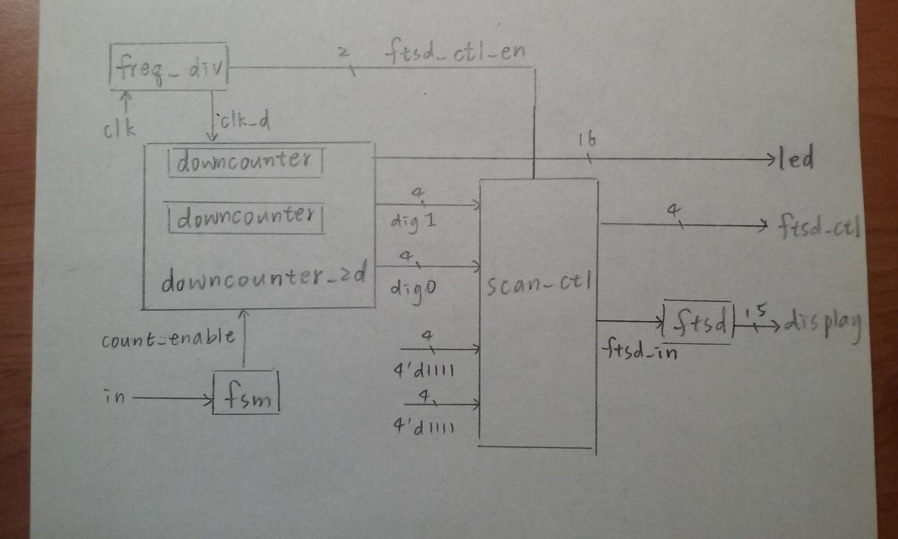

* 1. **Use a FSM to implement the function of pause/start function. Use one LED to represent current state.**

`define STAT_DEF 1'b0

`define STAT_COUNT 1'b1

`define STAT_PAUSE 1'b0

`define ENABLED 1

`define DISABLED 0

module fsm(

count_enable, // if counter is enabled

in, //input control

clk, // global clock signal

rst_n // low active reset

);

// outputs

output count_enable; // if counter is enabled

// inputs

input clk; // global clock signal

input rst_n; // low active reset

input in; //input control

reg count_enable; // if counter is enabled

reg state; // state of FSM

reg next_state; // next state of FSM

// FSM state decision

always @*

case (state)

`STAT_DEF:

if (in)

begin

next_state = `STAT_COUNT;

count_enable = `ENABLED;

end

else

begin

next_state = `STAT_DEF;

count_enable = `DISABLED;

end

`STAT_COUNT:

if (in)

begin

next_state = `STAT_PAUSE;

count_enable = `DISABLED;

end

else

begin

next_state = `STAT_COUNT;

count_enable = `ENABLED;

end

`STAT_PAUSE:

if (in)

begin

next_state = `STAT_COUNT;

count_enable = `ENABLED;

end

else

begin

next_state = `STAT_PAUSE;

count_enable = `DISABLED;

end

default:

begin

next_state = `STAT_DEF;

count_enable = `DISABLED;

end

endcase

// FSM state transition

always @(posedge clk or negedge rst_n)

if (~rst_n)

state <= `STAT_DEF;

else

state <= next_state;

endmodule

**1.4 Use Verilog to implement 1.3 and verify the design with simulation results.**

**The Final Result:**

