**邏輯設計實驗Lab04結報**

**104060012邱怡庭**

**prelab1 Cascade eight DFFs together as the figure shown below with the input bits D=(d), output Q=(q7q6q5q4q3q2q1q0), and tie all their Cs together as clk (the divided clock). This is a serial shift register circuit. By adding a multiplexer before the first DFF, we can choose the input**

**from outside or from q0. As the clk changes 0,1,0,1,…, let the output of LEDs be (01010101), (10101010), (01010101), (10101010), ….**

**1.1 Construct the Verilog RTL representation for the logics with verification**

**1 Implement pre-lab1 with the following pin assignments.**

**Design Specification**

**Input:** clk, rst_n, mode, in;

**Output:** [7:0]q;

**Wire**: mode, in, [7:0]q, [1:0]clk_ctl, clk_d;

**block diagram:**

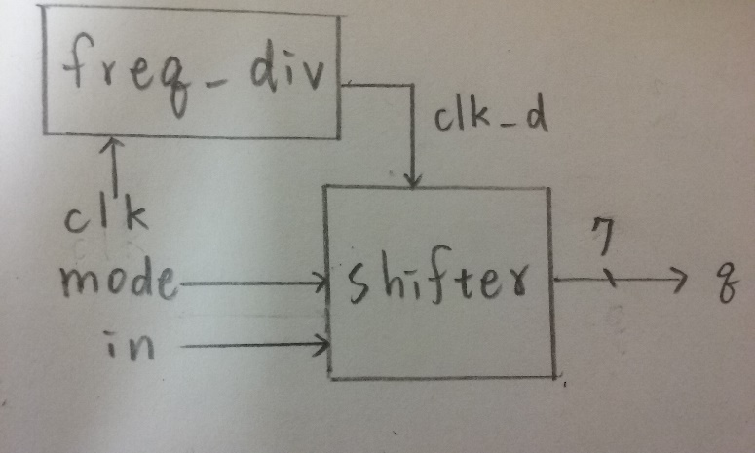

**Design Implementation**

**logic function**:

***shifter***

*always @(posedge clk or negedge rst_n)*

*if (~rst_n)*

*begin*

*q<=8'b01010101;*

*end*

*else if(~mode)*

*begin*

*q[0]<=q[1];*

*q[1]<=q[2];*

*q[2]<=q[3];*

*q[3]<=q[4];*

*q[4]<=q[5];*

*q[5]<=q[6];*

*q[6]<=q[7];*

*q[7]<=q[0];*

*end*

*else*

*begin*

*q[0]<=q[1];*

*q[1]<=q[2];*

*q[2]<=q[3];*

*q[3]<=q[4];*

*q[4]<=q[5];*

*q[5]<=q[6];*

*q[6]<=q[7];*

*q[7]<=in;*

*end*

***freq_div:***

*cnt_tmp = {clk_out,cnt_h,clk_ctl,cnt_l} + 1'b1;*

**logic diagram:**

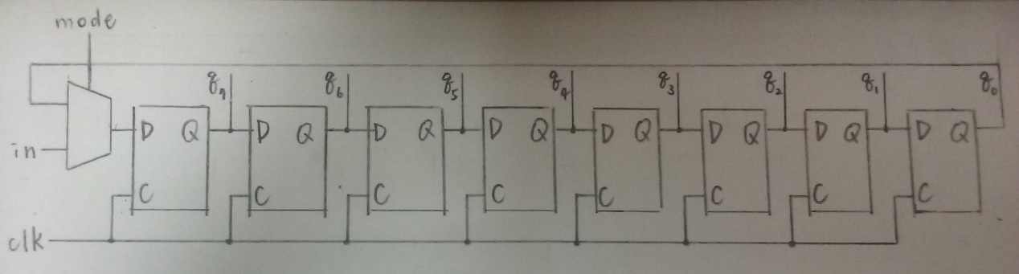

**I/O pin assignment:**

NET "q[7]" LOC = K6;

NET "q[6]" LOC = L7;

NET "q[5]" LOC = H3;

NET "q[4]" LOC = H4;

NET "q[3]" LOC = K5;

NET "q[2]" LOC = L5;

NET "q[1]" LOC = K3;

NET "q[0]" LOC = K4;

NET "clk" LOC = R10;

NET "rst_n" LOC = P2;

NET "mode" LOC = T1;

NET "in" LOC = P1;

**Discussion:**

用always裡的邏輯去架構出一個8個1bit的flip-flops，以及透過mode的控制來選擇是否得到in的值。

**2 Use the idea from pre-lab1. We can do something on the seven-segment display. Assume we have the pattern of E, H, N, T, U for seven-segment display as shown below. Try to implement the scrolling pre-stored pattern NTHUEE with the four seven-segment displays.**

**inpu**t clk, rst_n

**wire** clk_d, [1:0]clk_ctl, [14:0]a, [14:0]b, [14:0]c, [14:0]d;

**output** [14:0] display, [3:0] display_ctl;

**block diagram:**

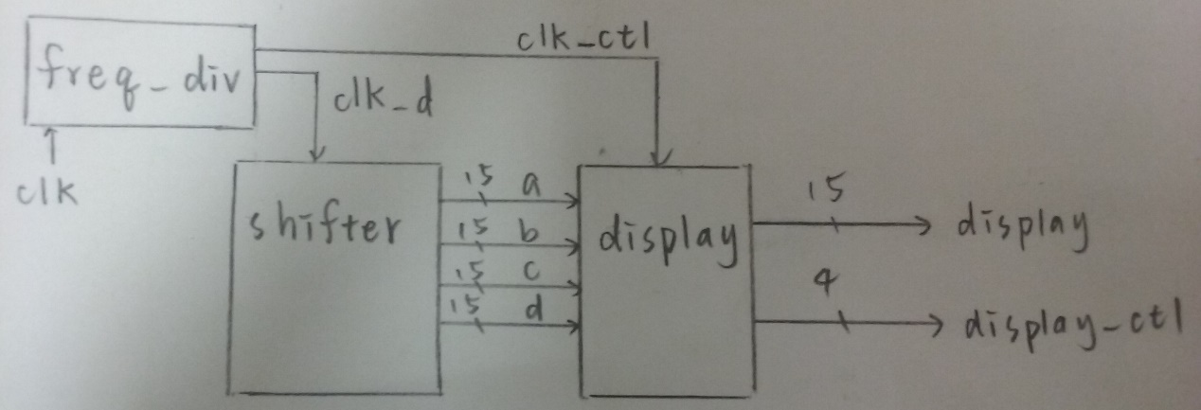

**Design Implementation**

**logic function**:

***display:***

*always @(posedge clk or negedge rst_n)*

*if (~rst_n)*

*begin*

*a<=15'b 10010011_011110_1; //N*

*b<=15'b 01111111_101101_1; //T*

*c<=15'b 10010000_111111_1; //H*

*d<=15'b 10000011_111111_1; //U*

*e<=15'b 01100000_111111_1; //E*

*f<=15'b 01100000_111111_1; //E*

*end*

*else*

*begin*

*a[14:0]<=b[14:0];*

*b[14:0]<=c[14:0];*

*c[14:0]<=d[14:0];*

*d[14:0]<=e[14:0];*

*e[14:0]<=f[14:0];*

*f[14:0]<=a[14:0];*

*end*

***freq_div:***

*cnt_tmp = {clk_out,cnt_h,clk_ctl,cnt_l} + 1'b1;*

***ssd_ctl:***

*// display value selection*

*always @(clk_ctl or display0 or display1 or display2 or display3)*

*case(clk_ctl)*

*2'b00: display = display0;*

*2'b01: display = display1;*

*2'b10: display = display2;*

*2'b11: display = display3;*

*default : display = 15'b11111111_111111_1;*

*endcase*

*// 7-segment control*

*always @(clk_ctl)*

*case(clk_ctl)*

*2'b00: display_ctl = 4'b1110;*

*2'b01: display_ctl = 4'b1101;*

*2'b10: display_ctl = 4'b1011;*

*2'b11: display_ctl = 4'b0111;*

*default : display_ctl = 4'b1111;*

*endcase*

**logic diagram:**

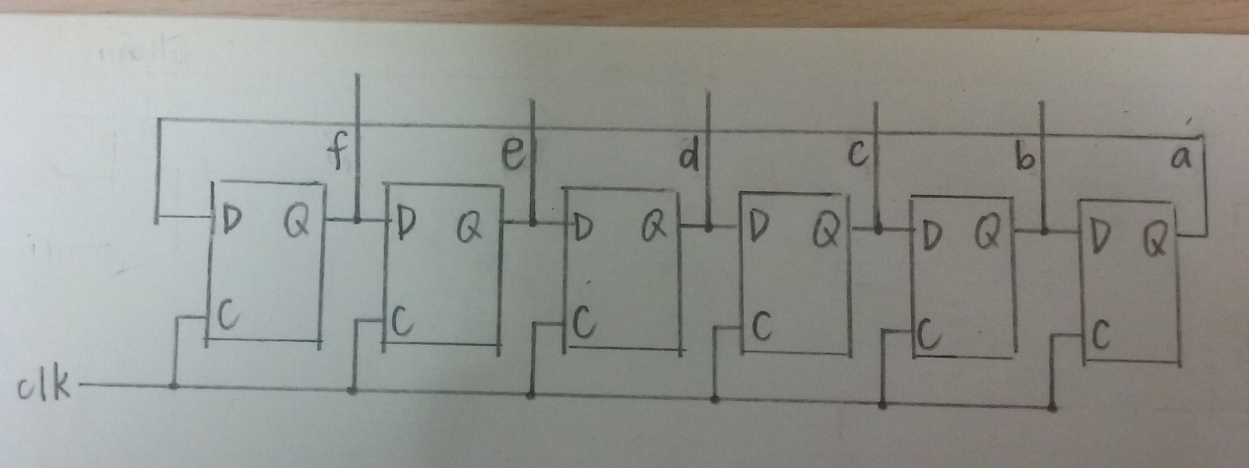

**I/O pin assignment:**

NET "display_ctl[3]" LOC = "T6";

NET "display_ctl[2]" LOC = "V6";

NET "display_ctl[1]" LOC = "U8";

NET "display_ctl[0]" LOC = "V8";

NET "display[14]" LOC = "P6";

NET "display[13]" LOC = "N4";

NET "display[12]" LOC = "V5";

NET "display[11]" LOC = "T5";

NET "display[10]" LOC = "U7";

NET "display[9]" LOC = "R3";

NET "display[8]" LOC = "N5";

NET "display[7]" LOC = "R5";

NET "display[6]" LOC = "T3";

NET "display[5]" LOC = "T4";

NET "display[4]" LOC = "V4";

NET "display[3]" LOC = "V7";

NET "display[2]" LOC = "R7";

NET "display[1]" LOC = "T7";

NET "display[0]" LOC = "U5";

NET "clk" LOC = "R10";

NET "rst_n" LOC = "T1";

**Discussion:**

設置6個15bits的暫存器，然後使用邏輯帶出a<=b, b<=c, c<=d, d<=e, e<=f, f<=a，最後只要顯示出a,b,c,d即可，另外由於是顯示4個14段顯示器，因此需再使用ssd control。

**Conclusion:**

實驗的步驟雖然越來越繁雜，但當完成時總是相當有成就感，像是這次成功看到NTHUEE在顯示器上移動時，覺得很開心，希望未來能學會更多控制的功能!