NUCLEAR PHYSICS

38

Exercises
Section 38.1 Elements, Isotopes, and Nuclear Structure
13. Interpret This problem involves writing the conventional symbols for three isotopes of radon.
Develop The conventional symbol for a nucleus X is 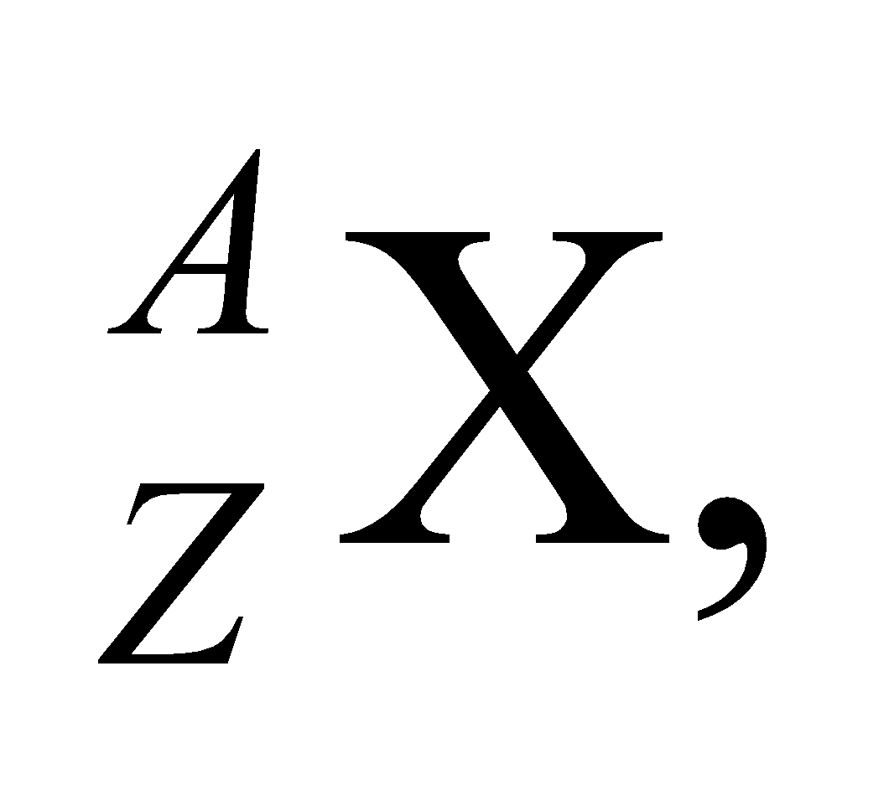 where A is the mass number and Z is the atomic number.
Evaluate With the number of protons (Z = 86 for all radon isotopes) and neutrons (N = A − Z) given, the mass numbers A of the three isotopes are, respectively,
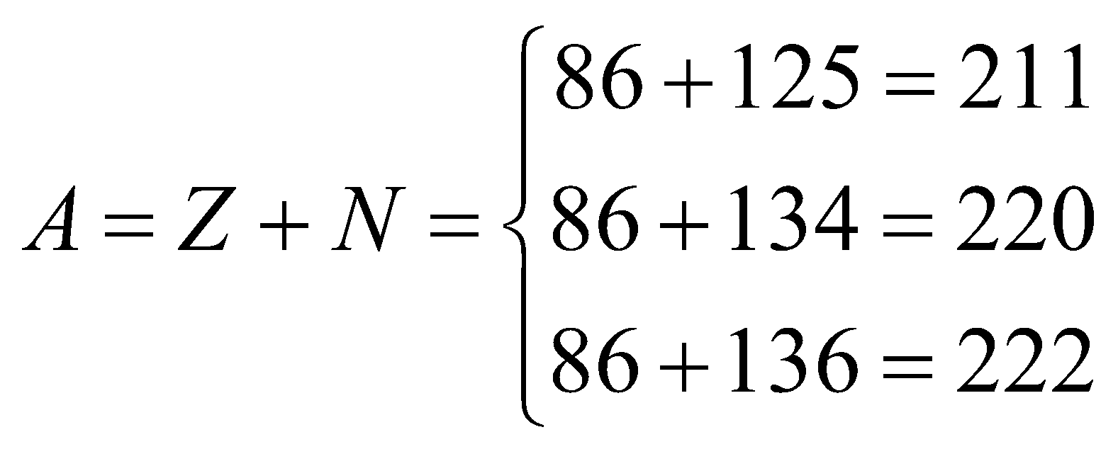
Therefore, the nuclear symbols are 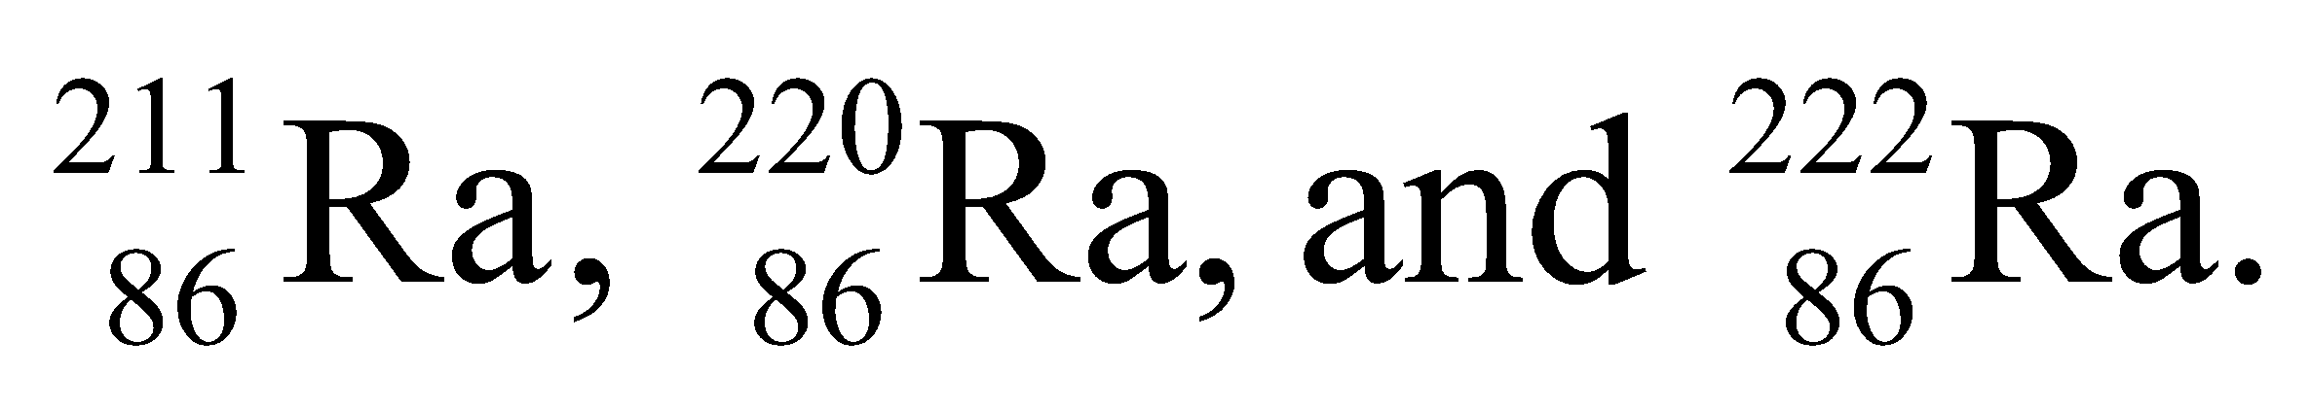
Assess Isotopes of a given element have the same number Z of protons but different number of neutrons (and thus a different value for A).
14. Interpret We are to give the symbol for the isotope of Ge with 44 neutrons.
Develop The mass number A = Z + N, where N = 44 is the number of neutrons. For Ge (a semiconductor under silicon in the periodic table), Z =32.
Evaluate The mass number A = 32 + 44 = 76, so its symbol is 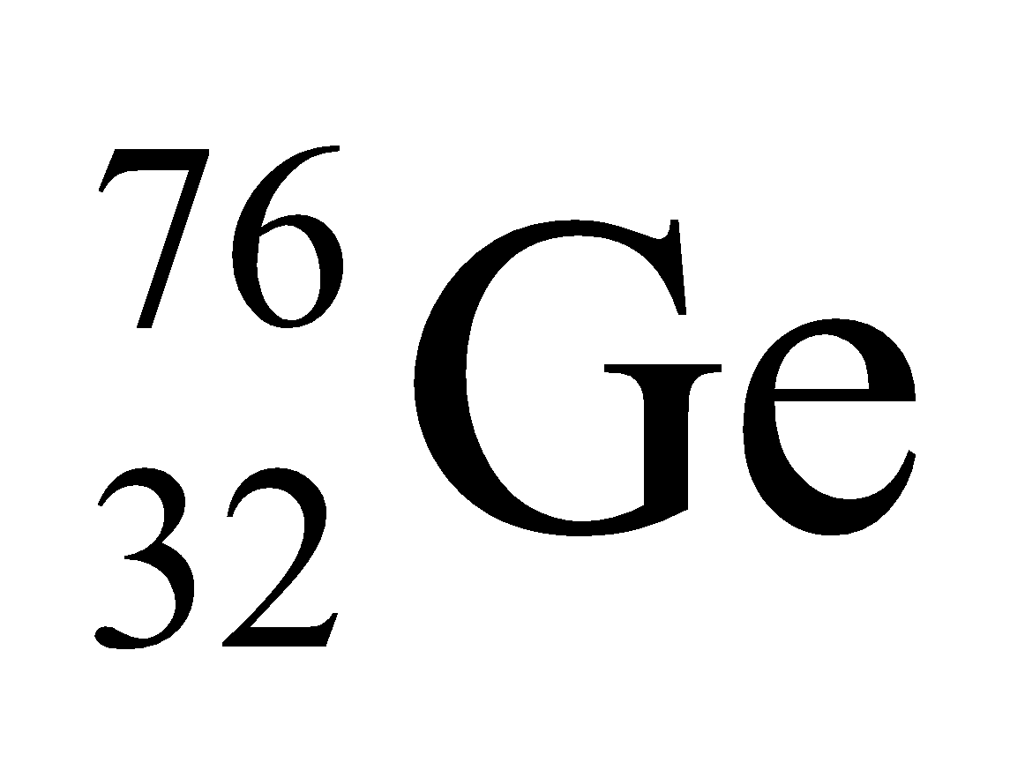.
Assess Recall that the mass of the isotope is given by the sum of the neutrons and protons in the nucleus.
15. Interpret We are given the symbol for two nuclei and asked to compare the number of nucleons and charges between them.
Develop The comparison can be made by noting that the conventional symbol for a nucleus X is 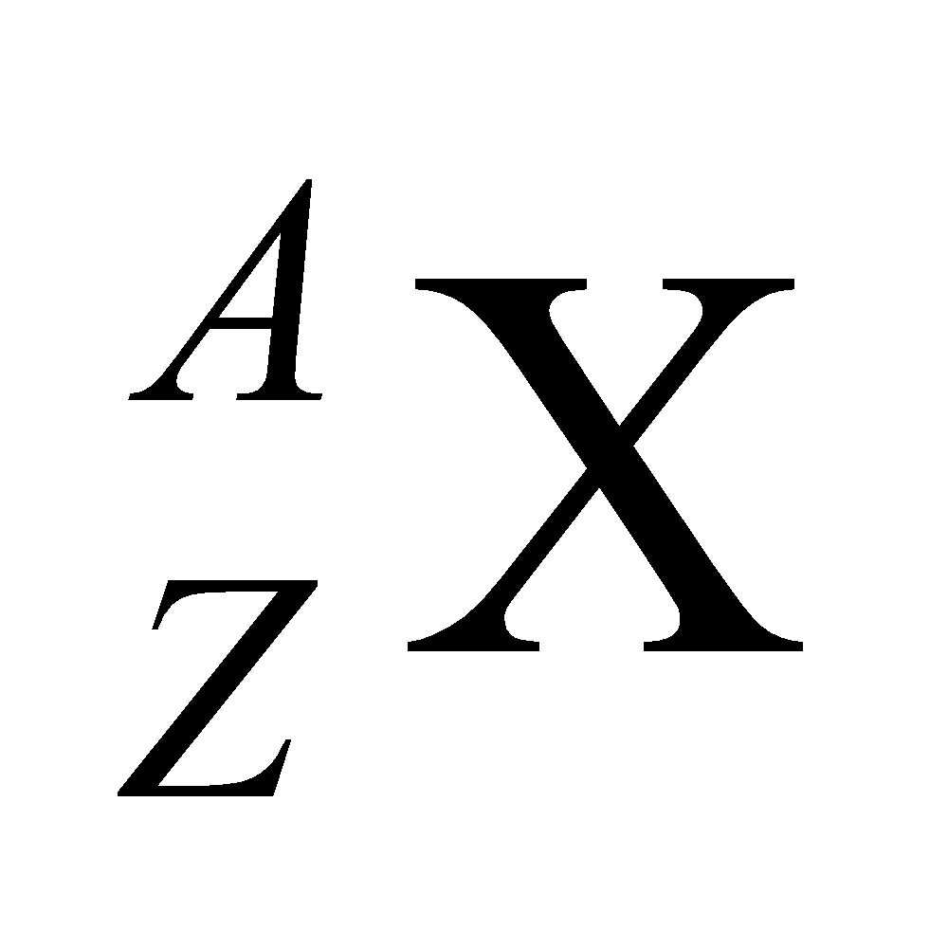 where A is the mass number and Z is the atomic number.
Evaluate (a) The mass number (number of nucleons) is A = 35 for both.
(b) The charge Ze of a potassium nucleus (Z = 19) is two electronic charge units greater than that for a chlorine nucleus, which has Z =17.
Assess Equality in mass number A does not imply equality in atomic number Z. Two nuclei have the same Z only when they are isotopes.
16. Interpret We are to compare the radius of the proton with the Bohr radius, which is a typical size to use for an atom.
Develop The “radius” of the proton may be estimated by applying Equation 38.1, 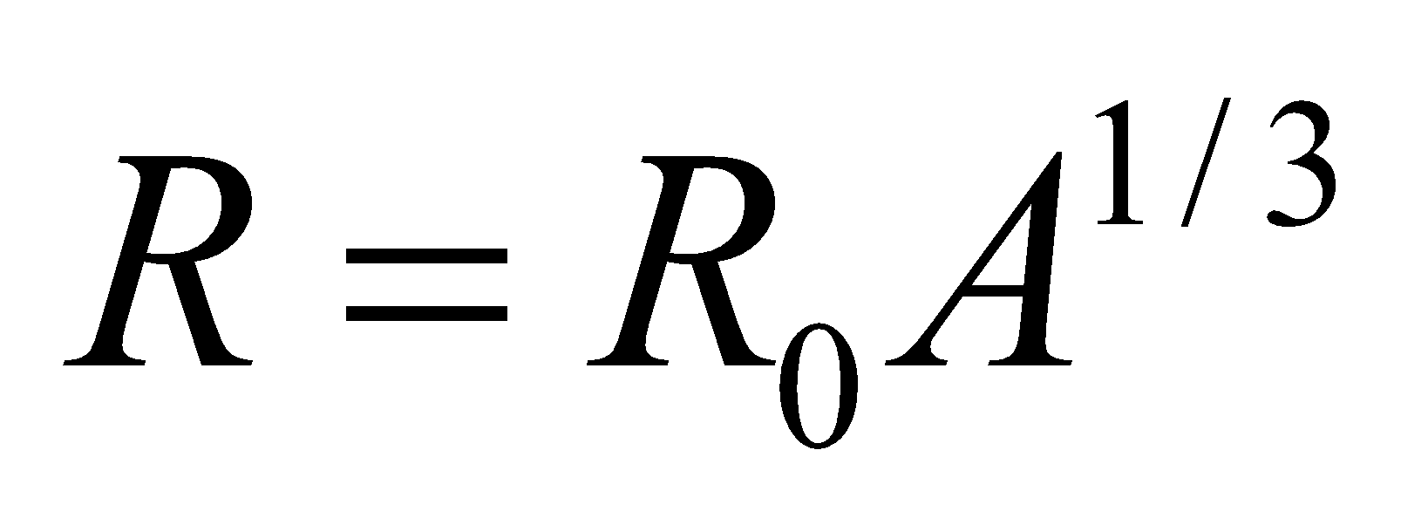 to a hydrogen nucleus (A = 1), which gives R_{H} = 1.2 fm (the constant R₀ = 1.2 fm). From the derivation of Equation 34.12a, the Bohr radius is a₀ = 52.9 pm.
Evaluate Comparing the two gives
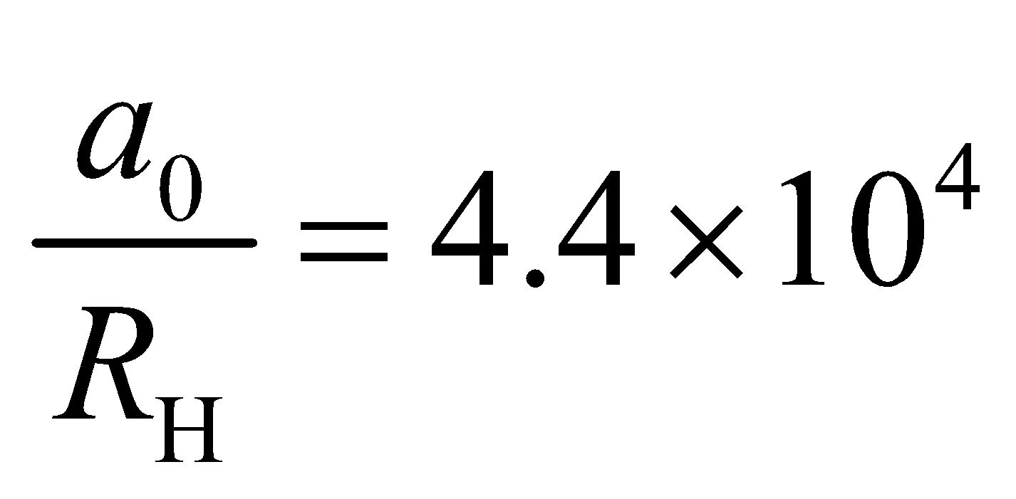
so the Bohr radius is about 44,000 times larger than the radius of a proton.
Assess In terms of volume, the fraction of space in a hydrogen atom that is not empty space is
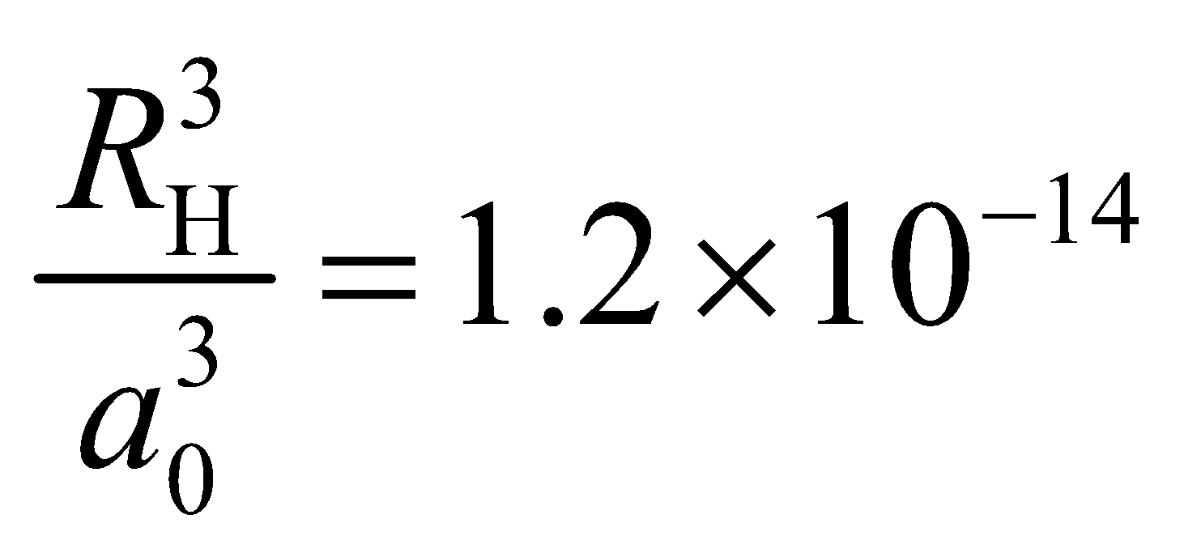
In other words, the hydrogen atom is mostly empty space!
17. Interpret We are to deduce the size of the fission products of 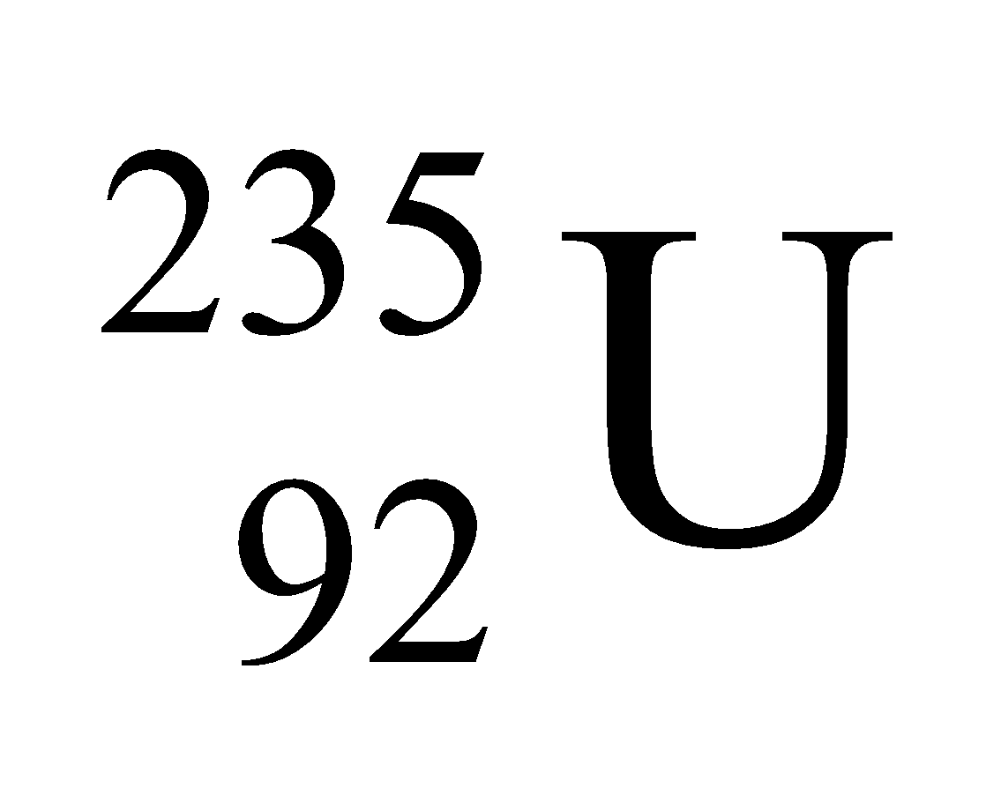, and find the radius of the daughter nuclei, given that they are of the same size.
Develop The nuclear radius can be estimated using Equation 38.1:
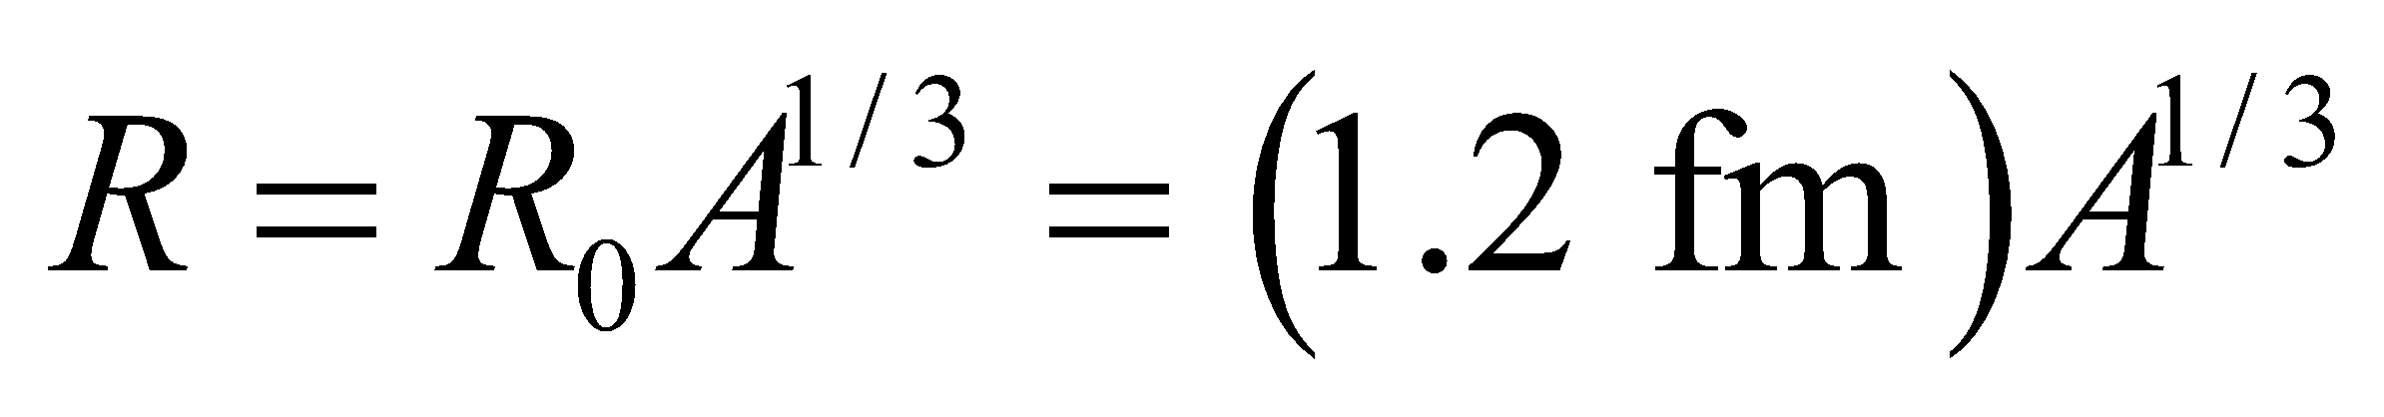
Given that the daughter nuclei are of the same size, the will each have half the number of nucleons of the parent nucleus, which has A = 235. Thus, the daughter nuclei will have A = 235/2 = 117 or 118.
Evaluate Inserting A = 117 or 118 into the expression above for the radius gives
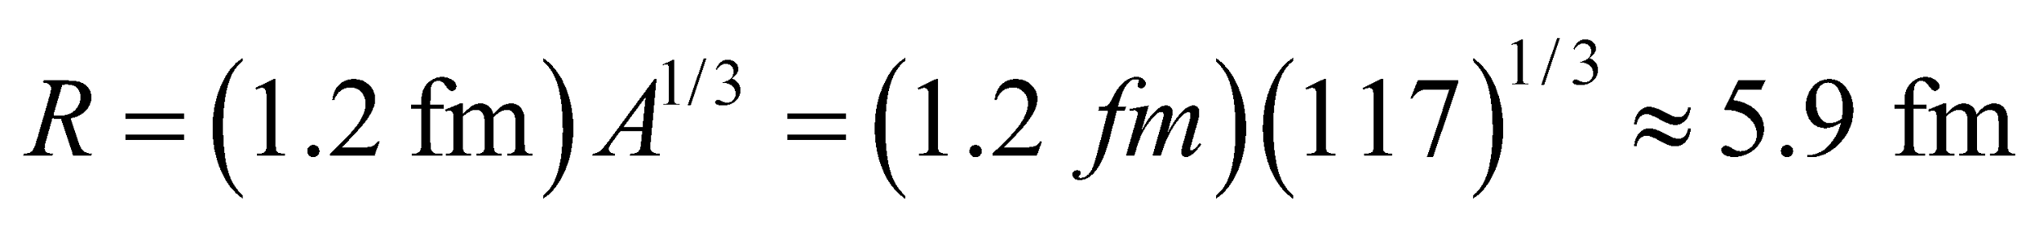
Assess Equation 38.1 is a good approximation for R since nucleons are packed tightly into the nucleus. The tight packing also suggests that all nuclei have roughly the same density.
Section 38.2 Radioactivity
18. Interpret This involves radioactive decay. We are to determine the number of half-lives it takes for a radioactive sample to decay to 10% of its initial activity.
Develop Apply Equation 38.3b with N = N₀/10 and solve for t in terms of t_{1/2}.
Evaluate The number of half-lives required is
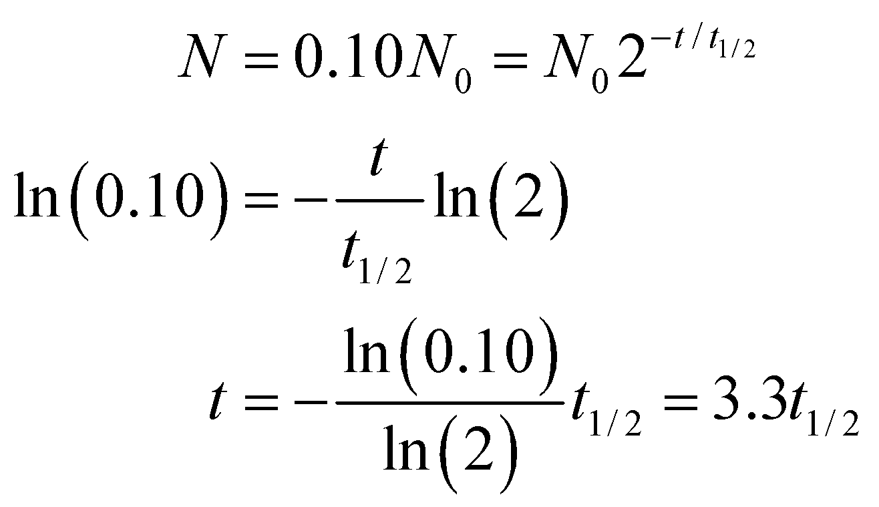
Assess Let’s see if our result makes sense. After one half-life, the activity is 1/2 the initial activity, after 2 it’s ¼ and after 3 it’s 1/8. The target of 10% of the original activity is just a bit less than 1/8, so our answer of a little more than three half-lives seems about right.
19. Interpret In this problem we are asked to write down all possible beta-decay processes for 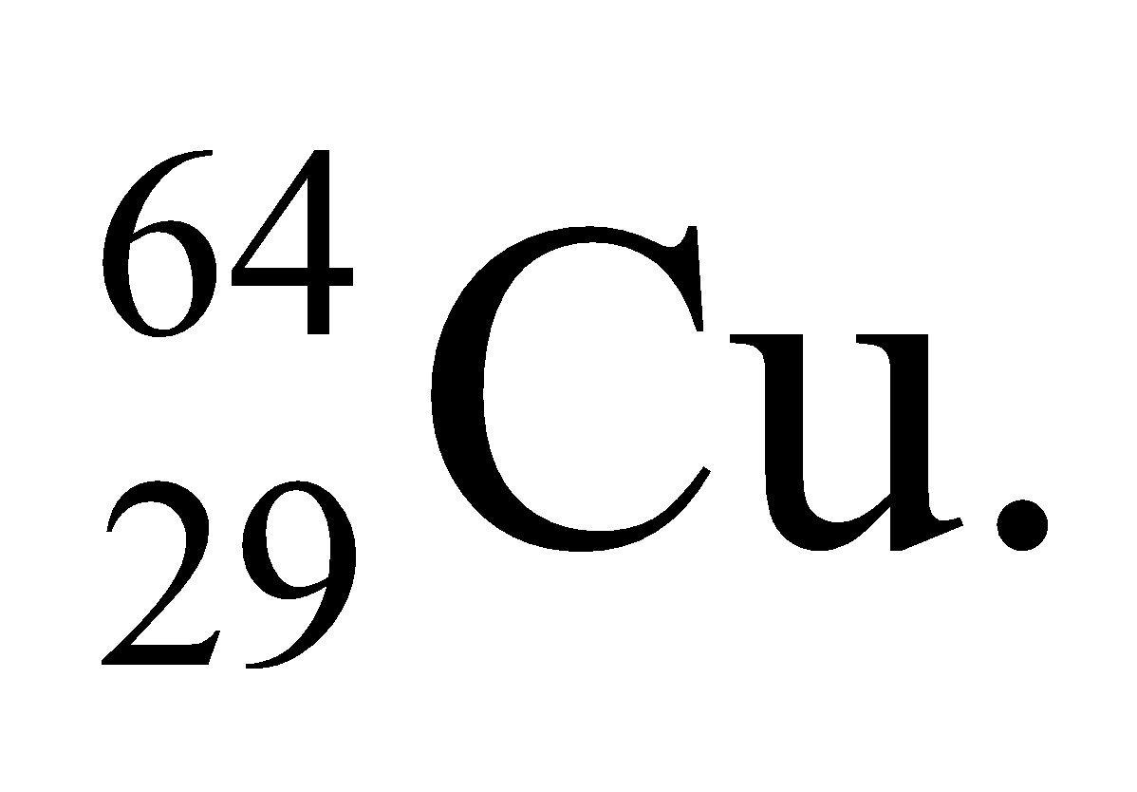
Develop As detailed by Equations 38.5a, 38.5b, and 38.5c, beta decay in 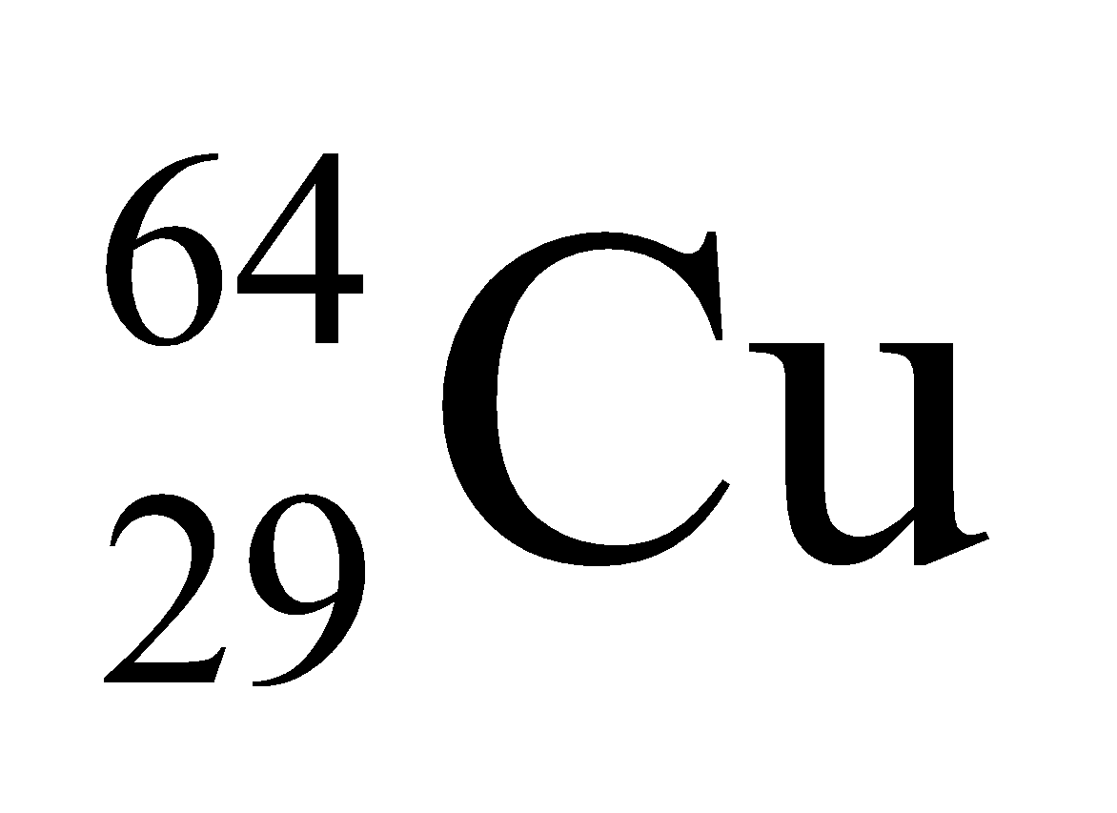 can involve positron-neutrino or electron-anti-neutrino emission, or electron capture. In each reaction, charge and mass number must be conserved.
Evaluate The reactions are
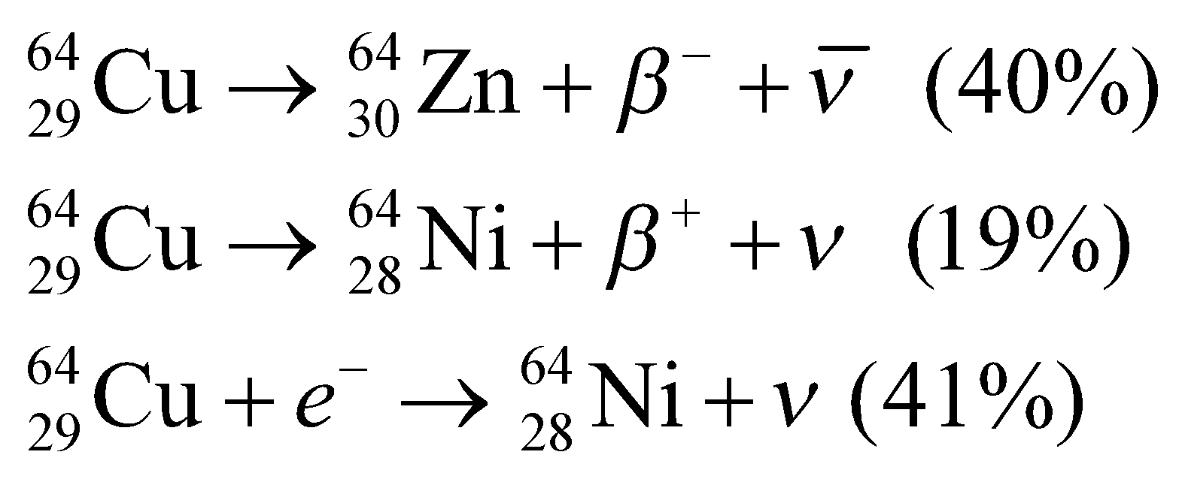
Assess In each decay mode, charge and mass number are conserved.
20. Interpret We are to give the reactions for the two given nuclei using data from Figure 38.7.
Develop Radon-222 decays by emitting two neutrons and two protons, which constitutes an alpha particle. Thus, A is decremented by 4 nucleons and Z is decremented by 2 protons so the daughter nucleus has A = 222 − 4 = 218 and Z = 86 − 2 = 84 (i.e., Po). The decay of lead-214 proceeds by the conversion of a neutron into a proton via beta decay. The mass number A is unchanged (addition of a proton and loss of a neutron), and the atomic number Z is incremented by one, so the daughter nucleus has Z = 82 + 1 = 83 (i.e., Bi) and A = 214 +1 − 1 = 214.
Evaluate (a) The decay reaction for radon-222 is
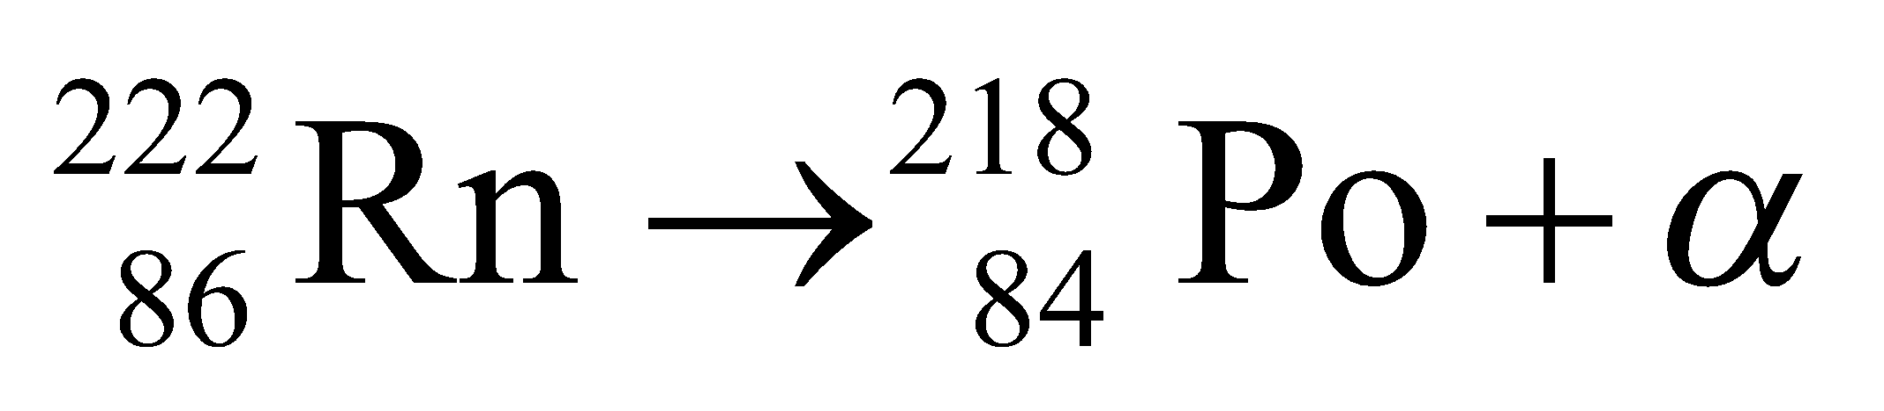
(b) The reaction for lead-214 is
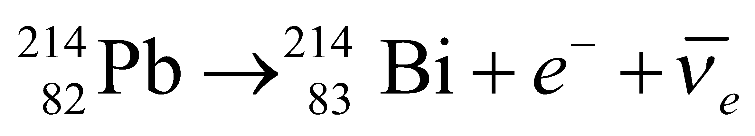
Assess Charge and mass are conserved in each reaction.
21. Interpret This problem is an exercise in conversion between Ci and Bq.
Develop Section 38.2 gives the relation between Ci and Bq: 1 Ci = 3.7 × 10¹⁰ Bq.
Evaluate The activity of the milk sample in SI units is
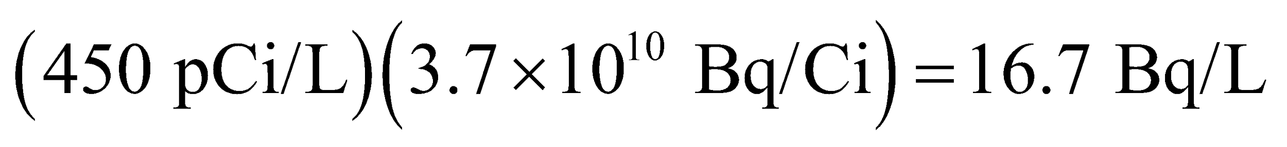
Assess The more modern unit is the Bq.
22. Interpret The problem considers how long a prescribed dose of carbon-11 will remain significantly radioactive following a PET scan.
Develop The radioactivity of a sample is proportional to the number, N, of radioactive atoms it contains. Over time, this number decreases according to Equation 38.3b, 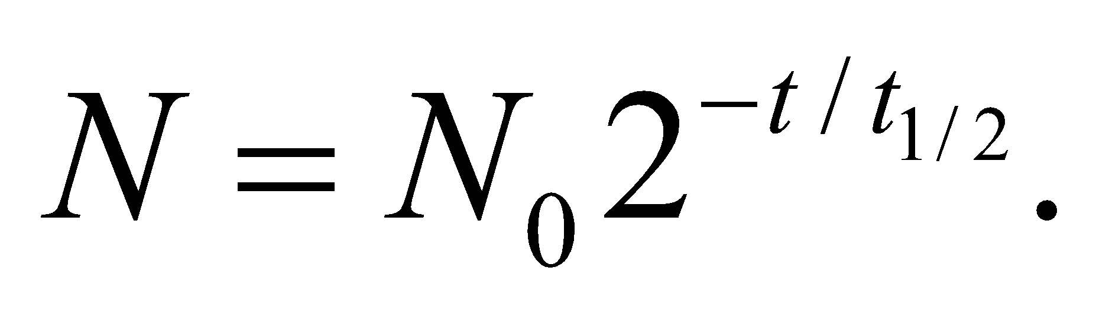The half-life of C-11 is given as 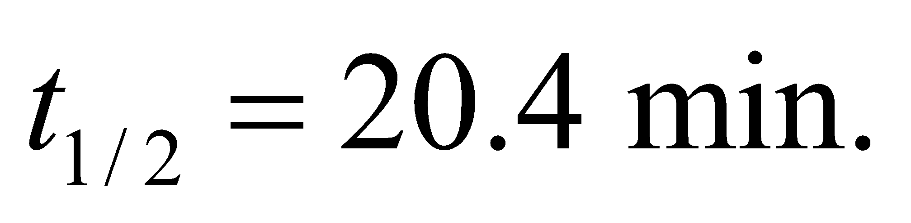
Evaluate (a) The time it will take for the activity of C-11 to drop from 2 billion to 7000 becquerel (Bq) is the same as the time it takes for the number of C-11 to drop by the same factor:
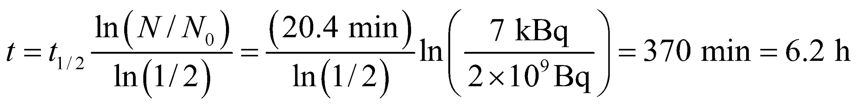
(b) As described in Equation 38.5b, positron emission converts a proton to a neutron:
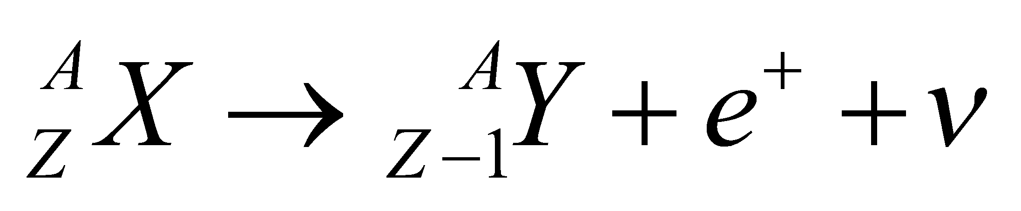
The carbon-11 nucleus 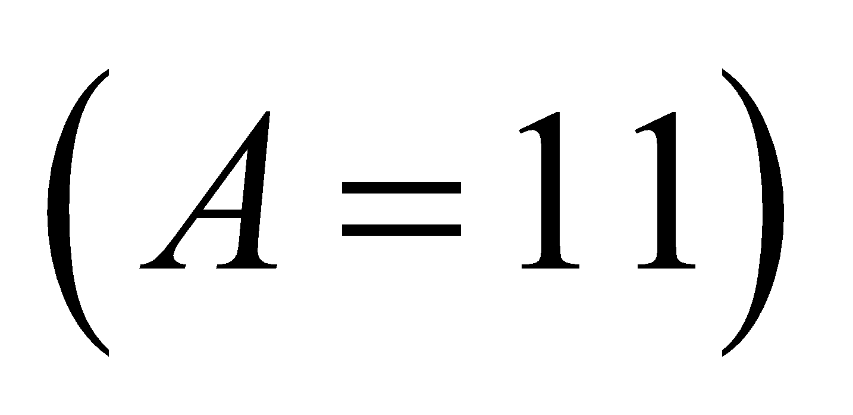has 6 protons 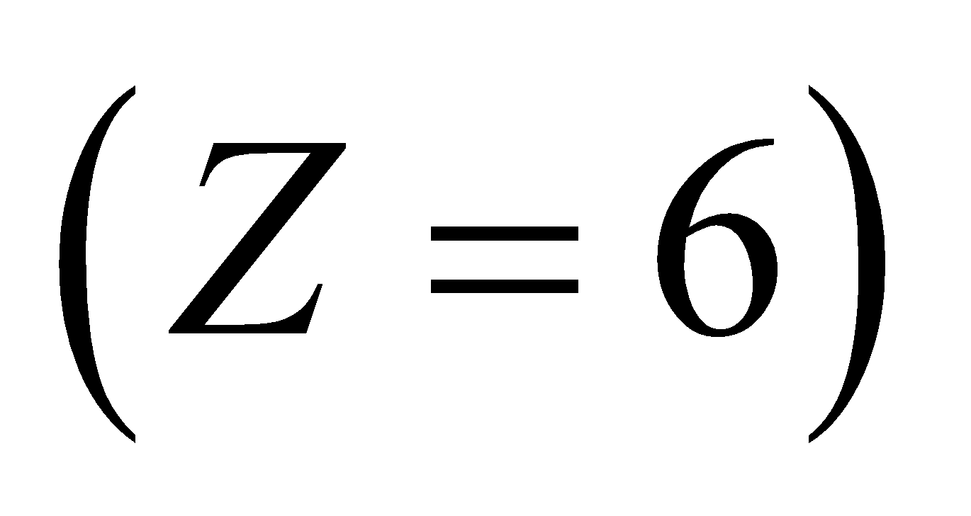 and 5 neutrons. If it decays through positron emission (Equation 38.5b), then its atomic number drops by one to 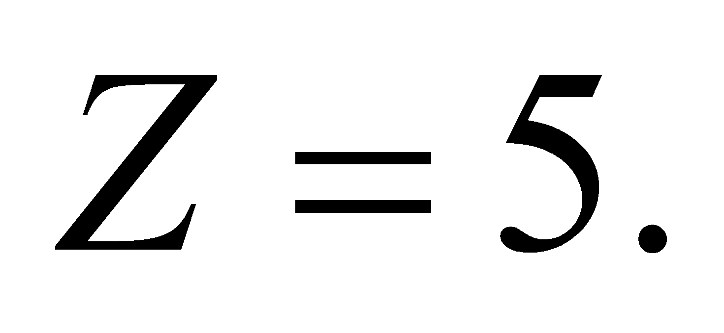 In the Periodic Table, that would correspond to boron, specifically 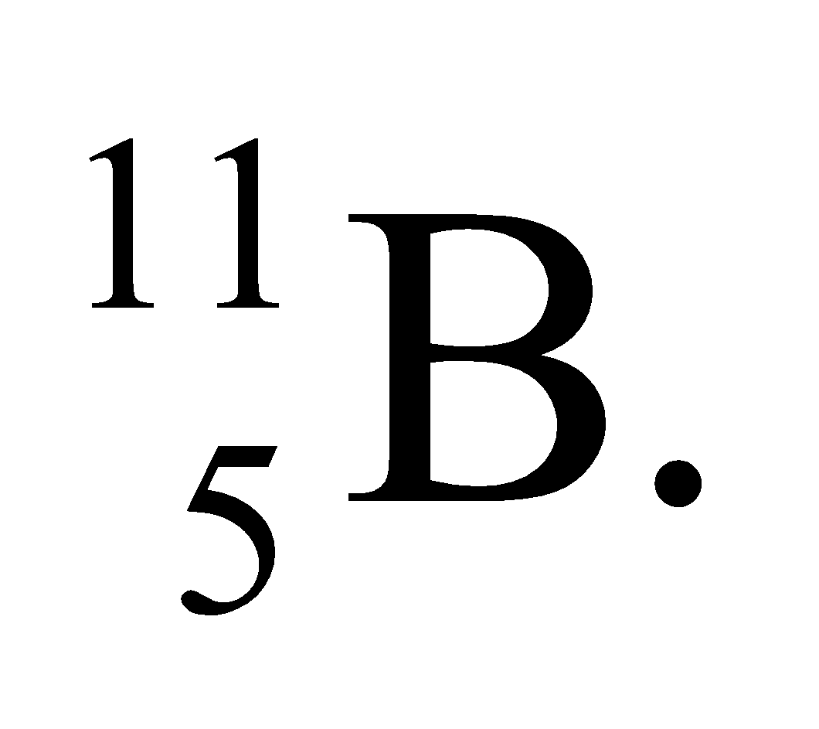
Assess For medical scans, a short lifetime such as that for C-11 is desirable, so that the total radiation exposure is limited.
23. Interpret This is a problem about the decay of ⁹⁰Sr. We are to find the time it will take for the activity of ₉₀Sr to decay to the 99% and 99.9% of its original activity.
Develop From Table 38.1, we find the half-life of ⁹⁰Sr to be 29 years. Solving for the elapsed time t in Equation 38.3b, 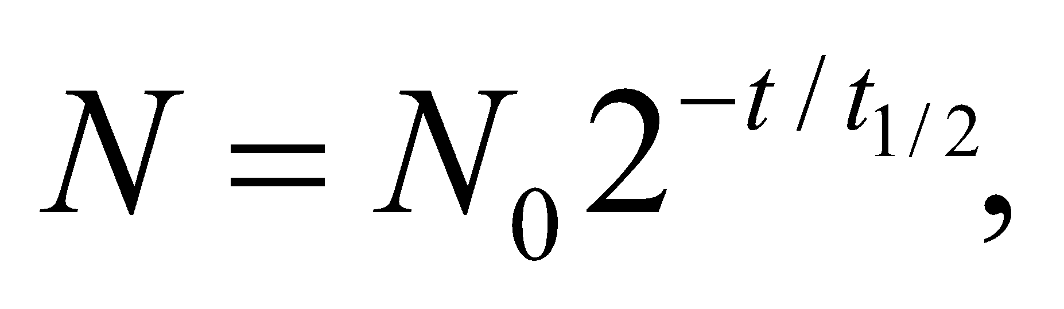 the time elapsed since the bomb tests is
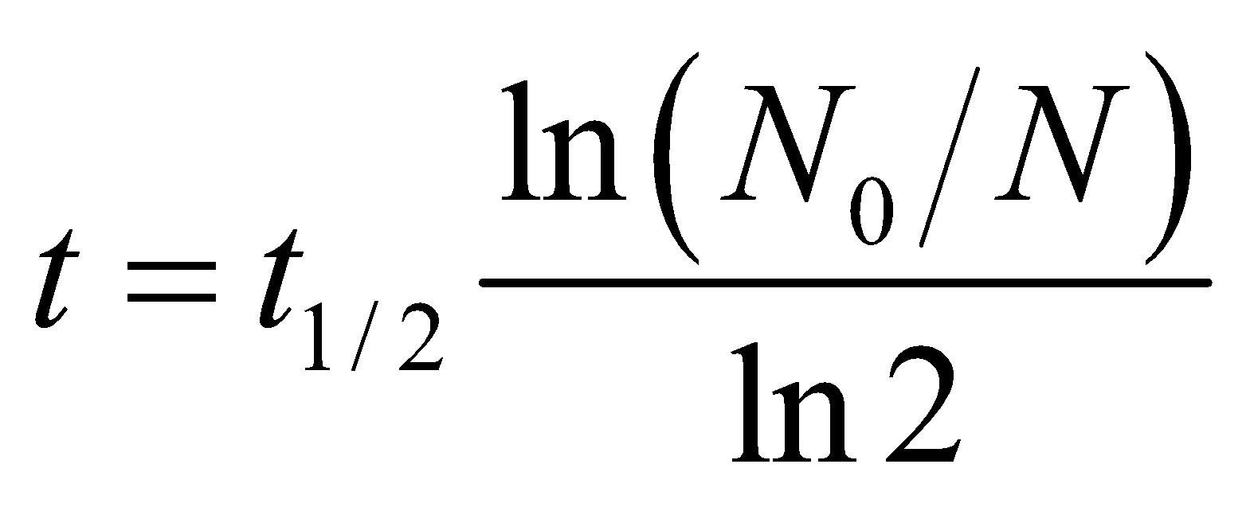
The fraction N/N₀ of ⁹⁰Sr that remains is one minus the fraction that decays.
Evaluate (a) For 99% of the radioactive contaminant to decay, or 1% to remain (N/N₀ = 1.00 − 0.99 = 0.01) the time required is
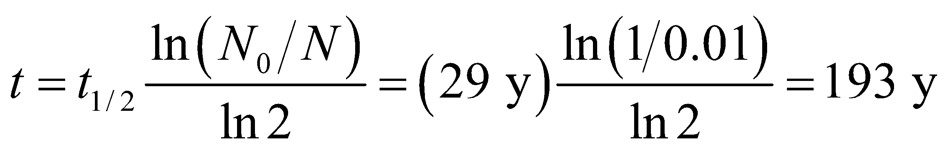
(b) Similarly, for 99.9% of the radioactive contaminant to decay, or 0.1% to remain, the time required is
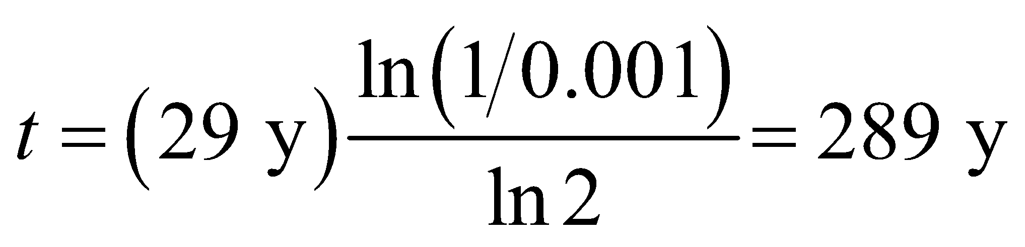
Assess Since 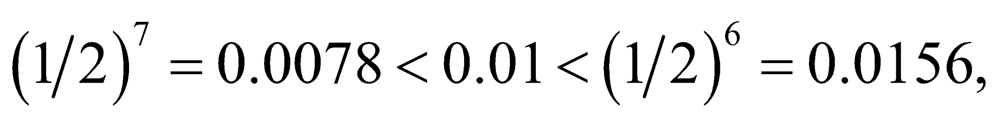 for 1% of contaminant to remain, 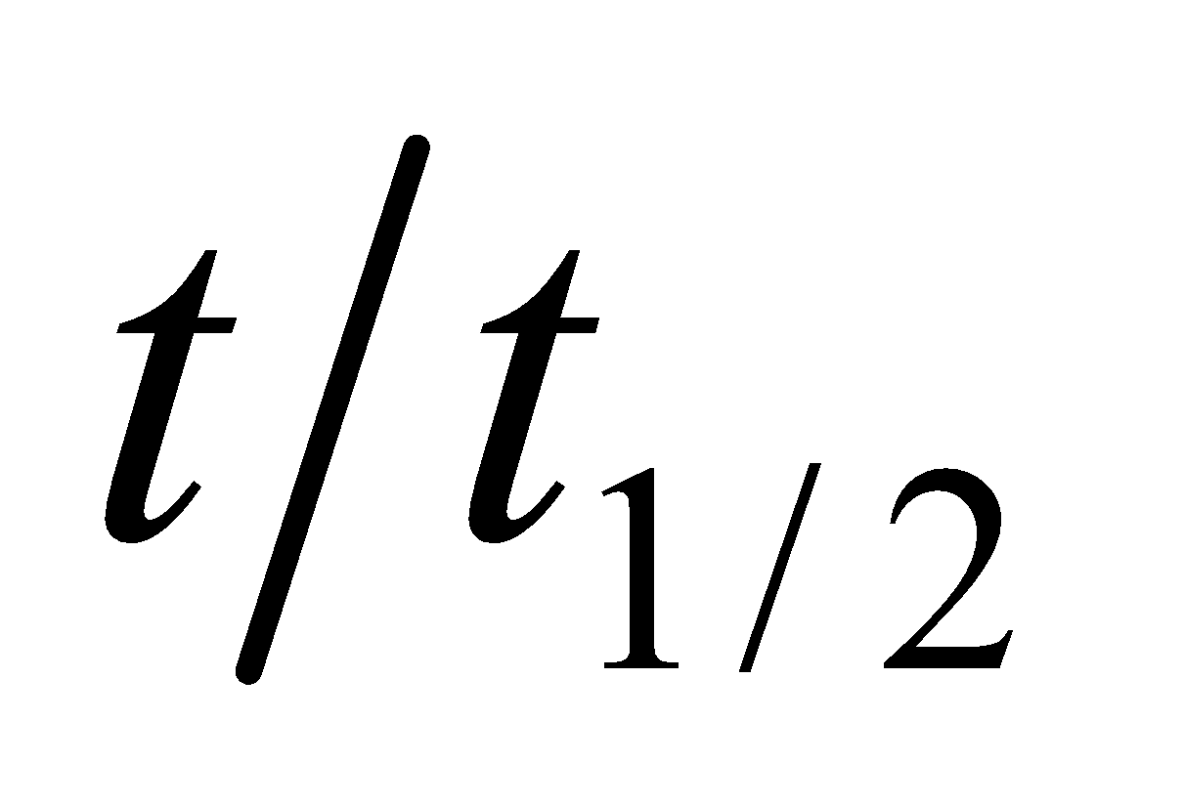 must be between 6 and 7, so our result of 193/29 = 6.66 is reasonable. Similarly reasoning also shows that our result for (b) is about right.
Section 38.3 Binding Energy and Nucleosynthesis
24. Interpret We are to find the total binding energy of the given nucleus, given its nuclear mass.
Develop Solve Equation 38.7
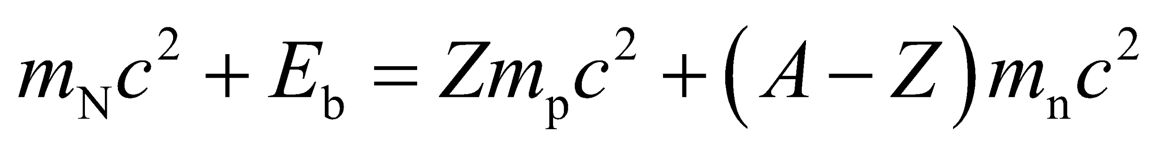
for the binding energy E_{b}, with the help of the data from Table 38.2.
Evaluate The binding energy of ¹⁶O is
Assess This works out to about 8 MeV/nucleon.
25. Interpret We’re given the binding energy per nucleon for 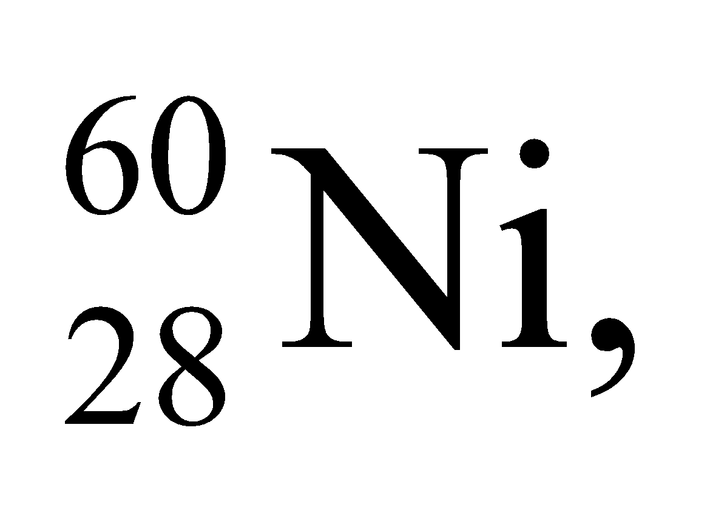 and asked to find its atomic mass.
Develop Using Equation 38.7, the binding energy of a nucleus can be written as
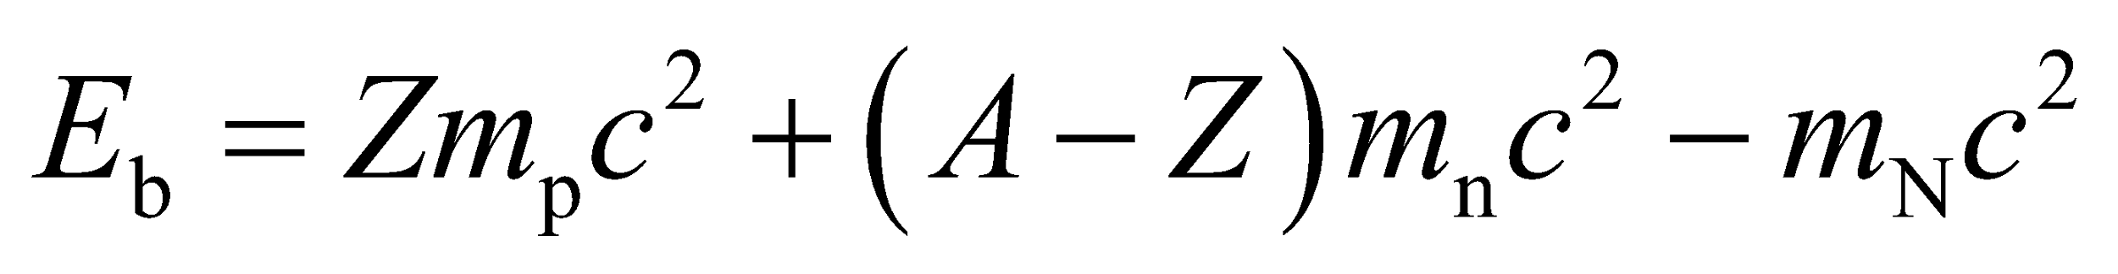
where m_{b}, m_{n}, and m_{N} are the masses of the protons, neutrons, and the nucleus, respectively. The total nuclear binding energy of 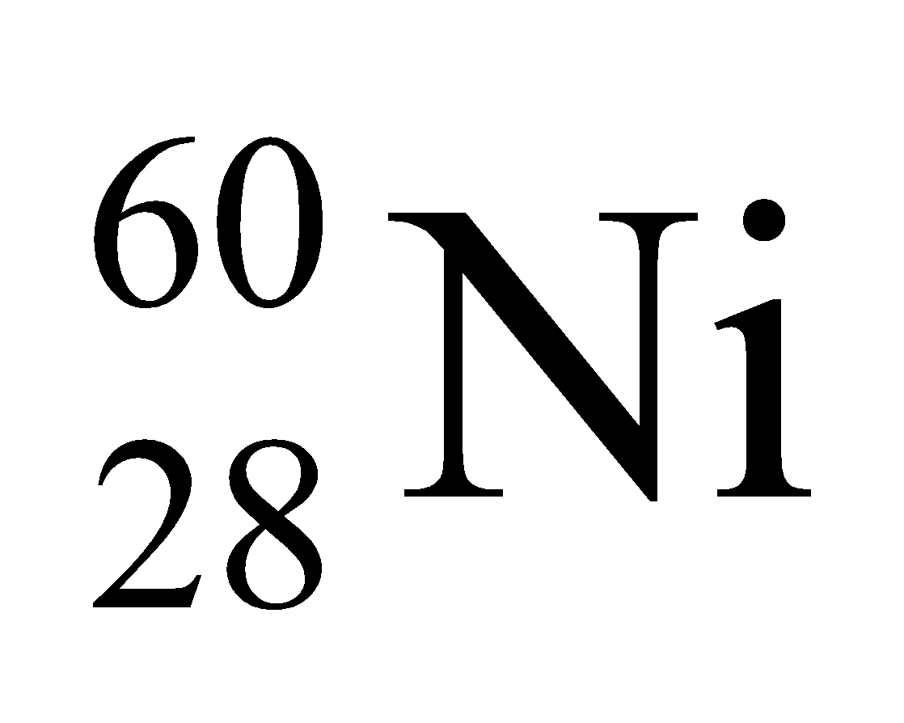 is the number of nucleons (A = 60) times the given binding energy per nucleon, or
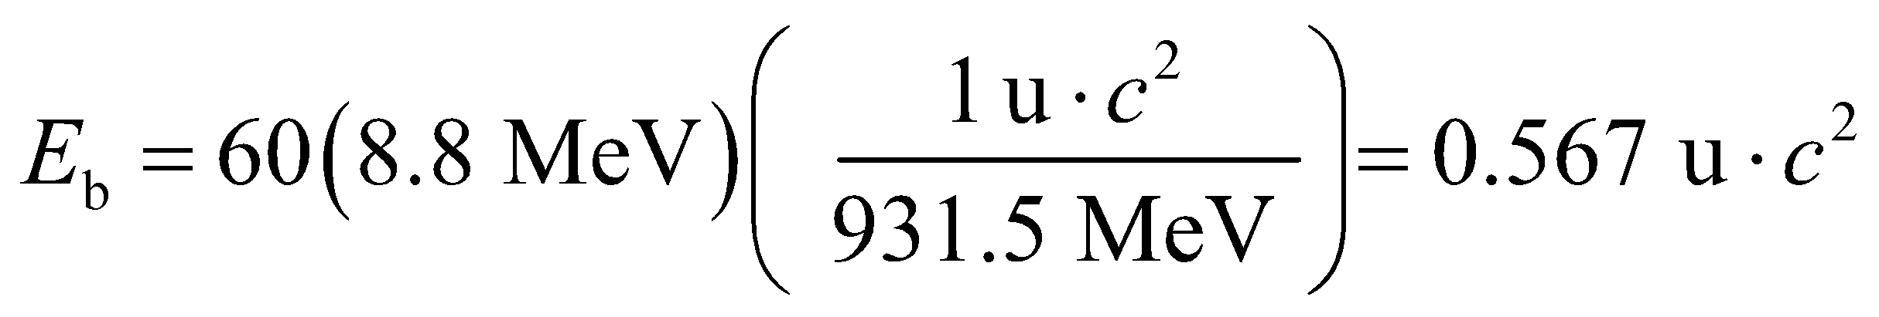
The result can be used to solve for the atomic mass of .
Evaluate If we express Equation 38.7 in terms of atomic masses, by adding Z = 28 electron rest energies
(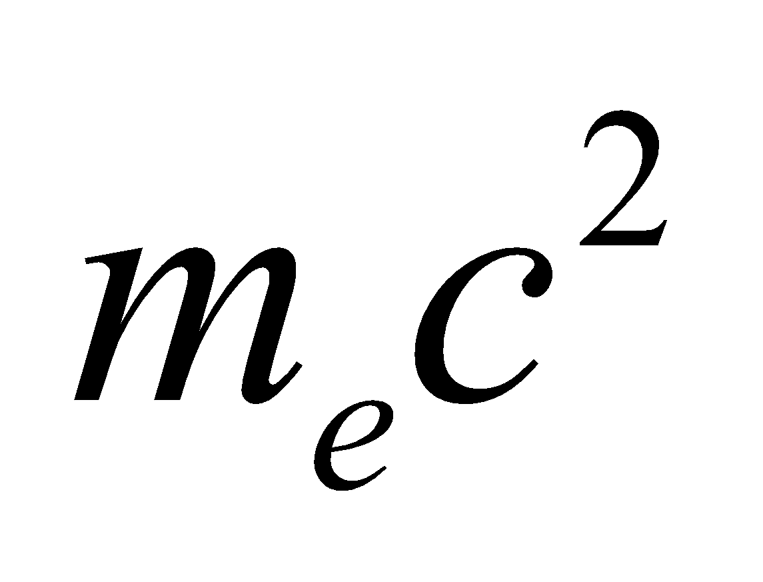) to both sides, and neglect atomic binding energies, we obtain:
where we have retained only two figures after the decimal point because the binding energy is known with that precision.
Assess The actual binding energy of 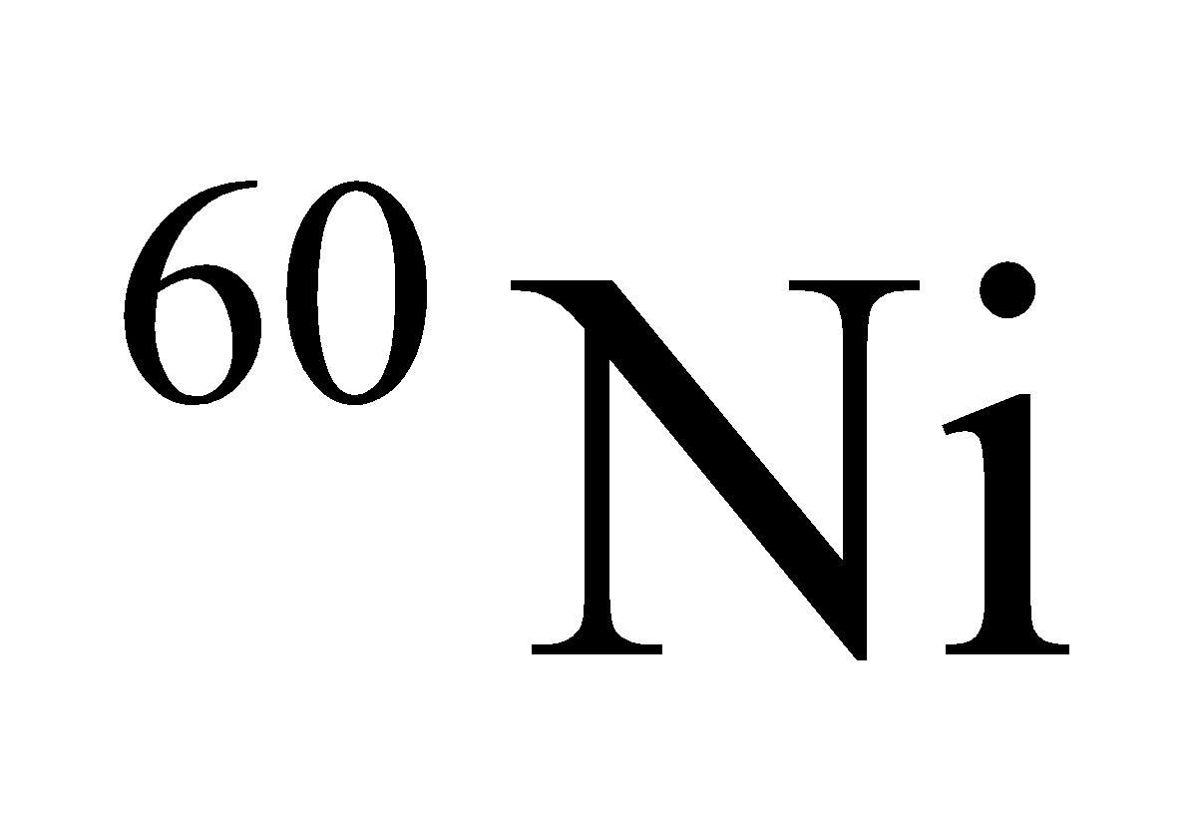 is so close to 8.8 MeV/nucleon that the accuracy of the atomic mass just calculated is better than one might expect from data given to two significant figures.
26. Interpret We are to find the nuclear mass of the given element, using its known atomic mass.
Develop To obtain the nuclear mass, subtract the mass of Z = 94 electrons from the given atomic mass of plutonium, and neglect the atomic binding energy.
Evaluate The nuclear mass of plutonium-239 is
Assess The nuclear mass differs from the atomic mass by about 0.02%.
27. Interpret In this problem we are asked to find the binding energy per nucleon for 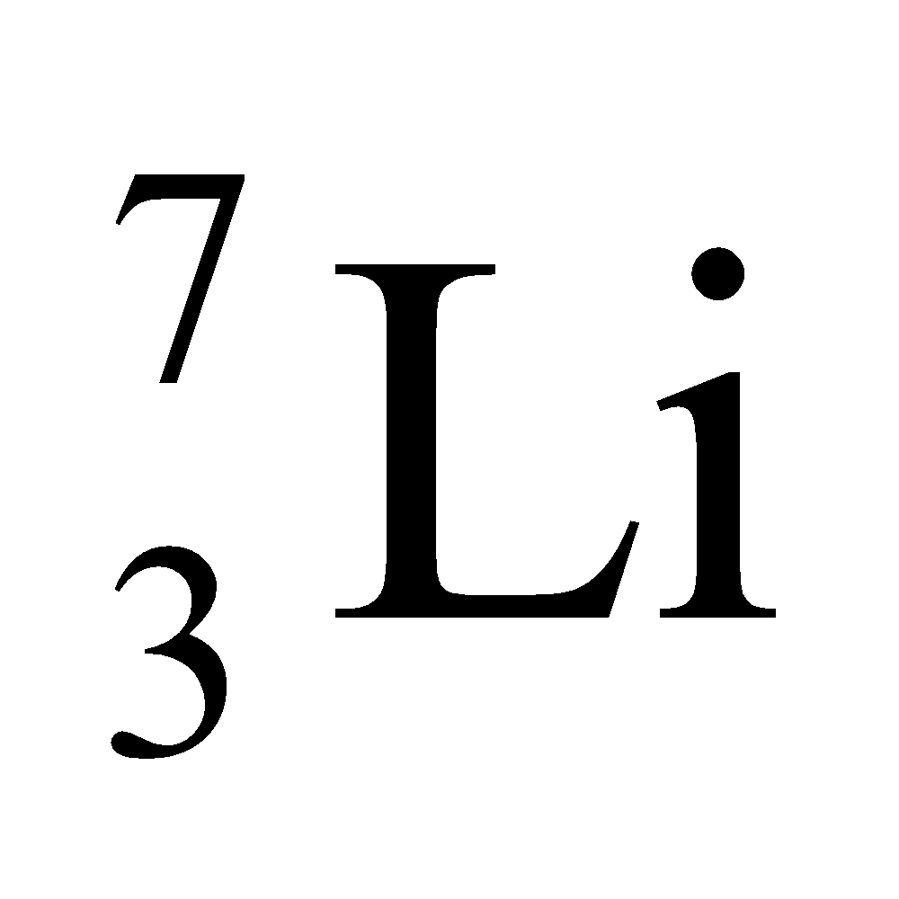 given its nuclear mass.
Develop Using Equation 38.7, the binding energy per nucleon of a nucleus can be written as
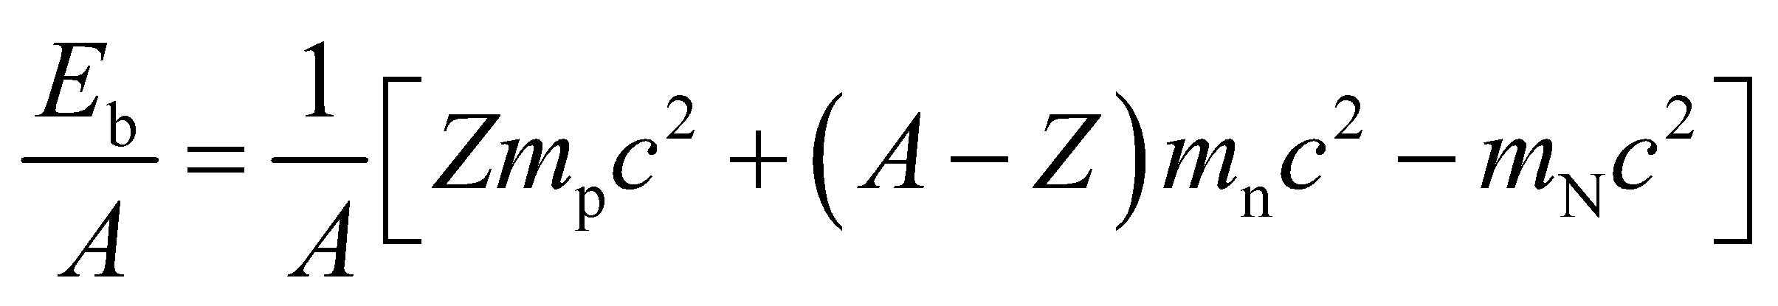
where m_{p}, m_{n}, and m_{N} are the masses of the protons, neutrons, and the nucleus, respectively.
Evaluate Substituting the values given, we find
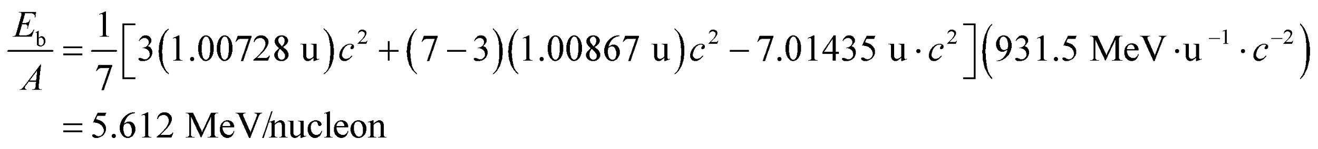
Assess The binding energy per nucleon as a function of A is plotted in Fig. 38.9. For very light nuclides such as 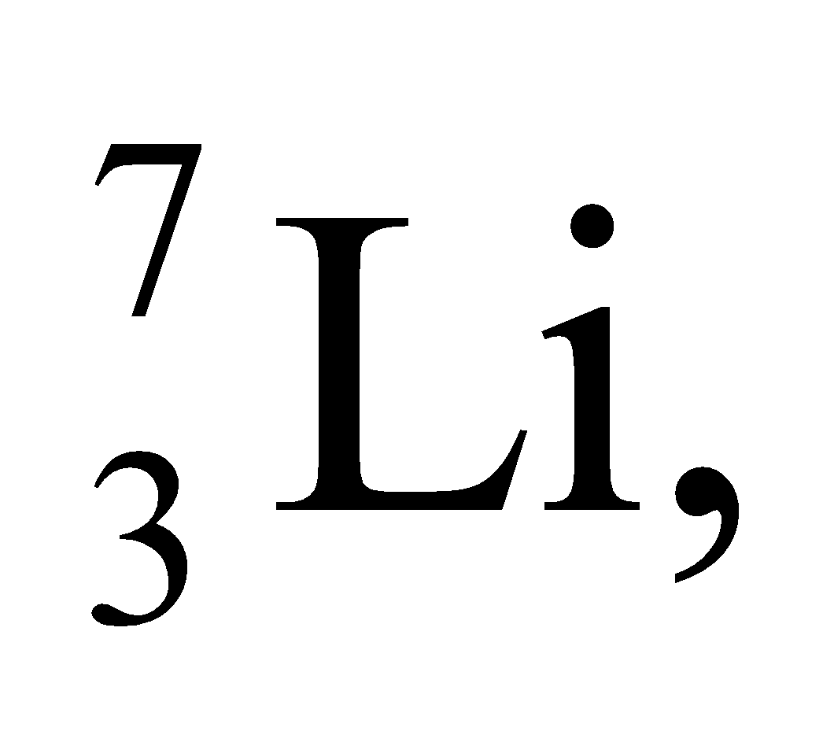 the energy is low because the nuclear force is not yet saturated for so few nucleons.
Section 38.4 Nuclear Fission
28. Interpret This problem involves a reaction in which 235U is fissioned via a reaction involving a neutron. We are given the decay products except for one daughter nucleus, which we are to find.
Develop The fission reaction described is
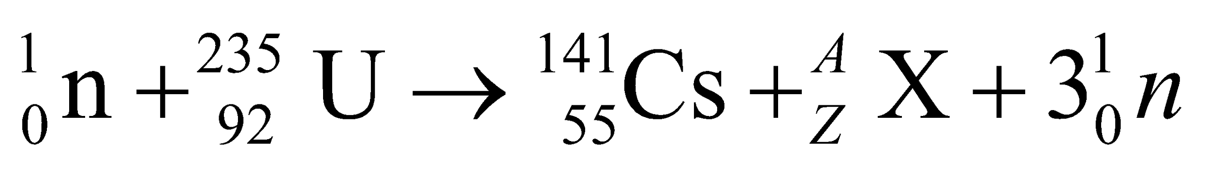
Apply conservation of mass and atomic number to find the daughter nucleus X.
Evaluate Conservation of mass number and atomic number requires 1 + 235 = 141 + 3 + A and 0 + 92 = 55 + 0 + Z, so A = 92 and Z = 37. Reference to Appendix D identifies this nuclide as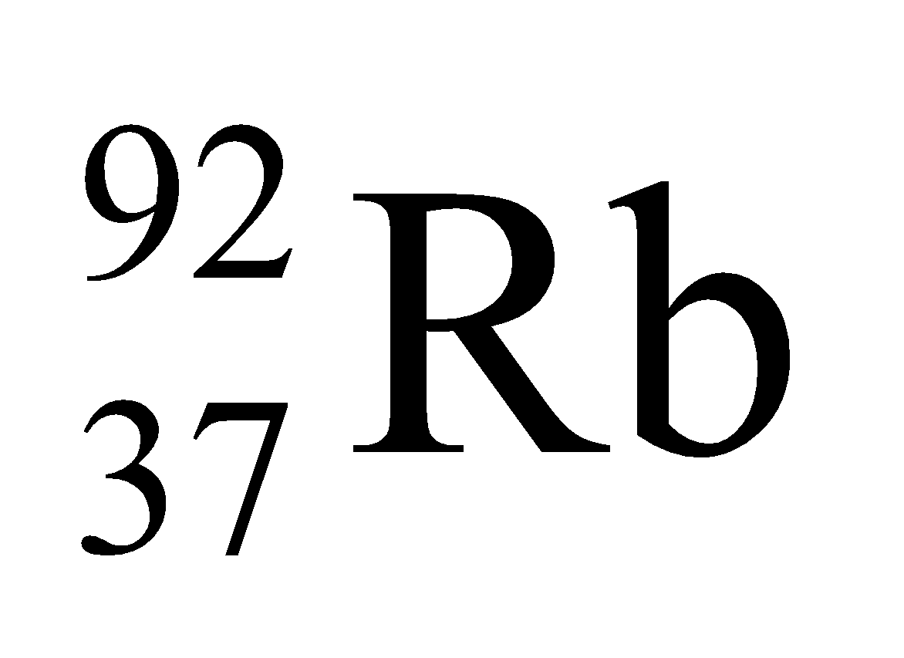.
Assess Thus, ¹⁴¹Cs and ⁹²Rb are byproducts of nuclear fission reactors.
29. Interpret This problem is about the number of neutrons released in the fission of ²³⁵U. We are given the daughter nuclei produced in neutron-induced fission of ²³⁵U and are asked to find the number of neutrons released.
Develop This reaction is described by the formula
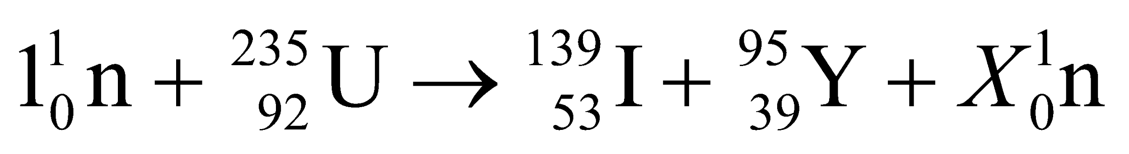
Thus, the initial number of neutrons is 1 + (235 − 92) = 144. The final number of neutrons, which must be the same because charge is conserved and the number of protons does not change, is 144 = (139 − 53) + (95 − 39) + X.
Evaluate Solving the equation above for the number of neutrons X gives X = 144 − (139 − 53) − (95 − 39) = 2.
Assess As expected, the fission process produces two middle-weight products with notably unequal masses. The number of neutrons released is in accordance with conservation of the number of nucleons.
30. Interpret We are to give the complete formula for the given reaction, for which we must first find one of the two daughter nuclei.
Develop Apply conservation of charge and nucleons in the reaction
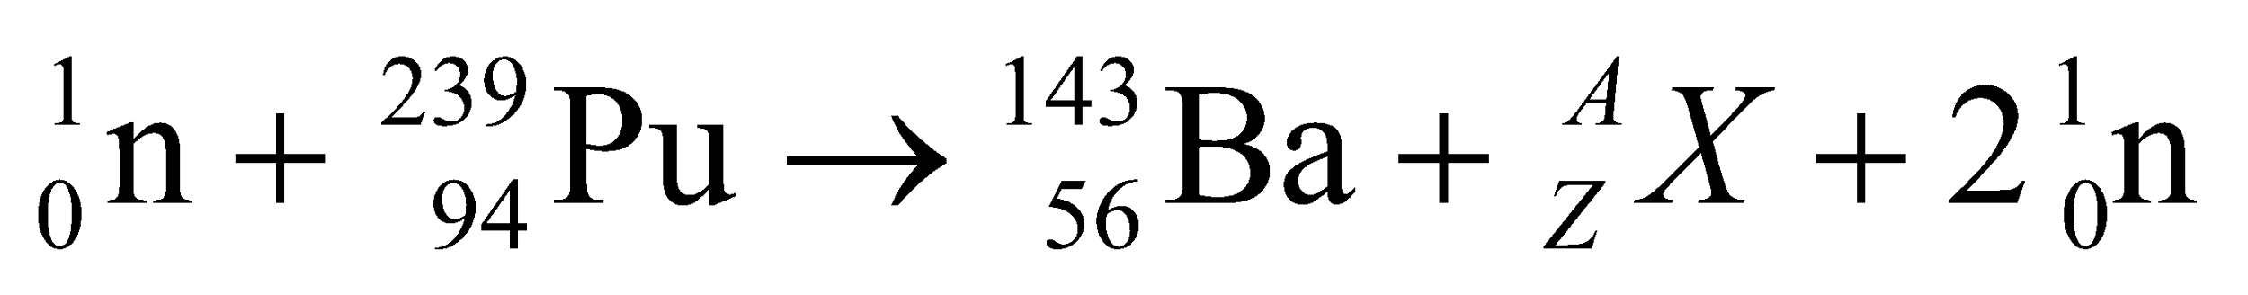
Conservation of charge gives 0 + 94 = 56 + Z + 0, or Z = 38. Conservation of nucleon number gives 1 + 239 + 143 + A + 2, or A = 95.
Evaluate Thus, the missing nucleon is ⁹⁵Sr and the complete reaction is 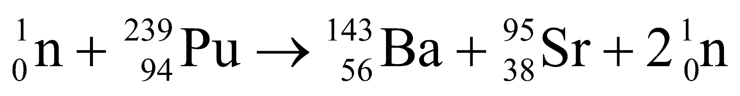.
Assess The conservation of charge and mass number are respected in this reaction.
31. Interpret We are given the power output in a fission reactor and energy released per fission event and are asked to find the fission rate.
Develop We assume that all of the energy released in fissions goes into thermal power. Thus,
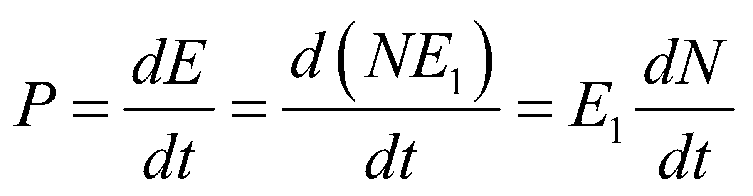
where E₁ = 200 MeV is the energy released per fission event and P = 3.2 GW.
Evaluate The fission rate dN/dt is
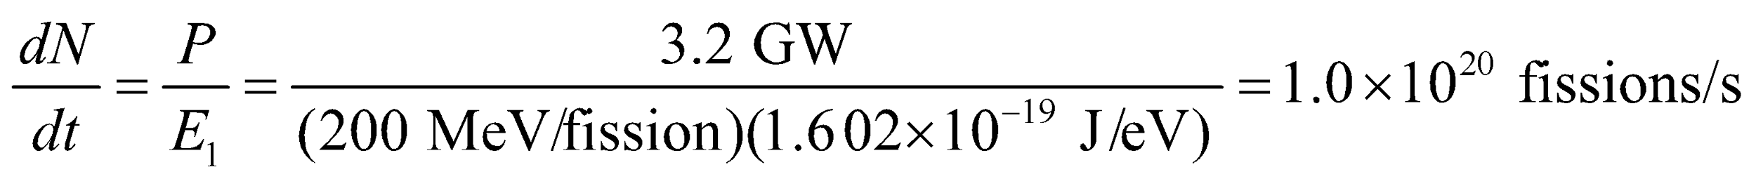
Assess A very high fission rate is required to achieve this power output.
Section 38.5 Nuclear Fusion
32. Interpret We are to sum up the energies released in each step of the proton-proton cycle to verify that the net energy released is as given in the text.
Develop In the proton-proton cycle, reactions 38.9a and 38.9b occur twice for each ⁴He-nucleus produced in reaction 38.9c.
Evaluate The net energy yield is 2(0.42 + 5.49 + 1.02) MeV + 12.86 MeV = 26.72 MeV. This agrees with the value given in the text.
Assess The individual Q-values, or energy released, given in these reactions can be verified from tabulated isotope masses.
33. Interpret This problem is about the Lawson criterion for D-T fusion. We are interested in the density of the nuclei required to meet this criteria for the given confinement time.
Develop The Lawson criterion for D-T fusion is 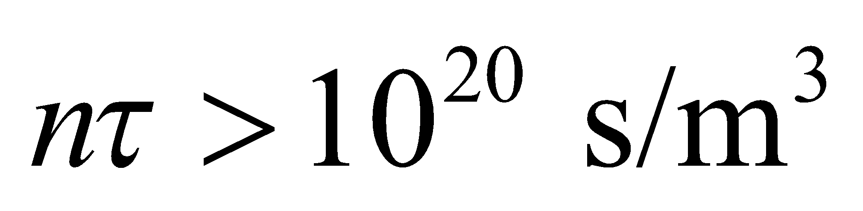 (Equation 38.11). This condition allows us to solve for n.
Evaluate For τ = 0.5 s, a particle density of
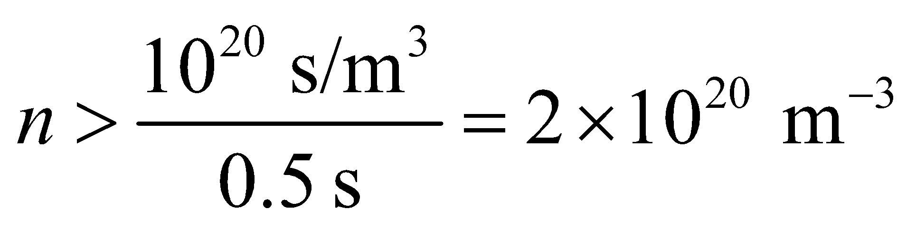
would be required.
Assess This is a very high density. From the Lawson criterion, we see that in order to achieve self-sustaining fusion, we must have a high nuclei density and confine them long enough such that the product nτ exceeds 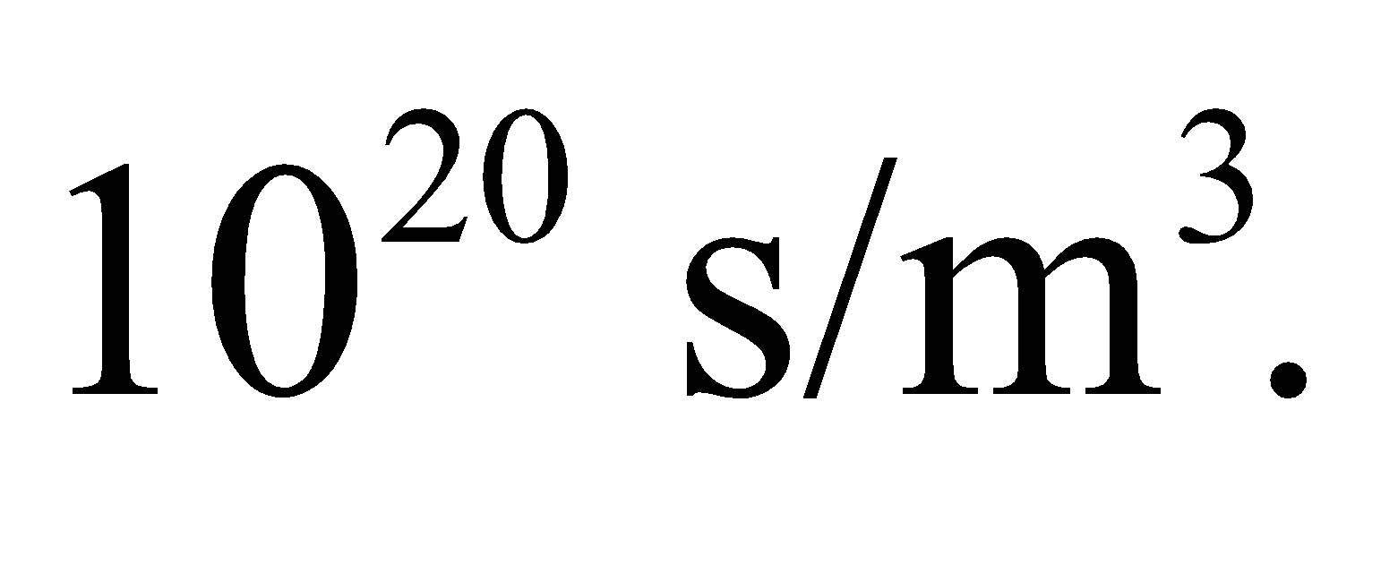 So far, the approach has not yet produced a sustained energy yield.
34. Interpret We are given a confinement time for D-T fusion and are asked to find the corresponding density required to satisfy the Lawson criterion.
Develop Apply Equation 38.11 for D-T fusion, using τ = 0.1 ns.
Evaluate For a confinement time as short as 0.1 ns, the Lawson criterion (Equation 38.11) demands a particle density of
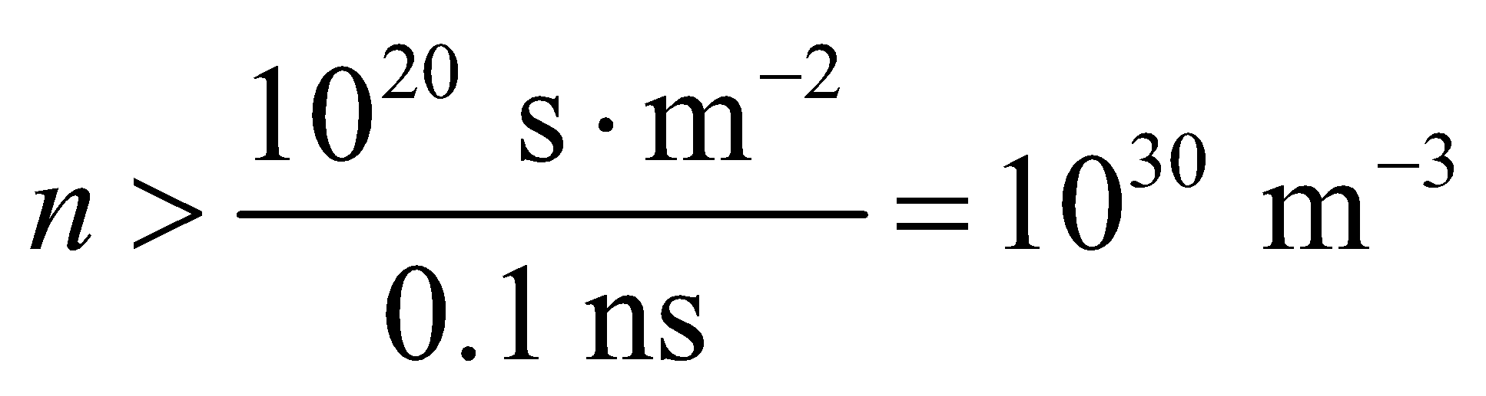
Assess This is 30 times the particle density of water molecules under ordinary conditions.
35. Interpret Using the Lawson criterion, we are to find the required confinement time for D-T fusion, given the plasma density.
Develop The D-T Lawson criterion is 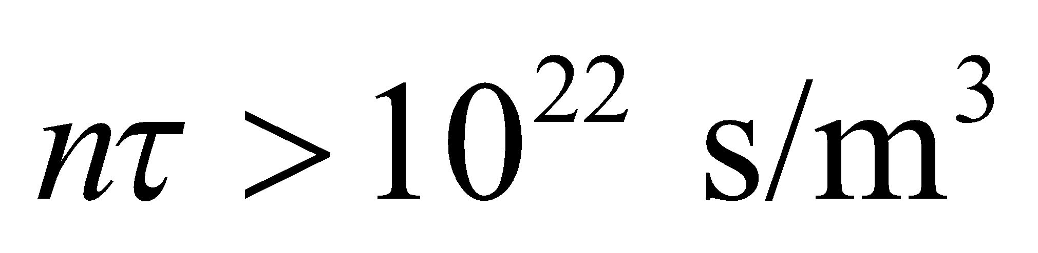 (Equation 38.10), and the number density given in the problem is n = 10¹⁹ m⁻³. We will solve for the confinement time τ.
Evaluate The confinement time must satisfy
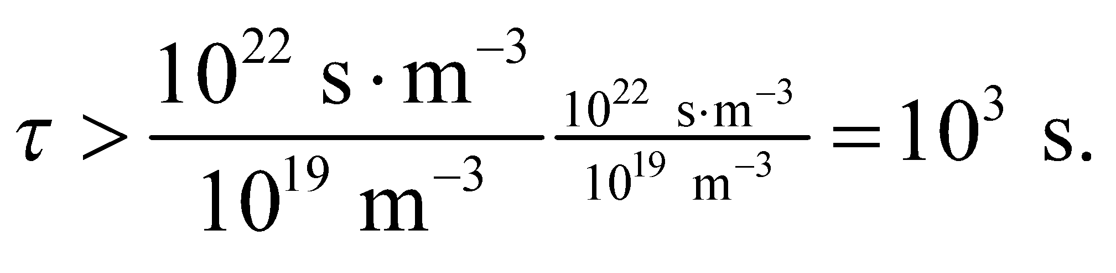
Assess This confinement time is inconveniently long, but creating a greater particle density so as to decrease the time is also difficult.
Problems
36. Interpret We are to estimate the diameter of the Earth required for it to have a density equal to that of nuclear matter.
Develop The density of the Earth
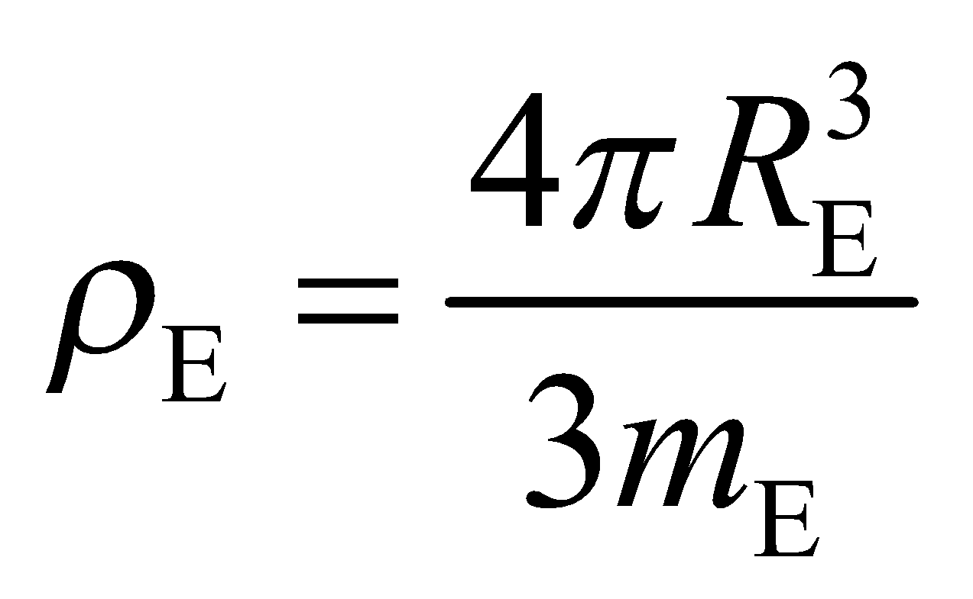
may be estimated using data from Appendix E, which gives m_{E} = 5.97 × 10²⁴ kg. The density of nuclear matter is given in the text following Figure 38.3 as approximately ρ_{N} = 10¹⁷ kg/m³. Equating the two densities allows us to solve for R_{E}.
Evaluate The radius required for the Earth to achieve nuclear density is approximately
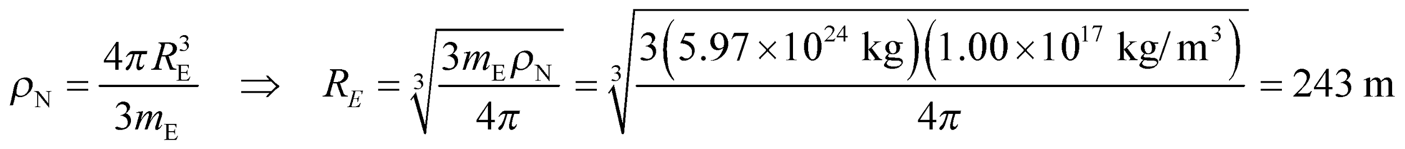
so the diameter is approximately 486 m.
Assess This is some 4 orders of magnitude less than the actual diameter of the Earth.
37. Interpret We are to find the energy required to flip the spin state of a proton, which acts like a magnetic dipole, in the Earth’s magnetic field.
Develop As discussed in Example 38.1, a proton acts like a magnetic dipole whose component along the magnetic field is 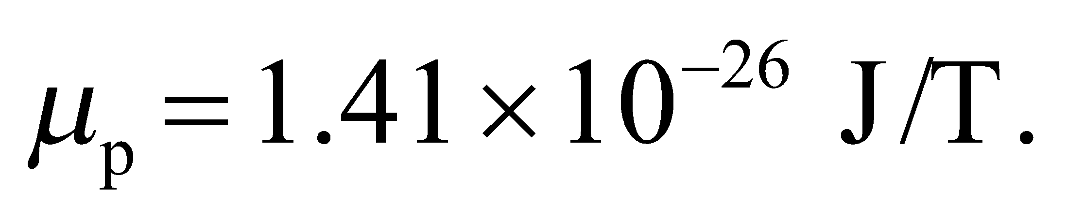 The energy needed to flip the spin (Equation 26.16) is
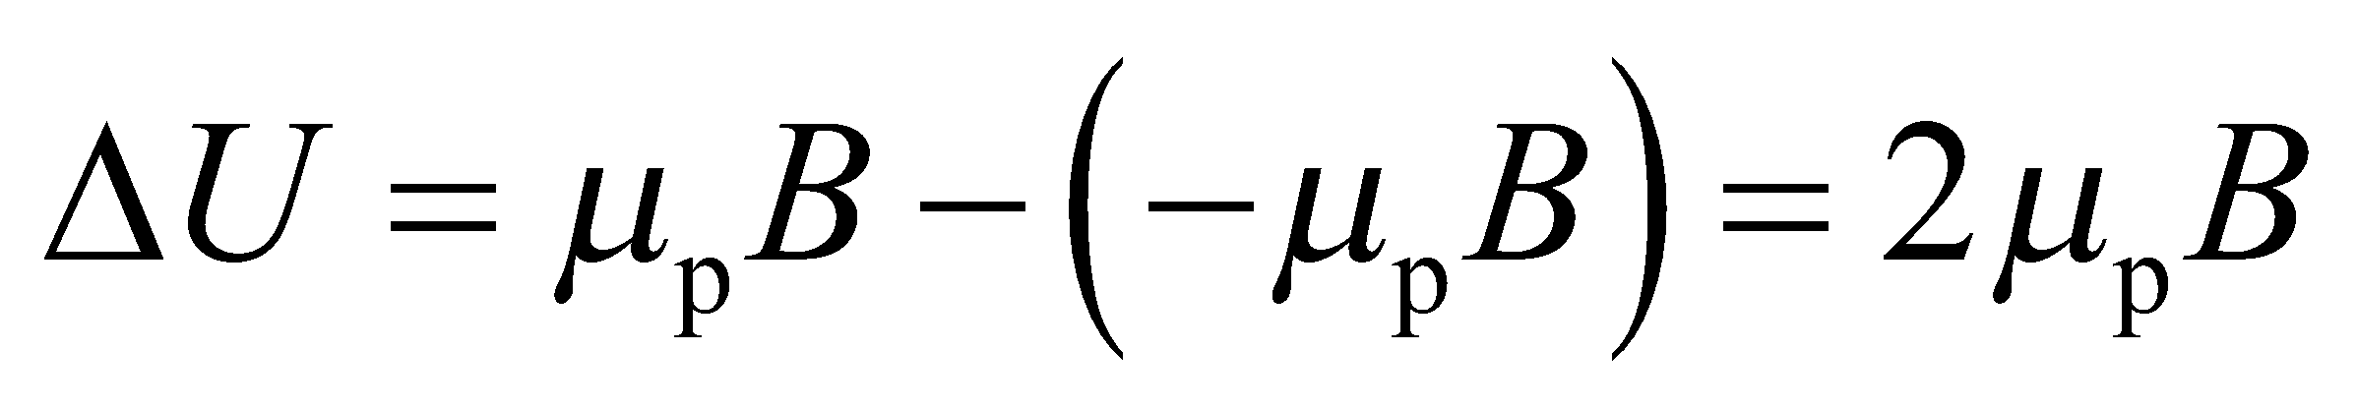
Evaluate With 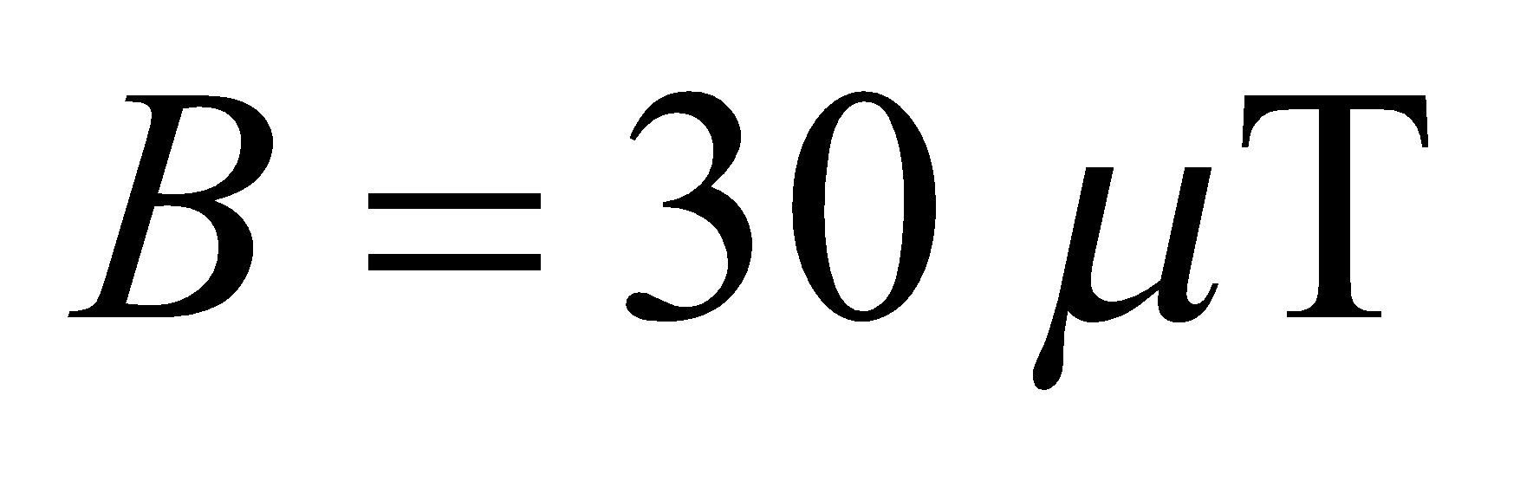 we get
Assess The frequency of a photon with this energy, 1.28 kHz, is in the audible range!
38. Interpret Given the frequency of the transmitter coil in an NMR spectrometer, we are to find the strength of the unperturbed magnetic field.
Develop The energy required to flip a magnetic dipole in a magnetic field is (Equation 26.16)
where μ_{p} = 1.41 × 10⁻²⁶ J/T is the magnetic dipole of protons (see Example 38.1). The energy supplied by the transmitter coil is E = hf, which we can equate to ΔU to solve for the magnetic field B.
Evaluate The spin-flip transition energy is
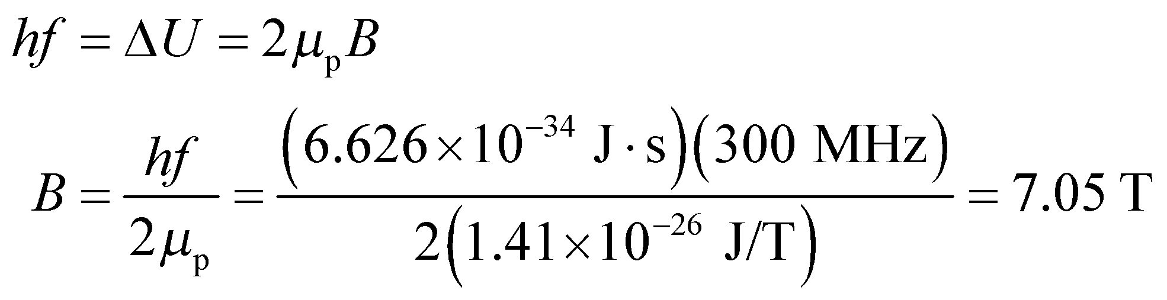
Assess This is a typical magnetic field strength for an NMR spectrometer.
39. Interpret In this problem, we are asked to find the binding energy per nucleon for 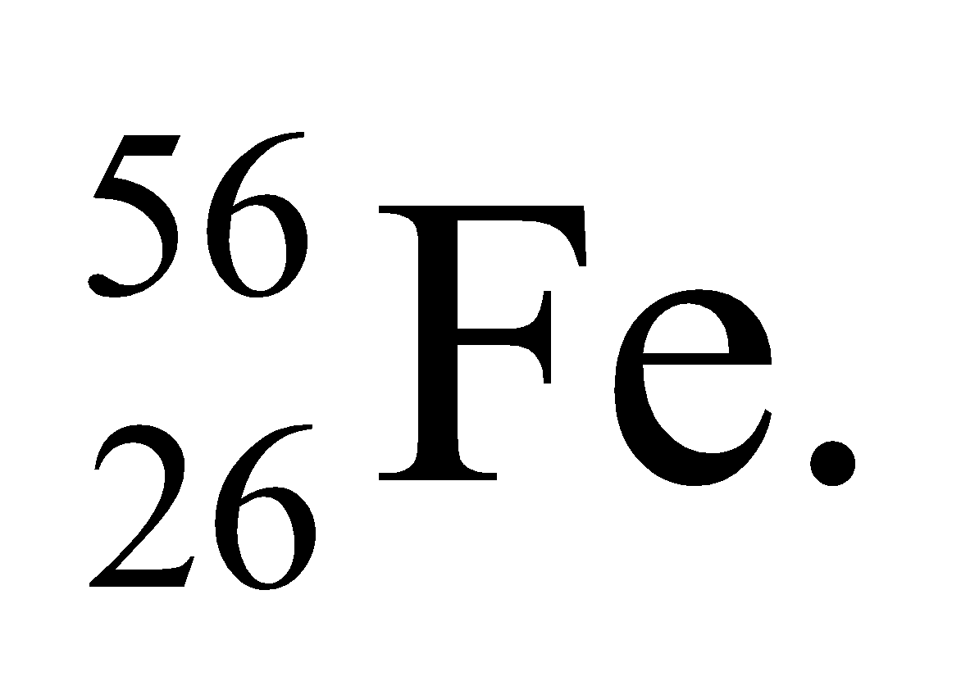
Develop Using Equation 38.7, the binding energy of a nucleus can be written as
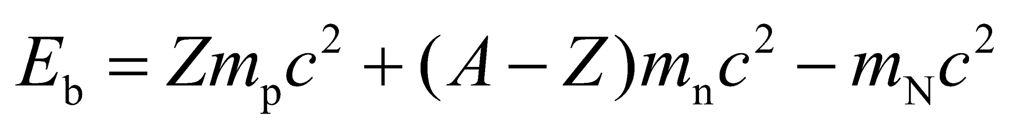
where m_{p}, m_{n}, and m_{N} are the masses of the proton, neutron, and the nucleus, respectively.
Evaluate Since the nuclear mass is given, the above equation gives directly
Therefore, the binding energy per nucleon is
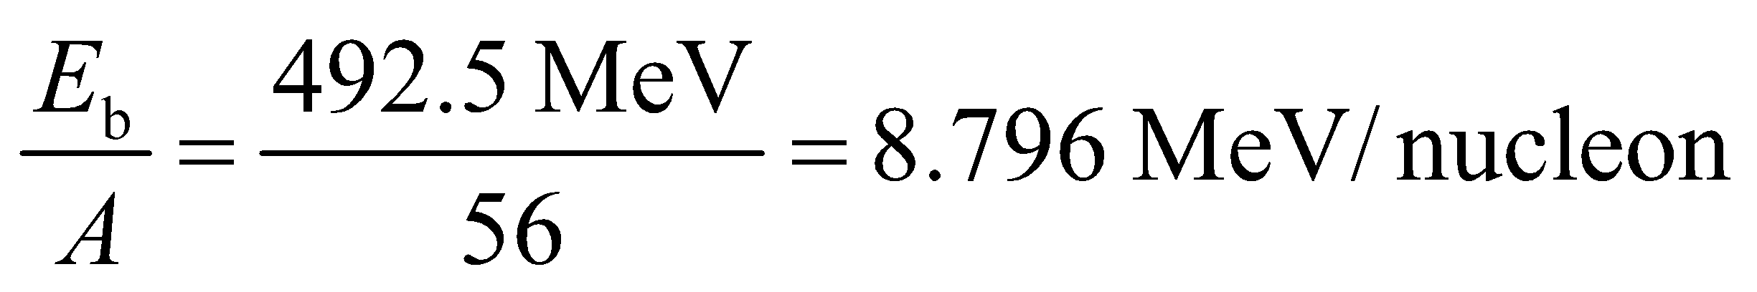
The result is in good agreement with the curve given in Fig. 38.9.
Assess This result is very close to the peak of the curve in Fig. 38.9. Nuclei with mass numbers around A = 60 are most tightly bound.
40. Interpret This problem is similar to Problem 38.25. We are to find the atomic mass of ¹⁹³Ir, given its binding energy per nucleon.
Develop Apply the solution strategy used in Problem 38.25. From the periodic table, we see that, for Ir, Z = 77 so the number of neutrons is N = A − Z = 193 − 77 = 116.
Evaluate As in the solution to Exercise 25,
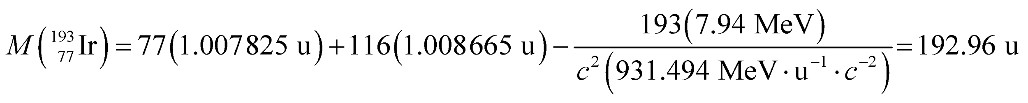
Assess Three figure accuracy in the binding energy per nucleon affects the third decimal place in this result.
41. Interpret This problem is about the age of the Earth in half-lives of the isotopes specified.
Develop From Table 38.1, the half-lives are 5730 y for 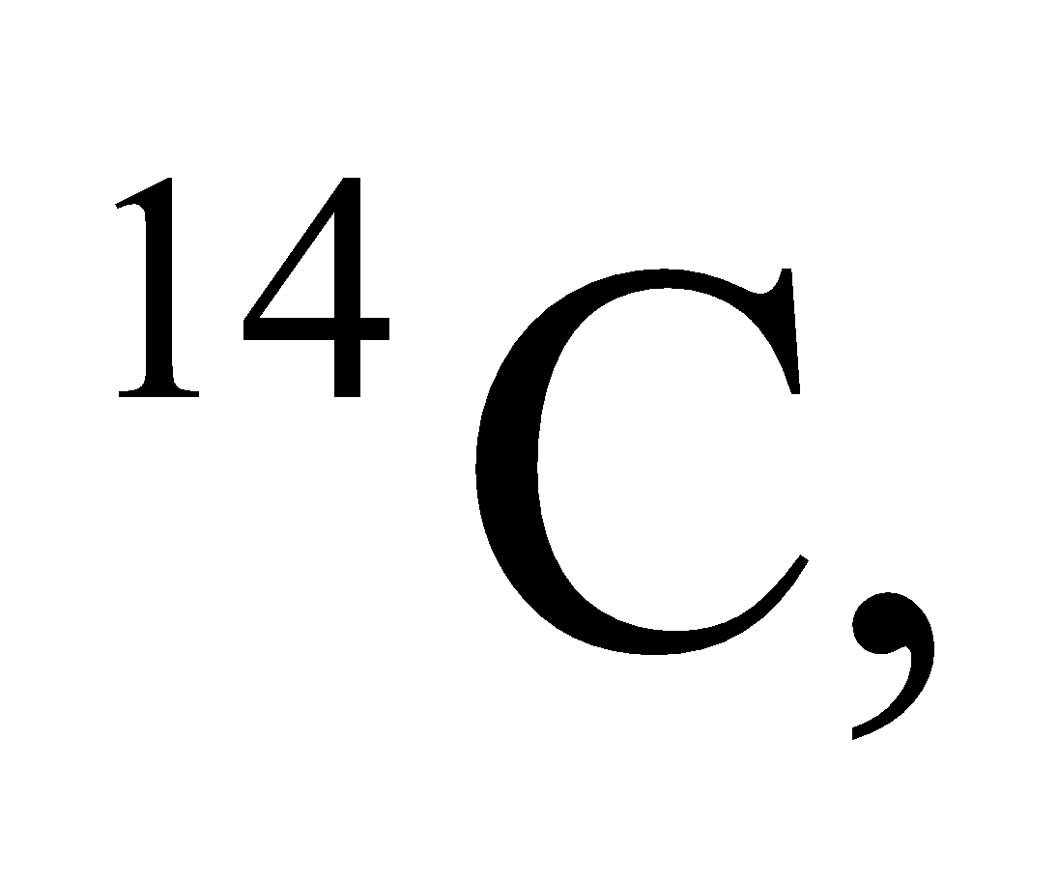 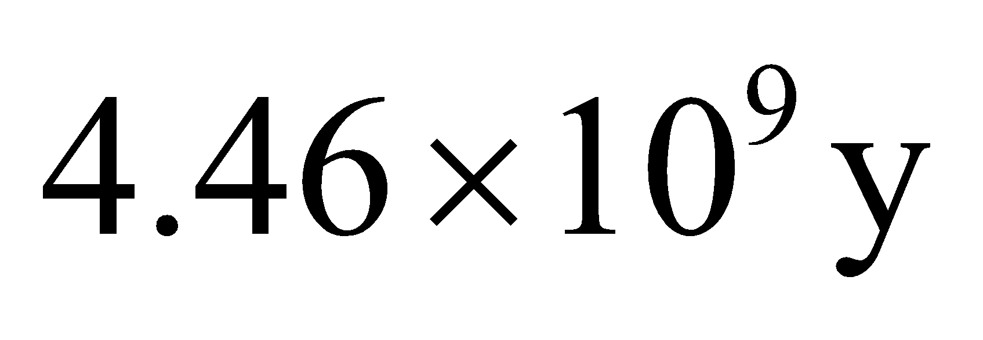 for 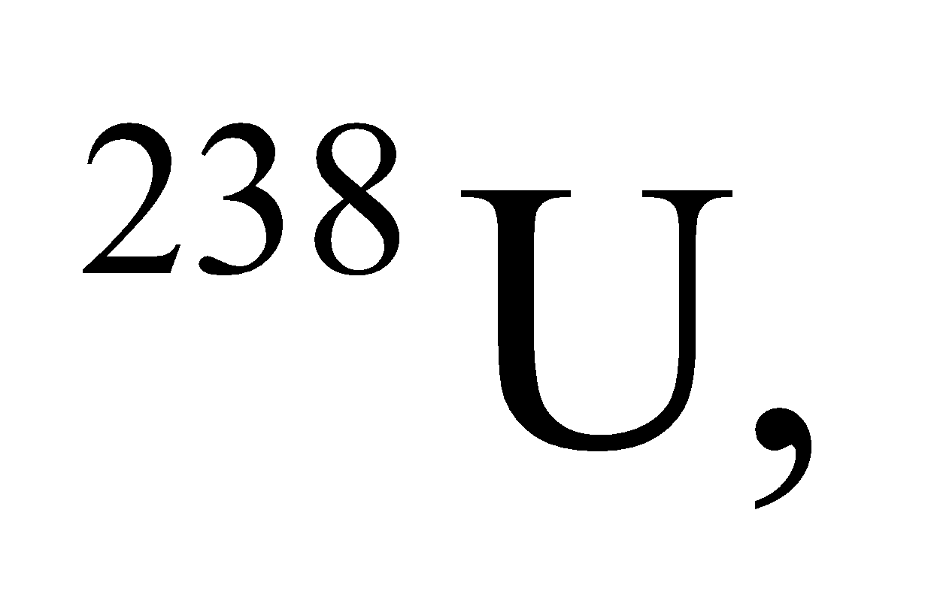 and 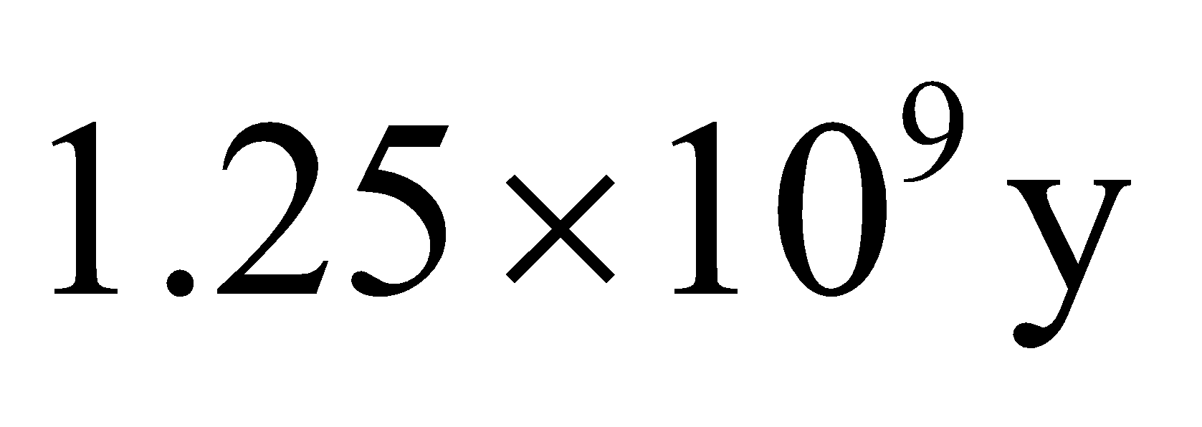 for 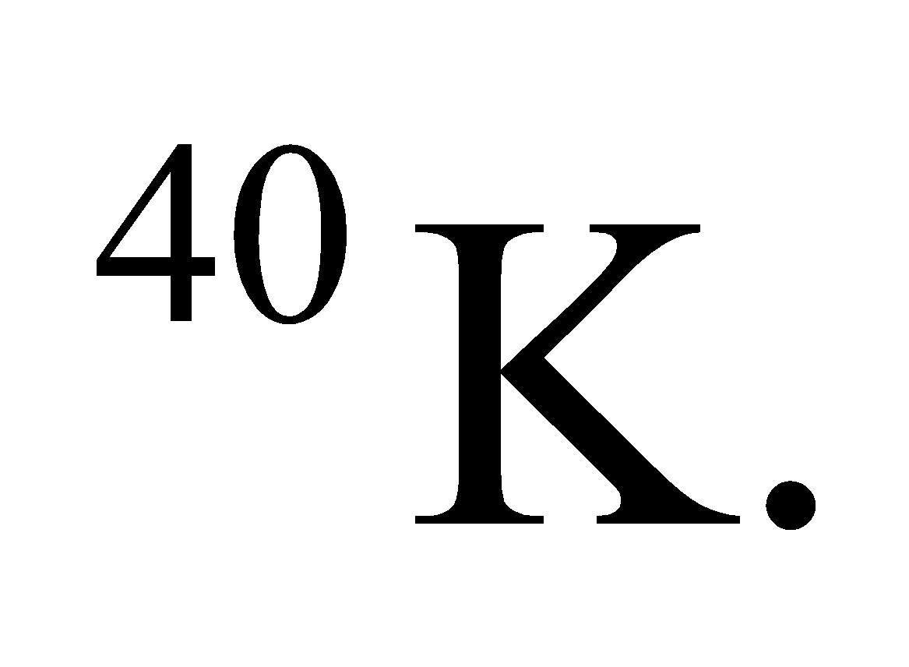 Starting with 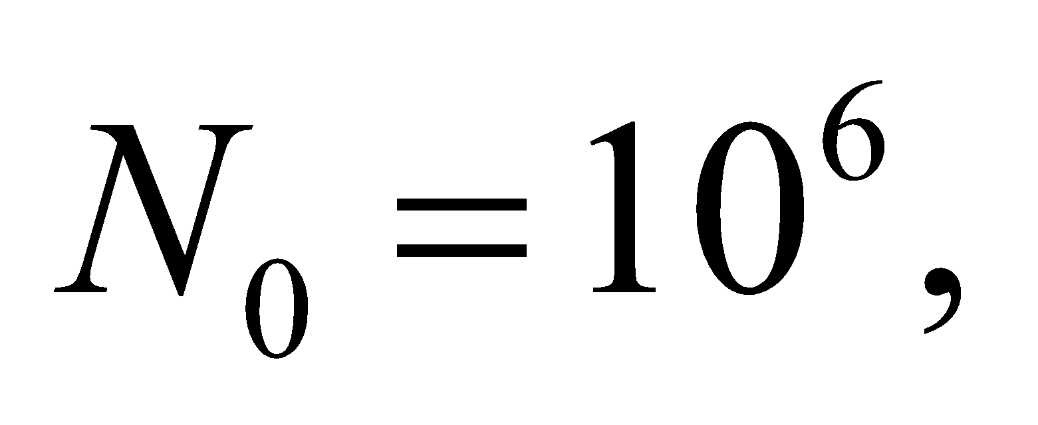 the number of atoms remaining after 4.5 billion years can be found with Equation 38.3b,
Evaluate For C-14, the number of half-lives since the Earth formed is so large, 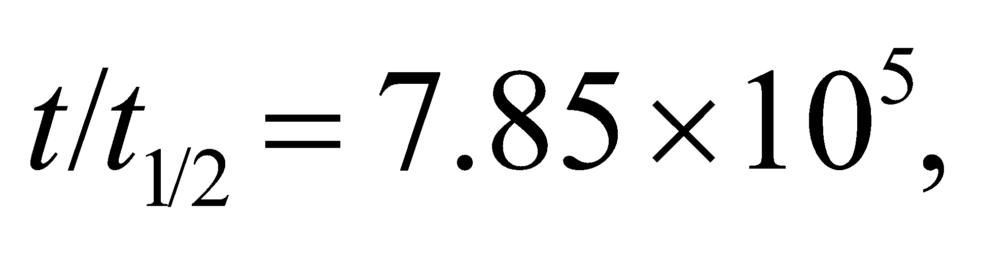that the number of these atoms left will be zero. The half-life of U-238 is roughly equal to Earth's lifetime, 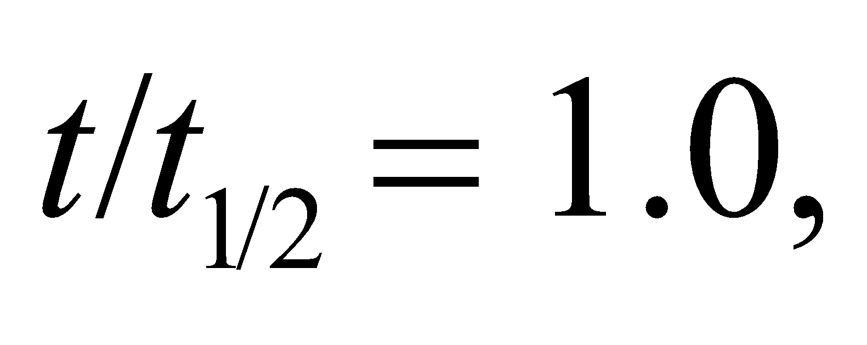 so the number of atoms left is
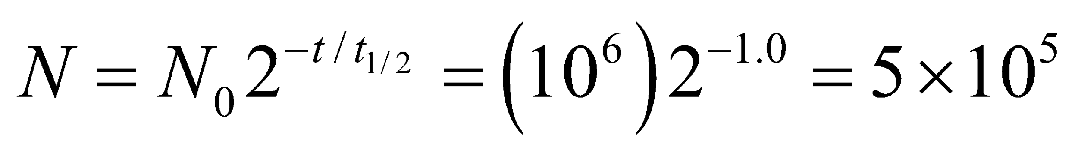
Lastly, the number of half-lives for K-40 is 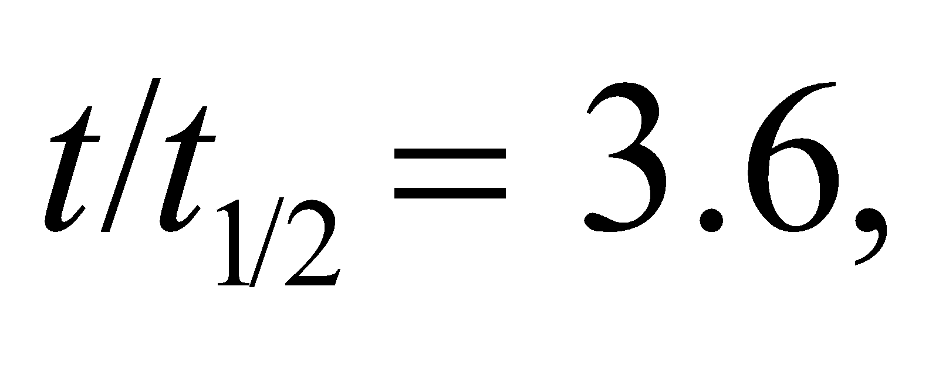 so
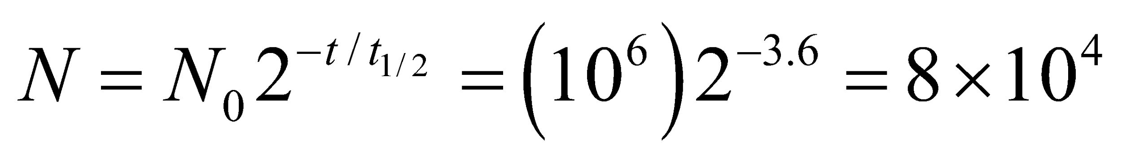
Thus, U-238 and K-40 are suitable for dating Earth's oldest rocks.
Assess Uranium is often used for radiometric dating of rocks. A geologist can determine how many U-238 atoms a rock sample originally had by estimating the excess number of lead atoms (Pb-206) in it: 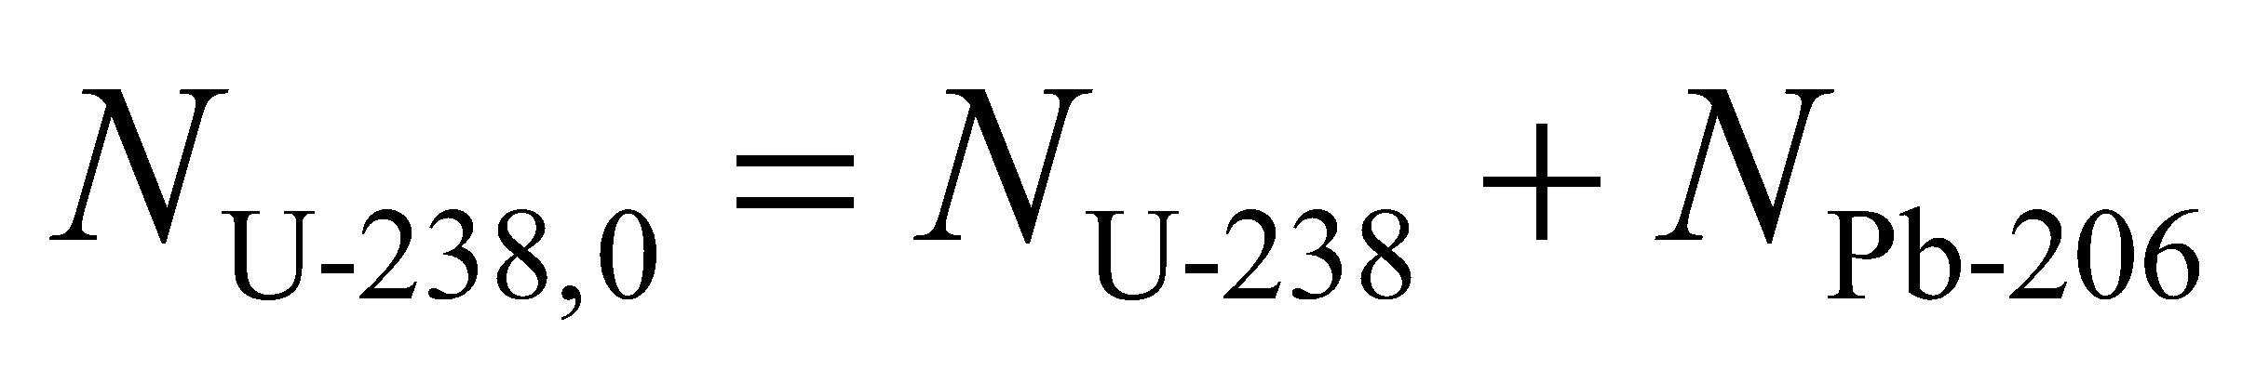. This is because Pb-206 is what becomes of a U-238 atom when it decays, as shown in Figure 38.7.
42. Interpret Given the radioactivity of a sample at two points in time, we are to find the material’s half-life.
Develop Because activity is proportional to the number of nuclei, the decay with the same time constant, so we can use Equation 38.3b
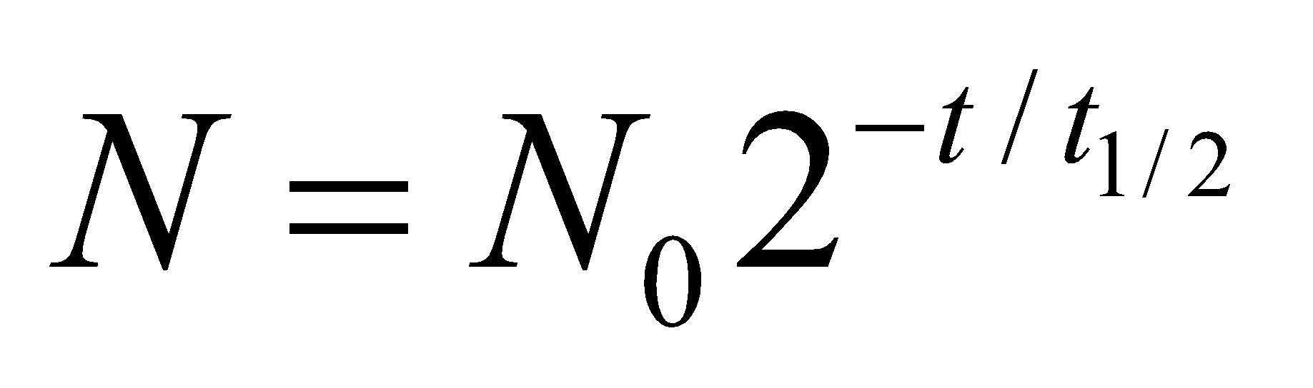
to find the half-life.
Evaluate Solving the expression above for the half-life gives
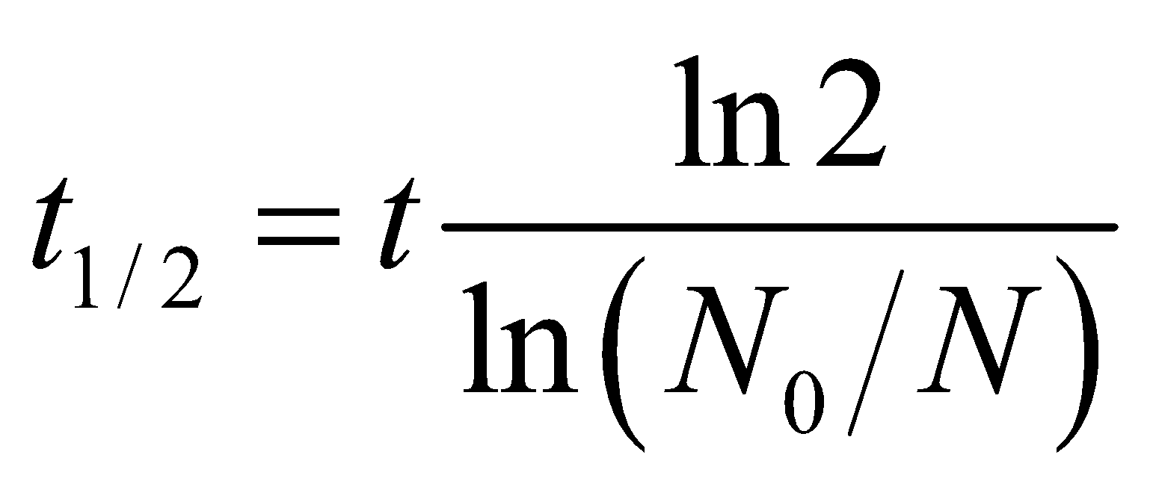
Inserting t = 30 min, N₀ = 2.4 MBq and N = 1.9 MBq, we find
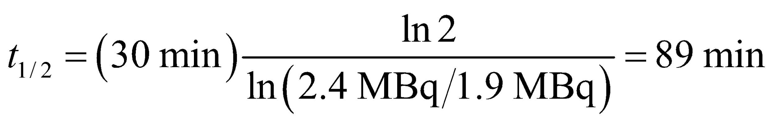
Assess This corresponds to a decay constant of
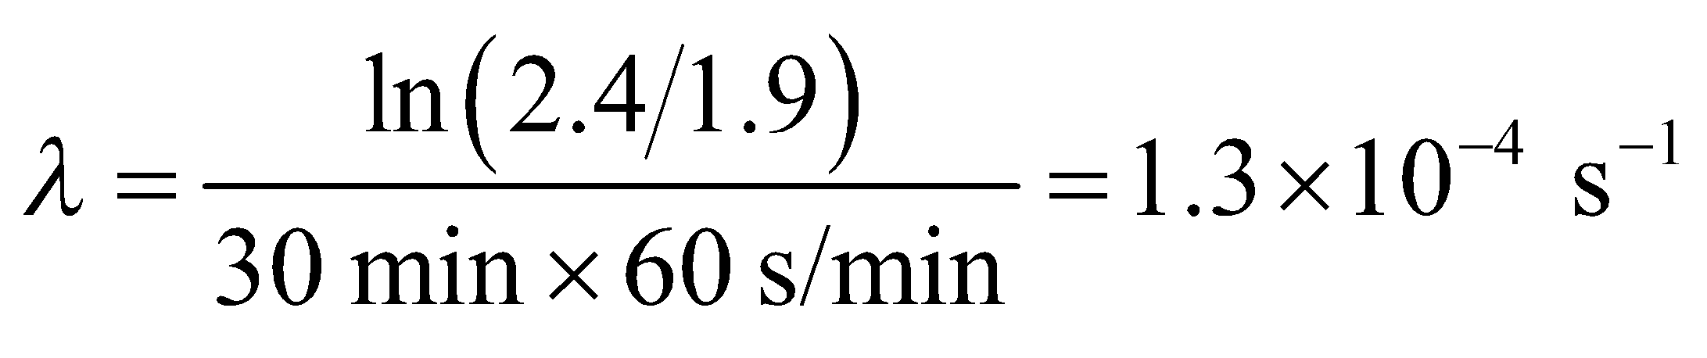
43. Interpret You need to determine when a house with excess radon will be safe to reenter.
Develop The half-life of Rn-222 is 3.82 days, from Table 38.1. Since the activity is proportional to the number of atoms, you can use Equation 38.3b, 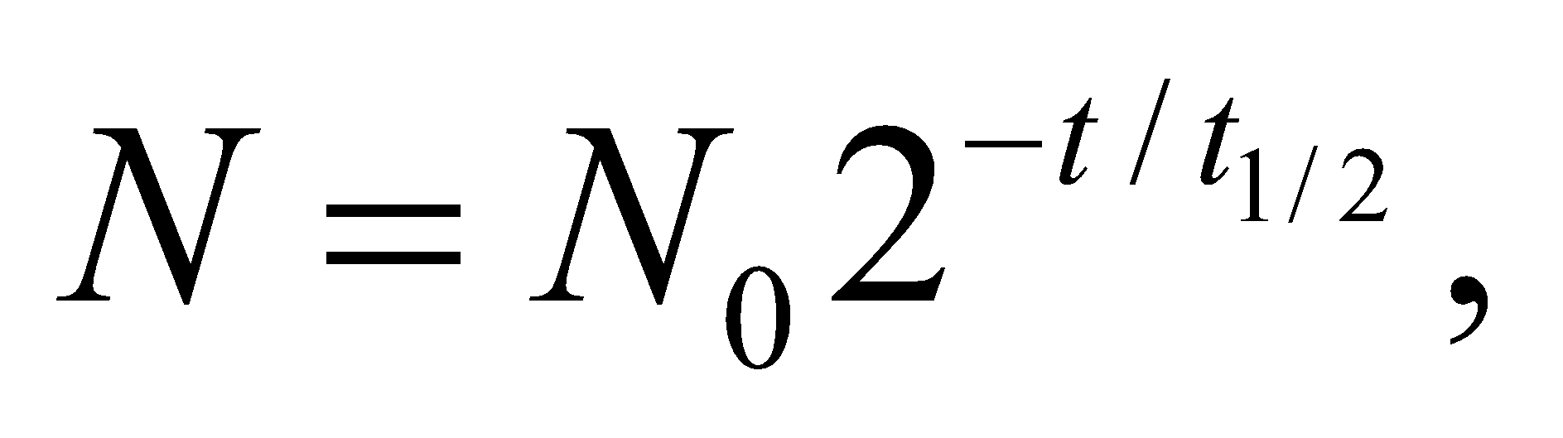to see how long until the activity drops from 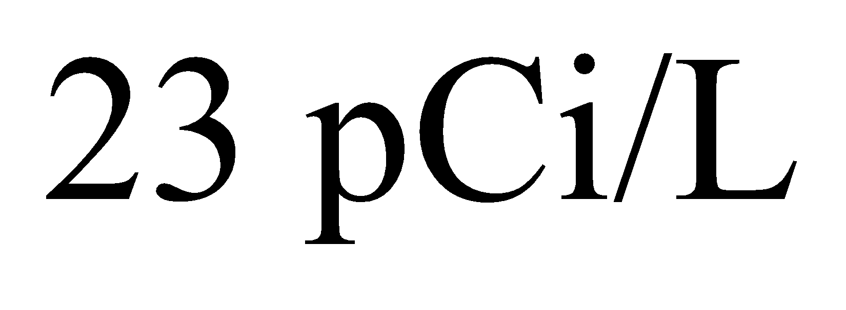to 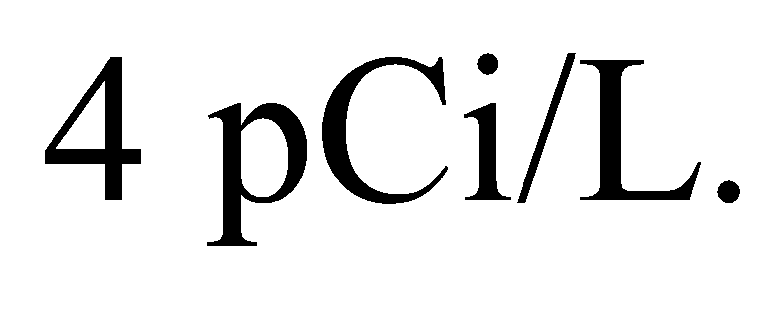
Evaluate Rearranging the equation for the number of atoms gives
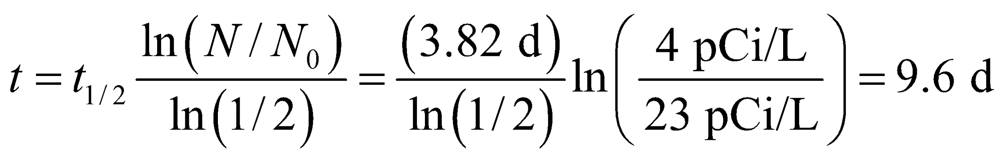
Assess This would be the maximum time to wait before returning to the house. The time can be less if windows are opened and the air is allowed to circulate.
44. Interpret We are to plot the activity of ¹³N as a function of time on a semi-log plot and explain the result, including the significance of the slope of the line.
Develop The number of nuclei remaining after time t is, from Equation 38.3b,
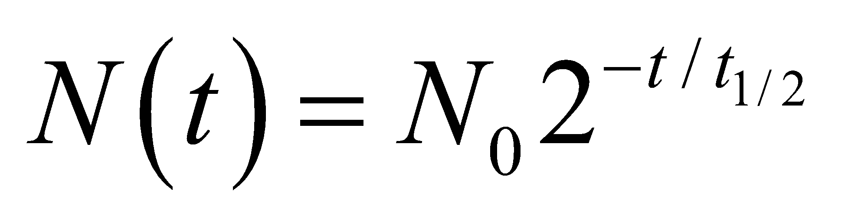
so
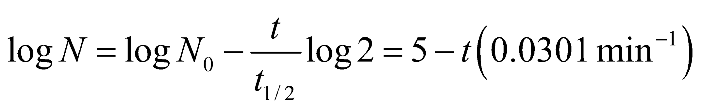
where N₀ = 10⁵ and t _{1/2} = 10 min. (Note that logarithmic graphs are normally base ten.)
Evaluate This function is plotted below on a semi-log plot. The plot is a straight line because, on a semi-log scale, the function is of the form y = ax + b with
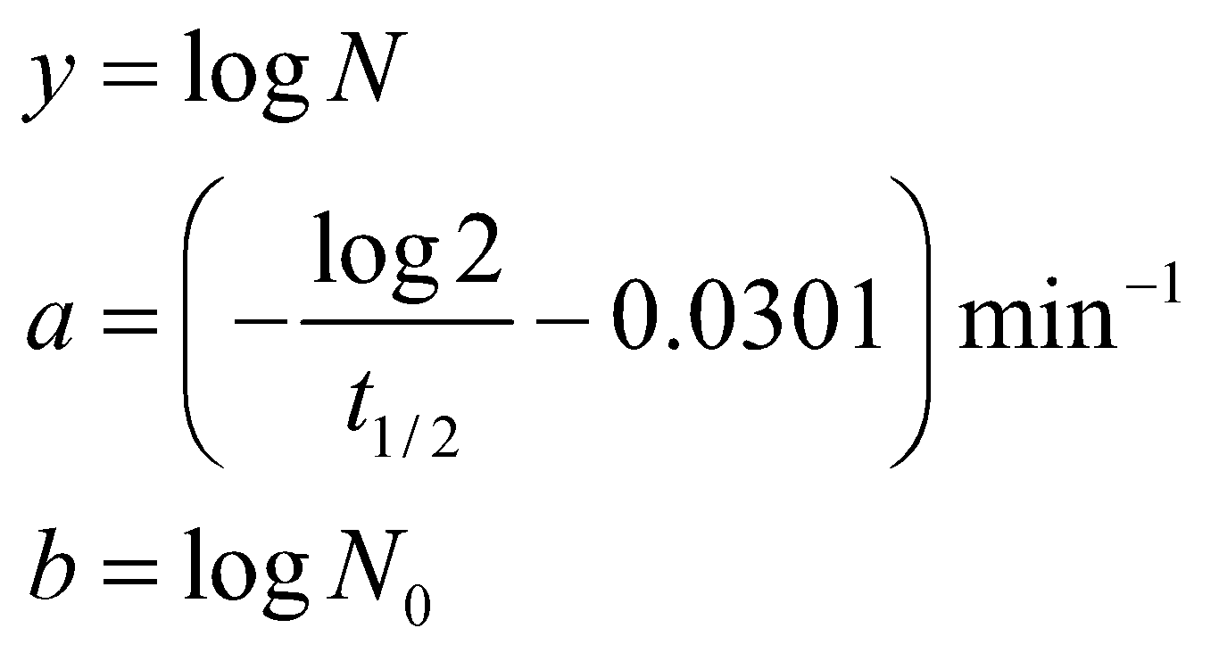
The slope is related to the half-life according to
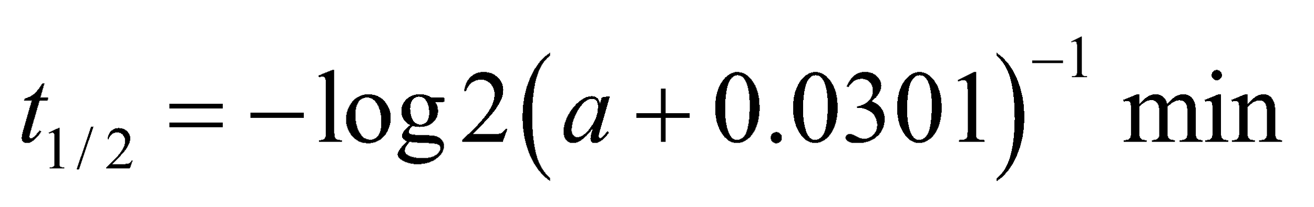
so the steeper the slope, the shorter the half-life (and vice-versa).

Assess The time range specified in this case covers six half-lives.
45. Interpret This problem concerns the decay of 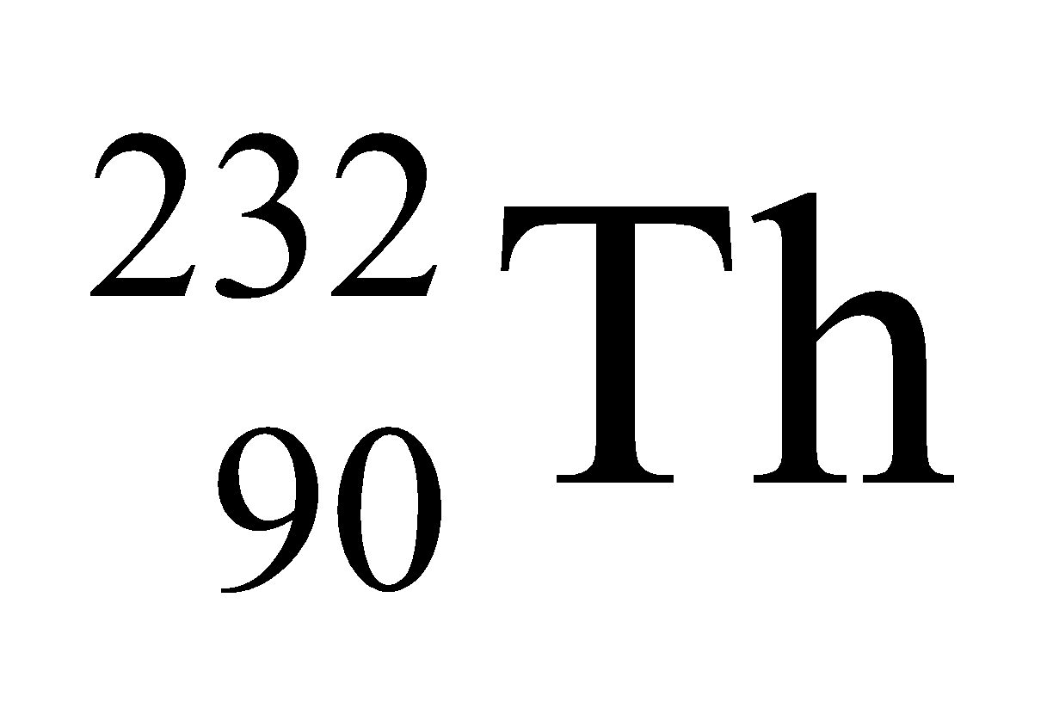 that results in a series of short-lived nuclei. We are to find the third daughter nuclei in the decay series of thorium-232, given the decay mechanism of the second daughter nuclei, and make a chart showing the first three steps in its decay.
Develop In a-decay, the numbers of neutrons and protons both decrease by two, whereas in 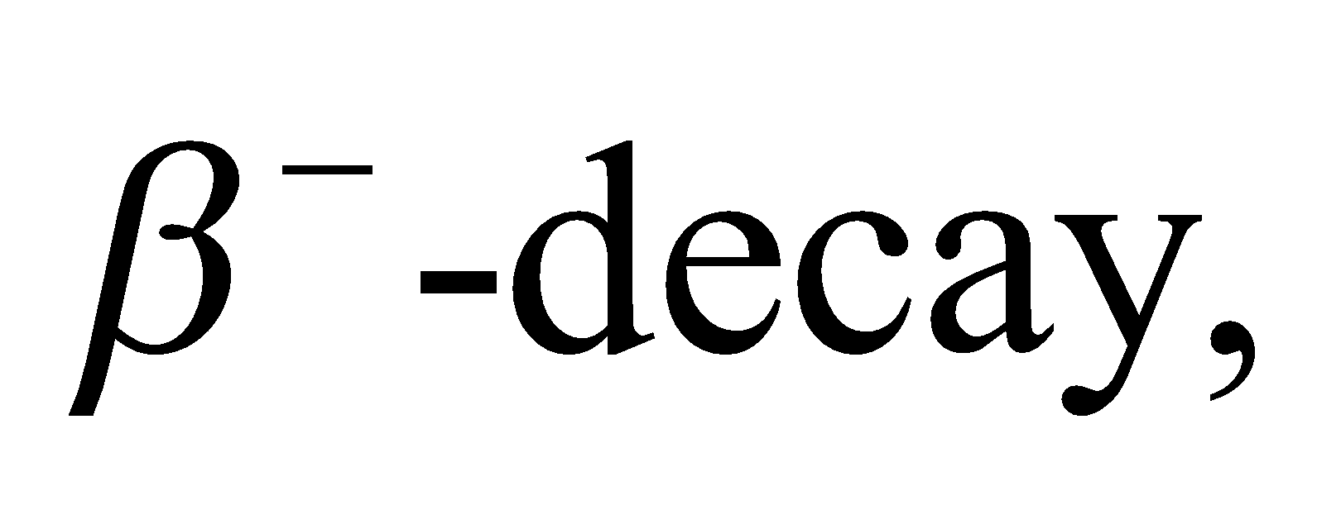 the number of neutrons decreases by one and the number of protons increases by one (see Equations 38.4 and 38.5a). Thus, after one α- and two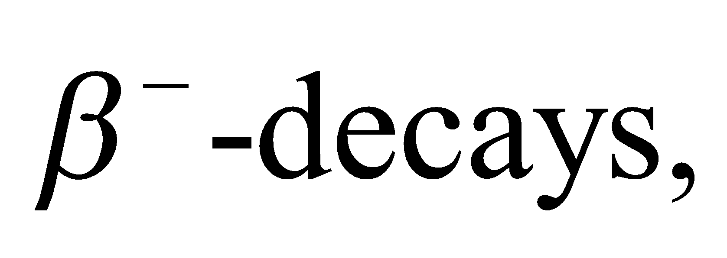 the number of neutrons is decremented by four and the number of protons is unchanged. Given that A = 232 and Z = 90 for thorium-232, the third daughter nuclei must have A = 232 − 4 = 228 and Z = 90.
Evaluate The third daughter nucleus is therefore 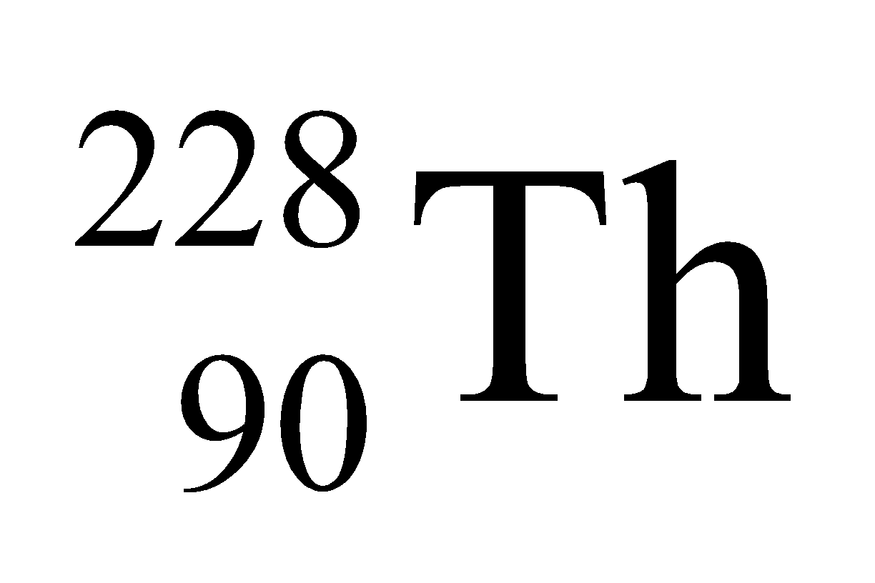, which is another thorium isotope.
(b) The chart is shown in the figure below. The half-lives are given in the figure.

Assess The reactions shown in the figure are
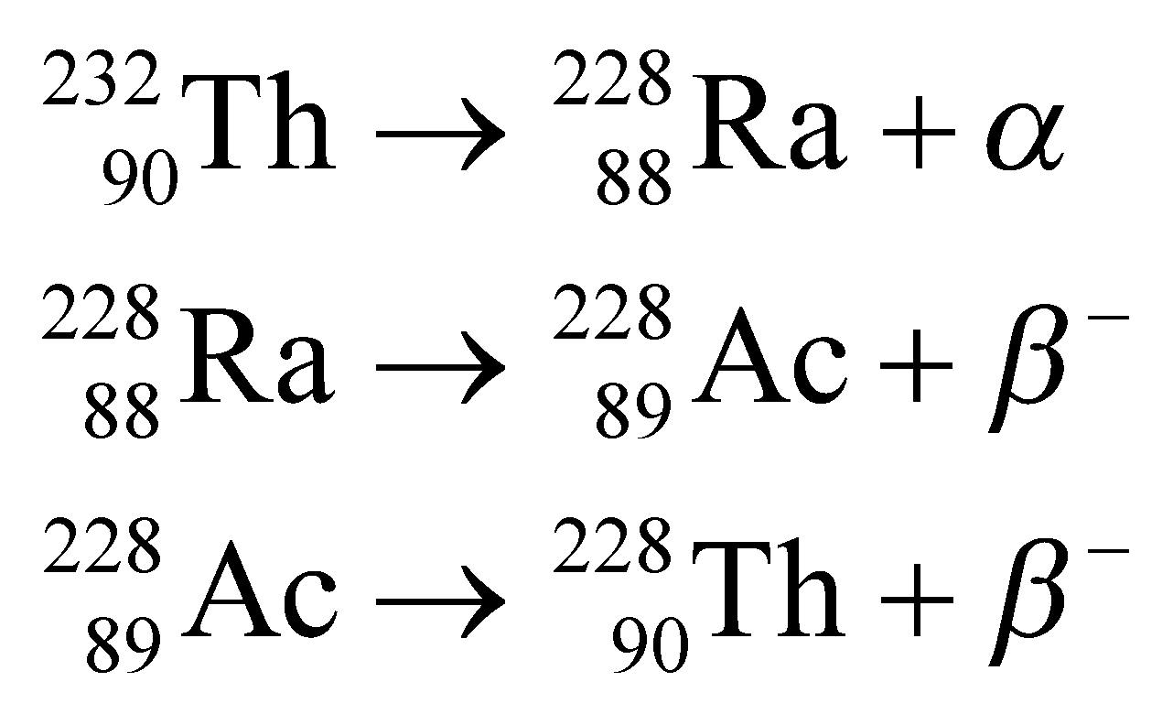
46. Interpret For this problem, we are to find the mass of cobalt-60 required to make a source of radioactivity that will exceed the given level for two years, given the half-life of this nucleus.
Develop The activity decays with the same time constant as the number of nuclei (see discussion following Equation 38.3b). Thus, we can use Equation 38.3a,
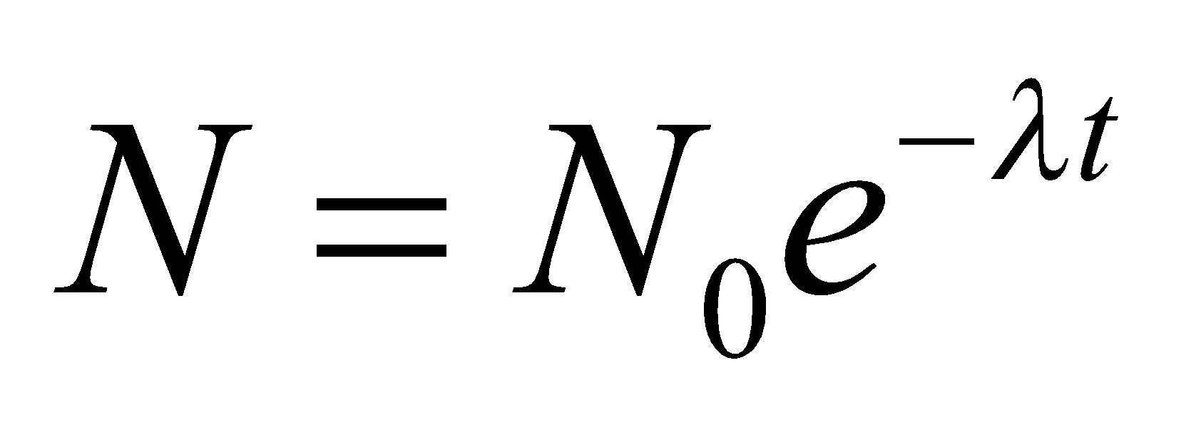
and equate the resulting time constant with the half-life using
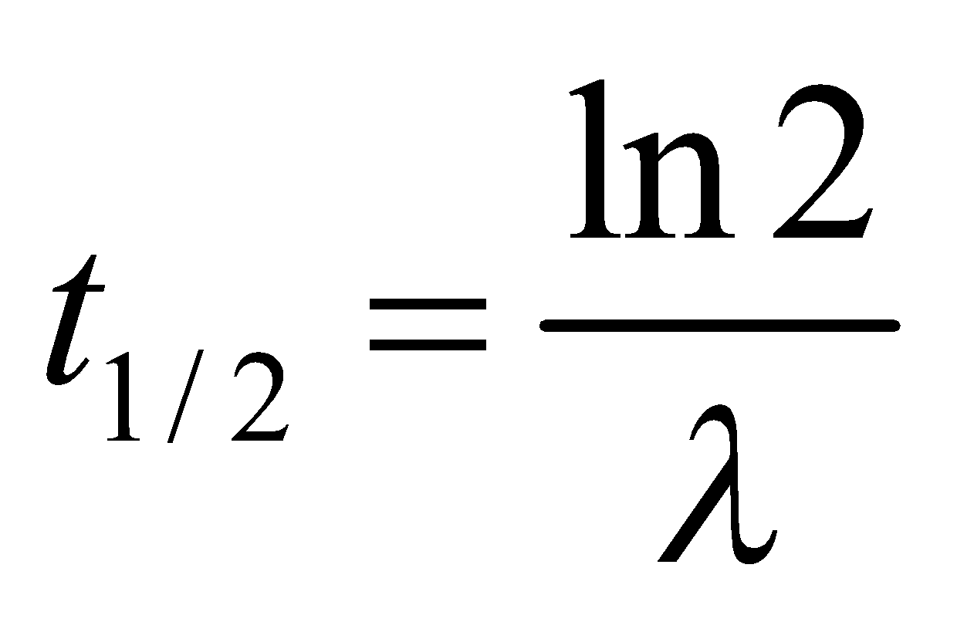
The activity is given by
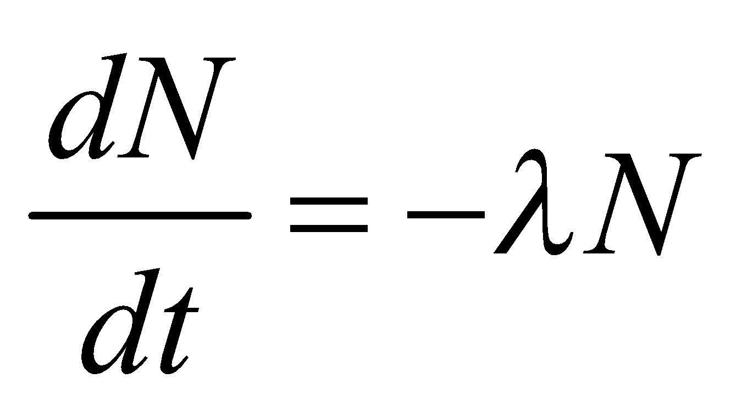
which may be found by differentiating Equation 38.3a. If the activity of 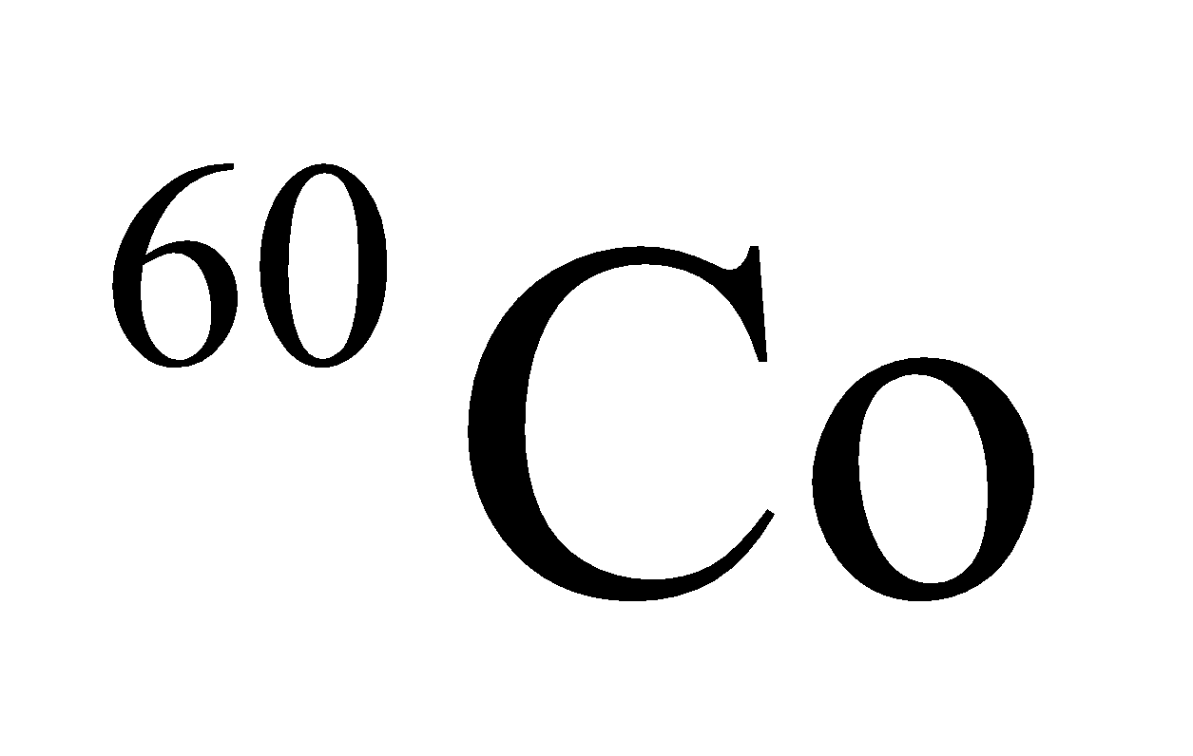 must meet the specified condition after t = 2 y, then
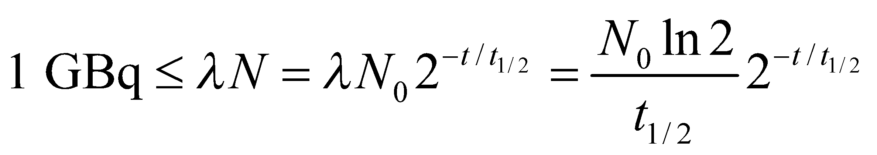
which allows us to solve for the initial number of nuclei N₀.
Evaluate Using , we find that the initial number of cobalt-60 nuclei needed is
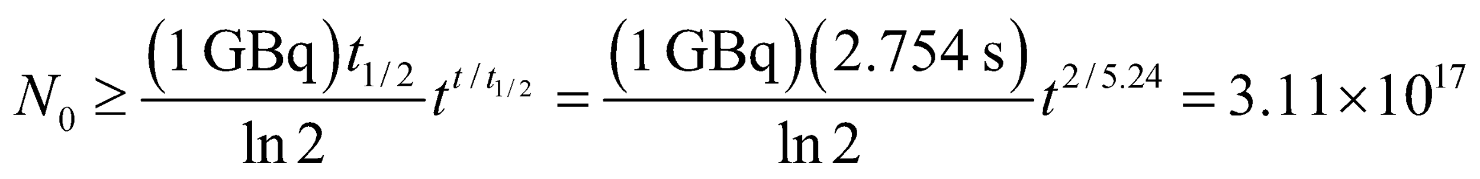
The atomic weight ofis about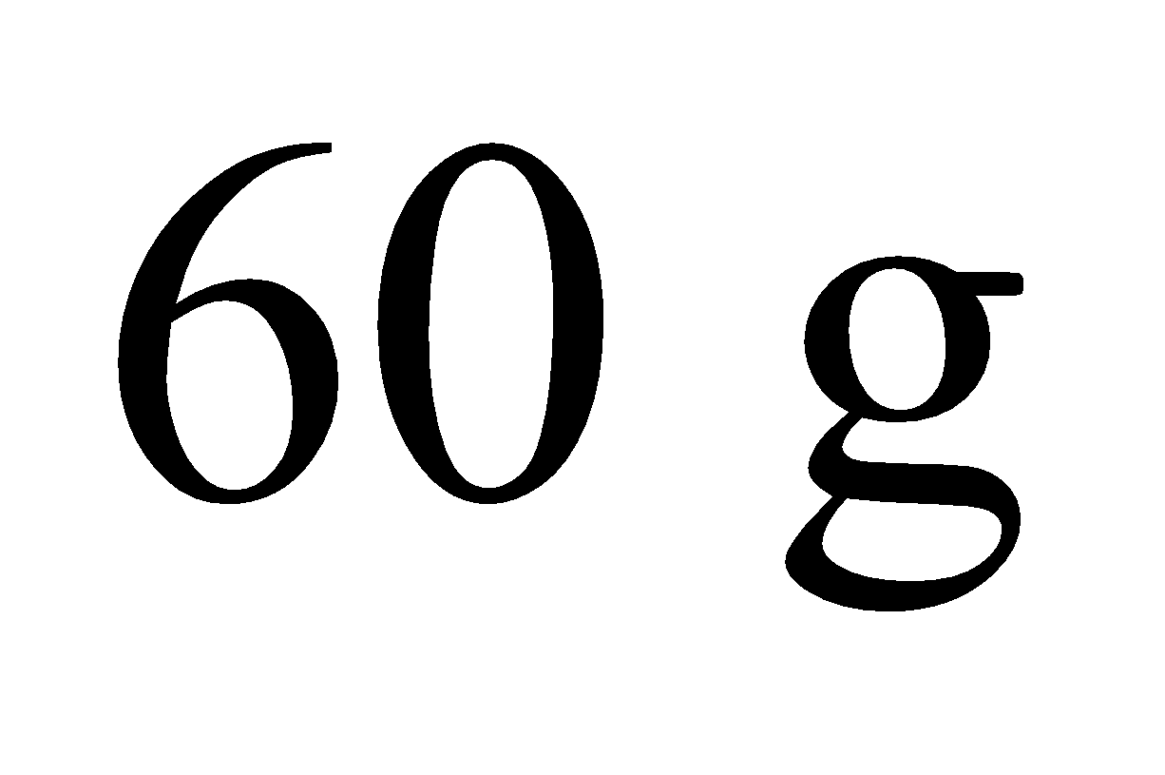and contains Avogadro’s number of atoms, so the sample should have a mass of at least
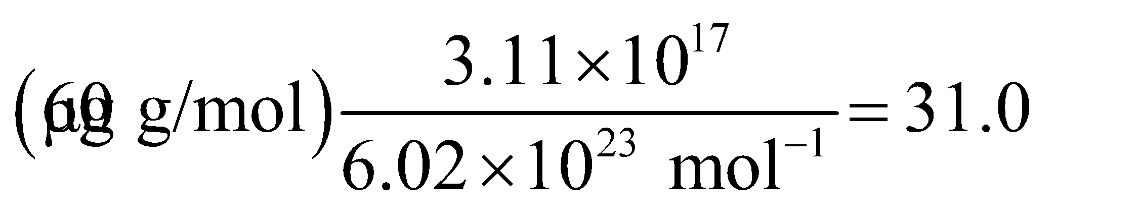
Assess Note the time is expressed in seconds in the quotient to accommodate the units Bq, which are SI units and therefore involve seconds for time. In the exponent, the time is expressed in years because the delay time t = 2 years is given in years.
47. Interpret This is a problem about carbon-14 dating, which we are to use to deduce the age of a bone.
Develop Using Equation 38.3b, the age t of the bone is given by
where N is the number of nuclei remaining when the bone is unearthed by the archeologists. From Table 38.1, the half-life of ¹⁴C is 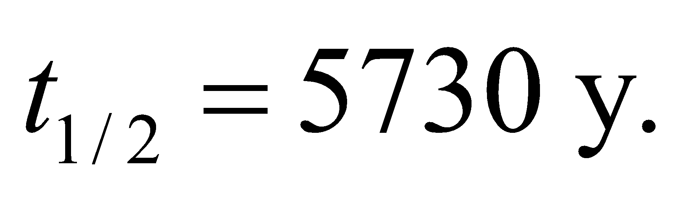
Evaluate From the above equation, we determine the age of the bone to be
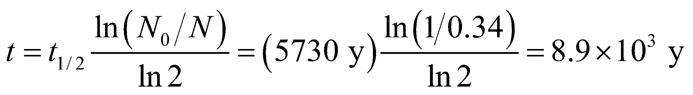
Assess As a quick check, we note that one half-life reduces the number to 50% of the original, two half-lives to 25%, three to 12.5%, and so on. In our ¹⁴C dating case, we have 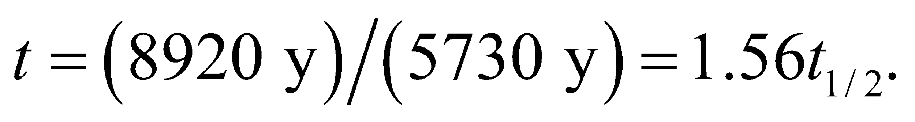 Therefore, we expect the fraction remaining to be between 25% and 50%. This is consistent with the 34% given in the problem statement.
48. Interpret This problem is a mathematical exercise in which we are to show that the half-life and the decay constant defined in Equations 38.3b and 38.3a, respectively, are related as given in the problem statement.
Develop Because the activity is proportional to the number of nuclei, the ratio N/N₀ from Equation 38.3a should equate to that given by Equation 38.3b for any given time t. Thus, we can write
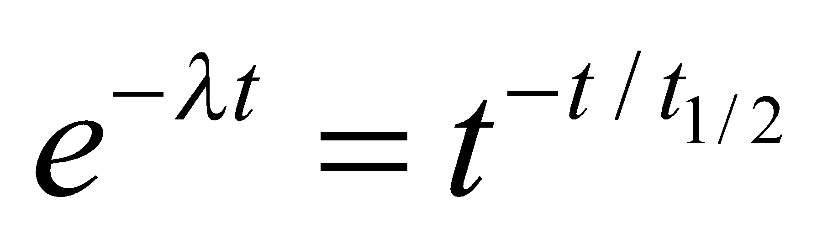
which we can solve for t_{1/2} in terms of λ.
Evaluate Taking the natural logarithm of both sides, we find
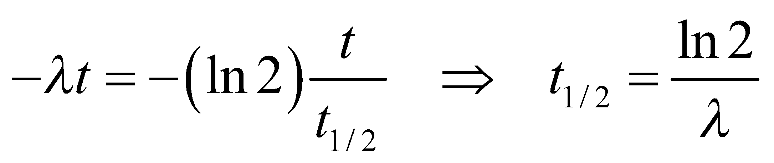
Assess This result agrees with that given in the text.
49. Interpret This problem is about the decay of ¹³¹I in milk. We are given the initial activity per liter of milk, and we want to know how long it takes for the activity to decay to the level provided by the given safety guideline.
Develop Using Equation 38.3a, 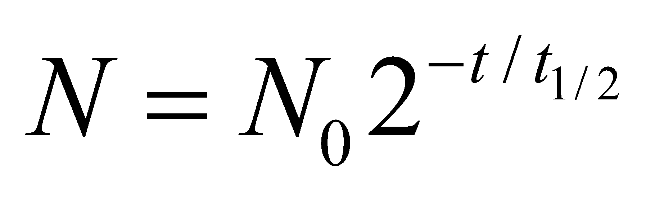 the waiting time t required can be written as
where the ratio N₀/N is the ratio of the initial activity to the final activity. The half-life of ¹³¹I is 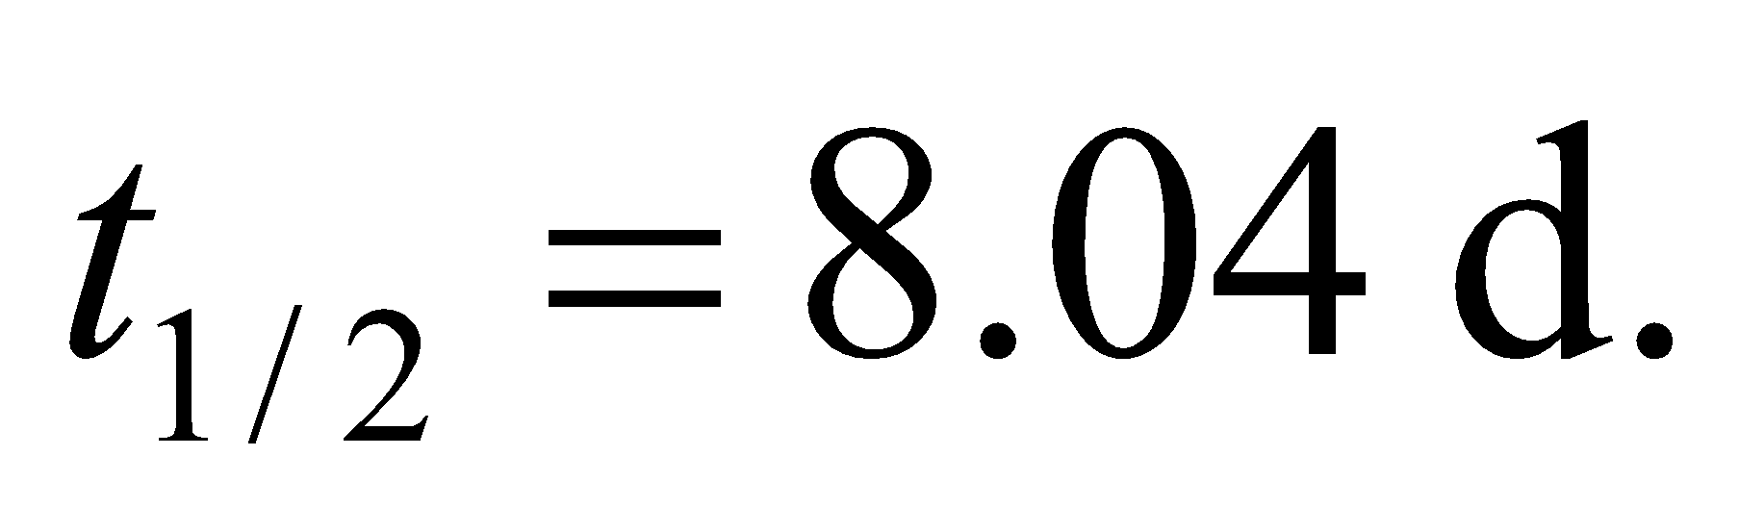
Evaluate For Poland, we find
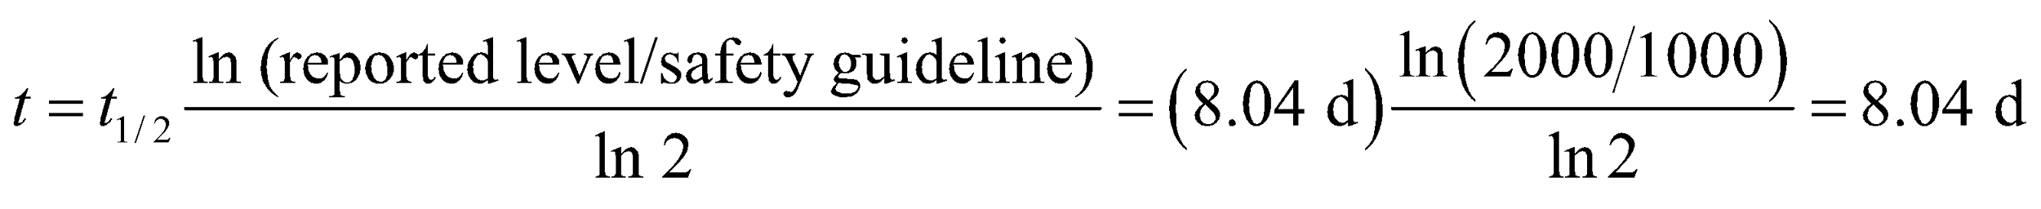
Similar calculations yield 16.2 d for Austria, and 10.0 d for Germany.
Assess As a quick check, we note that one half-life reduces the number to 50% of the original, two half-lives to 25%, three to 12.5%, and so on. For Poland, the waiting time is exactly one half-life since the initial reported level is twice the safety guideline. For Austria, 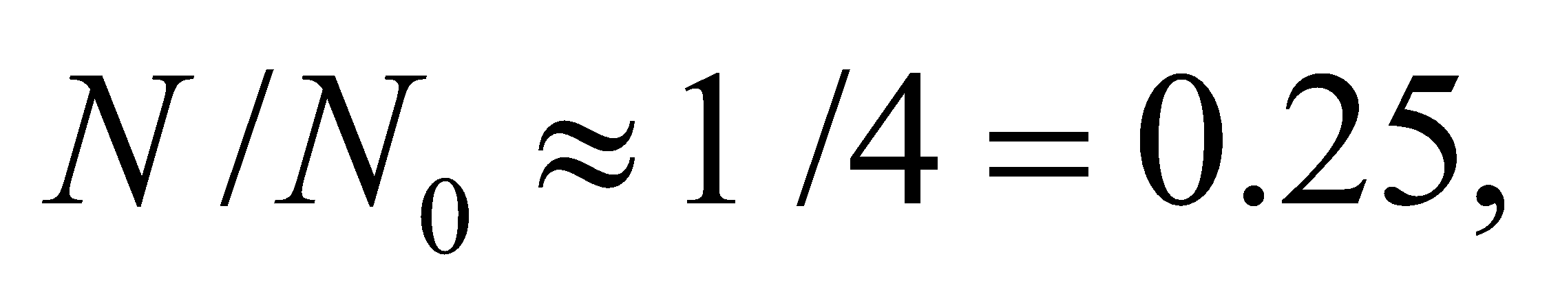 so about two half-lives (16 days) of waiting time are required. Similar reasoning can be applied to the Germany case.
50. Interpret Given the activity and the half-life of a sample, we are to find the number of atoms in the sample.
Develop Apply Equation 38.3a
The activity of the sample is 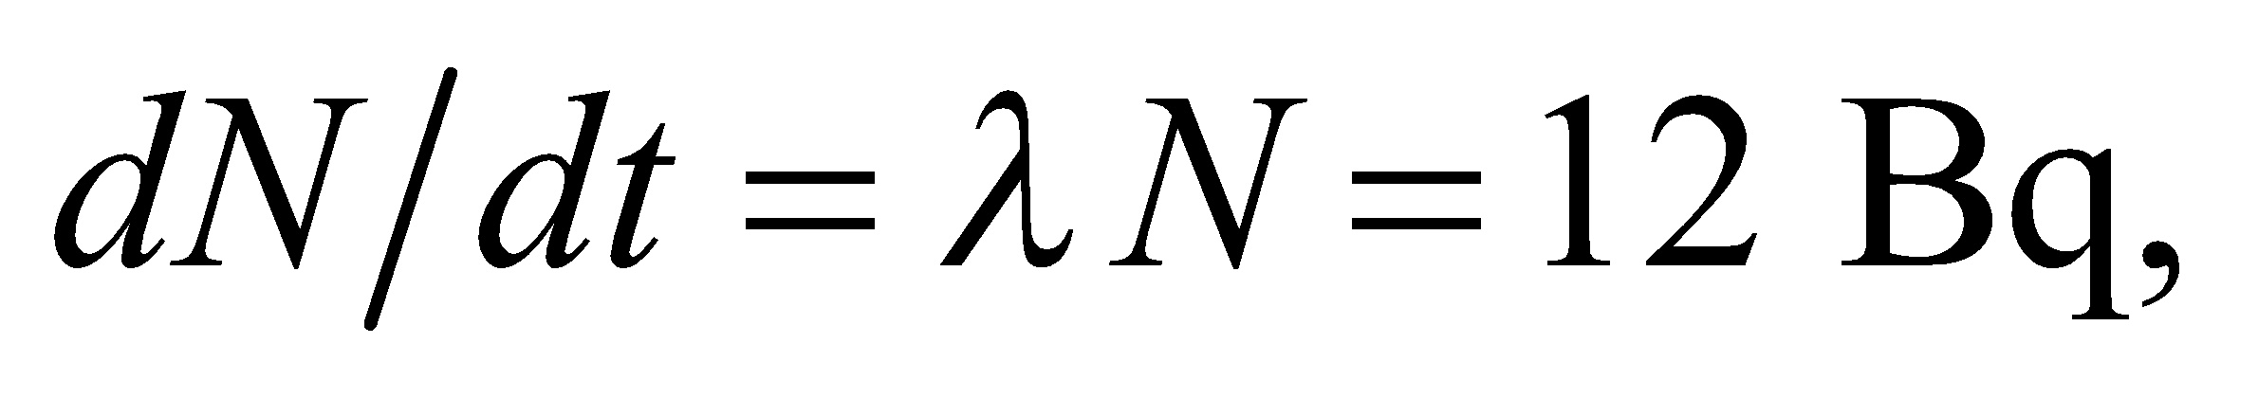 where
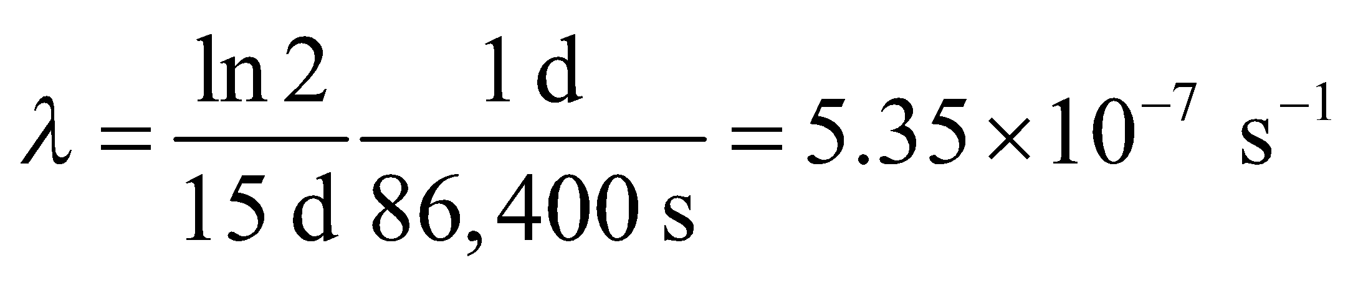
Evaluate Solving for N, we find
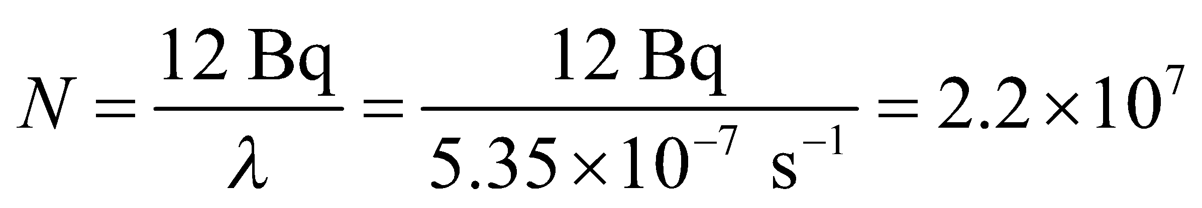
Assess Given that atomic masses are on the order of 10² g/mol, this corresponds to a mass m of around
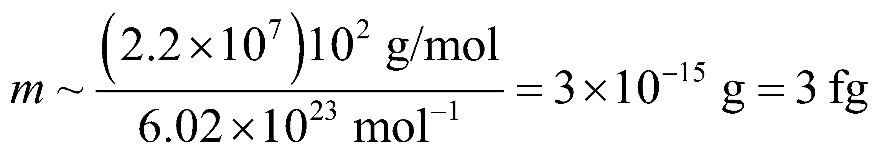
which is a very small sample.
51. Interpret This problem involves using the decay rate of ⁴⁰K to deduce the age of a rock.
Develop Using Equation 38.3b, 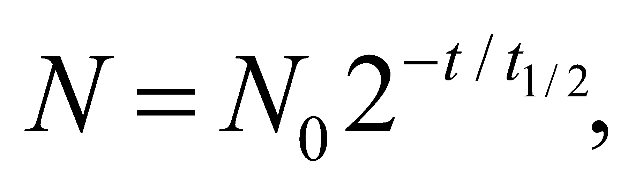 the age t of the rock is given by
where N is the number of ⁴⁰K nuclei remaining and N₀ is the original number of ⁴⁰K nuclei. The half-life of ⁴⁰K is 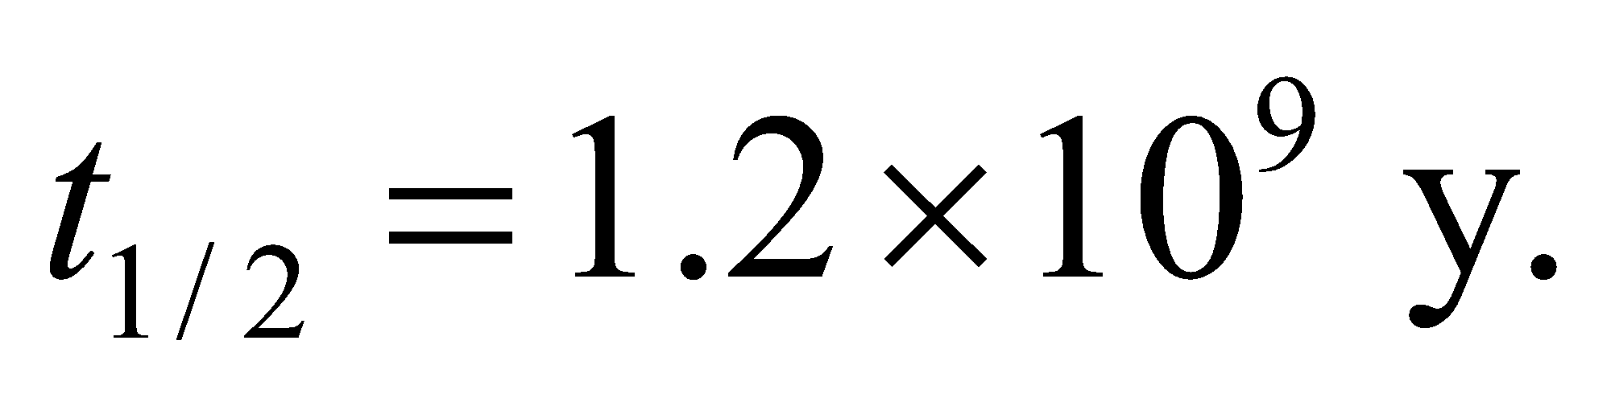 If 82% of the original ⁴⁰K decayed, then 18% remains in a rock of age t, so N₀/N = 1/0.18.
Evaluate From the above equation and the given half-life, we get
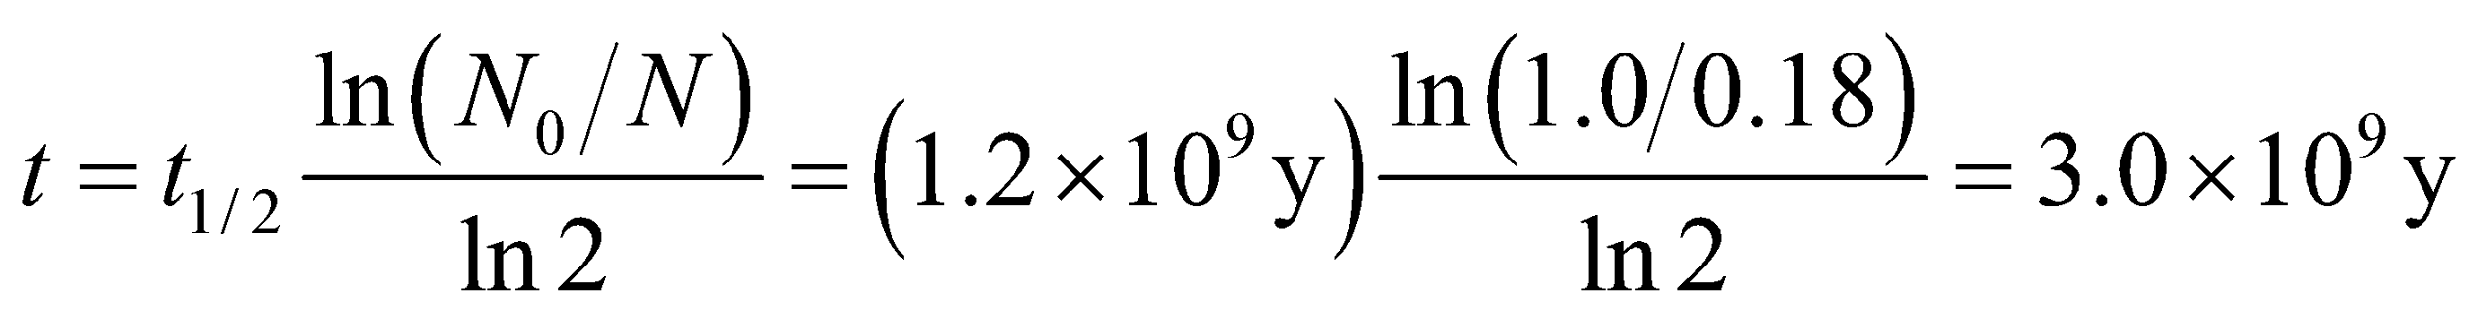
Note: A type of lunar highlands rock rich in potassium (K), rare earth elements (REE), and phosphorus (P), is called KREEP norite.
Assess The age of the rock is on the same order as the age of the Earth, which is about 4.5 billion years old.
52. Interpret Given the half-life of ¹⁶N, we are to estimate the time required for the activity of ¹⁶N to decrease by a factor of 10⁶.
Develop The activity drops by roughly a thousand in ten half-lives (see tip following Example 38.2) and by a factor of 10⁶ in 20 half-lives.
Evaluate Twenty half-lives corresponds to
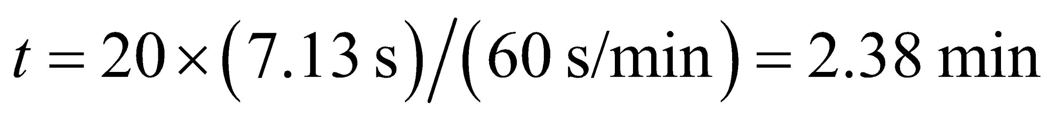
Assess The exact calculation from Equation 38.3b gives 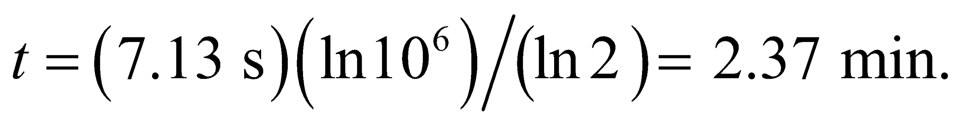
53. Interpret The problem asks what fraction of a cancer-fighting agent will remain radioactive one year after the intervention.
Develop The number of Ir-182 will drop relative to the initial amount according to 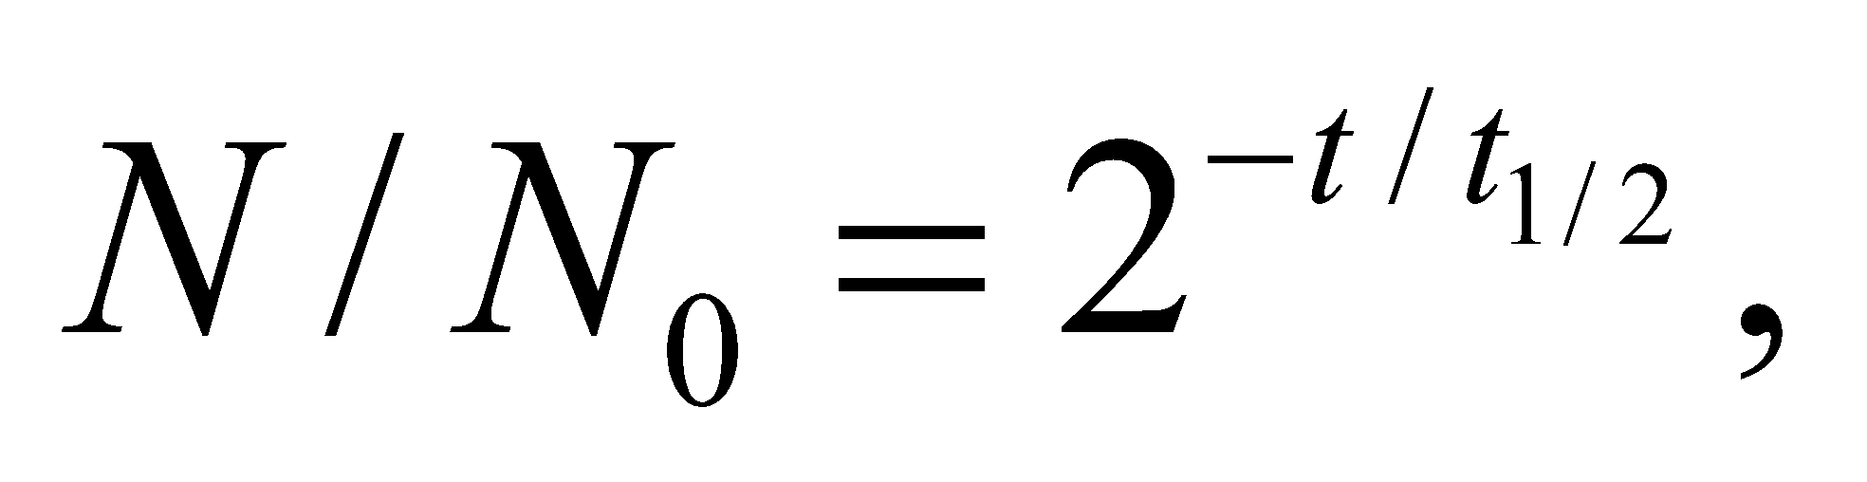where the half-life is 74.2 days.
Evaluate The percentage of radioactive iridium left after 365 days is
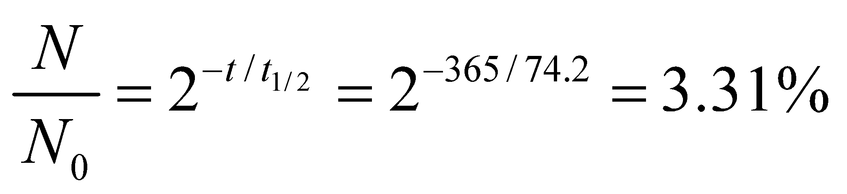
Assess Although the seeds remain radioactive for a considerable time, the gamma rays produced only travel a few millimeters through the body, so ideally only the tumor site is irradiated.
54. Interpret Uranium-235 and uranium-238 have different half lives. We are given their relative abundance at the present time and asked to find their relative abundance 4.5 billion years ago.
Develop Suppose that when the Earth formed at t = 0, natural uranium consisted of just the two longest-lived isotopes in Table 38.1 (we ignore ²³⁴U which has an abundance of 0.0057%). Then the percentage of ²³⁵U today
(t = 4.5 × 10⁹ y) is
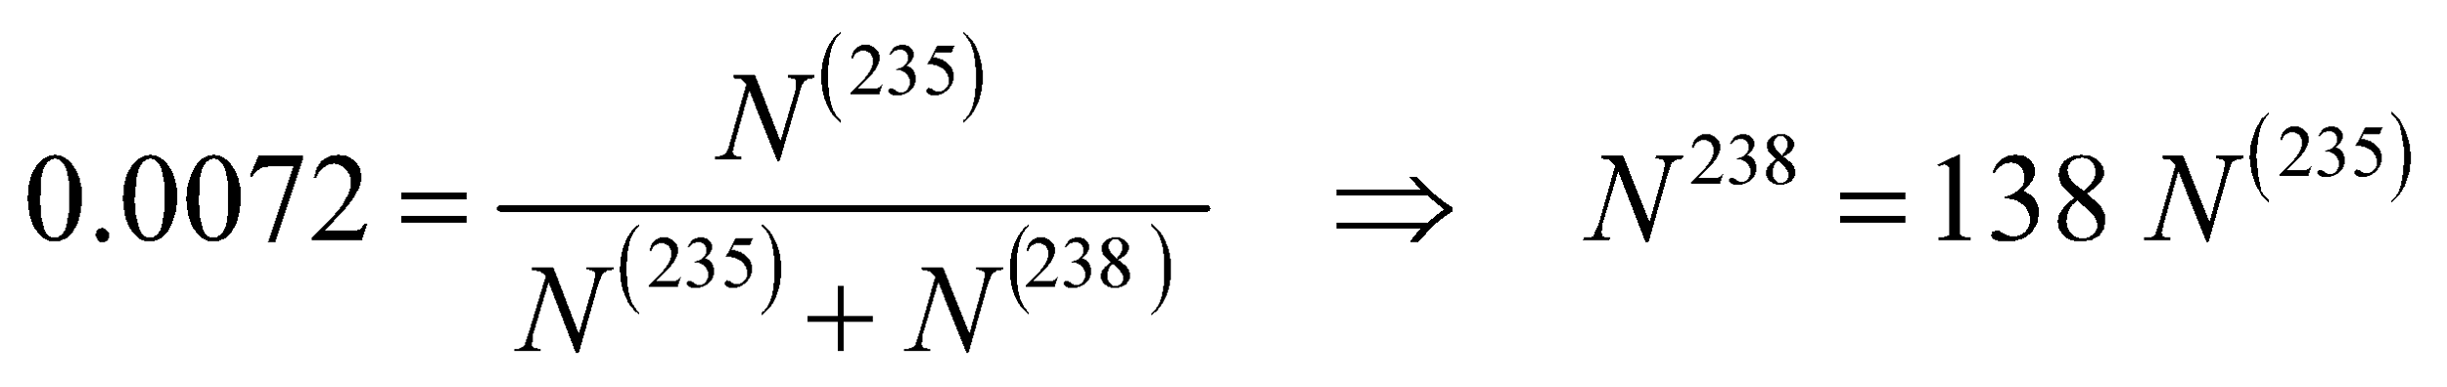
The original amounts of the two isotopes are given by Equation 38.3b, with half-lives from Table 38.1. The results are
Evaluate Thus, the original percentage must have been
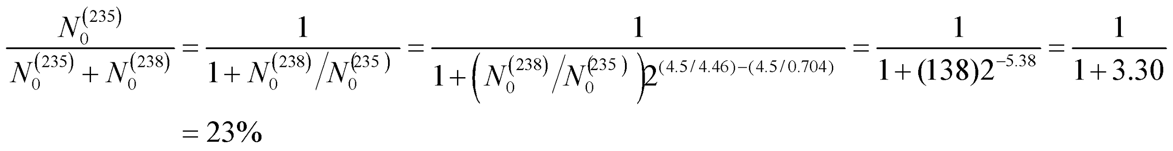
Assess Since ²³⁵U has a shorter half-life than ²³⁸U, we expect the ratio 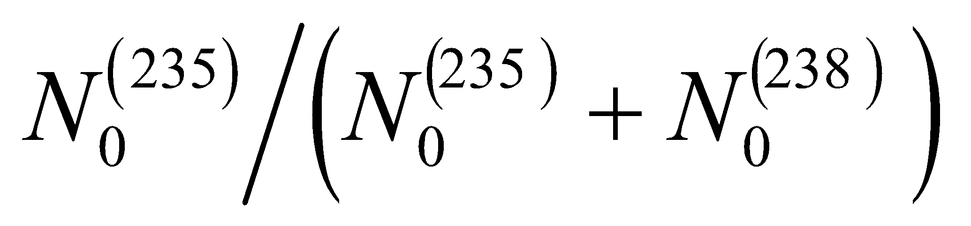 to decrease with time. Note that from current data on nuclear reactions and models of nucleosynthesis in supernova explosions, one can predict the isotopic abundances of ²³⁵U and ²³⁸U when they were produced. By reversing the above argument, one can then estimate the age of the elements in the nebula from which the solar system formed.
55. Interpret You're asked what is the long-term radioactivity of plutonium in terms of nuclear waste storage.
Develop The amount of plutonium will decrease by 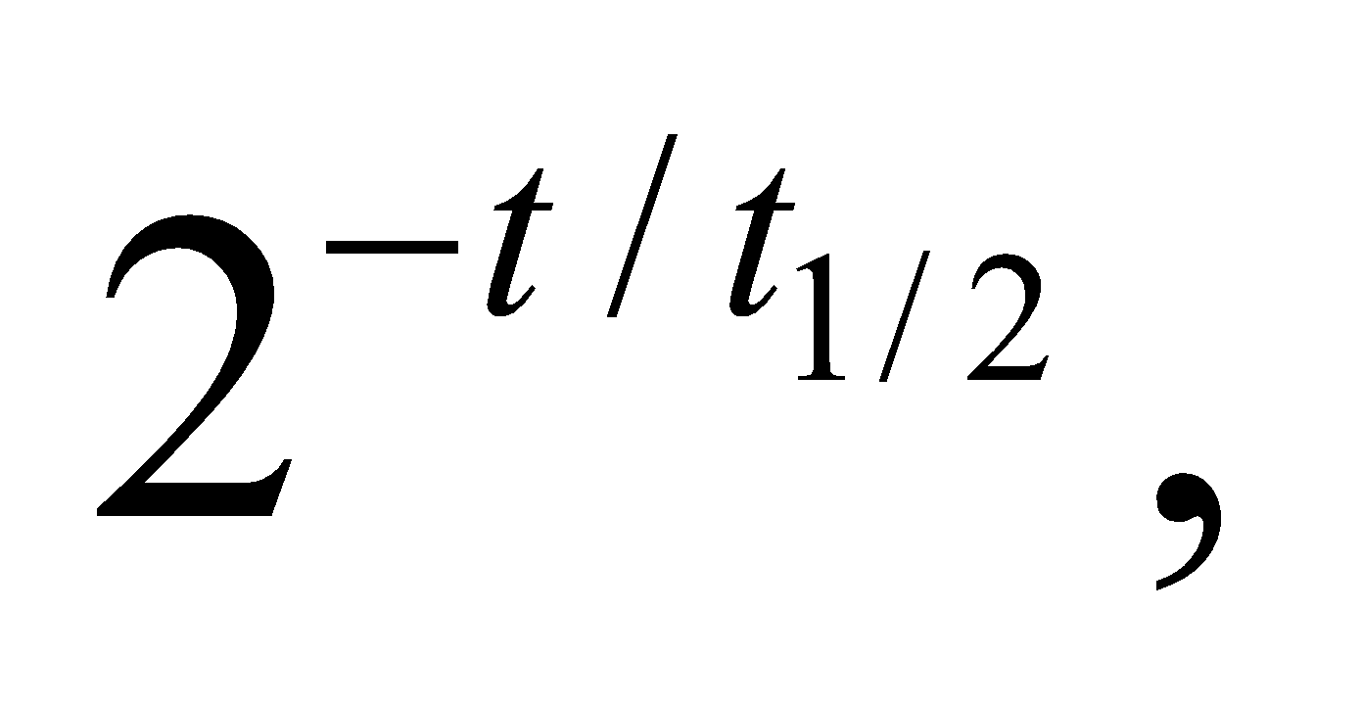where the half-life is 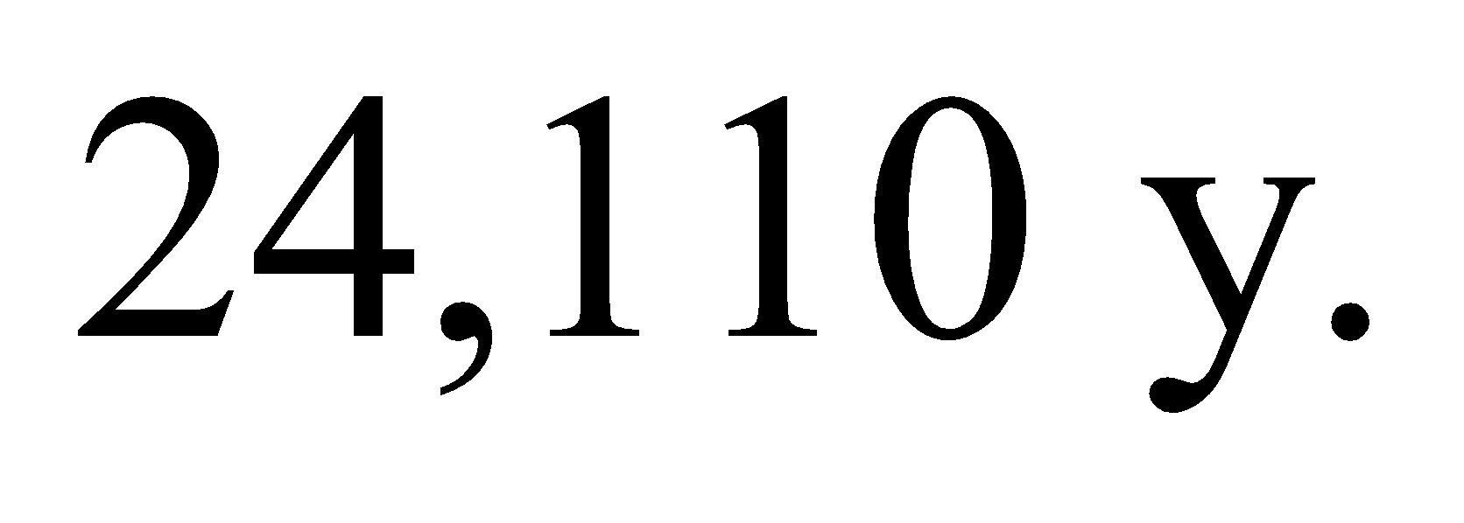
Evaluate The fraction of Pu-239 after 1 million years is
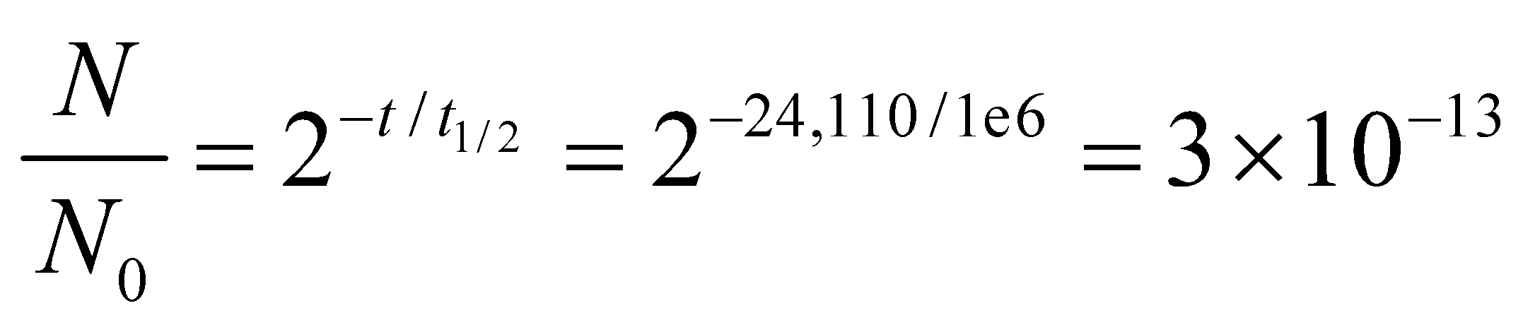
Assess This is almost nothing, as we'd expect after 41 half-lives of plutonium. However, the plutonium itself is only part of the problem, since it's decay products will be radioactive as well. Notably, Pu-239 decays to U-235, which has a half-life of 704 million years.
56. Interpret This problem concerns the decay rate of ¹⁵O. We are given its activity concentration at time t and asked to find its initial activity concentration.
Develop From the derivation of Equation 38.3a, we see that the activity concentration dN/dt = lN. Combining this with Equation 38.3b, we may write
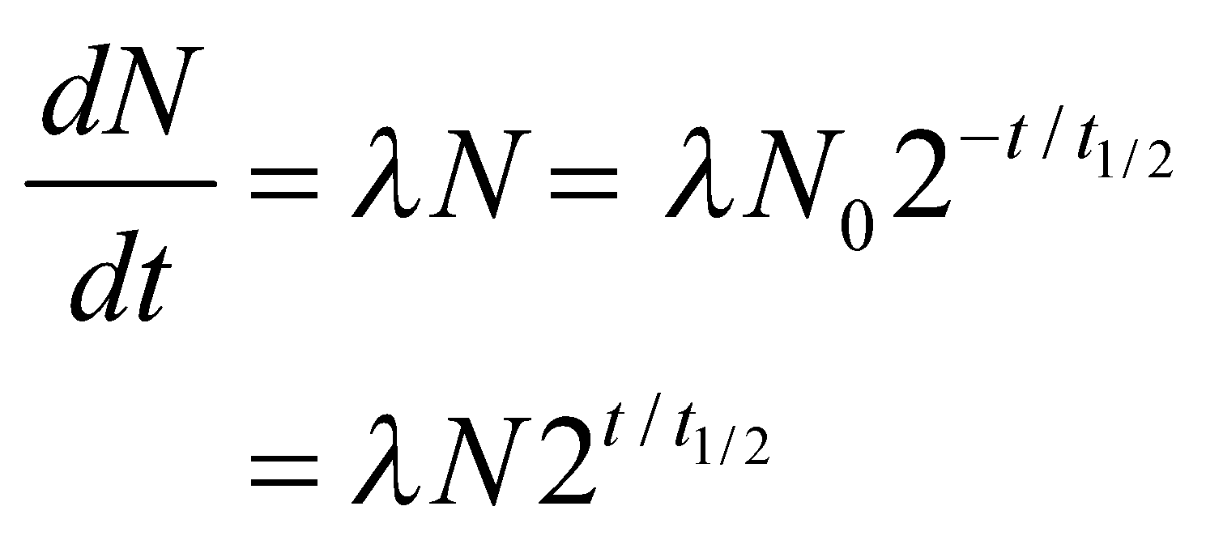
where λN is the activity concentration at t = 3.5 min.
Evaluate With 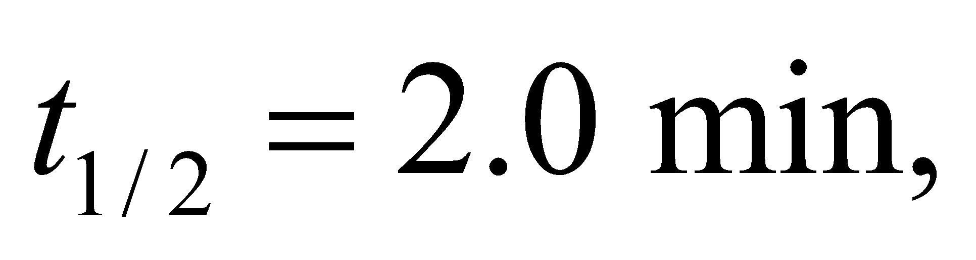 we get
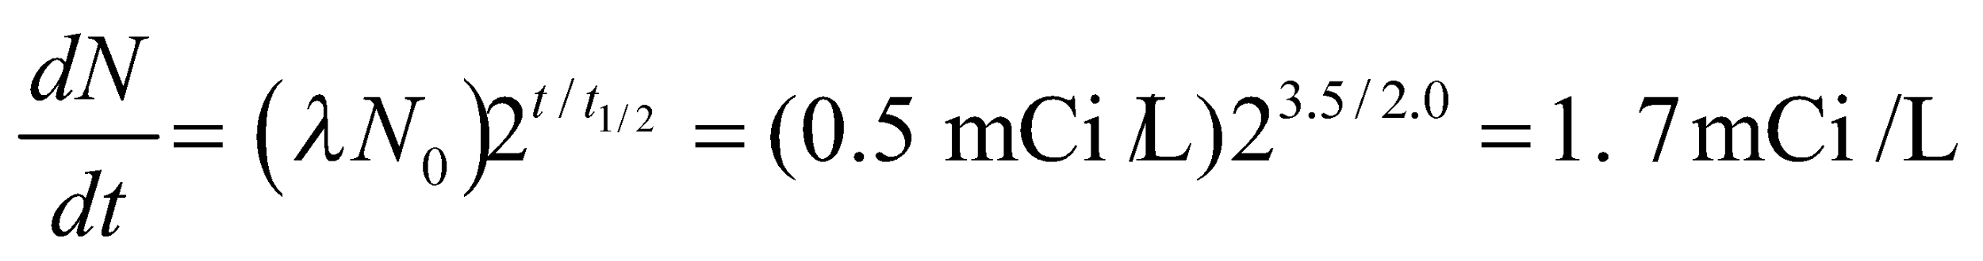
Assess As a quick check, we note that one half-life reduces the activity to 50% of the original, two half-lives to 25%, three to 12.5%, and so on. In our case, 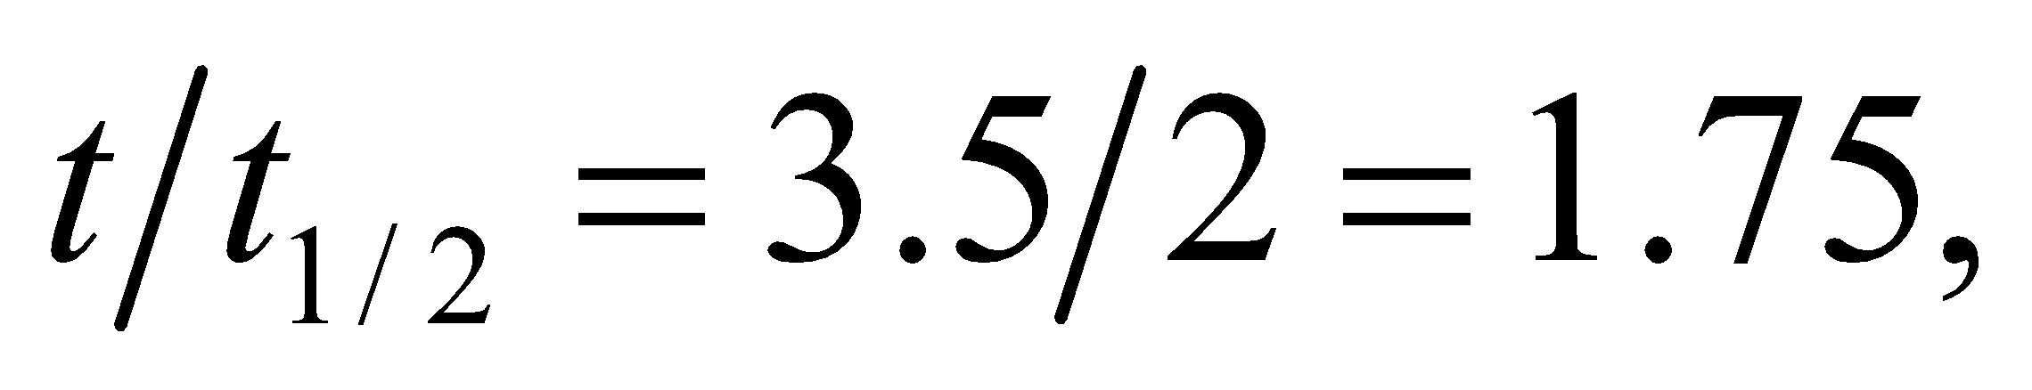 which is less than 2. So we expect the activity to be between 25% and 50% of the original. Indeed, we have 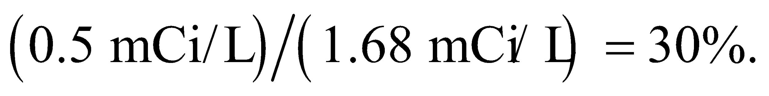
57. Interpret For a 3.2-GW reactor, we are to determine how much ²³⁵U would be needed to fuel the reactor for one year.
Develop The energy content of ²³⁵U is (see Appendix C) 2.3 × 10⁷ kWh/kg. Thus, we can calculate the amount needed to power a 3.2-GW reactor for one year.
Evaluate Letting the units guide us, we find that the mass m_{U} of ²³⁵U needed to power the reactor for one year is
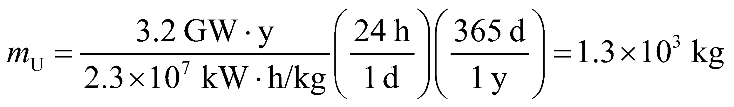
Assess How much natural uranium do we need to obtain this amount of ²³⁵U? Because natural uranium contains about 0.7% 235U, we would need (1.3 × 10³ kg)/(0.007) ~ 2 × 10⁵ kg of natural uranium. If we estimate the ratio of the densities of natural uranium (i.e., ²³⁸U) and water by the ratio of their atomic masses, we can estimate that the volume of ²³⁸U to be
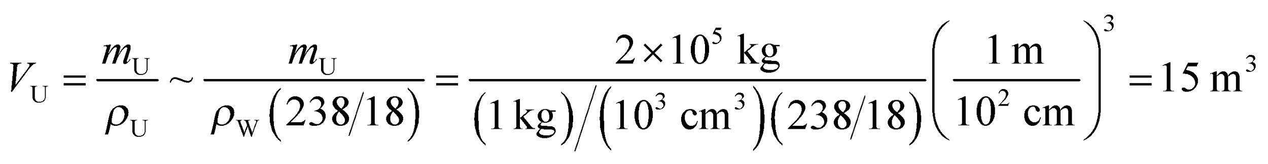
This would fit nicely into an average-sized truck, in agreement with Example 38.5.
58. Interpret We are to calculate the amount of uranium-235 needed for a fission bomb with a 20-kt explosive yield.
Develop Using the data in Appendix C, we find that a 1-kt explosive yield is about 4.18 × 10¹² J. The fission of ²³⁵U yields 8.2 × 10¹³ J/kg. Therefore, 1 kt is equivalent to the energy released in the fission of about
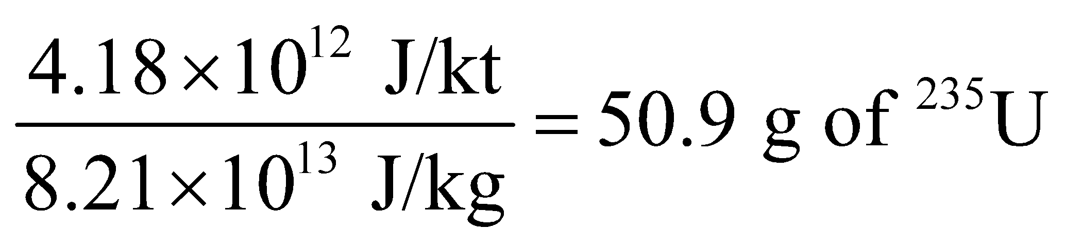
Evaluate A 20-kt yield is equivalent to the fission energy of 20 × 50.9 g = 1.0 kg of ²³⁵U.
Assess The bomb “Little Boy” was a uranium-235 fission bomb which had a yield of about 12–15 kt.
59. Interpret This problem concerns a nonrelativistic collision between a neutron and a stationary deuteron, so conservation of momentum and energy are involved. We are to find the fraction of the kinetic energy that is transferred from the neutron to the deuteron.
Develop The particles involved in the fission reactions discussed all have nonrelativistic energies, so Equations 9.15a and 9.15b, for a head-on elastic collision between a neutron (mass m_{n}) and a deuteron initially at rest (v_{d,i} = 0) gives
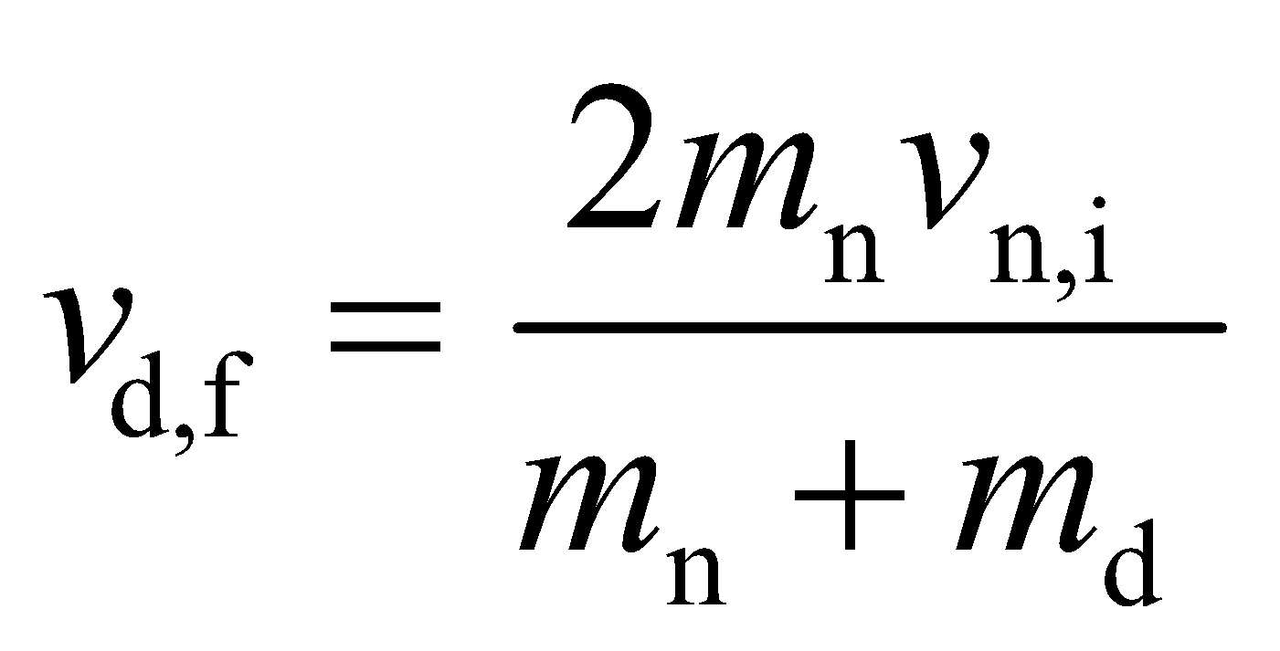
The ratio of the initial to final kinetic energy is
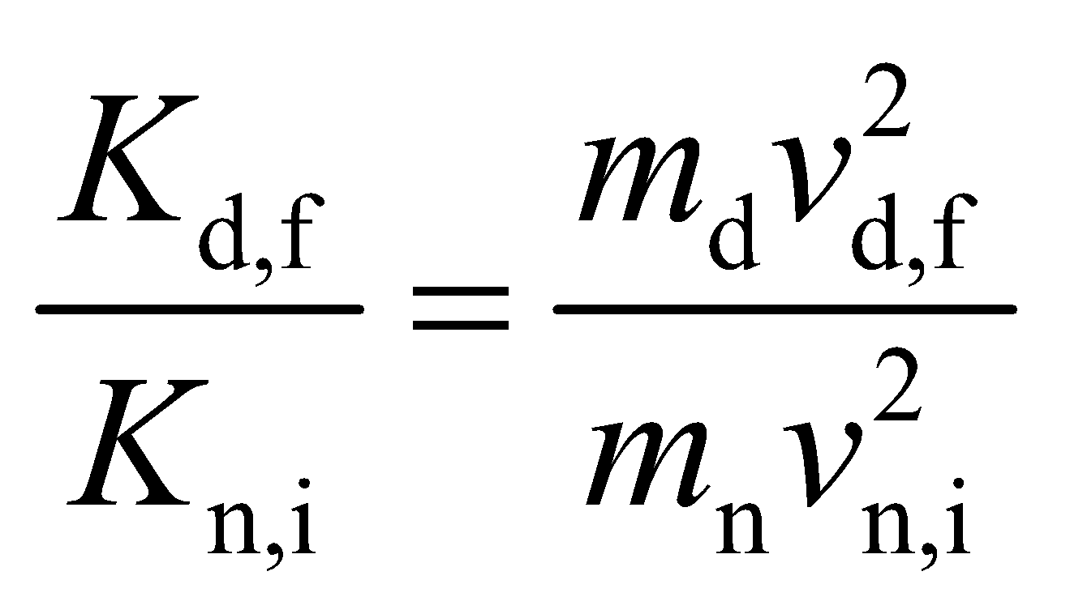
Using the expression above for v_{d,f} and the fact that m_{d} = 2m_{n} allows us to calculate this ratio.
Evaluate The fraction of the neutron’s initial kinetic energy transferred to the deuteron is therefore
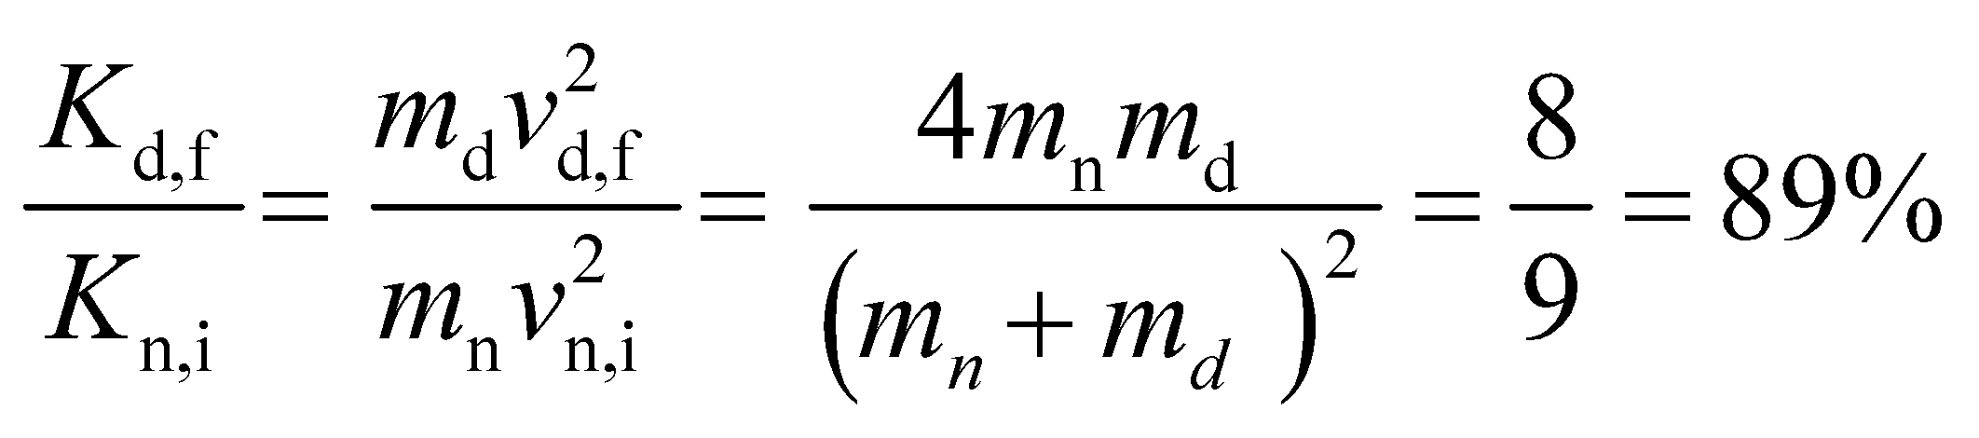
Assess The remainder of the kinetic energy is retained by the neutron.
60. Interpret This problem is about a reactor in a subcritical state with multiplication factor k < 1. We’re asked to calculate the time it takes for the power to be reduced by half, given the generation time.
Develop As outlined in Example 38.6, the multiplication factor k means that the fission rate is multiplied by a factor k with each generation time. The reactor power changes by a factor of 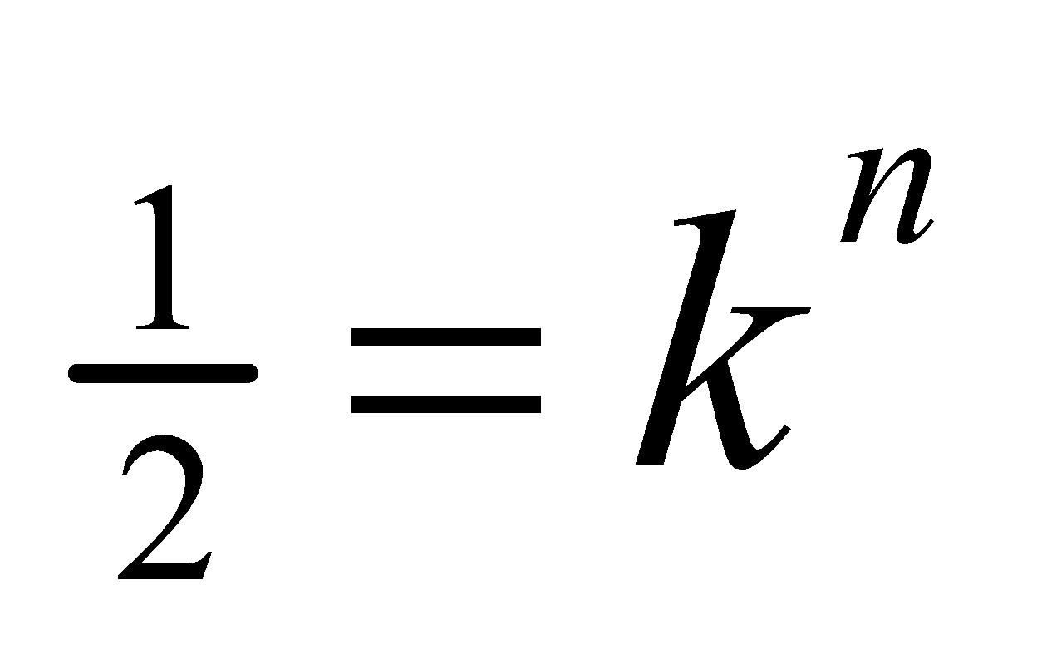 in n generations. The time t elapsed during this process is t = nτ, where τ is the generation time.
Evaluate Taking the logarithm on both sides of gives
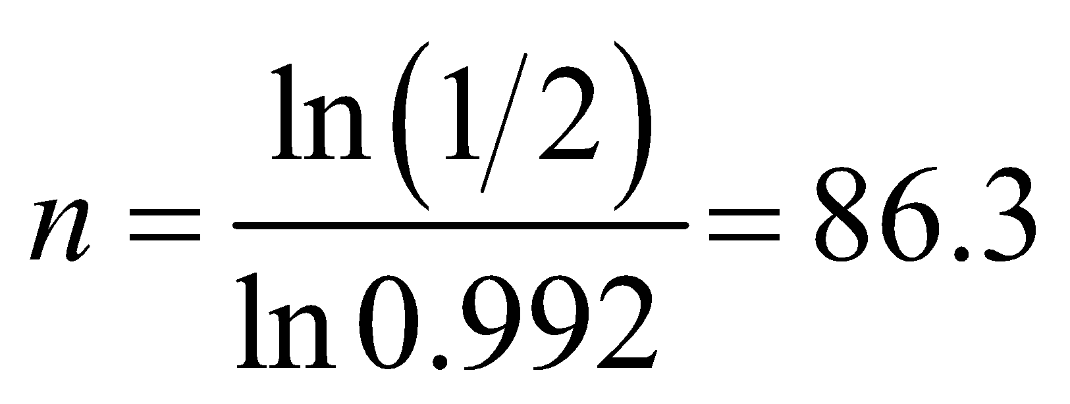
If the generation time is τ = 0.10 s, this process takes t = nτ = (86.3)(0.10 s) = 8.6 s.
Assess The power output decreases rather rapidly. A fission reactor with k < 1 produces fission without achieving criticality, and thus no sustaining chain reaction.
61. Interpret We are to calculate the amount of ²³⁵U consumed in one year in a reactor that produces 1.5 GW of power.
Develop This problem is similar to Problem 38.57, except that we are asked to find the amount of ²³⁵U required for the reactor instead of the amount of 238U. From Appendix C, we find that the energy content of pure ²³⁵U is 2.3 × 10⁷ kW·h/kg. The energy required for the reactor for a full year’s operation is 1.5 GW·y, so we can calculate the mass of ²³⁵U required.
Evaluate The amount of ²³⁵U required is
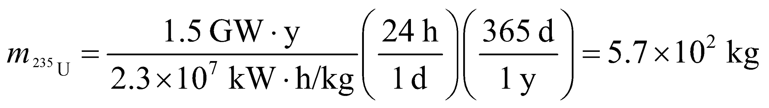
Assess As expected, this is much less than the amount of natural uranium required (cf. Problem 38.57).
62. Interpret This problem is about the power output and efficiency of a nuclear plant. We are given its power output and are to calculate the power output and efficiency.
Develop To compute the power output, we note that the energy content of 235U is 8.2 × 1013 J/kg (see Appendix C).
Evaluate (a) If all the ²³⁵U consumed fissions to produce heat, the thermal power output would be
(b) The efficiency is
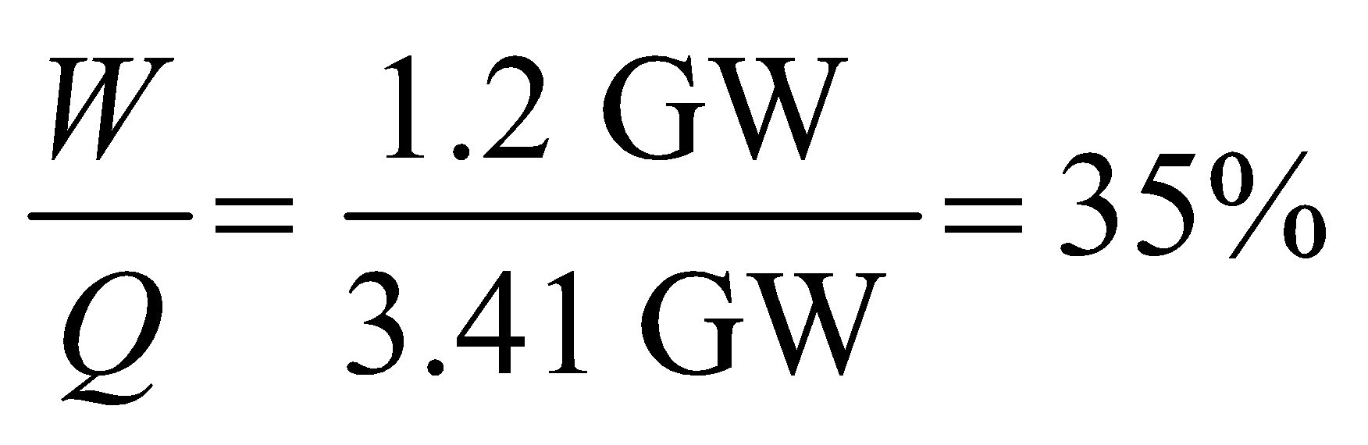
Assess An alternative way to calculate the power output is to follow the procedure used in Example 38.6. Since each fission produces about 200 MeV of energy, the power output is
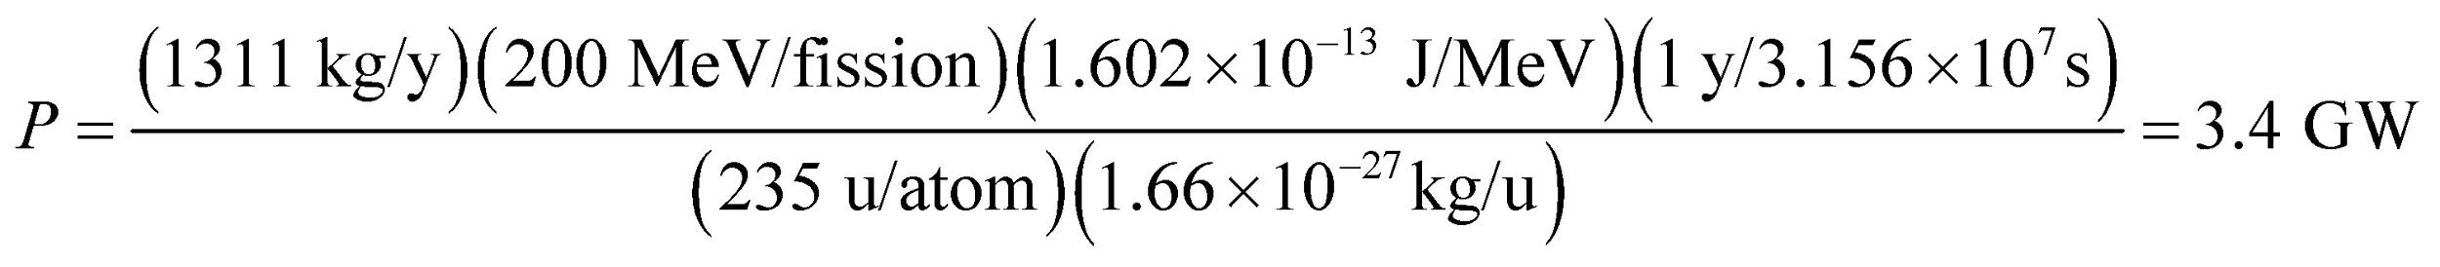
As illustrated in Example 38.6, only 0.35g of ²³⁵U is required to provide the same amount of energy as 1000 kg of coal. That’s why a nuclear power plant is more efficient.
63. Interpret This problem involves fission reactor dynamics. We are to find the time it takes for a 100-fold increase in power for a reactor that goes prompt critical.
Develop This problem is similar to Example 38.6. Similar reasoning leads in this case to the equation 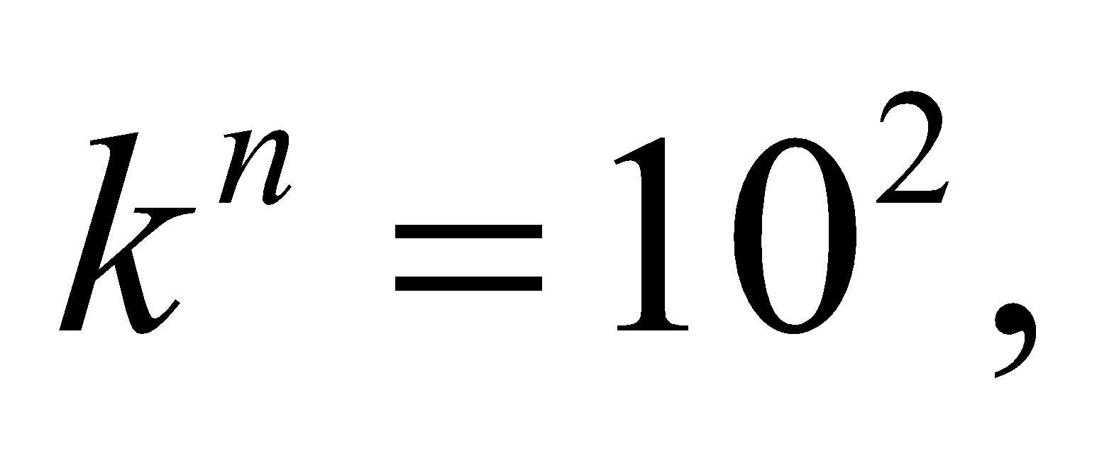 or 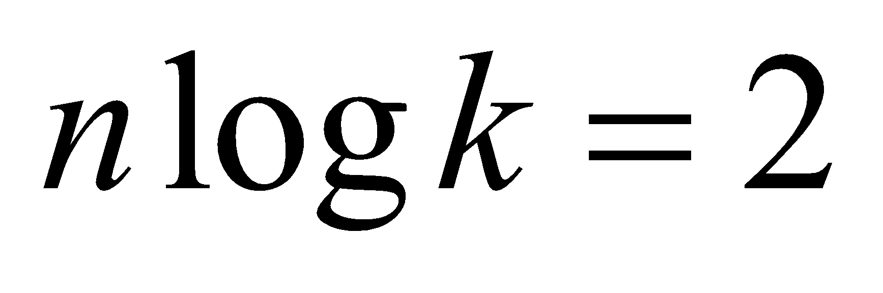, where n is the number of generations. The time t required for this increase in power is the number of generations n multiplied by the generation time τ:
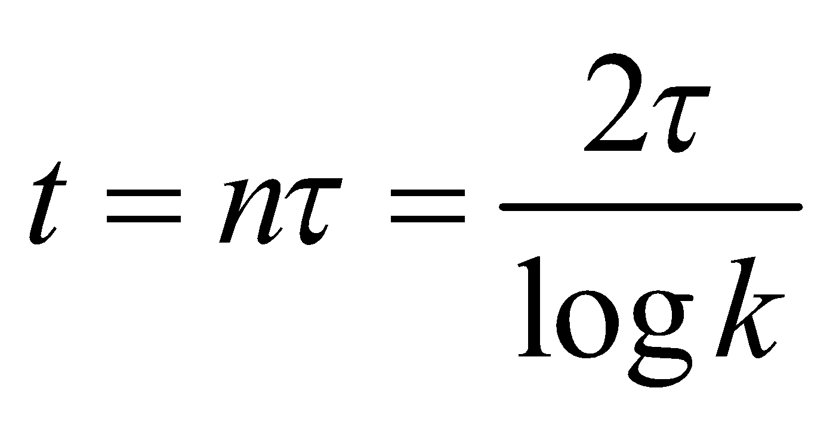
Evaluate Inserting τ = 100 μs and k = 1.001 gives
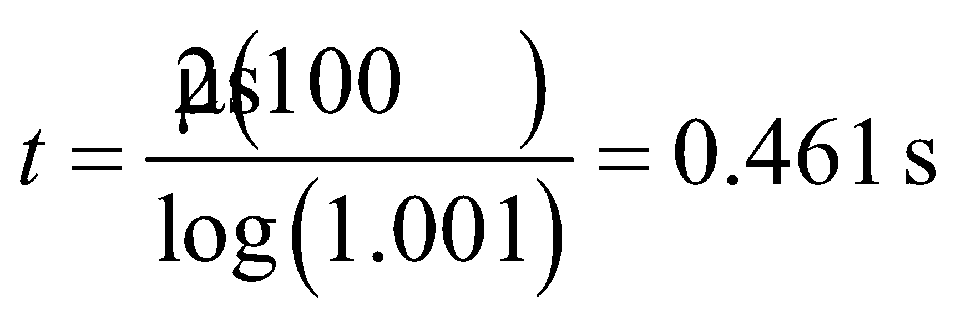
Assess This is a very fast increase in power, which gives an indication of the care that must be taken to prevent the reaction from going prompt critical.
64. Interpret This problem is similar to Problems 38.57 and 38.61, except that the material powering the power plant in question is now deuterium oxide instead of uranium. We are to find the amount of deuterium needed to give the desired annual energy output in D-D fusion.
Develop In one year (= 3.156 × 10⁷ s), the amount of energy produced by a 1.000-GW power plant is
We shall use 7.20 MeV/deuteron as the average energy release in a D-D reactor (note that the D-D reactions of Equations 38.10b and 38.10c produce 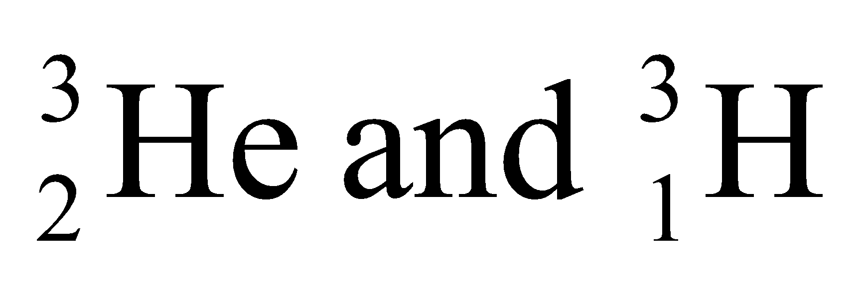 that can undergo further fusion reaction). Thus,
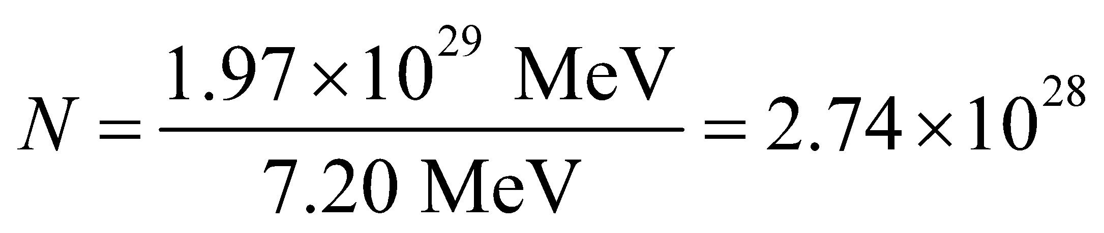
deuterons are required.
Evaluate The molecular weight of D₂O is about 20 u, so about
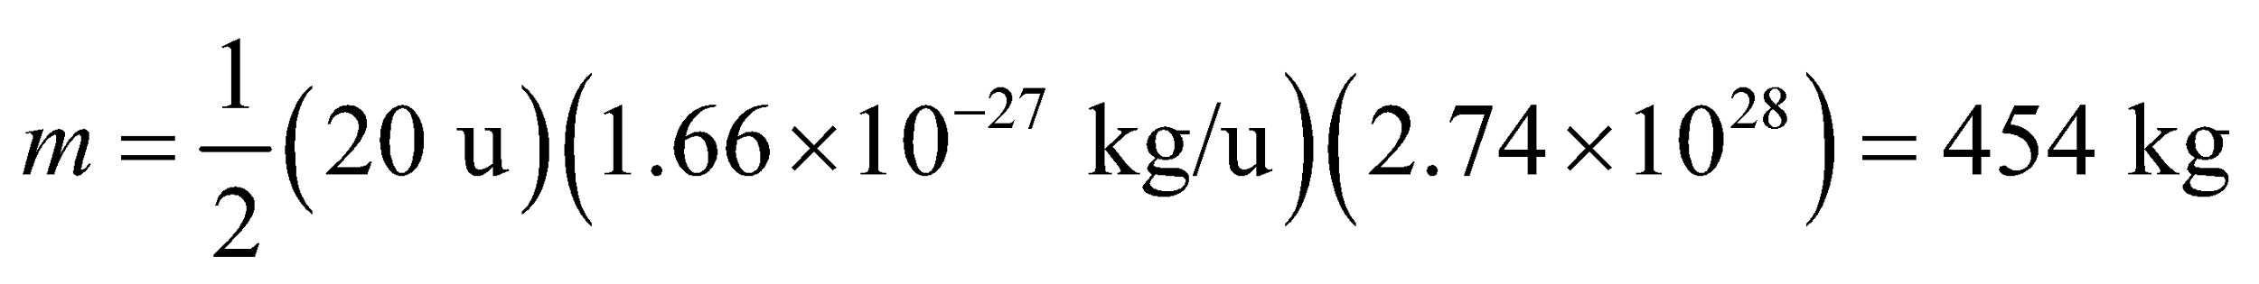
of heavy water (each molecule of which contains two deuterium atoms) would be needed.
Assess About 0.015% of hydrogen nuclei in seawater molecules are deuterium. They can be used to produce heavy water. Note that heavy water plays the role of moderator and coolant in certain reactors (e.g., the Canadian CANDU design).
65. Interpret This problem involves calculating the rate at which the Sun consumes protons given that 4 protons must combine to give 27 MeV. We are also to find how long the Sun’s current proton-consuming phase will last.
Develop The number of protons consumed per second is the power output divided by the energy release E per proton, where E = (27 MeV)/4 because 4 protons are required for each reaction that produces 27 MeV. The amount of hydrogen originally contained by the Sun is (0.71)(2 × 10³⁰ kg)/(1.67 × 10⁻²⁷ kg/proton) = 8.5 × 10⁵⁵ protons, so we can find how long it takes to consume 10% of this by dividing by the consumption rate.
Evaluate (a) The proton consumption rate dN_{p}/dt is about
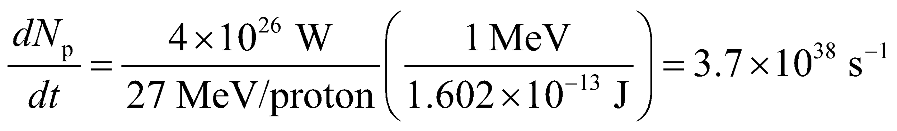
(b) The consumption of 8.5 × 10⁵⁵ protons at the rate found in part (a) would take about
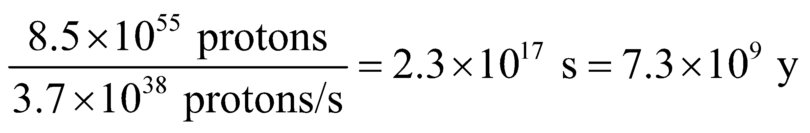
Assess The present age of the Sun is about 4.5 billion years.
66. Interpret You want to convince others of the potential of nuclear fusion by estimating how much energy is in a gallon of seawater, due to its concentration of deuterium nuclei.
Develop The number of deuterium 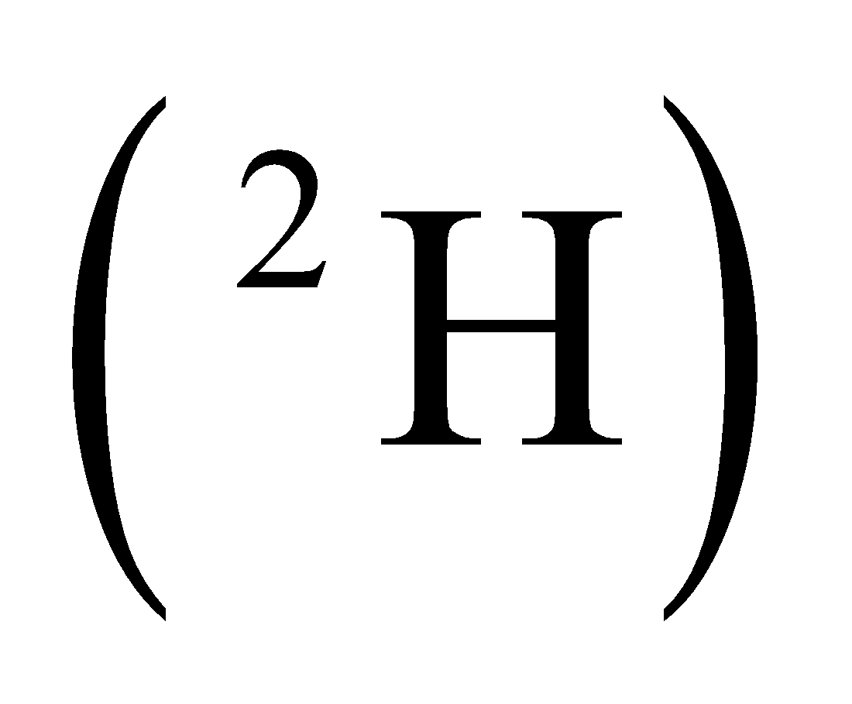 is a small fraction of the number of hydrogen 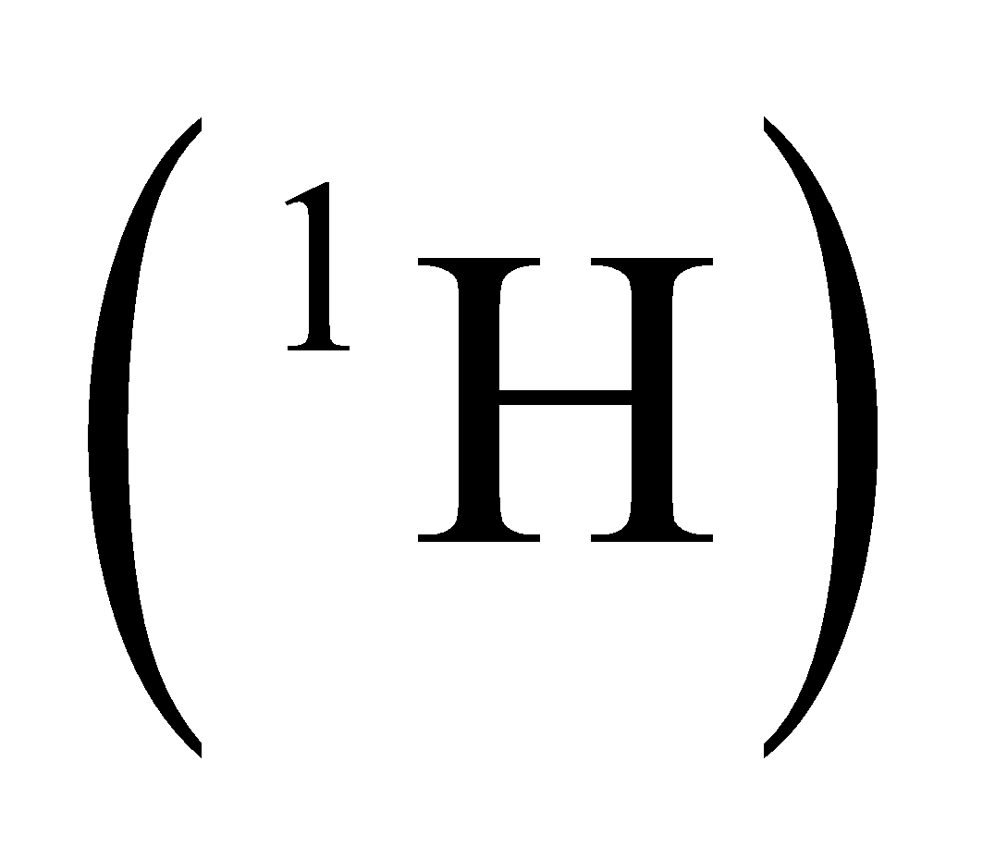in a given sample: 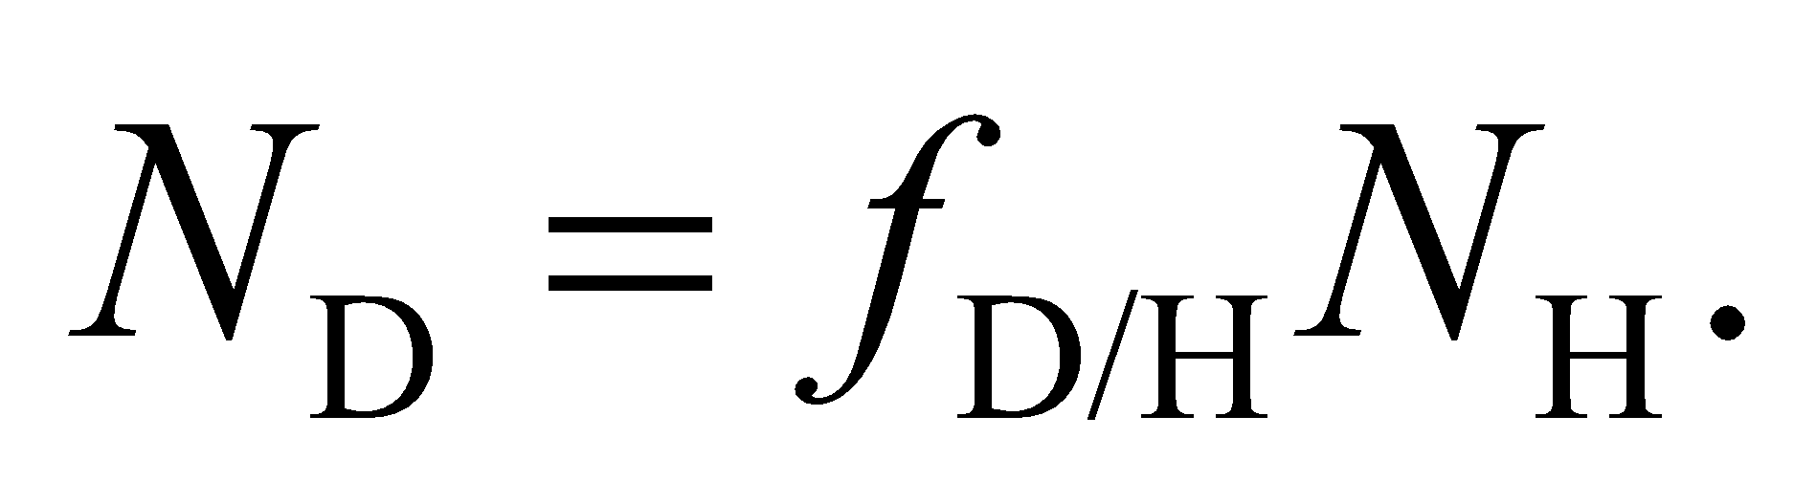 In water, the number of hydrogen is twice the number of water molecules: 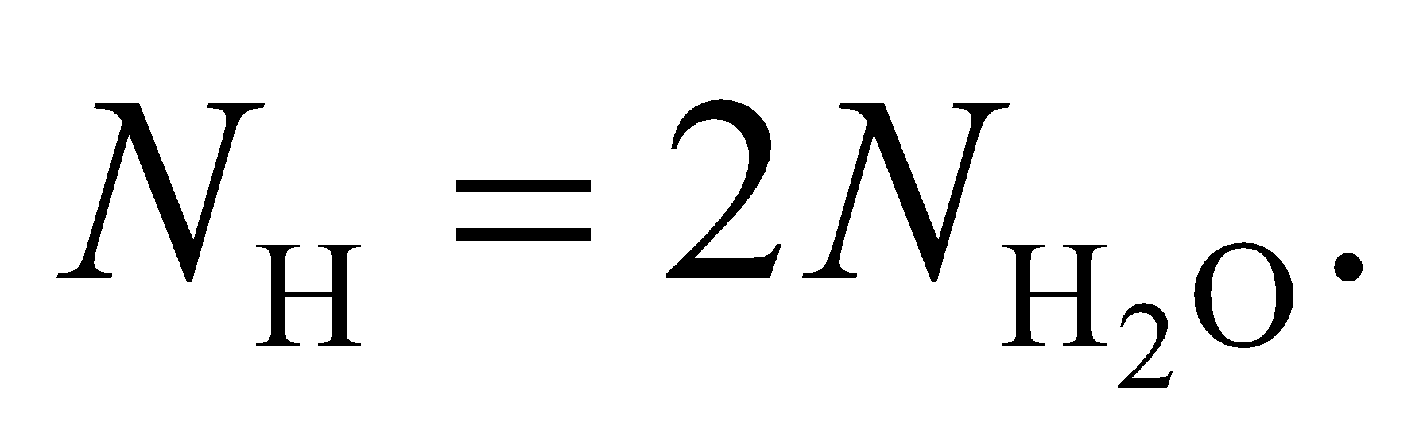 If you assume seawater is pure water, the number of water molecules is the ratio of the total mass and the mass of a single molecule: 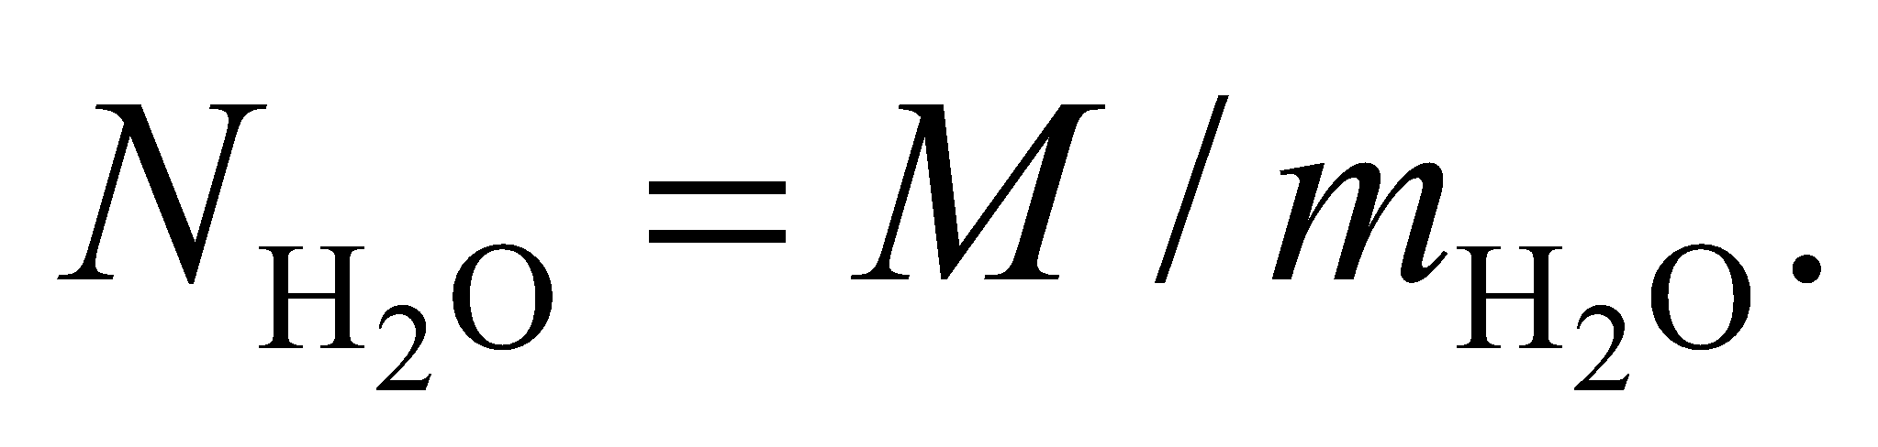 Since the density of water is 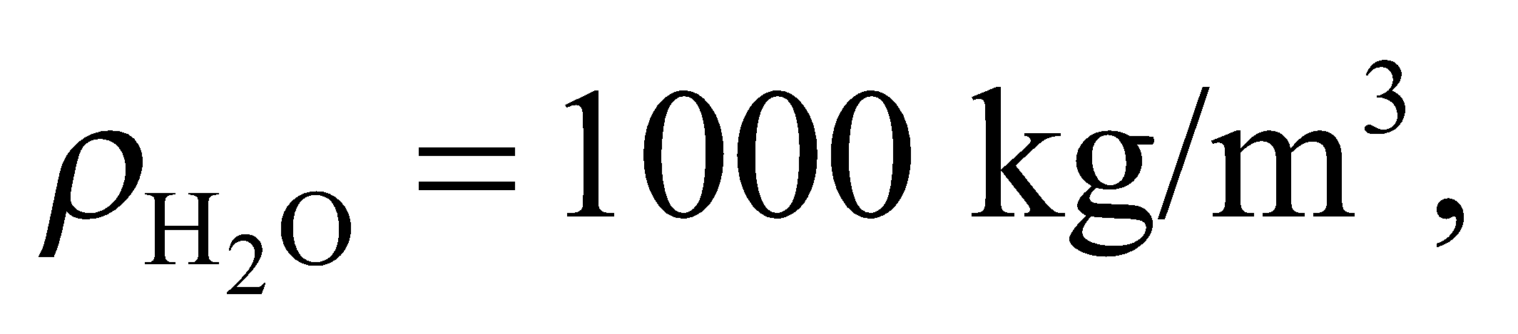 the mass of one gallon of water is
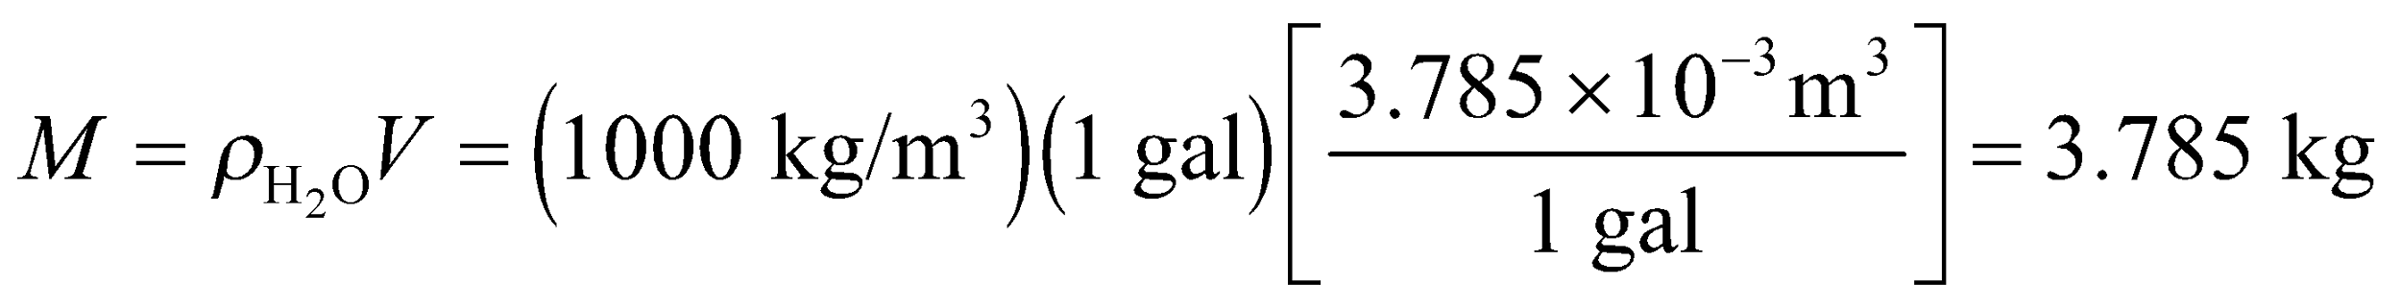
The mass of a single water molecule is the sum of two hydrogen and one oxygen:
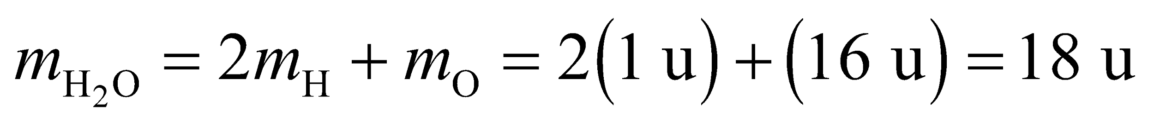
Evaluate Combining the information from above, the number of deuterium in a gallon of seawater is
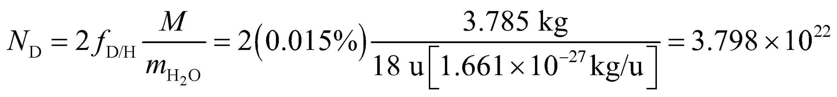
Assuming 7.2 MeV per deuterium, the available fusion energy in a gallon of seawater is
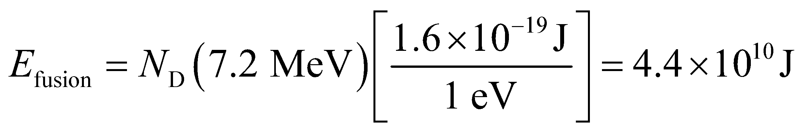
Thus, the energy density of seawater is about 12,000 kWh/gal, compared to 36 kWh/gal for gasoline (see Appendix C). In other words, the energy in a gallon seawater is equivalent to 340 gallons of gasoline.
Assess Although there is reason to be enthusiastic about nuclear fusion, the technology is not there yet for harnessing this powerful source.
67. Interpret To continue the argument of the previous problem, you want to estimate how long nuclear fusion could supply the human population with energy it demands.
Develop Since you have already calculated the energy density of seawater in the previous problem 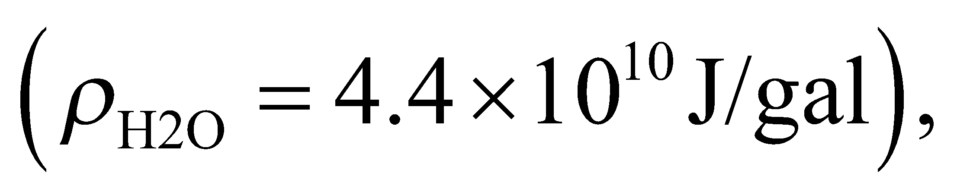 you need now only estimate the number of gallons in the world's oceans. Assuming that 70% of the Earth's area 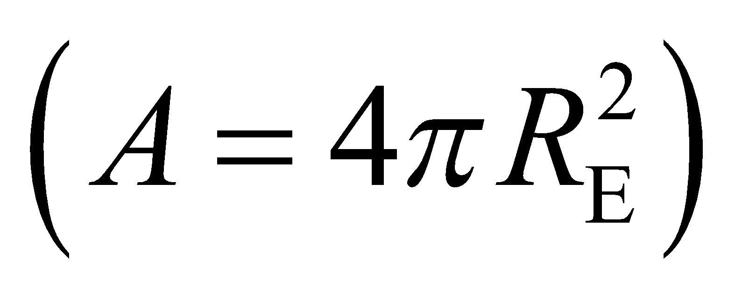 is covered with water to an average depth of 3 km, the volume of water is
Evaluate Using the planet's water supply, the total energy available from fusion is
Assuming humans continue to consume energy at the current rate of 15 TW, fusion energy could last for
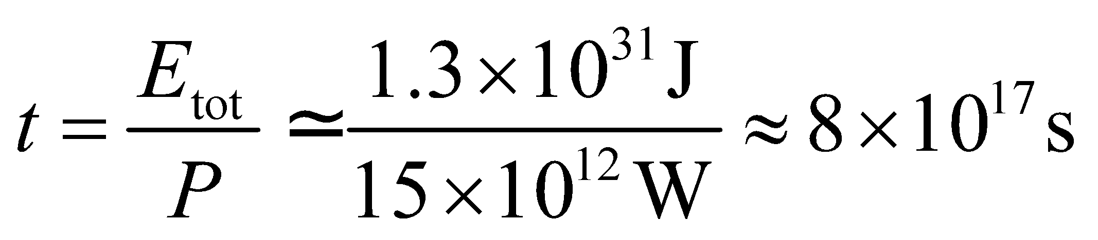
This is about 26 billion years, or roughly 20 billion years longer than the Sun will shine.
Assess This is a very rough calculation, but even so it should make it clear that fusion energy is effectively limitless once the technological hurdles can be overcome.
68. Interpret We are asked to find the energy released in the α-decay of ²³⁸U.
Develop The energy released in the decay is the difference in the mass-energy of the initial nucleus and that of the decay products. Rewriting Equation 38.7 gives
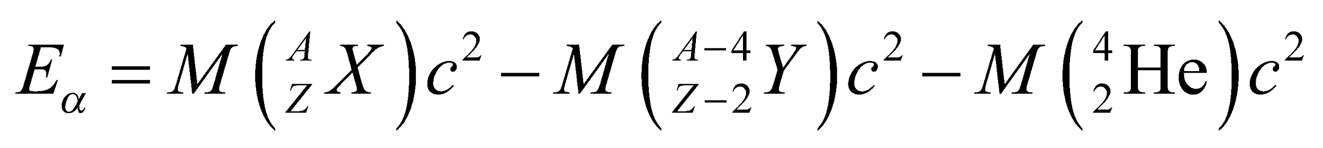
Note that atomic or nuclear masses can be used to calculate 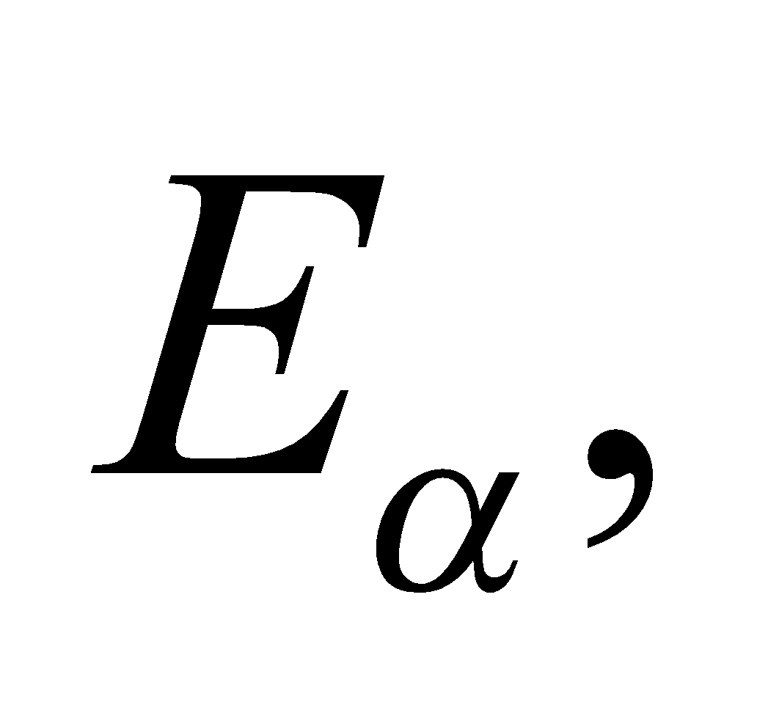 since in α-decay, the mass of the Z electrons cancels. The neglect of atomic binding energies is also less serious here than in Equation 38.7 because only differences enter. For 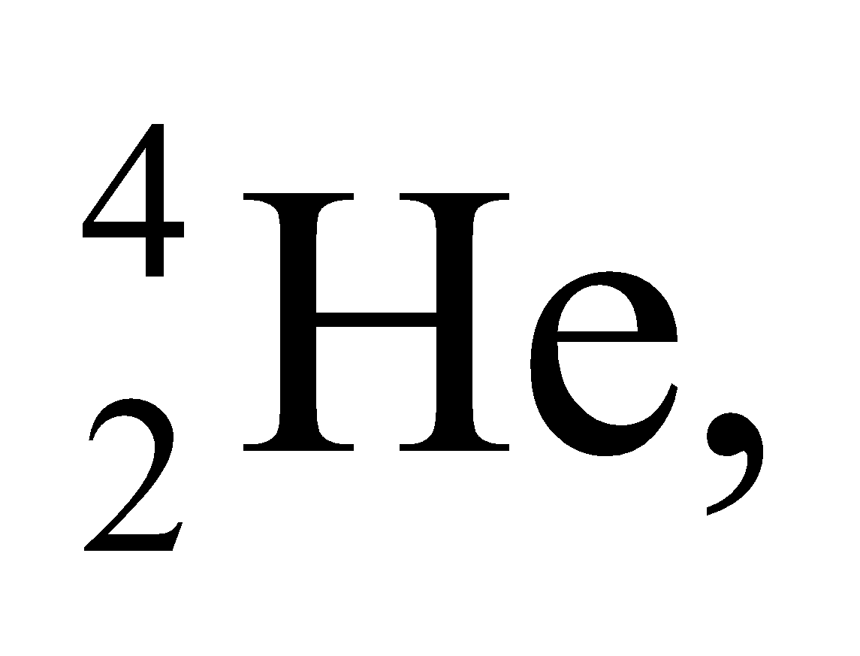 from Table 38.2, we have 4.001506 u + 2(0.000548579 u) = 4.002603 u; the atomic masses of 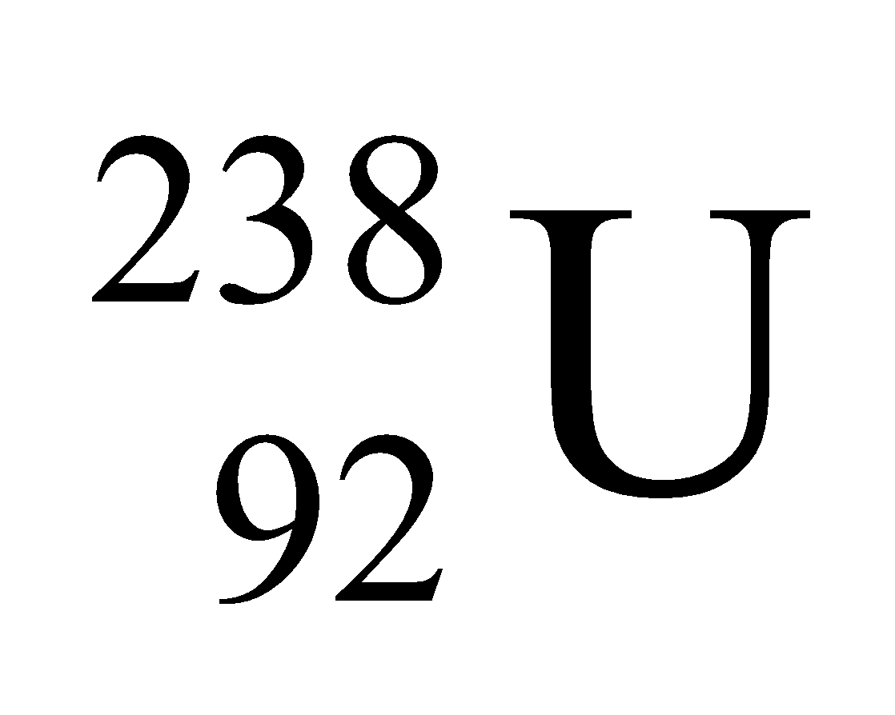 and 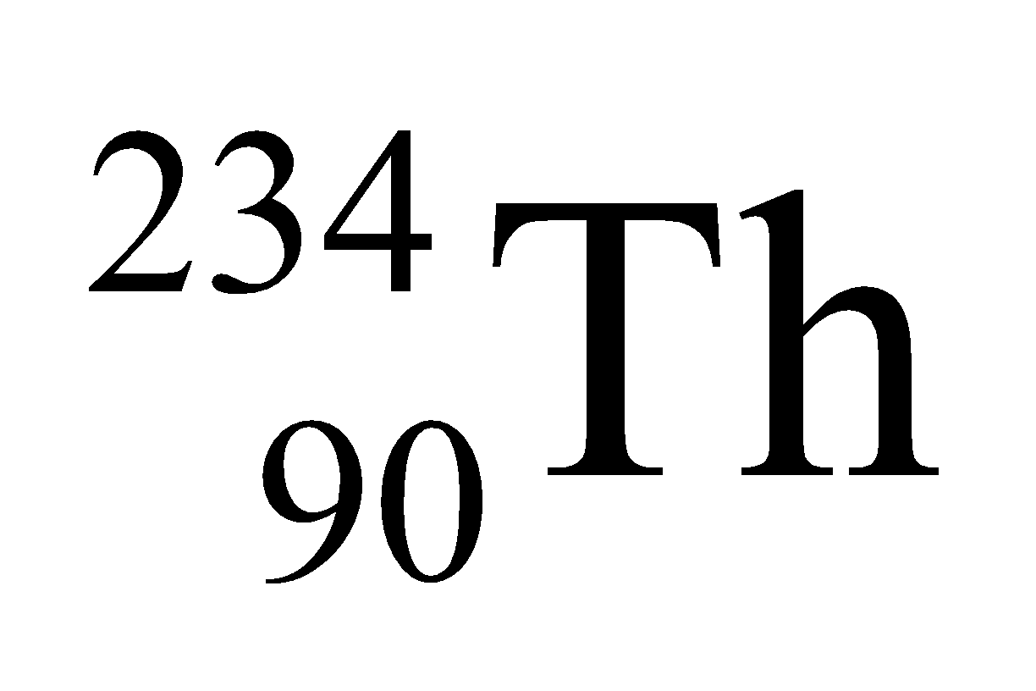 are given.
Evaluate Substituting the values obtained, we get
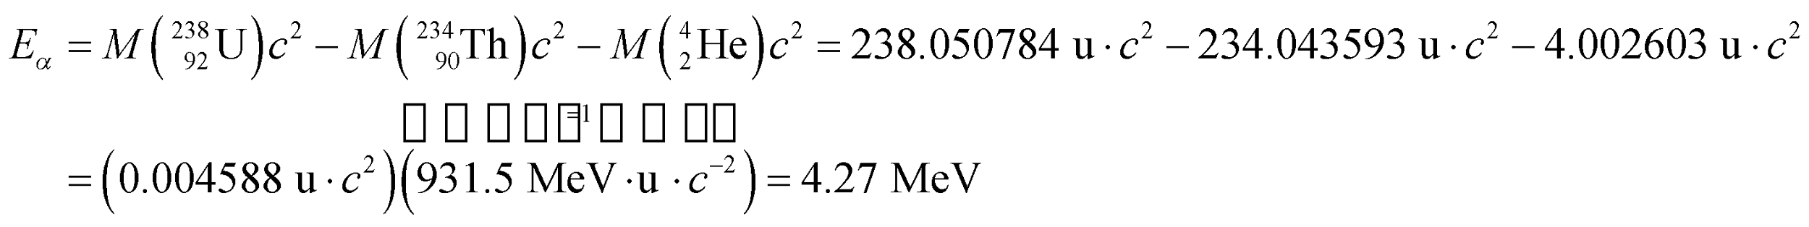
Thus, the energy released during the α-decay is 4.27 MeV. Note that the half-life of this decay process is about
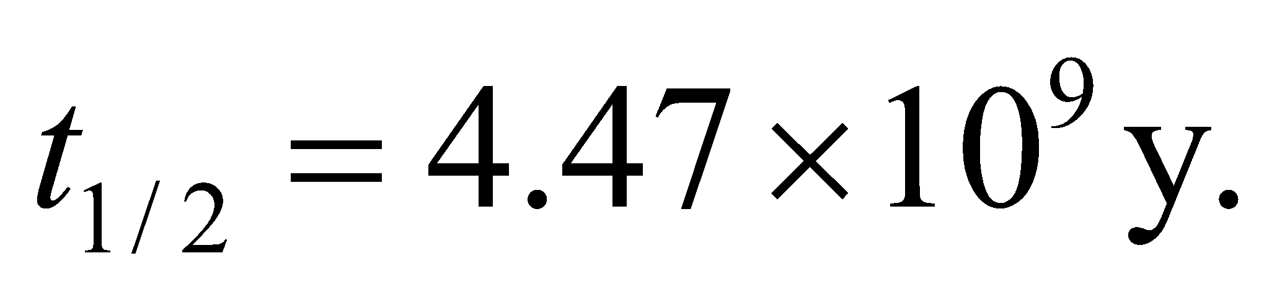
Assess The energy released in the decay is analogous to the binding energy for a stable nucleus, which has the opposite sign. In nuclear reactions, the difference in mass-energy between the initial and final reactants is called the Q-value, which is positive for exothermic (energy releasing) and negative for endothermic (energy absorbing) reactions.
69. Interpret We want to identify the product of a nuclear fusion reaction.
Develop Bismuth has atomic number 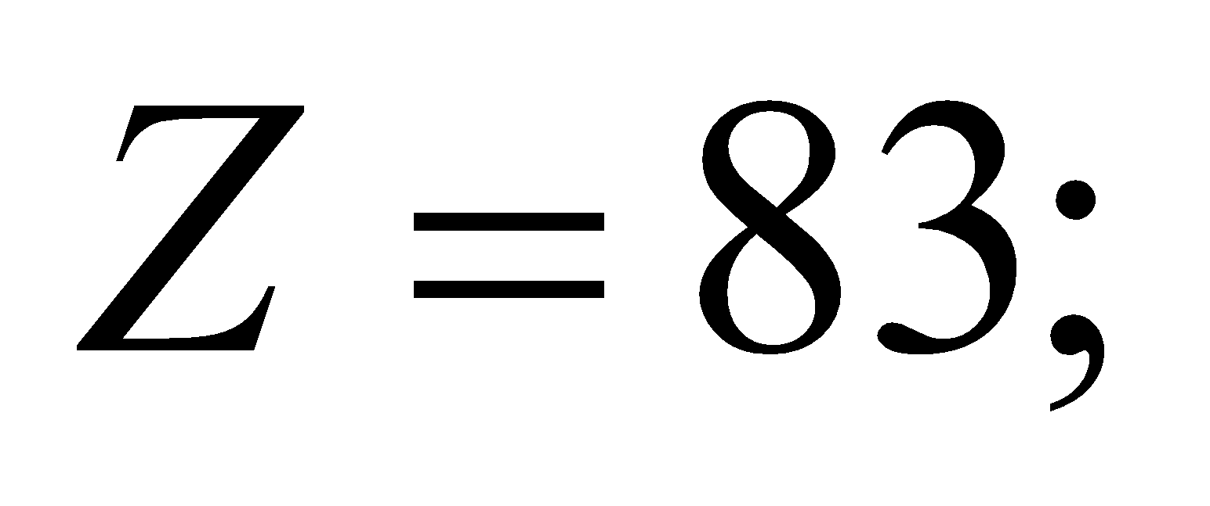chromium has atomic number 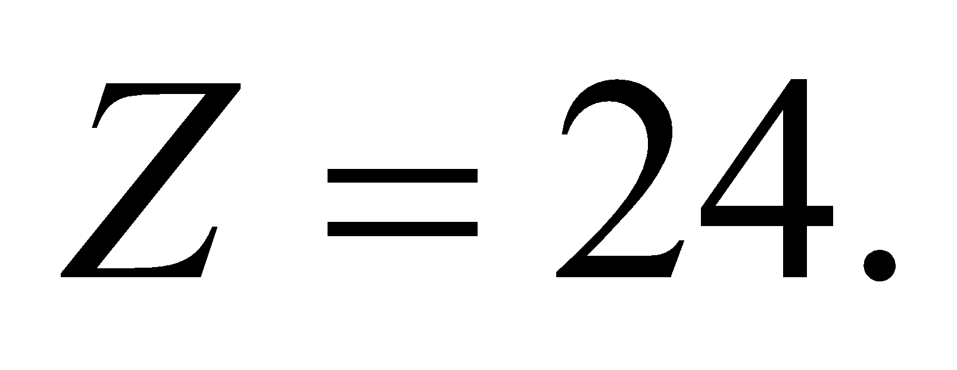 Since the nuclear reaction does not produce any beta particles, we can assume that the number of protons and the number of neutrons are both conserved separately.
Evaluate To conserve the proton number, the final product must have an atomic number equal to the sum of reactants' atomic numbers:
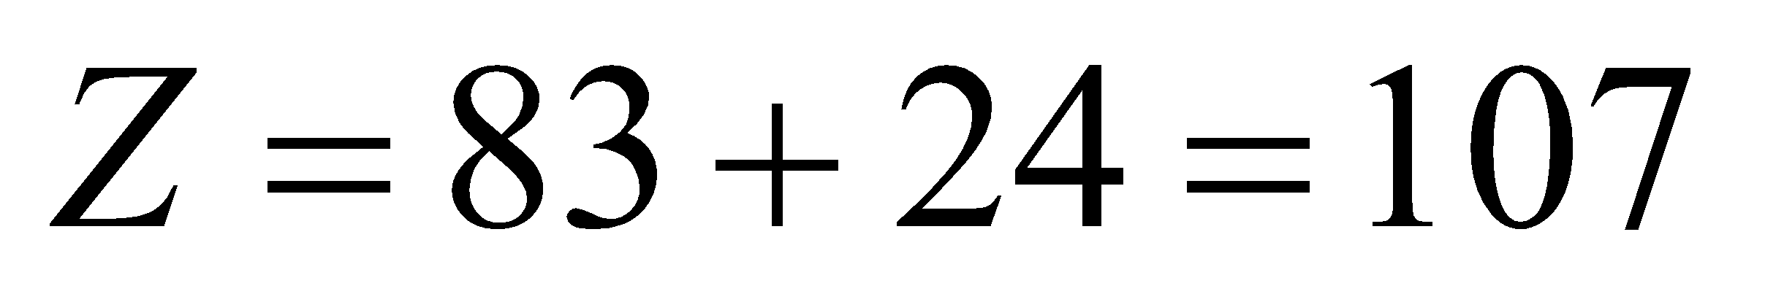
Looking in the periodic table, this corresponds to the element bohrium (Bh). To find its mass number, we need to account for the extra neutron produced in the reaction:
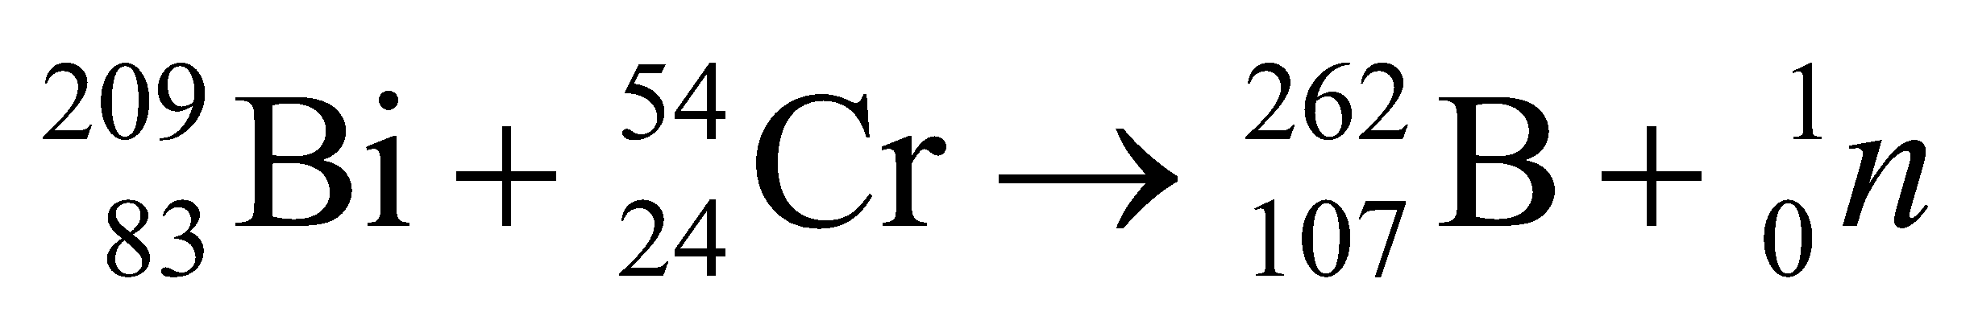
So the heavy nucleus is borhium-262 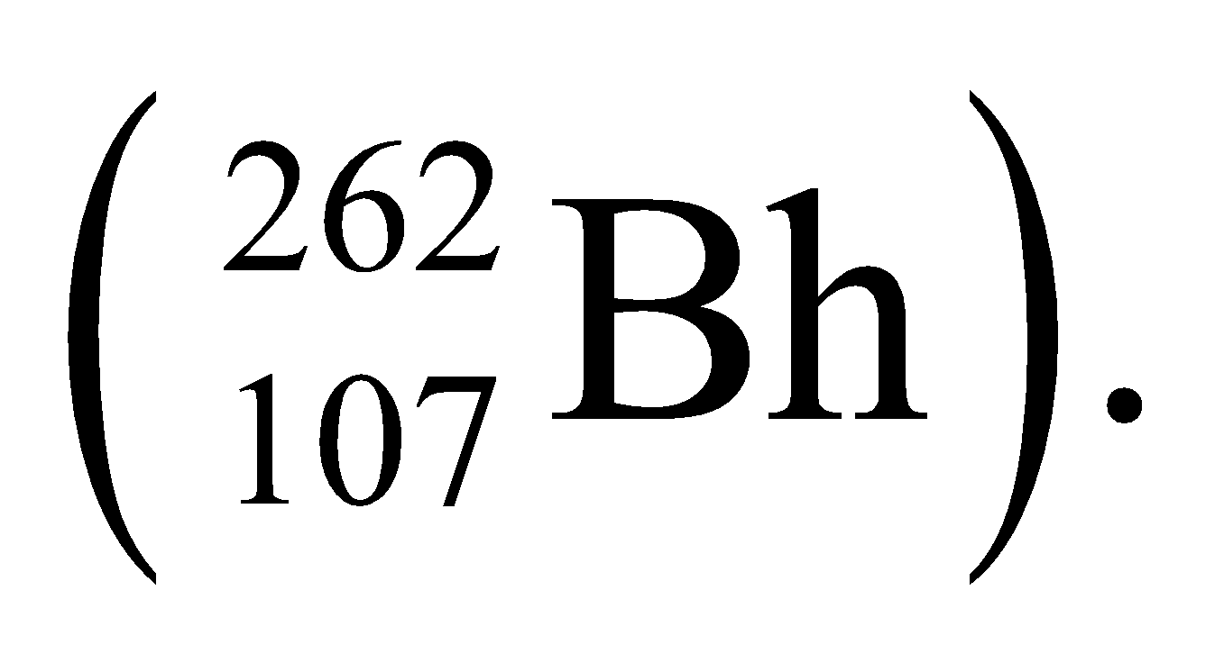
Assess This isotope of borhium has a half-life of only about a tenth of a second. There are no stable forms of this element, so it is not found naturally in the environment. It was first synthesized in a laboratory in the 1980s.
70. Interpret We are to write the reaction for producing a gold nucleus from bombarding mercury with neutrons.
Develop If we assume only one unknown product, the reaction will be of the form
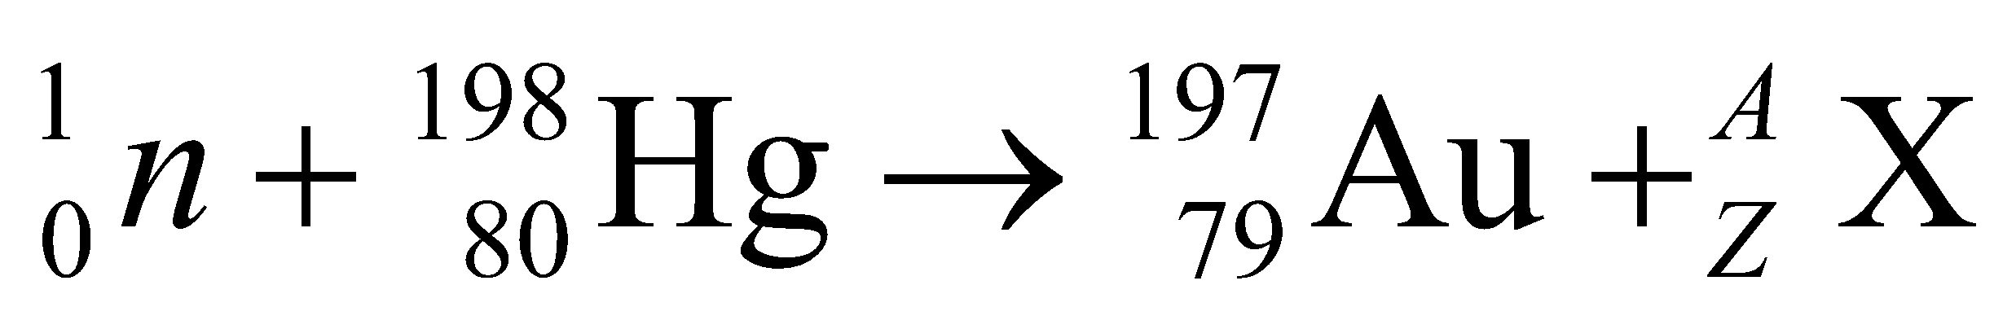
Conservation of charge and mass number implies that 80 = 79 + Z and 1 + 198 = 197 + A, so Z = 1 and A = 2.
Evaluate Thus, the unknown product is a deuteron, 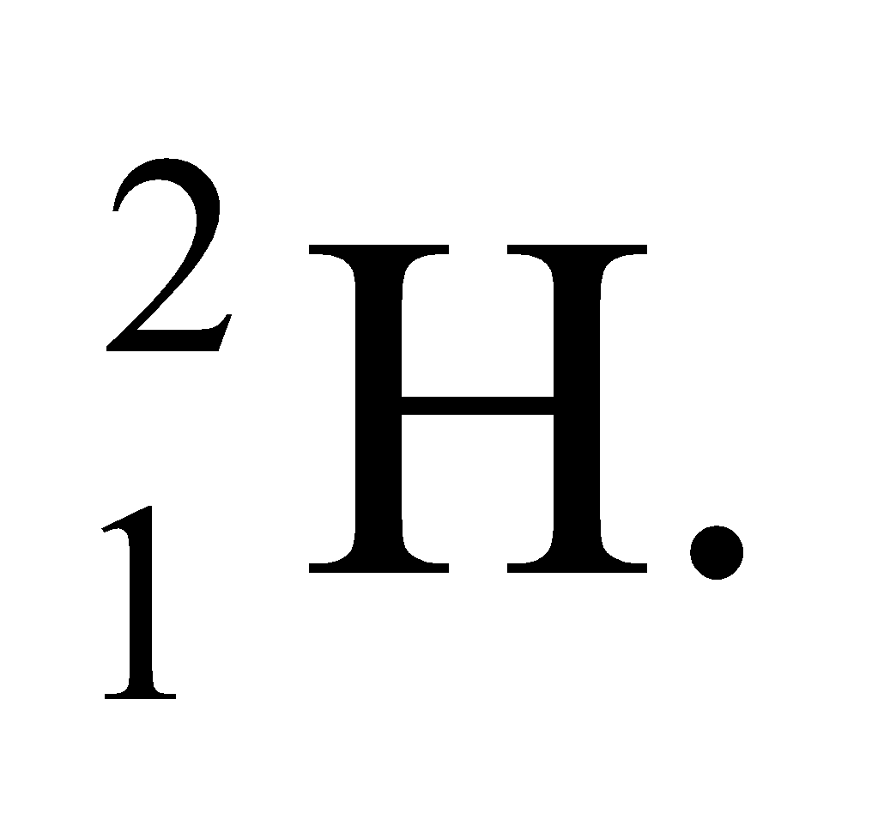 The reaction can be written as
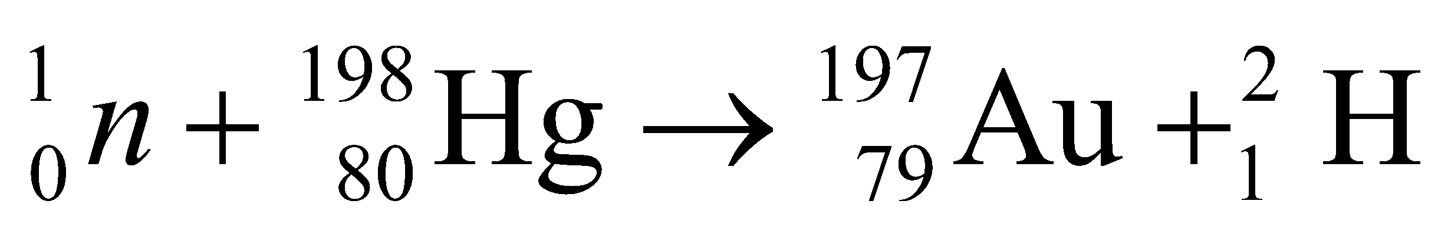
or symbolized by 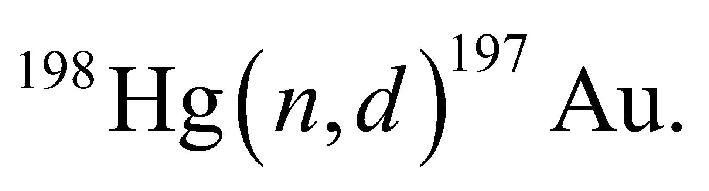
Assess The production of gold is an age-old dream of alchemists. While it is possible in nuclear reactors, the expense of the procedure far exceeds the financial gain!
71. Interpret This problem involves finding the products of a nuclear decay reaction. In addition, given the decay constant, we are to find the time required for the daughter nuclei to outnumber the parents by 2 to 1.
Develop In a the atomic number of the parent nucleus increases by one while the mass number stays the same (i.e., 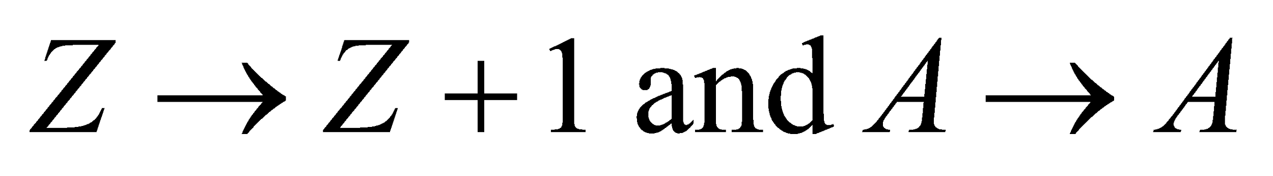). Given the Ni has Z = 28 and A = 65, we can identify the daughter nucleus. The number of parent nuclei at time t (in a sample that was pure at t = 0) is (see Equation 28.3a) which, when we solve for t, gives
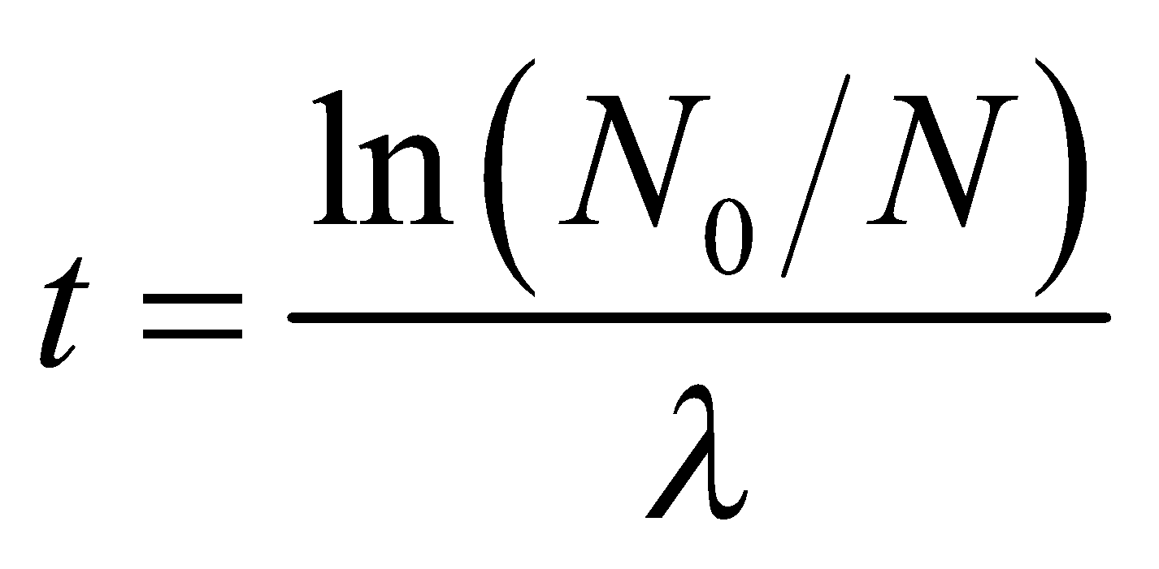
Since a single daughter nucleus is produced each time a parent nuclei is consumed in the reaction, the number of daughter nuclei is N_{d} = N₀ − N, which allows us to find the time t when N_{d} = 2N (recall that N is the number of parent nuclei).
Evaluate (a) The daughter nuclei is 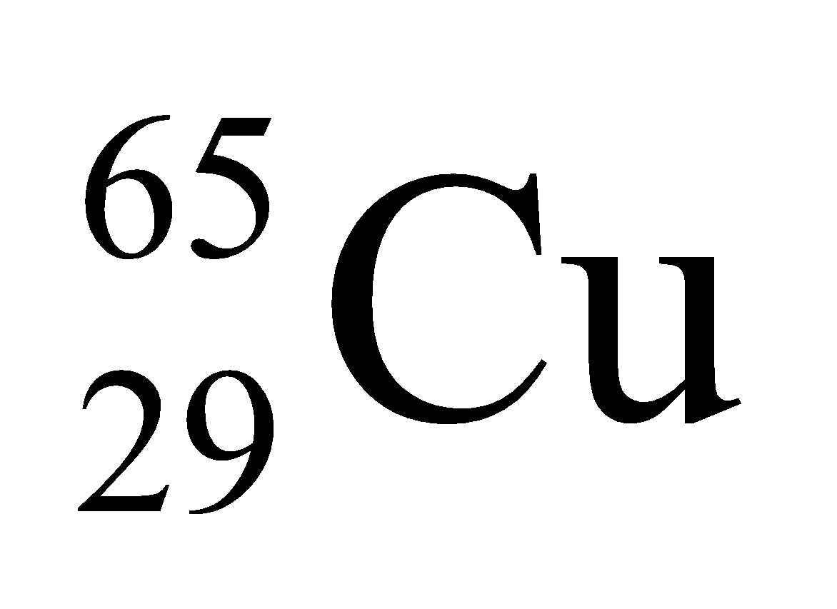.
(b) When N_{d} = 2N, N0/N = 3, so the time required is
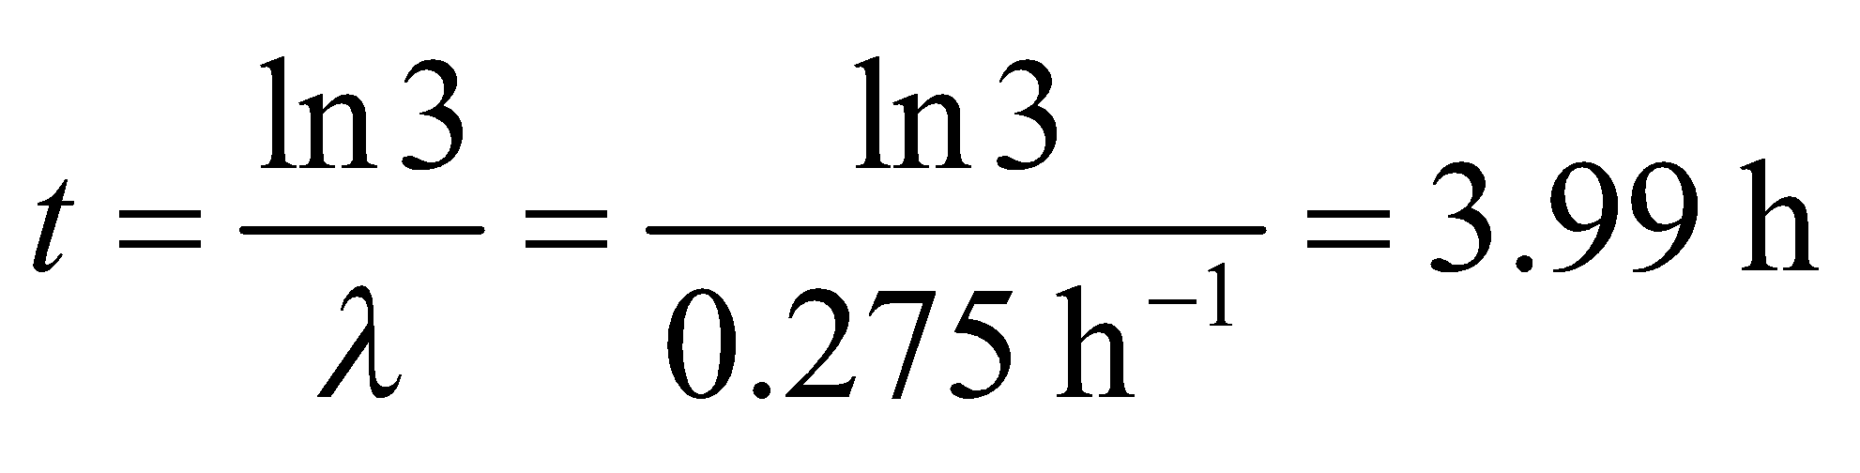
Assess The reaction may be written as
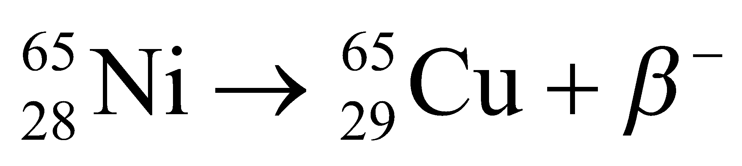
72. Interpret We're asked to estimate the human body's natural radioactivity, given the mass of the dominant radioactive elements in the body.
Develop For a given element, the radioactivity is the number of decays per unit time given by 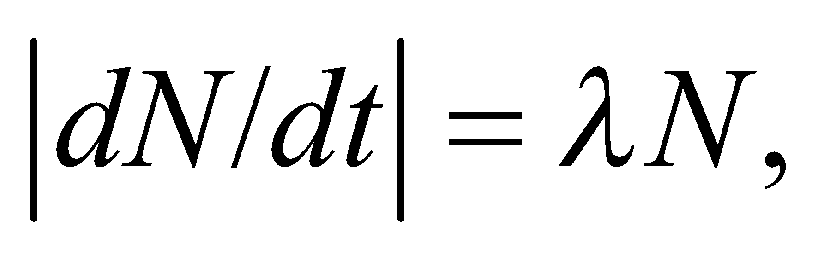where 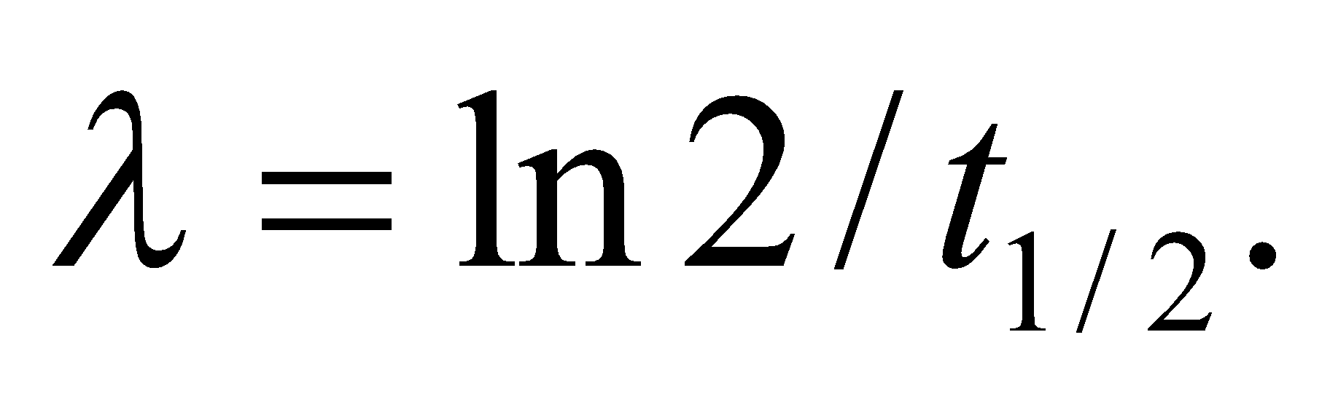 The half-life of potassium-40 is 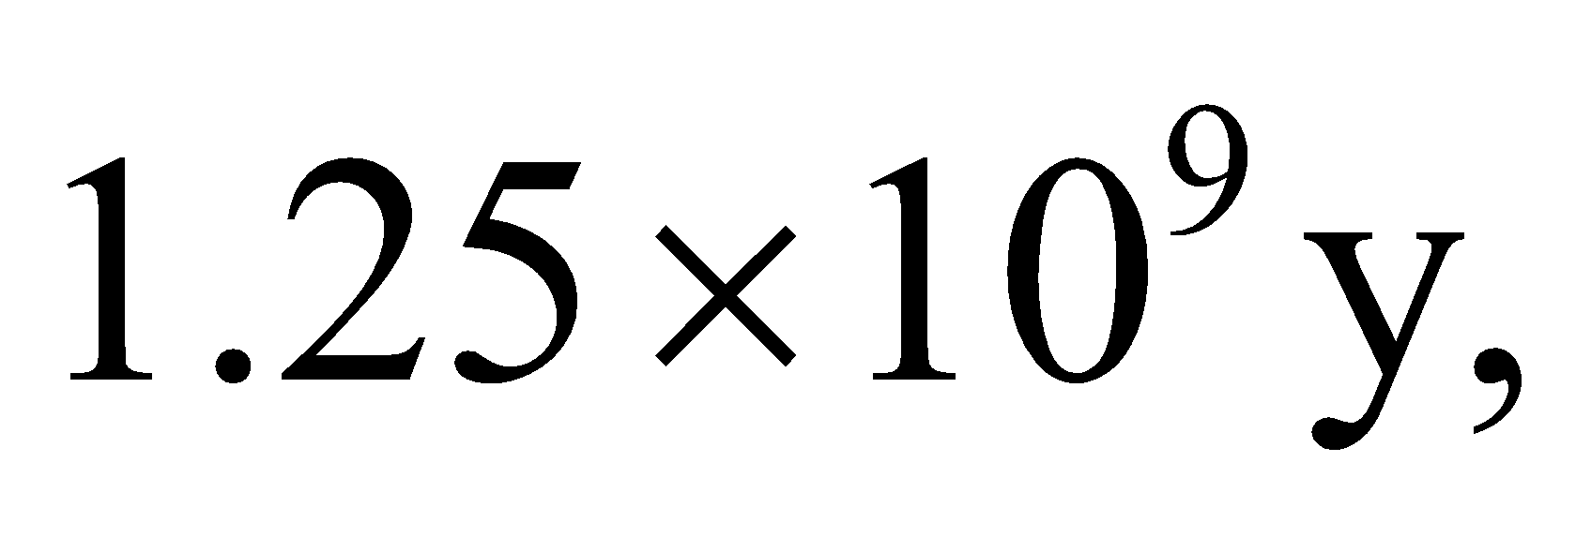 while that of carbon-14 is 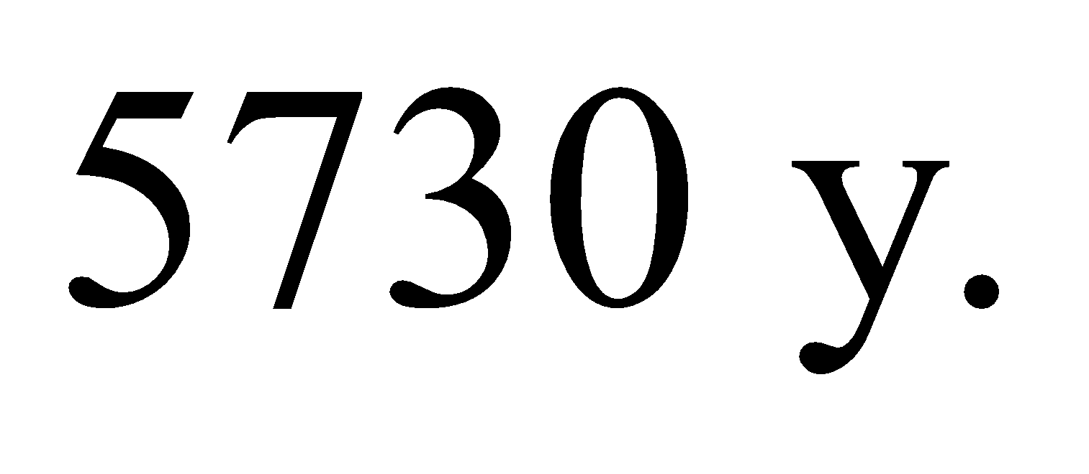The number of each element is 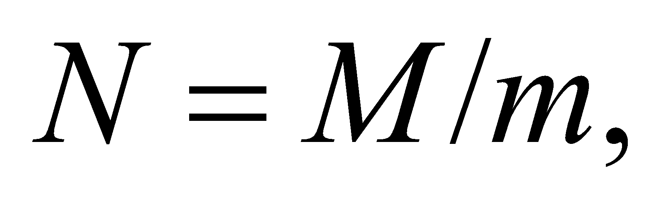 where M is the total mass found in the body and m is the mass of a single nuclei, which is just the mass number multiplied by the atomic mass unit, u.
Evaluate We will use as our unit of radioactivity the becquerel (Bq), which is defined as one decay per second. For K-40, the radioactivity is
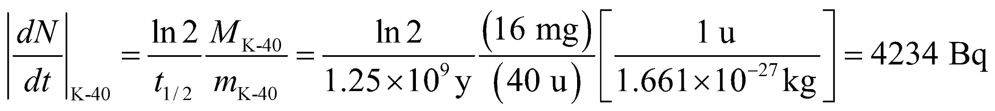
For C-14, the radioactivity is
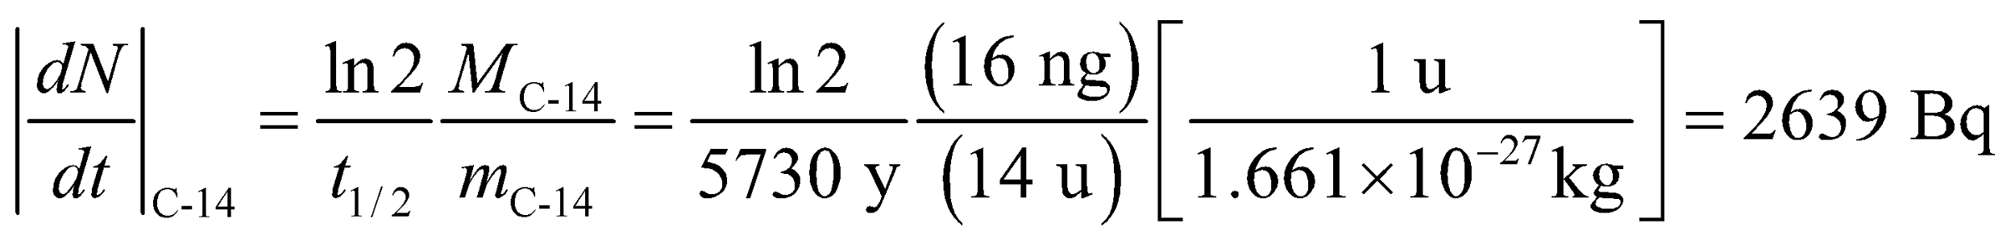
Adding these two results together gives the body's total radioactivity
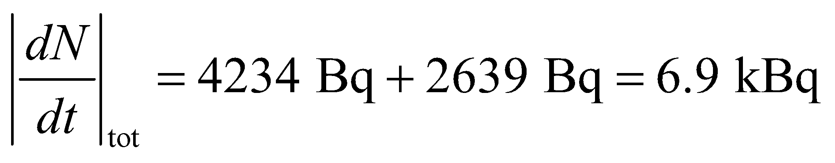
Assess The answer agrees with Problem 38.22, where we were told that the human body's natural radioactivity is about 7 kBq.
73. Interpret This problem is about the energy released in D-T fusion. We also want to compare the fusion energy with the energy produced by a coal-burning power plant.
Develop Half of the number of deuterons in one fuel pellet is
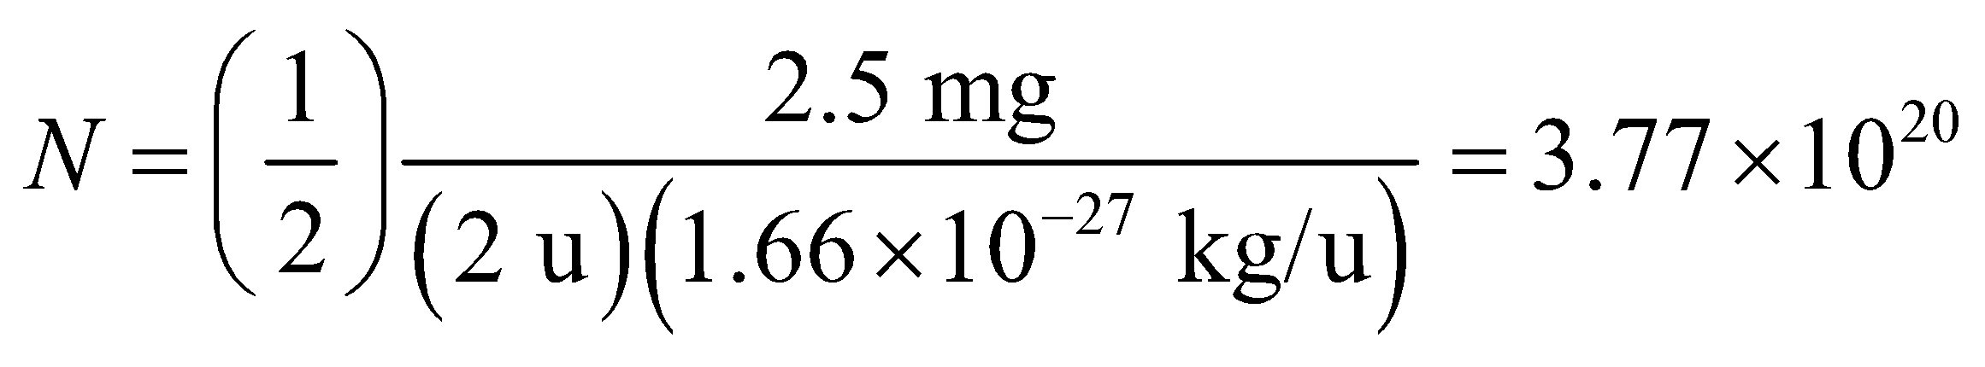
since there is 2.5 mg of deuterium in a pellet and the mass of a deuteron is approximately 2 u. As given in Equation 38.10a, each D-T reaction releases E₁ = 17.6 MeV of energy.
Evaluate (a) The total amount of energy released in the D-T fusion reaction is
(b) The thermal power output, 3.000 GW, is equal to the energy release per pellet times the rate that pellets are consumed, hence this rate dN_{pel}/dt of pellet consumption is
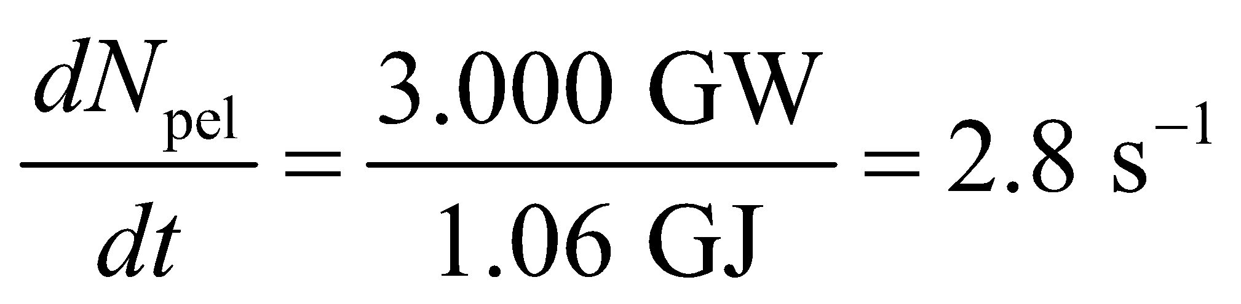
(c) 5.0-mg pellets, consumed at this rate for a year, have a total mass of
A comparable coal-burning power plant uses more than 7 million times this mass for its fuel.
Assess The amount of energy released by D-T fusion is enormous compared to the energy content of coal fuel. Controlled fusion devices could play a key role in future energy production.
74. Interpret This problem involves calculating the amount of ²³⁹Pu produced in a uranium power plant. We are also to estimate the number of potential plutonium bombs that could be produced by such a plant.
Develop In one year, the number N of fission events in a power plant whose thermal output is (0.30)(1.0 GW) = 3.33 GW is
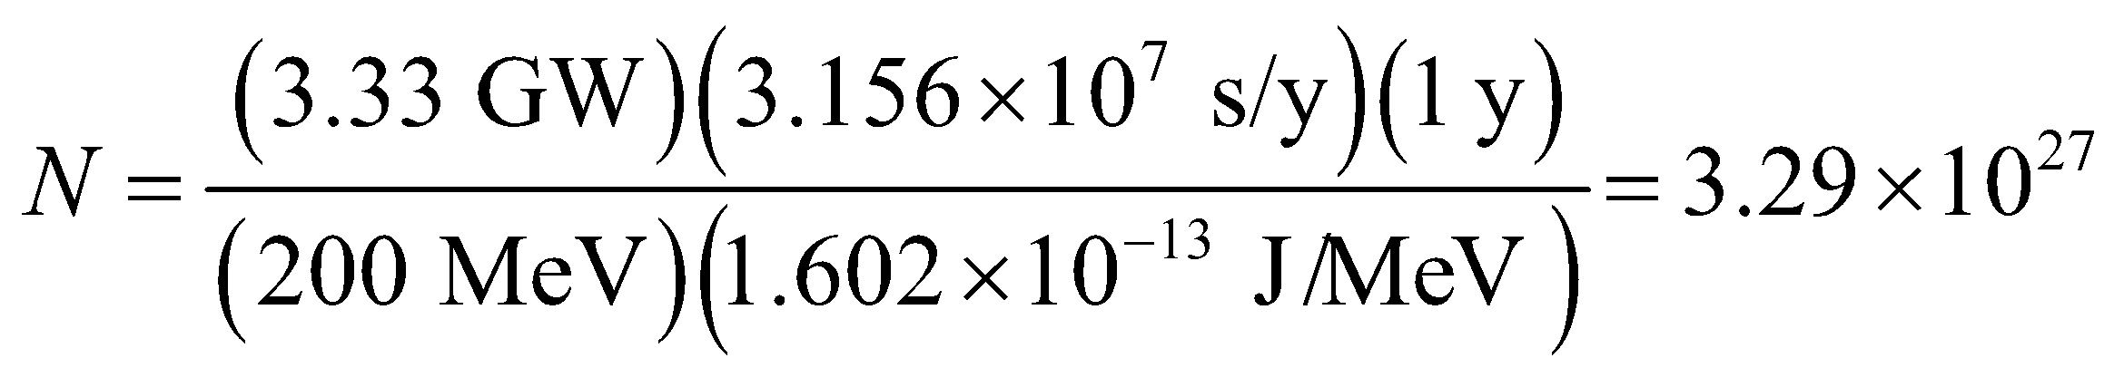
is the total energy released in a year divided by the energy release in one fission event, as in Example 38.6. The number of ²³⁹Pu nuclei produced is the number of fission events times the neutron absorption probability (= 0.6), from which we can find the mass of ²³⁹Pu produced. Since it takes 5 kg of ²³⁹Pu to produce a single bomb, we can divide the mass of ²³⁹Pu produced by 5 kg to find the total number of potential bombs that can be produced from this reactor.
Evaluate (a) The amount of ²³⁹Pu formed (atomic weight approximately 239 u) is
(b) This is enough to make (783 kg)/(5 kg) = 157 bombs, if all of the ²³⁹Pu could be extracted from the spent reactor fuel.
Assess This is another reason nuclear energy is controversial.
75. Interpret We are to find the value of Z within the liquid-drop model that gives the minimum nuclear mass as a function of A. This value of Z will be the most stable of the nuclei for that atomic mass.
Develop The formula given us for the liquid-drop model is
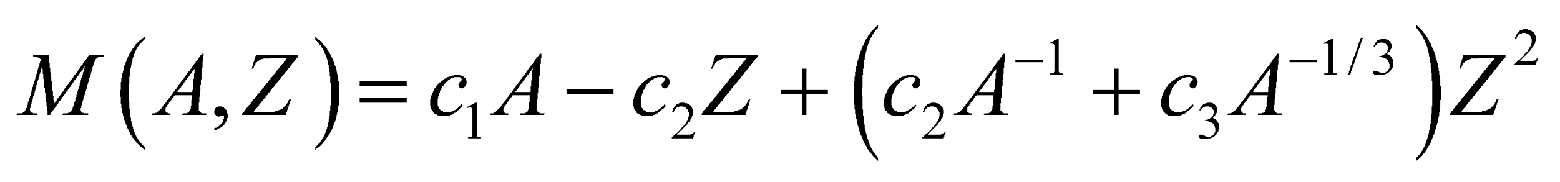
We shall take the partial derivative 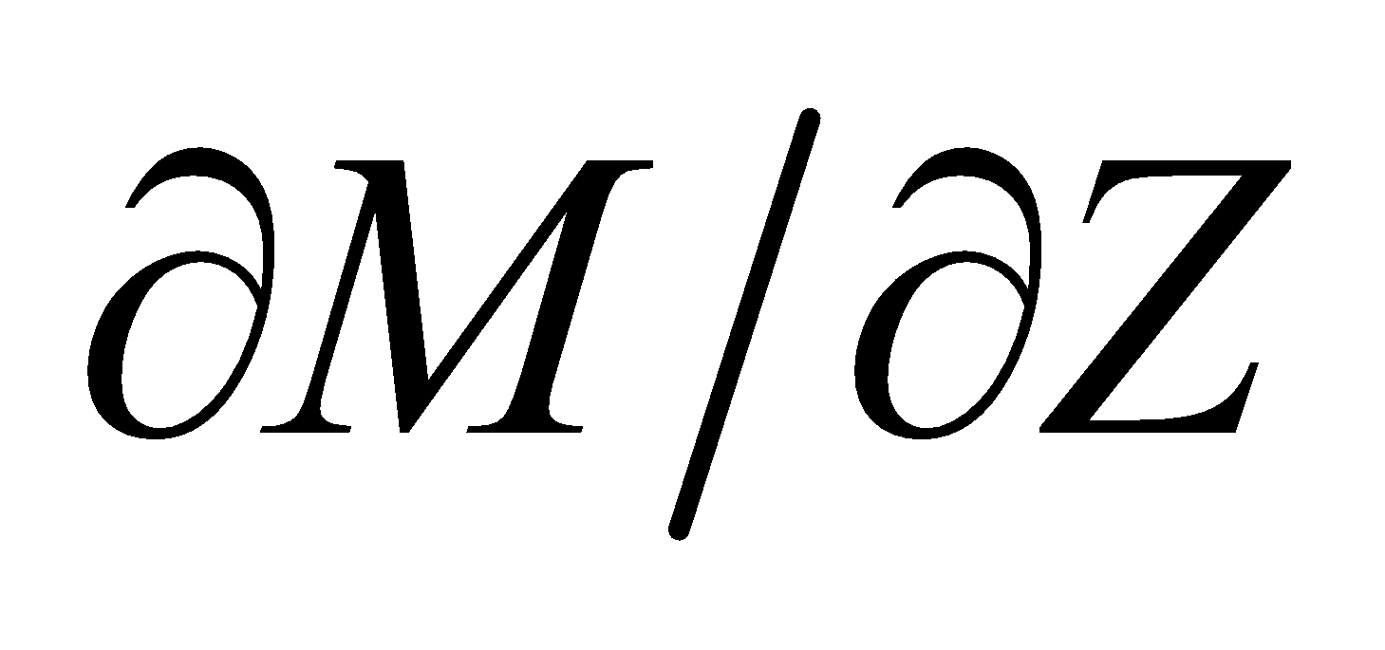 and set it equal to zero to find 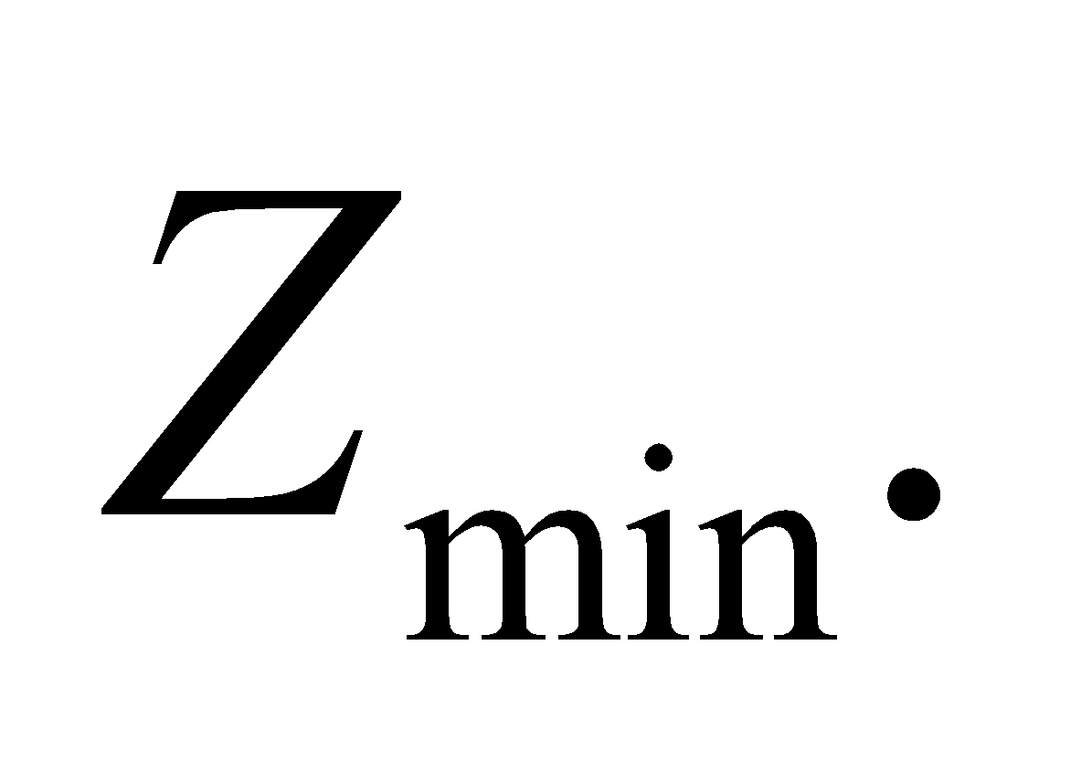
Evaluate Taking the derivative gives
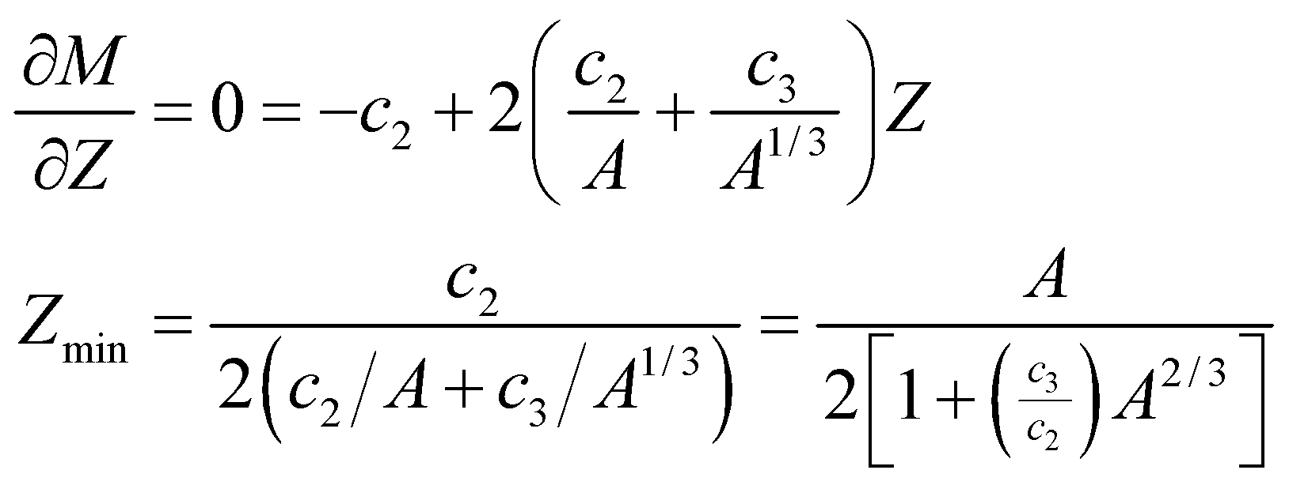
Assess To check that this is a minimum, we take the second partial derivative, evaluate it at Z_{min}, and verify that the result is positive:
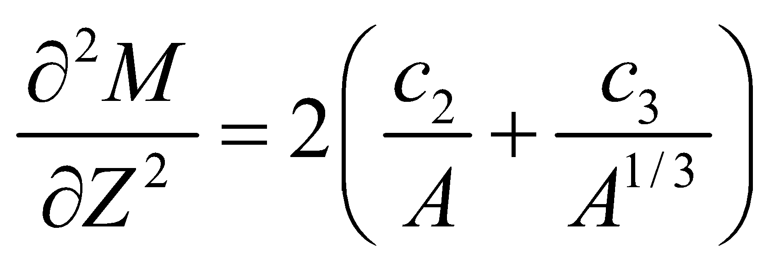
which is positive if 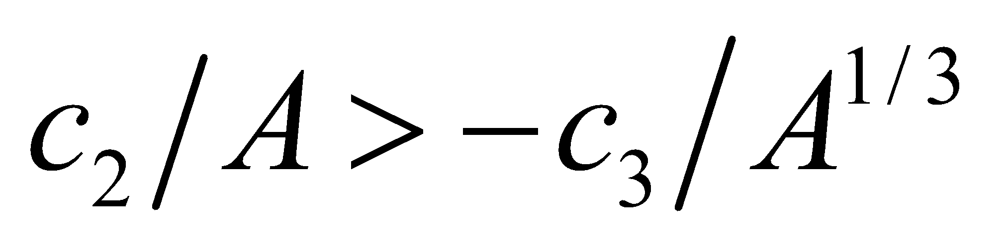.
76. Interpret We are to find the average lifetime of a radioactive nucleus using the approach outlined in the problem statement, and show that the result is the inverse of the decay constant of Equation 38.3a.
Develop The number of nuclei that will decay in a given time interval dt is 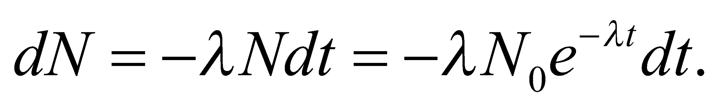 To find the average lifetime of a nucleus, we sum number of nuclei that survive to time t and divide by the total number of nuclei:
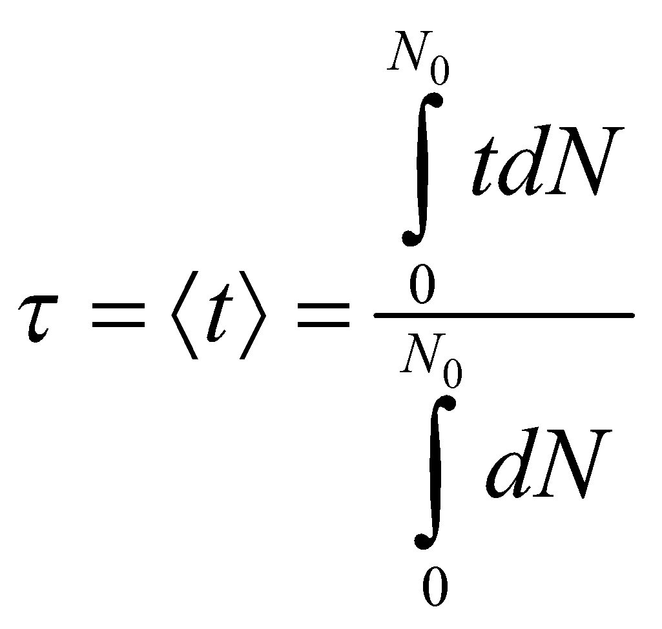
Evaluate We can evaluate the integrals with the help of the integral table in Appendix A. The result is
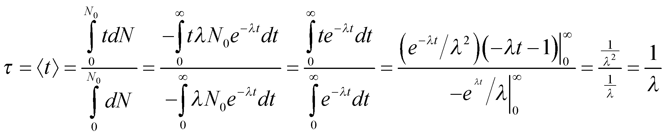
Assess We find that the average lifetime of a nucleus is the inverse of the decay constant λ.
77. Interpret When one radionuclide decays into another radioactive nucleus, the total activity of the sample becomes somewhat complicated. Here we will calculate the total activity for a two-step decay reaction, starting with the differential equations that define activity.
Develop The activity of a sample is 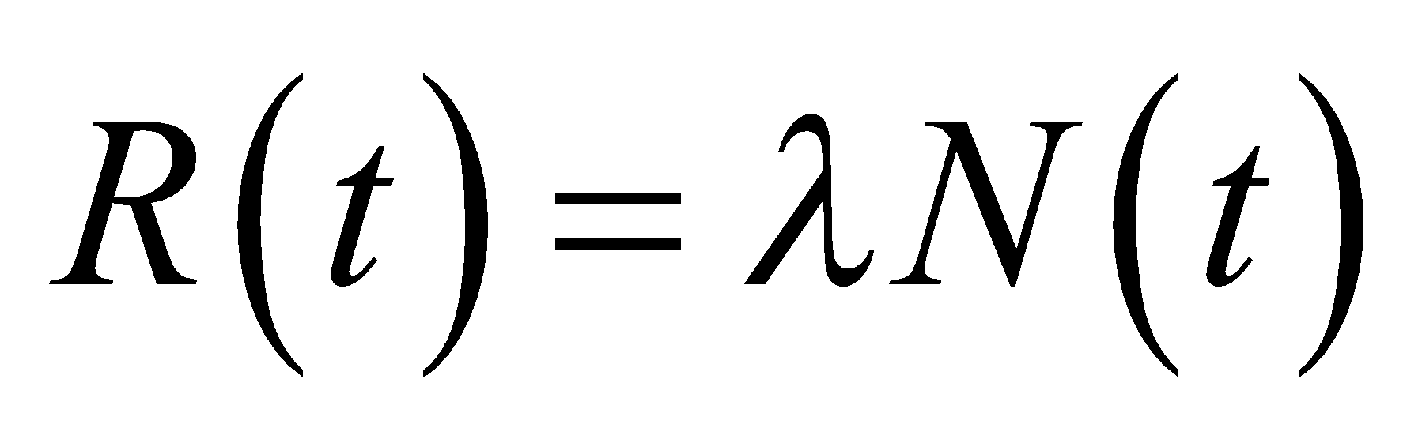 so if we find N(t) for each radionuclide, we can find the activity
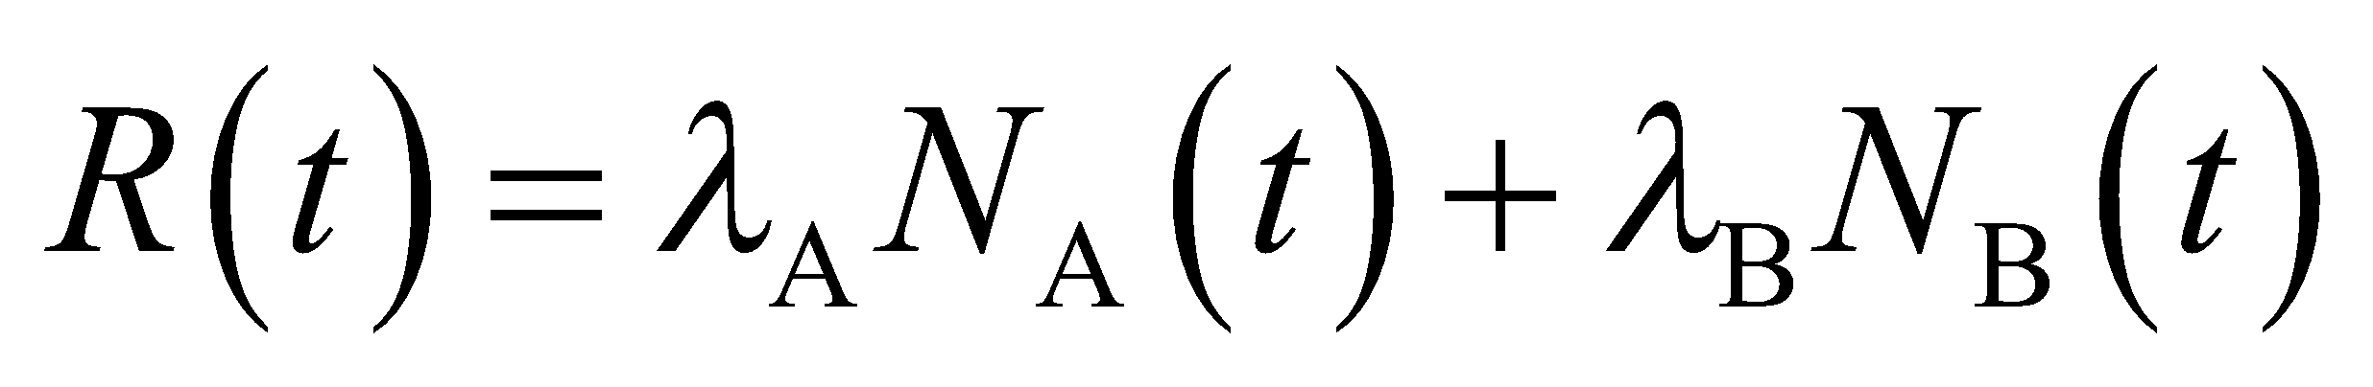
The equation for the parent nuclide is found in the usual way—it does not depend on the daughter at all. Thus, it is given by Equation 38.3a:
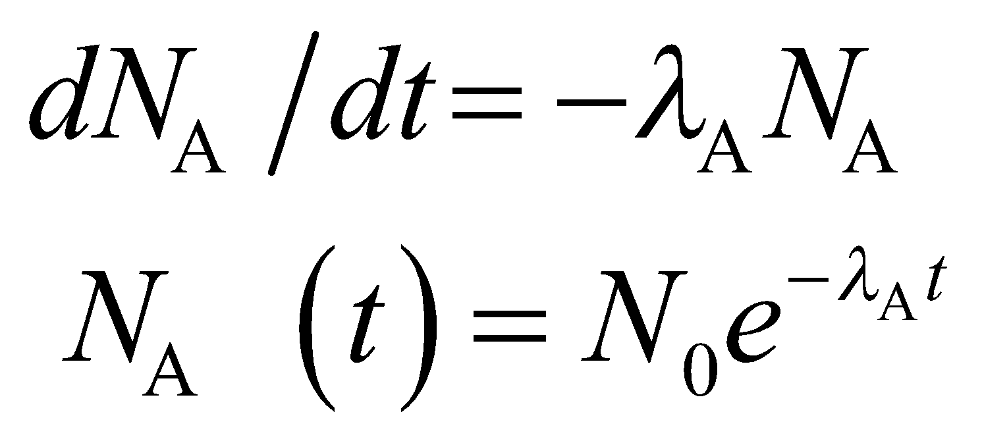
The differential equation for the daughter nuclide has the usual decay term, but it also has a growth term since each decay of a parent nucleus creates a daughter nucleus. Thus,
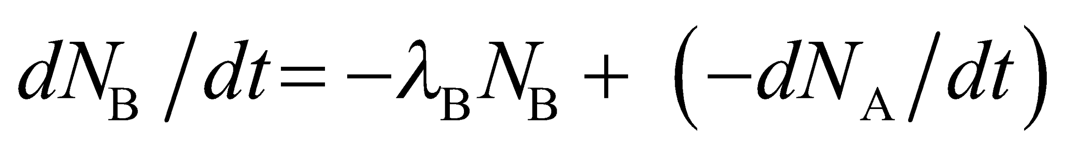
where we subtract the rate of change in the number of parent nuclides because a decrease in the parent (i.e., dN_{A}/dt < 0) count is an increase in the daughter count. We will solve this second differential equation for 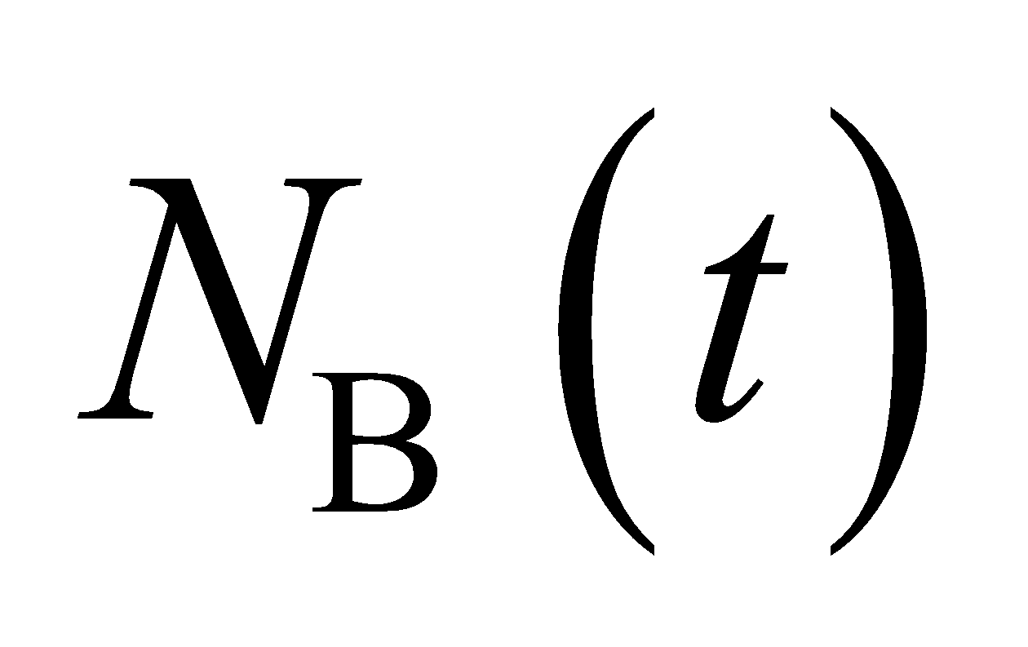 and then find the activity R(t).
Evaluate The rate of change in the daughter nuclide is
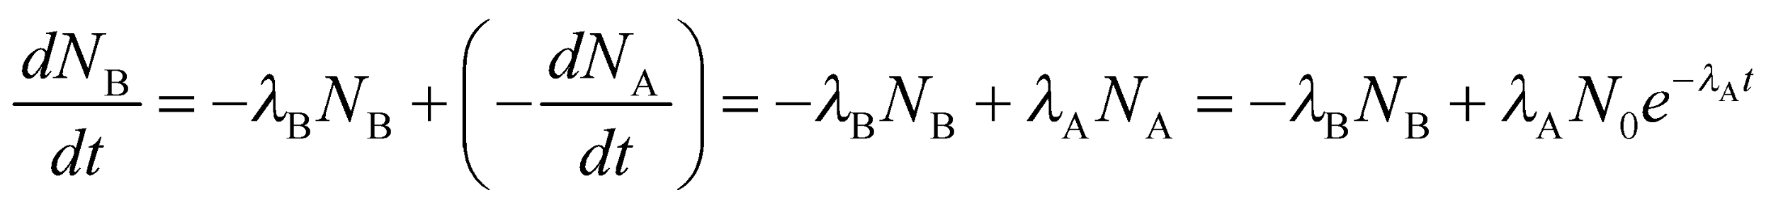
Try a solution of the form 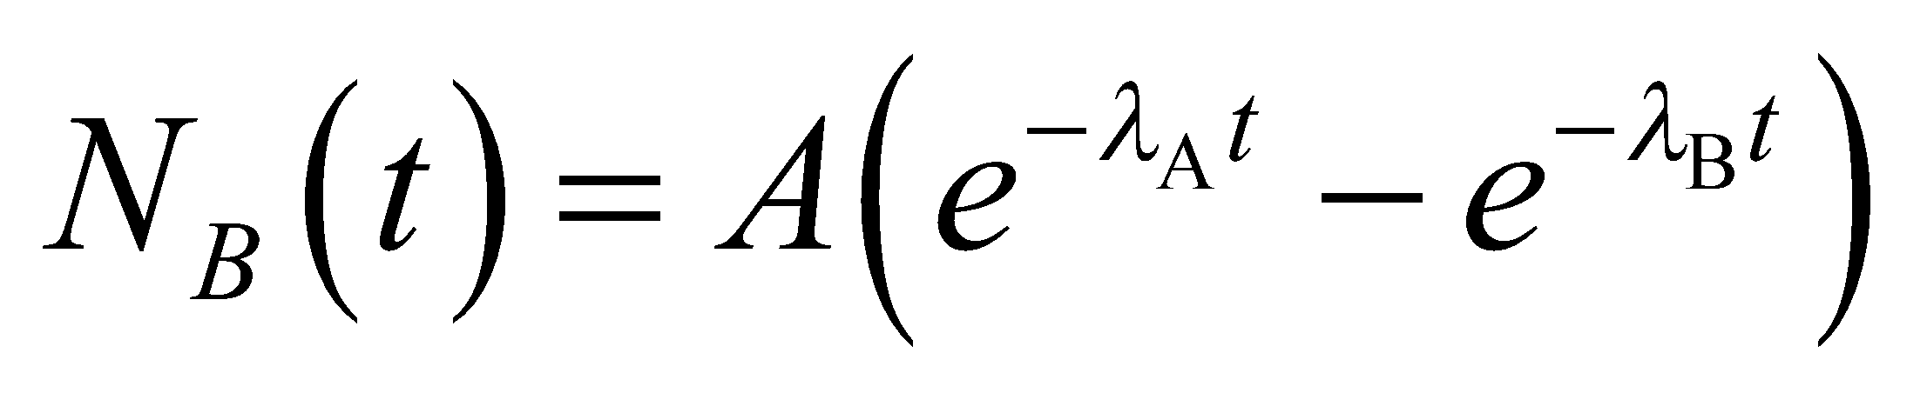. Inserting this into the differential equation for N_{B}(t) to find the coeficient A gives
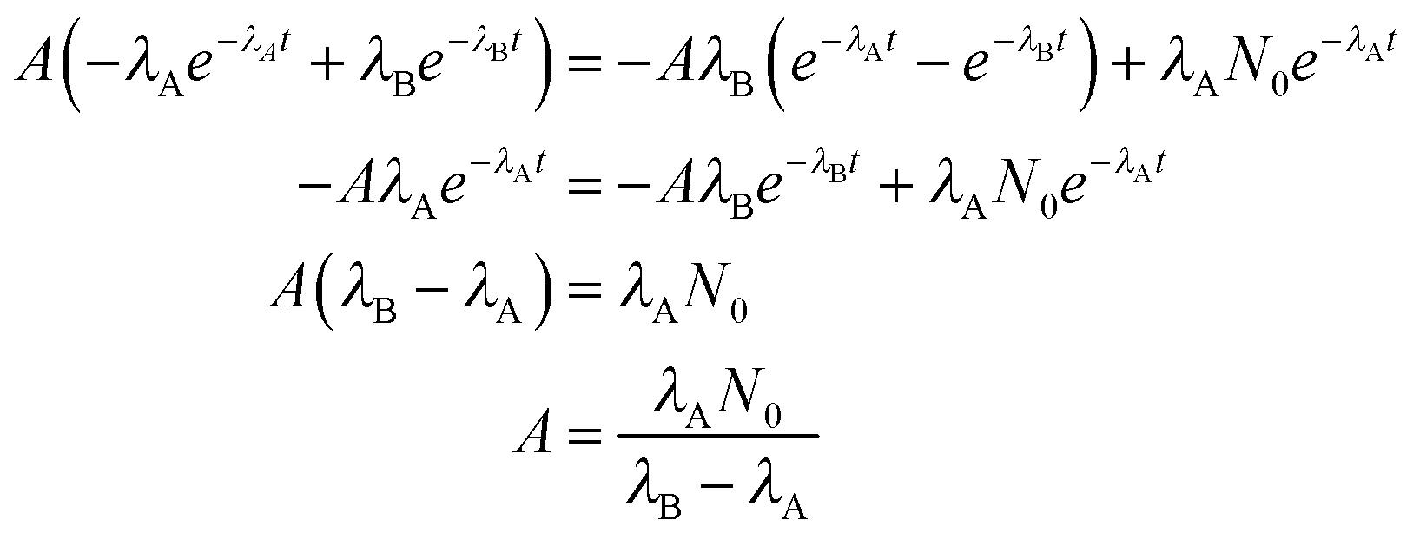
so
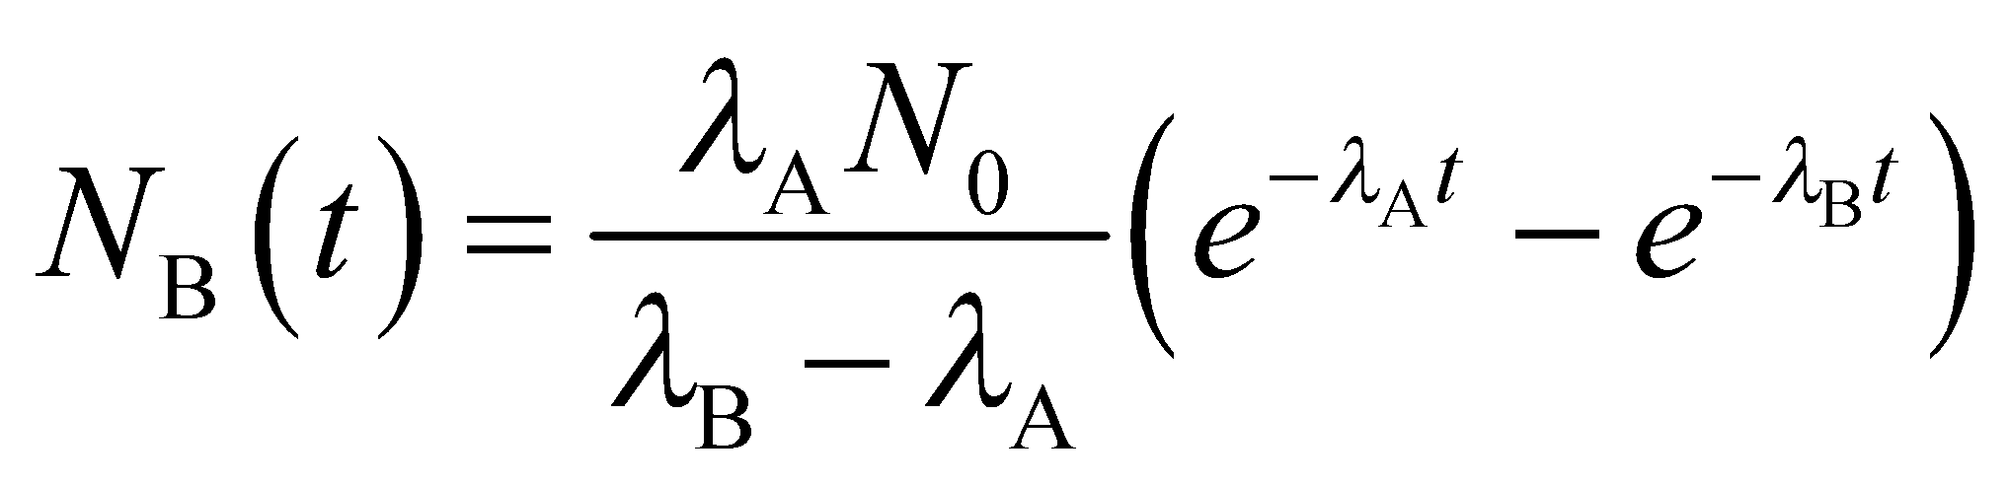
Combining this with N_{B}(t) to get the total activity R(t) gives
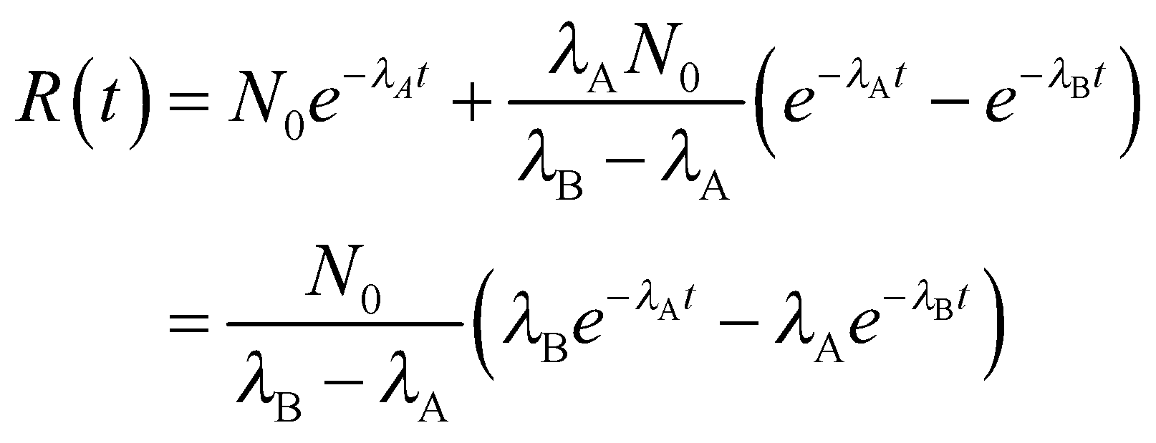
Assess Interestingly, the activity can actually increase with time! This is a serious problem right now with some of the radioactive holding tanks left over from the production of bomb-making material during WWII—their activity is increasing, and is expected to continue increasing for several more decades.
78. Interpret We are to find the total number of fission events that occur in n generations when the k-factor is greater than unity. We are to use this result to determine the time it would take for all nuclei in 10 kg of uranium to react.
Develop In part (a), we shall show that 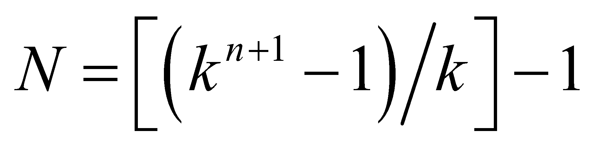 by summing the atoms that react each generation:
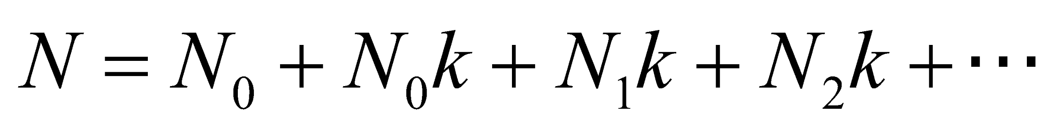
In part (b), we shall use the sum from part (a) to find the time it takes to split 10 kg 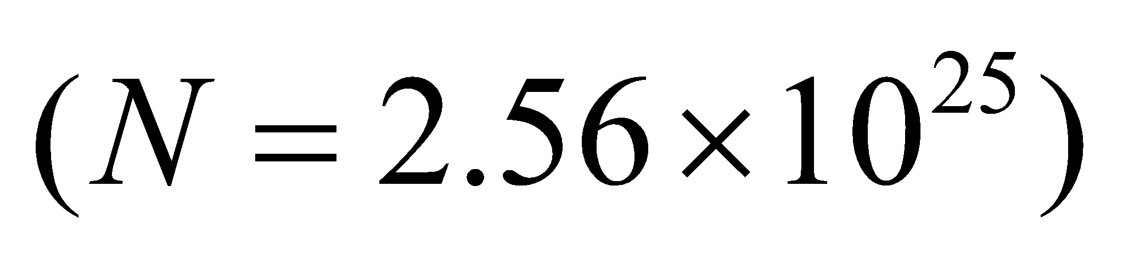 of ²³⁵U atoms, given that the time between generations is τ = 10 ns and k = 1.5. We will solve for the number of generations and multiply by t to find the total time to fission all the nuclei.
Evaluate
(a) Take N₀ = 1 and let each subsequent N be equal to the previous N times k. This gives
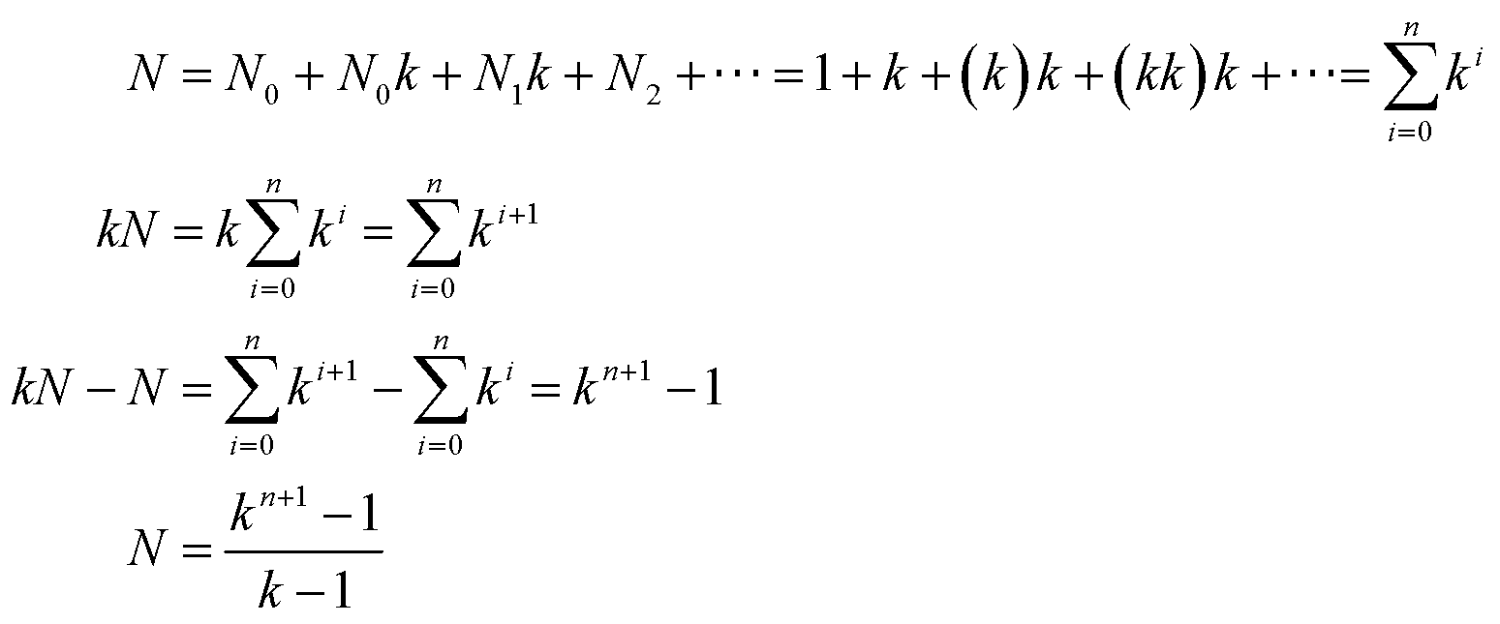
(b) Solving for the number of generations n yields
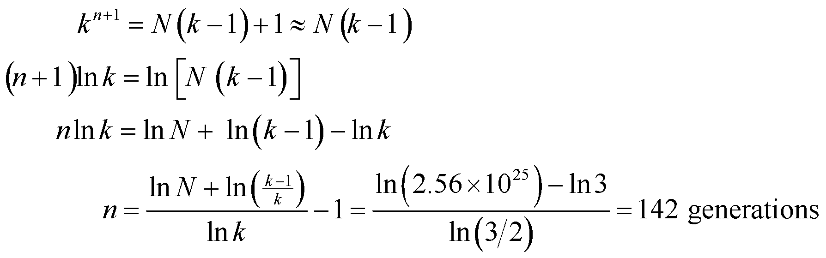
where we have neglected unity compared to N(k − 1) in the first line. Thus, the total time for all fission events is
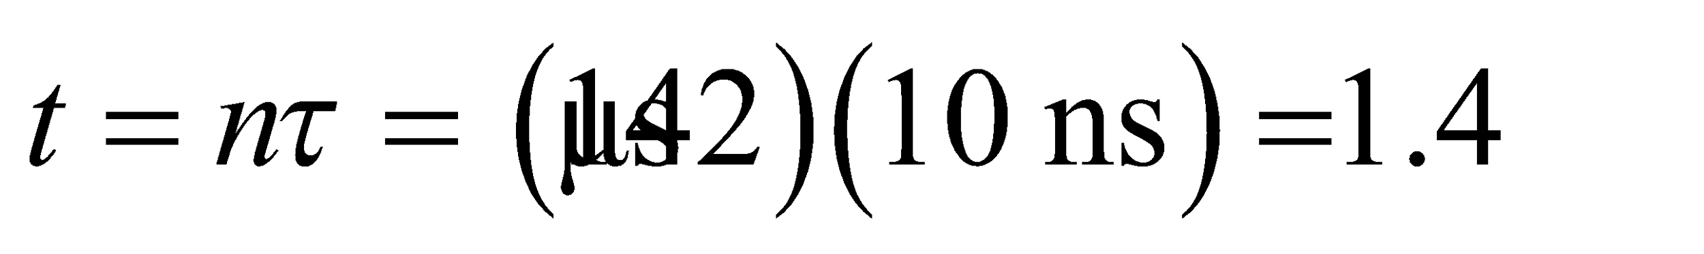
Assess For a controlled nuclear reaction, the value of k must be kept very close to unity. Large values such as k = 1.5 are impossible to control mechanically.
79. Interpret You're curious whether enough of a short-lived radioisotope is being made for a medical scan planned for one of your family members.
Develop The initial mass of Tc-99* will be reduced to 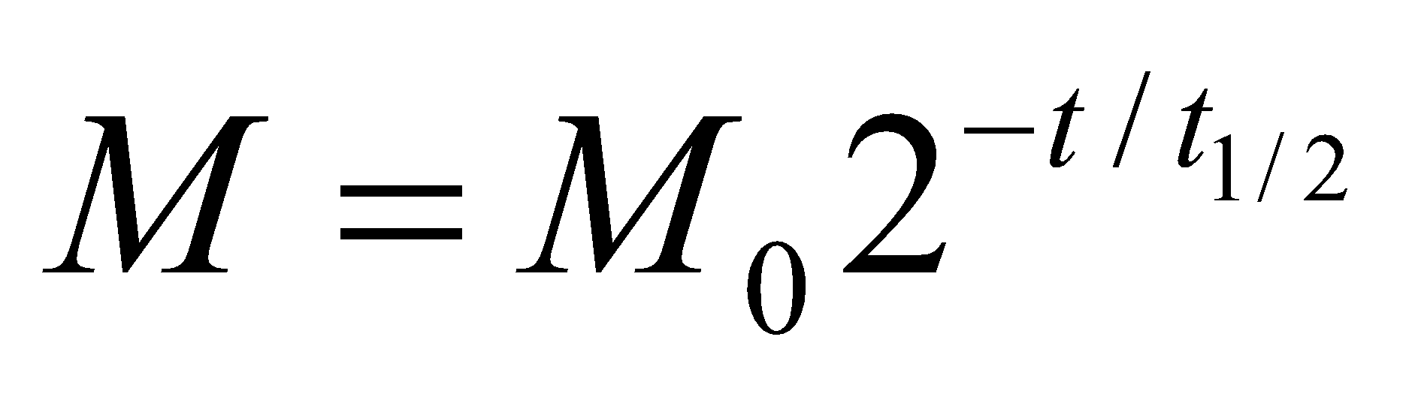 (a variation on Equation 38.3b) during the 90 minutes that it takes to transport it to the nuclear medicine department. Although you are given the half-life of the parent isotope, molybdenum-99, the only relevant half-life is that of the excited state of technetium-99, 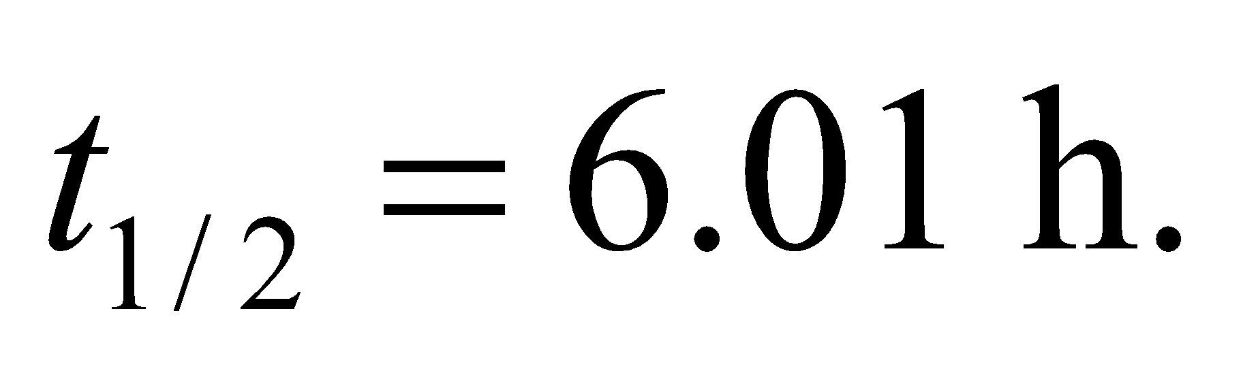
Evaluate Writing 90 min as 1.5 h, the amount of the initial 12 mg of Tc-99* that remains is
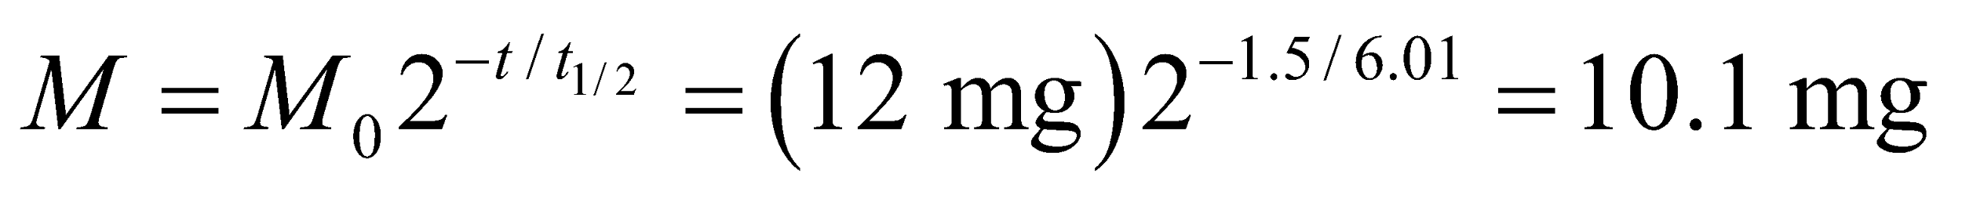
This is (barely) above the required 10 mg, so yes, the initial amount will be enough.
Assess It might seem like the hospital staff is not leaving themselves much room for delay, but they presumably do not want to over-produce the amount of Tc-99*, since that would increase costs, as well as increase the risks from handling this radioactive material.
80. Interpret We will explore the circumstances surrounding a natural nuclear fission reaction that occurred 2 billion years ago.
Develop Since the Oklo fission reaction, there have passed several half-lives of U-235, more precisely
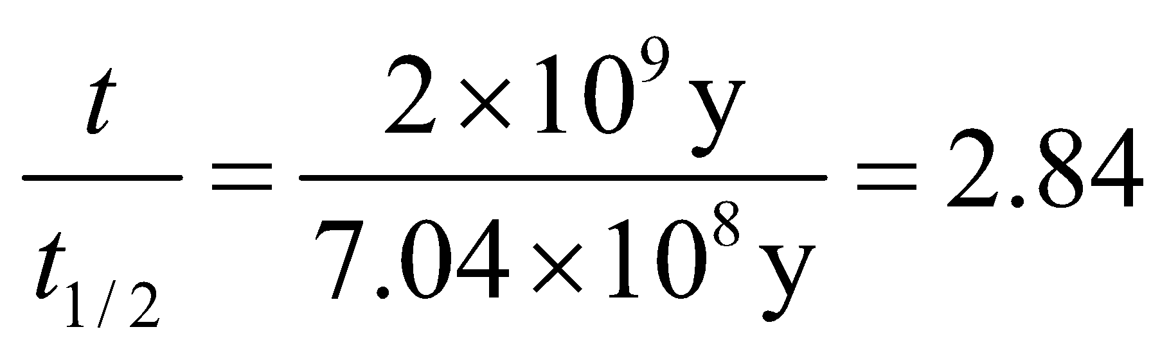
Evaluate Two billion years ago, the number of U-235 at the Oklo site relative to now was
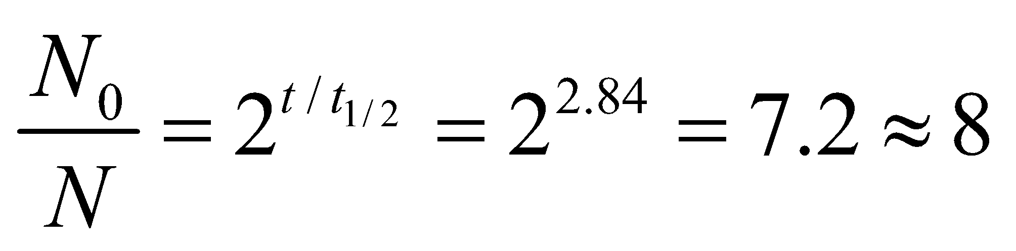
The answer is (d).
Assess Notice that this result is completely general. The amount of U-235 here or anywhere in the solar system was 8 times greater 2 billion years ago.
81. Interpret We will explore the circumstances surrounding a natural nuclear fission reaction that occurred 2 billion years ago.
Develop We want to know what the ratio between U-235 and U-238 was two billion years ago in natural uranium. In the previous problem, we showed that 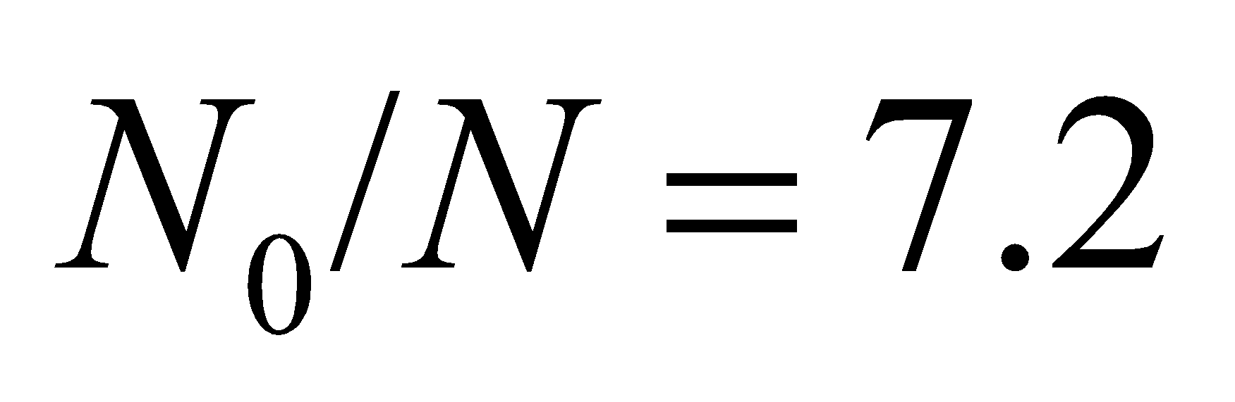 for U-235. For U-238 with 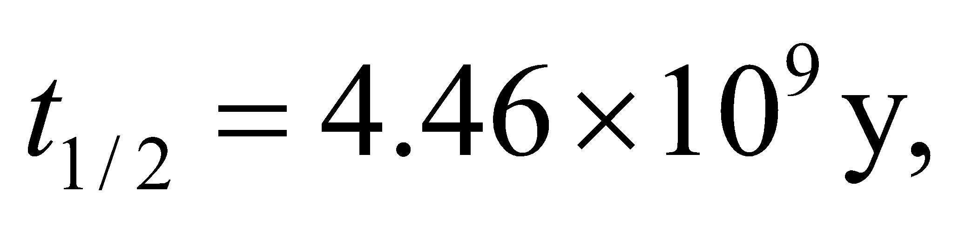
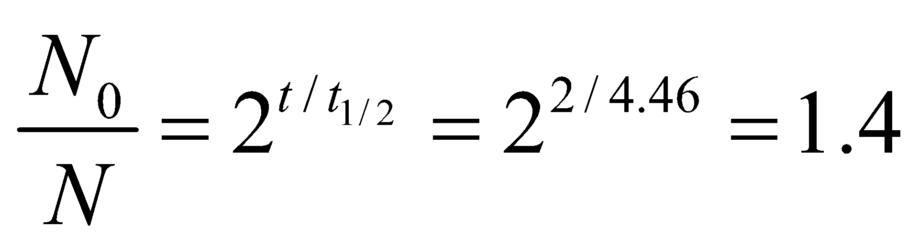
Evaluate Two billion years ago, a typical sample of uranium would have as its ratio of U-235 to U-238:
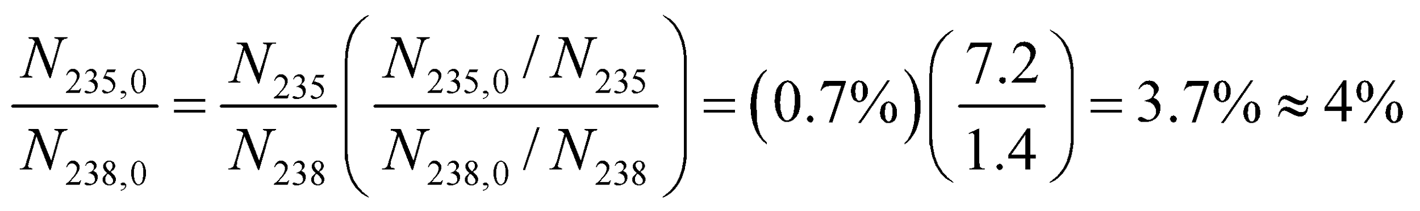
The answer is (b).
Assess Since U-235 decays 6 times faster than U-238, there had to be relatively more of U-235 in the past.
82. Interpret We will explore the circumstances surrounding a natural nuclear fission reaction that occurred 2 billion years ago.
Develop The water at Oklo served as the moderator. It slowed down neutrons created in the fission reaction. These slow neutrons were vital to the chain reaction, as they were what initiated the next generation of fission reactions.
Evaluate In the description of nuclear reactor types, the text makes it clear that a loss of moderator will cause the chain reaction to halt. Therefore, if the water boiled away at Oklo, the fission reaction would cease.
The answer is (a).
Assess We can think of this in terms of the multiplication factor, k, which is the average number of neutrons from a fission event that cause additional fission. We can assume that Oklo when it was working had 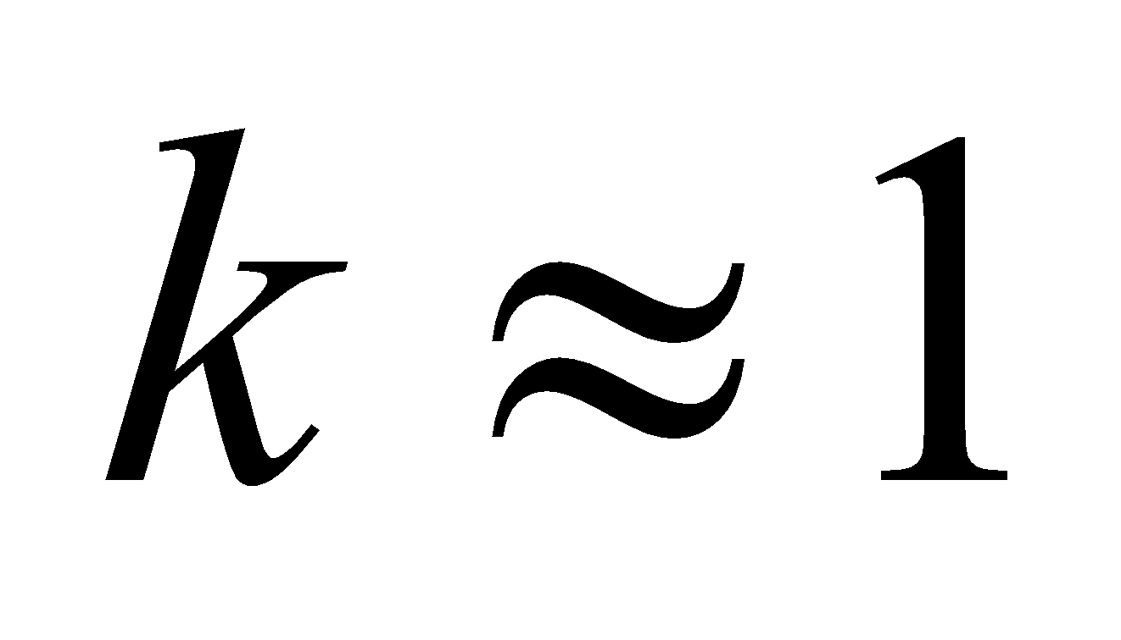 (critical mass), since the supercritical case with 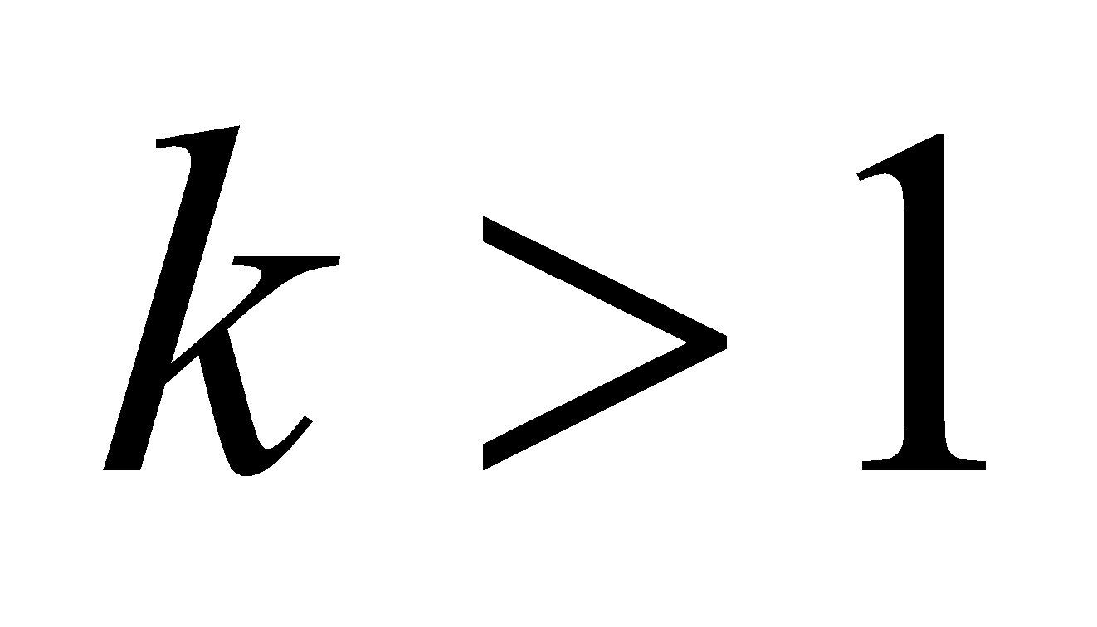 would have resulted in the fuel being burned up in a very short time, which is inconsistent with the estimated 100,000-year-lifetime of this natural reactor. If the water evaporated, then there would no longer be anything to slow down the neutrons. Although fast neutrons can still induce further fission reactions, they are less effective than slow neutrons, so the factor k would certainly fall below 1. As such, the chain reaction would no longer be able to sustain itself.
83. Interpret We will explore the circumstances surrounding a natural nuclear fission reaction that occurred 2 billion years ago.
Develop There are many radioactive products from nuclear fission, and so we might expect small amounts of the three given isotopes were created at Oklo.
Evaluate The half-lives of Sr-90, C-14 and Pu-239 are, respectively, 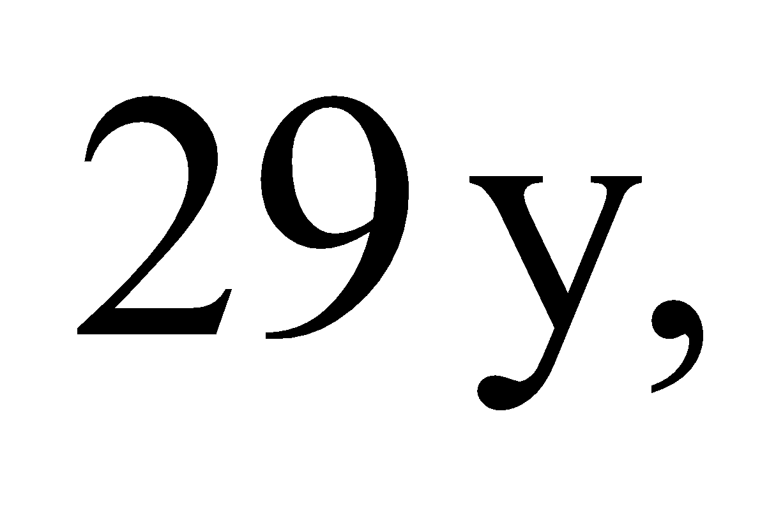 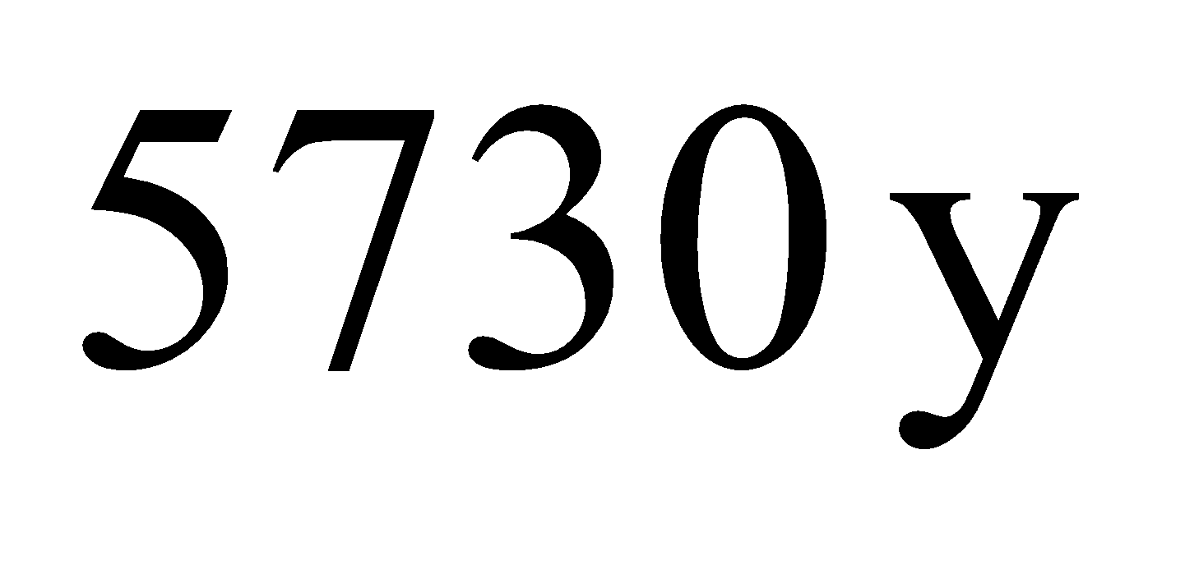 and 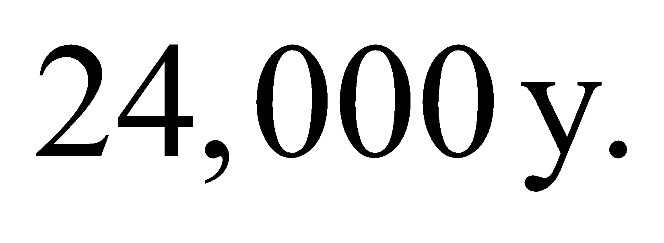Over the 2 billion years since the fission reactions ended, there have been over 60 million lifetimes of strontium-90, 350,000 lifetimes of carbon-14, and over 80,000 lifetimes of plutonium-239. Clearly, there will no longer be any trace of these elements.
The answer is (d).
Assess Scientists have found measurable amounts of other fission products at Oklo, such as particular isotopes of neodymium and ruthenium. These products happen to be stable, so there's no risk of them decaying away like the ones in this problem.

