MOLECULES AND SOLIDS

37

Exercises
Section 37.2 Molecular Energy Levels
16. Interpret We are to find the energies of the first four rotational states of an HCl molecule.
Develop The energies of rotational states (above the j = 0 state) are given by Equation 37.2, where for the HCl molecule, 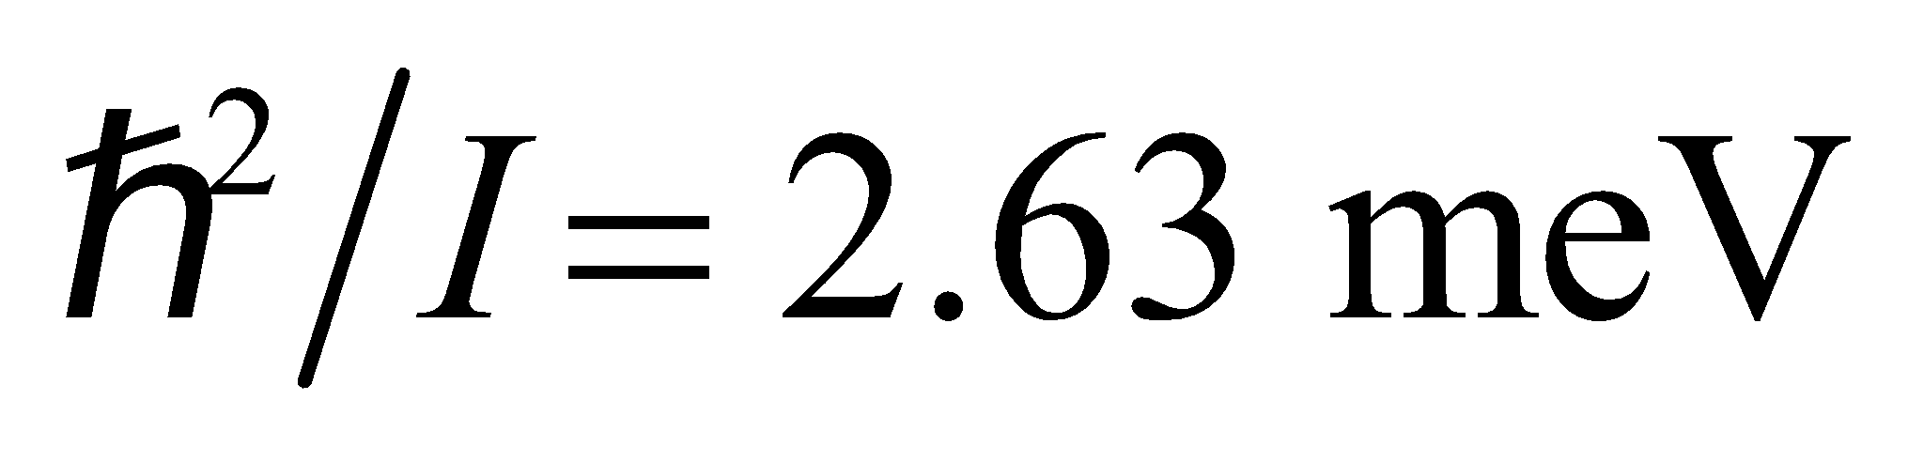 (from Example 37.1).
Evaluate Thus, 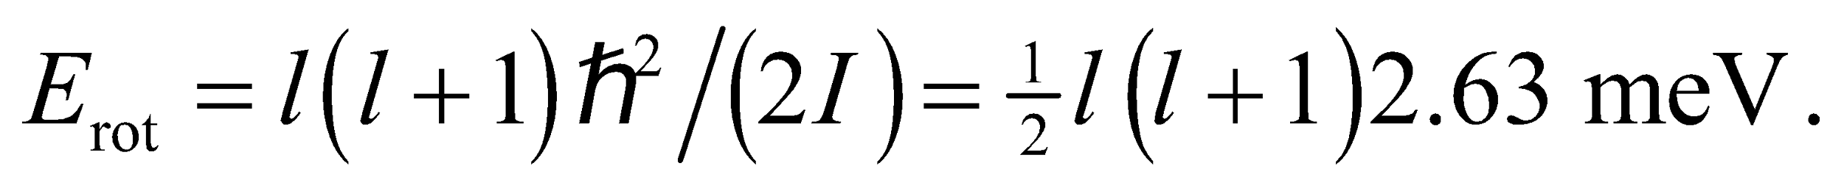 For l = 0, 1, 2, and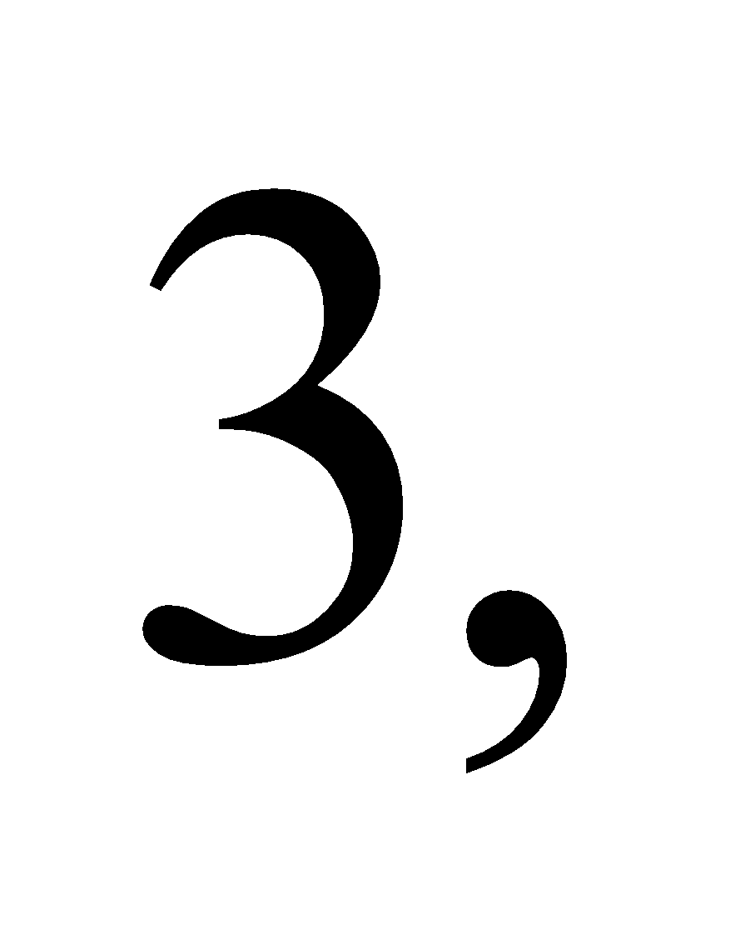 so
Assess The rotational energy levels are some three orders of magnitude closely spaced than is the case for the atomic energy levels.
17. Interpret We are looking for the wavelength of the photons that would cause a transition in an oxygen molecule to the first excited rotational energy state above the ground state.
Develop Using Equation 37.2, the difference in energy between the l = 1 and l =0 states is
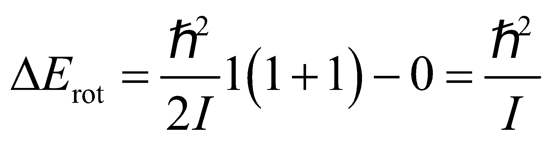
The photon wavelength corresponding to this transition is 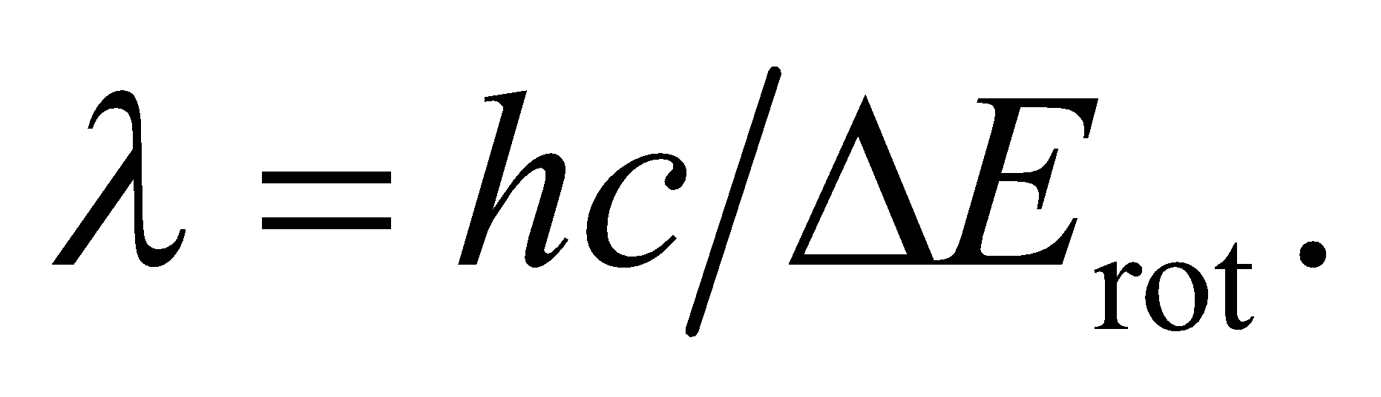
Evaluate Substituting the value of I given in the problem, we get
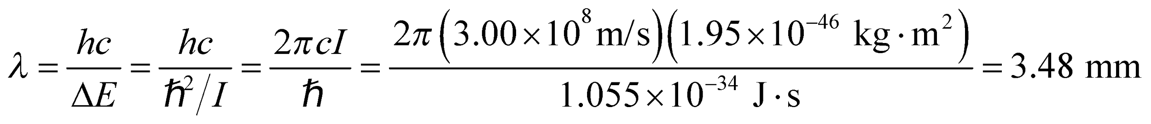
Assess Transition between adjacent rotational energy levels requires absorbing a photon in the microwave region (frequency f ~ 10¹¹ Hz).
18. Interpret We are given the rotational inertia of a molecule and are to find the wavelength (i.e., energy) of a photon emitted by the given transition between rotational states.
Develop The energy of the rotational states is given by Equation 37.2,
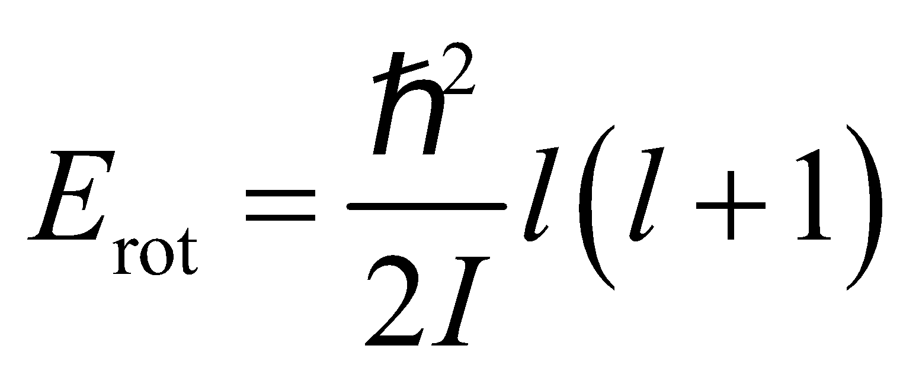
The energy difference between adjacent states is
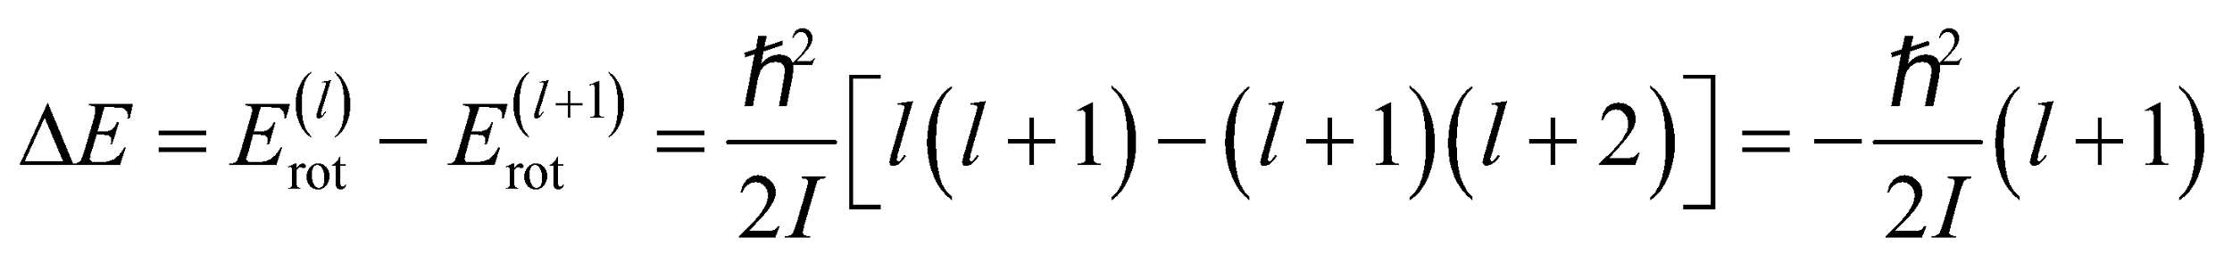
For this problem, l = 4. The energy of the photon emitted is given by Equation 34.6, E = hf = hc/λ, and must equate to the magnitude of the energy of the rotational transition, which gives
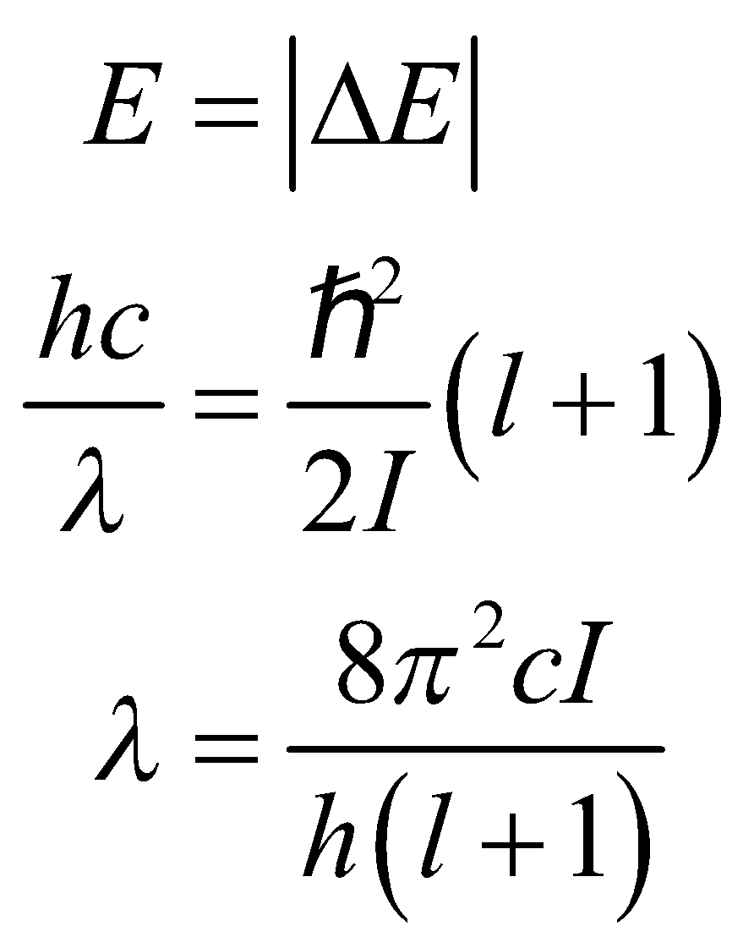
Evaluate Inserting the given values gives
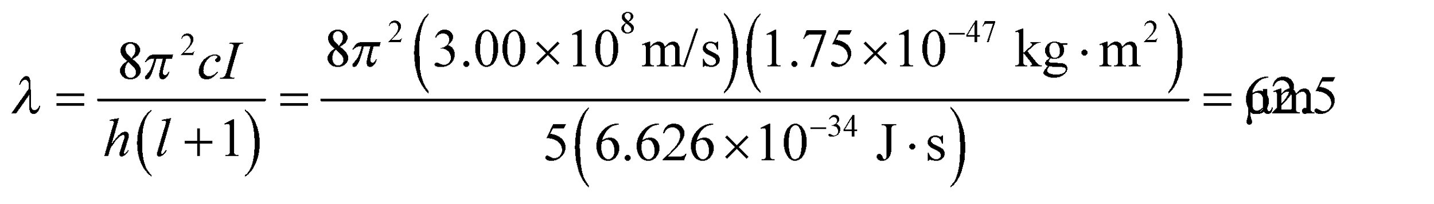
Assess This wavelength is in the infrared portion of the electromagnetic spectrum, as indicated in the text.
19. Interpret The gas molecules must absorb a photon in order to make a transition to the excited rotational state. We are given the wavelength of the photon, and asked to find the rotational inertia of the molecule.
Develop Using Equation 37.2, the difference in energy between the l = 1 and l = 0 states is
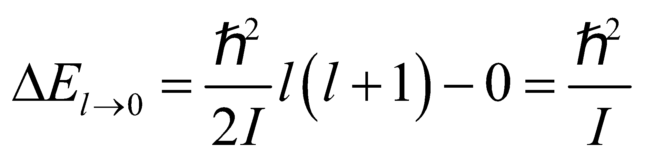
The energy of the absorbed photon must equate to this difference in energy: 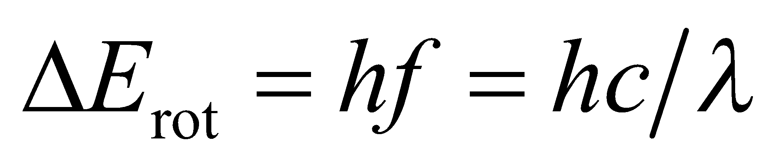 Thus,
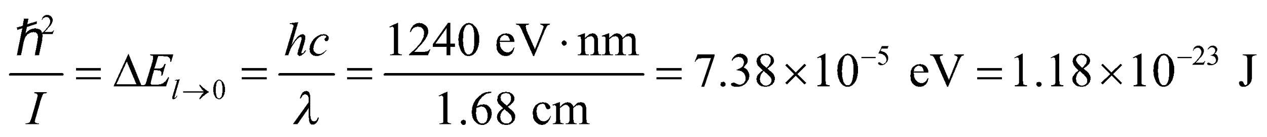
We can find I from the above equation.
Evaluate The rotational inertia is
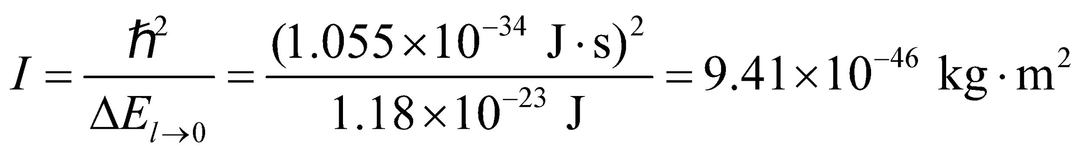
Assess The value of I is reasonable for a molecule (compare with previous problem). We can estimate the bond length of the molecule using 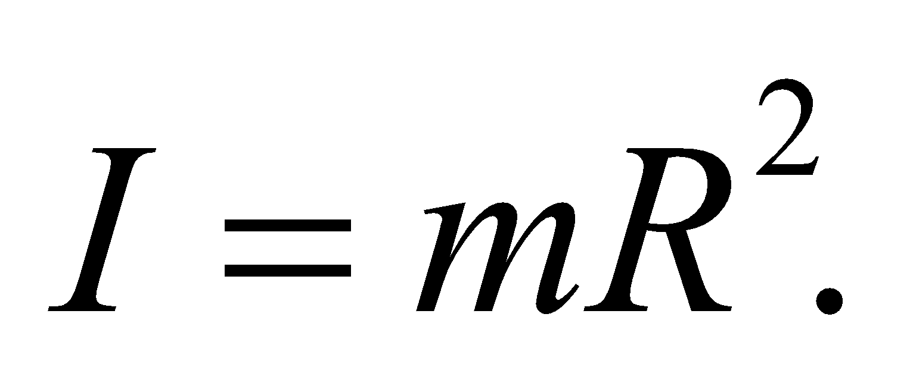 With m ~ 10⁻²⁶ kg, we get R = 0.3 nm, which is also a reasonable value.
20. Interpret We are given the vibration frequency for diatomic hydrogen (i.e., a hydrogen molecule; H₂) and are to find the spacing between its vibrational energy levels.
Develop Applying Equation 37.3, 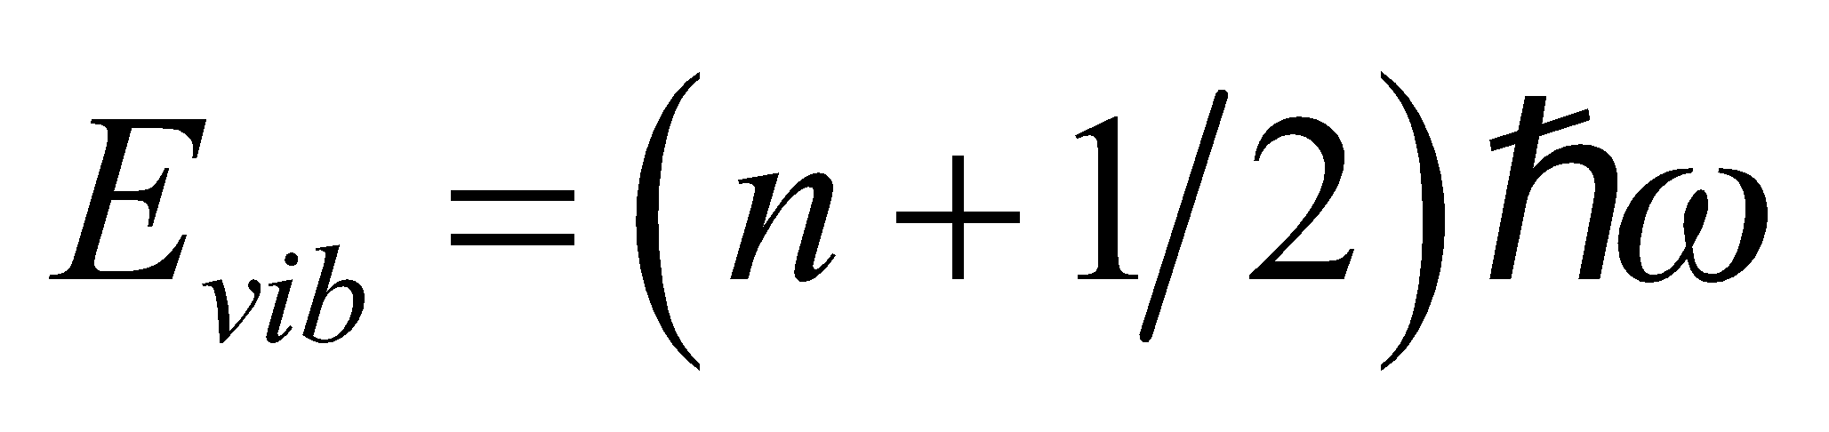, we see that the spacing between vibration energy levels is
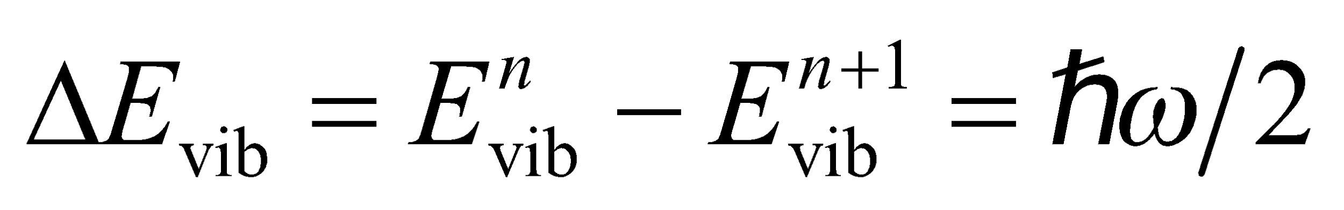
Using the relation ω = 2πf, the energy spacing may be written as
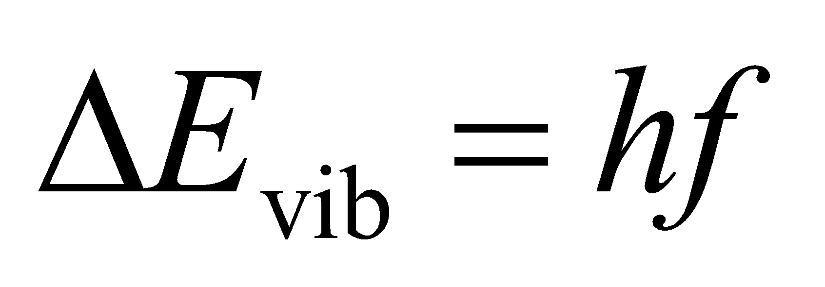
Evaluate Using the value given for f leads to
Assess This corresponds to the infrared portion of the electromagnetic spectrum.
21. Interpret This problem is about the vibrational motion of the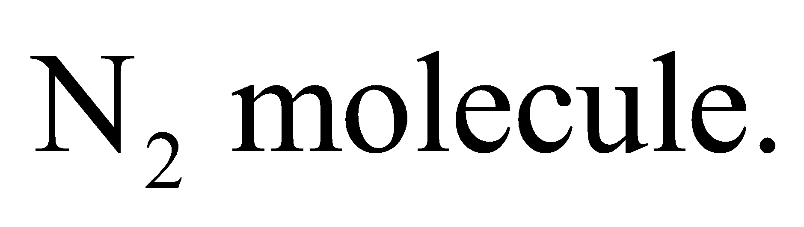 We are given the energy spacing between adjacent vibrational energy levels of the molecule and are asked to find the corresponding classical frequency of vibration.
Develop The quantized vibrational energy levels are given by Equation 37.3:
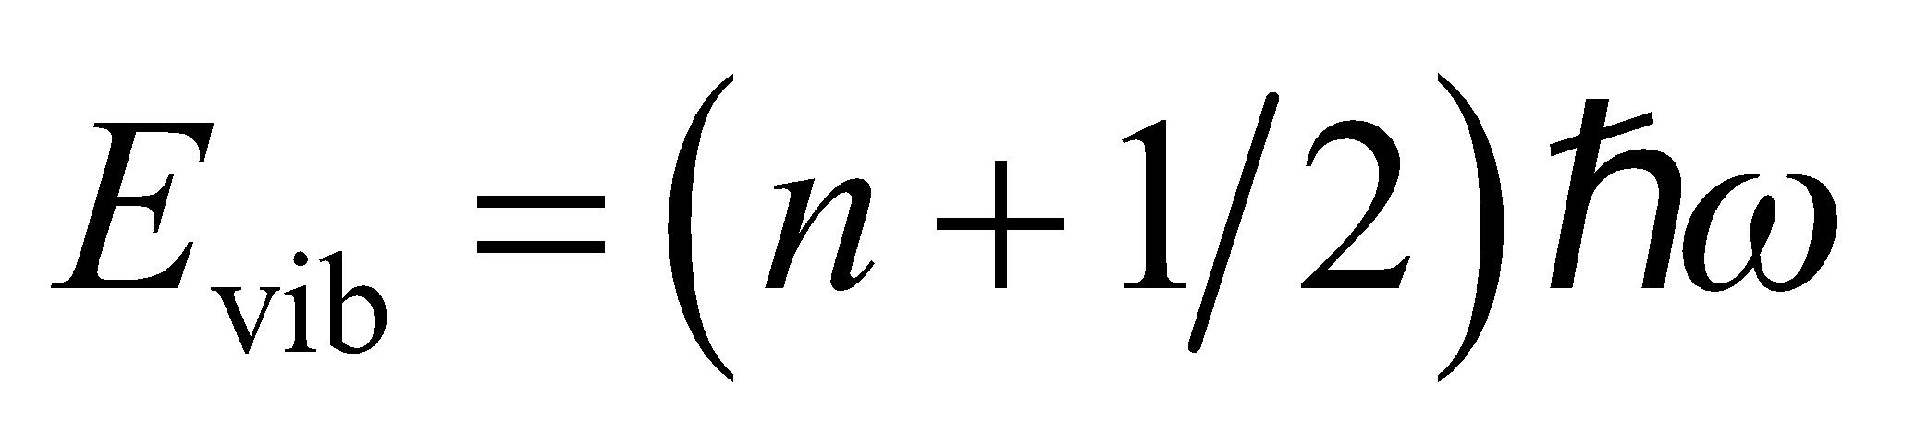
Therefore, the energy difference between the adjacent levels is 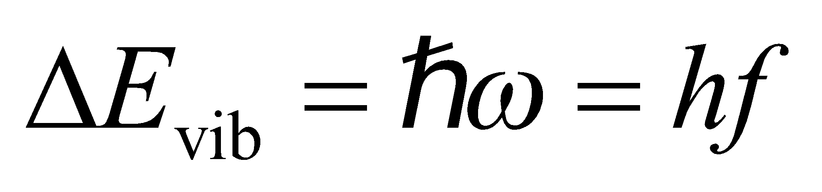.
Evaluate The classical vibrational frequency is
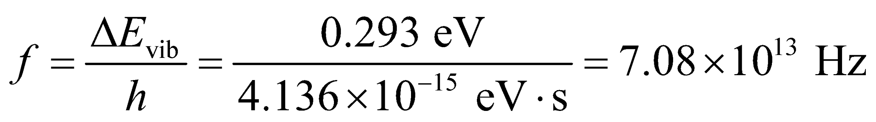
Assess The frequency associated with vibrational motion is 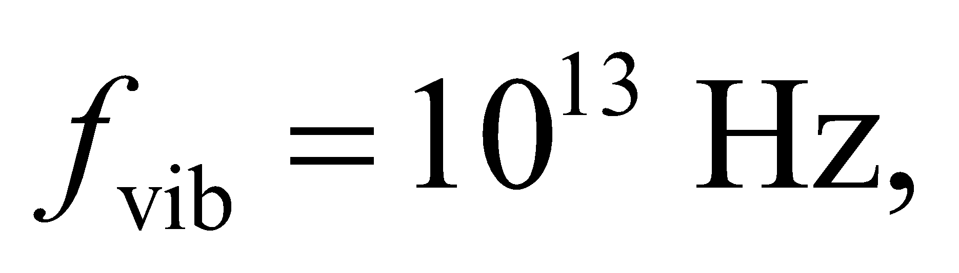 which is higher than that associated with rotation, 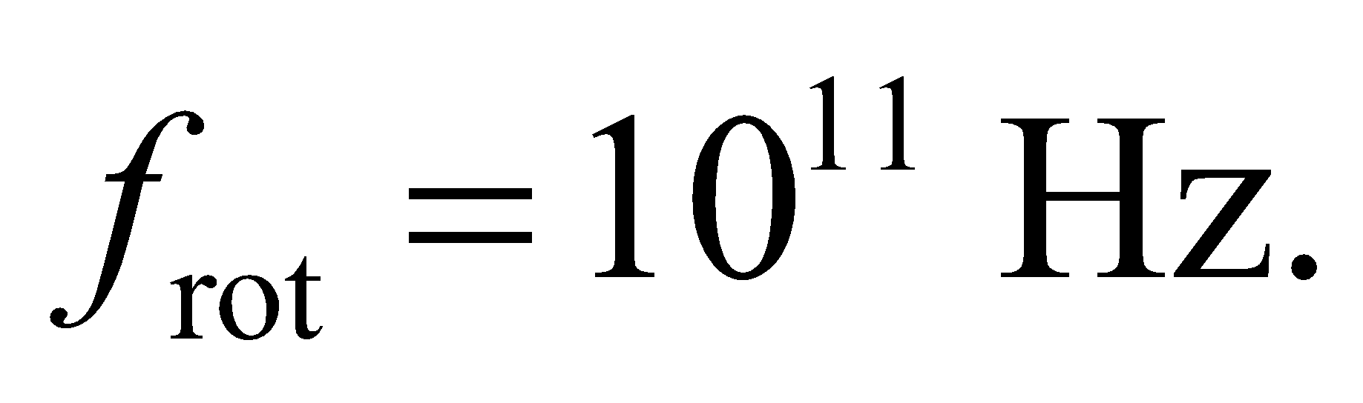 This means that a more energetic photon must be absorbed by the molecule in order to excite the vibrational modes.
Section 37.3 Solids
22. Interpret Given the density of NaCl, we are to estimate the spacing between ions in the crystalline solid.
Develop The atomic weights of Na and Cl are 22.99 and 35.45 (see Appendix D), so the average masses of these ions are
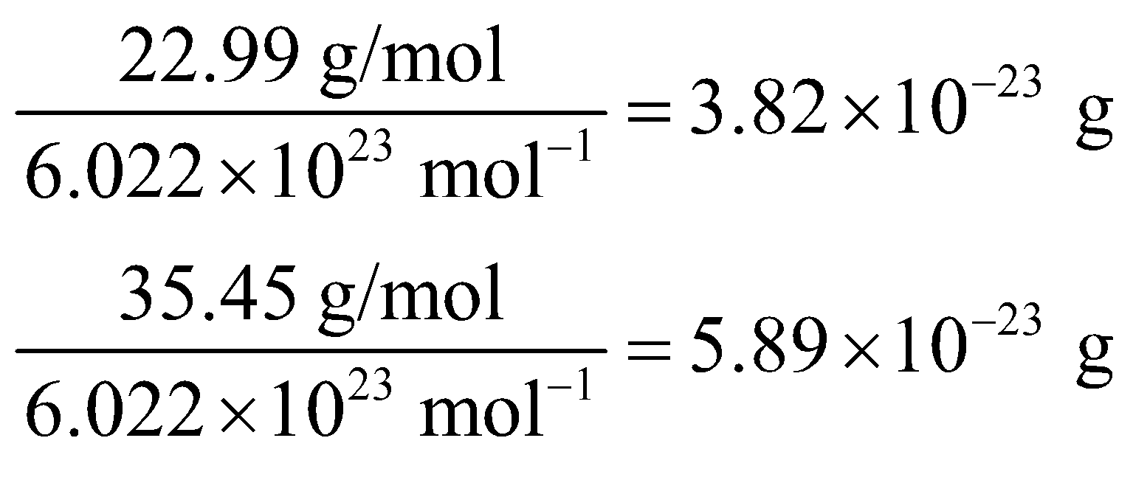
respectively. If each ion occupies the same cubic volume 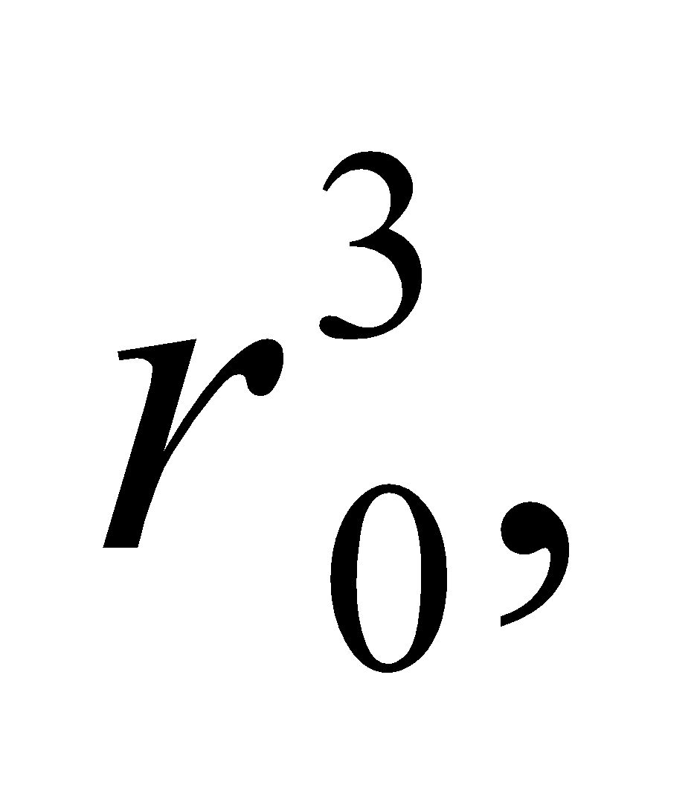 then the density of the crystal is
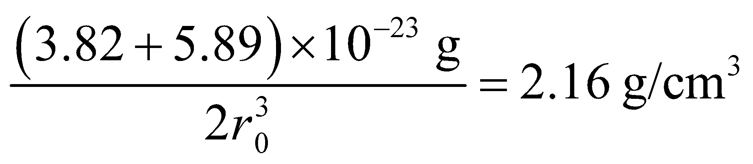
Evaluate Solving for the ionic separation r₀ gives
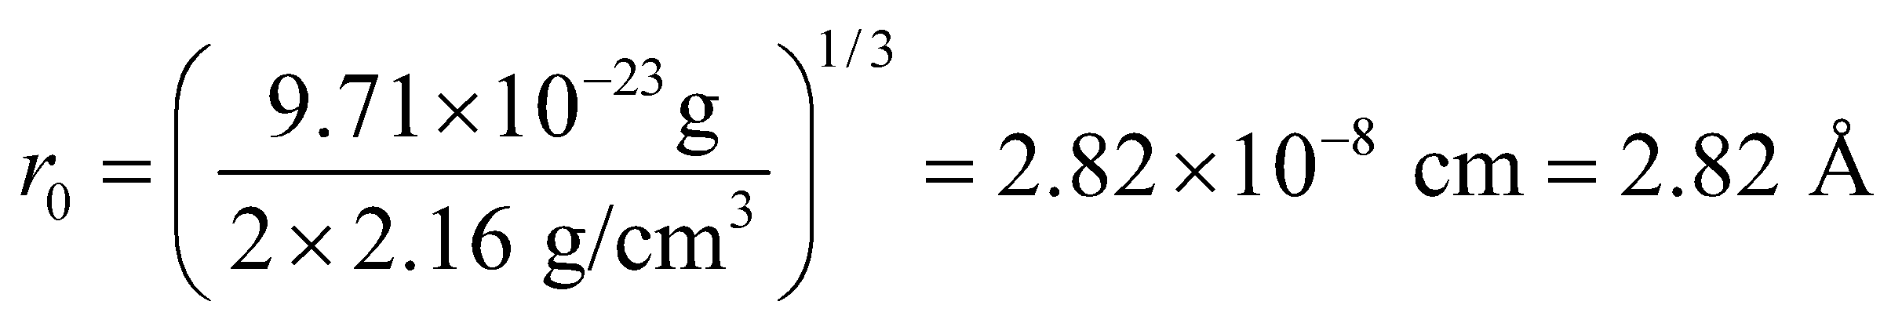
Assess Actually, the ionic radii of Na and Cl are different, but each cubic cell of NaCl crystal contains half Na and half Cl atoms, so the above estimate is the same; namely, 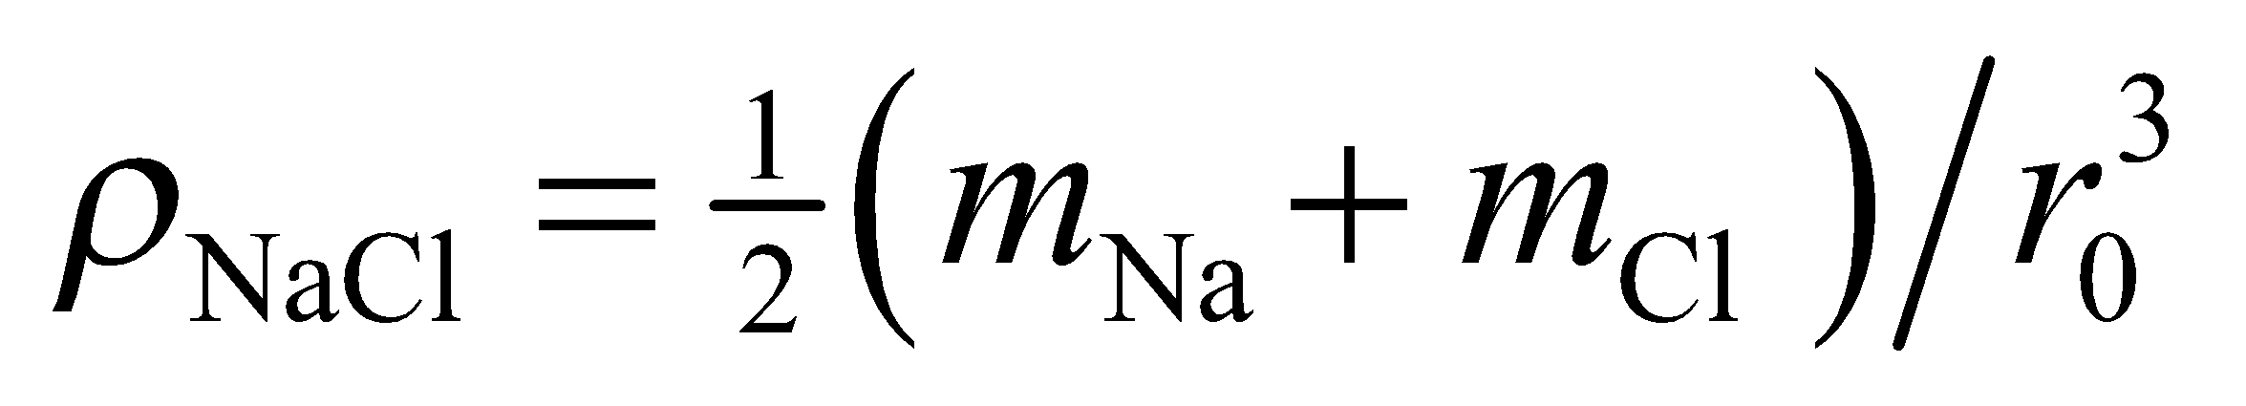.
23. Interpret This problem is an exercise in unit conversion. We are to express the ionic cohesive energy of NaCl in units of kcal/mol.
Develop To convert eV to kcal/mol, we use the following conversion factors (see Appendix C):
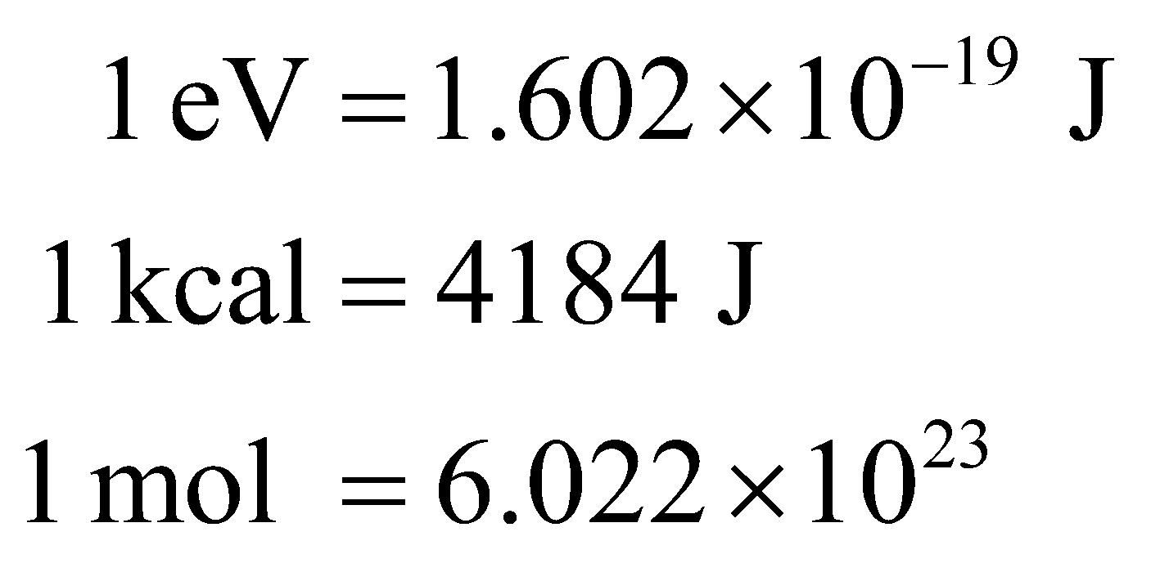
Evaluate Using the above conversion factors, we find:
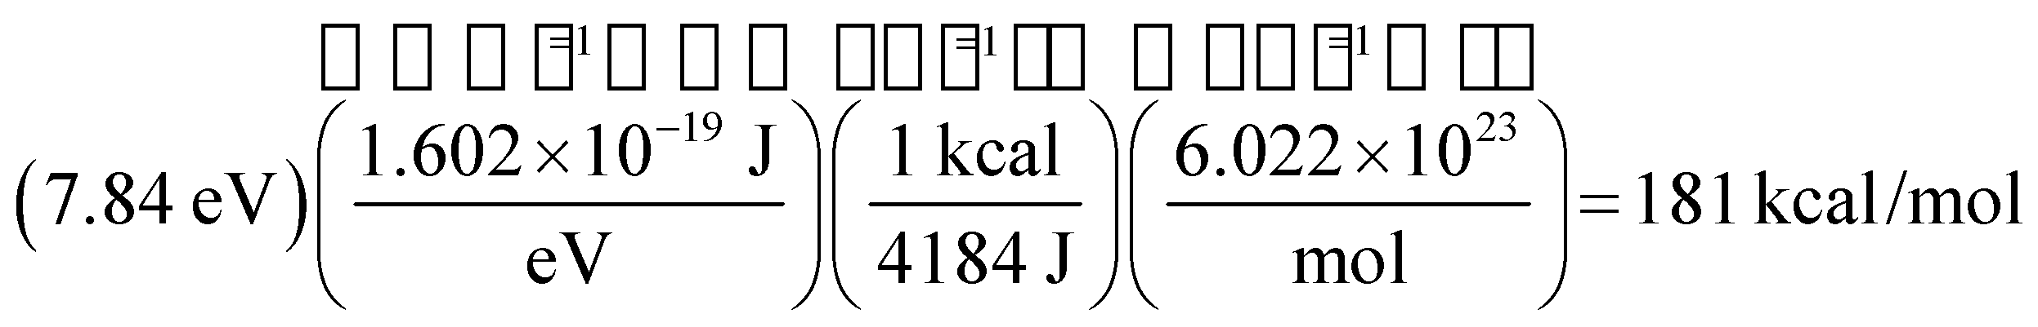
Assess The result means that it takes 181 kcal to break one mole of NaCl into its constituent ions.
24. Interpret We are to find the equilibrium separation of ions in the ionic crystal LiFl.
Develop At equilibrium, r = r₀ and Equation 37.4 takes the form
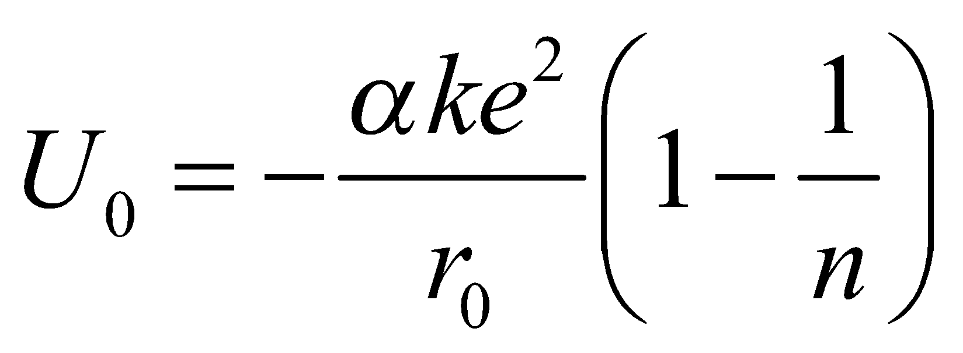
which we can solve for the equilibrium separation r₀, given α = 1.748, n = 6.25, and U₀ = −10.5 eV.
Evaluate Using
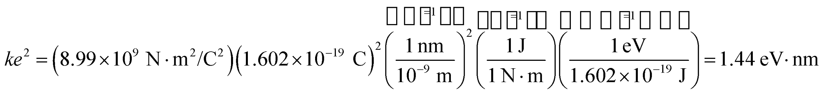
we find that the equilibrium separation is
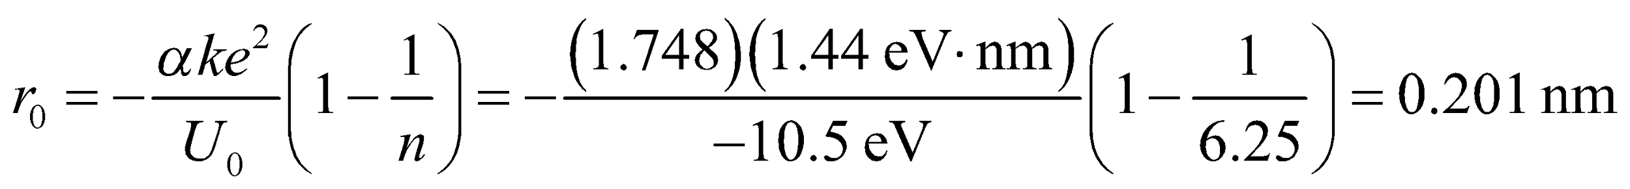
Assess This result is similar to that found in Problem 37.22.
25. Interpret We are to find the wavelength of light emitted by electrons that make transitions across the band gap of Gallium phosphide.
Develop Gallium phosphide is a semiconductor with a band-gap energy of 2.26 eV (see Table 37.1). From Equation 34.6, E = hf, we know that a photon of energy corresponding to the band gap would have a wavelength of 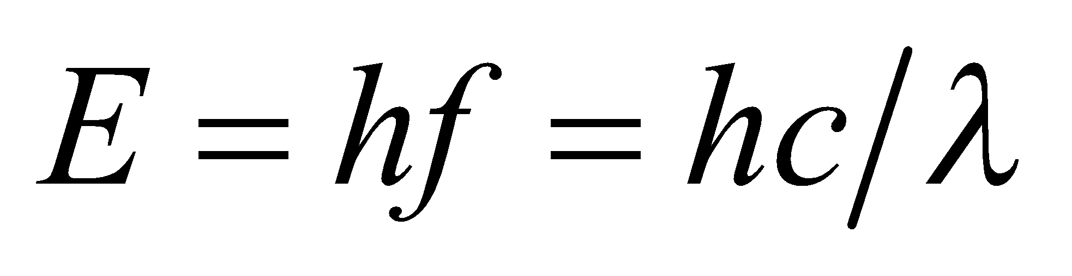, where E is the band-gap energy.
Evaluate Solving the expression above for the wavelength gives
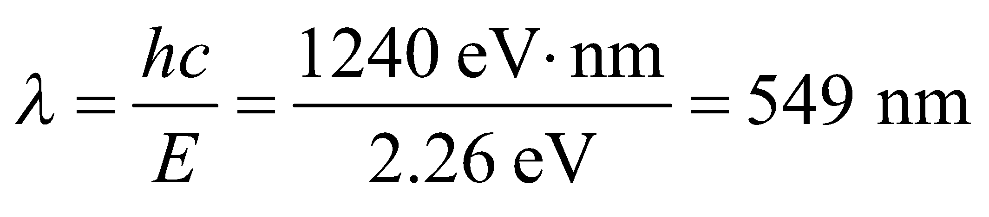
Assess This light is green in color.
26. Interpret We are to find the shortest wavelength emitted by electrons making transitions across the energy gaps of materials listed in Table 37.1 and the corresponding material.
Develop The solution to the previous problem shows us that the wavelength emitted when electrons make transitions across the energy gap depends on the energy gap according to 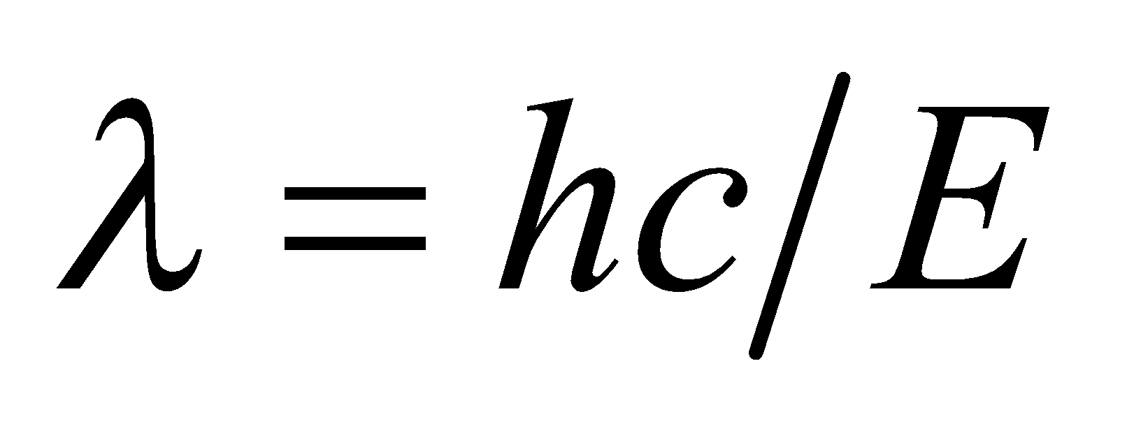. Thus, the shortest wavelength corresponds to the largest bandgap.
Evaluate The largest bandgap of materials listed in Table 37.1 is Zns, which has E = 3.6 eV. The wavelength emitted by this material is
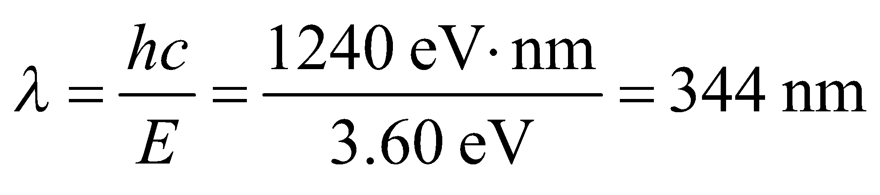
Assess This wavelength is in the ultraviolet portion of the electromagnetic spectrum.
27. Interpret From the list of materials given in Table 37.1, we want to know which would emit the longest wavelength if used in a light-emitting diode.
Develop The wavelength emitted depends on the energy gap according to . Thus, the maximum wavelength for the materials in Table 37.1 corresponds to the smallest energy gap.
Evaluate The material with the smallest energy gap is InAs, which has an energy gap of E = 0.350 eV. The wavelength of this emission is
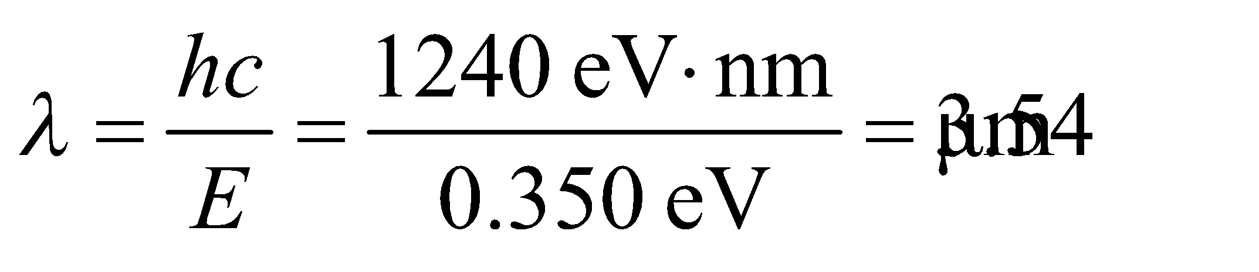
Assess The wavelength is in the infrared portion of the electromagnetic spectrum.
28. Interpret Given the wavelength of light emitted from a semiconductor material, we are to find the energy gap of the material.
Develop Equation 34.6, , gives the relationship between the wavelength and the energy of photons. By conservation of energy, the photon emitted when an electron makes a transition across the band gap of a material must equate to the energy of that band gap.
Evaluate The band gap corresponding to this wavelength is therefore
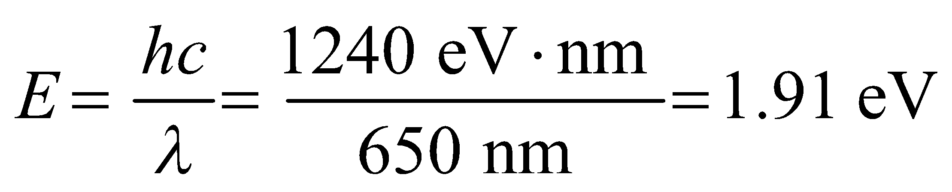
Assess This is a deep red color.
Problems
29. Interpret We have a molecule that emits a photon to make a transition to a state with lower rotational energy. We want to know the energy of the photon emitted for the 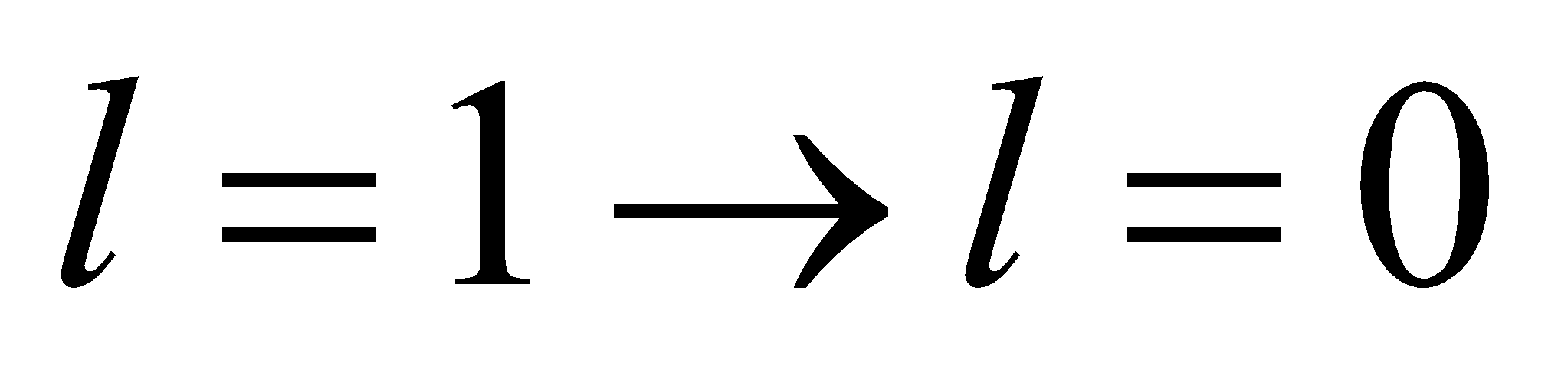 transition.
Develop Using Equation 37.2, the difference in energy between the l = 2 and the l = 1 state is
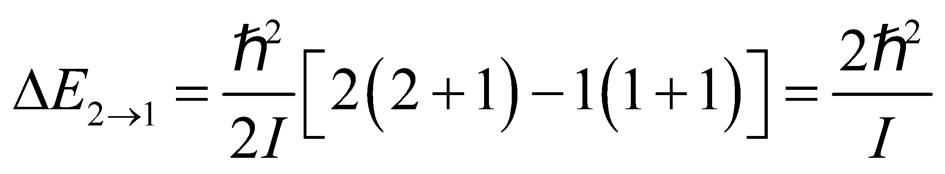
This means that 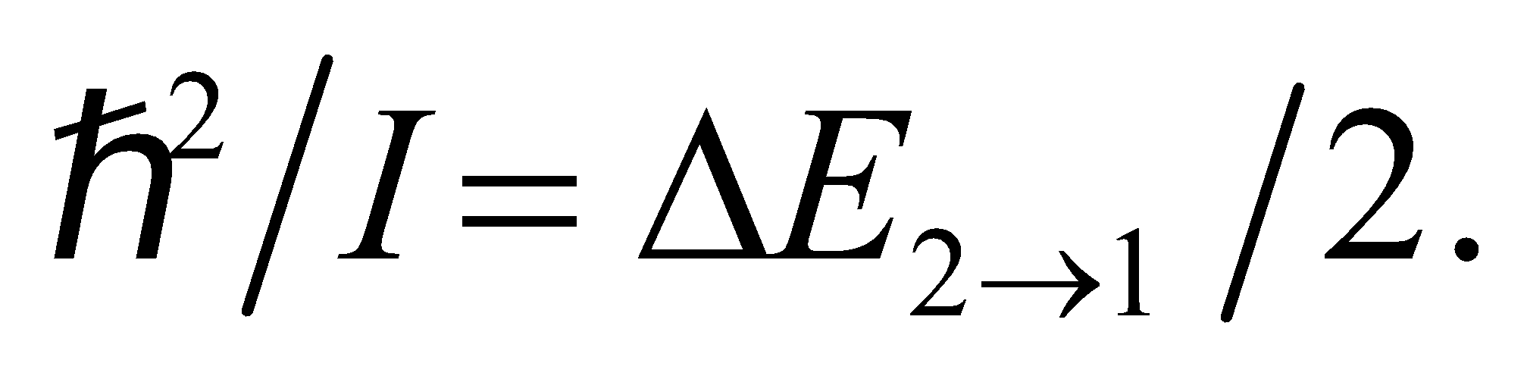 For the transition,
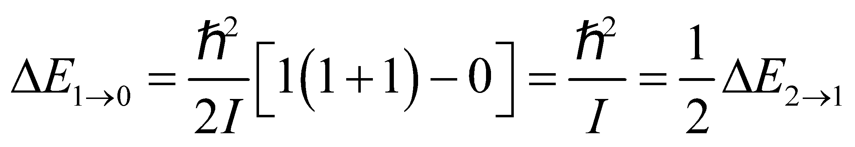
Evaluate Since 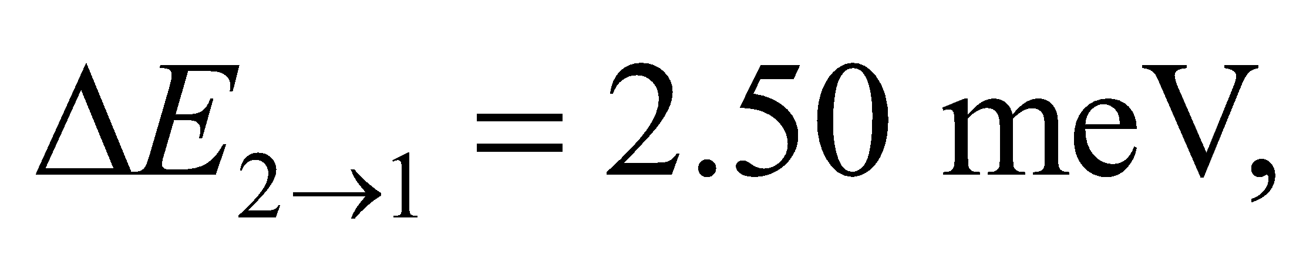 we have 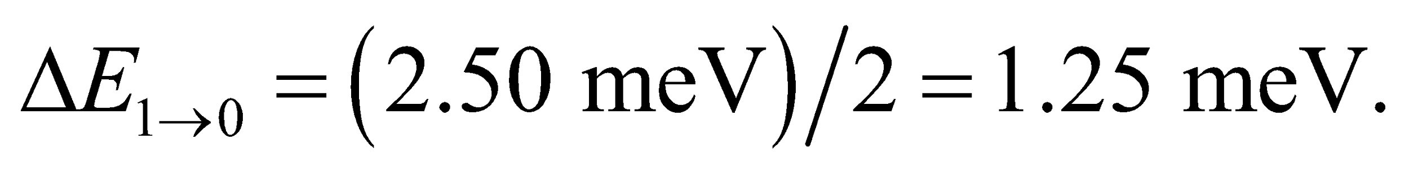
Assess The result shows that the energy levels are not evenly spaced. In general, the energy of a photon emitted in a transition between rotational levels with 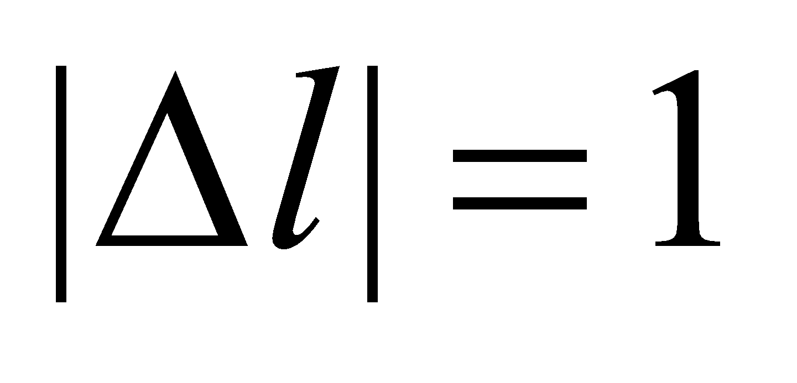is 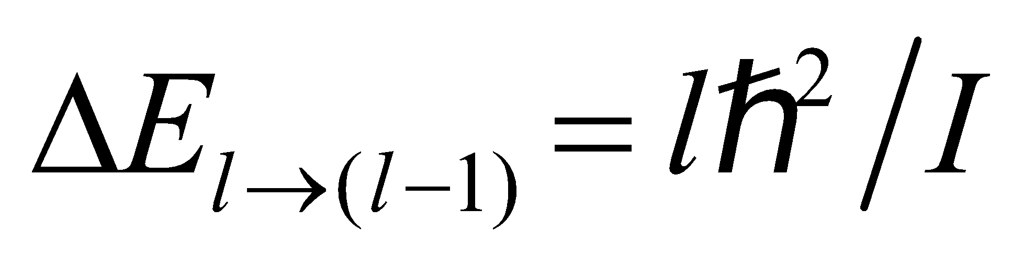.
30. Interpret We are told that a rotational transition requires three times the energy for the rotational transition between the rotational ground state and first excited state and are asked to find the two levels involved in the higher energy transition.
Develop From Equation 37.2, the photon energy absorbed in a 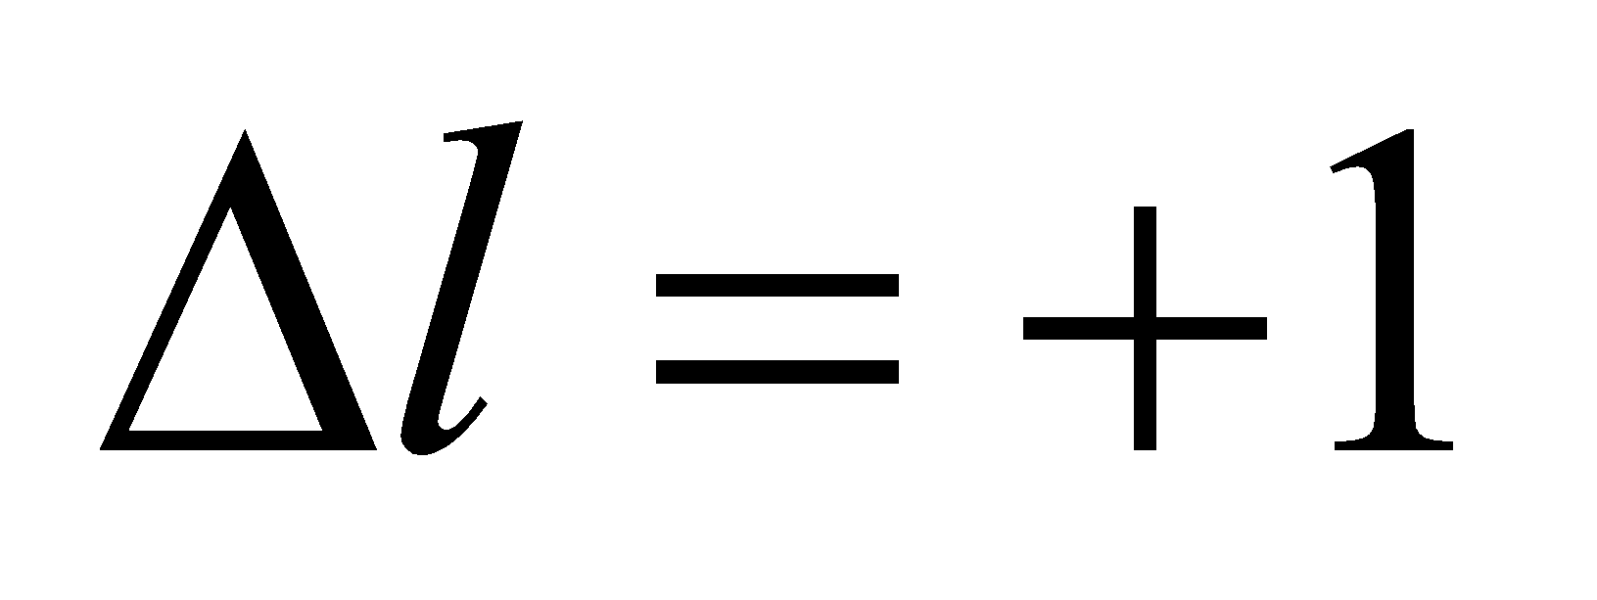 transition must be
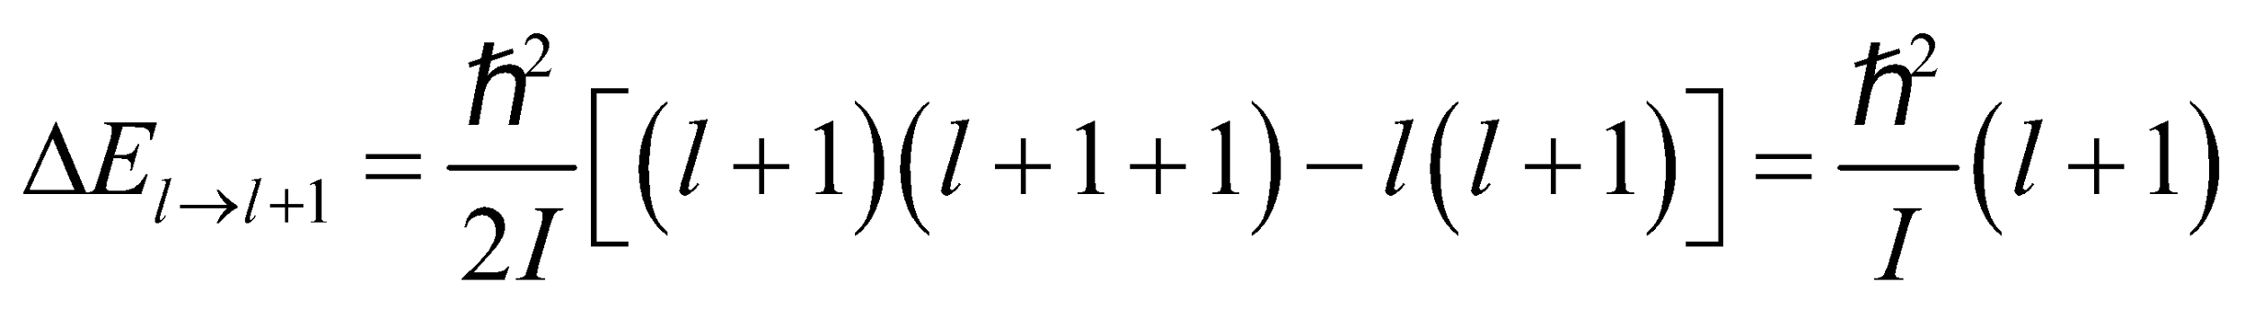
We are given that
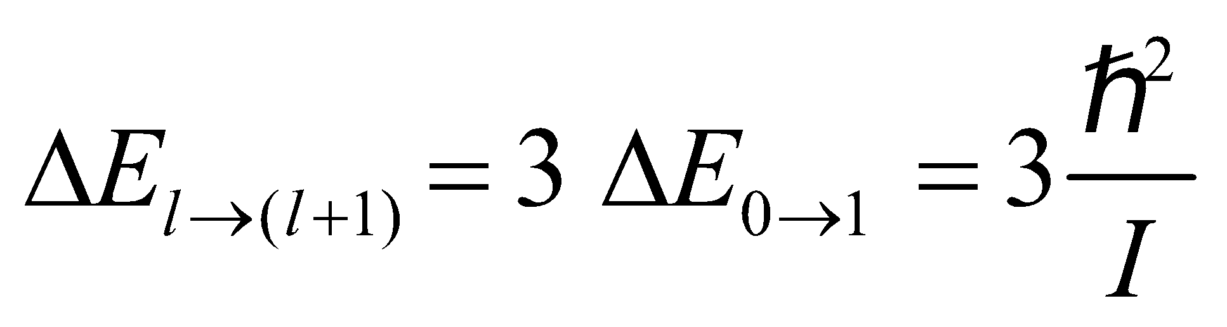
(where the last equality is derived in the solution to Problem 37.29), so we can solve for the quantum numbers of the two states involved in the unknown transition (i.e., l and l + 1).
Evaluate Combining the expressions above and solving for l gives
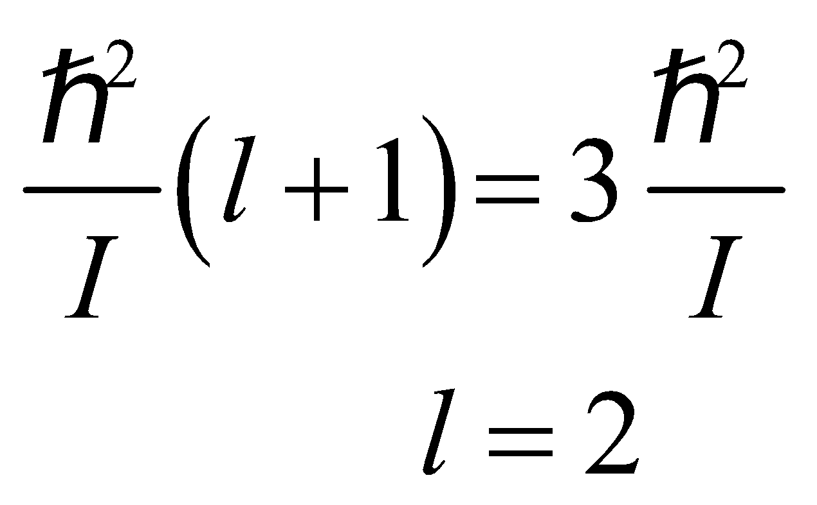
so the transition is from level 2 to level 3.
Assess The final state is at higher energy than the initial state because the system has absorbed the energy of a photon with energy 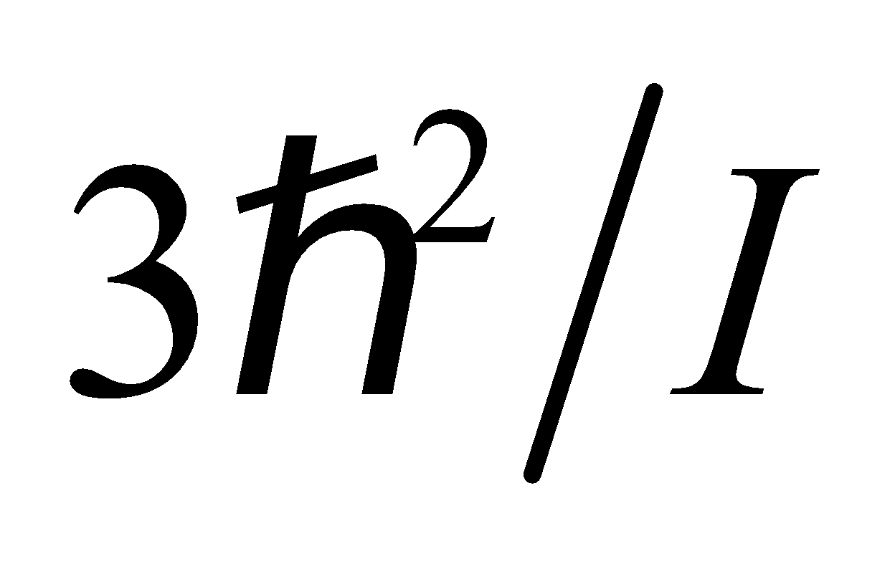.
31. Interpret A molecule must absorb a photon to make a transition to a higher energy rotational state. We want to find an expression for the energy of the photon associated with the transition 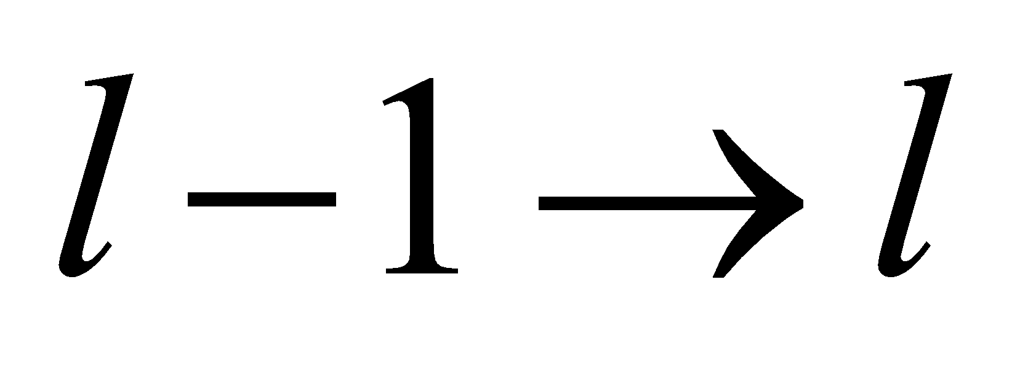.
Develop The quantized rotational energy of a molecule is given by Equation 37.2:
By conservation of energy, we know that the energy of the photon is equal to the energy difference between levels l and l − 1.
Evaluate Thus, the photon energy may be expressed as
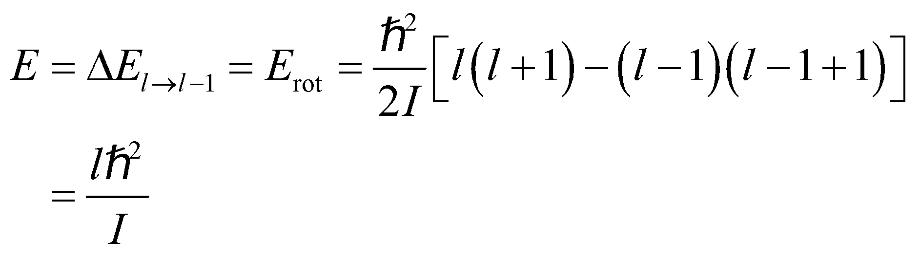
Assess The energy difference between two adjacent rotational levels is proportional to the upper l-value.
32. Interpret We are to derive the given expression for the wavelength of a photon emitted by a transition between adjacent rotational levels.
Develop Equation 37.2 gives the energy as a function of the rotational quantum number:
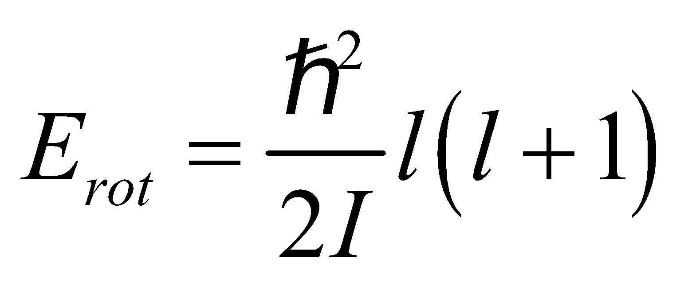
For a transition from state l to state l − 1, the energy difference is
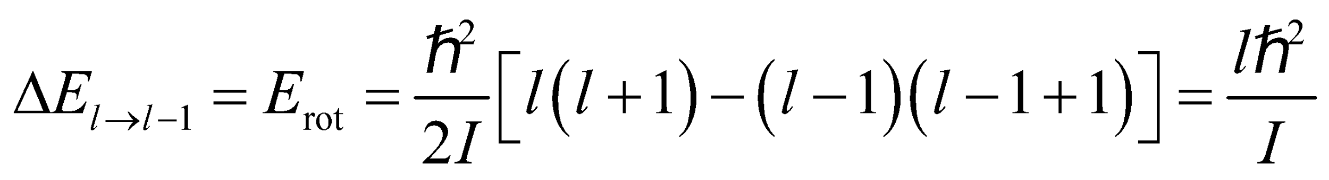
This is the energy E that must be carried away by the emitted photon (conservation of energy). The photon energy may be expressed in terms of wavelength using Equation 34.6:
Evaluate Equating these two expressions for the photon energy gives
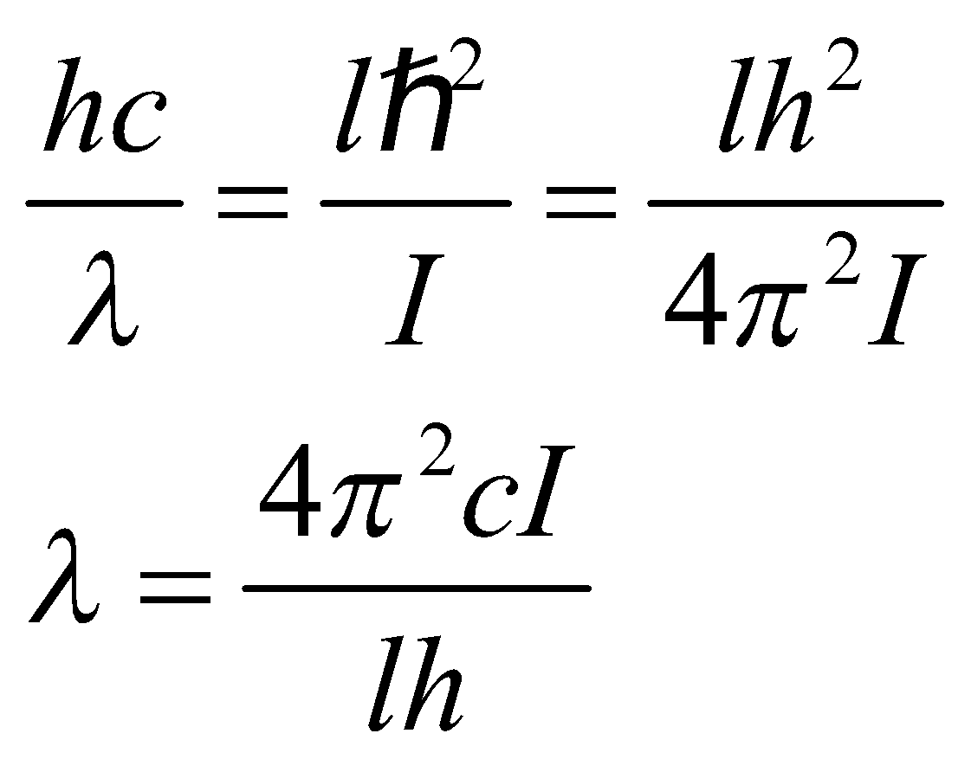
Assess We have expressed the wavelength in term of the crystal parameters.
33. Interpret In this problem we are asked to find the energy separation between the atomic rotational levels in the O₂ molecule.
Develop The separation of the rotational spectral lines in energy is 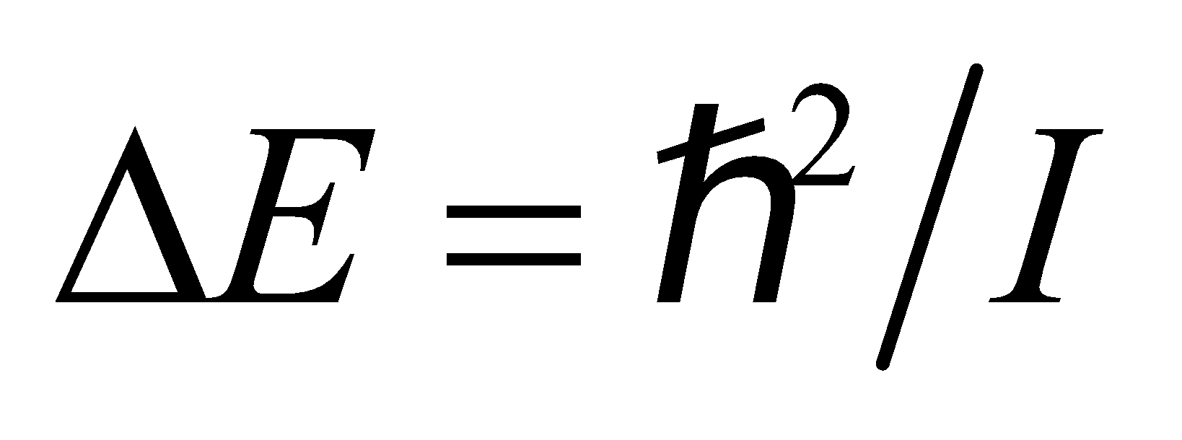 (see Example 37.1), or 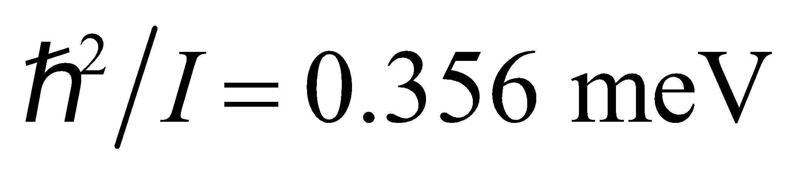 for O₂. In a diatomic molecule, with equal-mass atoms and atomic separation R, each atom
rotates about the center of mass at a distance of R/2, so 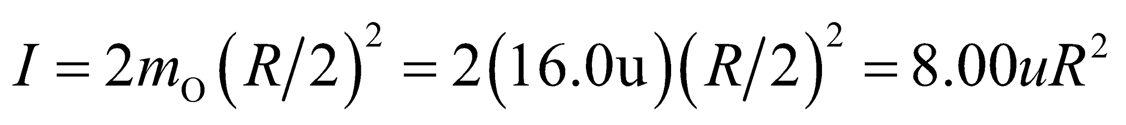, where the mass of an oxygen atom is taken to be m_{O} = 16.0u.
Evaluate The above expressions can be simplified to give
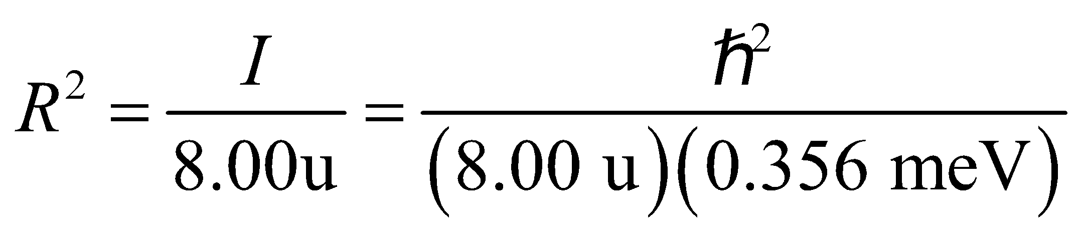
or
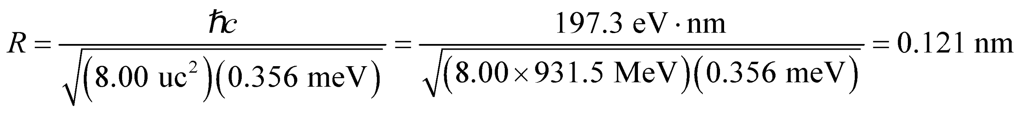
Assess Our result is in reasonable agreement with the experimental value of 0.146 nm.
34. Interpret We are asked to find the bond length of carbon monoxide (CO), given the wavelength of light needed to excite it to its first rotational state.
Develop The quantized rotational energy levels are given in Equation 37.2: 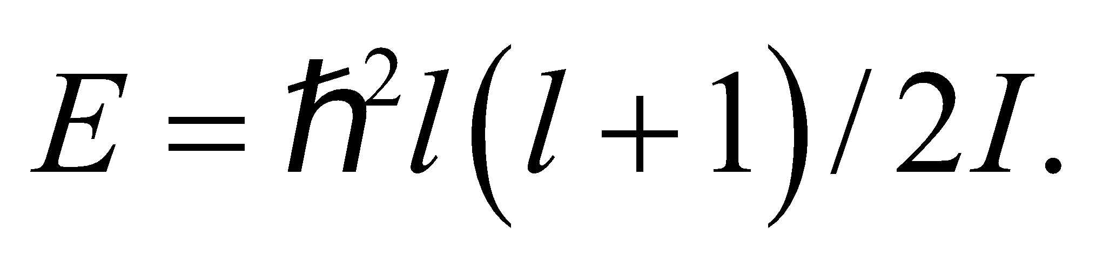 Therefore, the energy needed to excite a molecule from the non-rotating 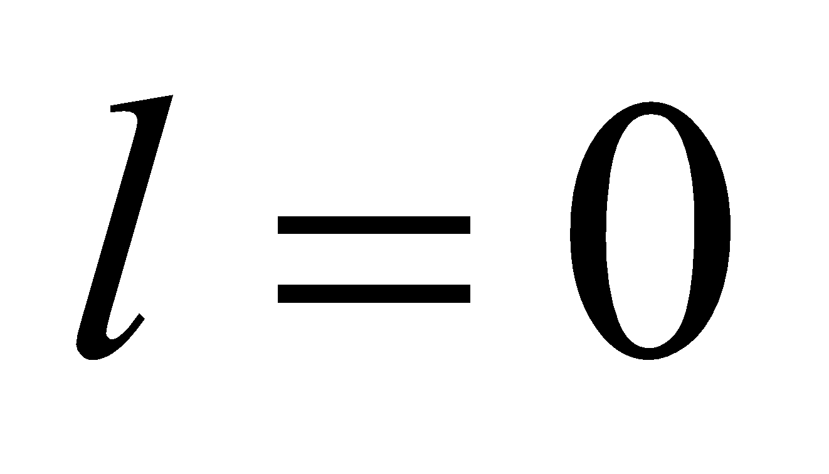 state to the first 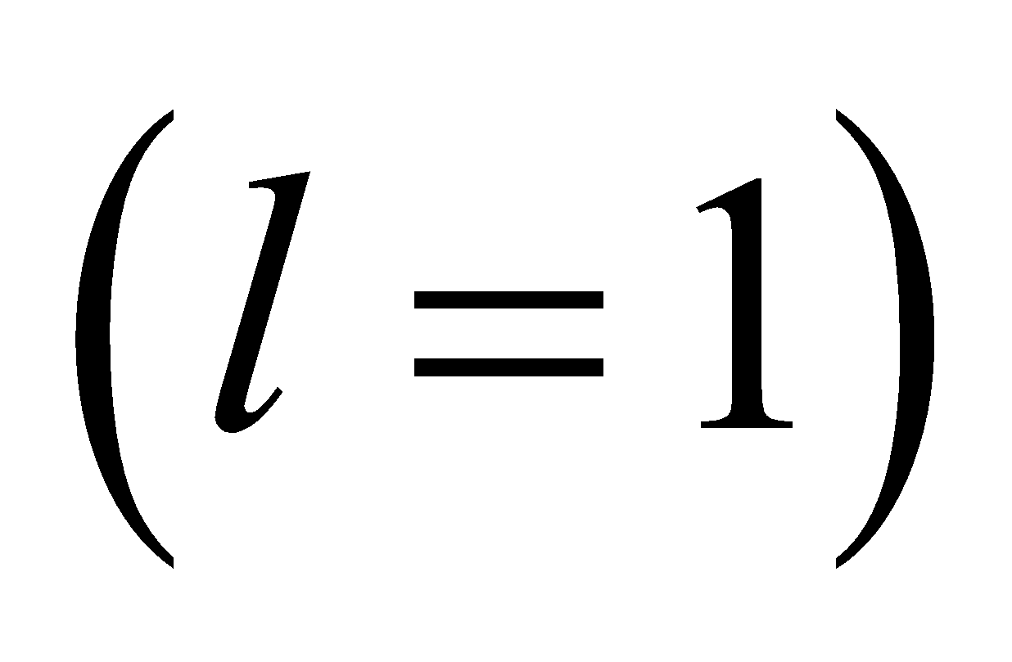 rotational state is 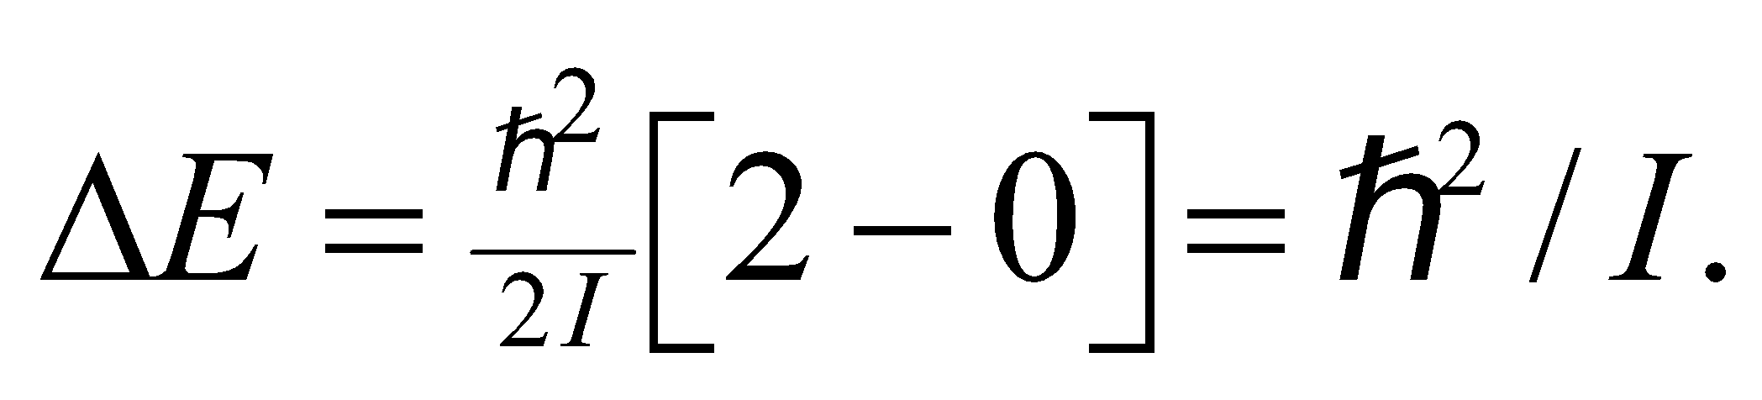 In terms of the photon wavelength, the rotational inertia is 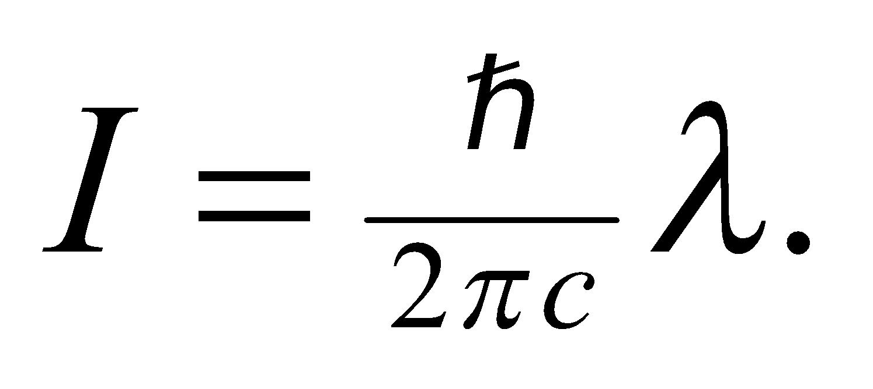 To find the bond length, R, we use the result from Problem 37.59 for the rotational inertia of a diatomic molecule: 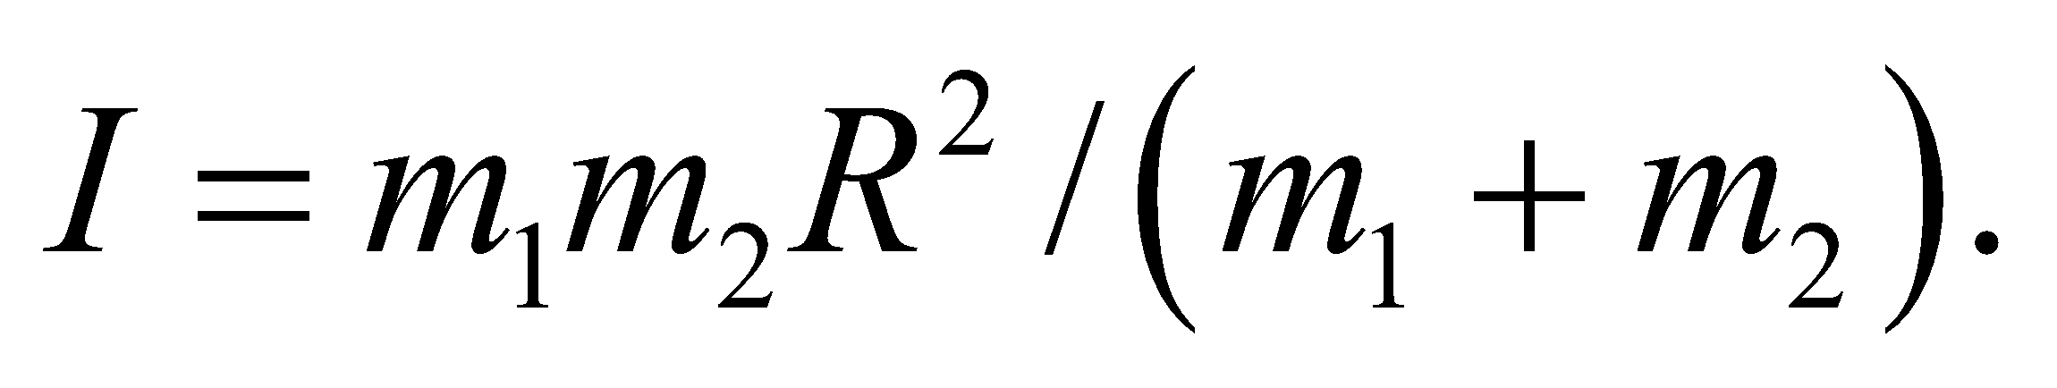 In this case, the masses are 12 u for carbon and 16 u for oxygen.
Evaluate Combining the two equations for the rotational inertia,
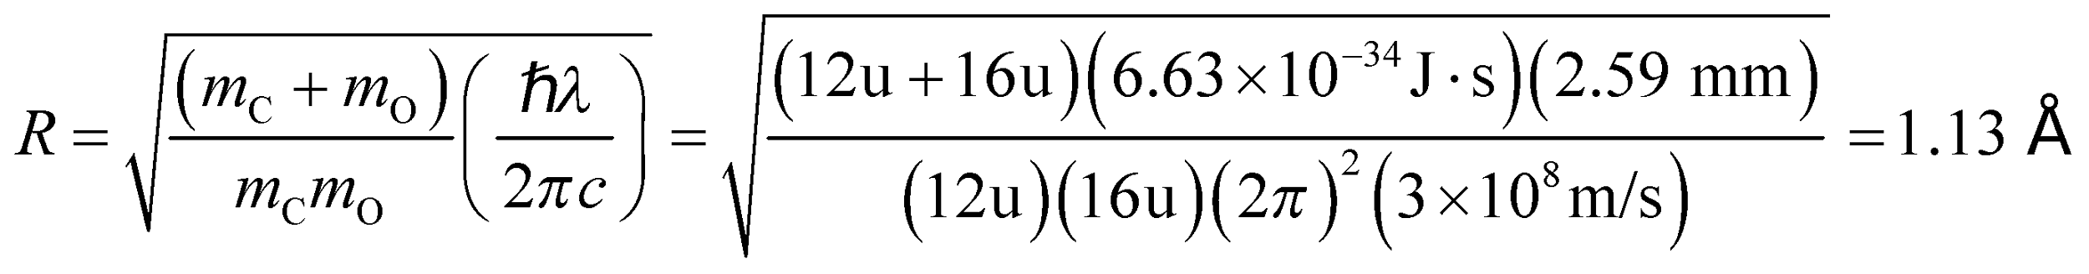
Assess This answer seems reasonable, since this is the typical size for atoms and molecules.
35. Interpret This problem is about the vibrational energy levels of the HCl molecule. We are given its classical vibration frequency and are to find its ground-state energy and the energy spacing between its vibrational levels.
Develop The quantized vibrational energy levels are given by Equation 37.3:
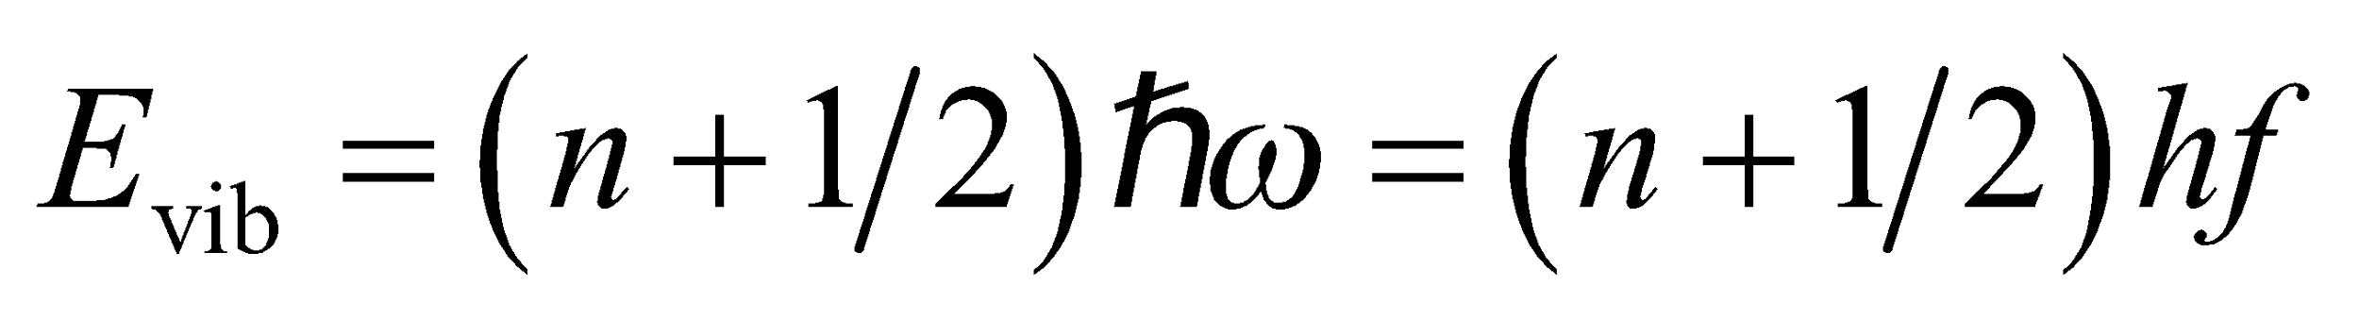
where we have used ω = 2πf. In the ground state energy n = 0, and the energy spacing between the adjacent levels is
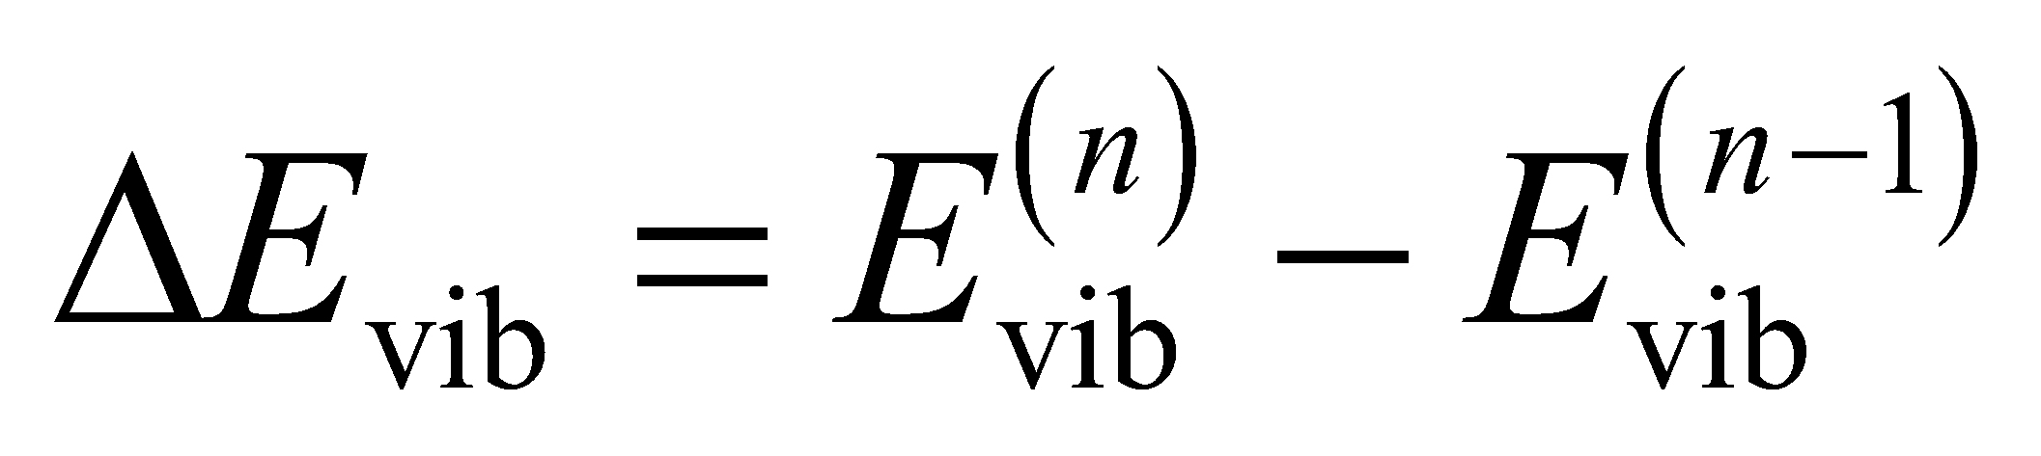
Evaluate (a) The vibrational ground-state energy is
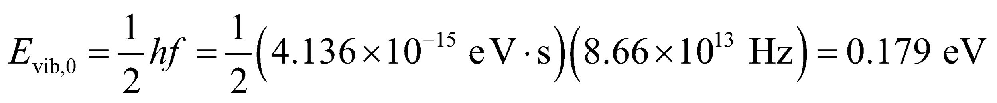
(b) The photon energy for allowed transitions 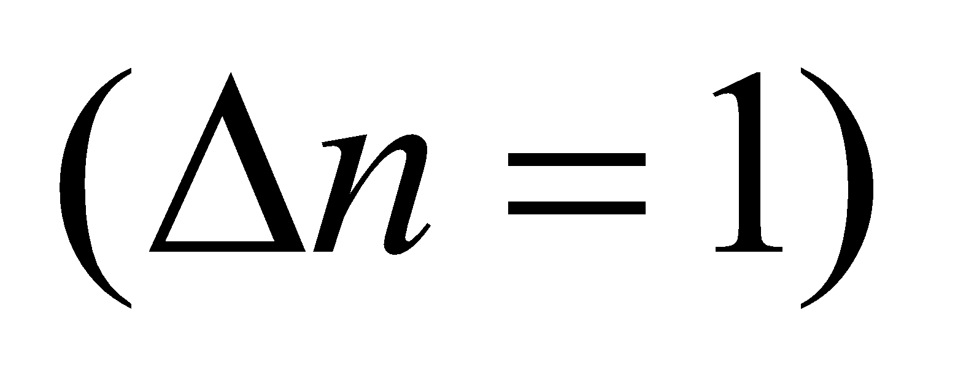 is
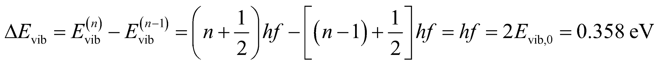
Assess Since f = 10¹⁴ Hz is in the infrared region of the spectrum, the study of molecular vibrations typically involves infrared spectroscopy.
36. Interpret We are given the classical vibration frequency and the rotational inertia of a molecule and are asked to find the energy between two quantum states with different vibrational and rotational quantum numbers.
Develop We shall apply Equations 37.2 and 37.3 to find the rotational and vibrational energy, respectively, of the initial and final quantum states and take the difference to find the energy difference between these states. By conservation of energy, the photon emitted by this transition must carry this energy difference. The initial state has n = 1 and l = 1, so its energy is
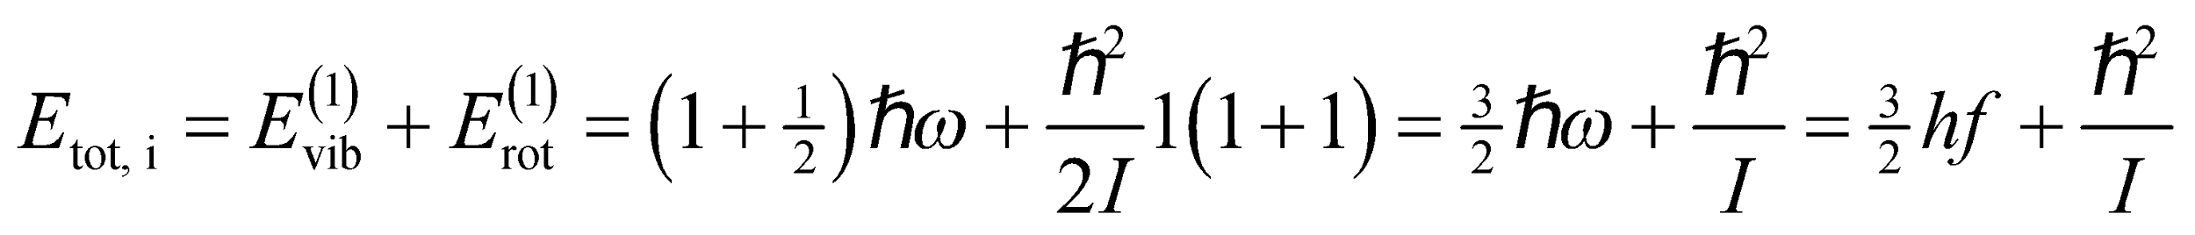
The final state has n = 0 and l = 2, so its energy is
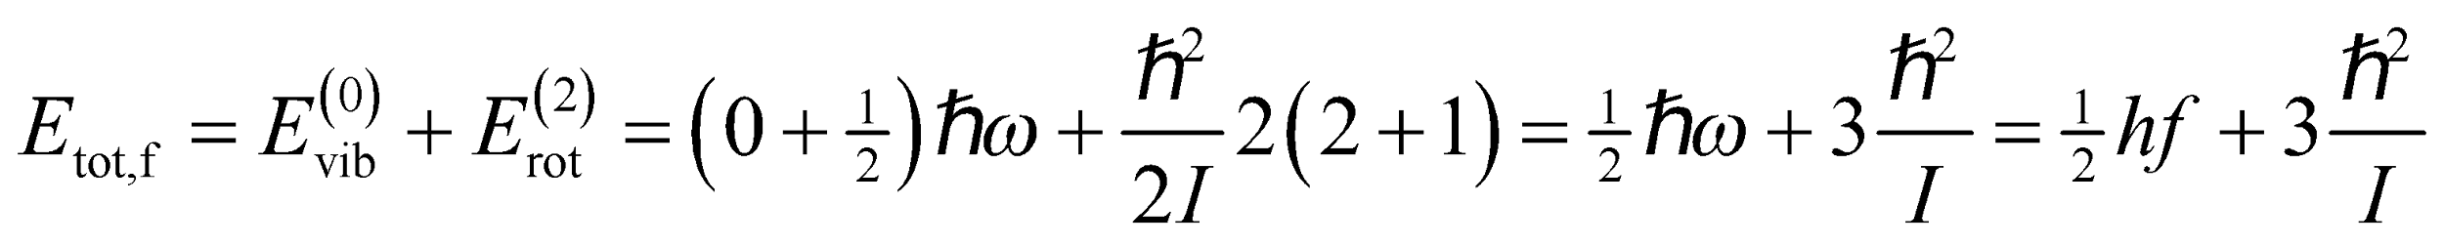
Evaluate (a) The transition energy is
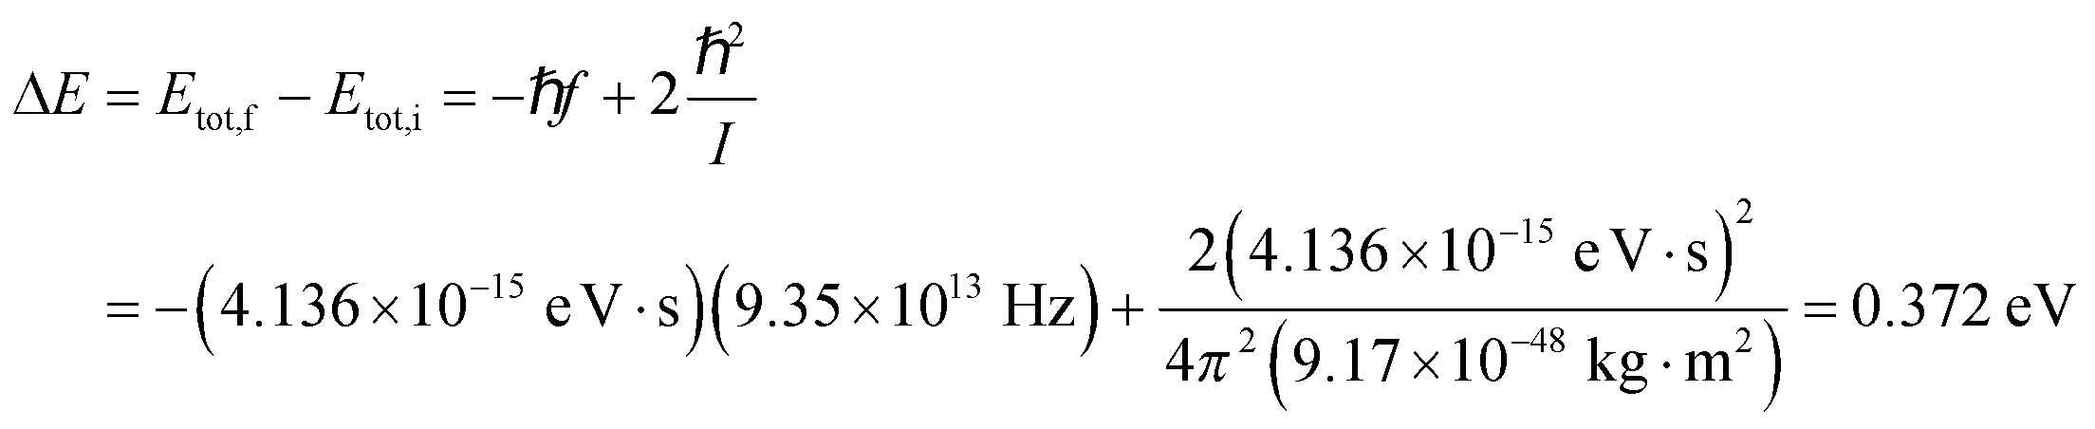
(b) From Equation 34.6, the corresponding photon wavelength is
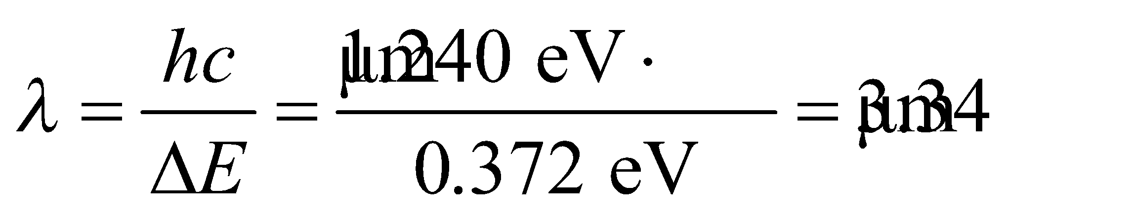
Assess This transition is in the infrared portion of the electromagnetic spectrum.
37. Interpret The problem concerns one of the dominant absorption wavelengths of carbon dioxide molecules.
Develop The relation between transition energy and photon wavelength is given by 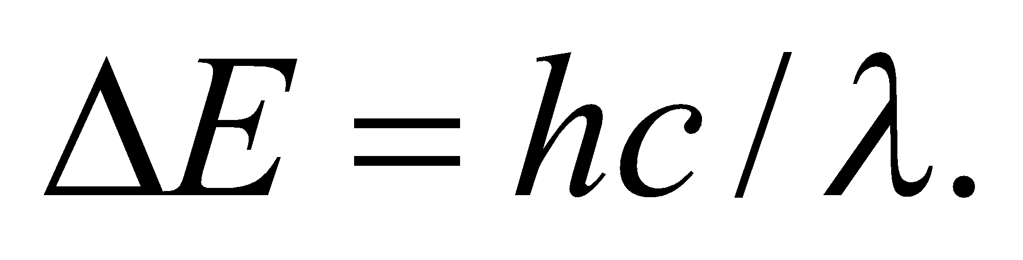
Evaluate Solving for the wavelength and using a shorthand expression for the quantity hc,
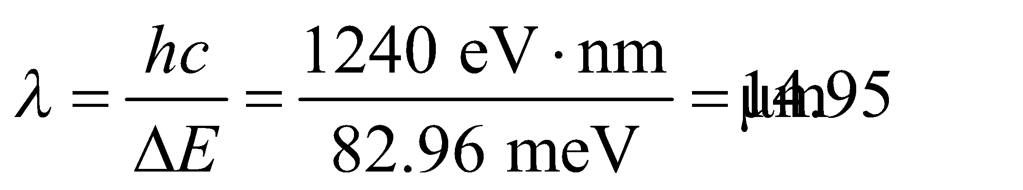
Assess The wavelength is longer than the limit of the visible region 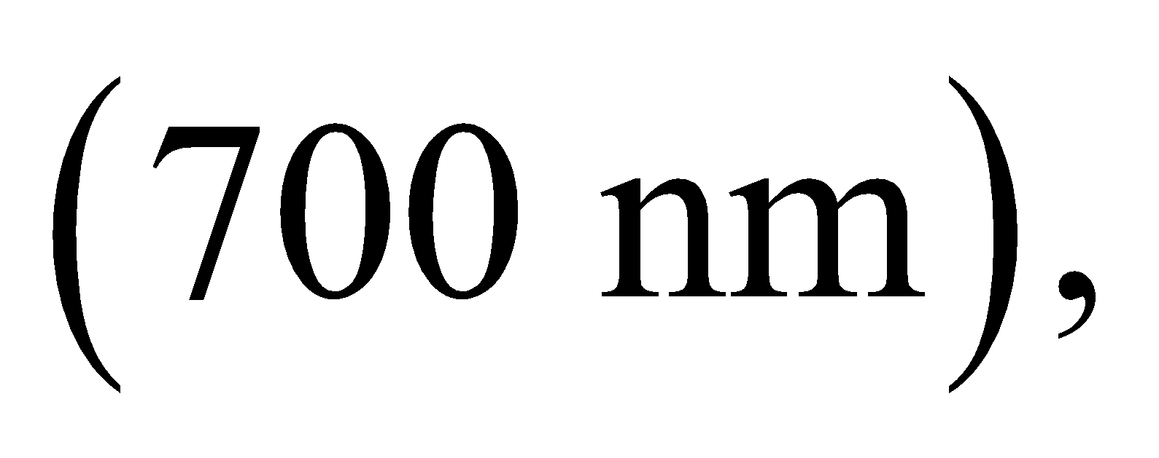 as we'd expect for infrared light.
38. Interpret This problem involves both rotational and vibrational transitions of an oxygen molecule which is initially in the ground state with n = 0 and l = 0. Given the energy difference between two different states, we are to find the classical vibration frequency and the rotational inertia of the molecule.
Develop The quantized vibrational energy levels are given by Equation 37.3:
Therefore, the energy difference between adjacent vibrational levels is 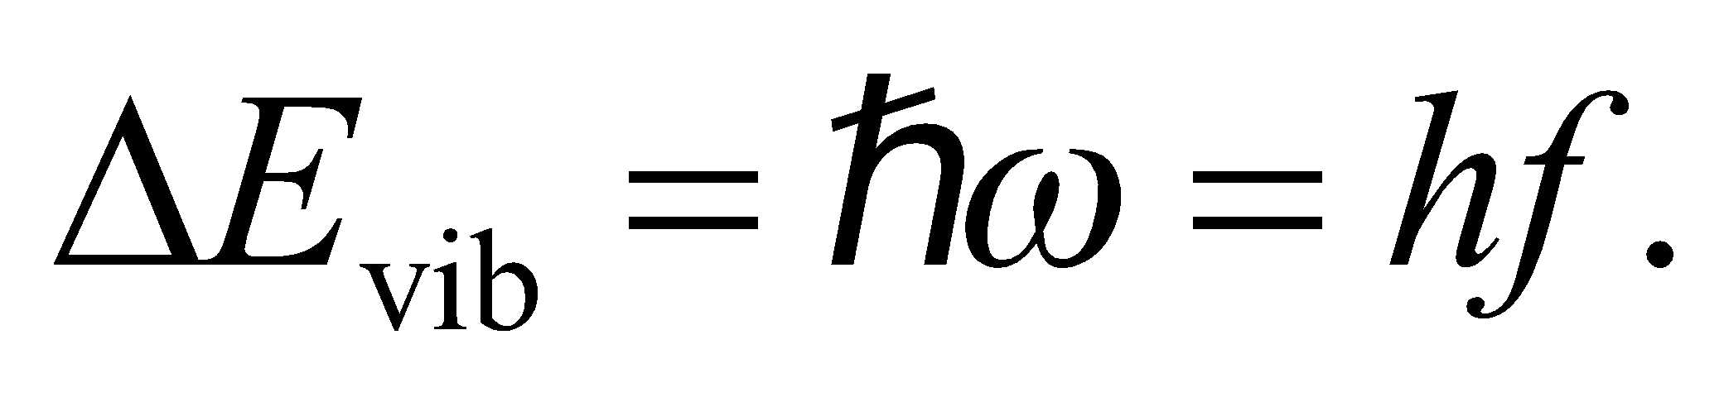 Similarly, using Equation 37.2, the difference in energy between the l = 1 and l = 0 states is
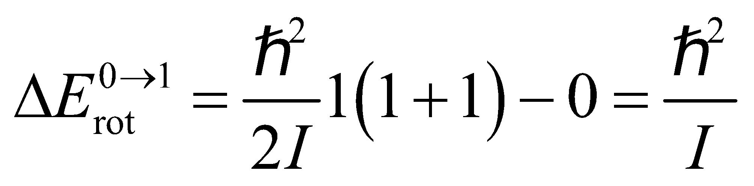
and between the l = 1 and l = 2 states, the rotational energy difference is
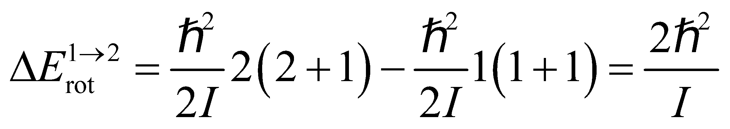
Thus, for the n = 0, l = 0 to n = 1, l = 1 transition, the energy difference is
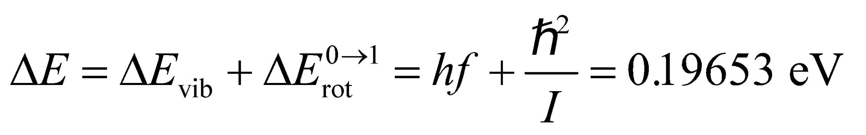
and for the n = 1, l = 1 to n = 0, l = 2 transition, the energy difference is
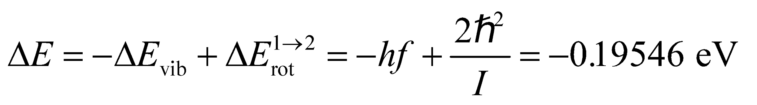
We can solve these equations simultaneously for f and I.
Evaluate (a) Multiplying the first equation by 2 and adding to the second, we get
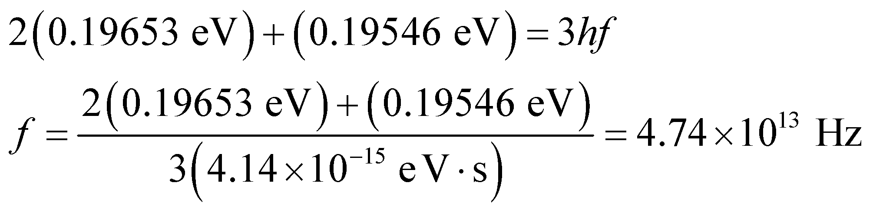
(b) Similarly, subtracting the second equation from the first one gives
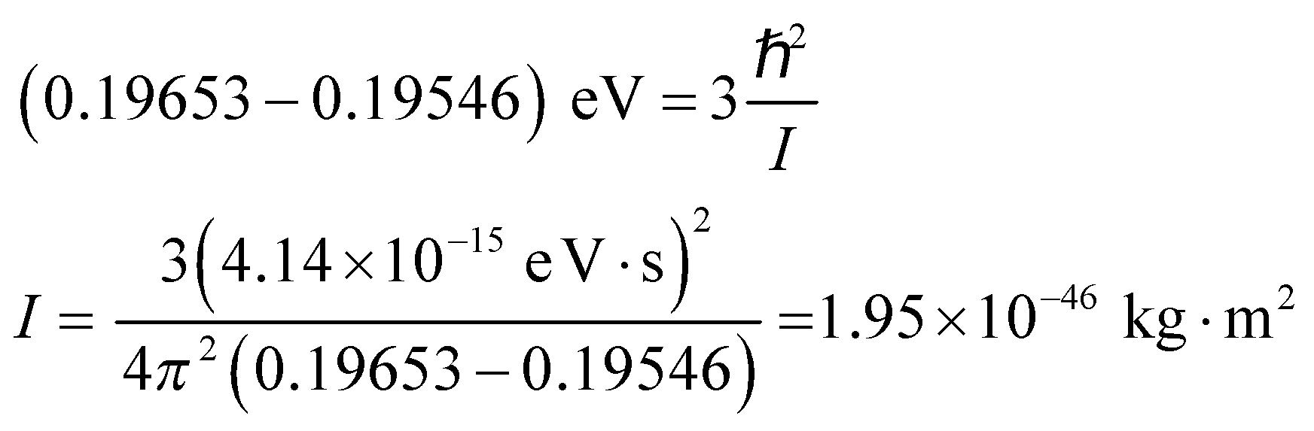
Assess Since 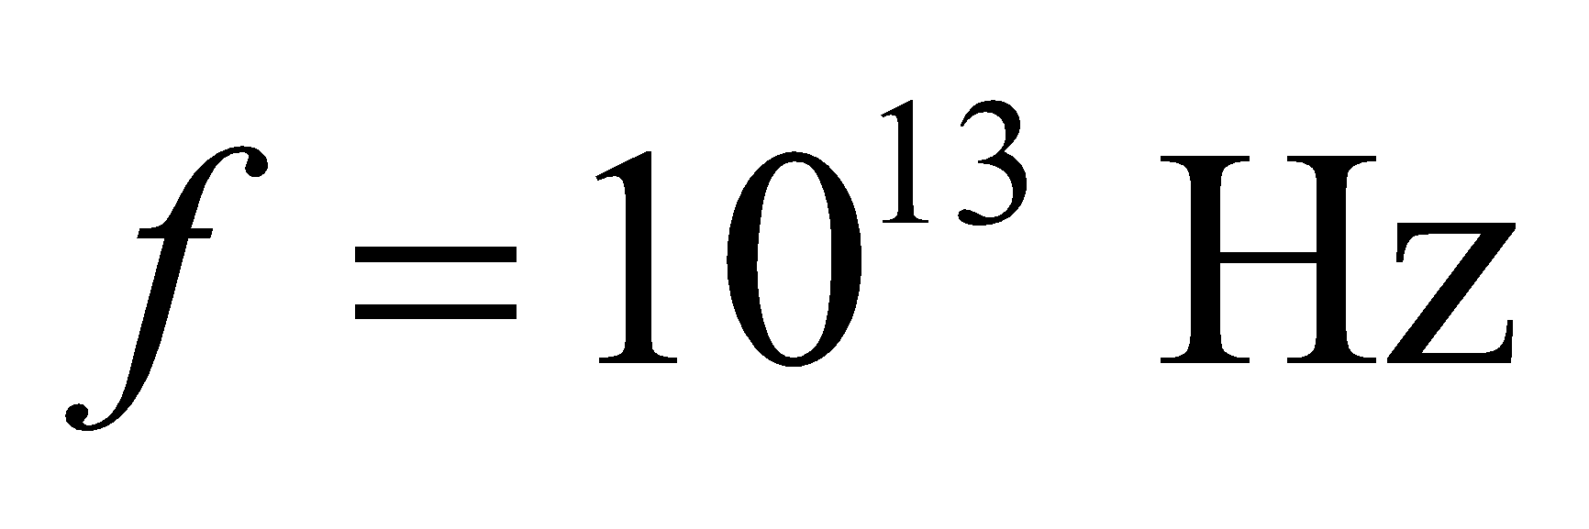 is in the infrared region of the spectrum, study of molecular vibrations typically involves infrared spectroscopy. A rotational inertia 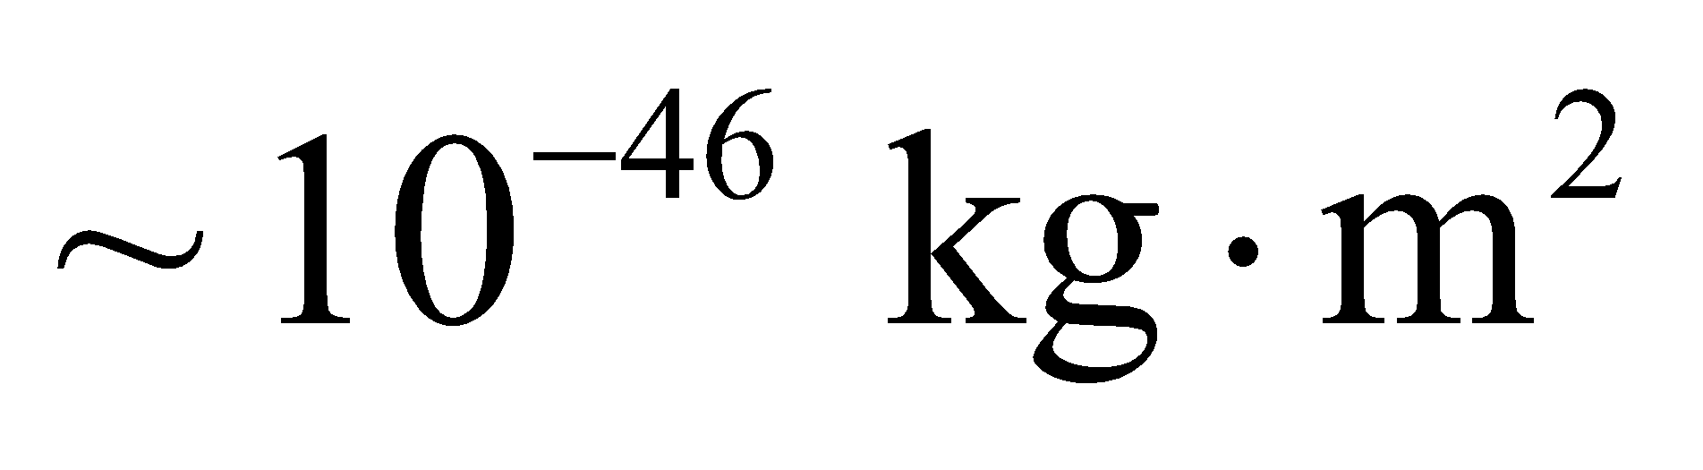 is typical of diatomic molecules.
39. Interpret We are given the distance between the atoms in diatomic hydrogen (i.e., H₂) and are asked to find the energy spacing between the rotational ground state and the first rotational excited state.
Develop From Equation 10.12, the rotational inertia of an H₂ molecule is
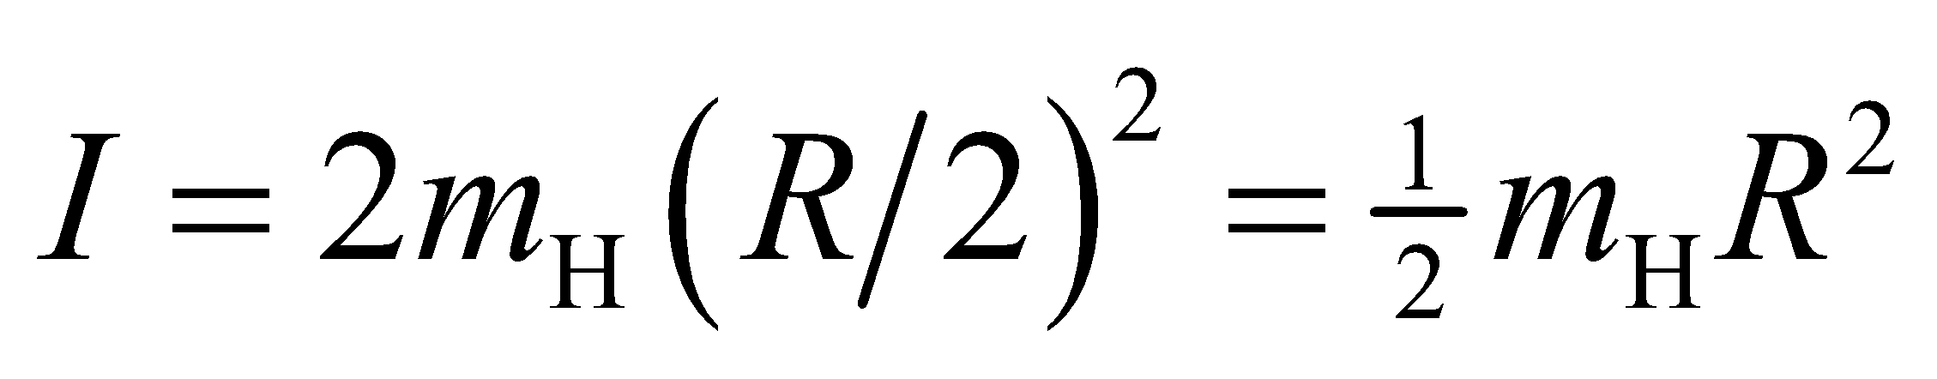
where R = 74 pm and R/2 is the distance from each atom to the center-of-mass, which is the point about which they rotate. From Equation 37.2, the energy difference between the rotational ground state and first excited state (l = 0 and l = 1, respectively) is
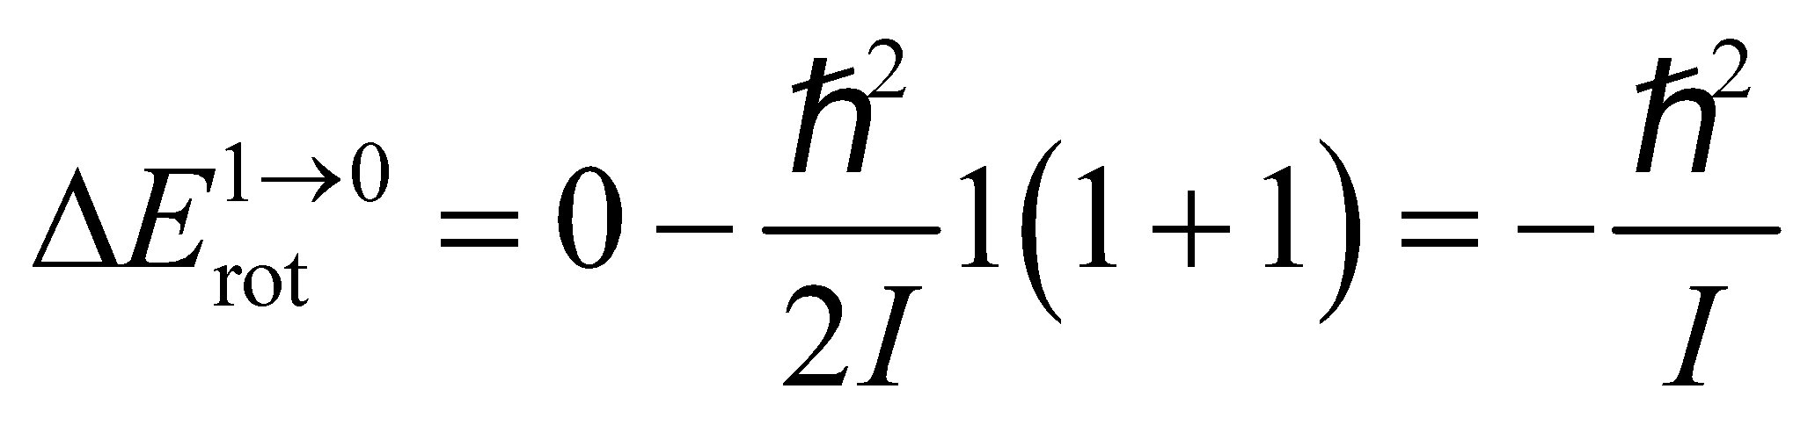
By conservation of energy, this is the magnitude of the energy that must be carried away by the photon emitted by this transition.
Evaluate The energy of the photon released in the l = 1 to l = 0 transition is thus
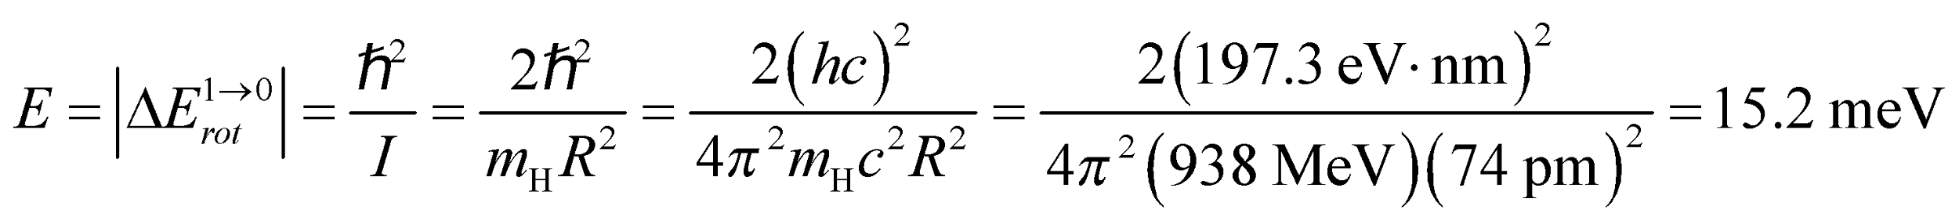
Assess The wavelength of this photon is ~81 μm, which is in the far infrared portion of the electromagnetic spectrum. Note that we have used the proton’s mass as the mass for the hydrogen atom, which is warranted because it is an accurate value for the precision of this problem.
40. Interpret We're asked to convert the wavelength of a "breathing mode" in DNA molecules into its associated frequency and energy.
Develop For light, the wavelength is related to frequency by 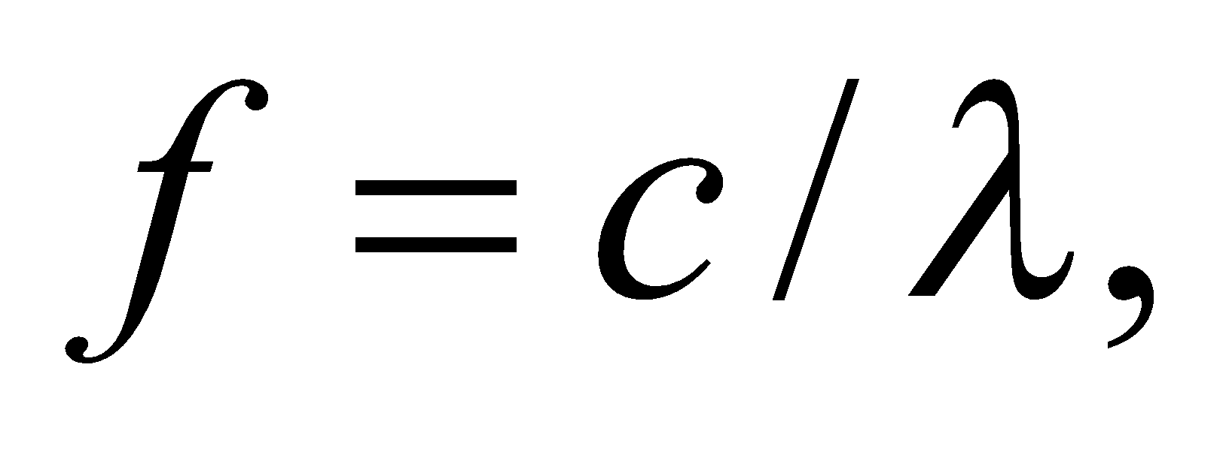and energy by
Evaluate (a) The frequency of the given mode is
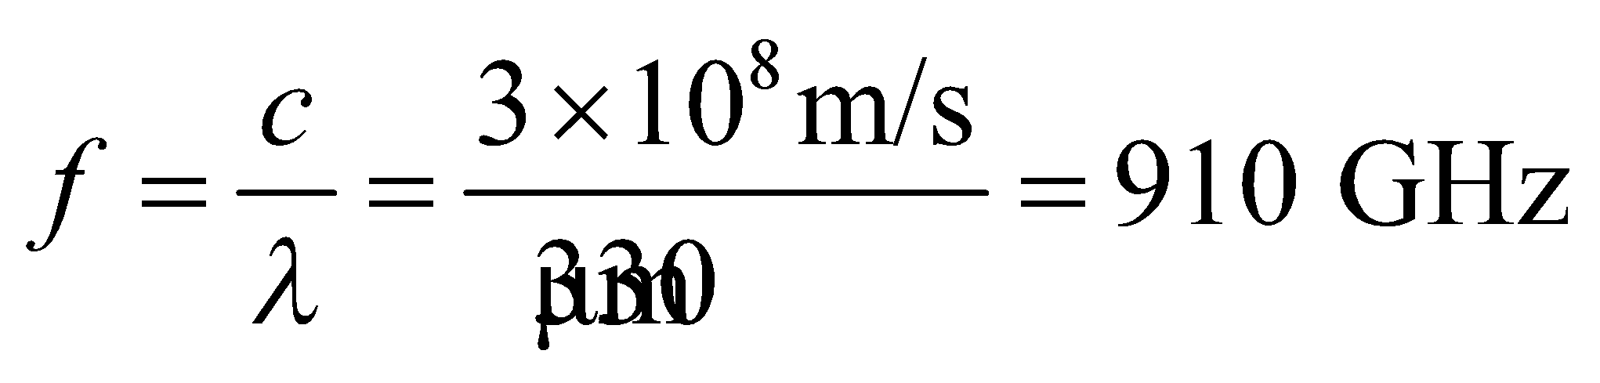
(b) The energy of the mode is
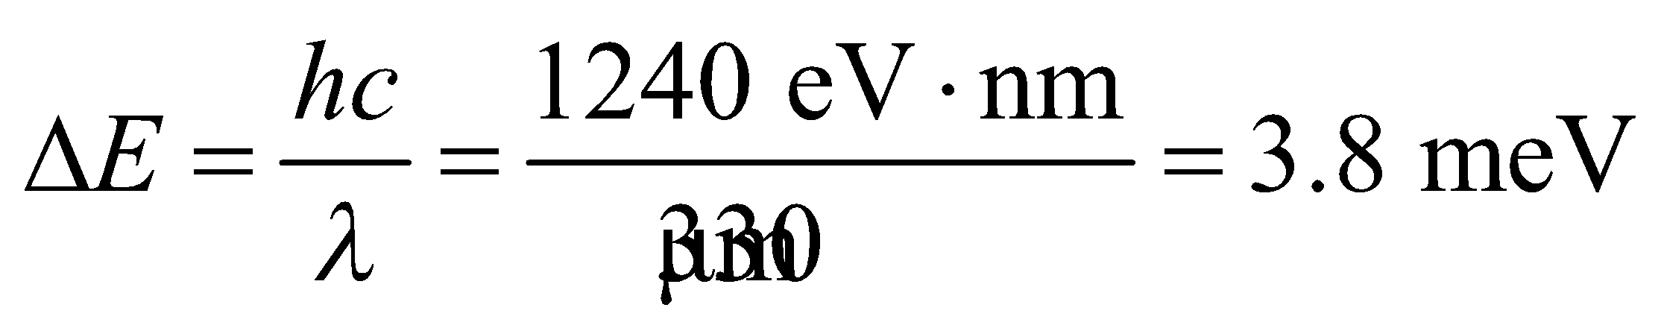
Assess The frequency is at the border between microwaves and infrared radiation, in a region of the electromagnetic spectrum that is sometimes referred to as terahertz light, or T-rays.
41. Interpret This problem involves both rotational and vibrational transitions of a KCl molecule. We are given the classical vibration frequency and the rotational inertia and are asked to find the energy difference for a given transition.
Develop The quantized vibrational energy levels are given by Equation 37.3:
Therefore, the energy difference between adjacent levels is 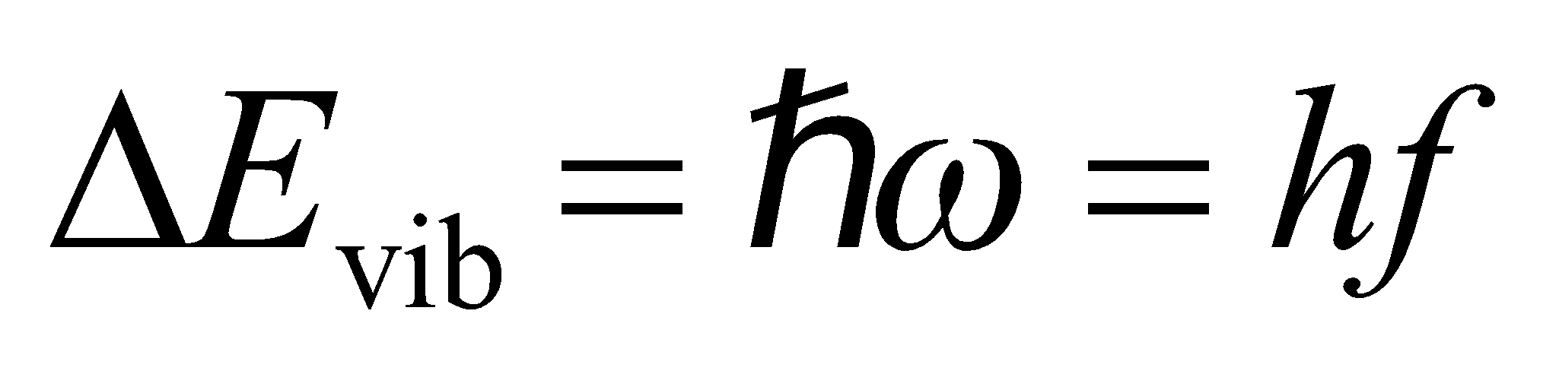. Similarly, using Equation 37.2, the difference in energy between the l = 2 and l = 3 states is
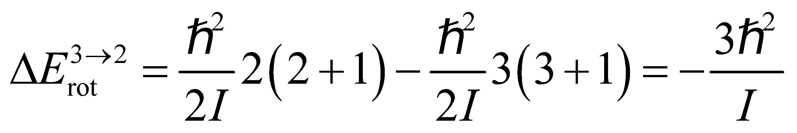
Thus, the difference in energy between these vibrational-rotational levels is
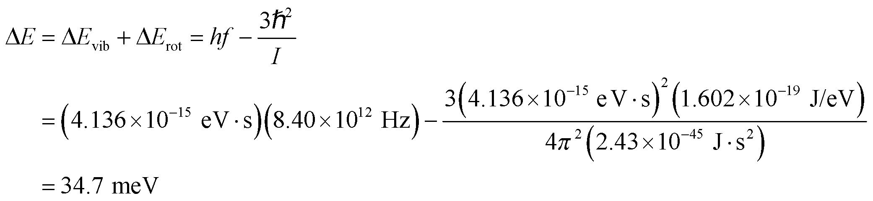
Evaluate The energy corresponds to a photon wavelength of 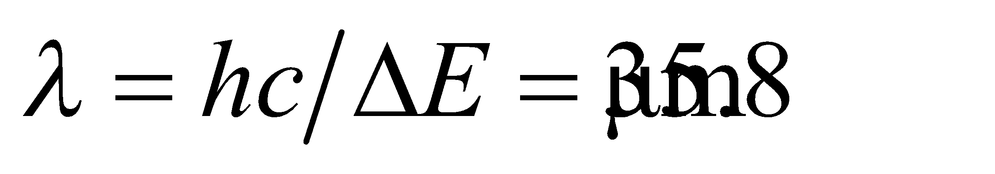.
Assess Since 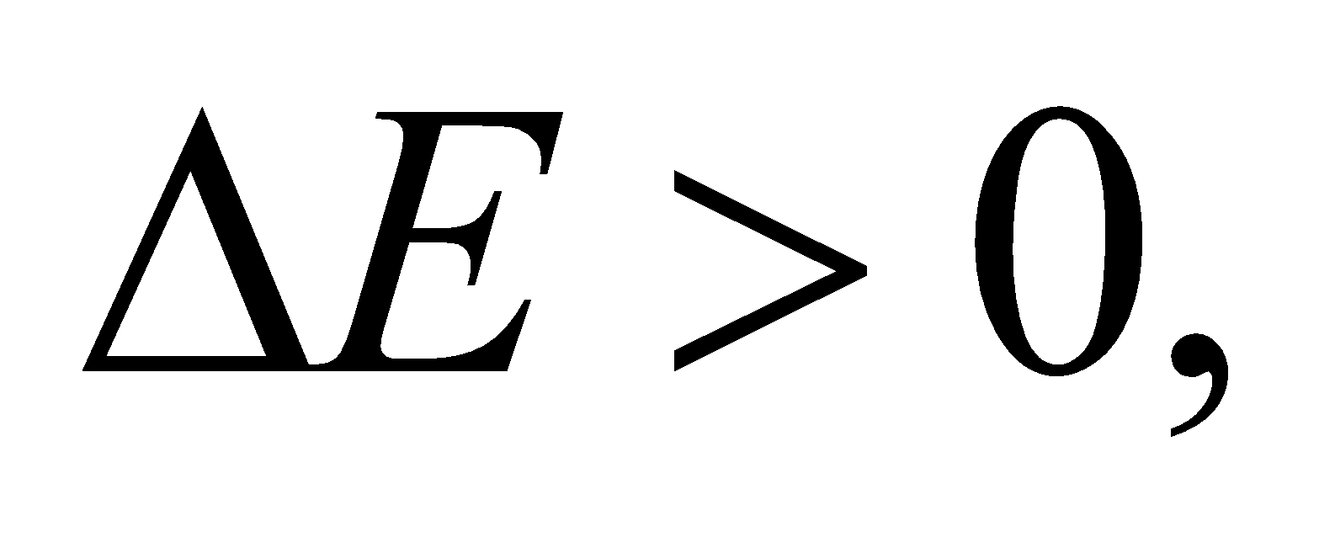 the final state has higher energy than the initial state, so the transition involves absorbing a photon in the infrared.
42. Interpret Given the rotational inertia and classical vibration frequency of H₂, we are to find the wavelength (i.e., energy) of photons emitted by all allowed transitions from the first three rotational levels in the n = 1 vibrational state to the n = 0 state.
Develop The allowed transitions are defined by Δn = ±1, Δl = ±1, so the allowed transitions from the first three rotational levels (l = 0, 1, 2) are
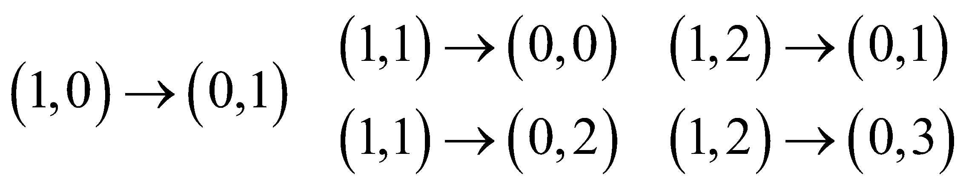
where we have used the notation (n, l) to define each state. The quantized vibrational energy levels are given by Equation 37.3:
Therefore, the energy difference for the transition from state n to state n − 1 is
The quantized rotational energy levels are given by Equation 37.2, so the energy difference for the transition from state l to state l − 1 is
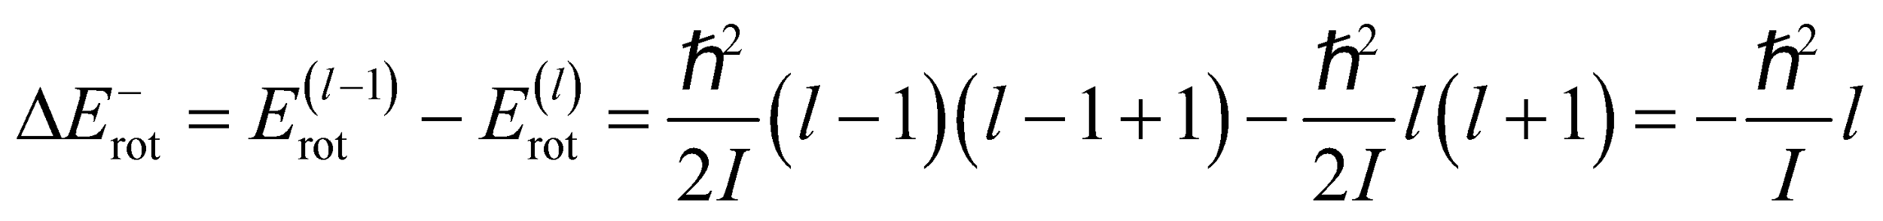
and the energy difference for the transition from state l to state l + 1 is
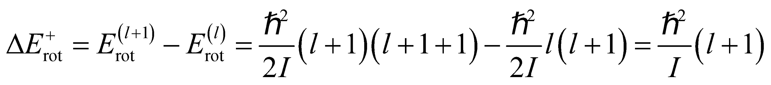
The total energy difference is the sum of the vibrational and rotational energy differences. Thus, the energy difference for each transition is
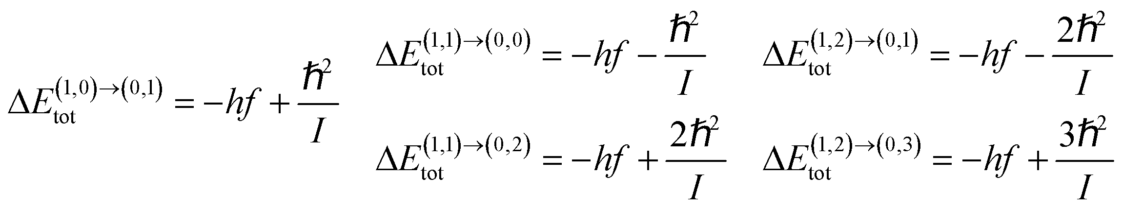
We can evaluate each of these differences using the data provided and, by conservation of energy, equate these energies to that of the photons emitted in the transitions. The wavelengths of the photons may then be found using Equation 34.6: E = hf = hc/λ.
Evaluate From the given data for the H₂ molecule,
and
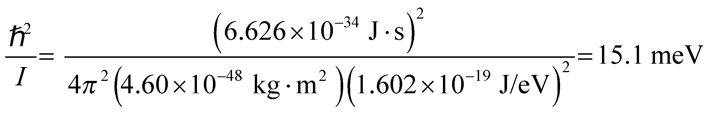
so the transition energies are
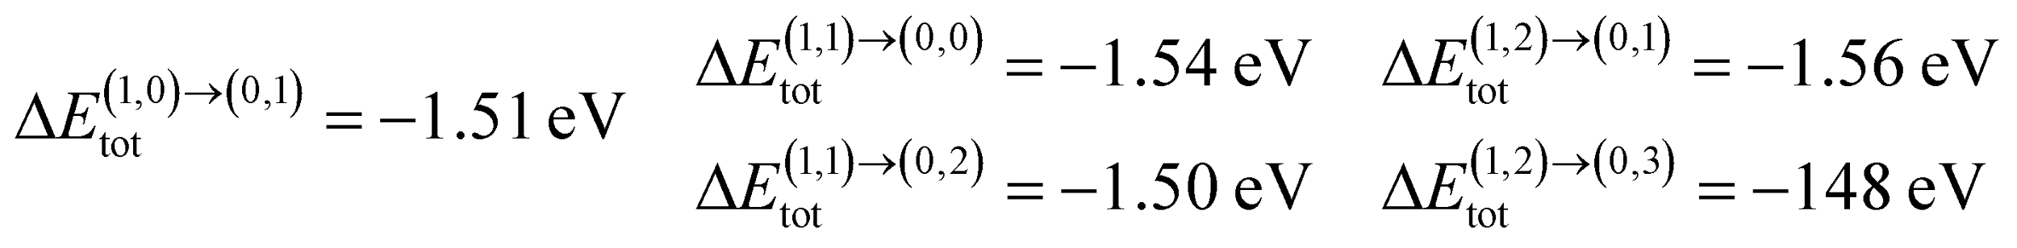
These energies are lost by the H2 molecule, so conservation of energy implies that the energies of the photon emitted must balance these energies, so E_{γ} = −ΔE_{tot}. Combining this with Equation 34.6 gives λ = −hc/ΔE_{tot}. Thus, the wavelengths are
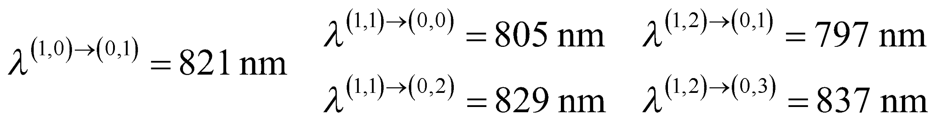
Assess These wavelengths are all in the near-infrared range of the electromagnetic spectrum.
43. Interpret This problem is about the ionic cohesive energy of KCl. We are asked to solve for the constant n in Equation 37.4.
Develop As shown in Example 37.3, the constant n (not to be confused with the quantum number n used above) is given by
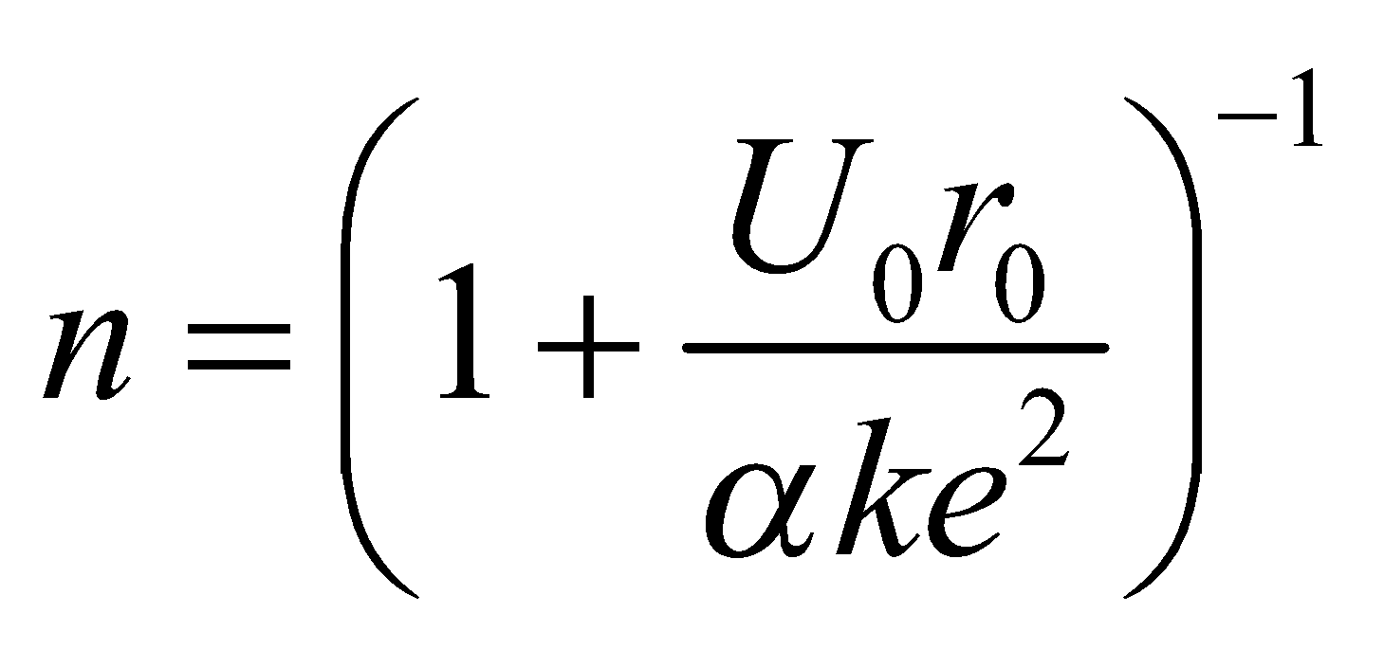
Since the crystal structures of KCl and NaCl are the same, α = 1.748.
Evaluate Substituting the values given, we get
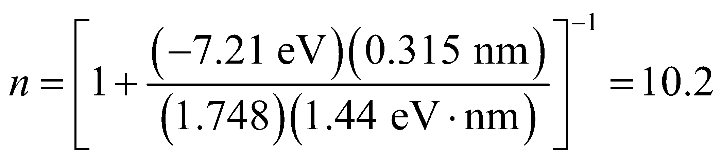
where we used a convenient value of 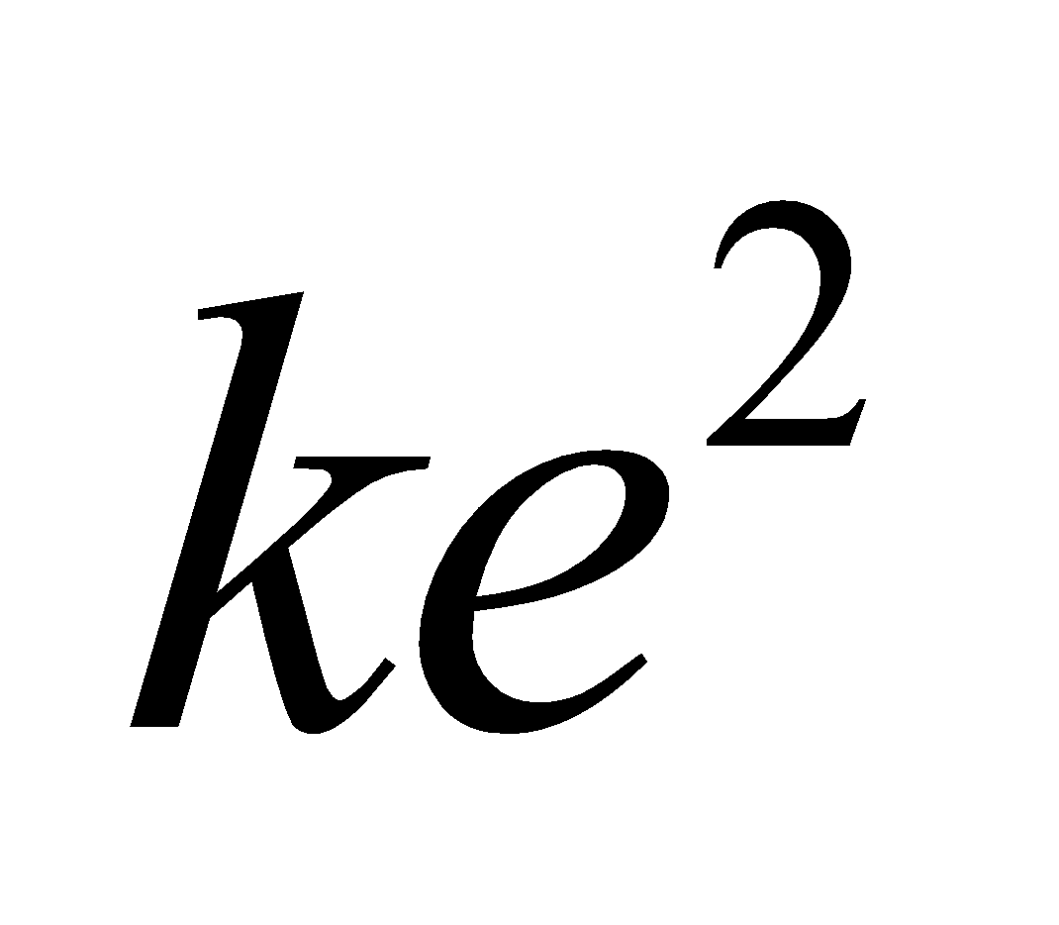 in atomic units:
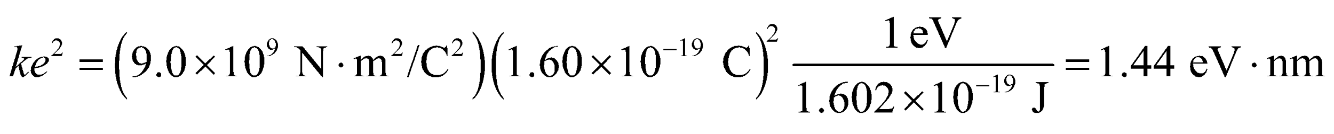
Assess The result can be compared with n = 8.22 for NaCl (see Example 37.3). The large value of the exponent implies that KCl is strongly resistant to compression.
44. Interpret We are to find the energy required to compress an NaCl crystal to 90% of its original volume.
Develop For the volume of the crystal to decrease to 90% of its original volume, the equilibrium separation r₀ between atoms must decrease by
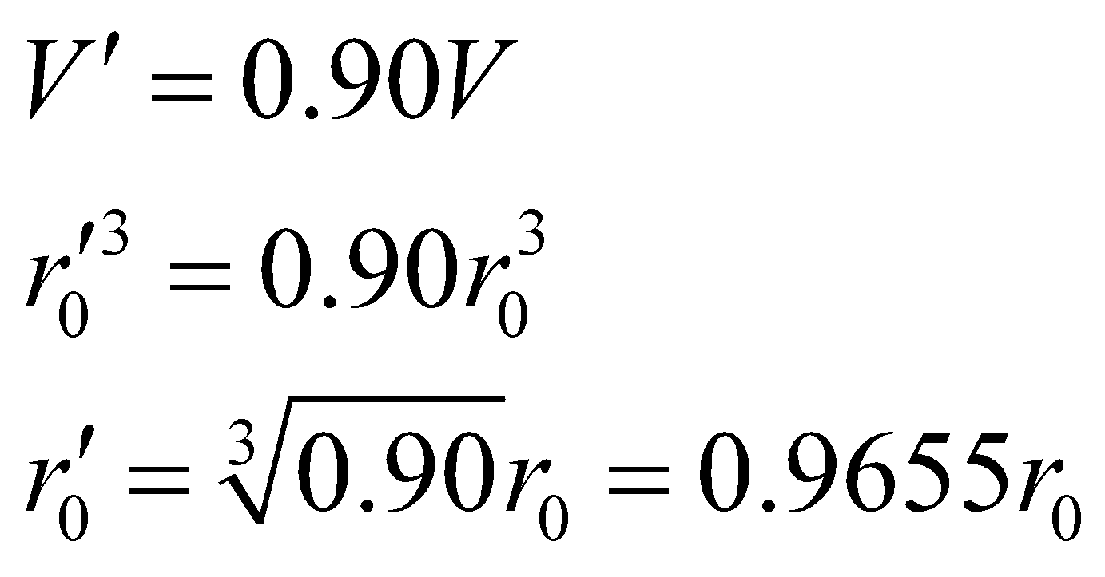
The energy per ion pair would increase, under compression, to
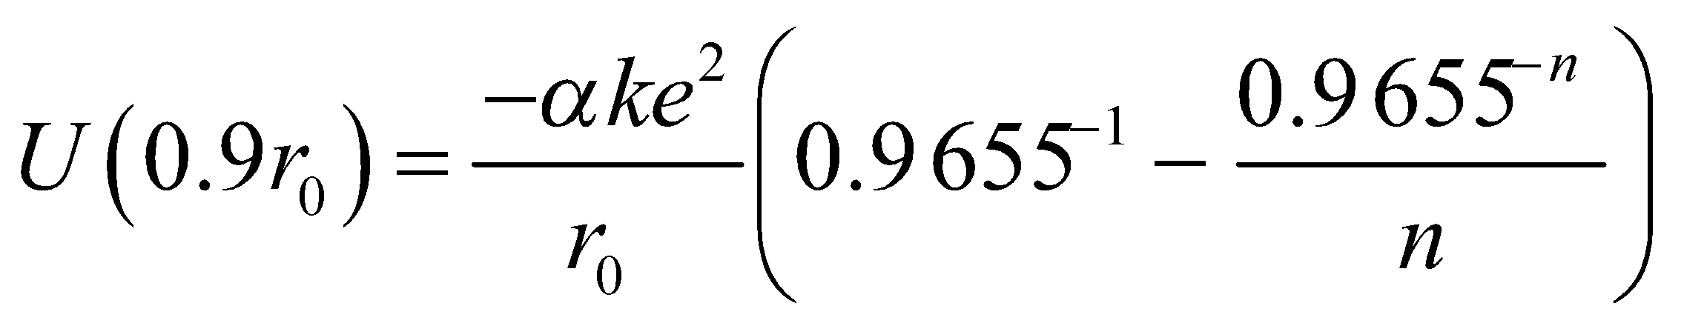
from its normal value of 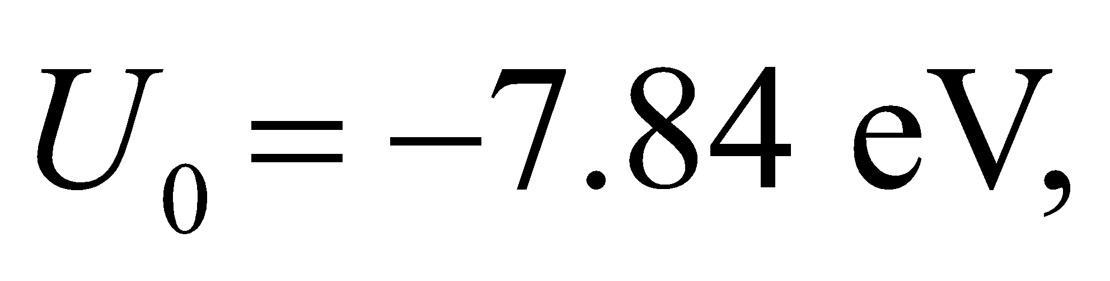 where n = 8.22 for NaCl. From the data for the noncompressed crystal, the constant 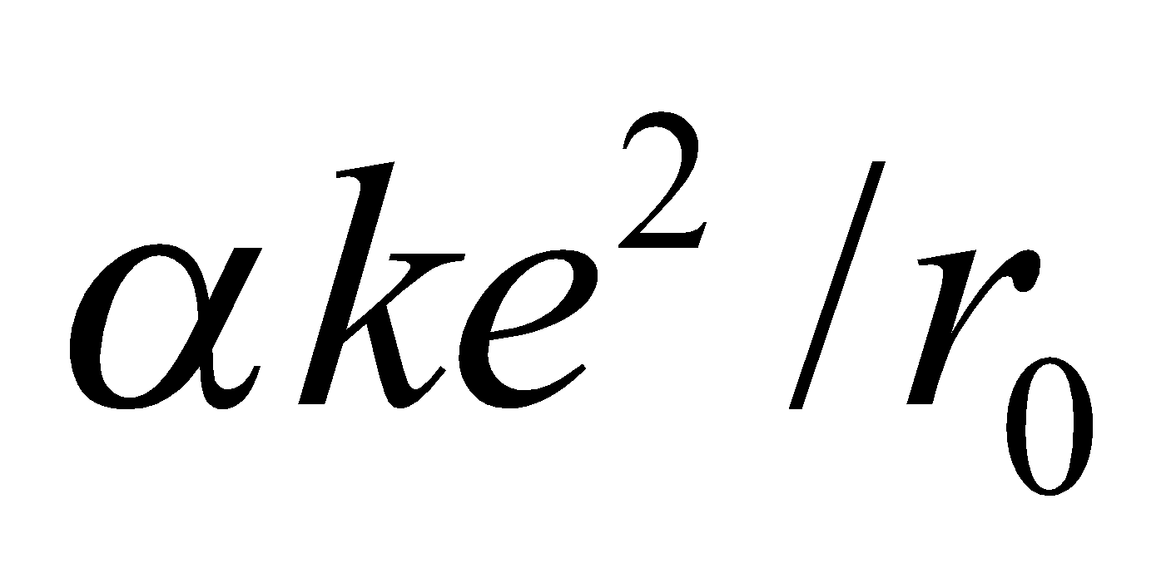 has the value
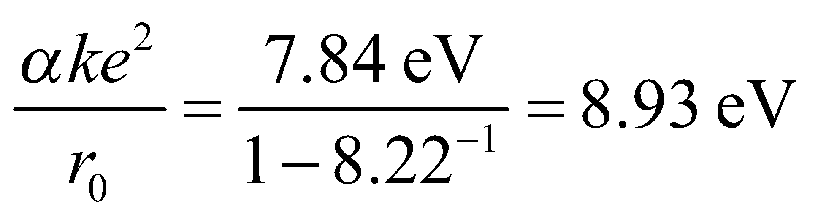
Evaluate The energy required to compress 10²¹ ion pairs is
Assess This energy is roughly equivalent to the kinetic energy of one liter of water dropped from rest through 66 cm.
45. Interpret For this problem, we are to find the ionic cohesive energy of LiCl, which has the same structure as NaCl.
Develop As calculated in Example 37.3, the ionic cohesive energy for NaCl is
Evaluate With n = 7 and r₀ = 0.257 nm, the cohesive energy for LiCl is
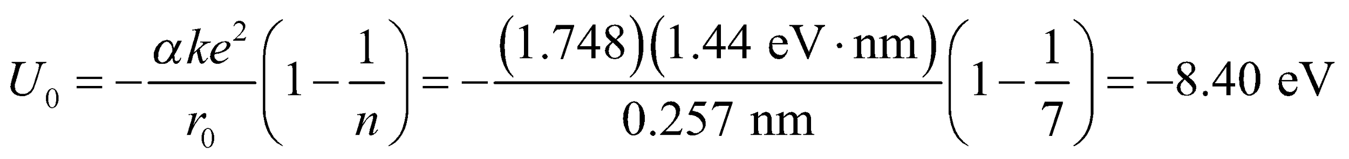
Assess The result can be compared with 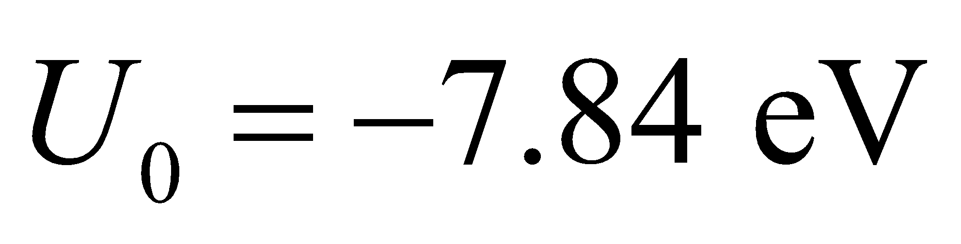 for NaCl (see Example 37.3). The large value of the exponent implies that LiCl is strongly resistant to compression.
46. Interpret You are arguing that a salt formation is structurally sound for storing waste. You support this conclusion by calculating the force between ions, which resists compression.
Develop Equation 37.4 gives the generic formula for the potential energy of an ion in a crystal structure:
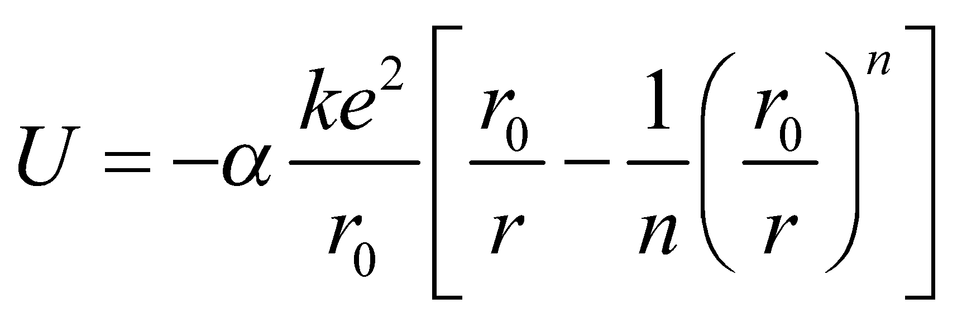
For NaCl, the values of this equation's parameters are given in Example 37.3: 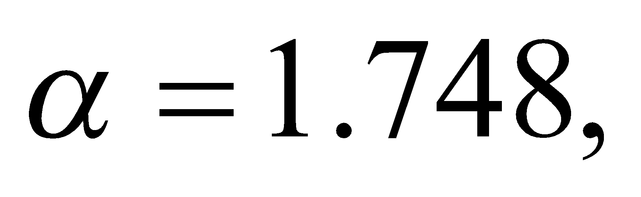 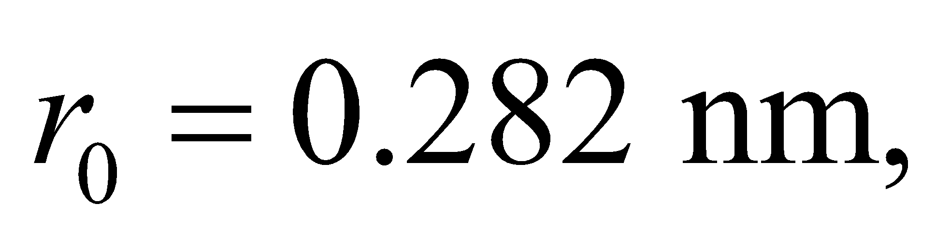 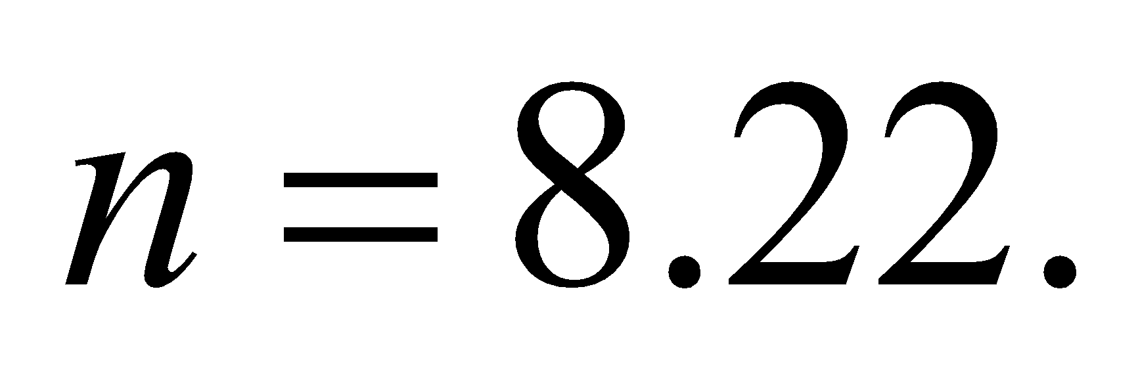 To find the force on an ion moved from its equilibrium position, we take the derivative with respect to 
Evaluate In general, the force on an ion in a crystal structure is
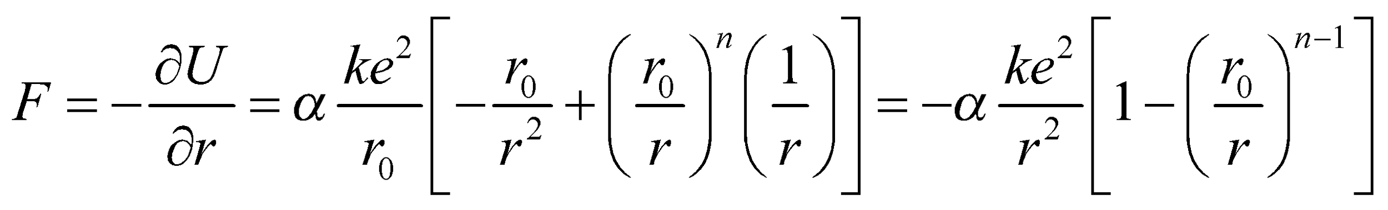
Note that the term 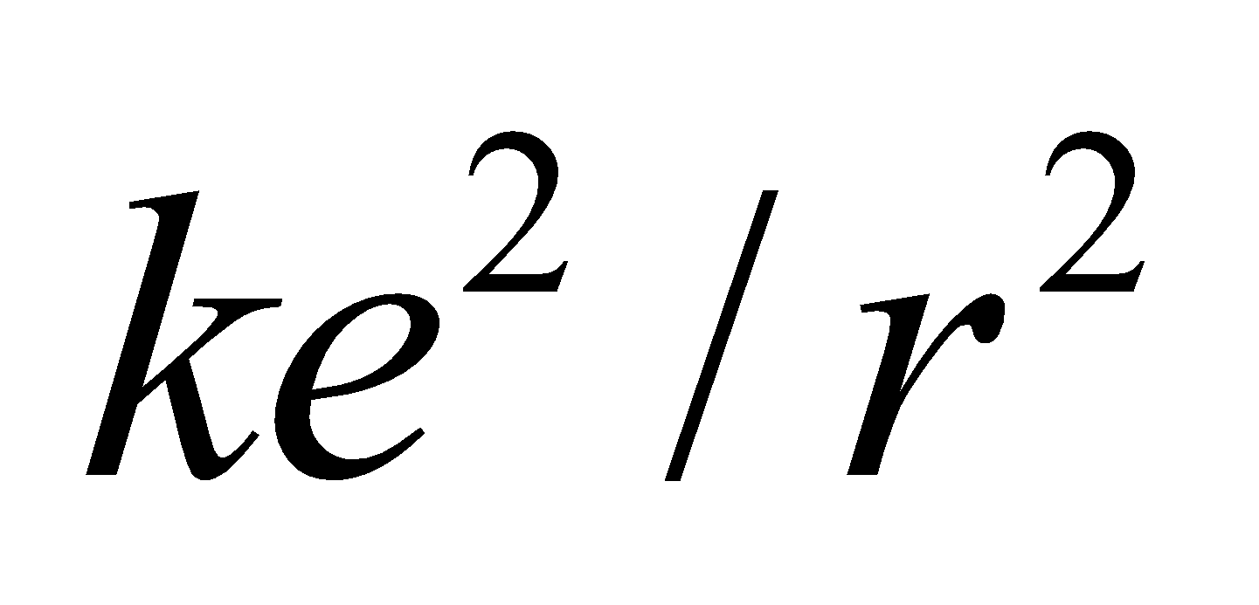is the Coulomb attraction, 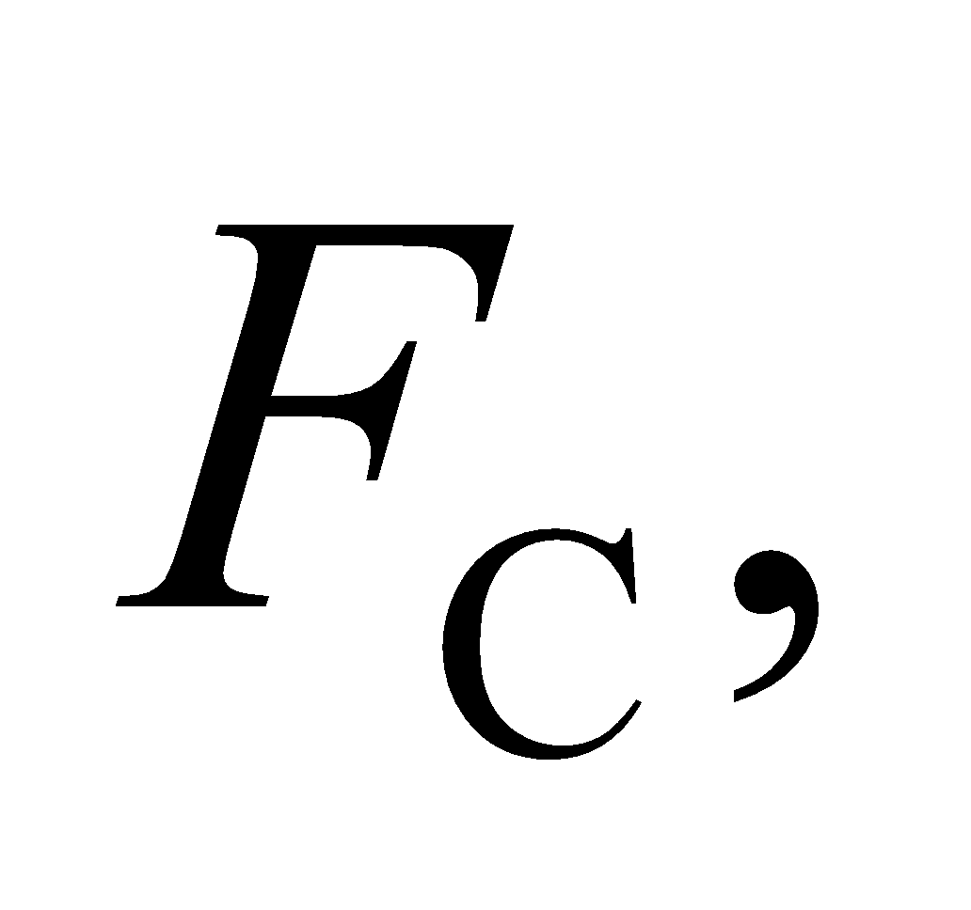which you can imagine is the attractive force between a positive sodium ion and a negative chlorine ion. If 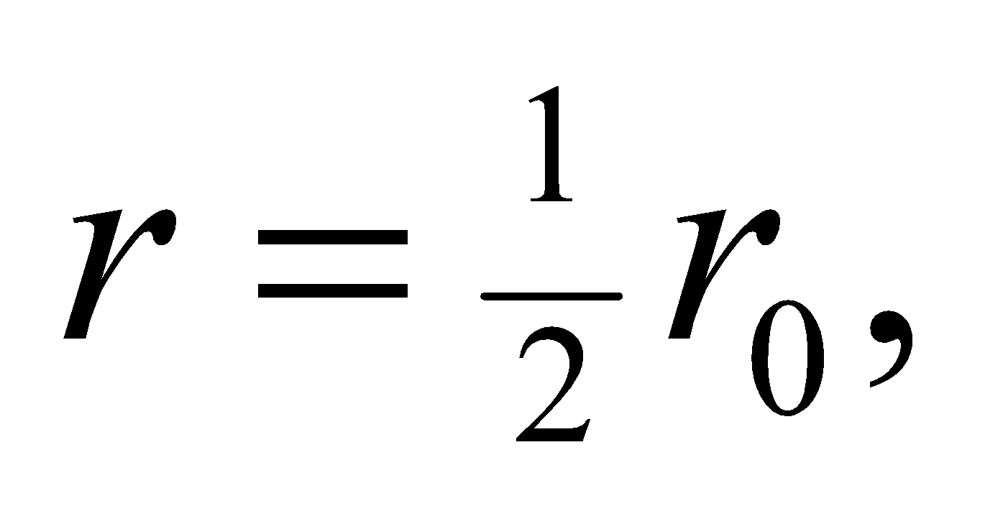then the Coulomb attraction and the force on a salt ion are
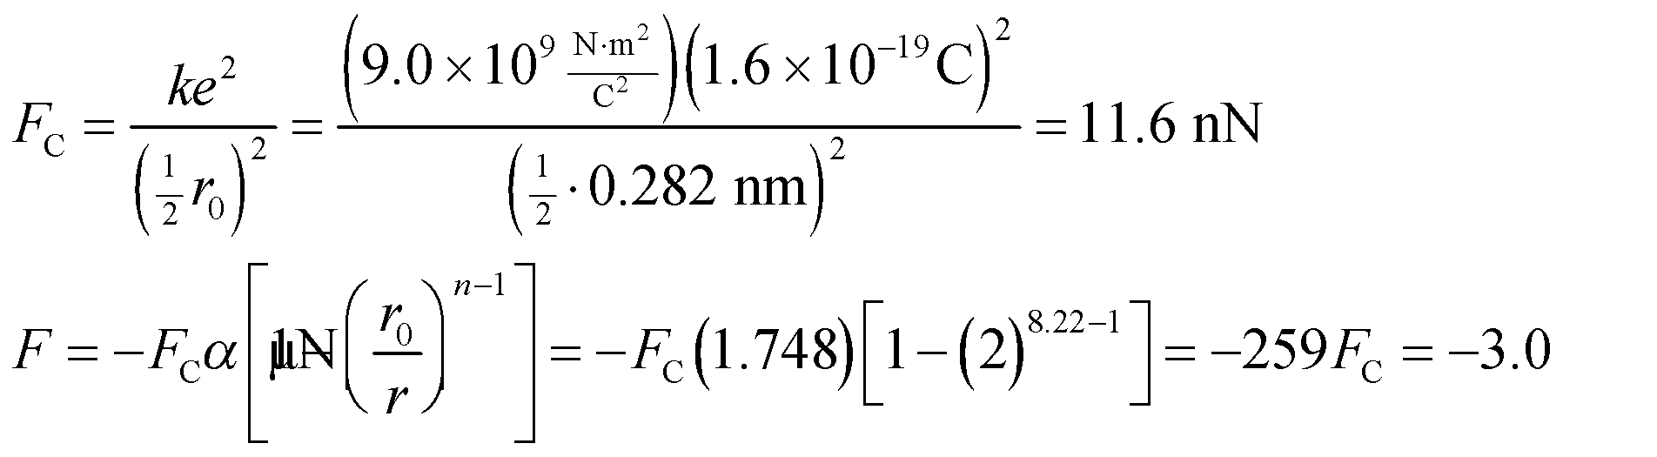
The negative sign for F signifies that it is a restoring force that opposes as the Coulomb attraction. The fact that this force is 259 times the Coulomb force assures you that salt is stable under compression.
Assess How compressible a crystal is will be determined by the exponent, n, in the repulsive part of the potential. The larger n is, the more the ions will resist compression. Typical values of n range from 5 to 12, which means there are crystals that are much more and much less compressible than NaCl.
47. Interpret We are to integrate the density of states for a metal over all occupied states to find the number of conduction electrons per unit volume.
Develop Equation 37.5 tells us that the density of states is
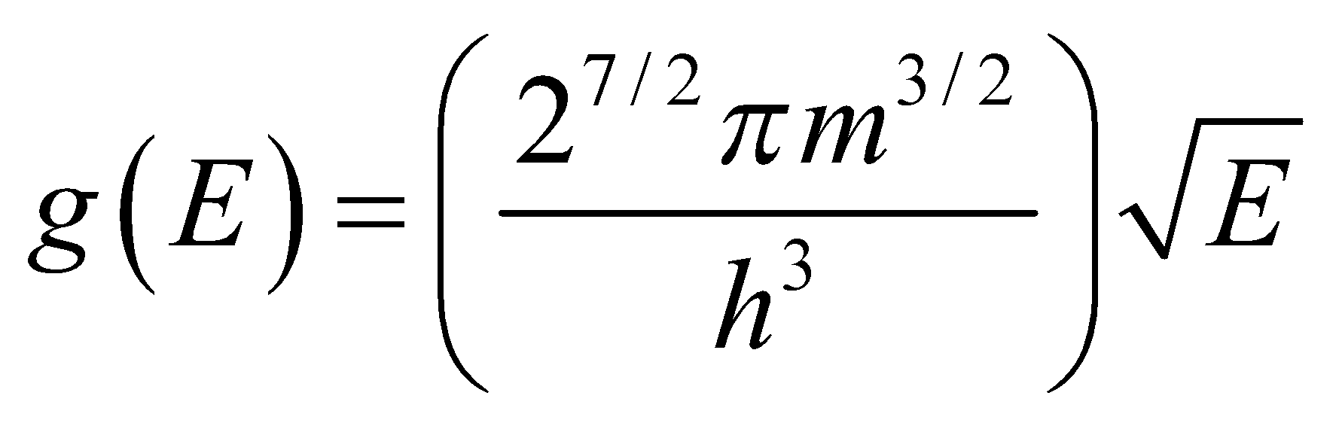
We will integrate this density from E = 0 to E = E_{F} to find the electron number density.
Evaluate Performing the integration gives
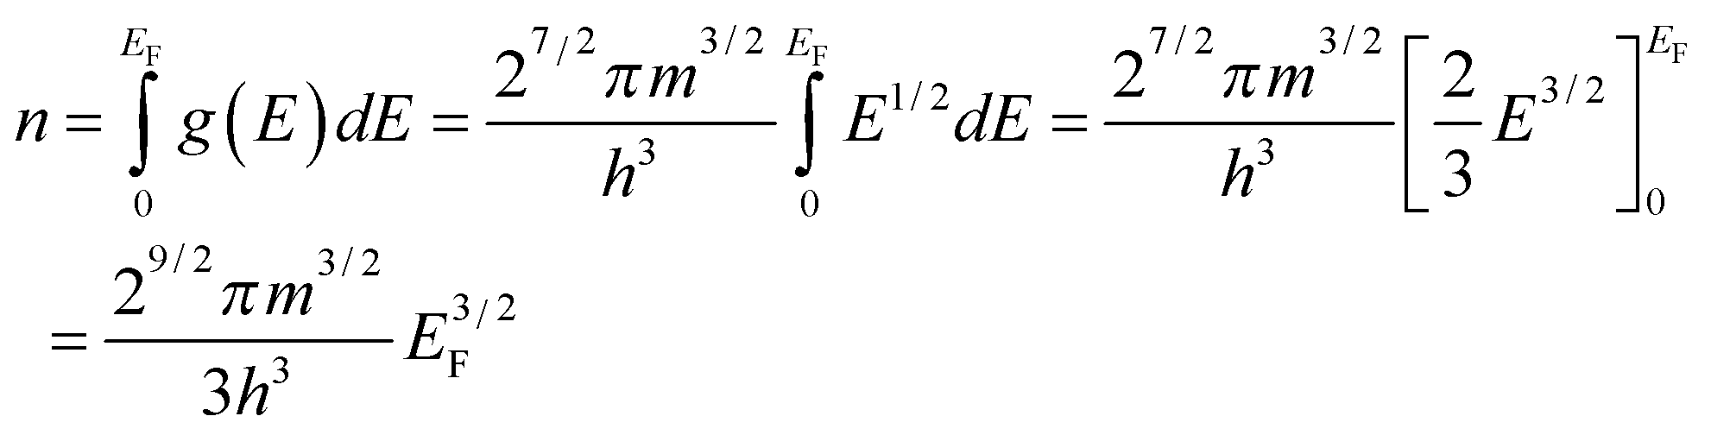
Assess We have shown what was required.
48. Interpret We shall use the results of Problem 37.47 to find the number density n of conduction electrons in aluminum.
Develop From Problem 37.47, we have 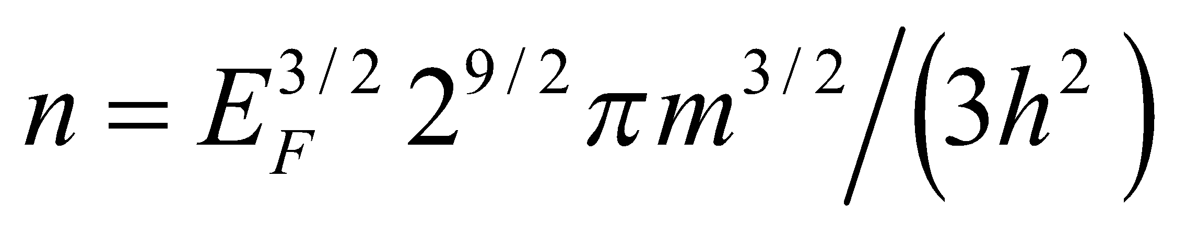 and in this problem we are given the Fermi energy E_{F} = 11.6 eV. We simply plug in the mass of the electron m = 9.109 × 10⁻³¹ kg and the rest of the constants to obtain the number density n.
Evaluate The number density is
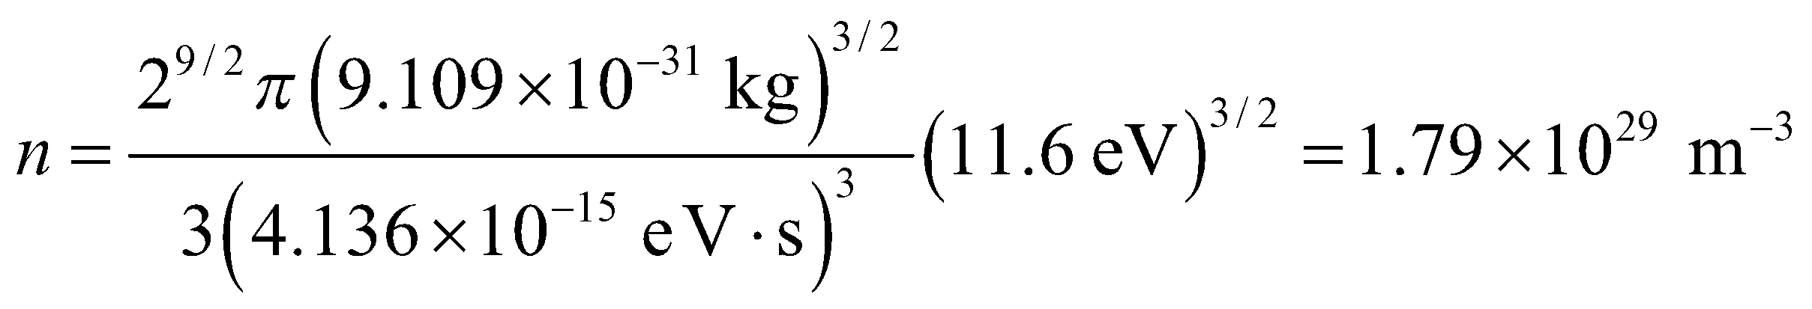
Assess It is actually more common to report number densities in terms of number per centimeter cubed, and in those units the answer would be 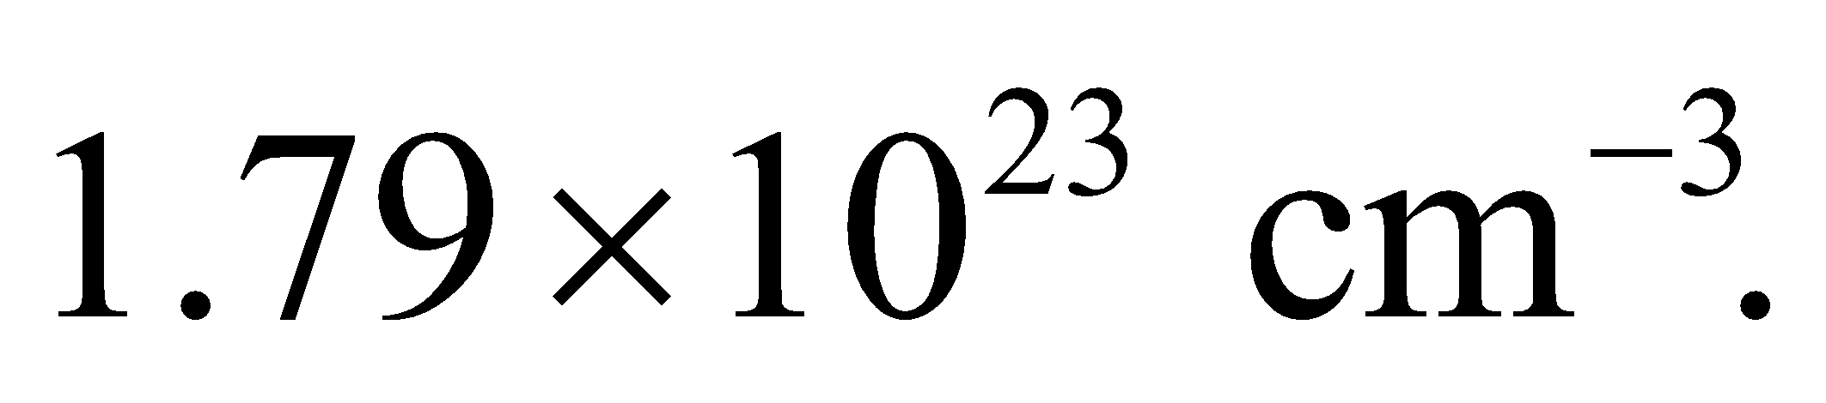 To check the units, we have
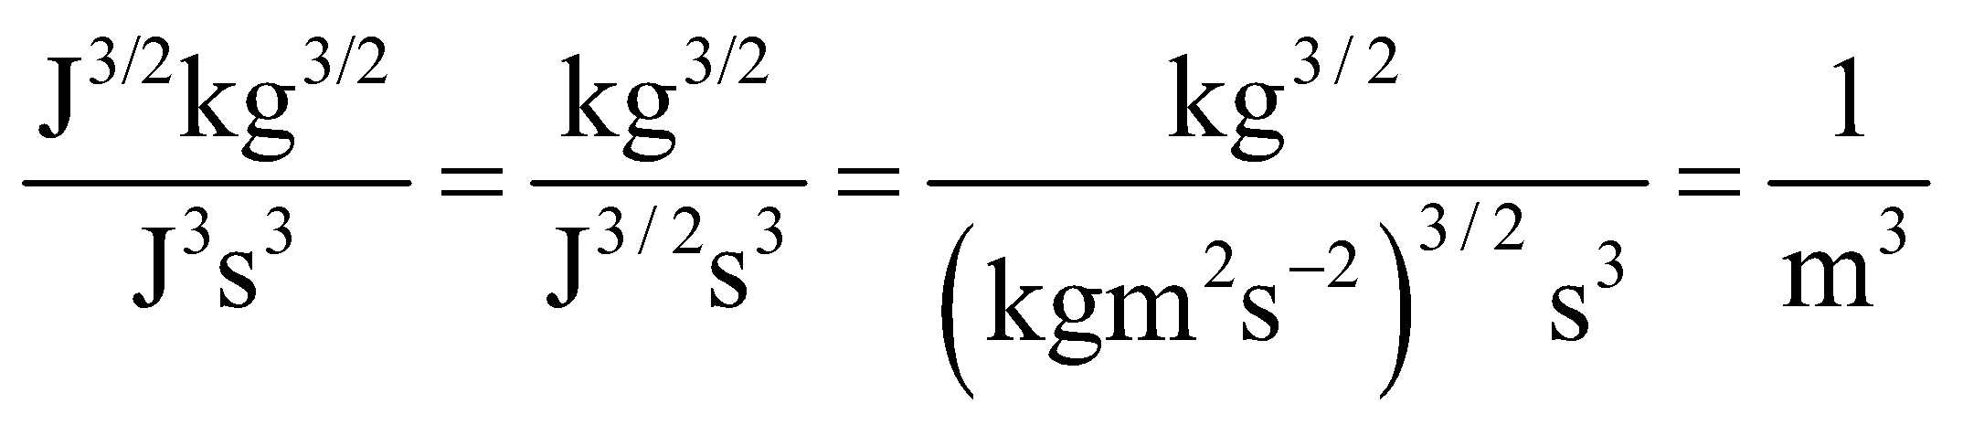
49. Interpret We shall use the results of Problem 47 to calculate the Fermi energy for calcium, given the number density.
Develop The number density of conduction electrons for calcium is 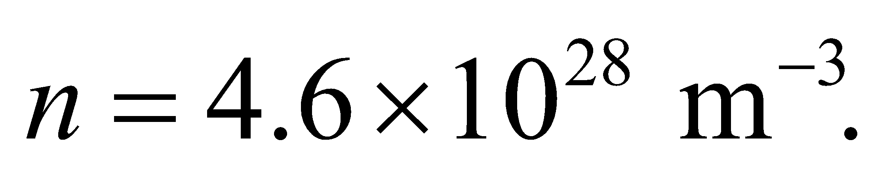 We use this, and the electron mass 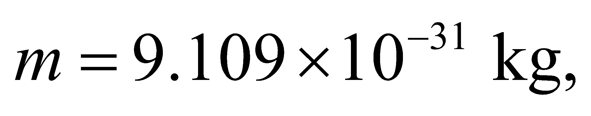 to solve 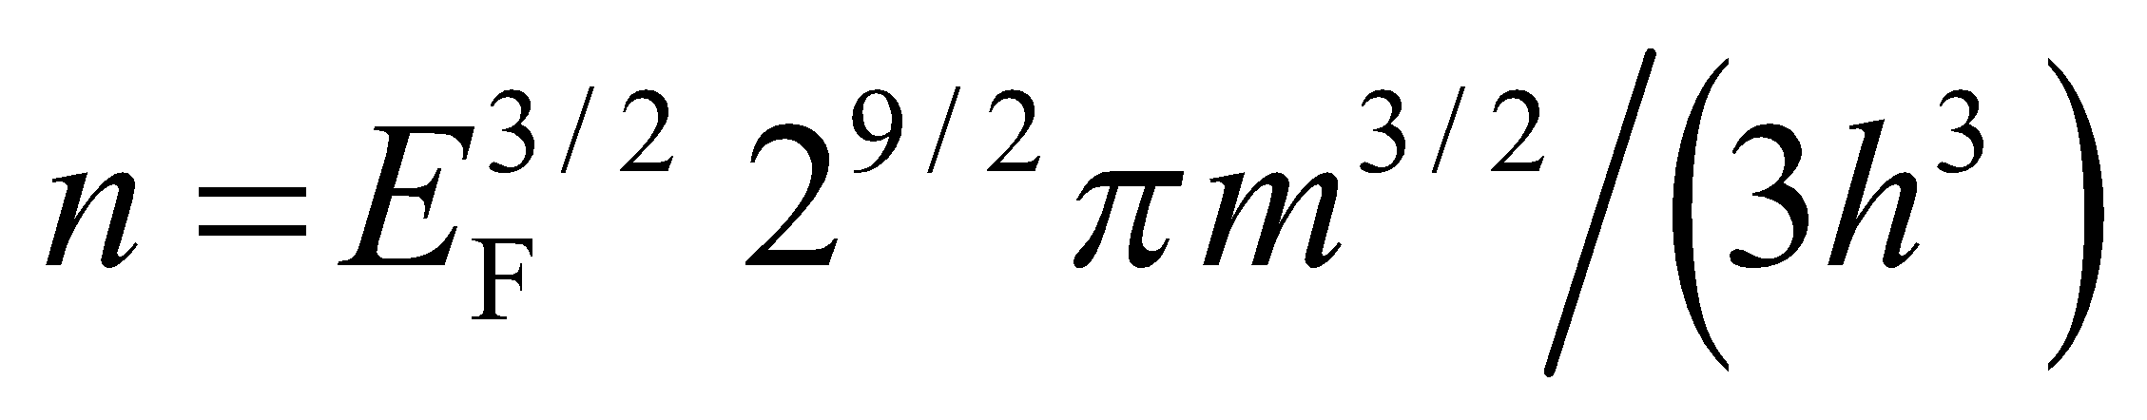 for E_{F}.
Evaluate Solving for the Fermi energy gives
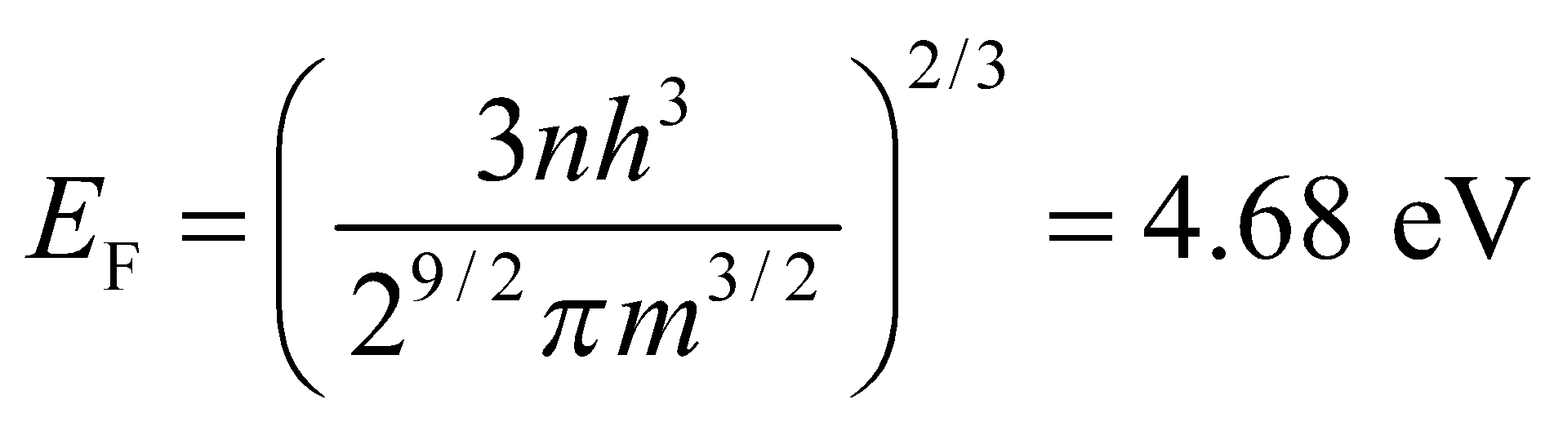
Assess This is a reasonable value for the Fermi energy in an alkali metal.
50. Interpret You want to compare a quantum and classical representation of electrical conduction.
Develop The Fermi energy is the maximum electron energy in a conductor at 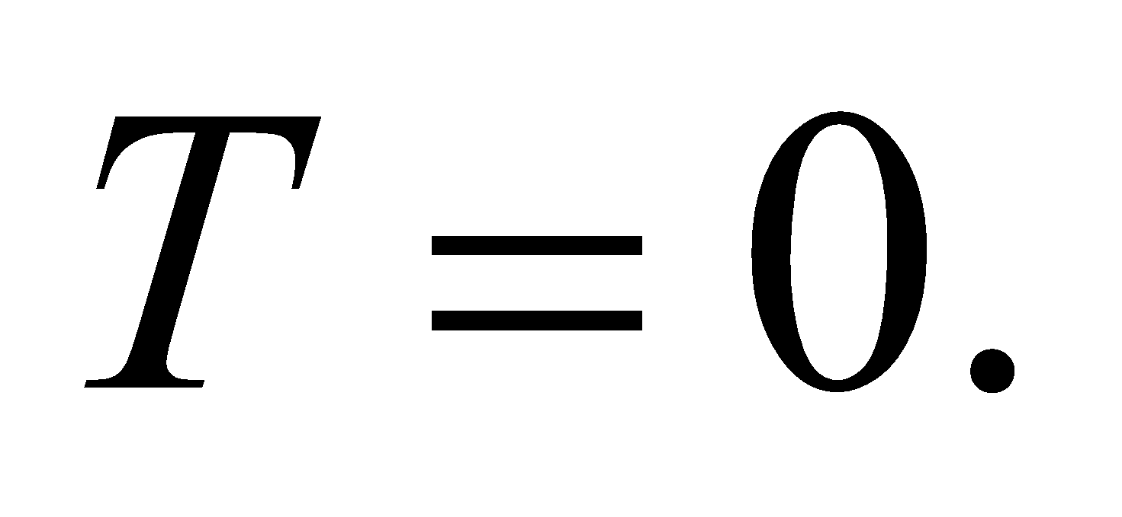 You can associate this with an electron speed: 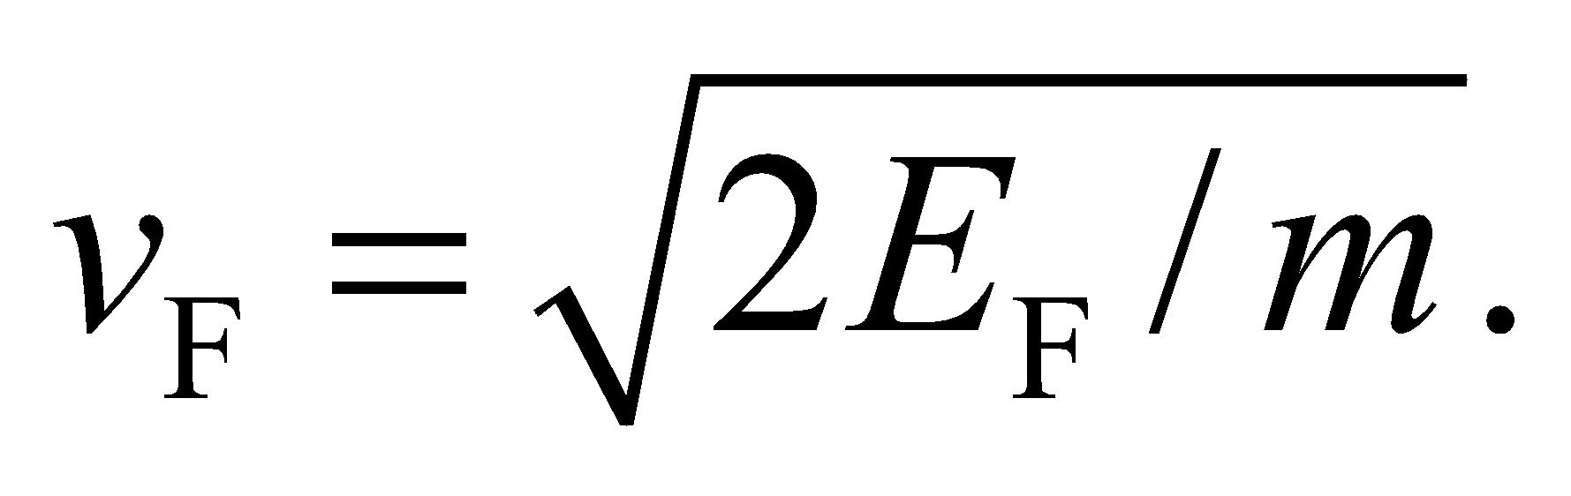 In the classical picture, electrons are like a gas with an average of 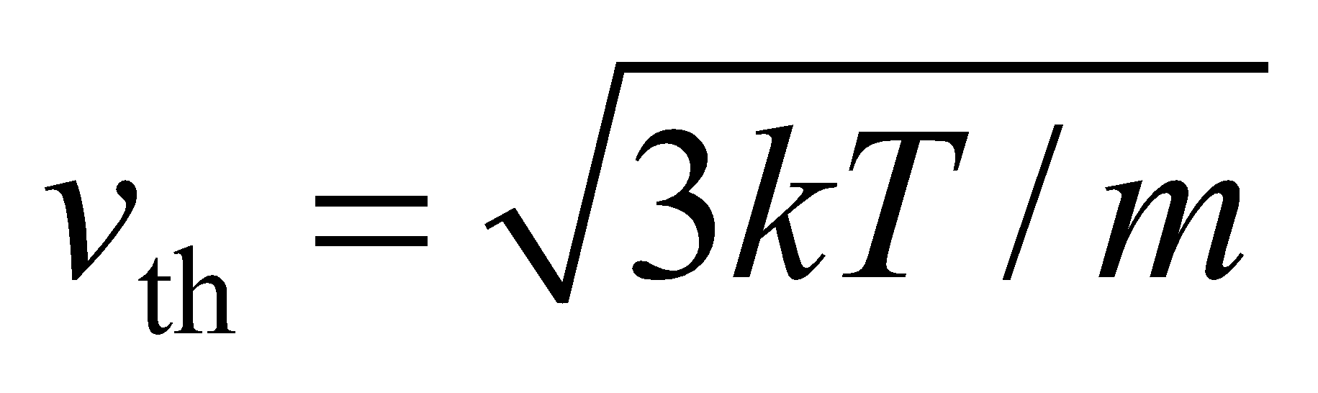 (Equation 17.4).
Evaluate The speed associated with the Fermi energy of copper is
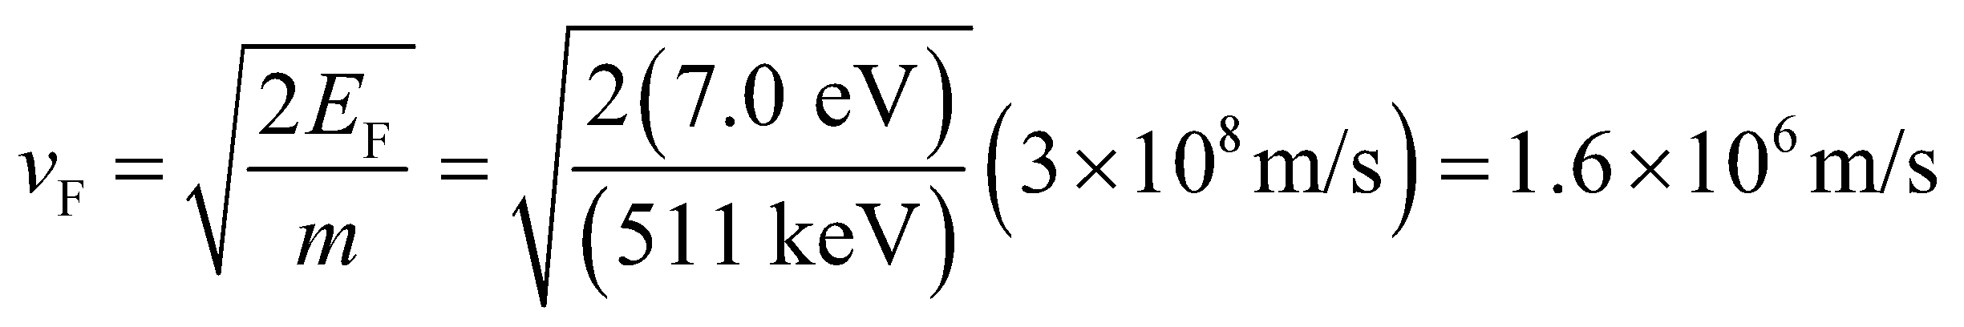
where for simplicity the rest energy 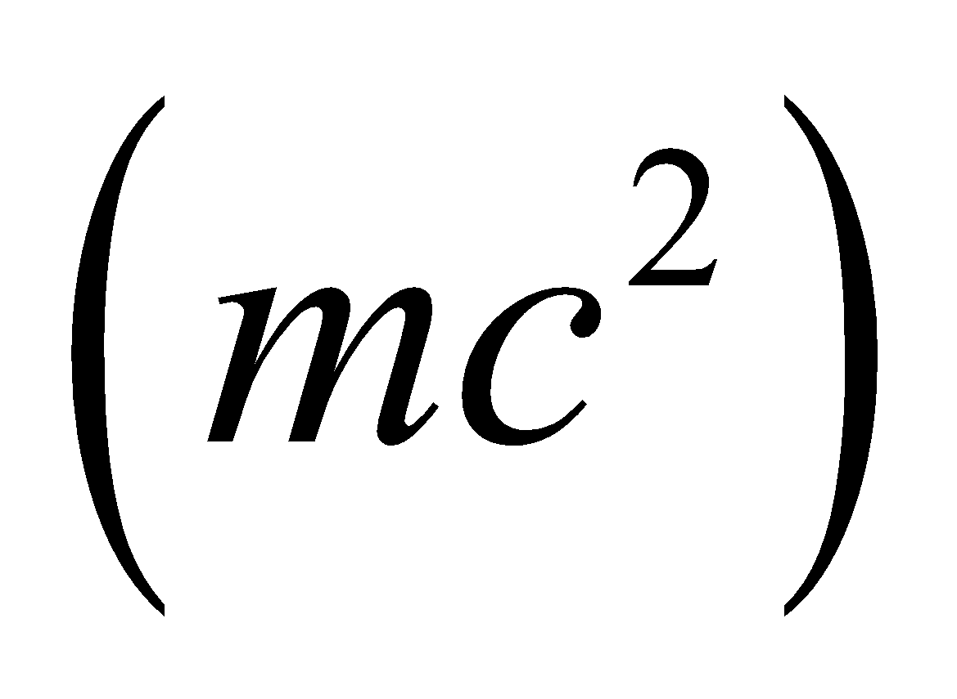 of the electron is used. In comparison, the classical thermal energy of electrons at room temperature is
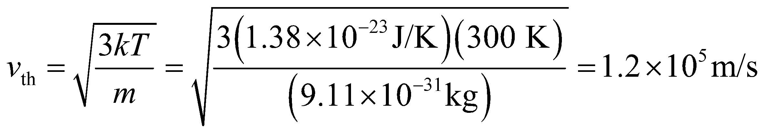
This is 13 times less than the Fermi speed.
Assess The difference between a quantum and classical description of conductivity was touched on in Chapter 24. The resistivity in a wire is proportional to the number of collisions each electron experiences, and this is proportional to the electron speed. In the classical picture, then, the resistivity should be related to the temperature by 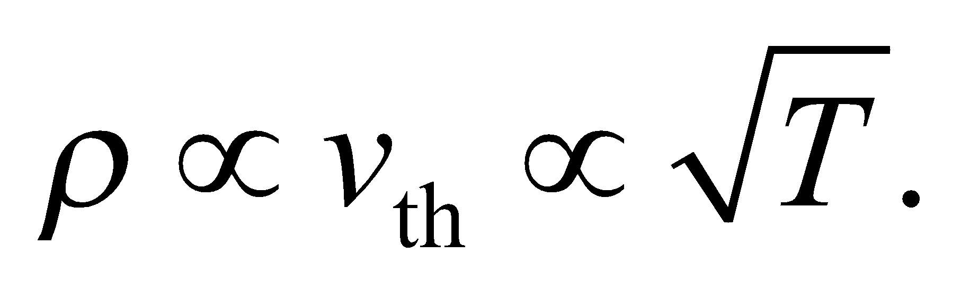 But in fact, the resistivity increases linearly with temperature, as depicted in Figure 24.7. This is a quantum mechanical effect, explained in part by the ions in the wire's crystal structure vibrating more as the temperature increases. The larger ion vibrations leads to more collisions with the electrons conducting through the wire.
51. Interpret We are to find the Fermi temperature for silver, given its Fermi energy.
Develop From the problem statement, we see that the Fermi temperature can be expressed mathematically as
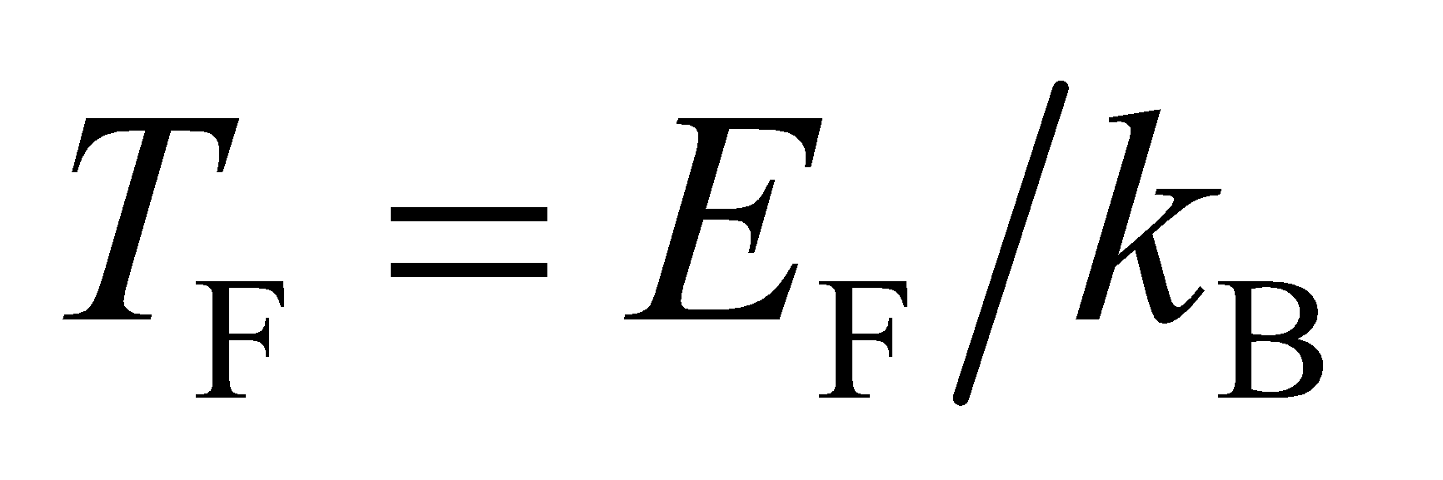
Evaluate With 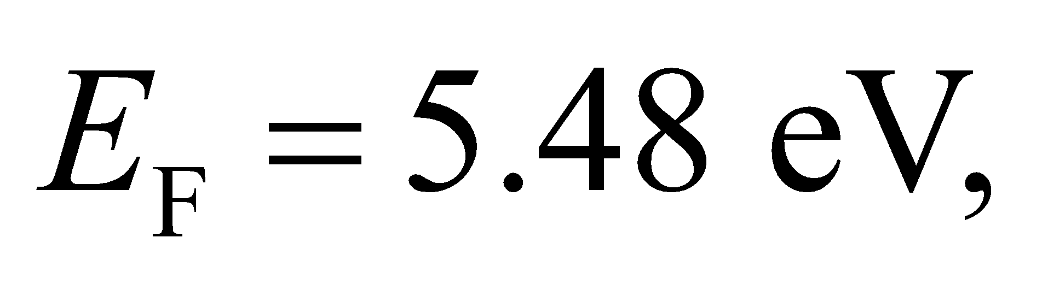 we find the Fermi temperature of silver to be
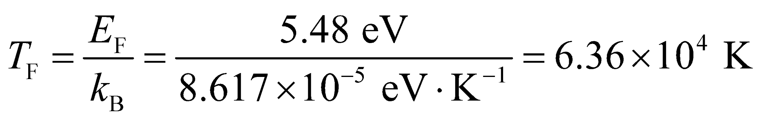
This is about 212 times the room temperature (300 K).
Assess The characteristic Fermi temperature is on the order of 10⁵ K for a metal, and the Fermi energy is about 1 to 10 eV, much higher than the thermal energy at typical temperatures (0.025 eV at room temperatures).
52. Interpret We are to calculate the band gap of Si given the maximum wavelength absorbed.
Develop The band-gap energy corresponds to the maximum wavelength (or minimum energy) photon absorbed by the material. Thus, using Equation 34.6, E_{g} = hf = hc/λ.
Evaluate The band gap is
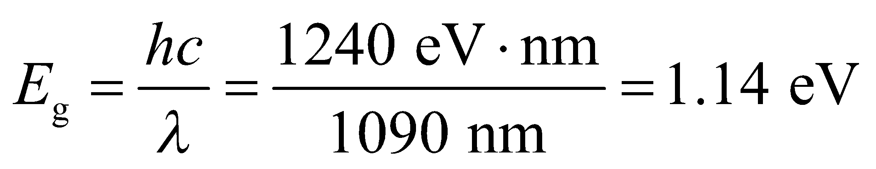
Assess This agrees with the entry in Table 37.1 for Si.
53. Interpret We want to know whether zinc selenide would make a good photovoltaic cell. We shall do this by treating the Sun as a blackbody and finding the median wavelength of solar emission then comparing that wavelength with the band-gap energy for ZnSe.
Develop We approximate the Sun as a 5800-K blackbody, and use 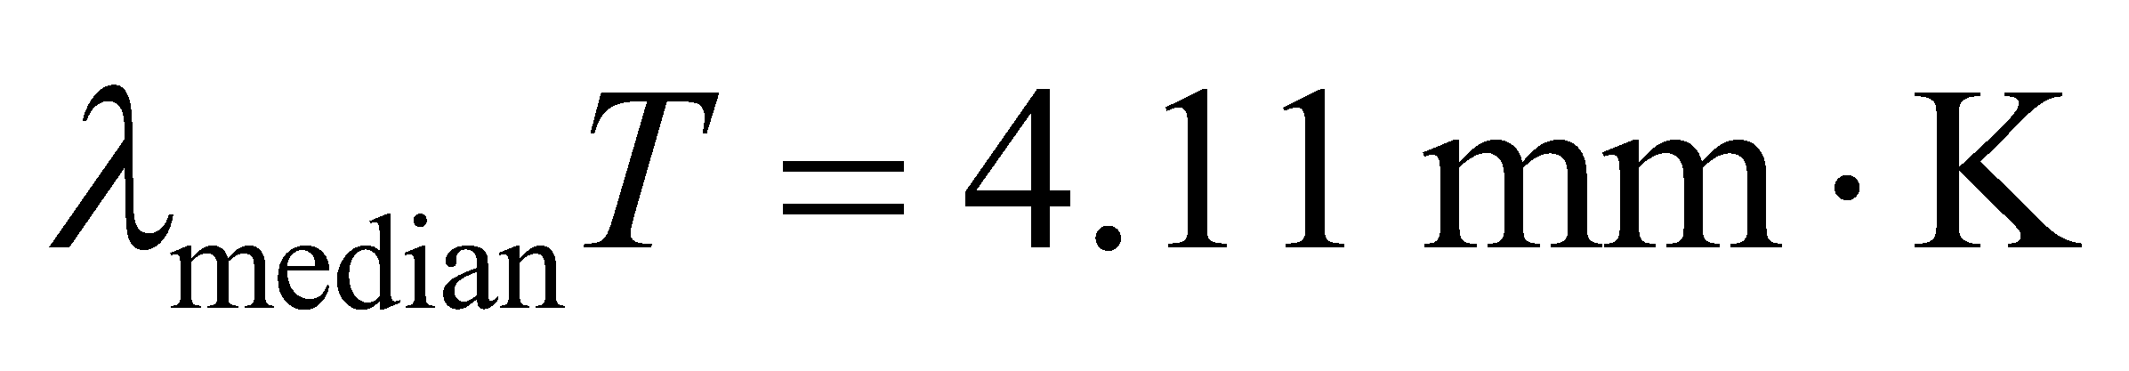 to find the median wavelength. Next, we convert that wavelength to an energy using Equation 34.6, E = hf = hc/λ and compare the energy of the median photon with the band-gap energy of ZnSe, E_{g} = 3.6 eV.
Evaluate 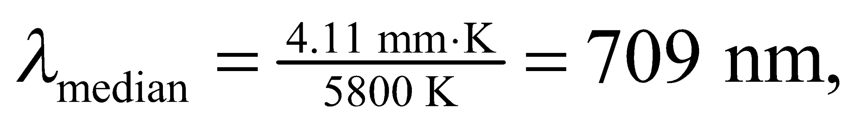 so the energy of the median photon is
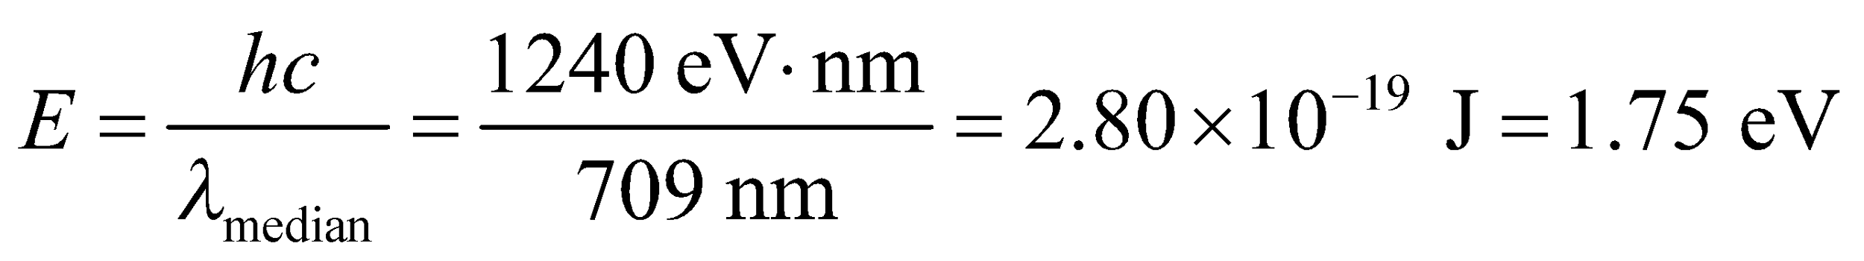
Assess The energy of this photon is less than the energy of the band gap for ZnSe, so ZnSe would not make a good photovoltaic cell.
54. Interpret We are to find the maximum current allowed in an Al wire without exceeding the given critical magnetic field.
Develop As shown in Figure 37.21, the maximum magnetic field occurs at the edge of the wire. Using Ampère’s law (Equation 26.17) as per Example 26.7, we find that the magnetic field at the surface of the wire is B_{max} = μ₀I/(2πR).
Evaluate The maximum magnetic field will be less than the critical field if
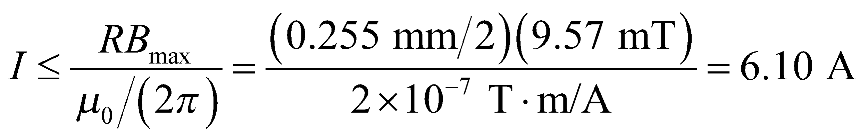
Assess This is a very significant current.
55. Interpret In this problem, we’re asked about the current required in a solenoid to achieve the critical magnetic field strength of the given superconductor.
Develop The magnetic field inside a long thin solenoid is given by Equation 26.21, 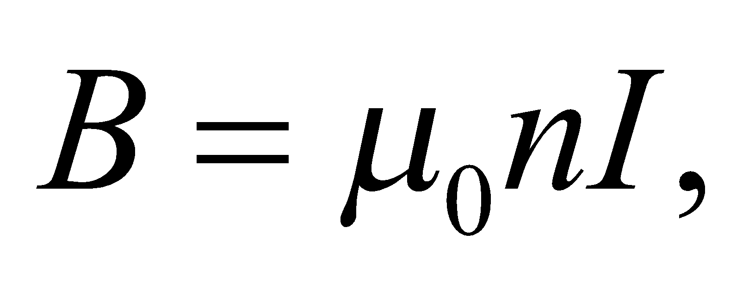 where n = 5000/(0.75 m) is the number of turns per unit length in the solenoid.
Evaluate Substituting the values given, we find the current is
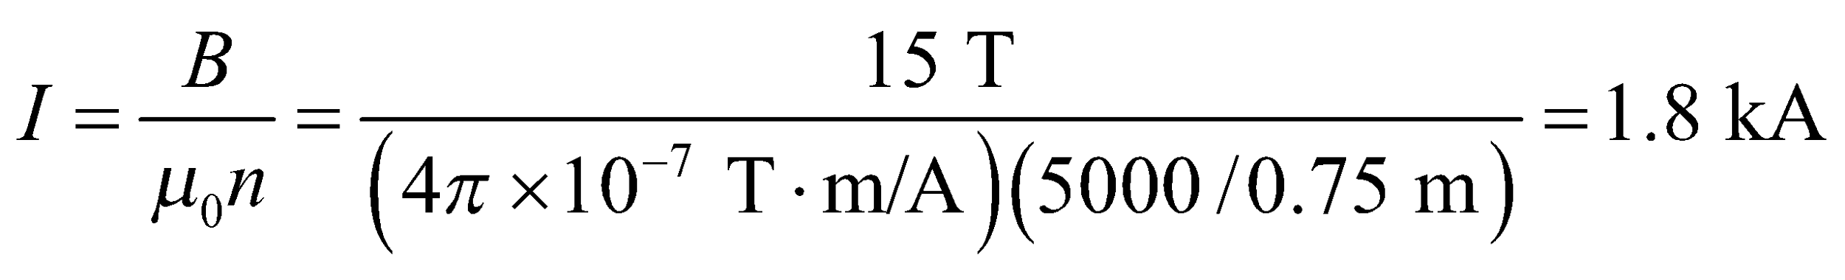
Assess The current required is enormous! Note that niobium titanium is a Type-II superconductor with a critical temperature of about 10 K.
56. Interpret We are to find the temperature necessary to excite the first rotational state of diatomic oxygen (O₂), and determine if this molecule would behave like a monatomic gas at normal pressure.
Develop O₂ would behave like a monatomic gas if there were insufficient thermal energy to excite the first rotational state. This implies that 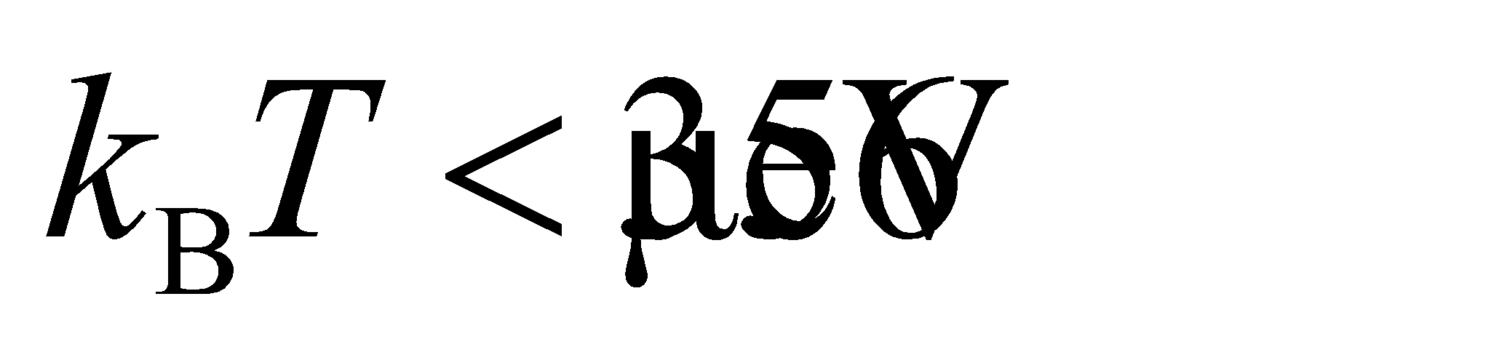.
Evaluate Solving for the temperature T gives
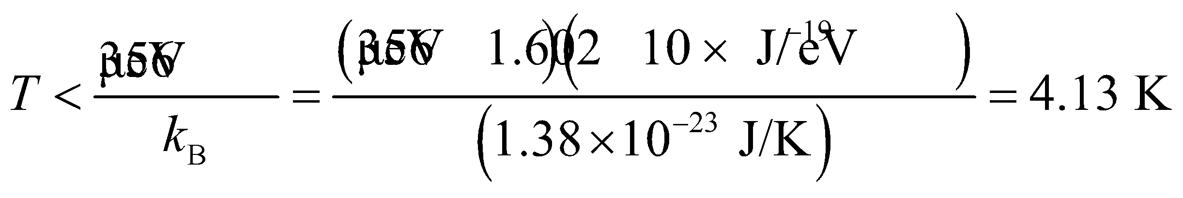
Assess Such behavior is not observed, however, since the normal boiling point of oxygen (below which 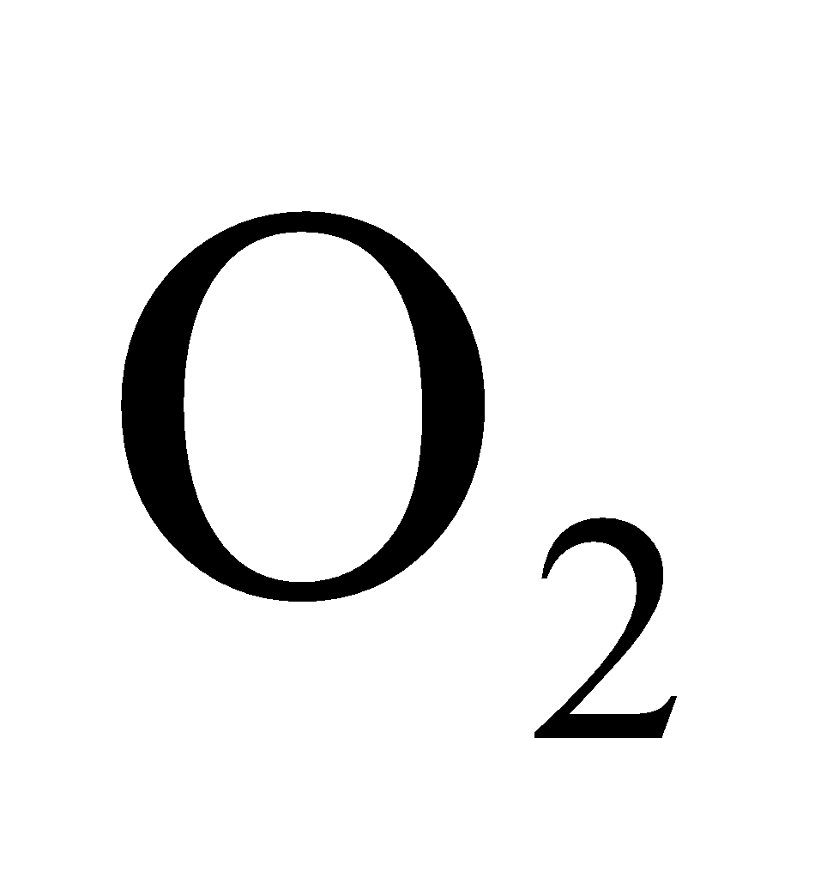 liquefies) is 90.2 K (see Table 17.1).
57. Interpret We are asked to find the emission wavelength of a fluorescent protein given the energy separation of its final transition.
Develop The relation between transition energy and photon wavelength is given by
Evaluate We're told that the protein absorbs light and then goes through an intermediate transition to an excited state that is 2.44 eV above the ground state. When the protein relaxes to its ground state, it will emit a photon with wavelength
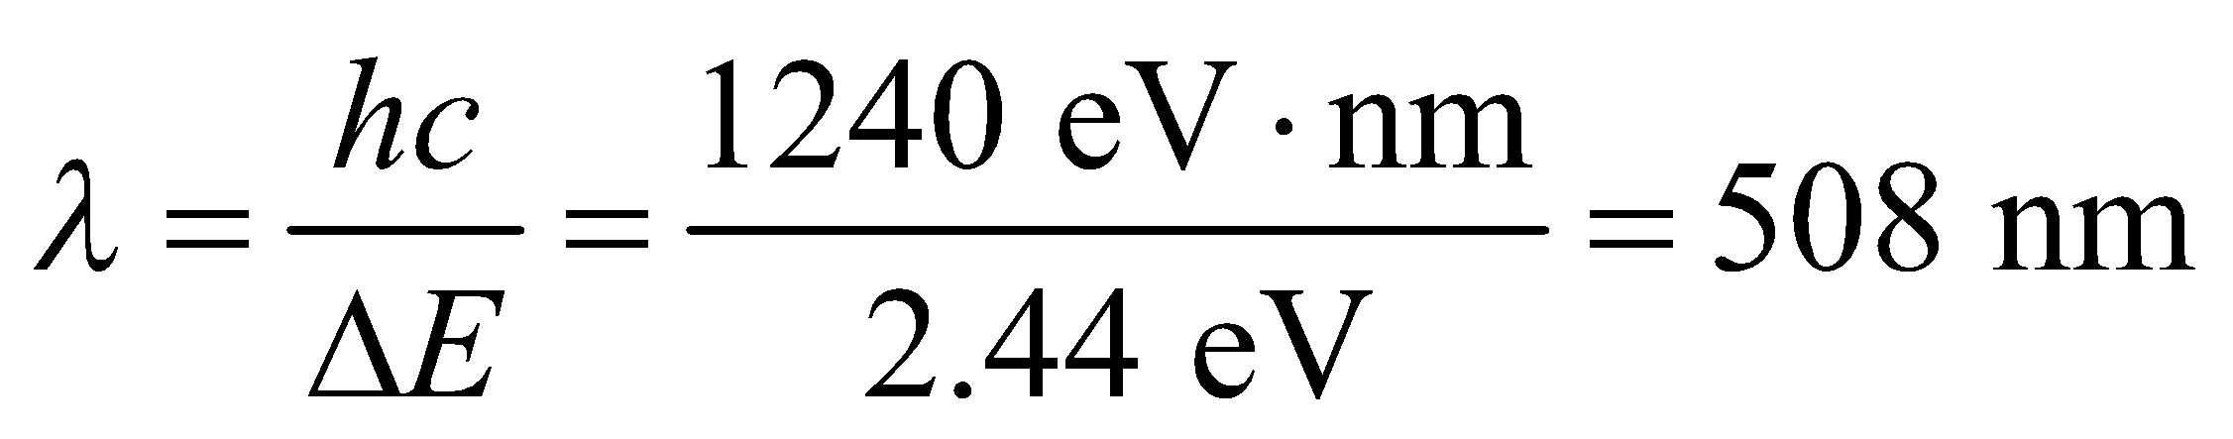
Assess This green wavelength is longer than the 395-nm wavelength that the protein absorbs, which implies that the emitted photon has less energy than the absorbed photon. The "missing energy" was expelled when the protein dropped from its initial excited state to the second excited state in the intermediate transition. This is typically how fluorescence works: a molecule absorbs a short wavelength and is excited to a high energy level; it then drops down to a slightly lower energy level before emitting a photon of longer wavelength.
58. Interpret We’re given the mass density and ionic cohesive energy of RbI and asked to solve for the equilibrium separation between Rb and I and the constant n in Equation 37.4.
Develop The equilibrium ionic separation r₀ can be estimated from the density ρ. The constant n is given by (see Example 37.3)
Evaluate (a) If we assume that the crystal structure of RbI is cubic, like NaCl in Example 37.3, then each cubic volume, 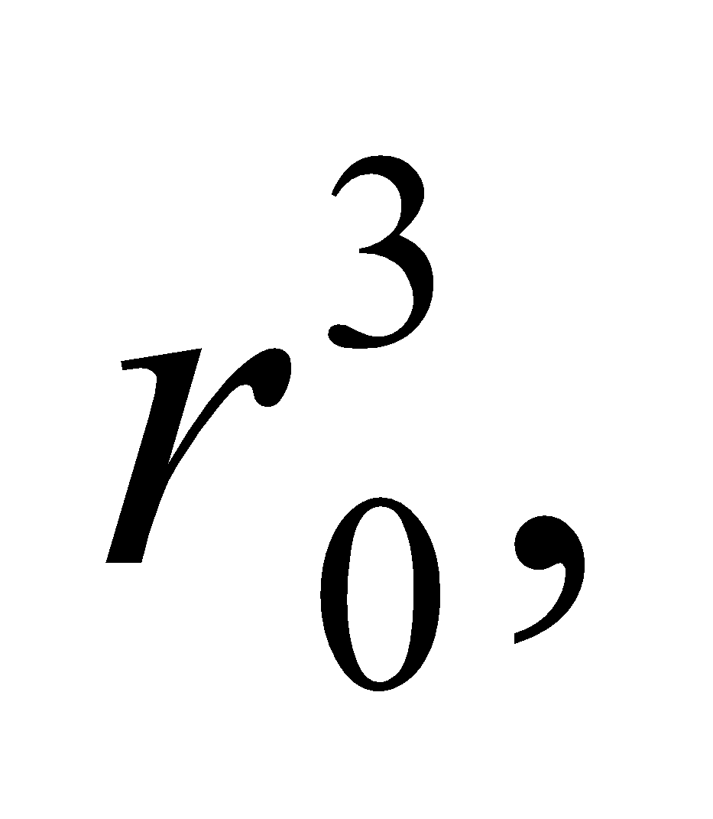 contains one ion of average mass 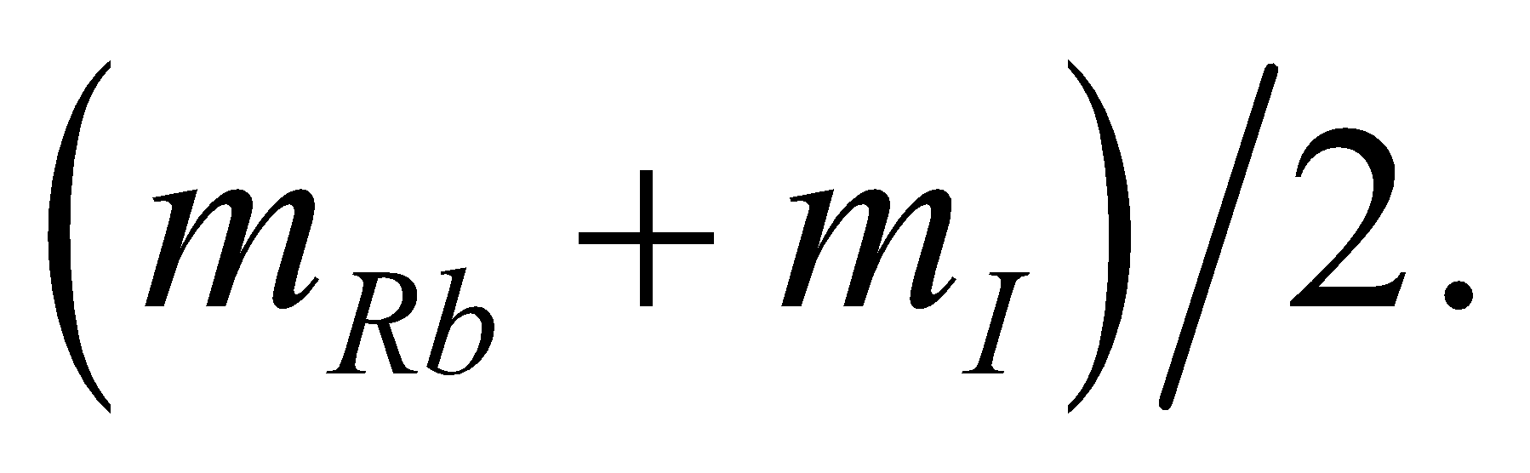 Thus,
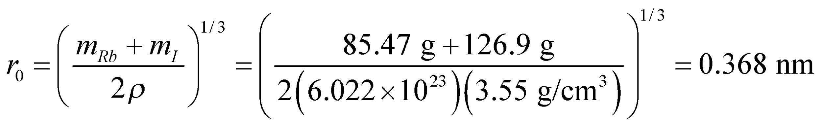
where we used Appendix D for the atomic weights.
(b) The ionic cohesive energy per ion pair is,
where we have used the conversion factors given in Appendix C. Equation 37.4 evaluated at r = r₀ can be solved for n (as in Example 37.3) with the following result:
Assess The results can be compared with n = 8.22 and r₀ = 0.282 nm for NaCl (see Example 37.3). The large value of the exponent implies that RbI is strongly resistant to compression.
59. Interpret You want to find the bond length of a diatomic molecule using the spacing between rotational energy levels inferred from spectral lines. You will use a more accurate model of the moment of inertia.
Develop In Example 37.1, the energy spacing between adjacent pairs of rotational energy levels was given for the HCl molecule. Using the quantized rotational energy levels in Equation 37.2: 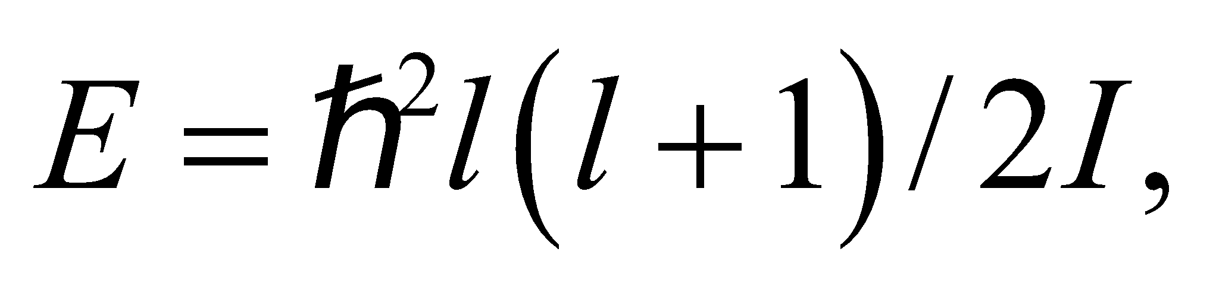an expression for the rotational inertia was found in terms of the energy spacing:
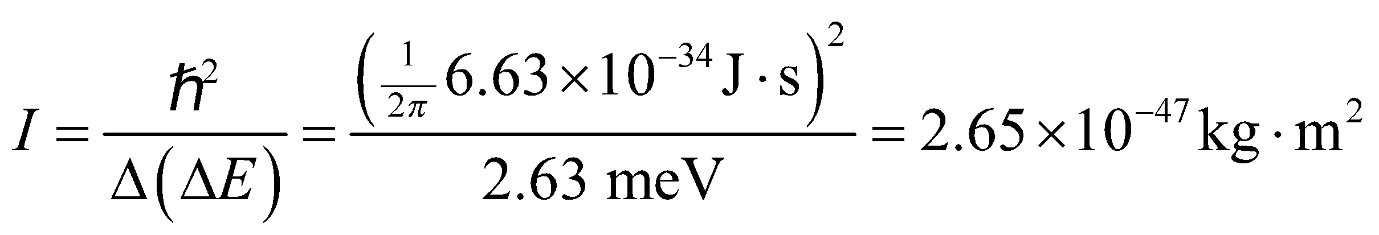
If the HCl molecule is approximated by the hydrogen atom rotating around a fixed chlorine atom, then 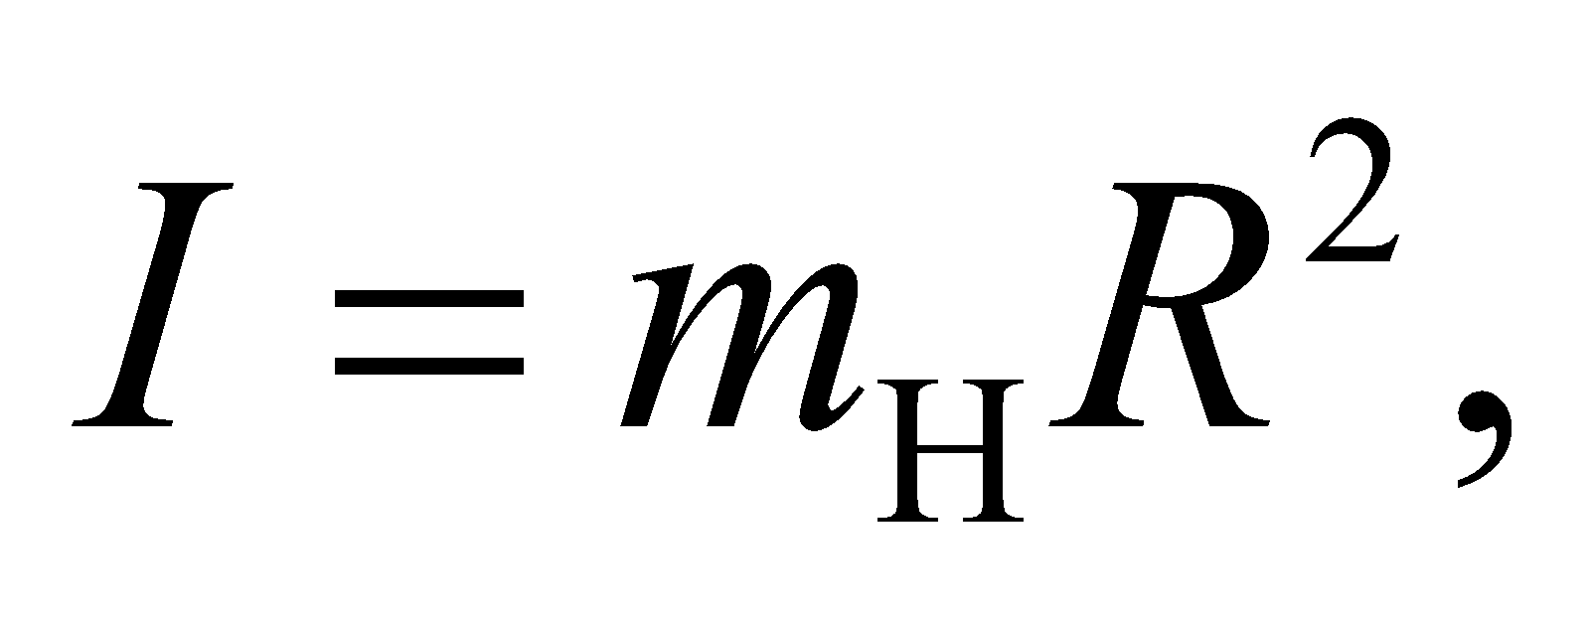and one can solve for the internuclear separation: 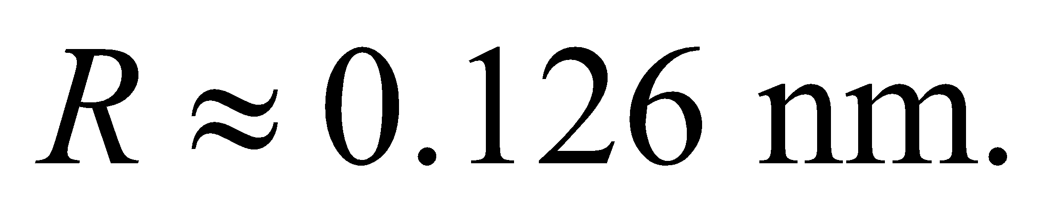 You now want to redo the calculation without assuming the chlorine atom is fixed.
Evaluate For a general diatomic molecule, the center of mass is located along the line between the two atoms. Let 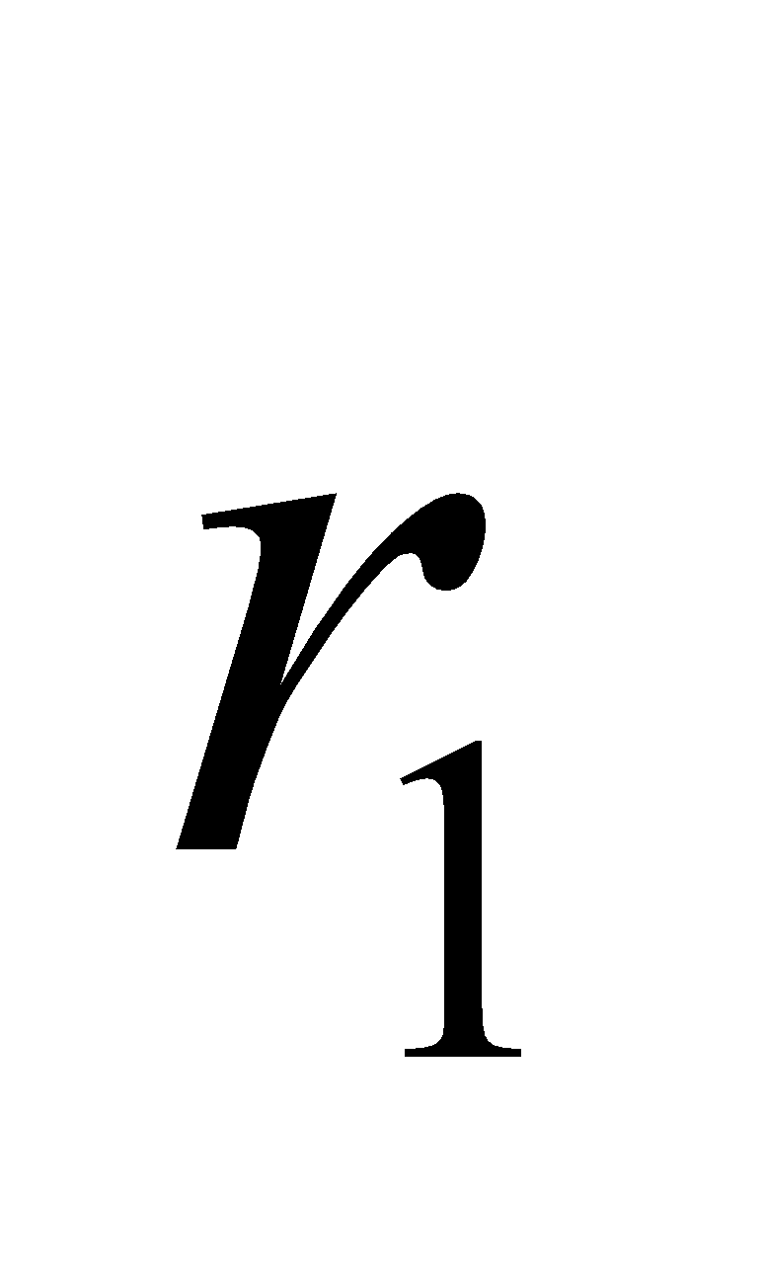 and 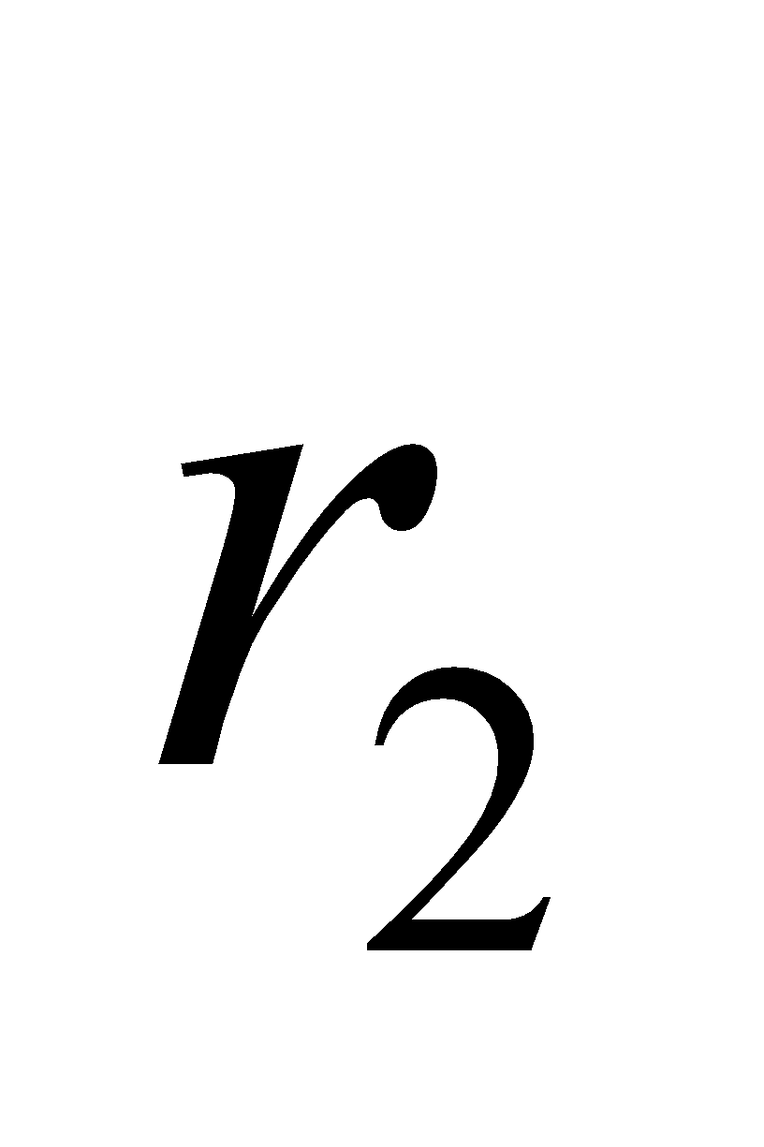 be the distance between the center of mass and the masses 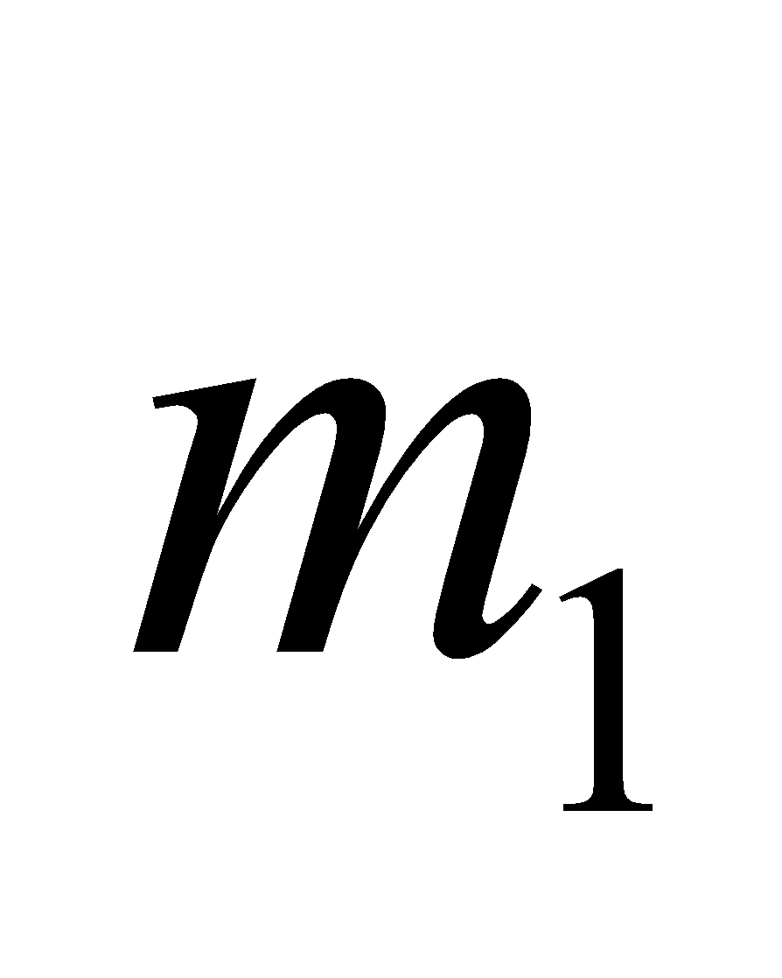 and 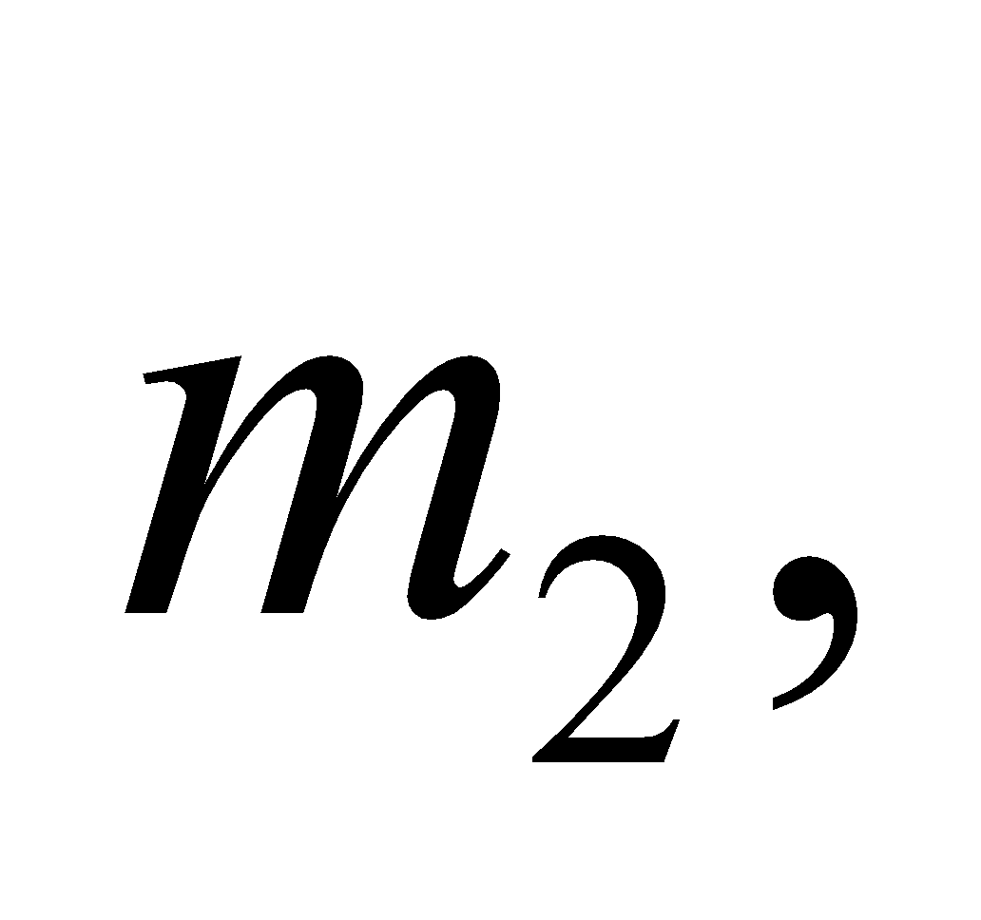respectively. If you choose the origin at the center of mass, then the center of mass equation gives
Combining this with the fact that 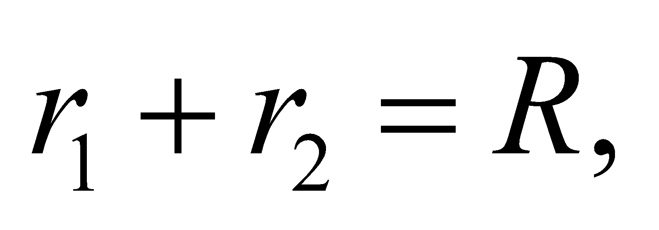you find 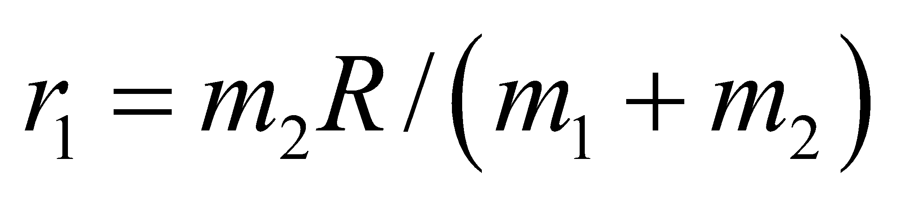 and Plugging these values into the rotational inertia equation:
With this expression in hand, the internuclear separation in HCl is
Notice that if we neglect the mass of the hydrogen atom (i.e., assumethis equation would reduce to the same solution in Example 37.1,
Assess Neglecting the mass of the hydrogen atom only introduces an error of 1.5% in the calculation of internuclear separation.
60. Interpret This problem is about the electron energy distribution at absolute zero (i.e., T = 0 K). We are to find the fraction of electrons that have energies below half the Fermi energy.
Develop The density of states of electrons in a metal is given by Equation 37.5:
Thus, the number of electrons with 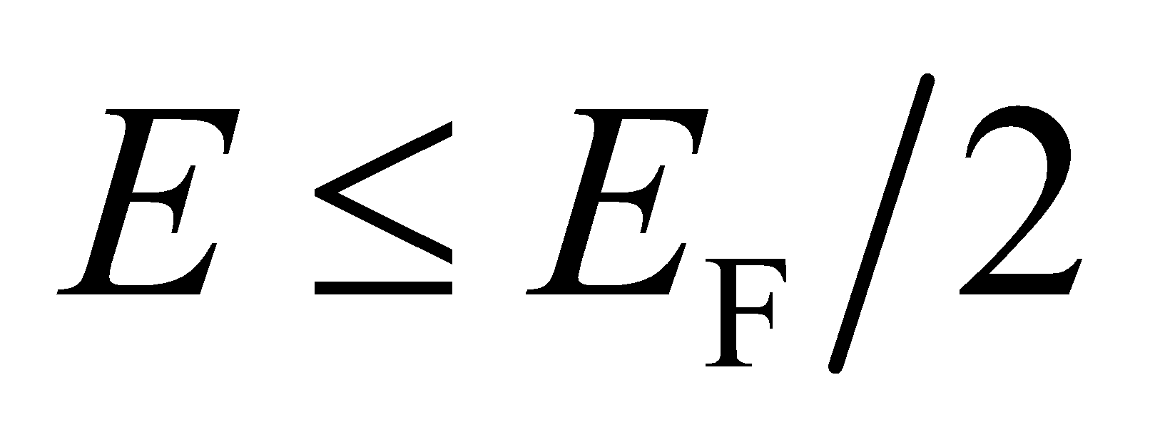 at T = 0 K is simply equal to
Evaluate Carrying out the integration, we obtain
where is the density (number per unit volume) of conduction electrons. Thus, the fraction is
Assess The density of states at T = 0 K is plotted in Figure 37.16a. We see that is less than half
.
61. Interpret We are to calculate the Madelung constant for a hypothetical one-dimensional crystal that consists of alternating positive and negative ions.
Develop The Madelung constant expresses the magnitude of the electrostatic potential energy of an ion in the crystal (see discussion preceding Equation 37.4). For any ion in the one-dimensional chain shown in Figure 37.24, there are two oppositely charged ions at distances of r₀, two similarly charged ions at distances of 2r₀, two opposite ions at 3r₀, etc. We can find the Madelung constant by summing these terms and using the series expansion of ln(1 + x).
Evaluate Thus, the electrostatic potential energy of any ion is
The Taylor expansion of ln(1 + x) is
When evaluated at x = 1, this gives
Comparing this with the series expression above for U shows that for this “crystal.”
Assess The convergence of this series, which needs special consideration for x = 1, is discussed in many first-year calculus textbooks.
62. Interpret This question deals with a model for the potential energy of a diatomic molecule. We are to determine if the model has a minimum and find what that minimum is and the minimum atomic separation.
Develop The Morse potential is
We shall use the first and second derivatives to find the minimum. For a minimum, first derivative must be zero and the second must be positive for some value of r. Part (a) asks for the minimum energy U_{min} and part (b) asks for the radius r_{min} at which this minimum occurs, but in order to find the minimum energy we must know the radius so we’ll do part (b) first.
Evaluate (b) Performing the differentiation gives
There is a local maximum or minimum at r = r₀ and the second derivative of the function at r = r₀ is greater than zero so it must be a minimum.
(a)
Assess Unlike the harmonic oscillator potential, the Morse potential is asymmetric. This asymmetry means that the average spacing between the atoms increases with energy level, which leads to a “prediction” that materials would expand with increasing temperature.
63. Interpret We are asked to derive the density of states equation for a metallic conductor.
Develop Equation 35.8 denotes the energy levels in a three dimensional cube of side L: where and are integers greater than or equal to zero. Each set of n's corresponds to a unique energy level that can be occupied by at most two electrons, according to the exclusion principle. So there are two electron states for each possible combination of and
Evaluate We need to count all the electron states that have energy less than some given energy E, so let's define an arbitrary vector Counting electron states will be the same as counting the number of vectors that have magnitude less than some radius r, where r is defined by the energy limit:
The number of vectors satisfying this inequality with integer components is just the volume inside a sphere of radius r, see the figure below. We don't consider negative values for the n's, so the relevant volume is that of just one octant of the sphere: Recalling that there are 2 electron states for each set of n's, the number of states with energy less than or equal to E is
(b) Differentiating the above result, we find the density of states:
Assess The density of states is the number of states with energy equal to E, as opposed to which is the number of states with energy less than or equal to E. Notice that is the integral of :
From this, it is clear why is the derivative of
64. Interpret We are to find the average energy of a conduction electron at very low temperature, using the metallic density of states (Equation 37.5).
Develop We find the average by dividing the total energy by the number of energy states At T = 0, all states above E_{F} are empty, so we can integrate to E_{F} rather than to . The density of states for a metallic conductor is
Evaluate Performing the integrations and forming the ratio gives
Assess It is not actually possible to reach T = 0, but the information gained by calculations such as this is applicable at other low temperatures, often including such “low” temperatures as T = 300 K.
65. Interpret You need to specify the maximum current in a solenoid in order to avoid exposing the superconductors in your device to the critical magnetic field.
Develop Recall Equation 26.21, for the magnetic field of a solenoid with n turns of wire per unit length. You want the maximum that the current can be in order to keep the magnetic field below half the critical field, i.e.,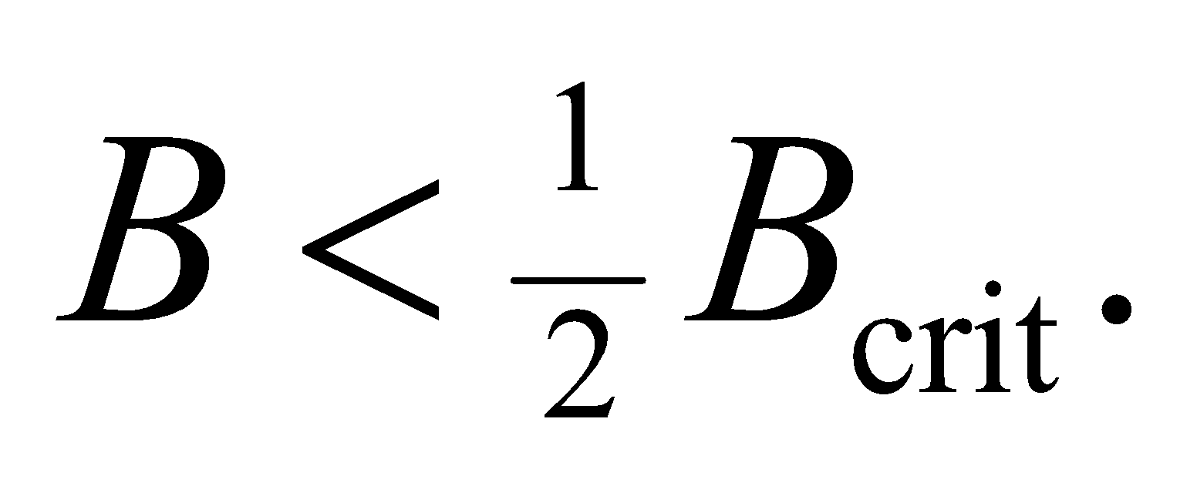
Evaluate Solving for the maximum current allowed gives
Assess A magnetic field of 6 T is fairly high, so it makes sense that the maximum allowed current is also fairly high.
66. Interpret We examine the physics behind photovoltaic cells that use semiconductors to convert sunlight into electricity.
Develop We are given the band gap energy of silicon, which corresponds to a photon wavelength of
Silicon can only absorb photons with wavelengths shorter than this.
Evaluate The median wavelength of an emitting source is defined such that 50% of the power is emitted at wavelengths above and below this mark. Since the median wavelength of sunlight (700 nm) is less than silicon can absorb at least 50% of sunlight. But is it more than this? In Figure 34.2, we can examine the blackbody spectrum of an object at 6000 K, which is approximately the temperature of the Sun. It is clear that the vast majority of the Sun's energy is emitted at wavelengths less than 1 μm, so we conclude that silicon can absorb about 75% of incident solar energy.
The answer is (c).
Assess For a more precise calculation, we can use the radiance, in Equation 34.3 to find the power emitted per unit area of the Sun for wavelengths shorter than :
This integral would be difficult to evaluate, but we can simplify it slightly by changing from wavelengths to photon energy:
The approximation for the exponential term is valid because for (note that for the Sun's temperature of 5800 K). The last integral can be found in an integral table:
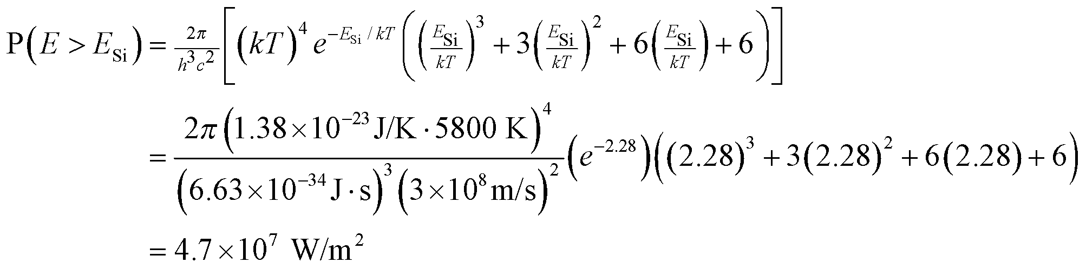
We can compare this with the Stefan-Boltzman law (Equation 34.1) for the total radiance per unit area from a blackbody
Comparing the two results, we see that silicon can absorb approximately 74% of the energy being emitted by the Sun. One might wonder why PV cells aren't more efficient if three-quarters of the solar spectrum is available to them for harvesting energy. As mentioned in the text, photons with more energy than the band gap (i.e., with ) give up their excess energy as heat.
67. Interpret We examine the physics behind photovoltaic cells that use semiconductors to convert sunlight into electricity.
Develop In the previous problem, we showed how one can calculate the power emitted per unit area of the Sun for energies greater than the band gap energy of silicon:
We can find the number of photons emitted by dividing out one factor of the energy from the integral:
Evaluate We could evaluate the integral for but it's not necessary. It should be clear that dividing out one factor of E shifts more of the "weight" of the integral to smaller energies below Therefore, the percentage of solar photons that silicon can absorb is less than the percentage of solar energy that silicon can absorb.
The answer is (a).
Assess A simple way to think about this is that there are less photons with wavelengths smaller than the median wavelength (700 nm for the Sun) than there are with larger wavelengths, even though the sum of each set of photons has the same amount of energy. This is because photons at the short-wavelength-end of the spectrum carry more energy per photon.
68. Interpret We examine the physics behind photovoltaic cells that use semiconductors to convert sunlight into electricity.
Develop A semiconductor with a lower band gap than silicon will be able to absorb photons that silicon cannot. However, for photons with energy right at the silicon band gap, the alternative semiconductor will only be able to use some of the absorbed energy, with the rest being lost as heat.
Evaluate Lowering the band gap will both increase the number of photons that are absorbed and increase the amount of absorbed energy lost as heat.
The answer is (b).
Assess This demonstrates why the band gap energy of a photovoltaic cell needs to be chosen very carefully. The band gap energy should optimally be very near the energy peak in the solar spectrum.
69. Interpret We examine the physics behind photovoltaic cells that use semiconductors to convert sunlight into electricity.
Develop Light that is not absorbed by a semiconductor passes through it and therefore can be used by another semiconductor below it. In a multi-layer cell, the first PN junction from the top should absorb a small fraction of the solar spectrum, so that there is plenty of light left for the next PN junction below. This second junction should only absorb a small fraction of the remainder, so there is still plenty left for the third junction, and so on and so forth. See the figure below, showing a representation of the solar spectrum with the absorption limits of three staggered PN junctions.
Evaluate A PN junction will absorb the light above its band gap energy. Looking at the figure, it's clear then that the first junction (closest to the top) should have the largest energy gap.
The answer is (a).
Assess Since the solar spectrum has a median wavelength of 700 nm, the largest band gap should be at a shorter wavelength (higher energy) in the visible or ultraviolet. This shows that answer (c) is false. Similarly, the smallest band gap should be at infrared wavelengths longer than 700 nm, which contradicts answer (d).

