QUANTUM MECHANICS

35

Exercises
Section 35.2 The Schrödinger Equation
10. Interpret We are to find the units of the wave function ψ(x) for a one-dimensional problem.
Develop The one-dimensional wave function is related to the probability by Equation 35.2, 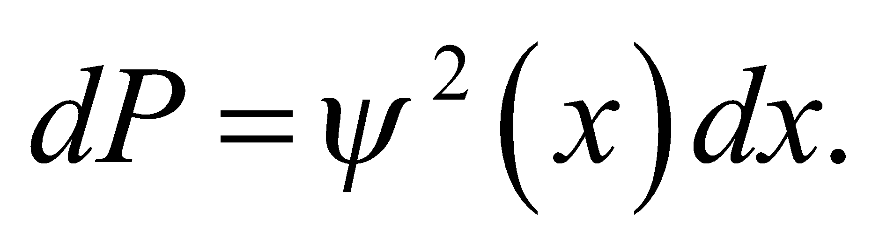 Given that dP is a probability and is therefore dimensionless, we can find the units for ψ(x).
Evaluate The units of ψ(x) are those of dP/dx, or inverse length. In SI units, this would be m⁻¹.
Assess The units of inverse length make sense because ψ(x) gives the probability per unit length of finding the particle.
11. Interpret We are given the wave function of a particle and are to deduce from this the most probable position of the particle and the position(s) where the probability of finding the particle is 50%.
Develop The quantity 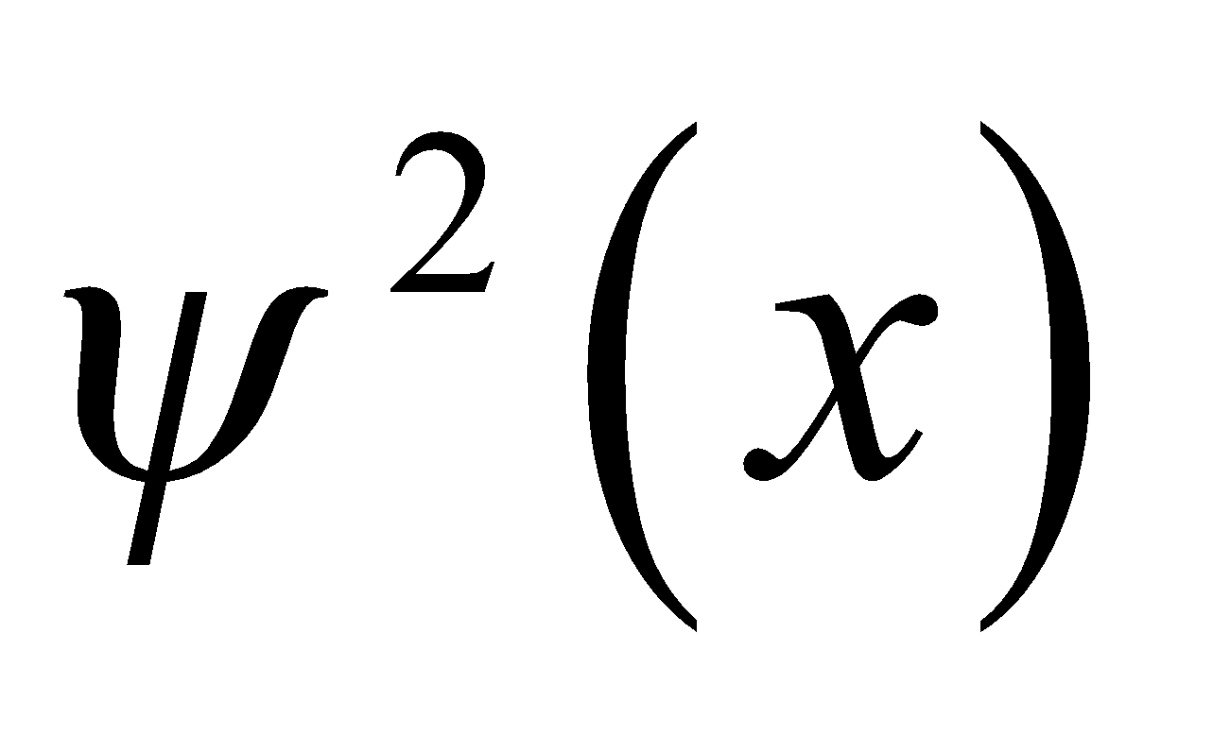 represents the probability of finding the particle at the position x. Therefore, the particle is most likely to be found at the position where the probability density is a maximum.
Evaluate (a) The maximum of 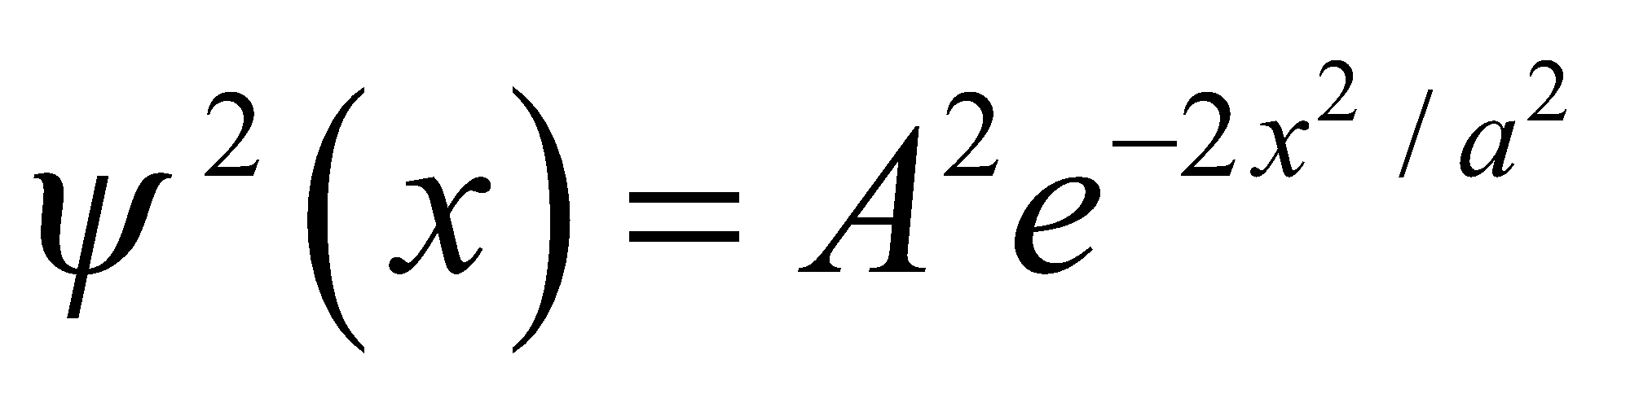 occurs where 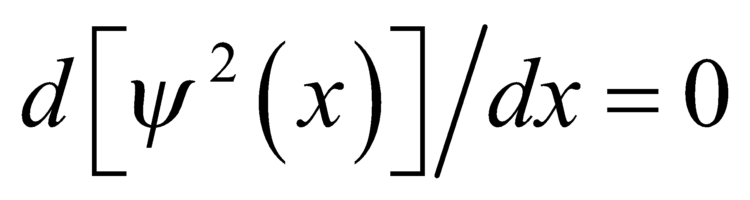 and 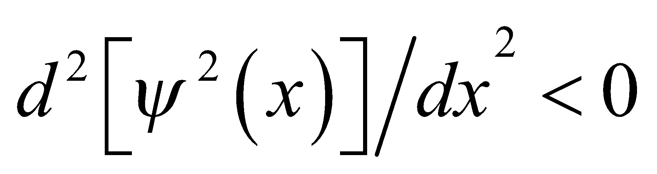. Evaluating the first derivative gives
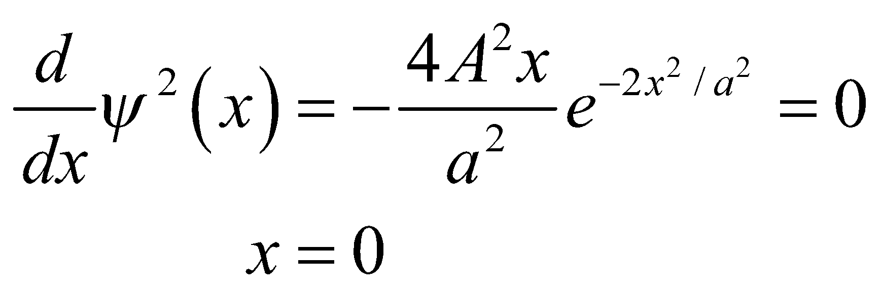
Evaluating the second derivative at x = 0 gives
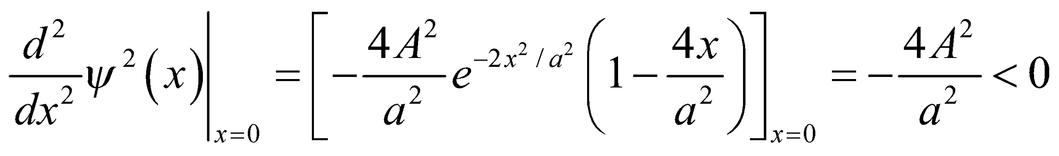
which shows that the extremum at x = 0 is indeed a maximum. Thus, most probable place to find the particle is at x = 0.
(b) The probability density falls to half its maximum value when 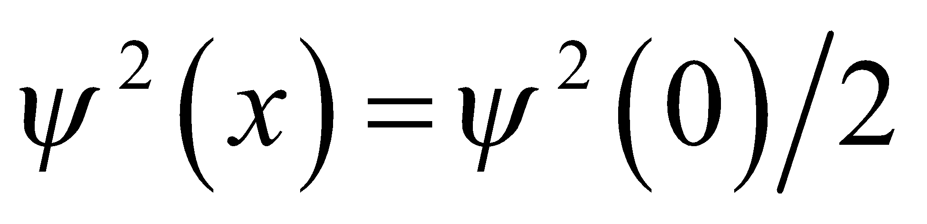. Solving this equation gives 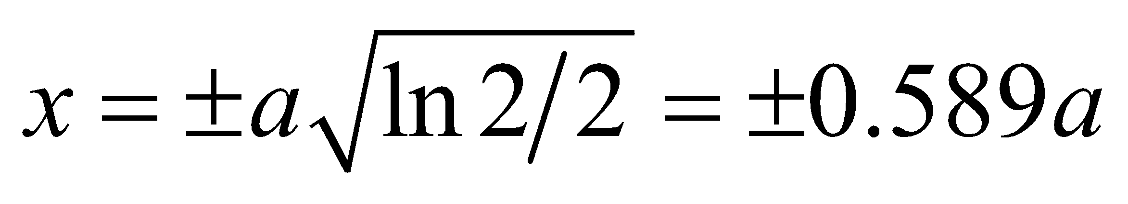.
Assess The probability distribution is shown below. Note that peaks at x = 0 and appears to be halved at x/a ~ ±0.6.

12. Interpret This problem is an exercise in normalizing the wave function ψ(x) given the boundary conditions.
Develop The wave function is like the first excited state of an infinite square well found in Section 35.3, except that 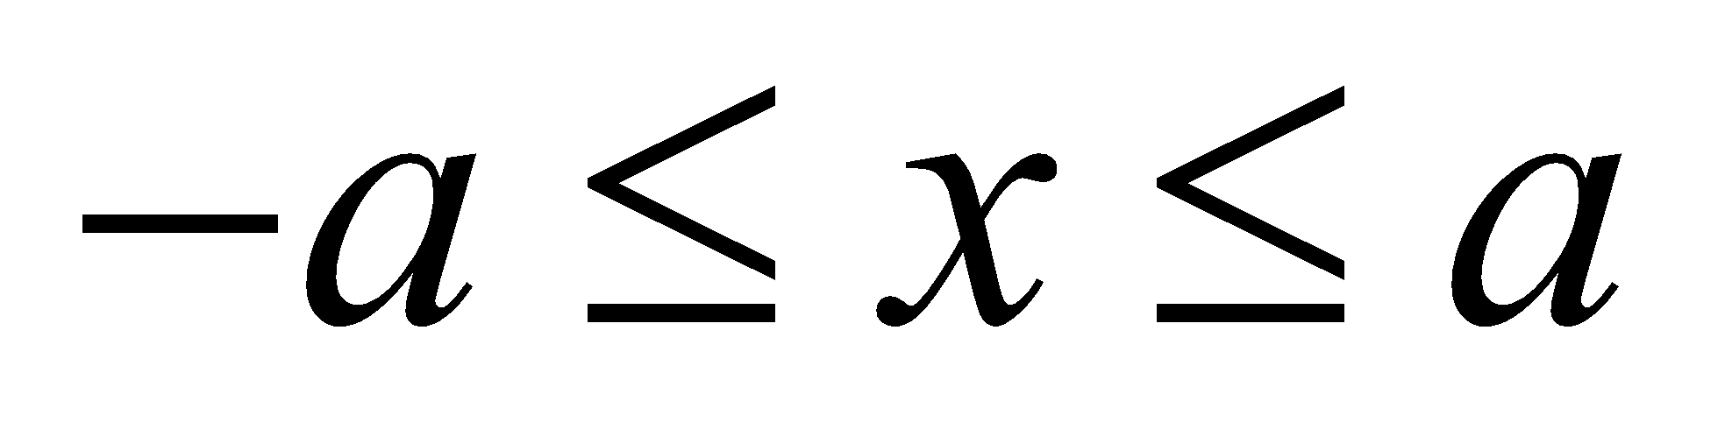 rather than 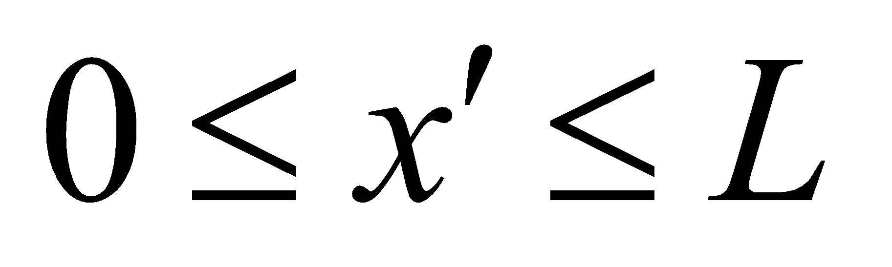, as in Fig. 35.5. The correspondence is explicit if one takes 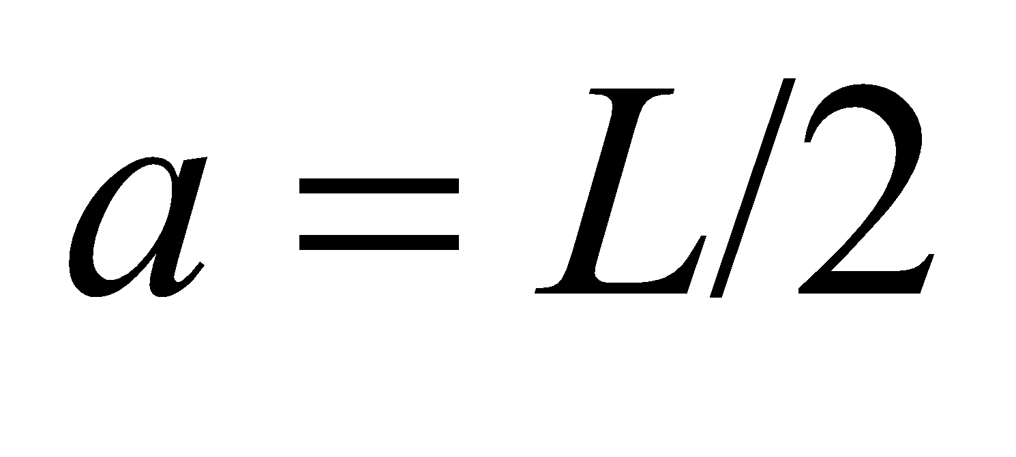 and 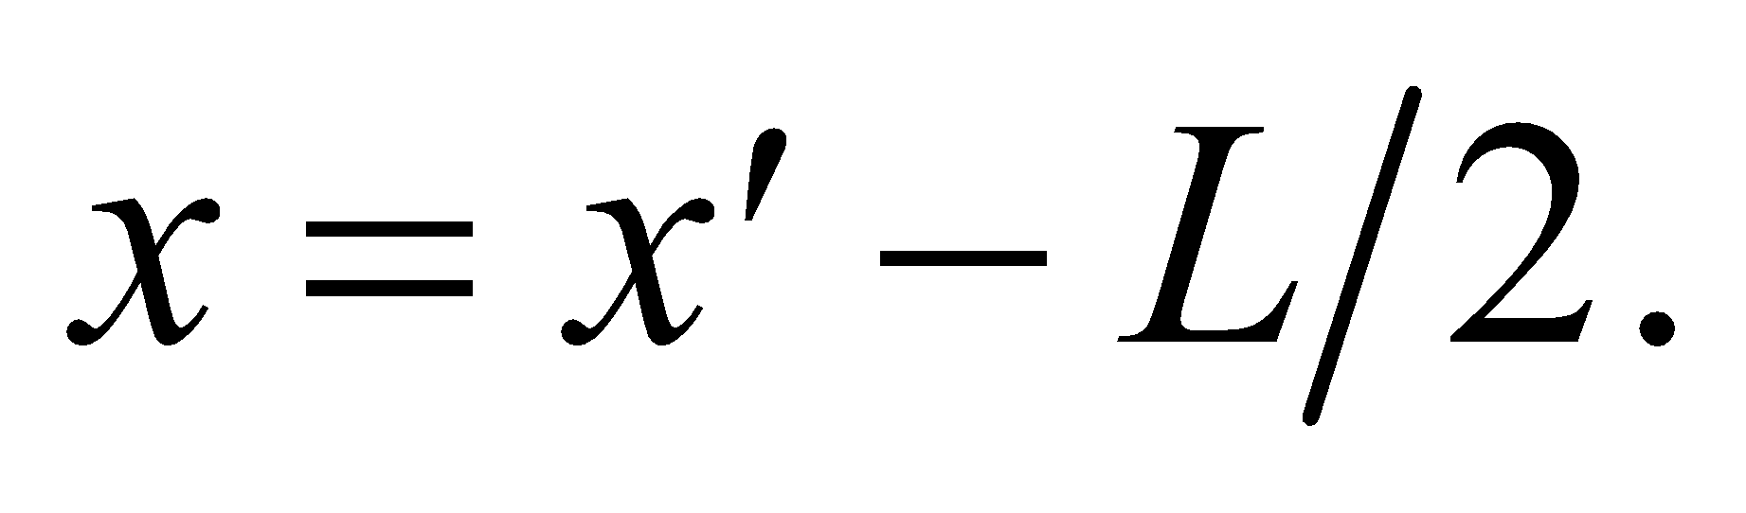 Then
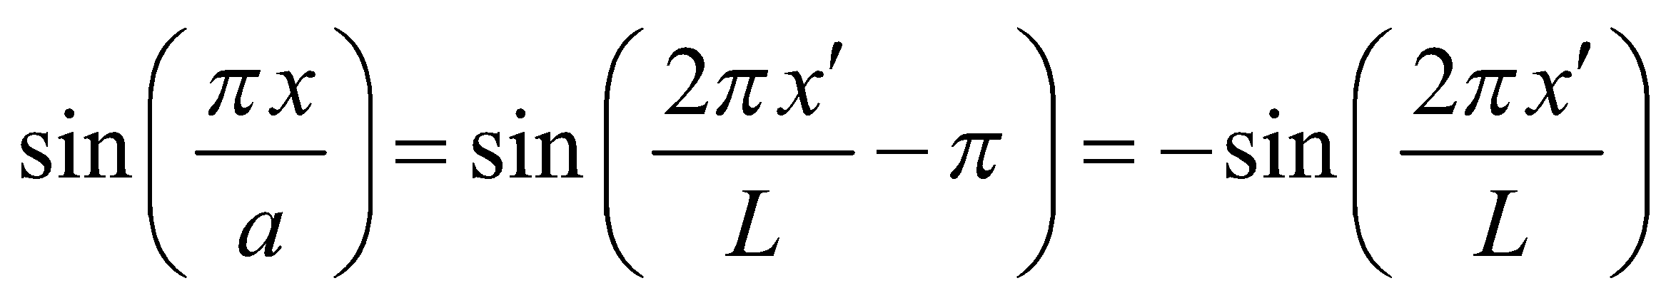
which is the wave function in the equation 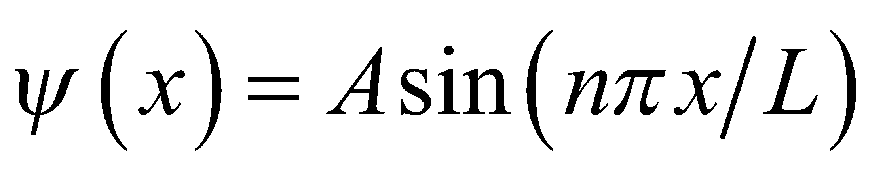 for n = 2, except for an overall phase.
Evaluate The normalization constant for this wave function is therefore 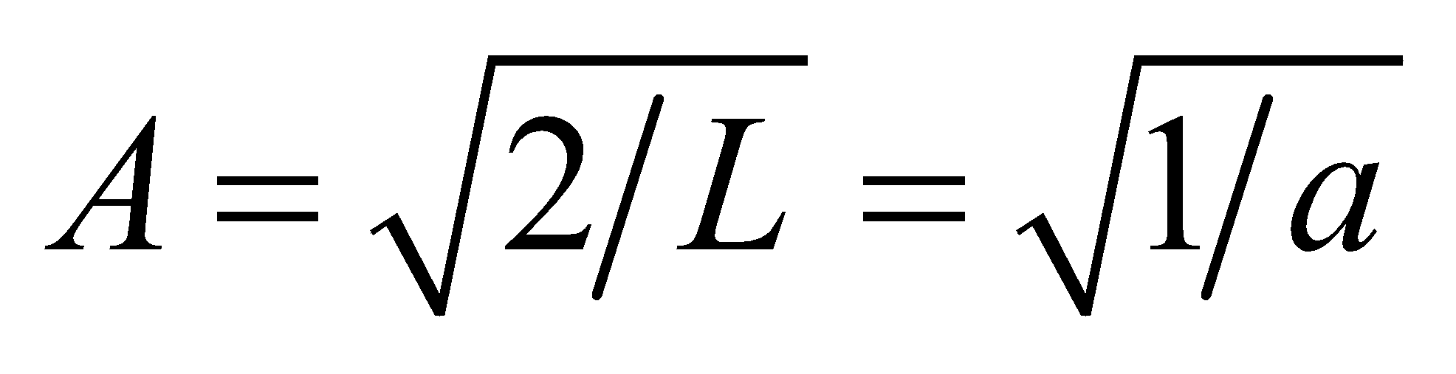.
Assess Of course, A can be determined by repeating the integration,
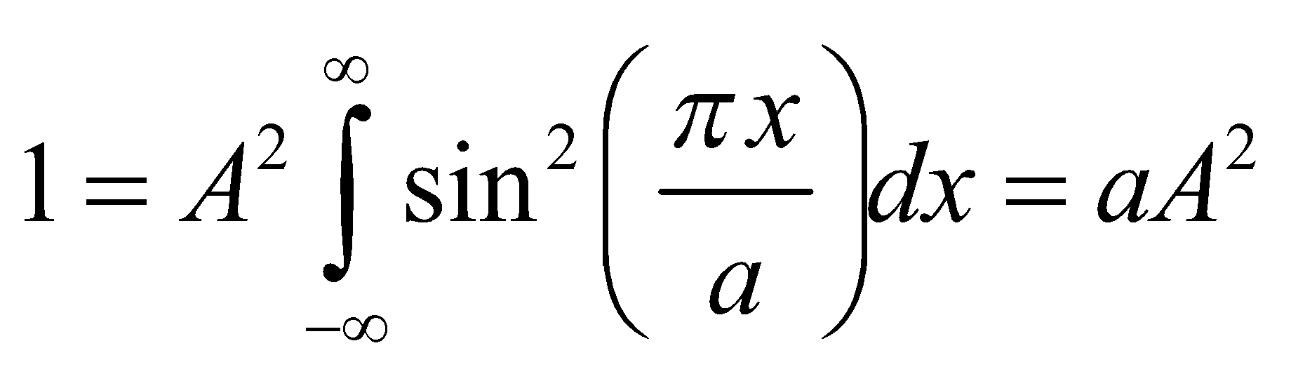
which gives the same result.
Section 35.3 Particles and Potentials
13. Interpret We are to find the principal quantum number of a particle in an infinite square well given the particle’s energy relative to the ground state.
Develop The energy levels for a particle in an infinite square well are (Equation 35.5) 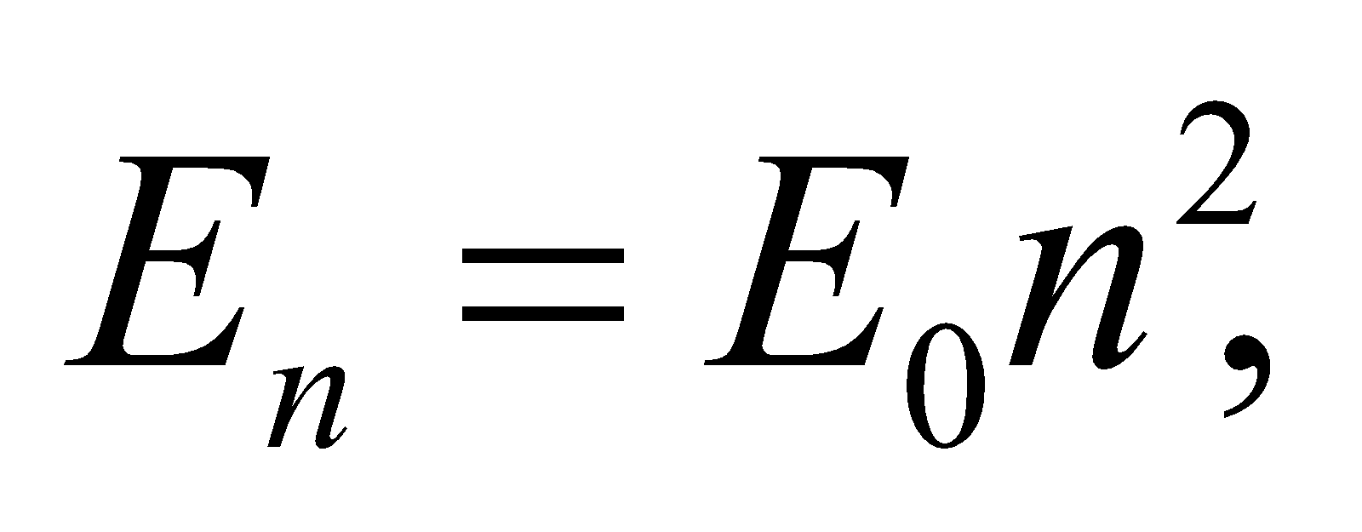 where 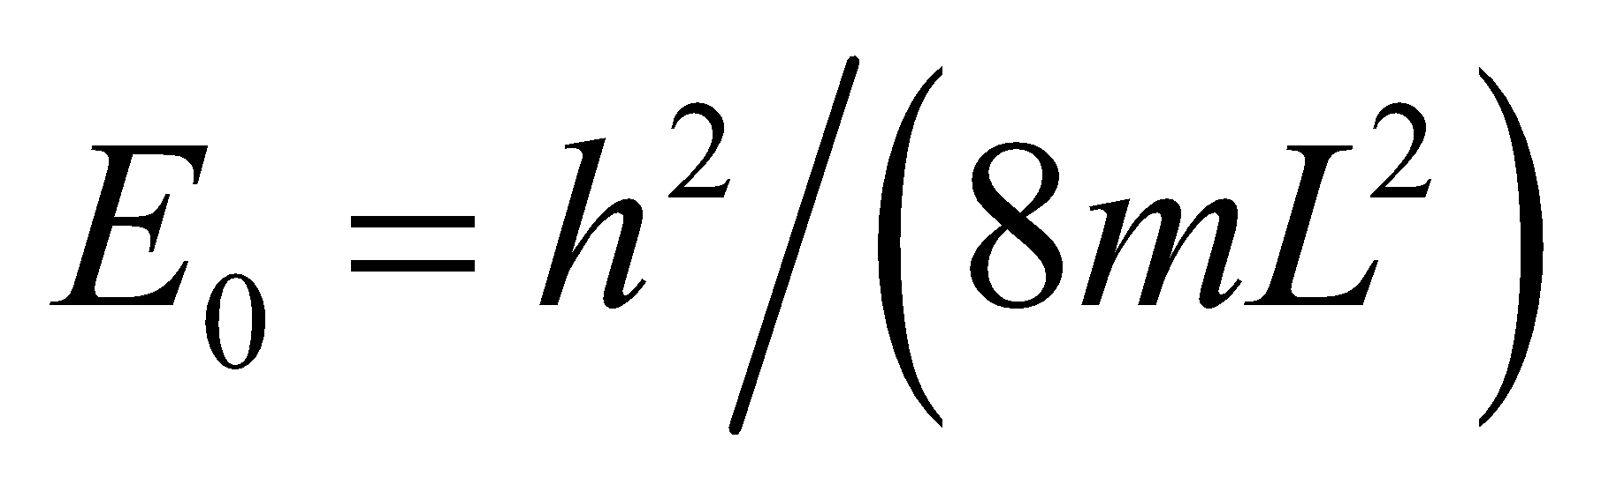 is the ground state energy. Thus, we must find the quantum number n such that
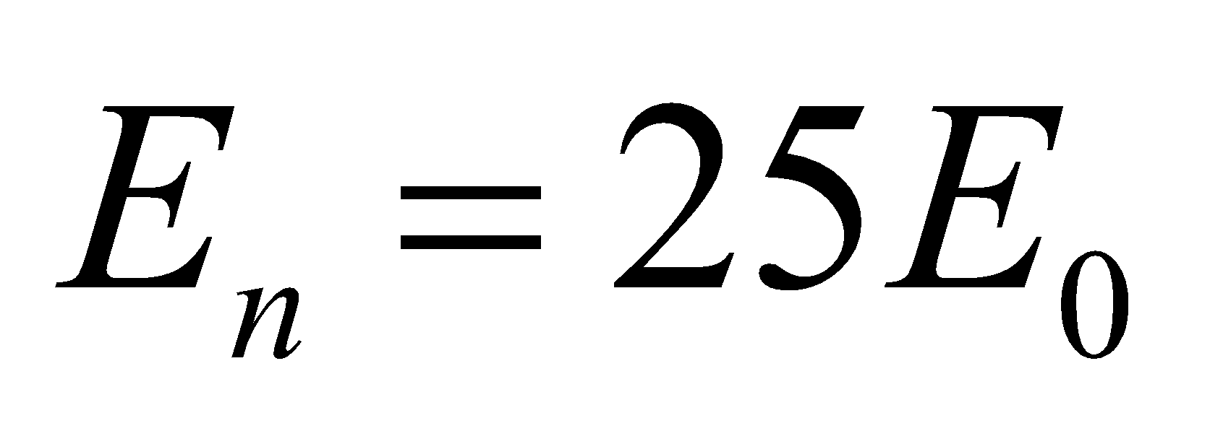.
Evaluate Solving the equation gives
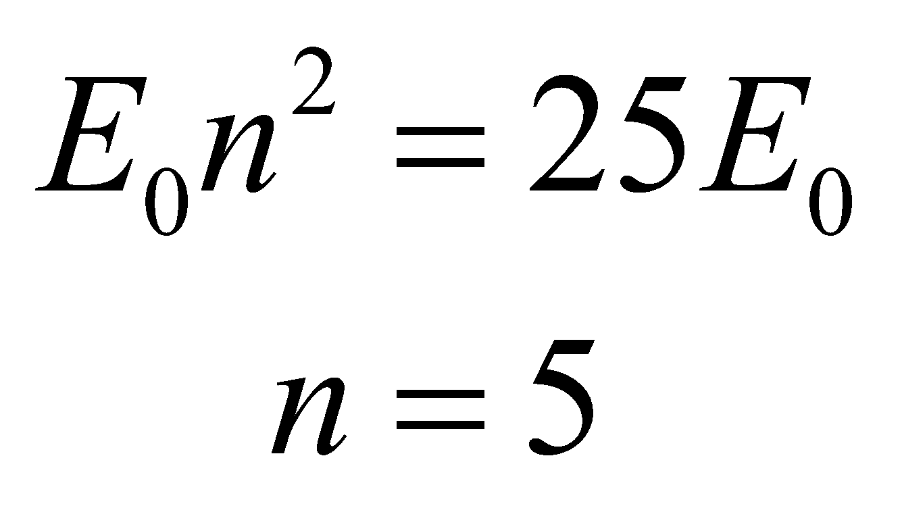
Assess The energy levels go as n squared.
14. Interpret The energy difference between two levels is 33 times the ground state energy. We are to find the principal quantum numbers for each of the levels.
Develop The energy levels in an infinite square well are 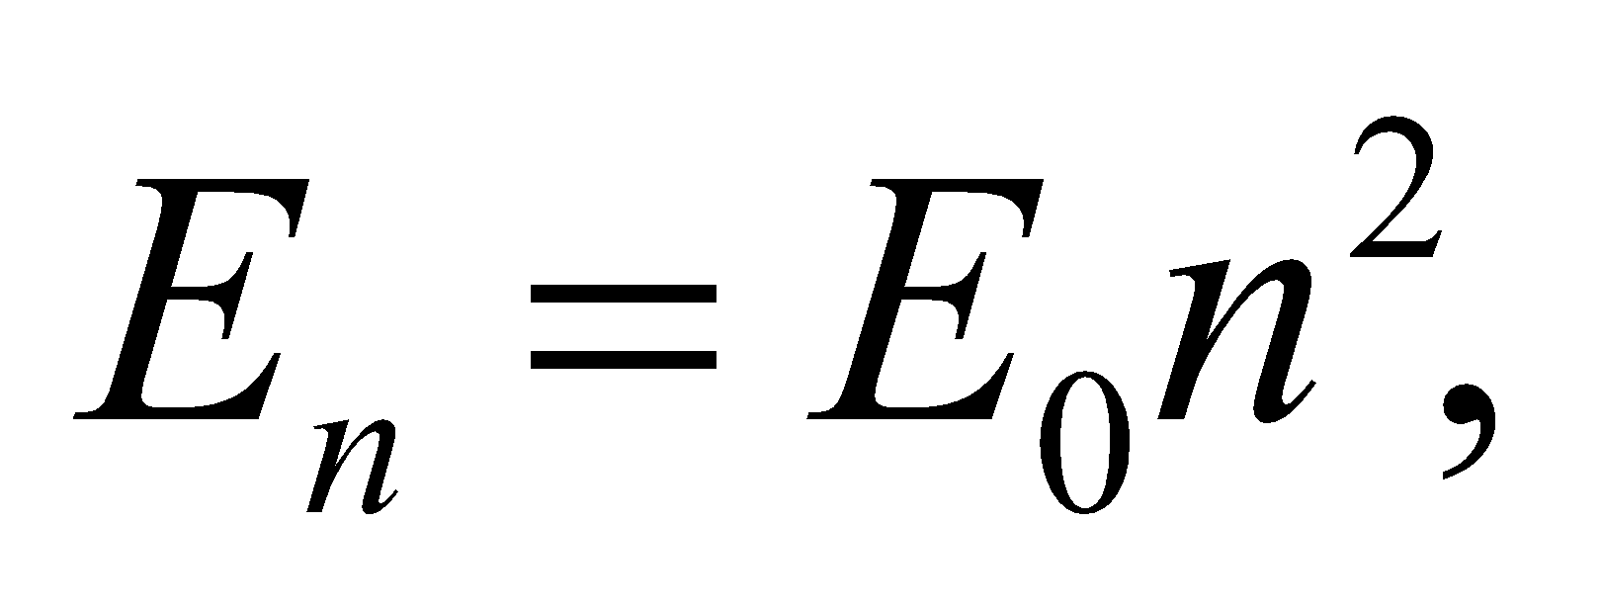 (Equation 35.5) where is the ground state energy. We are given that
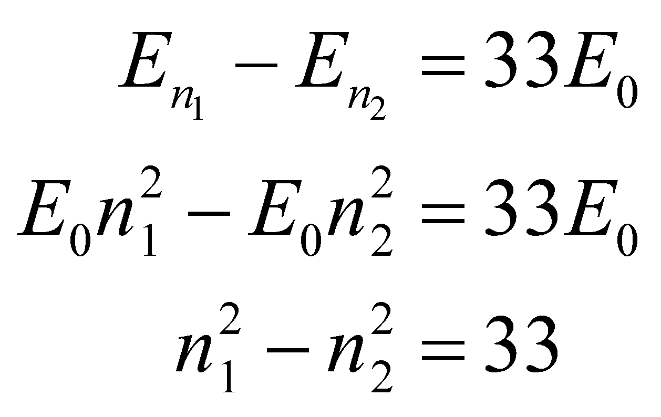
Evaluate The possible quantum numbers are 1, 4, 9, 16, 25, 36, 49…, so we see that 49 − 16 = 33. Thus, our quantum numbers are n₁ = 7 and n₂ = 4.
Assess Sometimes just looking at a problem and thinking about it like this is the best approach.
15. Interpret We have an electron confined in an infinite potential well, and are to find its ground-state energy.
Develop The energy levels for an infinite square potential well are given by Equation 35.5:
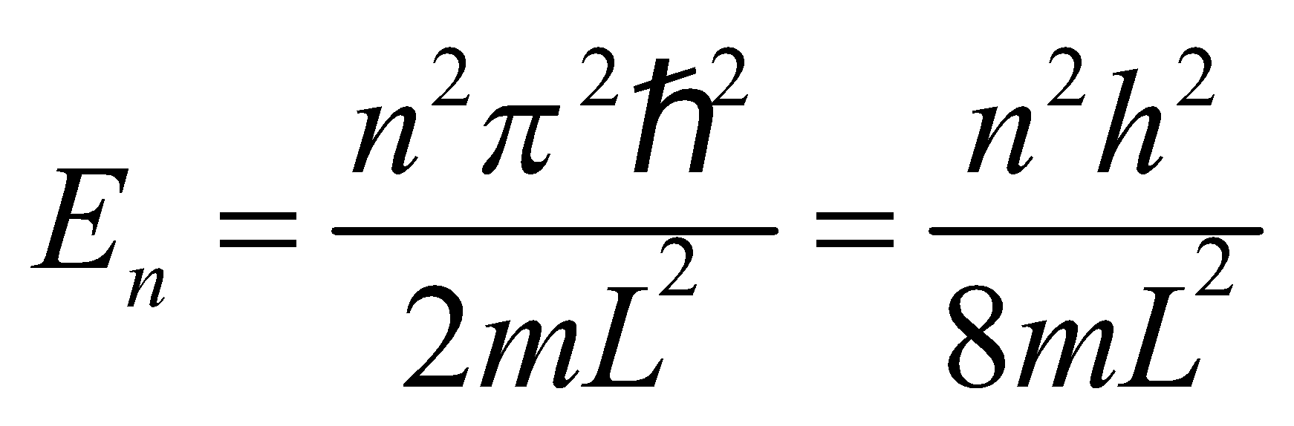
The ground-state energy corresponds to n = 1.
Evaluate From the above equation, we find the ground-state energy to be
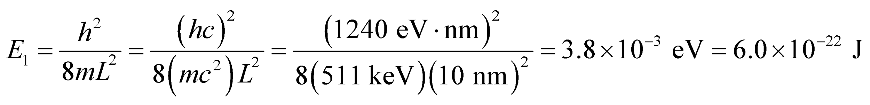
Assess A nonzero ground-state energy is a common feature of quantum systems. Note that the energy levels are quantized and proportional to n².
16. Interpret Given the ground-state energy of a proton in an infinite square well, we are to find the width of the well.
Develop The lowest possible energy of the proton (in a one-dimensional infinite square well) is its ground-state energy, which is given to be E₁ = 100 eV. Use Equation 35.5 to find the well width L.
Evaluate The well width is
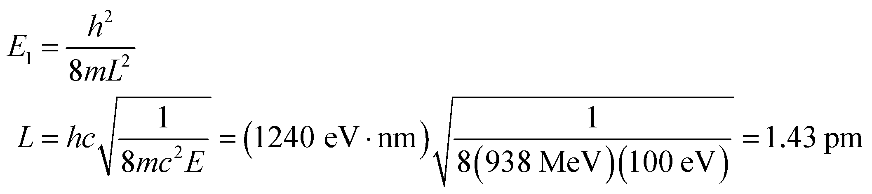
Assess This is much smaller than the Bohr radius a₀ = 52.9 pm, so this well is not realistic because it is smaller than the smallest atomic size.
17. Interpret The problem asks us to compute the lowest energy states of a quantum wire.
Develop The energy levels for an infinite square well potential is given in Equation 35.5:
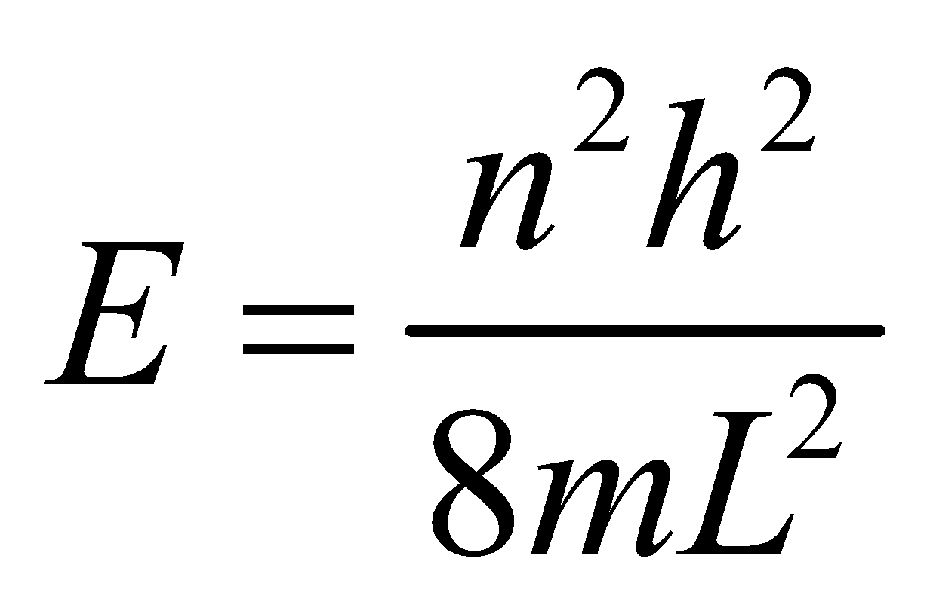
To simplify the calculation, we will multiply the top and bottom of the fraction by c², so that we can use the rest energy of the electron, 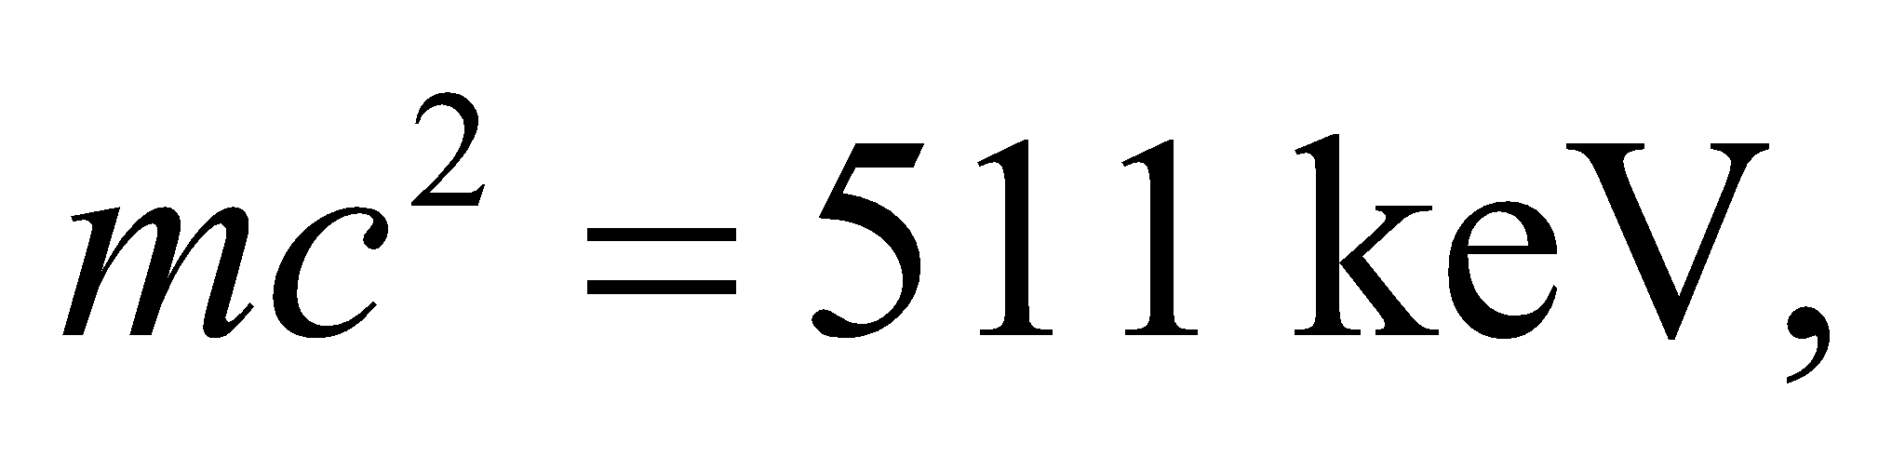and the shorthand 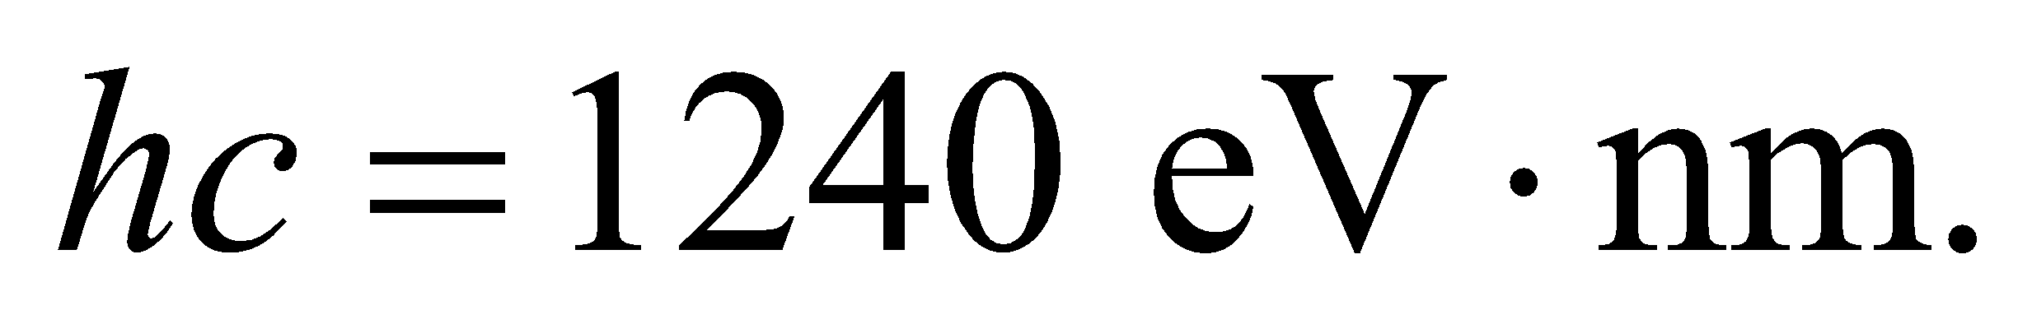
Evaluate (a) Plugging in the tube diameter for the well width, we get for the 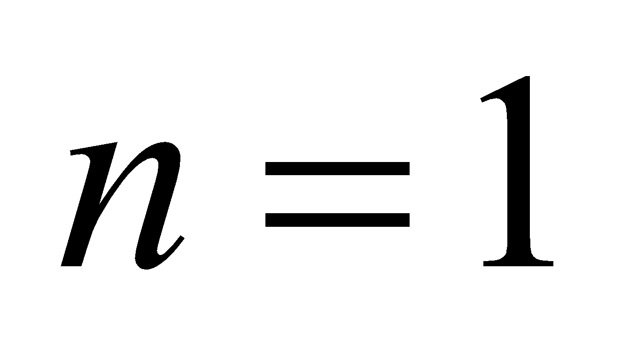 ground state
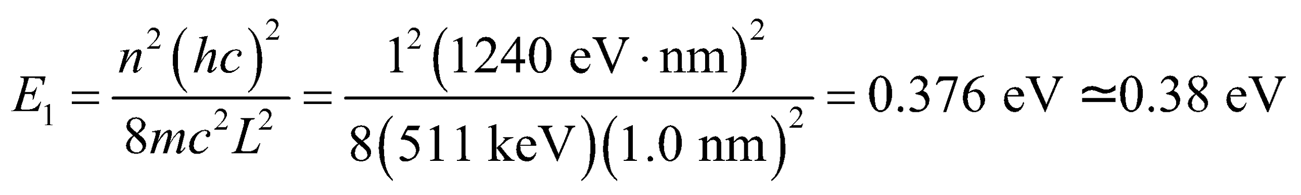
(b) The first excited state has 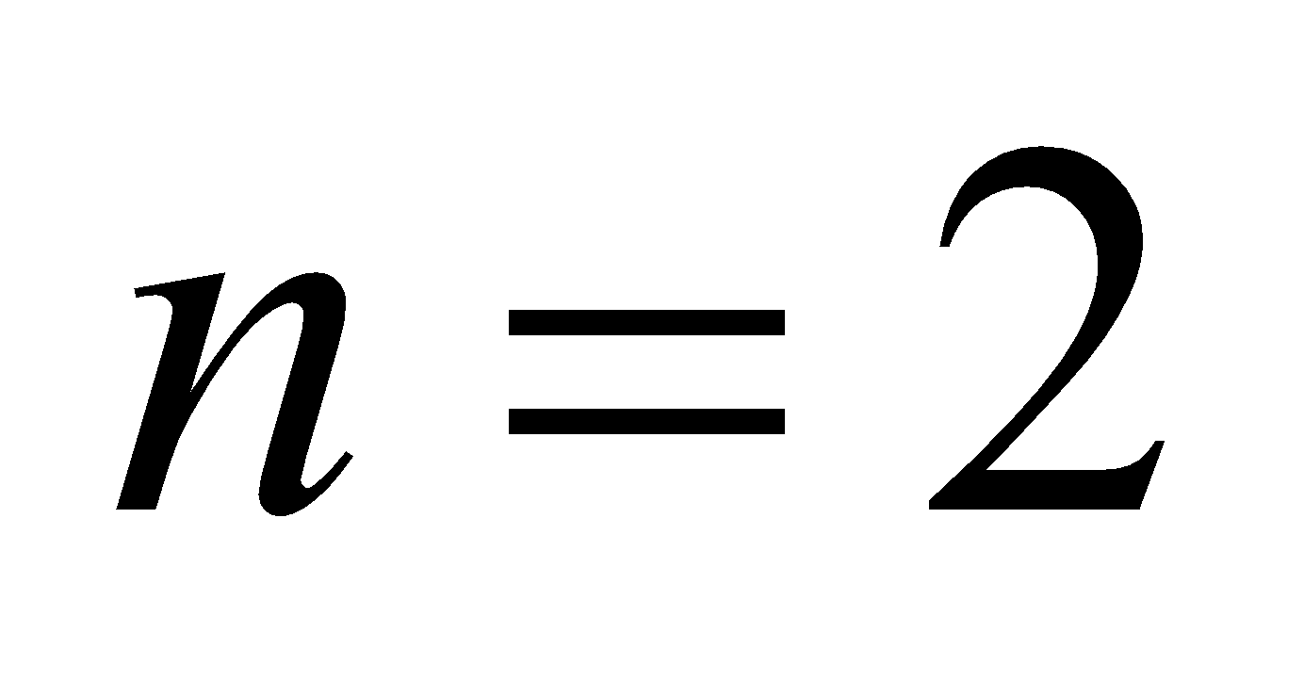 and its energy is 4 times the ground state:
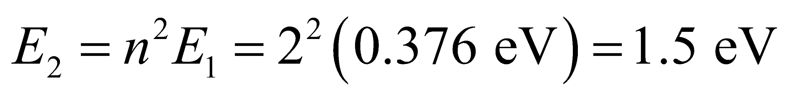
Assess The answers seem reasonable. In the lowest energy states, electrons in the nanotube will have roughly the same energy as electrons accelerated by a 1 V potential difference.
18. Interpret In this problem we want to demonstrate the smallness of the quantum effect when dealing with macroscopic objects. We are to imagine ourselves as a particle in a room-sized potential well, and find the value of Planck’s constant needed to give us the desired minimum speed.
Develop In a one-dimensional infinite square well, the lowest energy of a particle is (see Equation 35.5)
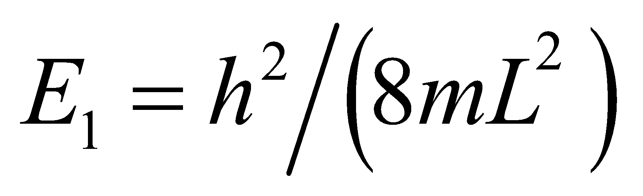. Since we are in the nonrelativistic domain, we can set 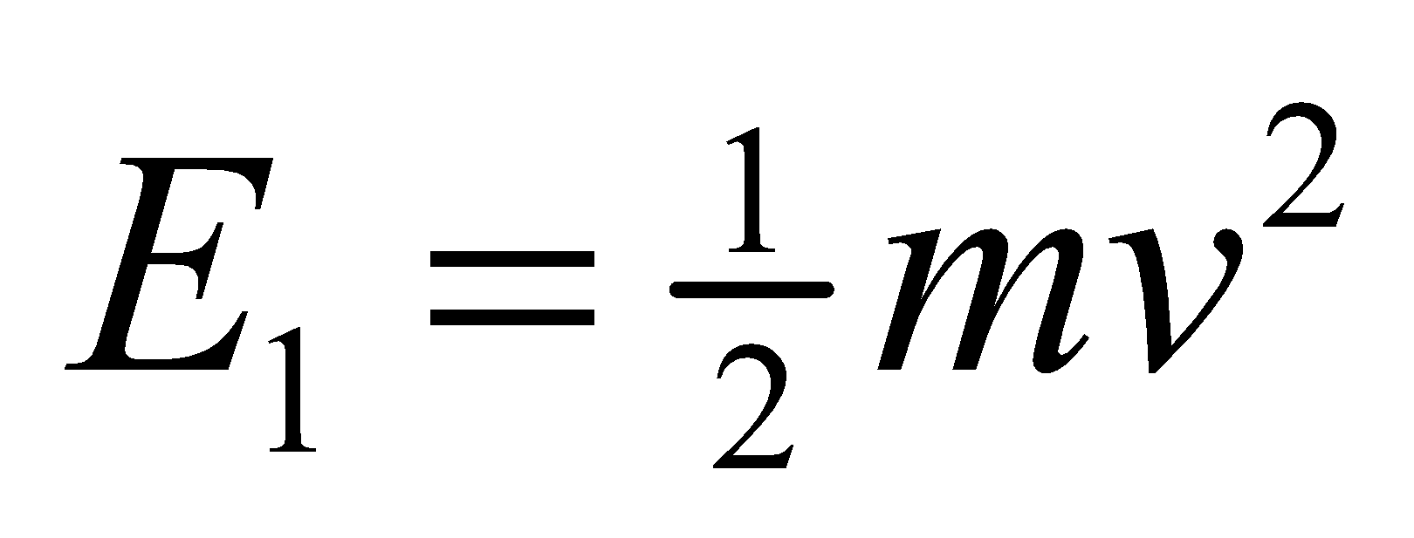 to deduce the “would-be” Planck constant for the quantum effect to be noticeable.
Evaluate Equating 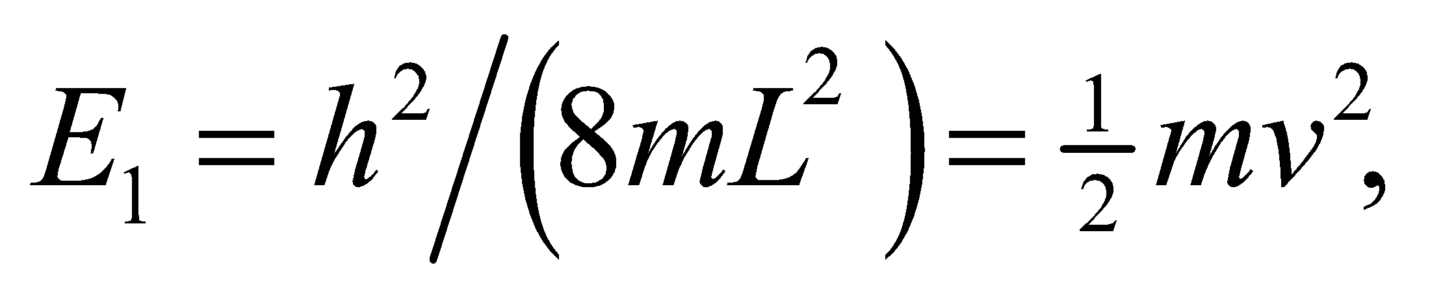 we get 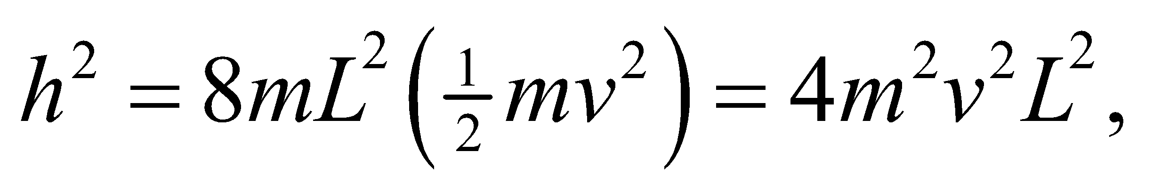 or
to two significant figures. This is 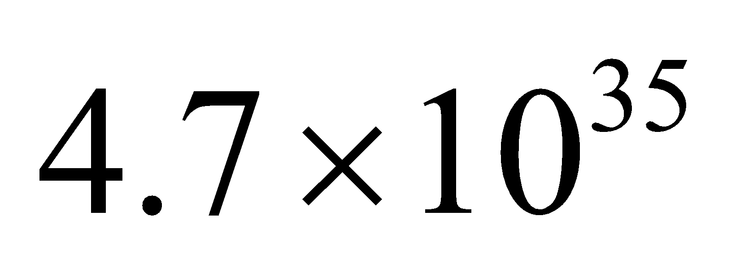 times larger than the actual value of Planck’s constant.
Assess When dealing with motion of macroscopic objects, one may simply apply classical physics and ignore quantum effect.
19. Interpret This problem involves and infinite potential well in which an unknown particle is trapped. Given the difference in energy between the ground state and the first excited state, we are to determine if the particle is an electron or a proton.
Develop Use the result of Schrödinger’s equation applied to an infinite potential well (Equation 35.5). The energy difference ΔE between the first excited state (n = 2) and the ground-state (n = 1) of a one-dimensional infinite square well is
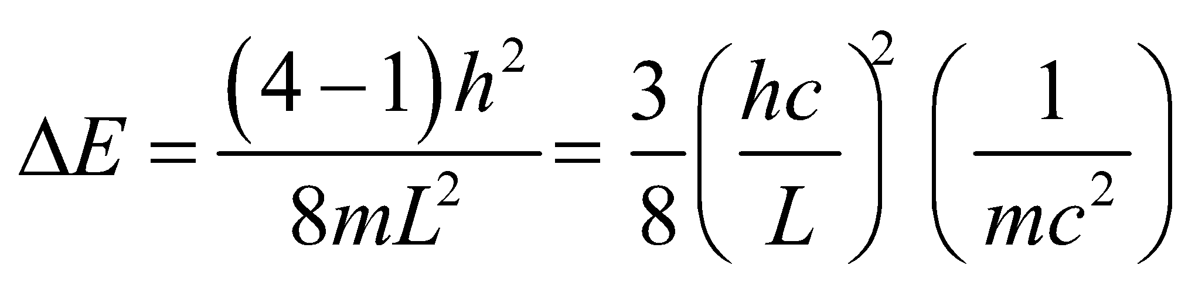
Evaluate Using given values, we find that
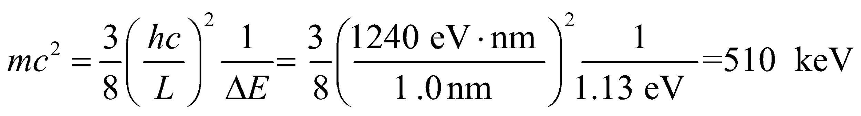
which is very close to the electron’s rest energy.
Assess The particle must be an electron.
20. Interpret We shall treat the snail as a particle confined in an infinite potential well. We want to show that a classical treatment of this problem is adequate for large quantum number n, in accordance with the correspondence principle.
Develop The kinetic energy of the snail is
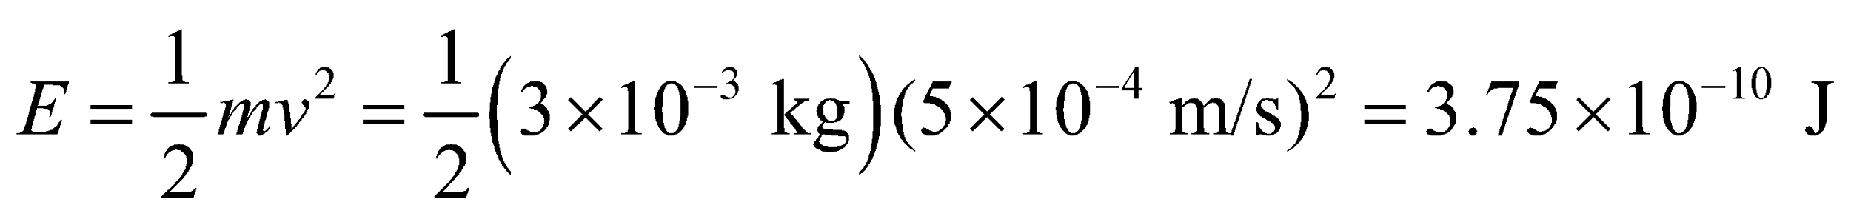
If this is regarded as the energy of a 3-g particle confined to a one-dimensional infinite square well of width L = 15 cm, the energy quantum number can be estimated from Equation 35.5:
Evaluate Equating the kinetic energy with the energy derived from Schrödinger’s equation, we find the quantum number to be
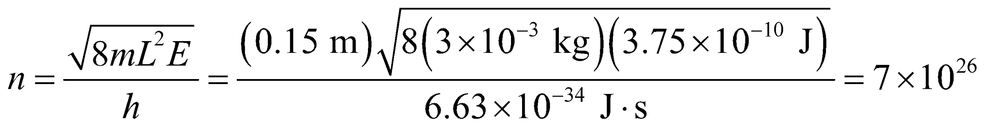
The correspondence principle implies that classical theory ought to be quite adequate for quantum numbers this large.
Assess We expect classical physics to be adequate in characterizing the motion of the crawling snail. When we try to quantize the system, we find n to be very large, as expected from the correspondence principle.
21. Interpret We are to find the ground-state energy of an alpha particle (i.e., He²⁺) trapped in the given infinite quantum well.
Develop Use the result of Schrödinger’s equation applied to an infinite potential well (Equation 35.5). For the ground state, n = 1. From Appendix C, we find that 1 u = 931.5 MeV/c².
Evaluate With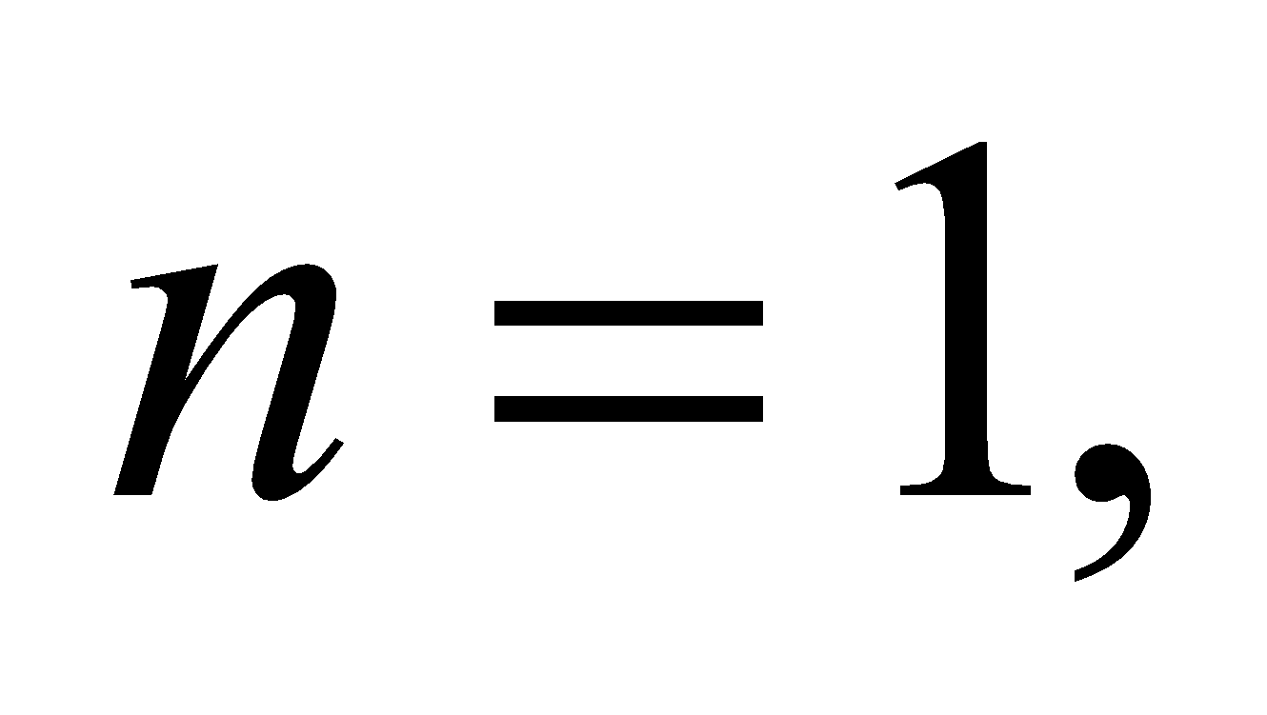 the lowest alpha-particle energy in a one-dimensional infinite square well of width L = 15 fm is
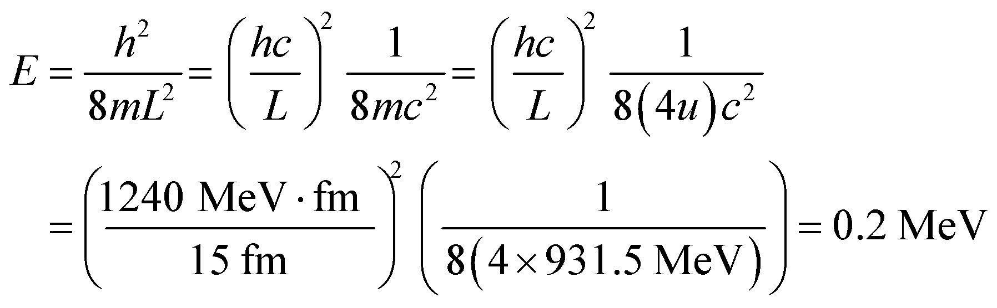
Assess This is a rather high energy, which is not surprising given the small size of the potential well. Note that the Bohr radius is a₀ = 52.9 pm gives the typical atomic size, which includes the electrons. Thus, our alpha particle is confined to a space much less than the size of an atom.
22. Interpret We are given the ground-state energy of a particle in a harmonic oscillator potential, and asked to find the corresponding classical frequency of the oscillator.
Develop The ground-state energy of a one-dimensional harmonic oscillator is given by Equation 35.7 with n = 0:
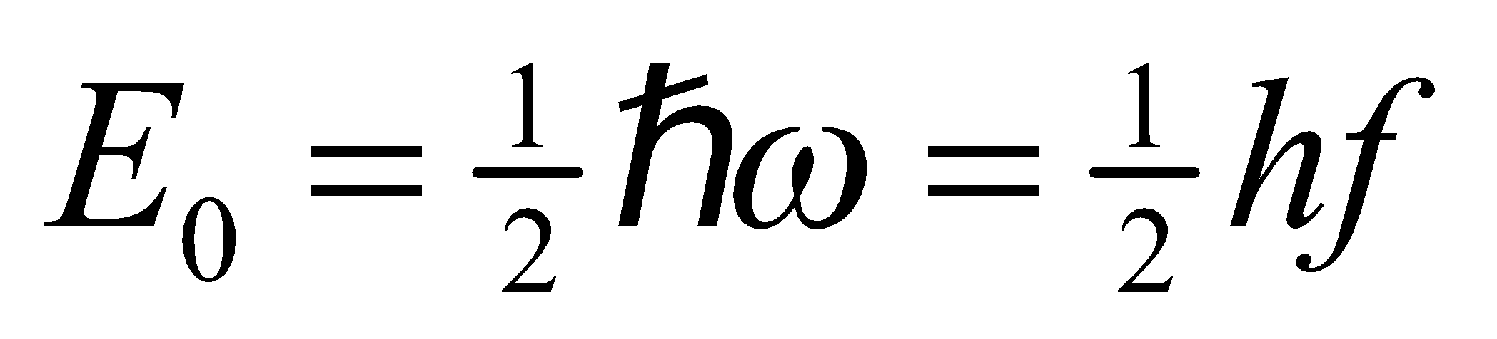
Evaluate Thus, the classical frequency is
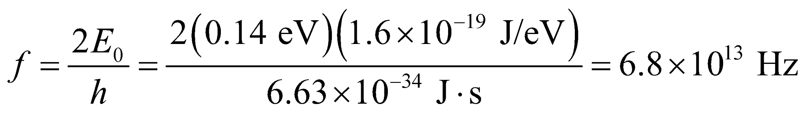
Assess A nonzero ground-state energy is a common feature of quantum systems. Note that because the spacing between adjacent energy levels is 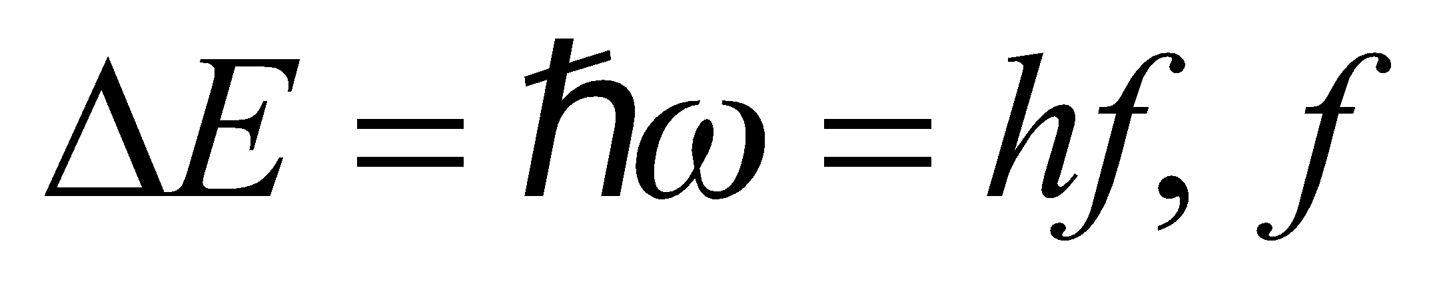 represents the frequency of the photon that must be absorbed or emitted for transitions to take place.
23. Interpret We are to find the energy of the lowest state for a particle in a harmonic oscillator potential.
Develop Apply Equation 35.7. The lowest state is the ground state and has quantum number n = 0 for a harmonic oscillator.
Evaluate With n = 0, Equation 35.7 gives the ground-state energy as
Assess Note that the energy of a particle in a harmonic oscillator potential is independent of mass.
24. Interpret In this problem we are asked to find the classical frequency of an oscillator, given the energy of photons emitted in a transition from an arbitrary state n to state n − 1.
Develop If a harmonic oscillator emits a photon, conservation of energy demands that the final state of the harmonic oscillator be lower than the initial state. For a one-dimensional harmonic oscillator, the energy spacing between adjacent states is 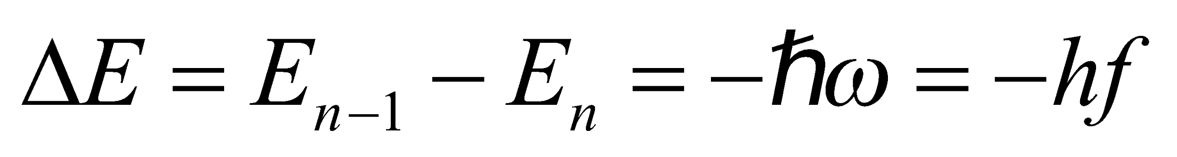 (see Equation 35.7). Conservation of energy demands that the initial energy be the same as the final energy, or
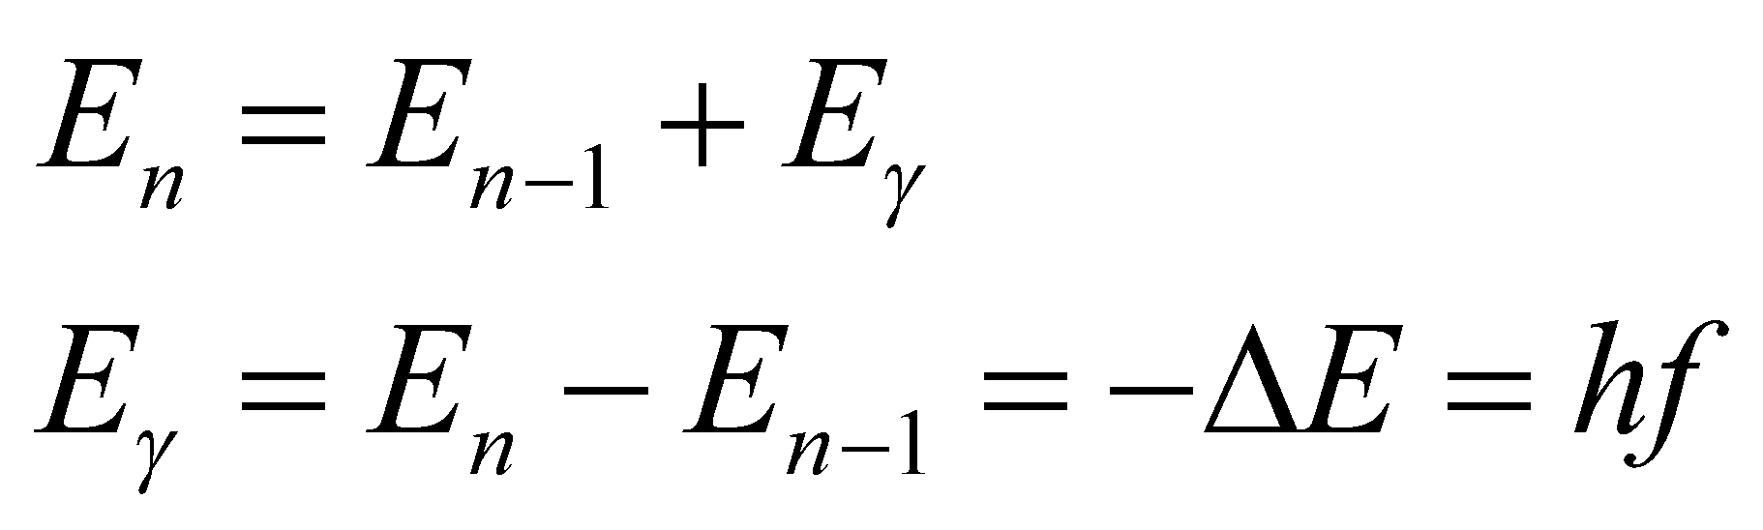
where 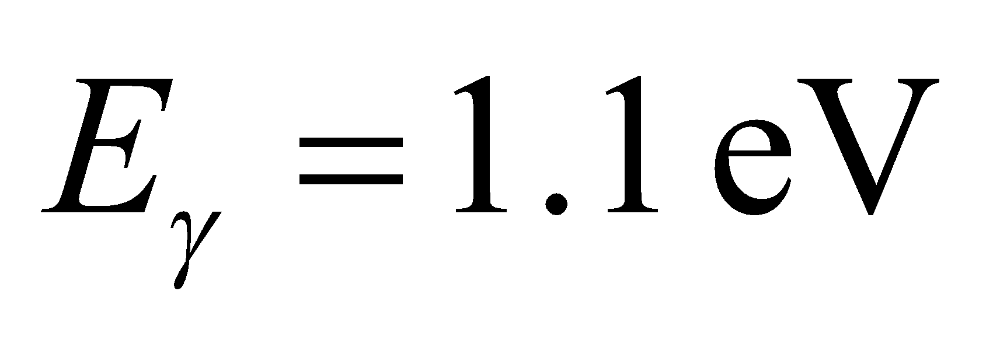 is the energy of the emitted photon.
Evaluate From the above equation, we find the classical oscillation frequency to be
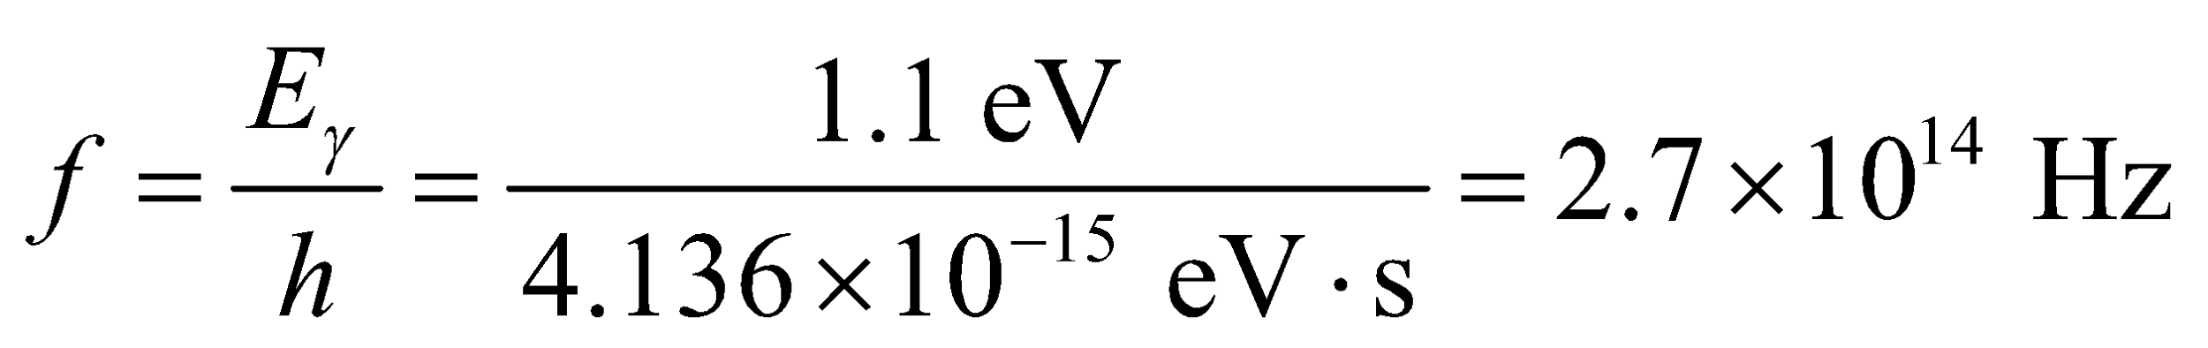
Assess For transition to occur, an oscillator must emit (or absorb) photons of this frequency.
25. Interpret We are to find the energy separation between states in a harmonic oscillator given the ground-state energy.
Develop Equation 35.7 gives the energy levels in a harmonic oscillator: 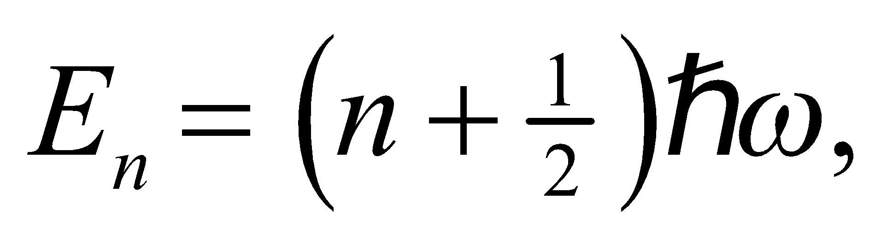 so the separation between levels is  Given that E₀ = 4.0 eV for n = 0, we can solve for
Evaluate The energy spacing 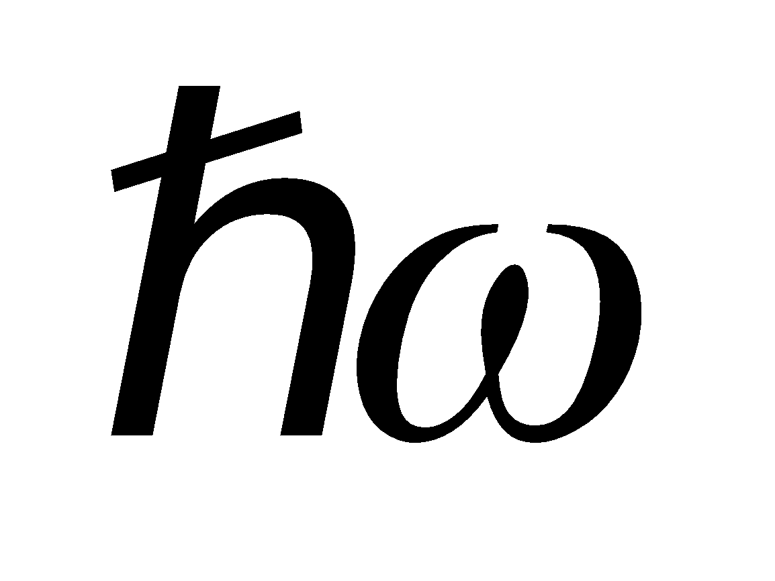 between adjacent levels is
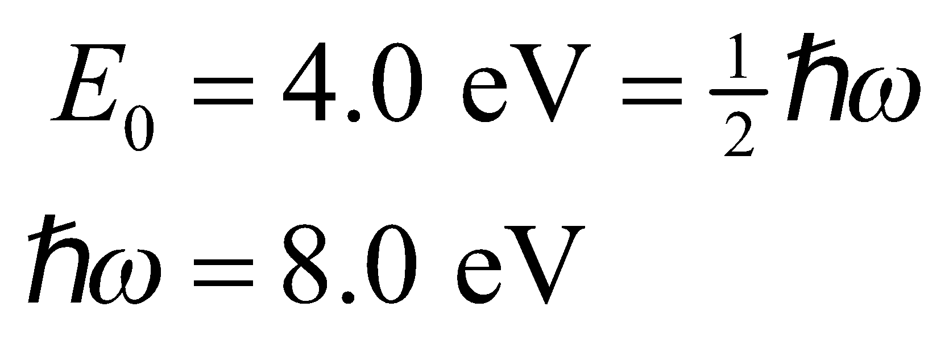
Assess Unlike the infinite square well, the energy levels for the harmonic oscillator are linear in n.
26. Interpret You're trying to convince your roommate that he shouldn't expect quantum mechanical effects in classical physics experiments, like a mass-spring system.
Develop The energy levels for a harmonic oscillator are written in Equation 35.7:
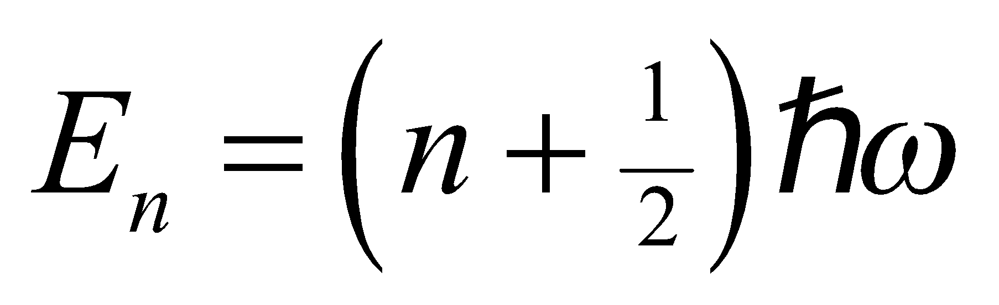
The angular frequency for a mass-spring system is given by Equation 13.7a: 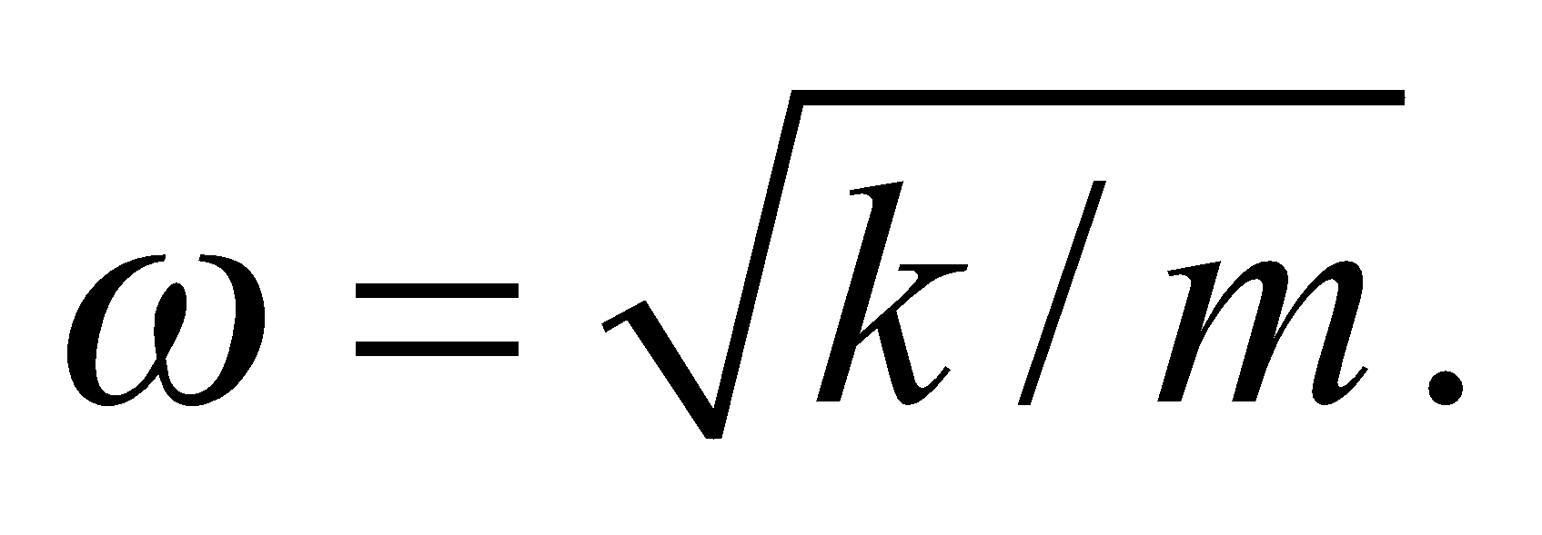
Evaluate For two adjacent energy levels, the energy difference is
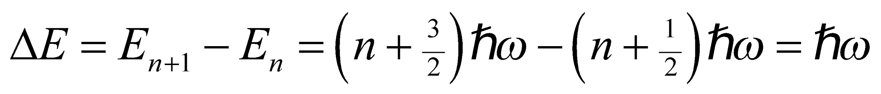
For the mass-spring system being considered,
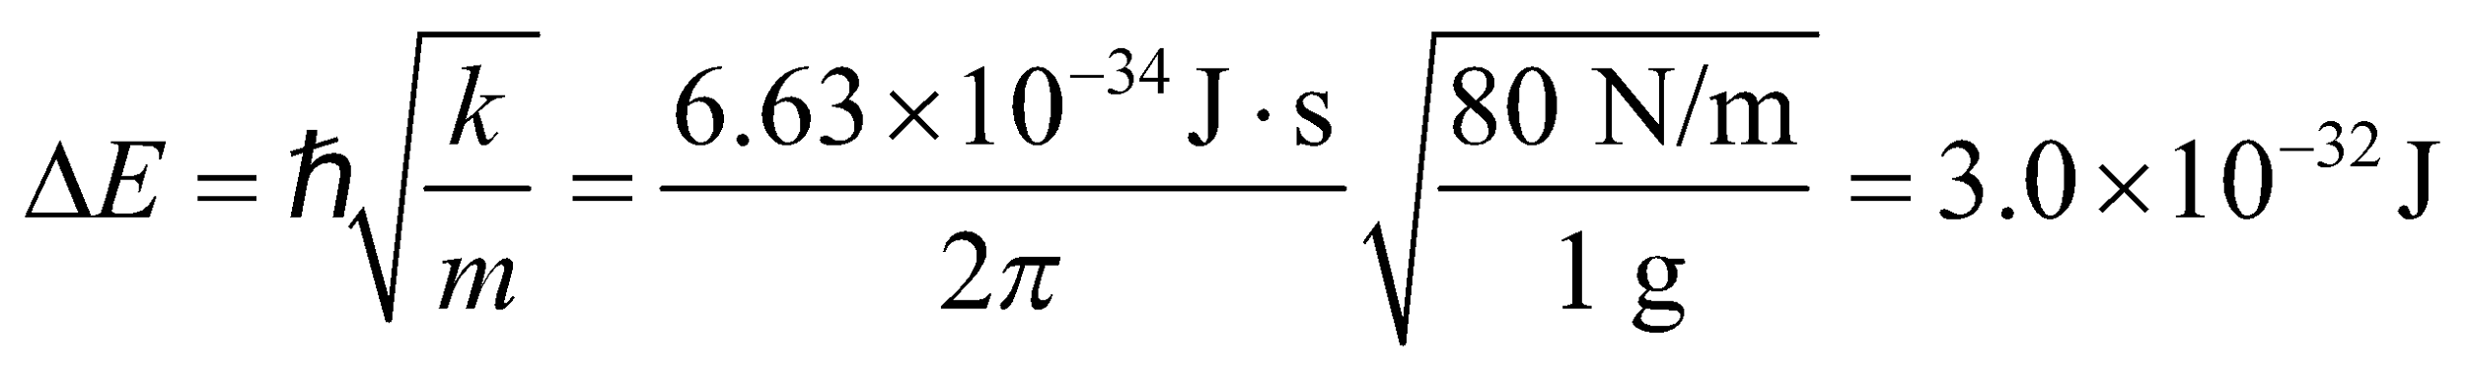
This is far too small to be measurable. This is why your roommate never observes any quantum "jumps" in the energy of the mass-spring systems of Newtonian physics.
Assess To further demonstrate how impossible it would be to detect quantum mechanical effects in macroscopic objects, consider the classical energy of a harmonic oscillator: 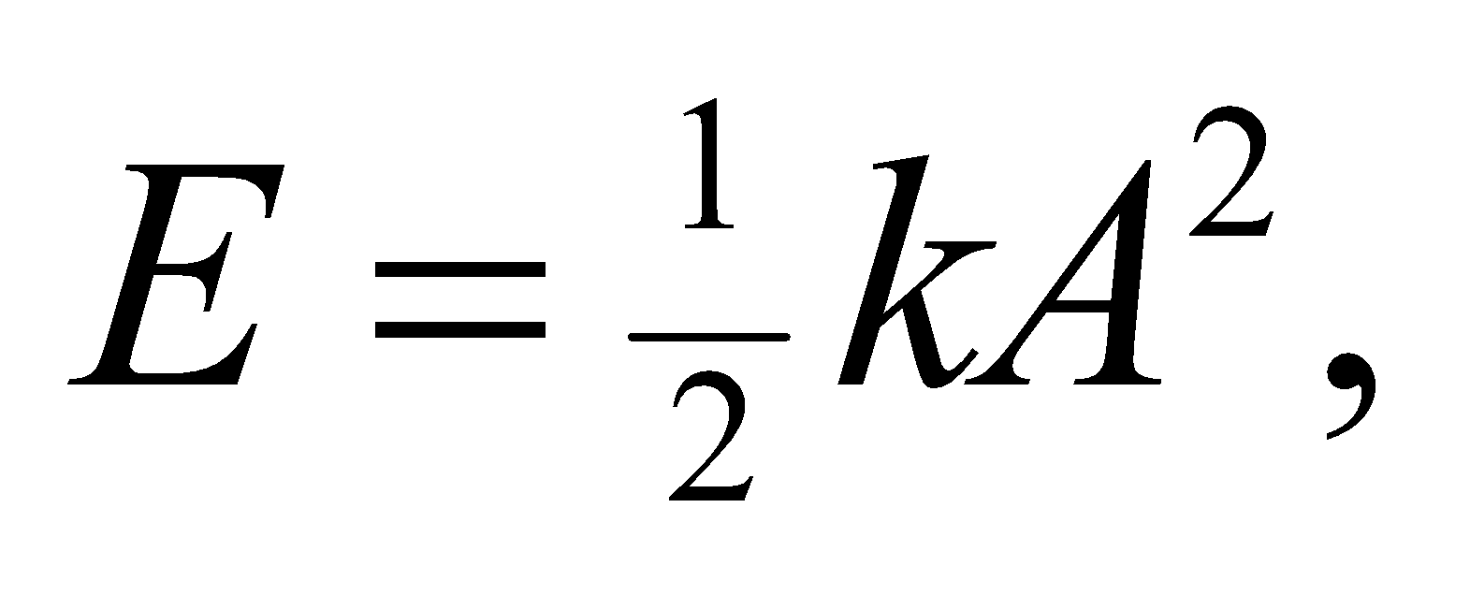 where A is the amplitude of the oscillations (see Section 13.5). Taking the derivative, 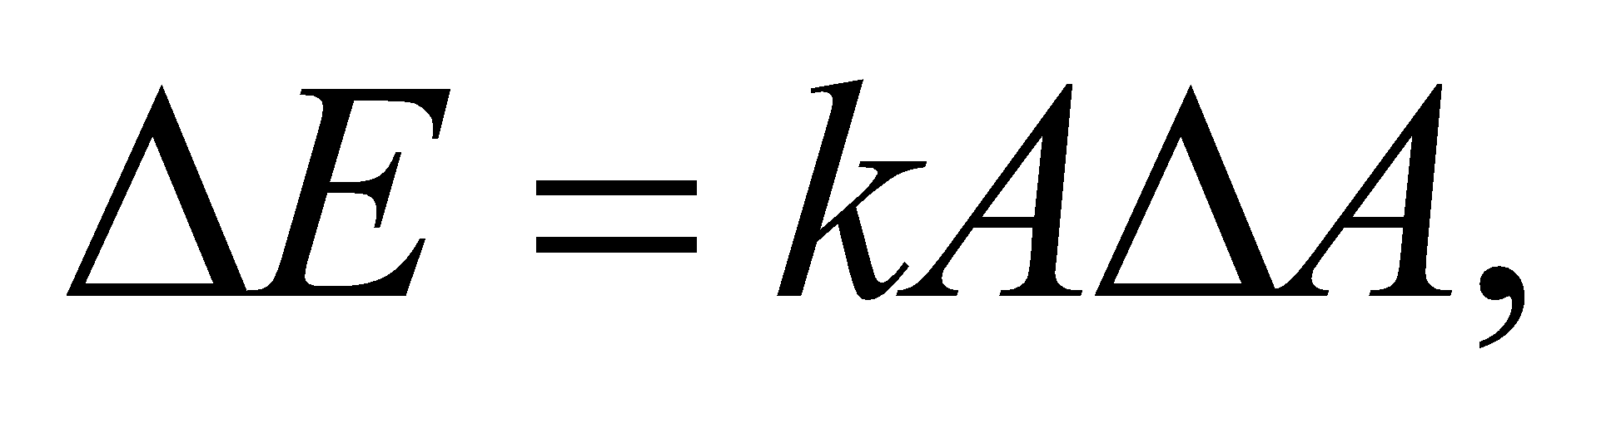shows how the energy changes with changes in the amplitude. If you were going to try to detect energy levels of a mass-spring system, you might observe the amplitude of the oscillations, since they relate to the energy by 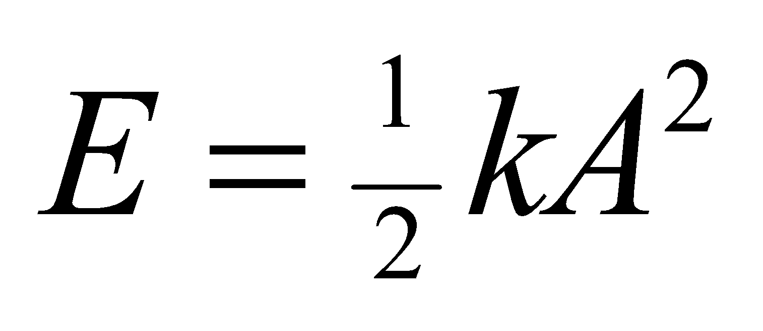 (recall Section 13.5). If you are able to measure the amplitude with nanometer resolution, then the smallest energy level separations that you could measure for the above spring would be around 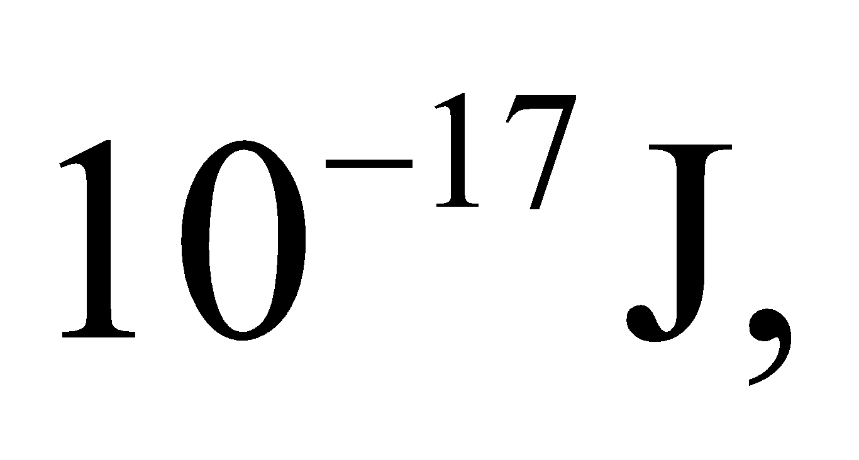which is still a long way from the sensitivity needed.
Section 35.4 Quantum Mechanics in Three Dimensions
27. Interpret We are to consider a particle three-dimensionally confined in a cubic potential well. If the length of all sides of the box is doubled, how is the particle’s ground-state energy affected?
Develop From Equation 35.8, we see that the energy of a particle in a cubical box is inversely proportional to the square of the length of the sides of the box. In the ground state, n_{x} = n_{y} = n_{z} =1, so the ground-state energy is
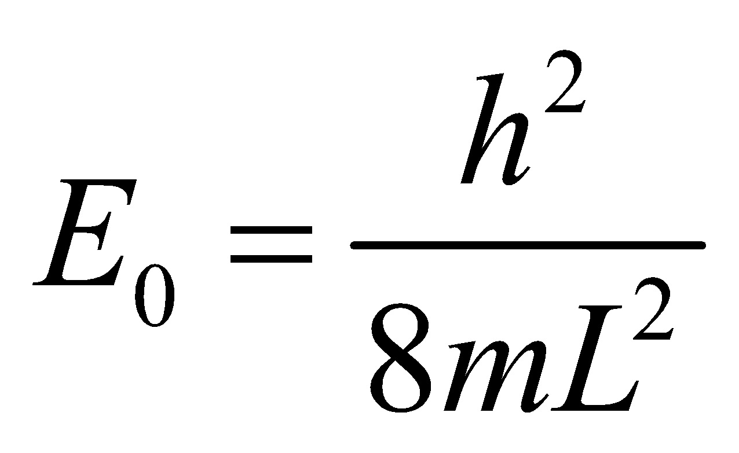
If we double the length, 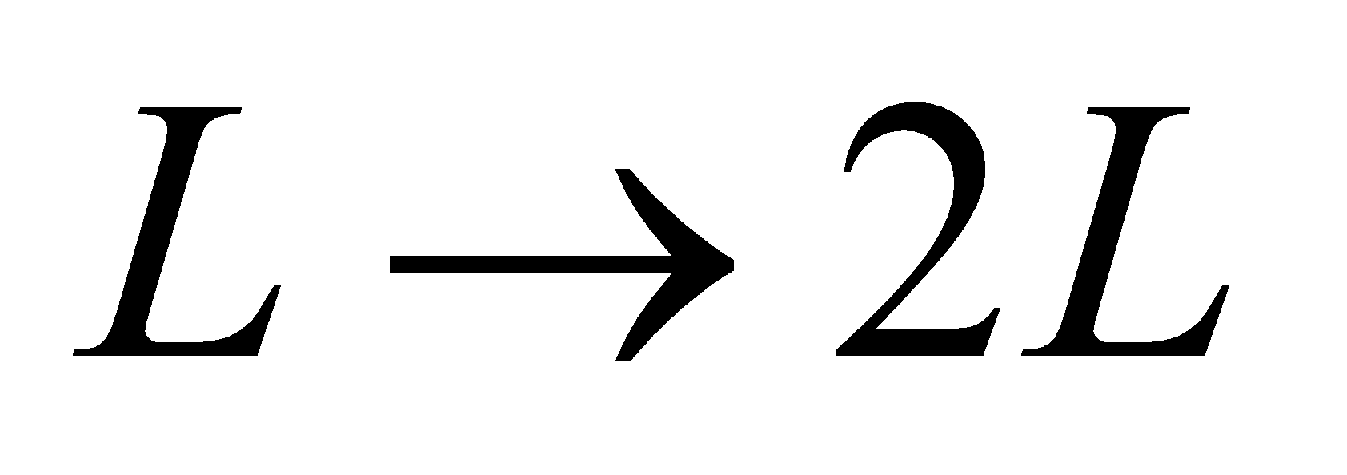, so we can recalculate the new ground-state energy.
Evaluate Replacing L by 2L, we find that the ground state energy becomes
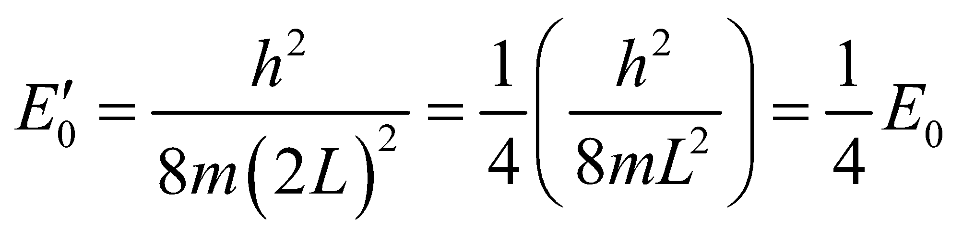
Assess The ground-state energy is inversely proportional to L², so doubling L reduces the ground-state energy by a factor of L² = 4.
28. Interpret This problem explores a crude model of an atomic nucleus in which the nucleus is considered to be a proton confined in a cubical potential well. We are to find the energy difference between the ground state and the first excited state.
Develop The energy levels of a particle in a three-dimensional box are given by Equation 35.8:
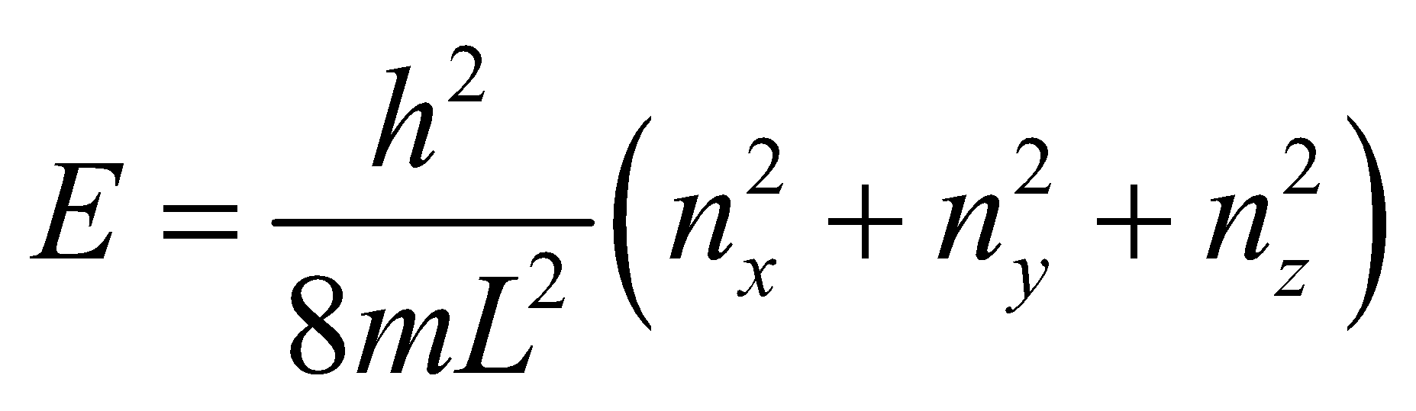
The ground state corresponds to n_{x} = n_{y} = n_{z} =1, whereas the first excited state has one of the quantum numbers equal to 2 (e.g., 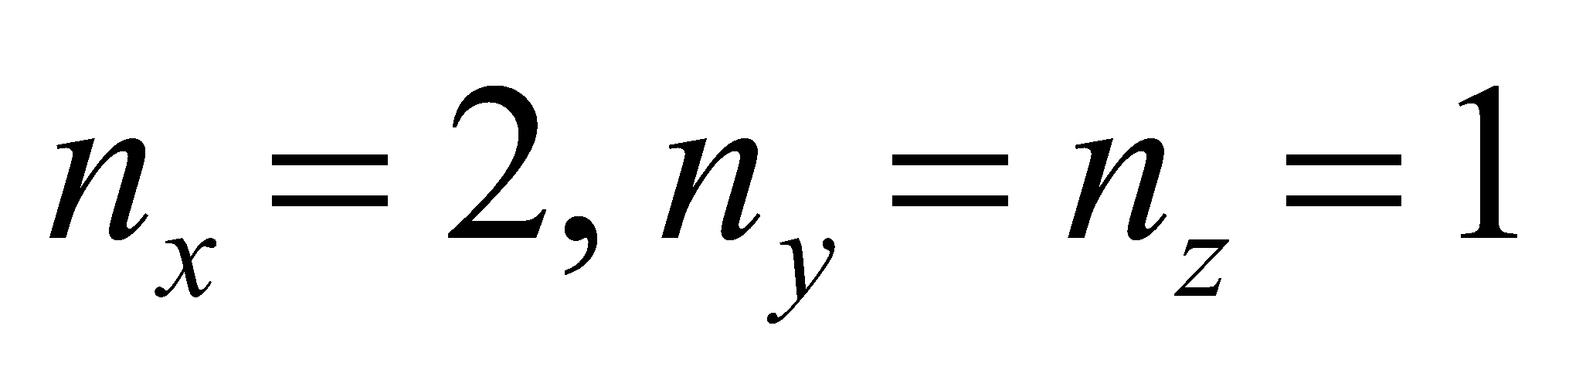).
Evaluate The difference in energy between the first excited state and the ground-state for a proton (mass
938 MeV/c²) in a cubical box (side length 1 fm) is
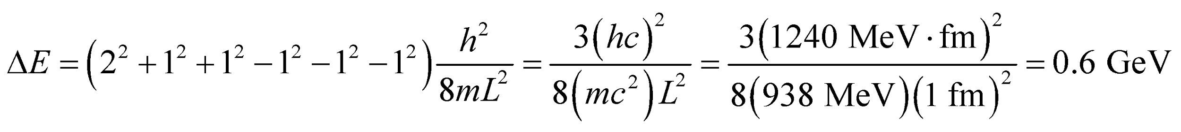
Assess Typical gamma-ray energies range from 100 keV to 10 MeV.
29. Interpret This problem is similar to the previous problem, except that we are now given energy of the photon emitted by an electron confined to a cubic quantum potential well and are asked for the size of the cube.
Develop From the solution to the previous problem, we know that the energy difference between the energy of the ground-state and of the first excited state is
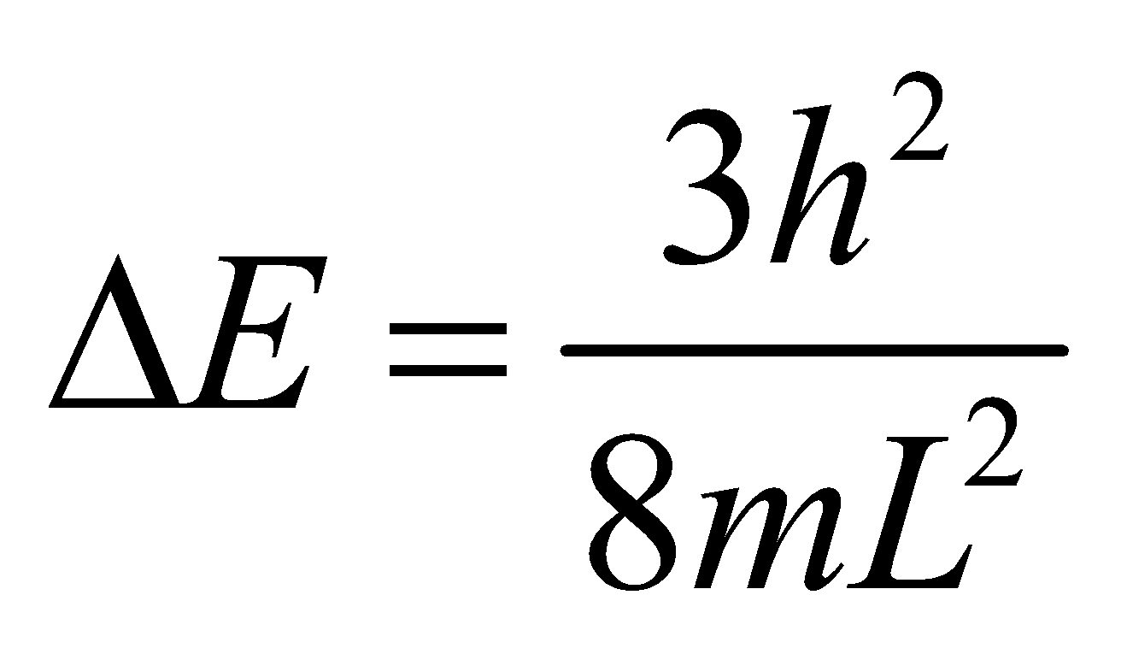
Set this equal to the photon energy (Equation 34.5) E_{γ} = hf = hc/λ to find the cubic box size L.
Evaluate Inserting the given quantities and solving for L gives
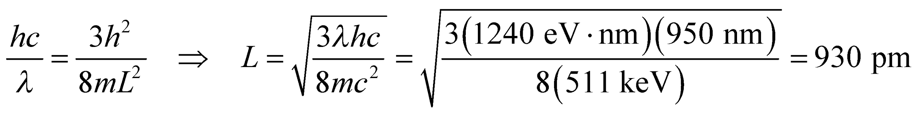
where we have used me = 511 MeV/c².
Assess This cubic potential well is about the same size as in the previous problem, but the corresponding energy difference is much less because the electron’s mass is much less than that of the proton.
Problems
30. Interpret We are to derive the normalization constant of the given wave function with the given boundary conditions.
Develop Because the particle under consideration must be somewhere, the probability distribution y integrated over all space must be unity. This leads to the normalization condition of a wave function (Equation 35.3)
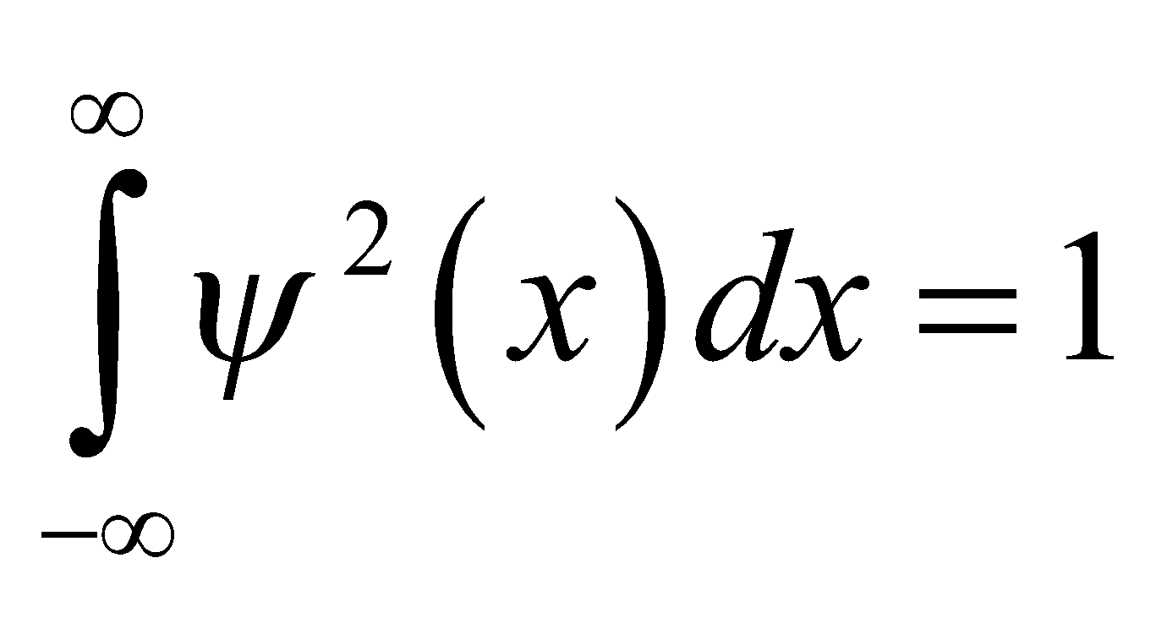
This condition allows us to deduce the form of the normalization constant A.
Evaluate Inserting the given wave function into the integral leads to
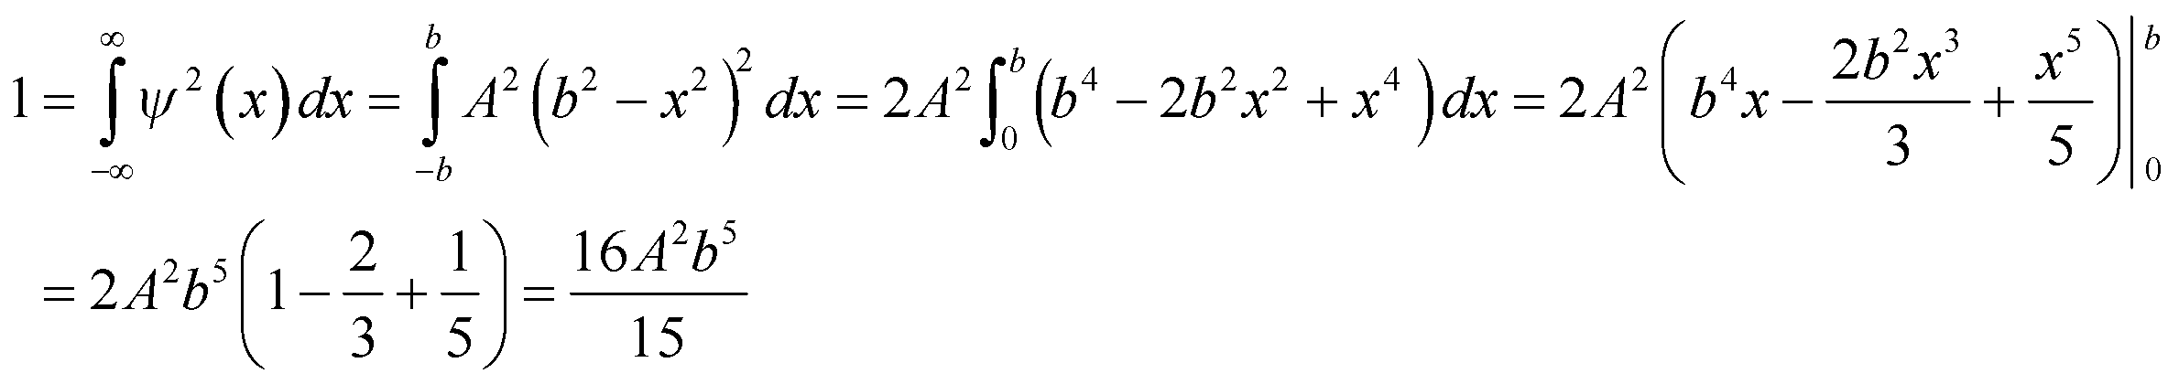
Therefore, the normalization constant is 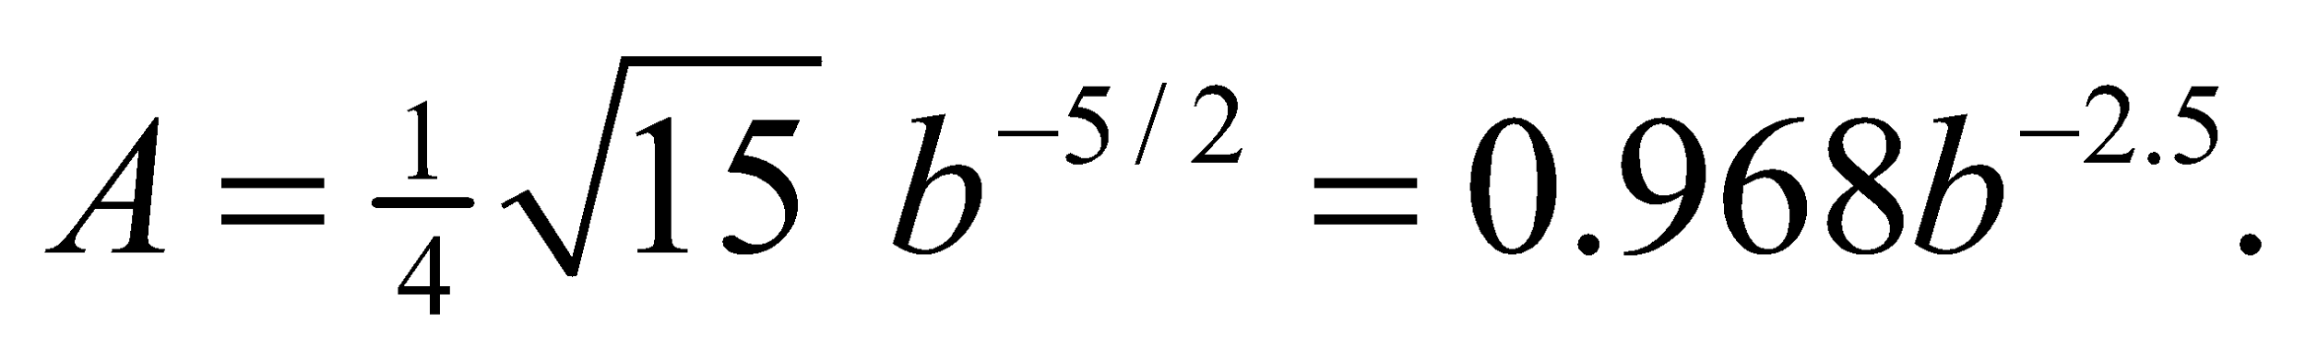
Assess The normalization condition implies that ψ(x) has dimension 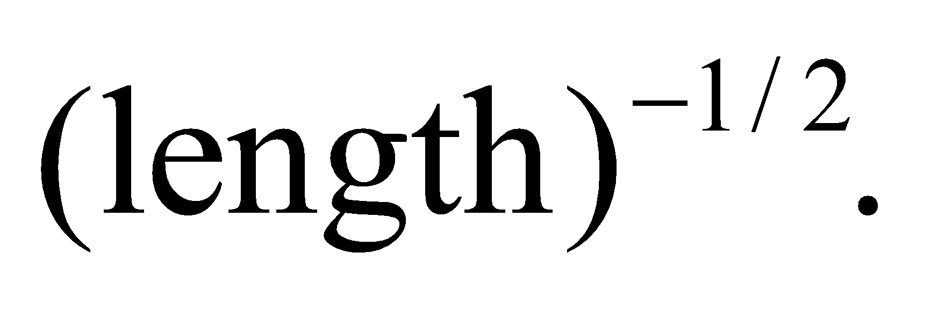 With 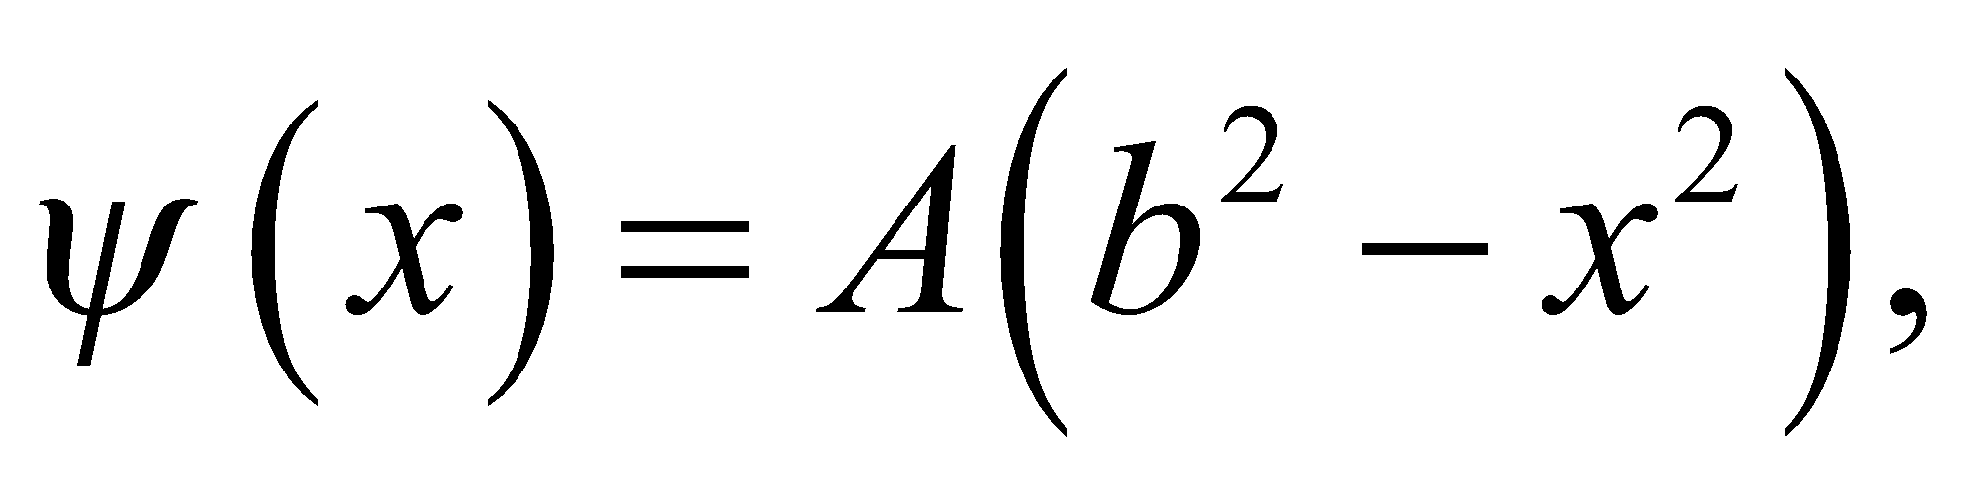 we expect A to have dimension 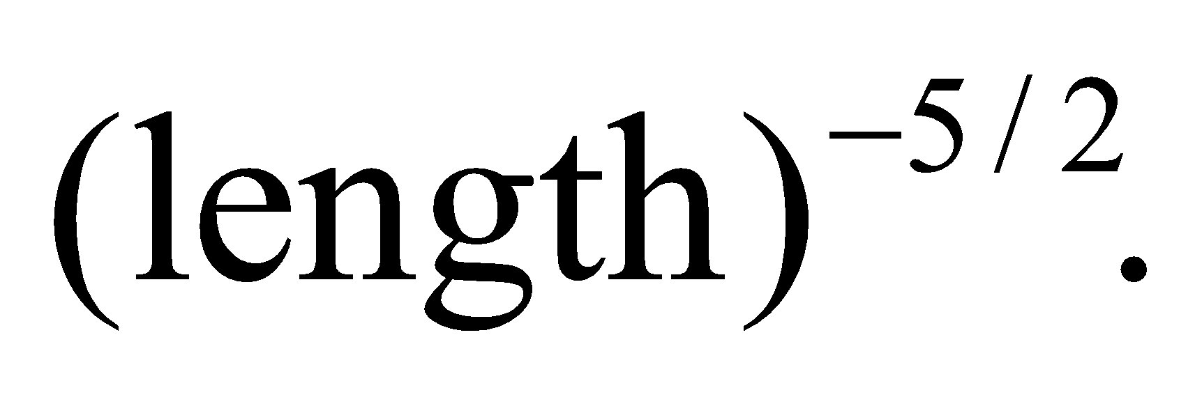 Since b also has dimensions of length, we see that our result is consistent with dimensional analysis.
31. Interpret For this problem, we are to show that if two wave functions are solutions of the Schrödinger equation, then their linear combination must also be a solution.
Develop The time-independent one-dimensional Schrödinger equation is given by Equation 35.1:
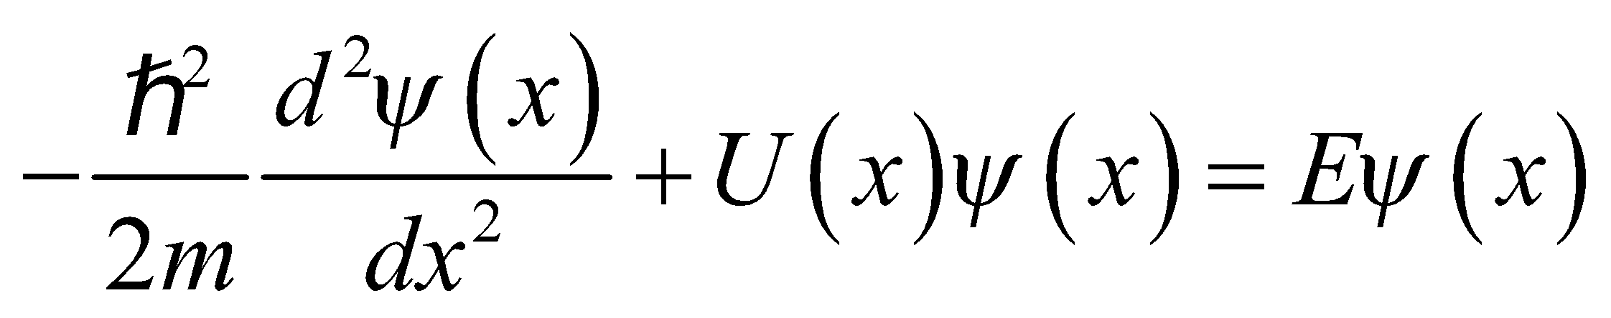
We want to show that for any constants a and b, 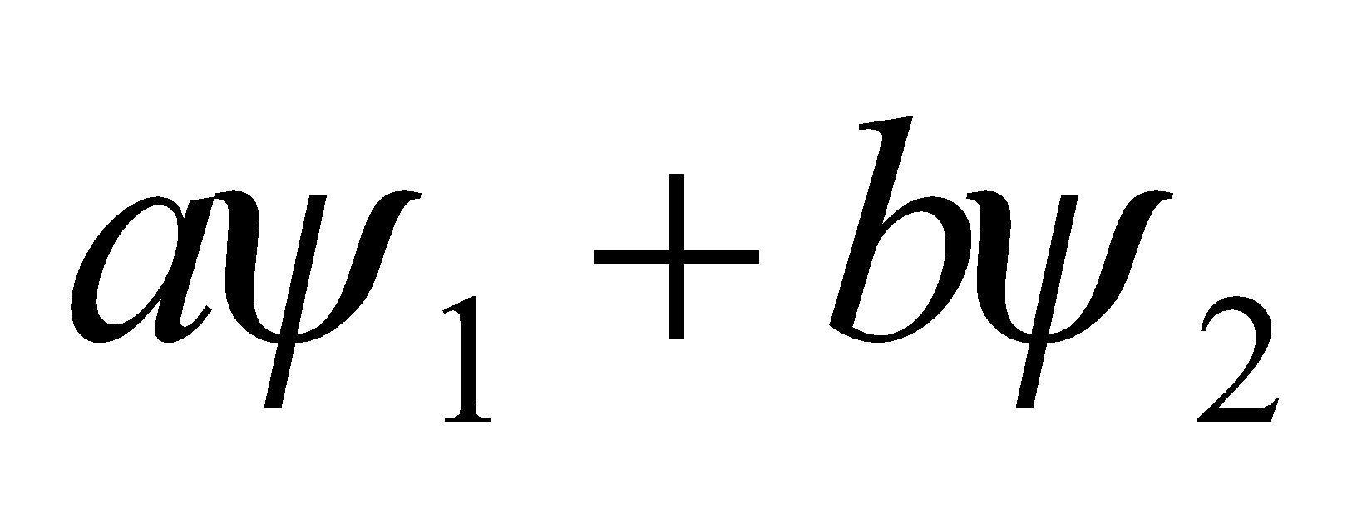 is a solution if 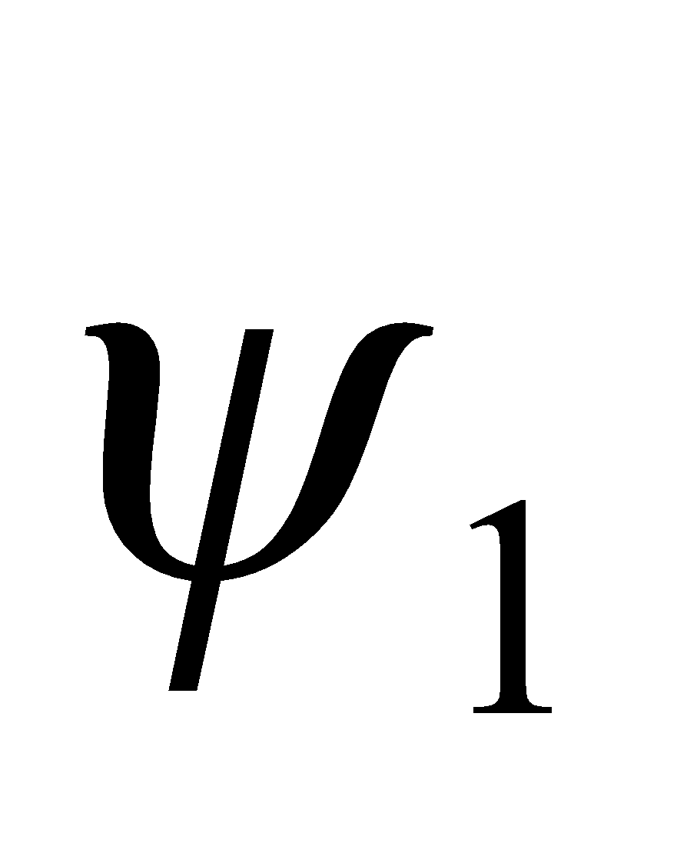 and 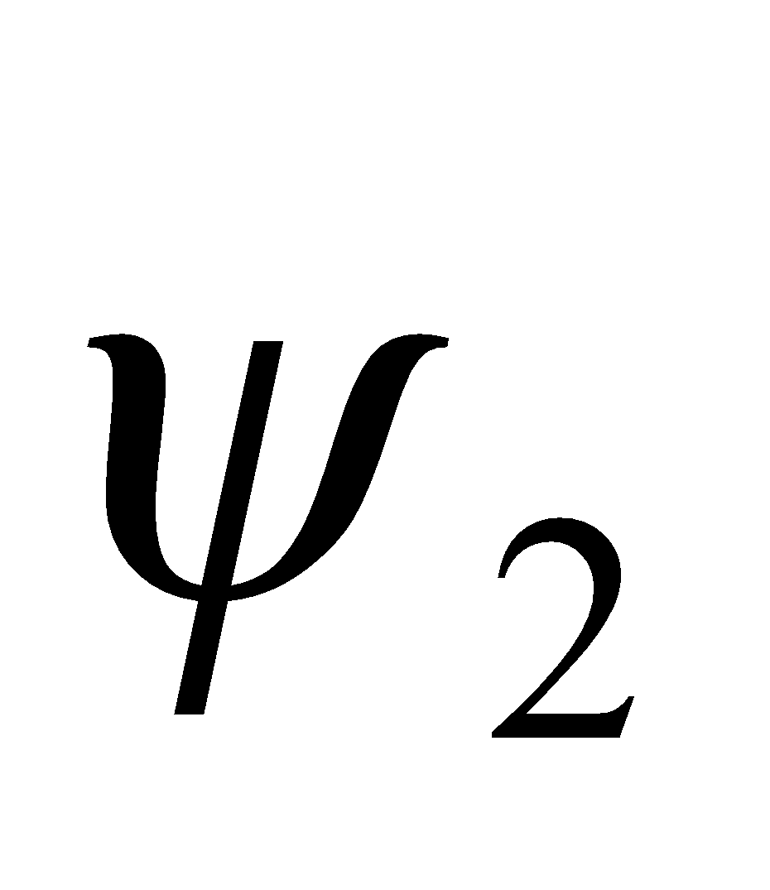 are.
Evaluate Substituting 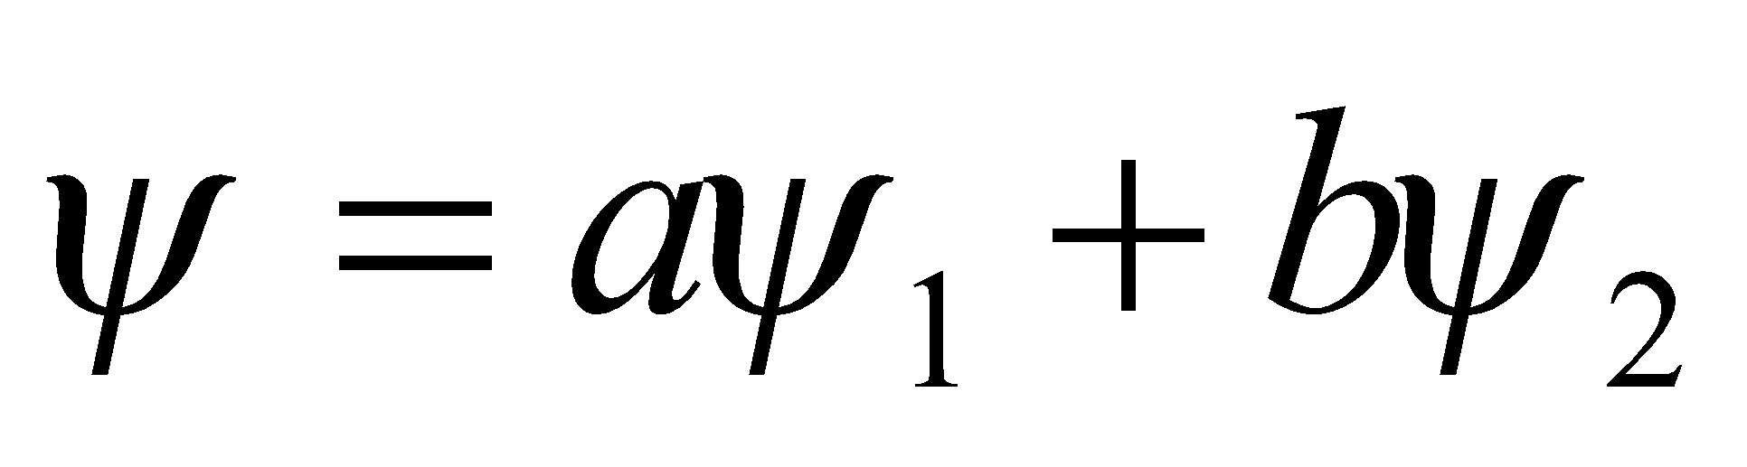 into the Schrödinger equation gives
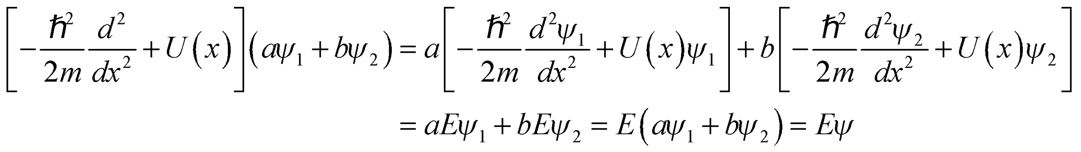
Assess The Schrödinger equation is a linear differential equation. Therefore, the result follows directly from the superposition principle.
32. Interpret This problem involves an electron trapped in an infinite potential well. We are to find the transition energies associated with the given transitions.
Develop From Equation 35.5, we see that the transition energies are
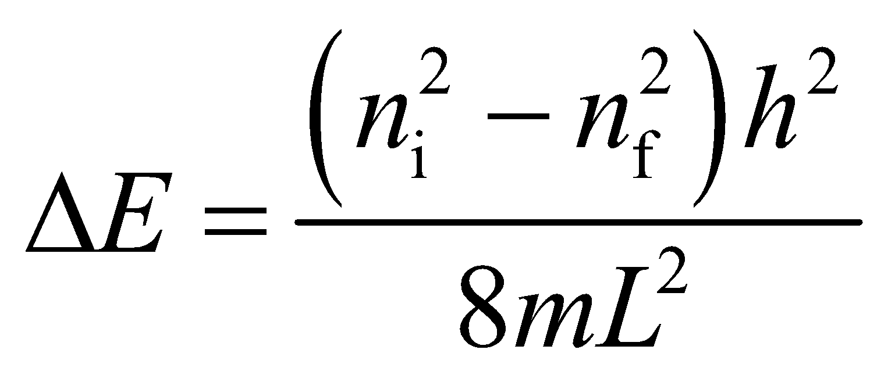
and the wavelengths of the corresponding photons are
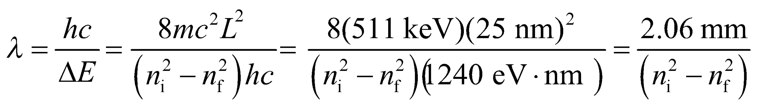
Evaluate To two significant figures, we find:
(a) For n_{i} = 2 and n_{f} = 1, λ = 0.690 mm.
(b) For n_{i} = 20 and n_{f} = 19, λ = 53 μm.
(c) For n_{i} = 100 and n_{f} = 1, λ = 210 nm.
Assess These wavelengths range from the ultraviolet to the far infrared to the microwave portion of the electromagnetic spectrum.
33. Interpret We are to find the energy and wavelength of the photon emitted as an electron trapped in an infinite square well makes a transition to the adjacent energy level.
Develop The energy levels for an infinite square potential well are given by Equation 35.5:
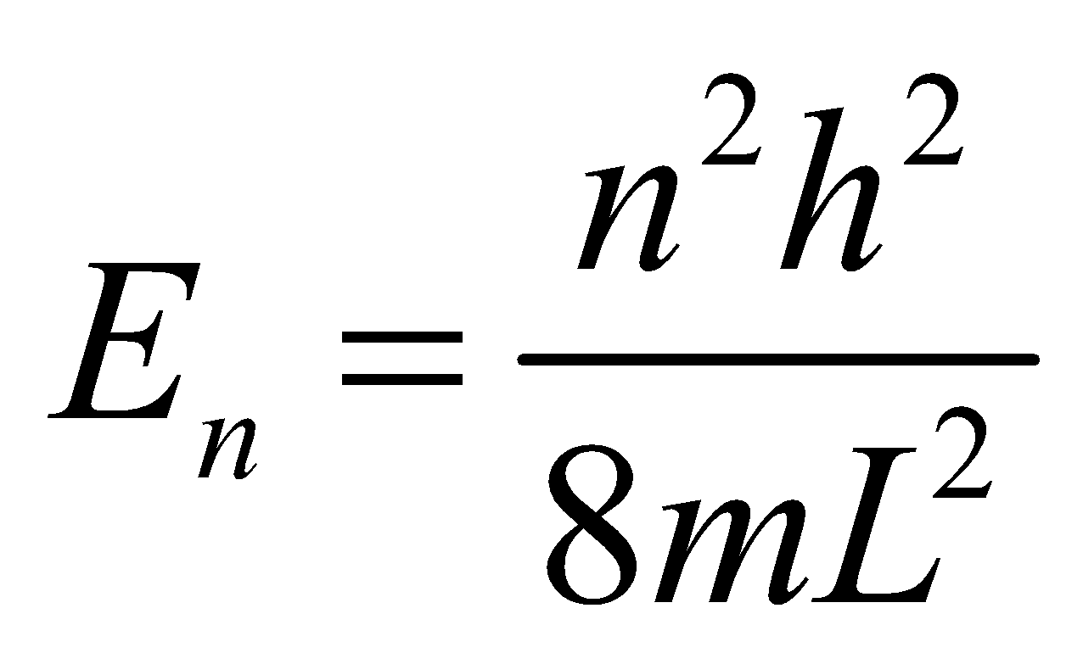
Thus, the energy of the photon emitted when the electron drops from n_{i} to n_{f} < n_{i} is
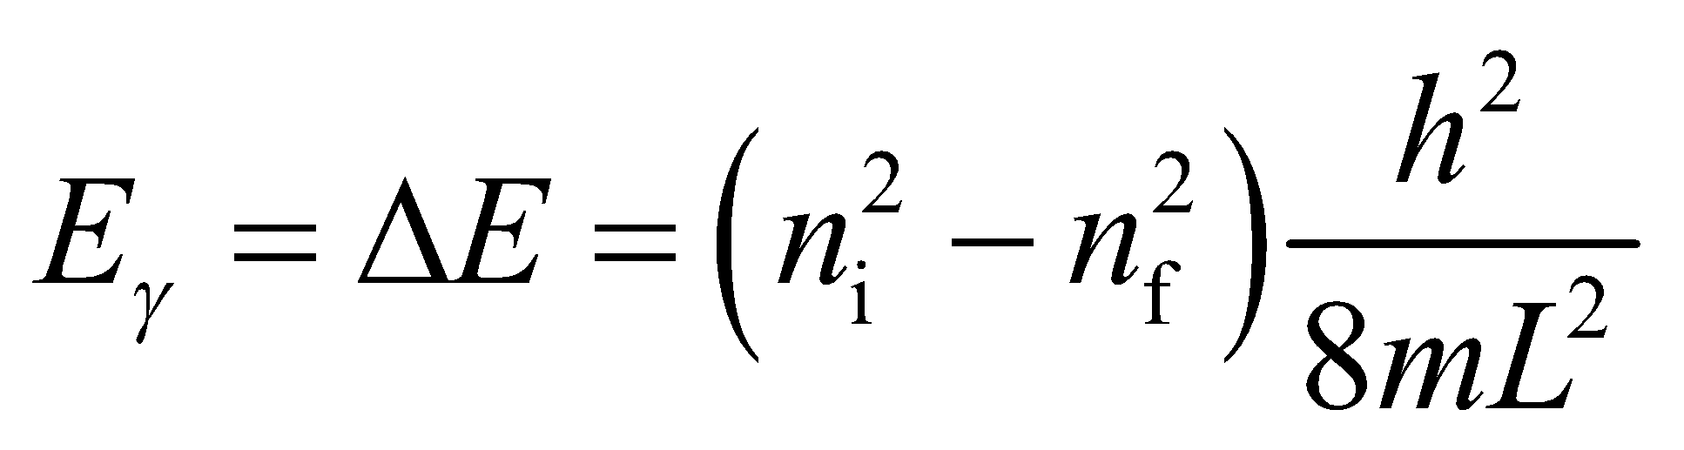
From Equation 34.6, the wavelength of the photon is 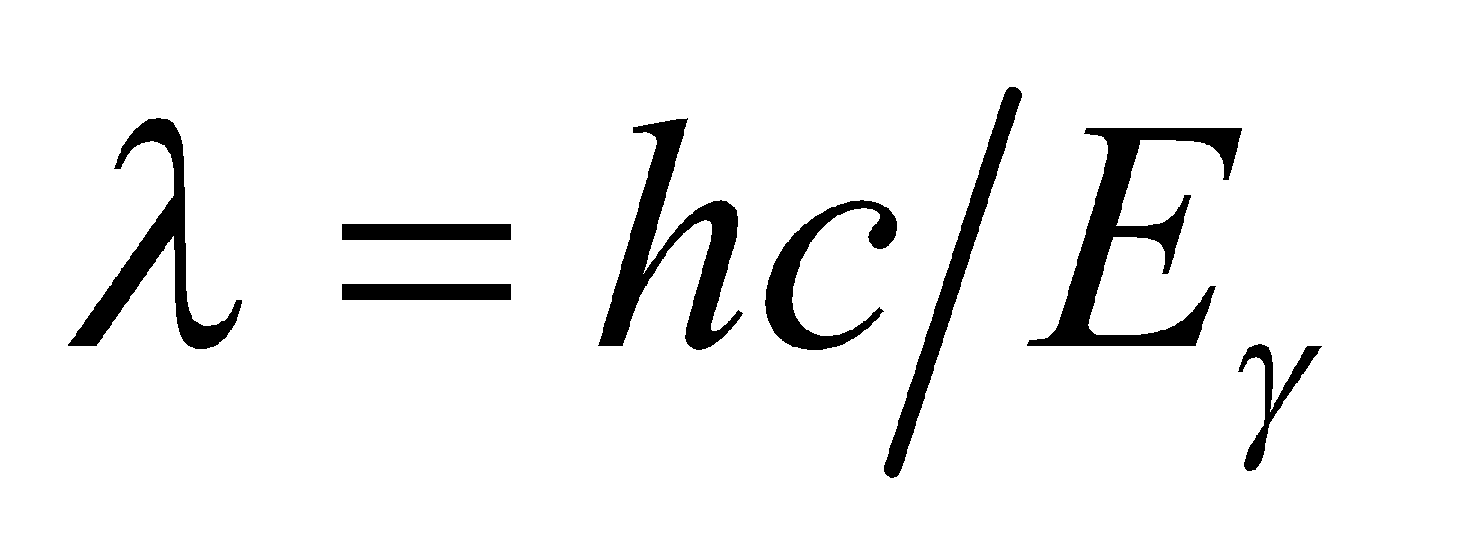.
Evaluate (a) Substituting the values given, we find
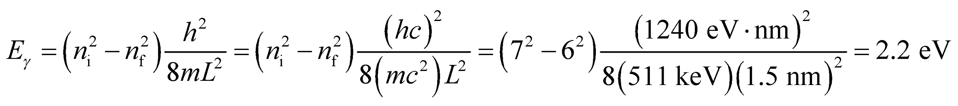
(b) The wavelength of the photon is
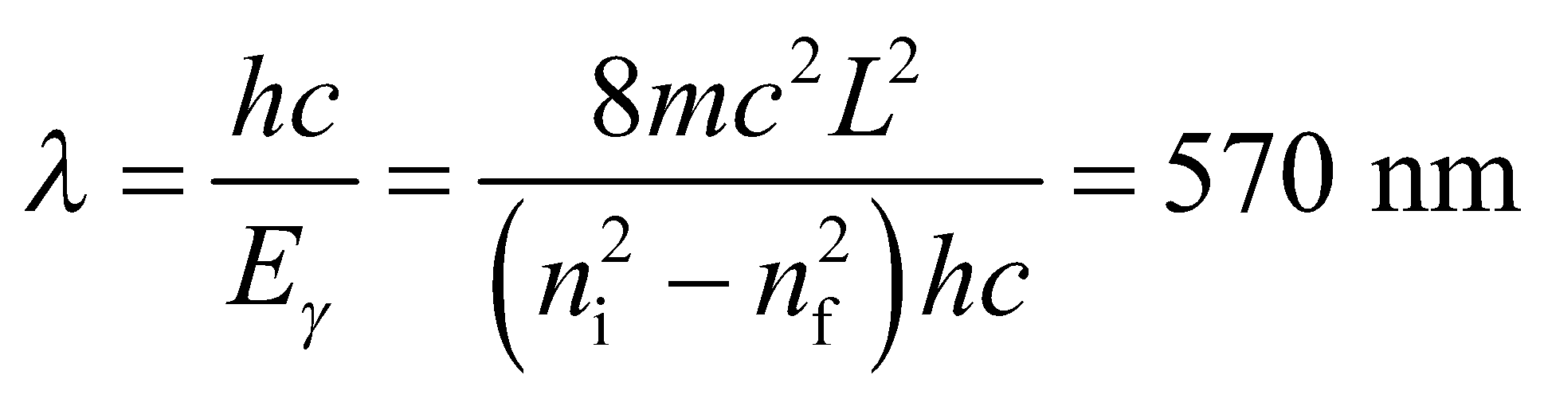
to two significant figures.
Assess The wavelength is in the visible region of the electromagnetic spectrum.
34. Interpret This problem demonstrates an aspect of the correspondence principle; namely, that as quantum numbers become arbitrarily large, the quantum nature is lost and is replaced by the continuous nature of classical physics.
Develop From Equation 35.5, we see that the difference between adjacent levels in an infinite square well is
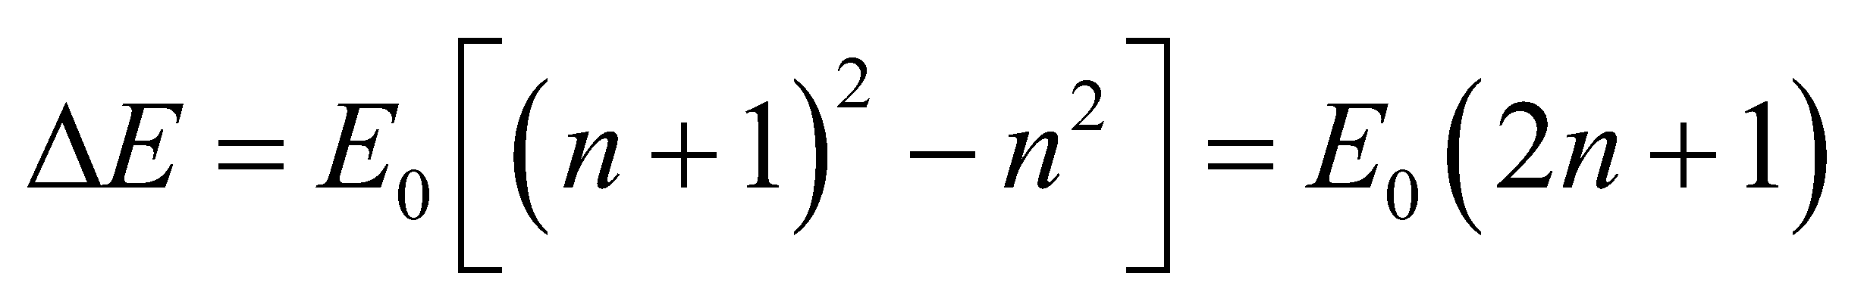
so we can form the ratio between ΔE and E_{n+1} and take the limit as 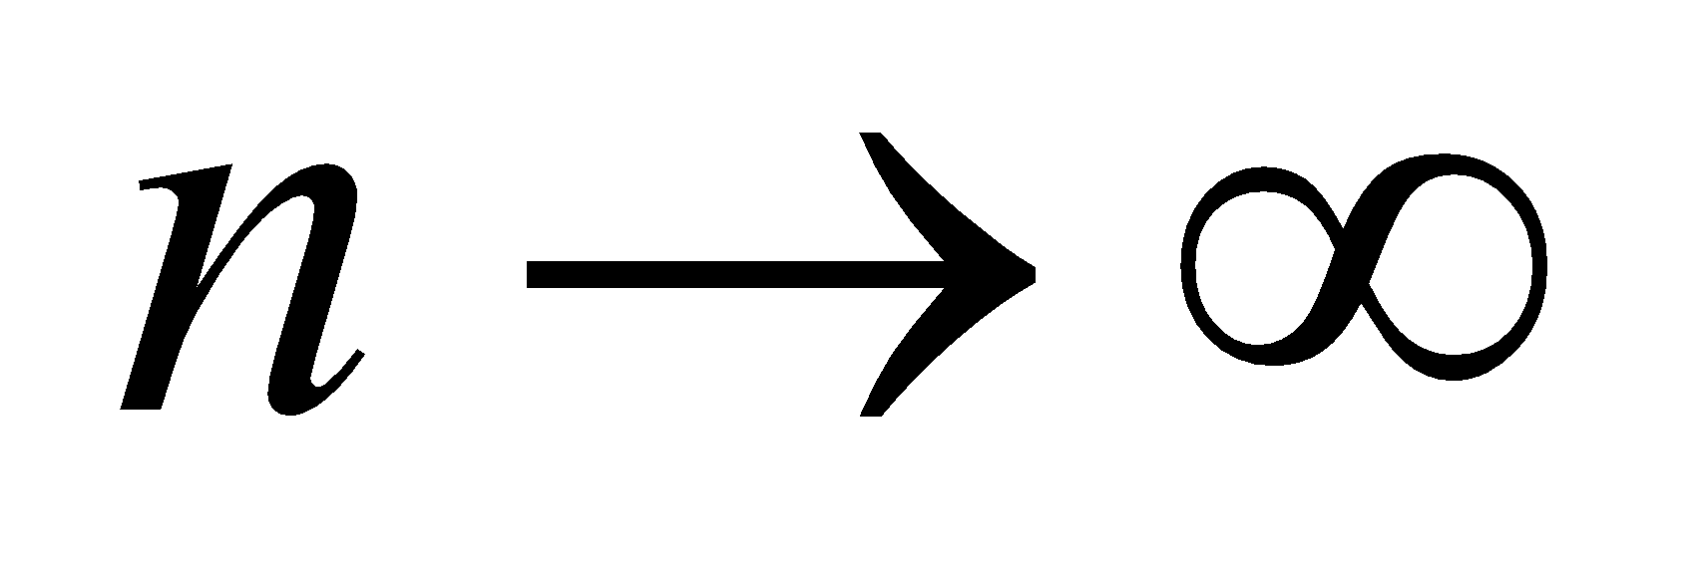.
Evaluate Comparing ΔE to the original energy level E_{n+1} and letting n go to infinity gives
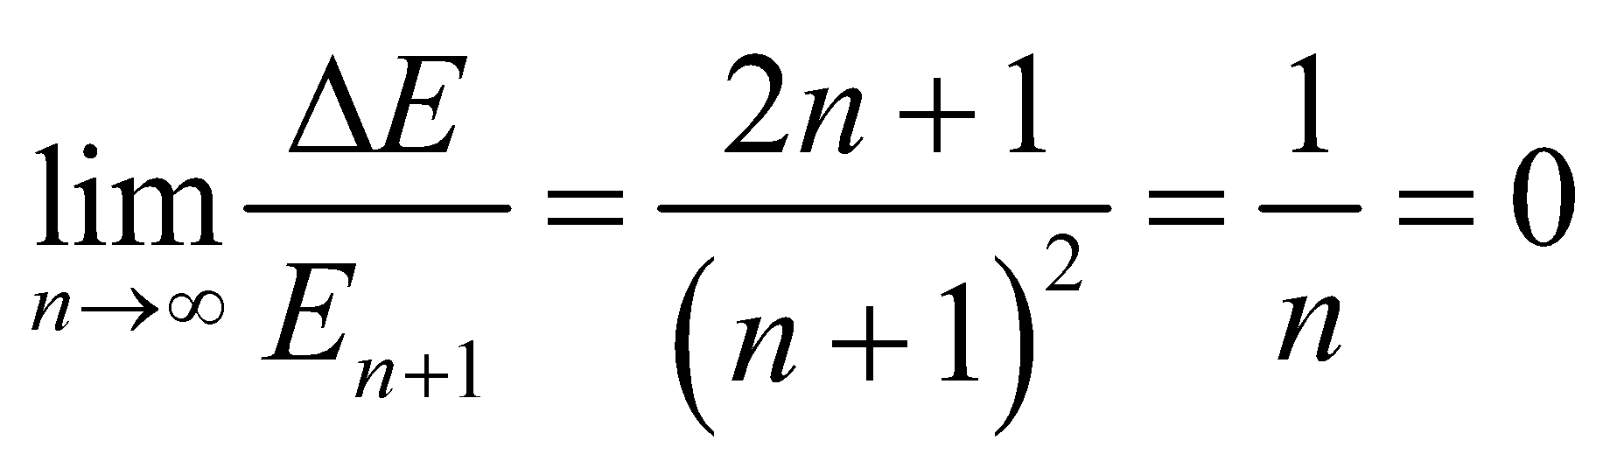
so the energy different ΔE is zero.
Assess Thus, we have found that the possible energy levels form a continuum of states in the classical limit, in accordance with the correspondence principle.
35. Interpret An electron trapped in the given one-dimensional potential well must absorb a photon in order to make a transition from the ground state to an excited state. We want to know the maximum wavelength associated with this transition.
Develop Equation 35.5 describes the allowed energy states for a particle trapped in a one-dimensional potential well. The allowed quantum numbers n are n = 1, 2, 3, …, so the smallest transition energy is to the first excited state (i.e., n = 1 to n = 2). The energy difference may be found from inserting these quantum numbers into Equation 35.5: so
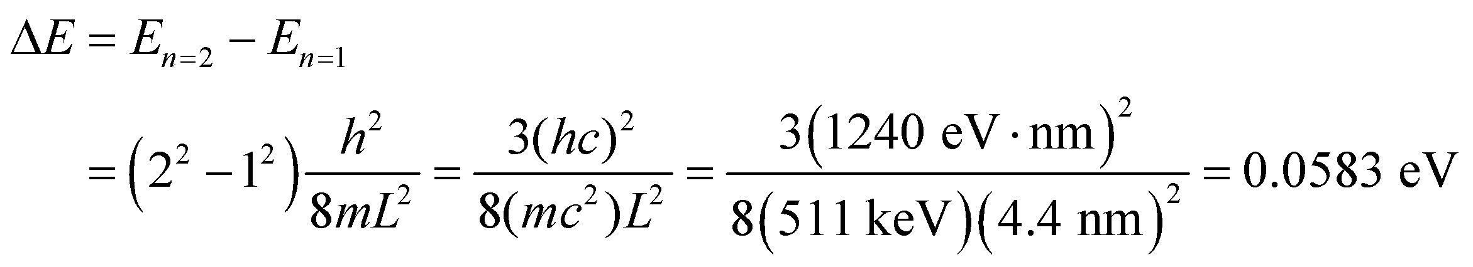
The wavelength that corresponds to this energy is (see Equation 34.6) E_{γ} = hf = hc/λ. Because of the inverse relationship between wavelength and energy, the smallest energy corresponds to the largest wavelength. Therefore, the maximum wavelength that can cause a transition is
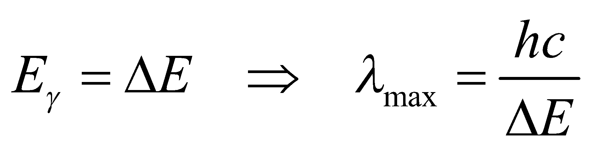
Evaluate Thus, the maximum wavelength that can be absorbed is
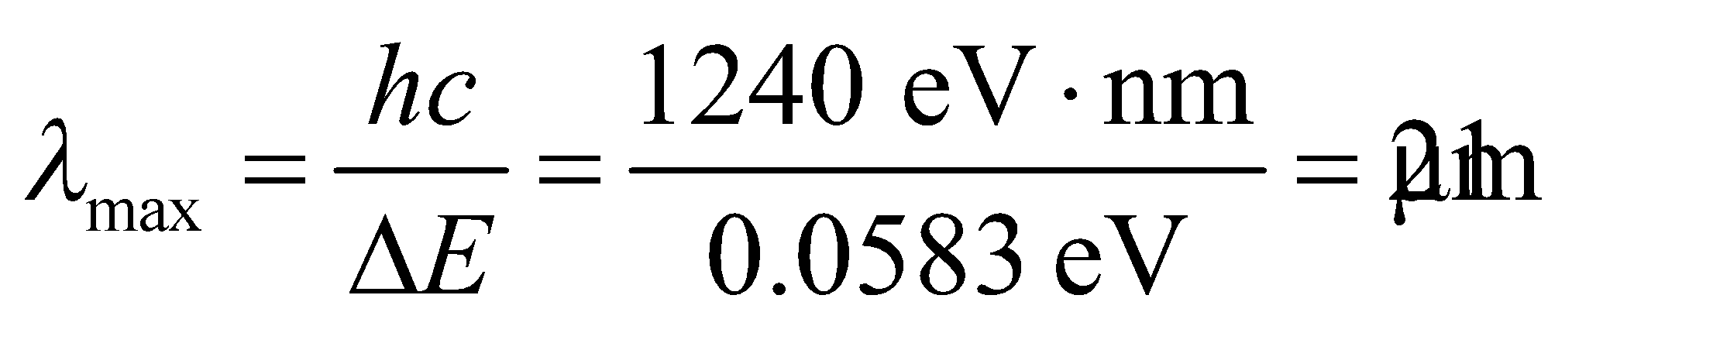
Assess The wavelength corresponds to the infrared region of the electromagnetic spectrum.
36. Interpret We are to compare the widths of two infinite square potential wells given the ratio of their ground-state energies.
Develop Equation 35.5 shows that the energy of a one-dimensional infinite square well is given by
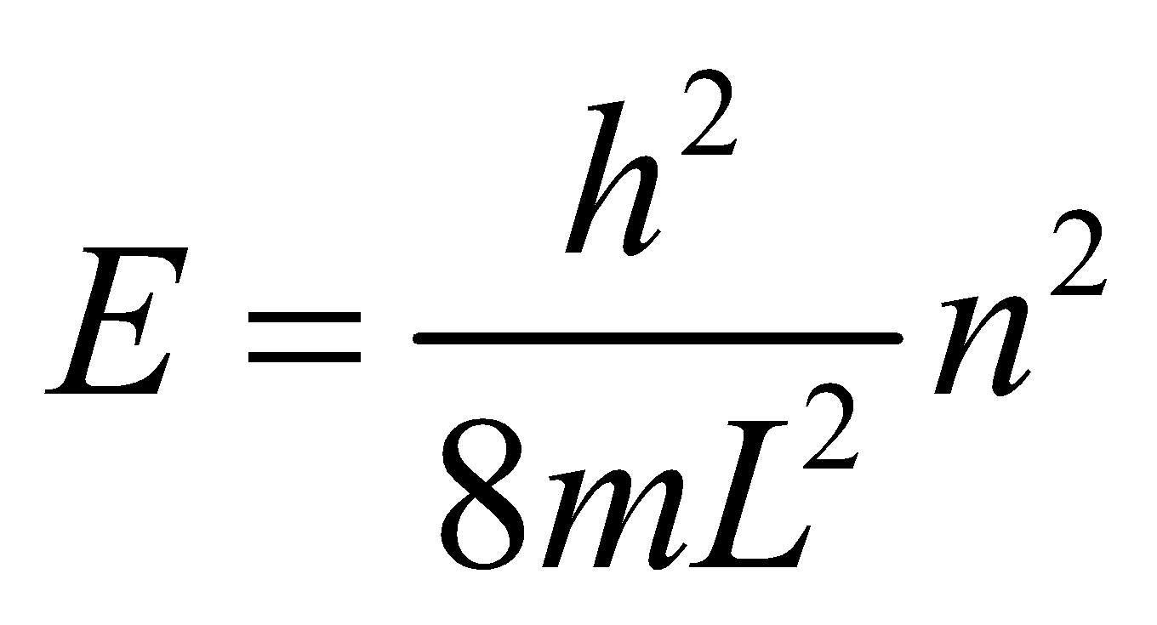
The ground state corresponds to n = 1 and the first excited state to n = 2. We are given that 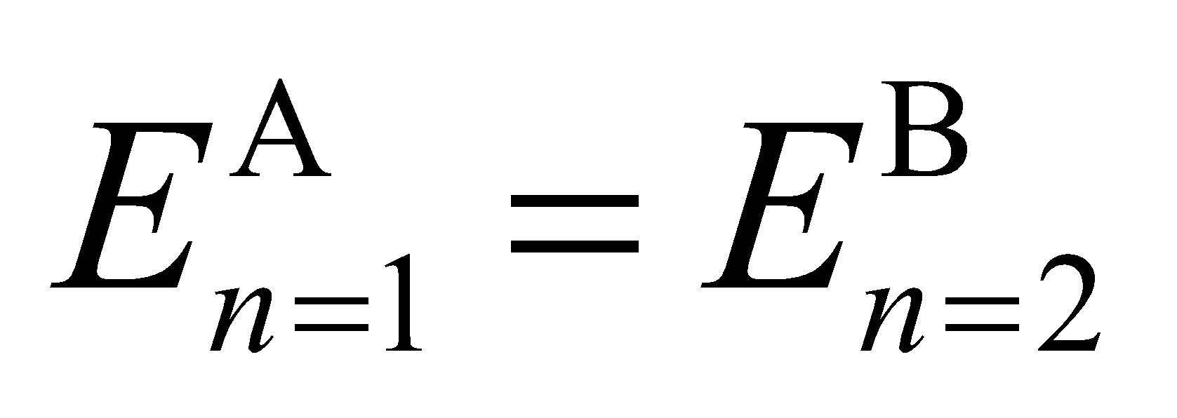, so we can find the ratio of the well widths.
Evaluate With 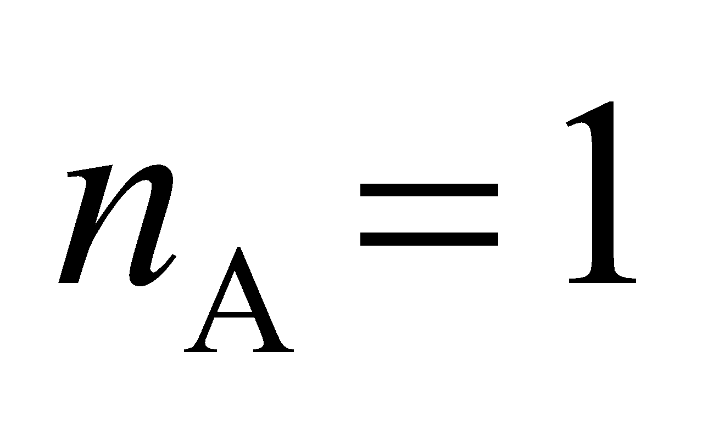 and 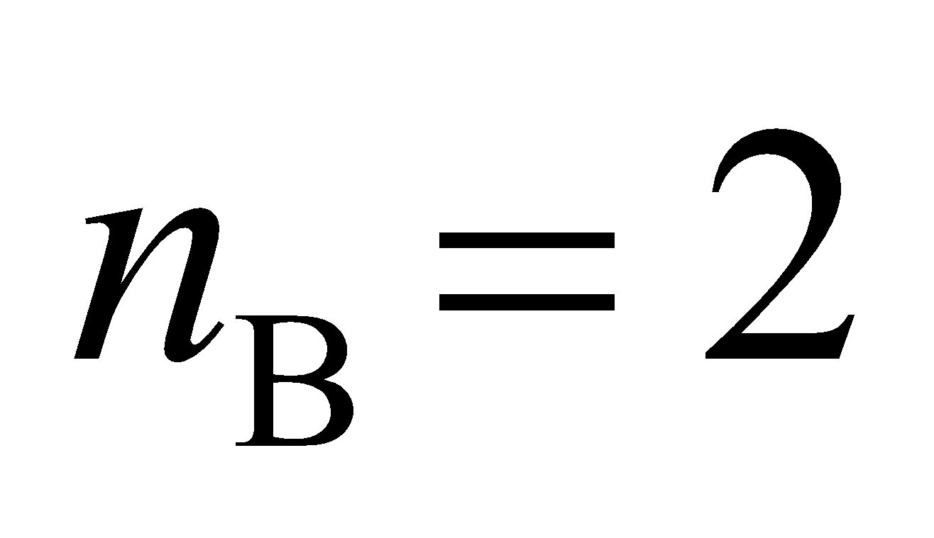,
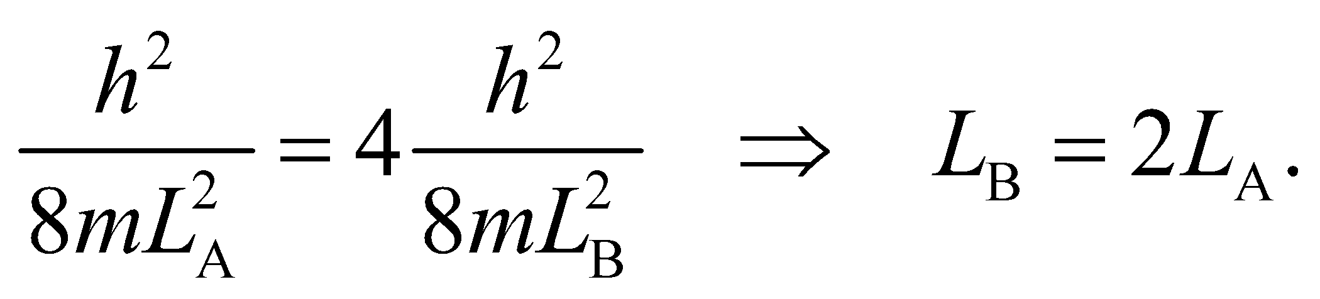
Assess The result of this depends on the dimensionality of the square well. For three dimensions, the result is 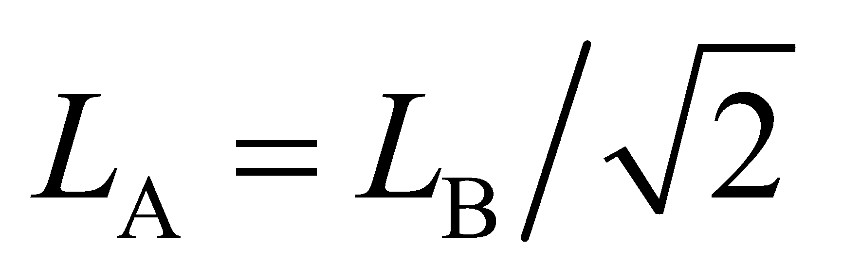.
37. Interpret There are various ways for the electron which is initially in the n = 4 state to make a transition to the ground state. We want to find the wavelengths associated with all possible spectral lines in this process.
Develop The energy levels for a one-dimensional infinite square potential well are given by Equation 35.5:
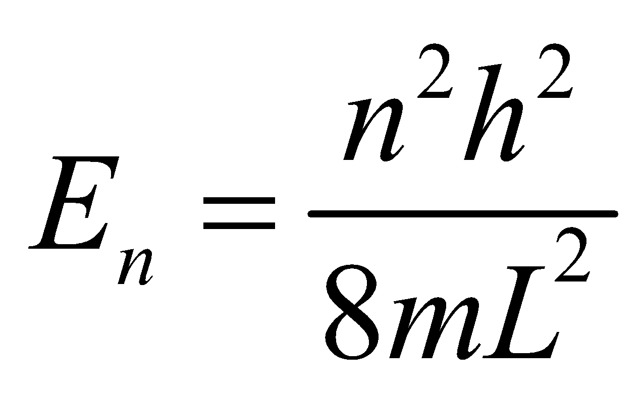
Thus, the energy of the photon emitted when the electron drops from n_{i} to n_{f} < n_{i} is
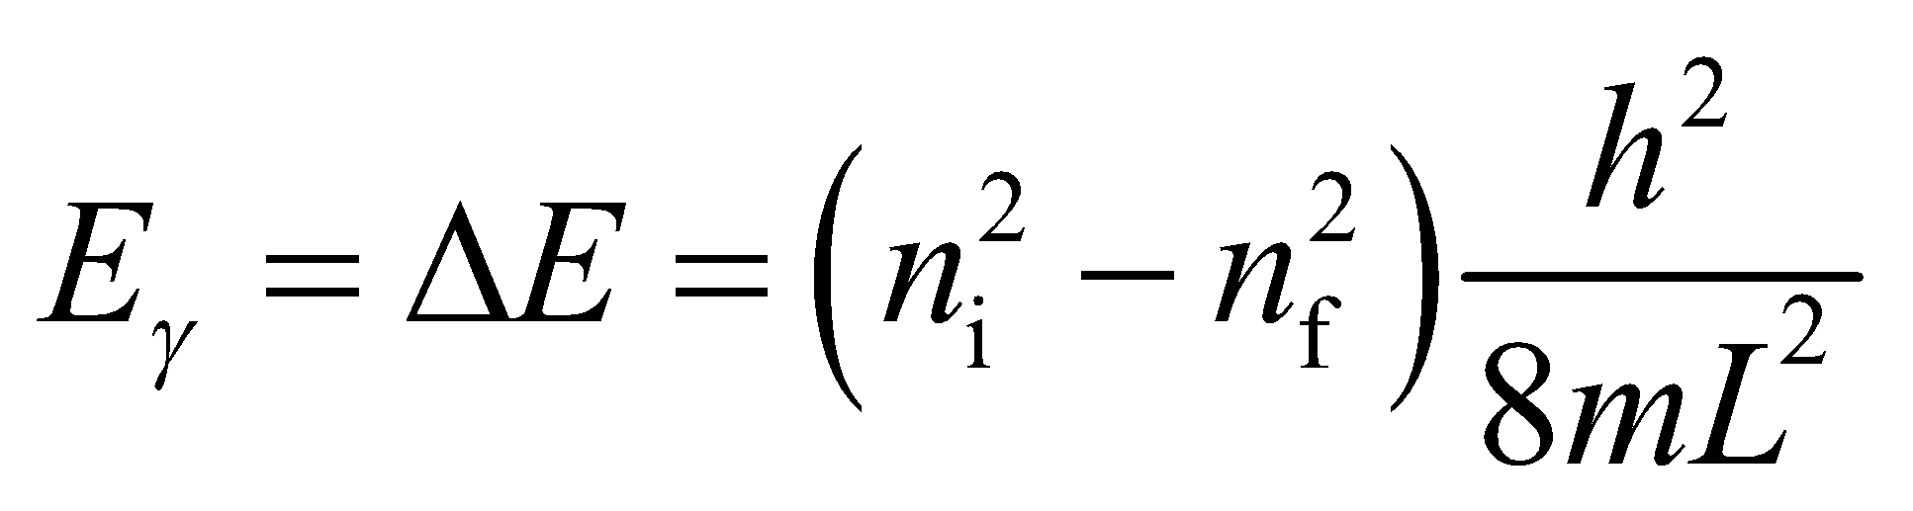
From Equation 34.6, we know that the corresponding photon wavelengths are
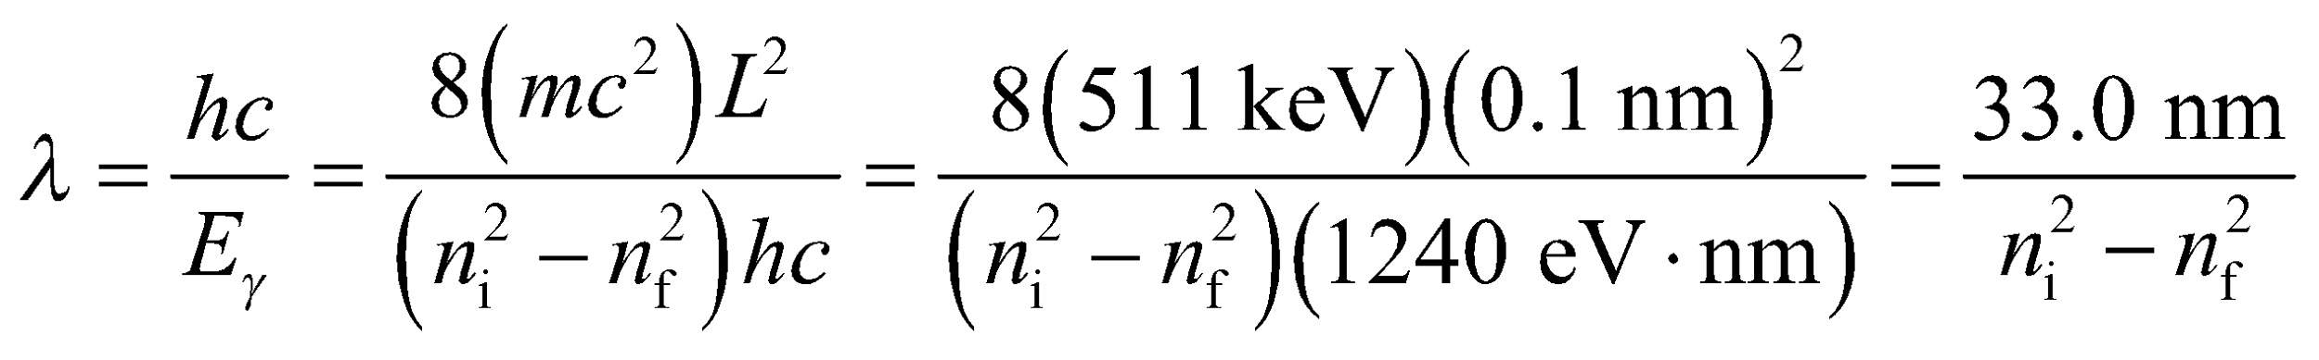
Evaluate Starting from the n = 4 state, the possible transitions to the ground state are 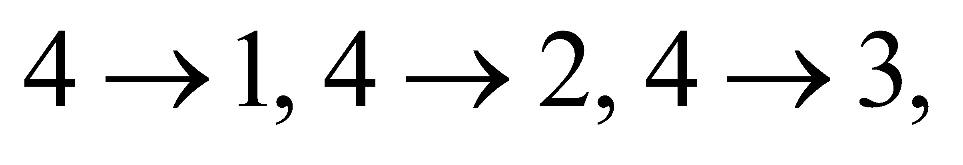
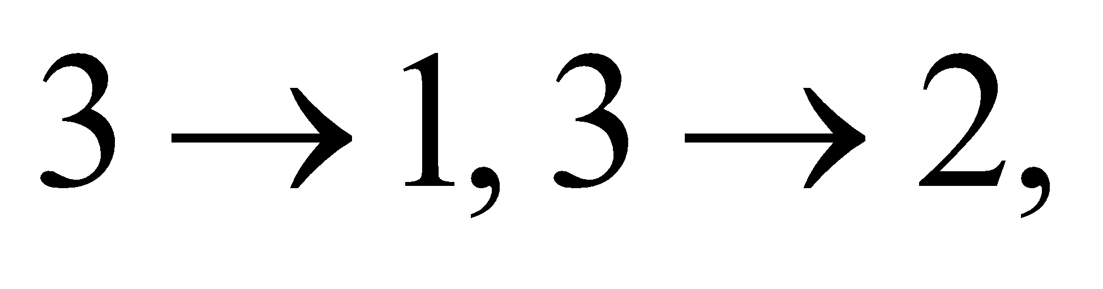 and 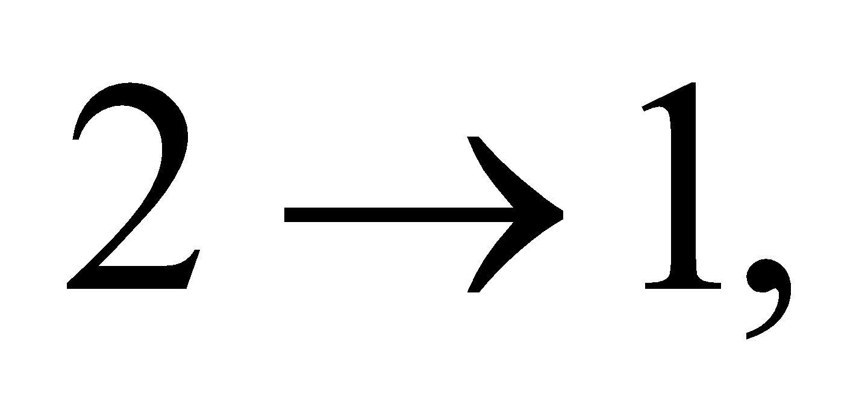 with corresponding wavelengths
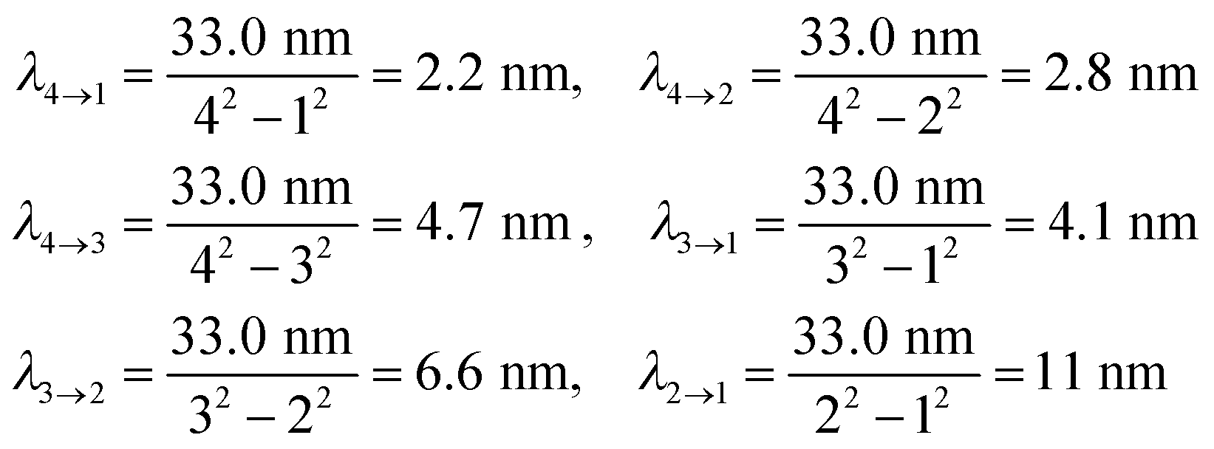
Assess Only photons of these discrete wavelengths will be emitted during the transition from n = 4 to n = 1. The wavelengths correspond to the ultraviolet region of the electromagnetic spectrum.
38. Interpret From the graph of the probability density [i.e., ], we are to determine the most likely position of the particle.
Develop The probability density for the n = 2 state of a one-dimensional infinite square well is 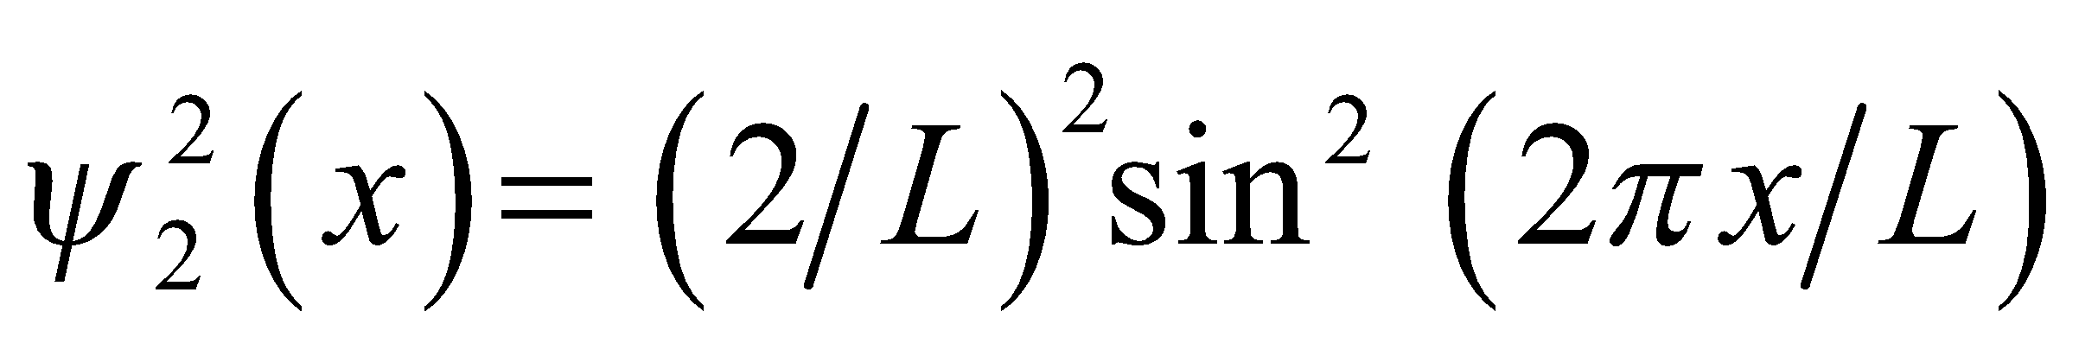 (see Equation 35.6), a graph of which is shown in Fig. 35.8.
Evaluate From Figure 35.8, we see that the highest probability for finding the particle is at x = L/4 and x = 3L/4.
Assess For larger n, the probability for finding the particle becomes equal from x = 0 to x = L (see top panel of Figure 3.58).
39. Interpret We are given a potential that is the same as in Fig. 35.5, except that the origin of coordinates is at the center of the well. We want to find expressions for the normalized wave function for even and odd quantum numbers and the corresponding energy levels.
Develop The wave function for this well can be found by using Equation 35.6 (which is already normalized), but replacing x by 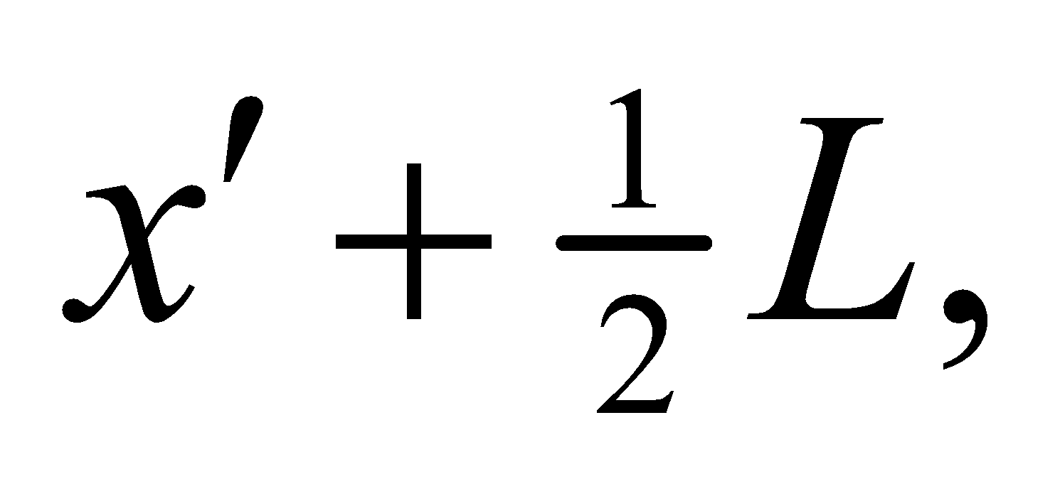 where 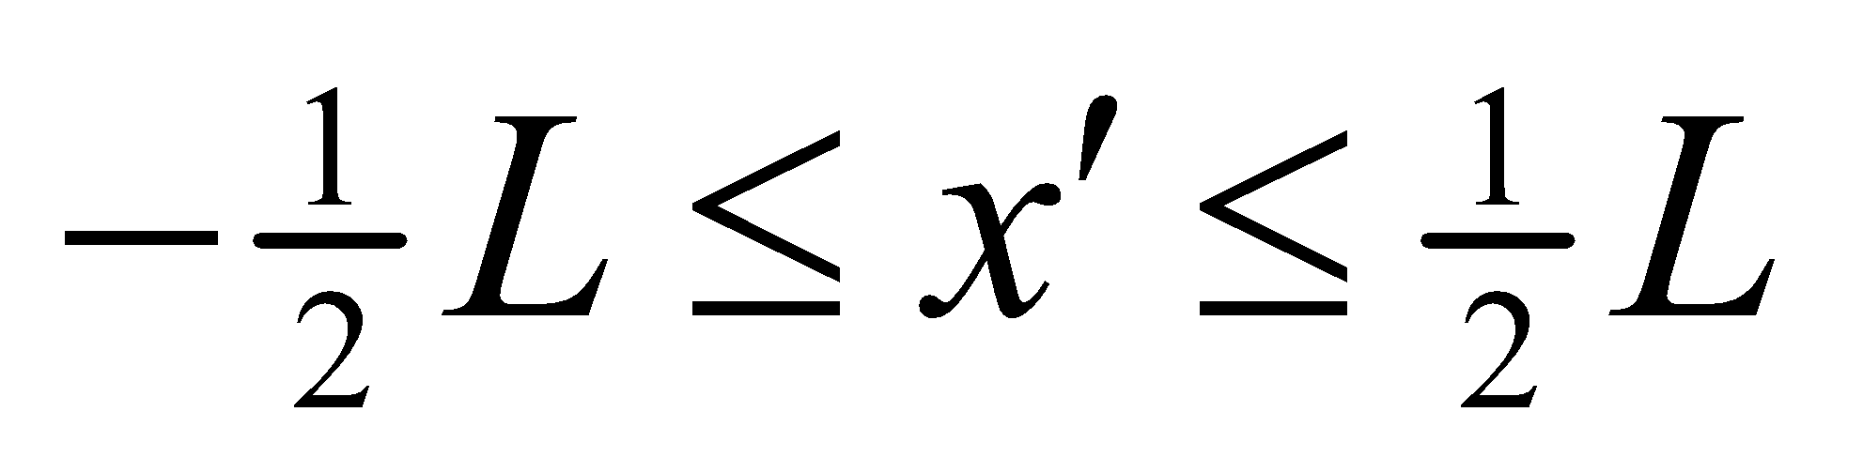. The normalized wave function thus takes the form
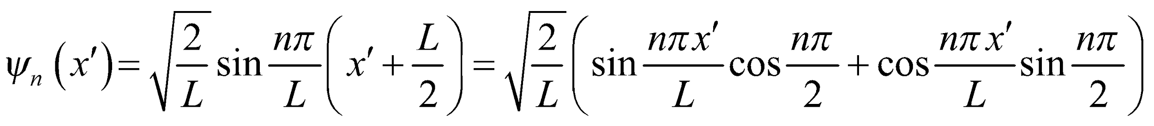
We need to distinguish between even and odd values of n.
Evaluate (a) If n is odd, then 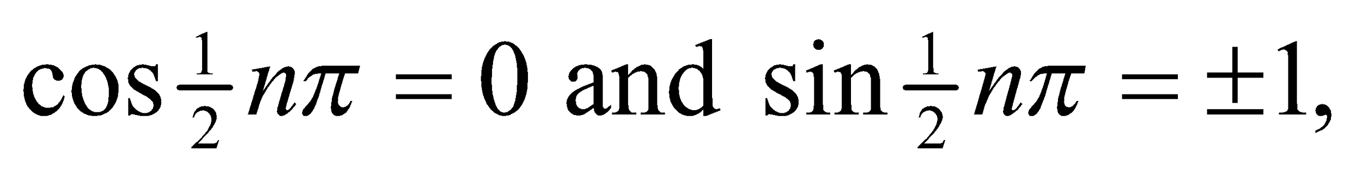 so the wave function is
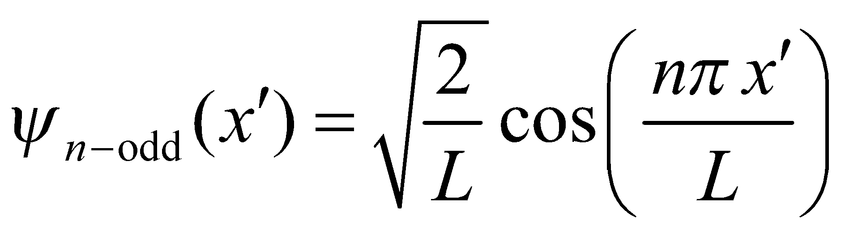
The probability density 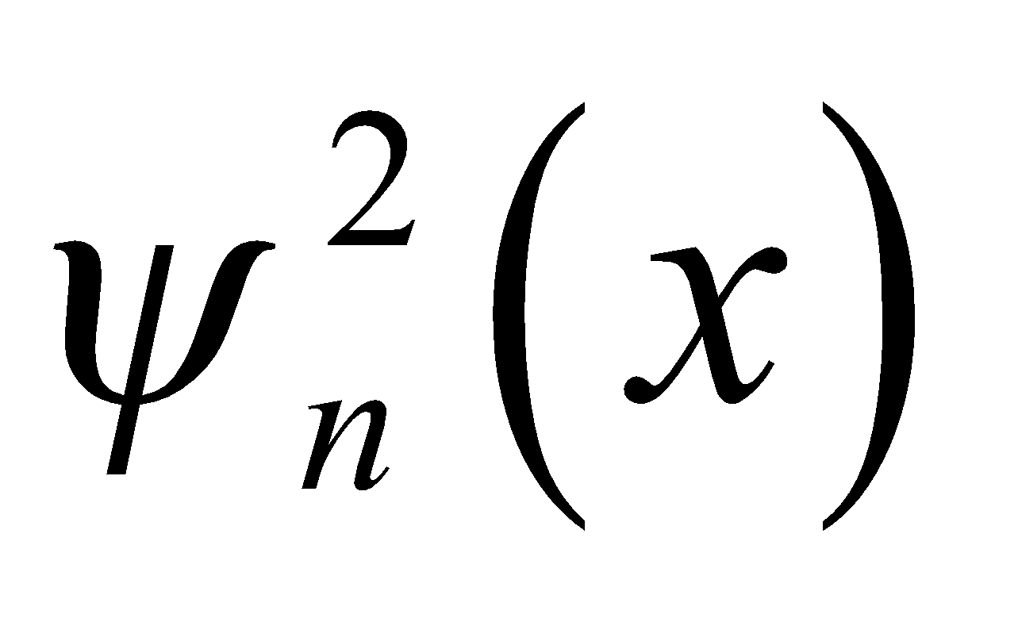 is unaffected by the overall sign of 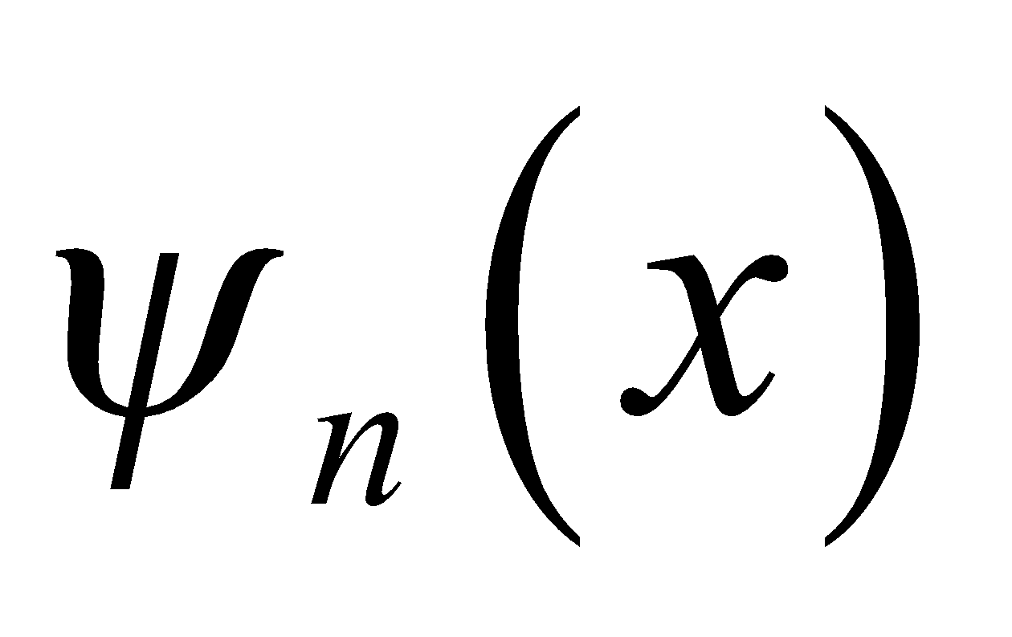, so we choose the sign to be positive. If n is even, then 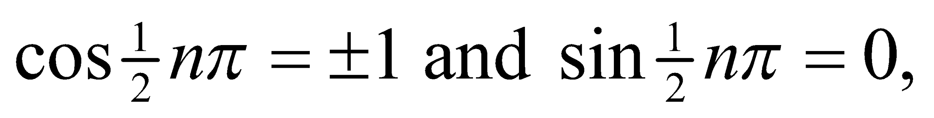 and the wave function is
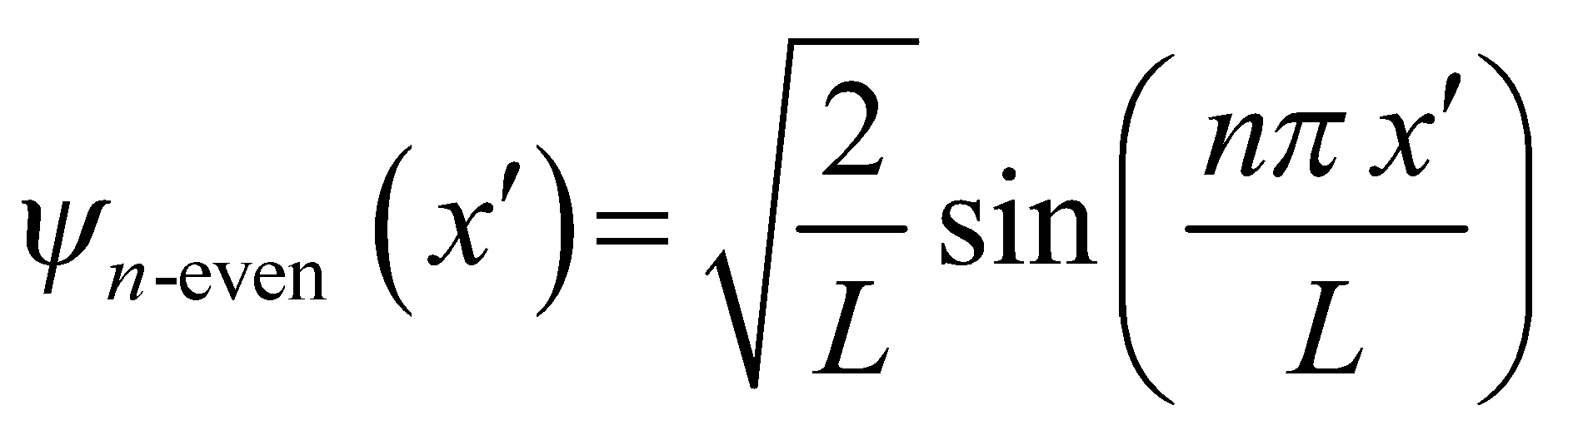
(b) The energy levels are the same, 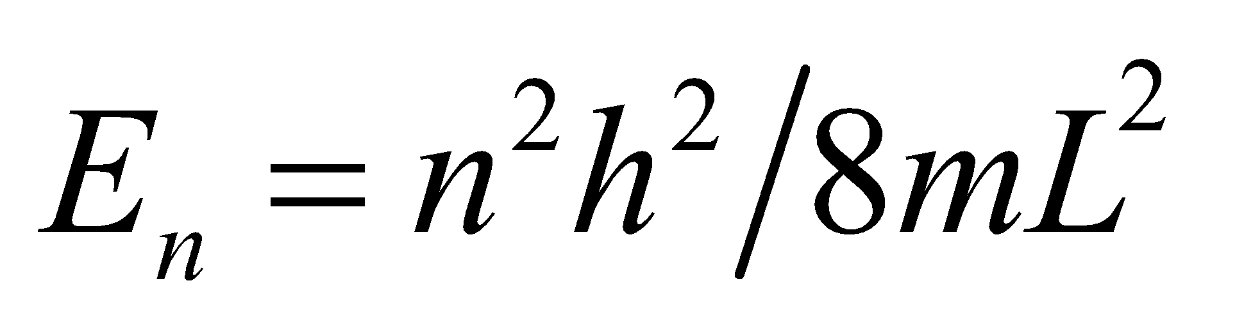 regardless of how the potential is parameterized.
Assess These results can be confirmed by direct solution of the Schrödinger equation. For 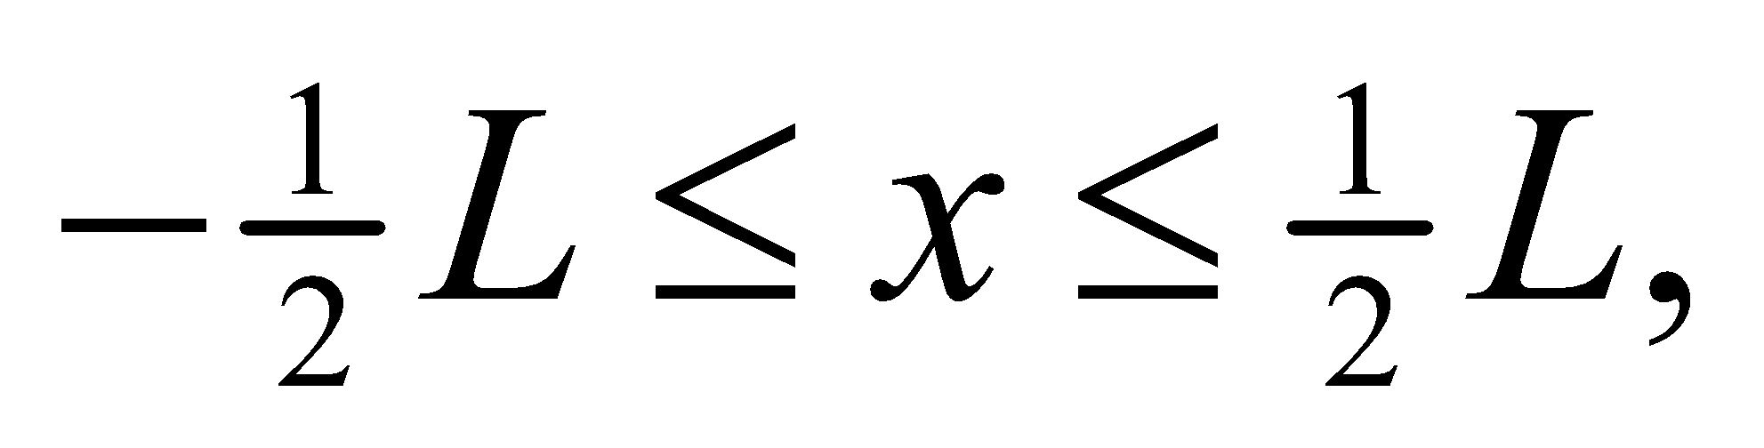 Equation 35.4 has two solutions: 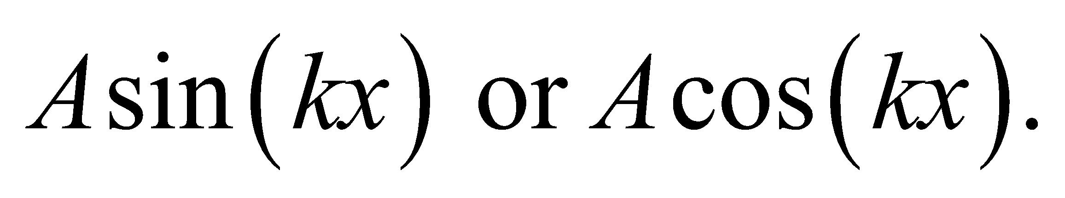 In order for ψ to vanish at 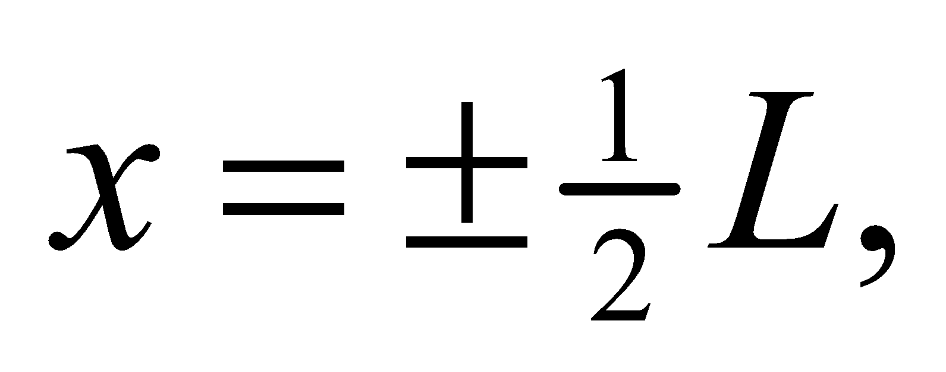 one must use the cosine solution for odd quantum numbers [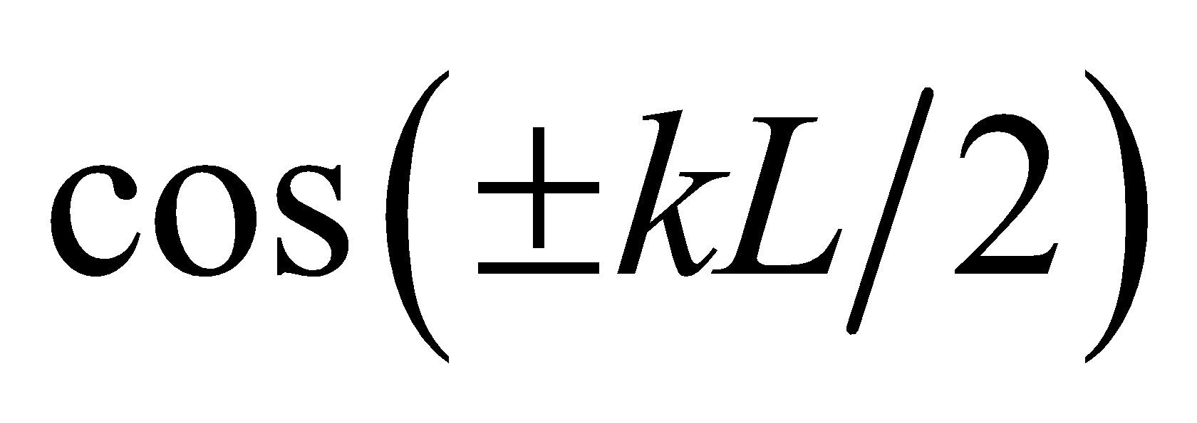] vanishes for kL equal to odd multiples of π and the sine solution for even quantum numbers [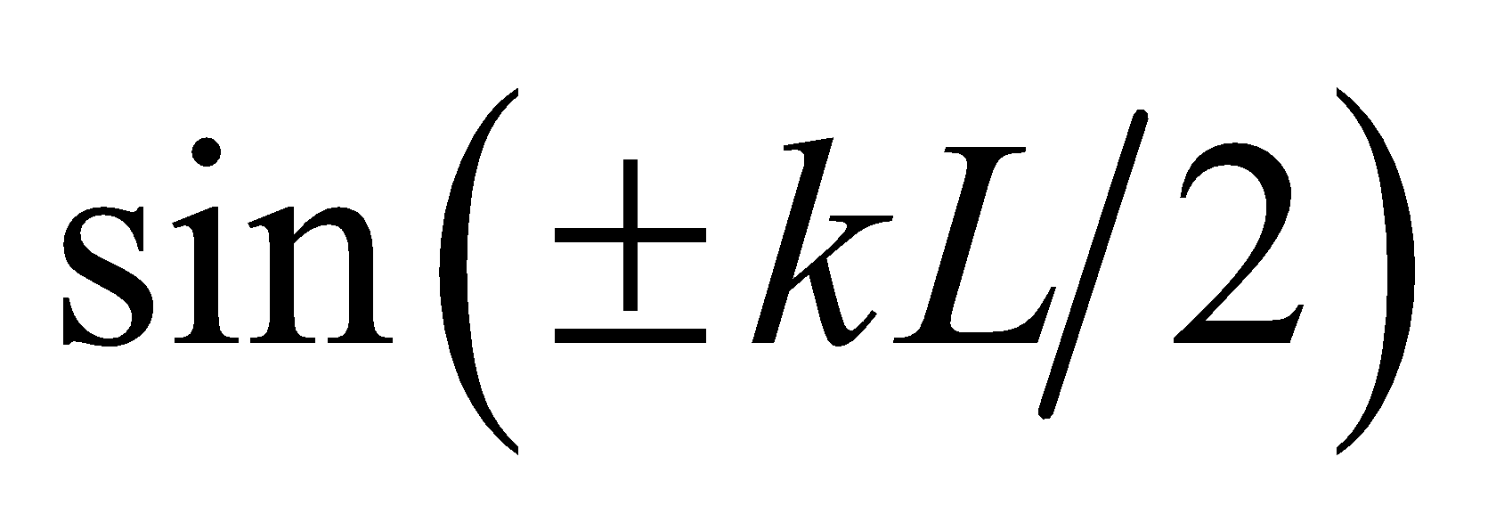] vanishes for kL equal to even multiples of π. Since the average of sin² or cos² over an integer number of half-cycles is ½, the normalization constant is 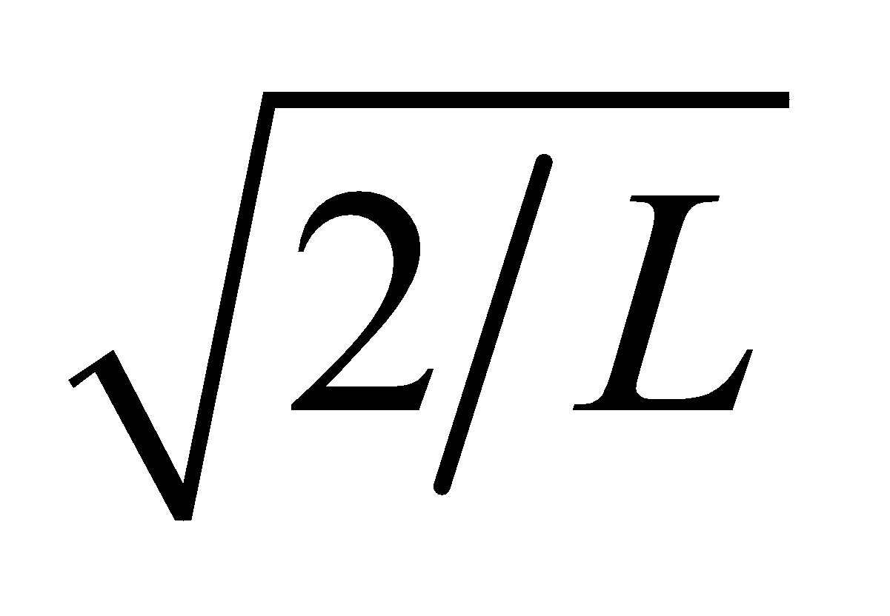for either wave function (or use integrals in Appendix A). Note that these wave functions have even or odd parity about the center of the potential well (see Section 39.2).
40. Interpret We are given a particle in a one-dimensional infinite square well, and we are to find the probability that it is located in the left-hand third of the well.
Develop The ground-state wave function for an infinite square well is 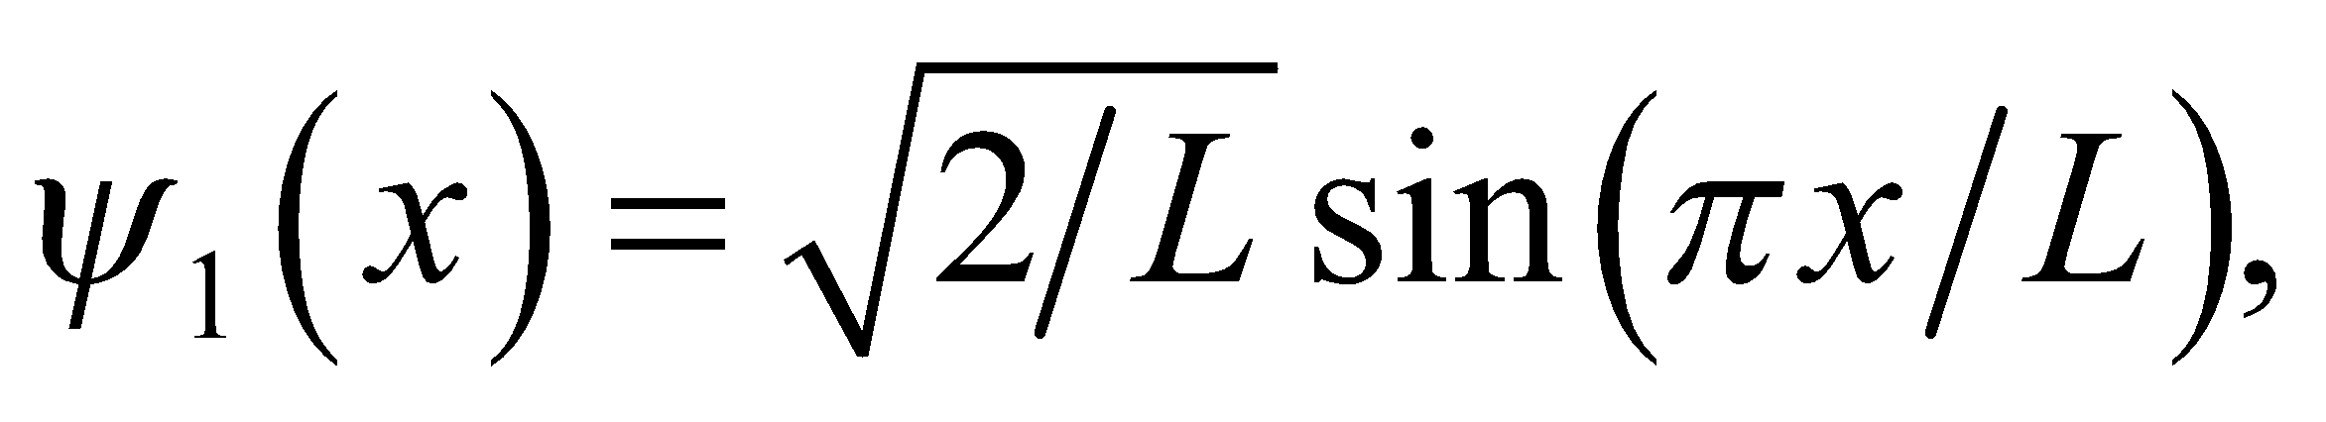 and the left-hand third of the well extends from x = 0 to x = L/3. The probability of finding the particle in this interval is (see Example 35.2):
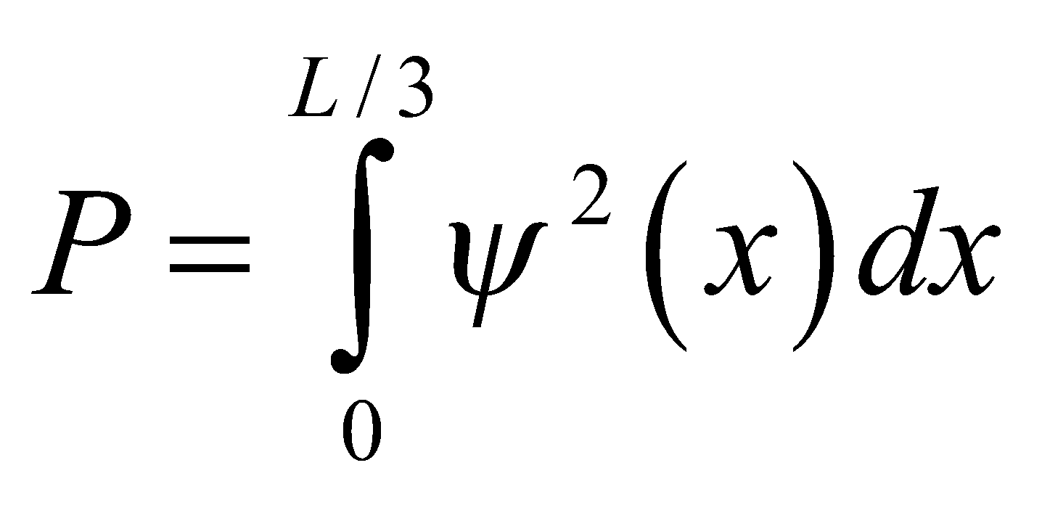
Evaluate Evaluating the integral gives
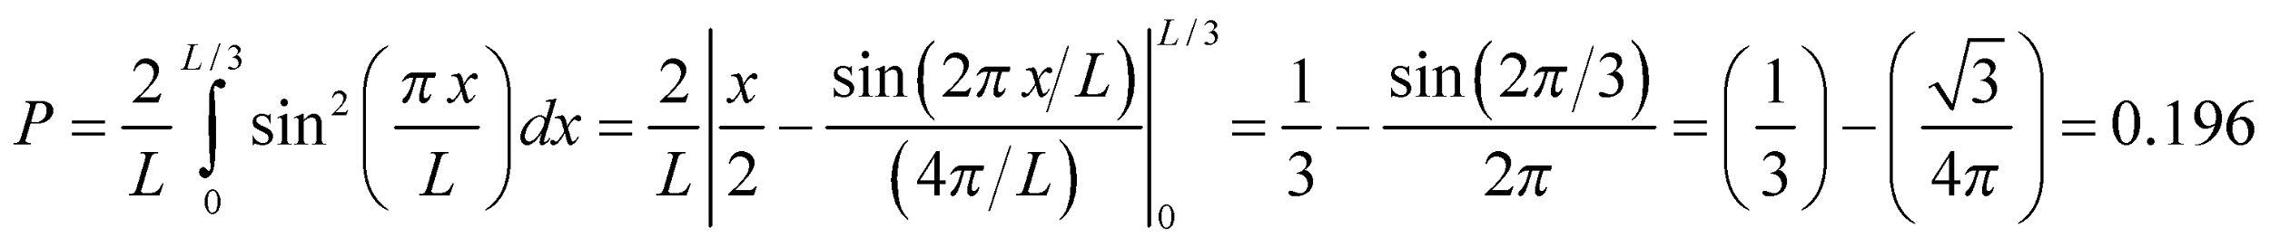
Assess Because the function is even, the probability for finding the particle in the right-hand one third of the well is also 0.196.
41. Interpret We’re given the energy of the photon emitted in a transition between adjacent quantum states and asked to find the width of the one-dimensional infinite potential well.
Develop The energy levels for a one-dimensional infinite square potential well are given by Equation 35.5:
Thus, the energy of the photon emitted when the electron drops from n_{i} to n_{f} < n_{i} is
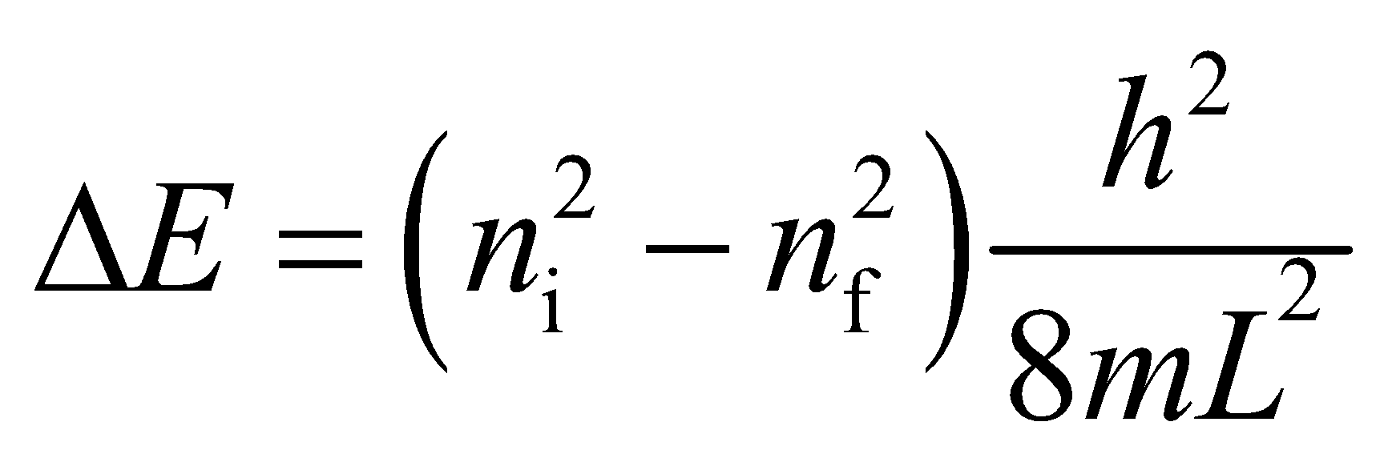
Evaluate From the above equation, the energy difference between n_{i} = 2 and n_{f} = 1 is 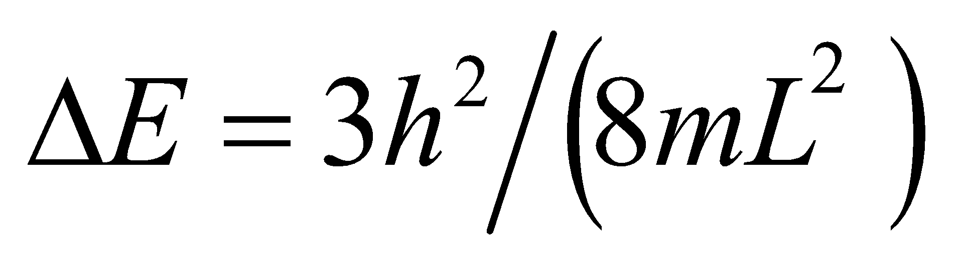, so the width of the potential well is
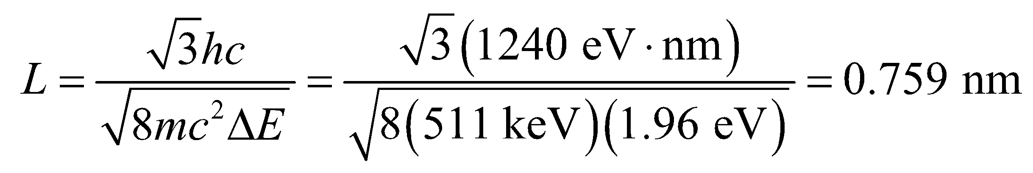
Assess The result is consistent with the typical quantum well width (about the size of an atom).
42. Interpret This problem involves a particle in a one-dimensional infinite square potential well. We are to find the probability of finding the particle in the middle 80% of the well.
Develop From the derivation of Equation 35.5, we see that the ground-state wave function is
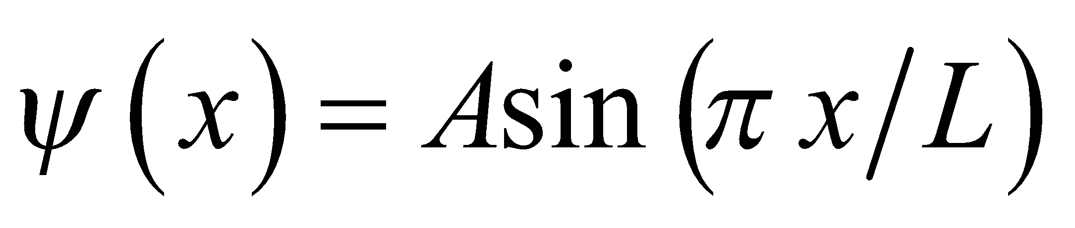
Because the particle must be somewhere, we know that
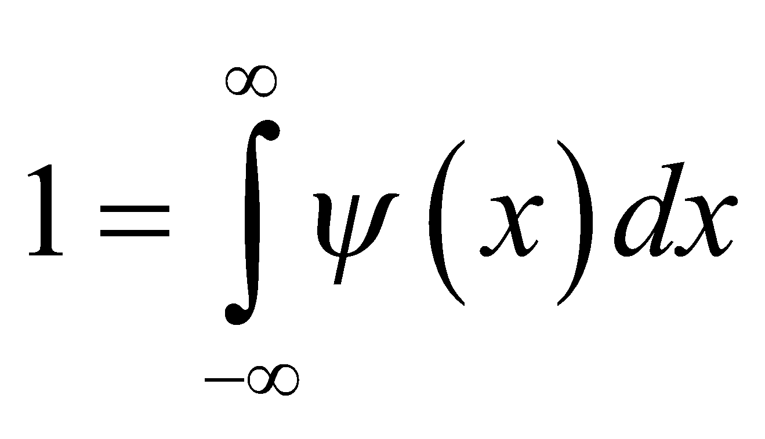
which allows us to find the constant A. The result is
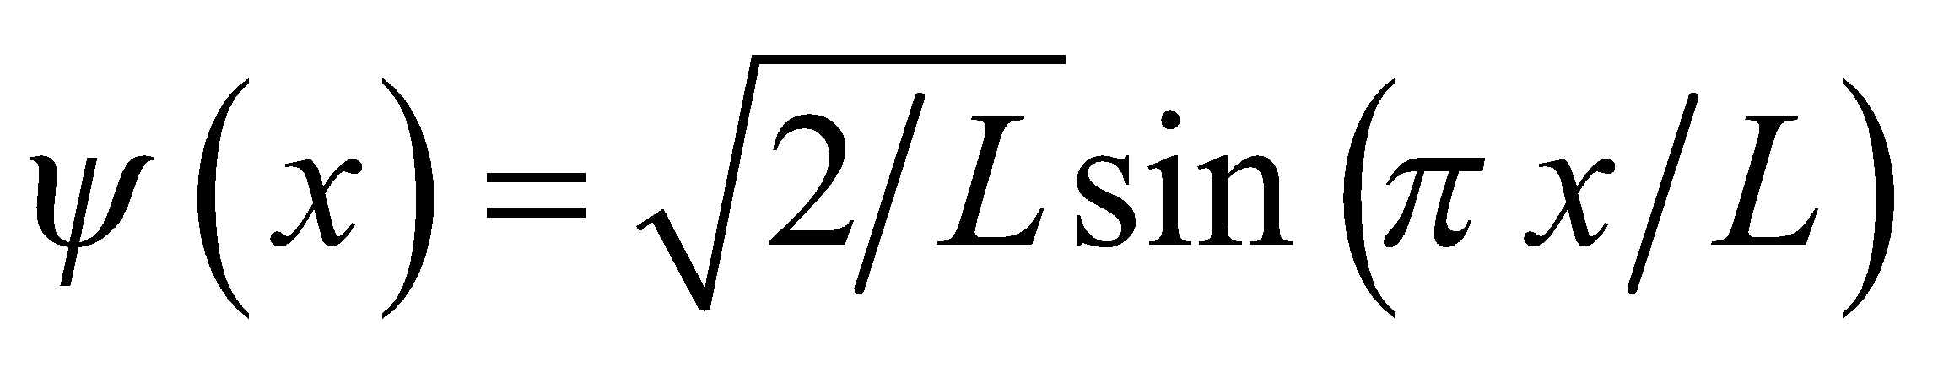
so the probability of finding the particle in the central 80% of the well 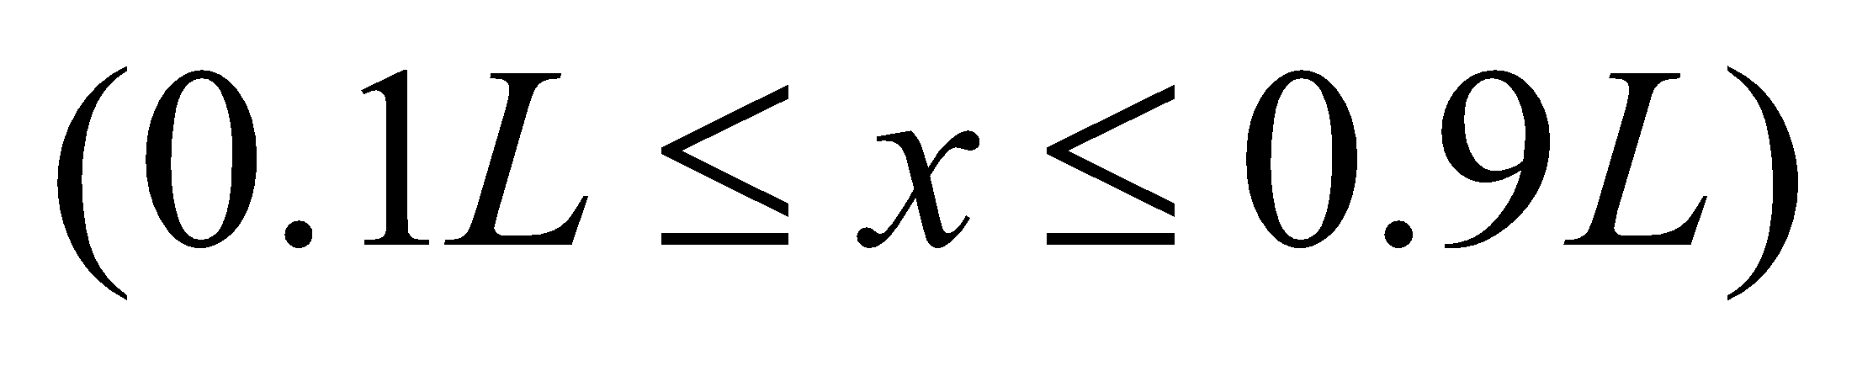 is found, as in Example 35.2, by integrating the wave function squared from 0.1L to 0.9L.
Evaluate Performing the integration gives
Assess The probability of finding the particle in either the left- or right-hand 5% of the well is 0.050.
43. Interpret The problem asks if quantum mechanics should be considered for macromolecules trapped inside a biological cell.
Develop We will treat the biological cell like a one-dimensional square well, so that the energy levels are given by Equation 35.5: 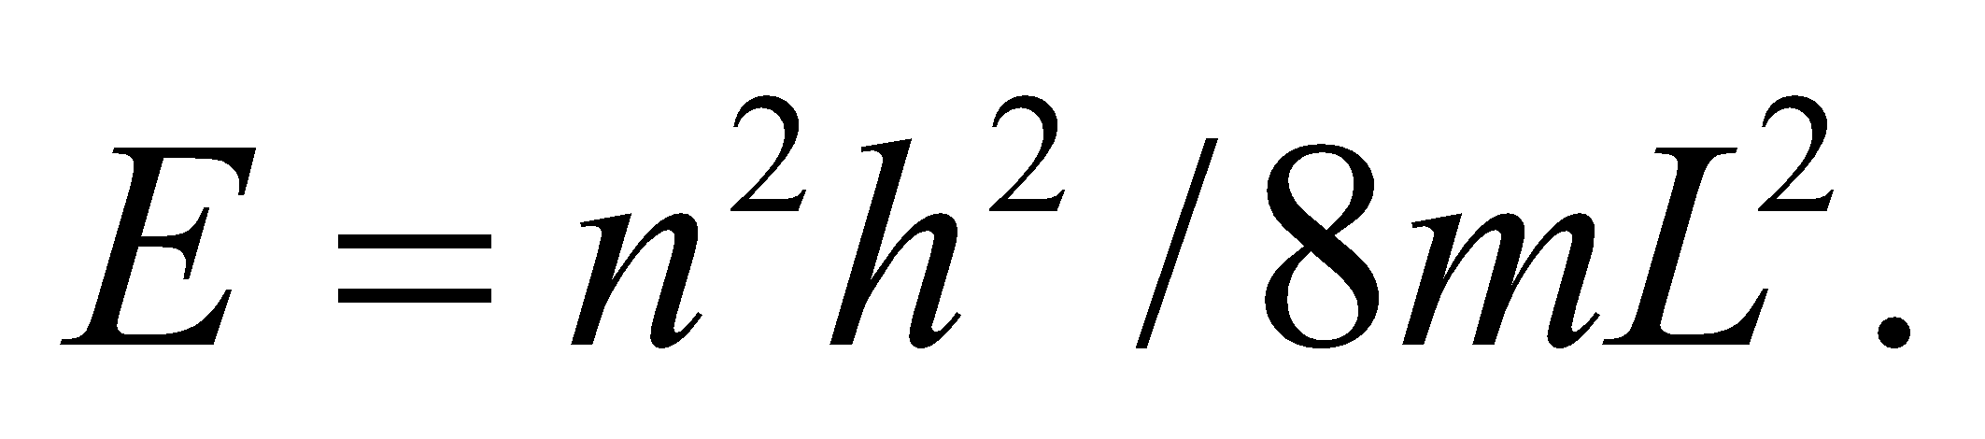
Evaluate The energy difference between the ground state and the first excited state is
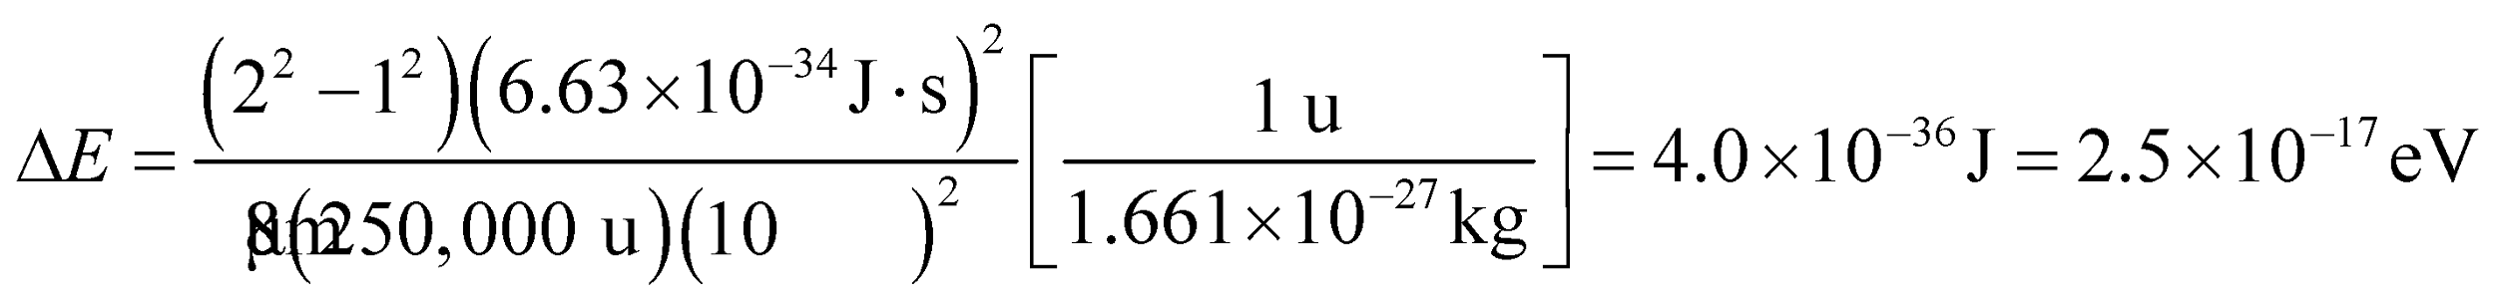
This is so much smaller than the energy of biochemical reactions (1 eV) that quantization is not relevant.
Assess Quantization is rarely considered in biology because the objects of interest are too large. One exception is photosynthesis, where the conversion of sunlight into chemical energy appears to exhibit some quantum effects.
44. Interpret You model the hydrogen in hydrogen chloride as a mass on a spring. Accordingly, the spring constant can be determined from the energy separation between the ground state and first excited state.
Develop In terms of a simple harmonic oscillator, the energy difference between the ground state and first excited state is 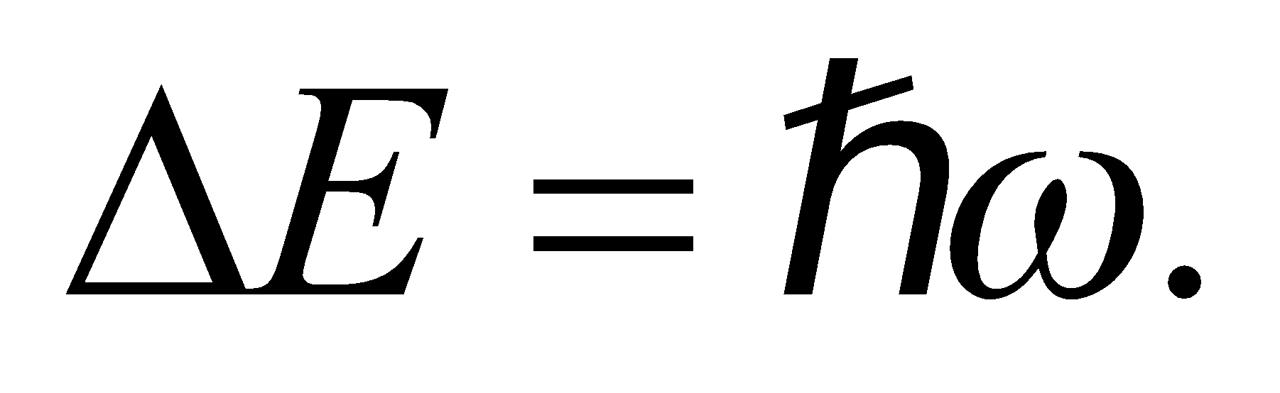 The angular frequency for the mass-spring system is In this case, the mass is that of the hydrogen atom: 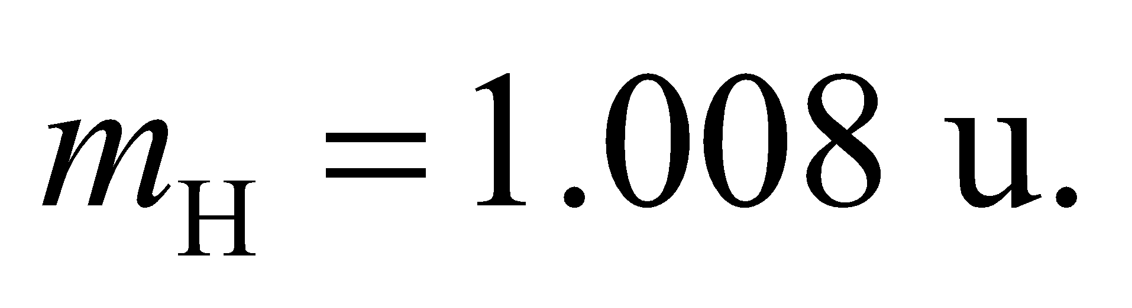
Evaluate Combining the above equations, the spring constant in the model for HCl is
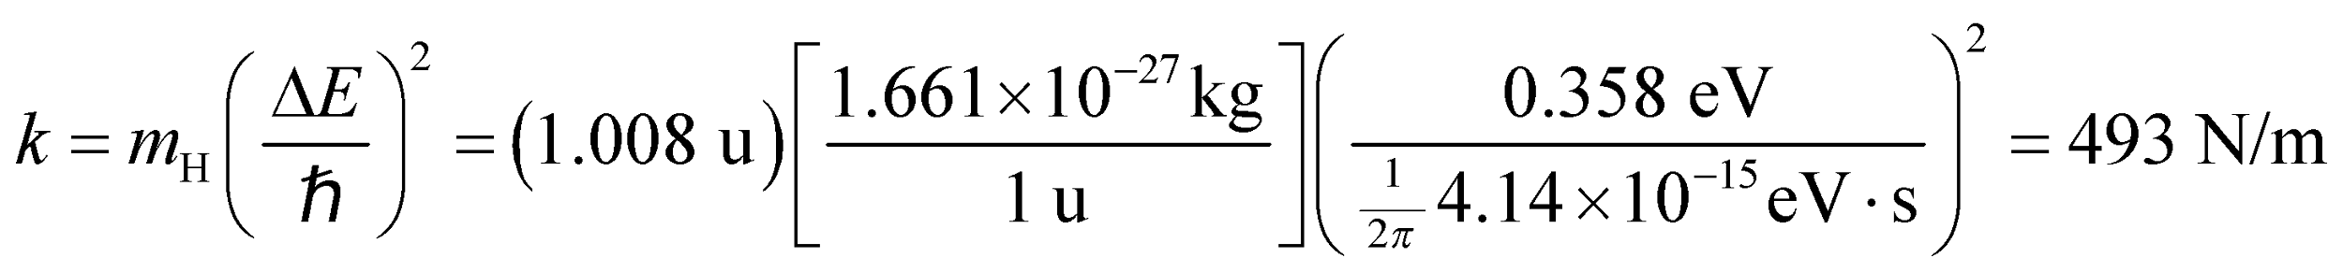
Assess You can try to estimate the size of this molecule using the relation between the energy of a spring and the amplitude of its oscillations: 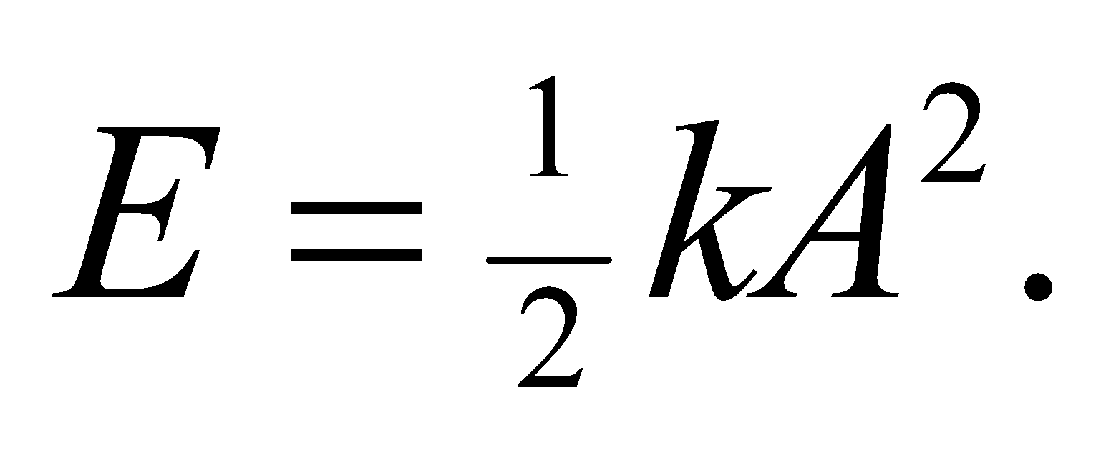 Using the energy of the first excited state, the amplitude of the above system is roughly:
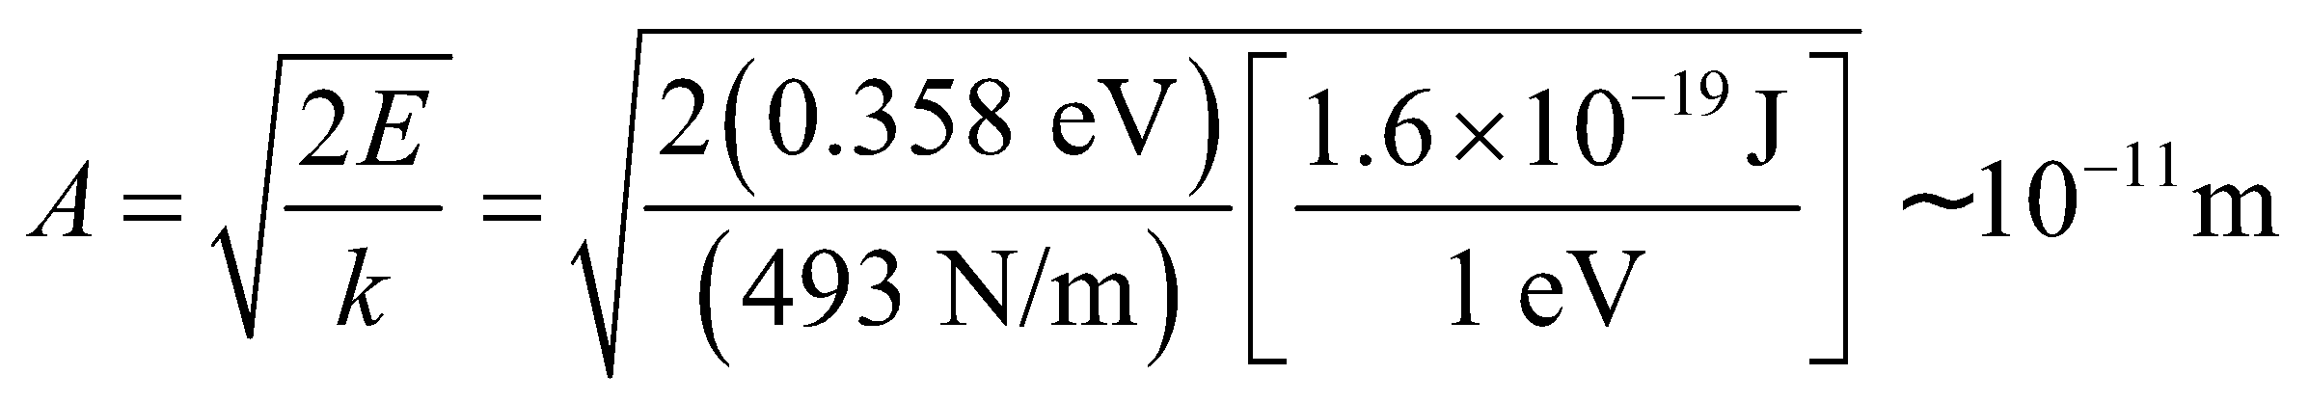
This is about an order of magnitude too small, but it gives an idea of the size of the HCl molecule.
45. Interpret This problem concerns a particle in a one-dimensional infinite square potential well. We are asked to find the probability that the particle will be found within a given ranged centered at two different points in the square well.
Develop As in Problem 42, the probability of finding the particle between x₁ and x₂ (where 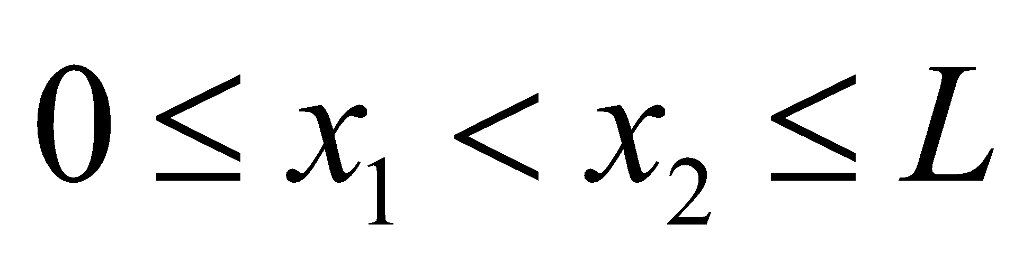) is
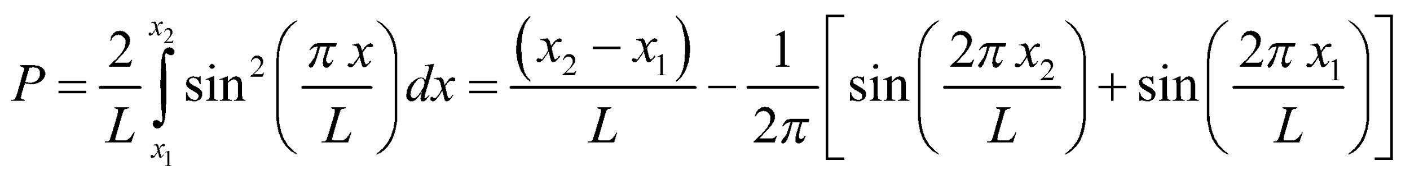
We shall evaluate this probability function for the two ranges given.
Evaluate (a) The probability P of finding the particle between x₁ = 0.500L − 0.075L = 0.425L and x₂ = 0.500L +0.075L = 0.575L is
(b) The probability P of finding the particle between x₁ = 0.250L − 0.075L = 0.425L and x₂ = 0.250L + 0.075L = 0.575L is
Assess The probability is greater for the particle to be found in the center of the well than near the edges, which is reasonable in view of the probability distribution function (see Figure 35.7).
46. Interpret We are to calculate the probability of finding a particle in the central quarter of an infinite square well for various energy states and compare our answers with the classical probability.
Develop From the discussion preceding Equation 35.5, we see that the wave function for the infinite square well is 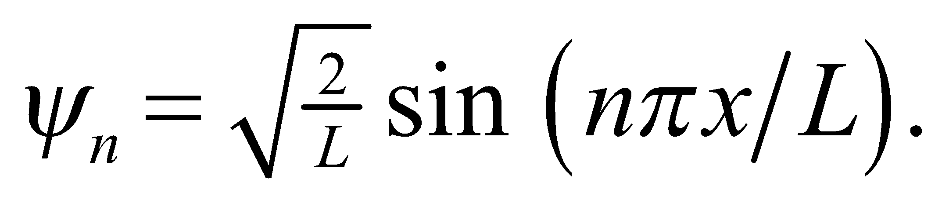 The region in which we are interested is the central fourth: 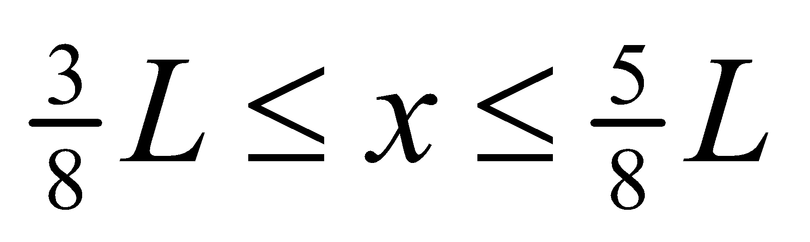. We will calculate the probability by integrating 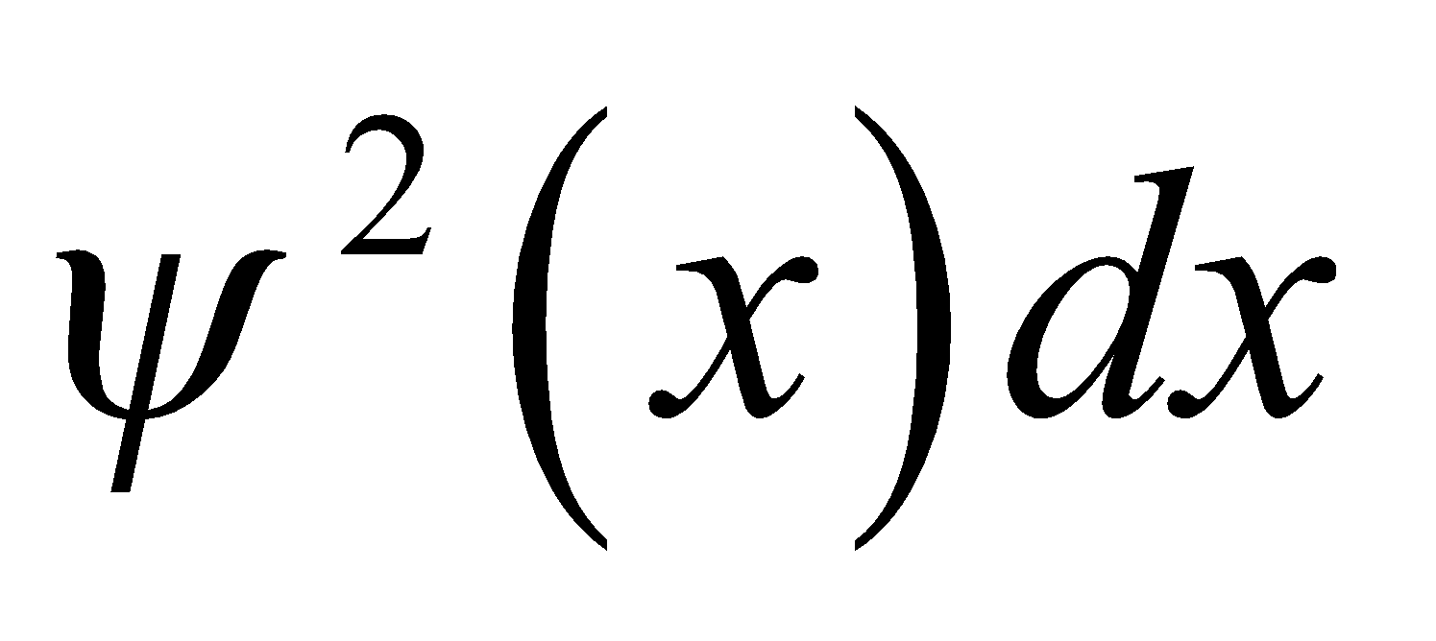 from x = 3L/8 to x = 5L/8.
Evaluate First, we find the general solution for any value of n:
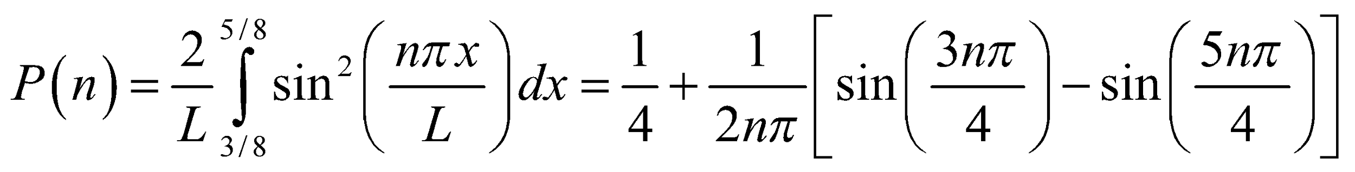
(a) 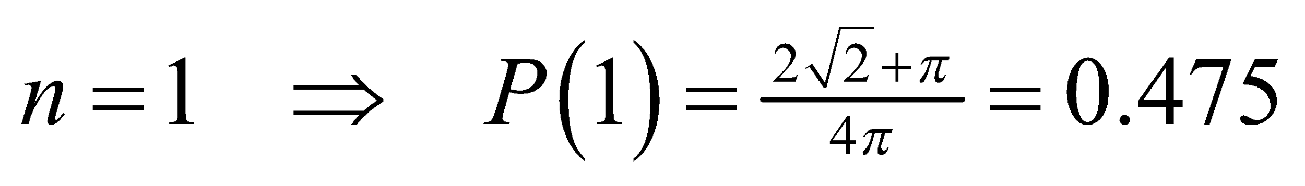
(b) 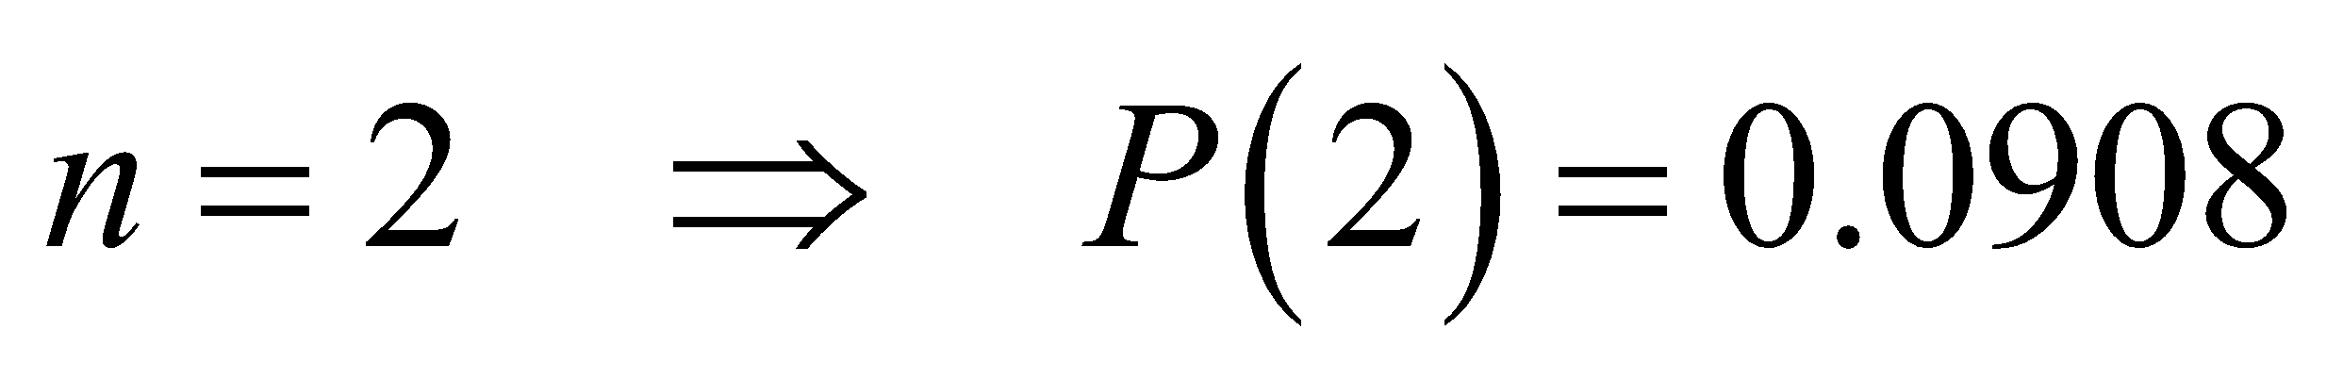
(c) 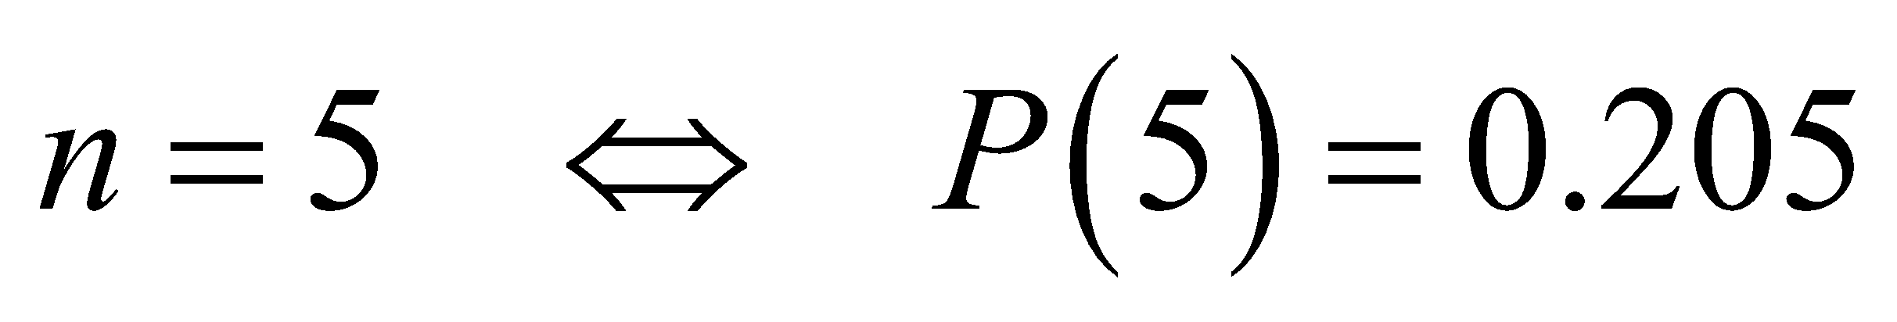
(d) 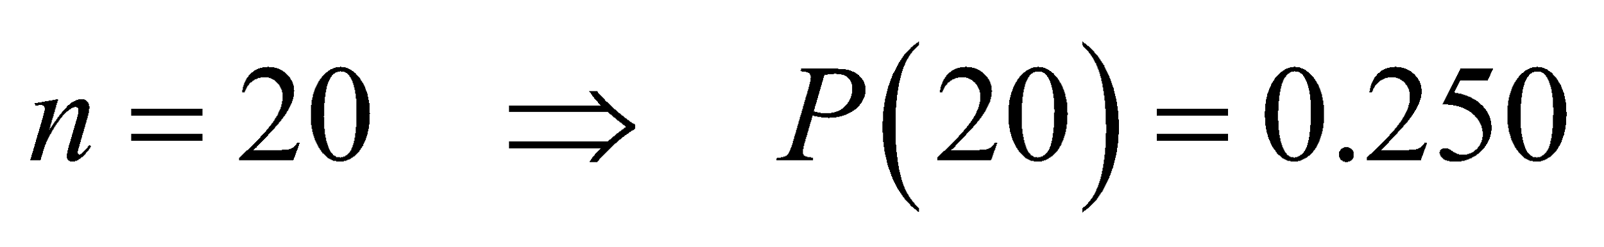
(e) The classical model predicts that the particle would be anywhere in the box with equal probability, so the total probability of being in the central ¼ of the box is 0.25.
Assess Note that as n becomes higher, the quantum probability becomes closer to the classical probability.
47. Interpret We are to show that the Schrödinger equation has nonzero solutions in classically forbidden regions where E < U.
Develop We are given solutions of the form 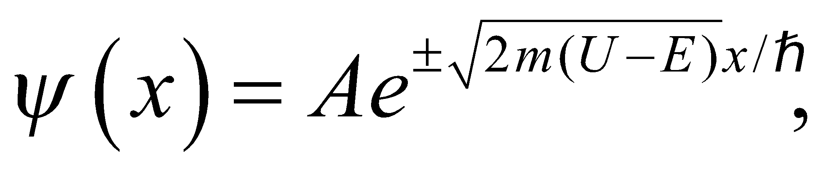 so all we need to do is substitute this wavefunction into the time-independent Schrödinger equation
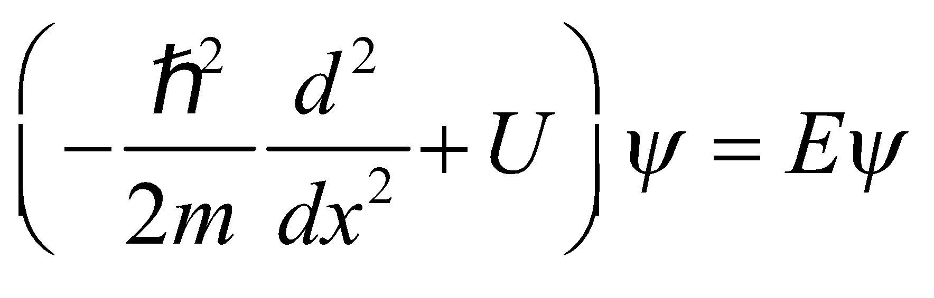
(see Section 35.3) and see if it fits.
Evaluate Inserting the trial solution into the Schrödinger equation gives
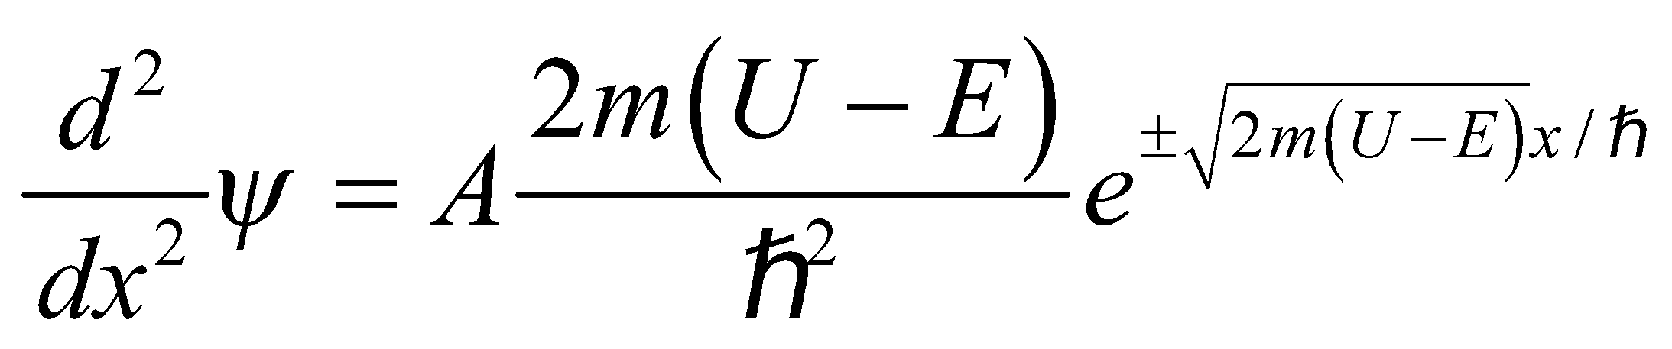
Substitute this into the time-independent Schrödinger equation:
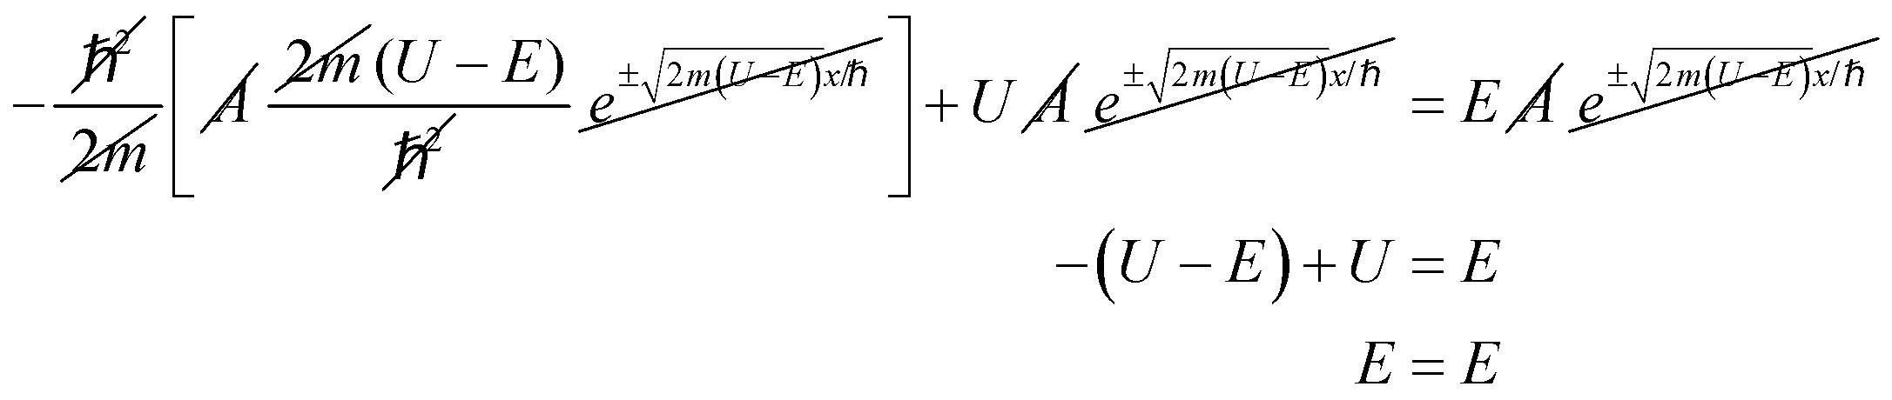
Thus, we have shown that the proposed solution is a valid solution for the time-independent Schrödinger equation.
Assess This form of 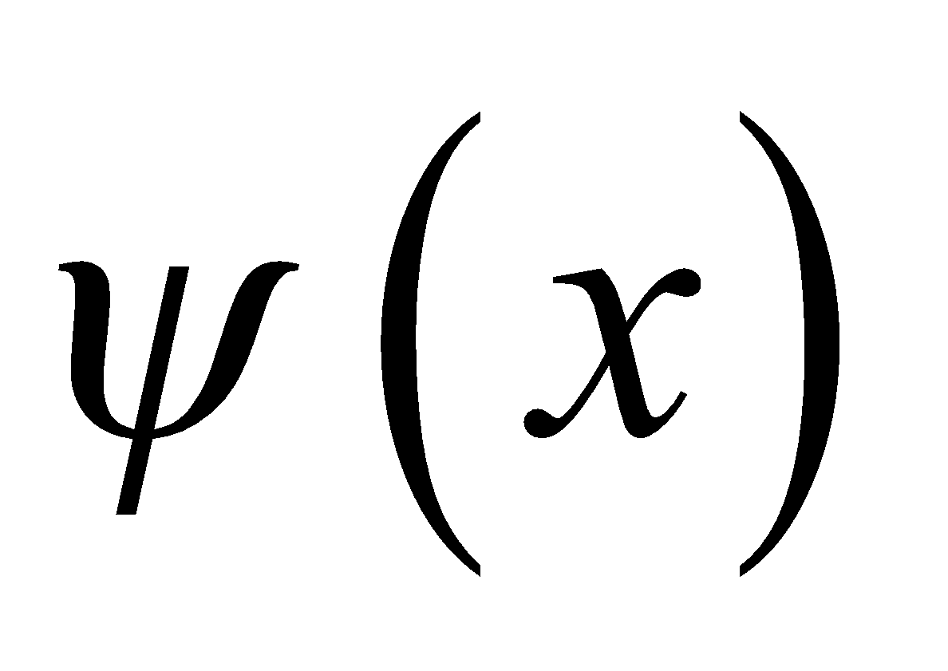 is a solution to the time-independent Schrödinger equation. Note that this form of solution is not “wave like”: it exponentially decays (or increases) instead of oscillating.
48. Interpret This problem involves quantum mechanics in a three-dimensional cubical box. We are to make an energy diagram and show the degeneracy of each level.
Develop The energy levels of a particle in a three-dimensional box are given by Equation 35.8:
The ground state corresponds to 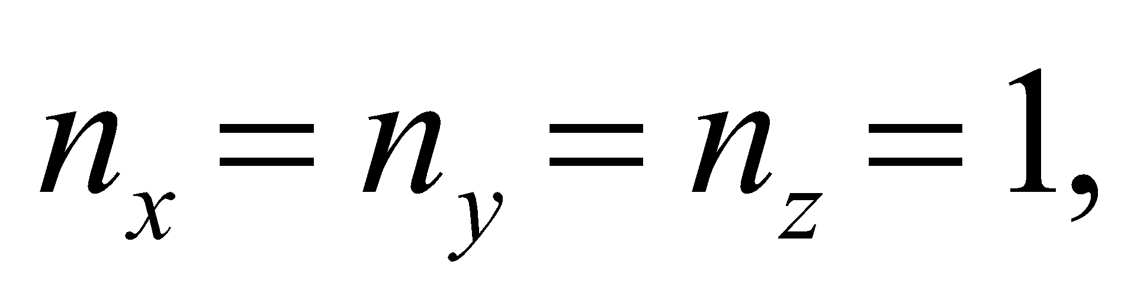 while the first excited state has one of the quantum numbers equal to 2 (e.g.,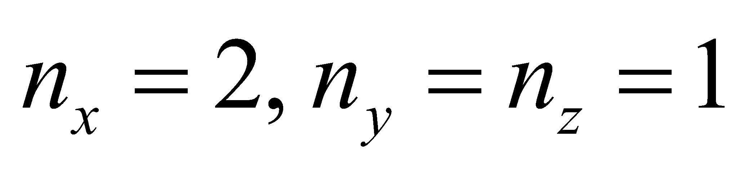).
Evaluate The quantum numbers, energy, and degeneracy of the first six levels in the three-dimensional infinite square well are summarized below:
Energy level | 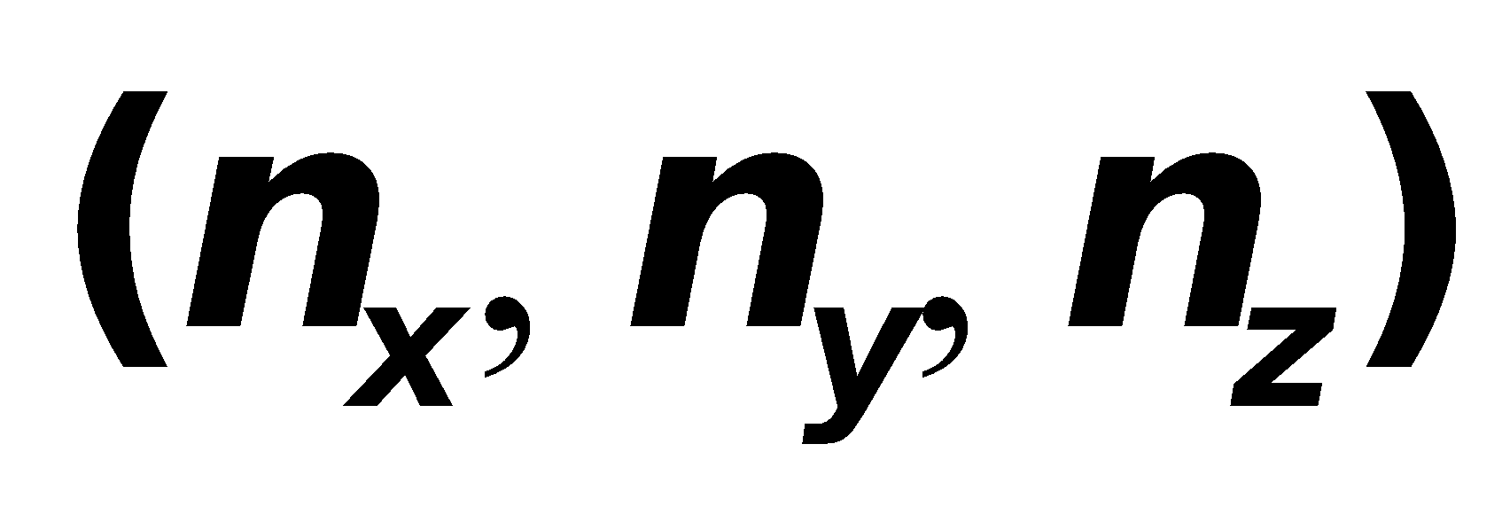 | 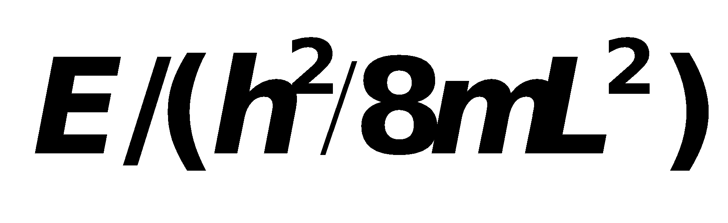 | Degeneracy factor
1 | (1,1,1) | 3 | 1
2 | (2,1,1), (1,2,1), (1,1,2) | 6 | 3
3 | (2,2,1), (1,2,2), (2,1,2) | 9 | 3
4 | (3,1,1), (1,3,1), (1,1,3) | 11 | 3
5 | (2,2,2) | 12 | 1
6 | (1,2,3), (1,3,2), (2,1,3)  (2,3,1), (3,1,2), (3,2,1) | 14 | 6
The energy-level diagram looks similar to that shown in Fig. 35.6.
Assess In general, degeneracy arises from symmetry in the system. In our case, the symmetry is due to the fact that we have a cube with 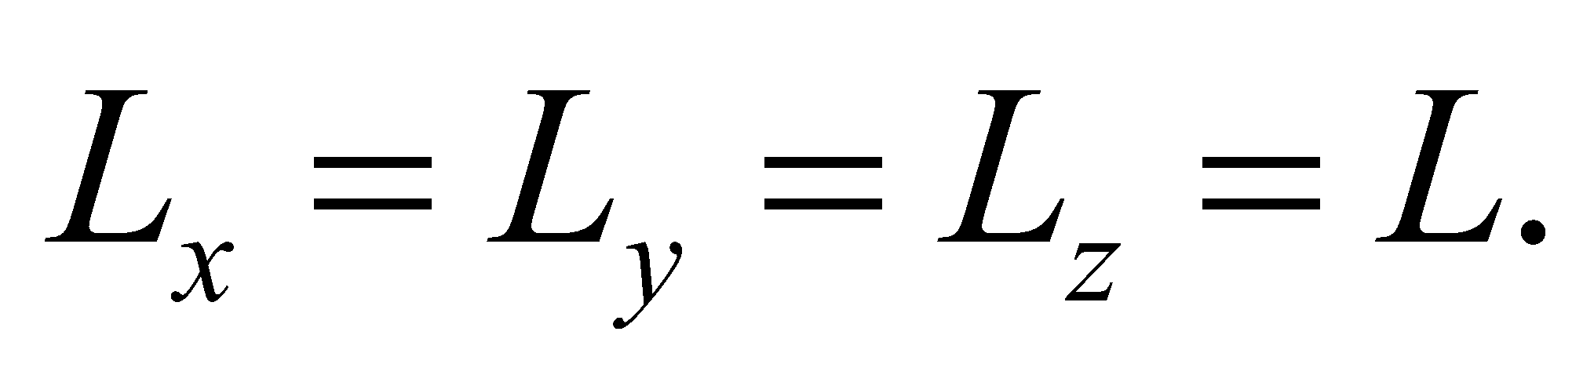
49. Interpret We are to verify that the given wave function is a solution to the three-dimensional Schrödinger equation and that the derived energy levels match those given by Equation 35.8.
Develop For the given wave function 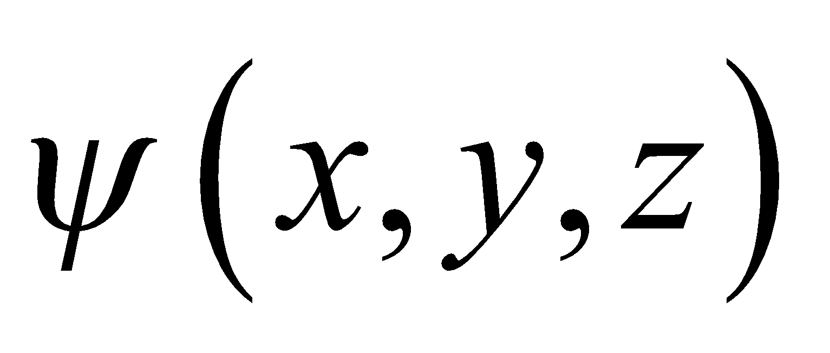 the second partial derivatives are
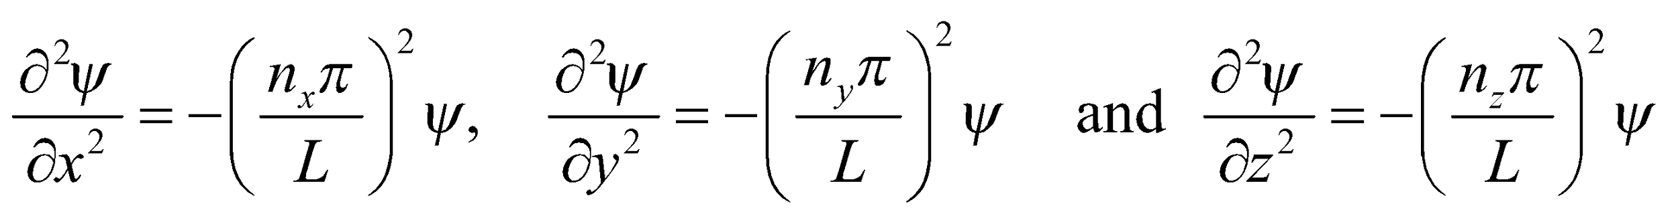
Substituting into the Schrödinger equation, with a potential for a cubical box (U = 0 inside and 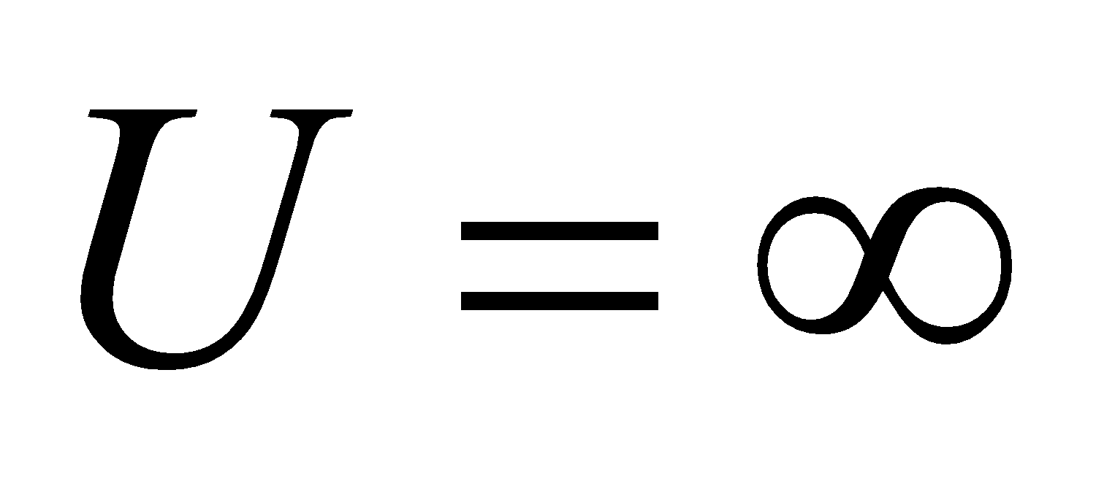 outside), we find
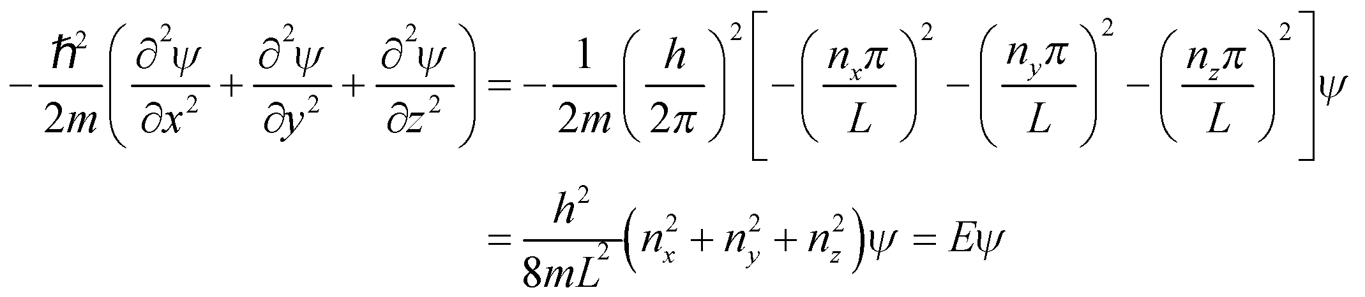
Evaluate The above derivation (a) demonstrates that is a solution, and (b) shows that the energy levels match those given in Equation 35.8.
Assess This wave function also satisfies the boundary conditions appropriate for confinement which are points where 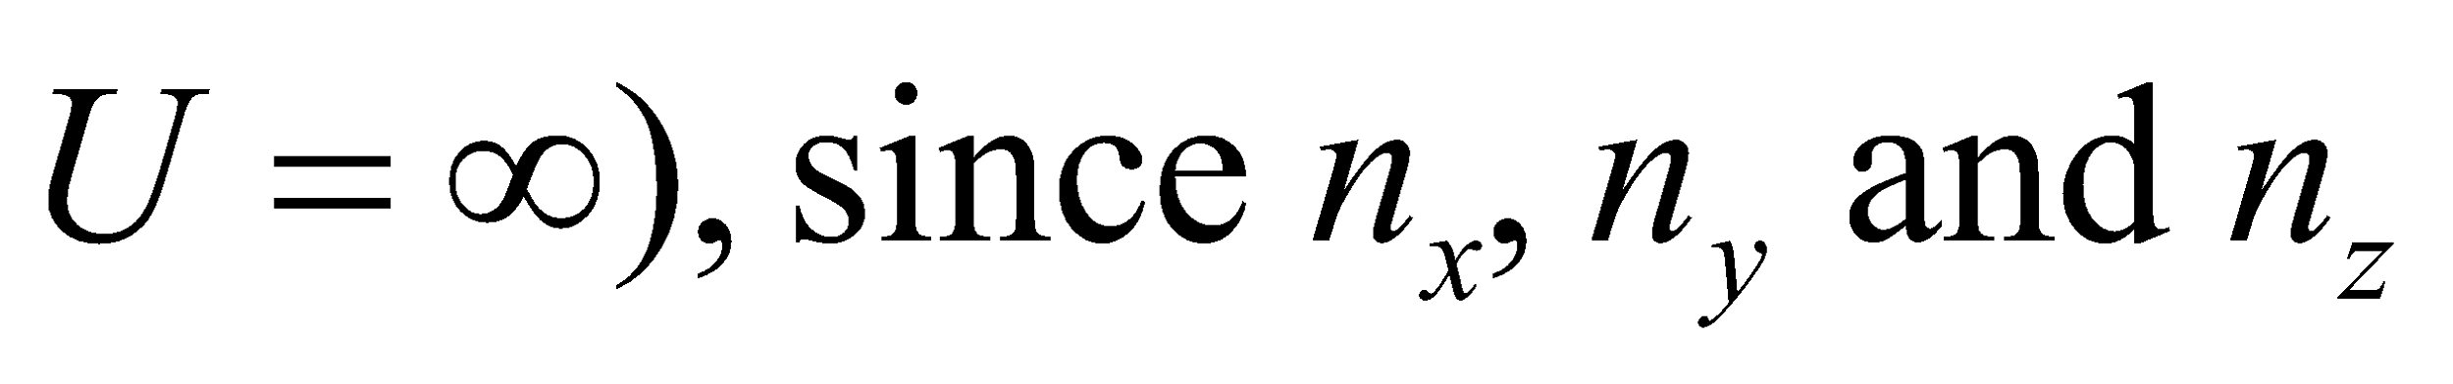 are integers.
50. Interpret We are given the number of photons per unit time that impinge upon an ensemble of electrons in quantum wells of the given size. Each photon is of sufficient energy to raise an electron to the first excited state, and we are to find the total number of electrons thus excited in a given time.
Develop The energy levels of a one-dimensional infinite quantum well are given by Equation 35.5, 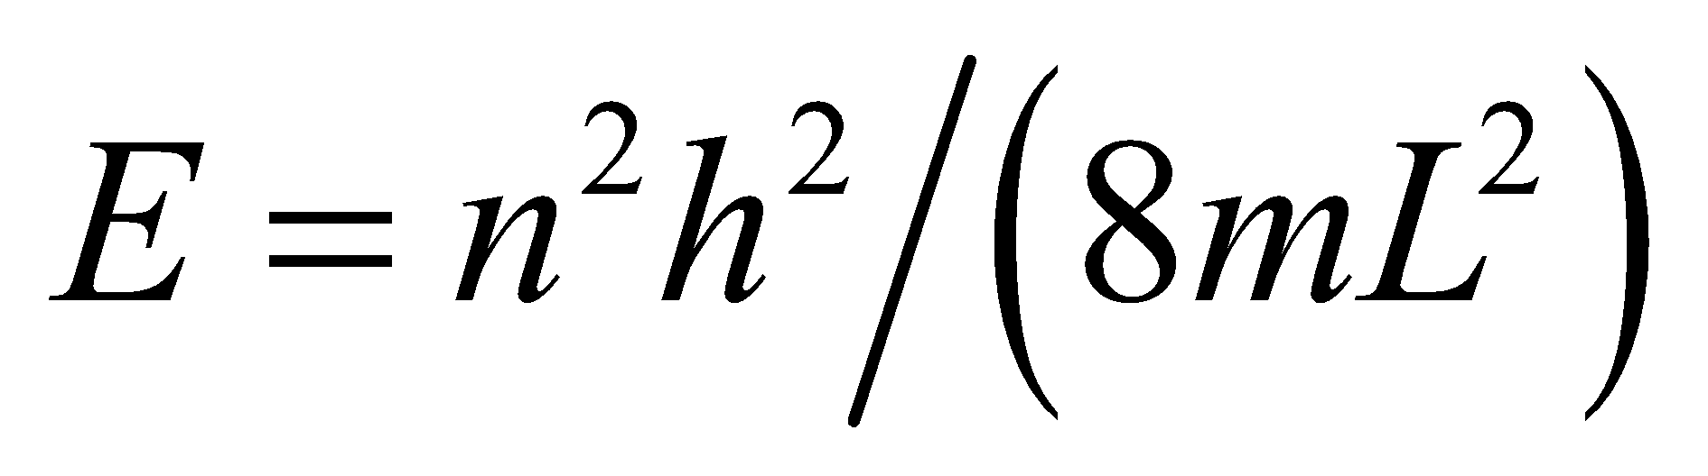. The ground state has n = 1 and the first excited state has n = 2, so the energy difference between the two is
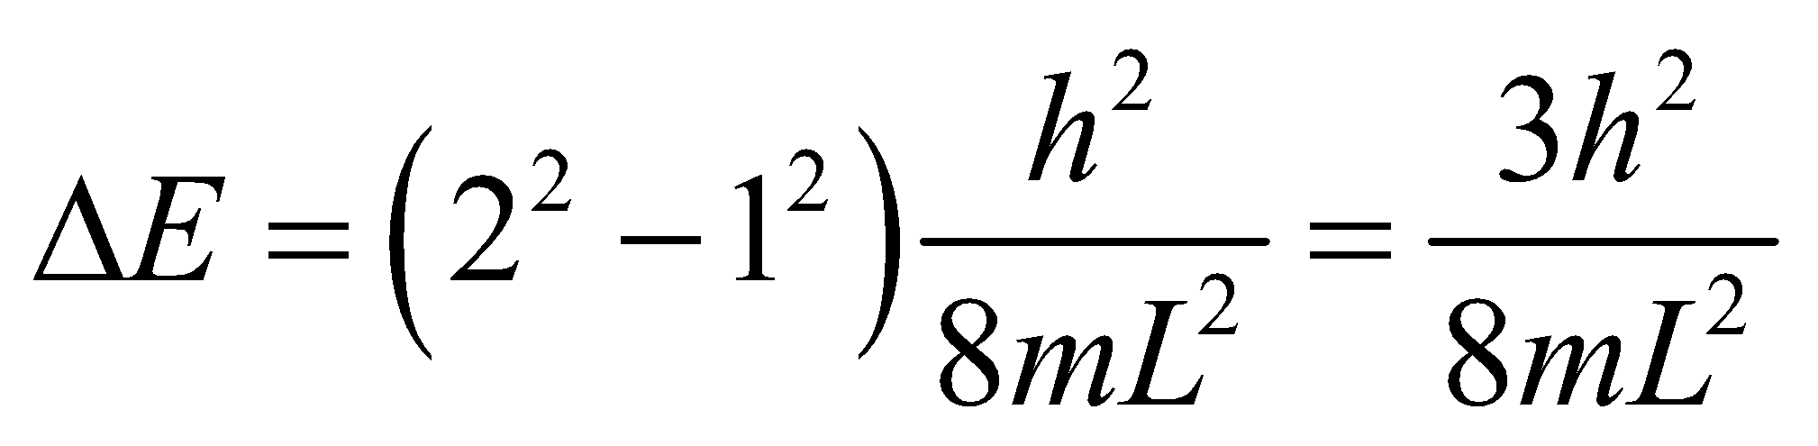
This is the energy required of the photon to excite an electron from the ground state to the first excited state. The average power in the light beam corresponds to a number of photons N per unit time of
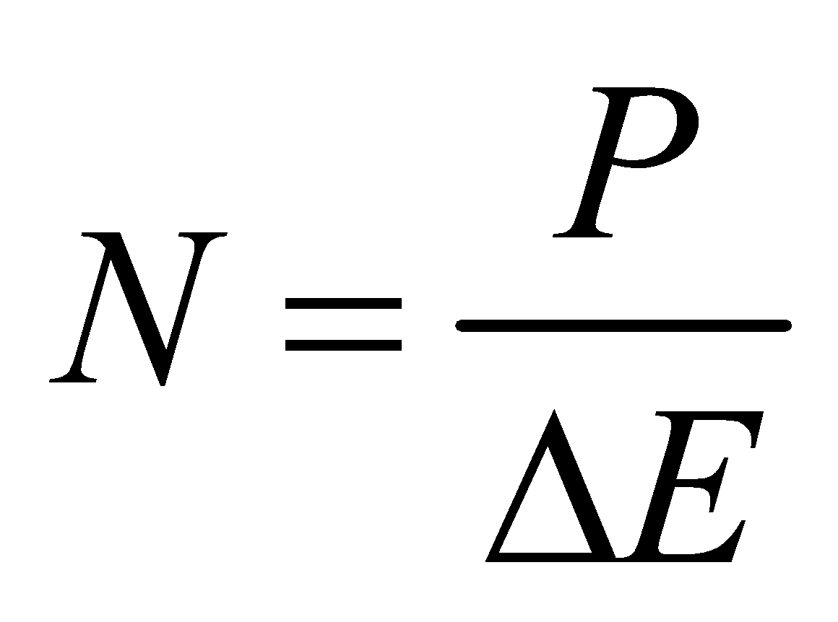
The number of electrons N_{e} excited to the first excited state in a time Δt is N_{e} = NΔt.
Evaluate Evaluating the expression for N_{e} gives
Assess The ensemble contains many more electrons (i.e., 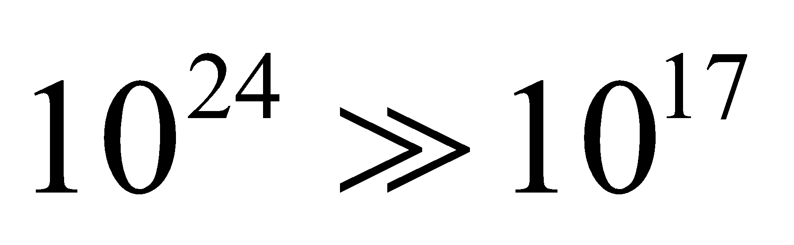) than are excited. Since the photon energy is insufficient to excite transitions other than the first transition, the result we found is also the maximum number of electrons that can be excited.
51. Interpret When transitioning to lower states, electrons emit photons to release energy. We are interested in all the visible photon wavelengths associated with all possible electronic transitions in the given quantum well.
Develop The energy levels for an infinite square potential well are given by Equation 35.5:
Thus, the energy of the photon emitted when the electron drops from initial state n_{i} to final state n_{f} < n_{i} is
The possible photon wavelengths are
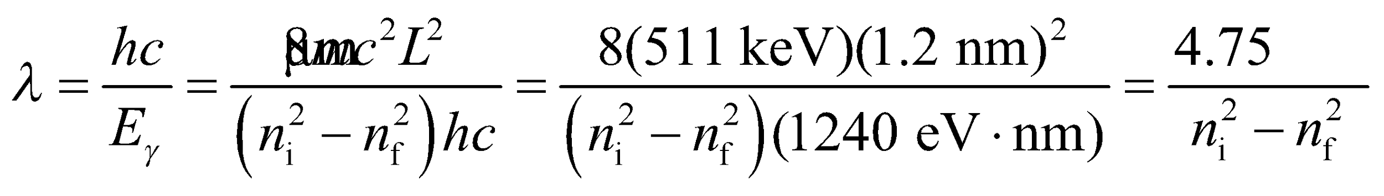
Evaluate (a) Visible photons fall within the wavelength range  or
There are four transitions satisfying this condition: 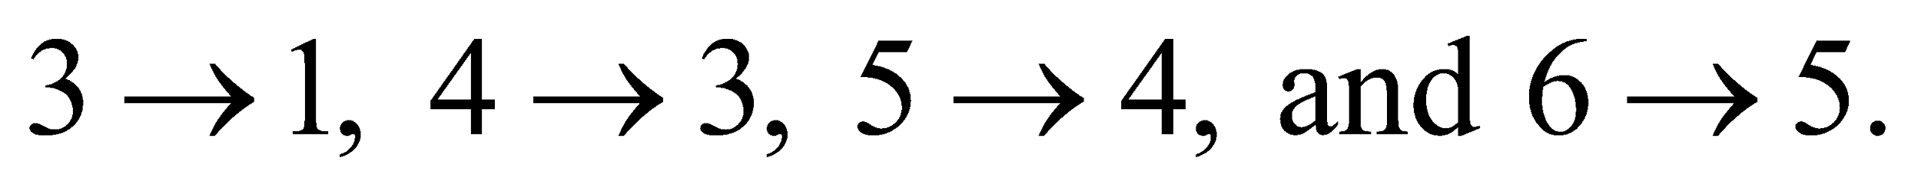
Assess Since energy is quantized, only photons with wavelengths that satisfy the above condition will be emitted during the transitions.
52. Interpret Since this is a question about probability, we analyze 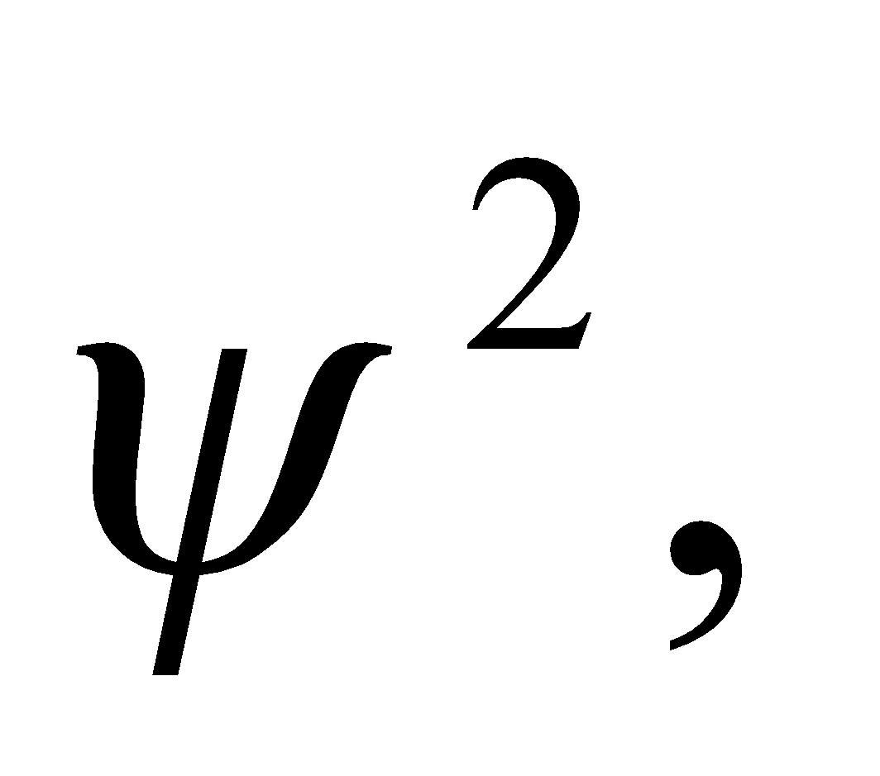 which represents the probability density. The result here is a generalization of that in Example 35.1.
Develop The wave function for the nth quantum state of a square potential is given in Equation 35.6:
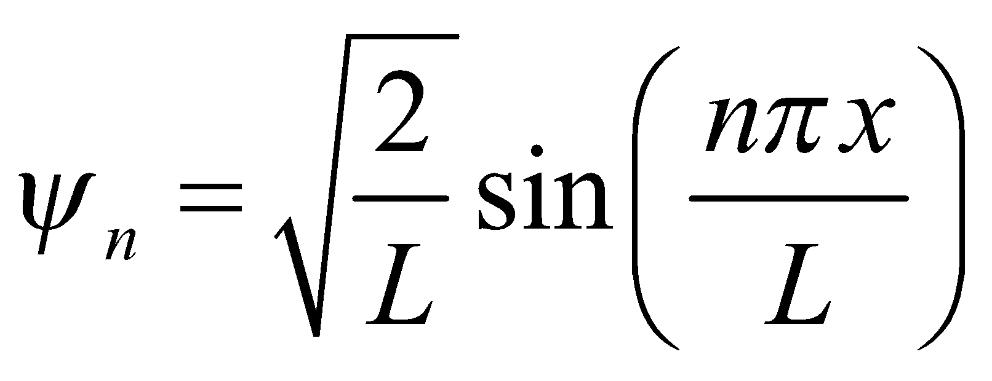
To find the probability that a particle will be found in the left-hand quarter of the well, we square the wave function and integrate from 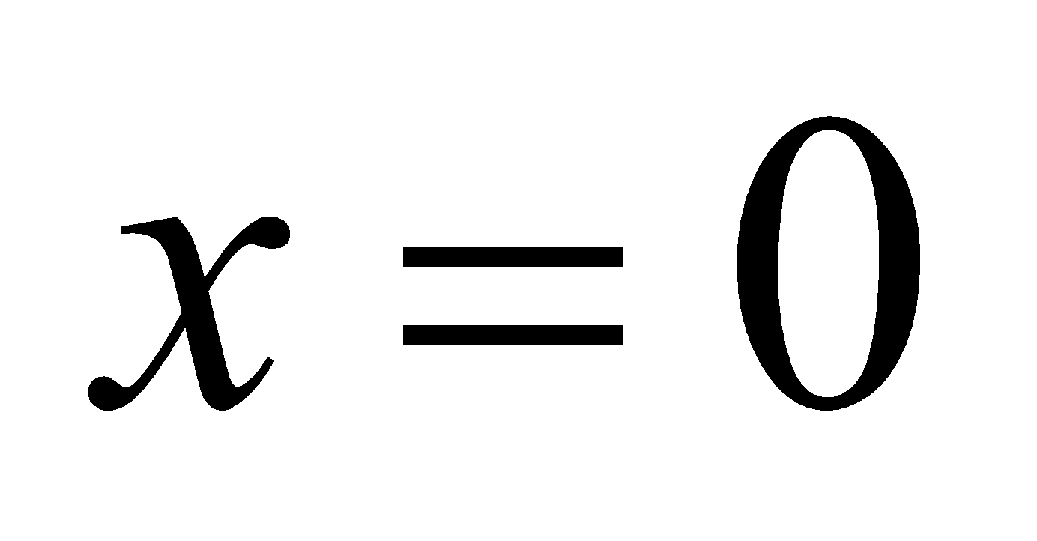 to 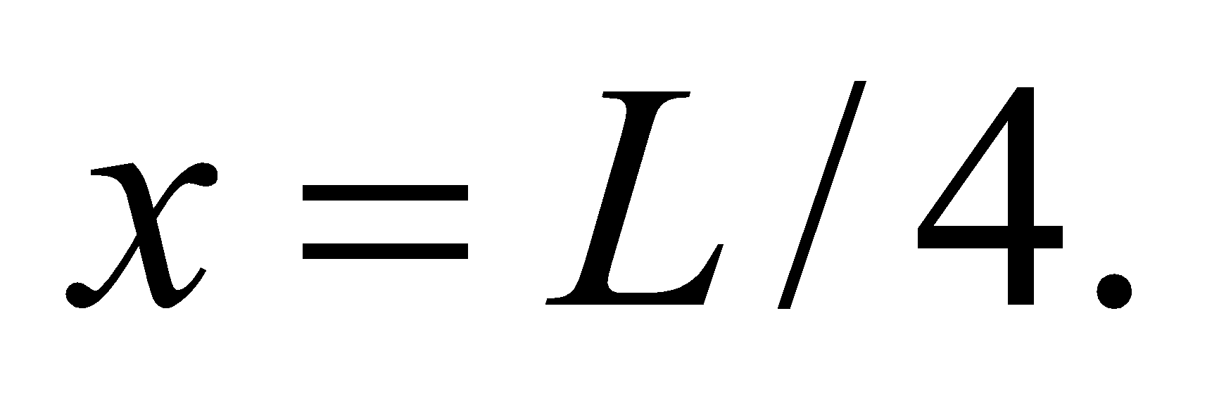
Evaluate (a) We use the integral for the sin²-function from Appendix A to solve for the probability:
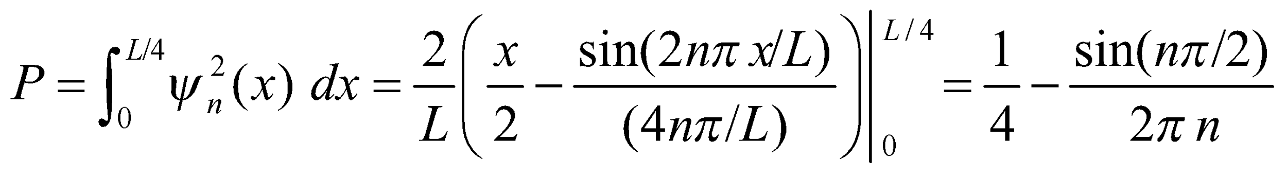
(b) If n is odd, then 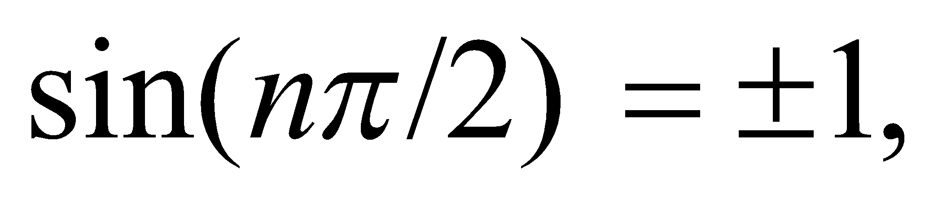 and the probability reduces to:
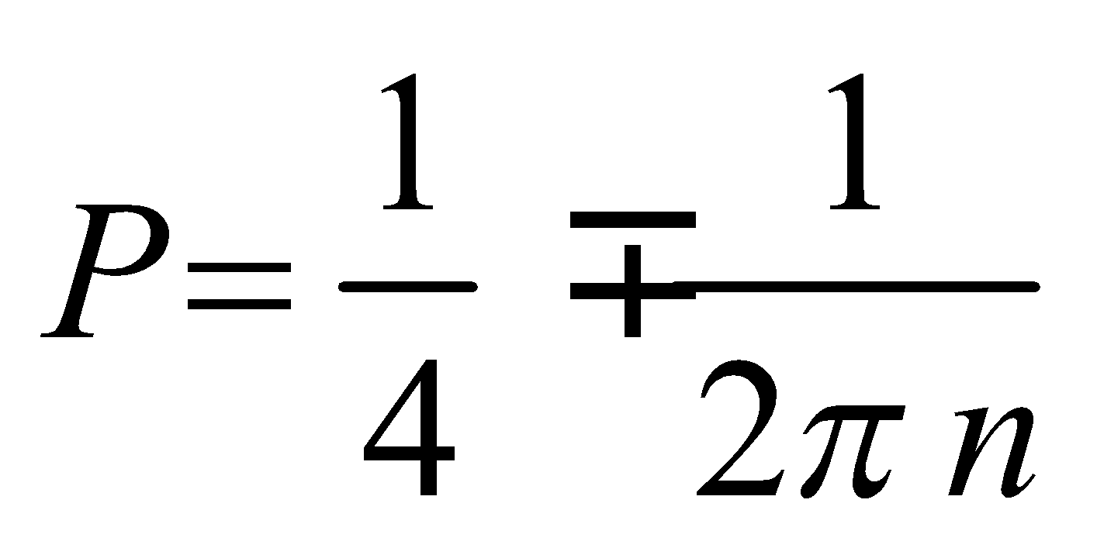
As 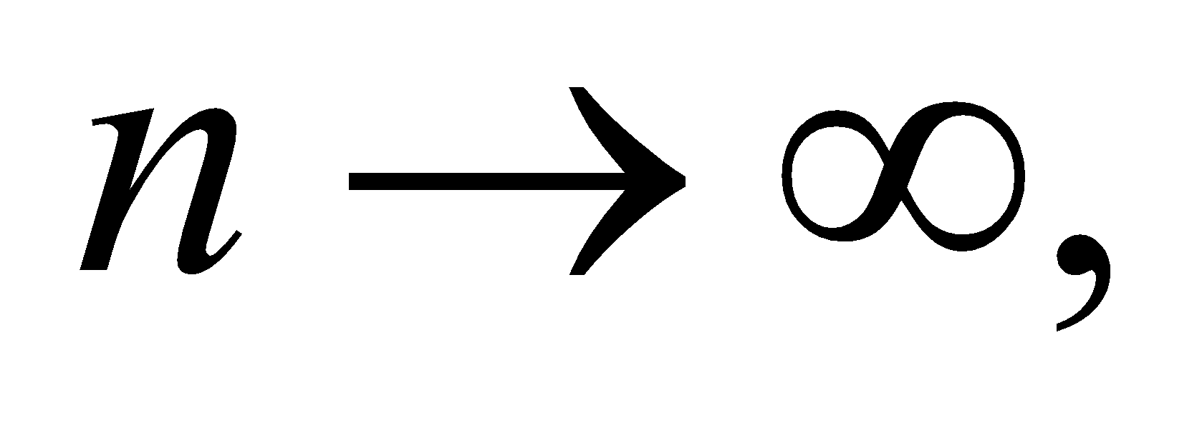the second term disappears, and the probability approaches ¼. Notice that the probability is exactly equal to ¼ when n is any even integer.
Assess The classical case can be thought of as a ping-pong ball in a box. If you shake the box randomly, the probability that the ball is in the left-hand quarter is 25%.
53. Interpret You're asked to develop the Schrödinger equation and the ground state wave function for the simple harmonic oscillator.
Develop You start with the time-independent Schrödinger equation:
Evaluate (a) Plugging in the potential energy of a harmonic oscillator, you arrive at
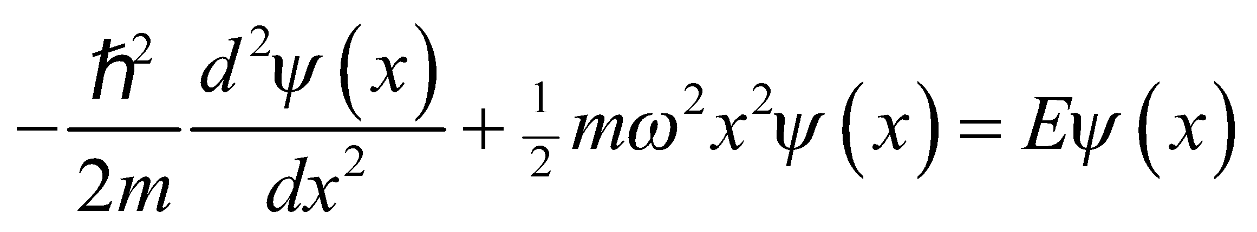
(b) For 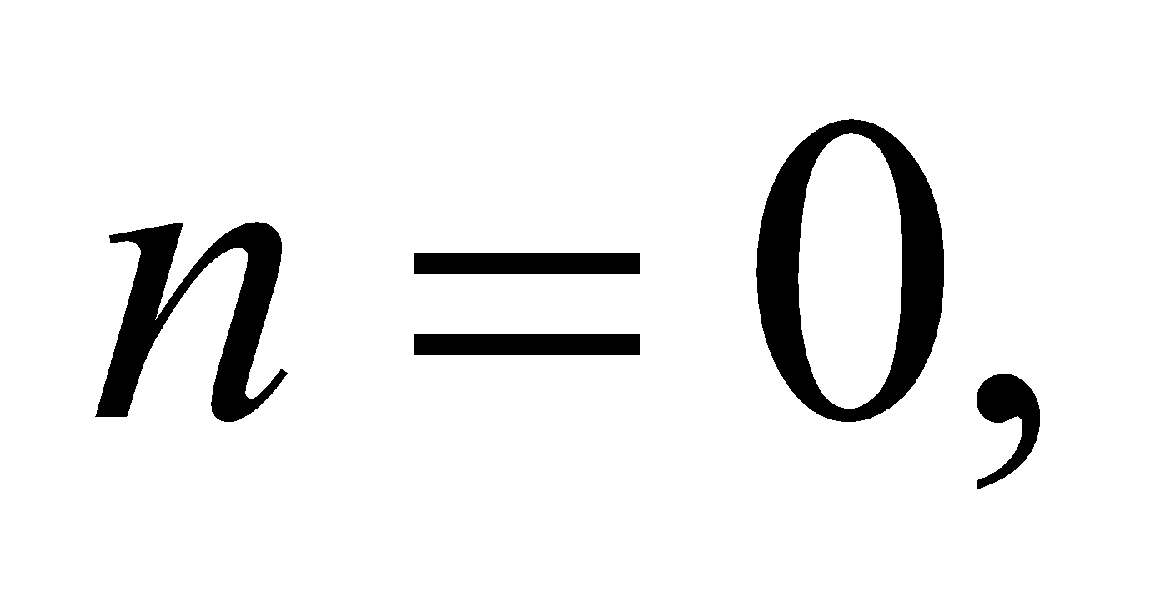the energy is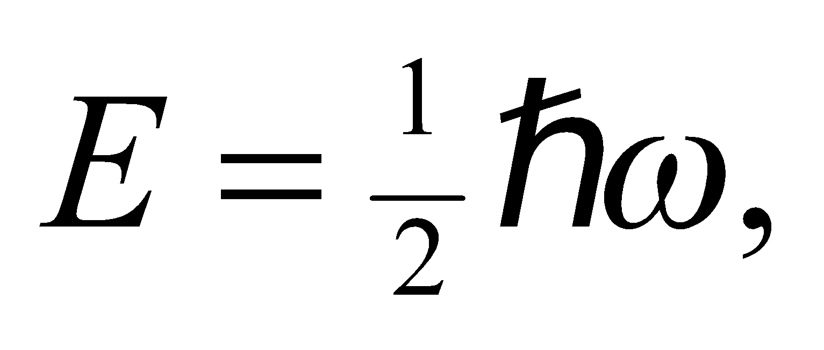 and the Schrödinger equation reduces to:
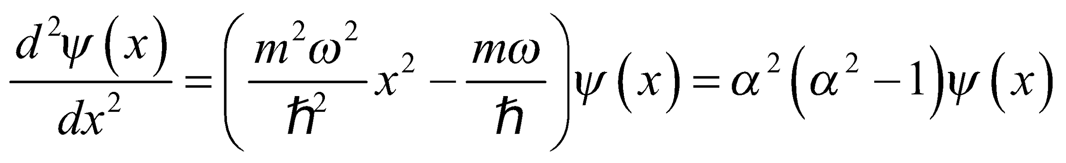
where 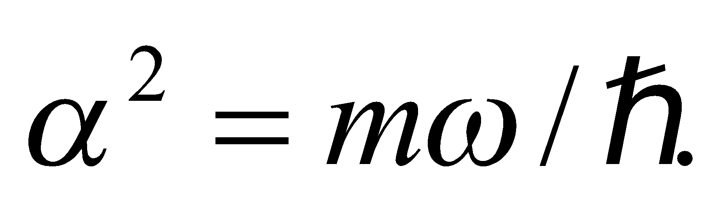If 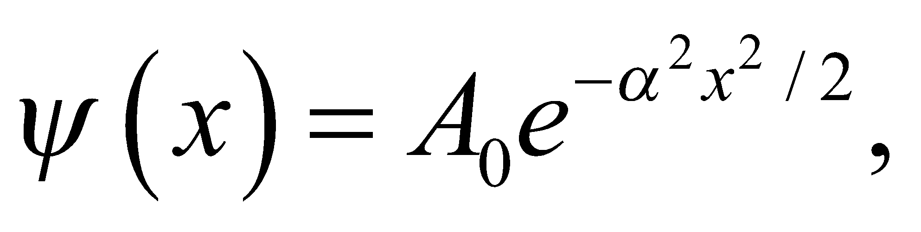then the first derivative is 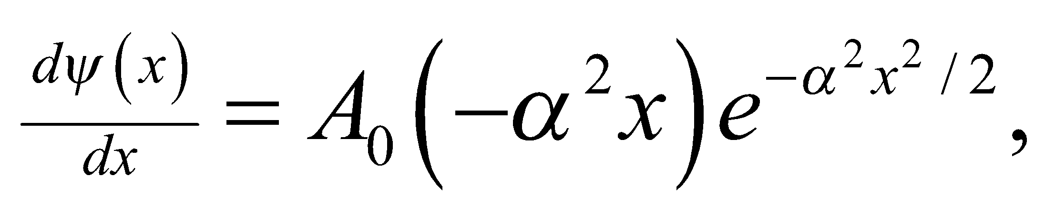and the second derivative is
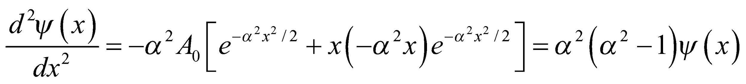
This proves that 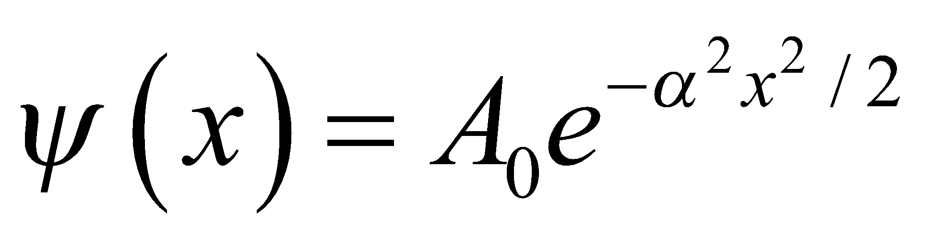is a solution to the ground state.
(c) To find the normalization constant, we use the normalization condition (Equation 35.3):
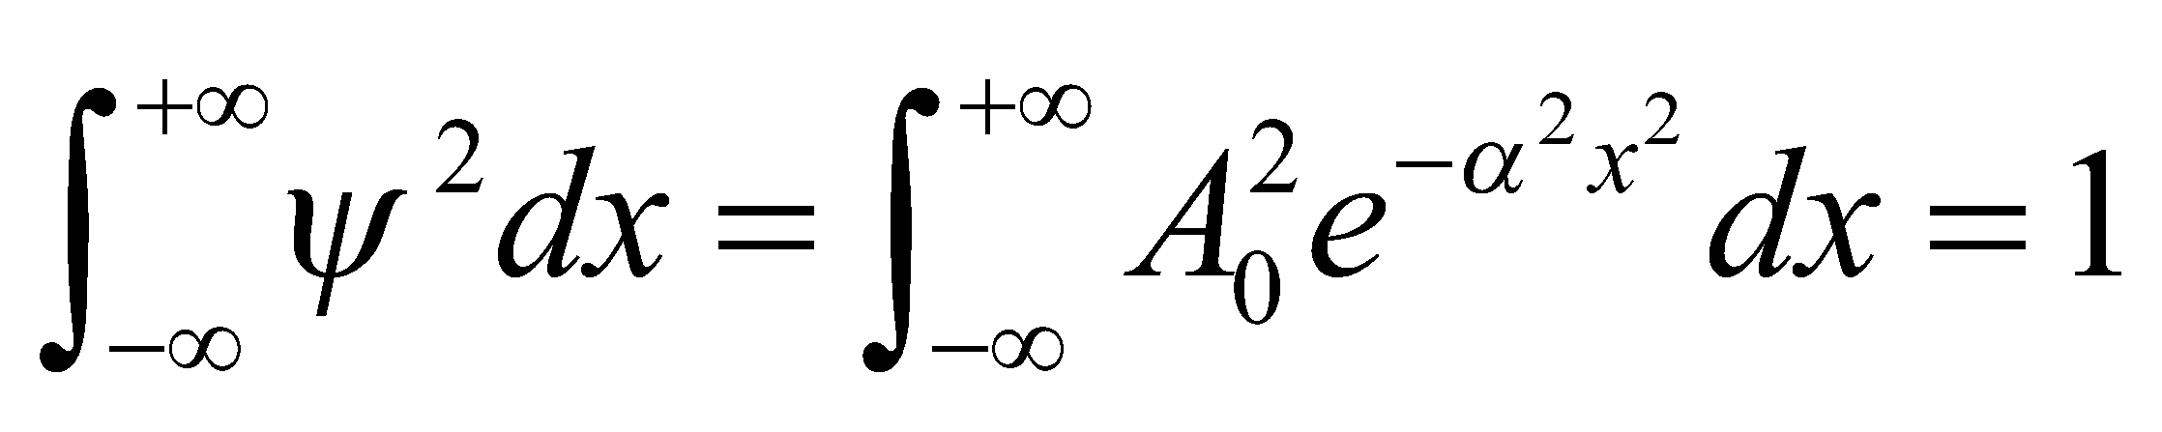
The integral is a Gaussian. One can find the value in an integral table, but we will give a short derivation here. We first define 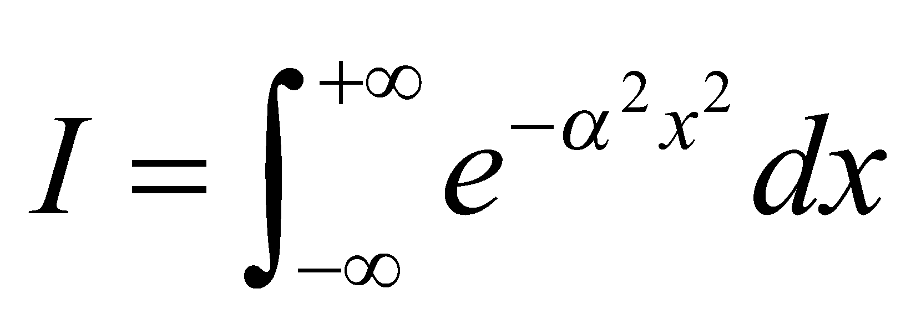and then square both sides. We combine the right-hand side into a single exponent and then change to polar coordinates, which puts the integral into a more solvable form:
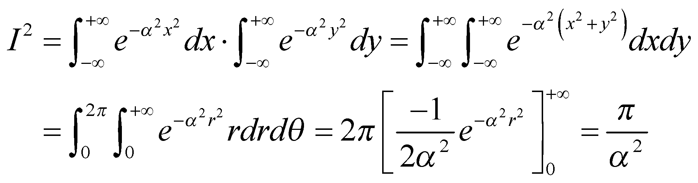
Therefore, 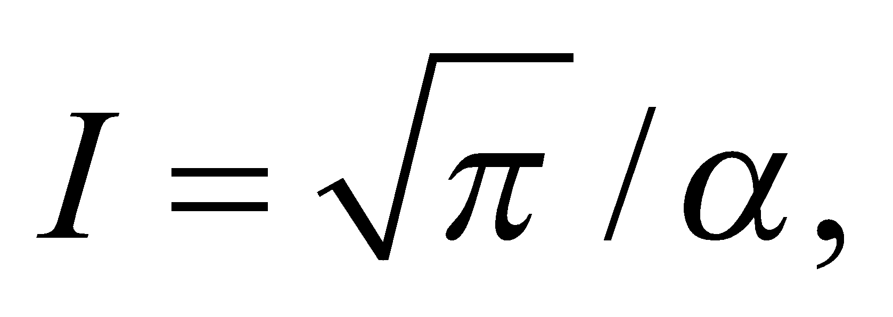 and the normalization constant must be 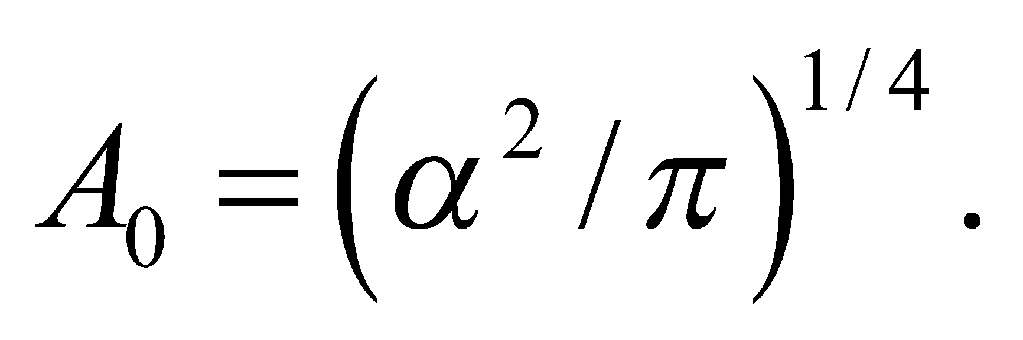 In summary, the normalized ground state wave function of the simple harmonic oscillator is
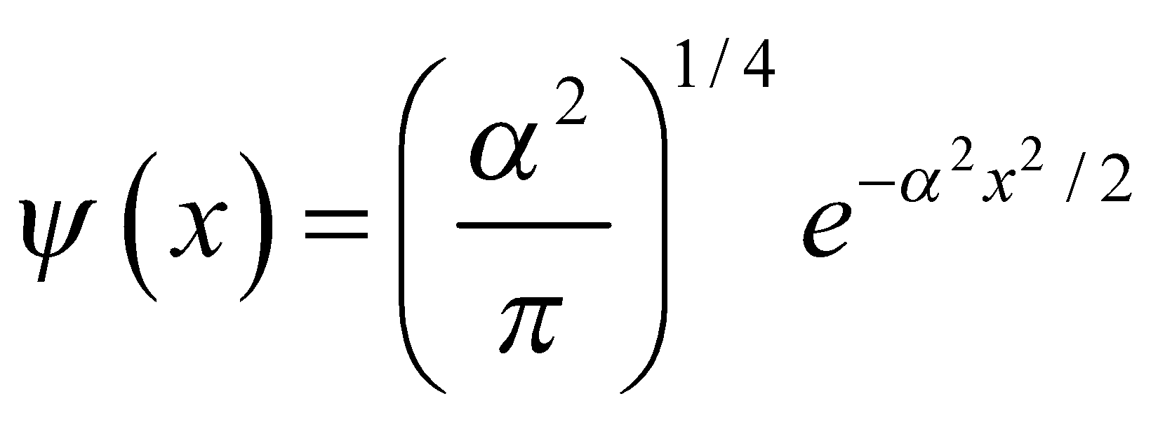
Assess The probability density for the ground state is a Gaussian, or "bell curve," as depicted in Figure 35.11a.
54. Interpret You want to show why fuel for a nuclear reactor is more concentrated in energy than traditional fuels that burn through chemical reactions.
Develop To make a rough comparison of the potential energy in nuclear and chemical or atomic physics, you model both the nucleus and the atom as square potentials, confining a proton and an electron in their respective cases. The ground state energy will be inversely proportional to the mass of the confined particle and the square of the potential's width: 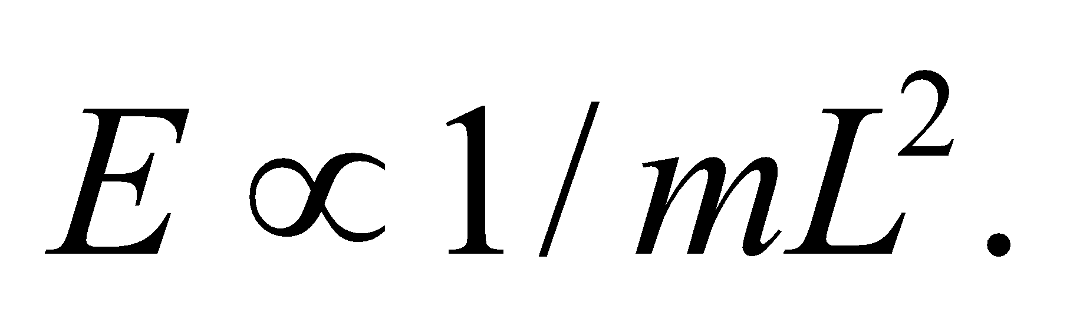
Evaluate Using the simplified model above, the ratio of nuclear energy to chemical energy is
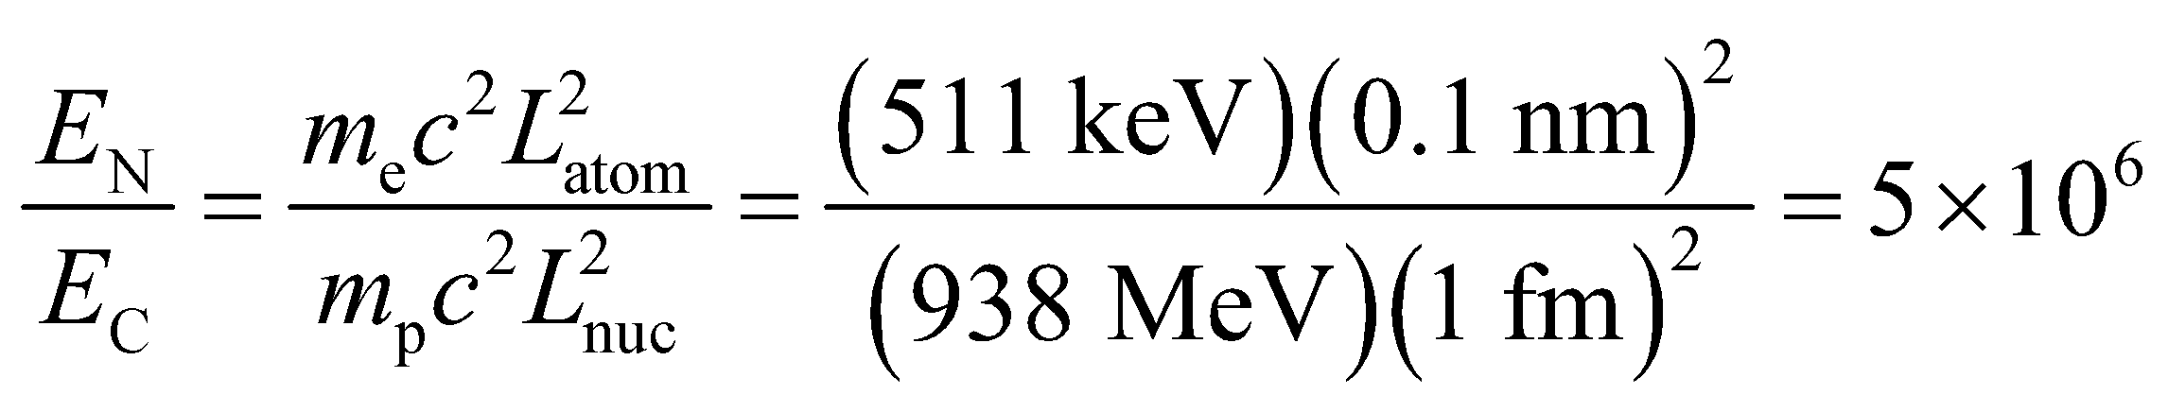
Assess This says that there is a million times more energy in the nucleus of an atom than in its electrons. This sounds about right, since a kilogram of pure uranium-235 contains 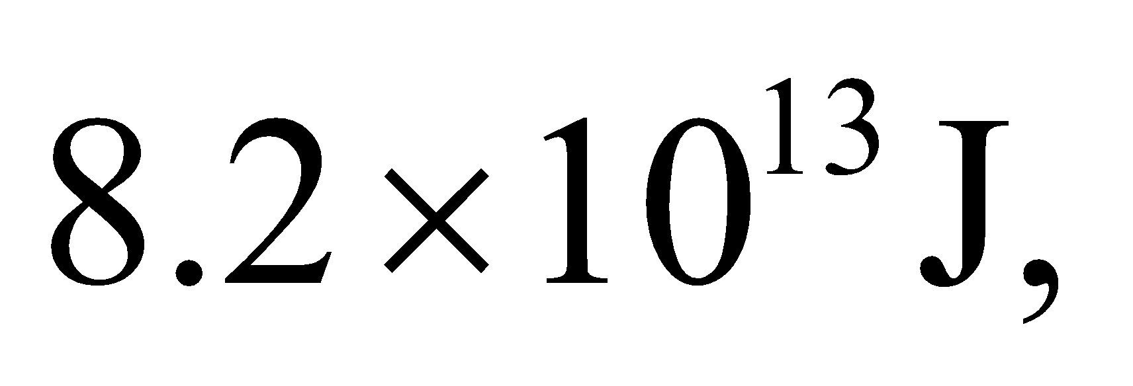 whereas a kilogram of gasoline has 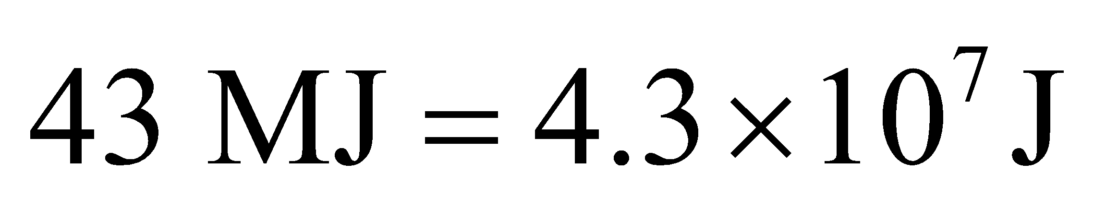 (see Appendix C).
55. Interpret We evaluate the energy levels of a quantum dot.
Develop A quantum dot is basically a three-dimensional square well. If we assume the qdot is a cube, the energy levels are given by Equation 35.8:
Evaluate The ground state has 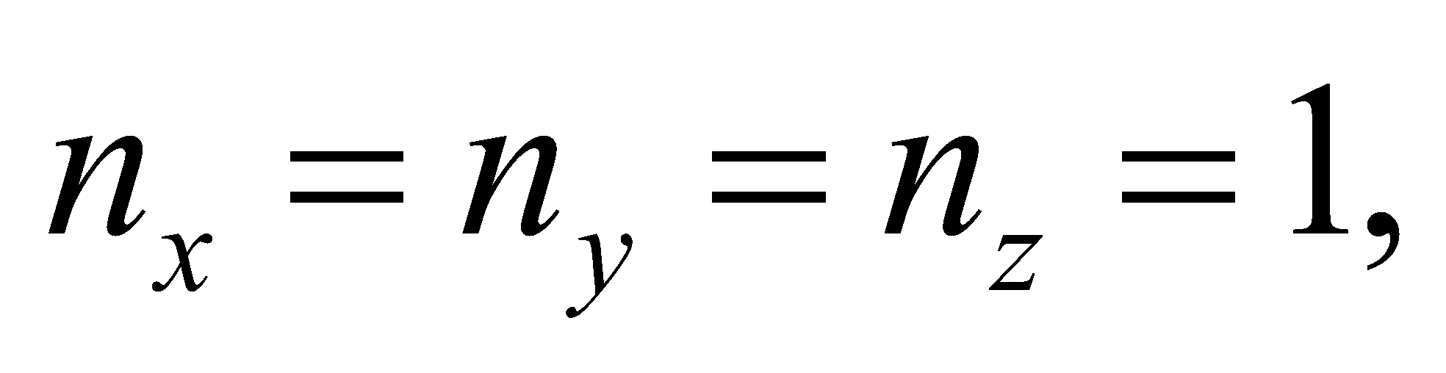whereas the first excited state has one of the n's equal to 2. The energy difference between the two states is
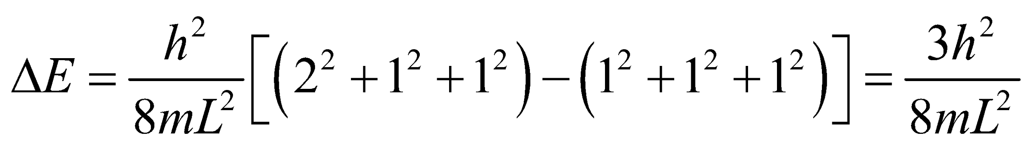
If the qdot decreases in size, the energy difference increases. The photon emitted when the qdot drops to its ground state will, therefore, have a smaller wavelength, since
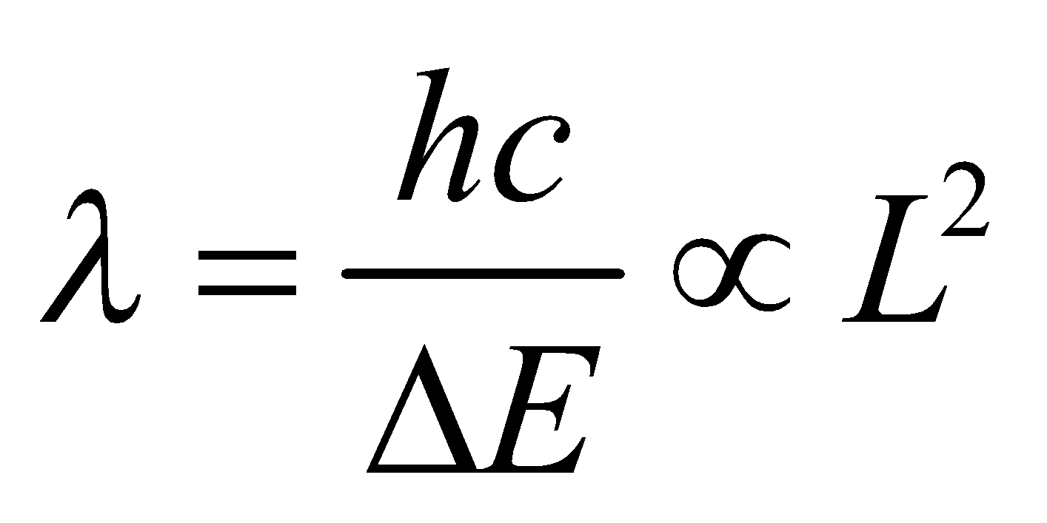
The answer is (b).
Assess The advantage of qdots is that they are like tunable atoms. You can essentially choose the wavelength at which it absorbs or emits by simply adjusting its size.
56. Interpret We evaluate the energy levels of a quantum dot.
Develop As was mentioned in the previous problem, a cubically symmetric qdot has a ground state given by 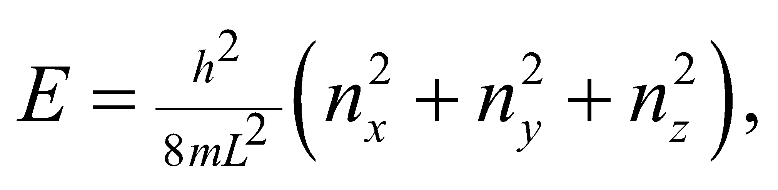where 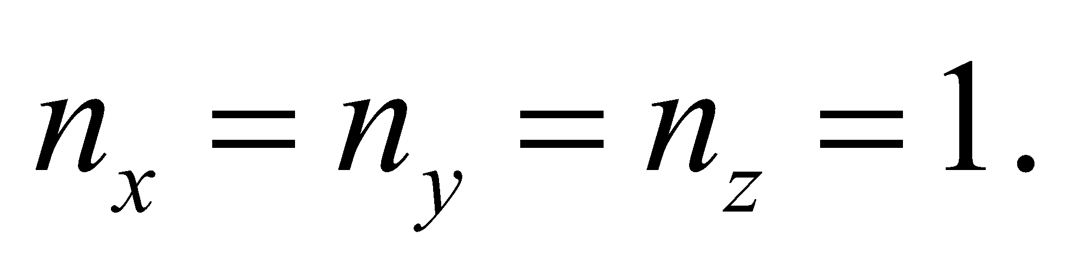 In other words, 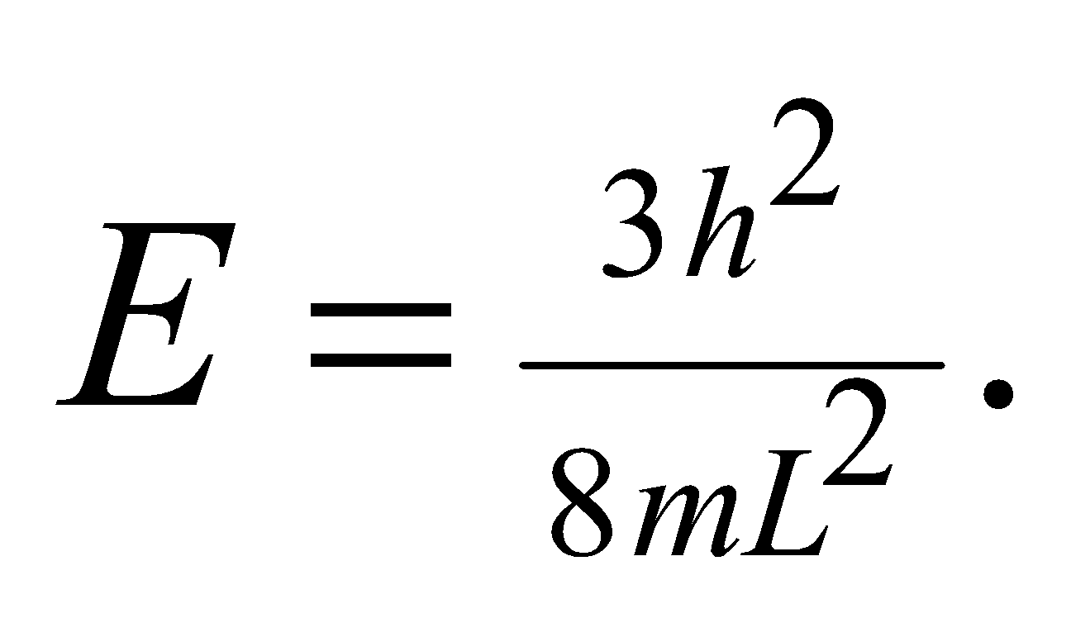
Evaluate There is only one ground state, since there are no ways to rearrange the n's of the three dimensions. Another way to say this is that the state is nondegenerate.
The answer is (a).
Assess The ground state could be degenerate when other quantum numbers are considered. As we'll learn in Chapter 36, the spin of an electron is specified by a quantum number, 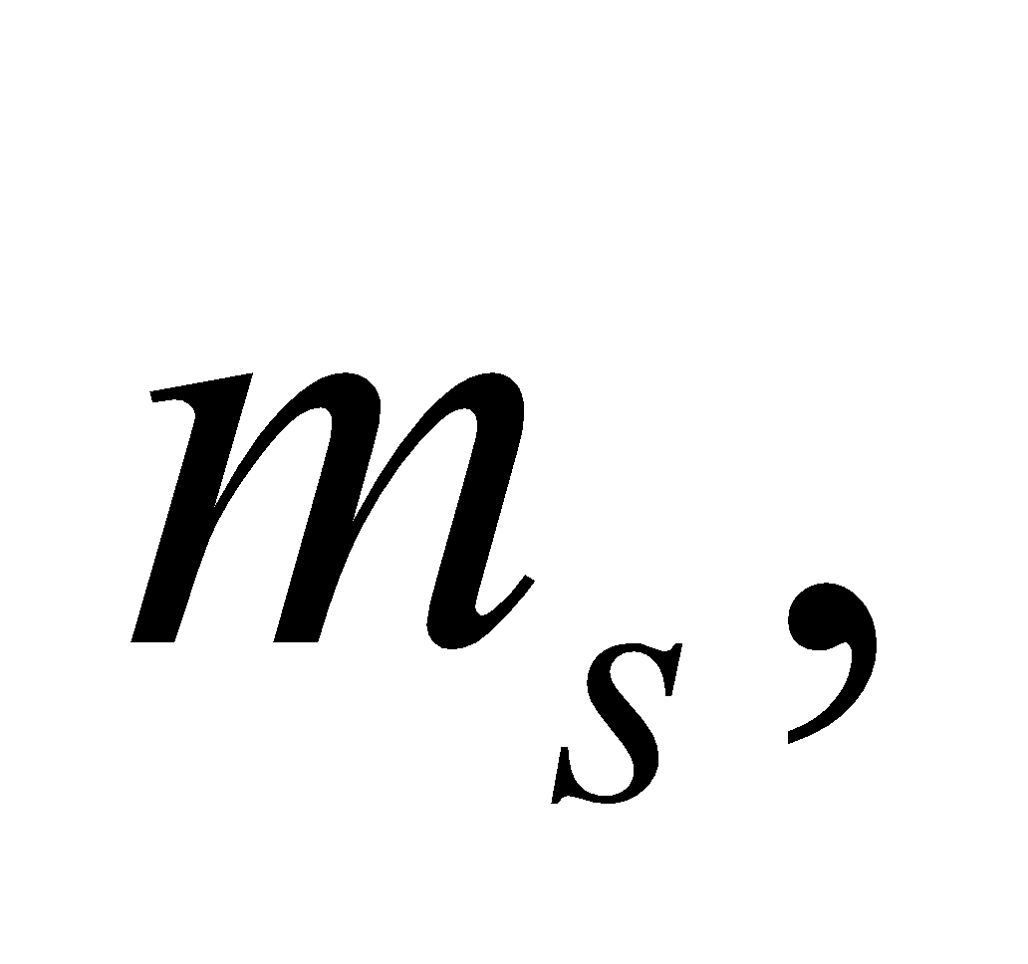which can be either +1/2 or –1/2. Assuming the spin doesn't affect the energy, the state with 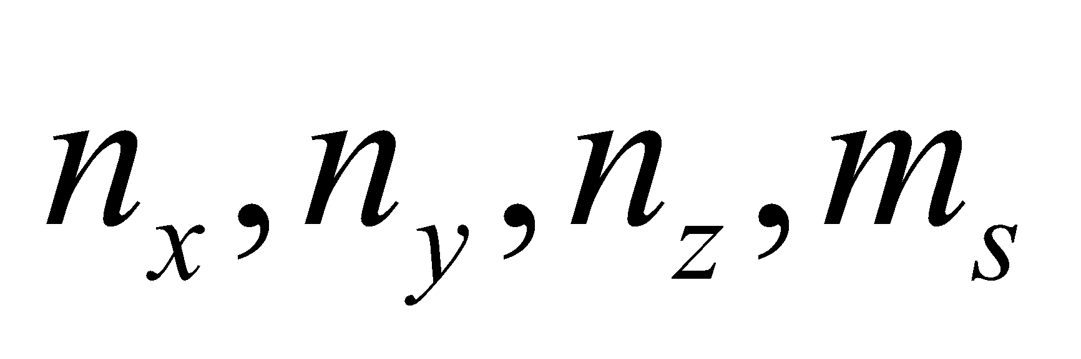 equal to 1,1,1,+1/2 is degenerate with the state with equal to 1,1,1,–1/2.
57. Interpret We evaluate the energy levels of a quantum dot.
Develop The first excited state of a cubically symmetric qdot has energy of where one of the three quantum numbers equals 2, while the other two equal 1.
Evaluate There are three states that have the energy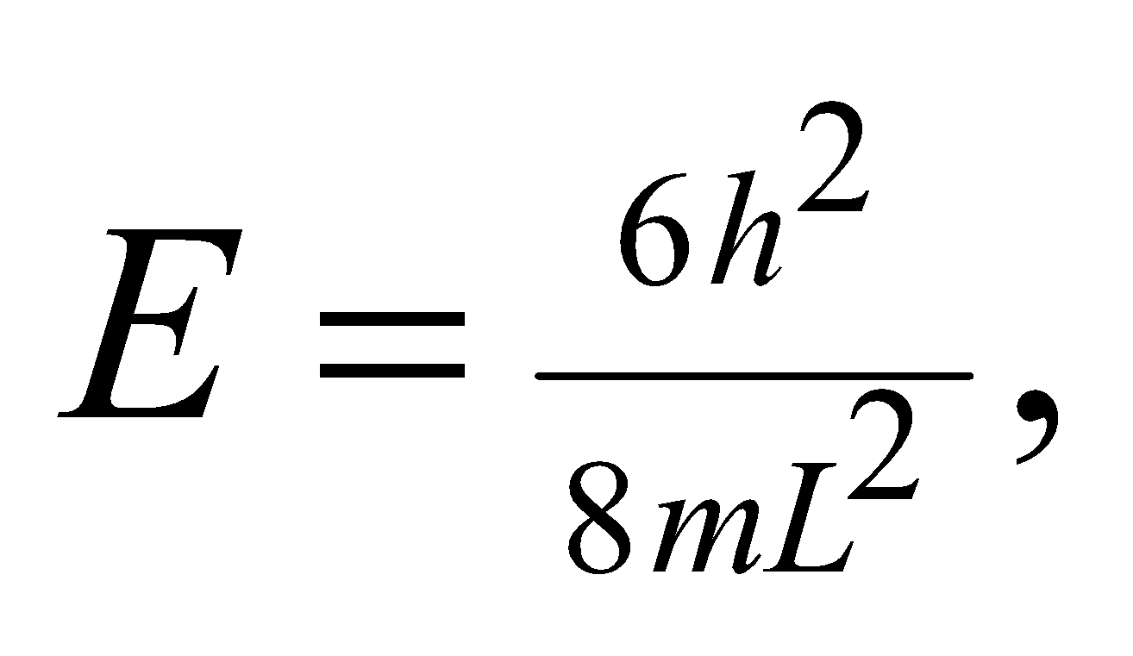 i.e., 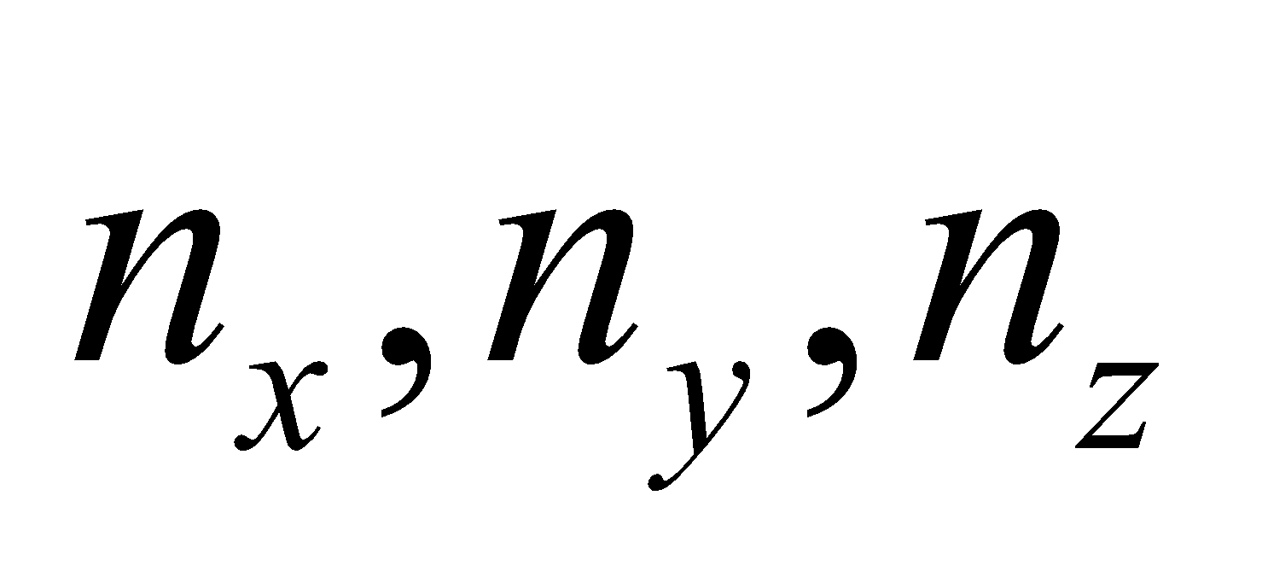 can equal 2,1,1 or 1,2,1 or 1,1,2. See Figure 35.17. We say this state is three-fold degenerate.
The answer is (c).
Assess Degeneracy often depends on there being some sort of symmetry. In this case, it is the symmetry of the cube. If the qdot's three sides were not equal, then the first excited state would nondegenerate.
58. Interpret We evaluate the energy levels of a quantum dot.
Develop For the general case of a quantum with sides of different length, the ground state energy is written as
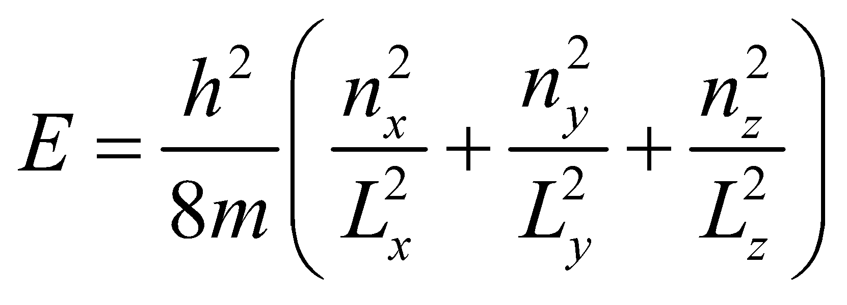
Evaluate If all three sides are reduced in length by half, then the ground state energy will increase by a factor of 4.
The answer is (d).
Assess The special case of a cubical qdot has 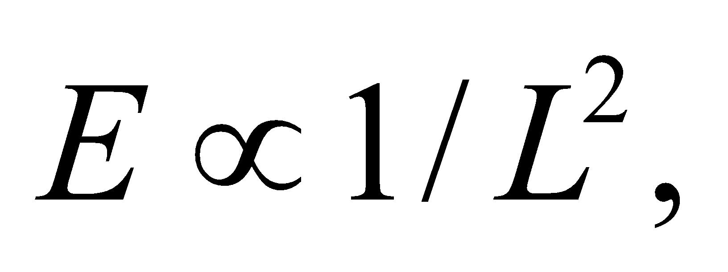 which clearly shows that the energy quadruples when the size of the cube shrinks by half.

