PARTICLES AND WAVES

34

Exercises
Section 34.2 Blackbody Radiation
15. Interpret This is a problem about blackbody radiation. We want to explore the connection between temperature and the radiated power.
Develop From the Stefan-Boltzmann law (Equation 34.1), 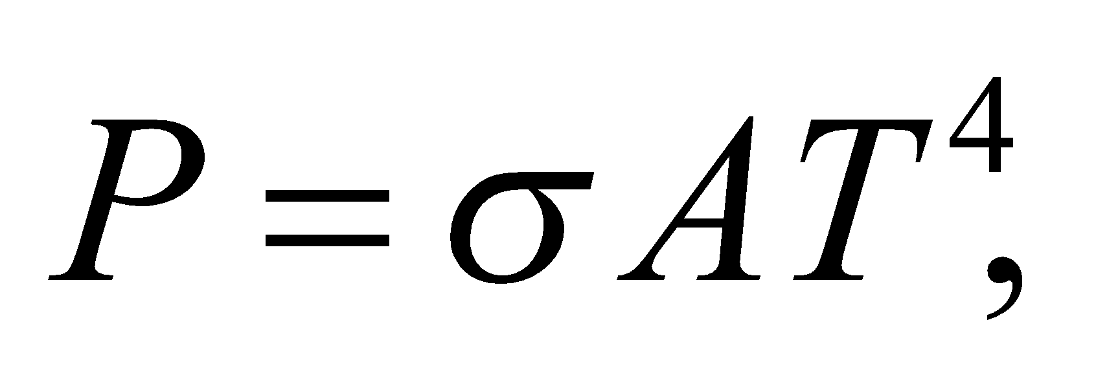 we see that the total radiated power, or luminosity, of a blackbody is proportional to T⁴.
Evaluate Doubling the absolute temperature increases the luminosity by a factor of 2⁴ = 16.
Assess A blackbody is a perfect absorber of electromagnetic radiation. As the temperature of the blackbody increases, its radiated power also goes up.
16. Interpret This problem explores black-body characteristics of a star. We are to find the power radiated, the peak emission wavelength, and the median emission wavelength of the star Rigel.
Develop To a good approximation, the surface of Rigel radiates like a blackbody, so the power radiated per unit area may be found from the Stefan-Boltzmann law (Equation 34.1), dividing both sides by the area A:
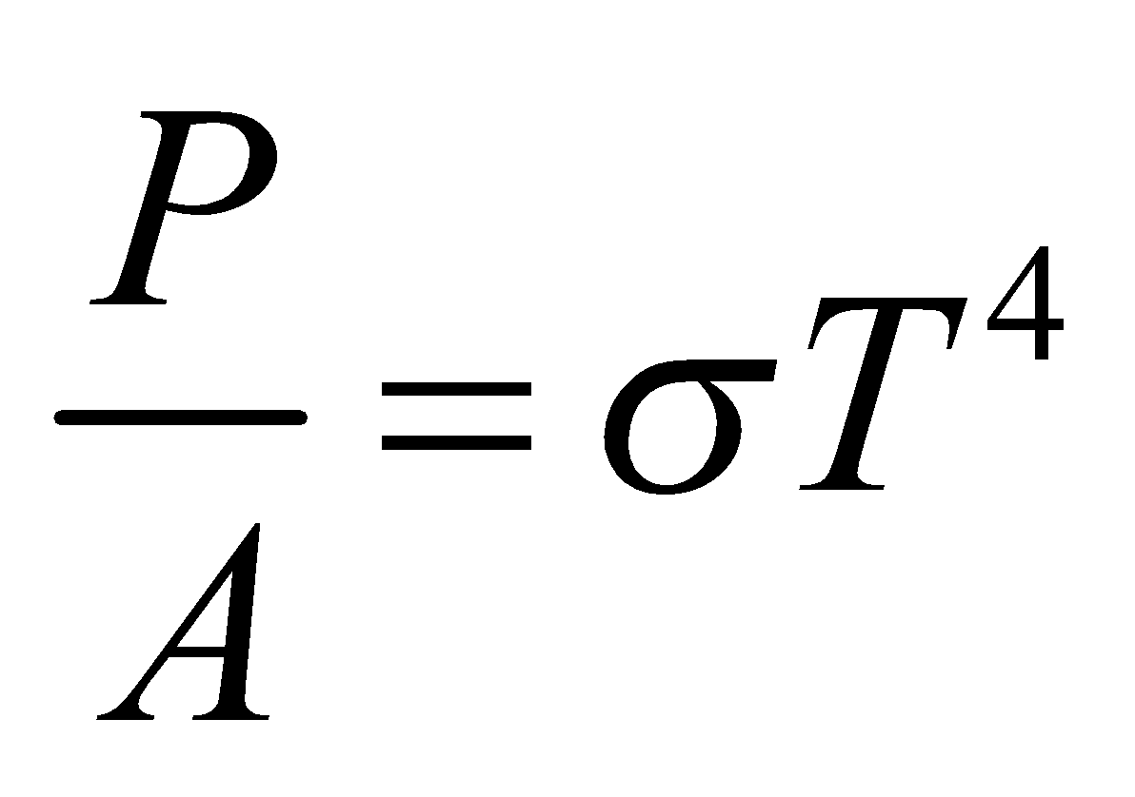
The peak and median wavelengths may be found from Equations 34.2a and 34.2b.
Evaluate (a) The power radiated per unit area is
(b) From Equation 34.2a, the peak wavelength is
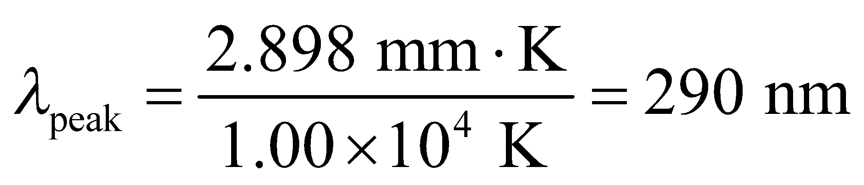
(c) From Equation 34.2b, the median wavelength is
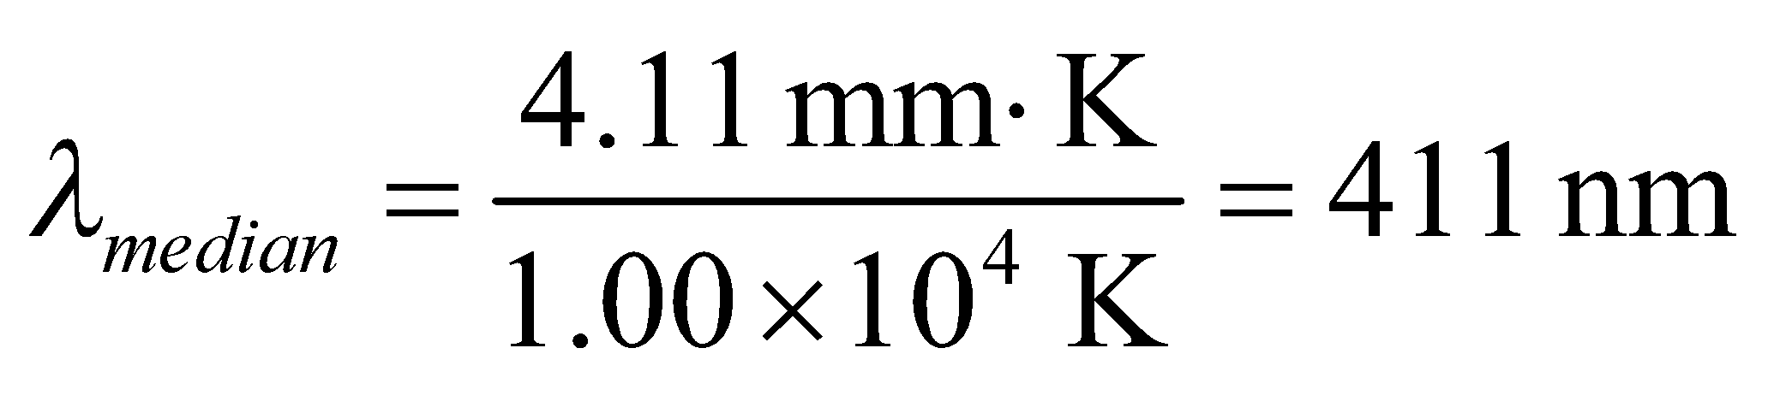
Assess The median wavelength is longer than the peak wavelength because of the long-wavelength tail of the temperature distribution (see Figure 34.2).
17. Interpret We are given the temperature of a blackbody (i.e., the Earth) and asked to find the wavelengths that correspond to peak radiance and median radiance.
Develop The wavelength at which a blackbody at a given temperature radiates the maximum power is given by Wien’s displacement law (Equation 34.2a):
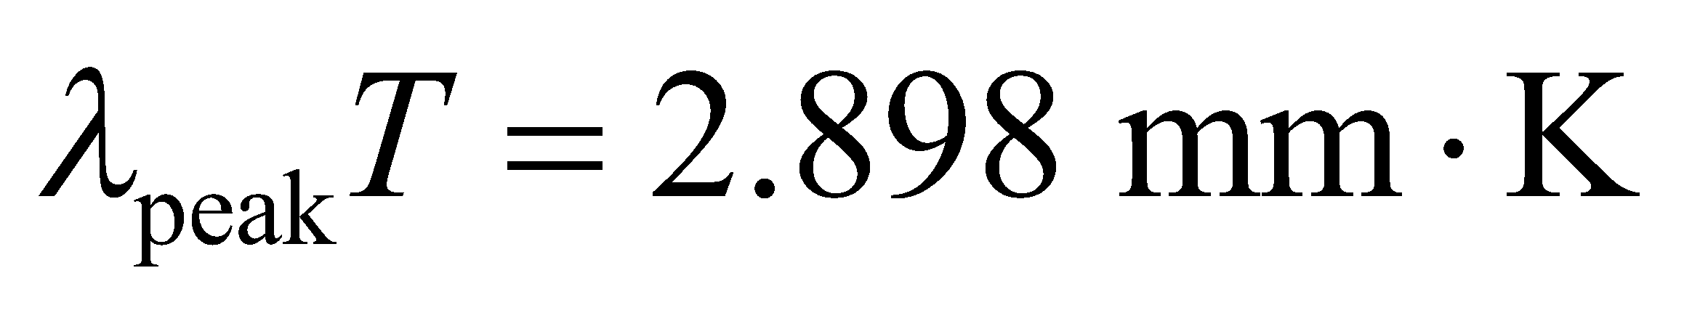
Similarly, the median wavelength, below and above which half the power is radiated, is given by Equation 34.2b:
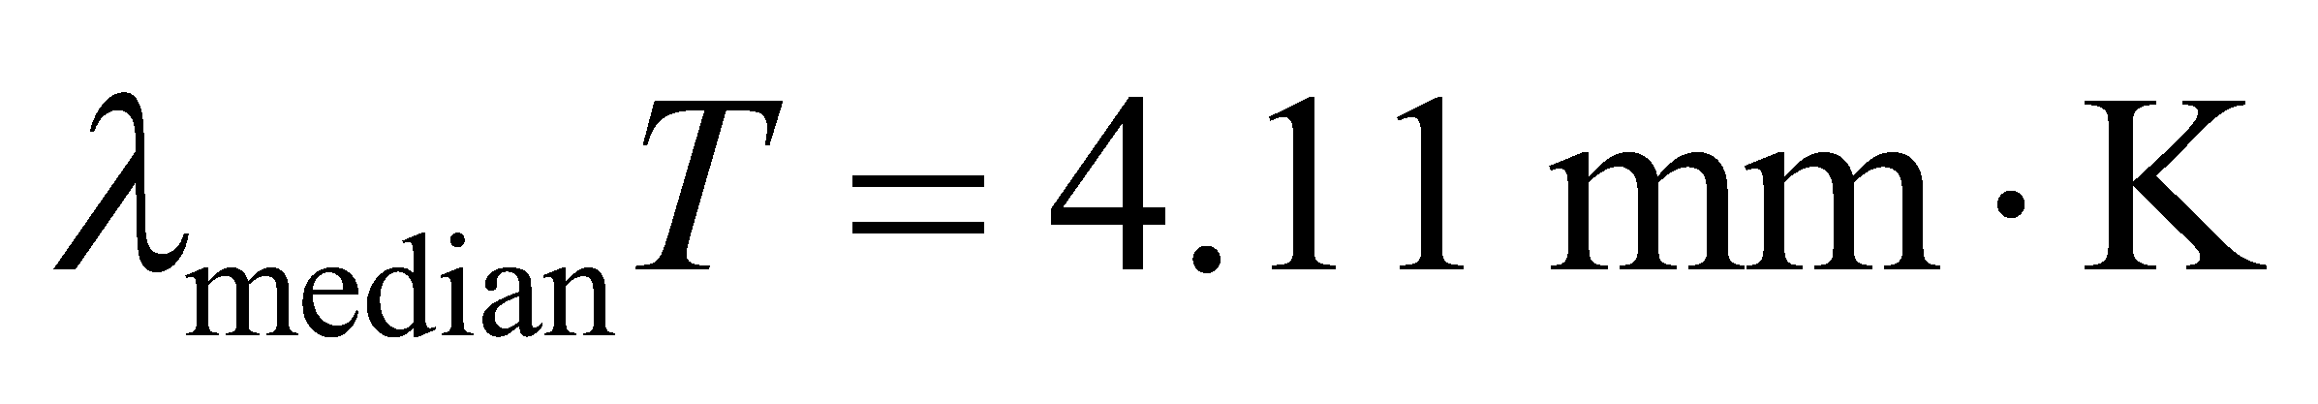
Evaluate Using the above formulas, we obtain
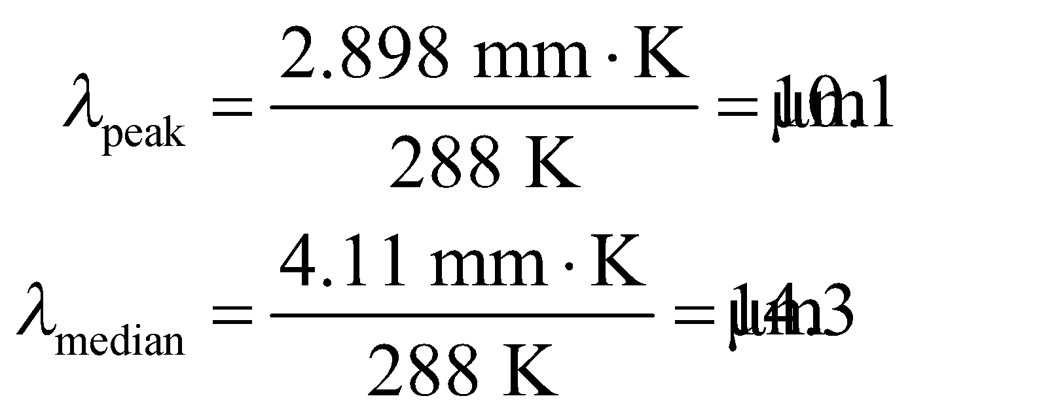
Assess The wavelengths are in the infrared. Note that 
18. Interpret This problem involves blackbody radiation. We are given the wavelength at which the peak power is emitted, and are asked to find the temperature.
Develop Apply Equation 34.2a
with λ_{peak} = 40 μm.
Evaluate The asteroid’s temperature is
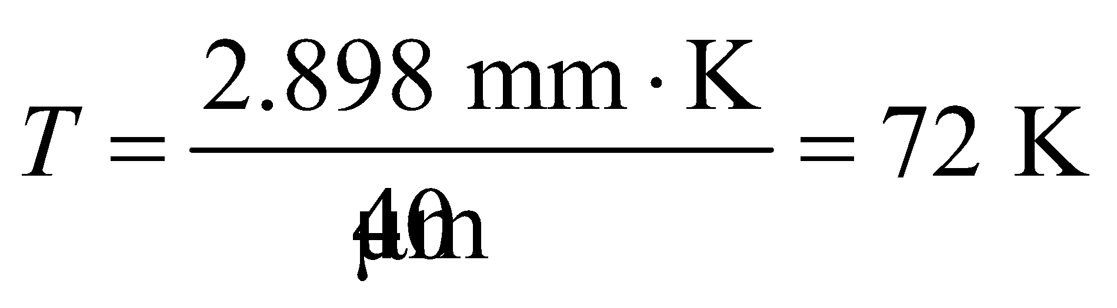
Assess This is a cold asteroid. According to NASA, the temperature of a typical asteroid in the asteroid belt is around 200 K.
19. Interpret We are to find the wavelength for the peak radiance of solar blackbody radiation, and the median wavelength. In both cases, we’ll use the per-unit-wavelength basis; Equations 34.2a and 34.2b.
Develop Wien’s law (Equation 34.2a) gives us the peak wavelength: 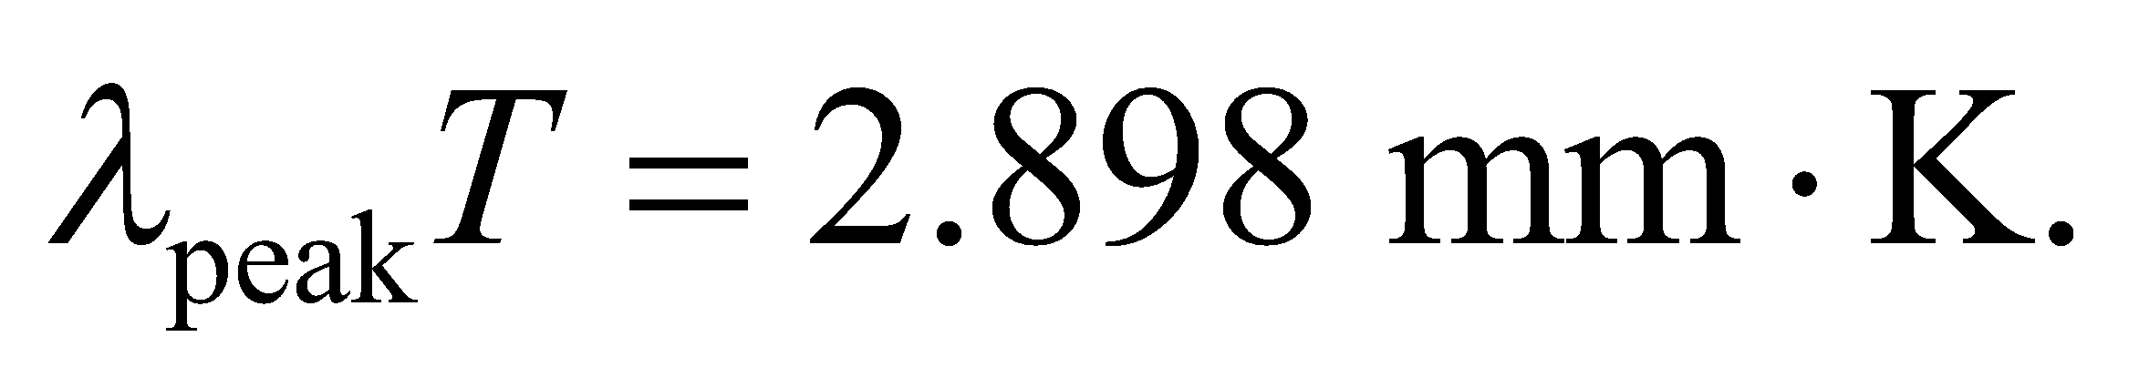 The median wavelength is given by Equation 34.2b:  The temperature of the Sun is T = 5800 K, so we can use these equations to solve for the respective wavelengths.
Evaluate Inserting the temperature gives
(a) 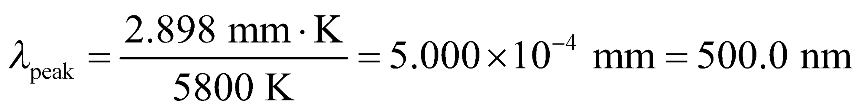
(b) 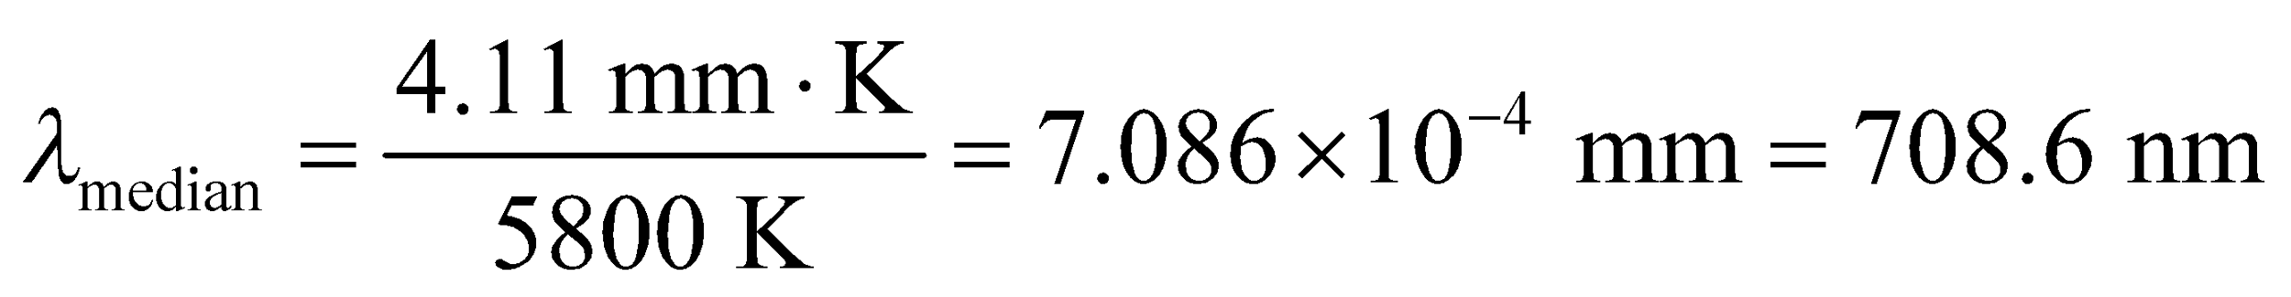
Assess The peak wavelength is near the center of the visible spectrum (green) and the median wavelength is just beyond the visible in the near-infrared region.
Section 34.3 Photons
20. Interpret This problem explores the connection between frequency and energy. We are given the frequency of photons and are asked to find the energy in electron volts (eV).
Develop Apply Equation 34.6, E = hf.
Evaluate (a) For f = 1.0 MHz,
(b) For f = 5.0 × 10¹⁴ Hz,
(c) For f = 3.0 × 10¹⁸ Hz,
Assess The energy for the photon of part (a) corresponds roughly to radio frequencies, that for part (b) is visible light, and that for part (c) is X-ray radiation.
21. Interpret We're asked to express the range of human eye sensitivity in terms of photon energies.
Develop The photon energy is given by Equation 34.6: 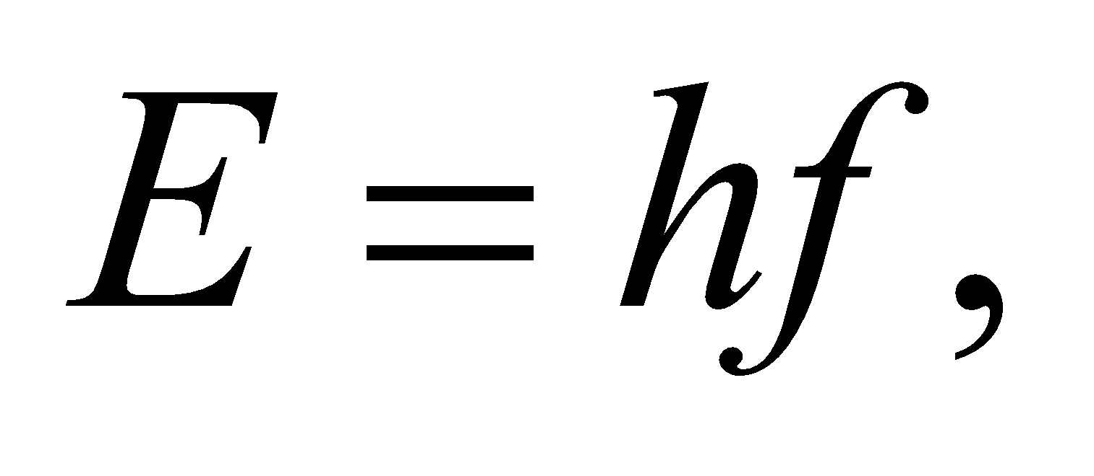 or in terms of wavelength: 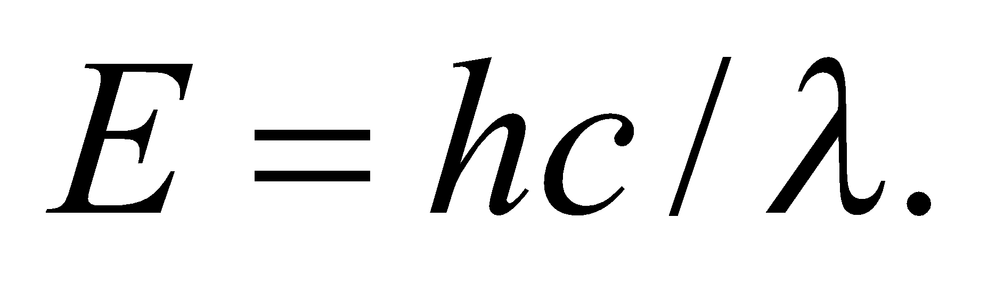
Evaluate The limits of human eye sensitivity are
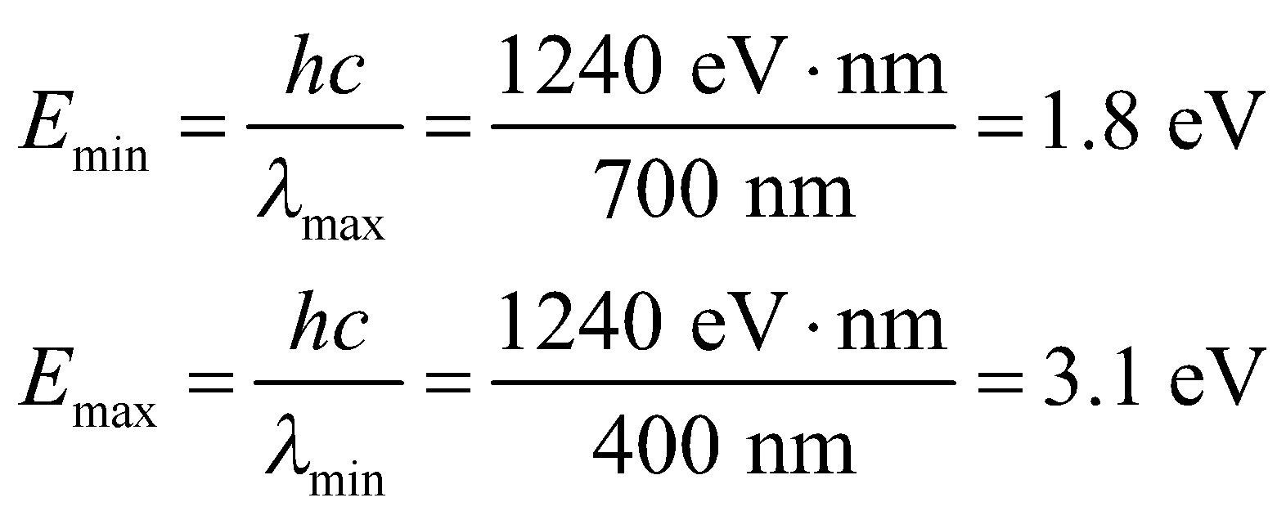
Assess We've used the common shorthand of 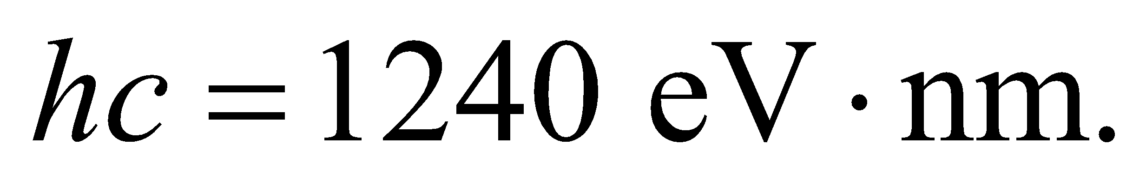
22. Interpret We are to find the energy of the photons produced by a microwave oven and the rate at which they are produced for a 900-W oven.
Develop Apply Equation 34.6, E = hf to find the photon energy E. To find the photon production rate, divide the oven power by the photon energy (in joules).
Evaluate (a) For f = 2.4 GHz, .
(b) The photon production rate is
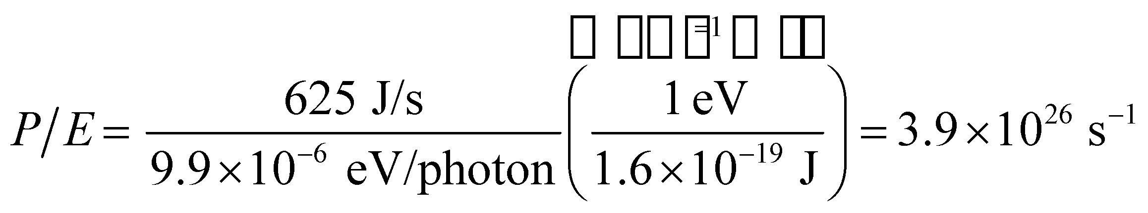
Assess The production rate is quite large because the photon energy is quite small.
23. Interpret The problem asks for a comparison of the power output by a red laser and a blue laser. The lasers emit photons at the same rate, but the photon energy of each laser is different.
Develop Using λ = c/f and Equation 34.6, E = hf, the ratio of the photon energies is
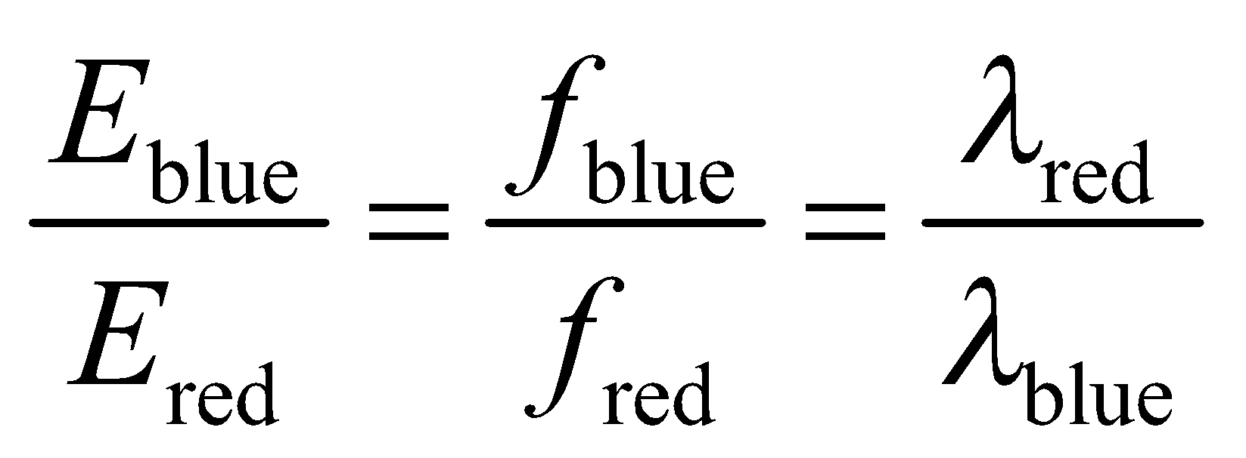
Evaluate Using the above equation, the ratio of the energies is
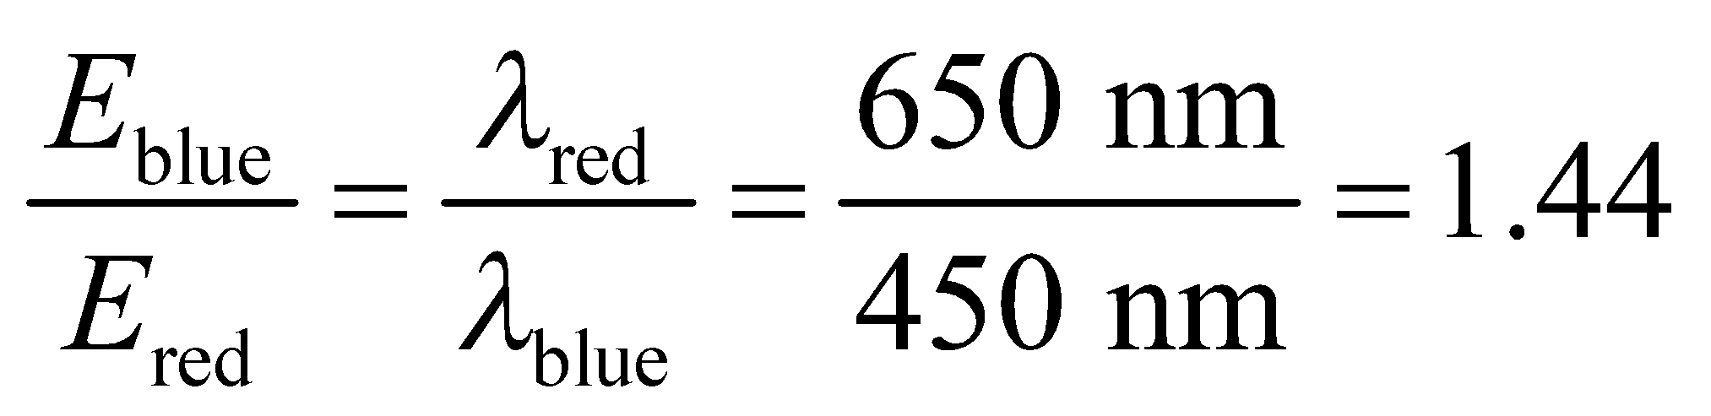
Since the lasers emit photons at the same rate, this is also the ratio of their power outputs. Thus the power of the blue laser is 1.44 times that of the red laser.
Assess Blue lasers, with shorter wavelength (higher frequency), are more energetic than red lasers.
24. Interpret We are to find the minimum work function that would allow photons to be ejected by 900-nm light.
Develop Equation 34.7 K_{max} = hf − φ gives the maximum kinetic energy for electrons ejected by light at a frequency f from a material with a work function φ. Use c = λf to convert this to a function of wavelength. The result is
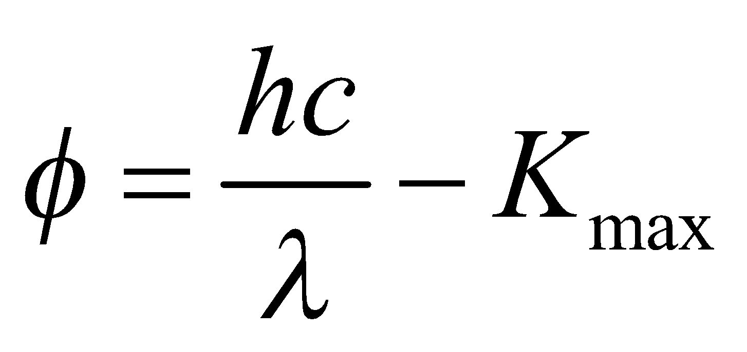
The minimum work function occurs for K_{max} = 0.
Evaluate For K_{max} = 0, the work function is .
Assess The work function for many materials is greater than this, so 900-nm light would not be able to eject electrons from these materials.
Section 34.4 Atomic Spectra and the Bohr Atom
25. Interpret This problem is about the energy levels of a hydrogen atom using the Bohr model. We are interested in the wavelengths of the first three lines in the Lyman series.
Develop The wavelength can be calculated using Equation 34.9:
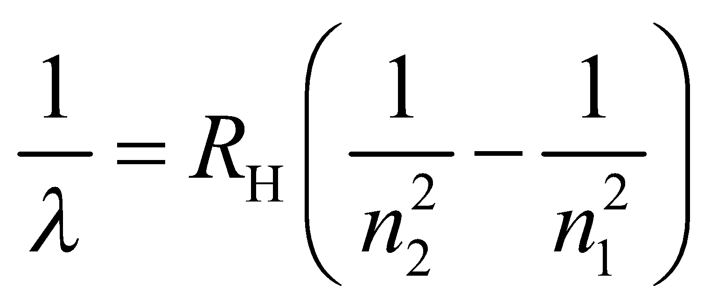
where 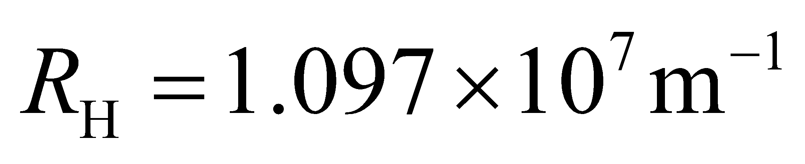 is the Rydberg constant and 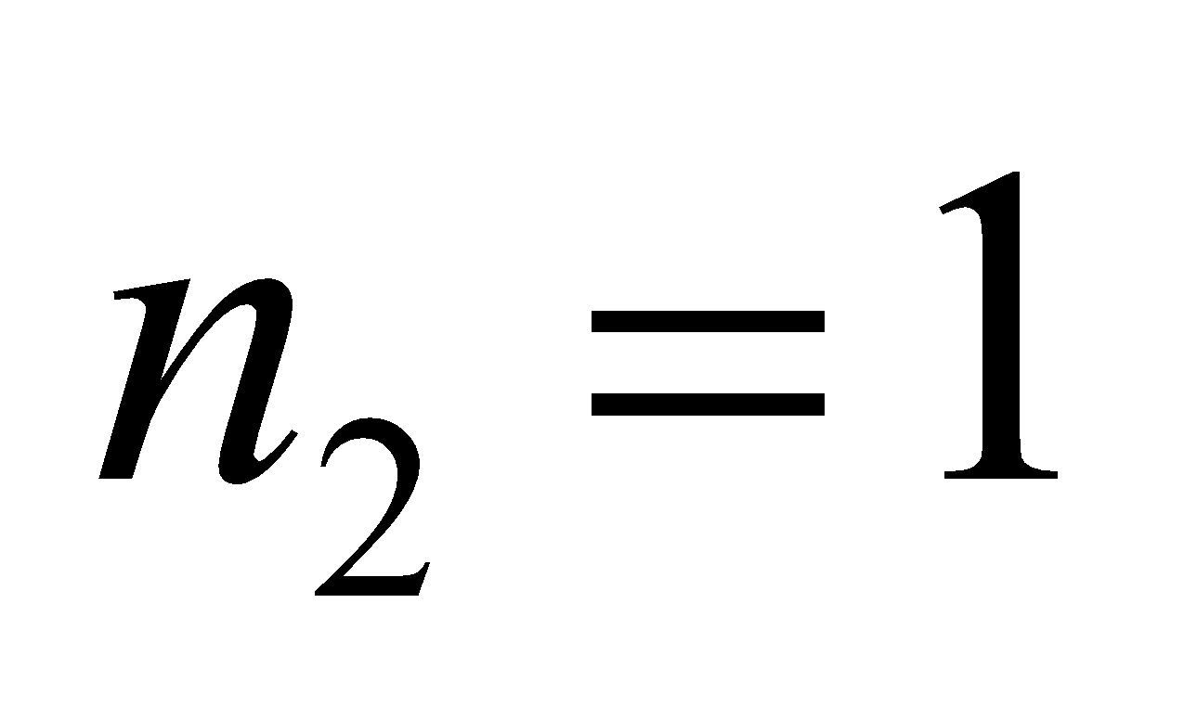 for the Lyman series.
Evaluate The first three lines correspond to 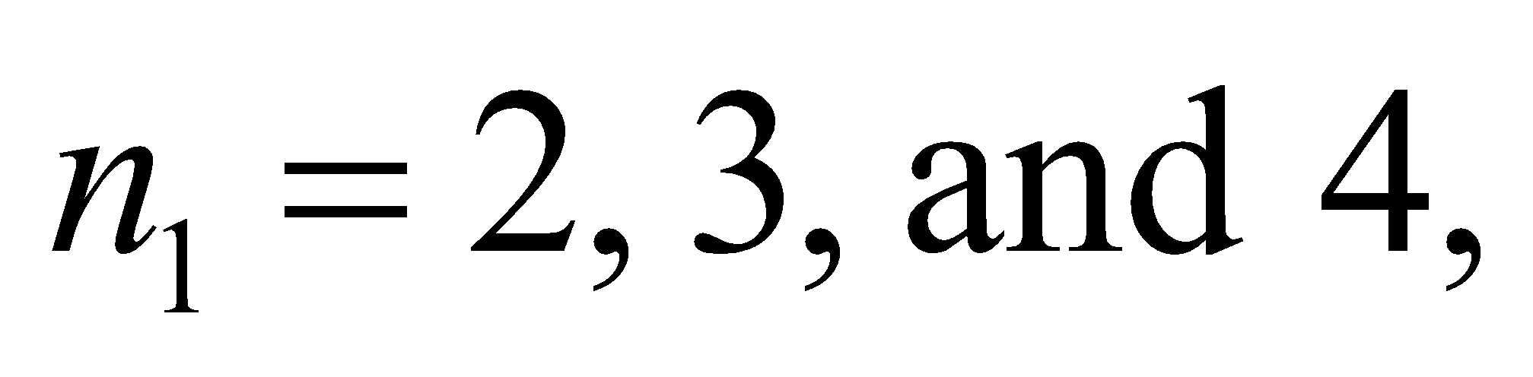 and the wavelengths are, respectively,
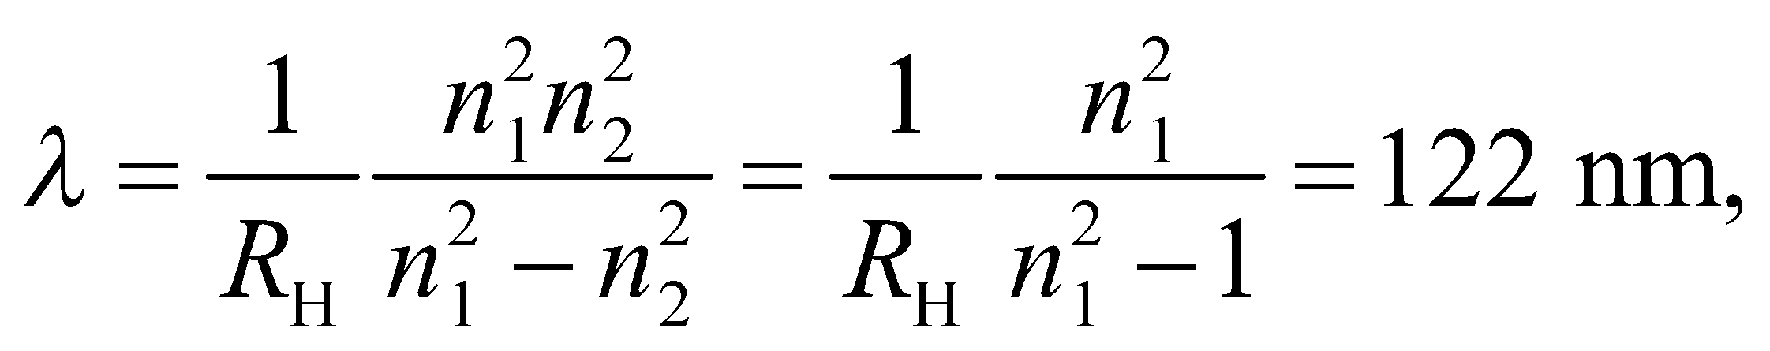103 nm, and 97.2 nm
Note that 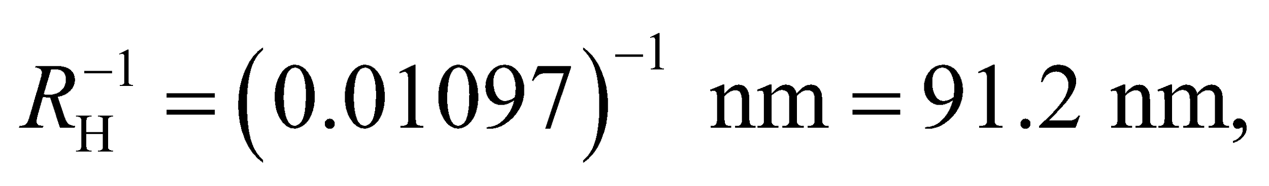 which is the Lyman series limit.
Assess The wavelengths are less than 400 nm. Therefore, the Lyman spectral lines are in the ultraviolet regime.
26. Interpret This problem involves finding the spectral line in the Paschen series that corresponds to the wavelength 1282 nm.
Develop The wavelengths in the Paschen series for hydrogen are given by Equation 34.9, with 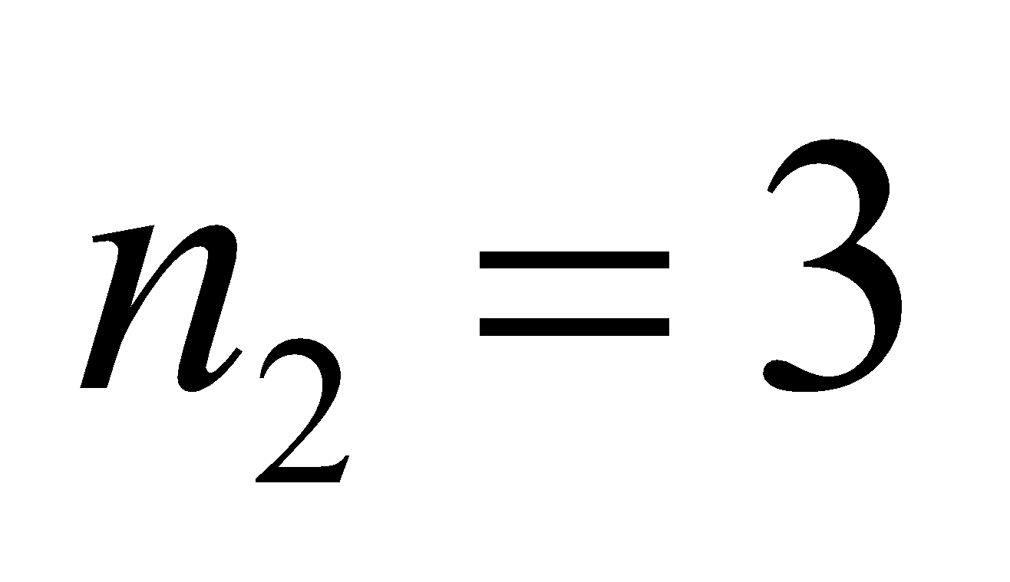 and
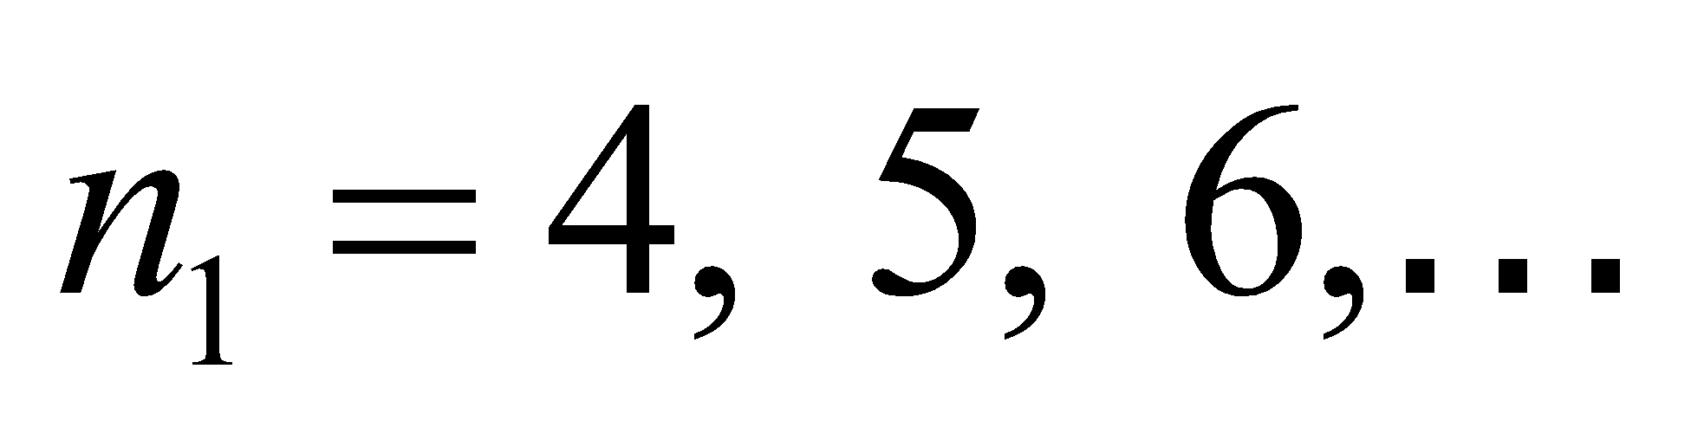, which gives
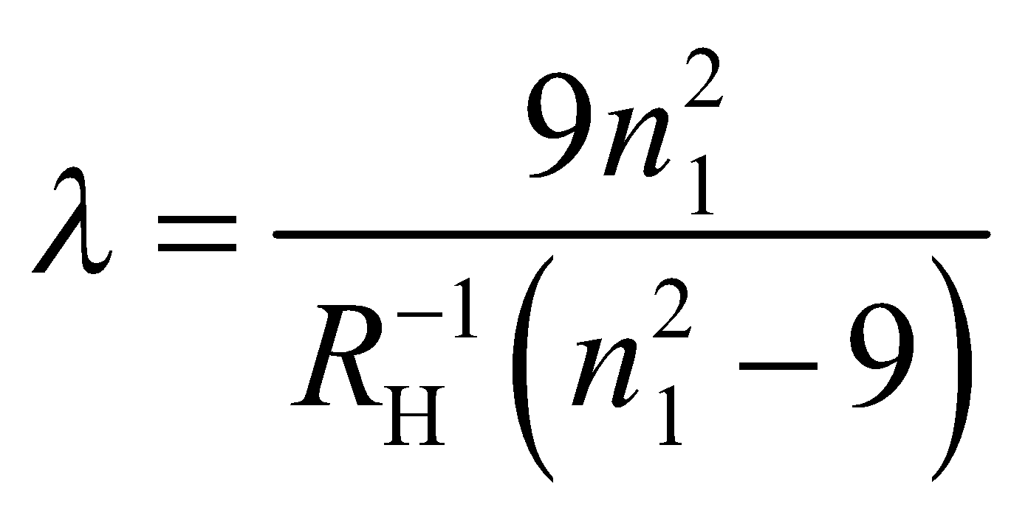
Evaluate With 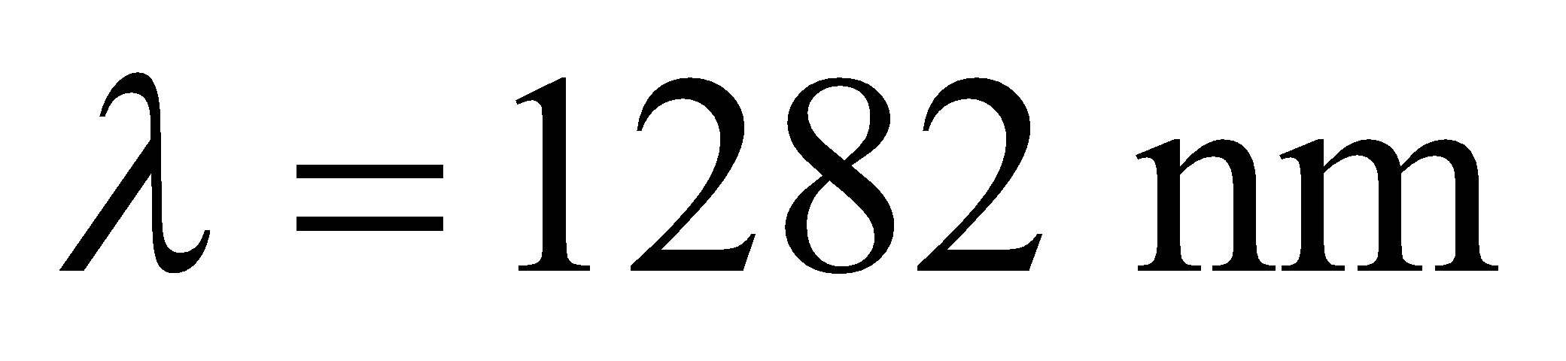 and 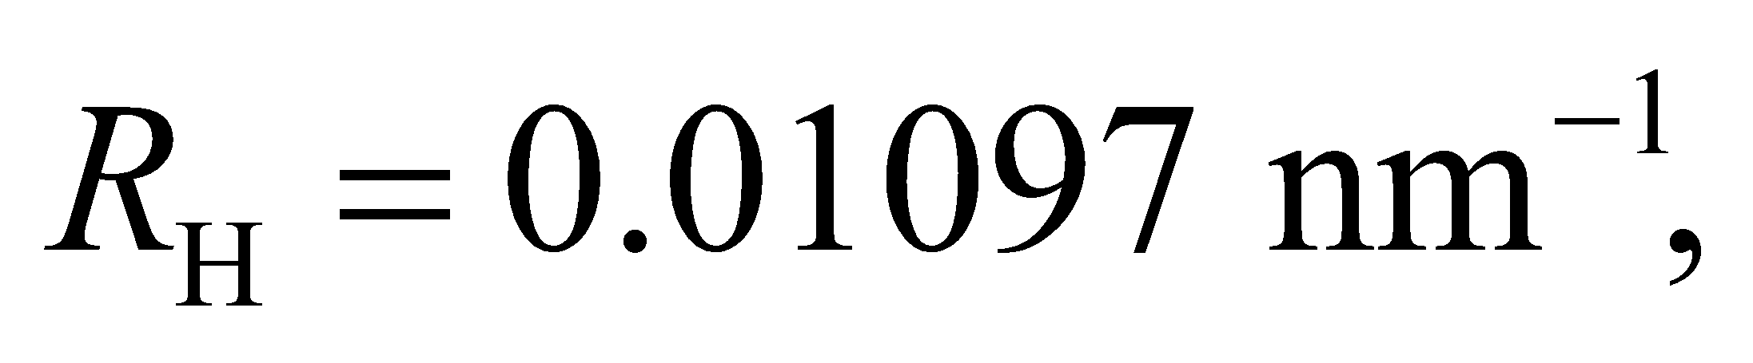 one finds
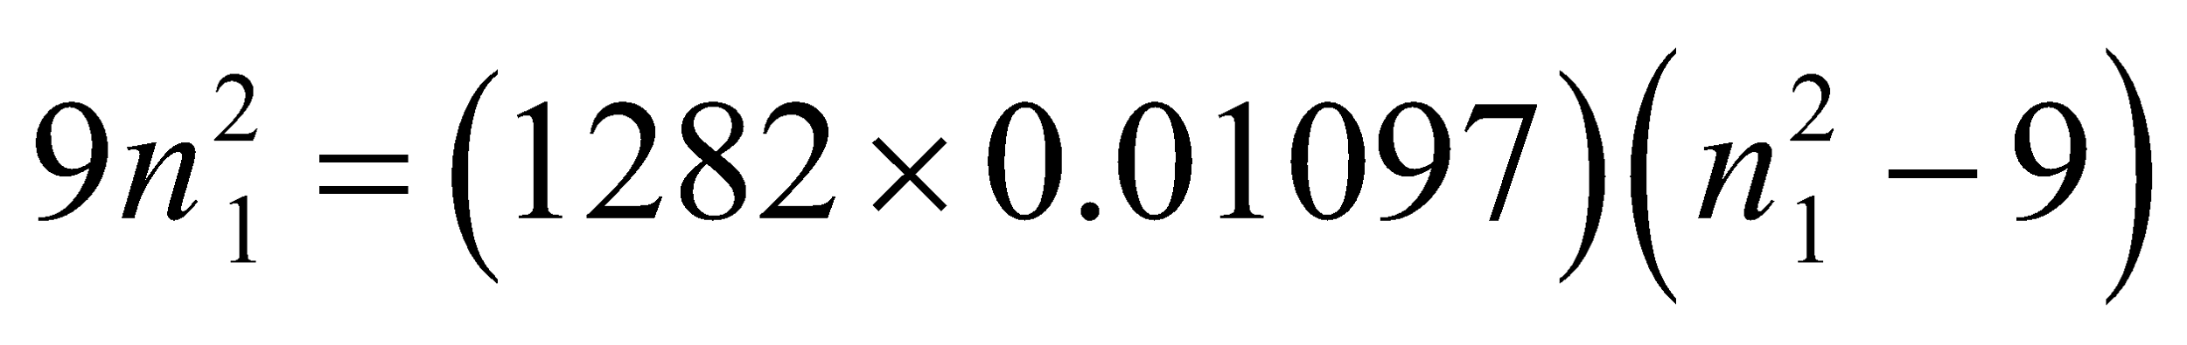
or
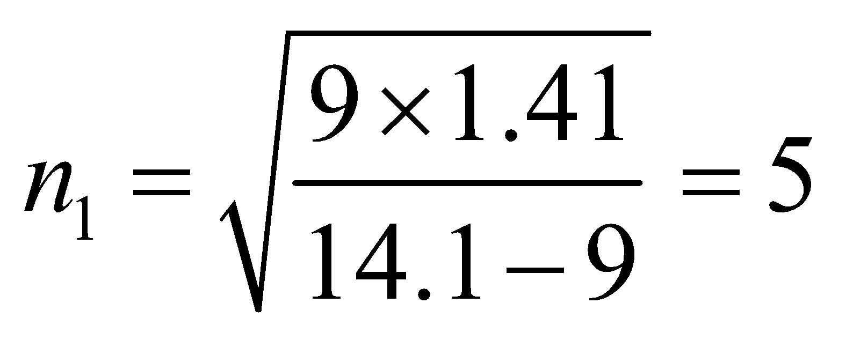
which corresponds to the second line in this series.
Assess The wavelength 1282 nm is in the infrared portion of the spectrum.
27. Interpret This problem is about the ionization energy of a hydrogen atom in its ground state. We want to find the wavelength that corresponds to a photon carrying this much energy.
Develop The energy of the ground state of hydrogen is given by Equation 34.12b (with n = 1): 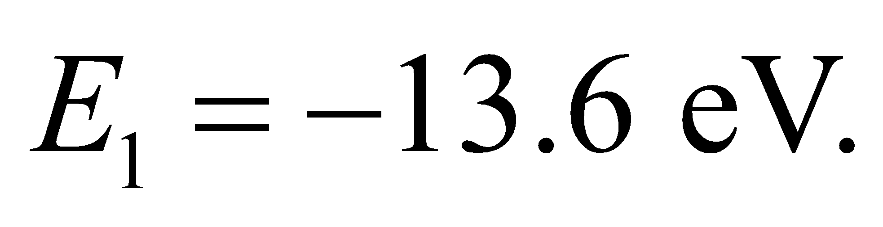 Therefore, the ionization energy is 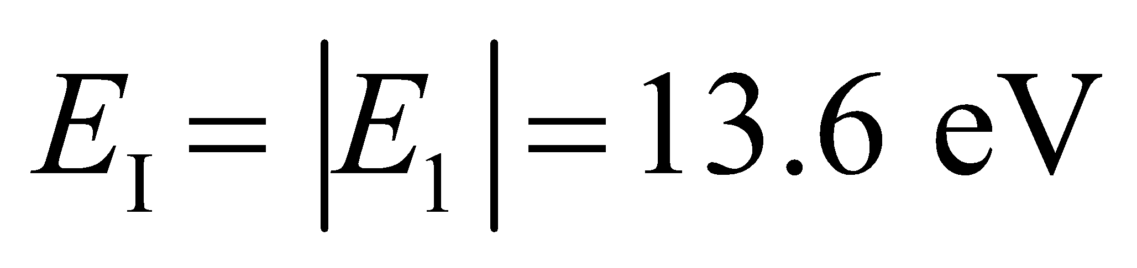 (the subscript “I” is for ionization). For a photon whose wavelength is λ, the energy it carries is (Equation 34.6) 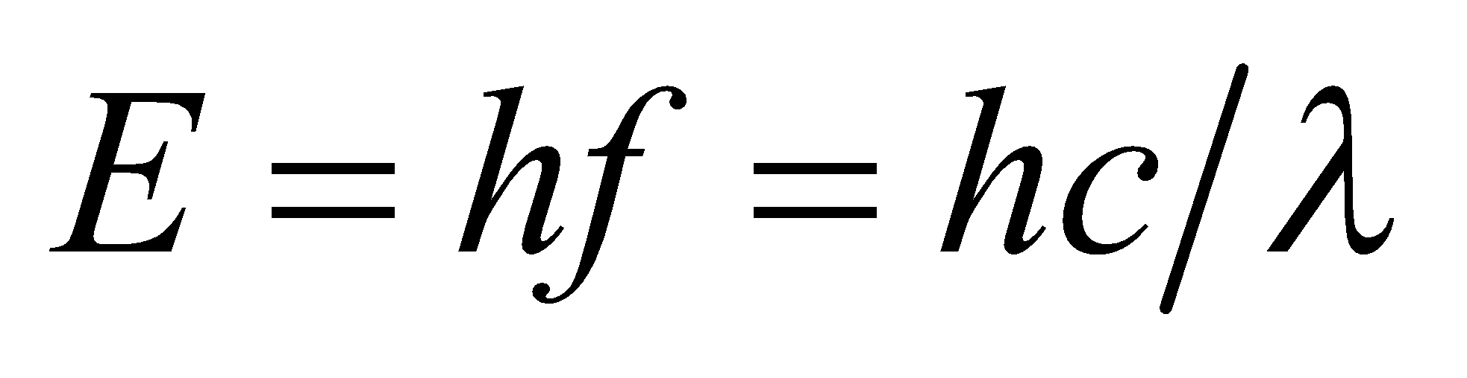.
Evaluate A photon with energy 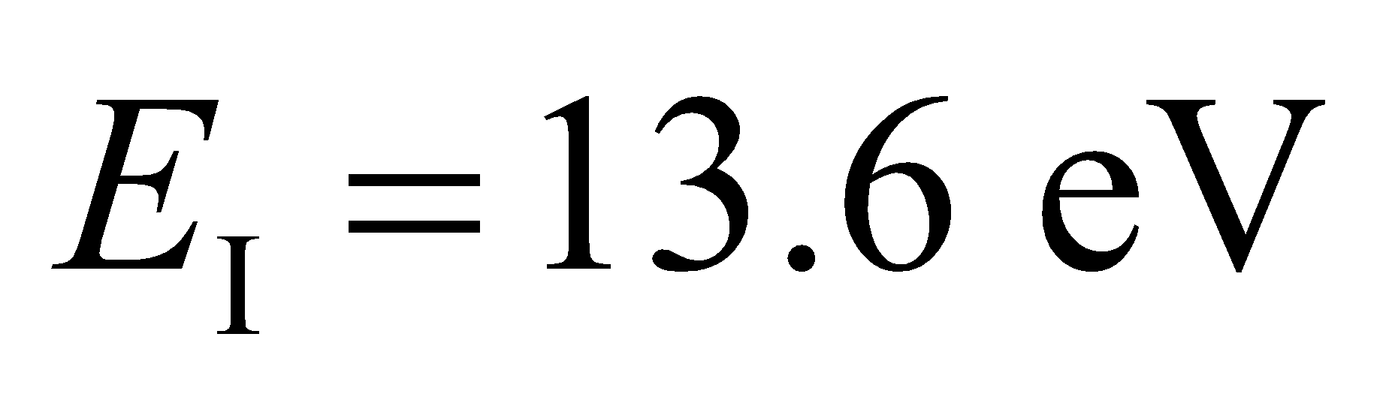 has wavelength
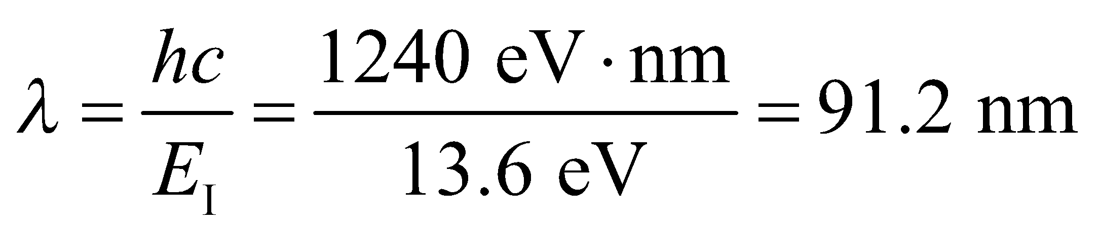
Assess This is the same as the Lyman series limit (Equation 34.9 with and 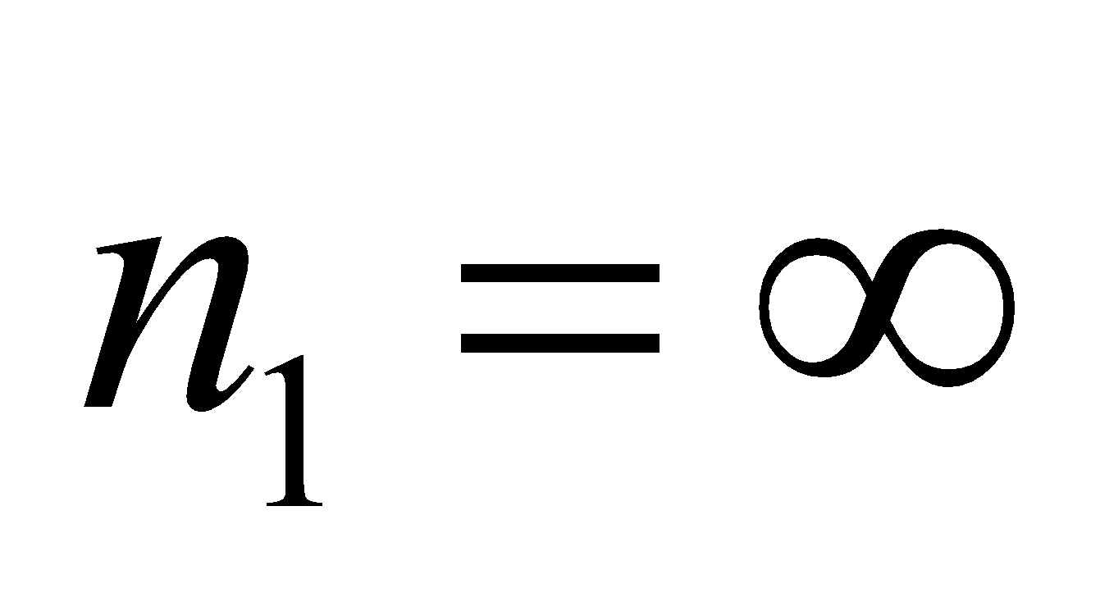) 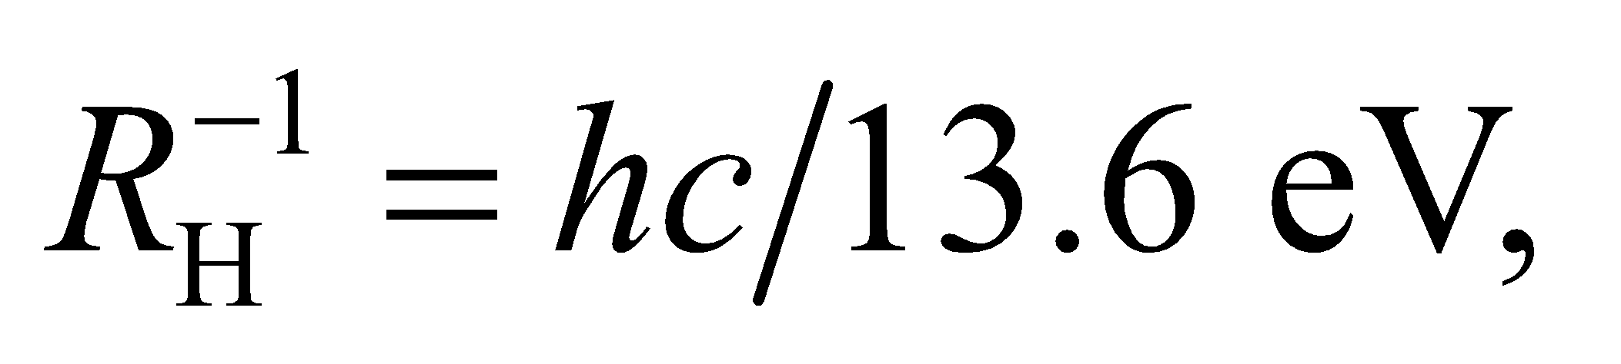 and lies in the ultraviolet.
28. Interpret We are to find the energy level of a Bohr hydrogen atom that has a diameter of 5.18 nm.
Develop The diameter of a hydrogen atom in the Bohr model is (Equation 34.13)
so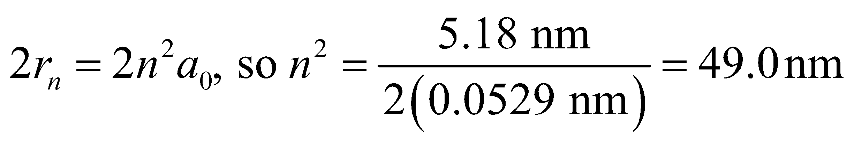
or n = 7.
Evaluate This is the sixth excited state.
Assess The radius of this state is two orders of magnitude larger than that of the ground state.
Section 34.5 Matter Waves
29. Interpret In this problem, we are asked to find the de Broglie wavelength of the Earth orbiting the Sun and an electron moving at the given speed.
Develop For nonrelativistic momentum, Equation 34.14 becomes
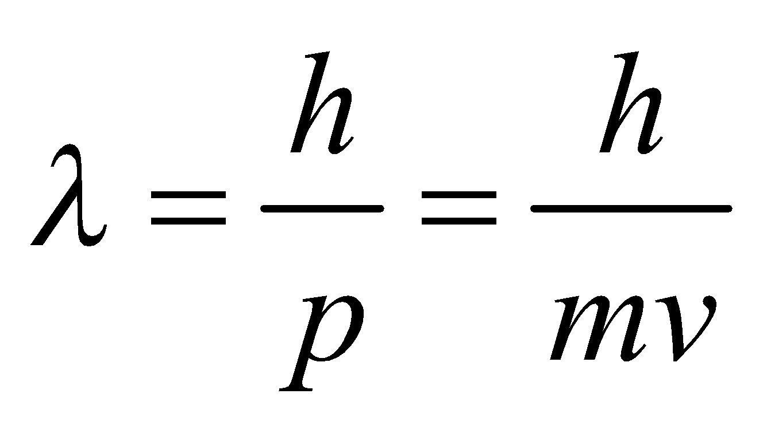
Evaluate (a) Using the orbital speed given and the Earth’s mass from Appendix E gives
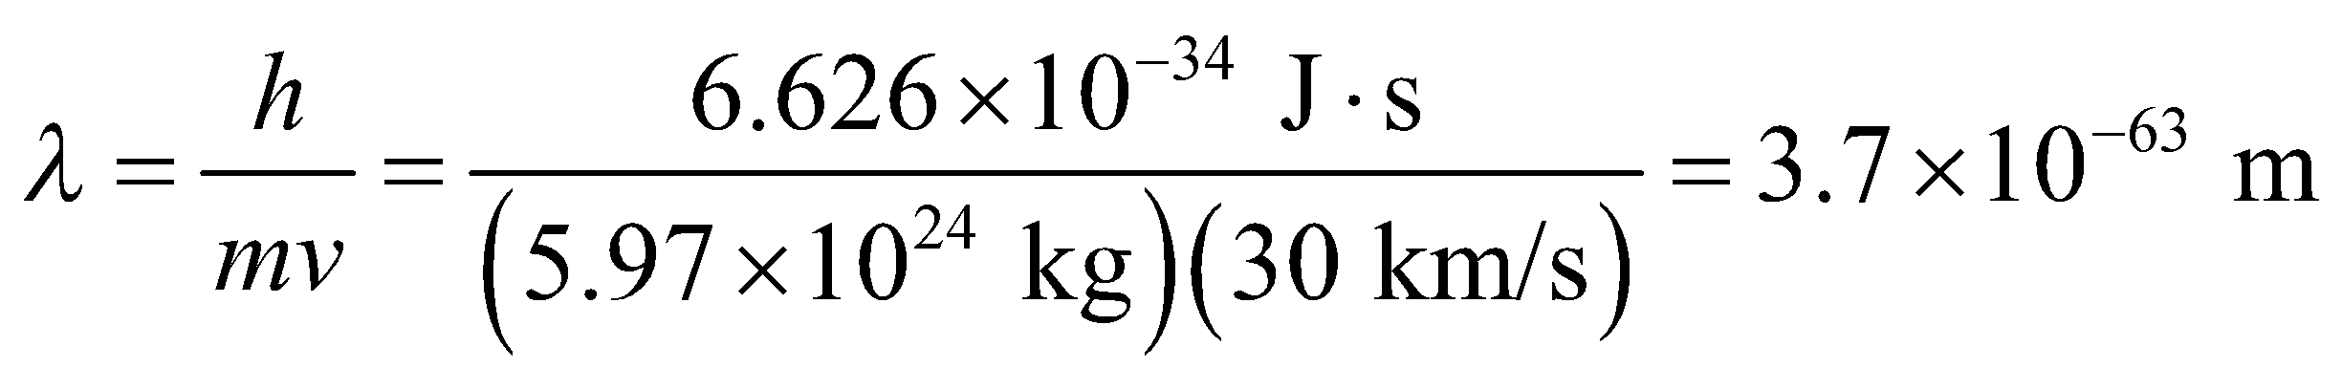
(b) For the given electron,
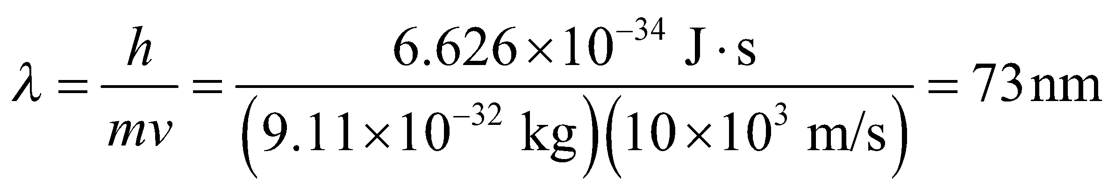
Assess The Earth’s de Broglie wavelength is much smaller than the smallest physically meaningful distance.
30. Interpret This problem involves finding the momentum of an electron with the given de Broglie wavelength.
Develop For a nonrelativistic electron 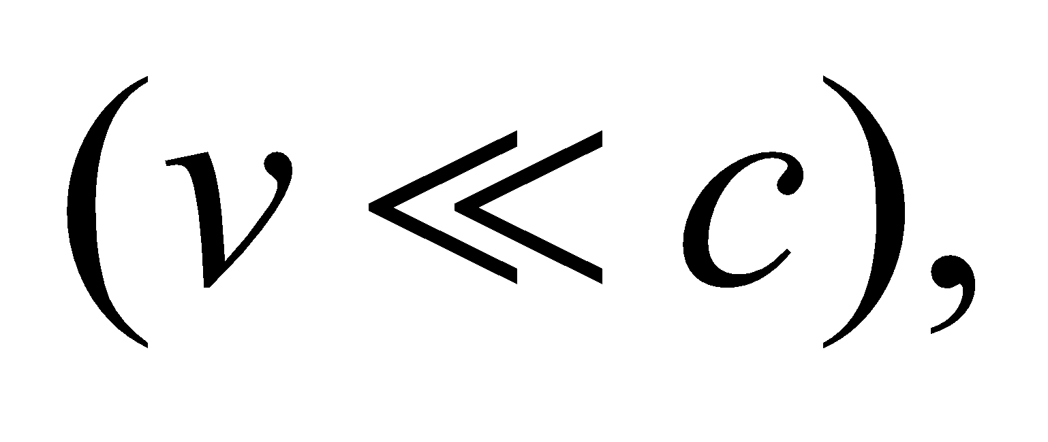 we can use the classical expression p = mv for momentum. The de Broglie wavelength is then λ = h/(mv).
Evaluate Solving for velocity gives
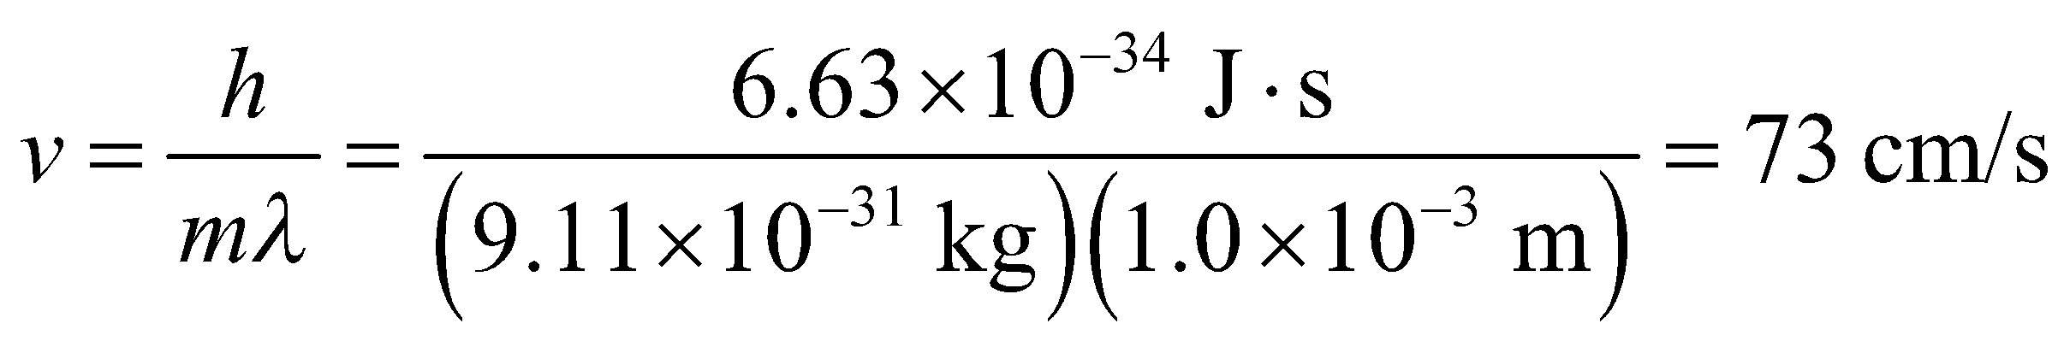
Assess This velocity is far less than the speed of light, so we were justified in using the classical expression for momentum.
31. Interpret The problem asks what relative speed must an electron have in order to have the same de Broglie wavelength as a proton.
Develop Since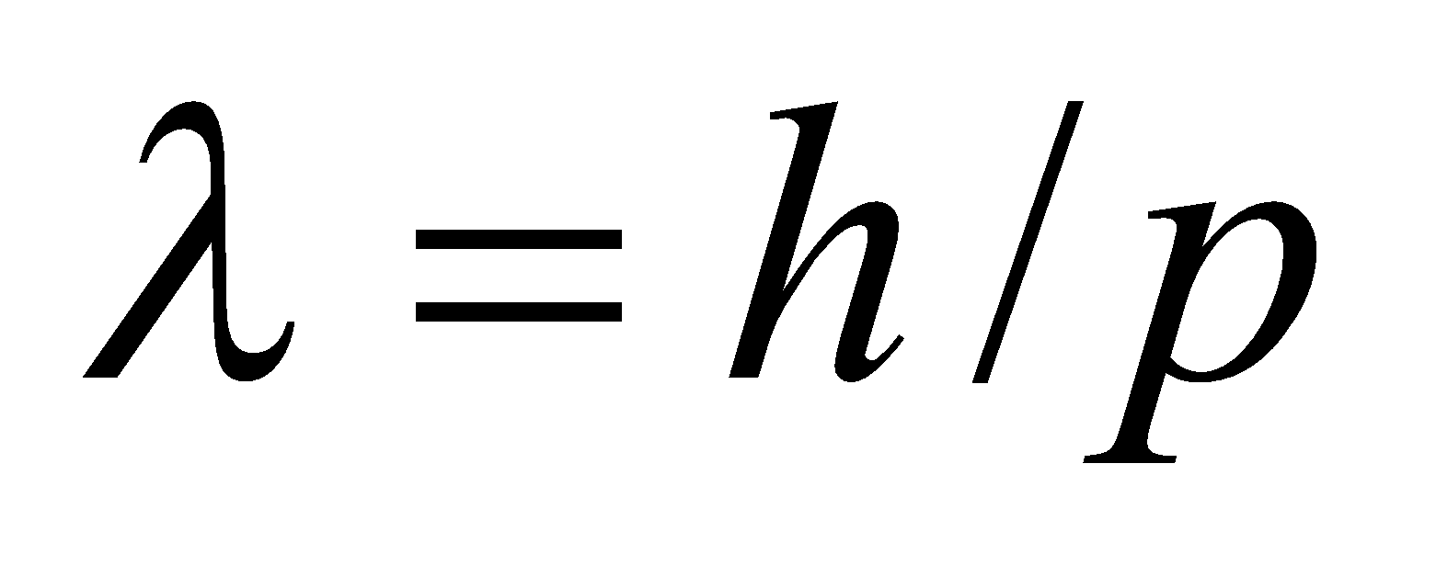 (Equation 34.14), the same de Broglie wavelength means the same momentum.
Evaluate At non-relativistic speeds, the equal momenta implies 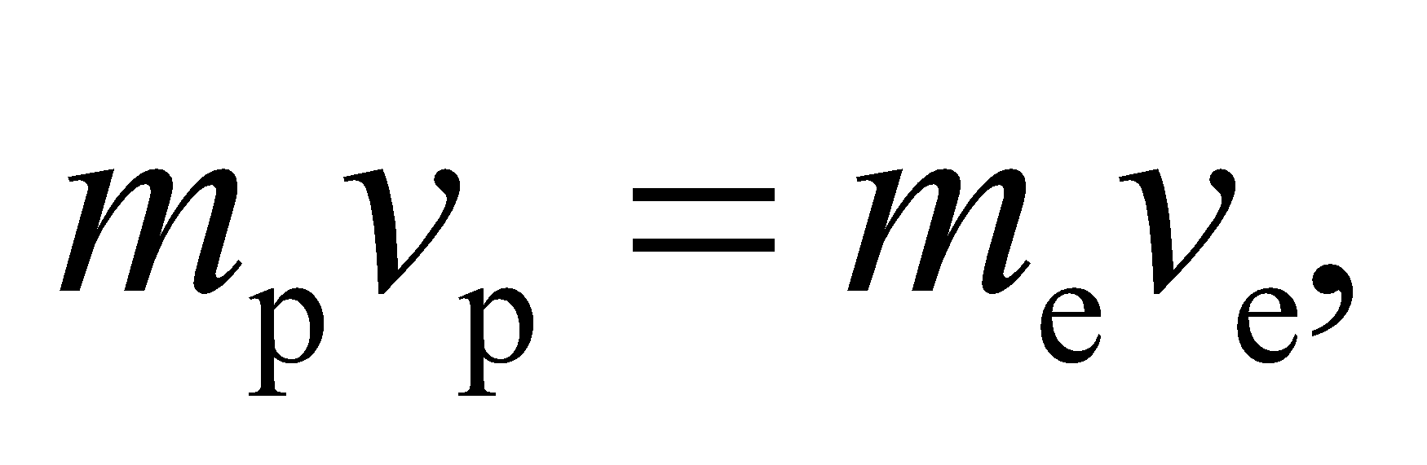or
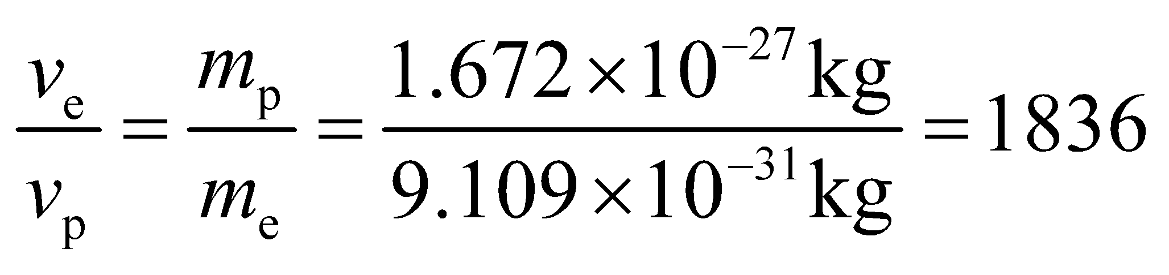
This says that the electron will need to be moving 1836 times faster than the proton.
Assess The problem would be more complicated if the momenta were relativistic: 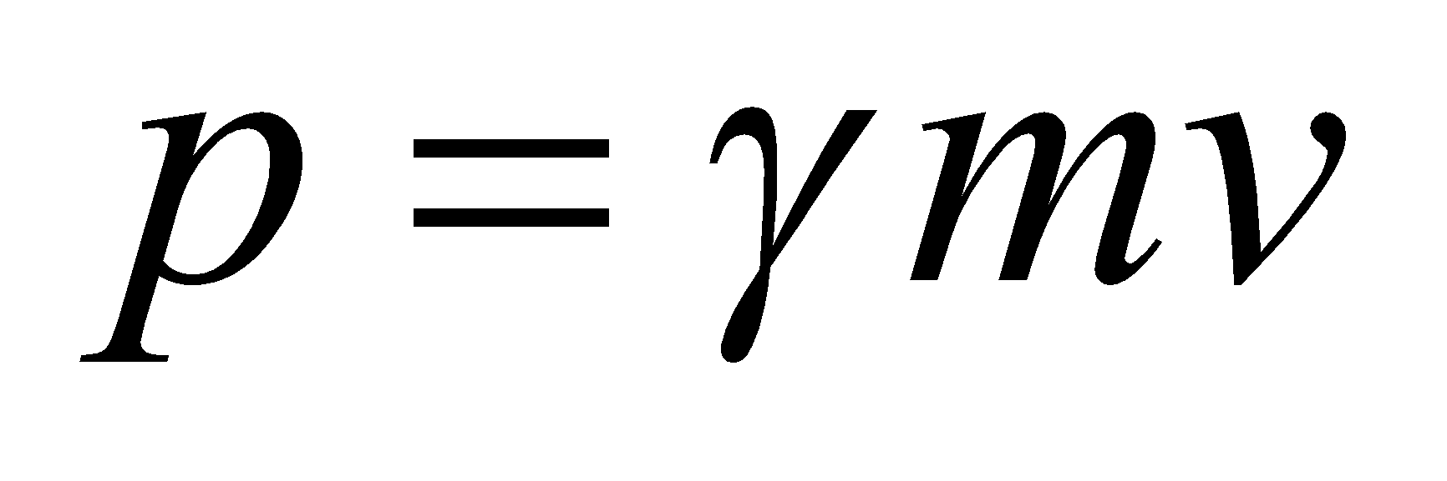 (Equation 33.7).
32. Interpret We are to find the de Broglie wavelength of electrons with various kinetic energies.
Develop We shall use Equation 34.14 λ = h/p for the de Broglie wavelength. Because the largest kinetic energy, 10 keV, is small compared to the electron’s rest energy mc² = 511 keV, we can use the nonrelativistic expressions K = p²/(2m), so the expression for the de Broglie wavelength becomes
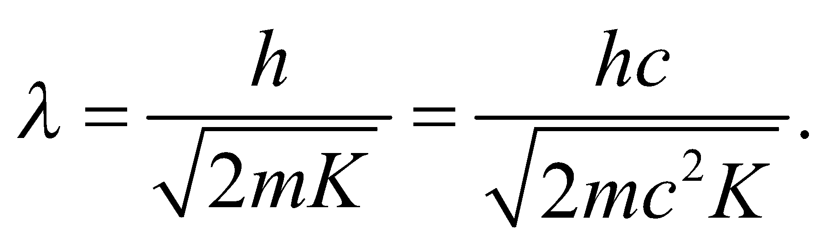
Evaluate (a) For K = 10 eV,
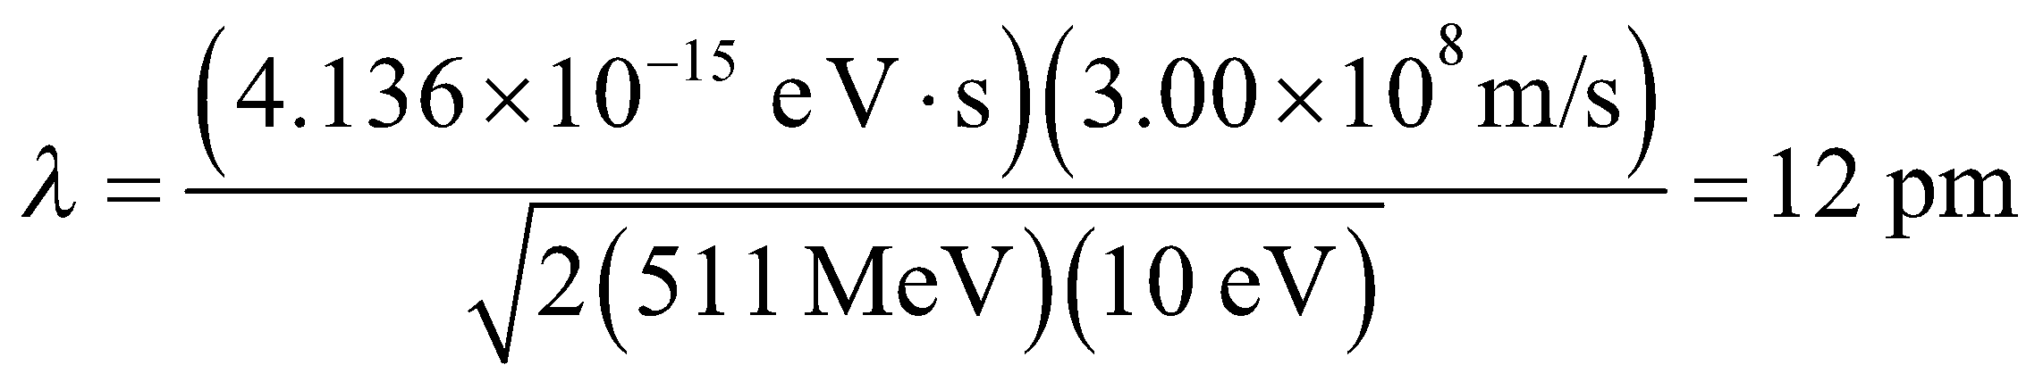
(b) For K = 1.0 eV,
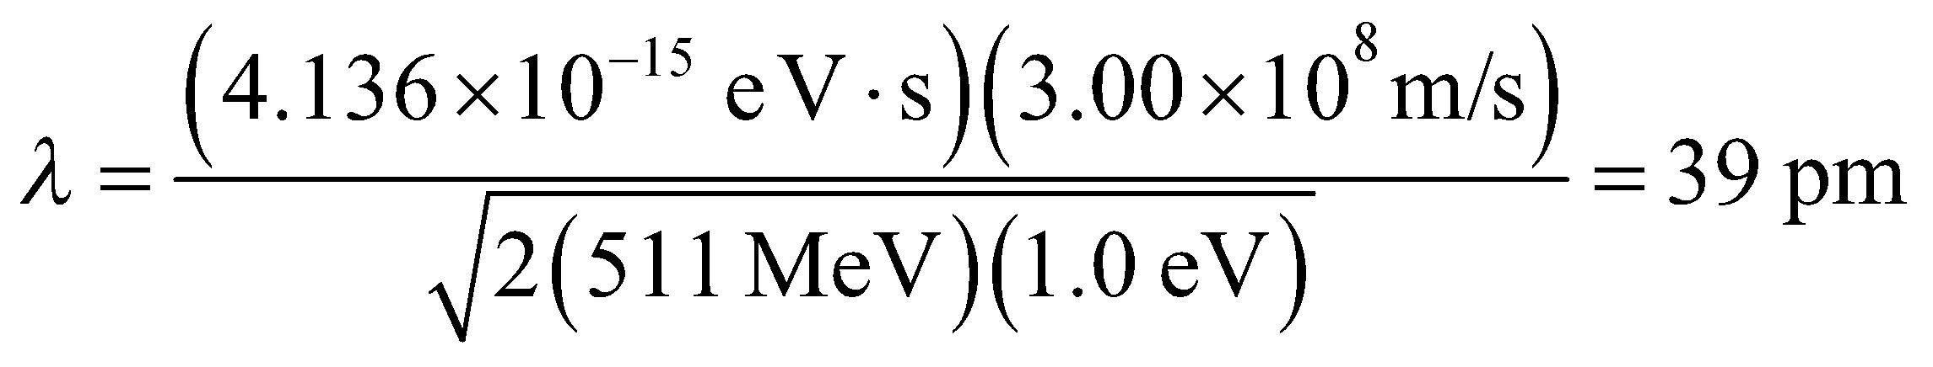
(c) For K = 10 keV,
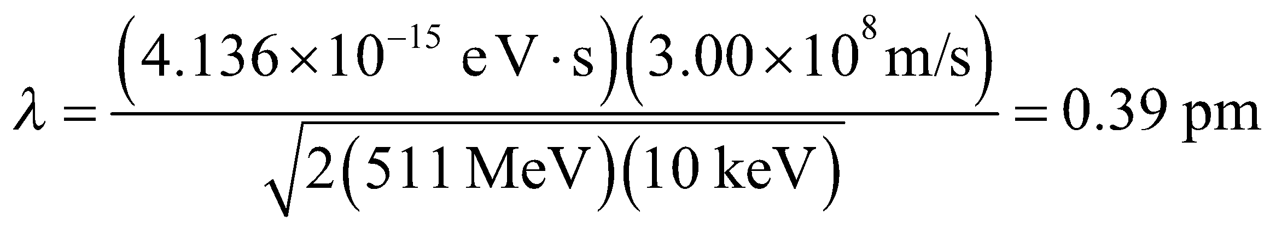
Assess For part (c), the relativistic relation 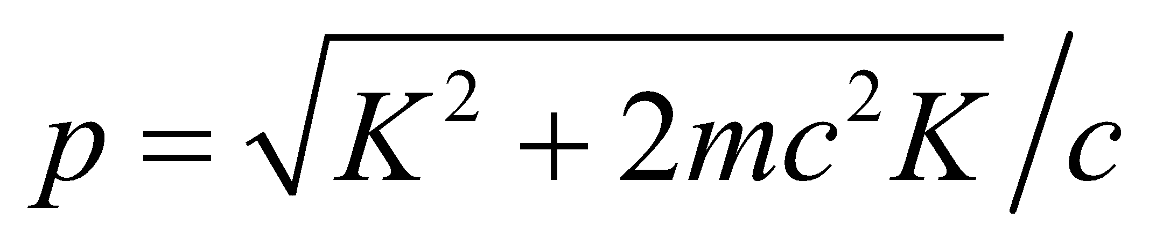 leads to a result that differs by about 0.0005%.
Section 34.6 The Uncertainty Principle
33. Interpret We want to find the minimum uncertainty in the velocity of a proton, given the uncertainty in its position.
Develop To find Δv, use the uncertainty principle, 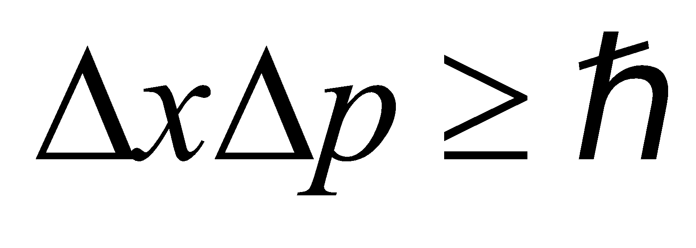 (Equation 34.15) with 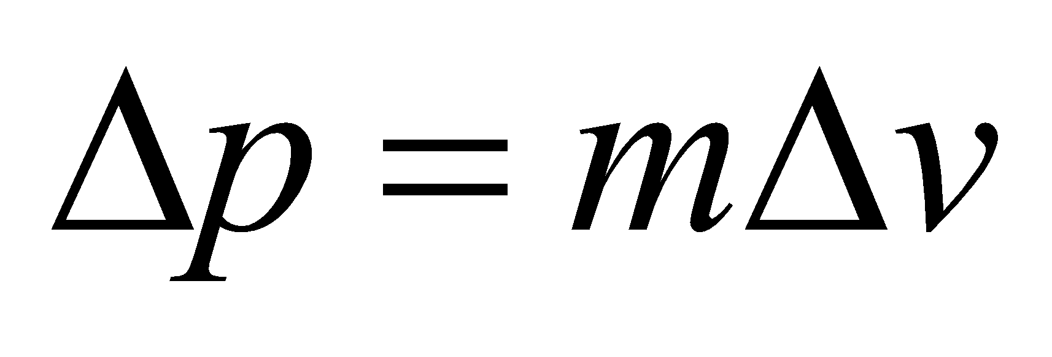 and
Δx = 1 fm.
Evaluate The above equation gives
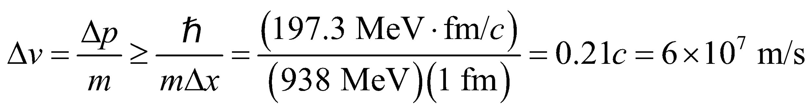
Assess The quantity 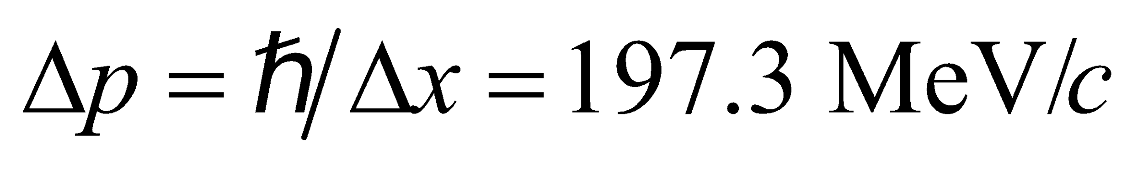 is barely small enough compared to mc = 938 MeV/c to justify using the nonrelativistic relation p = mv, but this is good enough for the purpose of approximation.
34. Interpret This problem involves the uncertainty principle, which we shall use to determine the precision with which we can measure an electrons velocity and position.
Develop The uncertainty principle (Equation 34.15) is . For the speeds considered in this problem, we can use the nonrelativistic expression p = mv for momentum, which leads to
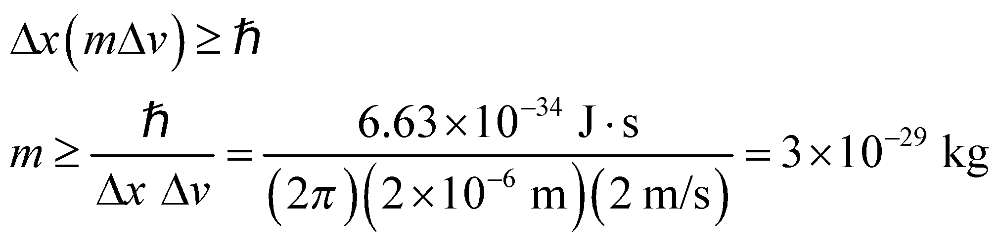
where we have used Δx = 2 μm and Δv = 2 m/s. Insert the mass of the electron and proton to see if the inequality is satisfied.
Evaluate For an electron, m = 9.11 × 10⁻³¹ kg, so the inequality is not satisfied. The mass of a proton is m = 1.67 × 10⁻²⁷ kg, so the inequality is satisfied.
Assess Thus, we cannot determine both the velocity and position to the desired precision for an electron, but we can do so for a proton.
35. Interpret In this problem, we want to find the uncertainty in the position of a proton given the uncertainty in its velocity.
Develop To find Δx, we use the uncertainty principle, (Equation 34.15), where 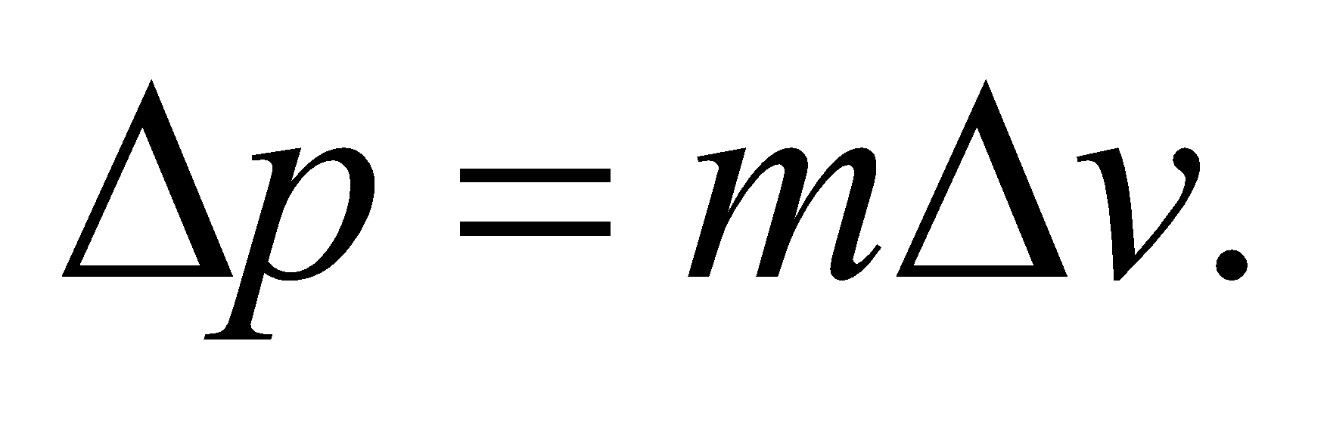 We take the uncertainty in velocity to be the full range of variation given; that is, 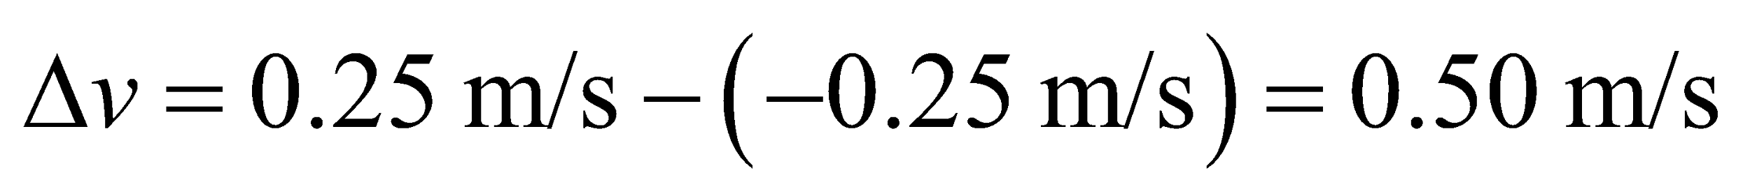.
Evaluate The position uncertainty of the proton is
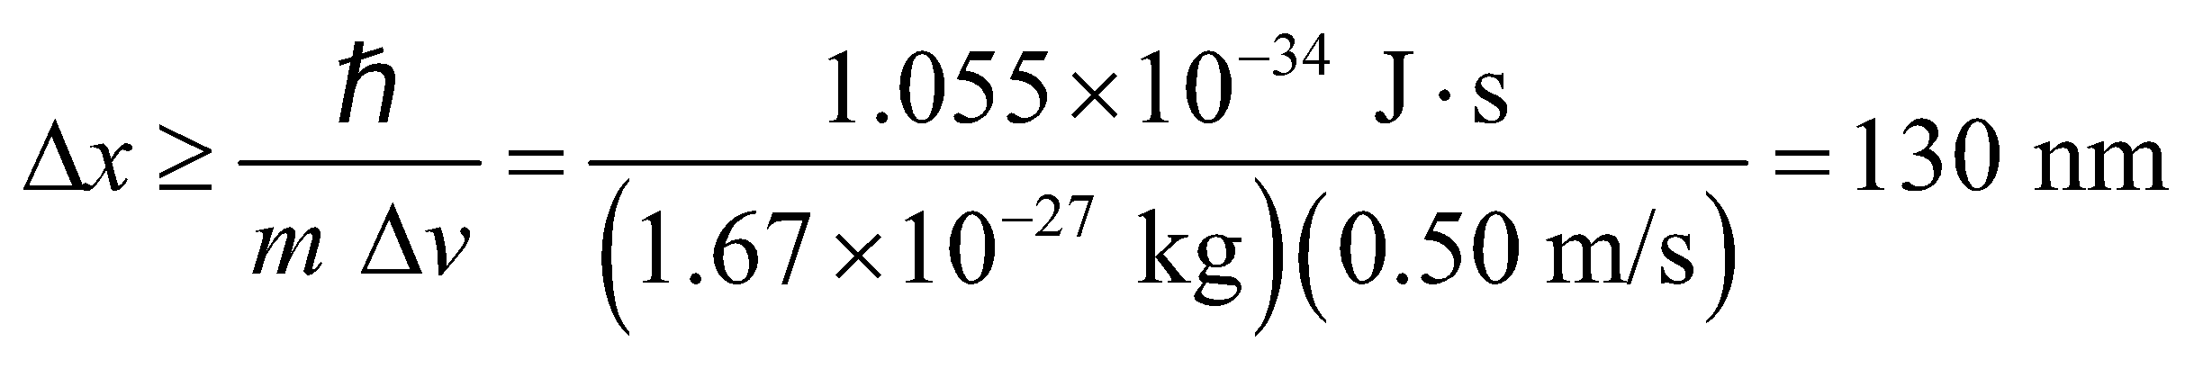
Assess The smaller the uncertainty Δv in velocity, the greater the uncertainty Δx in position.
36. Interpret We are given the uncertainty in the speed of an electron and are asked to find the uncertainty in its position.
Develop The electron is moving at
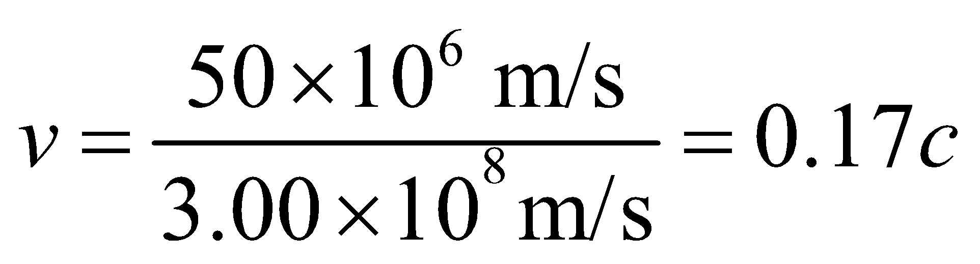
so we can use the classical approximation for the momentum, p = mv. Thus, the uncertainty in momentum is
where Δv = (0.20)(50 × 10⁶ m/s). Insert this into the expression for the uncertainty principle (Equation 34.15) to find the minimum uncertainty in position.
Evaluate This minimum uncertainty in position Δx is
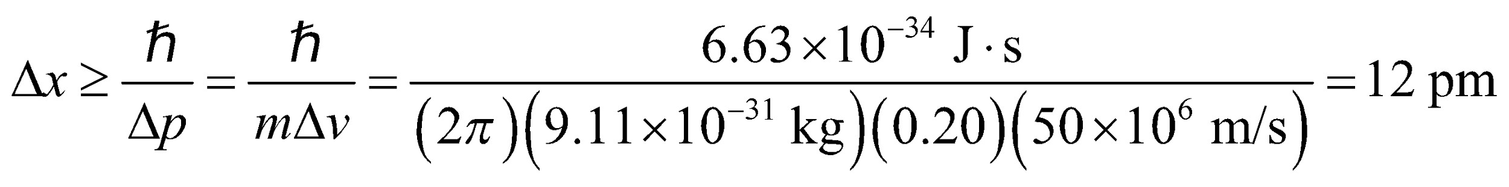
Assess As a rule of thumb, relativistic formulas should be used for 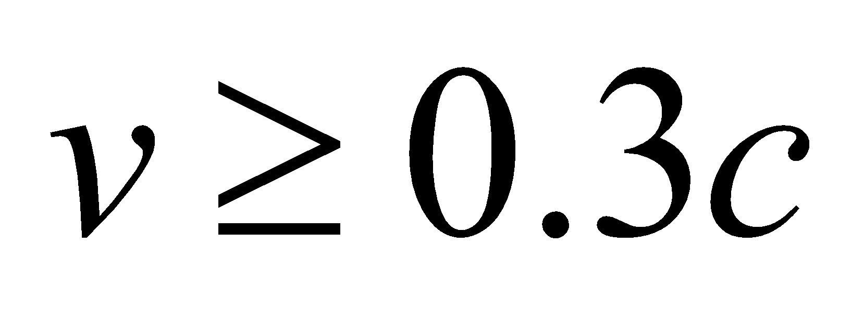.
37. Interpret The neutron is confined in the uranium nucleus with Δx equal to the diameter of the nucleus. We are to find the minimum energy of the neutron using the uncertainty principle.
Develop Using the same reasoning as given in Example 34.6, for a neutron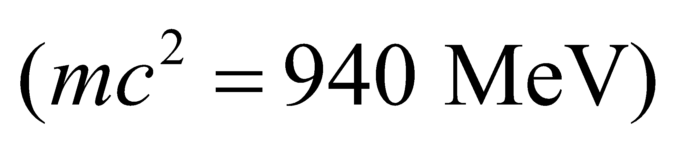confined to a uranium nucleus 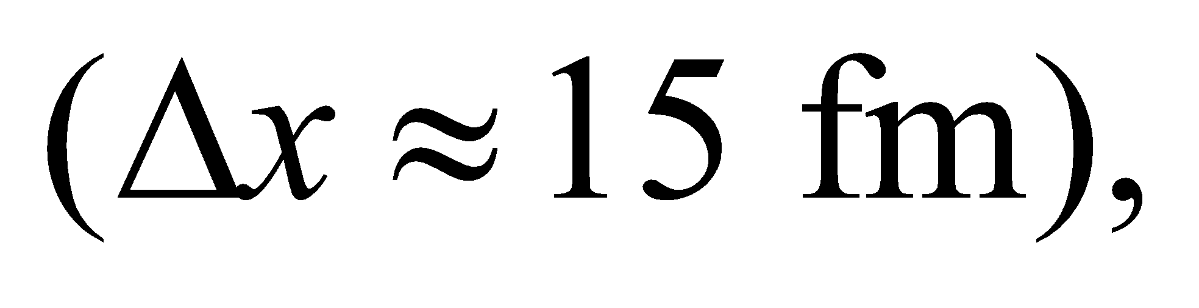 the uncertainty principle requires that
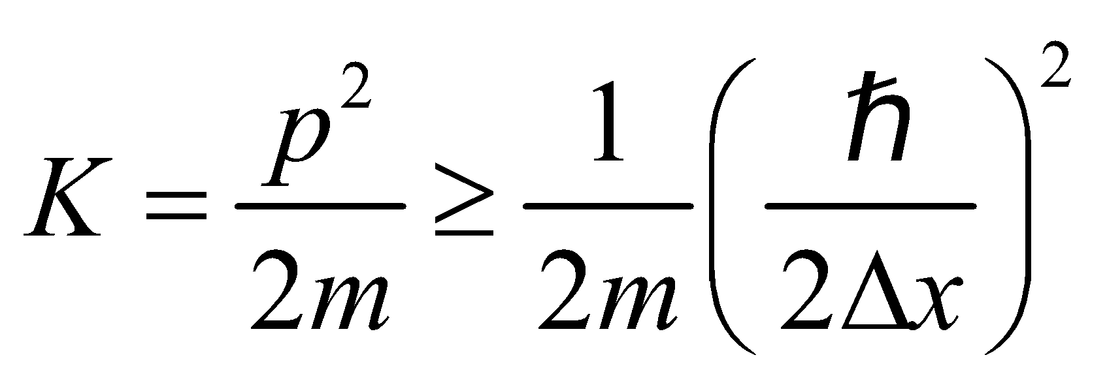
Evaluate From the above equation, we find the minimum kinetic energy to be
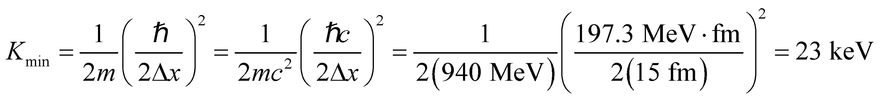
Assess This is smaller than the 5 MeV estimated for the nucleon in Example 34.6 by a factor of 15² = 225 because Δx is 15 times larger. Most estimates of nuclear energies for single-particle states, based on the uncertainty principle, give values of the order of 1 MeV, consistent with experimental measurements.
Problems
38. Interpret This problem involves blackbody radiation, which we can use to find the power emitted per unit area by the lamp within the given wavelength range.
Develop The power emitted is 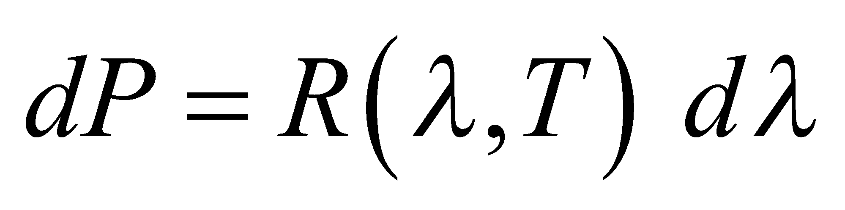 (Equation 34.3) where
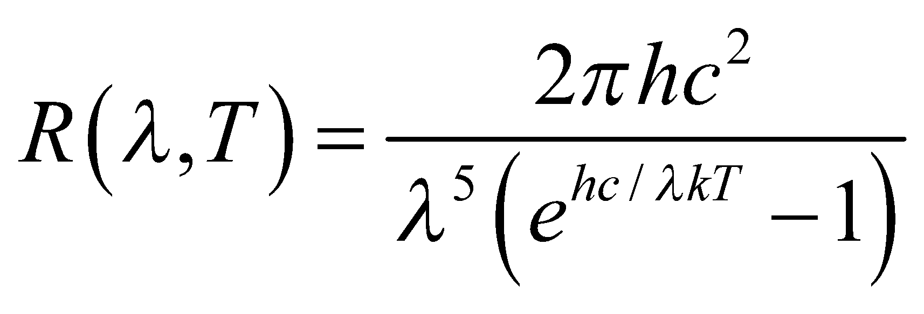
Since dλ = 2 nm is such a small interval around 500 nm, integration is not necessary.
Evaluate With 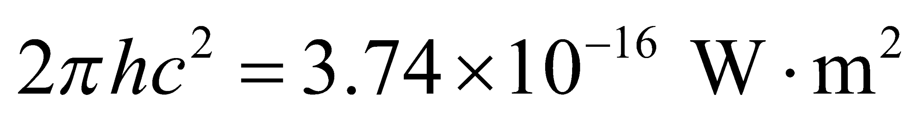 and 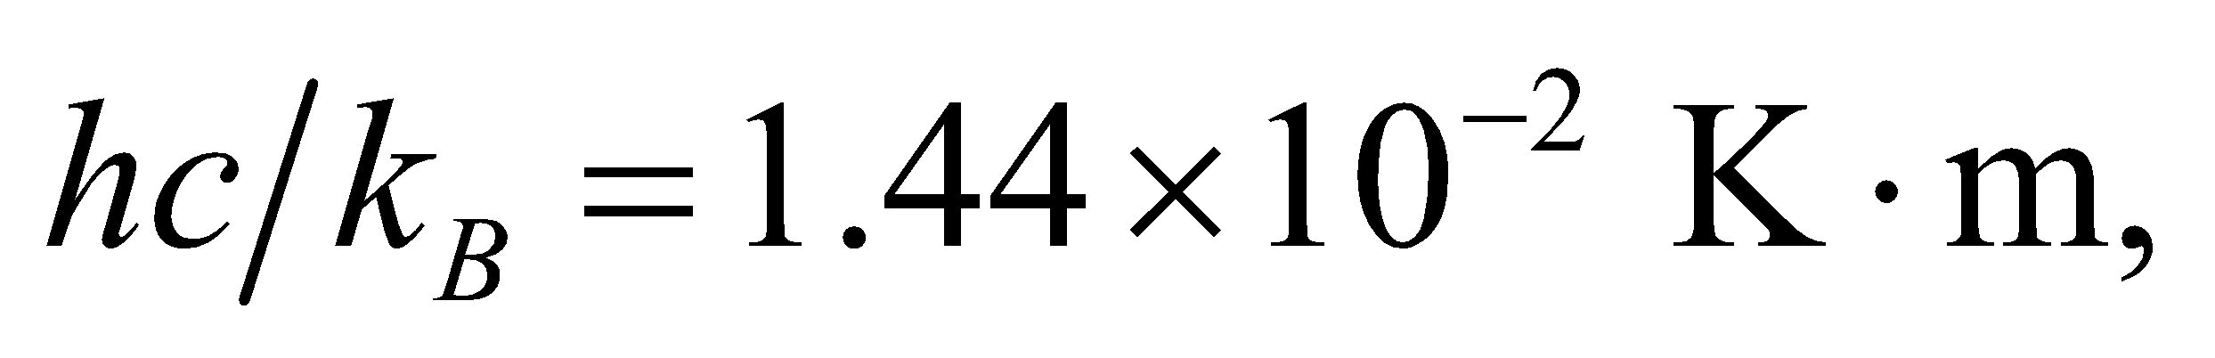 and with λ = 500 nm and T = 3000 K, we find
to a single significant figure.
Assess If we assume an average of half this value is emitted over the entire visible spectrum, then the surface area of a 60-W incandescent light bulb should be approximately
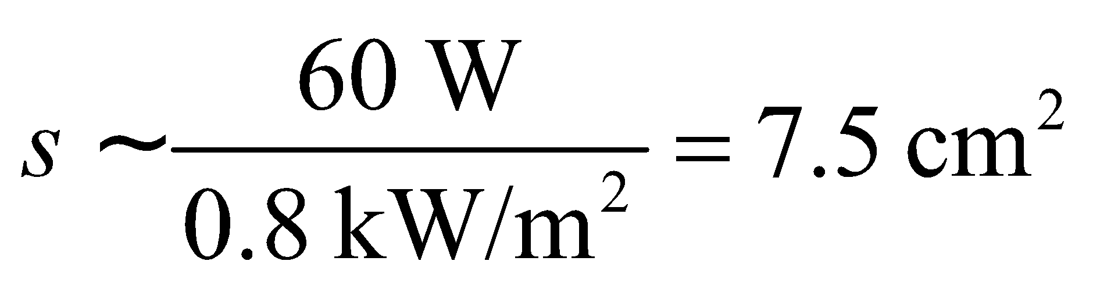
which seems like a reasonable order-of-magnitude estimate.
39. Interpret We are given the temperature of the Sun, which we shall treat as a blackbody, and asked to compare its radiance at two different wavelengths.
Develop The radiance of a blackbody is given by Equation 34.4:
This equation allows us to compare the radiance at two different wavelengths.
Evaluate From the above equation (also see Example 34.1), the ratio of the blackbody radiances for the two given wavelengths is
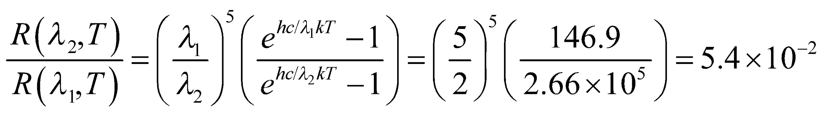
where
Assess The characteristic radiance as a function of wavelength is shown in Figure 34.2. For a given wavelength, the radiance increases with temperature.
40. Interpret We are to compare the Rayleigh-Jeans law to the Planck formula for blackbody radiation at the three wavelengths given.
Develop The ratio of the radiances for the Rayleigh-Jeans and Planck laws is
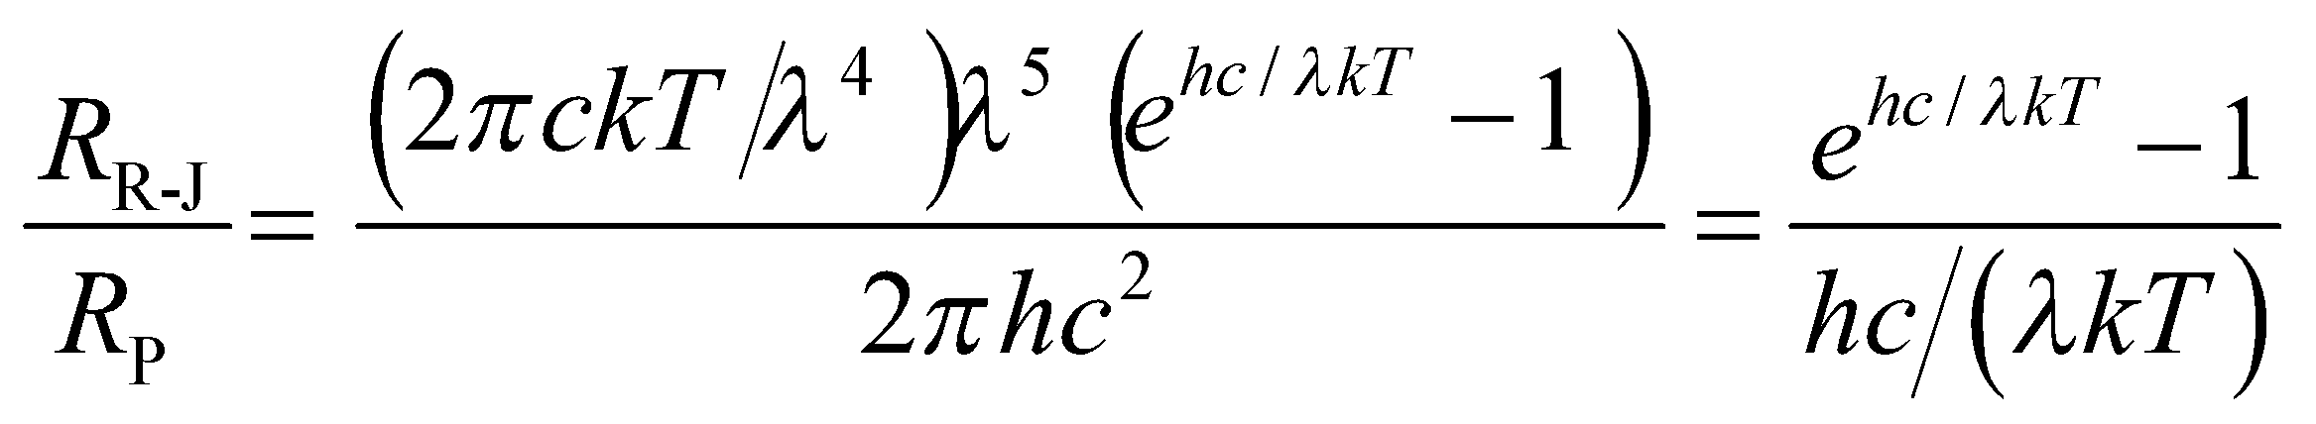
Accurate values of 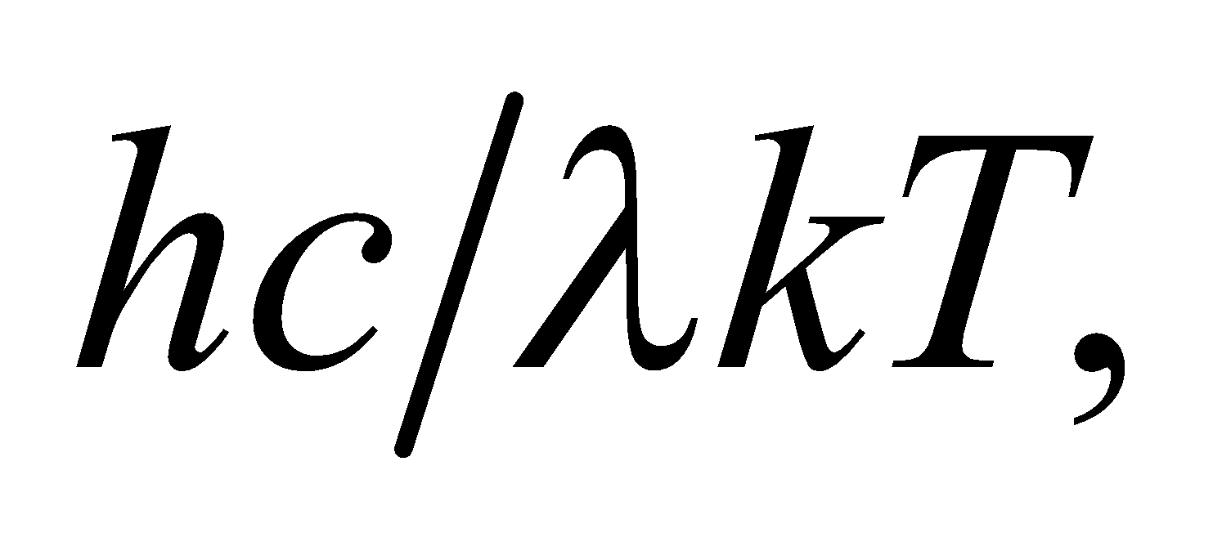 for are 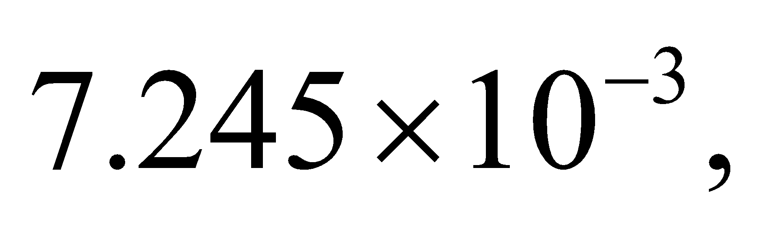 0.7245, and 7.245, respectively.
Evaluate The percent difference is
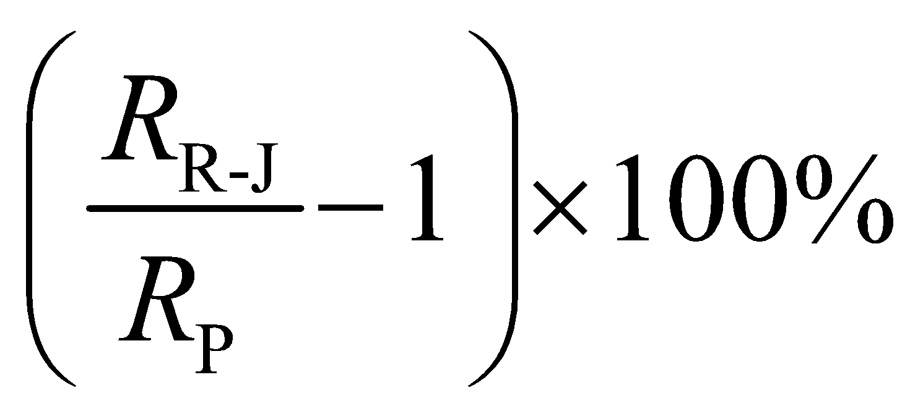
which equals (a) 0.36%, (b) 47%, and (c) (1.9 × 10⁴)% for the three given wavelengths.
Assess The error becomes increasingly large as the wavelengths approach the visible part of the spectrum.
41. Interpret This problem is about blackbody radiation. We are given the wavelengths that correspond to peak radiance and asked to find the temperature of the blackbody. We also want to compare the radiance at two different wavelengths.
Develop The wavelength at which a blackbody at a given temperature radiates the maximum power is given by Wien’s displacement law (Equation 34.2a): For part (b), to compare the radiance at two different wavelengths, we use Equation 34.4:
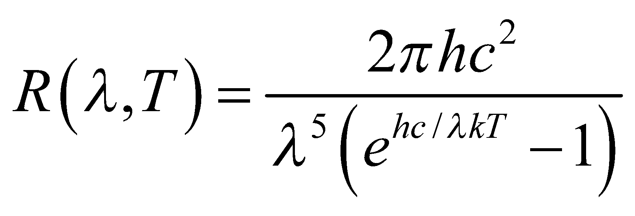
Evaluate (a) Equation 34.2a gives
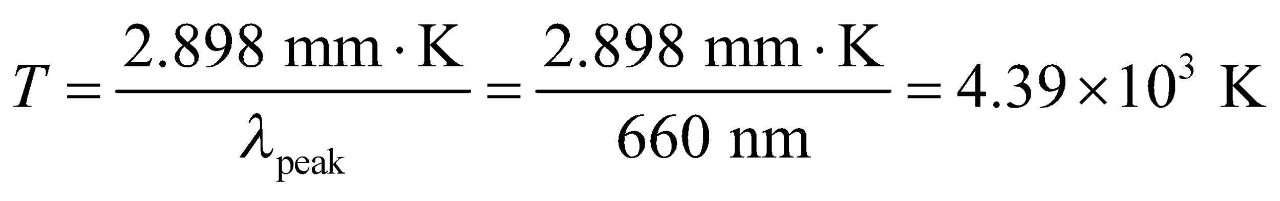
(b) With 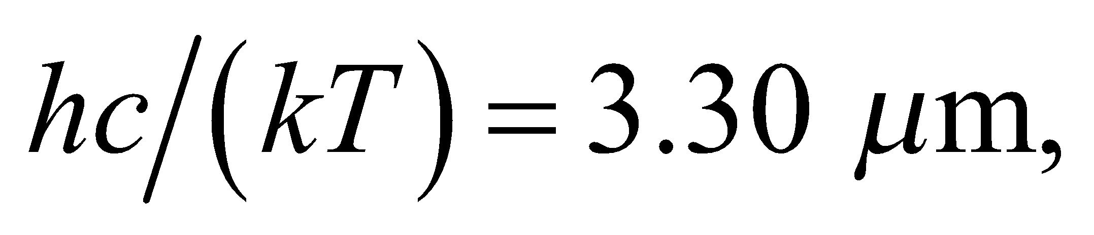 the ratio of the radiances is
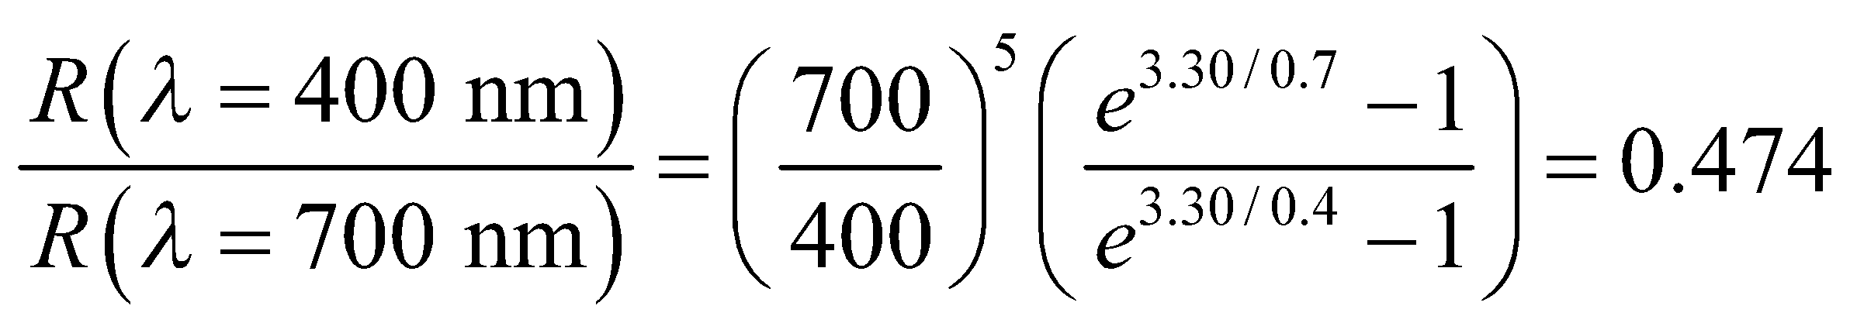
Assess The wavelengths considered are in the visible spectrum. Note that the characteristic radiance as a function of wavelength is shown in Figure 34.2. For a given wavelength, the radiance increases with temperature.
42. Interpret This problem examines the Compton wavelength of a proton and the energy of a gamma ray with an equivalent wavelength.
Develop The constant in Equation 34.8 gives the Compton wavelength 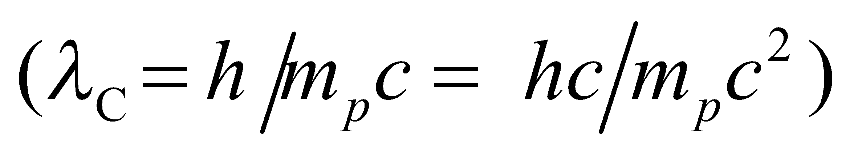 to find the Compton wavelength. Use Equation 34.6, 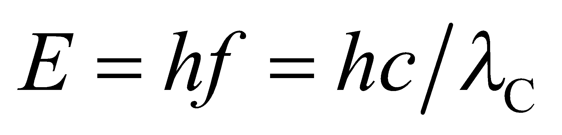, to find the energy of a photon of the same wavelength.
Evaluate (a) The proton’s Compton wavelength (the constant in Equation 34.8) is
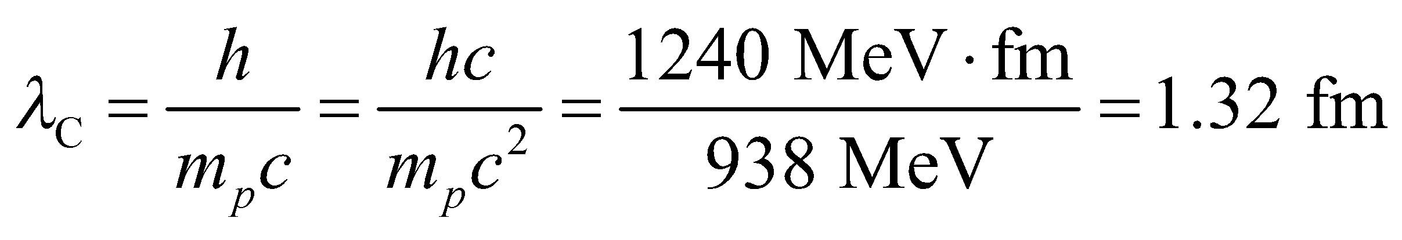
(b) The energy of a photon with this wavelength (Equation 34.6) is
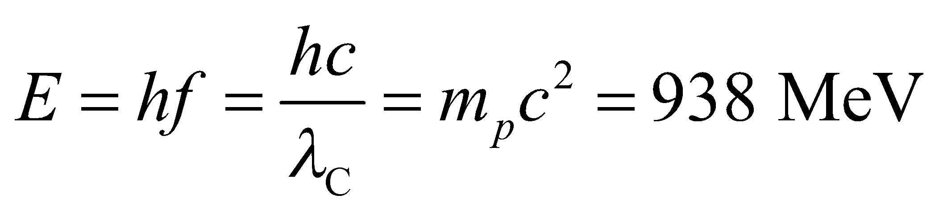
Assess The energy of the gamma ray is the same as the rest energy of a proton.
43. Interpret We are given the power output at various frequencies and asked to find the rate of photon emission.
Develop The rate dN/dt of photon emission is the electromagnetic power output divided by the photon energy:
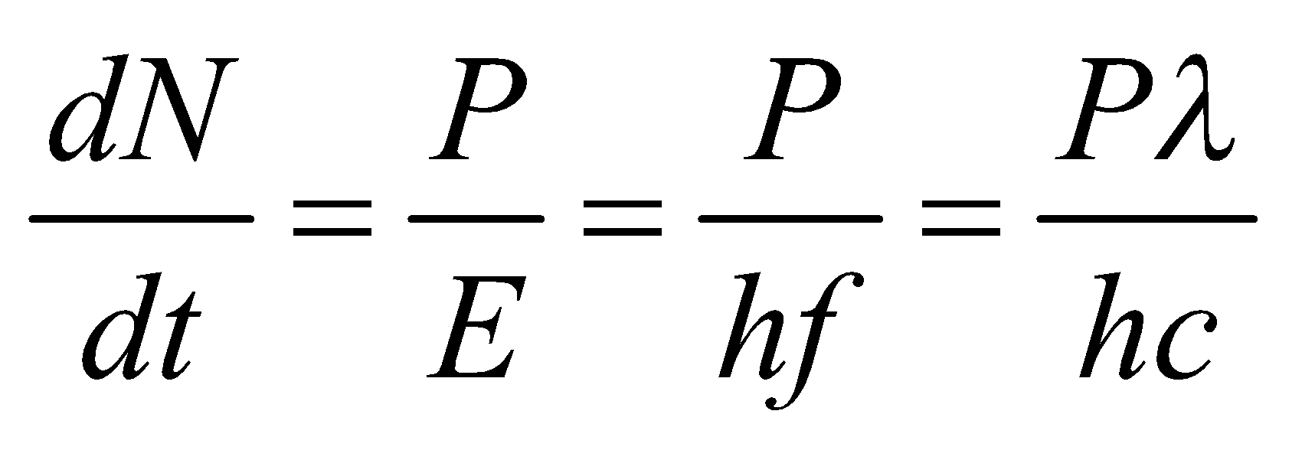
where we have used Equation 34.6 E = hf.
Evaluate (a) For the antenna, the rate is
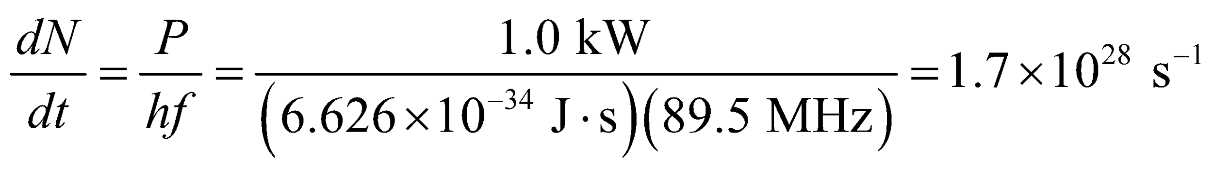
(b) For the laser, we have
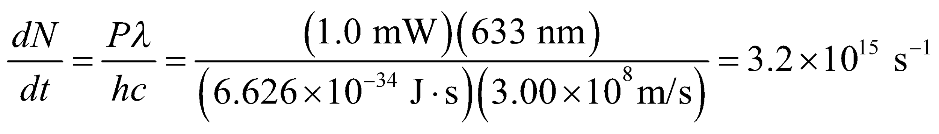
(c) Similarly, for the X-ray machine, the rate is
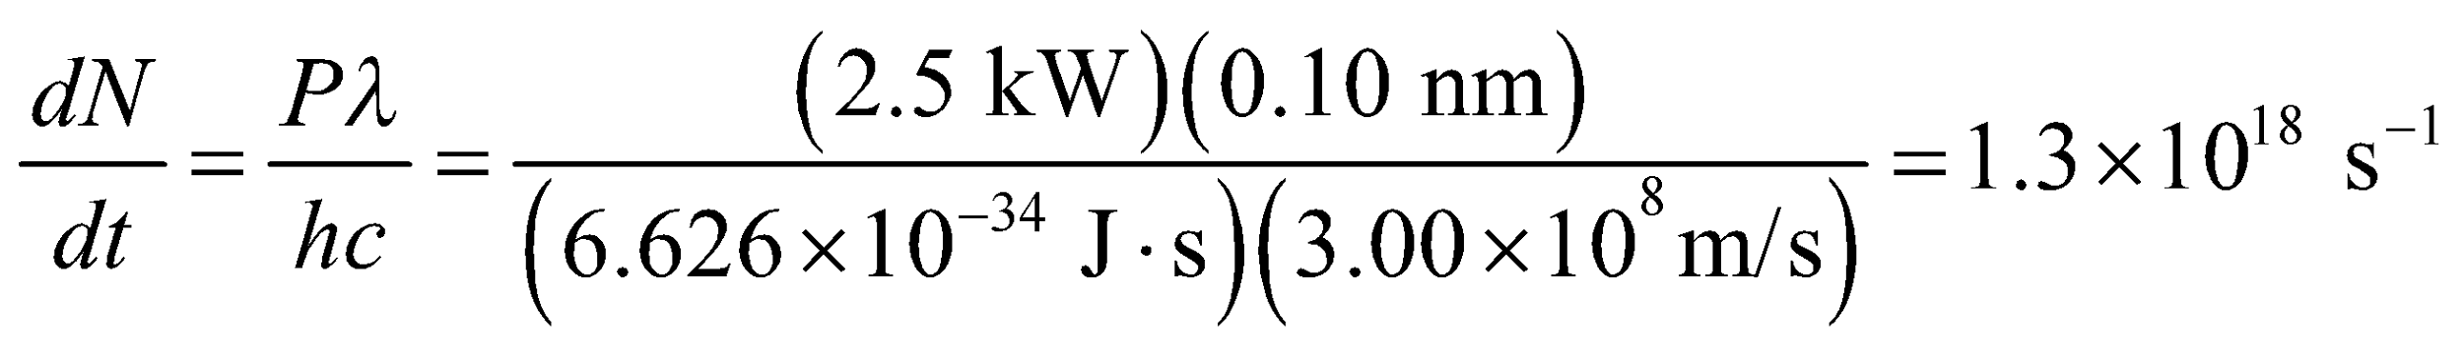
Assess For a general device at a given power output, the rate of photon production decreases with the energy of the photon; the more energetic the photons, the smaller the rate of production because each photon carries more energy.
44. Interpret This problem involves the photoelectric effect. Given the maximum kinetic energy with which electrons emerge from an aluminum surface, we are to find the wavelength of the illuminating radiation.
Develop Einstein’s equation for the photoelectric effect (Equation 34.7) gives
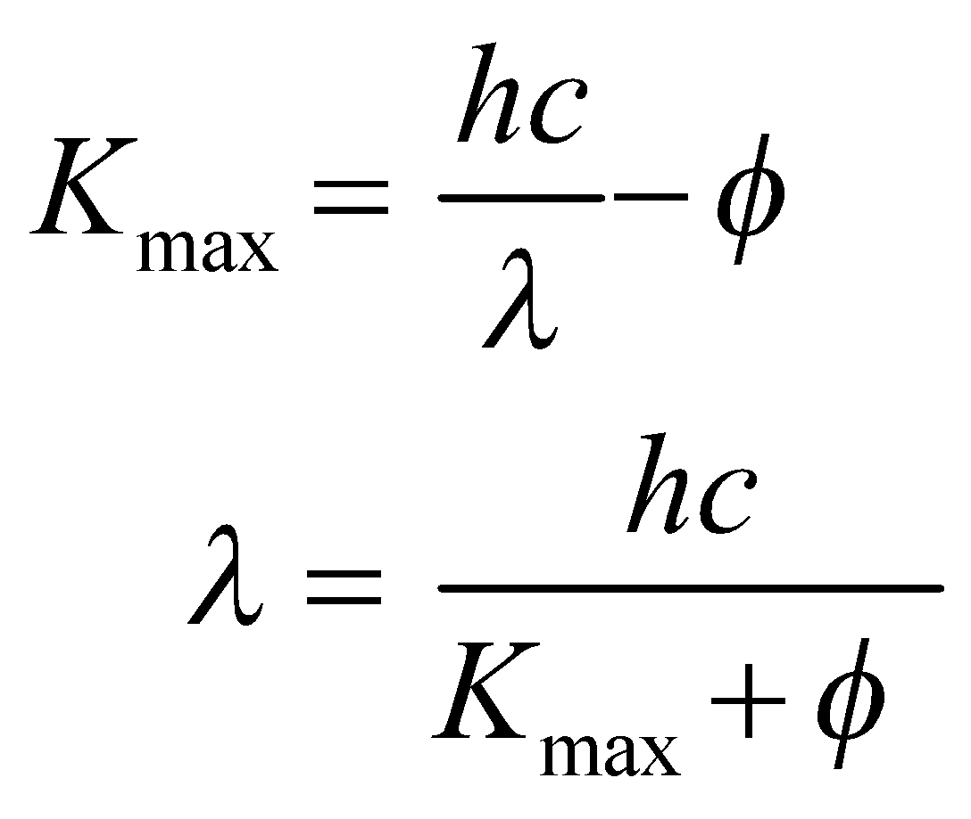
where φ = 4.28 eV (see Table 34.1) is the work function of Al.
Evaluate For K_{max} = 1.3 eV, the wavelength is
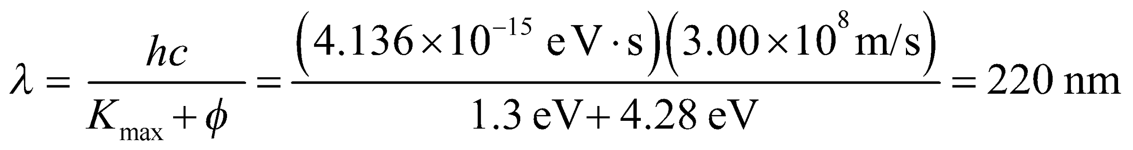
to two significant figures.
Assess This wavelength is in the ultraviolet portion of the electromagnetic spectrum.
45. Interpret This problem is about the photoelectric effect. We want to find the cutoff frequency and the maximum energy of electrons ejected by shining light with the given frequency on copper.
Develop At the cutoff frequency, K_{max} = 0 and the photon energy equals the work function,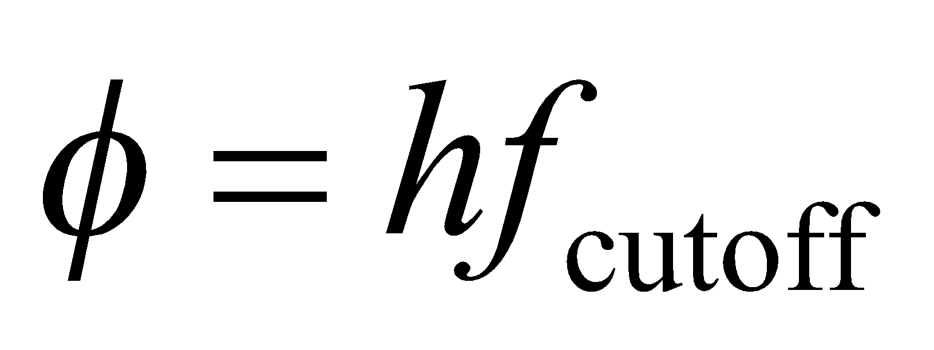 (see Equation 34.7), which we can find in Table 34.1. For part (b), apply Equation 34.7 to find the maximum kinetic energy possible for the given frequency f
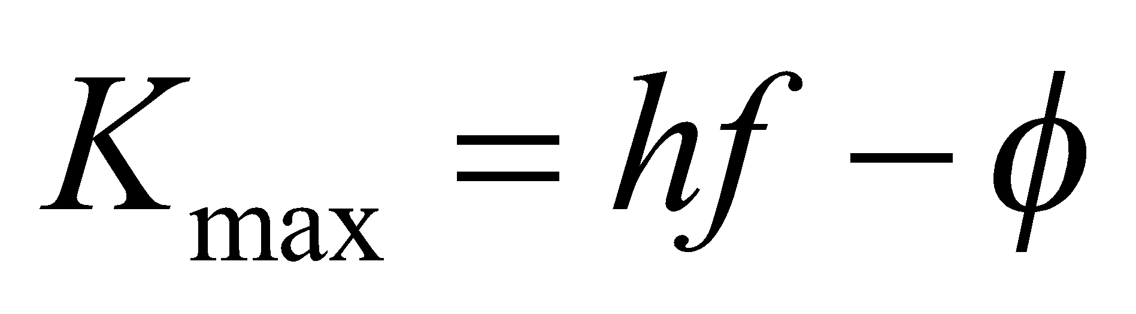
Evaluate (a) The work function of copper is 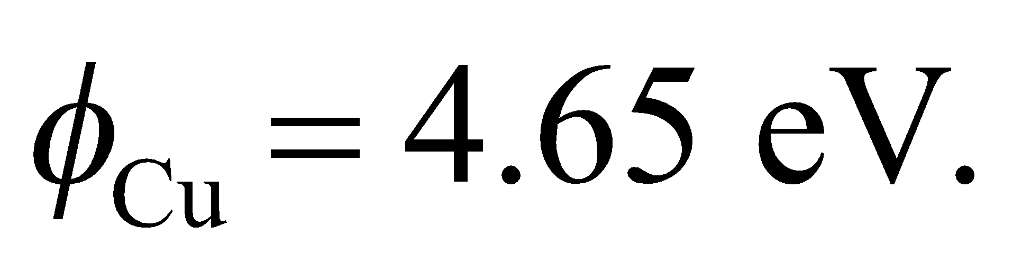 Therefore, the cutoff frequency is
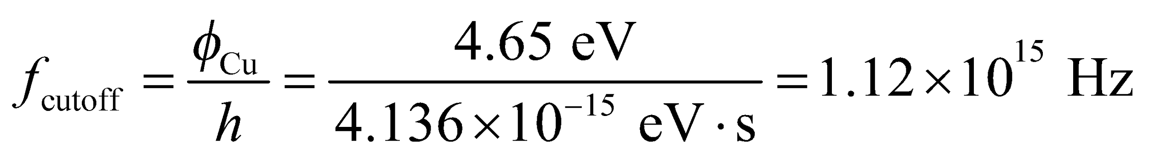
(b) The maximum kinetic energy of the ejected electrons is
Assess Upon illuminating copper with photons at 7.44 eV, it takes 4.65 eV to overcome the work function of copper, leaving the electrons with 2.79 eV of kinetic energy.
46. Interpret This problem involves the photoelectric effect. Given the electric potential energy difference needed to stop electrons emitted from a surface by the given radiation, we are to determine the work function of the material.
Develop The electron’s maximum kinetic energy is expended in crossing the stopping potential (see text), so
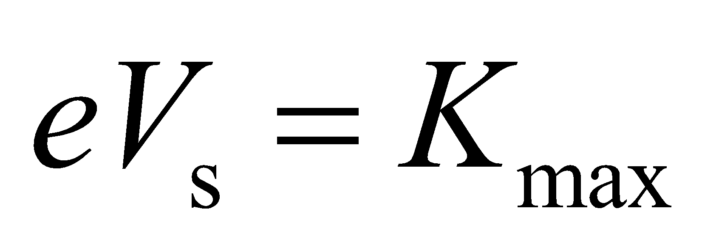
where V_{s} = 1.8 V. Apply Equation 34.7 to find the work function;
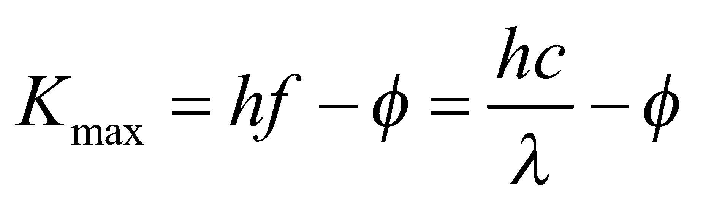
Evaluate (a) for λ = 365 nm, the work function is
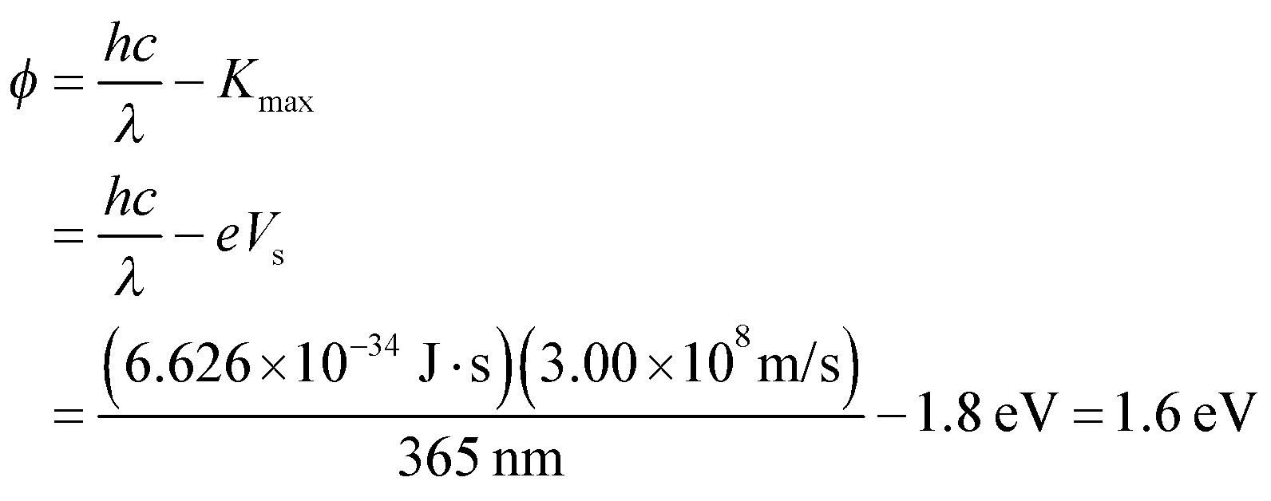
(b) At the new wavelength,
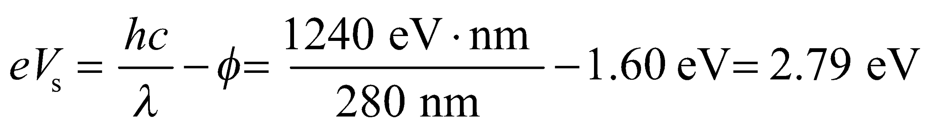
or
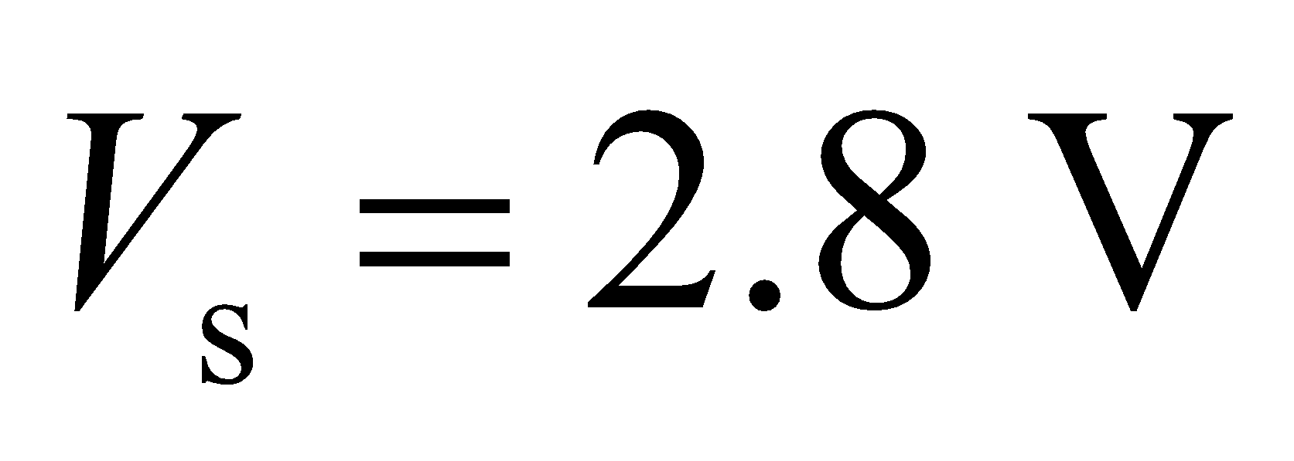
to two significant figures.
Assess The stopping potential increases because it takes a bigger “hill” to stop the electrons emitted by the 280-nm radiation, which contains photons of higher energy than radiation at 365 nm.
47. Interpret We are asked to explain why plants are green using the absorption peaks in the chlorophyll molecule.
Develop We can convert the wavelength peaks into energy peaks using 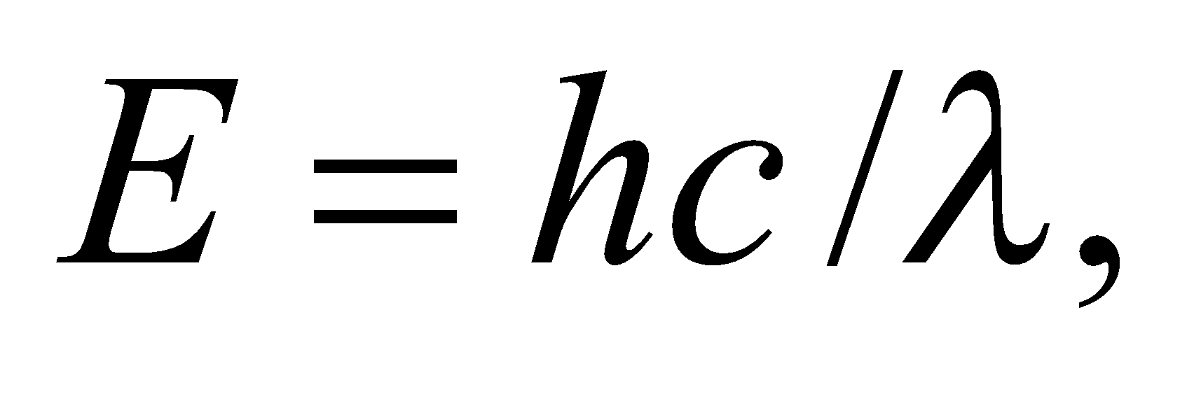and the shorthand
Evaluate (a) The energy peaks in chlorophyll's absorption spectrum are at
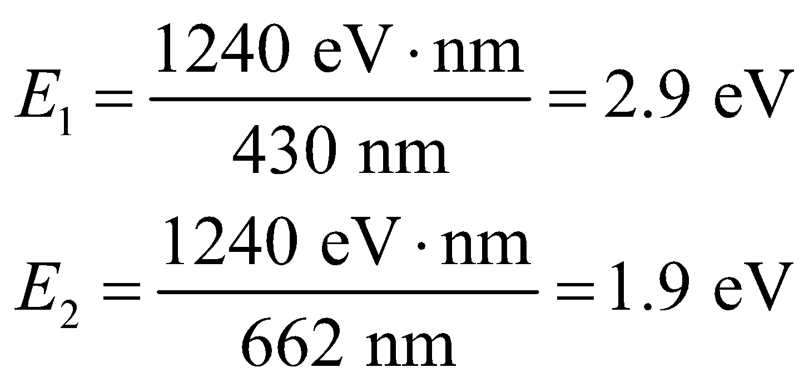
(b) These absorption peaks correspond to blue and red wavelengths, near the limits of the human visible range. The light that is not absorbed is reflected, and this is what we humans observe. Since the reflected light is primarily in the green region of the visible spectrum between blue and red, we perceive plants to be green.
Assess Plants also reflect a lot of infrared light with wavelengths longer than 700 nm.
48. Interpret This problem involves Compton scattering, which we can use to find the initial wavelength of photons that scatter at the given angle from electrons.
Develop Apply Equation 34.8, which describes Compton scattering (i.e., the scattering of photons off electrons). For a photon that loses half its initial energy, we have
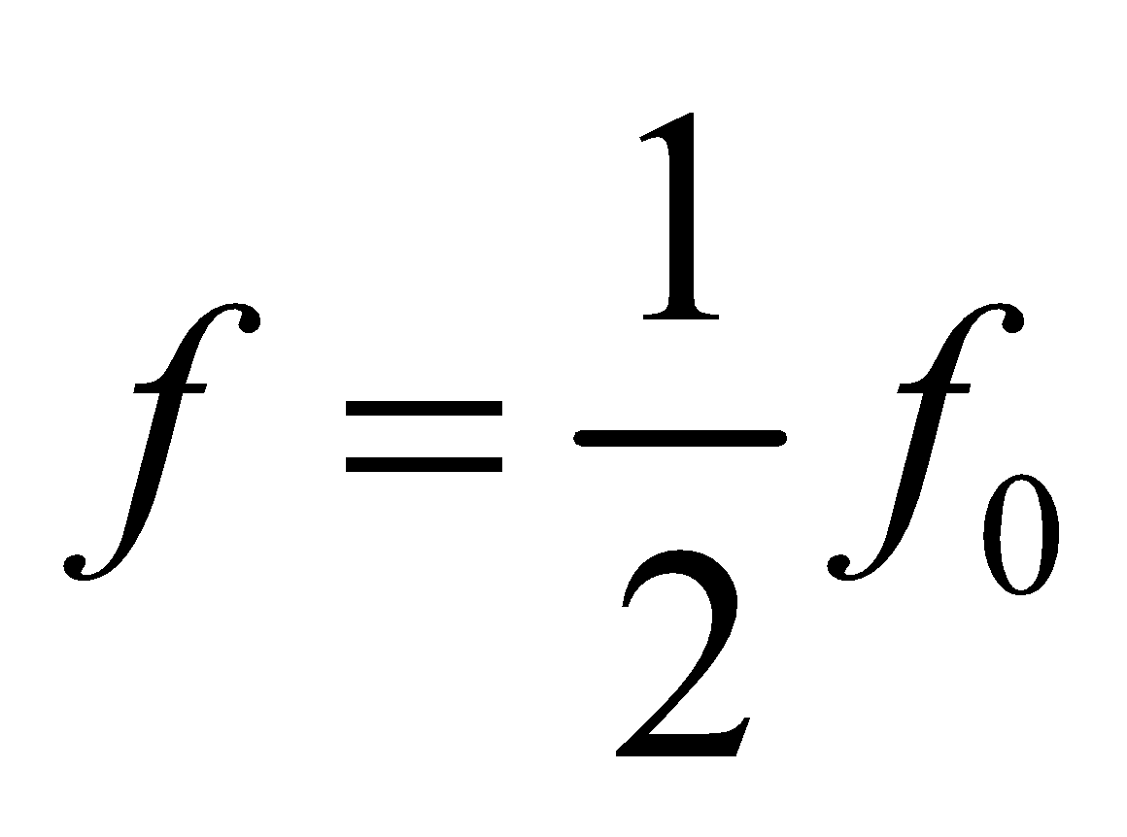
so the wavelength shift Δλ is
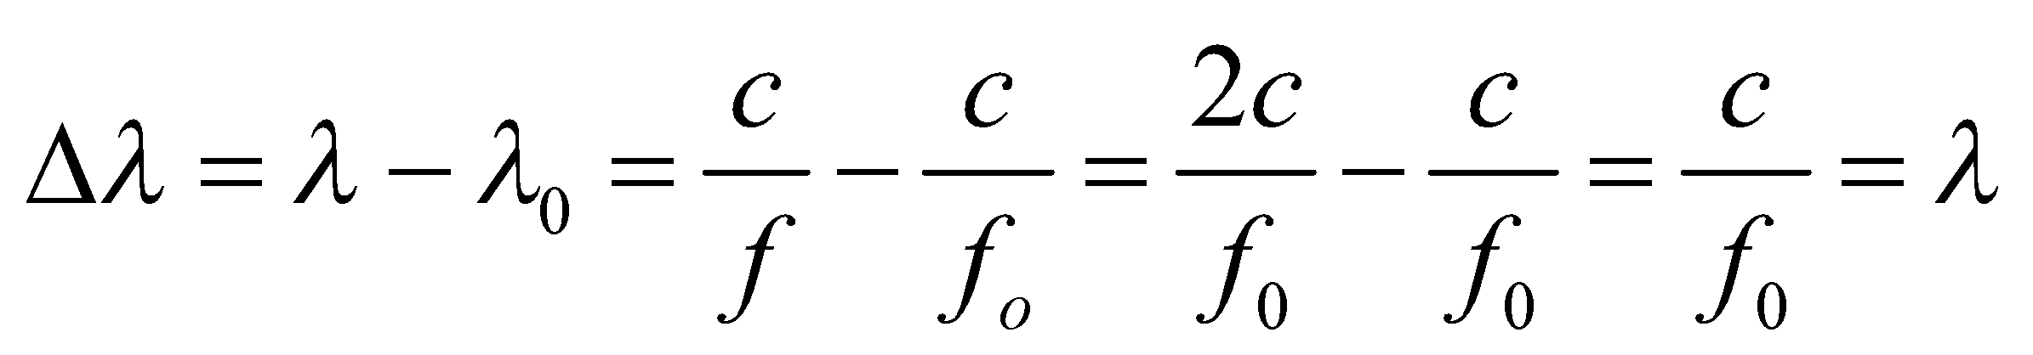
Evaluate Using this result for Δλ in Equation 34.8 gives
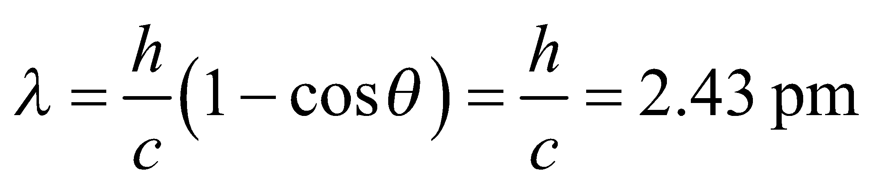
Assess The energy of these photons is about 0.5 MeV.
49. Interpret This problem is about the photoelectric effect. We are given the maximum speed of electrons ejected from potassium and asked to find the wavelength of the light that ejected the electrons.
Develop The maximum speed of the ejected electrons is related to the wavelength of the light by Einstein’s photoelectric effect equation (Equation 34.7):
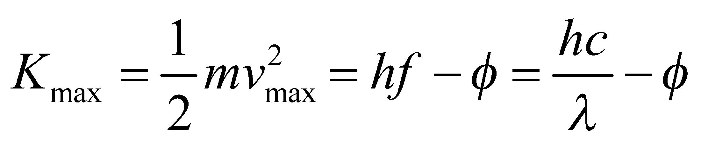
We shall use this equation to find λ.
Evaluate The maximum kinetic energy of the electron is
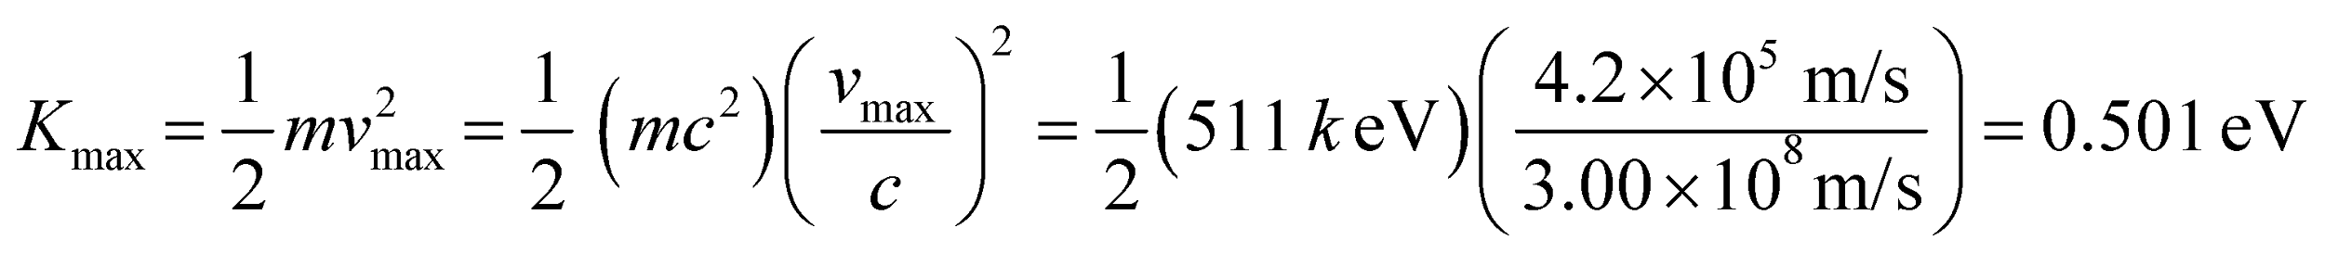
From Equation 34.7 and using Table 34.1 to find the work function φ, we find the wavelength to be
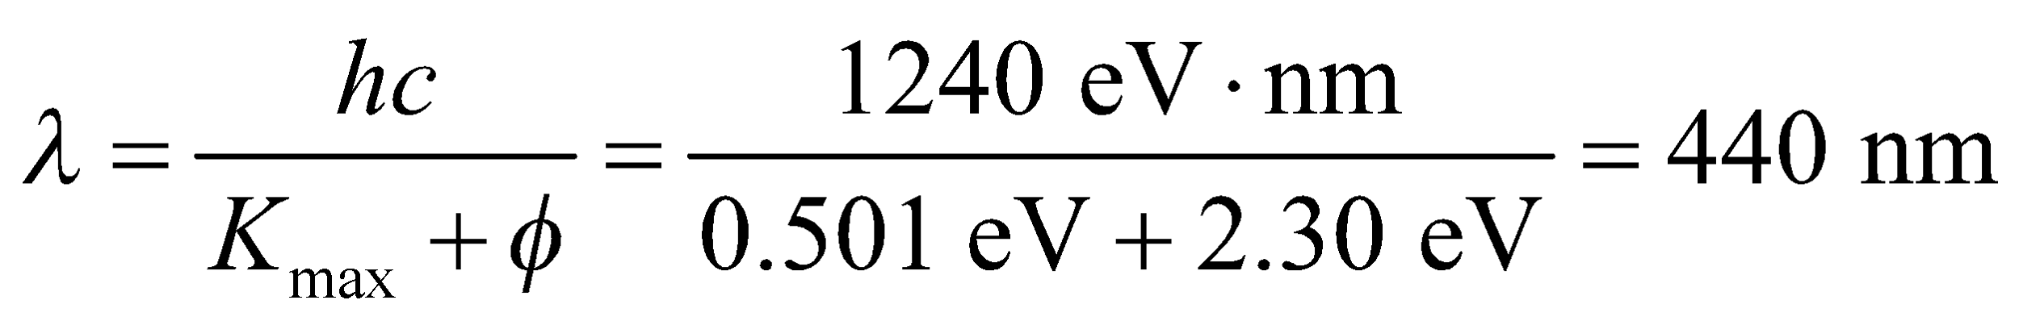
to two significant figures.
Assess Strictly speaking, the result should be reported as 44 ×10¹ nm to make the significant figures more obvious. The cutoff wavelength of potassium is
For the photoelectric effect to take place, we require 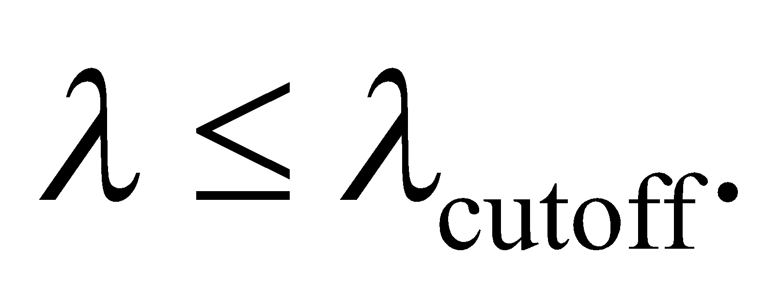
50. Interpret This problem involves the photoelectric effect. Given the maximum electron energy for two different illuminating wavelengths we are to find the work function of the material.
Develop The photoelectric effect equations (Equation 34.7) for the two experimental runs are
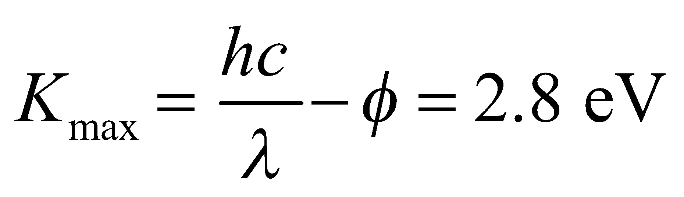
and
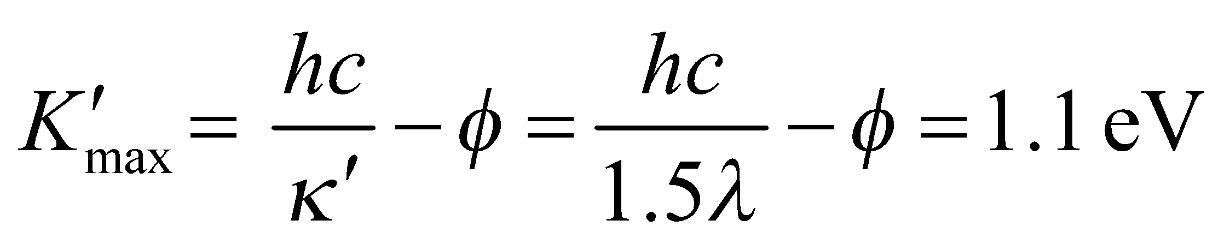
which we can solve for the work function φ and the initial wavelength λ.
Evaluate (a) Subtracting the two equations gives
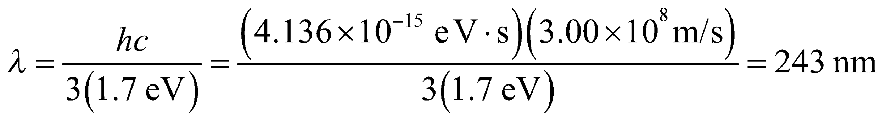
Adding the two equations gives
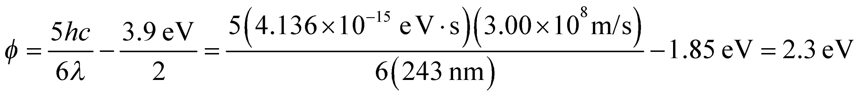
(b) From the calculation above, we find λ = 240 nm (to two significant figures).
Assess This material is probably potassium, which has a work function of φ = 2.3 eV.
51. Interpret This problem is about Compton scattering of a photon with an electron. We are interested in the wavelength of the scattered photon and the kinetic energy of the electron.
Develop The Compton shift of wavelength is given by Equation 34.8:
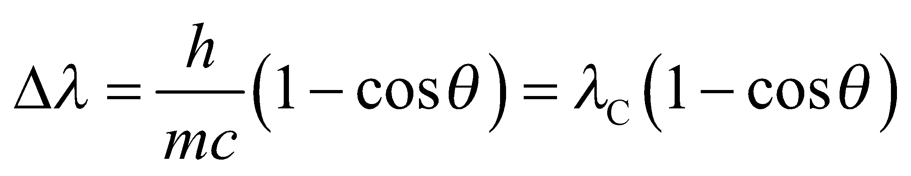
where 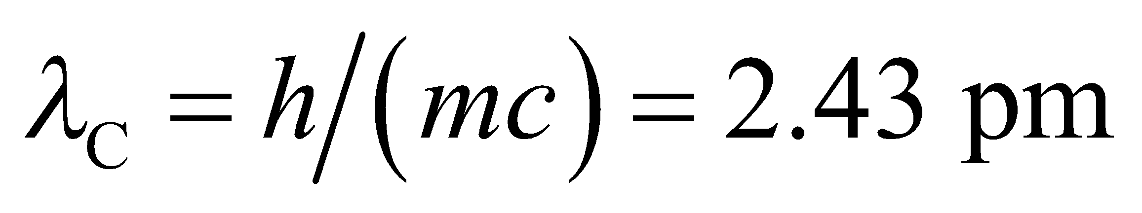 is the Compton wavelength of the electron. By conservation of energy, the kinetic energy of the scattered electron is equal to the energy lost by the photon.
Evaluate (a) From Equation 34.8, the wavelength of the scattered photon is
(b) The kinetic energy of the scattered electron is
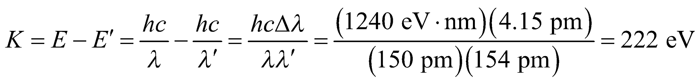
Assess For X rays, the wavelength is in the range 0.01–10 nm, so the detection of the Compton shift in X rays is difficult.
52. Interpret This problem involves Compton scattering of an X-ray at 90° from a stationary electron. We are to find the kinetic energy of the electron after the scattering event.
Develop In Compton scattering, the kinetic energy of the recoil electron equals the energy lost by the photon:
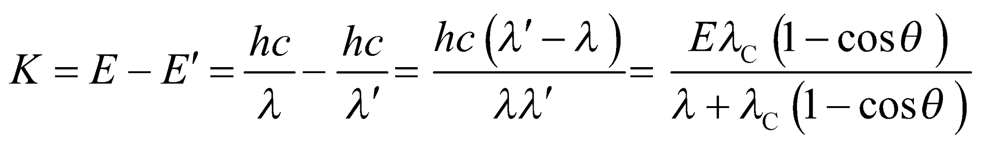
where we used Equation 34.8 for 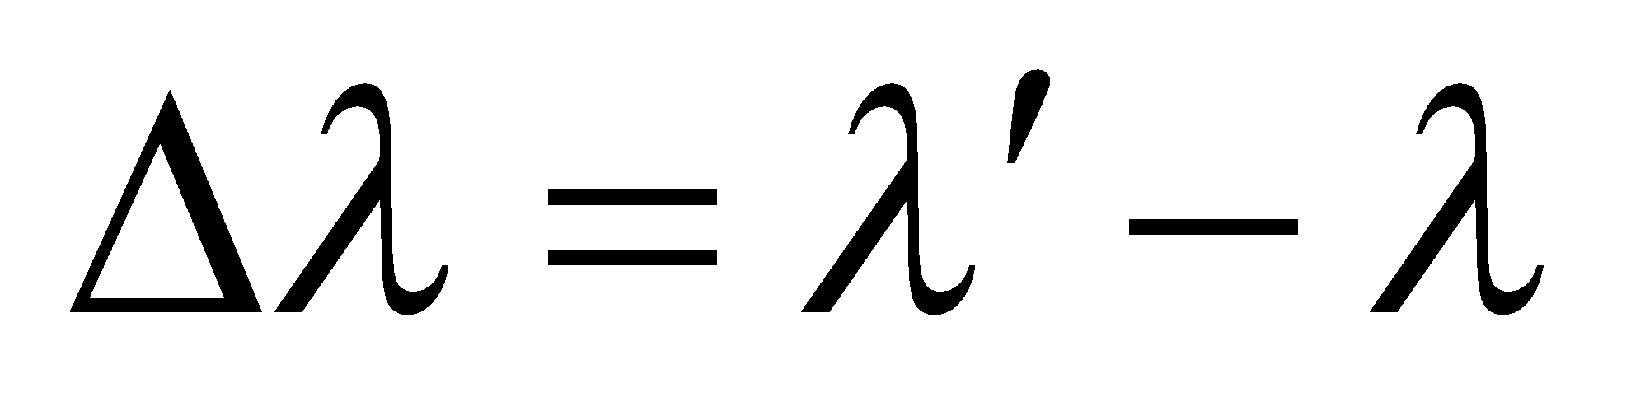.
Evaluate For the given datawe find
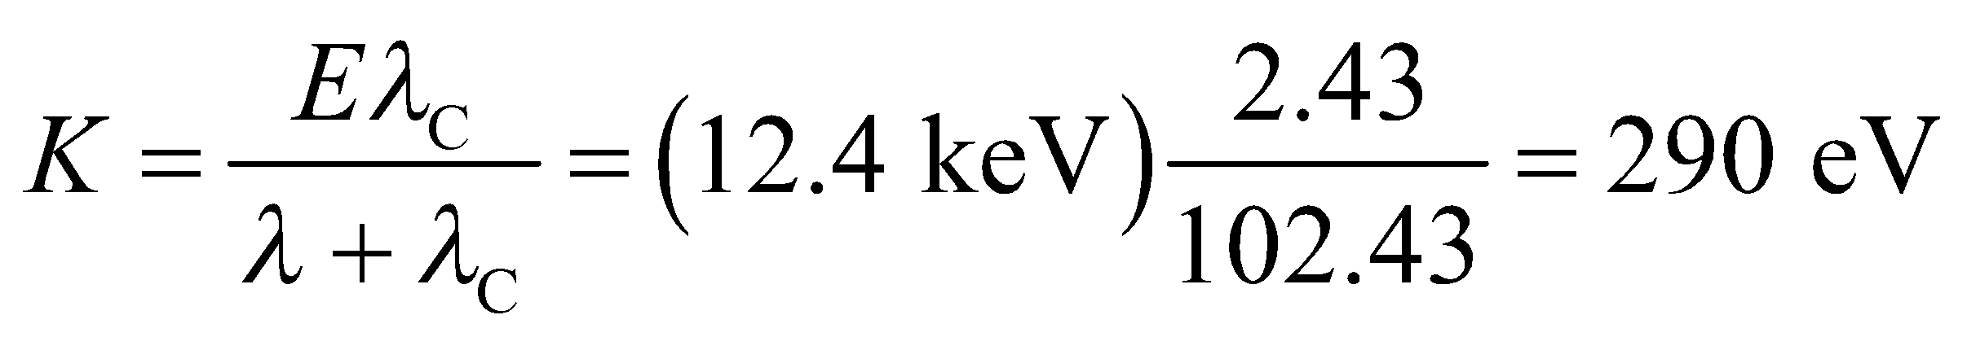
to two significant figures.
Assess This (nonrelativistic) energy corresponds to a speed of
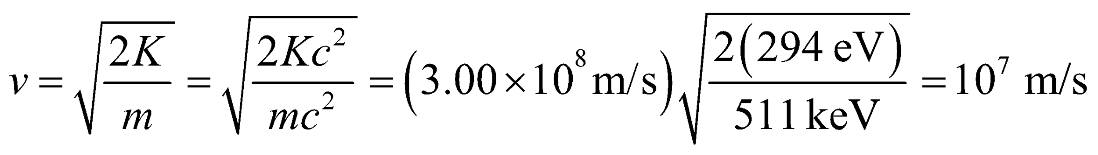
53. Interpret This problem involves the photoelectric effect. We are given enough information to find the work function of the material, and are asked if this material will emit electrons when illuminated with radiation at a longer wavelength and, if so, what will be the maximum electron energy.
Develop To determine whether or not the photoelectric effect can occur, we shall first find the work function from Einstein’s photoelectric effect equation (Equation 34.7). Using the data for the blue light, this gives the work function of the photocathode material as
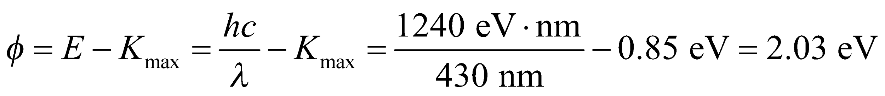
Evaluate The energy of a photon of the red light is only
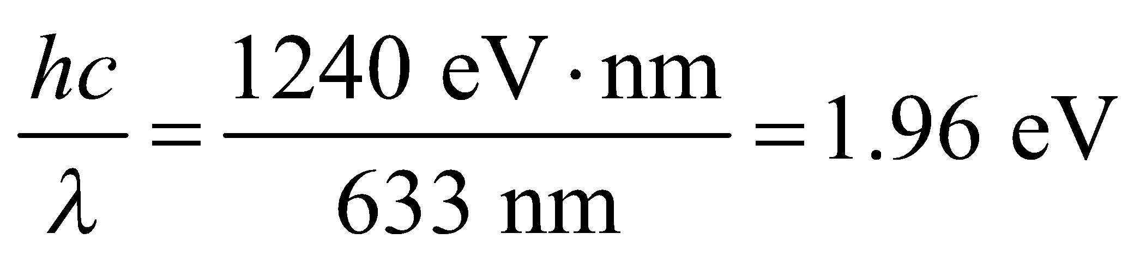
and therefore is insufficient to eject photoelectrons.
Assess A wavelength of 633 nm is greater than the cutoff wavelength of 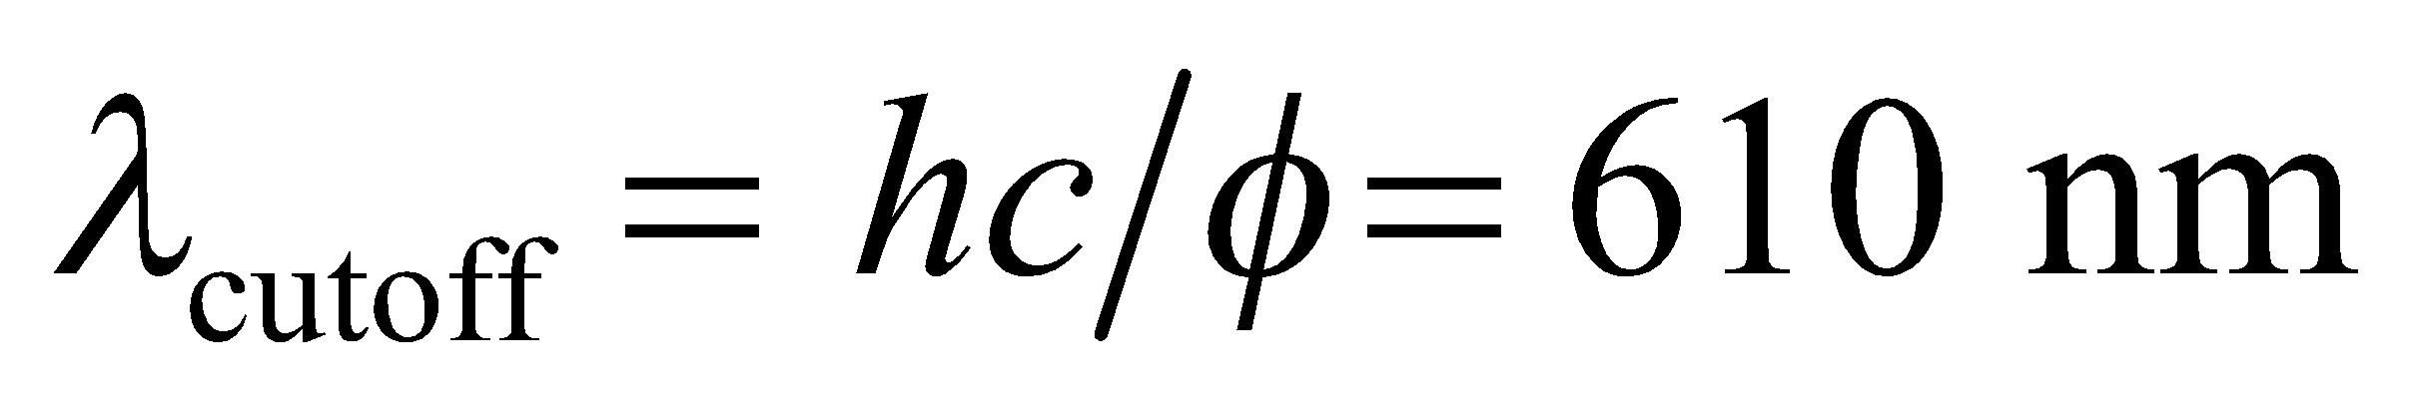 for the photocathode material.
54. Interpret This problem involves the Bohr atom (i.e., a hydrogen atom). We are to find the highest possible energy for a photon emitted by such an atom.
Develop The energy of the photon emitted in a hydrogen atom transition between adjacent states 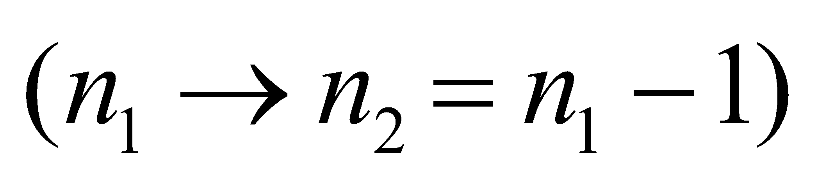 is
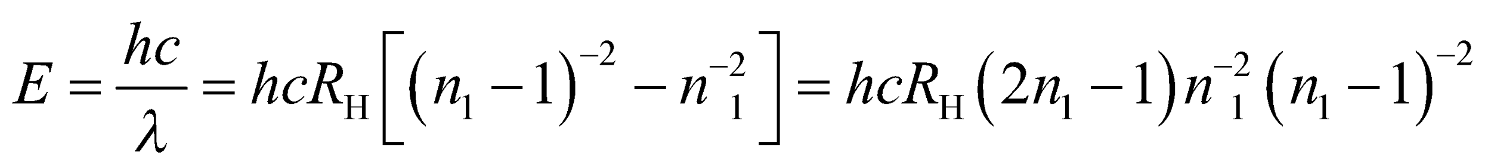
(see Equations 34.6 and 34.9 and the discussion of the Bohr atom in the text).
Evaluate (a) The maximum allowed energy occurs for n₁ = 2, which gives
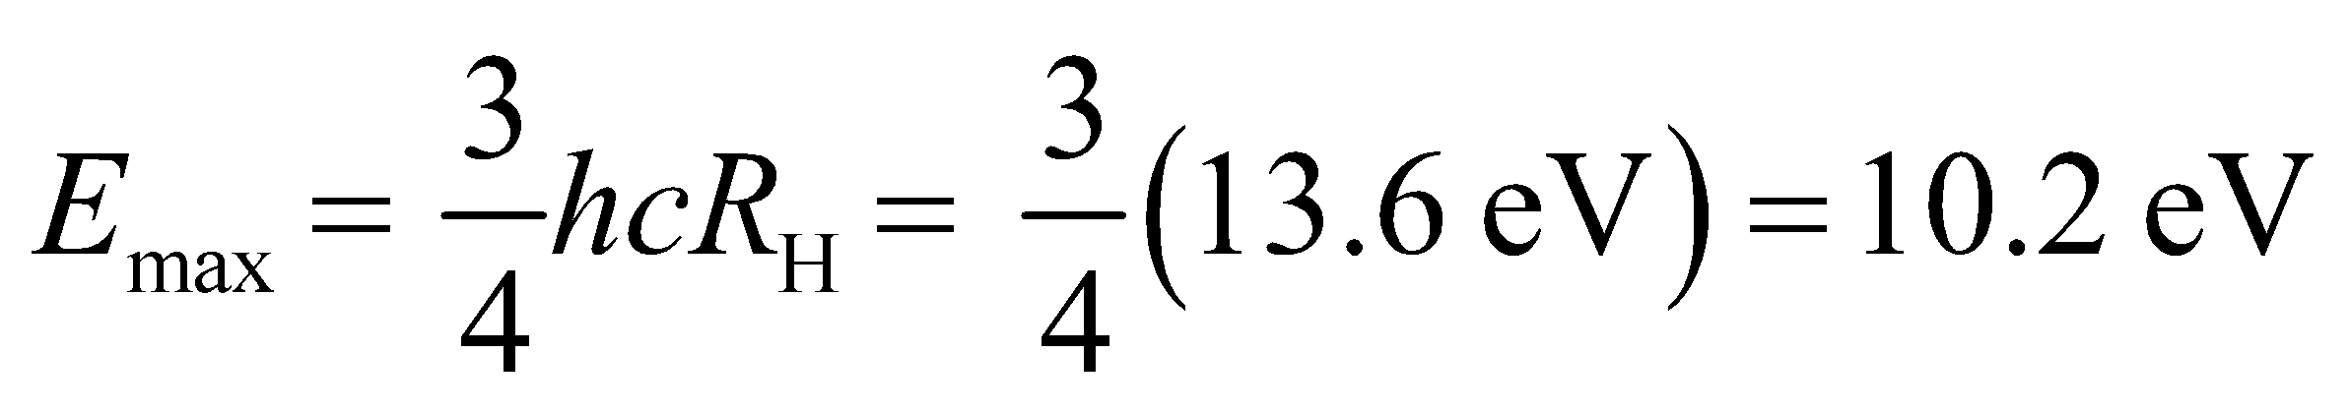
(b) The upper (initial) energy level is n₁ = 2 and the lower (final) energy level is n₂ = 1.
Assess This energy is in the ultraviolet portion of the electromagnetic spectrum.
55. Interpret This problem is about the wavelength and energy of the photon emitted when a Rydberg hydrogen atom undergoes a transition.
Develop The wavelength of the photon can be calculated using Equation 34.9:
where 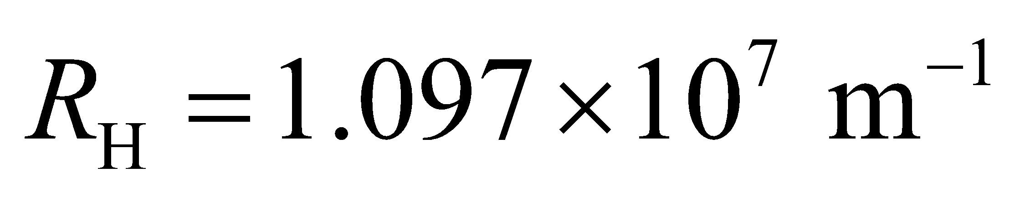 is the Rydberg constant. Once we know the wavelength, the energy of the photon may be found using .
Evaluate (a) The above equation gives
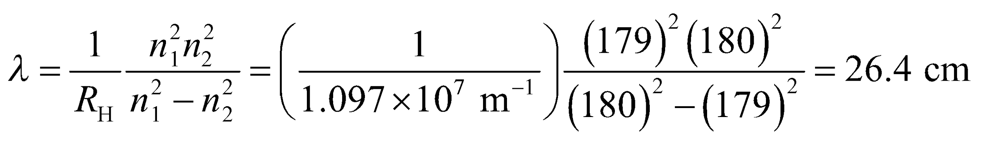
(b) The energy of the emitted photon is
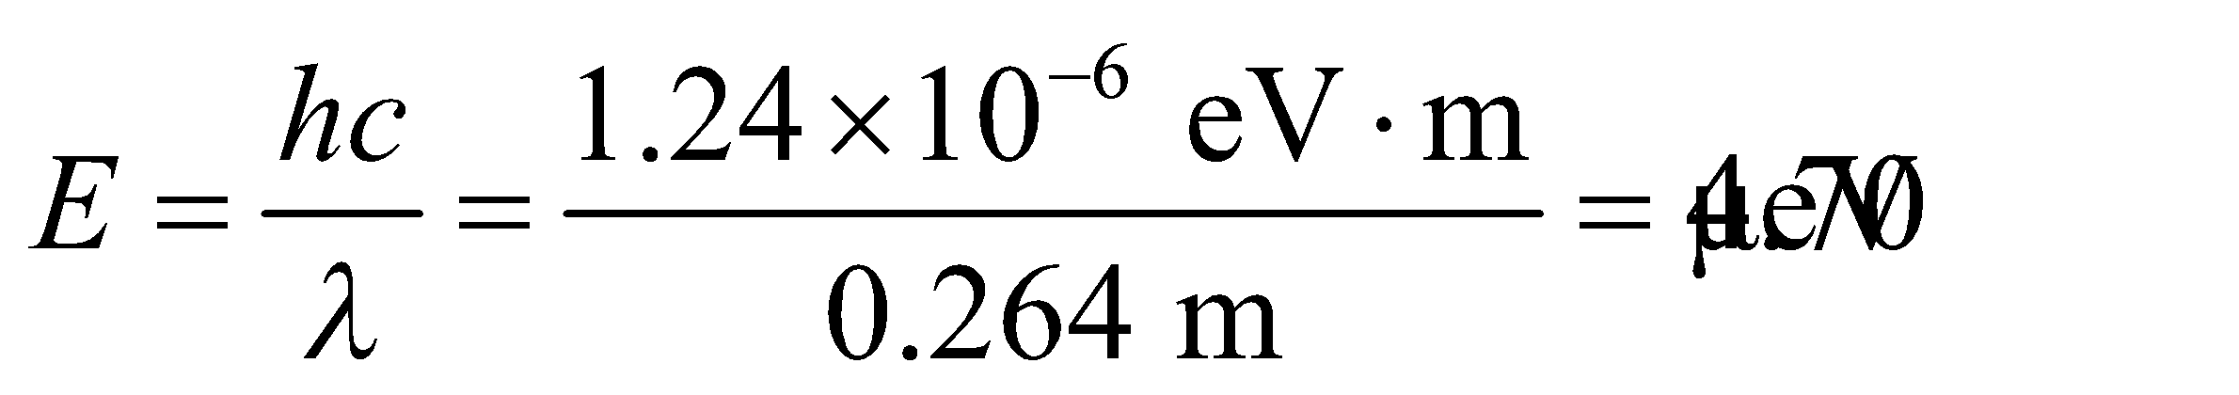
Assess The long wavelength corresponds to the radio region of the electromagnetic spectrum.
56. Interpret We are to find the maximum energy for a photon emitted by a transition in the Lyman series and in the Balmer series in a hydrogen atom.
Develop Apply Equation 13.12b,
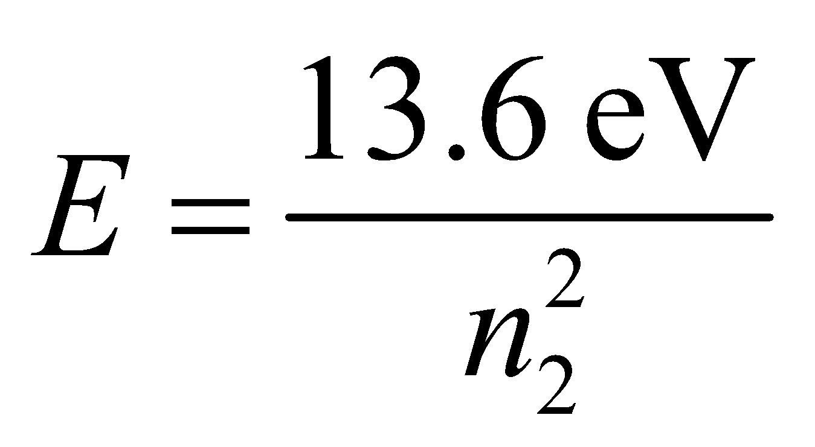
where n₂ is lowest quantum number for the given series. From Figure 34.11, we see that n₂ = 1 for the Lynam series and n₂ = 2 for the Balmer series. To find the corresponding wavelength, use Equation 34.6 E = hf = hc/λ.
Evaluate (a) For the Lyman series, the highest energy photon is
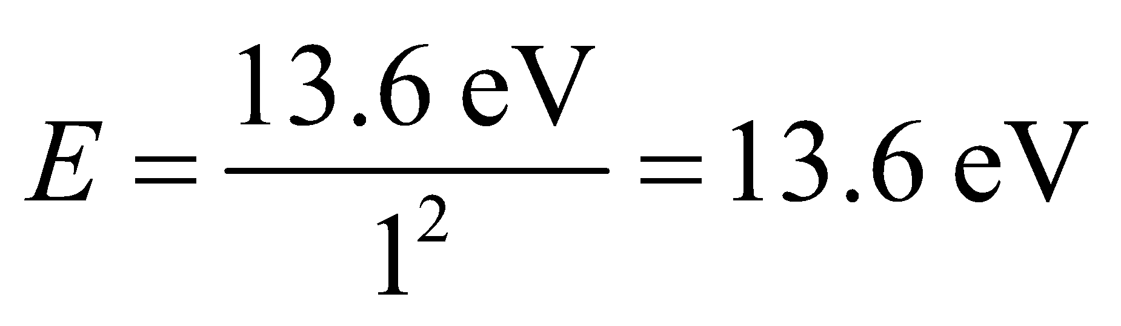
The wavelength of this is
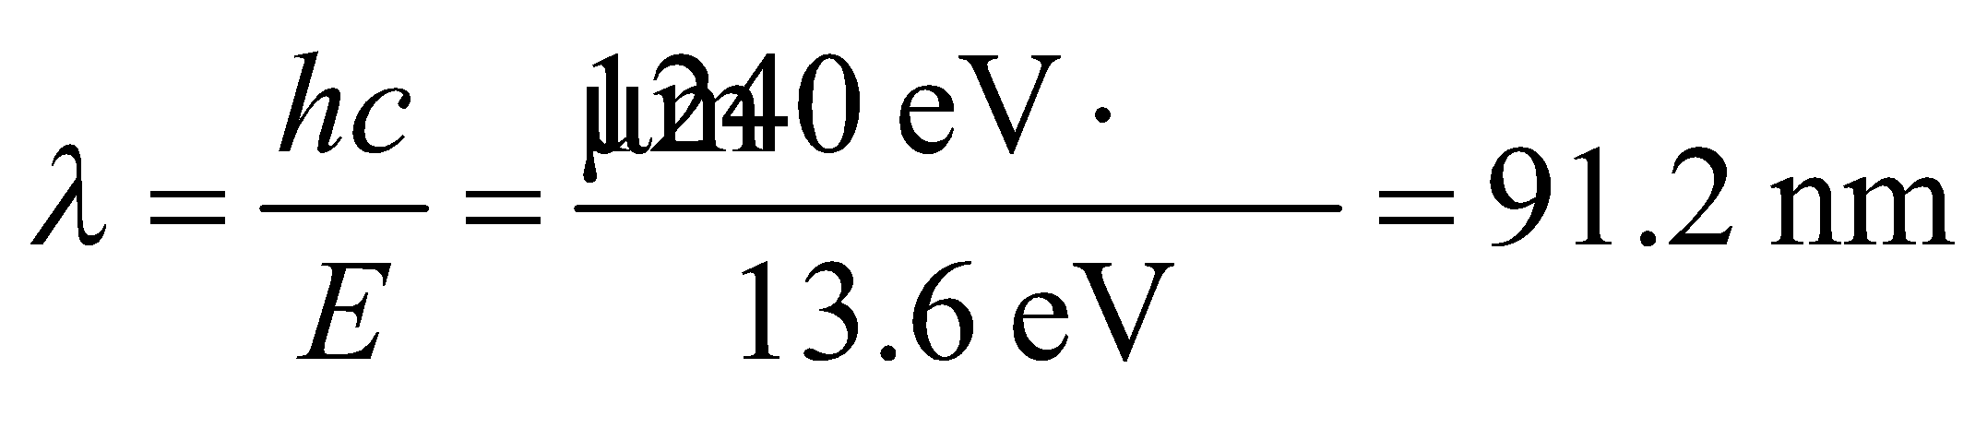
(b) For the Balmer series, the highest energy photon is
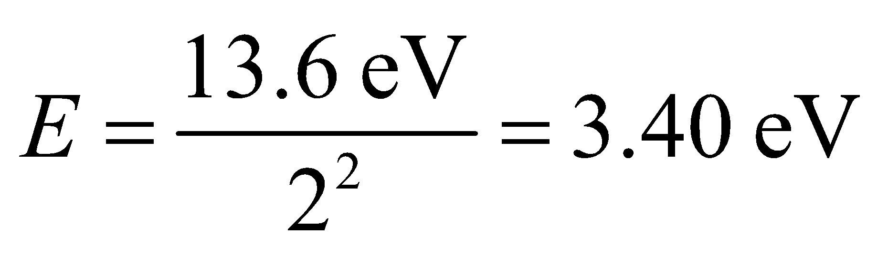
so the wavelength is
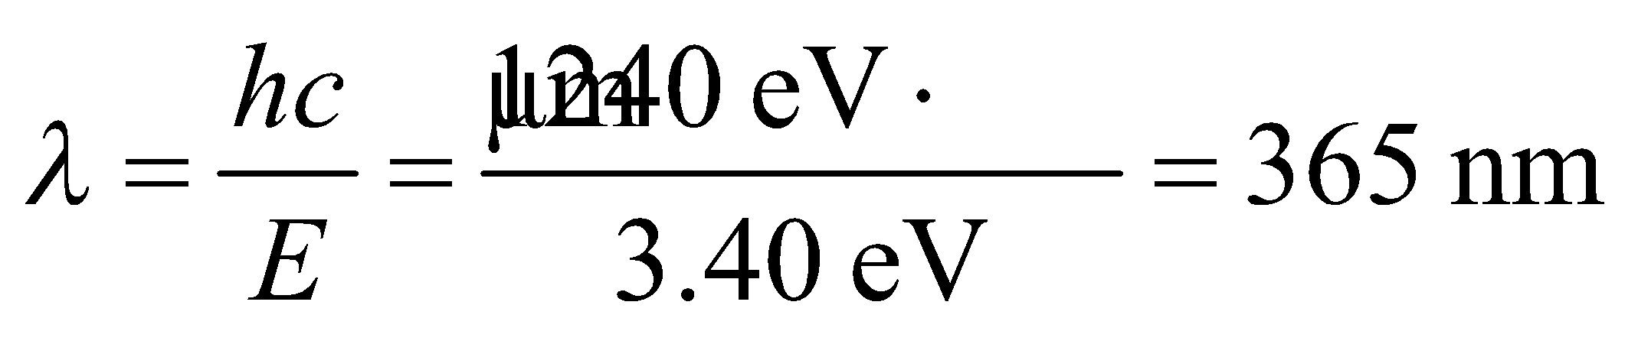
Assess The Lyman series limit is in the ultraviolet. The Balmer series limit is at the very high-energy end of the visible spectrum.
57. Interpret The hydrogen atom undergoing a downward transition emits a photon. We are interested in the original state of the atom, given the energy of the photon and the quantum number of the final state of the atom.
Develop The wavelength of the photon can be calculated using Equation 34.9:
where is the Rydberg constant. Once we know the wavelength, the energy of the photon may be found using Equation 34.6:
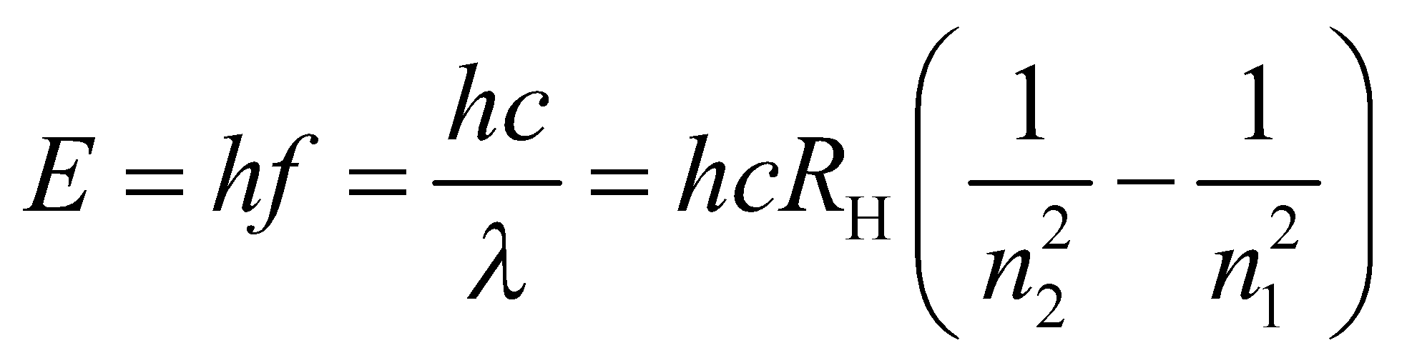
Evaluate Solving for n₁ gives
Note that 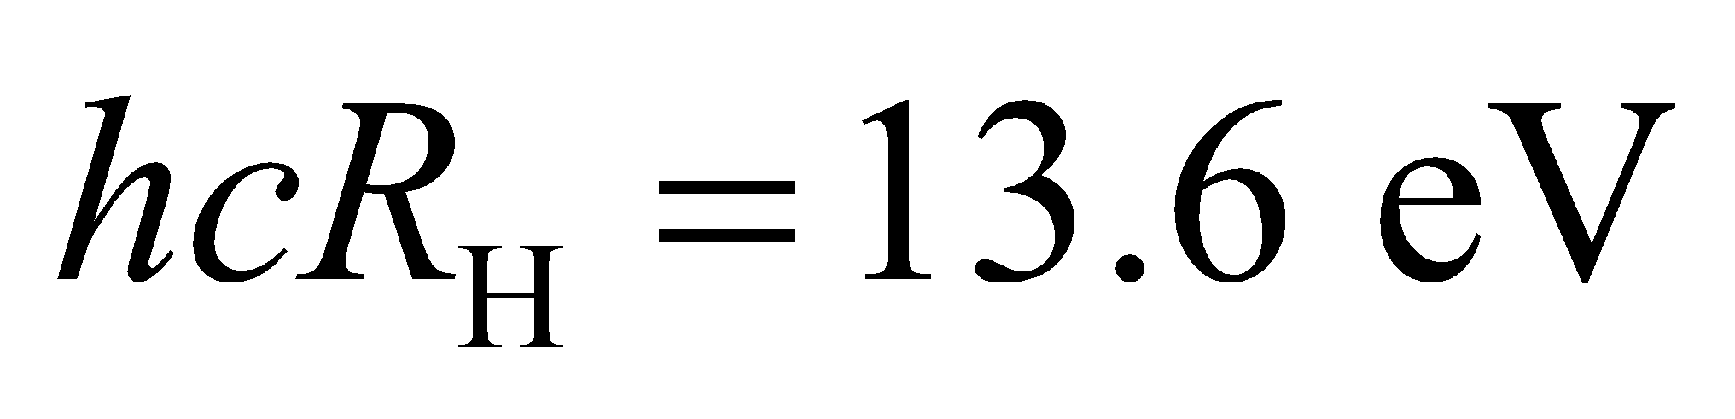 is the ionization energy.
Assess The wavelength of the emitted photon is 0.133 m, which falls into the radio wave spectrum.
58. Interpret This problem involves conservation of energy and the Bohr model of the atom. We can use these two concepts to find the energy of an electron ejected from the ground state of a hydrogen atom by a 48-eV photon.
Develop Energy must be conserved, so the final kinetic energy is the original (ground state) energy plus the absorbed photon energy.
Evaluate The final kinetic energy is thus
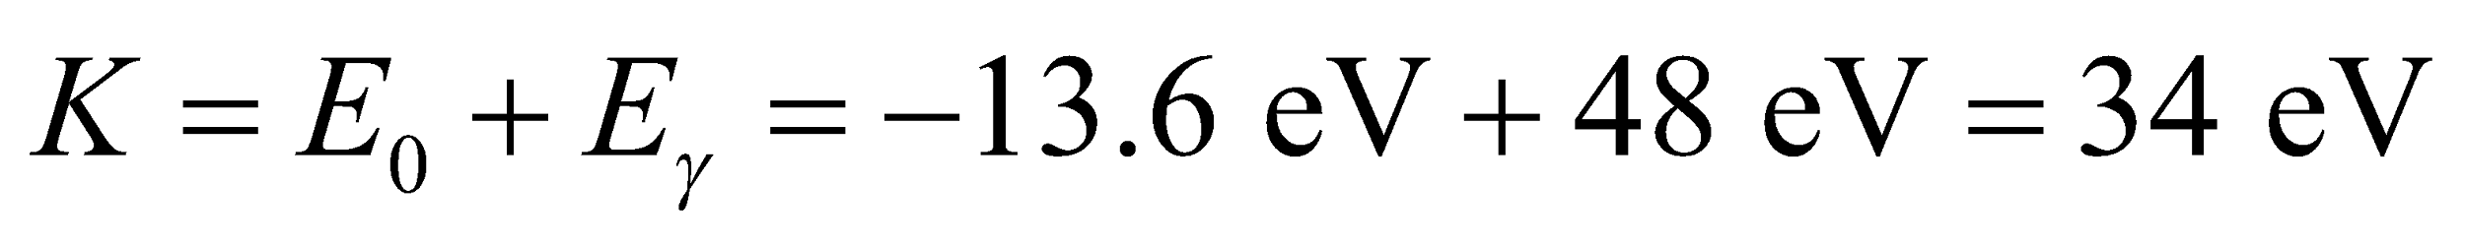
Assess This energy is much less than the electron’s rest mass, so relativistic effects do need to be considered.
59. Interpret This problem involves the Bohr model of the atom. We are to find the ionization energy of a hydrogen atom in its first excited state.
Develop Using Equation 34.12b, the energy of the first excited state (n = 2) is
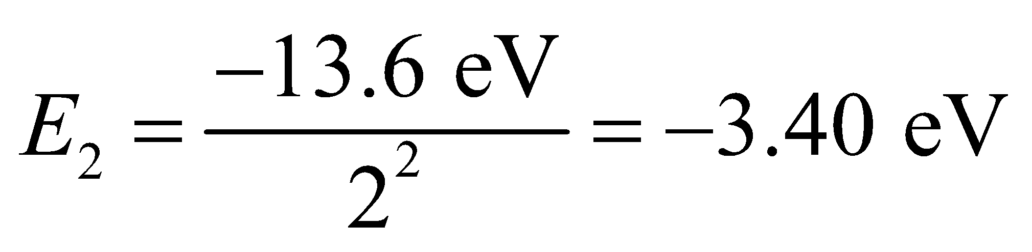
whereas an ionized atom (with zero electron kinetic energy) has energy zero.
Evaluate Thus, we must supply an energy E_{I} such that
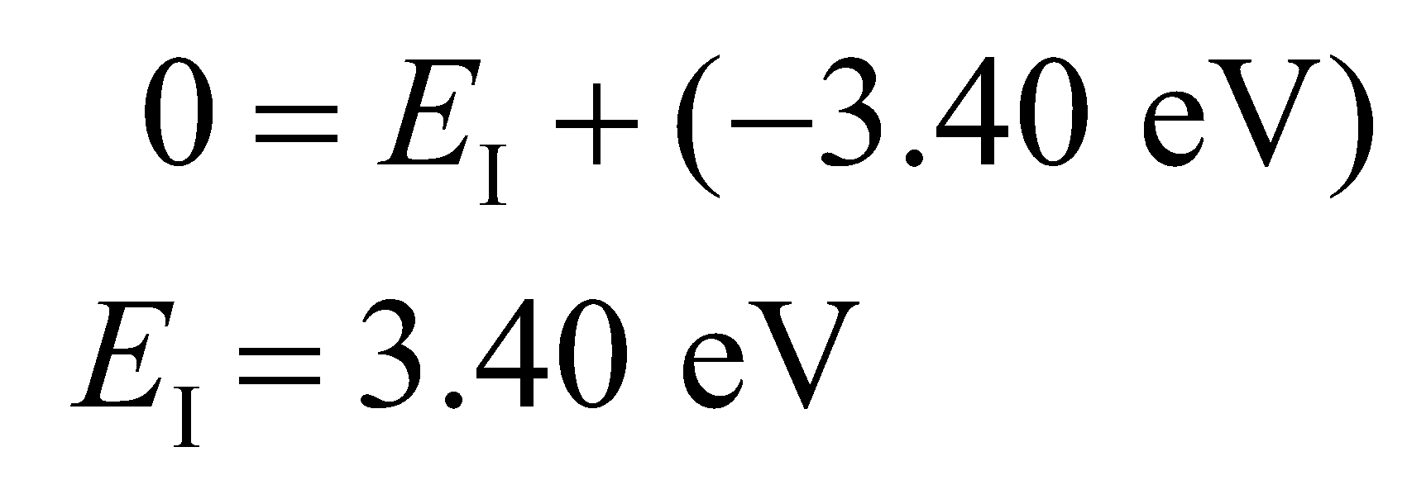
Assess The ionization energy here is only ¼ of the case where the atom is in the ground state. The higher the value of n, the smaller the ionization energy because the electron is less tightly bound to the nucleus.
60. Interpret We are to find the final energy of electrons ejected from ground-state hydrogen atoms by ultraviolet radiation. We will apply conservation of energy and use the Bohr model of the atom.
Develop By conservation of energy, the final kinetic energy of the electron (actually, the ionized atom with the nucleus assumed to be at rest) is its initial ground state energy (−13.6 eV) plus the energy E = hf = hc/λ (see Equation 34.6) absorbed from the photon.
Evaluate Summing the two energies, we find the kinetic energy of the electron to be
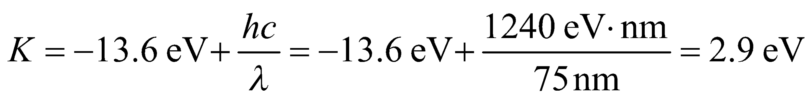
Assess The photon supplies a total energy of 13.6 eV + 2.9 eV = 15.5 eV.
61. Interpret 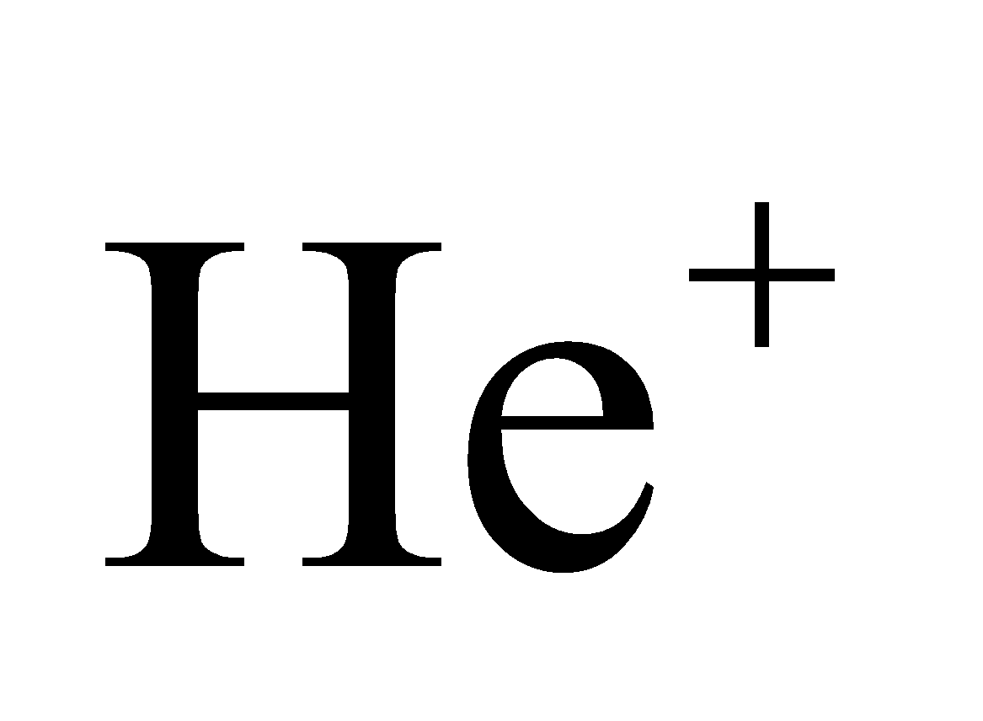is a hydrogen-like atom with a nuclear charge +2e. We are to apply the Bohr model to this system to find the ground-state electron radius and the energy difference between the n =2 and n = 1 state.
Develop Modifying the treatment of the Bohr atom in the text (see derivation of Equations 34.11 and 34.12) for singly ionized helium (He⁺) by replacing the nuclear charge with 2e, one gets 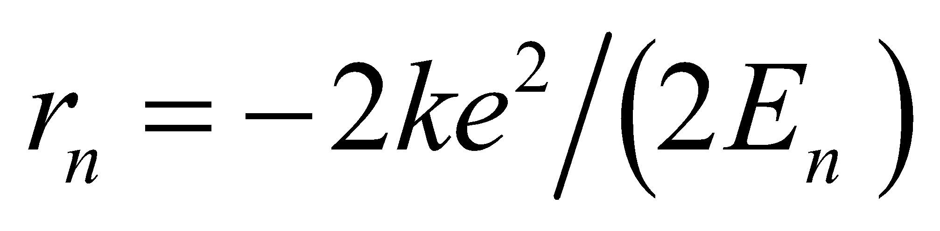 and 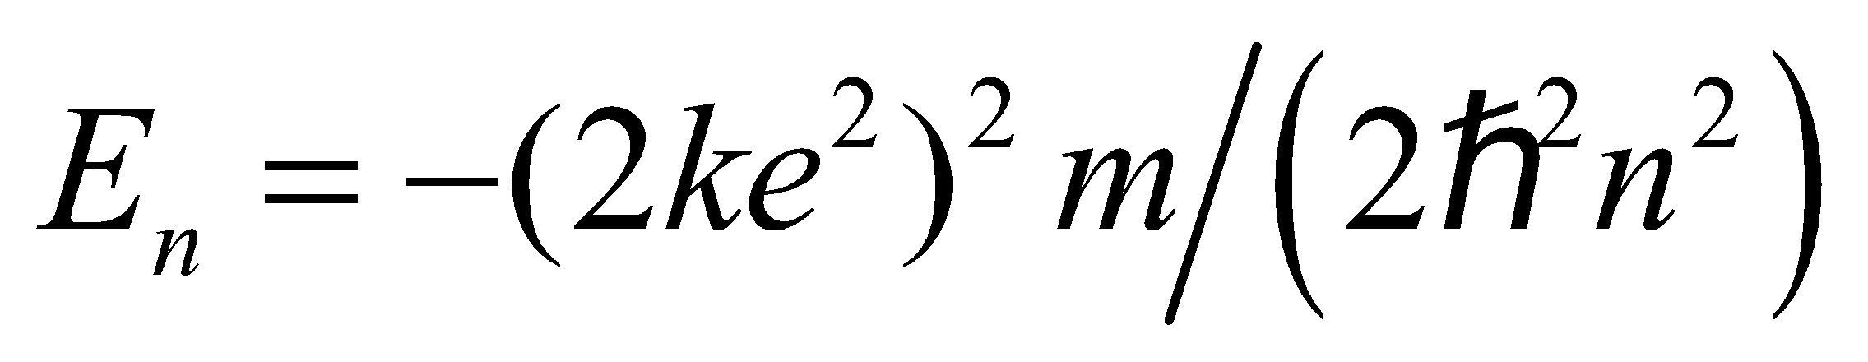. Thus,
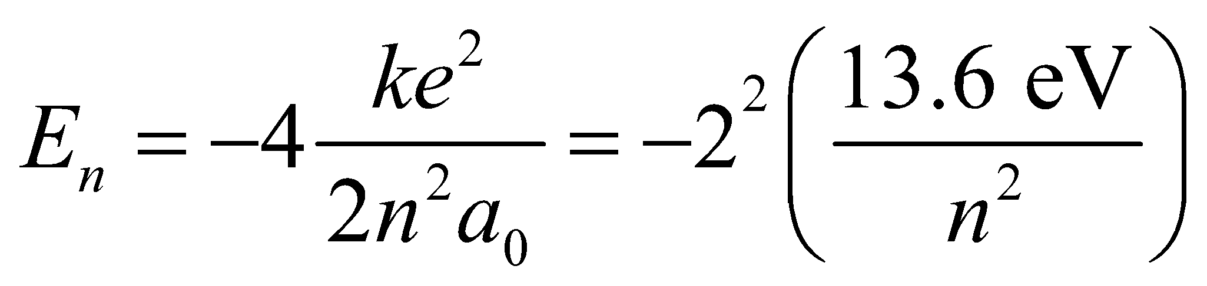
and
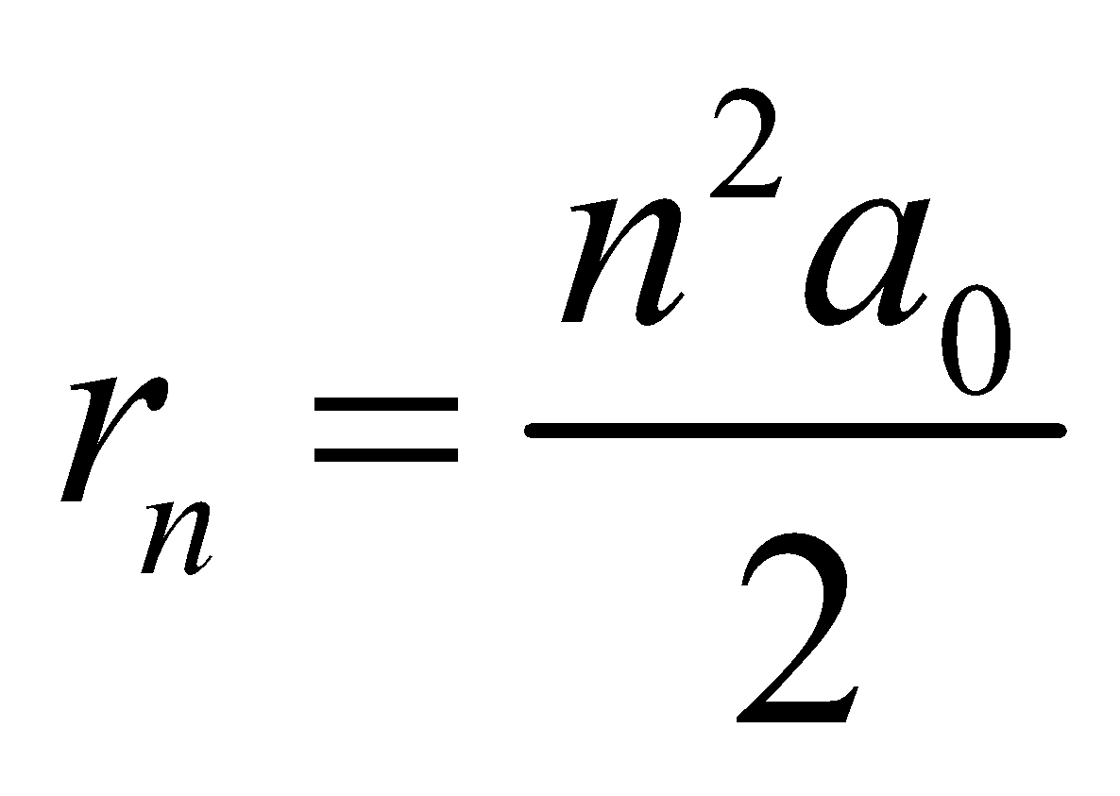
Evaluate (a) The radius of the ground state of He⁺ is
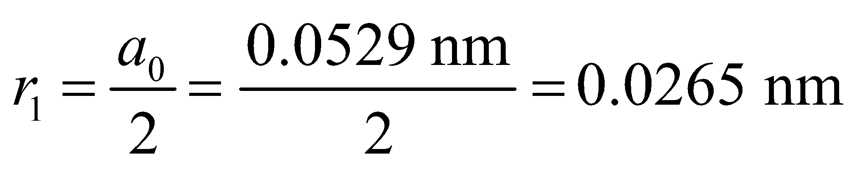
(b) The energy released in the transition from n = 2 to n = 1 is
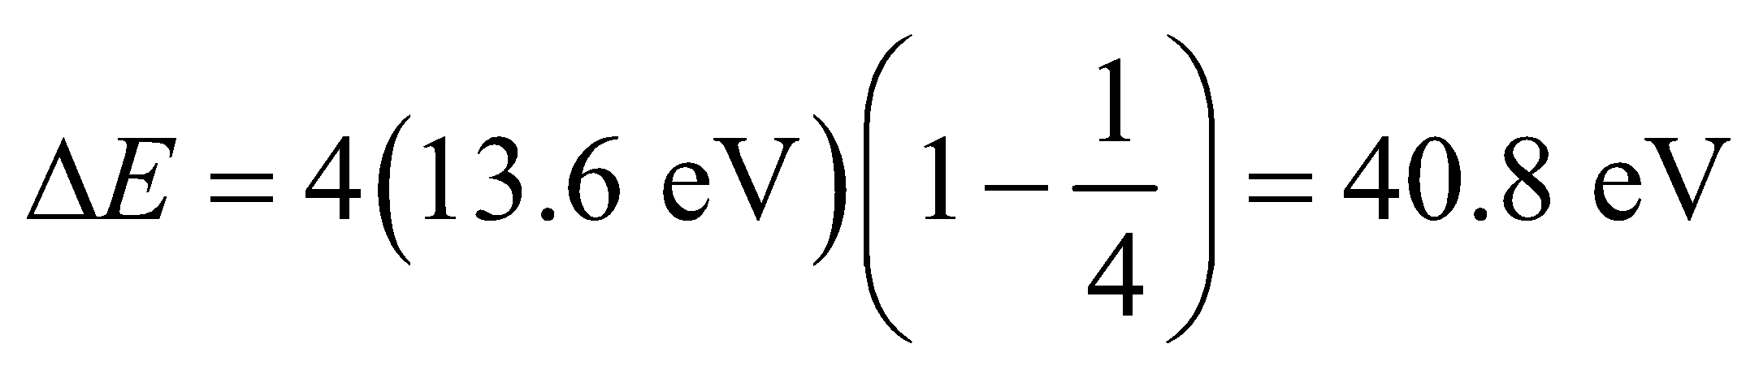
Note that there is also a small change in m for helium, different from the correction in hydrogen, for the motion of the nucleus.
Assess In general, replacing the nuclear charge with Ze gives results for any one-electron Bohr atom, where Z is the number of protons for the atom (i.e., the atomic number).
62. Interpret This problem involves the de Broglie wavelength. We are to find the kinetic energy needed for an electron to have a de Broglie wavelength the size of a hydrogen atom.
Develop Since 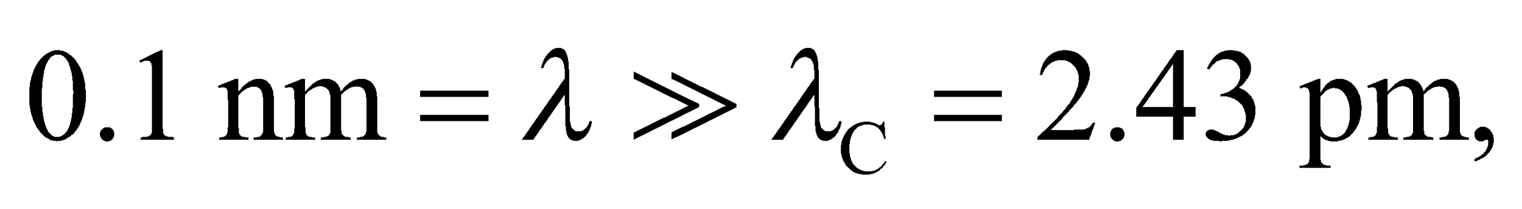 nonrelativistic expressions can be used to write the kinetic energy in terms of the de Broglie wavelength:
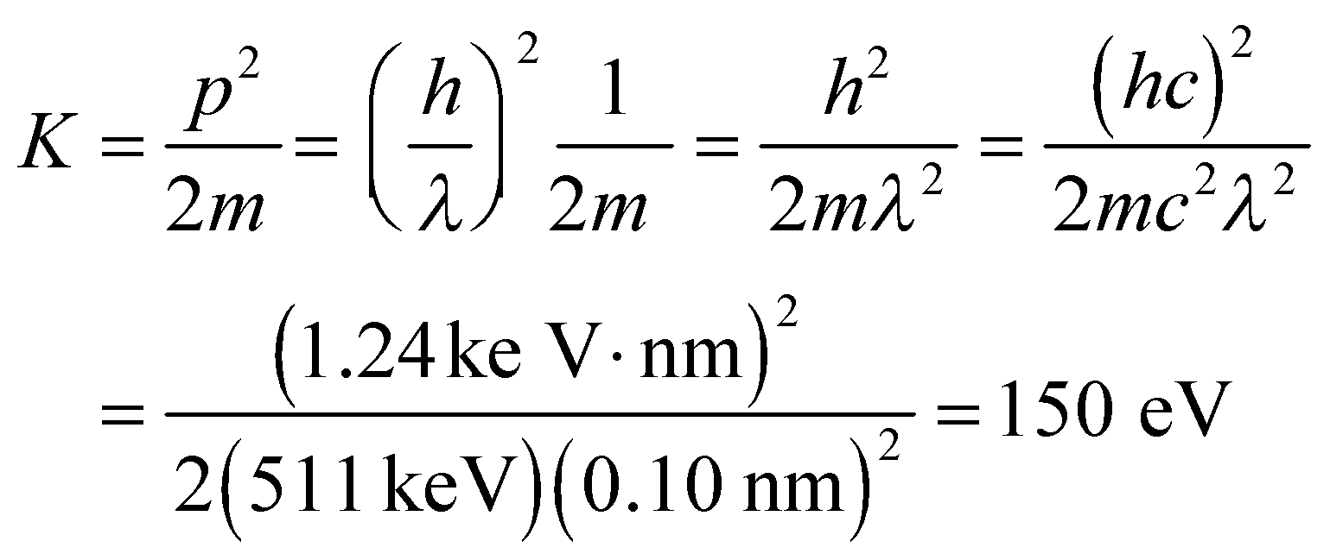
Evaluate Because the kinetic energy gained in an acceleration from rest equals the potential energy difference, 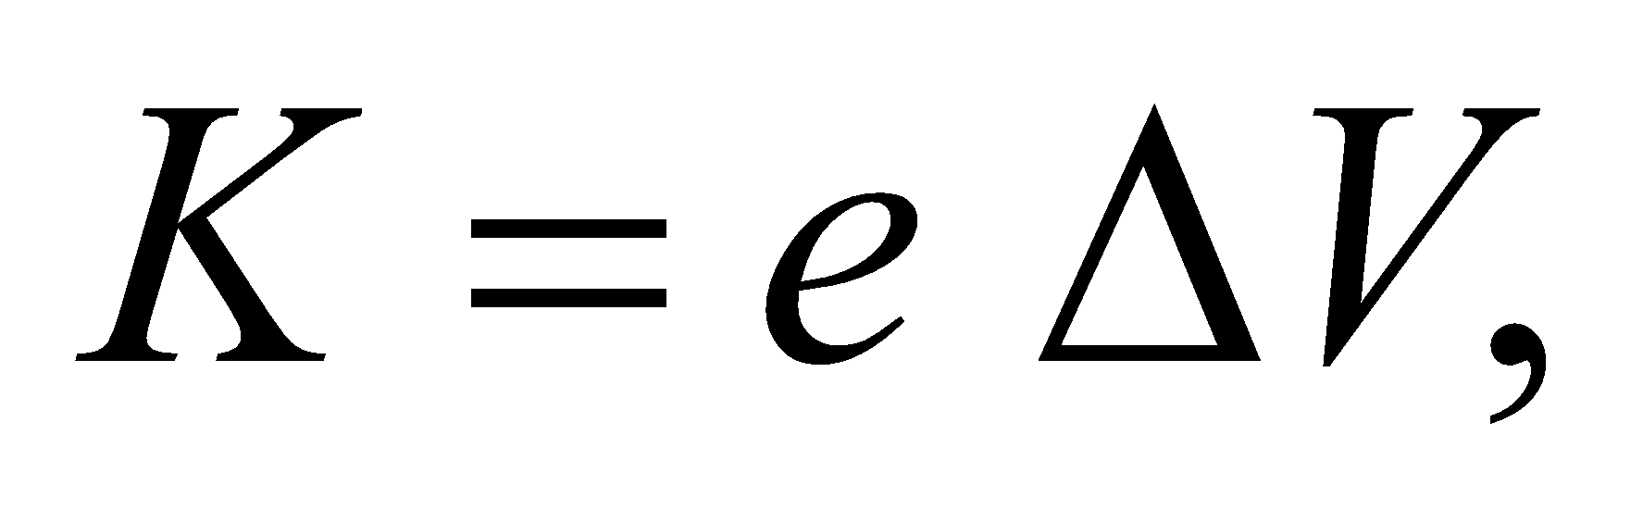 and 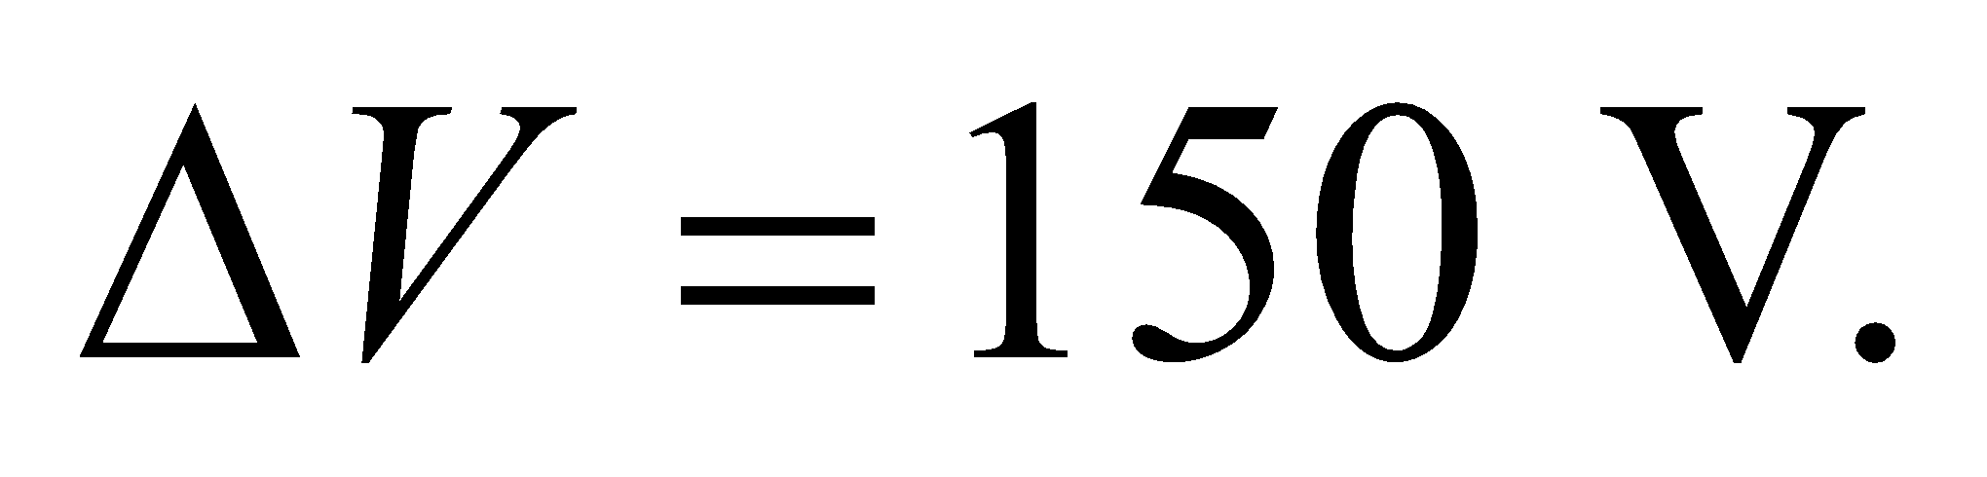
Assess Recall that λ_{C} = h/(mc) = 2.43 pm for an electron. The result of 150 V is an easily accessible potential difference.
63. Interpret The resolution of a microscope depends on the wavelength used. A smaller de Broglie wavelength will improve the resolution of an electron microscope. We are to find the minimum electron speed that will make its de Broglie wavelength less than 450 nm.
Develop The resolution of the electron microscope is better than the optical microscope with 450-nm light if the de Broglie wavelength λ of the electrons is less than 450 nm. Thus,
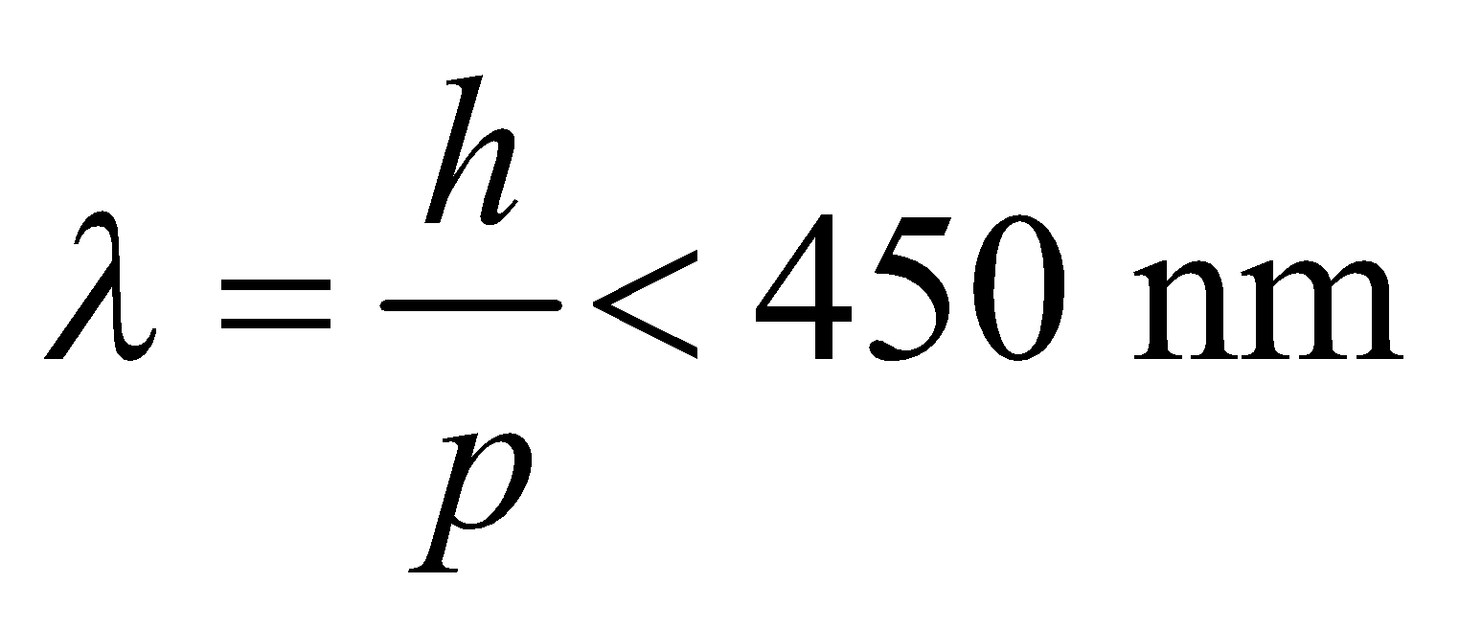
Since p = mv (for nonrelativistic electrons), the above condition allows us to obtain the minimum electron speed.
Evaluate The above inequality gives
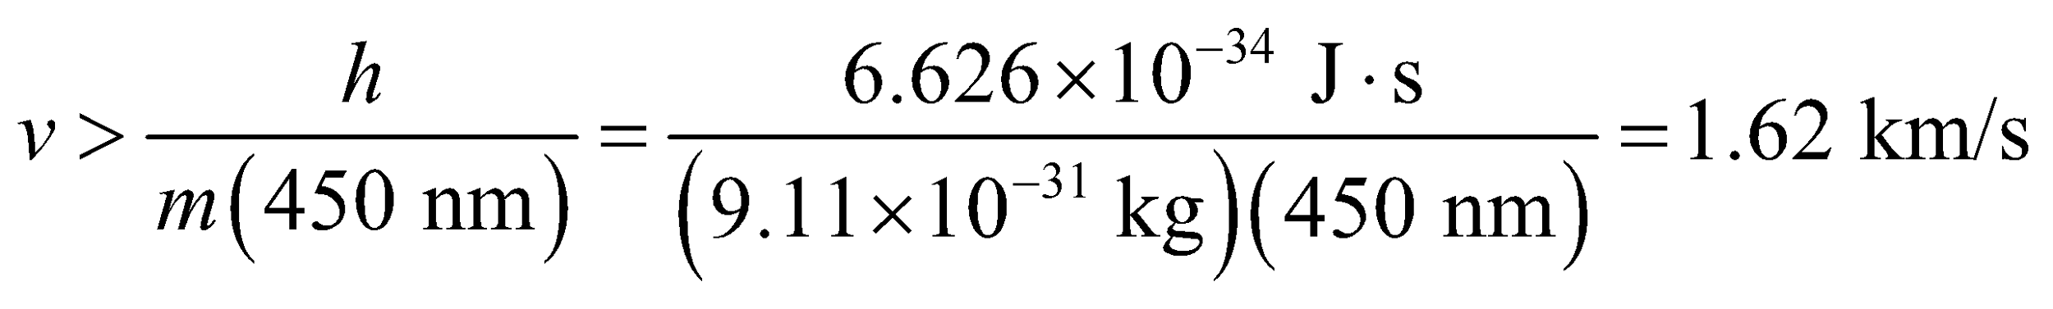
So the minimum speed is 1.62 km/s.
Assess Since  (Compton wavelength of the electron), our use of the nonrelativistic momentum was justified. The electron microscope can provide resolutions down to about 1 nm and magnifications of 10⁶.
64. Interpret You want to see what energy of electrons is needed to resolve microtubules. You'll need to consider the de Broglie wavelength of the particles.
Develop To resolve the microtubules, the electron microscope that you buy will need electrons with de Broglie wavelength less than or equal to the size of the microtubules (25 nm). This corresponds to a momentum of 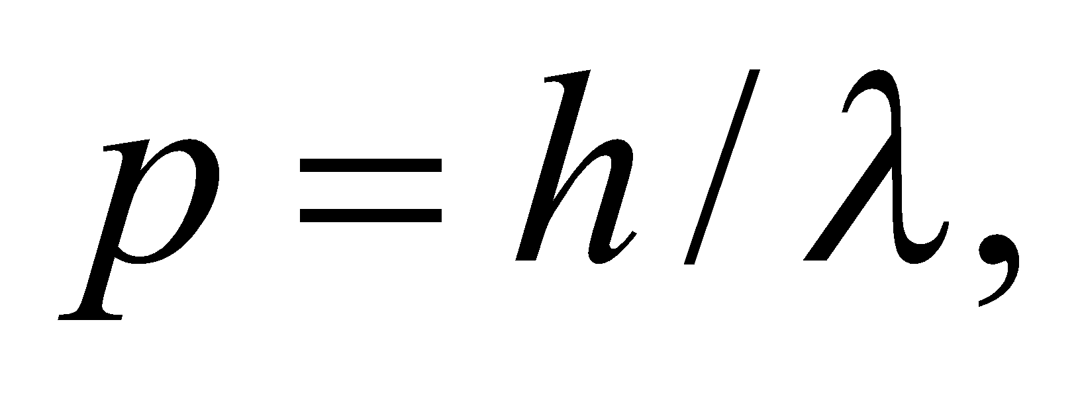and a kinetic energy of 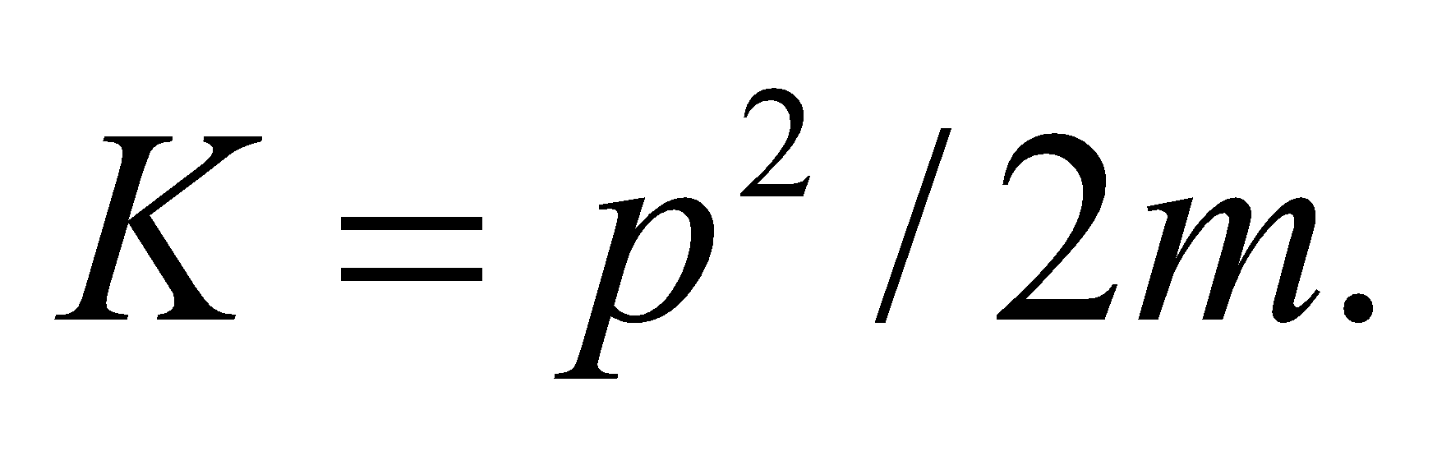 With these equations, you can calculate the minimum energy you need for an electron microscope.
Evaluate The minimum electron kinetic energy needed is
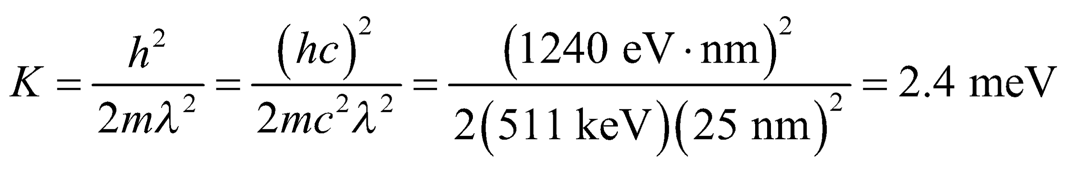
where we have used the rest-energy of the electron,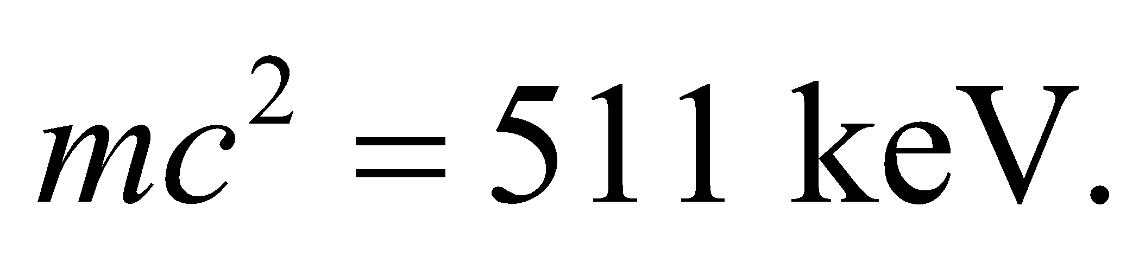The minimum kinetic energy is far below 40 keV, so you don't need to buy the more expensive microscope, since the less expensive microscope will work.
Assess By the above arguments, the 40 keV electron microscope should have resolution of around 6 pm, since that is the corresponding de Broglie wavelength of the electrons. However, there are complications involved in focusing a beam of electrons, so most electron microscopes have resolutions around a nanometer.
65. Interpret This problem involves the uncertainty principle. We want to find the minimum velocity of an electron based on its uncertainty in position.
Develop Using the uncertainty principle given in Equation 34.15 with Δx = 20 nm (the width of the well), we have
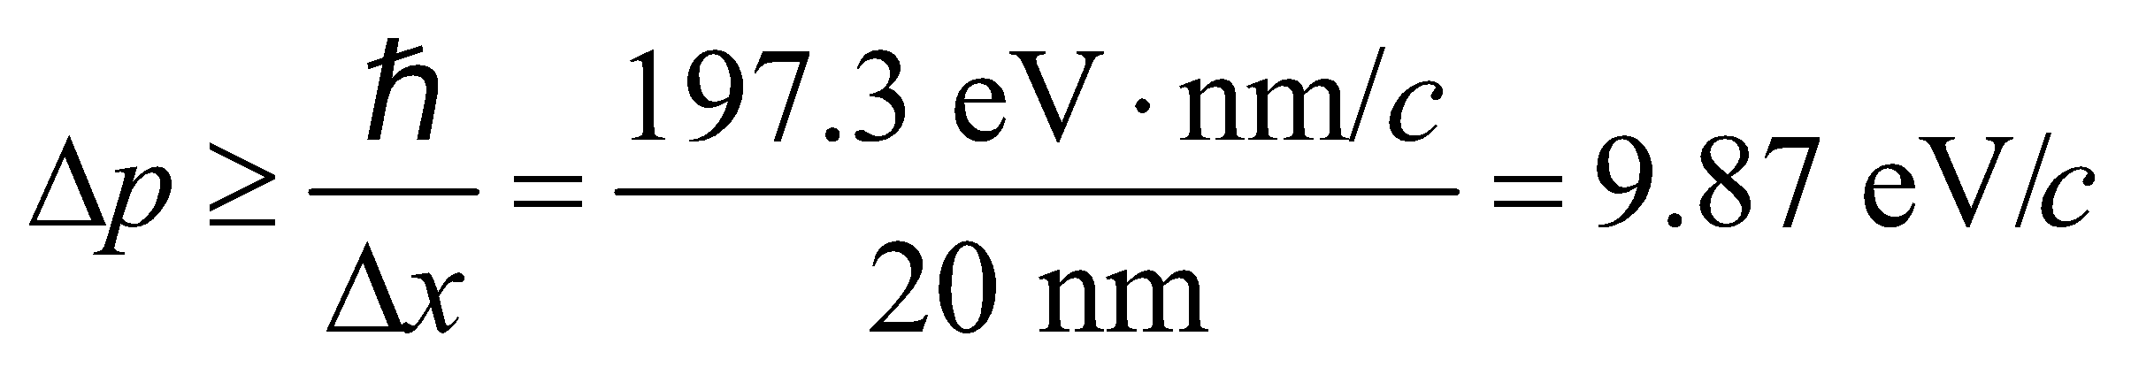
This is small compared to 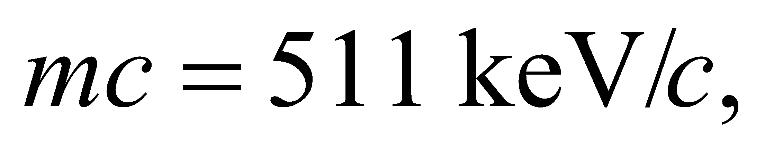 so nonrelativistic formulas are sufficient (see Example 34.6). Therefore, 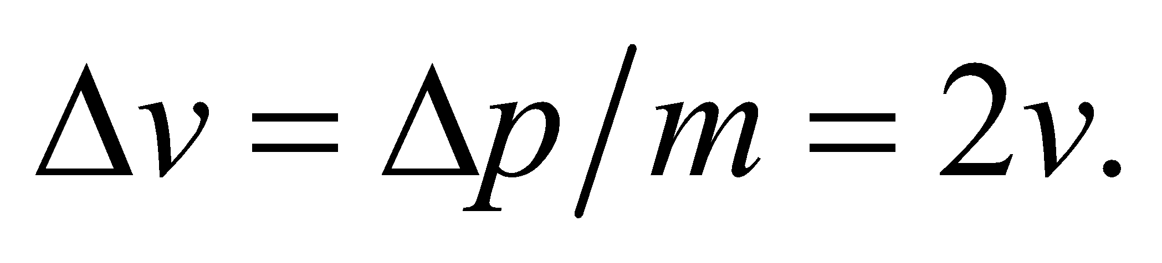
Evaluate The above conditions lead to
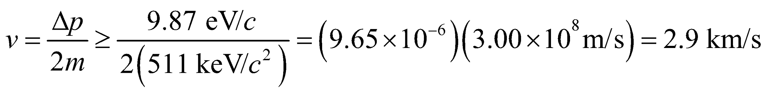
Thus, the minimum speed is v_{min} = 2.9 km/s.
Assess Quantum wells have important applications in the field of semiconductor fabrication. Note that the result is given to two significant digits, as warranted by the data.
66. Interpret This problem involves the uncertainty principle applied to the variable energy and time. We shall use this to find the uncertainty in energy in a typical atomic transition given the lifetime of the excited atomic state.
Develop The uncertainty principle (Equation 34.16) for energy and time is
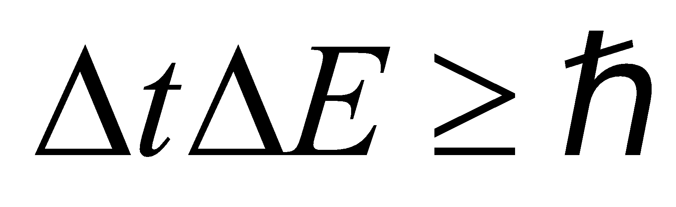
(note that the units of  are time-energy). Apply this to find the minimum energy given the uncertainty in time of Δt = 10⁻⁸ s.
Evaluate The uncertainty in energy is
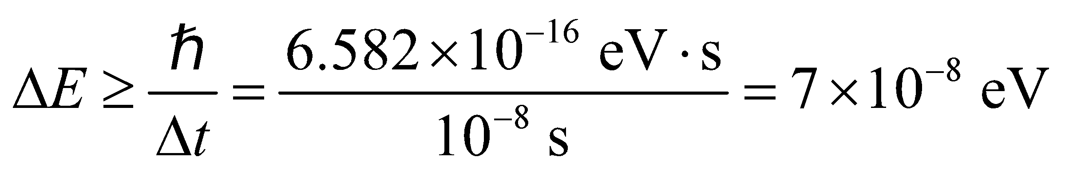
Assess This energy uncertainty is called the natural linewidth.
67. Interpret This problem involves energy-time uncertainty. We are interested in the minimum measurement time needed to measure the energy with the desired precision.
Develop The electron is nonrelativistic 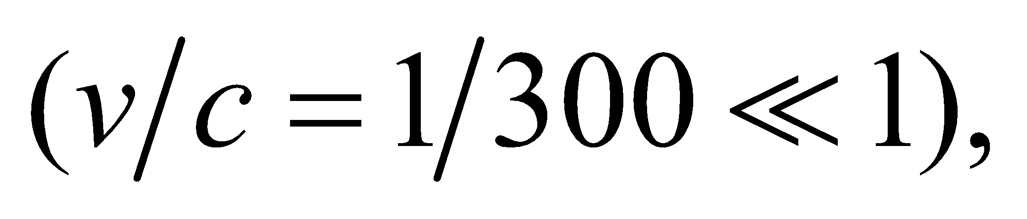 so we can use the nonrelativistic expression K = mv²/2 for kinetic energy. The desired uncertainty in the kinetic energy is
The minimum time can then be calculated using Equation 34.16, 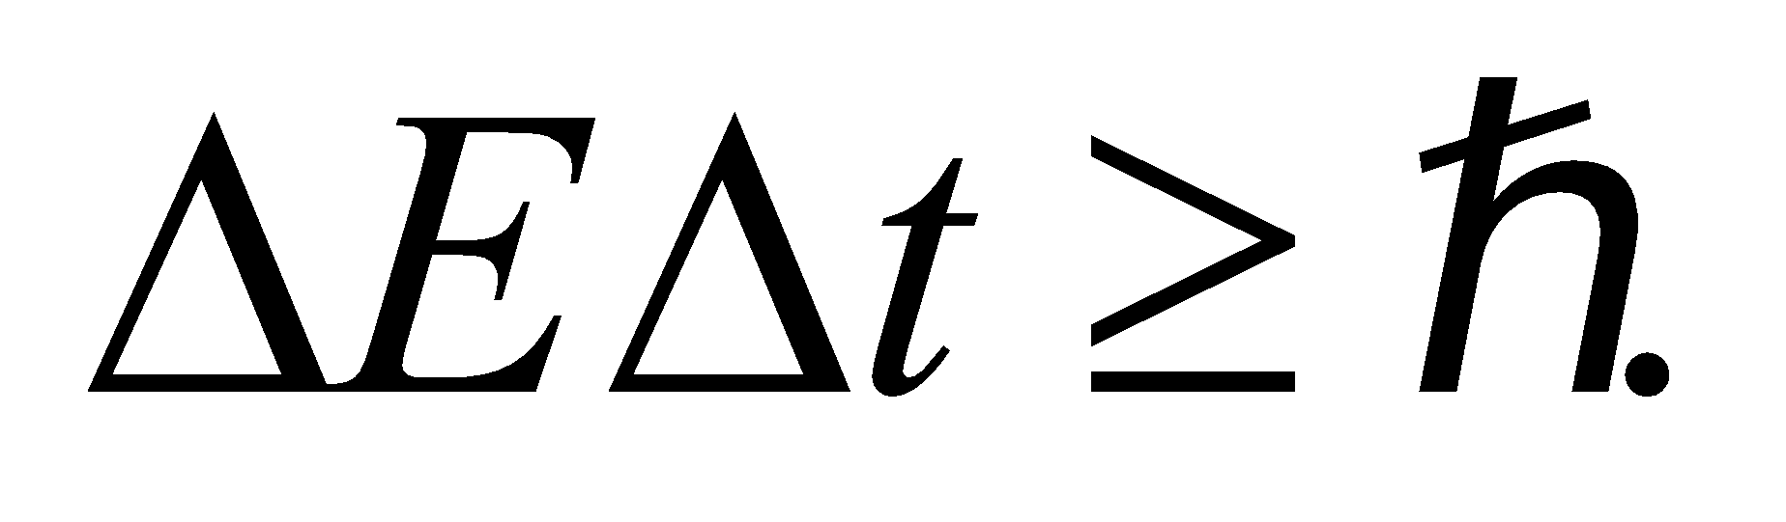
Evaluate An energy measurement of this precision requires a time
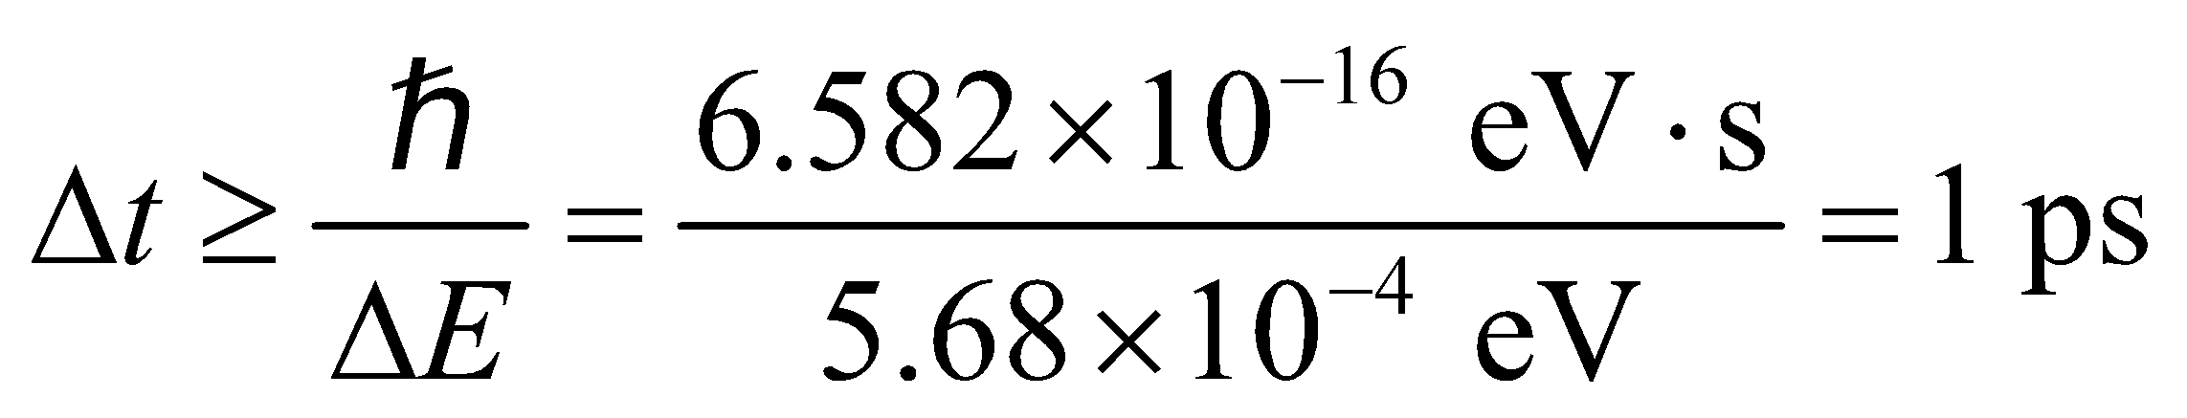
to a single significant figure.
Assess The energy-time uncertainty principle implies that the minimum measurement time must necessarily go up in order to achieve a greater accuracy in energy measurement.
68. Interpret We are to derive the classical Rayleigh–Jeans law (Equation 34.5) for blackbody radiation from Planck’s law (Equation 34.3).
Develop For 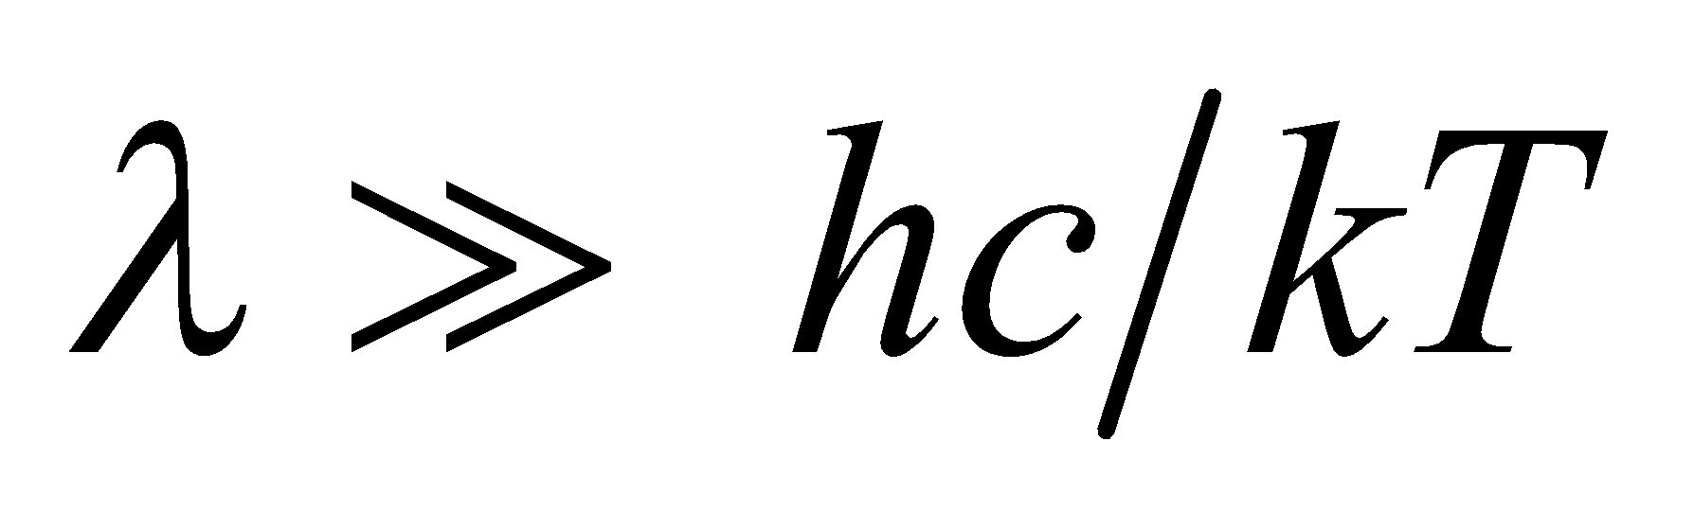, the exponent in Planck’s law (Equation 34.3) is much, much less than unity, so we can express the exponential function as
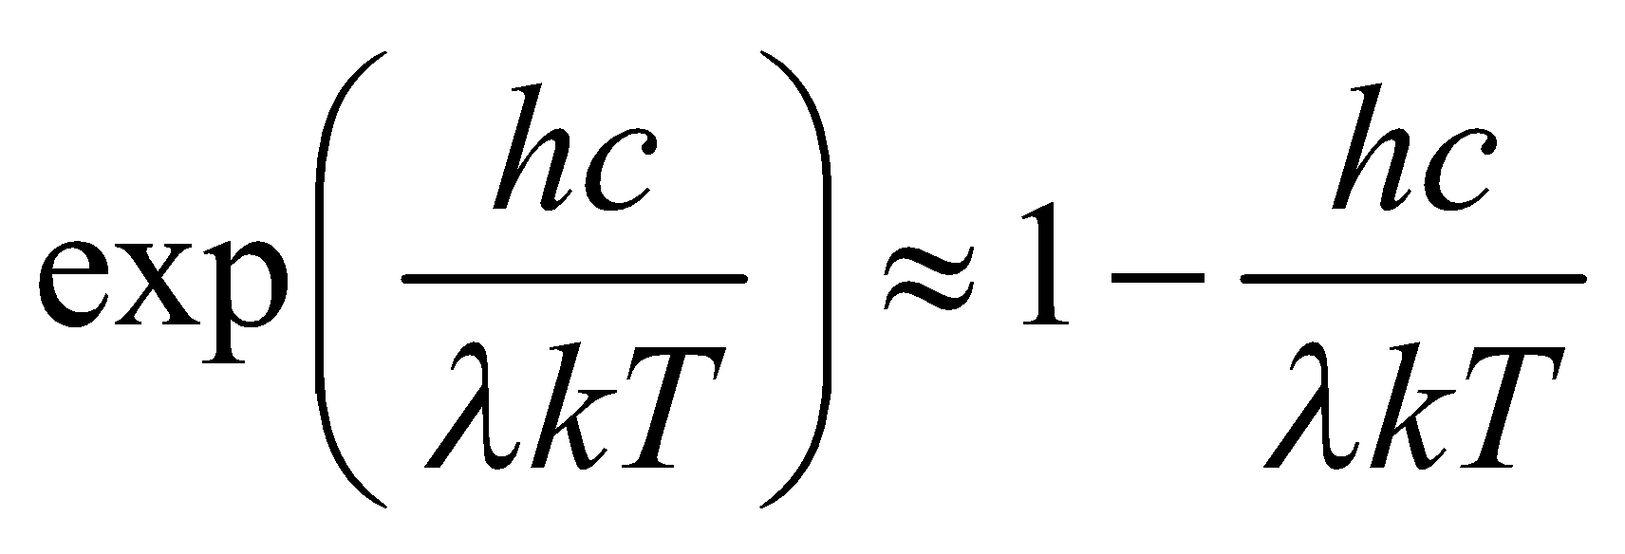
Insert this result into Planck’s law.
Evaluate With the above approximation, Planck’s law takes the form
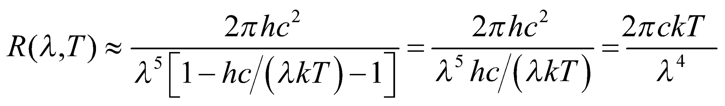
which is the Rayleigh–Jeans law.
Assess Thus, the Rayleigh–Jeans law is an approximation of the more accurate Planck law.
69. Interpret In this problem, we want to show that if a photon’s wavelength is equal to a particle’s Compton wavelength, then the photon’s energy is equal to the particle’s rest energy.
Develop From Equation 34.8, we see that the Compton wavelength of a particle is 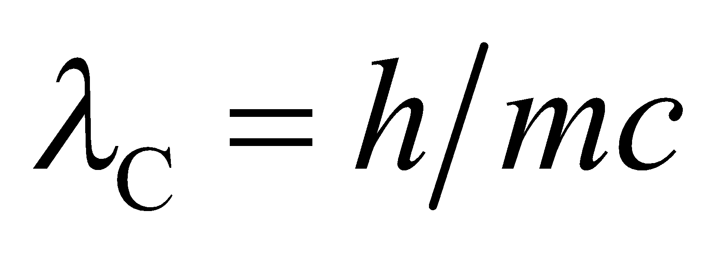. The rest energy of a particle is E = mc² (see discussion preceding Equation 33.9). From Equation 34.6, we see that the energy of a photon is E = hf = hc/λ.
Evaluate When the wavelength of the photon is λ = λ_{C}, its energy is
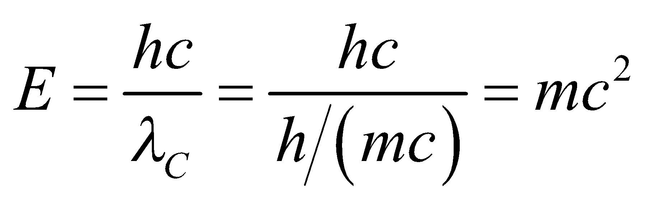
which is the same as the particle’s rest energy.
Assess This result is not surprising because photons have zero rest mass, so their energy is completely kinetic. Have you ever seen a photon that is not moving at the speed of light?
70. Interpret This problem involves the frequencies (i.e., energies) of the electronic transitions in hydrogen. We are to show that transitions to a level n from all higher levels cover the given frequency range.
Develop From Equation 34.9, we see that the frequency of a transition in which the electron is initially in state n₁ and ends up in state n₂ = n is
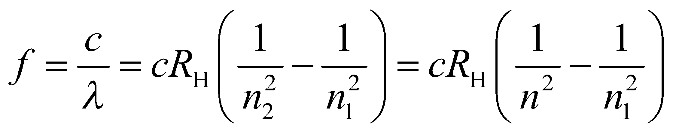
The possible values for n₁ are n + 1, n + 2, 😐, so the lowest possible frequency occurs for n₁ = n + 1 and the highest possible frequency occurs for .
Evaluate The frequency range is
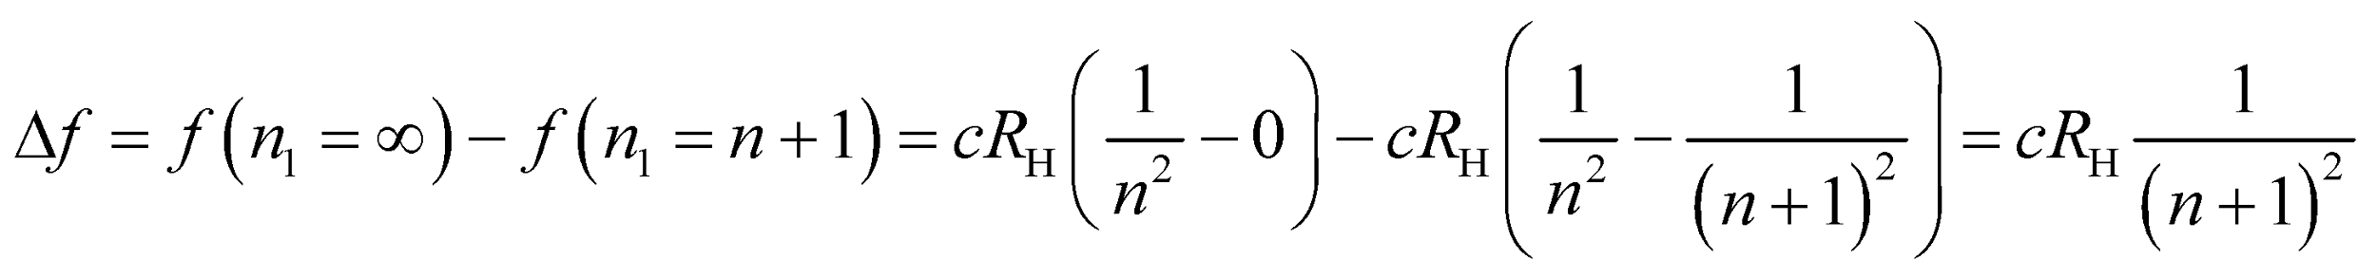
Assess This agrees with the formula given in the problem statement.
71. Interpret This problem involves Compton scattering of a photon off an electron that is initially at rest (zero kinetic energy). We are to find an expression for the initial photon energy given the final total energy (kinetic energy plus rest energy) of the electron.
Develop For Compton scattering at 90°, Equation 34.8 reduces to 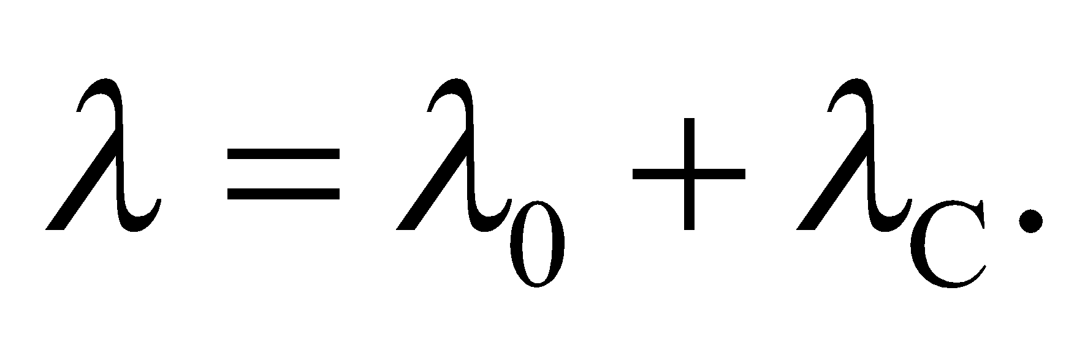 In terms of the photon energy (Equation 34.6) E = hf = hc/λ and the electron’s Compton wavelength [Equation 34.8, 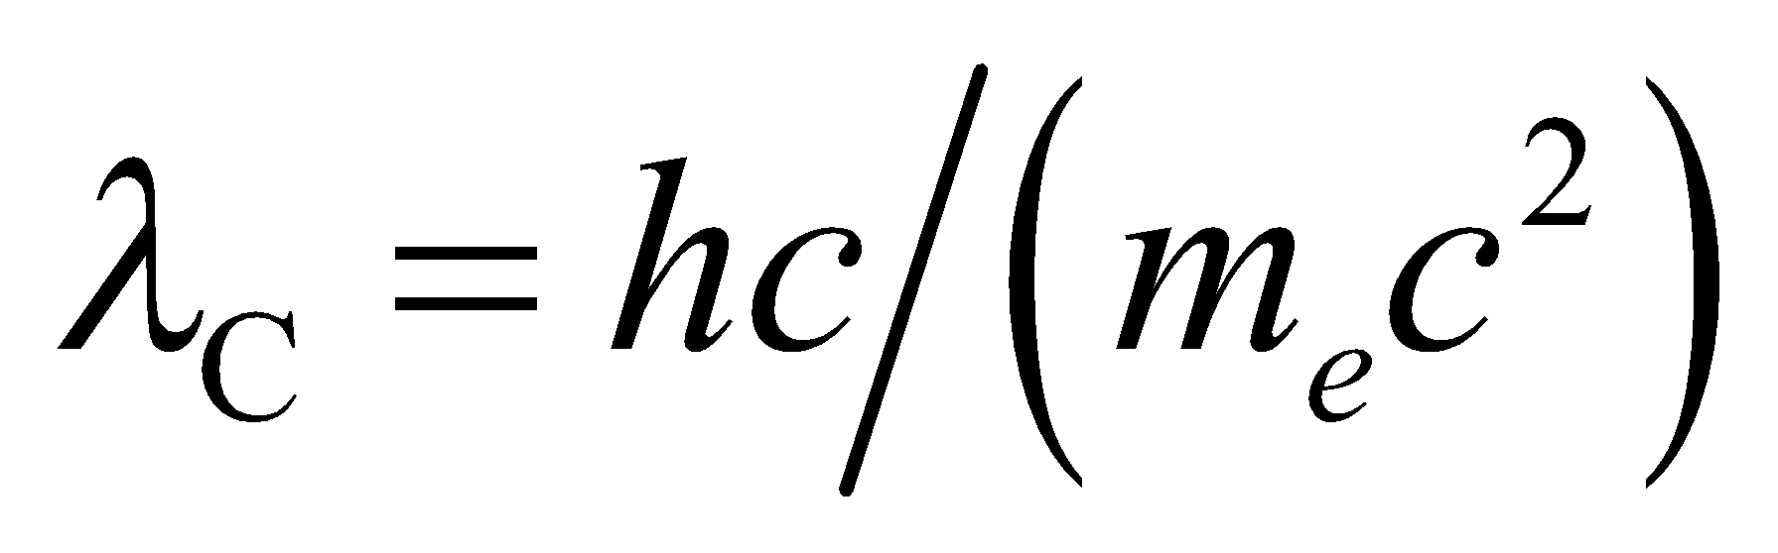], this can be written as
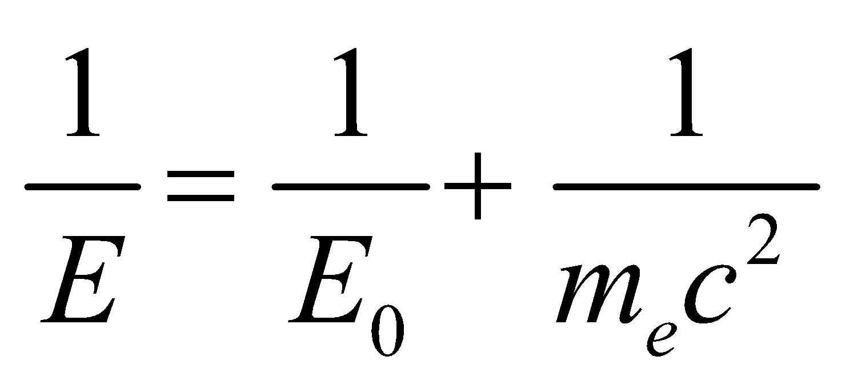
or
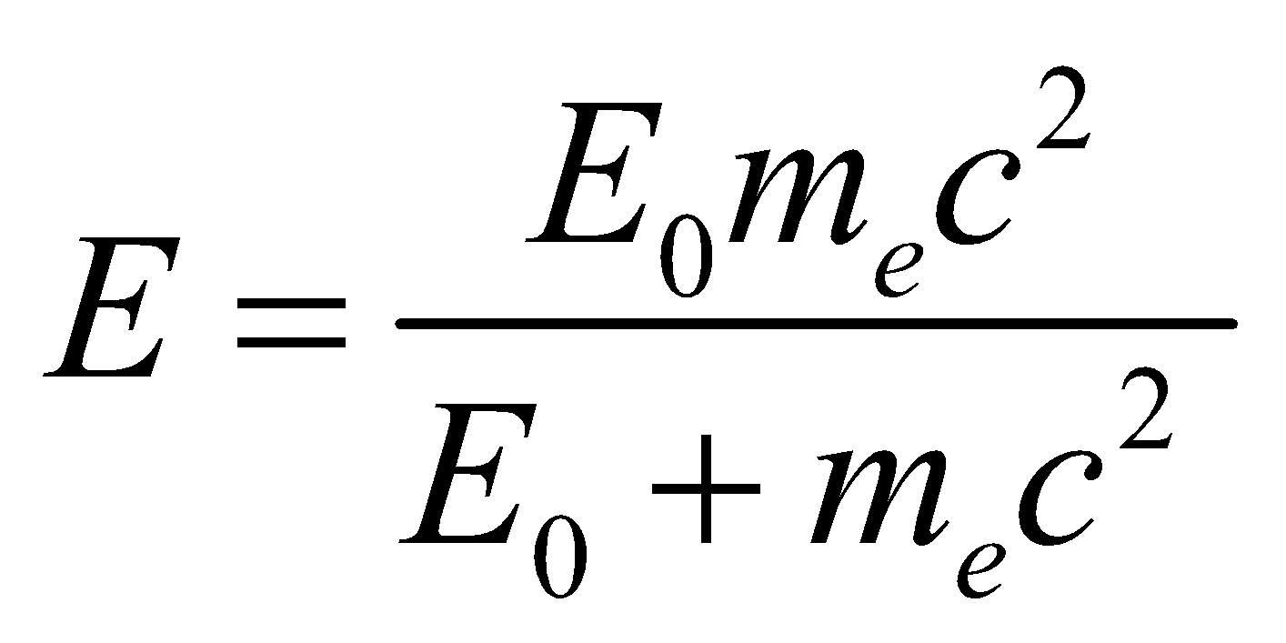
The recoil electron’s kinetic energy is
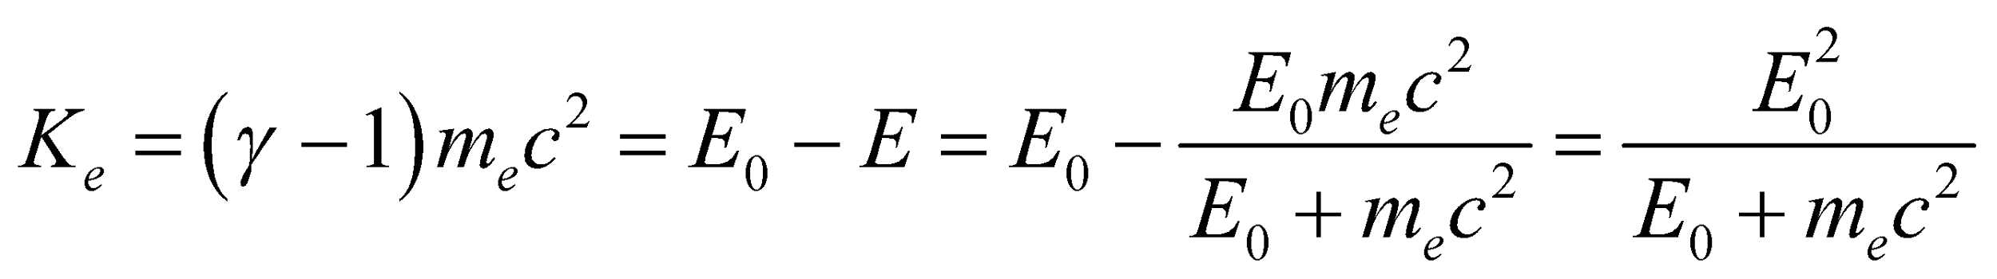
This is a quadratic equation in E₀, namely 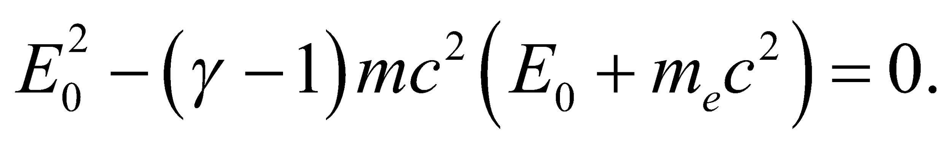 The positive solution corresponds to the initial photon energy that we seek.
Evaluate The positive solution for E₀ is
Assess With some algebra, the kinetic energy of the recoiled electron can be written as
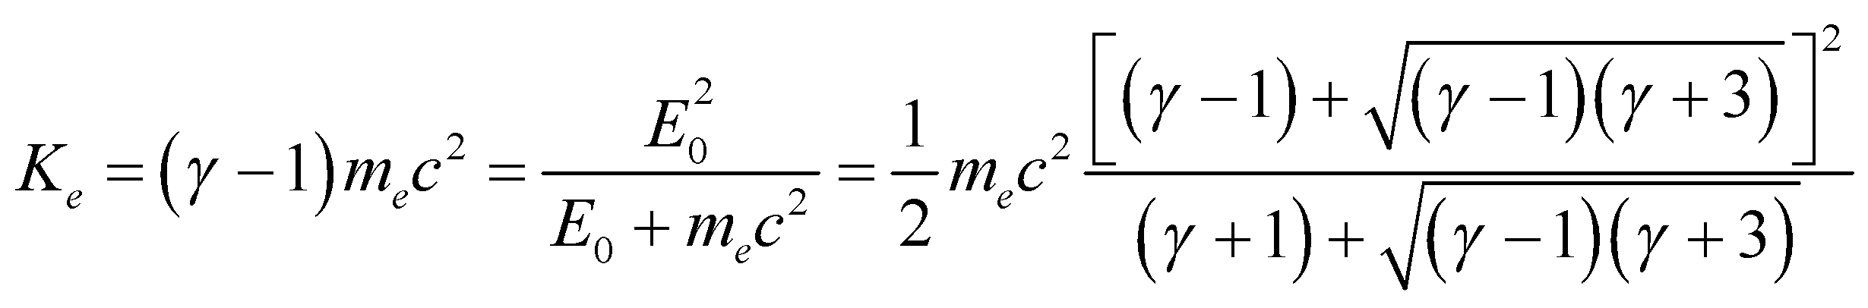
In the nonrelativistic limit where 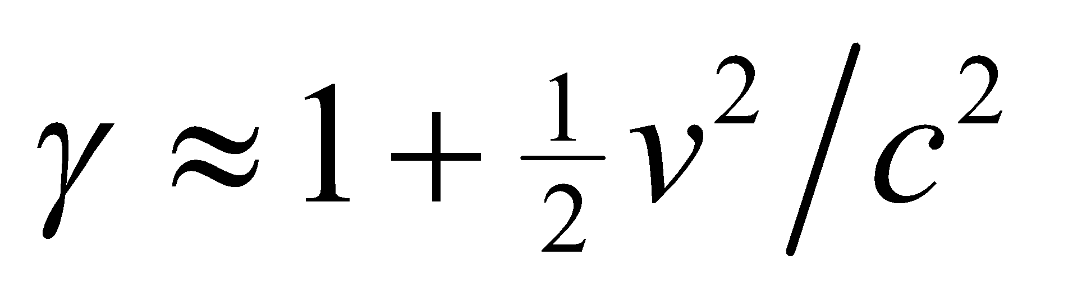, the above expression reduces to the expected result 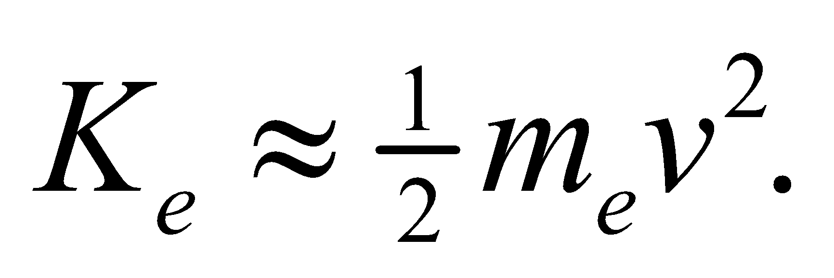
72. Interpret We are to derive Wien’s law (see Section 34.2 on blackbody radiation) from Planck’s law.
Develop If we introduce the dimensionless variable x = hc/(λkT) into Planck’s law, R(λ, T) is proportional to 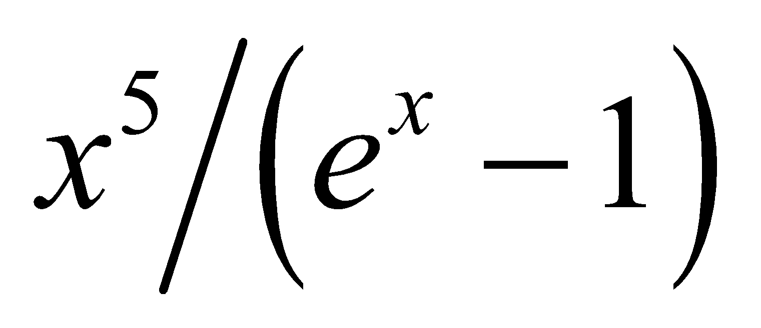. This can be a maximum when its derivative with respect to x is zero, which leads to the equation 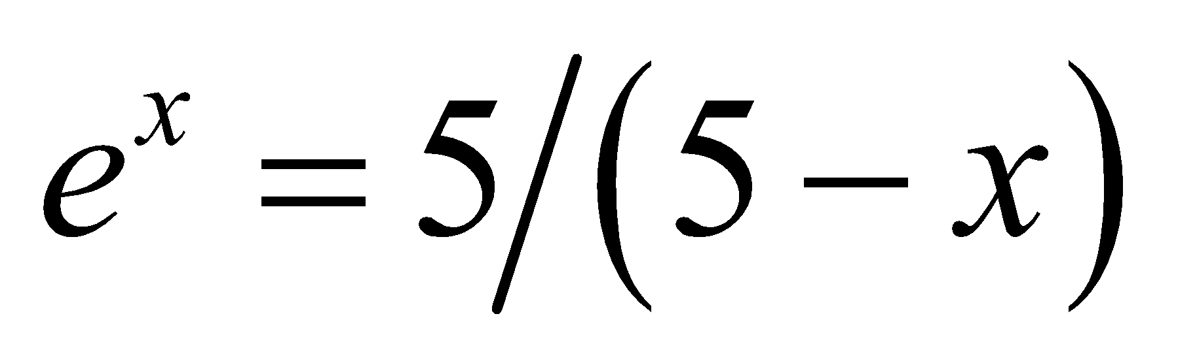.
Evaluate For a maximum, this condition is satisfied by a value of x nearly equal to 5 (since x = 0 corresponds to a minimum radiance). The value x_{max} can be found numerically to be about 4.965, so
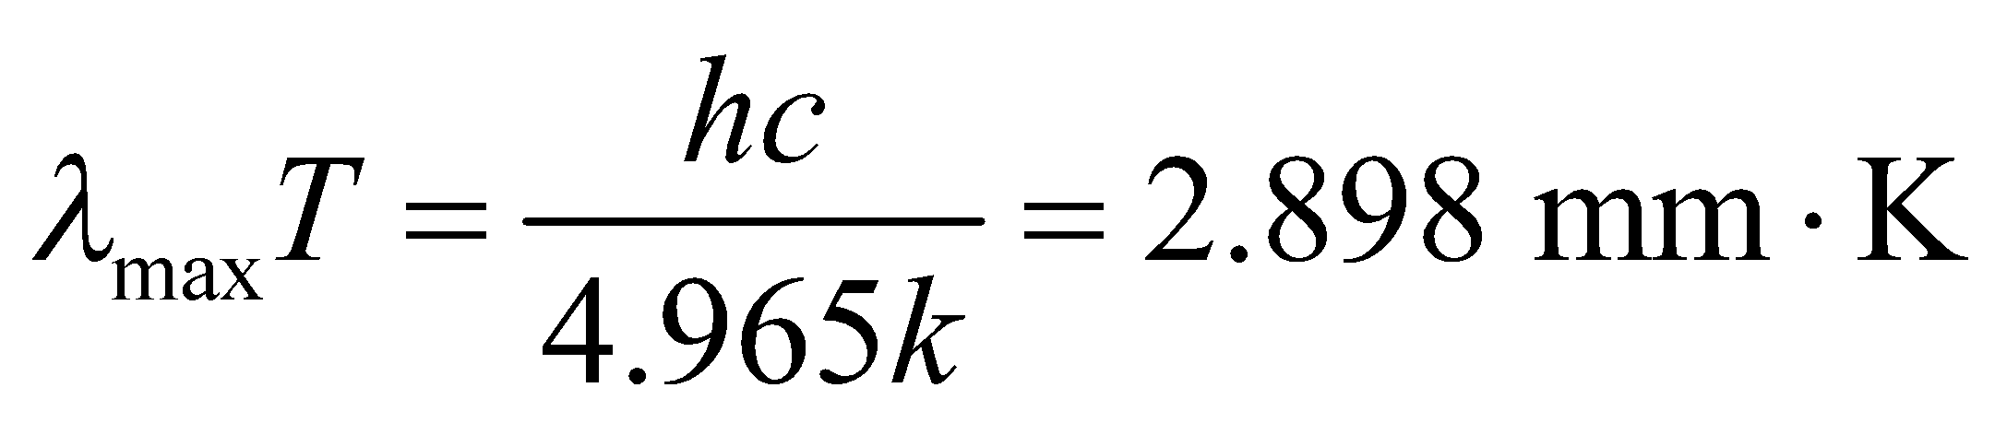
which is Equation 34.2.
Assess We have shown the desired relationship. Notice that Wien’s law is not a classical approximation, as is the case for the Rayleigh–Jeans law.
73. Interpret We shall use conservation of energy and conservation of momentum (with relativistic expressions for both energy and momentum) to derive equations related to Compton’s equation, and then derive the equation for the Compton shift.
Develop The energy of a photon is (Equation 34.6) and for a particle it is 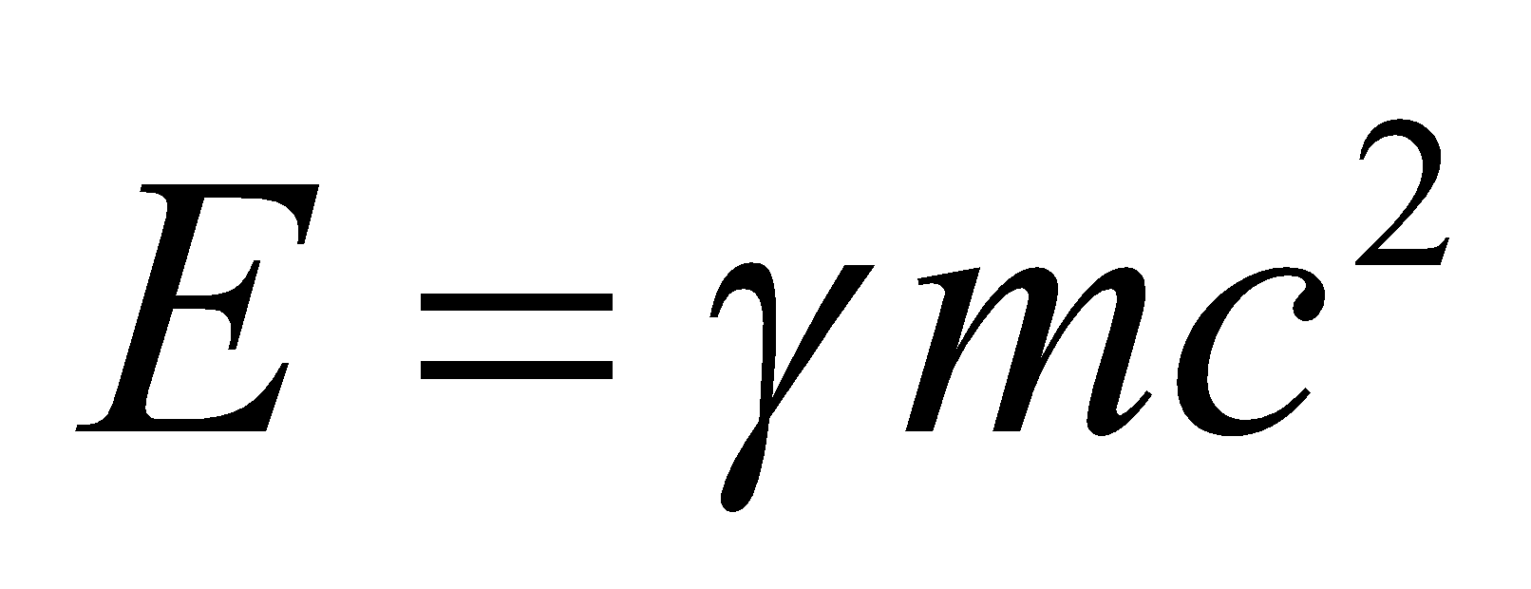 (Equation 33.9). The relativistic momentum is 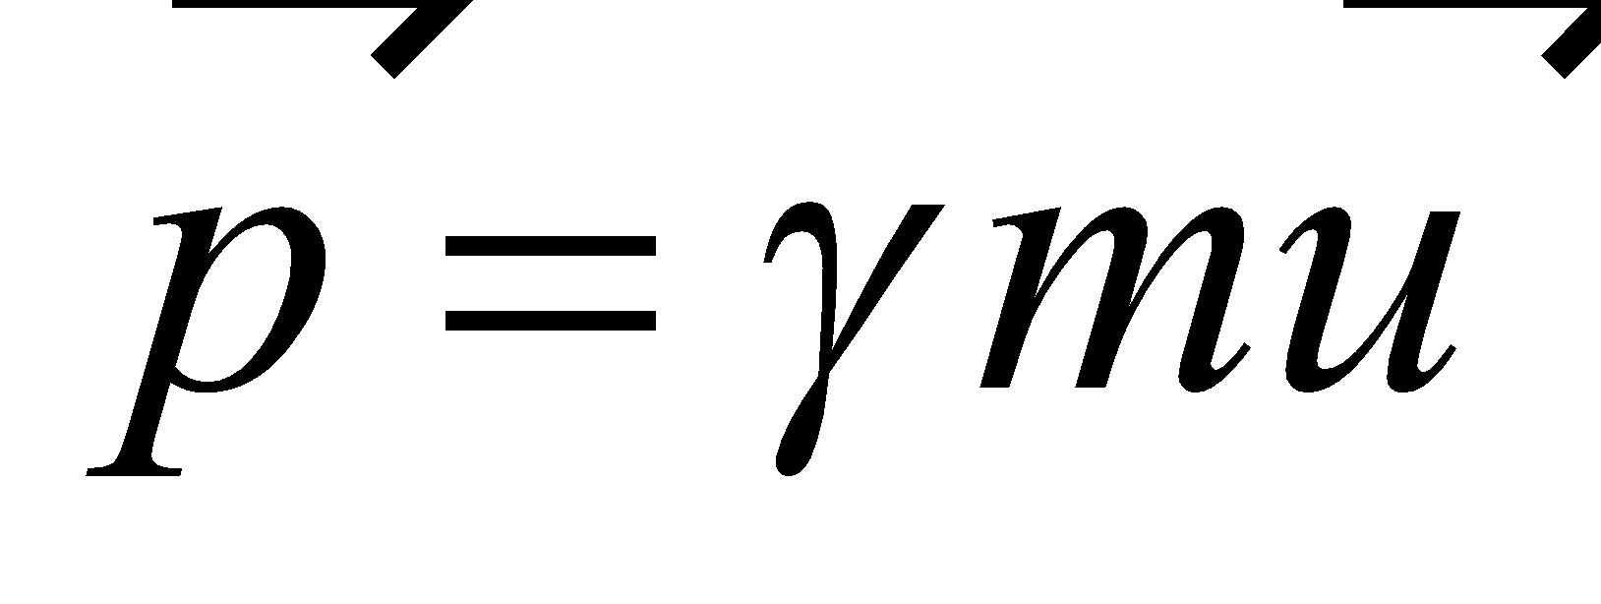 for the electron and 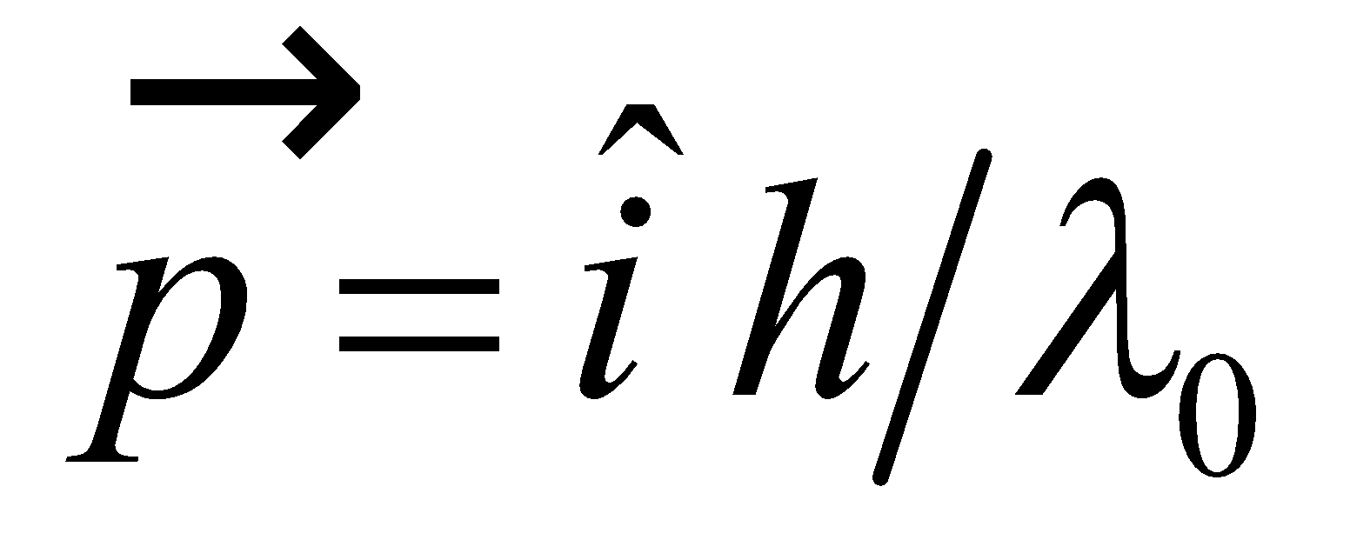 for the photon, where  is the direction of the photon’s motion. We will use conservation of energy to obtain one of the desired equations, and conservation of momentum in two dimensions to obtain the other two equations.
Evaluate The initial energy is the energy of the photon plus the rest energy of the electron:
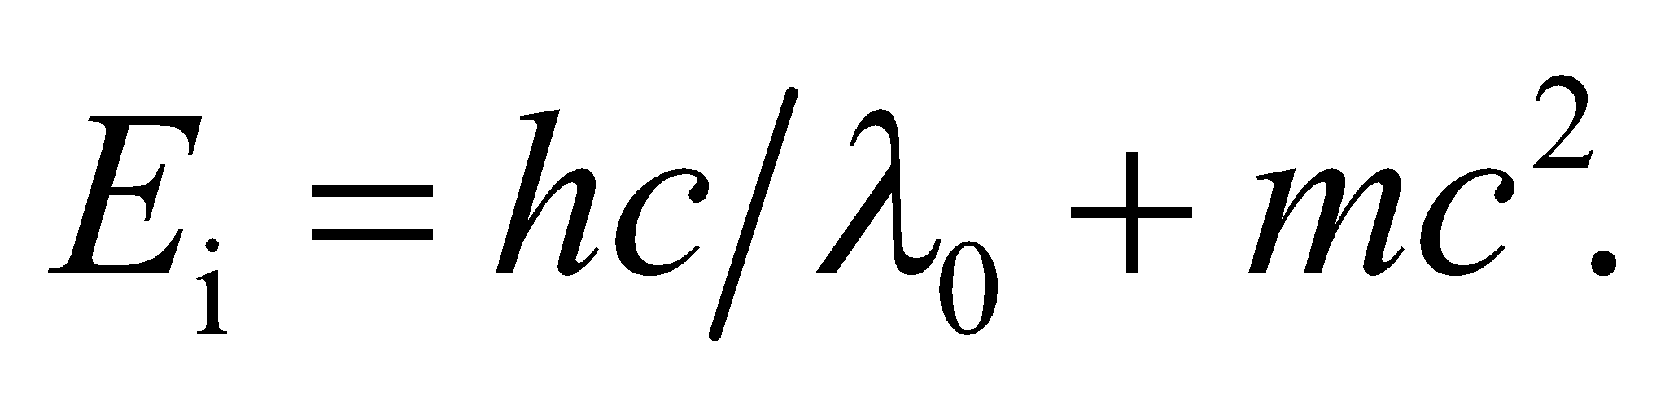
The final energy is the energy of the new photon plus the relativistic energy of the moving electron:
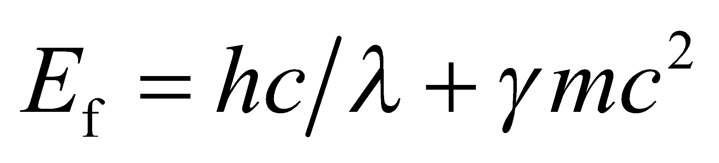
Equating these two energies (by conservation of energy) gives us the first of the three desired equations:
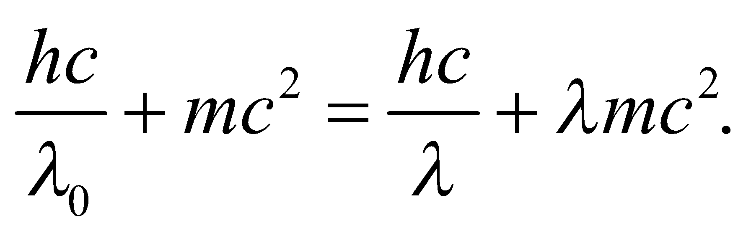
The next two equations come from the initial momentum,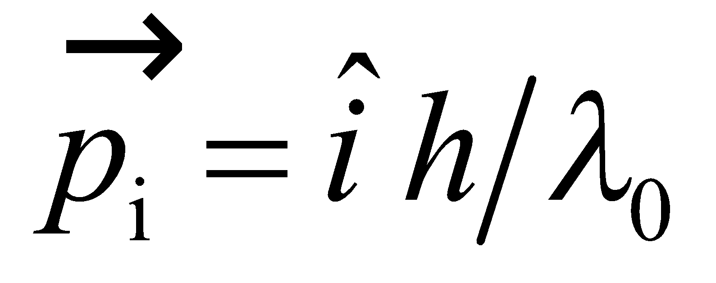 and the components of final momentum 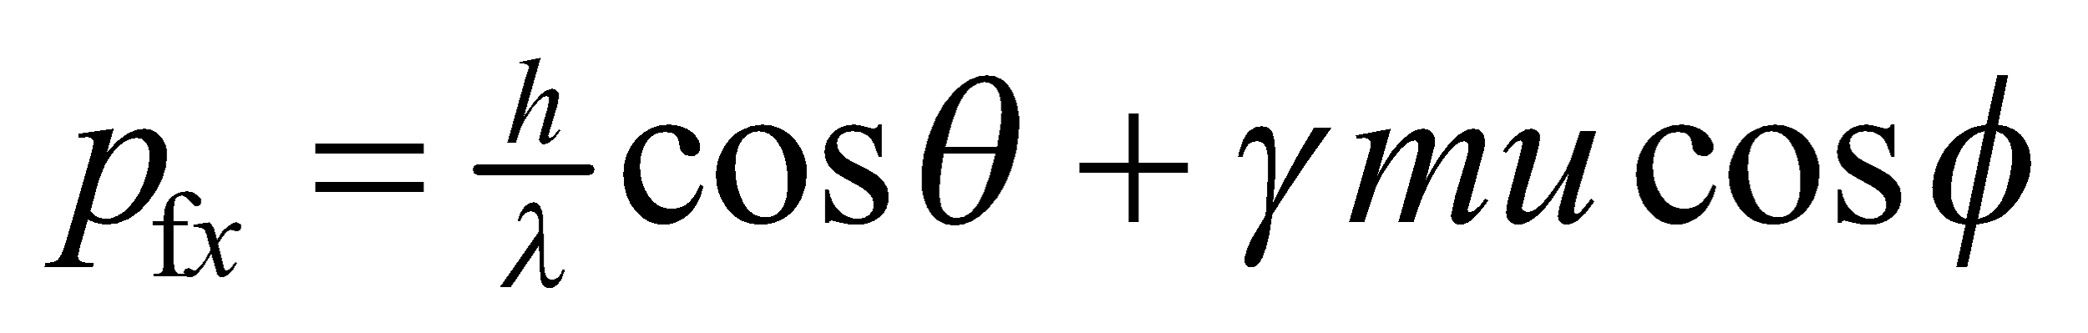 and 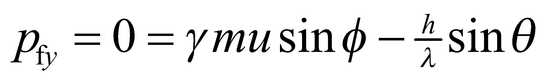. By conservation of momentum, we can equate the initial and final momentum in each direction, which leads to
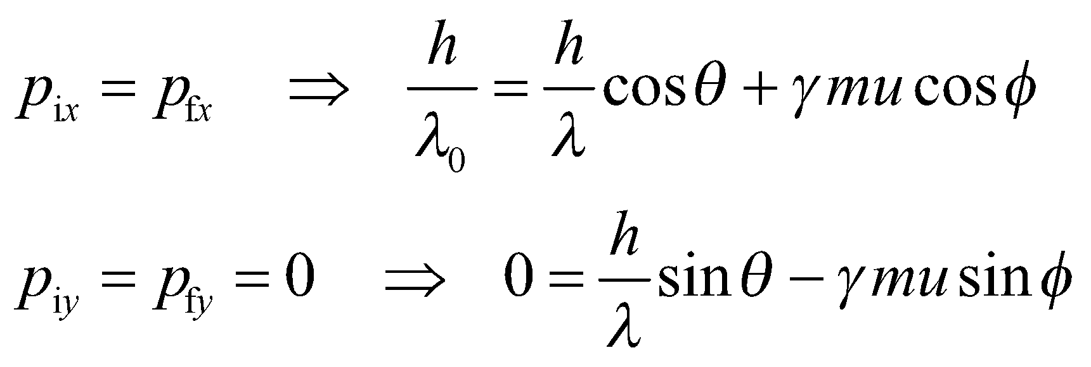
These are the second two of the desired relationships we were to derive. Solving these three equations for 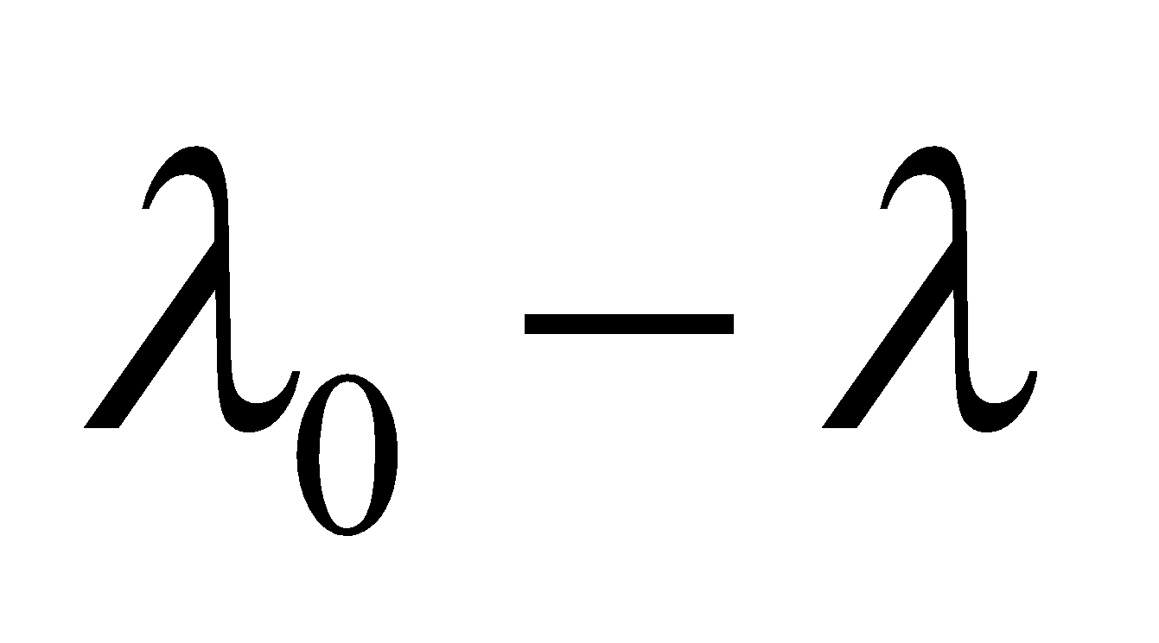 directly is a lengthy algebraic process. An easier approach is to start with the momentum in vector form and use the law of cosines:
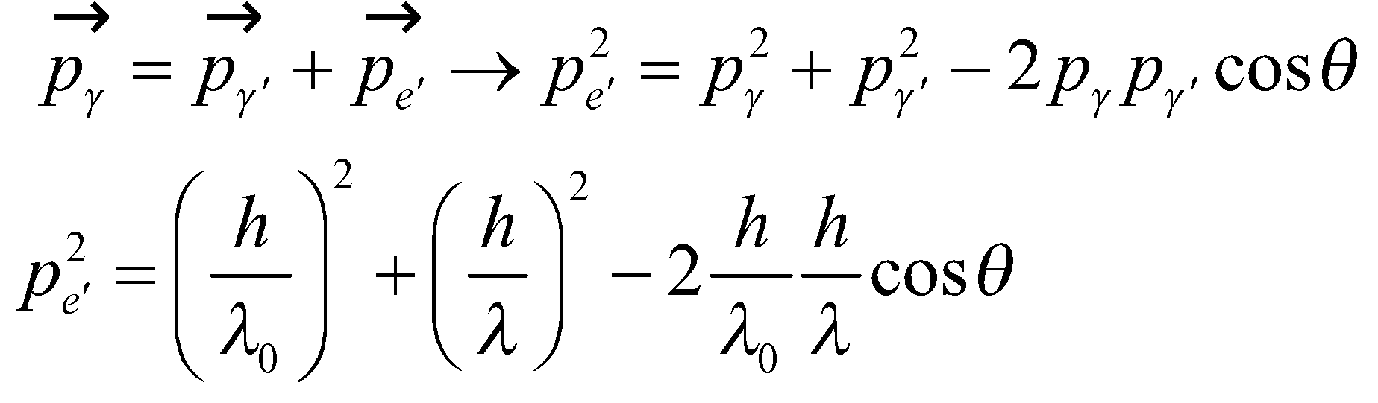
We now use conservation of energy in the form 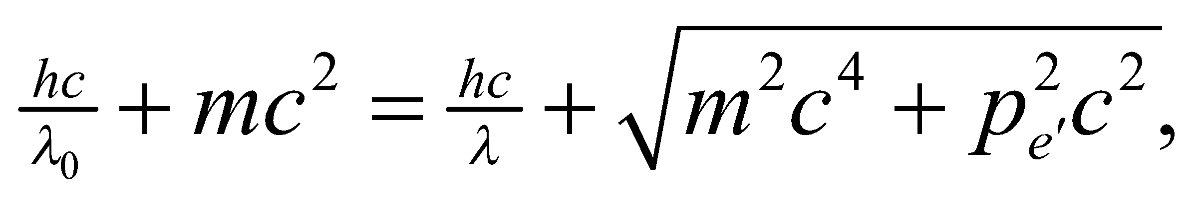 and solve for 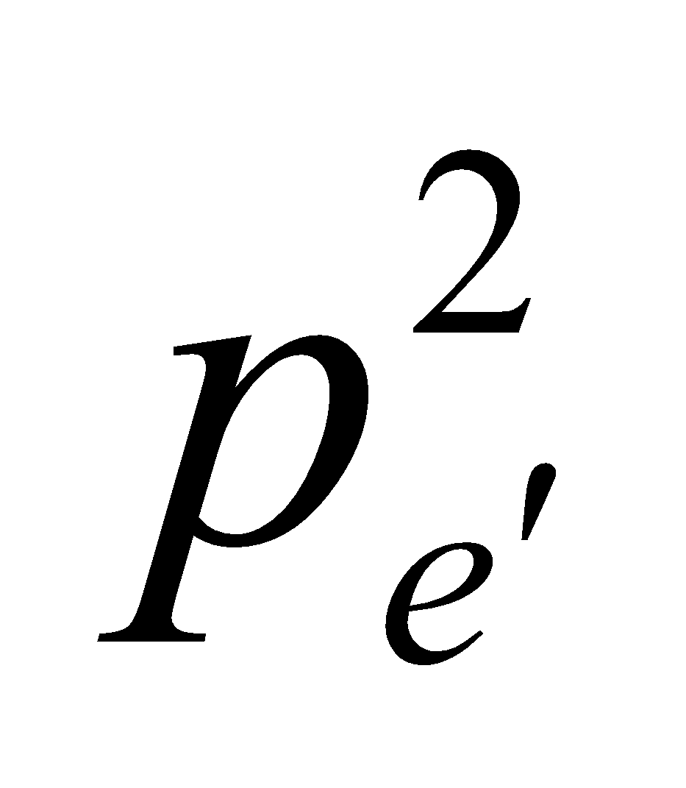 to obtain
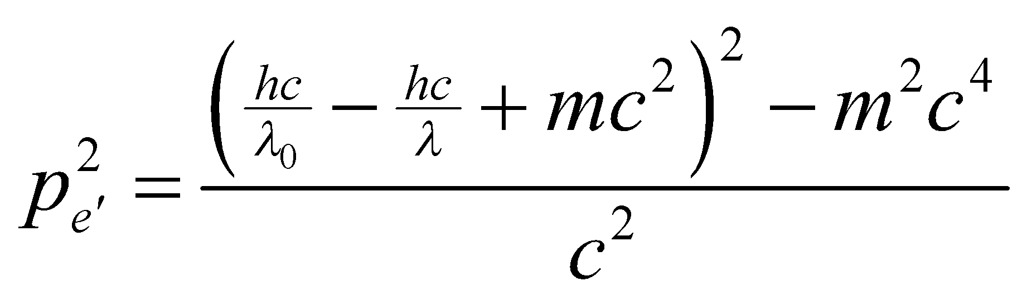
We equate the two equations for to obtain
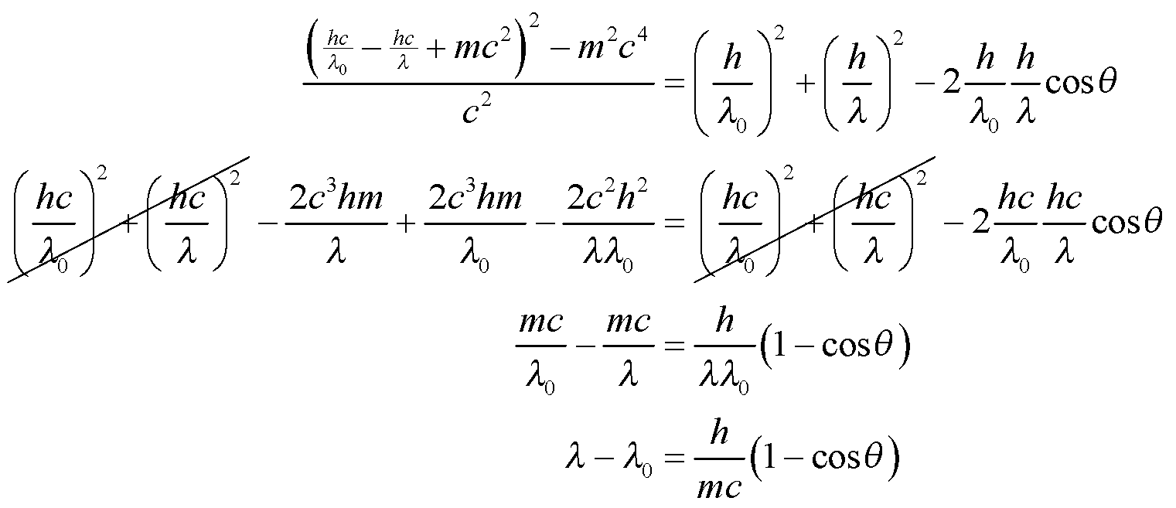
Assess We have derived the equation for the Compton shift, using conservation of energy and momentum.
74. Interpret We are to find the peak of blackbody radiation (i.e., Wien’s law, Equation 3.42a), looking at frequency intervals rather than wavelength intervals.
Develop We start with the radiance curve (Equation 34.3, Planck’s law)
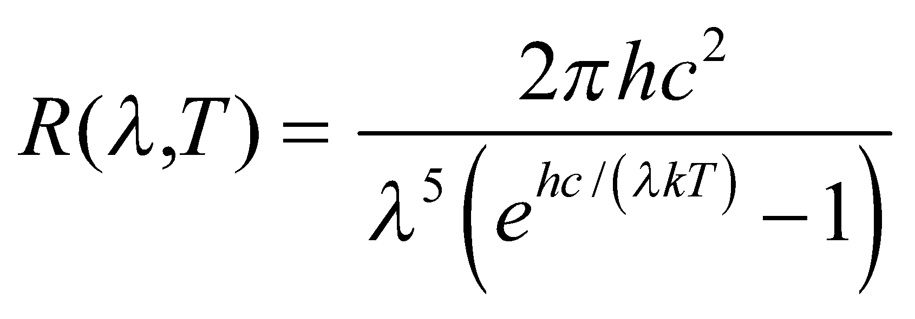
use λ =c/f and differentiate with respect to f to find the maximum. We’ll have to solve 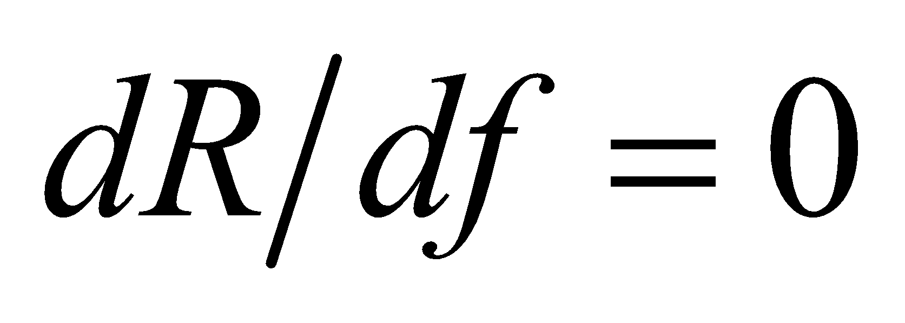 numerically.
Evaluate
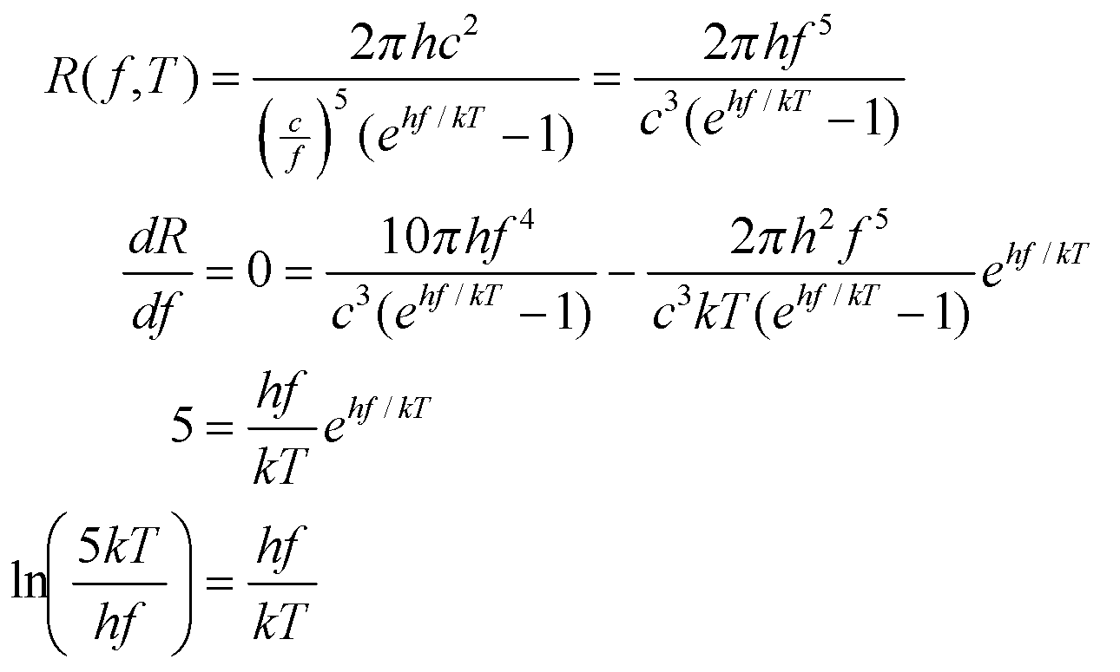
We solve this numerically for T/f to obtain T/f = 3.617 × 10¹¹ K·s.
Assess If we use this formula to find the peak frequency for the Sun (T = 5800 K), we obtain f = 1.6 × 10¹⁴ Hz. This corresponds to a wavelength of λ = 1.87 mm. Compare this with the wavelength peak found in Problem 34.19—it’s quite different!
75. Interpret We are to integrate the radiance equation (Equation 34.3, Planck’s law) over all wavelengths and show that the resulting total power radiated per unit area is equivalent to the Stefan-Boltzmann law (Equation 34.1).
Develop The Stefan-Boltzmann law gives the power per area as 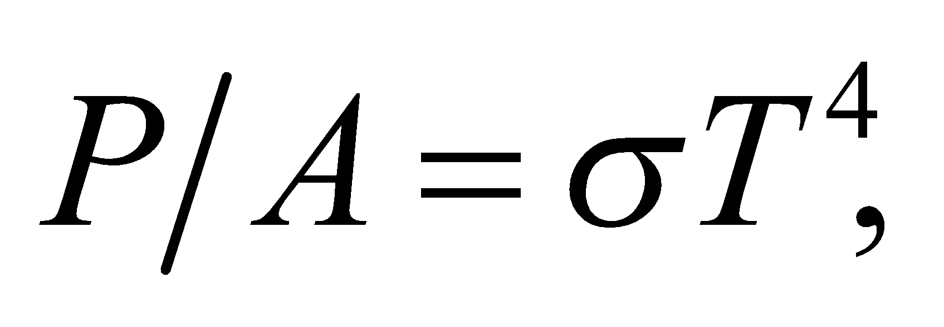 and the radiance equation is
Substituting hc/(λkT) by the integration variable x gives
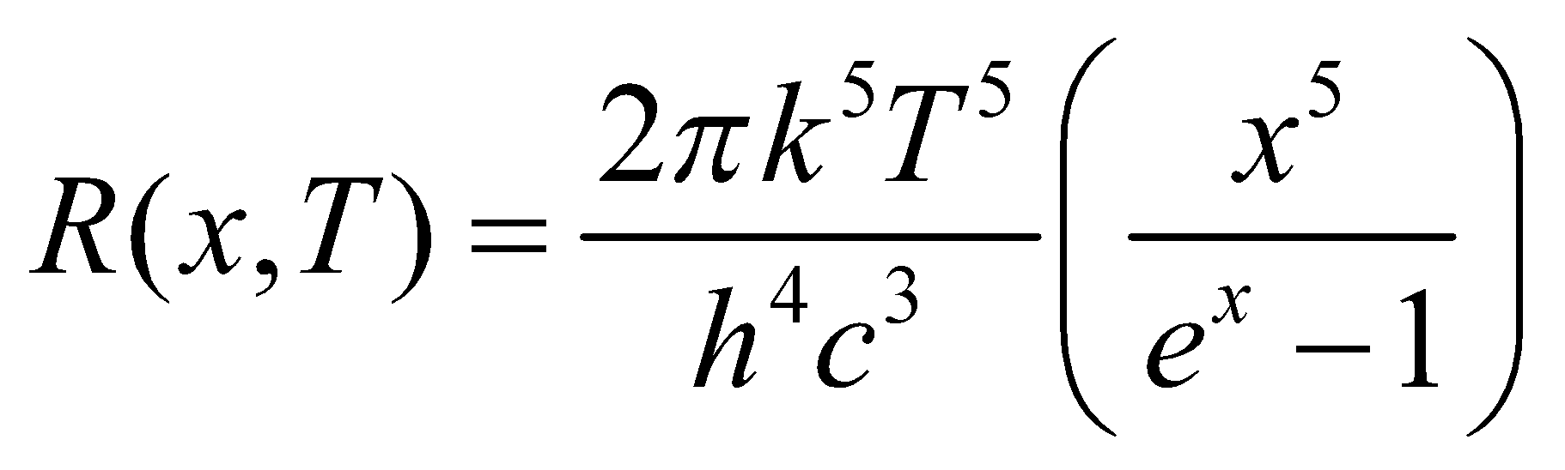
The differentials dx and dλ are related by
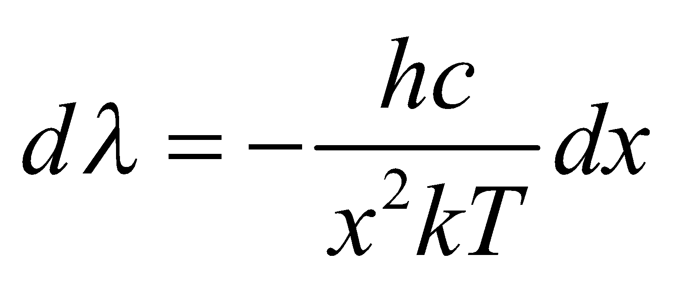
We will integrate R(x, T)dλ over all λ.
Evaluate Performing the integration gives
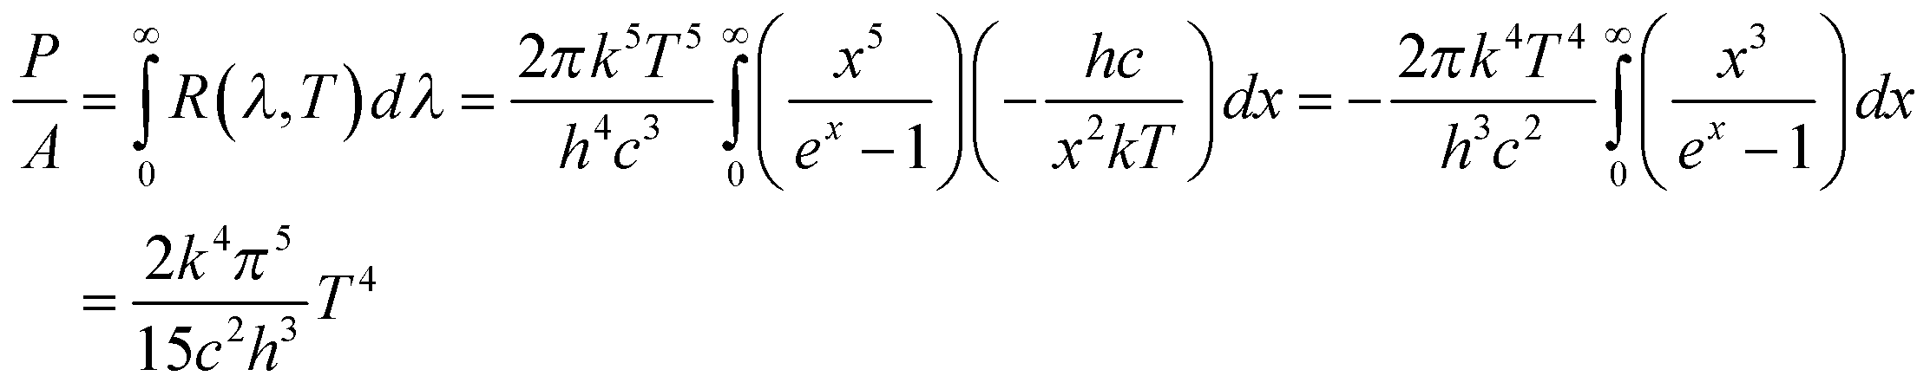
Assess This is equivalent to the Stefan-Boltzmann law, with 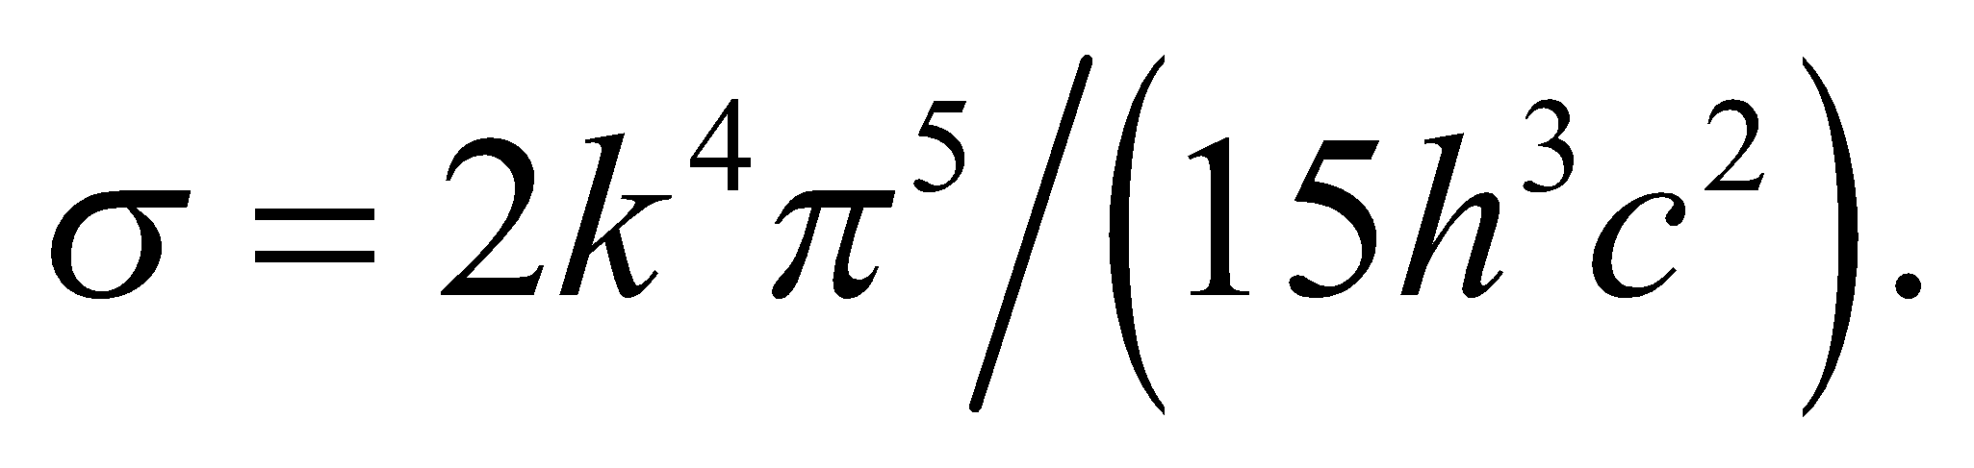
76. Interpret We are to numerically verify the median wavelength as given by Equation 34.2b by numerically integrating the radiance equation from zero to the value given by 34.2b—the result should be 1/2.
Develop We shall numerically integrate Equation 34.3
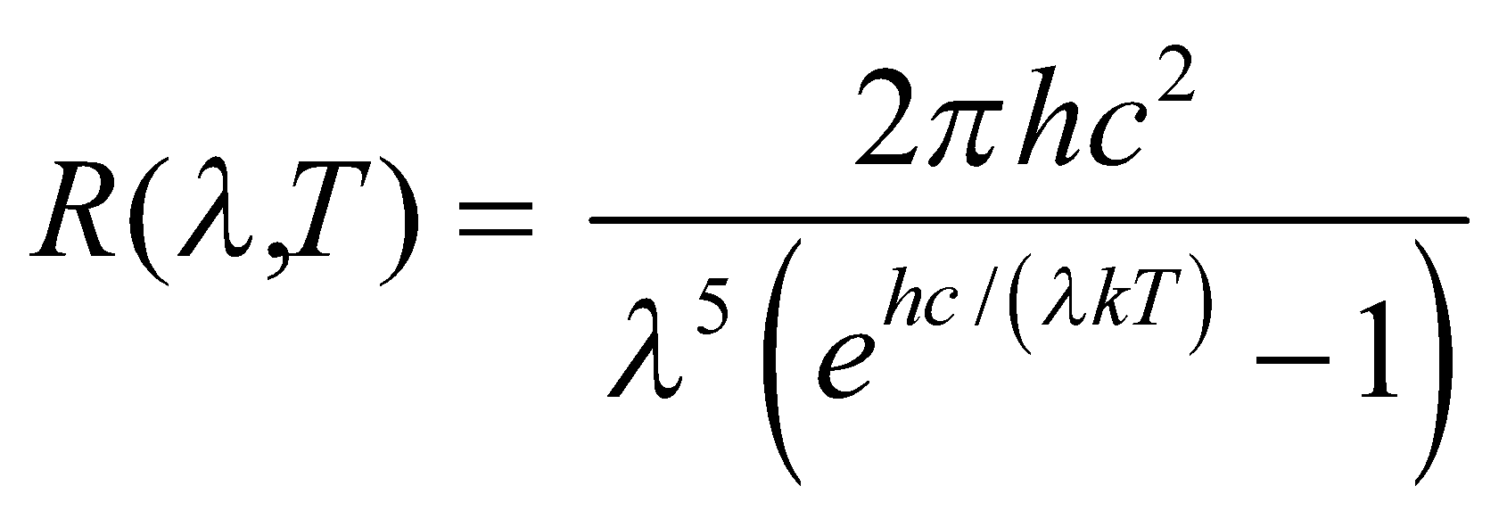
from λ = 0 to λ_{median} = 0.00411/T. If the value we get is half the value obtained when numerically integrating to “infinity”, then we will have verified that λ_{median} is indeed the median wavelength.
Evaluate With most numeric software packages or simple integration routines, it is easiest to substitute some value of T. For example, for T = 1000 K, the integral to λ_{median} is 28,379 and the integral to some approximately “infinite” number is 56,704. Other values of T give different values, but in each case the integral to λ_{median} is approximately half the integral over all values of λ.
Assess The median wavelength is given to only three significant figures. The numeric value of the integral taken to λ_{median} is half the numeric value of the entire integral to more than three significant figures, so we have verified that the median wavelength given is correct.
77. Interpret We use conservation of momentum to find the recoil angle of the electron in Compton scattering.
Develop The momentum conservation equations from problem 34.73 are
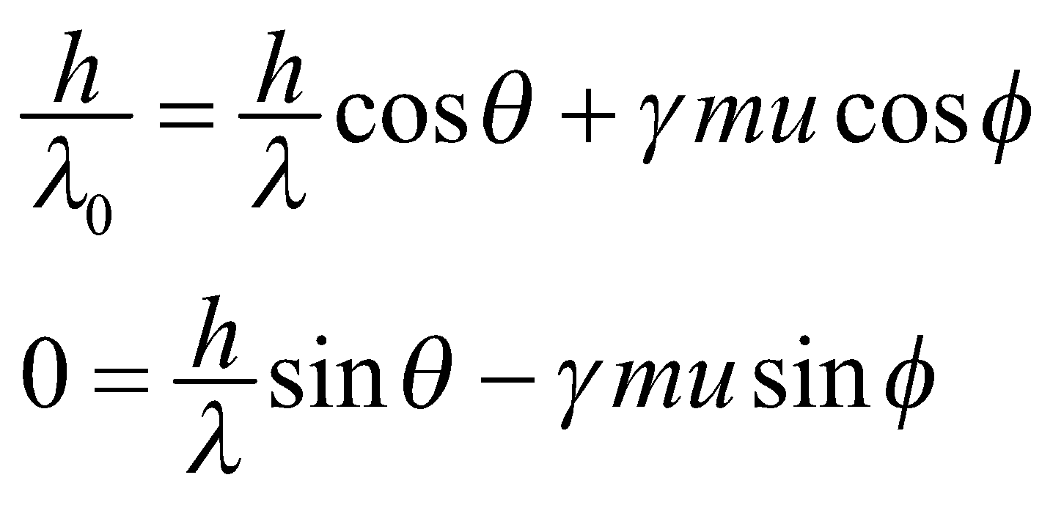
The Compton scattering equation is 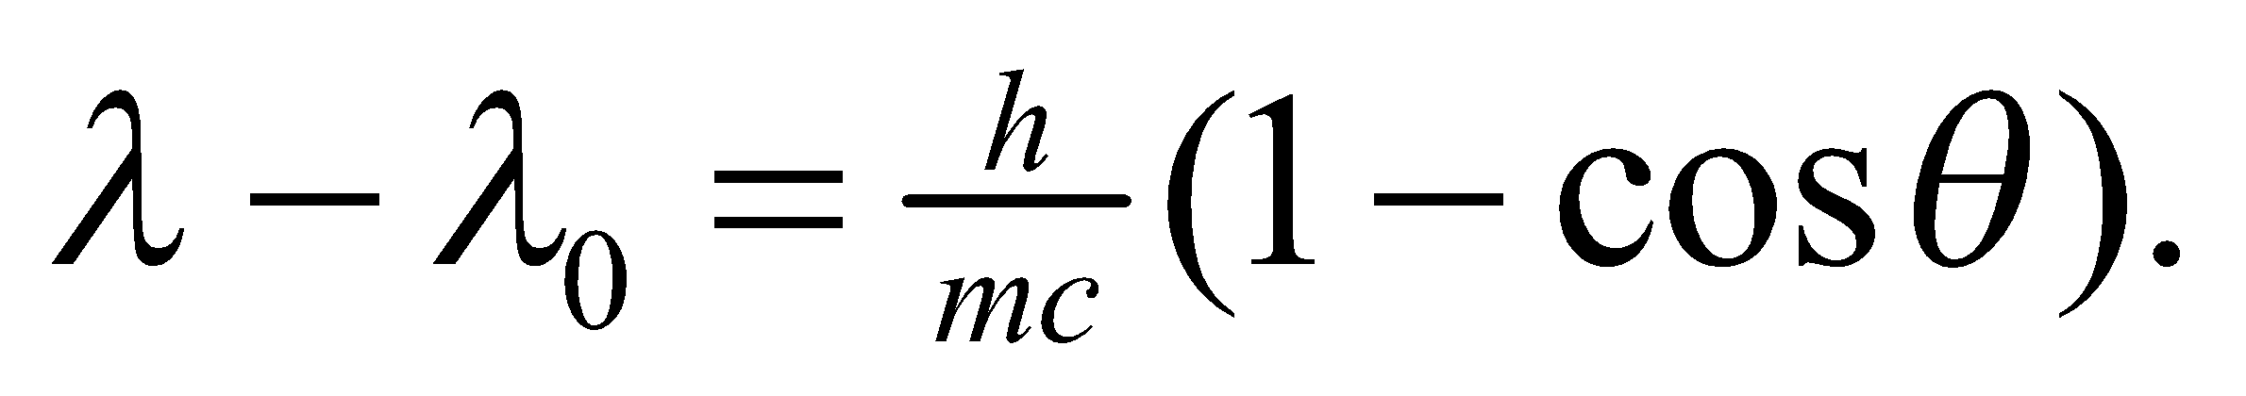 We will solve the momentum equations for 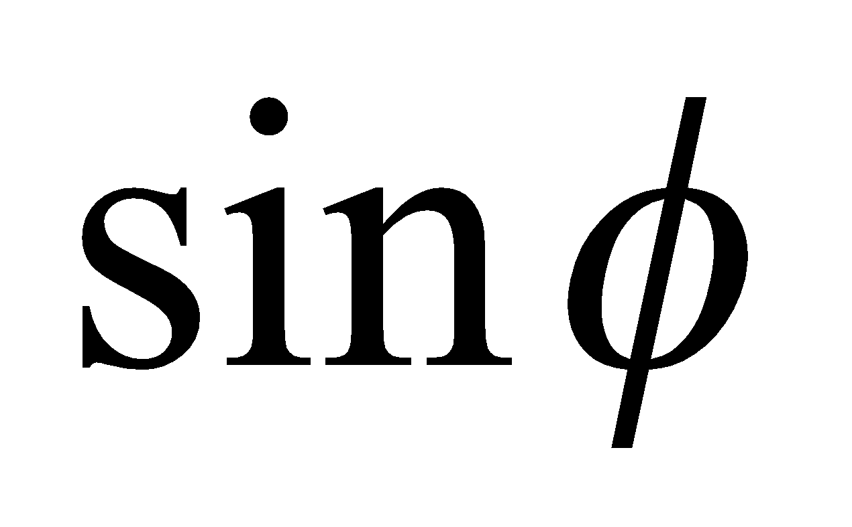 and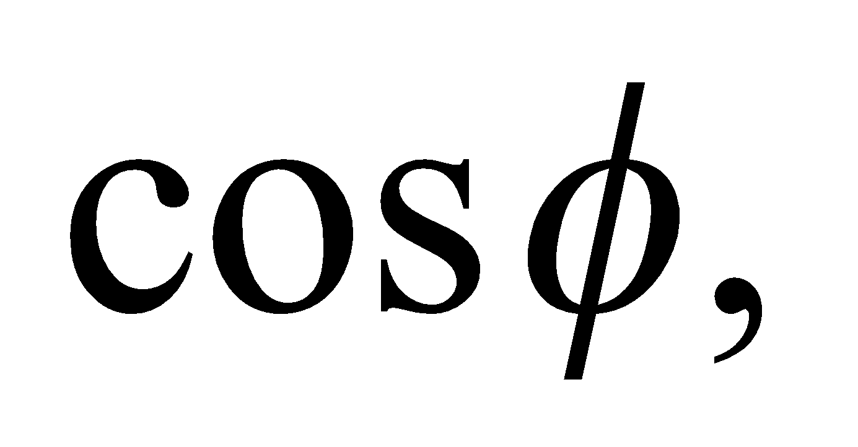 and then take the ratio to see if we can get the desired equation.
Evaluate First solving for and we get
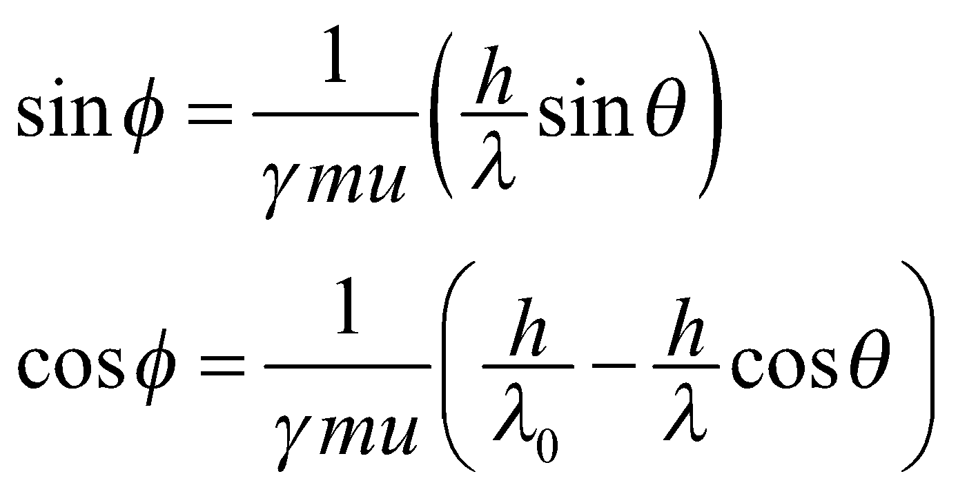
Taking the ratio and multiplying the numerator and denominator by 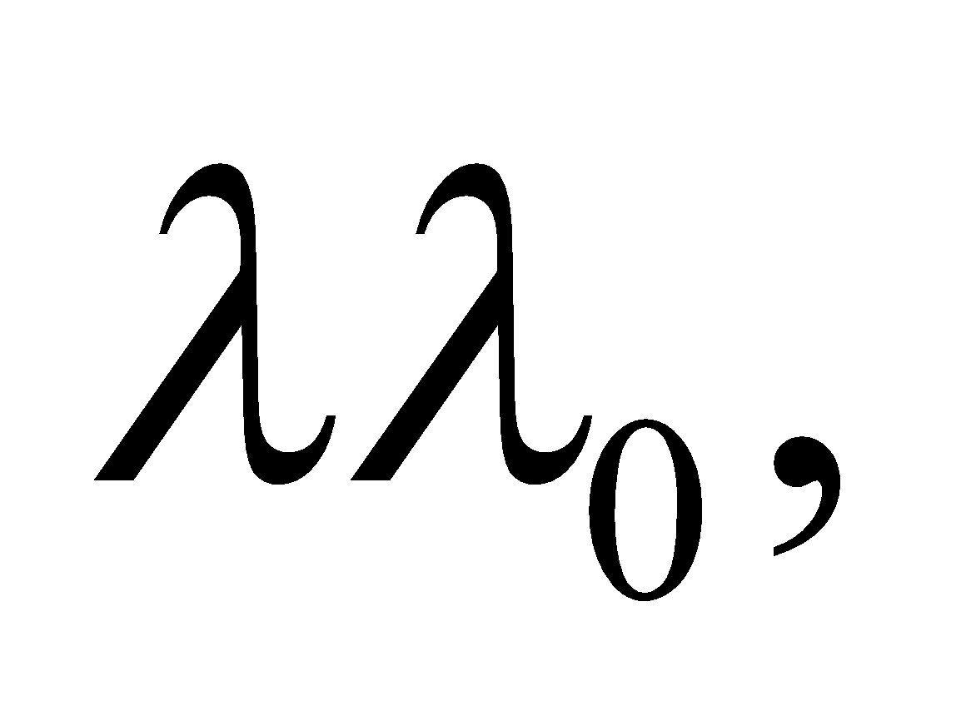 we arrive at the desired result:
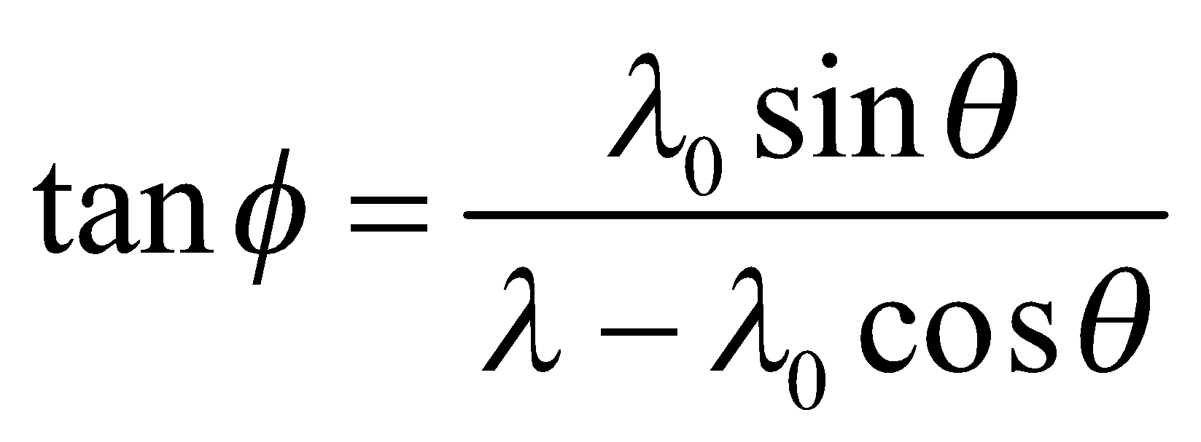
Assess To remove the dependence on the final wavelength, 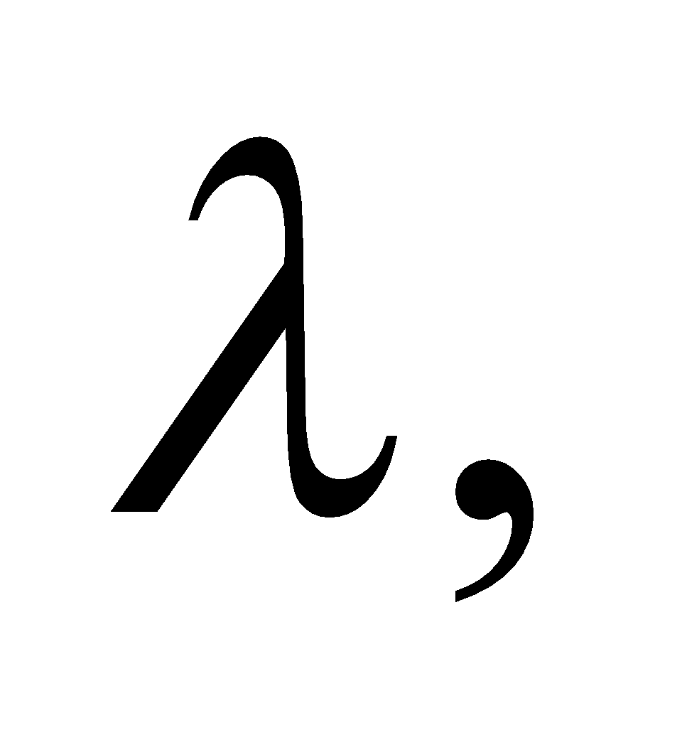we use the Compton shift equation:
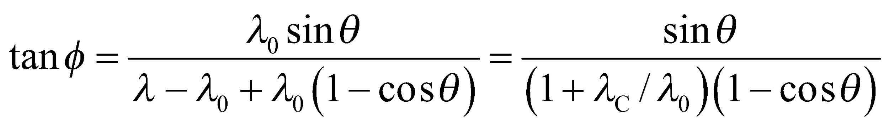
where 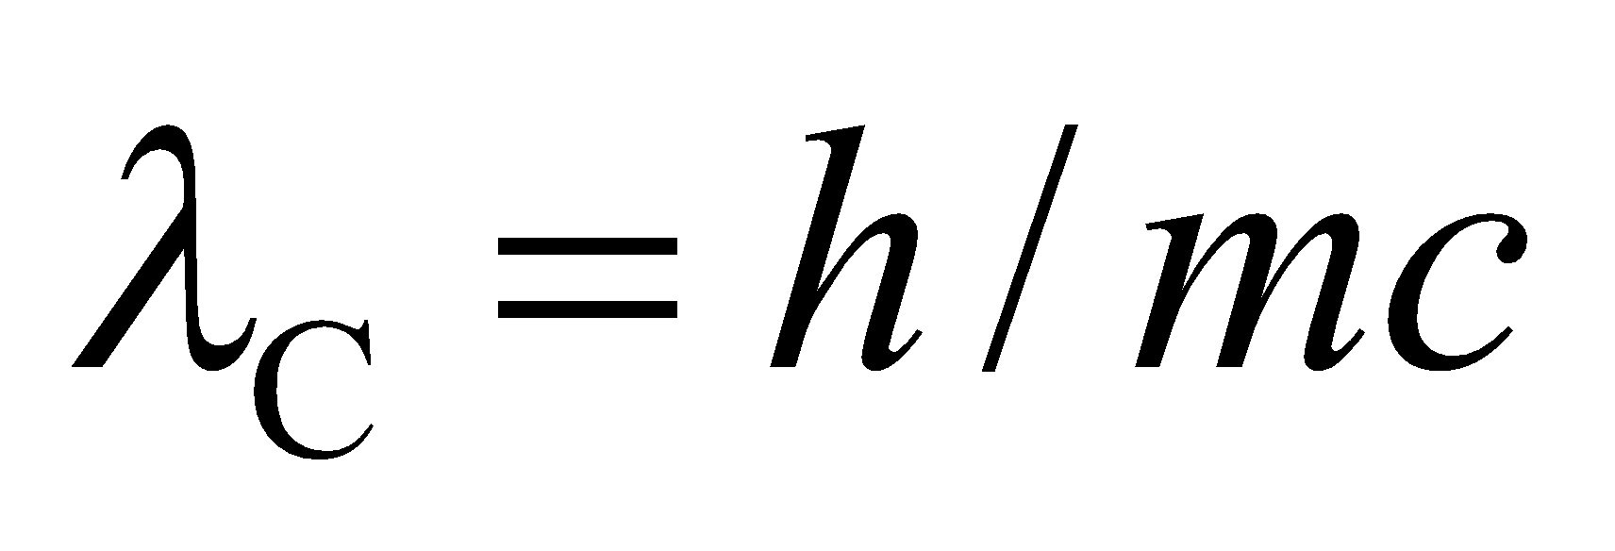is the Compton wavelength. This shows that as you decrease 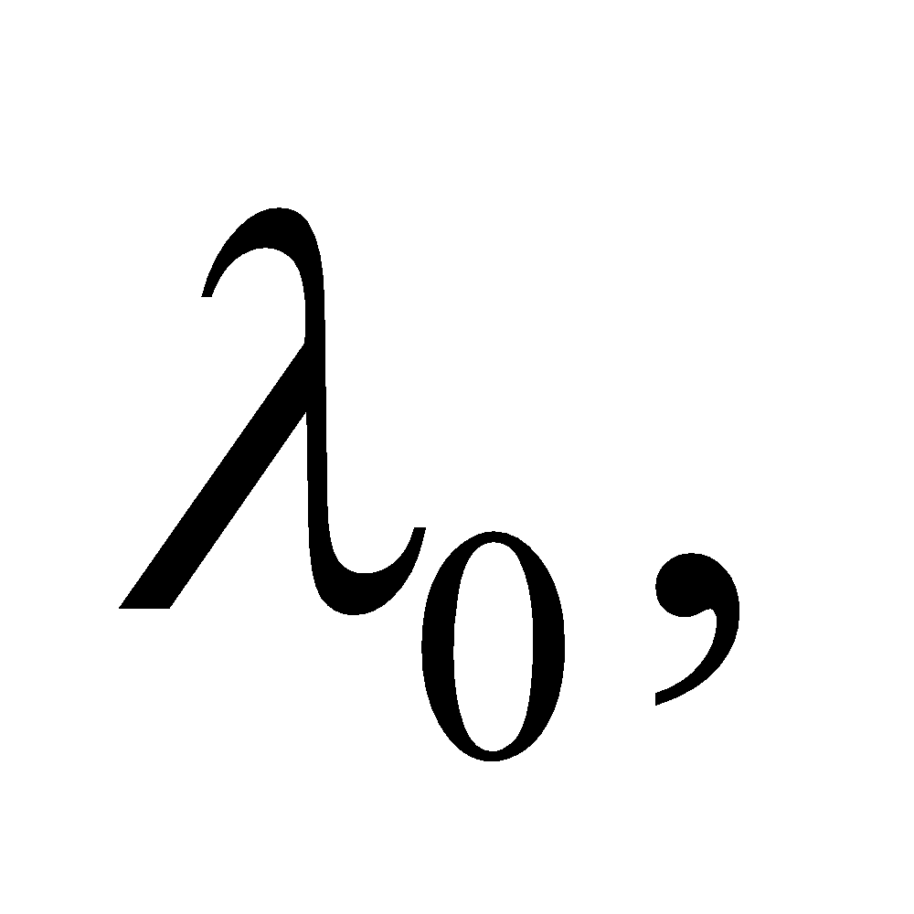i.e., as you go towards higher energy photons, the recoil angle, 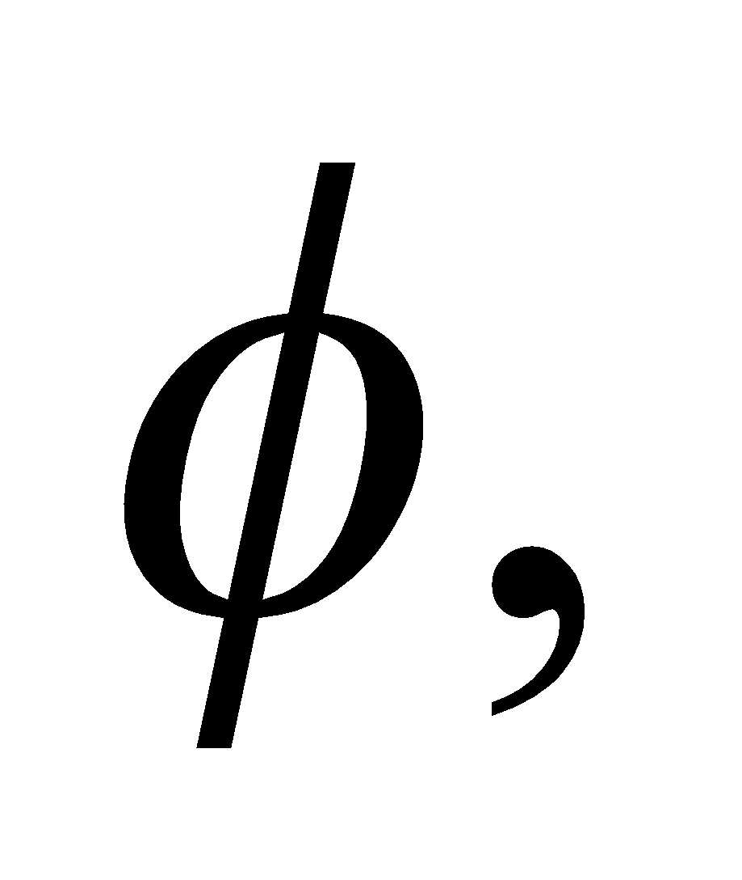of the electron decreases (for a given recoil angle, 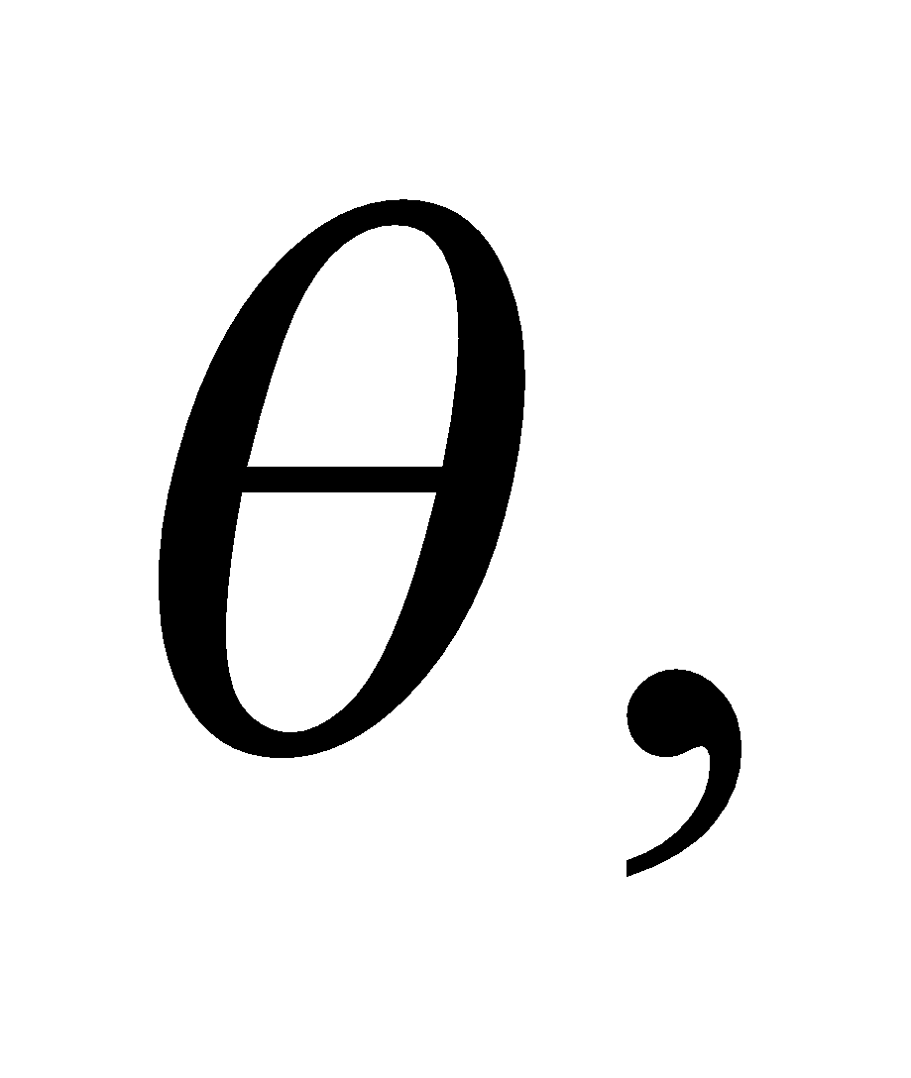for the photon).
78. Interpret We are to show that the correspondence principle (see Section 34.7) holds for the Bohr model in that the frequency of a photon emitted in a 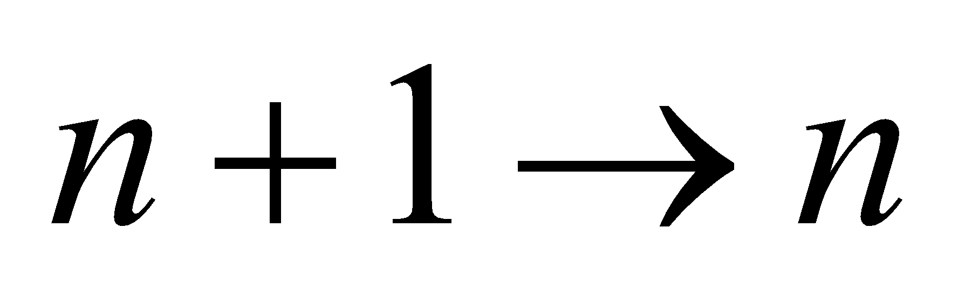 transition for large n equals the orbital frequency of the electron. We shall do this by taking the limit of both the transition energy and the orbital frequency as 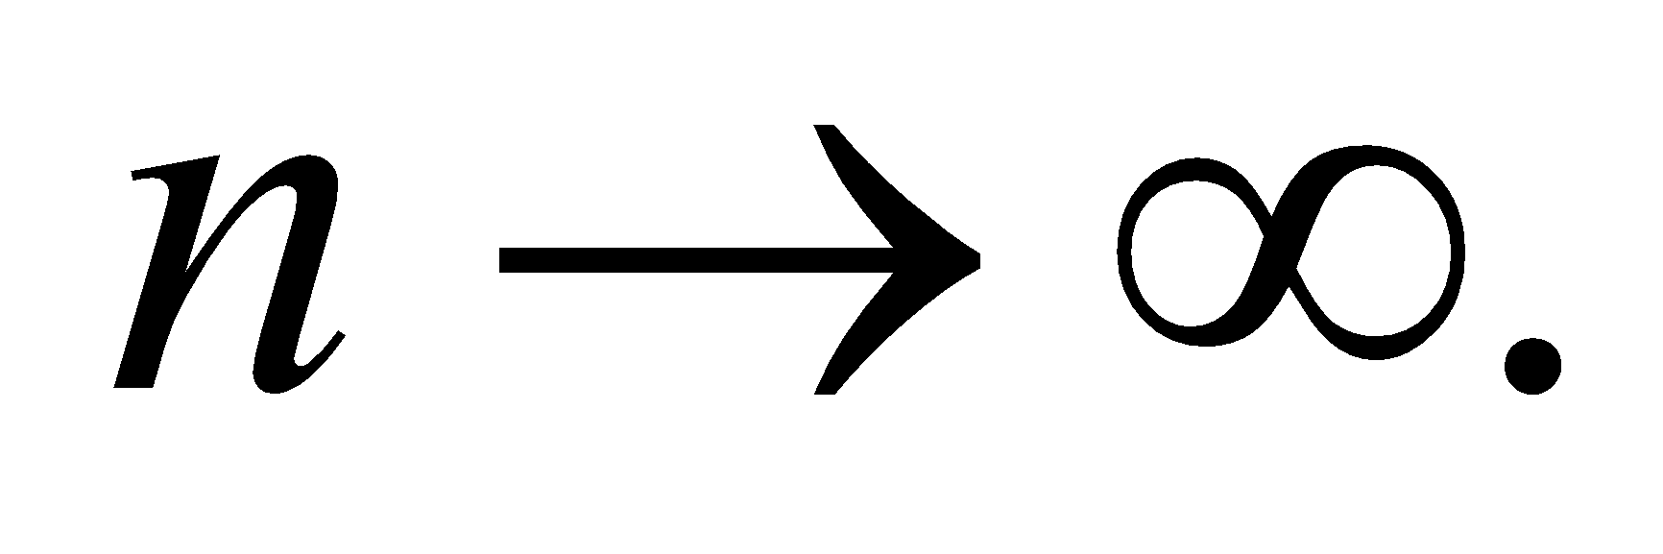
Develop The energy of the photon emitted in a transition from n₁ to n₂ is 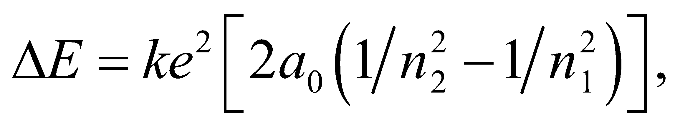 where n₂ = n and n₁ = n + 1. The frequency of the photon is ΔE/h. The orbital frequency can be calculated from the orbital radius 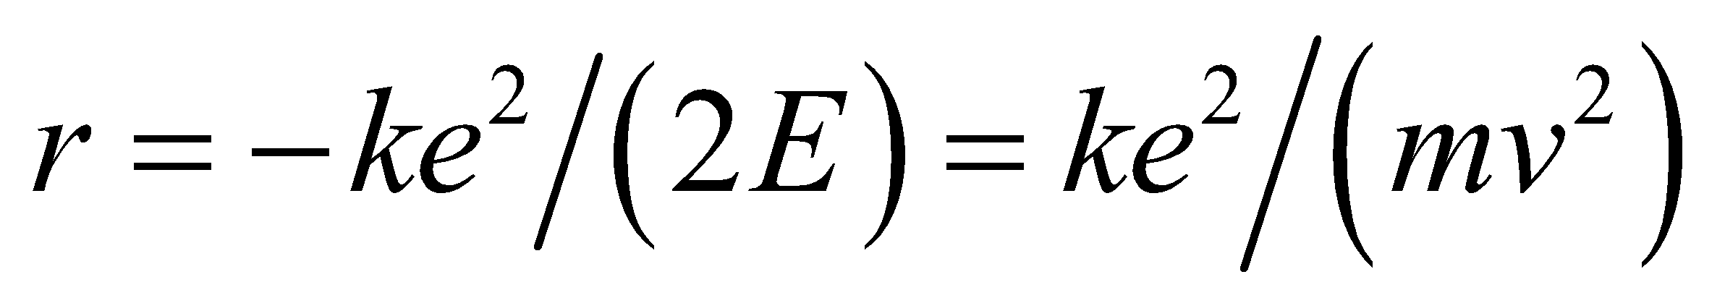 and the orbital velocity 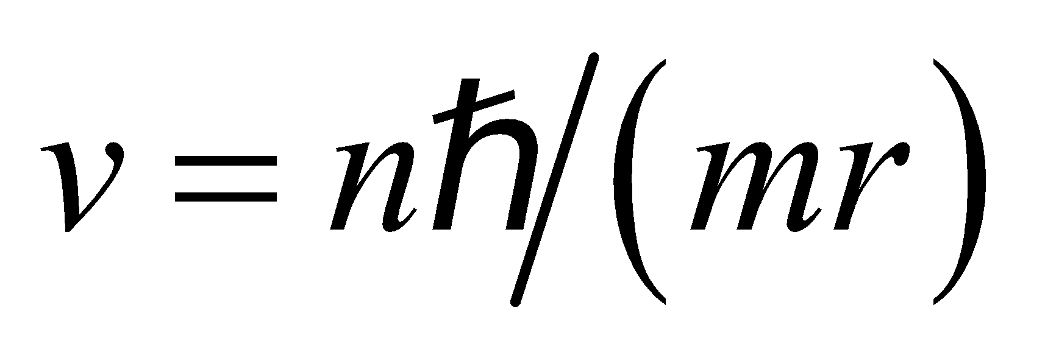 using 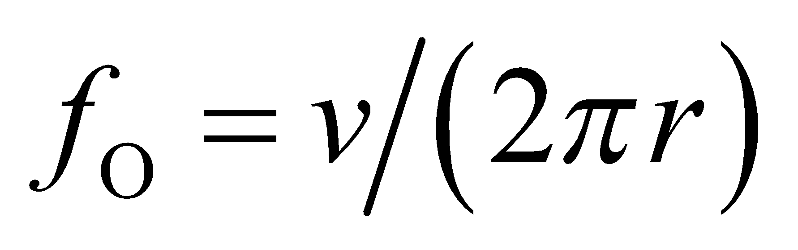.
We will use the binomial expansion to approximate 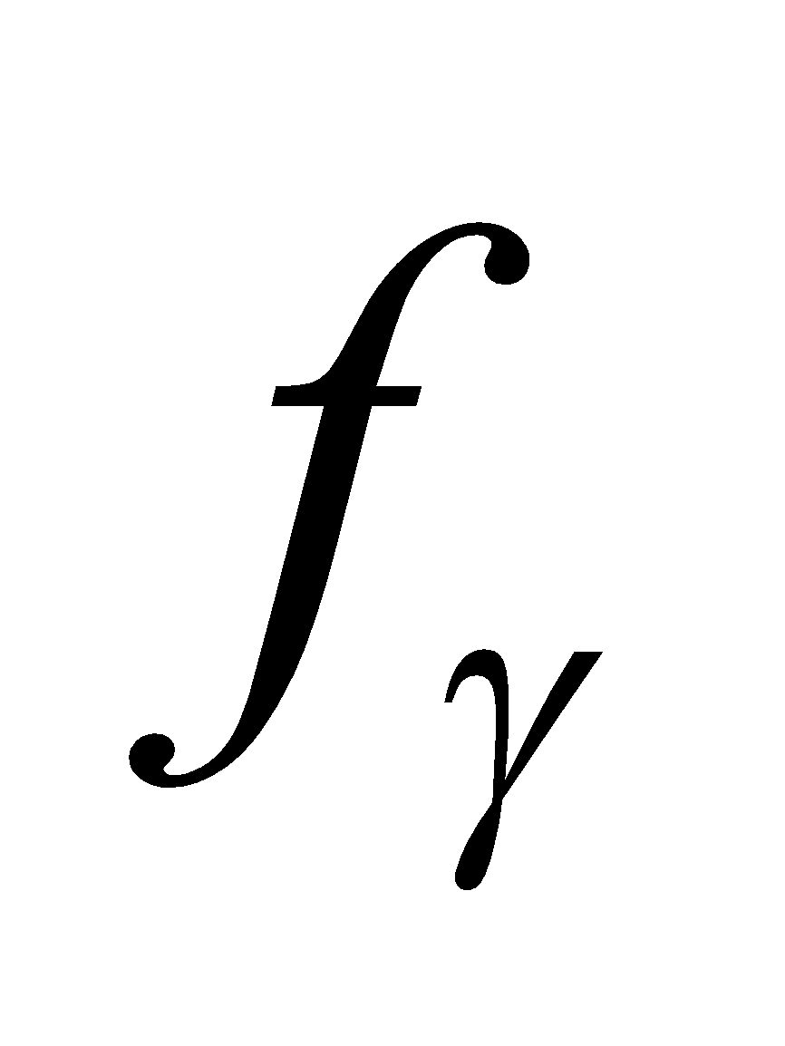 and compare the result with the orbital frequency 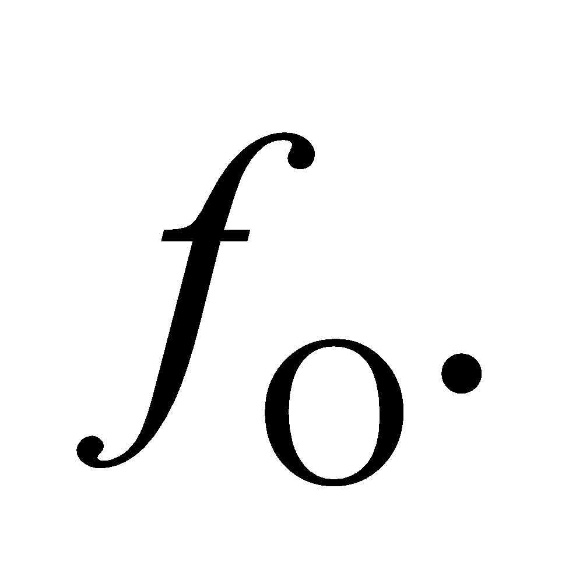
Evaluate From and 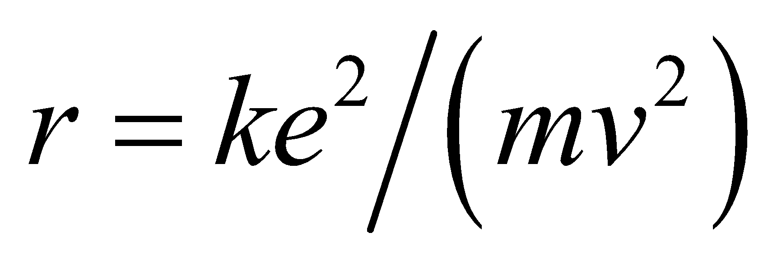 we obtain the orbital radius
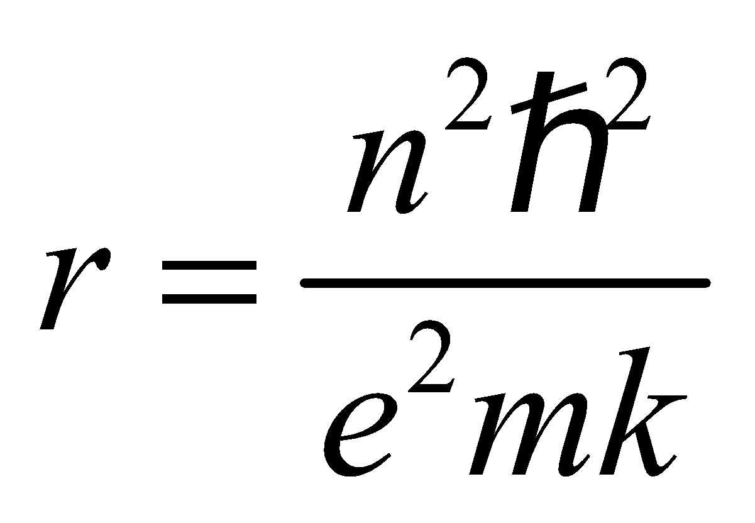
The orbital frequency is
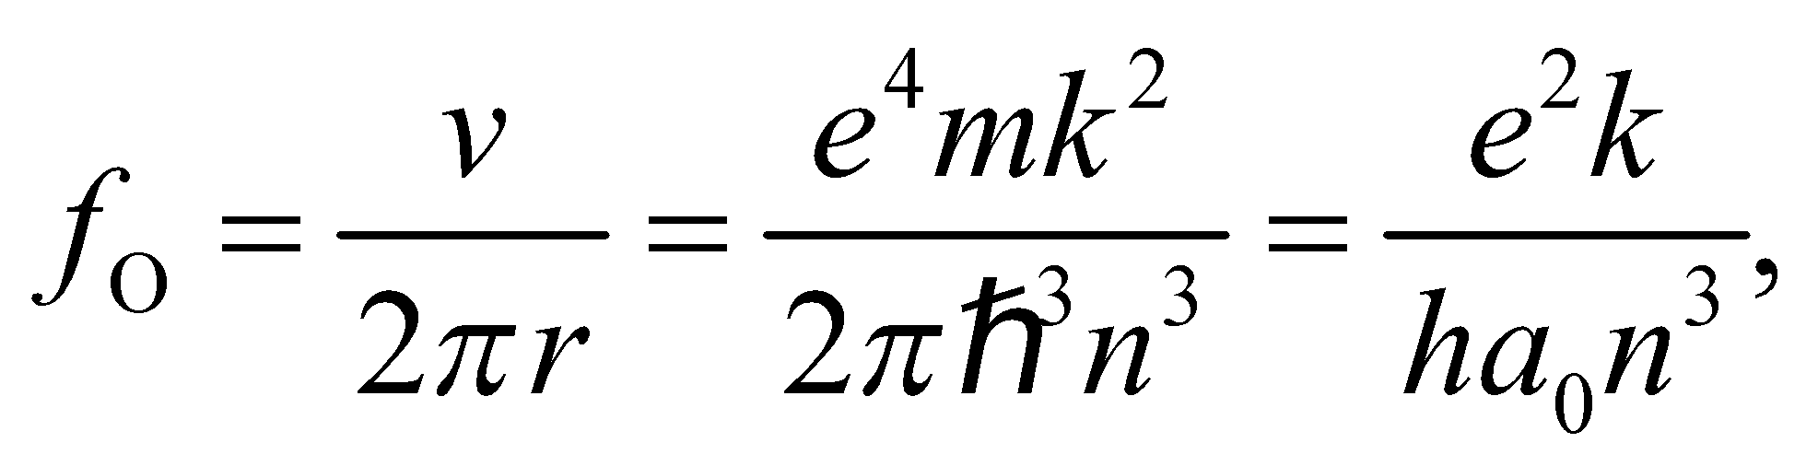 where 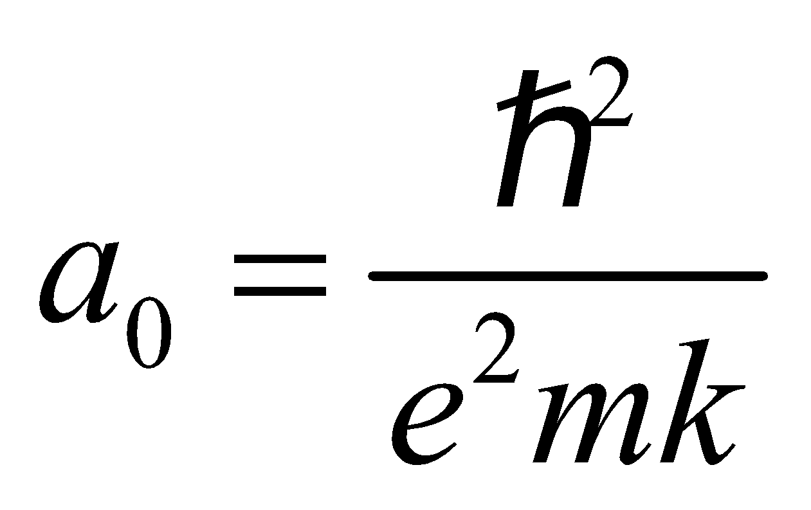
The frequency of the photon emitted is
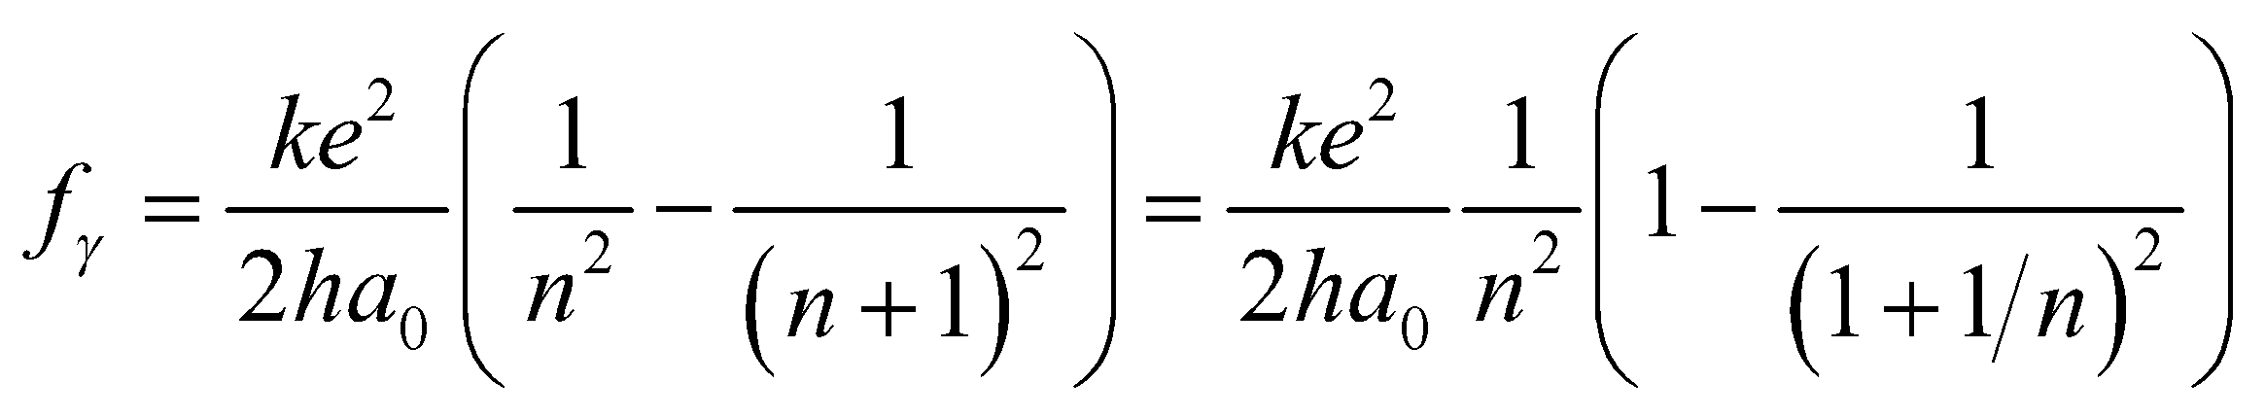
so for 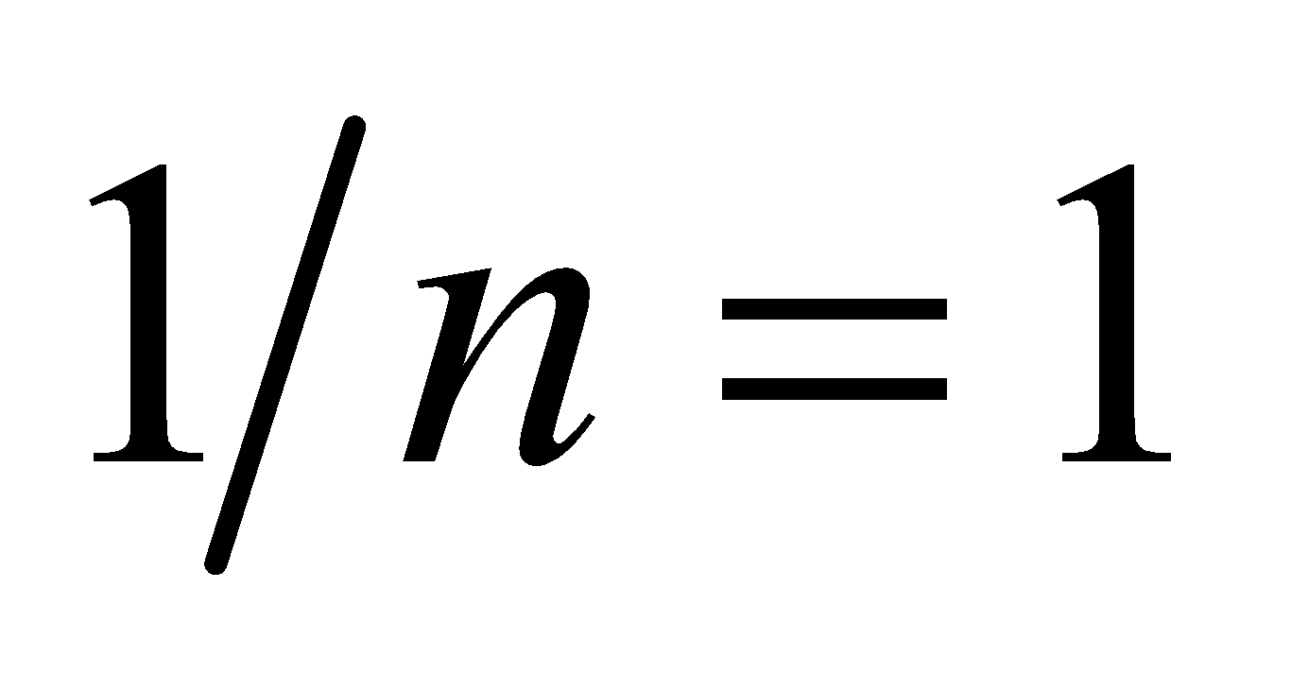
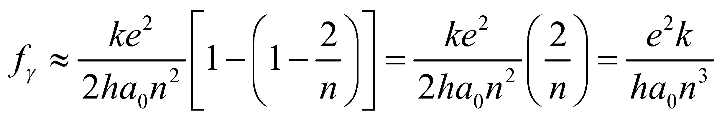
Assess For large values of n, the optical frequency is the same as the orbital frequency
79. Interpret We investigate the relation between particle lifetimes and uncertainty in their rest energy measurements.
Develop From Equation 34.16, the uncertainties in the energy and time are constrained by Therefore, the lifetime of a given particle will be inversely proportional to the uncertainty in its rest energy: 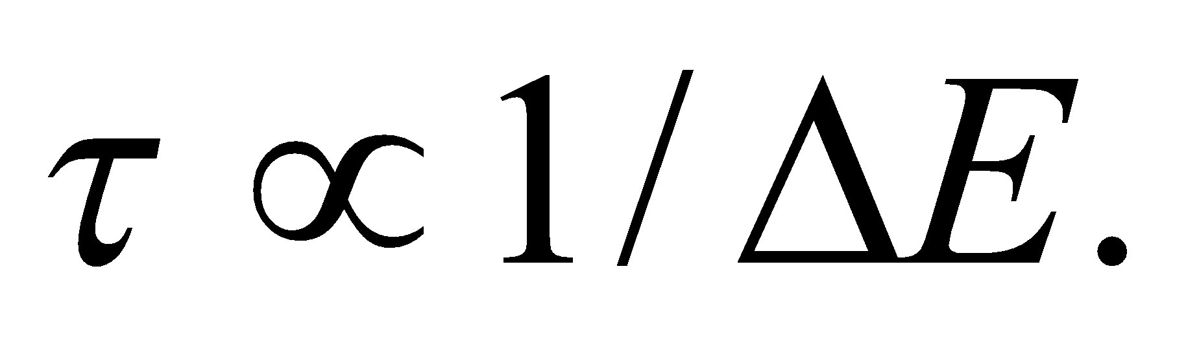
Evaluate The shortest lifetime will correspond to the curve with the largest uncertainty in its rest energy. In the graph, this is particle C.
The answer is (c).
Assess The distribution width shown in the graph is called the natural line width and is denoted by  It is called "natural" to signify that this uncertainty is inherent to the particle and does not, like other uncertainties, come simply from the imperfect instruments used to collect the data.
80. Interpret We investigate the relation between particle lifetimes and uncertainty in their rest energy measurements.
Develop As argued above, the lifetime is related to the uncertainty in its rest energy by 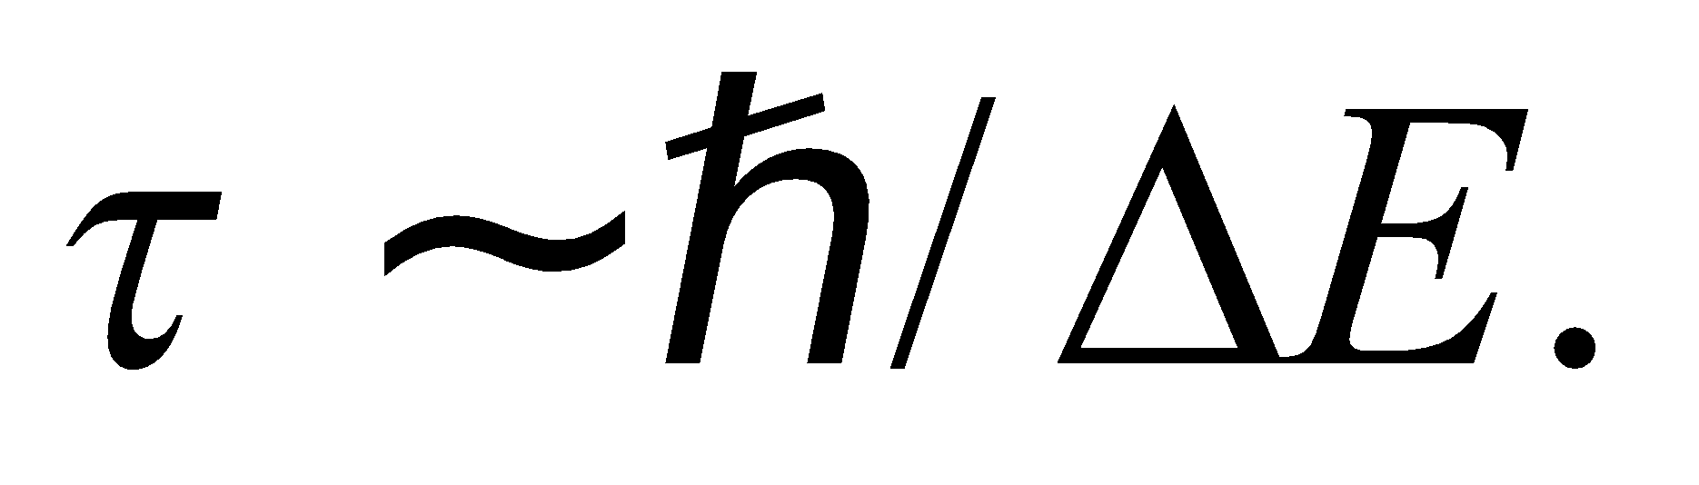
Evaluate For an uncertainty of 1 MeV, the lifetime must be roughly
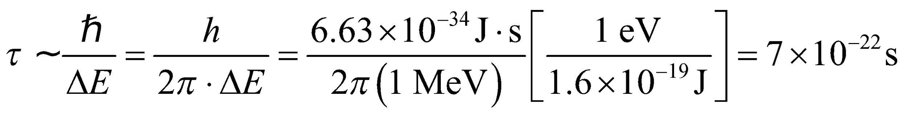
The answer is (b).
Assess Although this seems like an incredibly short amount of time, there are many particles that have lifetimes in this range.
81. Interpret We investigate the relation between particle lifetimes and uncertainty in their rest energy measurements.
Develop The inverse relation between energy uncertainty and lifetime is 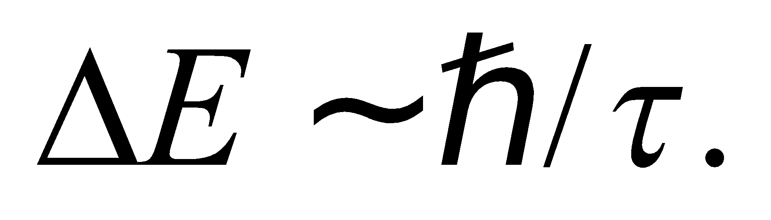
Evaluate A longer lifetime leads to a narrower range in the energy measurement. By Einstein's mass-energy equivalence, this corresponds to a narrower range in the mass, as well.
The answer is (d).
Assess Some particles, like the proton and the electron, appear to have infinite lifetimes, so we'd expect the uncertainty in their mass to be near to zero.
82. Interpret We investigate the relation between particle lifetimes and uncertainty in their rest energy measurements.
Develop Using Einstein's mass-energy equation 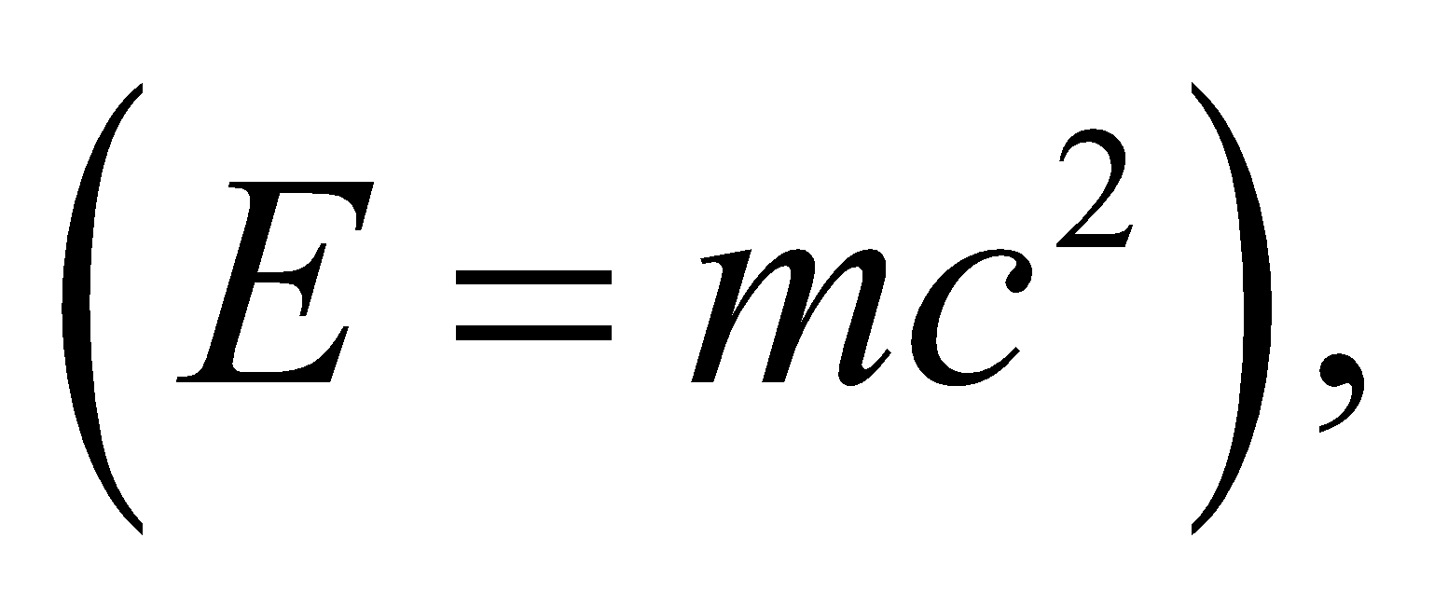we can write the time-energy uncertainty inequality as 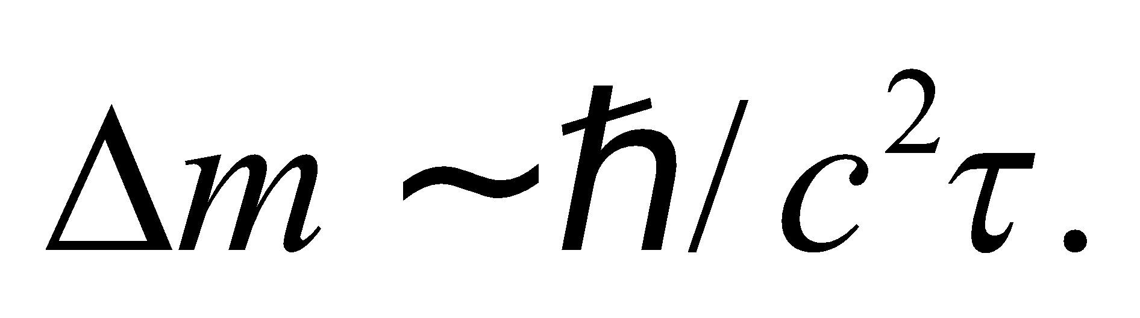
Evaluate Plugging in the lifetime, the mass range is
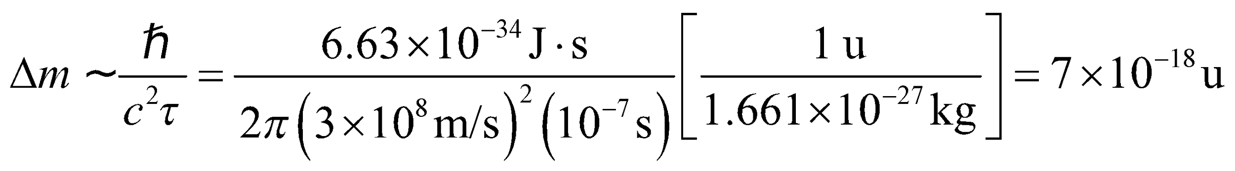
The answer is (c).
Assess In particle physics, 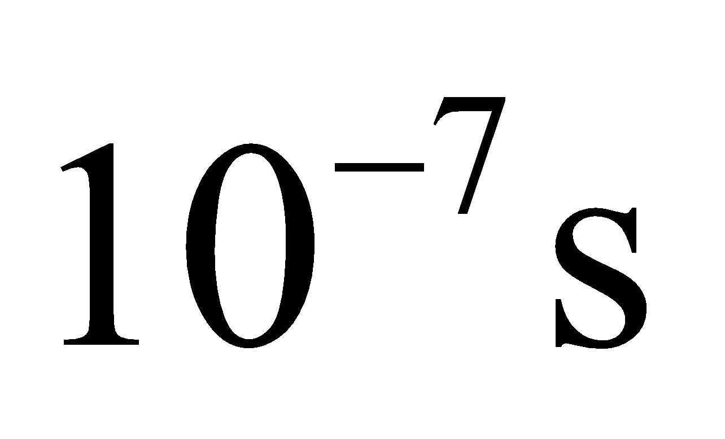is a relatively long lifetime. A particle with roughly this long of a lifetime is the charged pion with 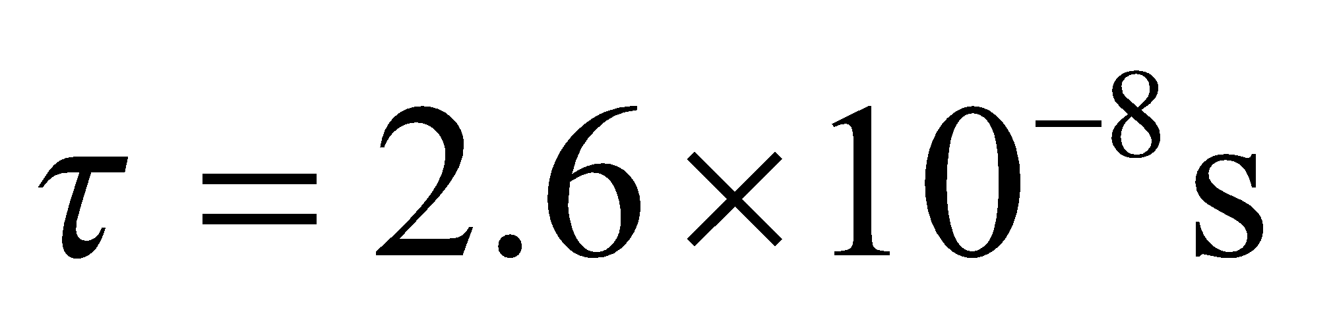 and a mass of 