INTERFERENCE AND DIFFRACTION

32

Exercises
Section 32.2 Double-Slit Interference
10. Interpret This problem involves interference from a double-slit arrangement. Given the parameters of the arrangement, we are to find the wavelength of the illuminating light.
Develop Because d  L, we can apply Equation 32.2a with d = 15 μm, L = 2.2 m, m = 1, and y = 7.1 cm to find the wavelength λ. We may also approximate sinθ by y/L because y  L (i.e., it’s a small angle).
Evaluate The wavelength is
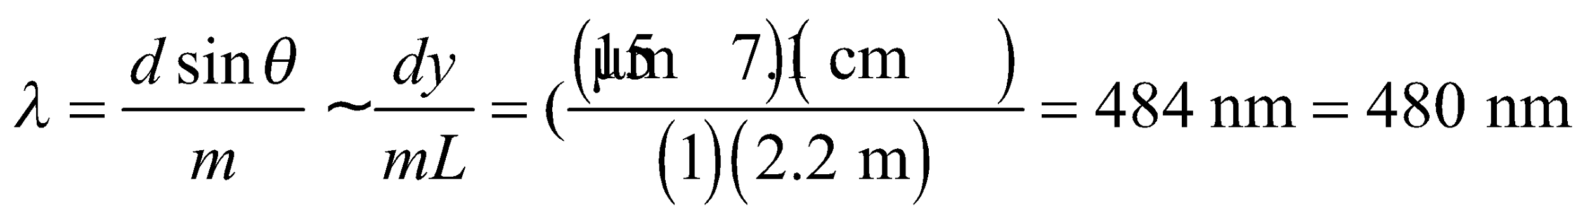
to two significant figures.
Assess The exact formula is
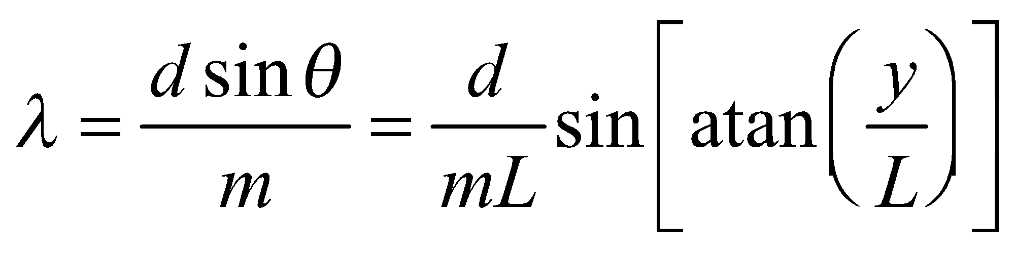
which differs by 0.05% from the result above (i.e., ± 0.2 nm, which is much less than the precision of the data).
11. Interpret This problem is about double-slit interference. We are to find the spacing between adjacent bright fringes given the wavelength of the light, the slit spacing, and the slit-screen distance.
Develop The geometrical parameters of the source, slits, and screen satisfy the conditions for which Equations 32.2a and 32.2b apply (i.e., d  L and λ  d). The locations of bright fringes are given by
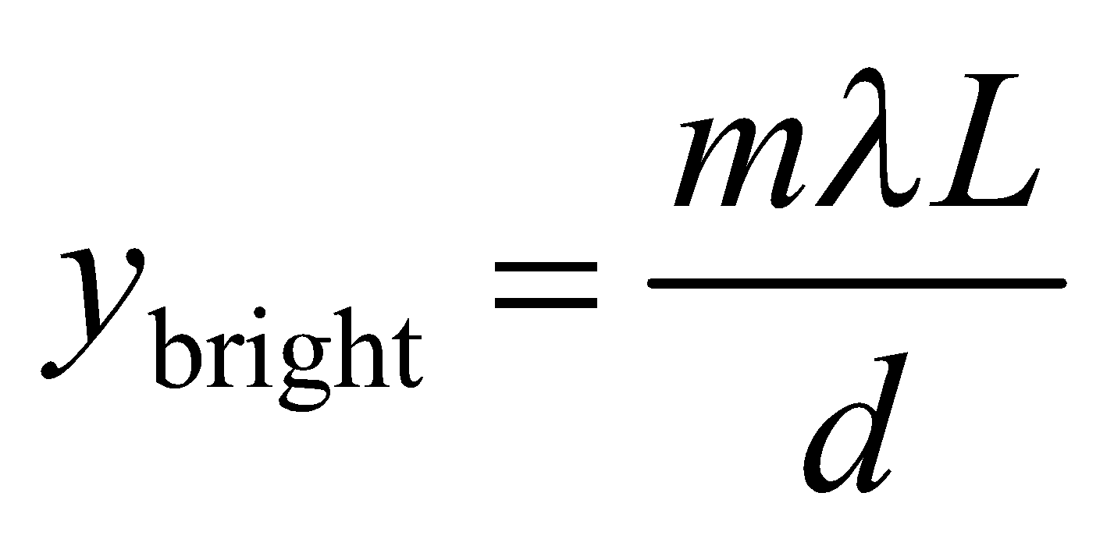
where m is the order number.
Evaluate The spacing of bright fringes is
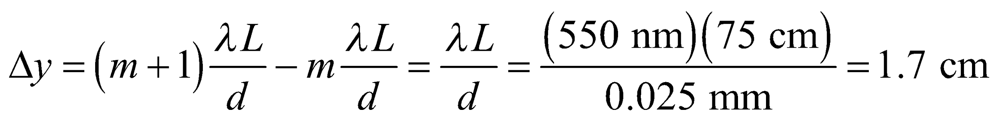
Assess Since 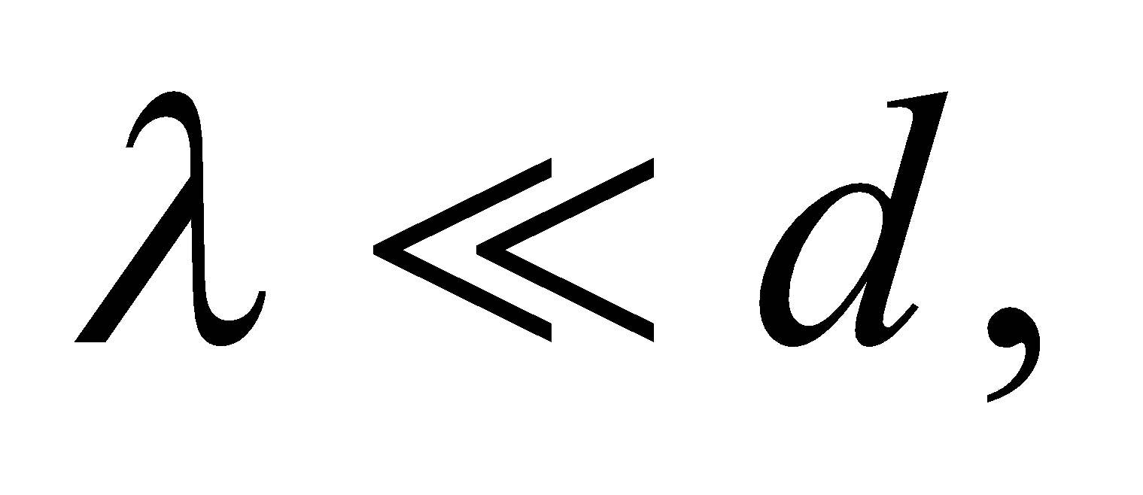 the spacing between bright fringes is much smaller than L, as it should be.
12. Interpret For a double-slit interference arrangement, we are to find the slit-to-screen distance given the wavelength, the slit spacing, and the spacing between bright fringes.
Develop We will assume that the particular geometry of this type of double-slit experiment satisfies the conditions for using Equations 32.2a and 32.2b (i.e., d  L and λ  L), and verify afterwards.
Evaluate (a) The slit-to-screen spacing on the screen is
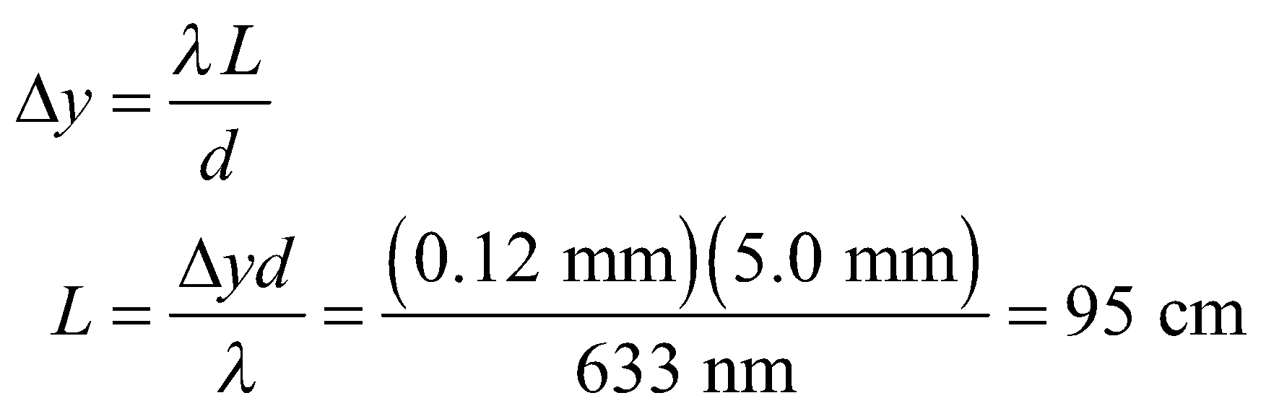
(b) For two different wavelengths, the ratio of the spacings is 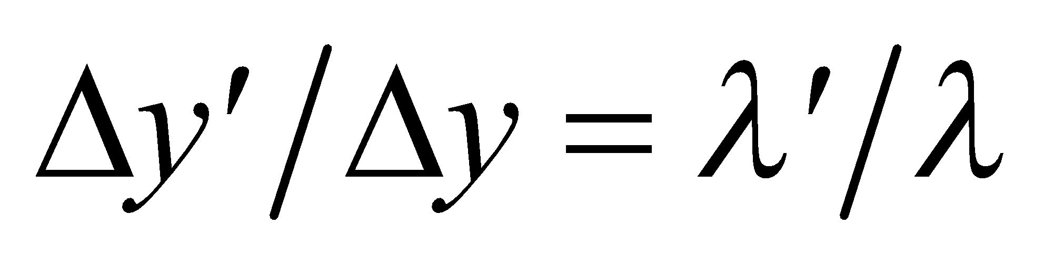; therefore 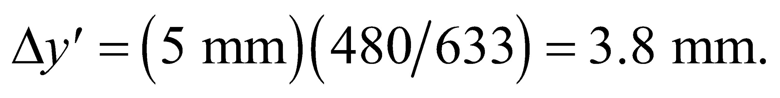
Assess Note that the conditions d  L and λ  L are indeed met, so we are justified in using Equation 32.2a. The fringe spacing for 480 nm may also be found by applying Equation 32.2a with L = 95 cm. The result is the same.
13. Interpret This problem is about double-slit interference. We are interested in the wavelength of the light source.
Develop For small angles, we may approximate sinθ ~ θ, so Equation 32.1 gives 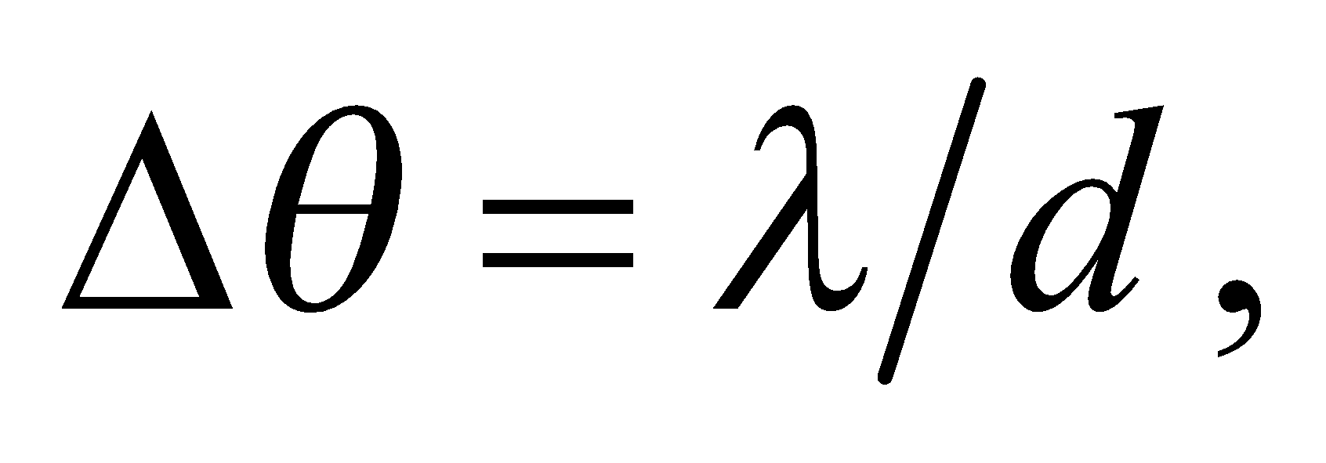 and the interference fringes are evenly spaced.
Evaluate Substituting the values given, we obtain
Assess The wavelength λ is much smaller than the slit spacing d, as needed for using Equation 32.1a.
14. Interpret Given the angular position of the 5th dark fringe and the wavelength of the light, we are to find the slit separation in a double-slit experiment.
Develop The interference minima fall at angles given by Equation 32.1b. The ratio y_{dark}/L = tanθ, so Equation 32.1b can be written as
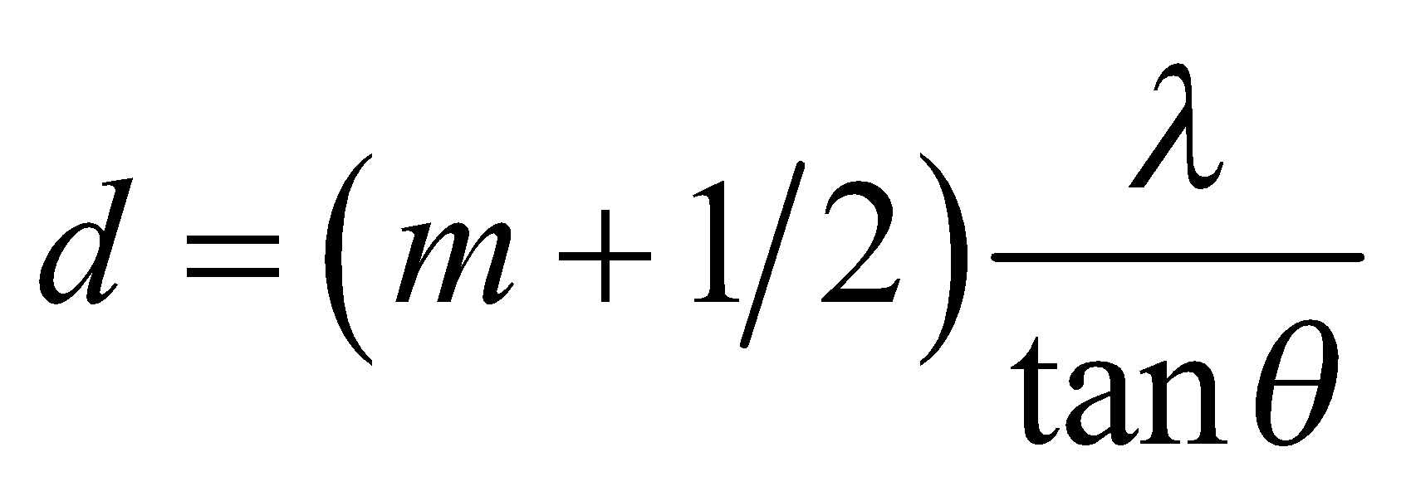
Notice that the order m is defined as the number of the bright fringe, with m = 0 corresponding to the central (bright) fringe. Thus, the 5th dark fringe corresponds to m = 5.
Evaluate For m = 5, Equation 32.1b gives
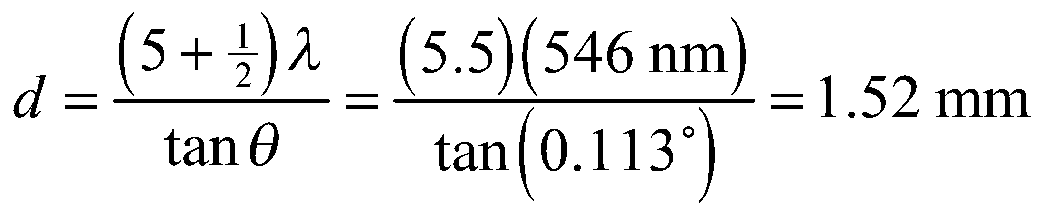
Assess The condition λ  d is met, so we are justified in using Equation 32.2b. Note that the significant figures are determined by the wavelength and the angle—not by the order number (which are defined as integers and so have infinite accuracy).
Section 32.3 Multiple-Slit Interference and Diffraction Gratings
15. Interpret The setup is a multiple-slit interference experiment. We want to know the number of minima (destructive interferences) between two adjacent maxima.
Develop In an N-slit system with slit separation d (illuminated by normally incident plane waves), the main maxima occur for angles (see Equation 32.1a) 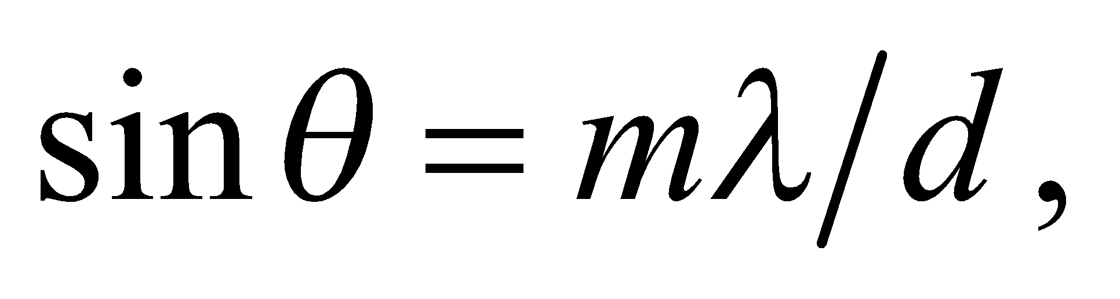 and minima for angles (see Equation 32.4) 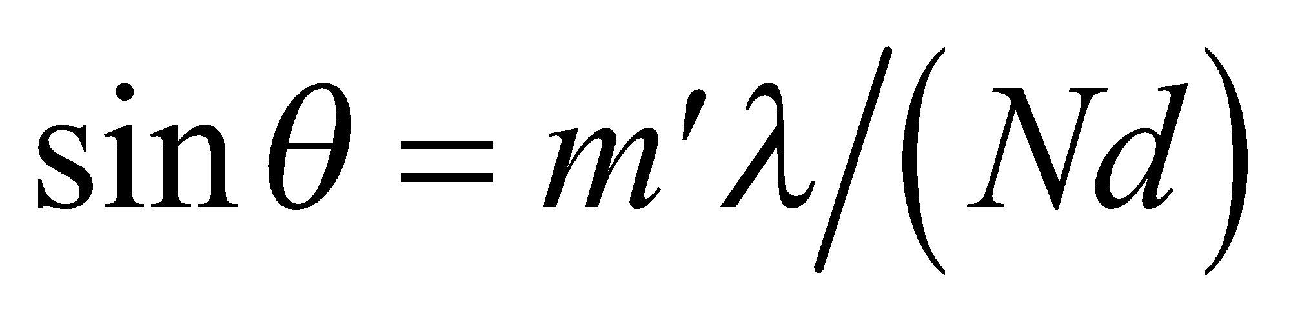 (excluding m′ = 0 or multiples of N).
Evaluate Between two adjacent maxima, say 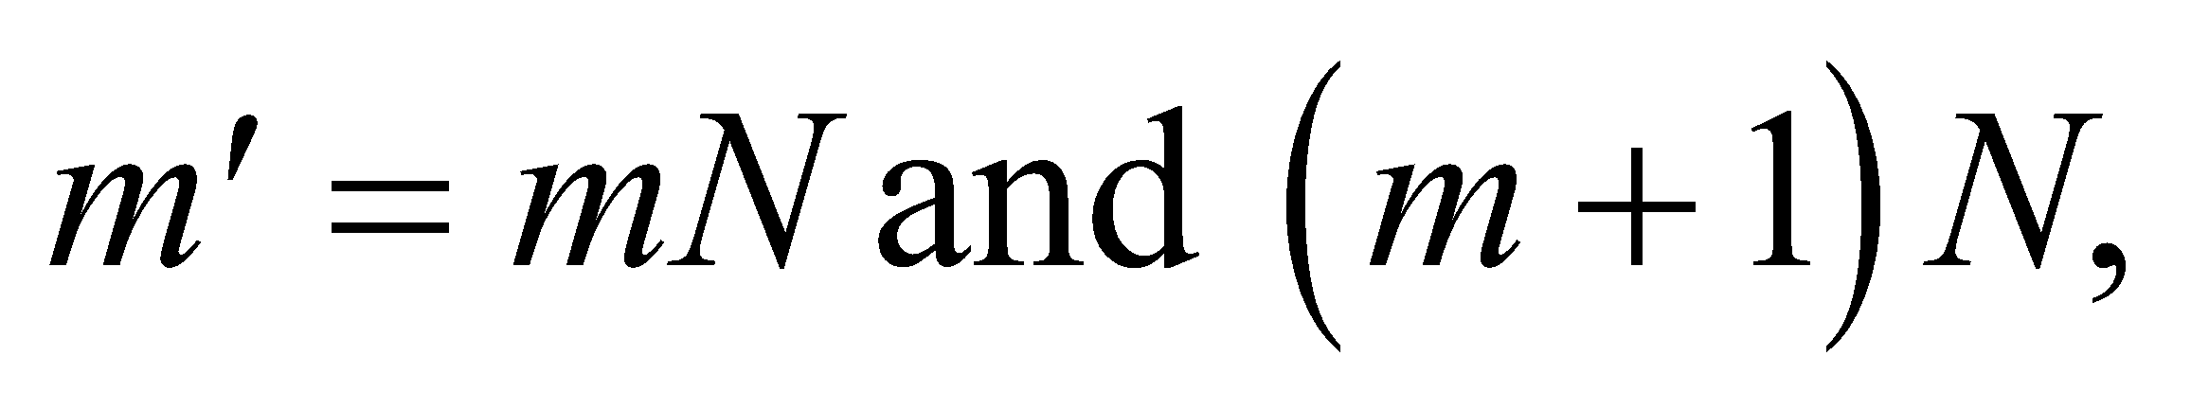 there are N − 1 minima. The number of integers between 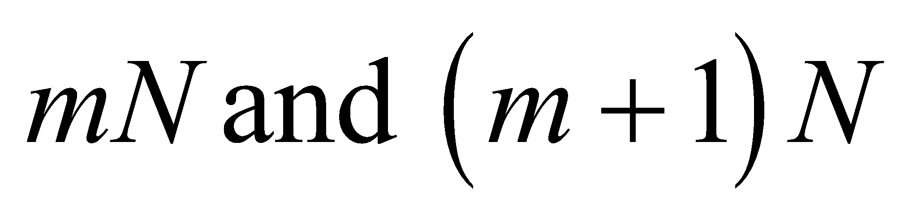 is
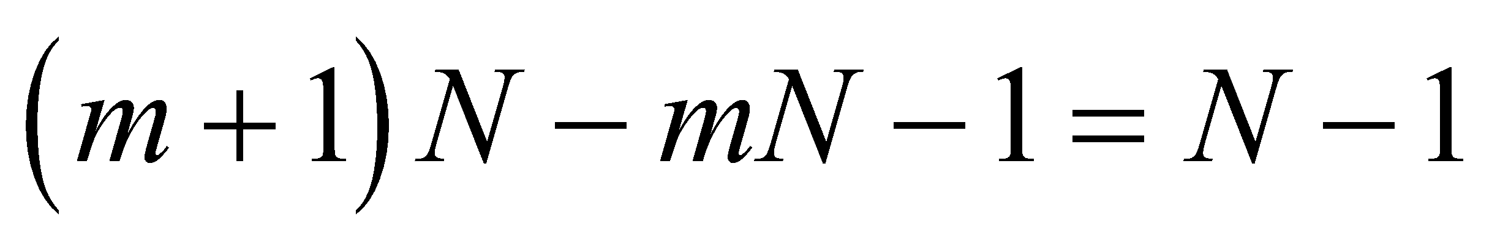
because the limits are not included. Therefore, For N = 5, the number of minima is 4.
Assess The interference pattern resembles that shown in Figure 32.8. Note that the number of minima is independent of the order number m. Also note that our result agrees with Figure 32.8.
16. Interpret This problem involves a multiple-slit system. We are to find the first maximum given the angular position of the first minimum.
Develop Apply Equation 32.4 to find the ratio λ/d. For the first minima (m = 1), this gives
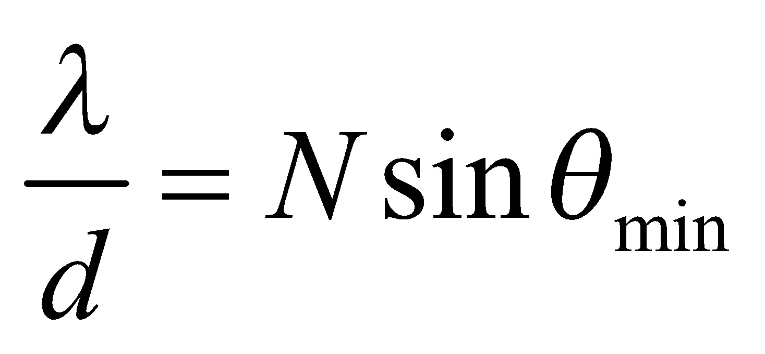
where N = 3 for this problem (i.e., three slits). The angular position of the first maxima can then be found using Equation 32.1a.
Evaluate The first maximum is at
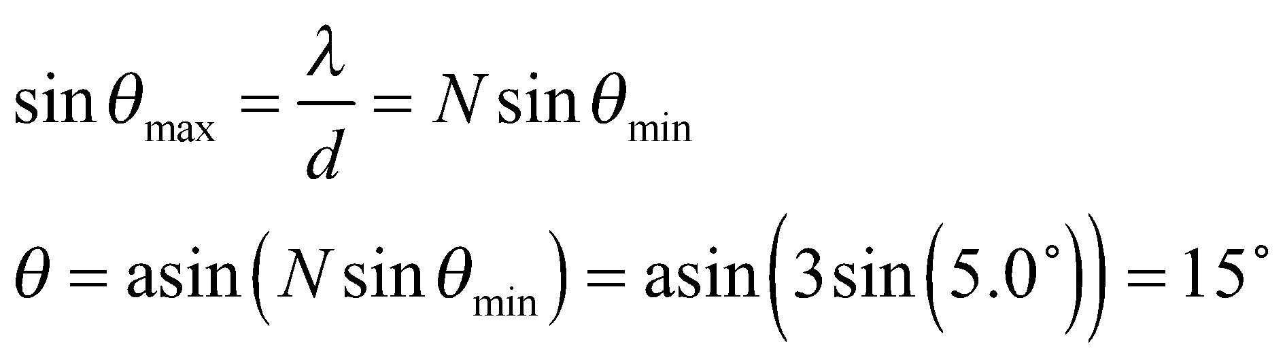
Assess The two minima occur at approximately 5° and 10°.
17. Interpret In this problem, we want to locate certain maxima and minima in a multiple-slit interference experiment. We are given the necessary parameters.
Develop According to Equation 32.1a, primary maxima occur at angles 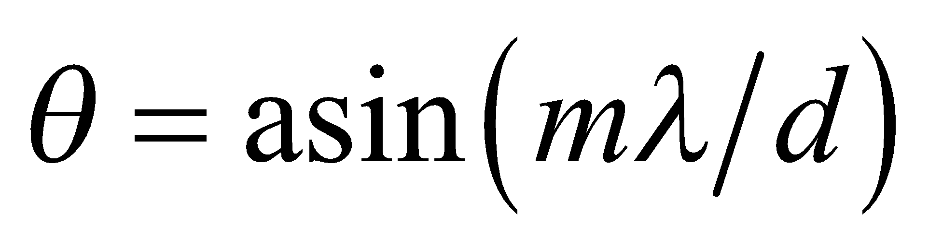. On the other hand, minima occur at angles (see Equation 32.4)
where m′ is an integer but not an integer multiple of N.
Evaluate (a) Using the above equation, the first two maxima (after the central peak,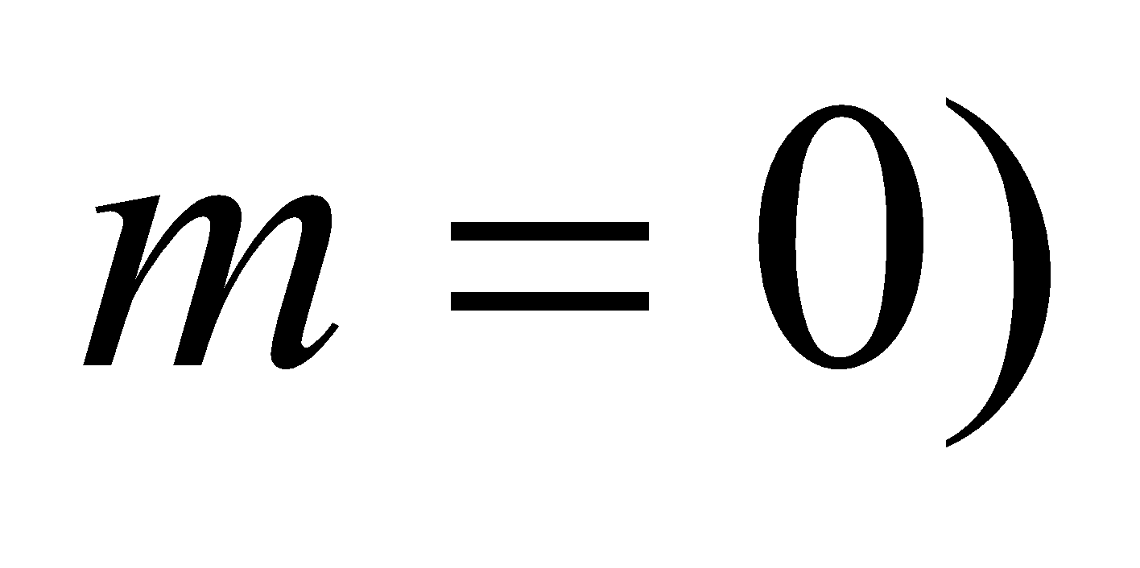are for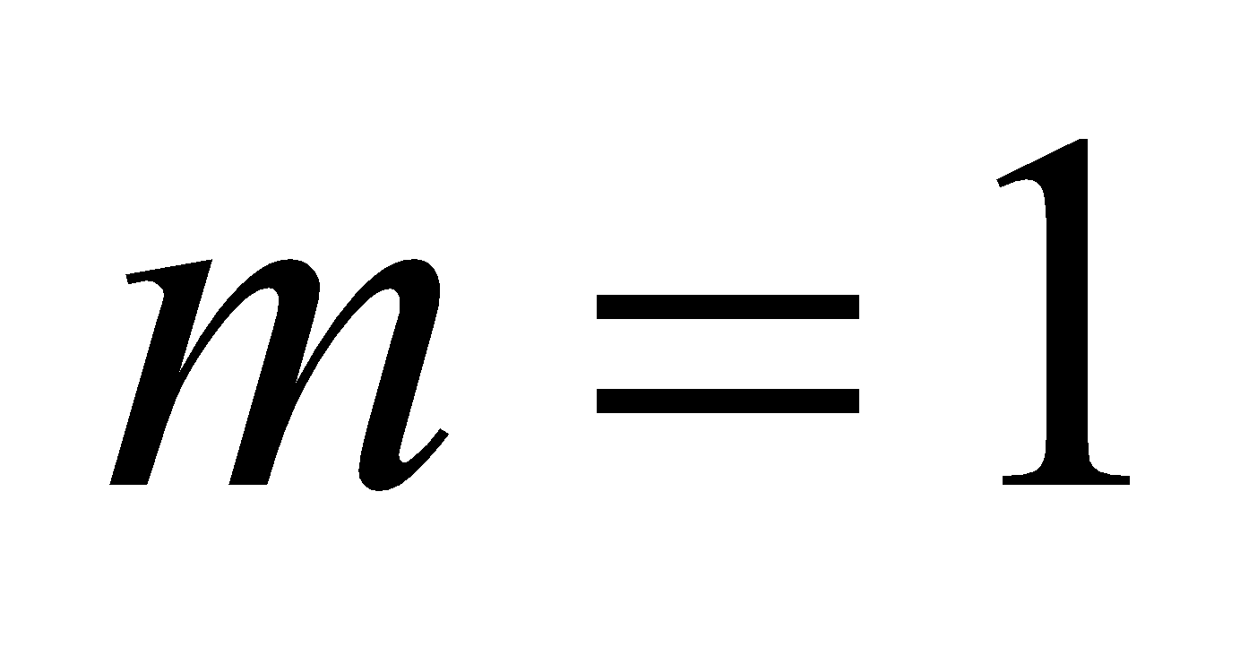and 2. The angular position for these maxima are at
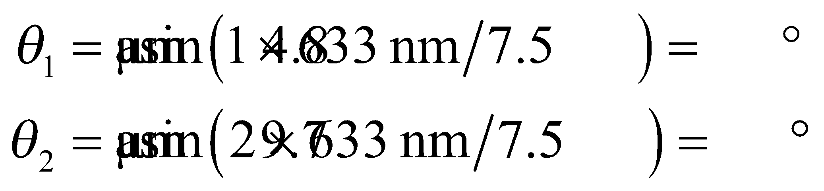
(b) With N = 5, excluded, the third minimum is for m′ = 3 and the sixth for m′ = 7 (because m′ = 5 doesn’t count). Then
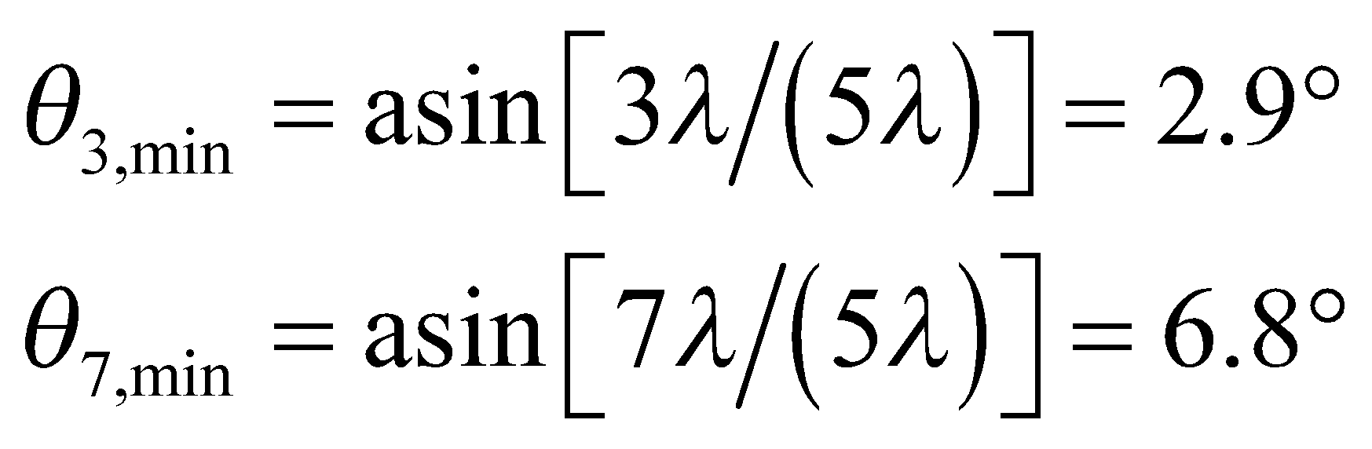
Assess The minima would be difficult to observe because the secondary maxima between them are faint.
18. Interpret We are to find the first- and fifth-order diffraction angle given the grating spacing and the wavelength.
Develop For light normally incident on a diffraction grating, maxima occur at angles
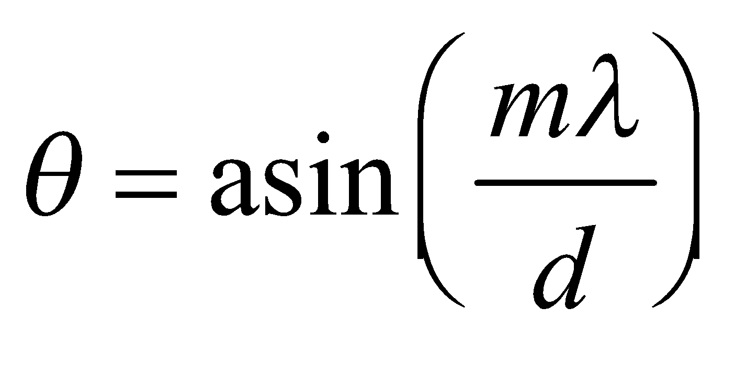
(see Equation 32.1a) where m is the order number and d is the grating spacing and is equal to the reciprocal of the number of lines per meter:
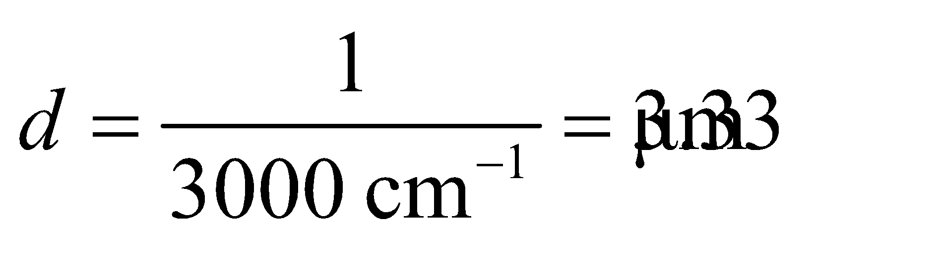
Evaluate (a) In first order,
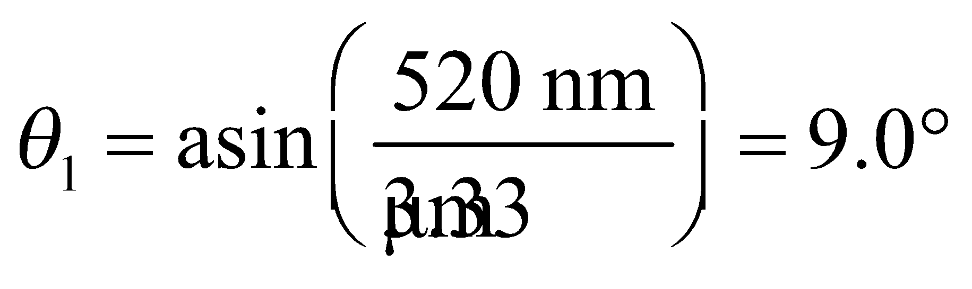
(b) In fifth order,
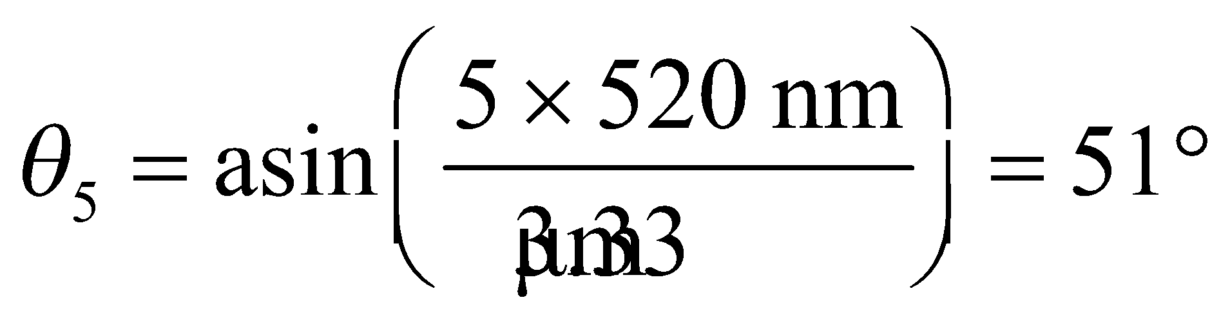
Assess One can see that the relationship between θ₁ and θ₅ is almost linear (i.e. θ₅ ~ 5 × θ₁).
19. Interpret This problem is about diffraction gratings. For a given wavelength, we are interested in the highest visible order.
Develop The grating condition is 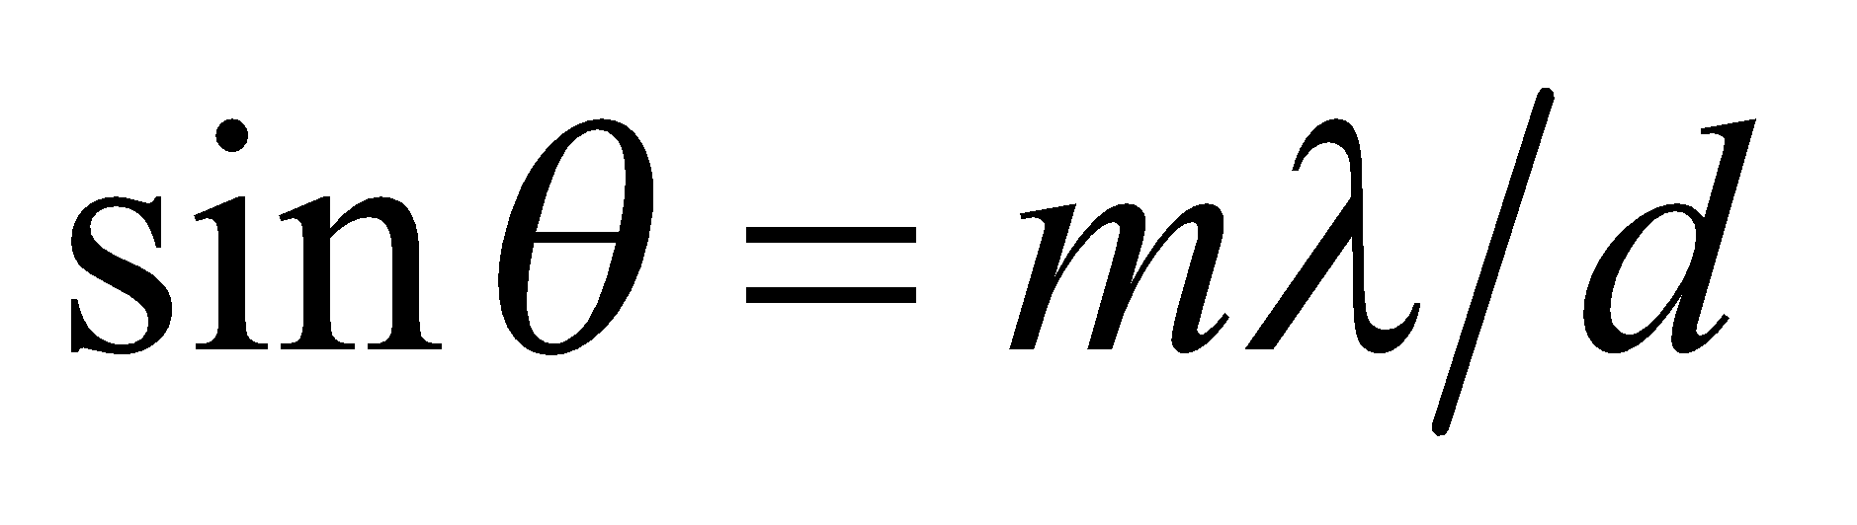 and q must be less than 90° (or mλ/d < 1) for the diffracted light to be visible. Therefore, the highest order visible is the greatest integer m less than d/λ. The grating spacing is d = (1 cm)/10⁴ = 10³ nm.
Evaluate (a) For λ = 450 nm, the highest visible order is
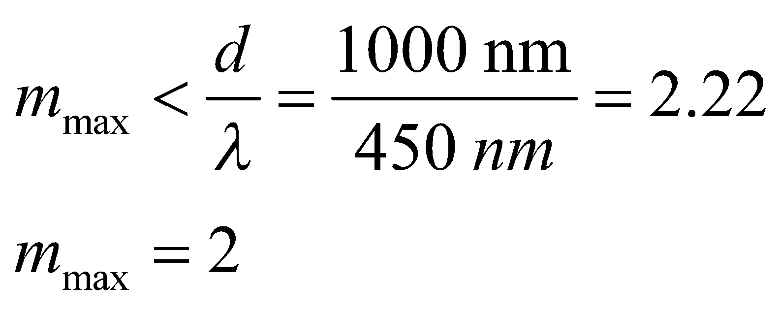
(b) Similarly, for λ = 650 nm, the highest visible order is
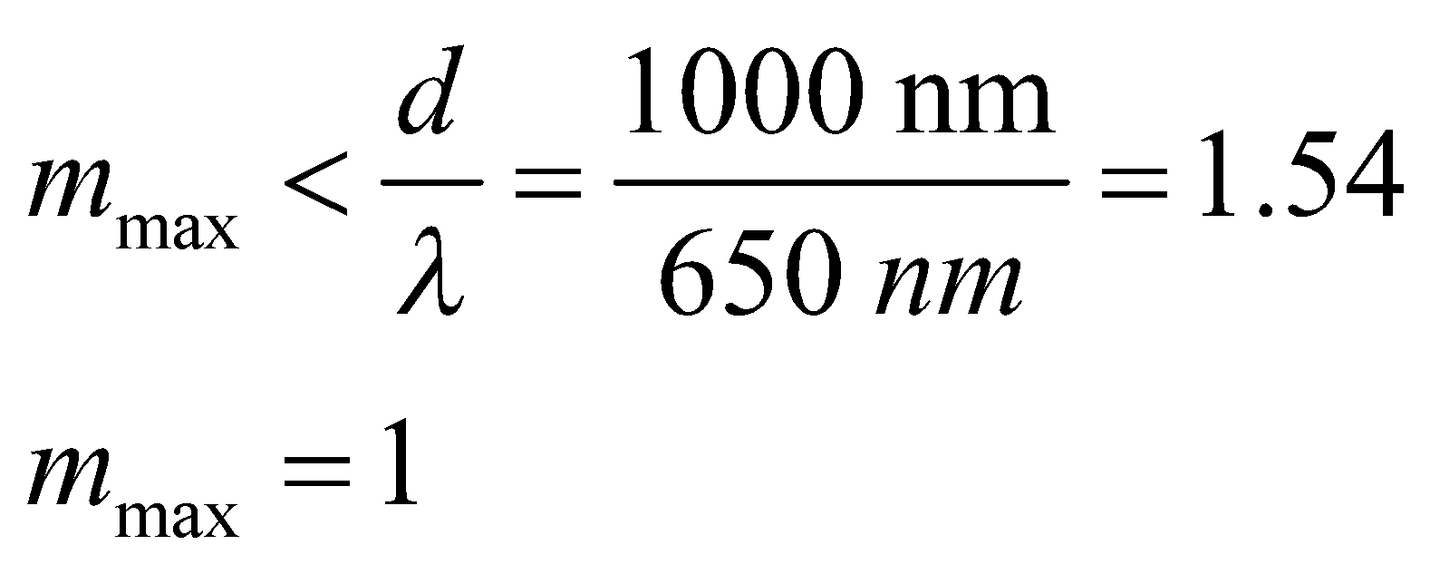
Assess Increasing wavelength lowers  This can be seen from Equation 32.1a, 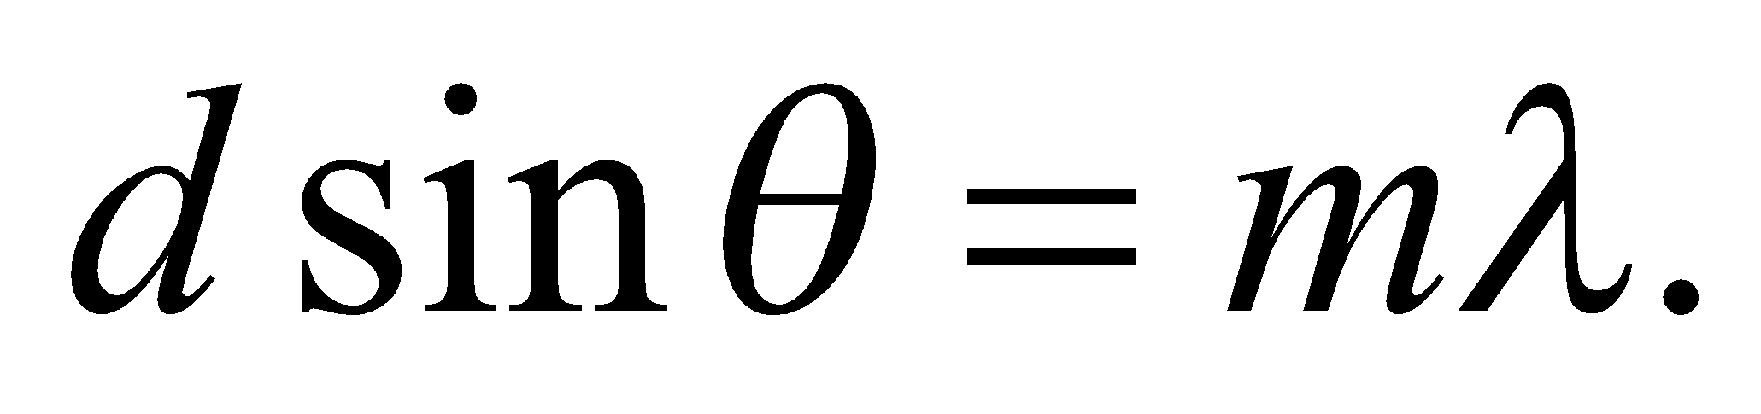
20. Interpret We will use interference to find the angular separation for the second-order (m = 2) interference maxima for the Hα and Hβ lines.
Develop The wavelengths of the two lines are 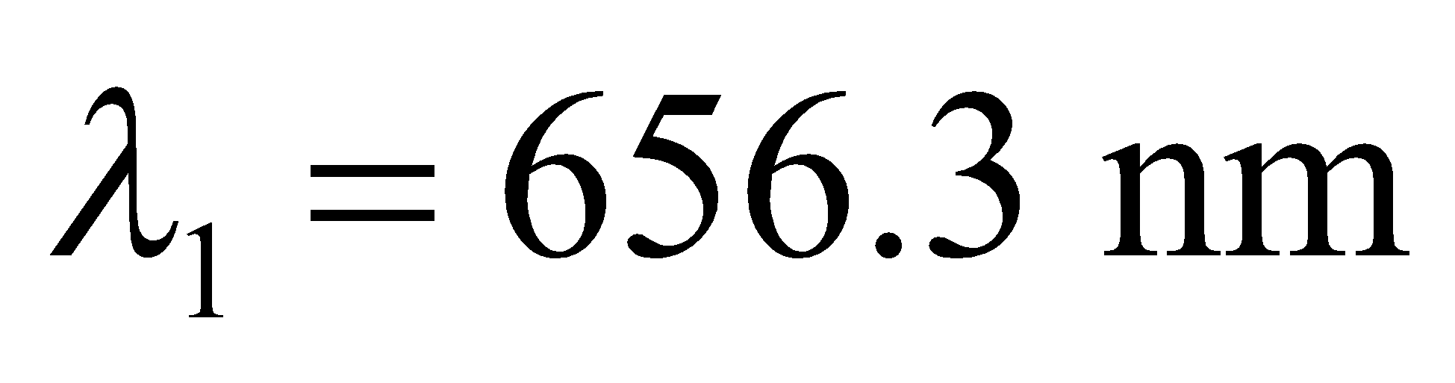 and 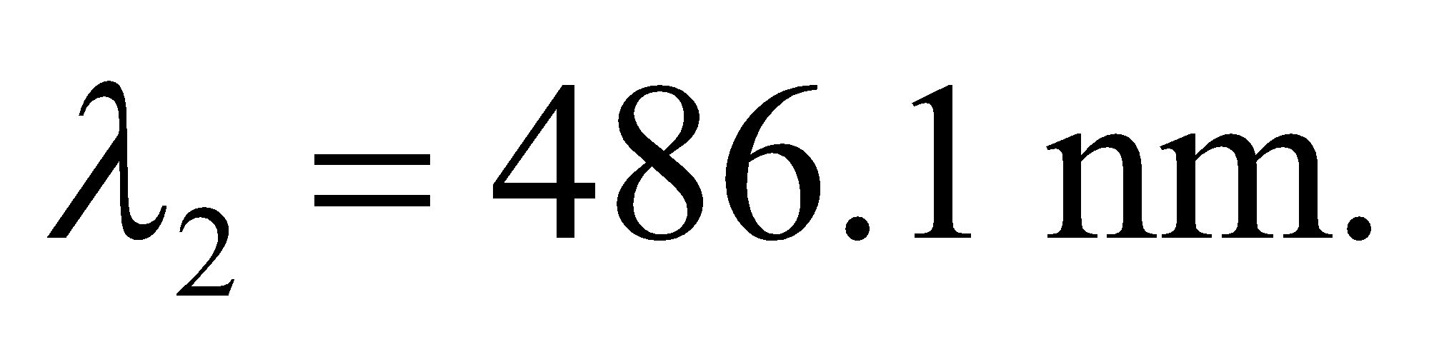 The interference equation (Equation 32.1a) is 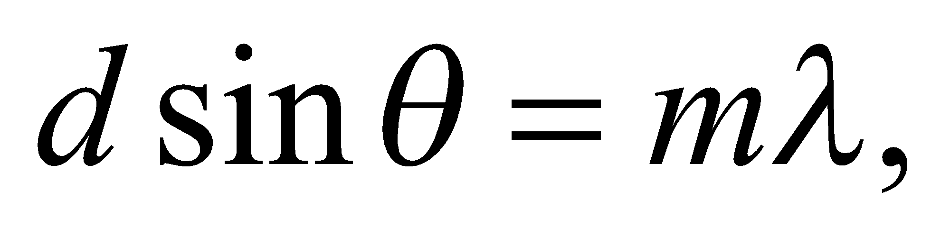 where from Example 32.2 we see that d = 1.667 μm. We shall find the value of θ for each line, then take the difference between the two.
Evaluate Solving for the angle θ gives
so
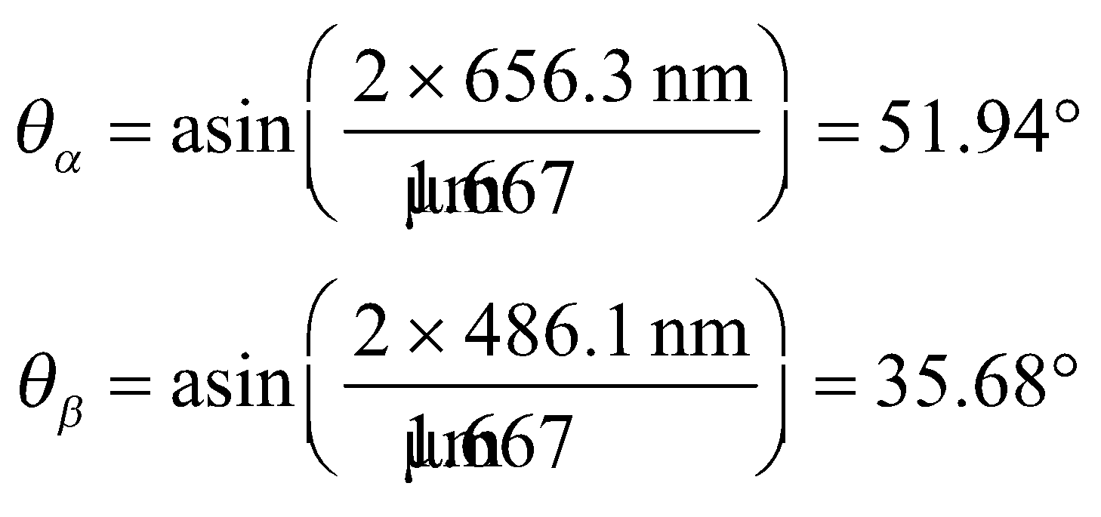
The angular difference between the two is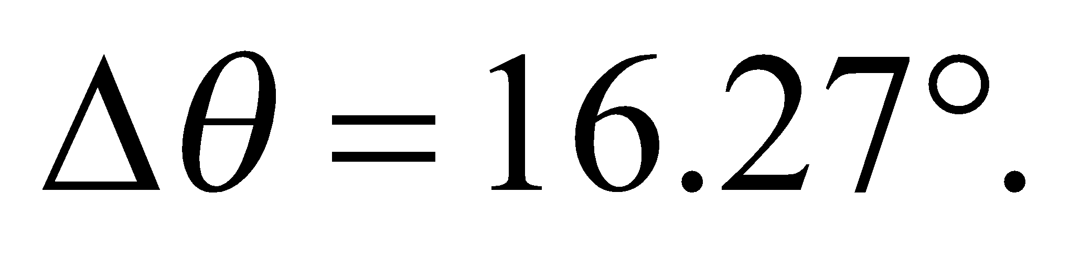
Assess Most optical spectrometers are designed to use second-order interference, rather than first-order, because the angular dispersion is larger.
Section 32.4 Interferometry
21. Interpret This problem involves interference in a thin film. We want to find the minimum film thickness that results in constructive interference for the given wavelength.
Develop The condition for constructive interference from a soap film is Equation 32.7:
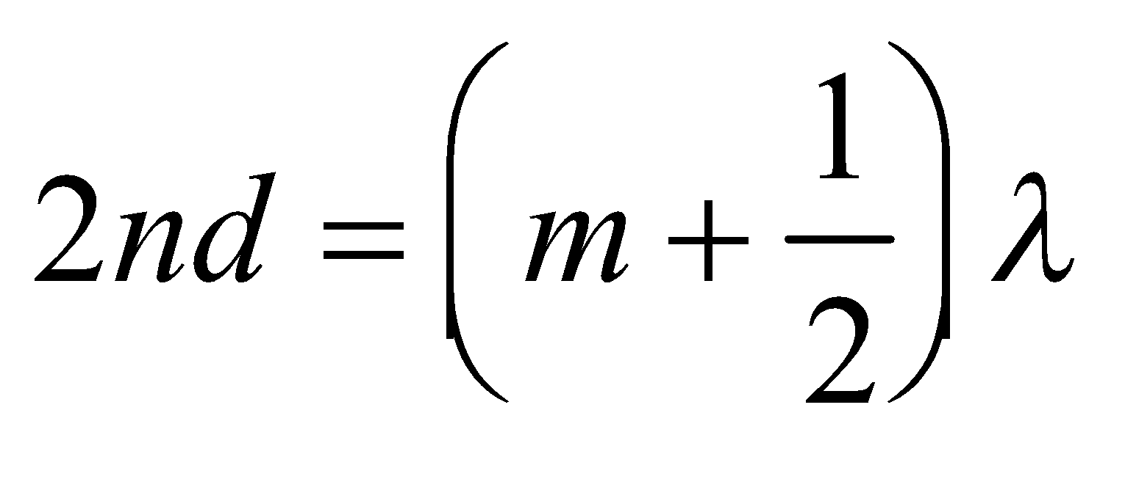
The minimum thickness corresponds to the integer m = 0.
Evaluate Substituting the values given, we get
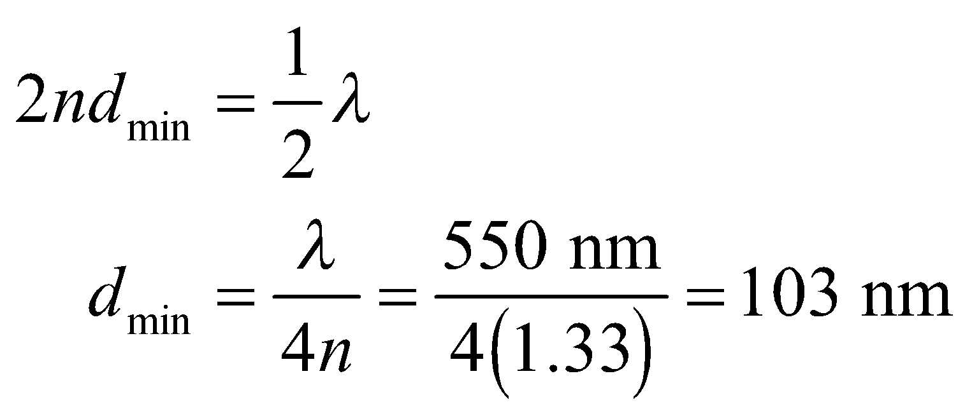
Note that Equation 32.7 applies to normal incidence on a thin film in air.
Assess The typical thickness of a thin film is on the order of 100 nm. Thin-film interference accounts for the bands of color seen in soap films or oil slicks.
22. Interpret This problem involves constructive interference. Given the thickness of the material, we are to find the wavelength which results in constructive interference.
Develop We shall use the result from Problem 32.21, which gives the minimum thickness for constructive interference in a thin material. Thus, the minimum thickness of the wedge at which constructive interference occurs is 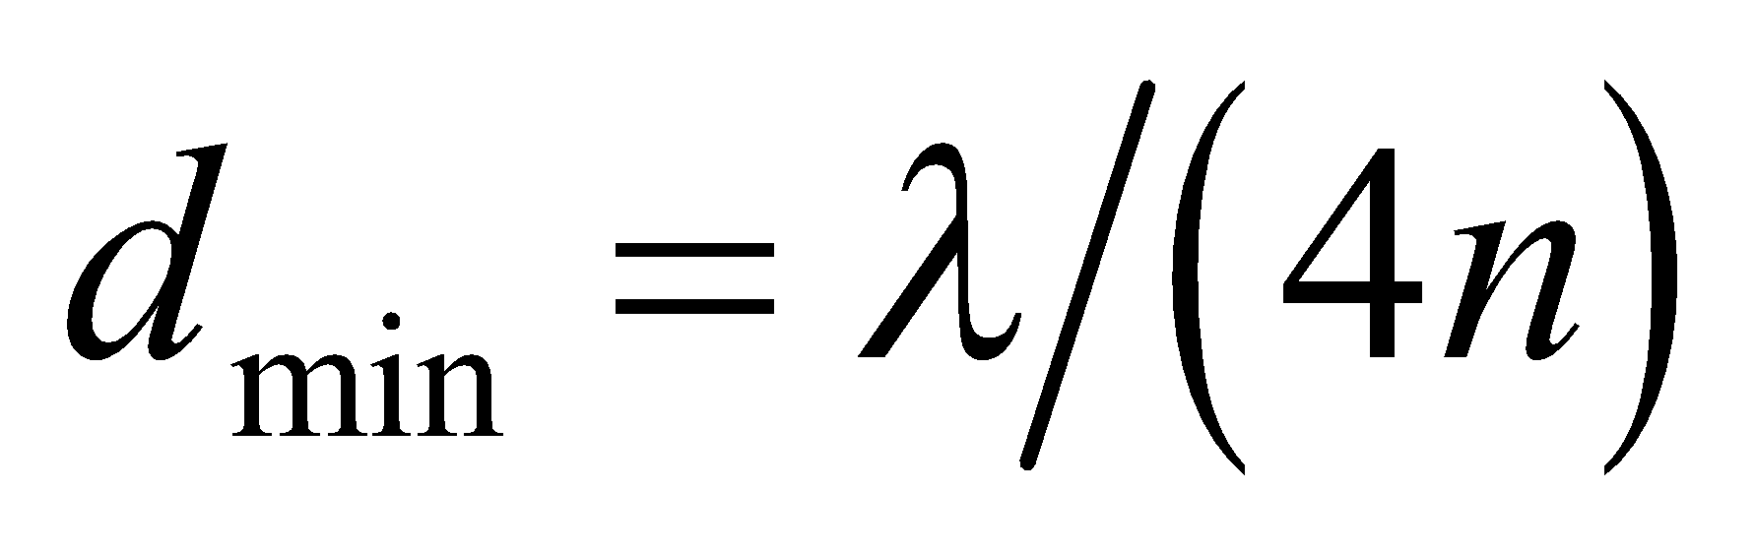. Solve this for λ to find the wavelength.
Evaluate Inserting the given quantities gives
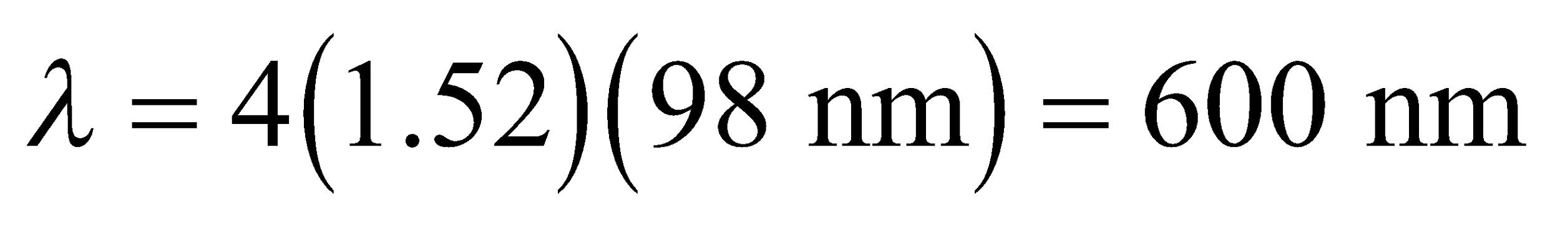
where the result is precise to two significant figures.
Assess This is orange light and is within the visible range.
23. Interpret The enhanced reflection is a consequence of constructive interference, so we shall look for the range of wavelengths that satisfies this condition.
Develop Equation 32.7 gives the condition for constructive interference from a given thickness of glass surrounded by air. Solving this equation for λ gives
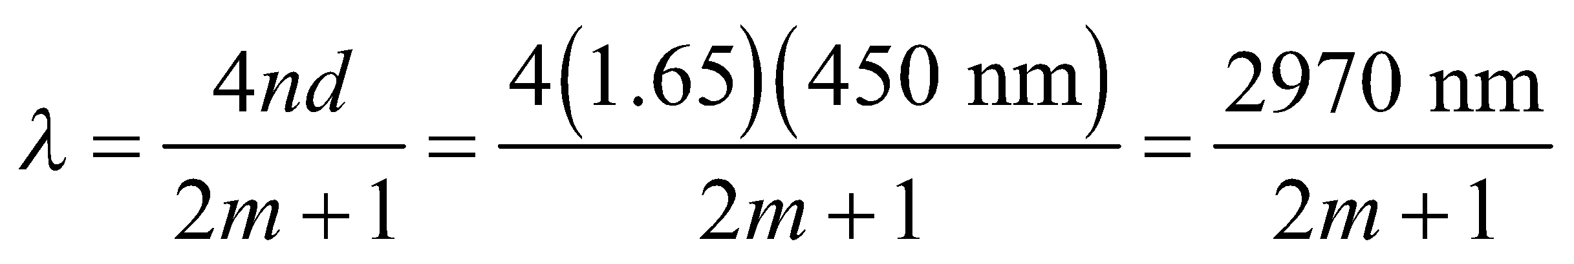
Evaluate Integers giving wavelengths in the visible range (400 to 750 nm) are m = 2 and 3, which correspond to λ = 594 and 424 nm, respectively.
Assess The wavelengths correspond to orange and blue colors, respectively.
24. Interpret We are to find the wavelength for which constructive interference makes it reflect most strongly from the given thin material.
Develop Apply the solution derived for Problem 32.22. Maximum constructive interference occurs for λ = 4nd.
Evaluate Inserting the given quantities yields
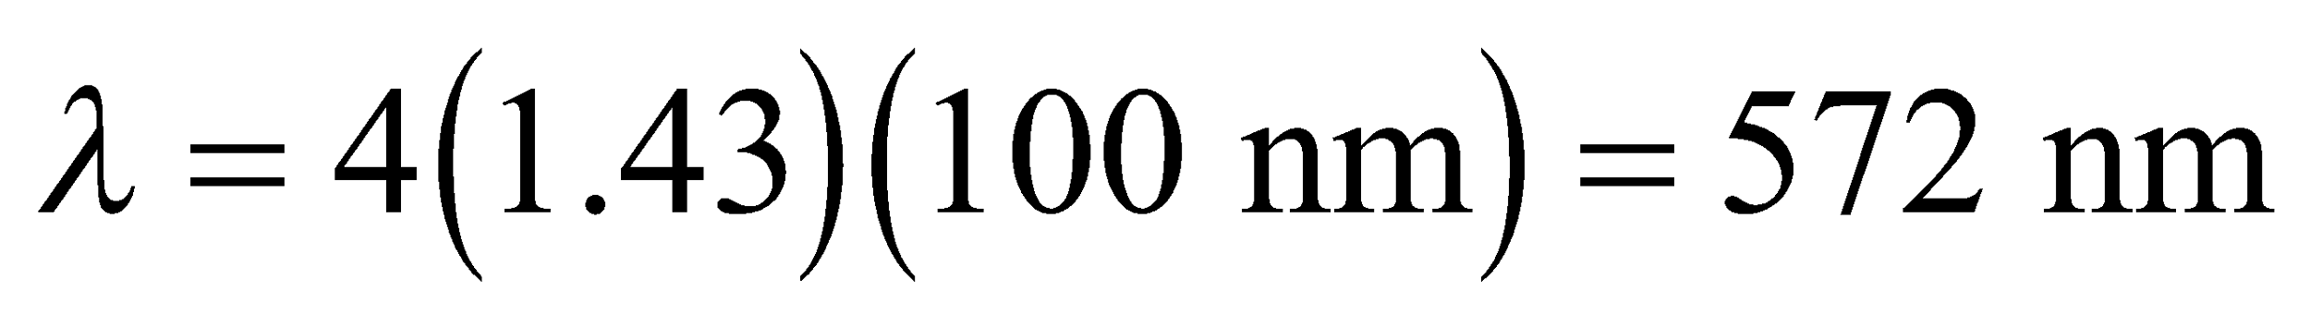
Assess This is yellow.
25. Interpret The problem asks what portion of a soap film will appear dark because it is too thin for constructive interference in reflected light.
Develop The soap film is 20 cm high and goes from zero thickness at the top to 1-μm thick at the bottom. See figure below. White light shines on the film and the reflected light from the two soap-air surfaces will constructively interfere when the thickness of the film satisfies Equation 32.7: 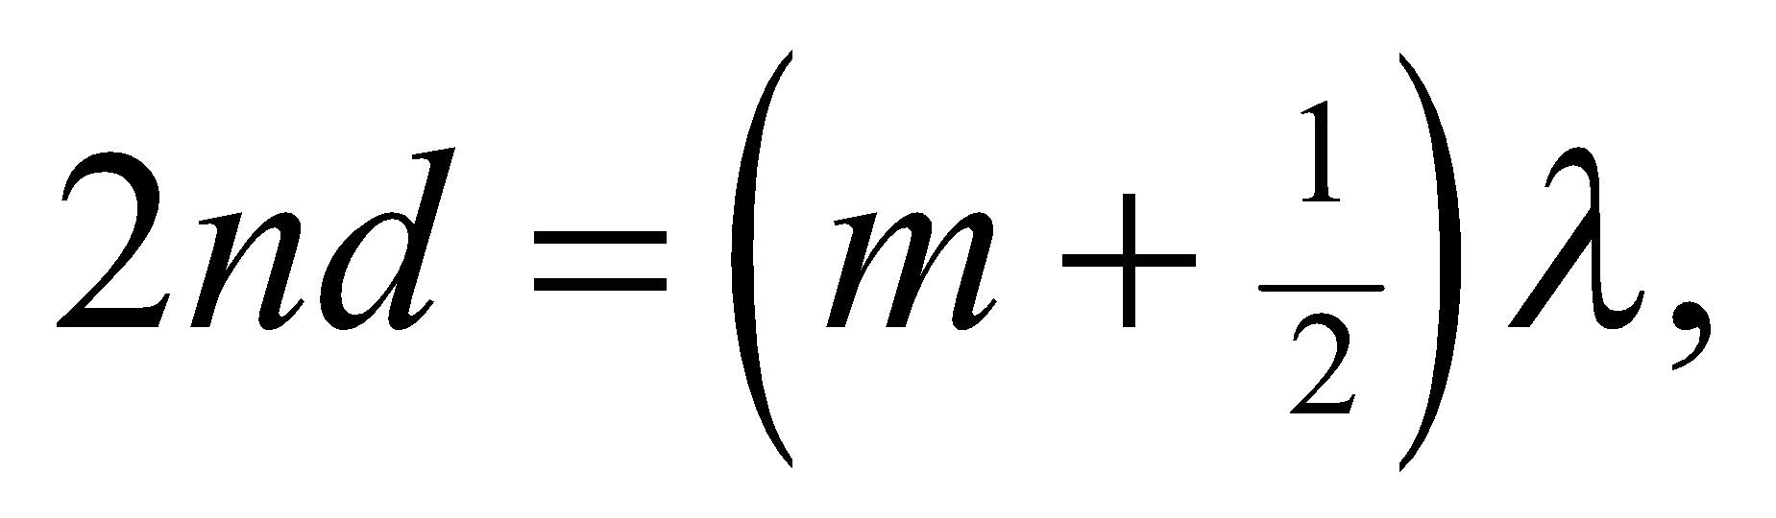 where the index of refraction is that of water 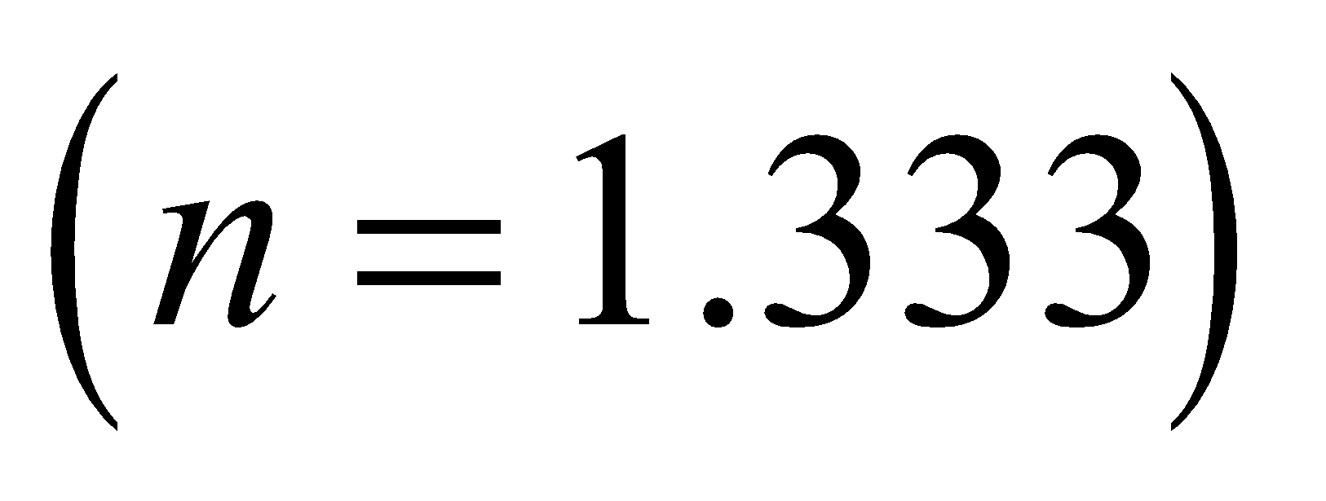 and the integer 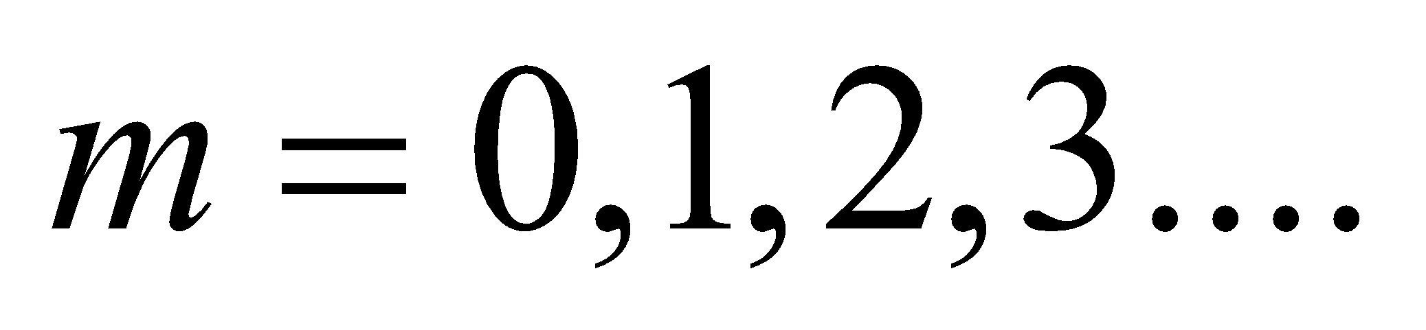 We are looking for the region of the film that is too thin to support constructive interference, so we will define  as the smallest thickness for a bright band and 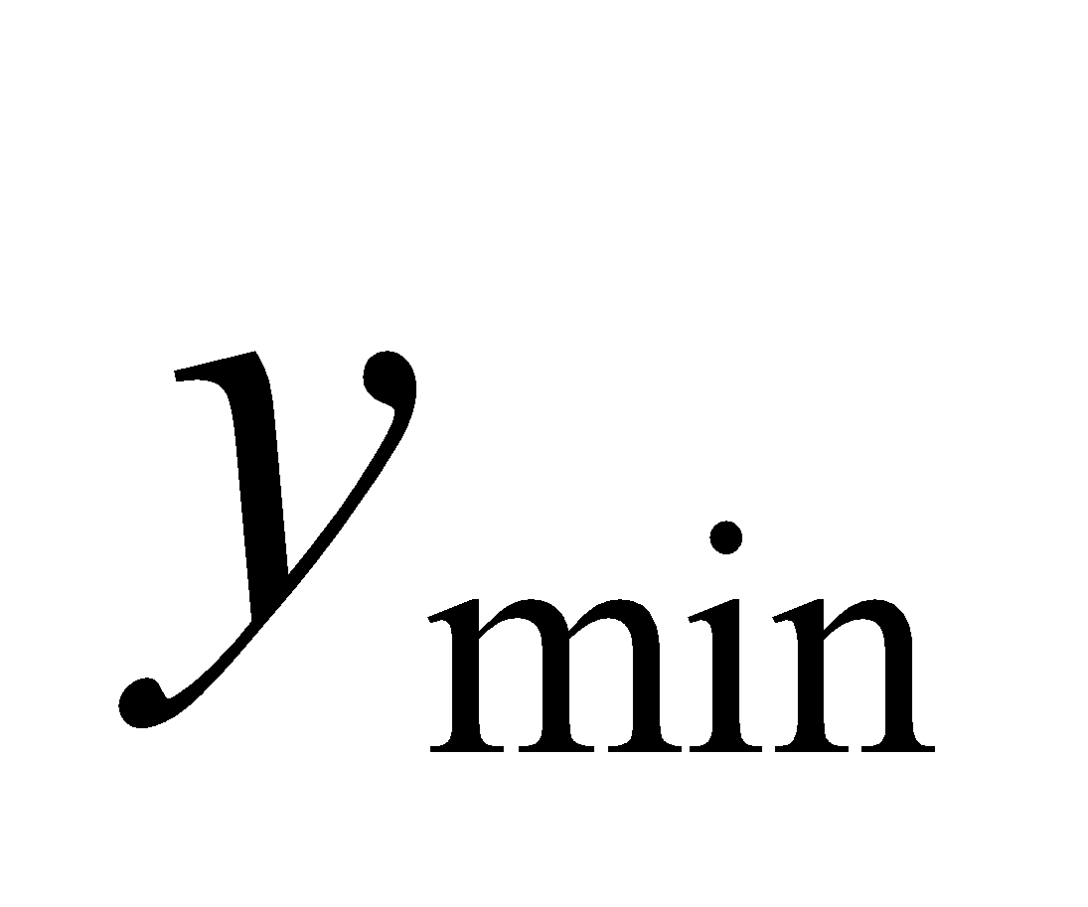 as the distance to this first band from the top, see figure. The region defined by will be dark.

Evaluate White light is a combination of wavelengths from 400 to 700 nm, so there will be bright bands of different colors coming from the soap film. Near the top of film, where it is thinnest, the bands will correspond to the zeroth order 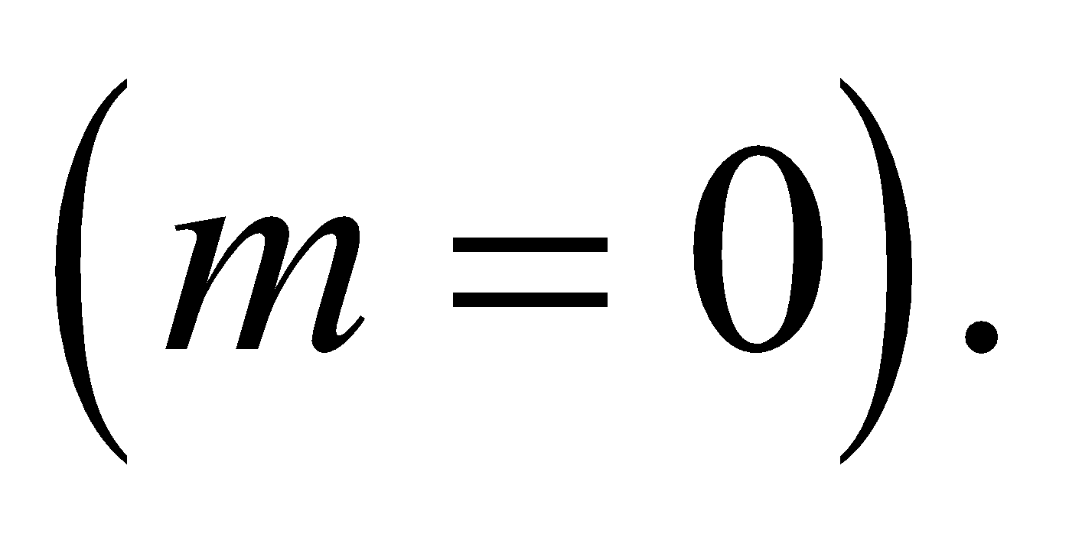At the top of this set of bands will be the blue band for 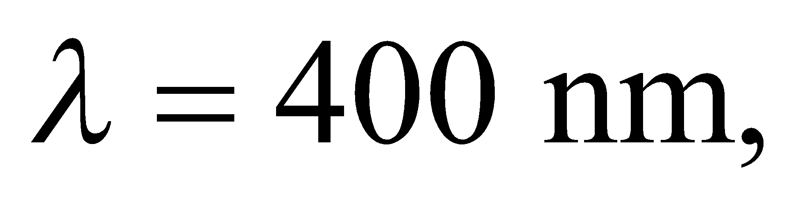since this corresponds to the thinnest part of the film that still supports constructive interference:
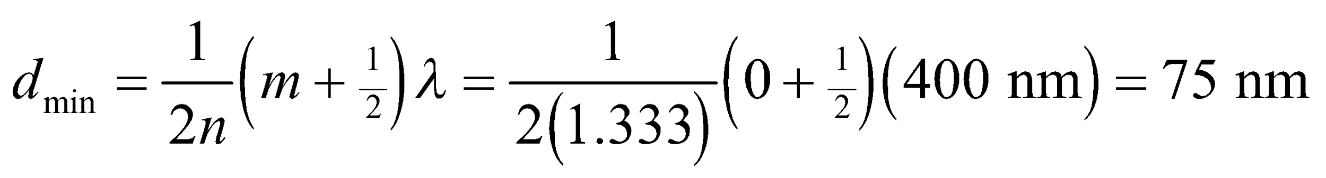
From the figure above, we can see that this minimum thickness occurs at
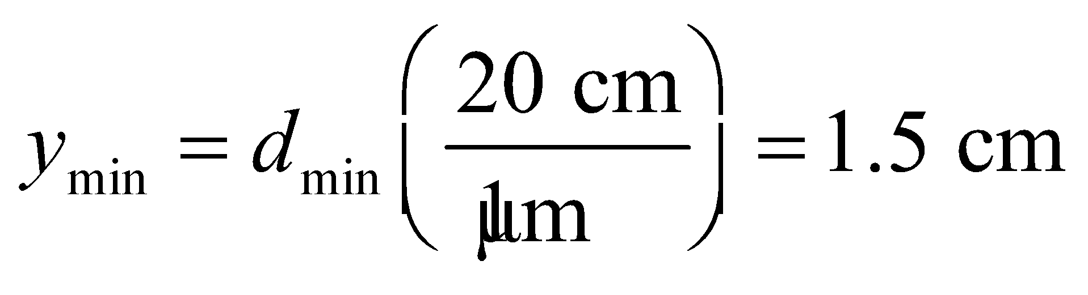
Therefore, the top 1.5-cm of the film will be dark.
Assess What happens to the light in this dark region? It is fully transmitted, so if we were to look at the backside of the soap film, the top portion would be bright, and we would see dark bands in transmission at the points corresponding to the bright bands in reflection.
Section 32.5 Huygens’ Principle and Diffraction
26. Interpret This problem involves Huygens’ principle, which we can use to find the ratio a/λ that causes the first diffraction minimum to occur at 90°.
Develop Huygen’s principle leads to Equation 32.8 for a single slit of size a. We shall apply this equation to find the ratio a/λ that corresponds to m = 1 and θ = 90°.
Evaluate For the given conditions, Equation 32.8 takes the form
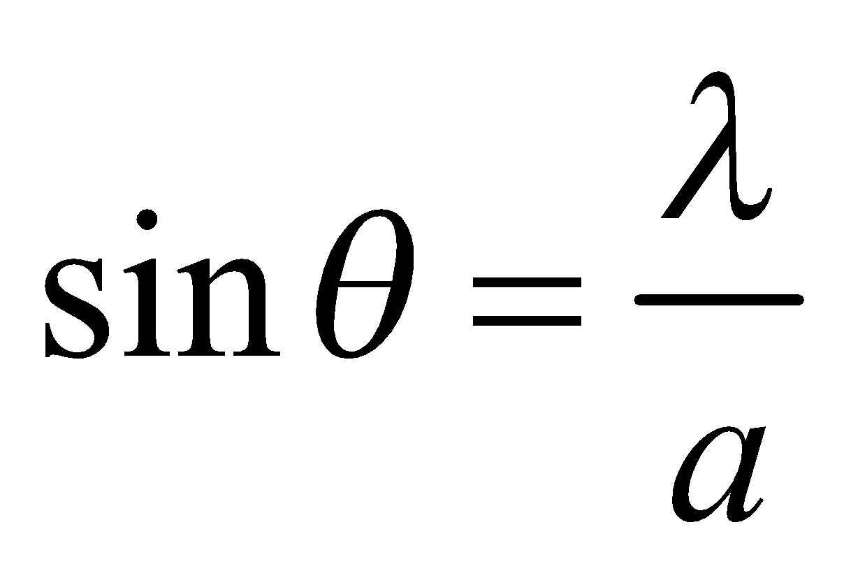
which leads to
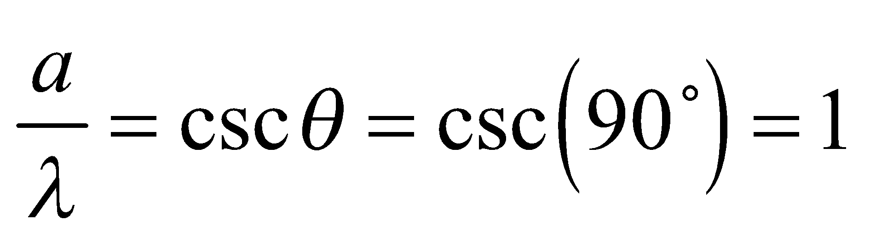
Assess This demonstrates that smaller slits will lead to wider diffraction maxima.
27. Interpret This problem involves a single-slit diffraction of light. We are interested in the angular width of the central peak.
Develop The condition for destructive interference in a single-slit diffraction is given by Equation 32.8:
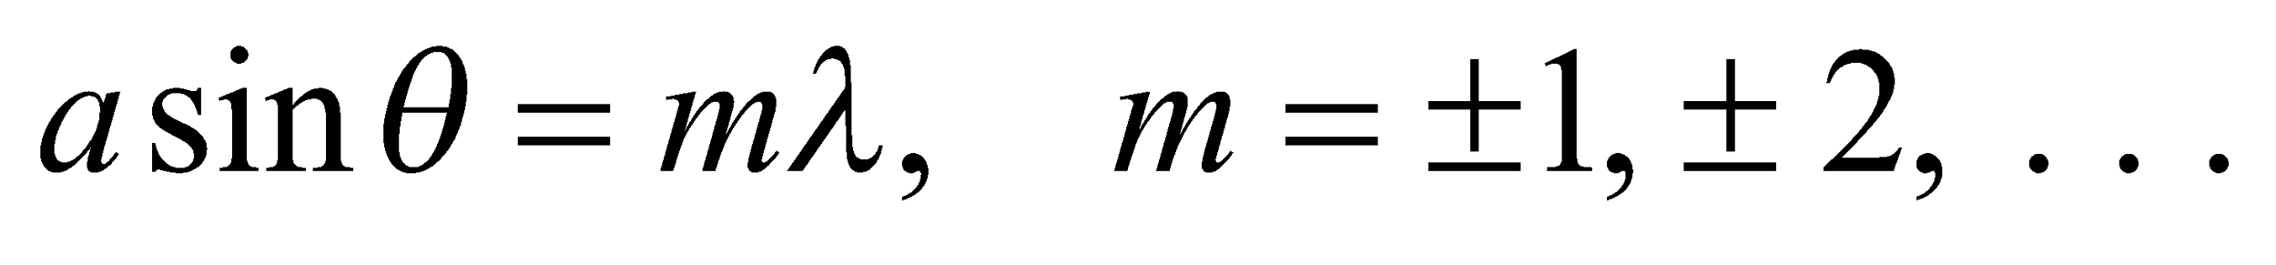
The first minima 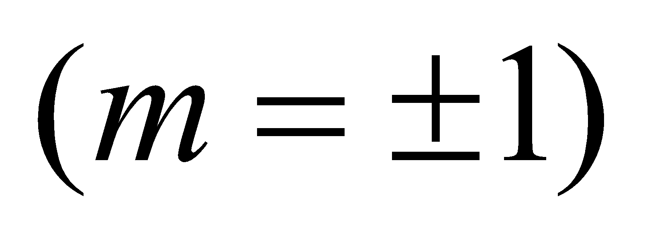 occur at
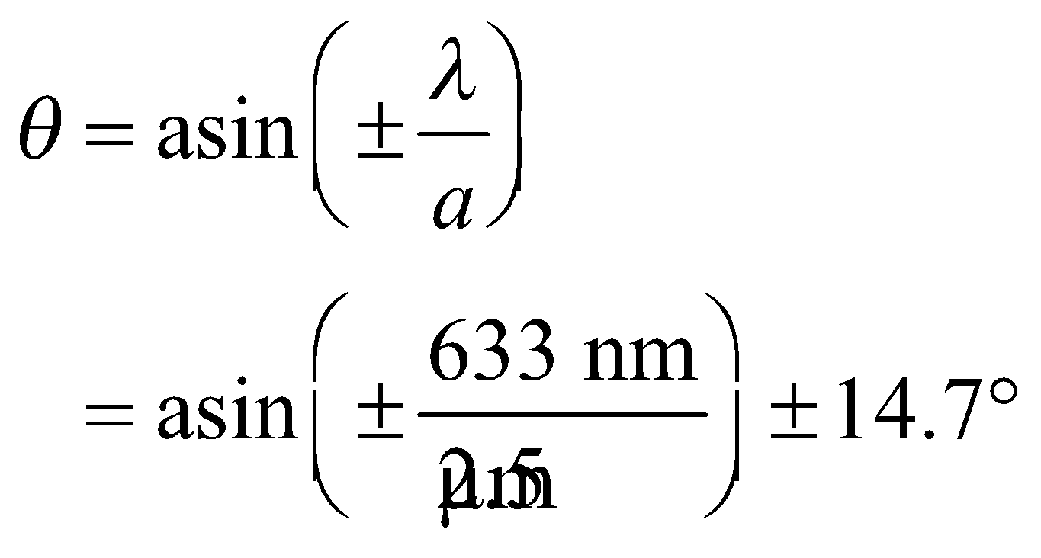
Evaluate The total angular width of the diffracted beam is 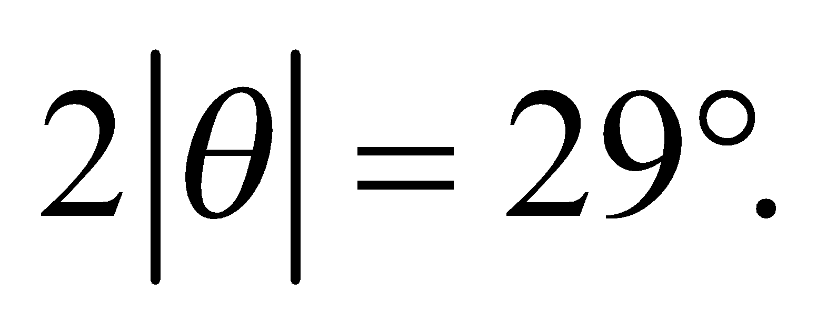
Assess The case m = 0 is excluded in Equation 32.8 because it corresponds to the central maximum in
which all waves are in phase.
28. Interpret This problem involves the diffraction of electromagnetic radiation due to a slit. We are to find the angular width of the beam when it emerges from the slit.
Develop Take the width of the diffracted beam to be the angular separation between the first minima. Using Equation 32.8, 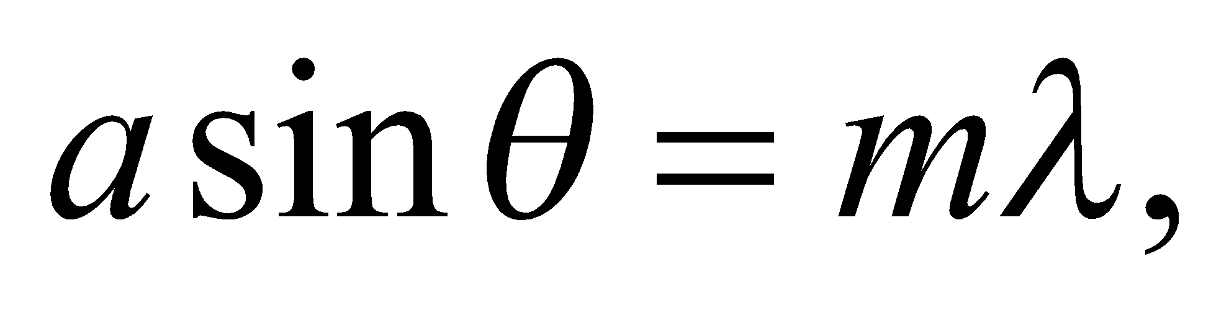 these occur at 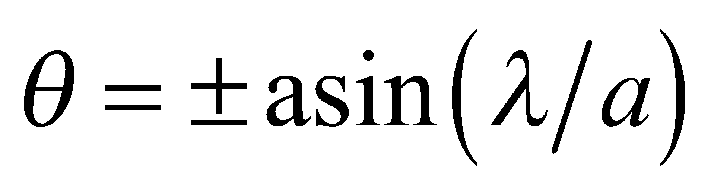, so the angular width is 2θ. The wavelength is λ = c/f, where f is the given frequency.
Evaluate Inserting the given quantities gives
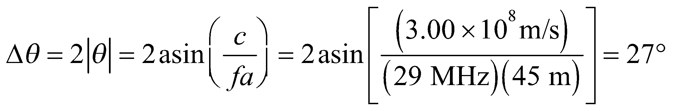
Assess The wavelength is ~10 m, so for more closely spaced buildings (i.e., smaller slits), the angular width would be larger.
29. Interpret We are to find the intensity of a diffraction maximum relative to the central peak. The second secondary maxima is the second small maxima next to the central peak.
Develop The intensity as a function of angle in single-slit diffraction is given by Equation 32.10:
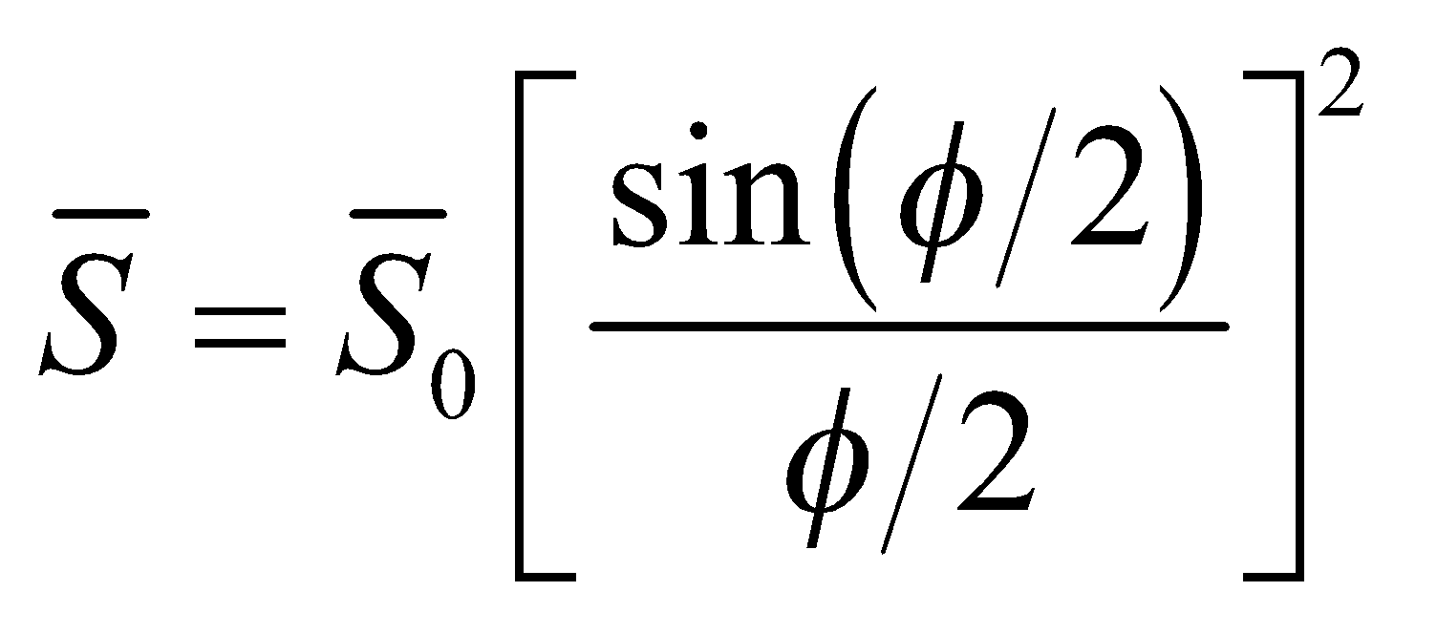
The second and third minima lie at angles 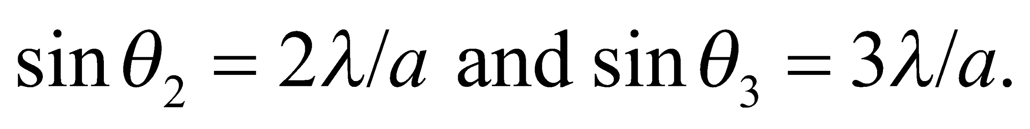
Evaluate If we take the mid-value to be at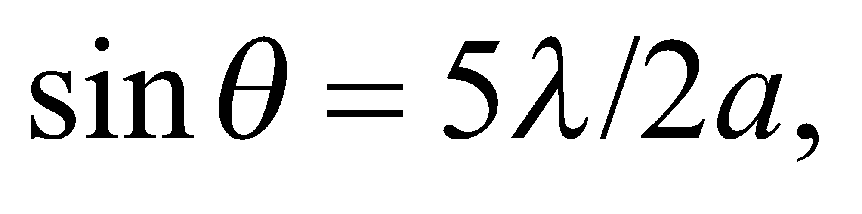then the intensity at this angle, relative to the central intensity, is
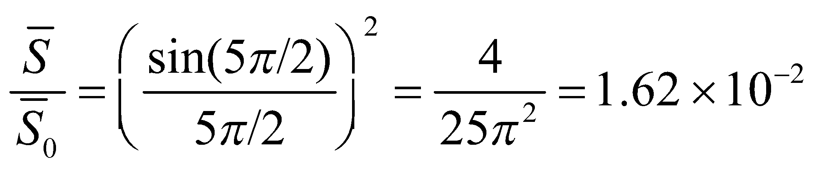
Assess The intensity at the second secondary maximum is only about 1.62% of the central-peak intensity.
Section 32.6 The Diffraction Limit
30. Interpret We are to find the minimum angular separation that can be resolved with 633-nm light through a 2.1-cm diameter aperture. We will assume that the limiting factor is diffraction, and use the Rayleigh criterion.
Develop Apply the Rayleigh criterion for circular apertures (Equation 32.11b): 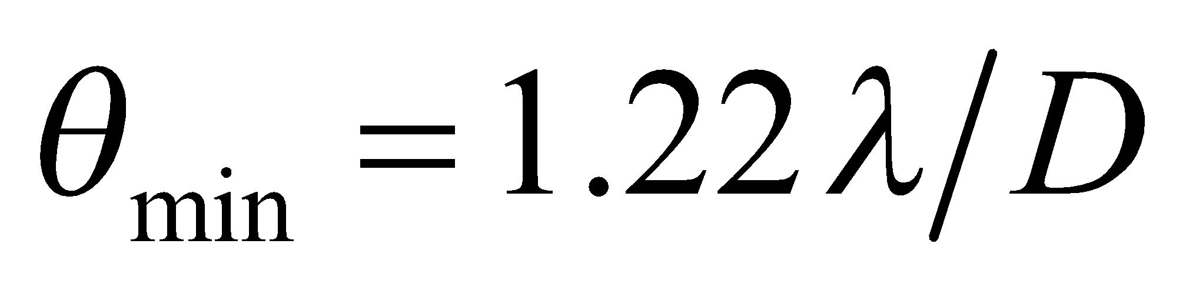. The wavelength is 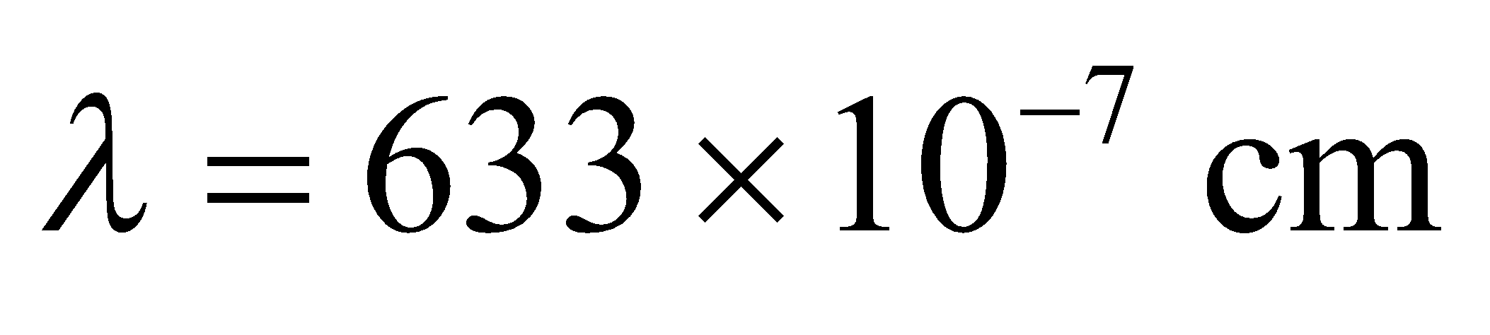 and the diameter is D = 2.1 cm.
Evaluate The minimum angular separation is
Assess This angular resolution is equivalent to distinguishing two objects 3.7 millimeters apart from 100 meters away.
31. Interpret We shall use the Rayleigh criterion to determine how large an aperture is needed on a telescope to resolve the given angle.
Develop Apply the Rayleigh criterion for circular apertures (Equation 32.11b): . The wavelength is λ = 500 nm and the angular resolution needed is
Solve for D.
Evaluate The diameter needed is
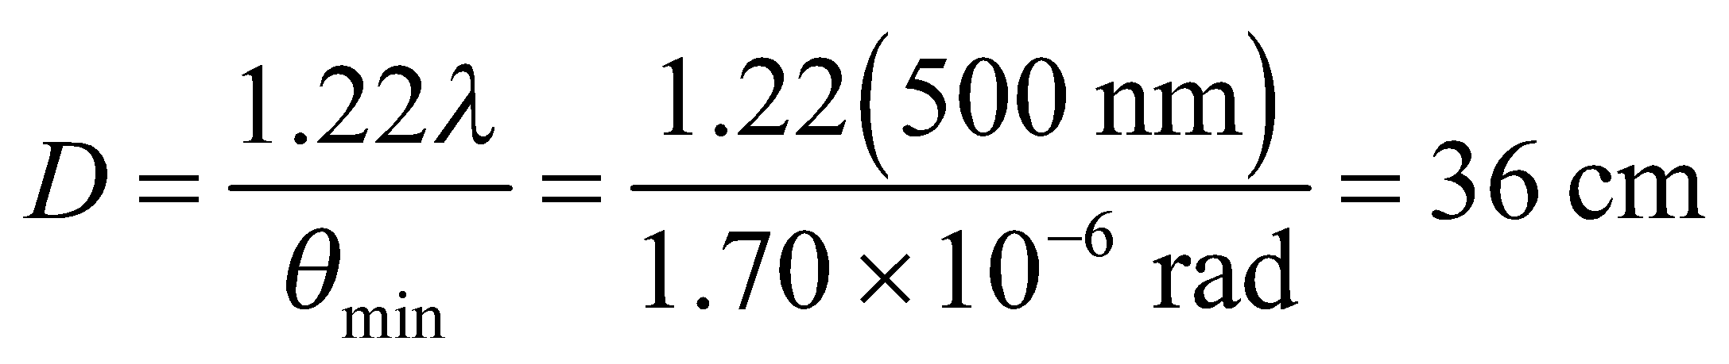
Assess Make sure that you always use radians for your angle measurements in this type of problem!
32. Interpret We shall use the Rayleigh criterion to determine the longest wavelength of light with which one is able to resolve the given angle through the given aperture.
Develop Apply the Rayleigh criterion for circular apertures (Equation 32.11b): . The angular resolution necessary is 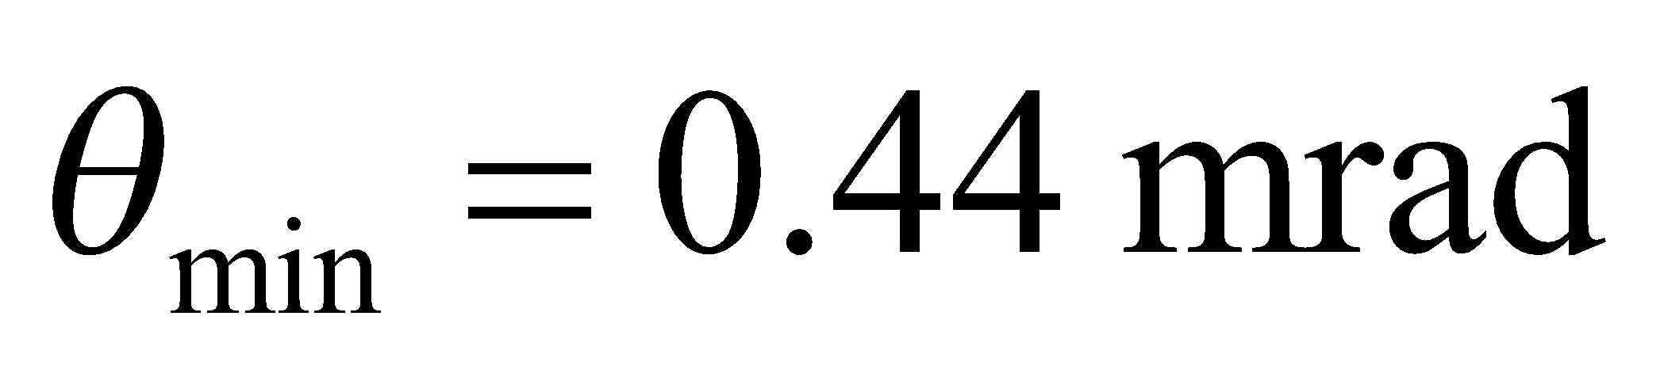 and the aperture is D = 1.2 mm. Solve for the wavelength.
Evaluate The longest wavelength able to resolve this is
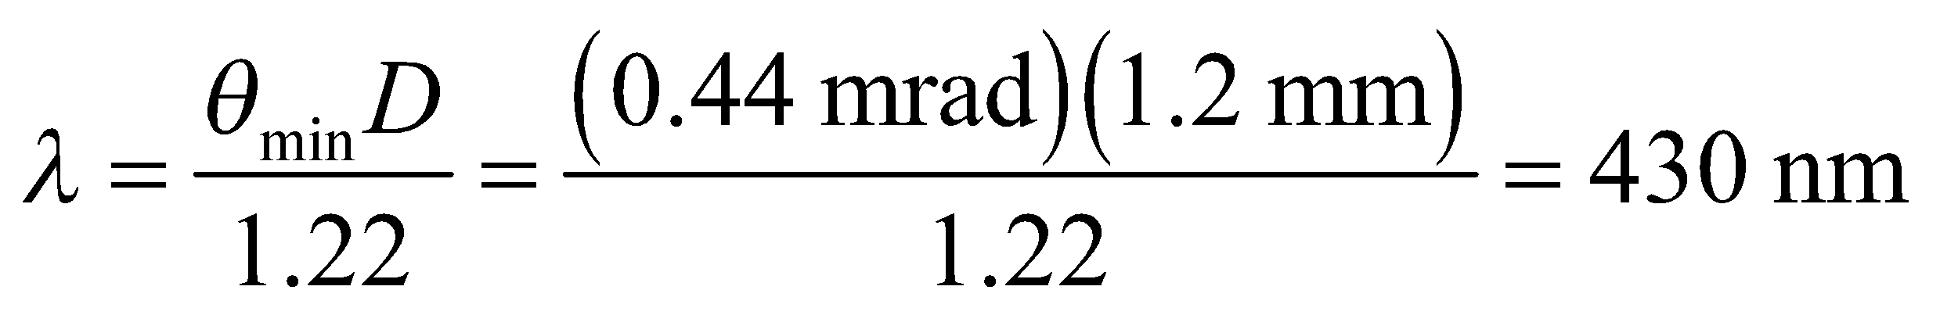
to two significant figures.
Assess Using a short wavelength gives you a much better angular resolution. This is why an electron microscope gives such high resolution, as we will discover later.
33. Interpret We're asked to find the diffraction limit of the eye in bright light when the pupil has contracted.
Develop The minimum angular resolution of a circular aperture is given in Equation 32.11b: 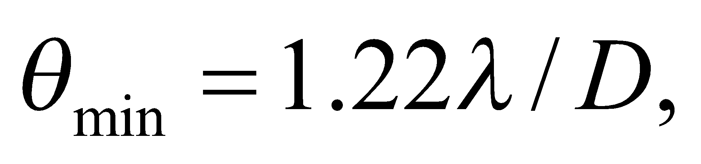where the result is in radians.
Evaluate For the given pupil diameter and light wavelength, the resolution is
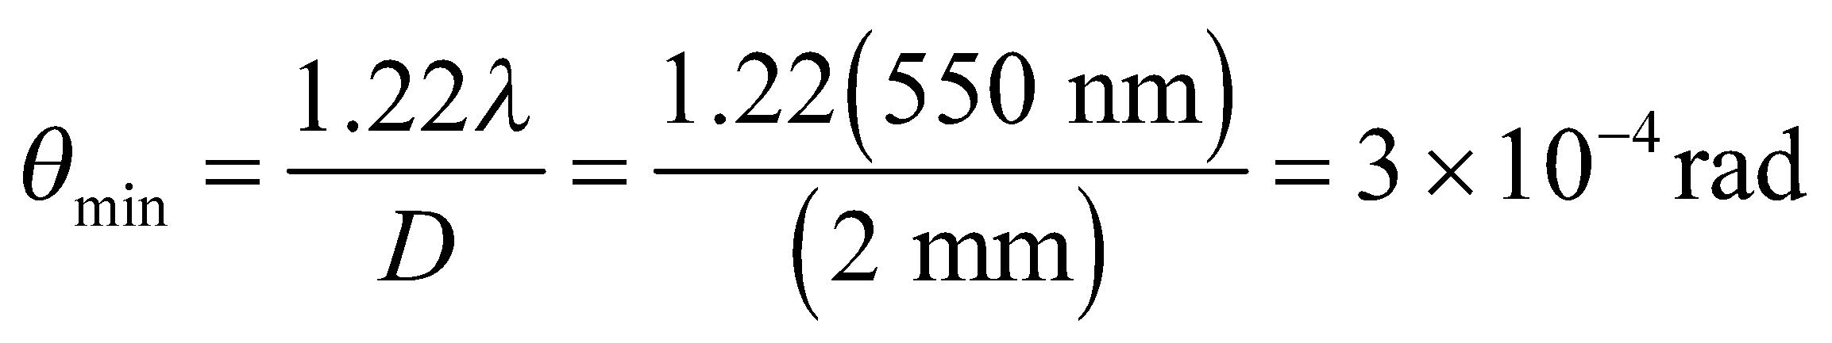
In terms of degrees, this is about 0.02°, or about 1 arcminute.
Assess This says that on a bright day our eyes would be able to distinguish objects 3 mm apart at a distance of 10 m. This is a little unrealistic. Our eyes are not only limited by the diffraction through the pupil; their resolution is also affected by the spacing of receptors (rods and cones) on the back of the retina.
Problems
34. Interpret We are to find the angle at which the second order (i.e., m = 2) bright fringe occurs in a double-slit experiment with the given parameters.
Develop Use Equation 32.1a to find the angle θ for the different wavelengths λ, with d = 1.5 μm.
Evaluate (a) For λ = 400 nm, the angle is
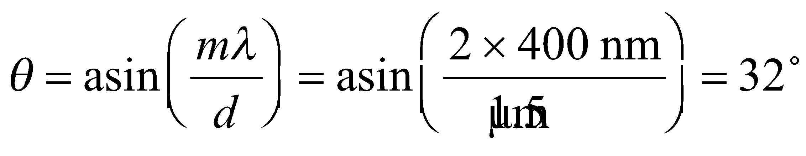
(b) For λ = 700 nm,
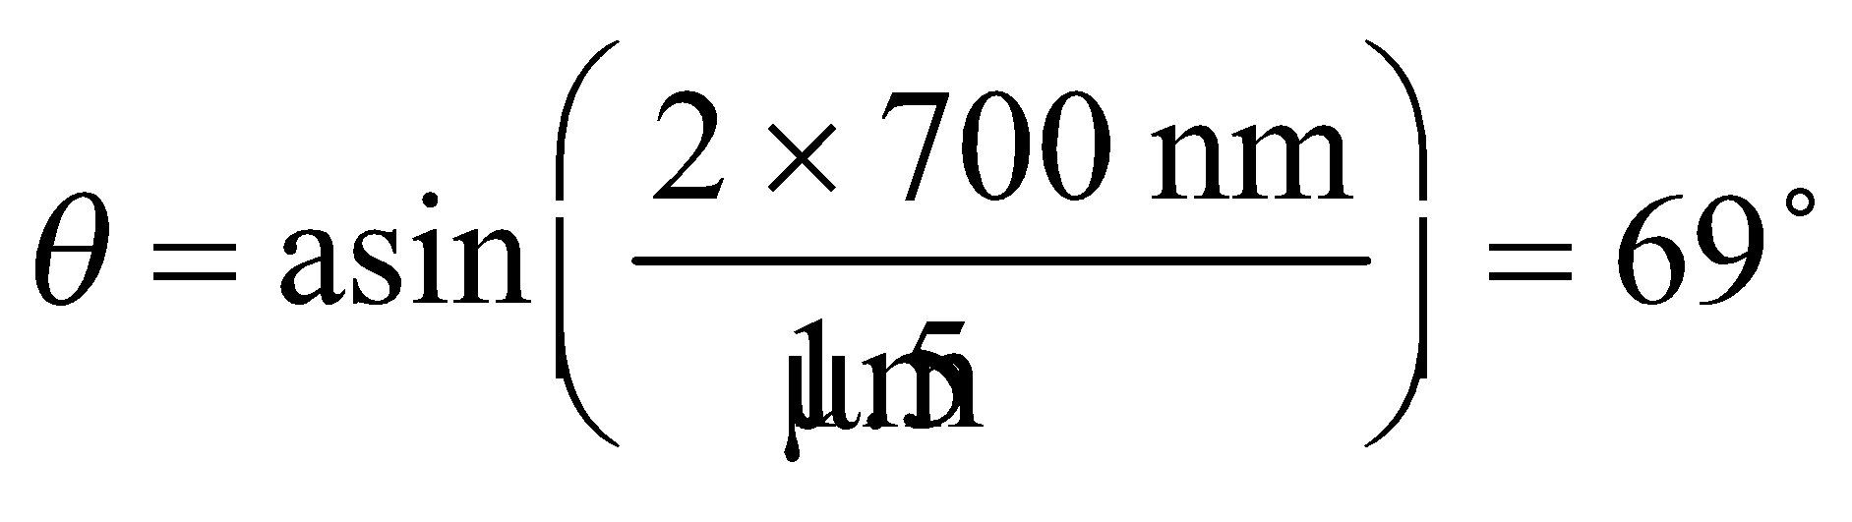
Assess Notice the nonlinear behavior. Were it linear, the result for part (b) would be 56º.
35. Interpret The concept behind this problem is double-slit interference. The object of interest is the phase difference between the waves emanating from the different slits.
Develop The path-length difference for waves arriving from the two different slits is
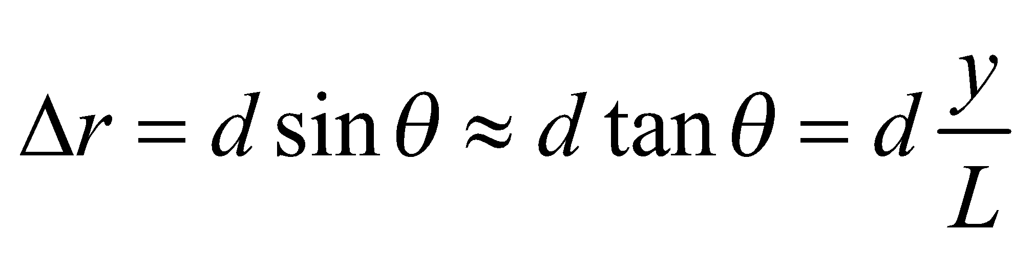
since 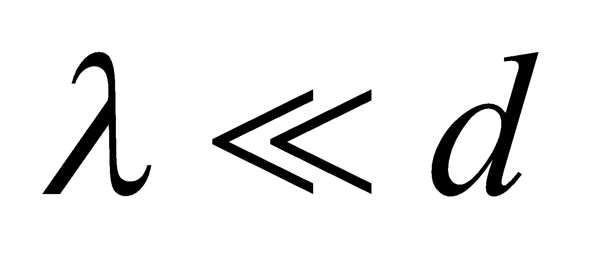 and the small-angle approximation can be used (see derivation of Equations 32.2a and 32.2b). The phase difference is
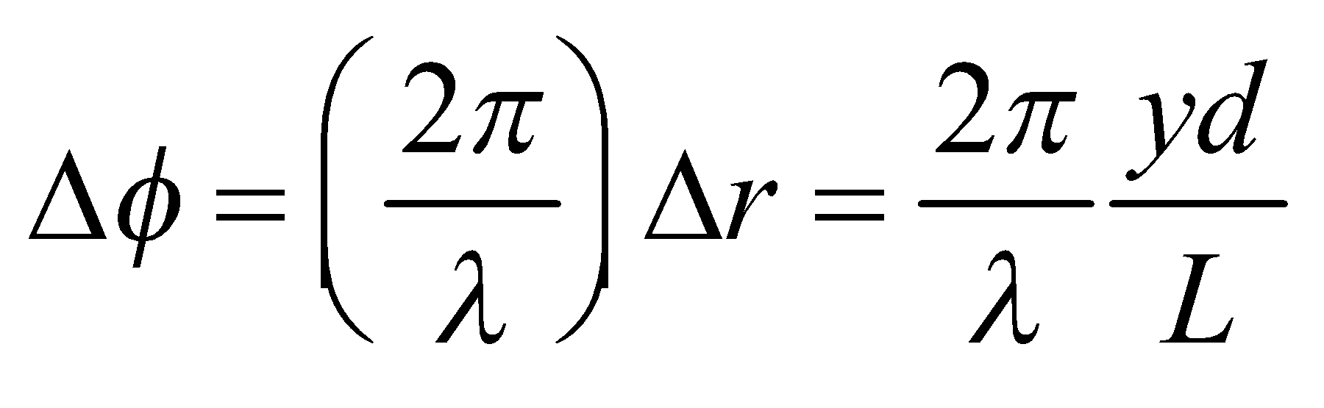
Evaluate The phase difference is
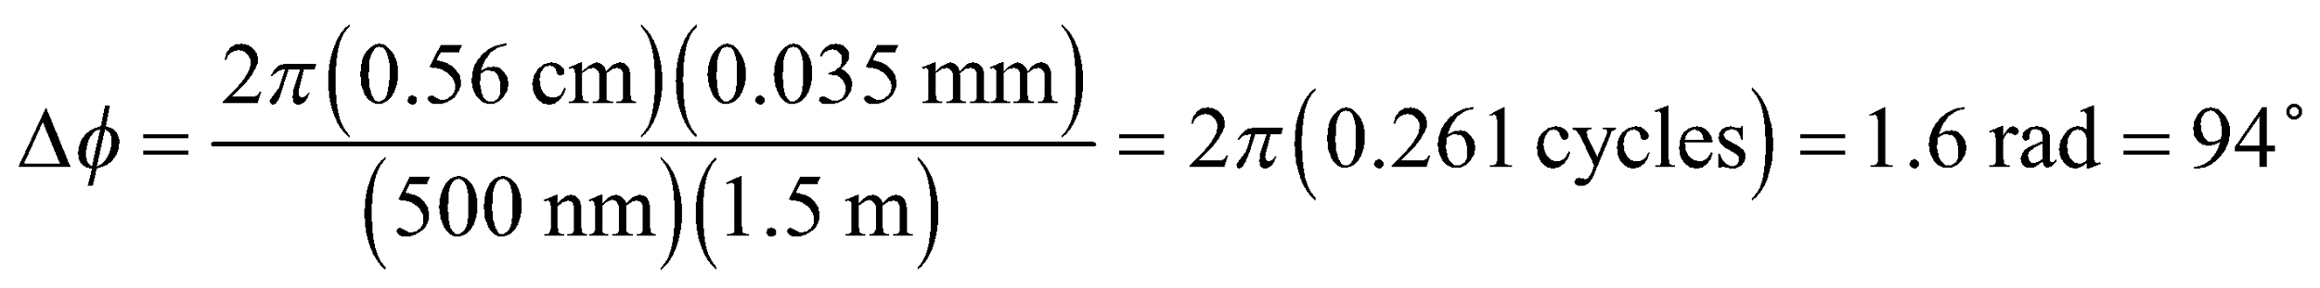
Assess Constructive interference corresponds to 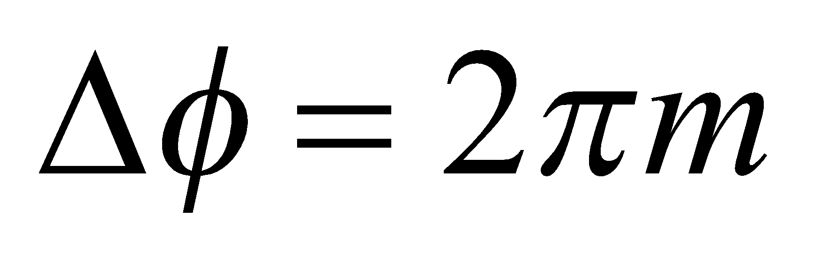, or 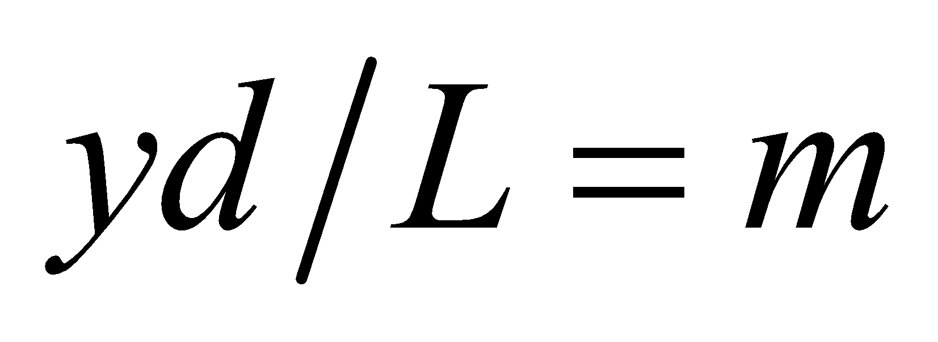, where m is an integer.
36. Interpret This problem involves a double-slit experiment with the given parameters, for which we are to find the angular position at which the path-length difference is a quarter wavelength.
Develop The path-length difference is the left side of Equation 32.1a (i.e., dsinθ), so we shall set this equal to a quarter wavelength and solve for the angle θ.
Evaluate Solving for q and inserting the given quantities yields
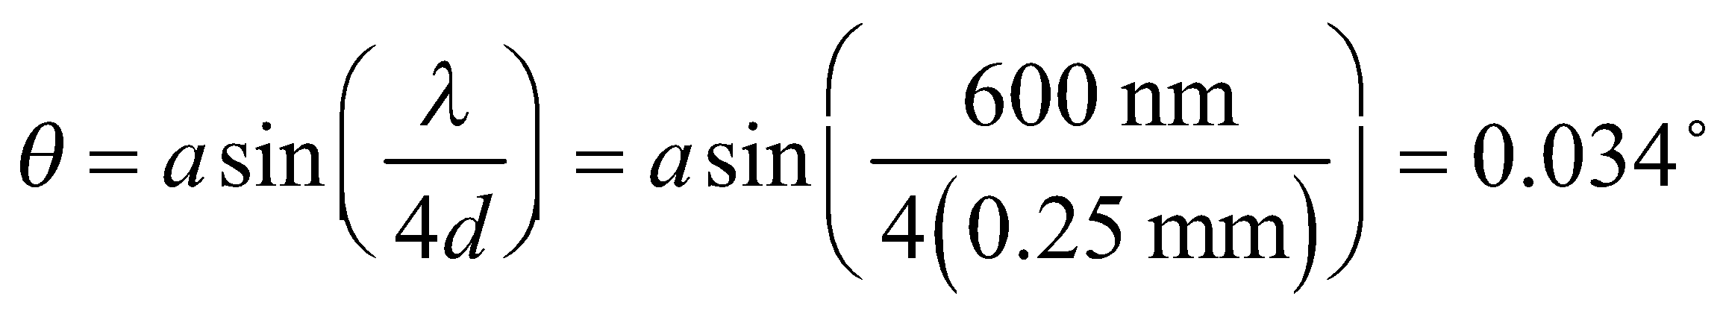
Assess We could have simplified the calculation by using the small-angle approximation sinθ ~ θ, which gives the same result.
37. Interpret This problem involves a double-slit experiment. Given the slit spacing, we are asked to find the highest-order bright fringes.
Develop The maximum diffraction angle for which light hits the screen is
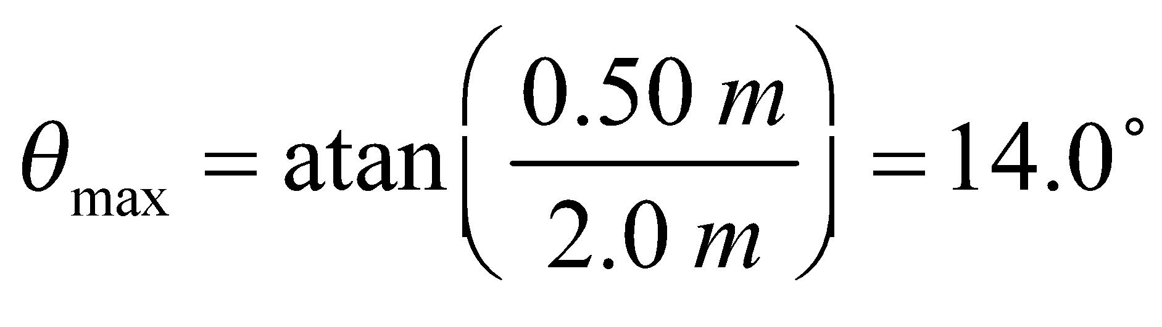
From Equation 32.1a, we know that bright fringes will appear on the screen in orders of interference for which
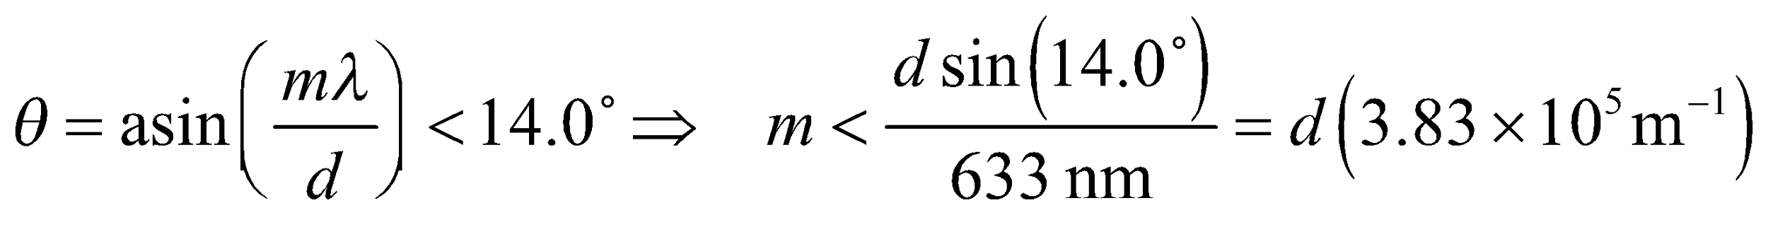
Evaluate (a) For d = 0.10 mm, 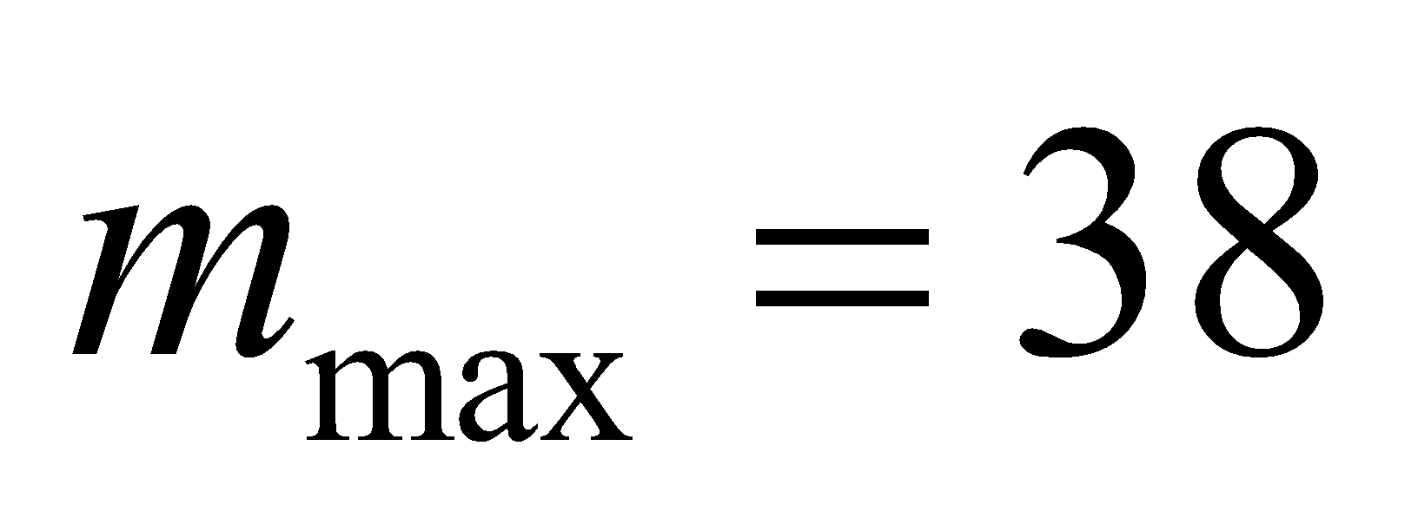.
(b) For 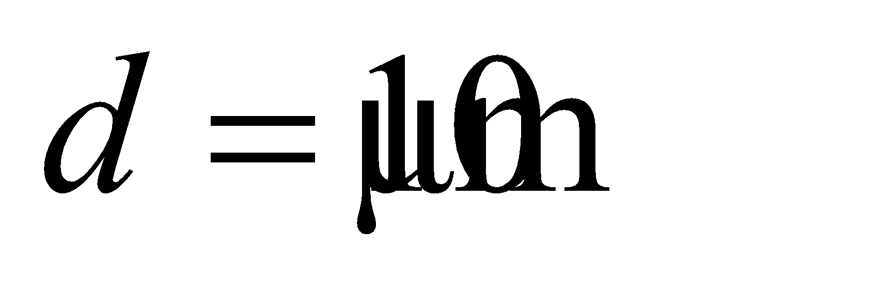, 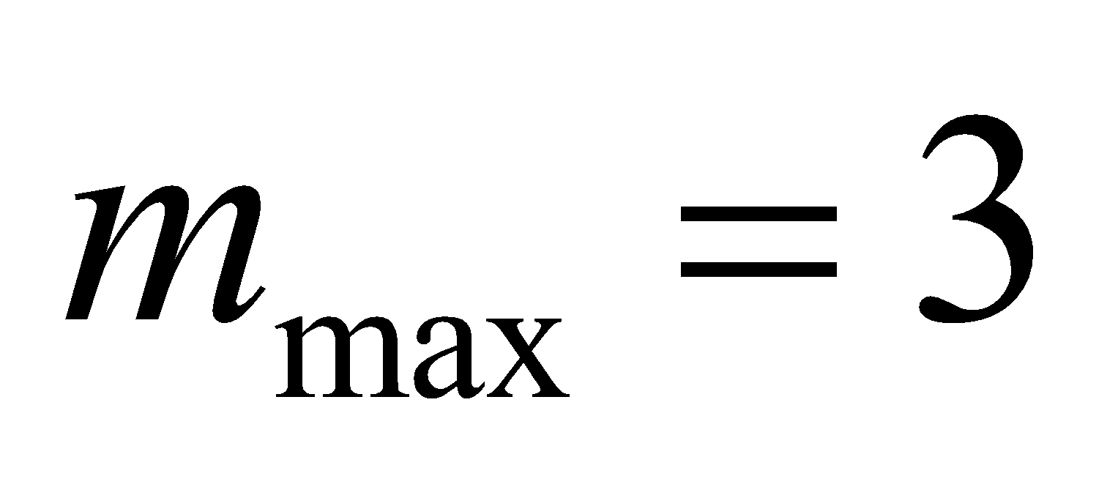.
Assess The maximum order  increases as the slit spacing d decreases.
38. Interpret Our light source for the double-slit experiment has two wavelengths. For the lowest order bright fringe, we are to find the angular position where interference is constructive for one wavelength and destructive for the other.
Develop In a double-slit apparatus of the type described in the text, for a bright fringe of order m₁ from wavelength λ₁ to have the same angular position as a dark fringe of order m₂ from wavelength λ₂, we must have (see Equations 32.1a and 32.1b)
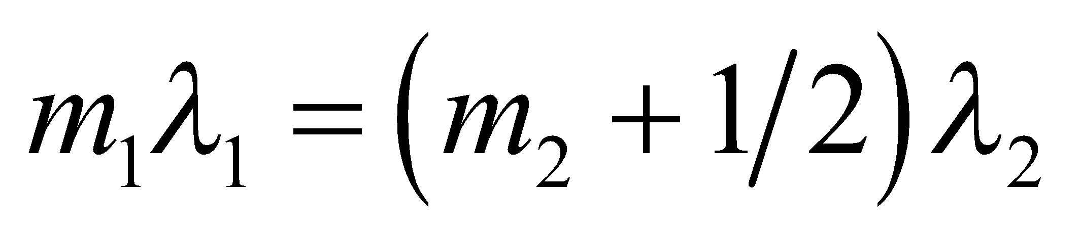
For λ₁ = 550 nm and λ₂ = 400 nm, one finds
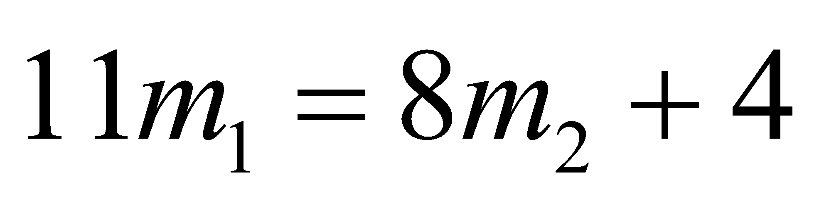
Evaluate By inspection, the smallest integer values satisfying this condition are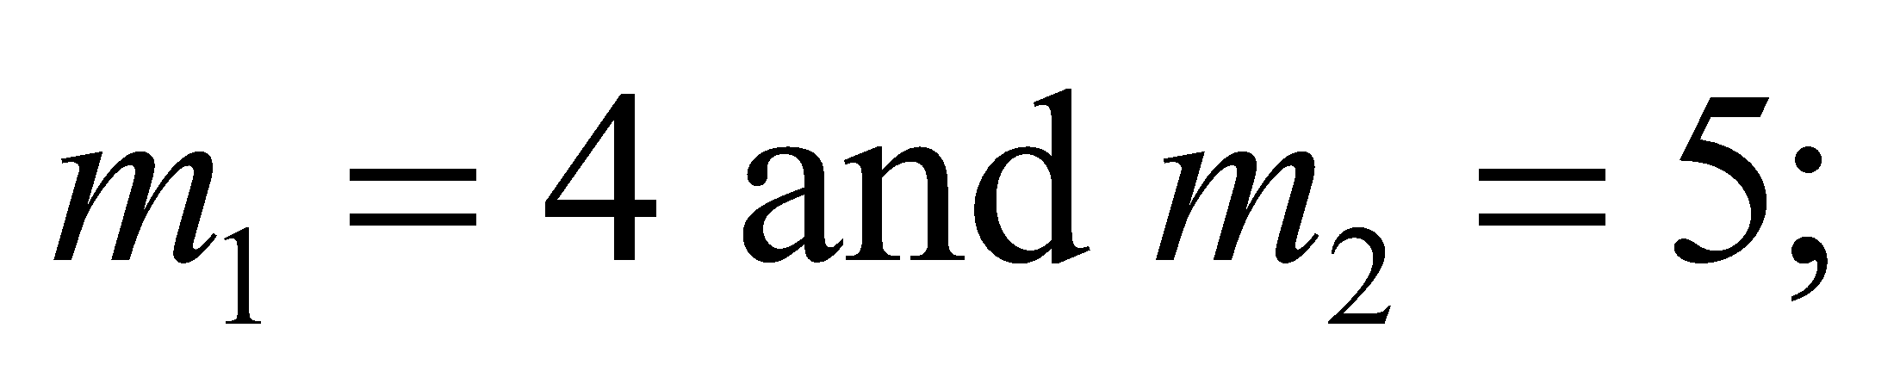that is, the fourth bright fringe of wavelength 550 nm coincides with the sixth dark fringe of wavelength 400 nm (recall that the first bright fringe has m = 1, whereas the first dark fringe has m = 0).
Assess This problem demonstrates the role played by the wavelength in determining the nature of the interference at an angular position.
39. Interpret This problem involves a multiple-slit apparatus. We are given the number of dark fringes between two adjacent major maxima, and are asked to find the number of slits in the apparatus. We are also to find the slit separation given.
Develop From Figure 32.8, we see that an N-slit system has 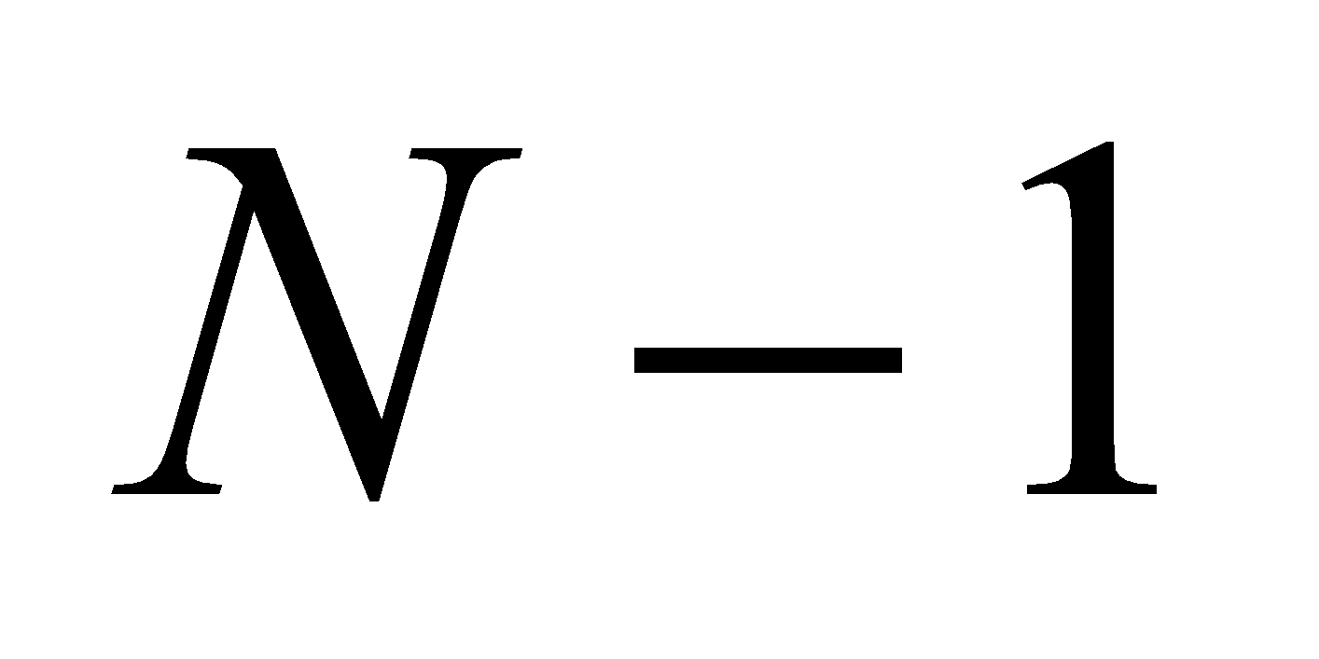 minima between the major maxima. The position of the maxima is governed by Equation 32.1a, which for small angles takes the form
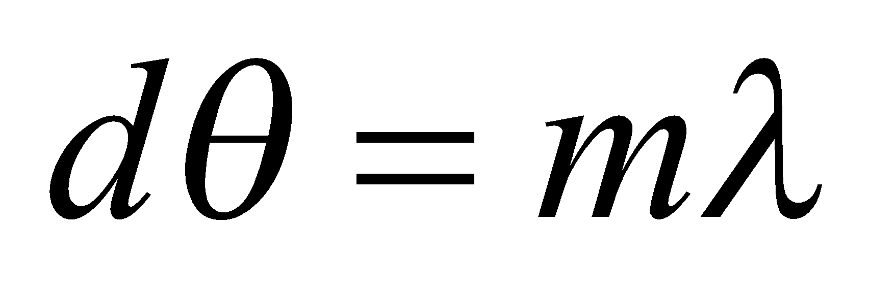
The angular separation between adjacent maxima (i.e., between m = n and m = n + 1) is
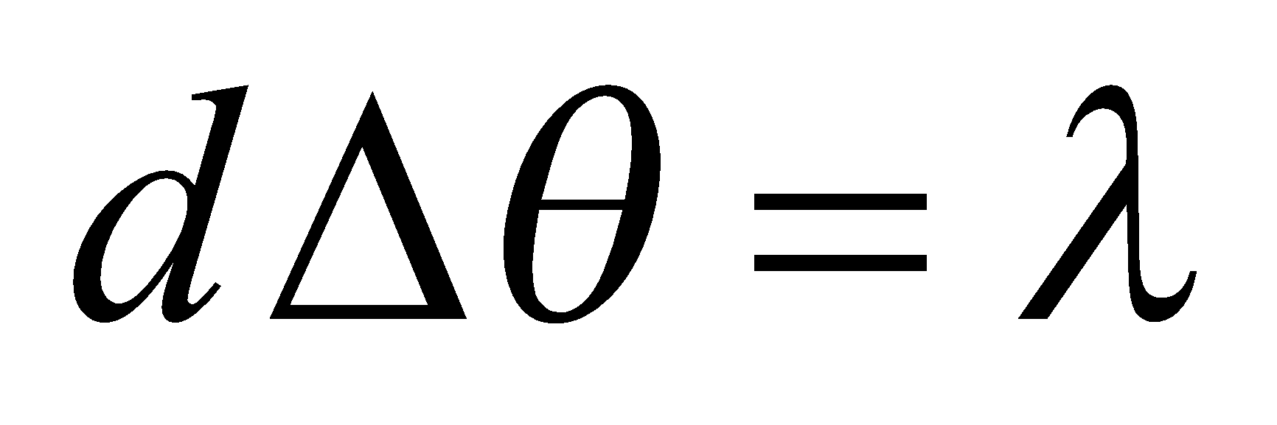
The angular separation is 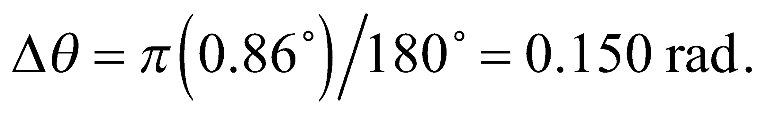
Evaluate (a) For 7 minima, we have N – 1 = 7, we have N = 8 slits.
(b) The slit separation is
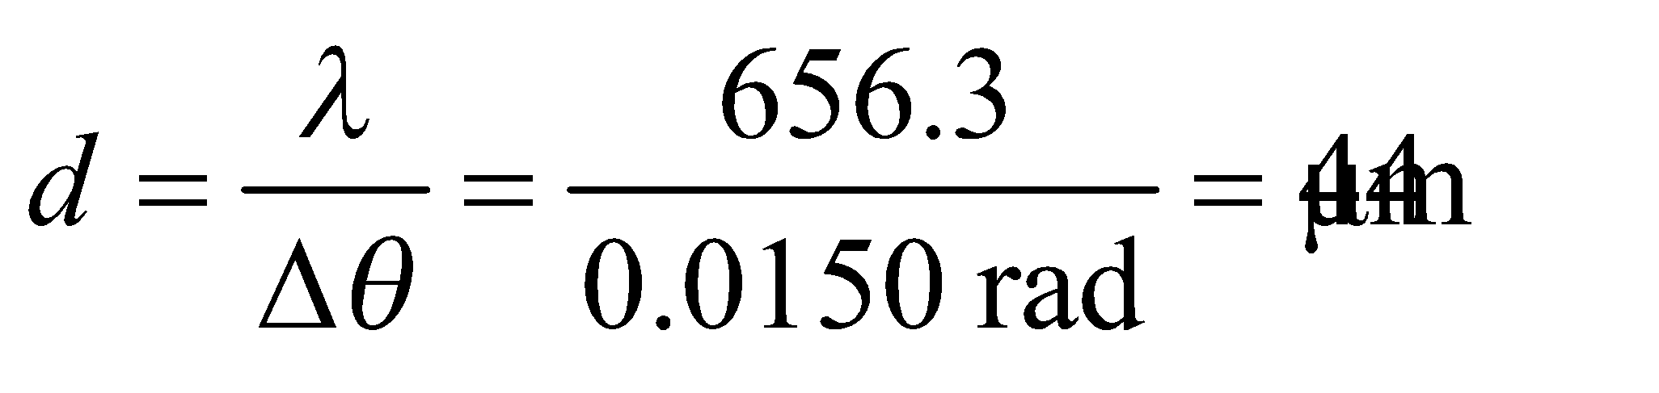
Assess The result is given to two significant figures because the angular separation Δθ is given to that precision. The angle in radians has 3 significant figures because it is an intermediate result.
40. Interpret You're determining the slit (line) spacing needed for a new spectrometer.
Develop You need at least an angular separation of 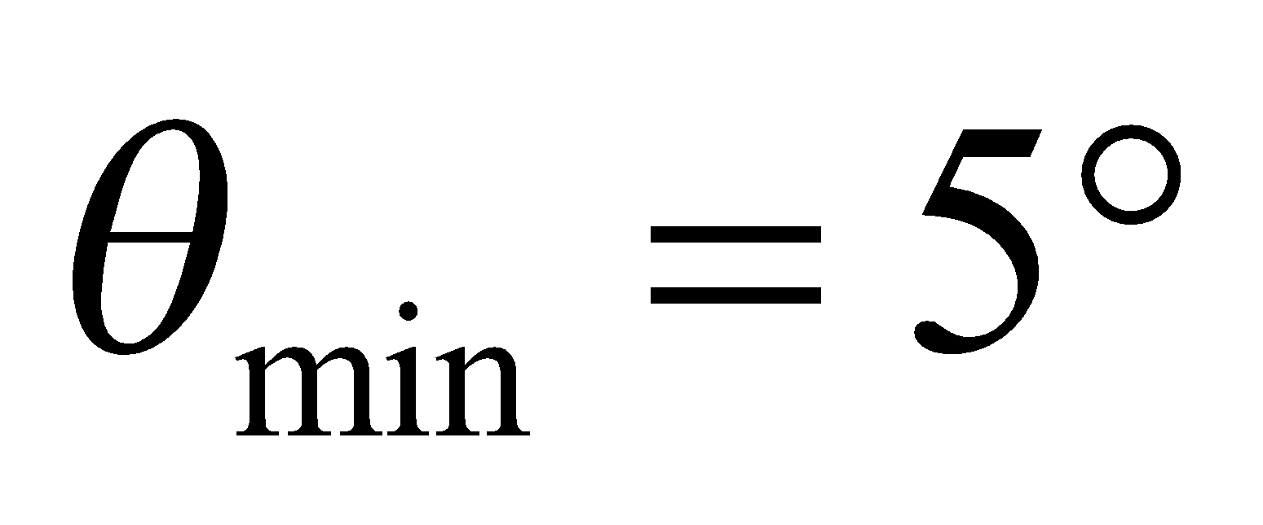 between the third-order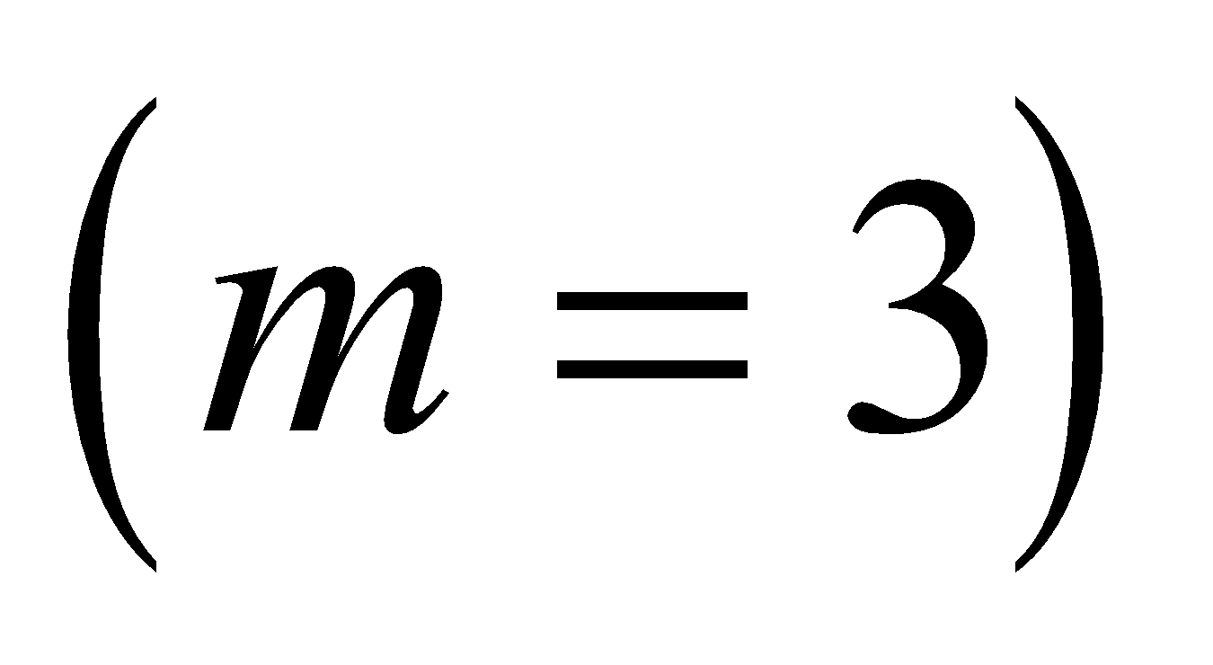 lines of hydrogen and sodium, specifically: 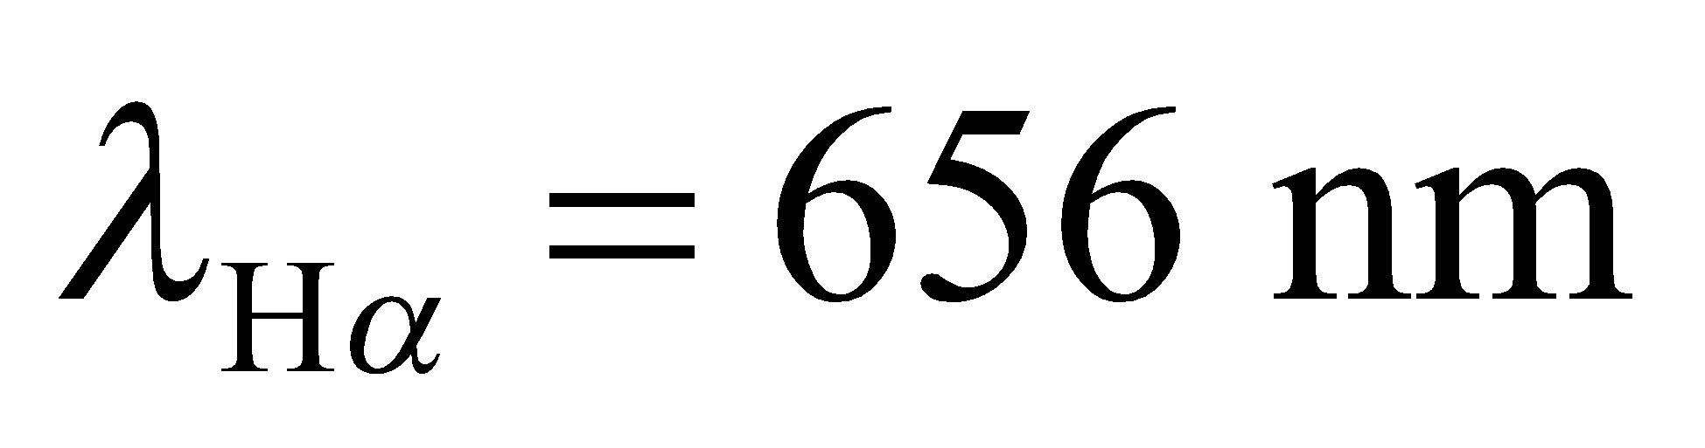 and 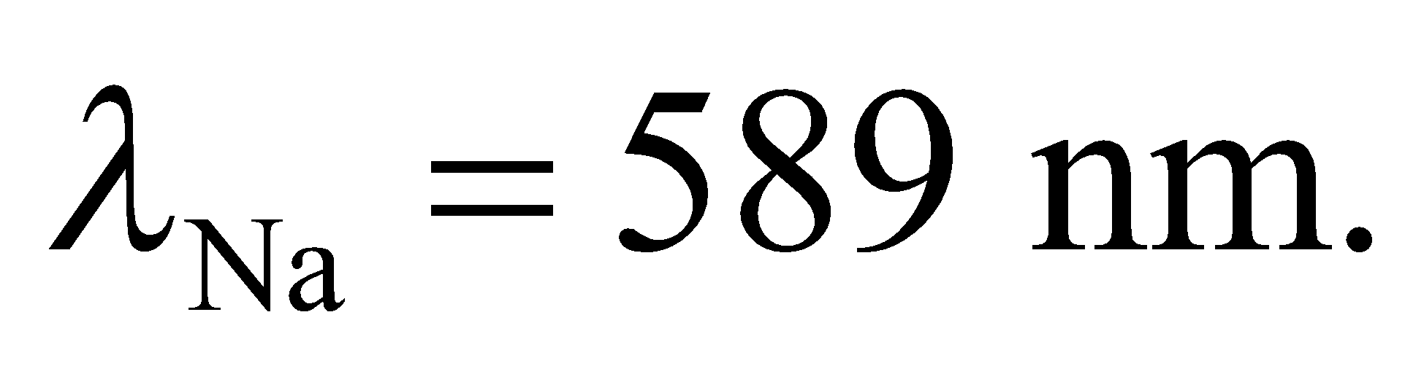 The angle of each these lines will satisfy Equation 32.1a:
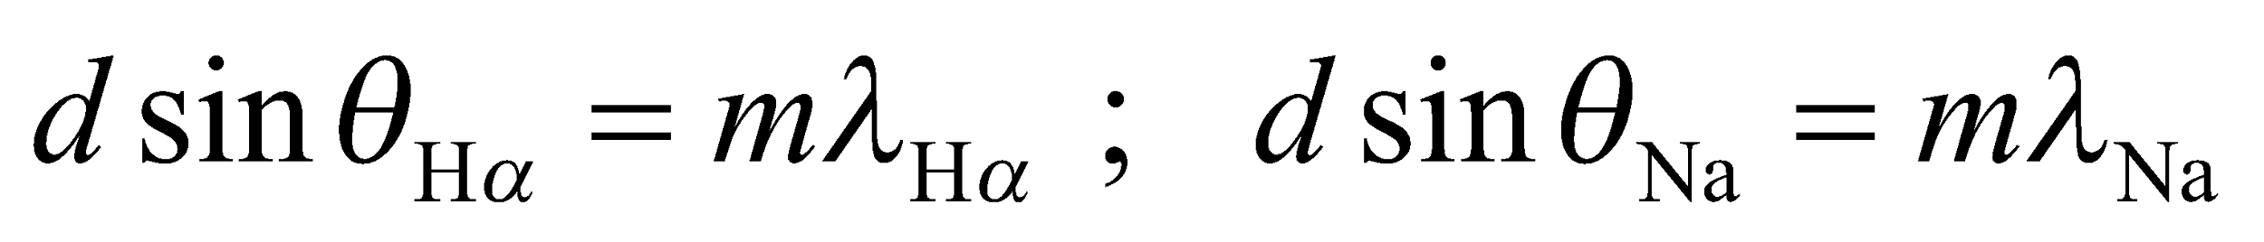
We will use these equations and the fact that 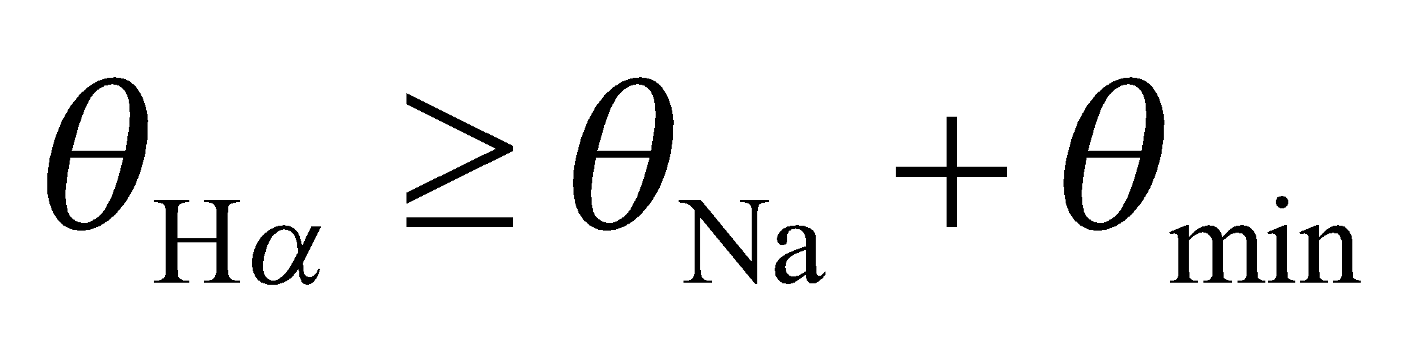to solve for the slit spacing, d. The number of slits (or lines) per cm is just the inverse of this, 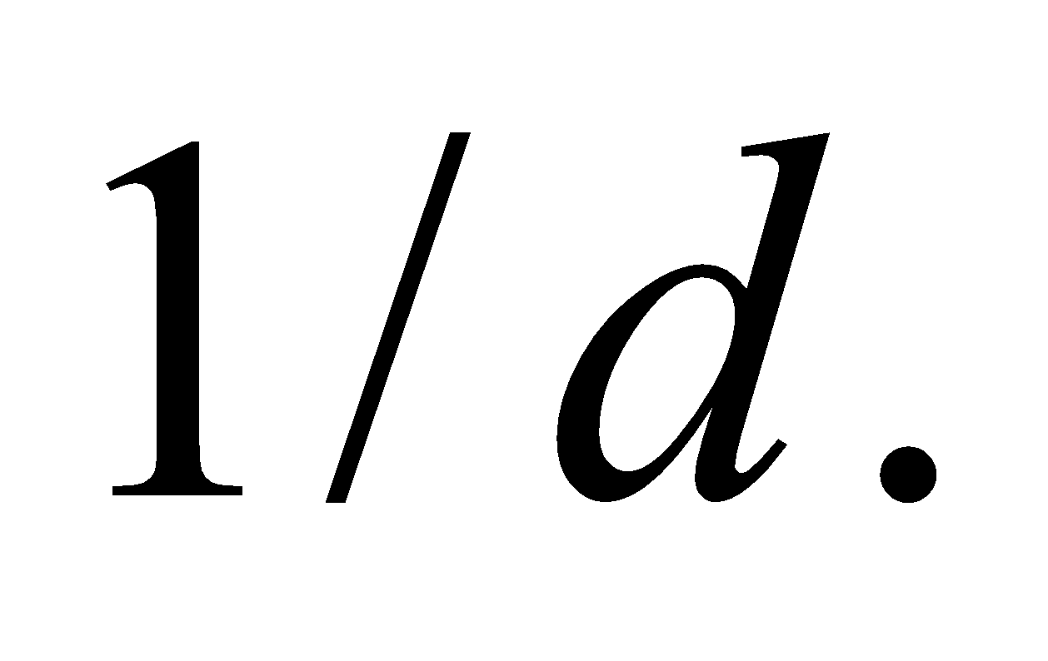
Evaluate For the given pupil diameter and light wavelength, the resolution is
In terms of degrees, this is about 0.02°, or about 1 arcminute.
Assess We first eliminate one of the unknown angles with a trig identity from Appendix A:
We can plug in 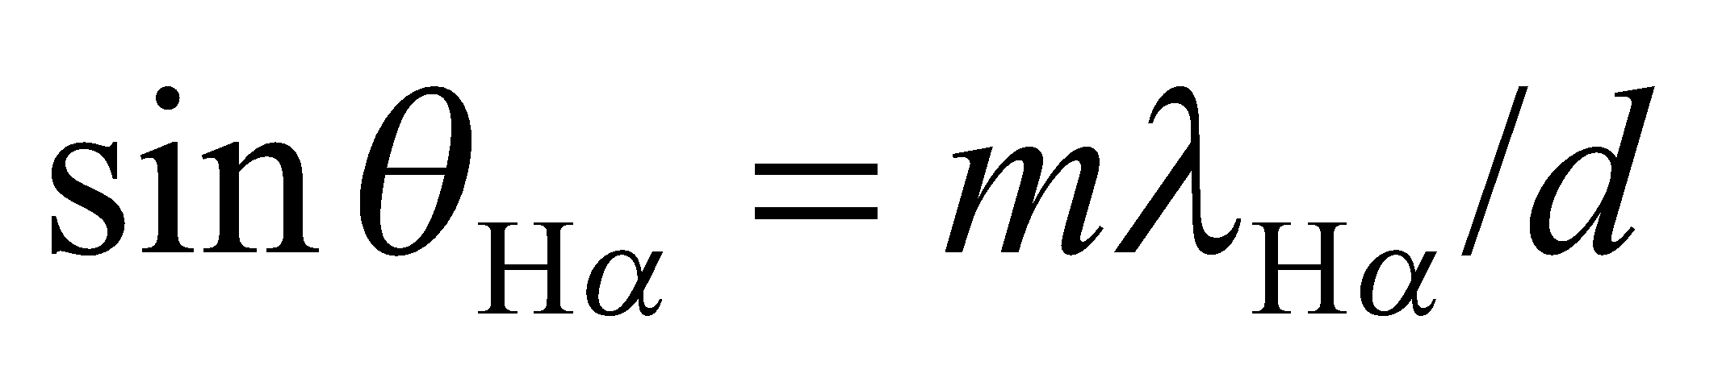 and 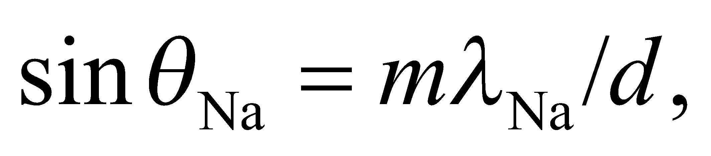 and use the fact that 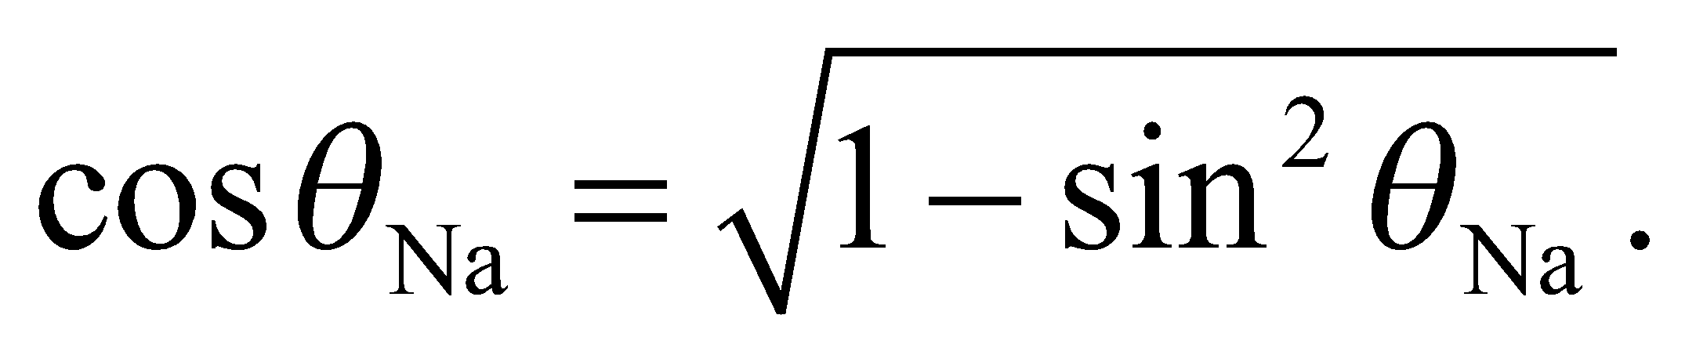 With some algebra, we arrive at:
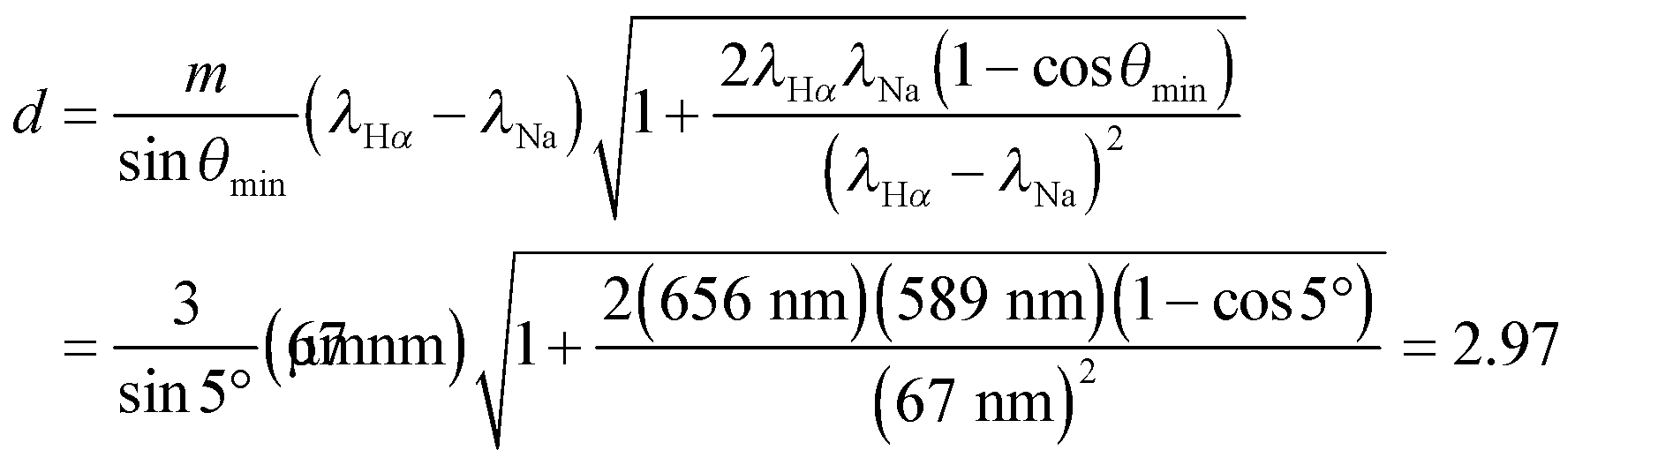
The inverse of this is 3370 lines/cm, so the coarsest grating you could use is the one with 3500 lines/cm.
Assess Notice that for a small minimum angle, the spacing equation simplifies to 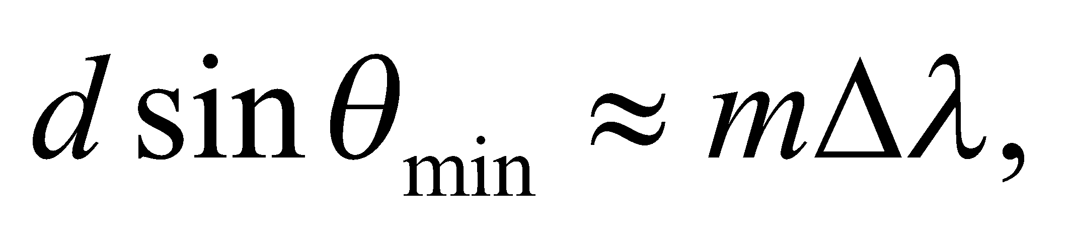 where 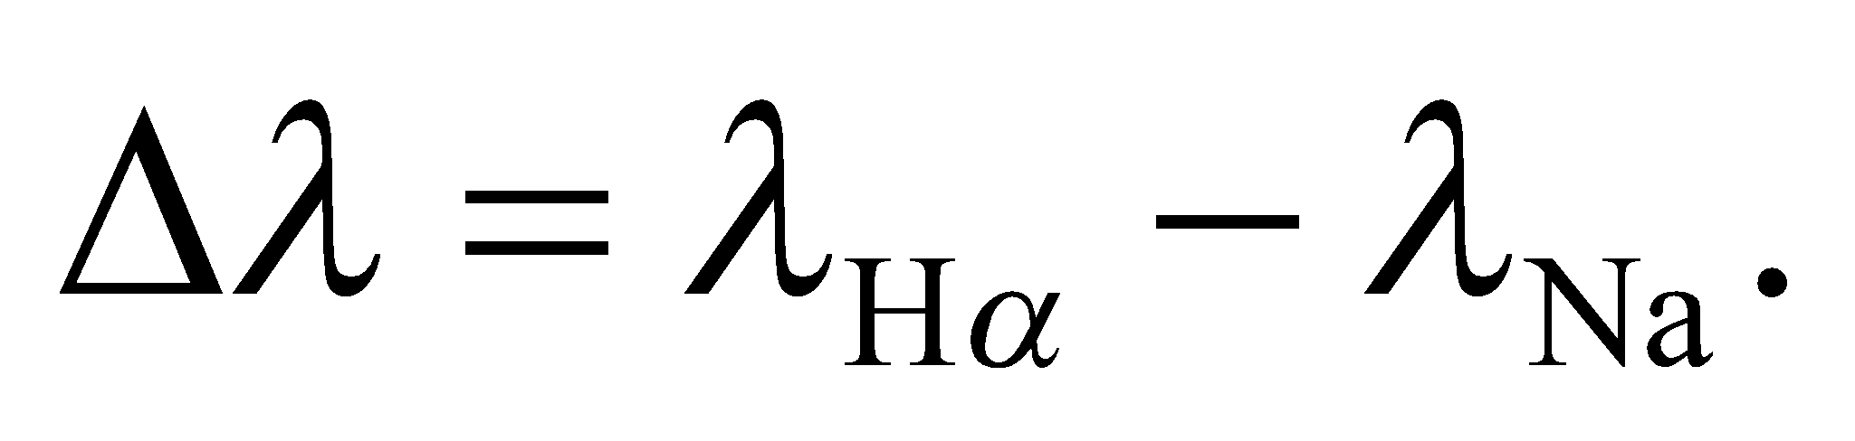This makes it clear that in order to increase the angular separation of two nearby spectral lines, one must use a spectrometer with more slits or gratings per cm.
41. Interpret We're asked to show that the only order where the visible spectrum doesn't overlap itself is the first order.
Develop Within a given order, m, the spectral lines in the visible region stretch from the angle 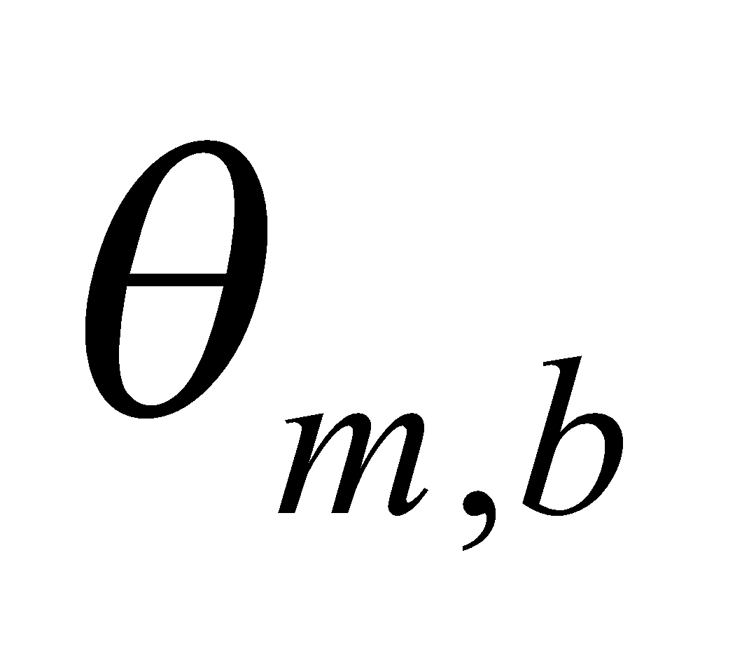for the blue wavelength, and 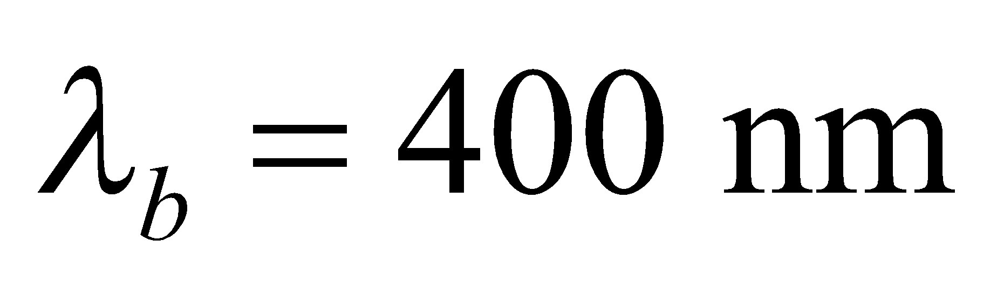 to the angle 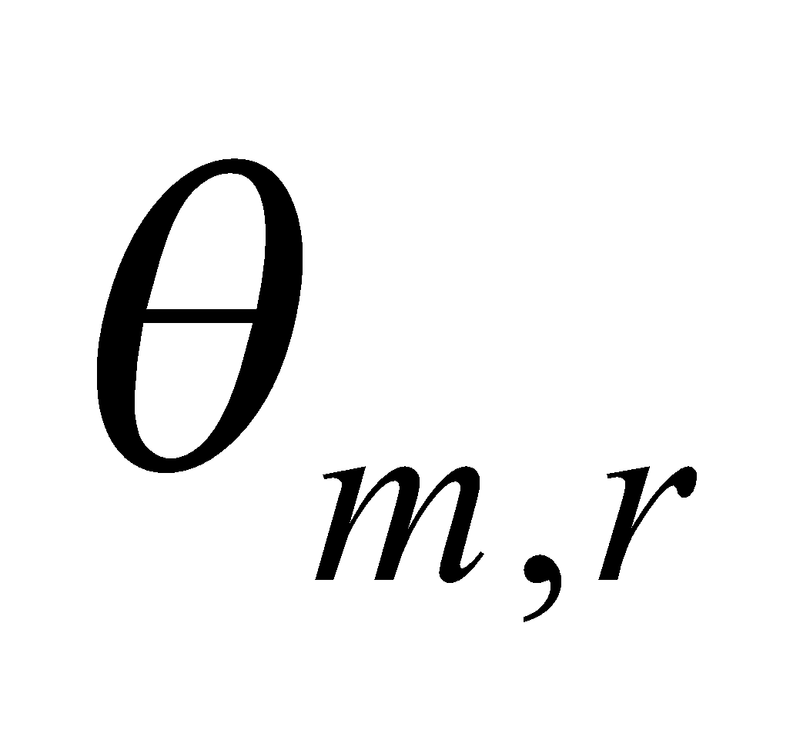for the red wavelength 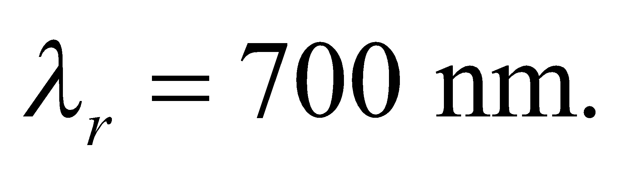 Each of these angles satisfies Equation 32.1a: 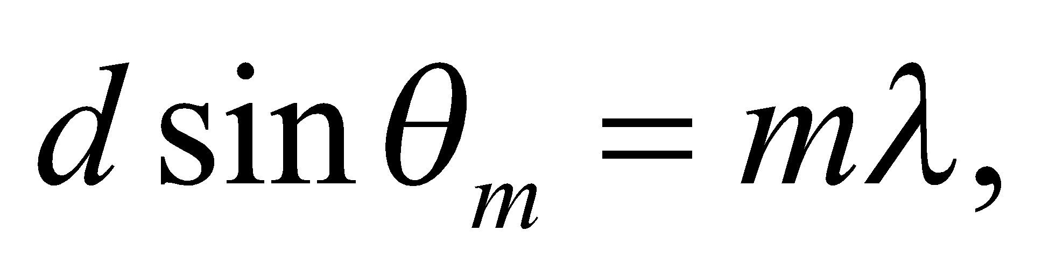 so 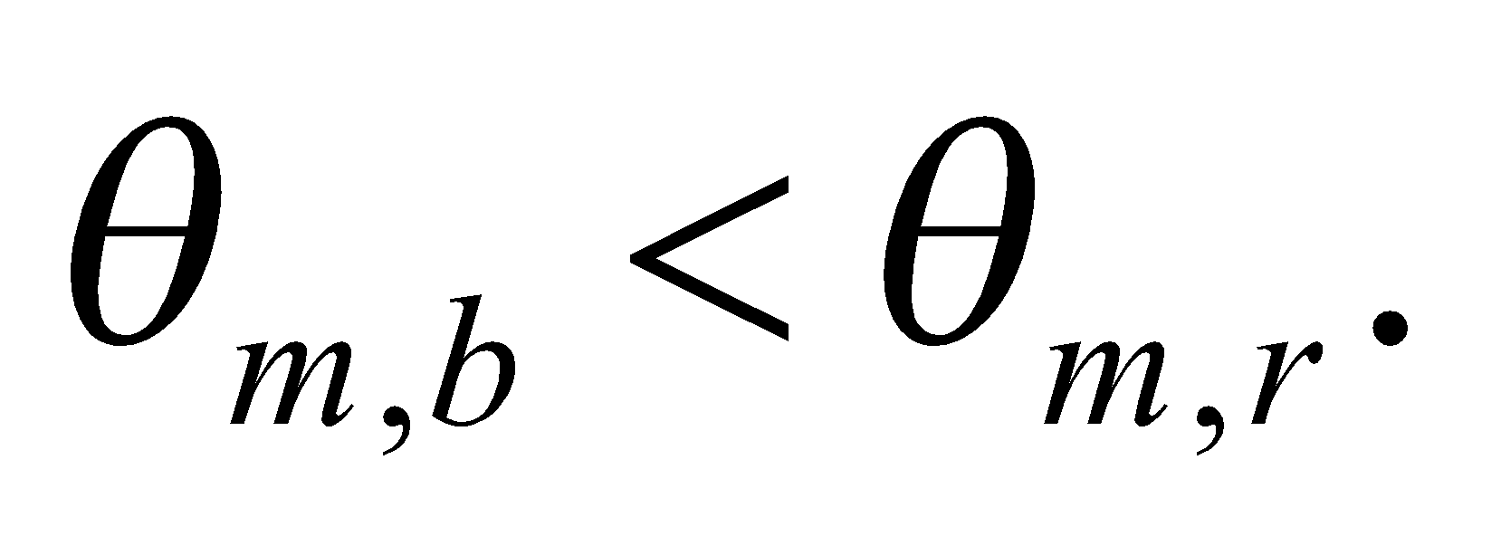 Overlap will occur when the blue spectral line of the 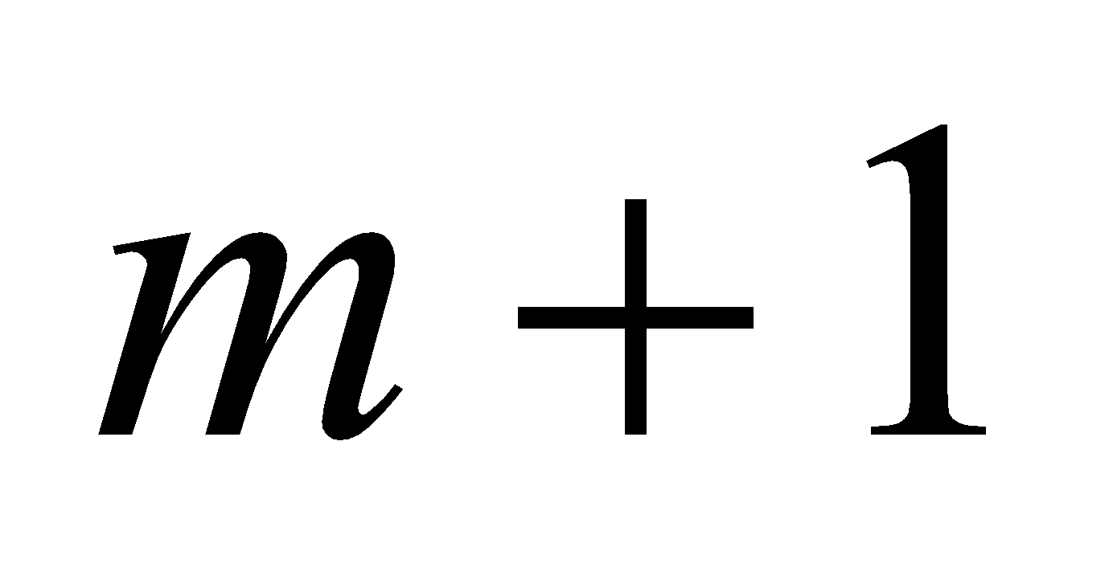 order occurs at an angle smaller than the red spectral line of the m order: 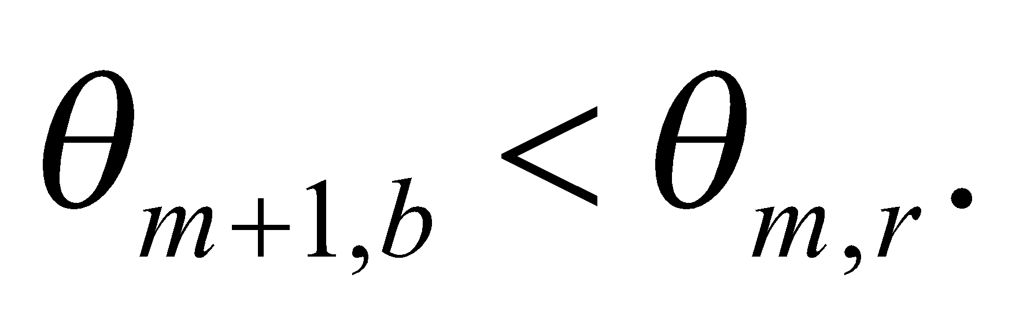
Evaluate If 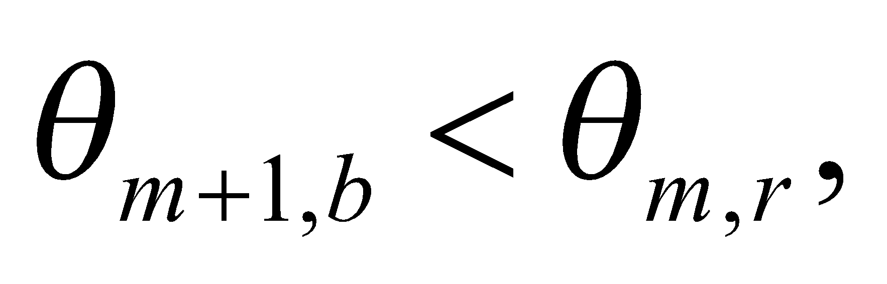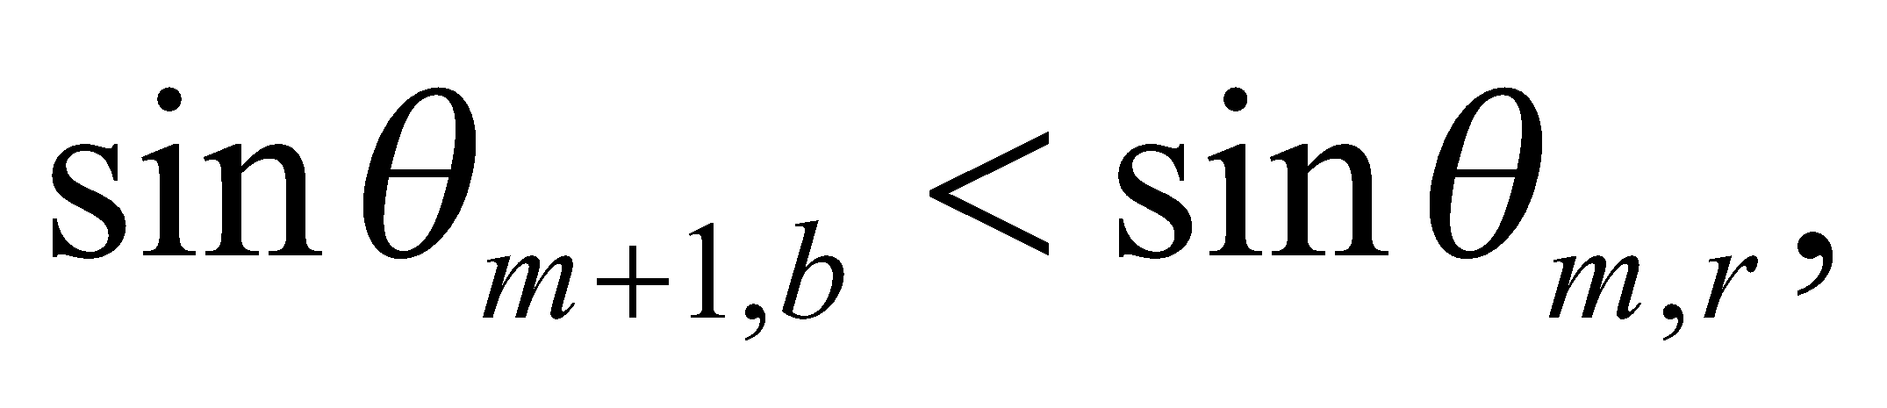and
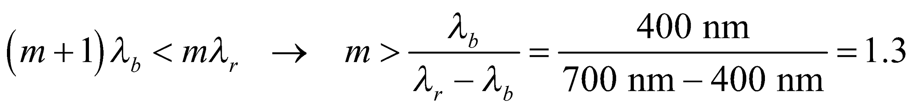
This says that there's no overlap for the first order, but there will be overlap for the second order and above.
Assess We can verify that there is overlap in the second order. The 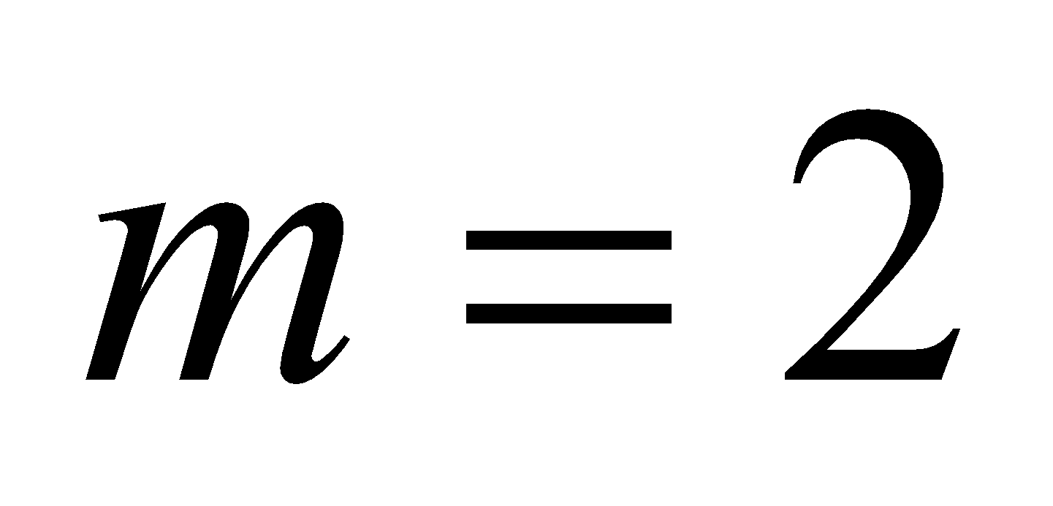 red line occurs at 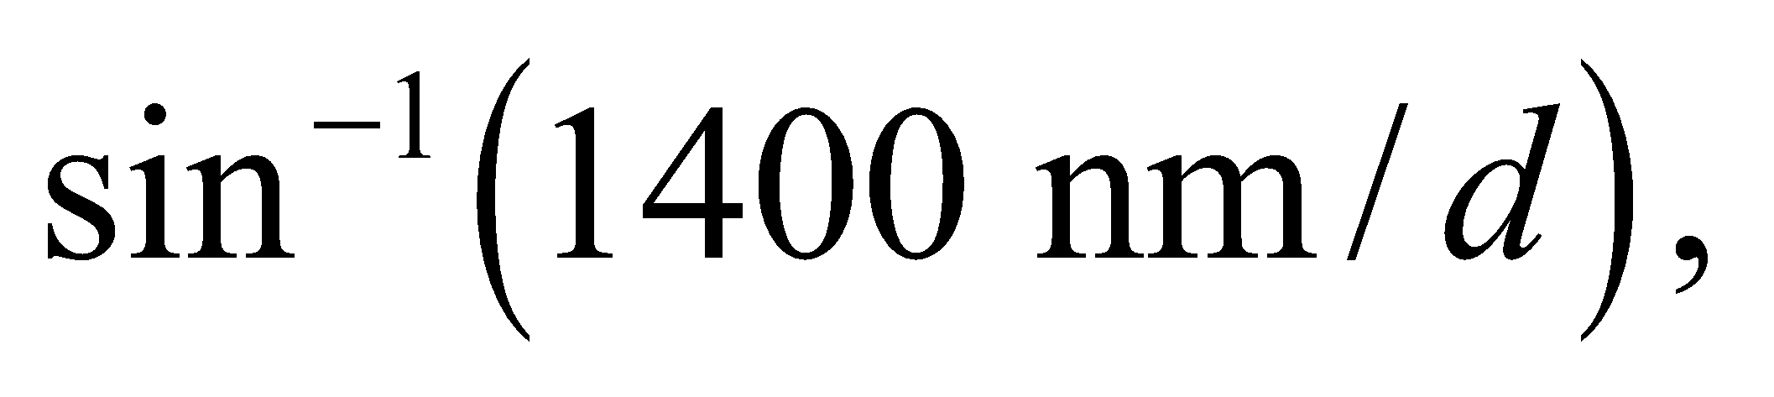 whereas the 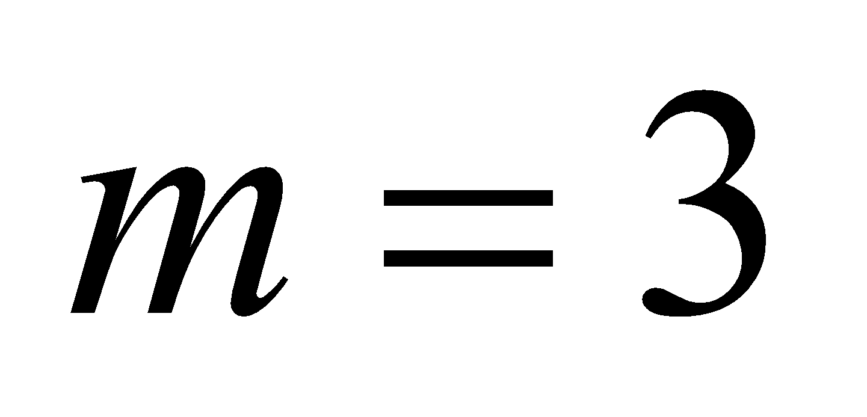 blue line occurs at 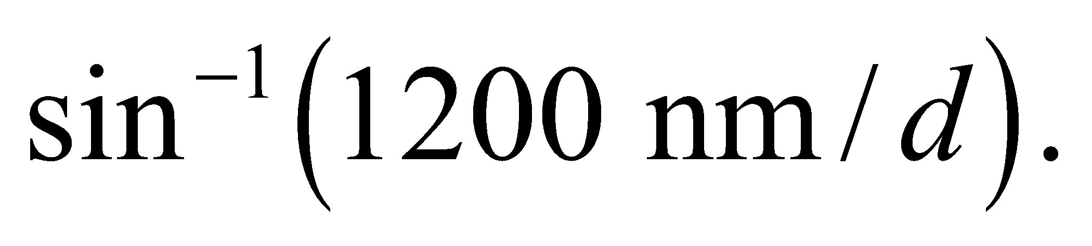 Therefore, 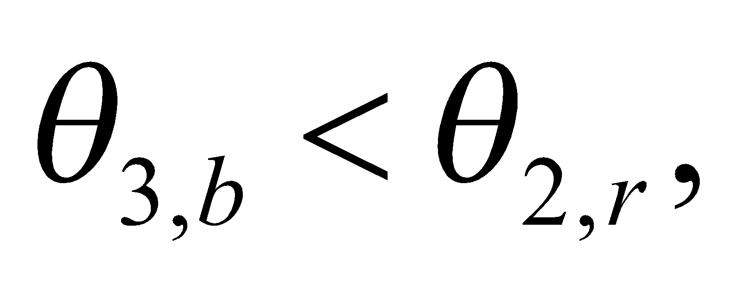which means the second and third orders overlap.
42. Interpret This problem involves a grating diffractometer for which we are to find the total number of lines in the grating that will give the desired angular separation between the central peak and the third-order peak.
Develop The grating condition for normally incident light (same as Equation 32.1a) and the given data imply a grating spacing of 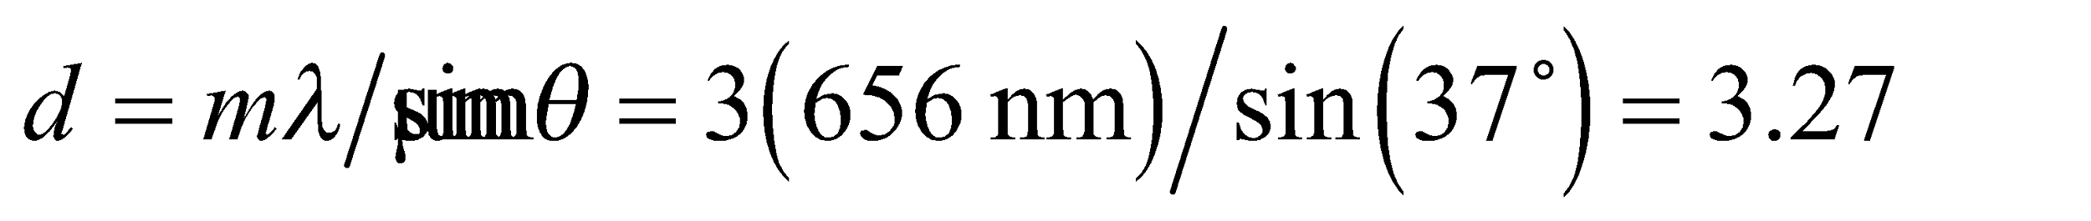 or a grating constant of 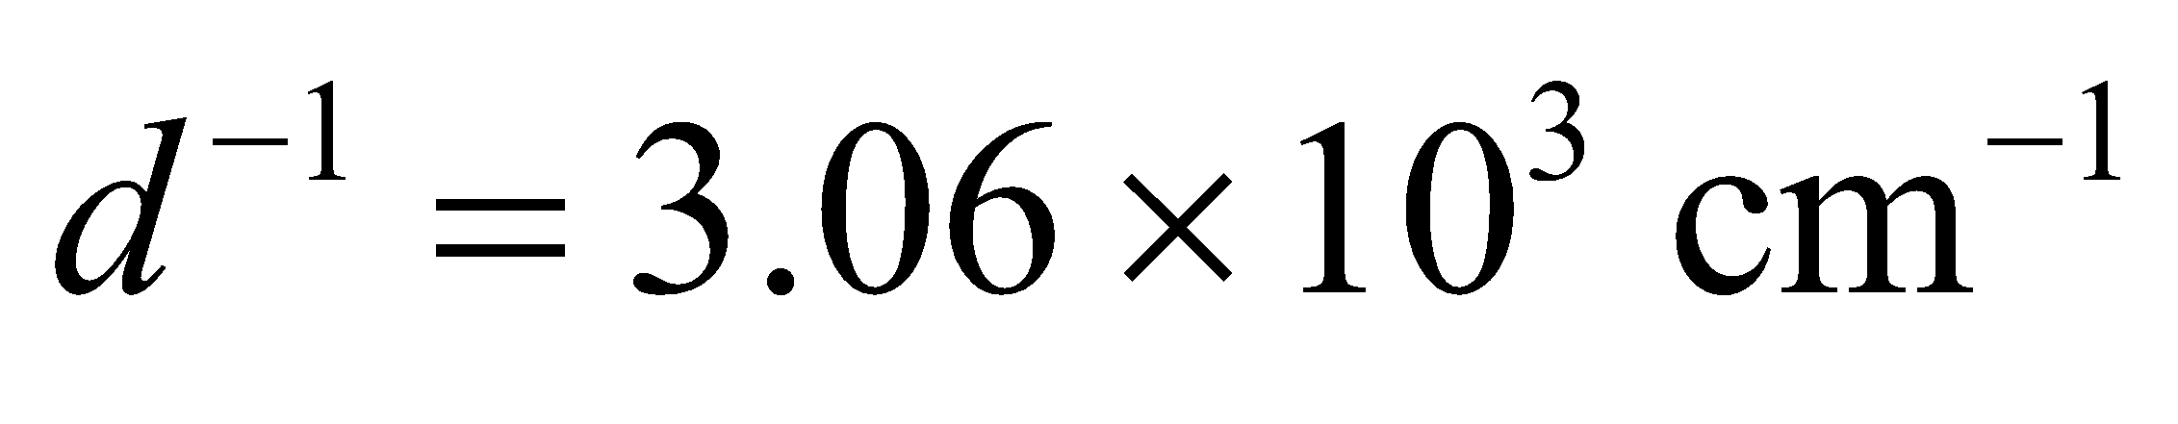.
Evaluate On a grating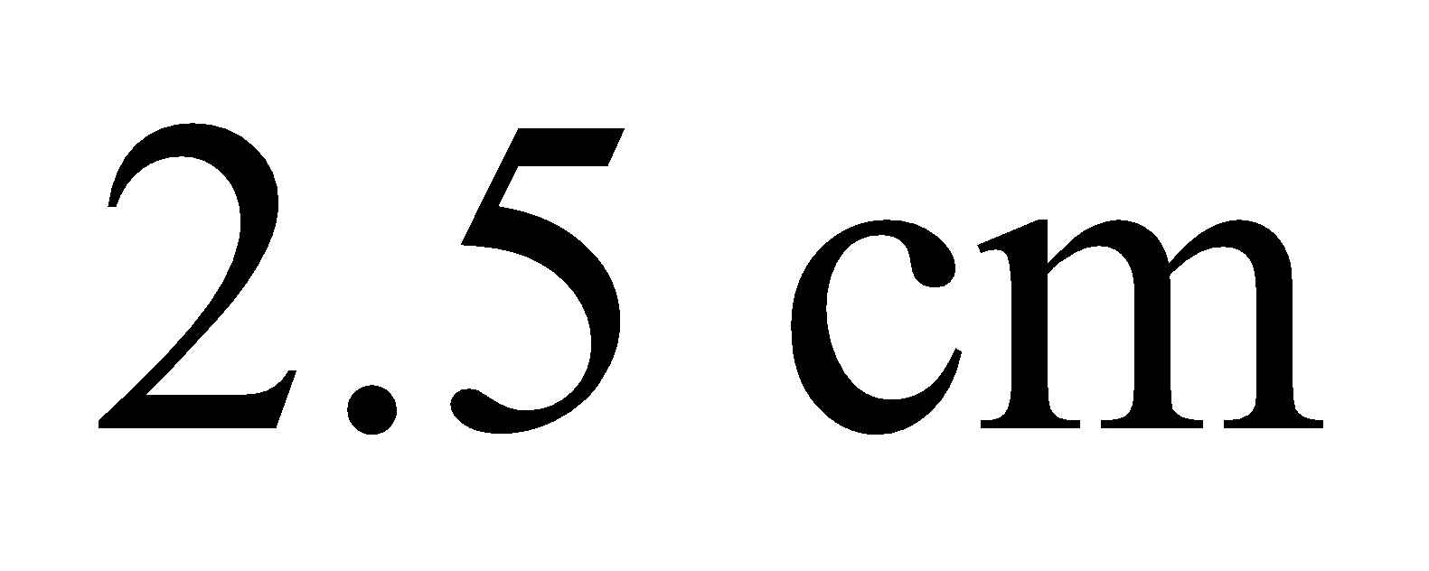wide, the total number of lines is 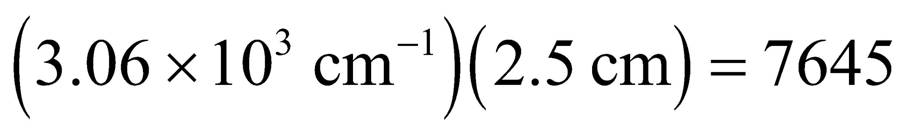, to within a hundredth of a line.
Assess This grating spacing is typical of visible-light spectrometers.
43. Interpret We are to find the diffraction order necessary to resolve (i.e., separate) two closely spaced spectral lines.
Develop From Equation 32.5, wavelengths can be resolved if
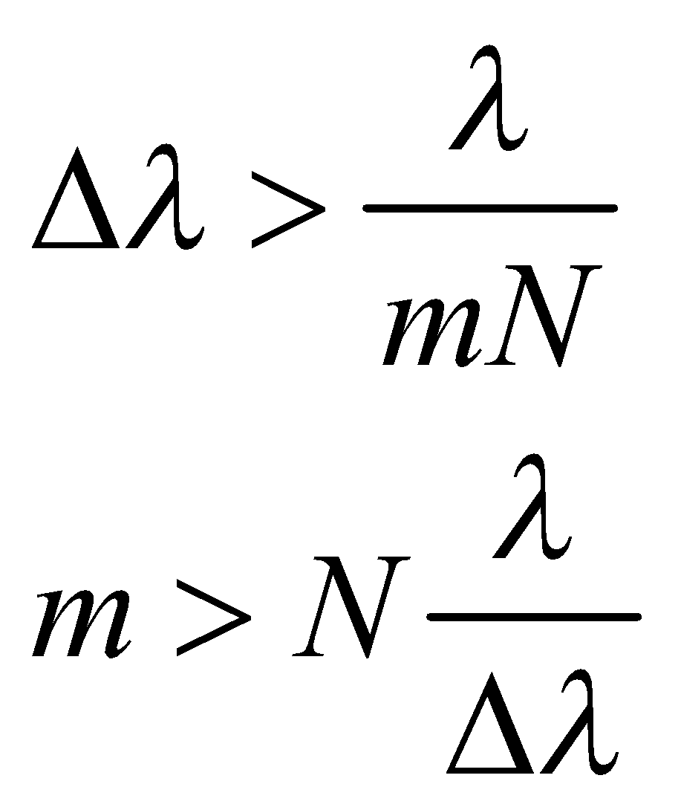
where Δλ = 648.07 – 647.98 nm = 0.090 nm and N = 4500.
Evaluate The requisite order is
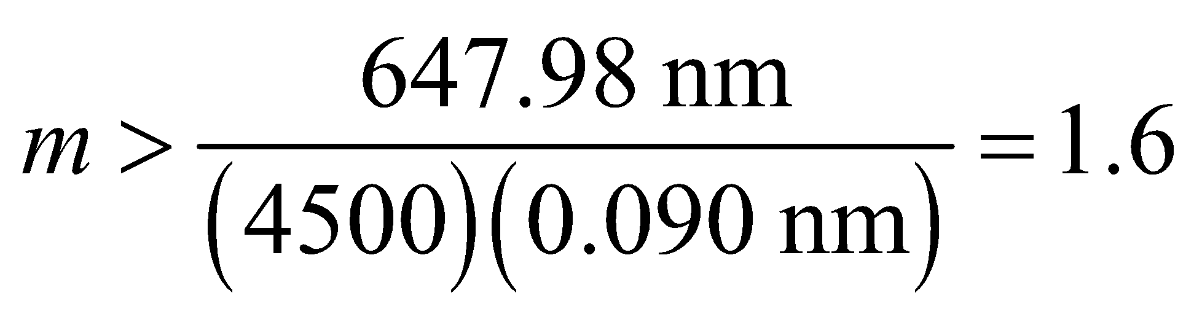
So the second or higher order is required to resolve these spectral lines.
Assess Note that N is a dimensionless number, so the dimensions work out in the expression for the minimum order number.
44. Interpret This problem is about thin-film interference. Three media involved are toluene, water, and air. We are to find the film thickness of toluene on water that results in the maximum reflectance of the given wavelength.
Develop Since 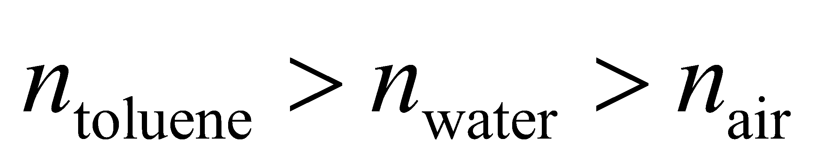 there is a 180° phase change for reflection at the air-toluene interface and no phase change at the toluene-water interface (see Figure 32.12). Equation 32.7 thus applies for constructive interference (of normally incident rays):
Evaluate Solving for the thickness d, we get
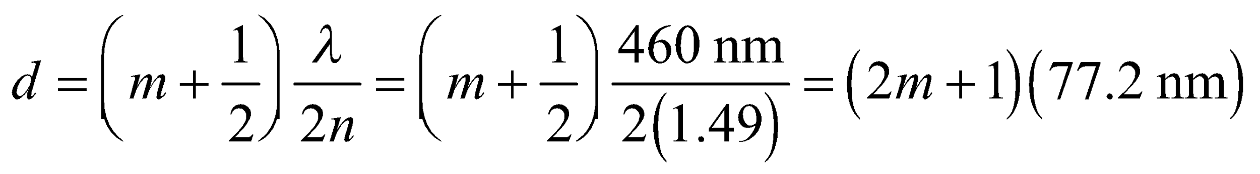
The minimum thickness is for m = 0, so d_{min} = 77.2 nm.
Assess The typical thickness of a thin film is on the order of 100 nm. Thin-film interference accounts for the bands of color seen in a soap film or oil slick. Note that odd multiples of our result will also give the desired maximum reflectance at 460 nm.
45. Interpret You're assessing the feasibility of resolving Earth-sized planets with a single space telescope.
Develop You can assume that resolving the planet means roughly that it's angular extent in the sky is at least equal to the diffraction limit of the proposed telescope. The angular extent of an Earth-sized planet at a distance of L is 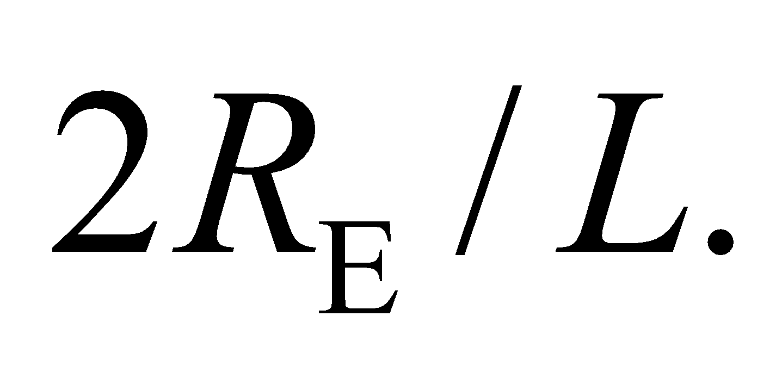 Equating this to Rayleigh criterion in Equation 32.11b gives for the minimum telescope diameter:
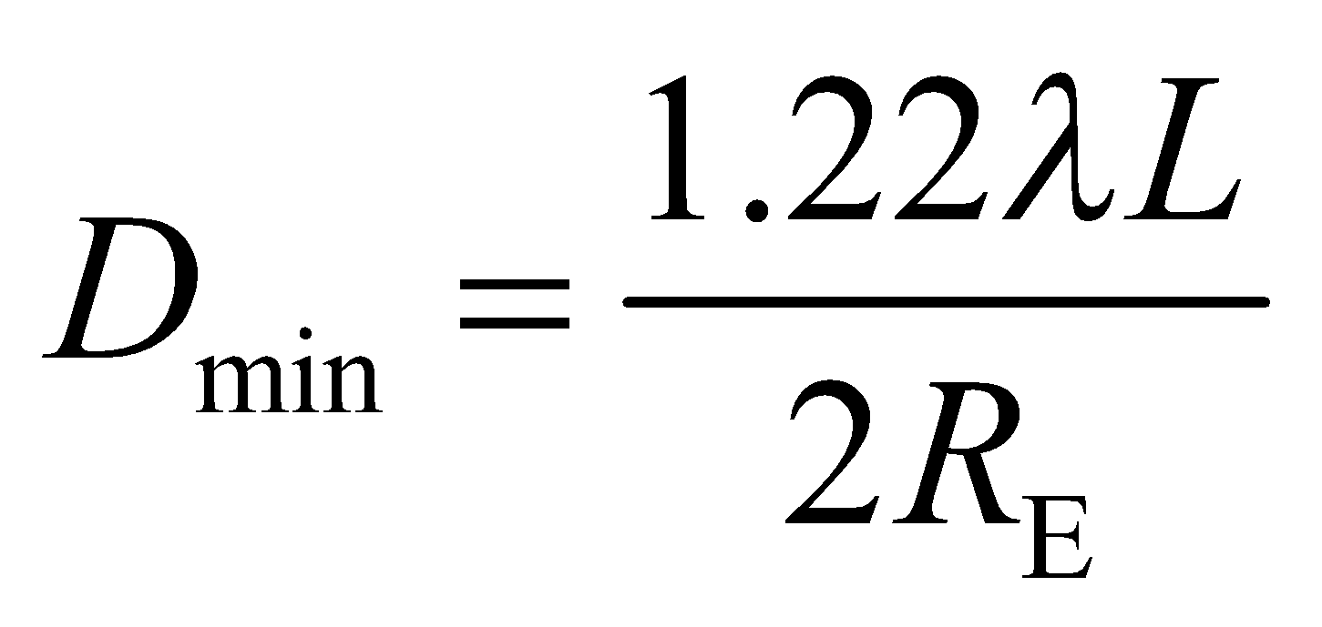
Evaluate Our equation says that the smaller the wavelength we use, the smaller the telescope has to be. So you might as well choose the lower limit of the optical wavelengths: 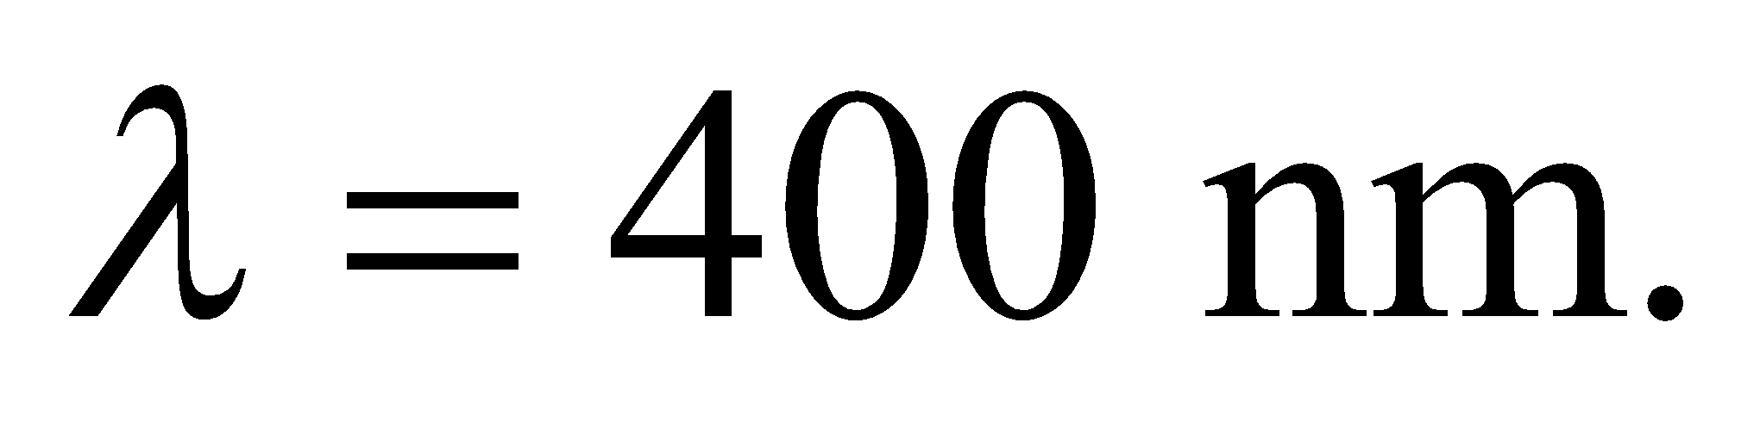 As such, the telescope diameter needed would be
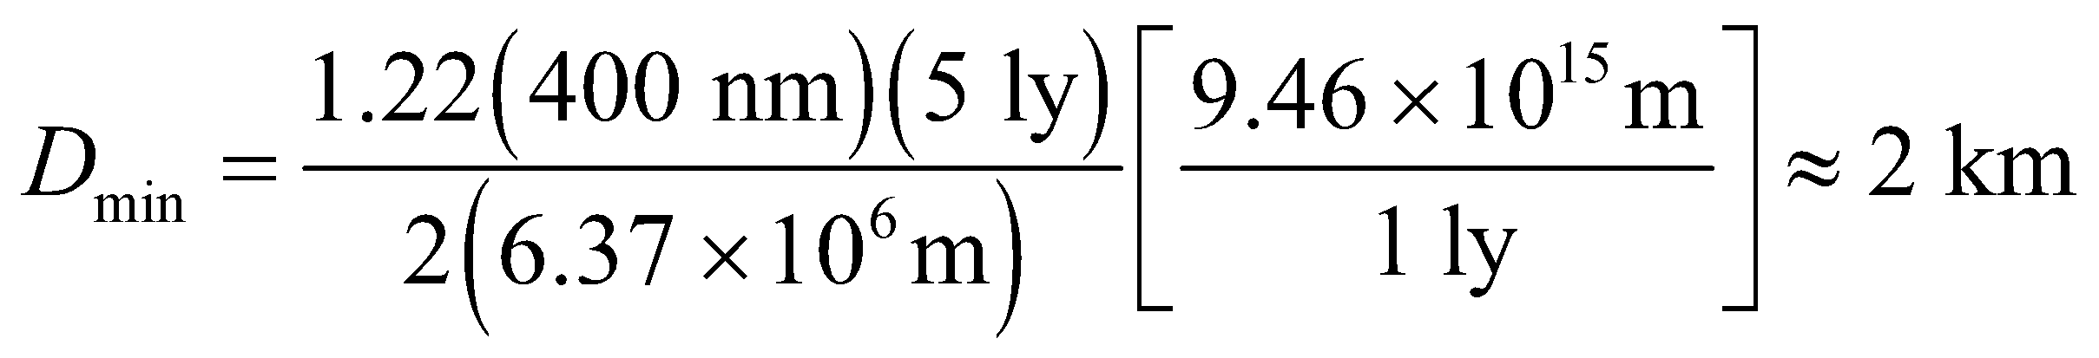
A 2-km-wide telescope in space, or even on the ground, is not feasible.
Assess NASA is considering ways to detect Earth-sized planets with a space telescope. However, the goal is not to resolve the planet, but merely separate its light signal from that of its host star. In this case, the angle is not set by the planet's diameter but by its orbital radius. For a planet orbiting its star at the same distance as Earth is from the sun 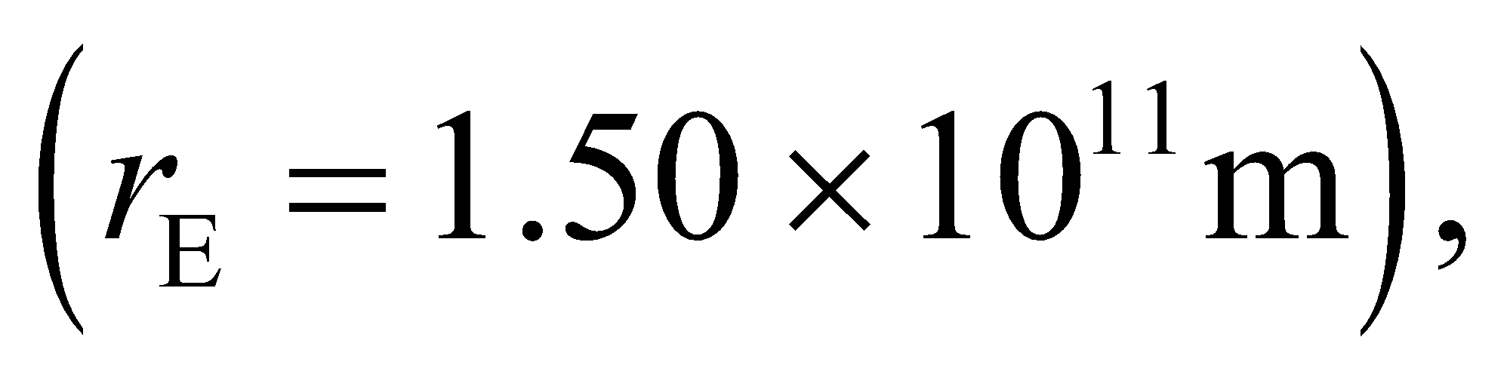 the minimum telescope diameter is less than 20 cm. However, this is largely irrelevant. The real challenge in getting a direct image of a distant planet is not the angular resolution, but the fact that the star is so much brighter than the planet. The starlight completely overwhelms the planet's signal, so astronomers are looking for ways to filter out the light coming from the star.
46. Interpret In this problem, we are asked to compare the resolving power between an echelle grating and a more conventional (i.e., more lines per cm) grating.
Develop If the echelle grating and the conventional grating have the same width, then the number of lines in each is proportional to the given line spacings, so 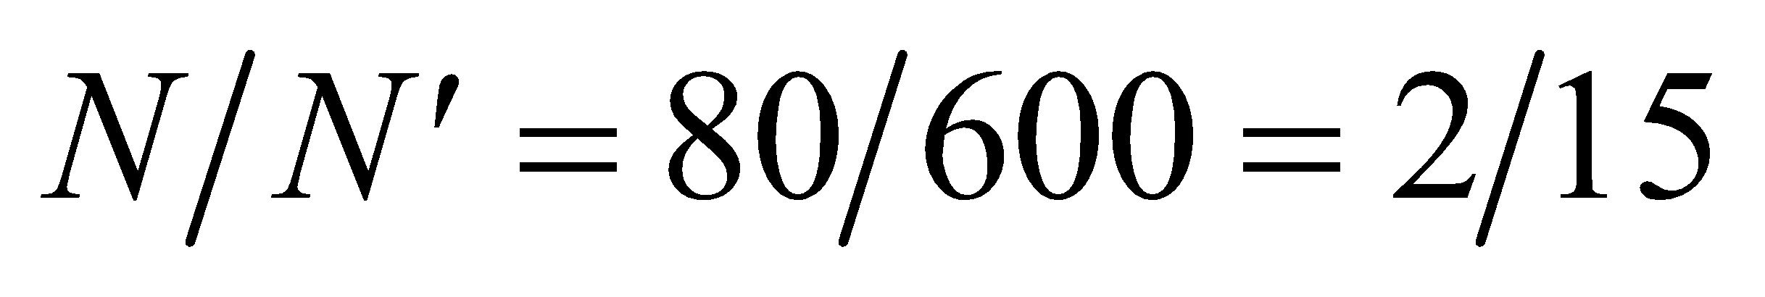. The resolving power of a grating is given by Equation 32.5:
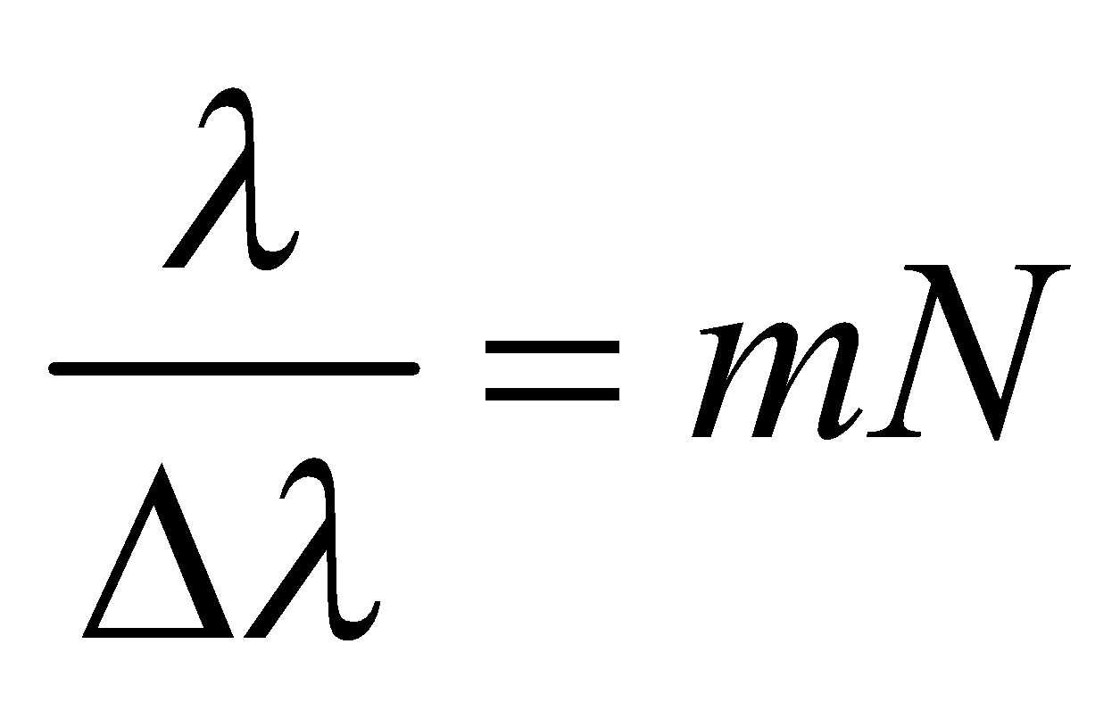
Evaluate The ratio of the resolving powers is
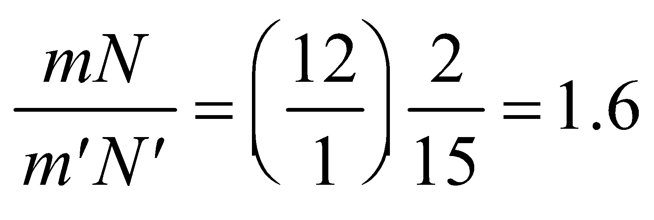
Assess The echelle grating with m = 12 offers about 60% greater resolving power than the grating with
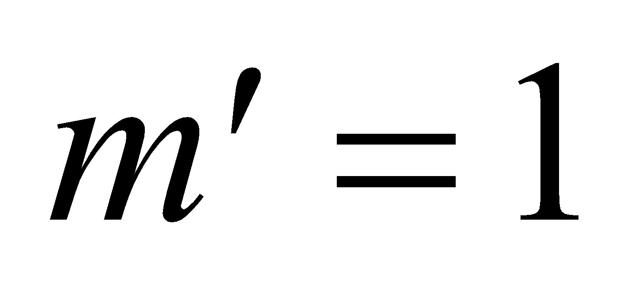.
47. Interpret This problem is about X-ray diffraction in a crystal. We are interested in the spacing between the crystal planes, which we can find using Bragg’s law.
Develop Constructive interference in X-ray diffraction is given by the Bragg condition (Equation 32.6):
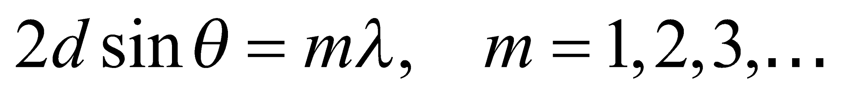
Solve this for d to find the spacing between crystal planes.
Evaluate From the Bragg condition, one finds
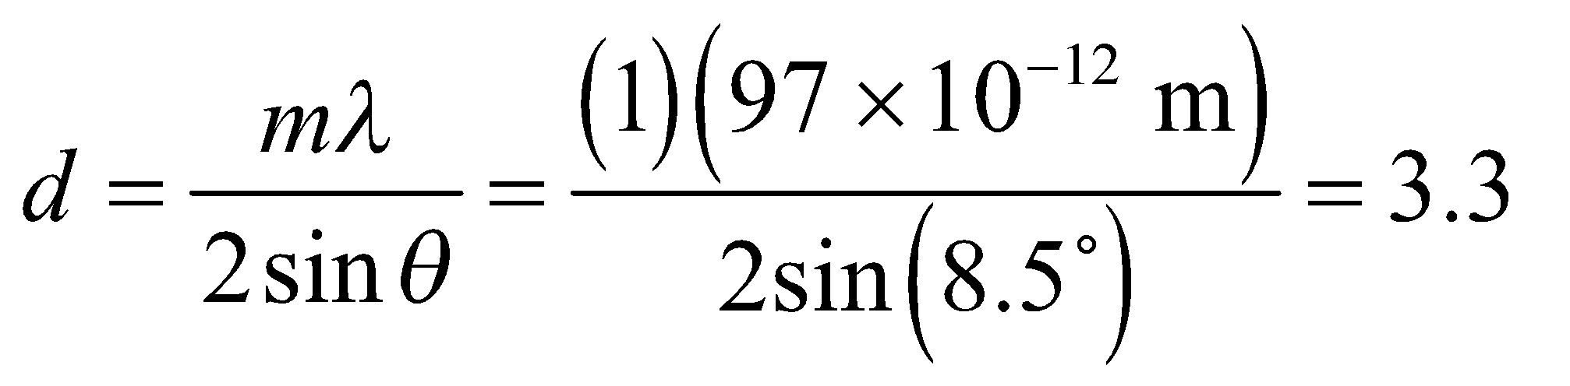Å
Assess The spacing between crystal planes is typically a few angstroms, so this result seems reasonable.
48. Interpret This problem involves interference from a thin film. In particular, we are to analyze a film to find the minimum thickness for which a reflectance of light in the visible regime still occurs.
Develop Apply Equation 32.7, which gives the condition for constructive interference from a thin film with index n higher than that of its environment. The minimum thickness d_{min} occurs for m = 0, which gives
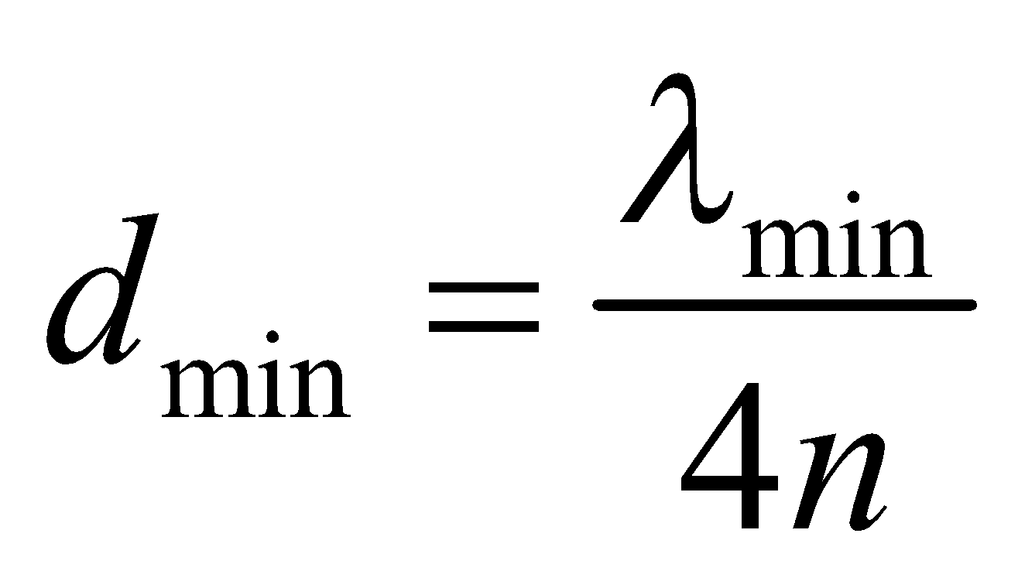
Evaluate The minimum wavelength that is visible to humans is normally taken to be 400 nm. Using this result and n = 1.33 and in this expression gives a minimum thickness of
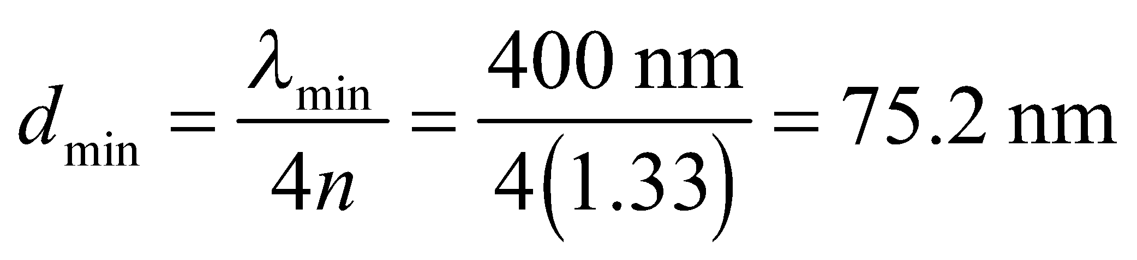
Assess Film thicknesses are typically around 100 nm, so the result seems reasonable because it is slightly less than 100 nm.
49. Interpret This problem involves constructive interference from a thin film. We are to find the number of times the condition for constructive interference is met for 630-nm light in a thin film that varies in thickness within the given range.
Develop In a thin film of oil between air and water (), there are 180° phase changes for reflection at both boundaries (i.e., for both rays 1 and 2 in Figure 32.7). These phase changes cancel each other, leaving only the film thickness to give the difference in path length. Therefore, for normally incident light, the term ½ in Equation 32.7 cancels due to a similar term on the left-hand side, leaving
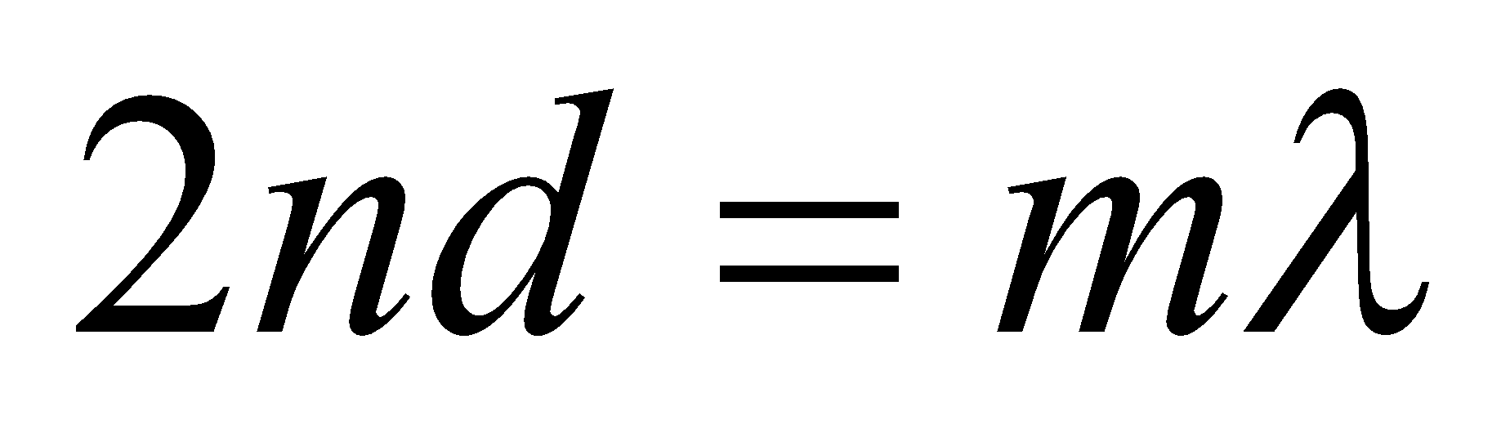
The thickness d varies in the range 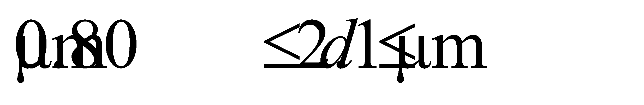, so we can find the integers m that satisfy this range for λ = 630 nm.
Evaluate The thickness range implies
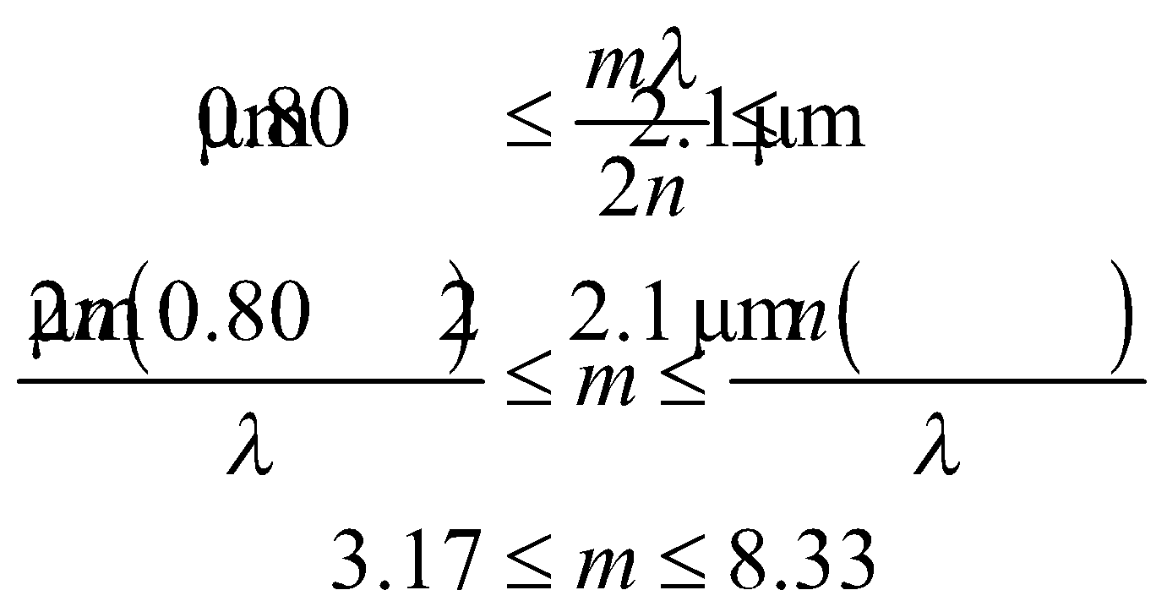
Since m is an integer, it can range from 4 to 8, inclusive.
Assess For 630 nm, this film will exhibit 5 bright fringes; for m = 4, 5, 6, 7, and 8.
50. Interpret You're worried that a plate may cause constructive interference inside a microwave oven.
Develop The minimum thickness for enhanced reflection can be determined from Equation 32.7 by setting 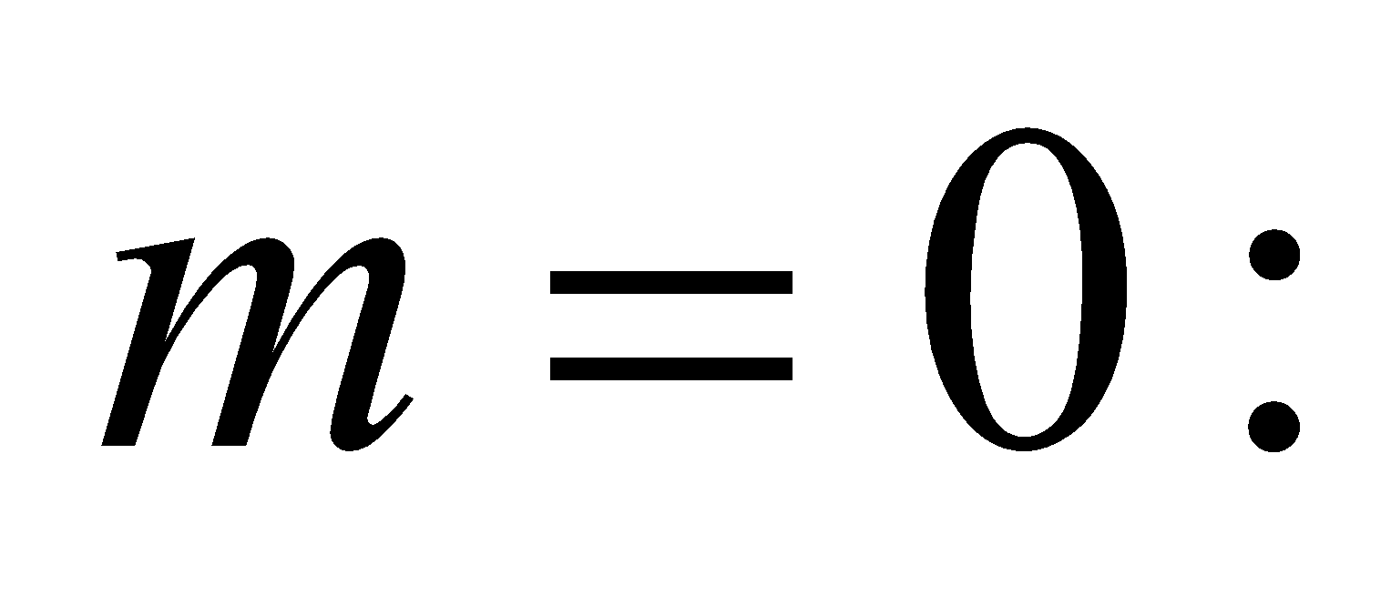 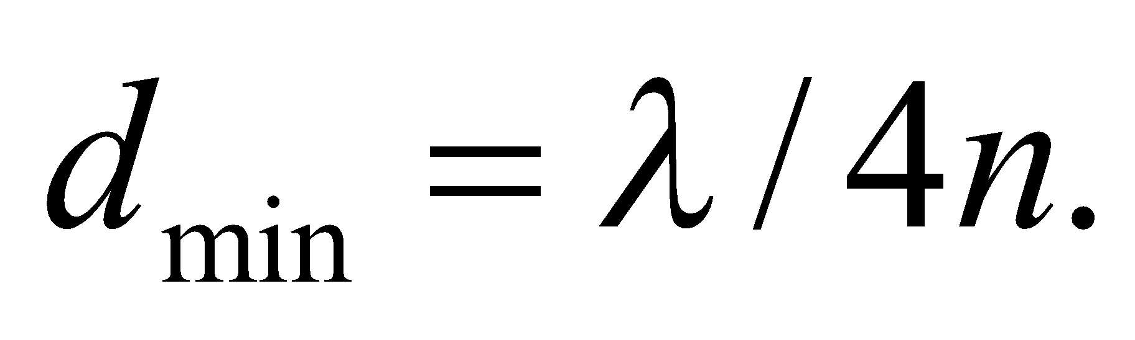
Evaluate In terms of the given frequency, the minimum thickness for a plastic plate to induce constructive interference is
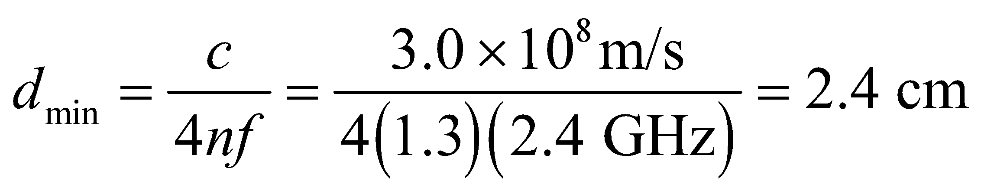
This is almost an inch thick, which is far thicker than normal plates.
Assess Interference often does occur inside a microwave oven, as waves bounce back and forth from one wall to the next. One might notice this by uneven heating of food coming out of the oven. The hot spots correspond to constructive interference, while the cold spots are regions where the waves destructively interfere. This is why many ovens have turntables, so that the food moves through these hot and cold spots and therefore experiences more uniform heating.
51. Interpret This problem involves constructive interference from a thin film; in this case a film of air between two glass plates. The index of air is less than that of glass, so there is a 180º phase change at the bottom interface (air-glass interface) instead of at the top interface (glass-air).
Develop Although the phase change occurs at the second interface, as opposed to the first interface as is assumed in deriving Equation 32.6, the net effect is the same—the path difference 2d must be an odd-integer multiple of half wavelengths. The thickness of the film varies between 0 and 0.065 mm, so we can apply Equation 32.6 to find the corresponding range of m.
Evaluate The minimum value for m is 0. The maximum value is
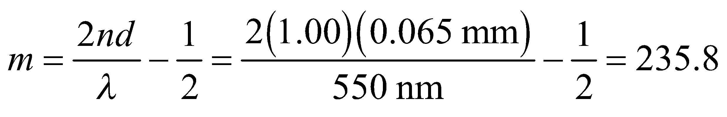
or m = 235. Thus, the observer will see 236 bright bands.
Assess The first bright band is at zero thickness, which corresponds to m = 0. This band is added to the 235 remaining bands to give the total of 236 bright bands.
52. Interpret This problem concerns constructive interference for normally incident light on the thin, wedge-shaped film of arbitrary medium between glass surfaces. We are to derive an expression giving the number of bright fringes that appear given that N bright bands are visible for air serving as the film medium.
Develop With N bright bands visible for an air wedge, the maximum value for m in the condition for constructive interference is m_{max} = N – 1 (see Problem 32.56), and this corresponds to the maximum film thickness d_{max}. Inserting this into Equation 32.6 and solving for the ratio d_{max}/λ gives
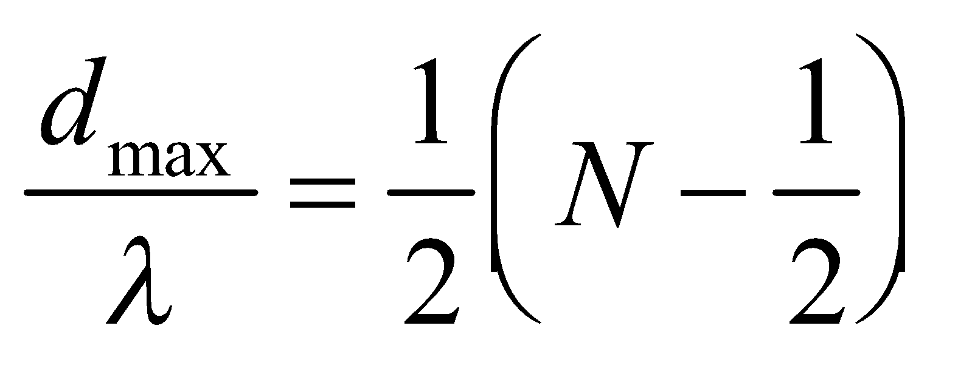
When liquid of refractive index 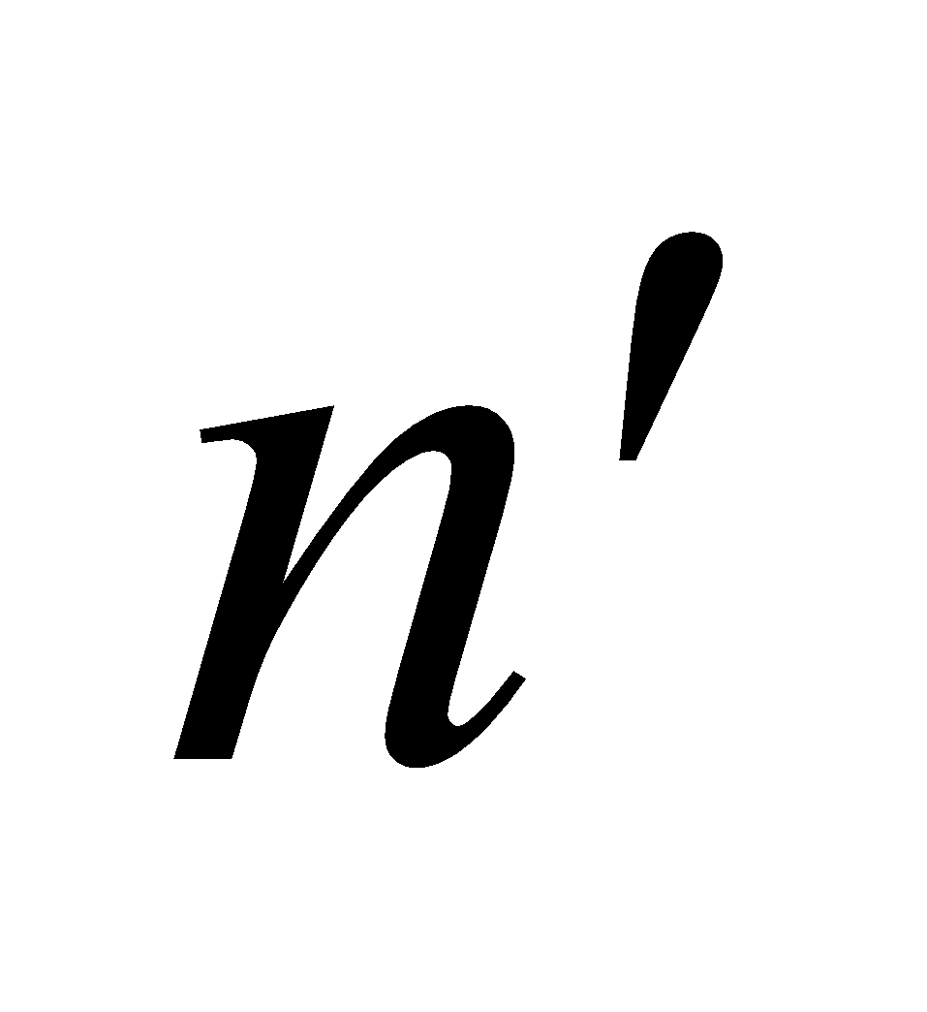 fills the wedge, there is still a 180° phase change at only one surface (regardless of whether or not 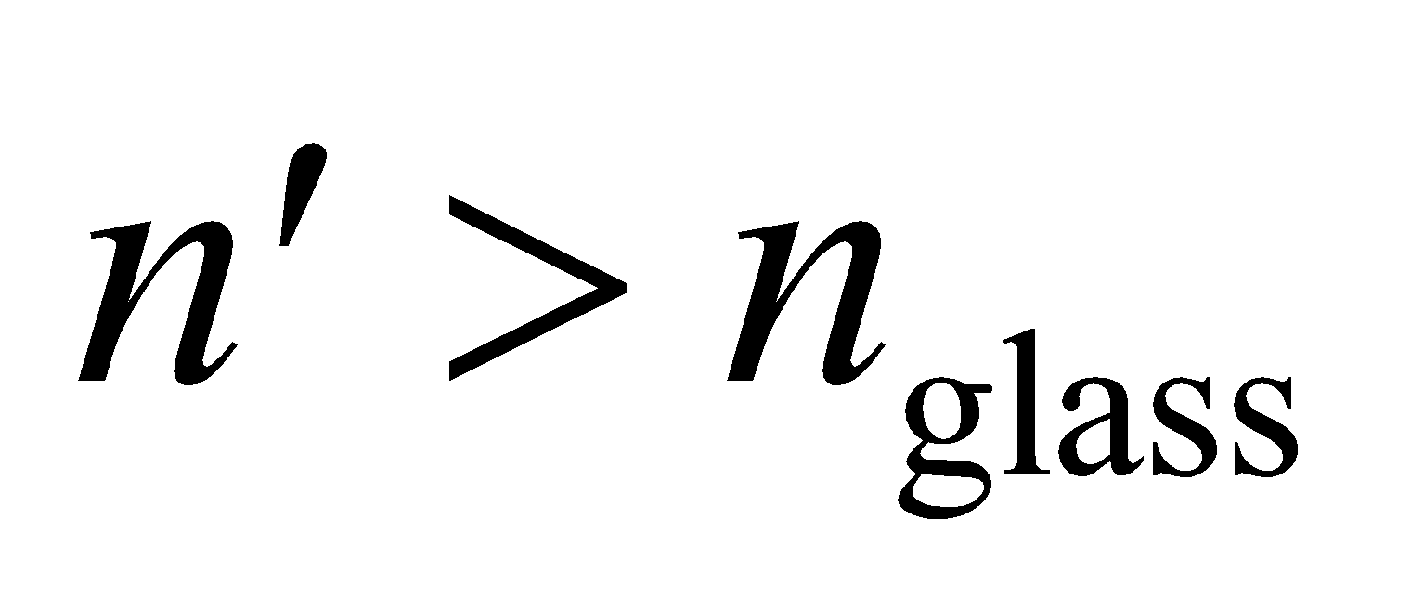). Thus, we can apply Equation 32.6, which gives
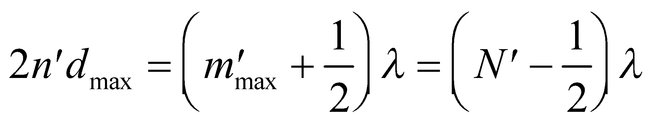
where 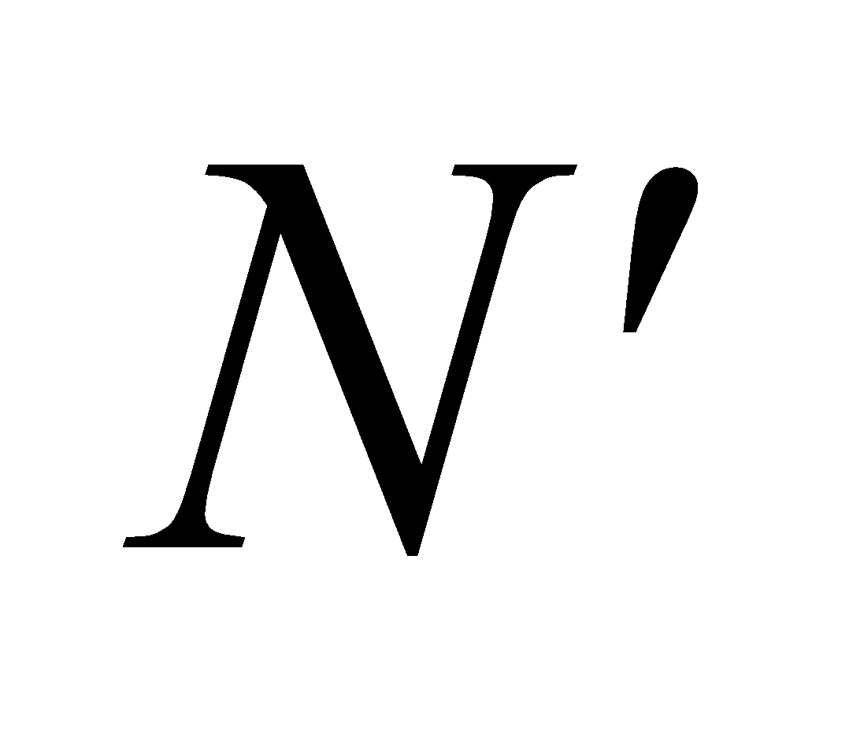 is the number of fringes in the new film. We can thus solve for in terms of N and .
Evaluate The new number of bright fringes is thus
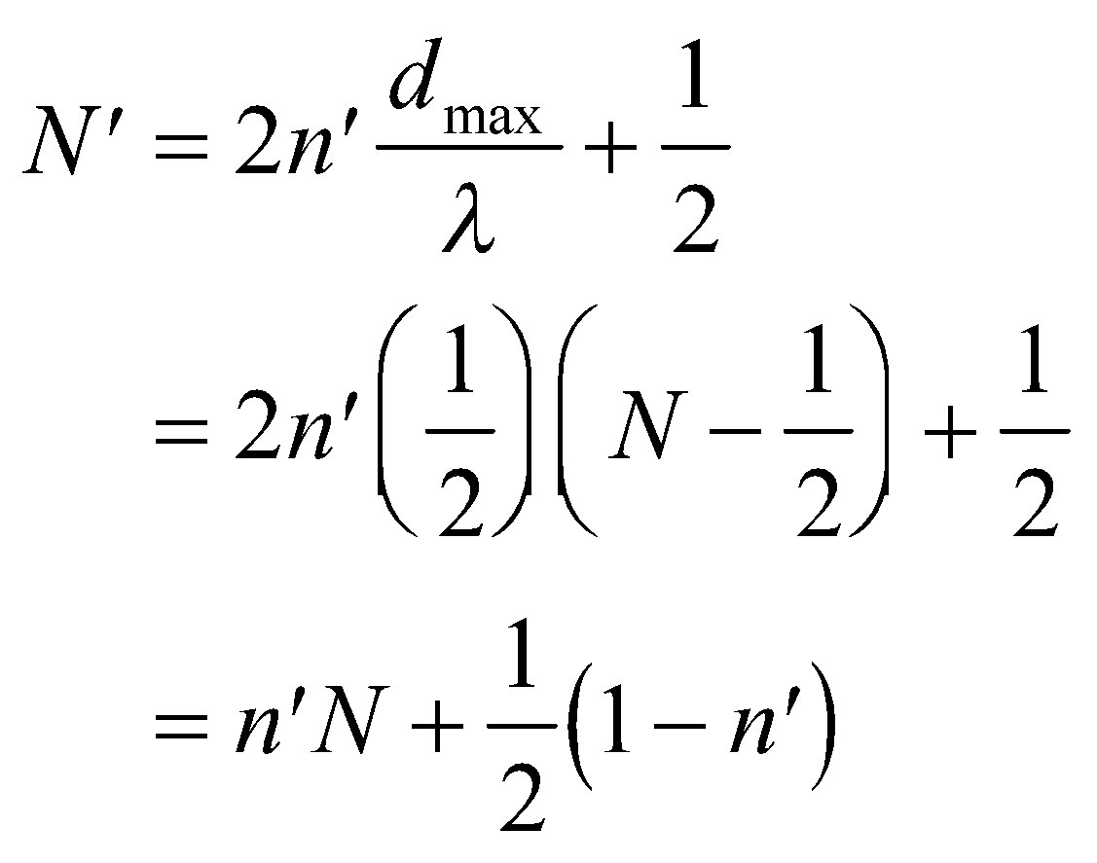
Assess This result is independent of the index of the enclosing material (the glass in this case).
53. Interpret We are asked to find the distance that corresponds to the passage of 530 bright fringes in an interferometer. Thus, as one arm of the interferometer moves, the path length in that arm changes, causing alternating constructive and destructive interference (or alternating bright and dark fringes) to occur at the output of the interferometer.
Develop In each arm of the interferometer, light must travel down and back, or twice the length of the arm (see, e.g., Figure 32.16). Thus, the path-length difference corresponding to 530 bright fringes is twice the distance moved by the mirror, and each successive fringe corresponds to the distance of one wavelength. This gives
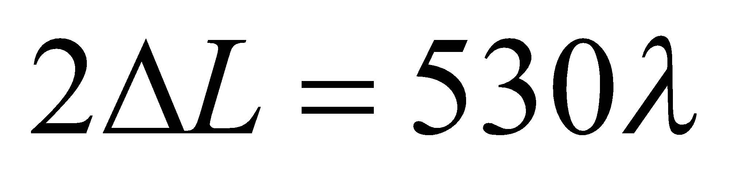
which we can solve for ΔL.
Evaluate Inserting the given quantities gives
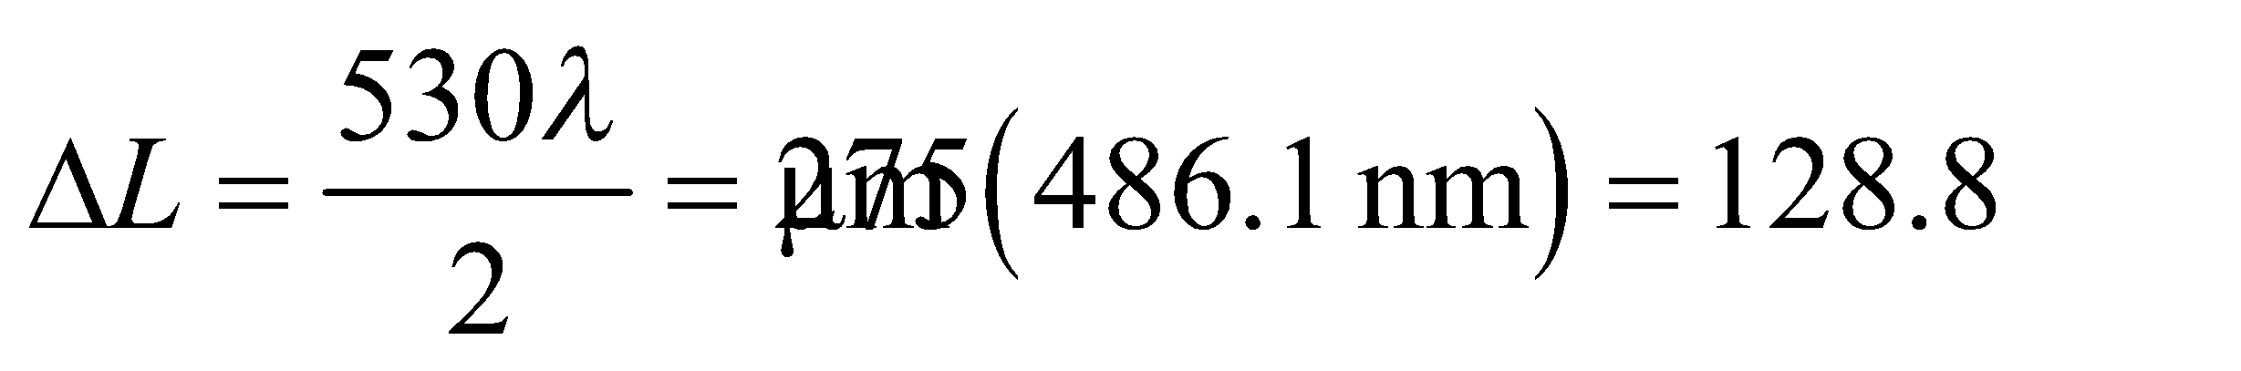
Assess This distance is greater than a single wavelength, which is the minimum distance this type of apparatus can detect.
54. Interpret This problem is similar to the previous one, except that we are given the distance moved by the interferometer and asked to find the wavelength of light used.
Develop Applying the same logic as for the previous problem gives
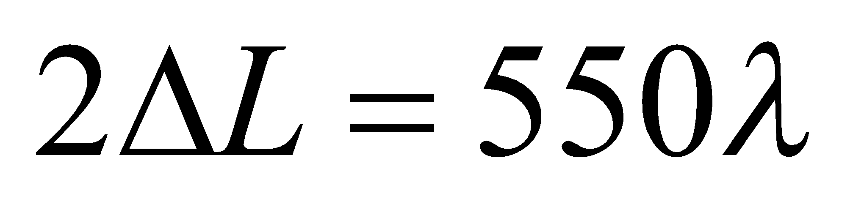
where we have used 550 because that is the number of fringes observed for this problem. The distance moved by the mirror is ΔL = 150 μm.
Evaluate The wavelength is
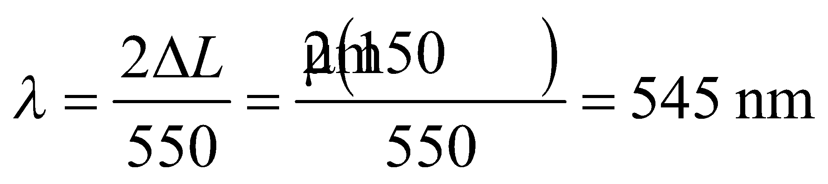
Assess This wavelength is in the visible spectrum and corresponds to yellow light.
55. Interpret This problem involves an interferometer, which is used to measure the refractive index of air. Initially, one arm of the interferometer contains air. This air is gradually pumped out, which reduces the index of refraction in the arm proportionally. When no air is left, 388 bright fringes have been observed at the recombination point of the interferometer. We are to calculate the index of refraction of the air.
Develop When the interferometer arm contains air, its length 2L in wavelengths is 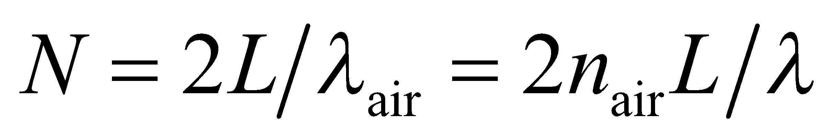, where 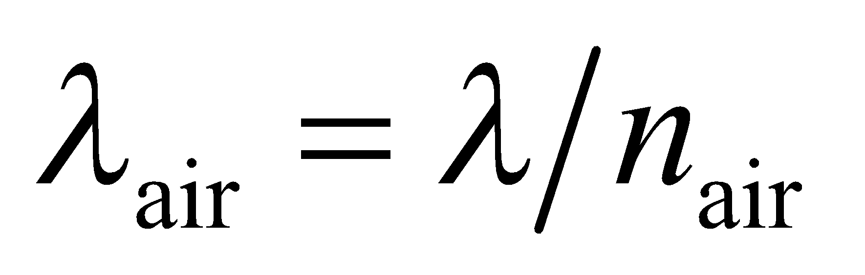is the wavelength in air and λ = 641.6 nm (the factor 2 arises because the light must travel down and back in the interferometer arm, so measures twice the actual length L). When the interferometer arm is in vacuum, its length in wavelengths becomes 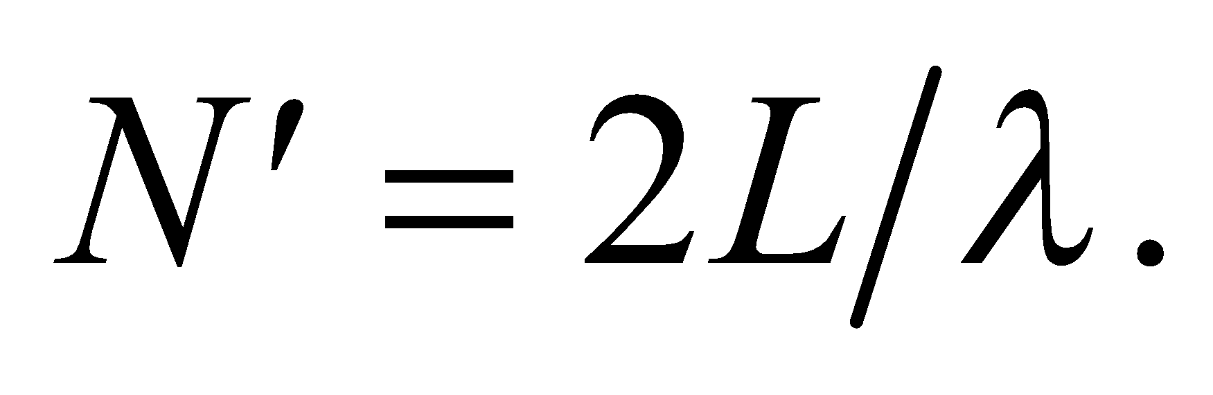
Evaluate The difference between the air length and the vacuum length, in number of wavelengths, gives the number of bright fringes observed. Therefore, we can solve for the index of refraction of air as follows:
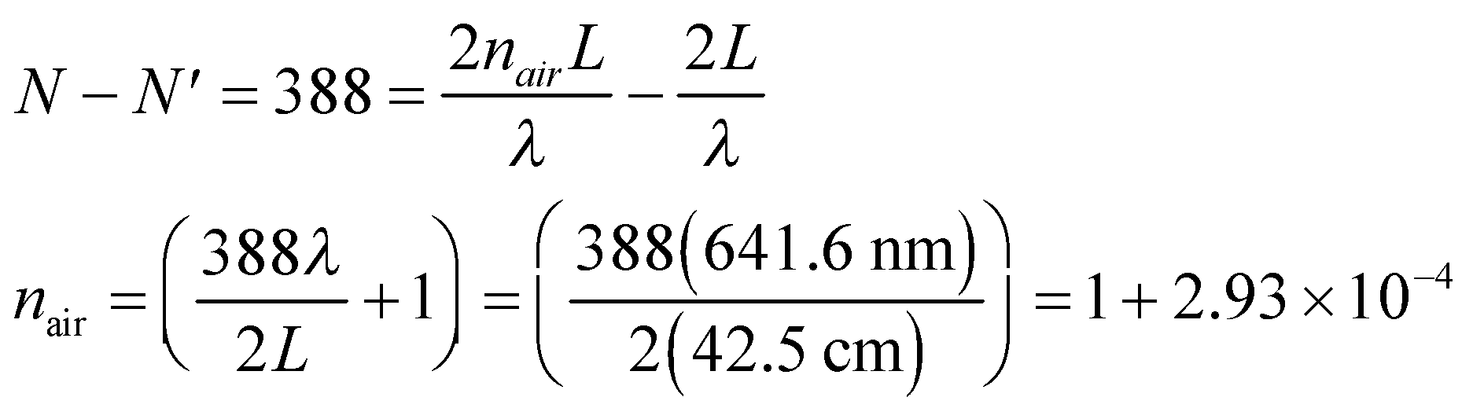
Assess This result agrees with published results dating from 2003.
56. Interpret This problem is about interference between incoming waves and reflected waves. We would like to adjust the path difference so that the interference is constructive.
Develop Consider the sketch of the situation below. If the incoming waves are roughly perpendicular to the wall, an additional path difference of 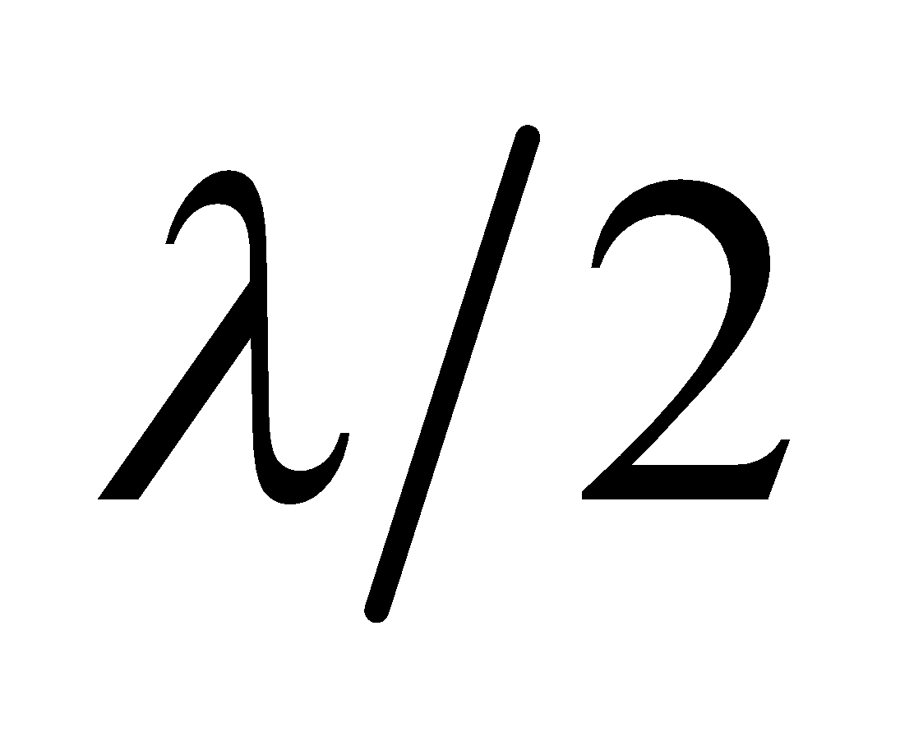 between the direct and reflected waves, corresponding to a radio receiver displacement of 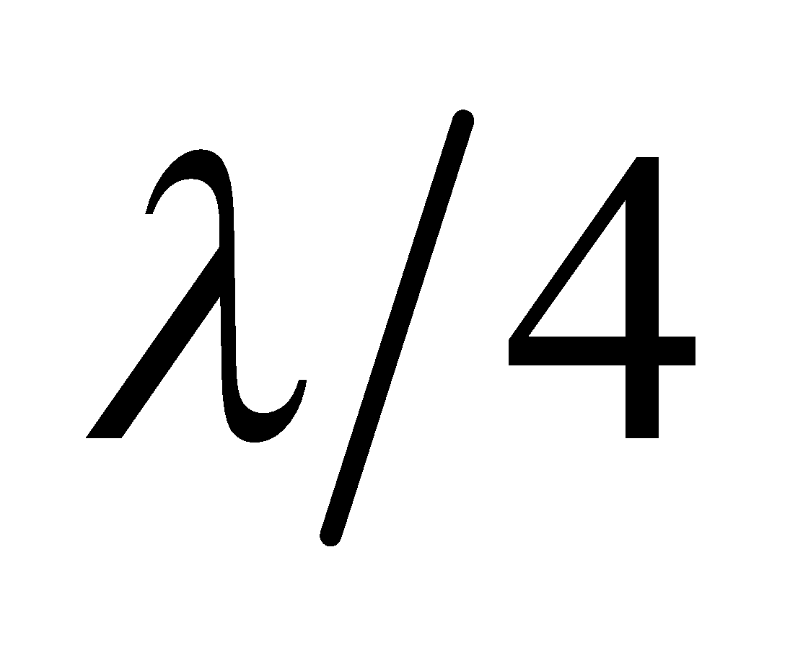 (the path difference of the waves is approximately twice the distance to the wall), will change an interference minimum into a maximum.

Evaluate Therefore, the distance you should move away from the wall is
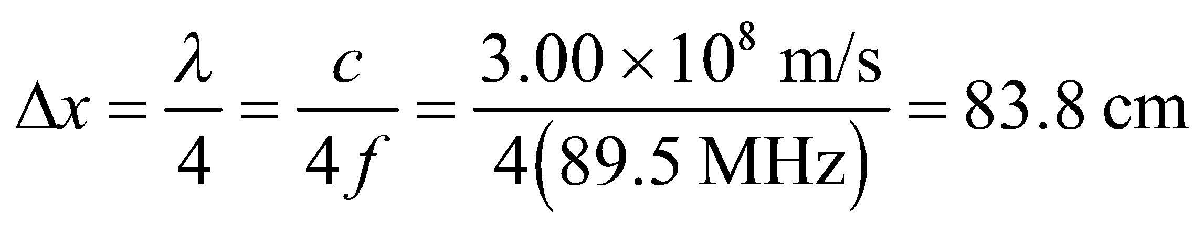
Assess The interference between the incoming and reflected signals is constructive when the path difference is an integer multiple of a wavelength, and destructive when it is an odd-integer multiple of a half wavelength.
57. Interpret This problem concerns the diffraction limit of an optical system. The optical system consists of a circular concave mirror. The system has circular symmetry, so we can use the Rayleigh criterion for circular apertures.
Develop To resolve a spot of 50-cm diameter at a distance of 2500 km, the necessary minimum angle to resolve is
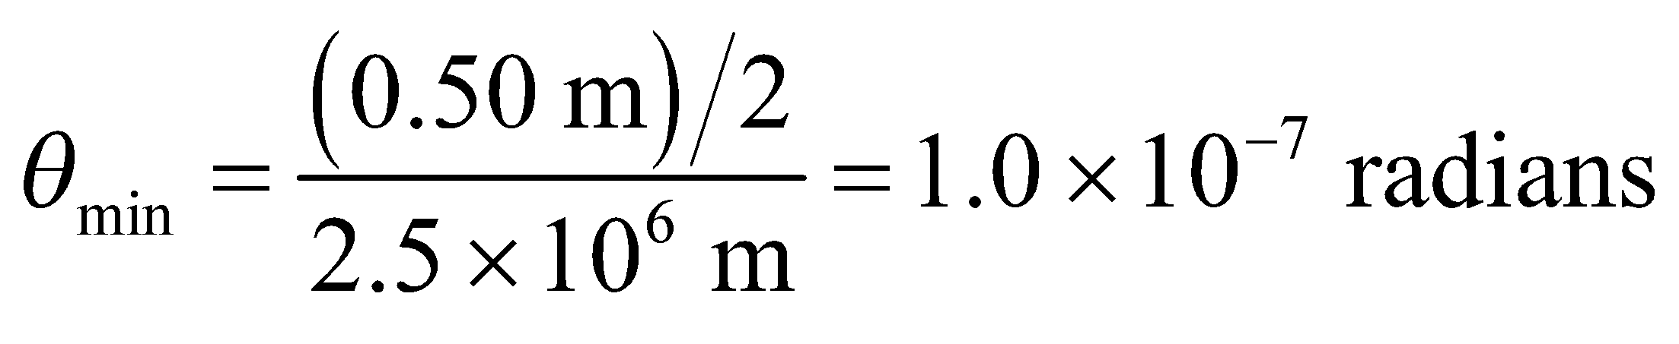
The circular mirror constitutes a circular aperture for the optical system, so the minimum resolvable source separation is given by the Rayleigh criterion for circular apertures (Equation 32.11b). We can insert θ_{min} into this expression and solve for the minimum mirror diameter.
Evaluate The minimum mirror diameter is
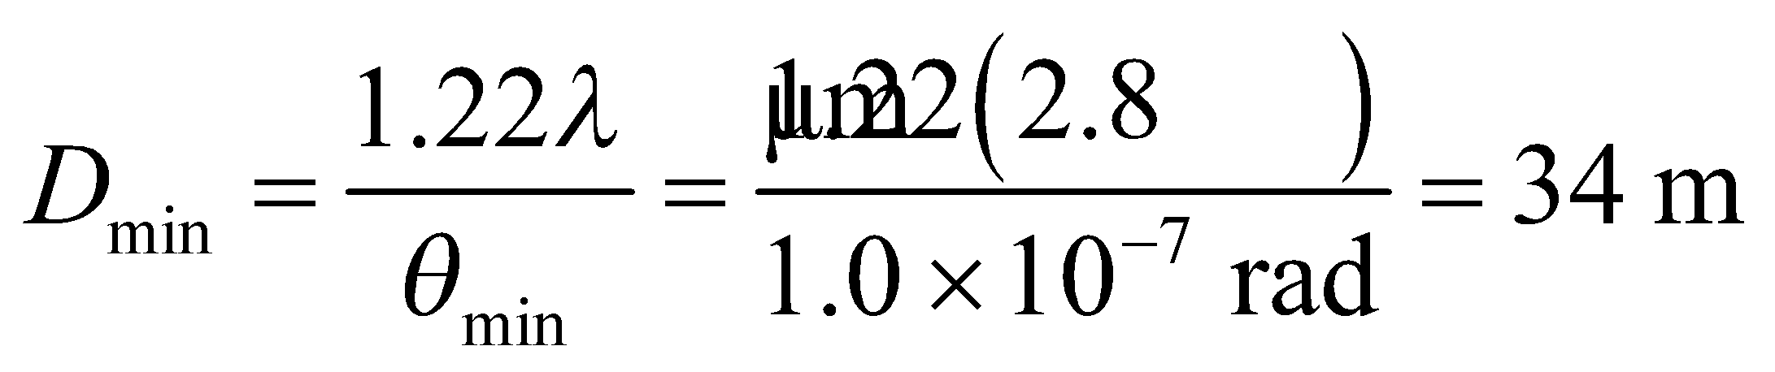
Assess This is a very large mirror, especially considering the wavelength for which it is to be used. Note that we use the spot radius in determining θ_{min}. This is because this angle is defined using the distance from the maximum of the central peak to the first diffraction minimum (see Figure 32.7 and accompanying discussion).
58. Interpret This is a problem about the diffraction limit with a circular aperture.
Develop If one of the Keck telescopes were diffraction-limited while observing with 550-nm light, its maximum resolution would be
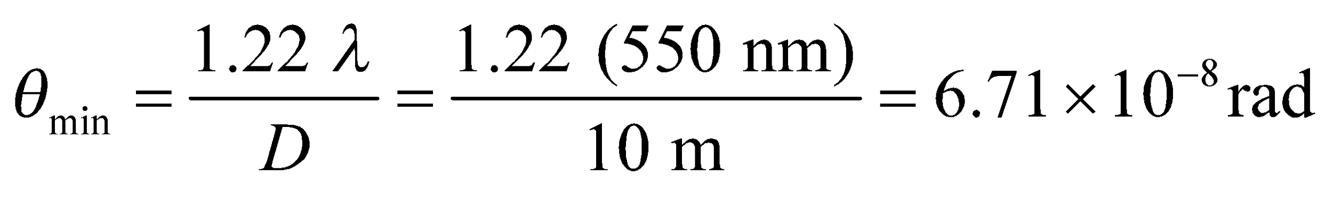
At the distance of San Francisco, resolving objects requires a separation of at least
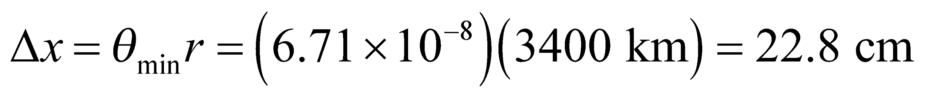
We will assume that letters that are bigger than this can be read with the telescope.
Evaluate (a) A newspaper headline might be a few centimeters high, so it would not be possible to read anything like that with a single Keck telescope.
(b) A billboard may have letters that are 50 cm tall or more, so it might be possible to read the sign.
(c) The effective aperture is 5 times wider, so the minimum angle is reduced by a factor of 5. That means letters that are about 4.6 cm tall can be resolved, so it might be possible to read very large headlines in San Francisco from Hawaii.
Assess We're assuming the telescope is diffraction limited, but atmospheric turbulence would reduce the resolving power.
59. Interpret We are to find the smallest spot that can be focused by the given lens system. Because the lens is circular, we shall apply the Rayleigh criterion for circular apertures.
Develop The diffraction limit for a lens opening of diameter D, focusing light of wavelength λ is given by Equation 32.11b (the Rayleigh criterion for circular apertures):
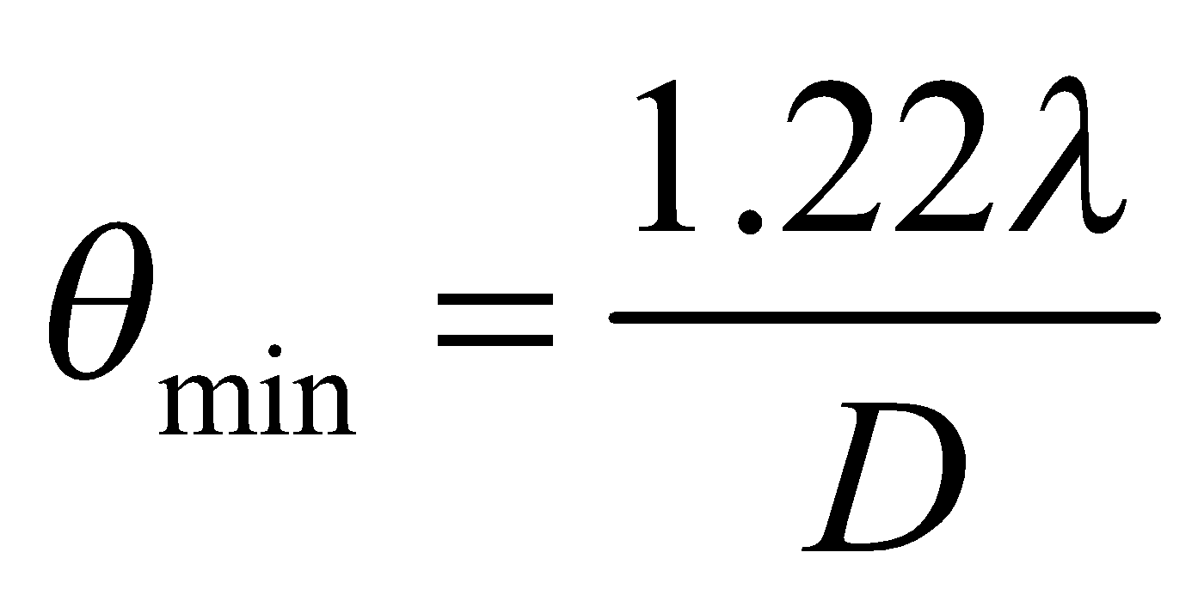
The radius of a spot, at the focal length of the lens, with this angular spread, is r = fθ_{min} (the spot radius equals the distance between the central maximum and first minimum; see Figure 32.7 and accompanying discussion). The minimum spot diameter is therefore d = 2r = 2 fθ_{min}.
Evaluate Inserting the given quantities gives
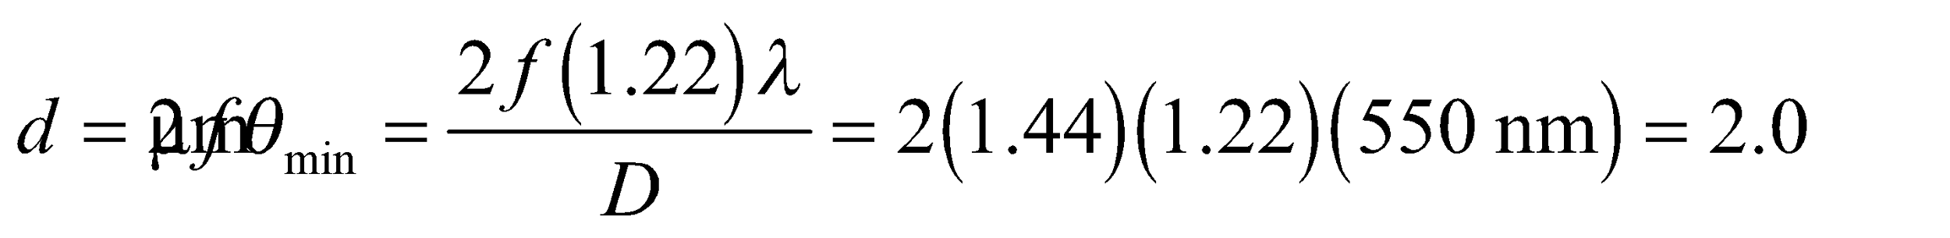
Where we have used f/D = 1.44, as given in the problem statement.
Assess This resolution is good enough for most commercial cameras.
60. Interpret You want to estimate the size of a spy satellite given the smallest features it can resolve on the ground.
Develop The altitude of the satellite, h, is so high that the angular separation between two objects on the ground is just: 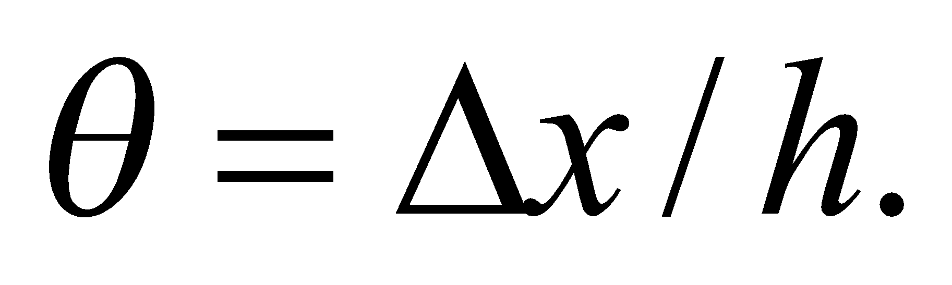 You can therefore estimate the minimum diameter of the camera's mirror or lens to be:
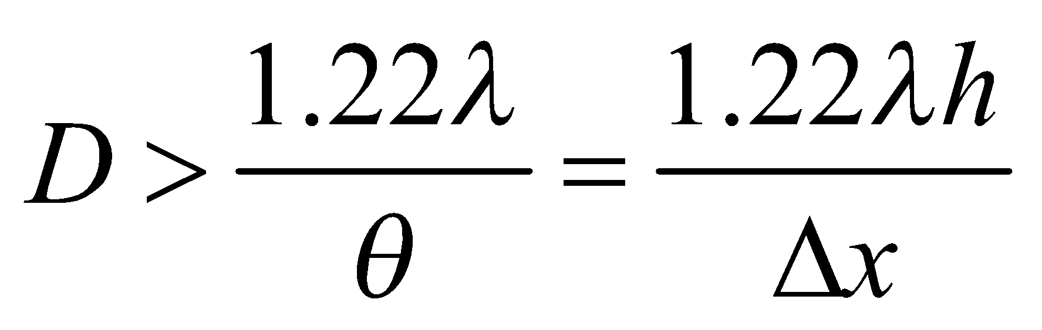
Evaluate Assuming 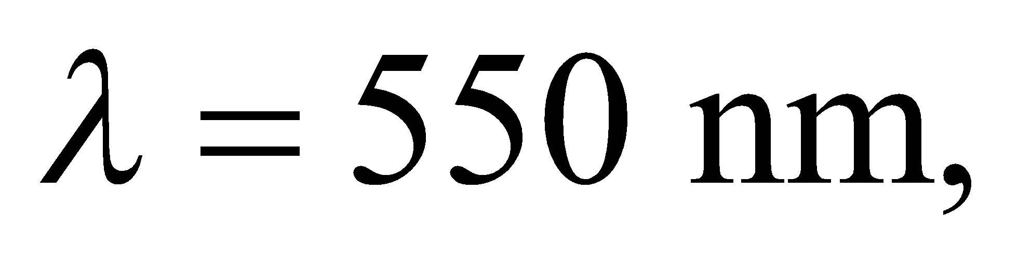the minimum diameter is
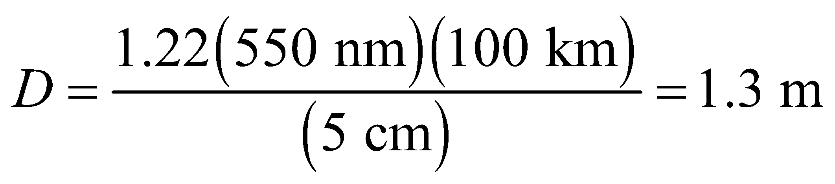
Because of the uncertainties, the most that you can probably say is that the satellite's mirror or lens is slightly more than 1-m-wide.
Assess Most optical systems this big use mirrors rather than lenses as the primary light collector. Lenses have chromatic aberration due to the wavelength dependence of the refractive index. Moreover, a meter-wide lens would weigh much more than a similar-sized mirror, which is a big consideration for anything going up into space.
61. Interpret We are to determine the largest distance at which humans can resolve a pair of automobile headlights. Because human pupils are circular, the Rayleigh criterion for circular apertures applies.
Develop If we use the Rayleigh criterion (Equation 32.11b for small angles) to estimate the diffraction-limited angular resolution of the eye, at a pupil diameter of 3.1 mm and with light of wavelength 550 nm, we obtain
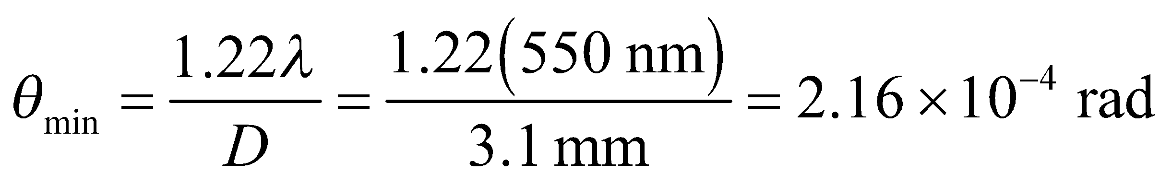
Evaluate This angle corresponds to a linear separation of y = 1.5 m at a distance of
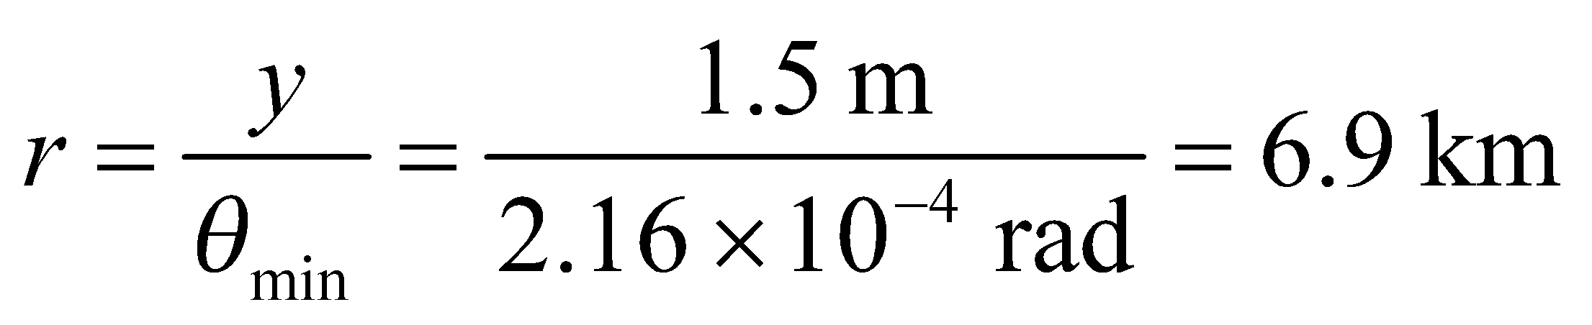
Assess Actually, the wavelength inside the eye is different (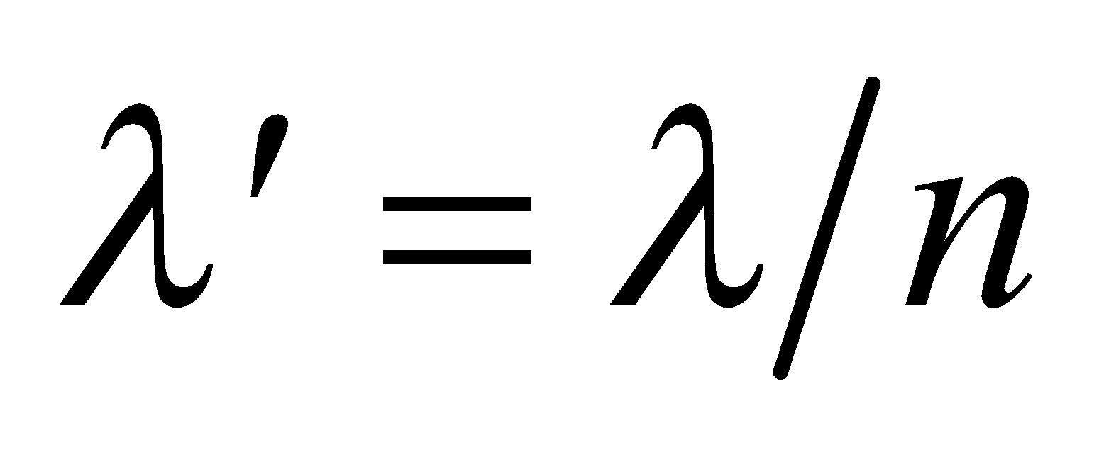) because of the average index of refraction of the eye. Even though other factors determine visual acuity, this is a reasonable ballpark estimate.
62. Interpret We are to compare the diffraction-limited resolution at 550 nm with the given limit due to atmospheric turbulence.
Develop Apply the Rayleigh criterion for circular apertures (Equation 32.11b), using
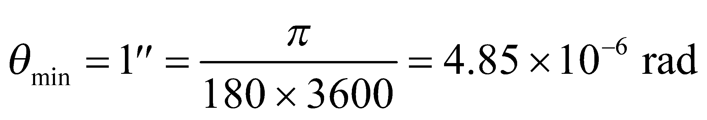
Evaluate The aperture satisfying the Rayleigh criterion at the given wavelength is
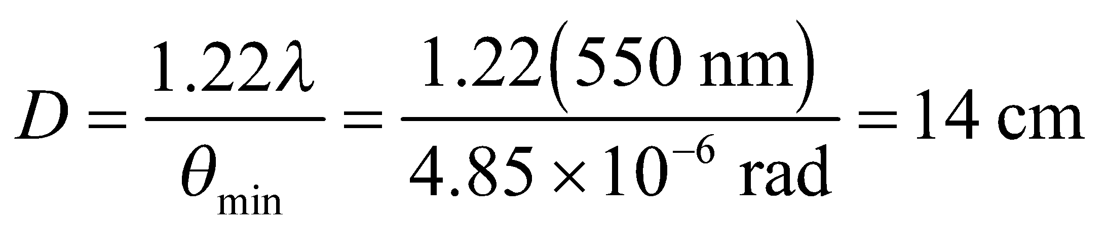
Assess The resolution of all larger-diameter ground-based telescopes is limited by atmospheric conditions at this wavelength.
63. Interpret The question is whether a microscope using ultraviolet light can resolve crystallized proteins.
Develop Suppose the minimum object size that your current optical microscope can resolve is
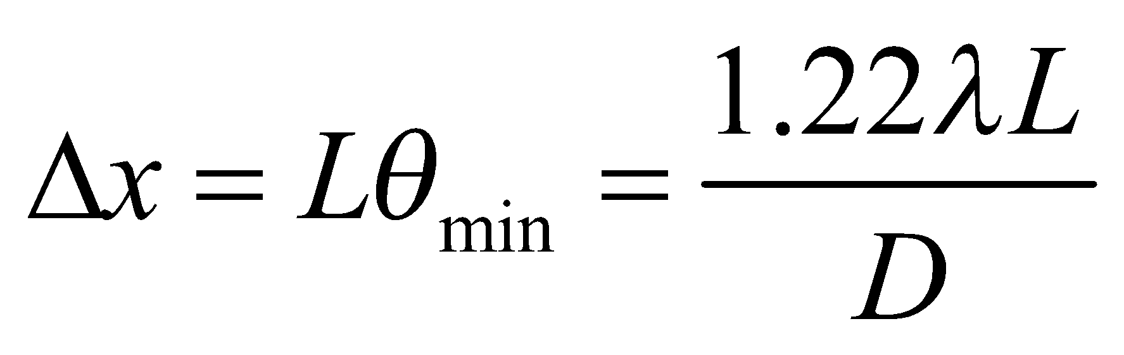
where L is the distance between the lens and the sample, and D is the microscope aperture. You can assume that the sales rep's UV microscope has roughly the same geometry, in which case 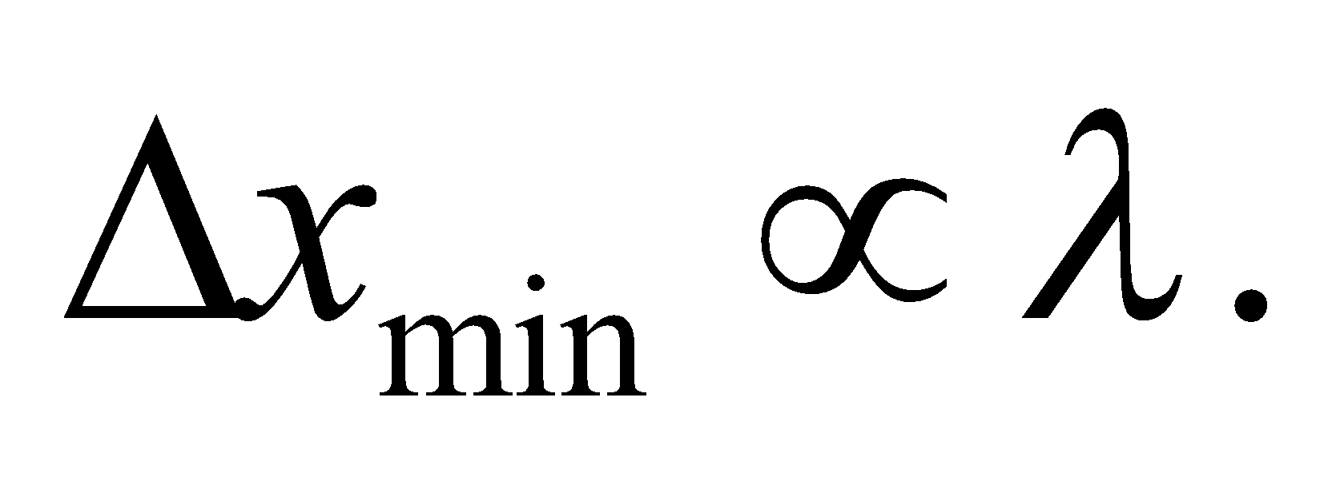
Evaluate You can assume your optical microscope uses the characteristic visible wavelength of 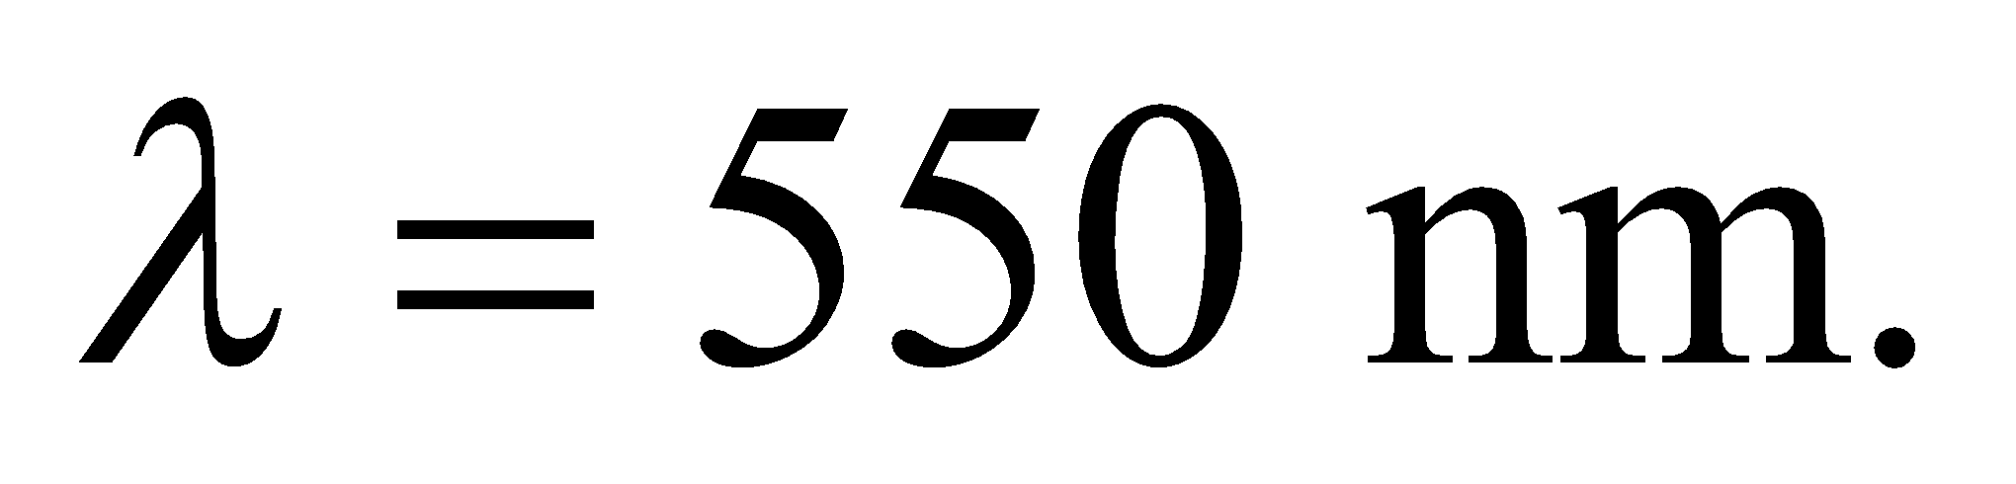 Therefore, the UV microscope using 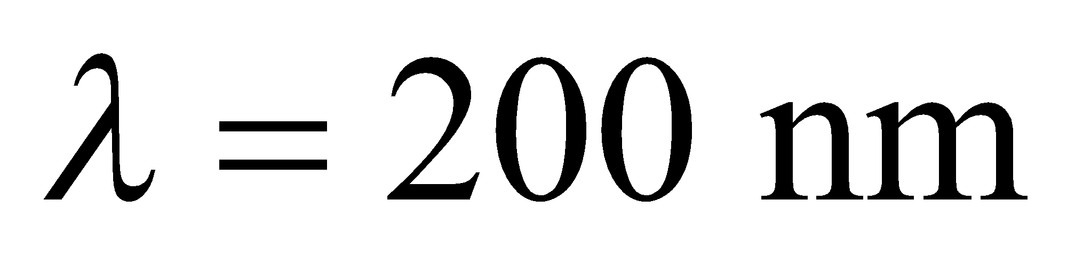will have about a factor of 2 better resolution:
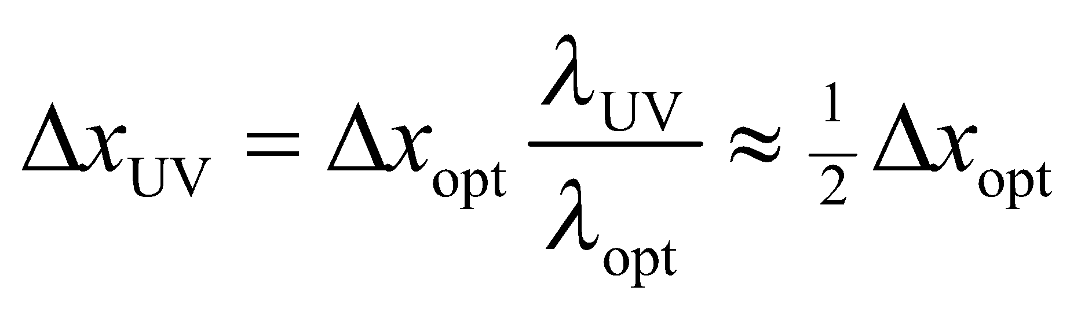
So, yes, the sales rep is apparently correct.
Assess In general, you can only resolve objects as big as the wavelength of the light that you are using. Proteins are typically only a few nanometers across, so most studies of crystallized proteins use x-ray diffraction with wavelengths between 0.1 and 10 nanometers.
64. Interpret We are to calculate the index of refraction of air by comparing the number of fringes in a wedge-shaped film of air trapped between two glass plates with the number of fringes with the air evacuated. The fringes are caused by alternating constructive and destructive interference as the film thickness varies along the wedge-shaped film.
Develop As shown in the solutions to Problems 32.51 and 32.52, the number of bright bands is the largest integer N less than or equal to 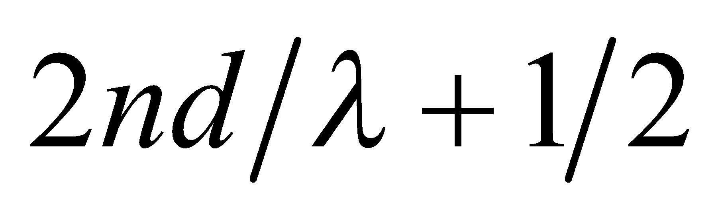, where d is the maximum wedge width. For air, this gives
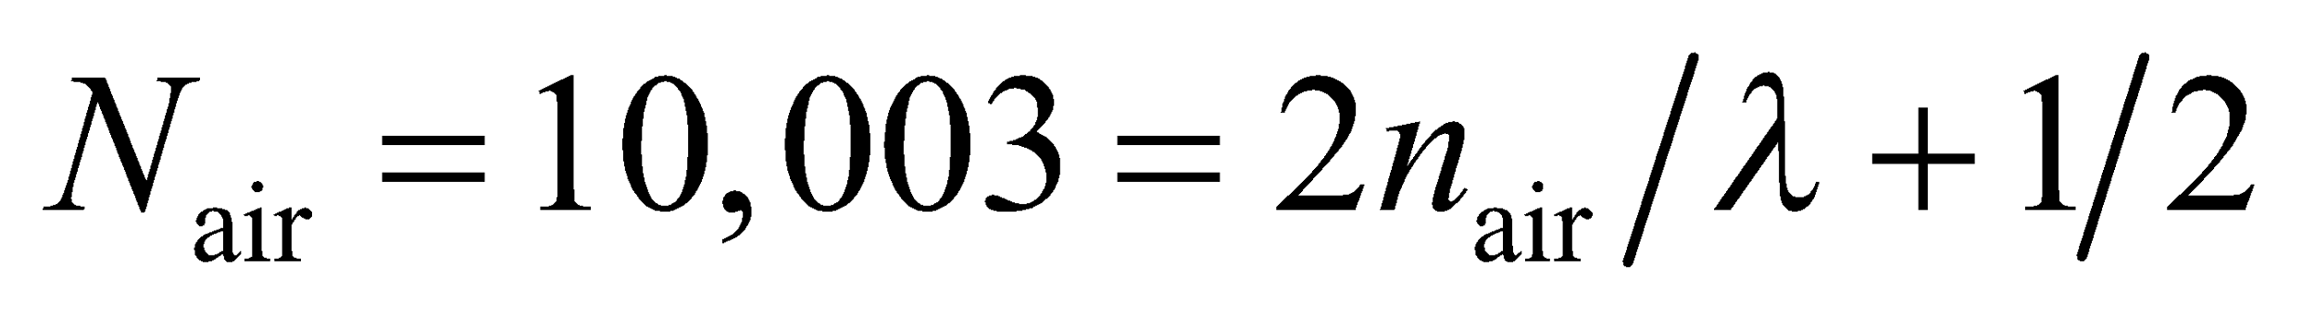
For vacuum, this gives

Where we have used 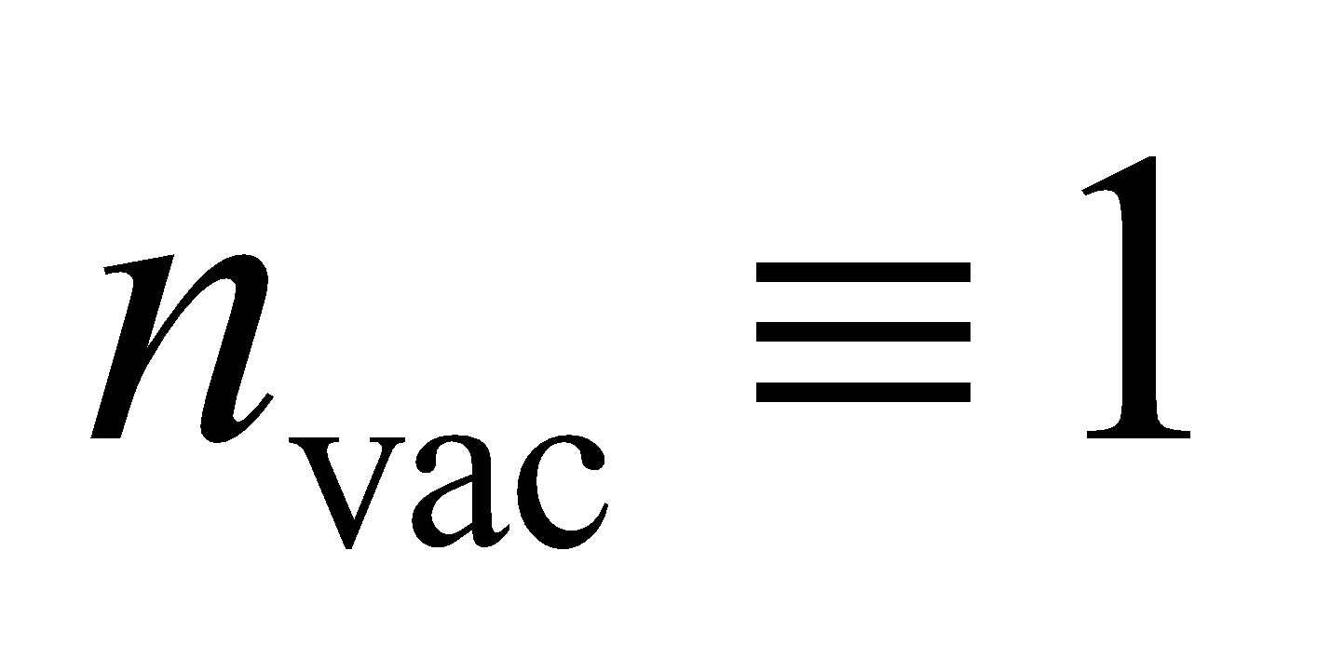.
Evaluate Solving this system of equations for n_{air} gives
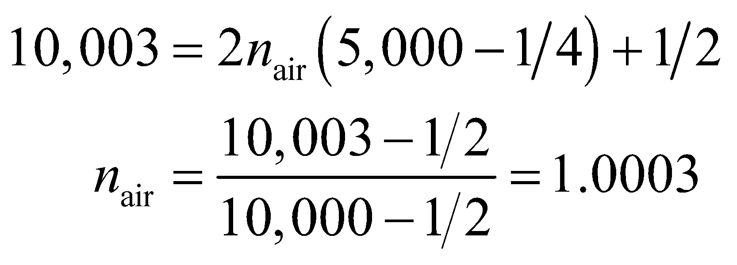
Assess Within the limit imposed by the precision of the data, this result agrees with published results.
65. Interpret We are to find an expression for the refractive index of a gas that is measured using a Michelson interferometer. We are given the difference in optical path length (i.e., the difference in the number of bright fringes) between a column of gas and an equal length of vacuum.
Develop The index of refraction in vacuum is defined to be unity. For light travelling through a gas, the wavelength of light depends on the gas through which it is travelling (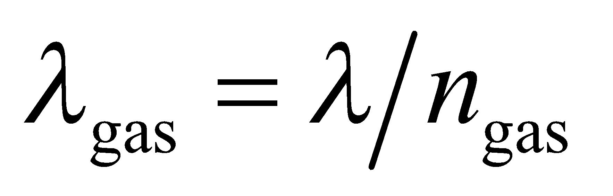; λ is the vacuum wavelength). Thus, there is a difference in the number of wave cycles in the enclosed interferometer arm when the
cylinder is evacuated or filled with gas. The light travels the length of the arm twice, out and back, and each cycle of difference results in one fringe shift. Thus, the number of fringes in the shift is
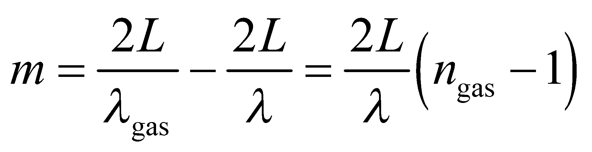
Evaluate From the above equation, the refractive index is
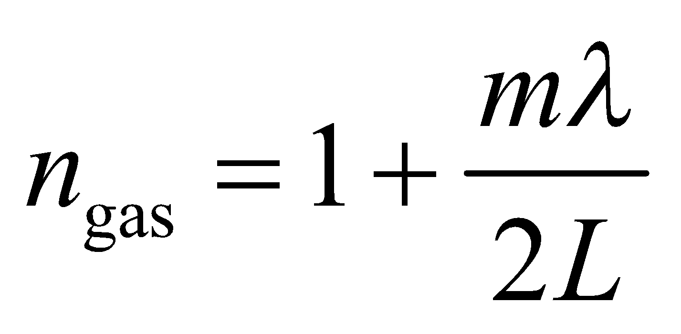
Assess The interferometer allows for the determination of the refractive index of a gas.
66. Interpret In this problem we want to verify the condition for maximum intensity when light is incident on a diffraction grating at an arbitrary angle.
Develop Consider the sketch below, which shows light incident on a grating at an angle α with respect to normal incidence. The path difference between the two rays incident on adjacent slits of the grating (A and B, with spacing AB = d) at an angle α with respect to the grating normal is 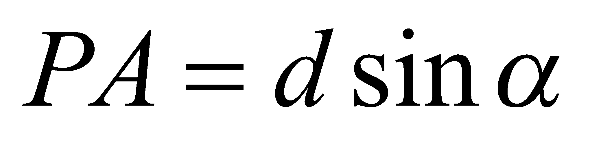. The path difference between corresponding outgoing rays making an angle θ on either side of the normal is 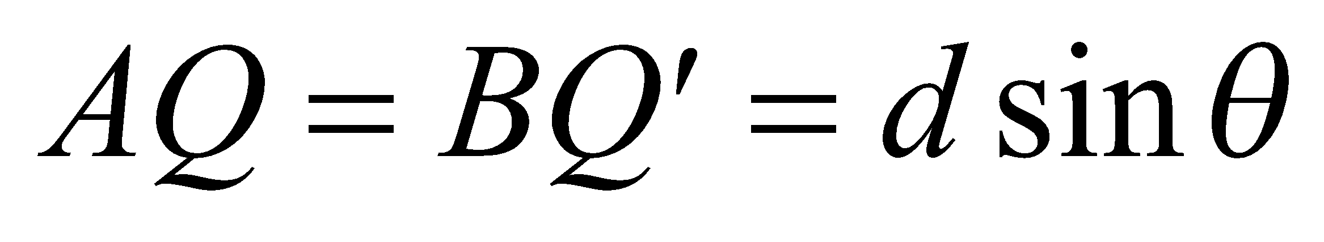. The total path difference is the sum (or difference) of these, depending on whether θ is on the same (or opposite) side of the normal as α (since we chose both angles to be positive).

Evaluate A maximum intensity occurs when the total path difference is an integral number of wavelengths,
or when
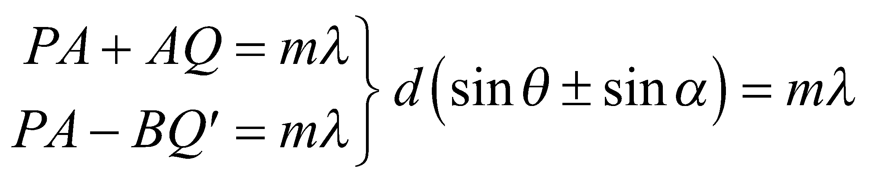
Assess When α = 0, we recover the usual condition given in Equation 32.1a.
67. Interpret We are asked to derive a formula for the interference pattern from Lloyd's mirror.
Develop The light reflecting off the flat mirror appears to be coming from a distance d below the surface, as shown in the figure below. Regarded in this way, the system is like a double-slit, with a slit separation of 2d. However, the difference is that there will be a 180° phase change at the point where the light reflects off the mirror (see Figure 32.12).

Evaluate Because of the extra 180° phase change, the direct and reflected beams of light will constructively interfere when their path lengths are an odd-integer multiple of half-wavelengths: 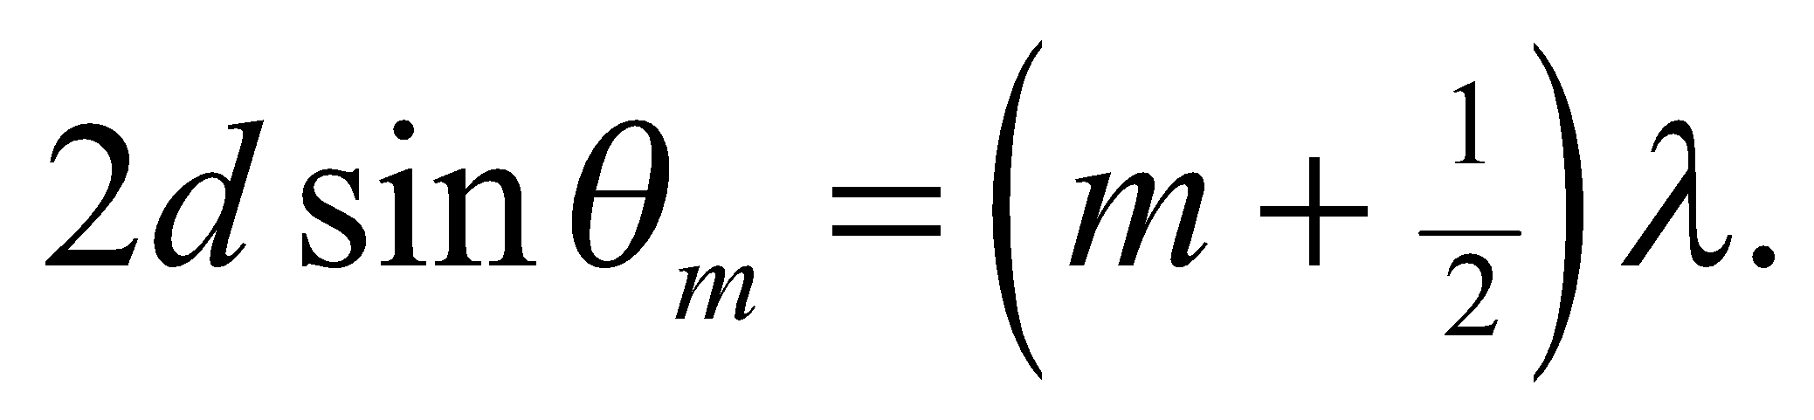 Therefore, the separation between fringes on the screen will be
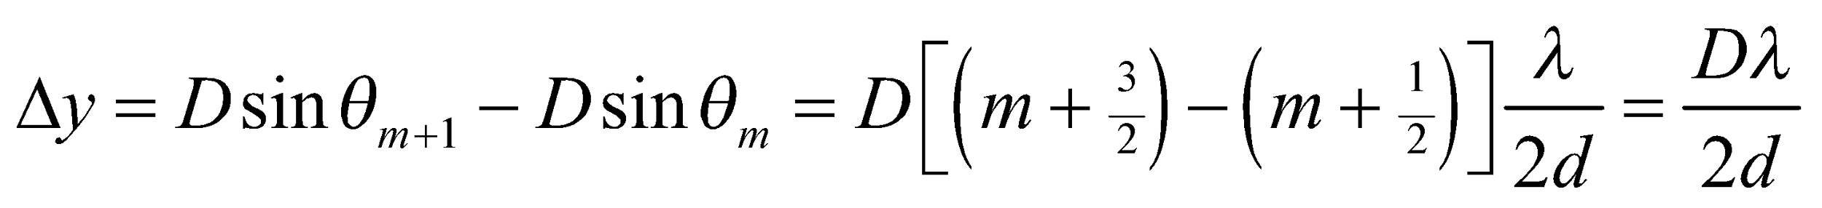
Assess This is the same separation between fringes as when the light is separated by two slits. All that is different is that the bright fringes in the Lloyd's mirror setup occur at the points of the dark fringes in the double-slit experiment.
68. Interpret We are to derive Equation 32.10 using calculus and geometry. We shall base our derivation on Figure 32.21.
Develop The electric field due to the light coming from a section of slit of width dy at position y in the slit will be the electric field at that portion of the slit multiplied by the phase factor. There are two contributors to the phase factor: the oscillation of the field in time and the distance the light has traveled from the section of slit. So
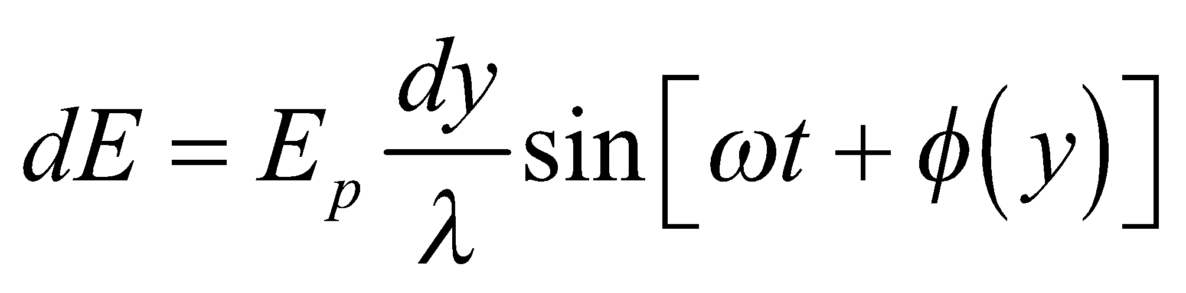
where the term 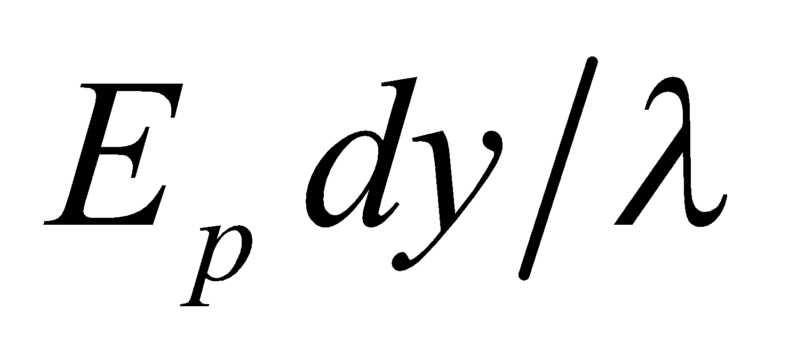 is the field originating at point y, and 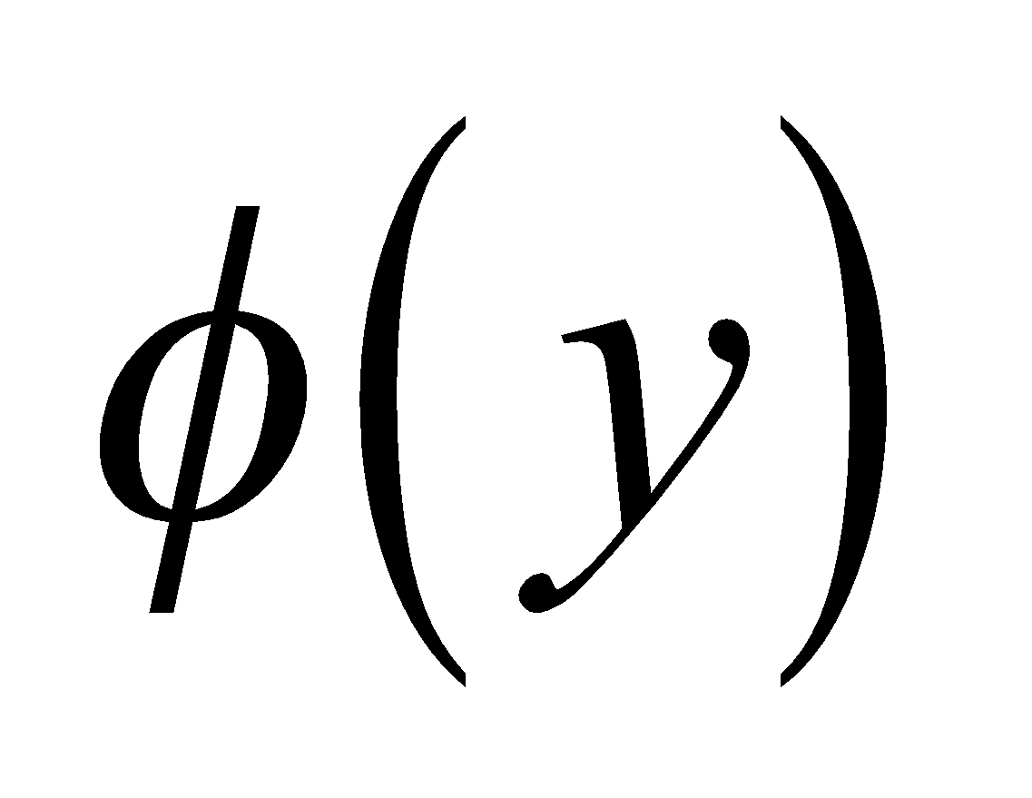 is the phase angle due to the distance. We will find and integrate over the entire slit to derive Equation 32.10.
Evaluate (a) The path length difference δ for different rays in Figure 32.21, as a function of y, is 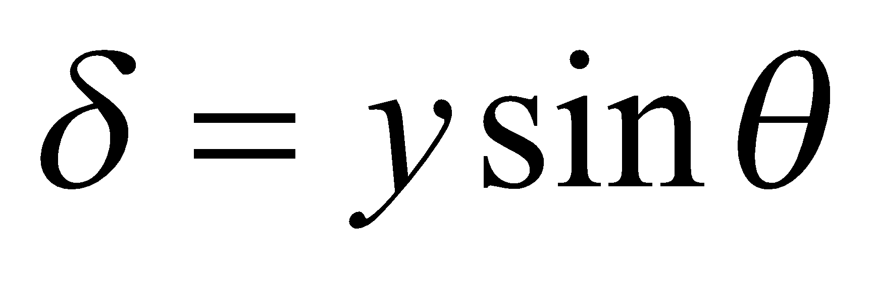.
This path length difference is to the wavelength as the phase difference φ is to 2π, so
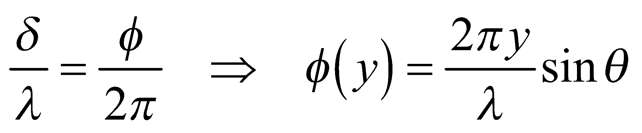
which is what we were to show.
(b) We integrate dE from 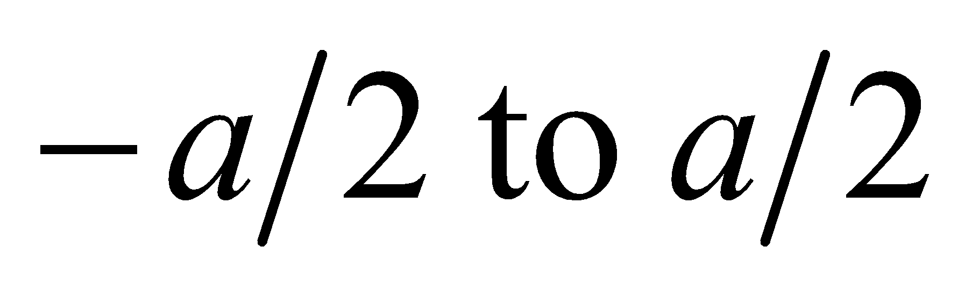:
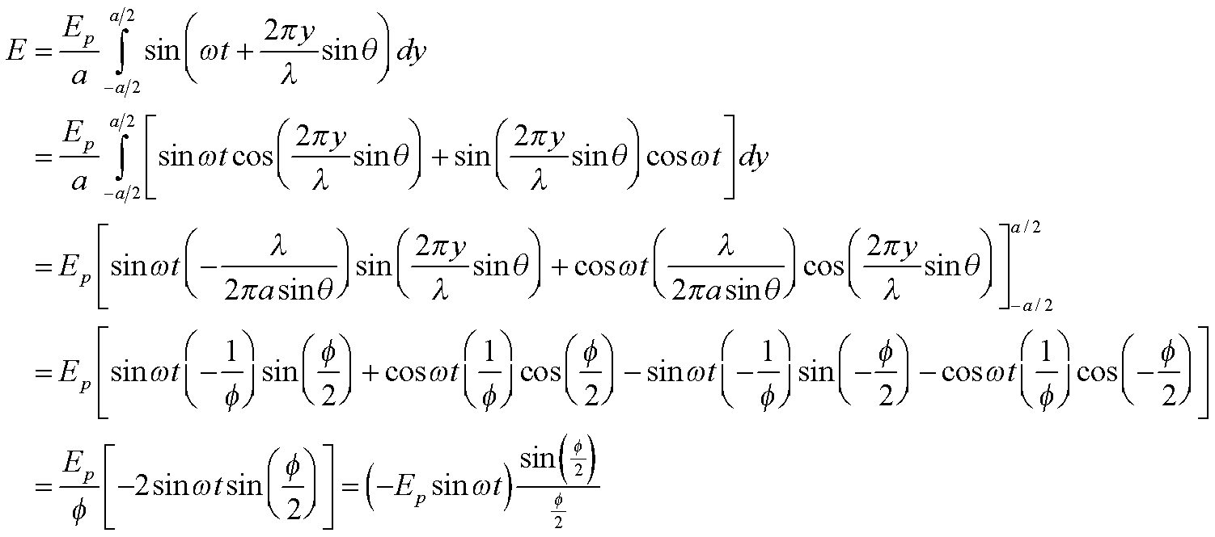
Where we have defined 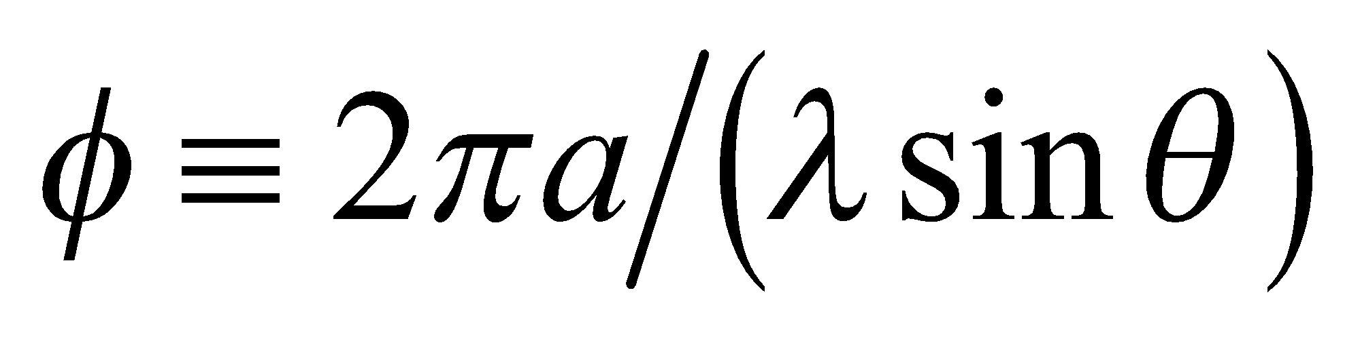. The light intensity is proportional to the square of the electric field, so
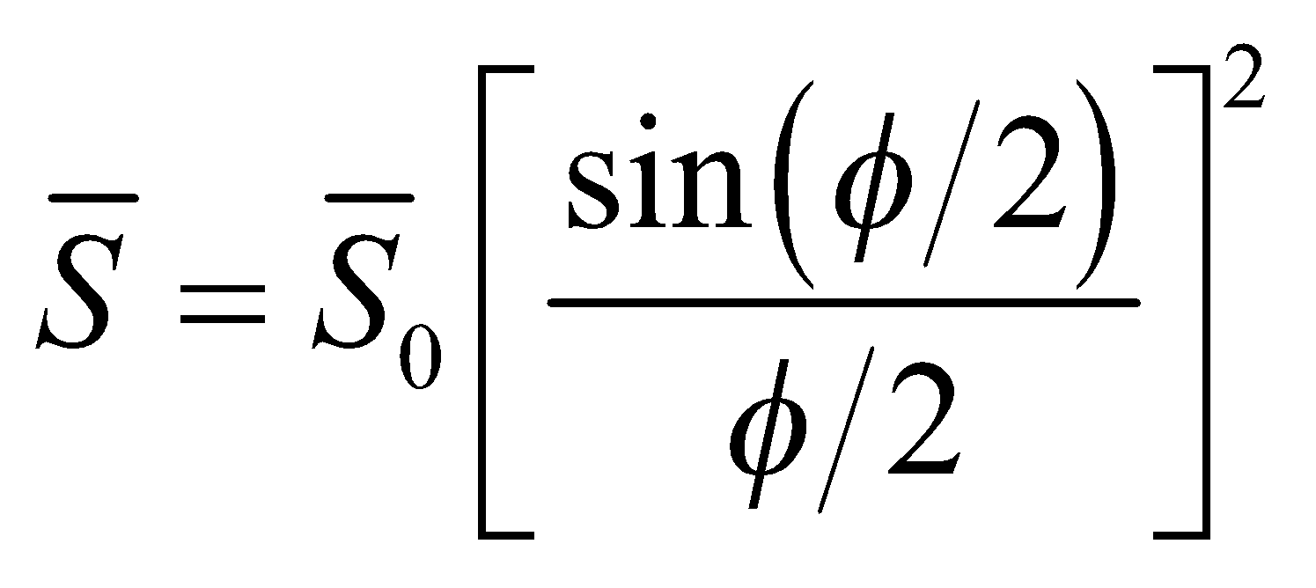.
Assess The function 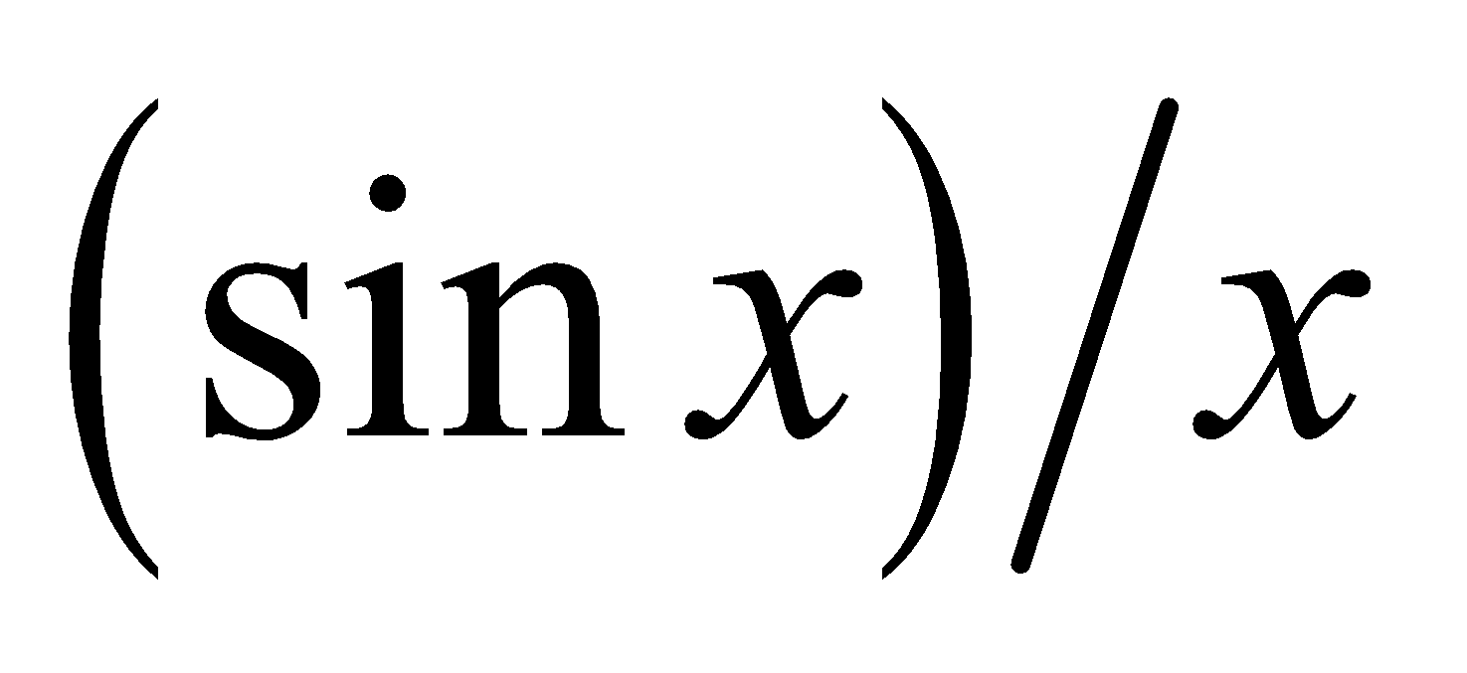is also called the “sinc” function: 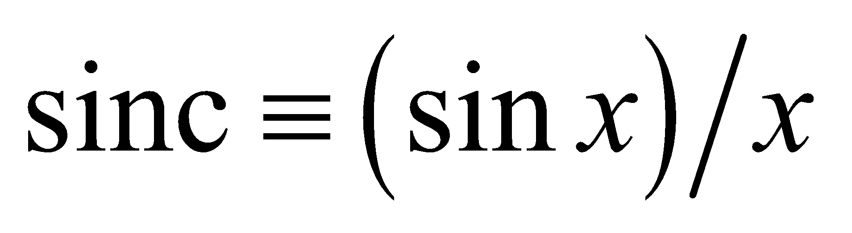. You will frequently see things written in this form in more advanced optics texts, should you have opportunity to study this field further.
69. Interpret In this problem we will use the Rayleigh criterion to determine what angular spacing can be allowed between communications satellites. With this value of angle, we can find the number of satellites allowed in geosynchronous orbit before their signals begin to overlap.
Develop The Rayleigh criterion for circular apertures (Equation 32.11b) is 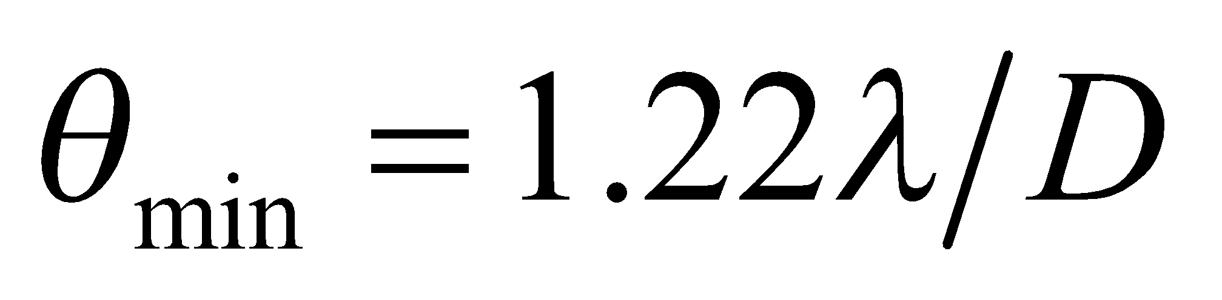, where the wavelength is
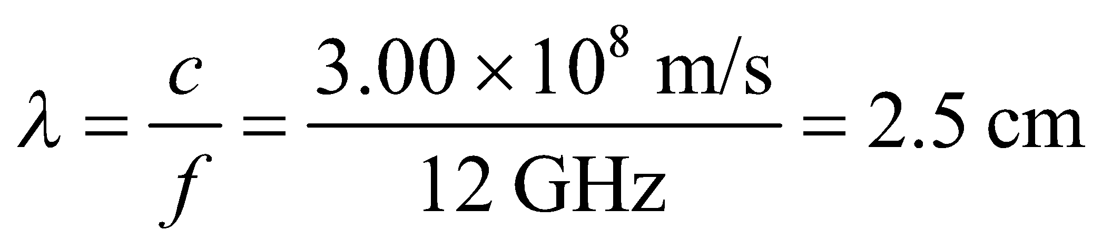
and the diameter of the satellite receiver is D = 45 cm. The number of satellites that can fit in a circle, with this angular spacing between satellites, is 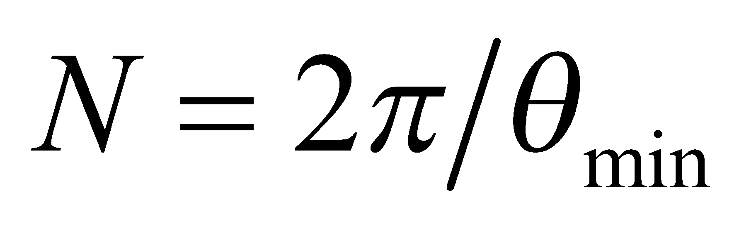.
Evaluate The maximum number of satellites is
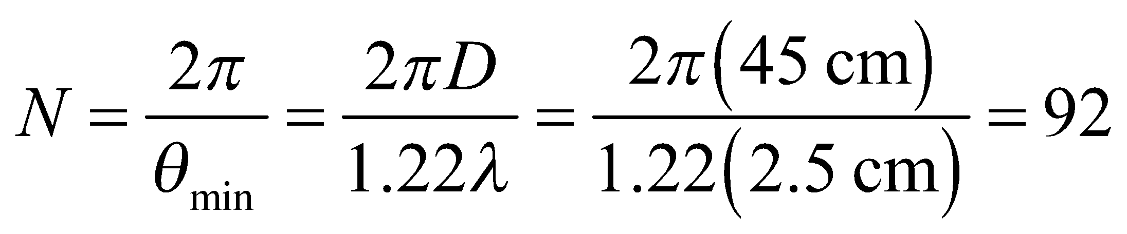
when rounded down to the nearest integer.
Assess This seems rather low, but calculating 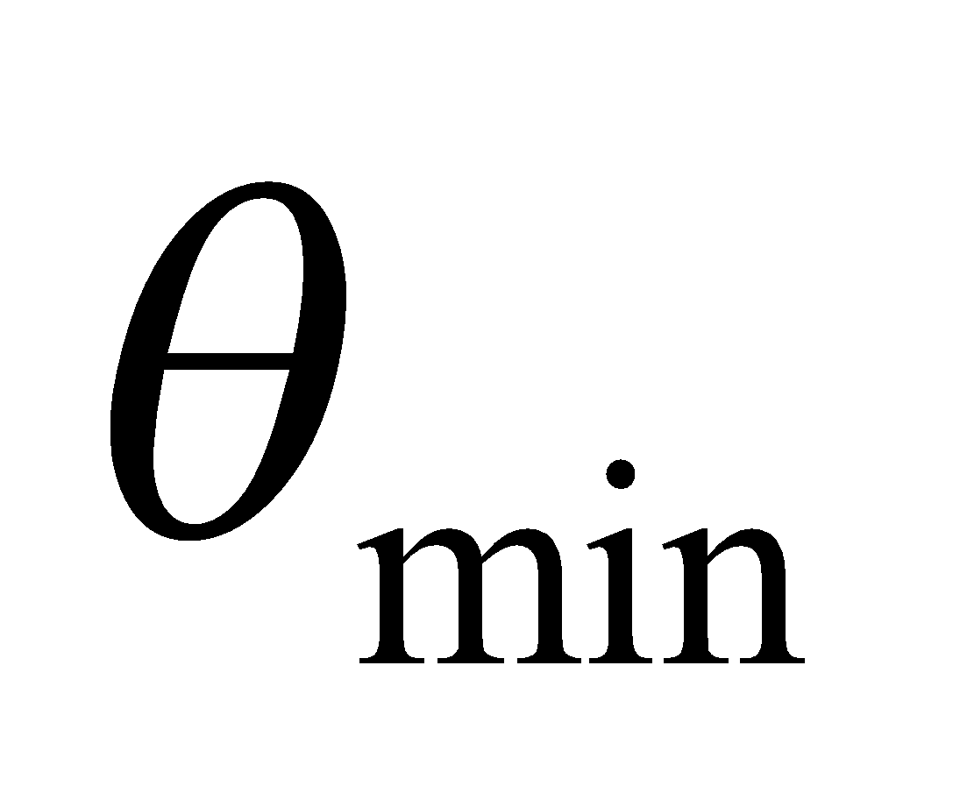 directly gives us an angle of 3.9°, which is consistent. We can pack more in by using shorter wavelengths or larger antennae.
70. Interpret You are trying to estimate the thickness of an oil spill from the interference pattern that you measure in reflected light.
Develop Some of the light reflects off of the air-oil interface, where it experiences a 180° phase change, since the index of refraction is going from lower 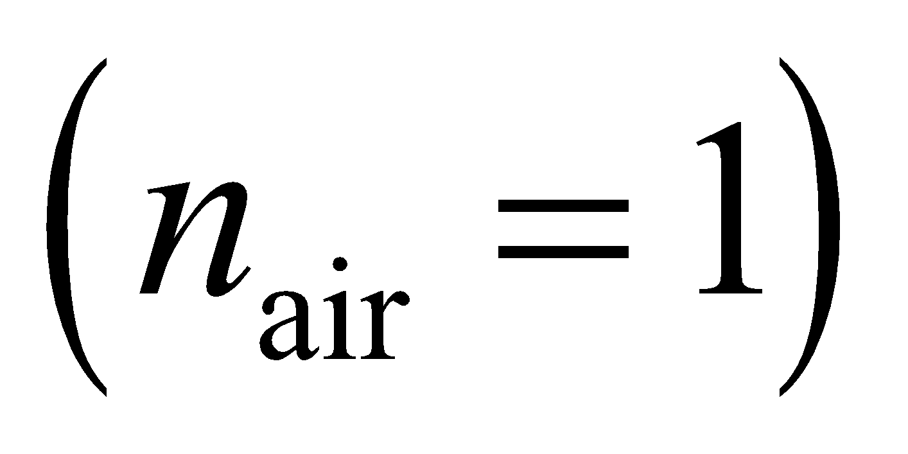 to higher 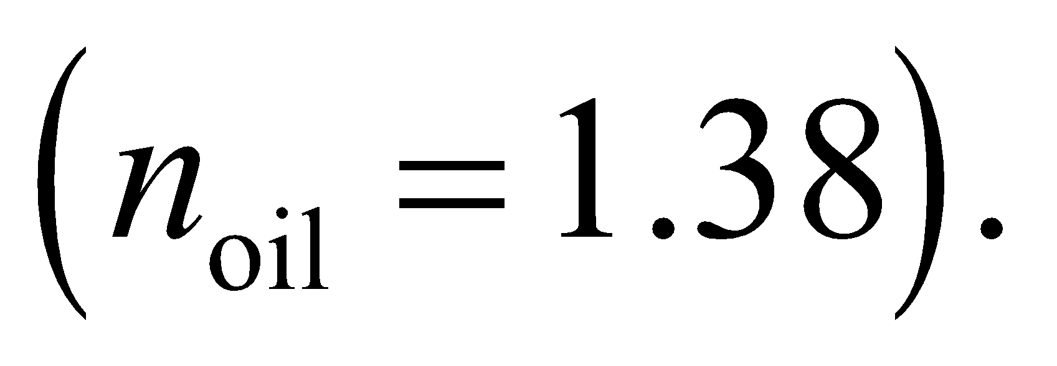 Some of the light also reflects off of the oil-water interface, but here there is no 180° phase change, since the index of refraction is going from higher 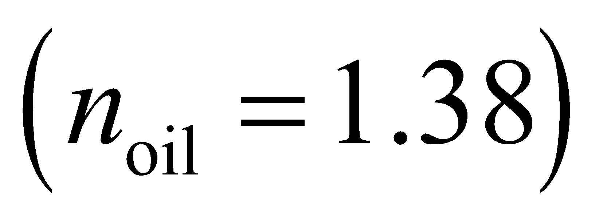 to lower 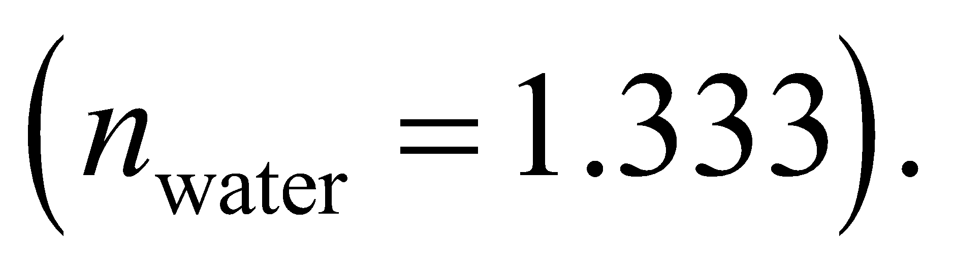 Therefore, the situation is the same as in Figure 32.12, and constructive interference will occur when 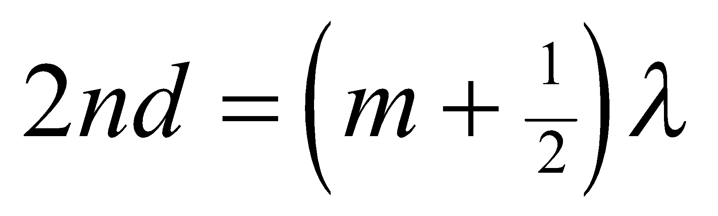 (Equation 32.7).
Evaluate If the brightest wavelength in reflection is 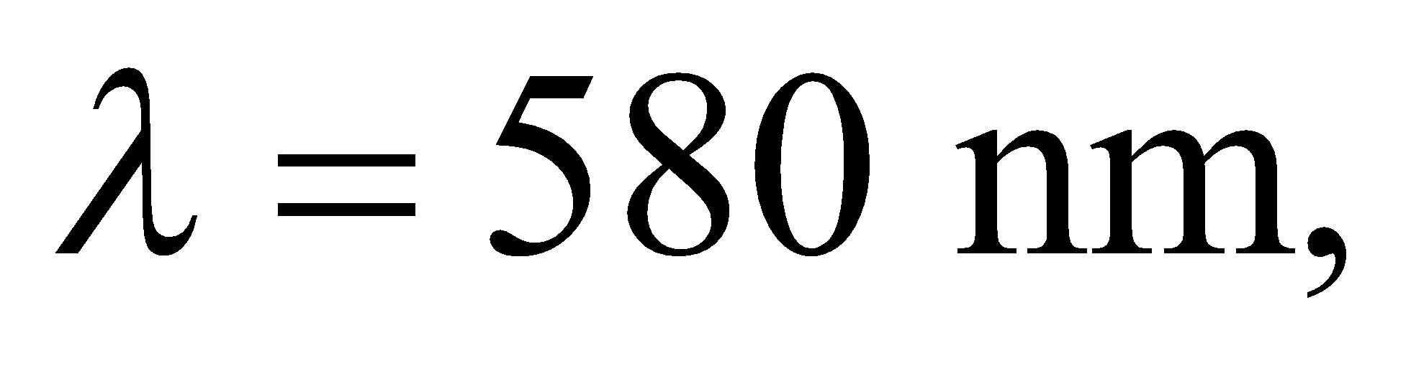 and you assume this corresponds to 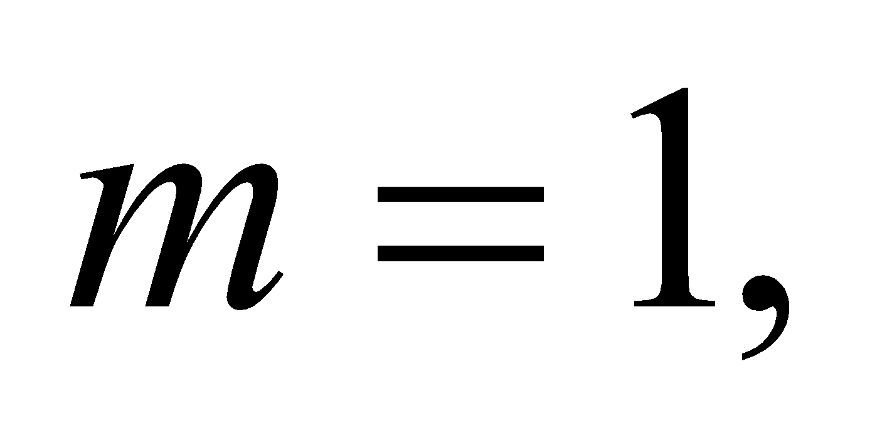 then the oil film's thickness must be
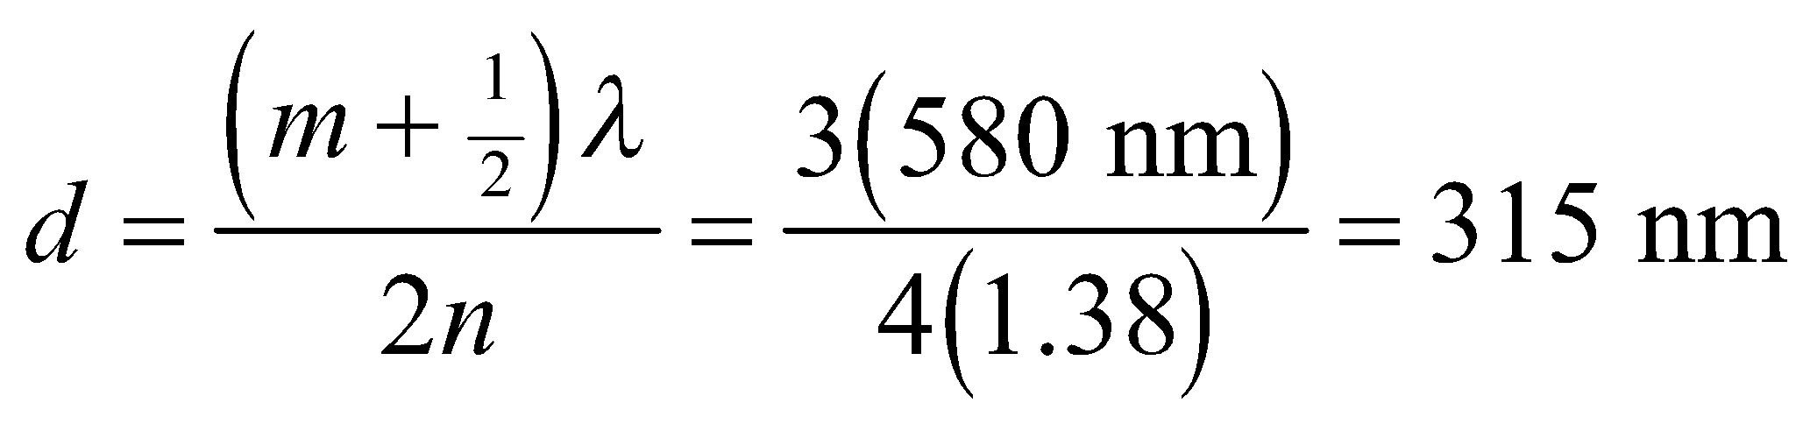
Assess This might seem too thin, but it's a reasonable thickness for an oil spill. At this thickness, one can estimate how much area a gallon of oil would cover:
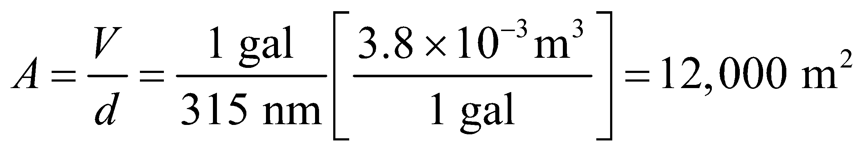
This is about 3 football fields!
71. Interpret We explore how interferometry can increase angular resolution in astronomy.
Develop We are told that interfering the signal of two telescopes will give the resolution of a single telescope with aperture equal to the distance between the two telescopes, i.e. 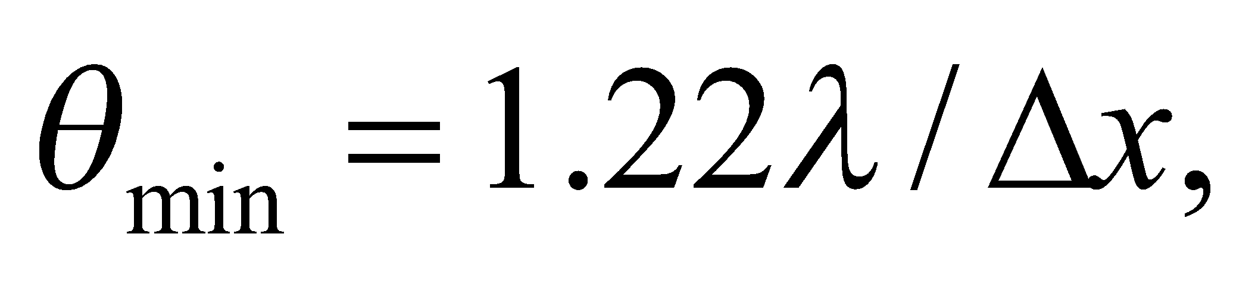 where 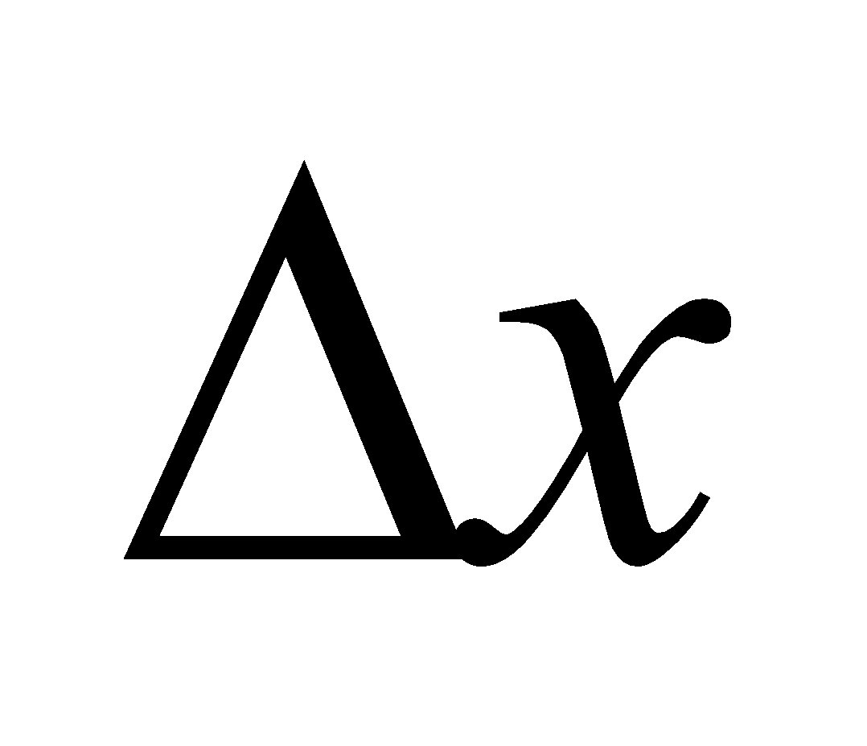is the telescope separation.
Evaluate Doubling the distance between the two telescopes should reduce by half the minimum angular separation that can be resolved.
The answer is (c).
Assess Astronomers use arrays of radio telescopes with individual elements separated by 10s of meters to 1000s of kilometers. The largest arrays can obtain milliarcsecond angular resolution, which is less than a millionth of a degree.
72. Interpret We explore how interferometry can increase angular resolution in astronomy.
Develop The amount of light collected will be proportional to the sum of the areas of the individual telescopes.
Evaluate Doubling the distance between the two telescopes does not have any effect on the areas of the telescopes, so there will be no change in the light-collecting power.
The answer is (a).
Assess Interferometry does not generally allow astronomers to see objects fainter than can be observed with a single telescope. It only gives them better angular resolution of relatively bright objects in the sky. To see deeper into space, the telescope collecting area has to be increased.
73. Interpret We explore how interferometry can increase angular resolution in astronomy.
Develop For a point source directly above an interferometer, the light path to each telescope will be the same.
Evaluate The phase difference is proportional to the path length difference, which in this case is zero. Therefore, the electromagnetic waves will be in phase.
The answer is (a).
Assess This answer is independent of the telescope separation or the wavelength being observed. The signals from a source on the bisector between two telescopes will always be in phase. It's a bit like the fact that the zeroth 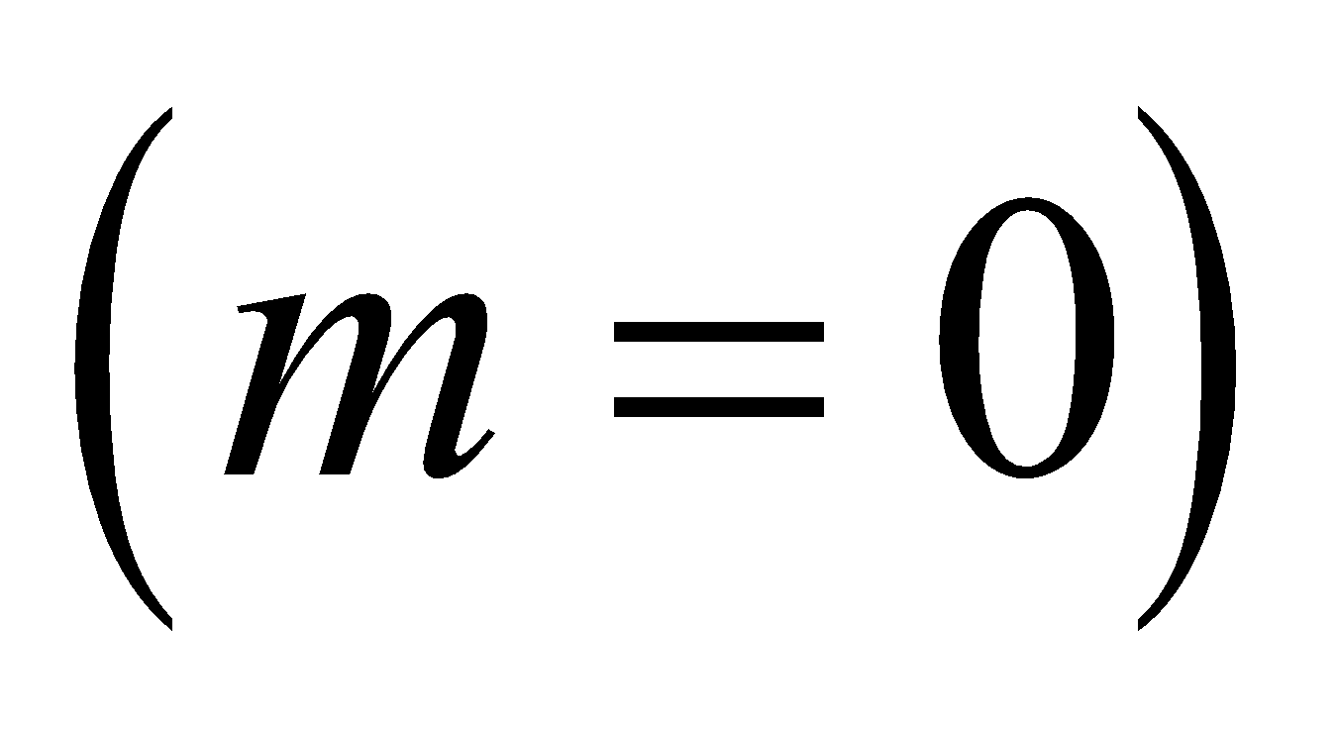 order of a double-slit is always a bright fringe, since the path lengths from the two slits are equal along the bisector between them.
74. Interpret We explore how interferometry can increase angular resolution in astronomy.
Develop In this case, the path length difference to each telescope will be 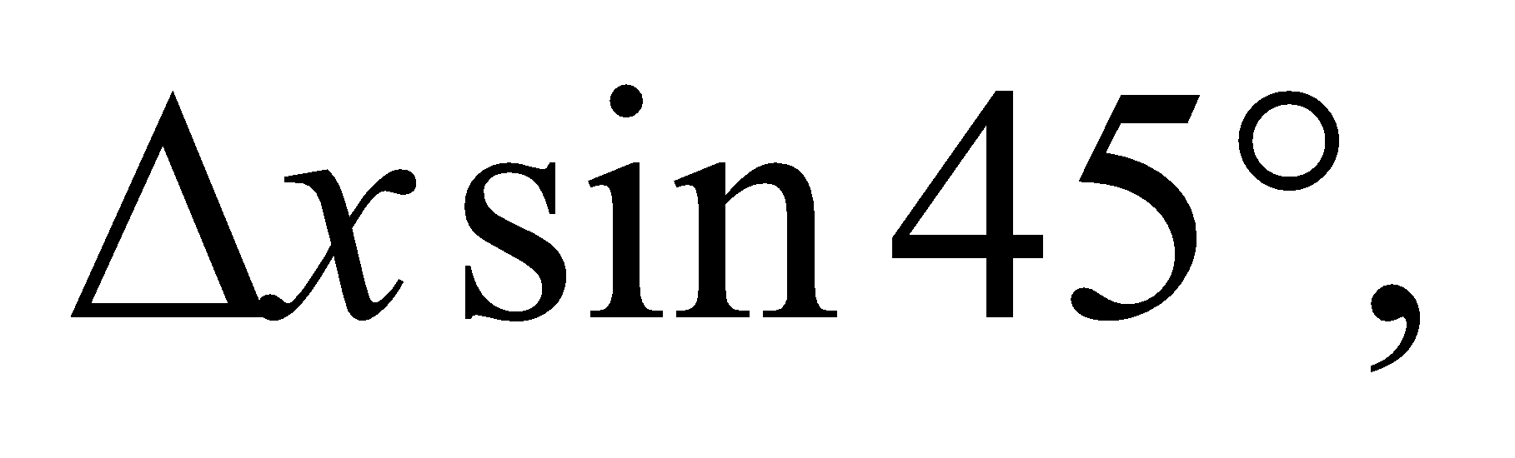 where is the telescope separation. This leads to a phase difference in the electromagnetic wave signals received by each telescope:
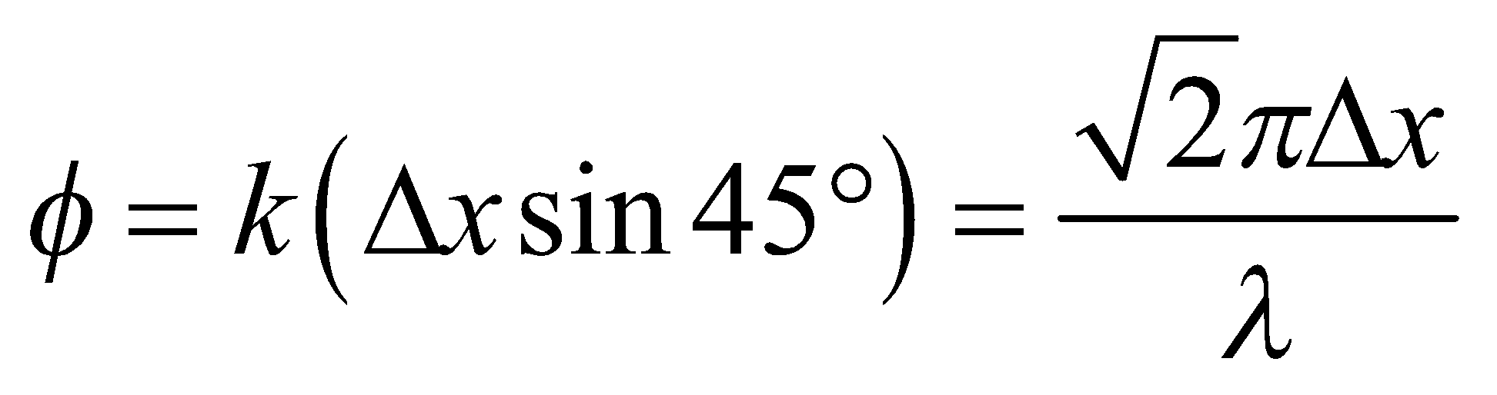
where we have used 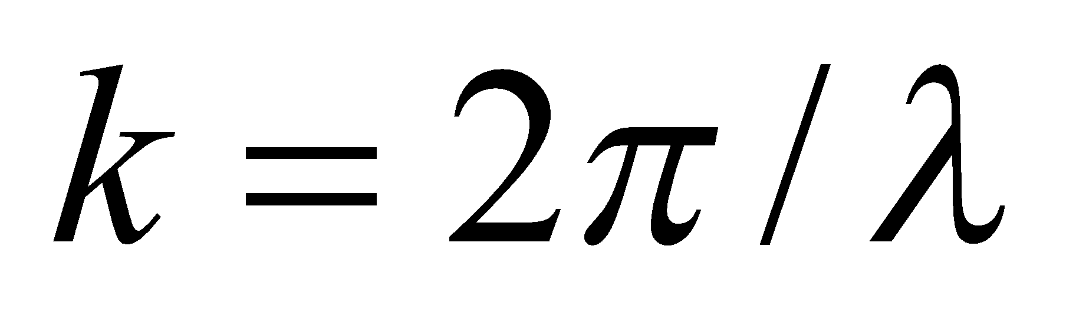 and 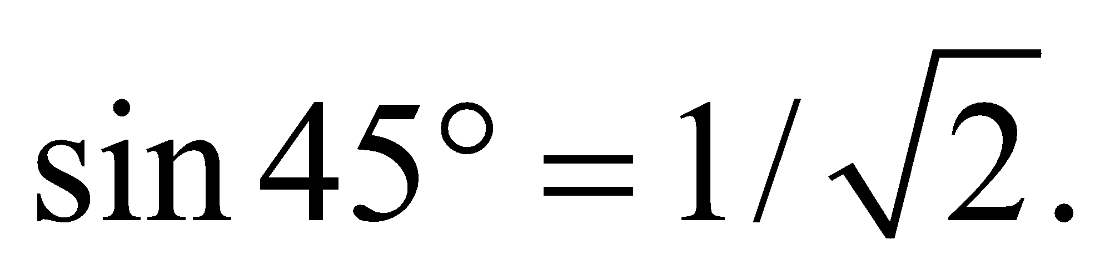
Evaluate Without knowing the separation and the wavelength, we can't say what the phase difference is.
The answer is (d).
Assess If the radio telescopes can receive multiple wavelengths, then it is likely that the two signals will be in phase (constructively interfere) for some wavelengths and 180° out of phase (destructively interfere) for others. Note too, that as the Earth rotates, the angle at which the source is located will change, so even at a fixed wavelength, the relative phase difference (and resultant interference pattern) will be changing with time.

