REFLECTION AND REFRACTION

30

Exercises
Section 30.1 Reflection
11. Interpret We are to find the angle through which we must rotate a specular reflecting surface so that the reflected light rotates through 30°.
Develop Since 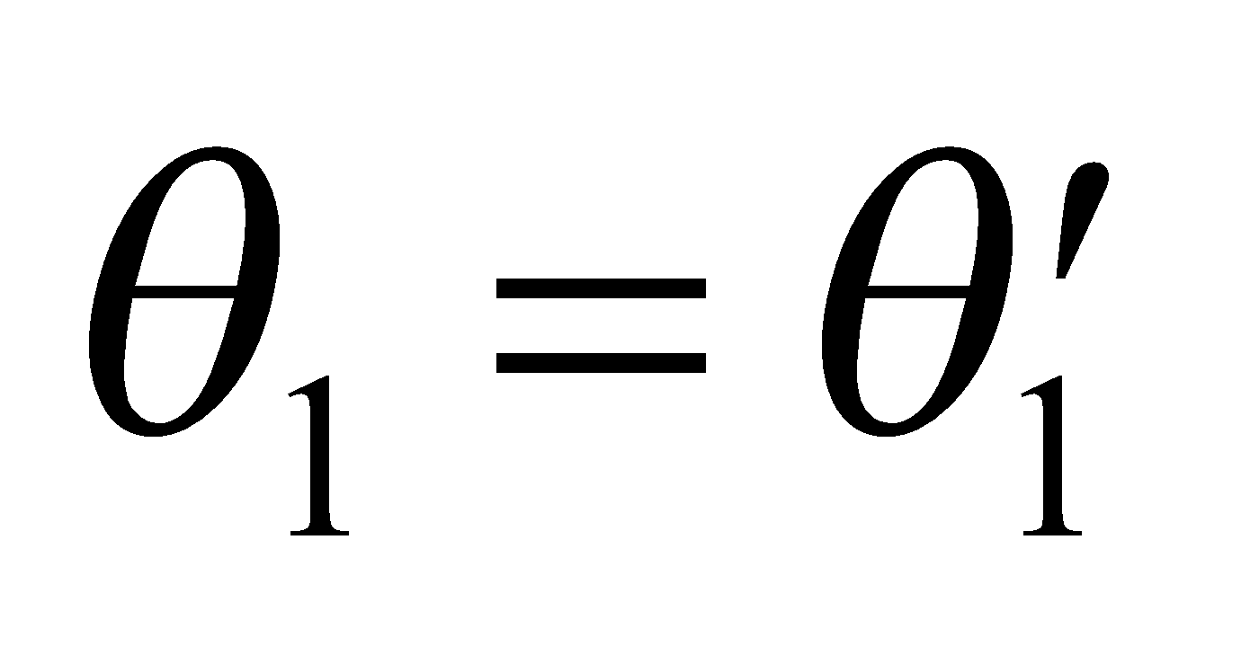 for specular reflection, (Equation 30.1) a reflected ray is deviated by 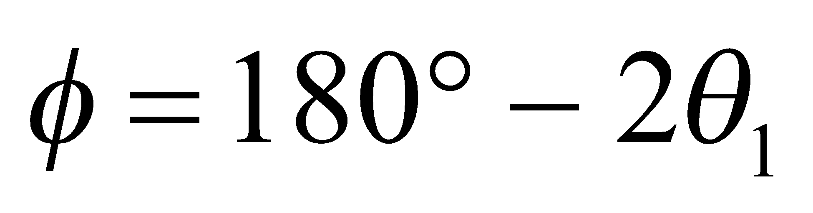 from the incident direction (see figure below). If rotating the mirror changes 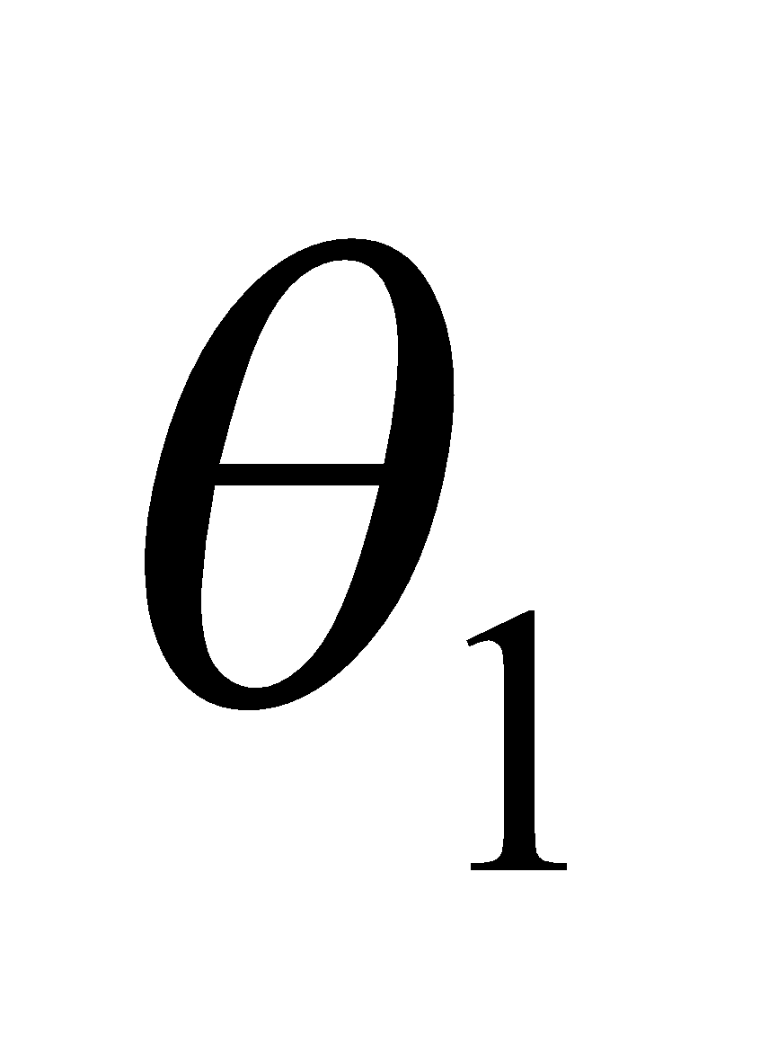by 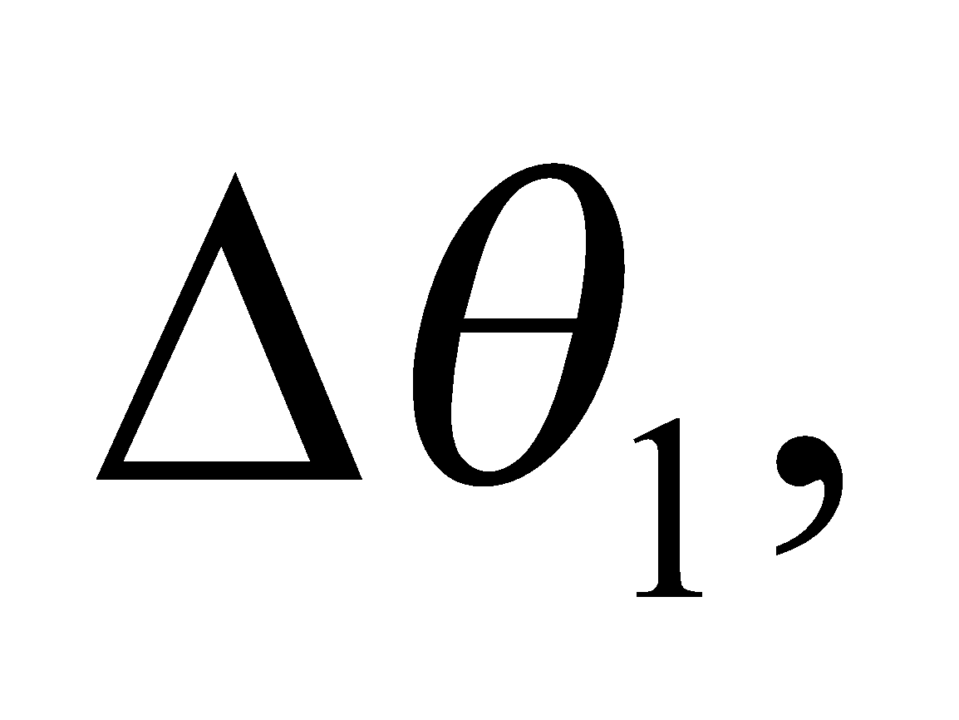 then the reflected ray is deviated by 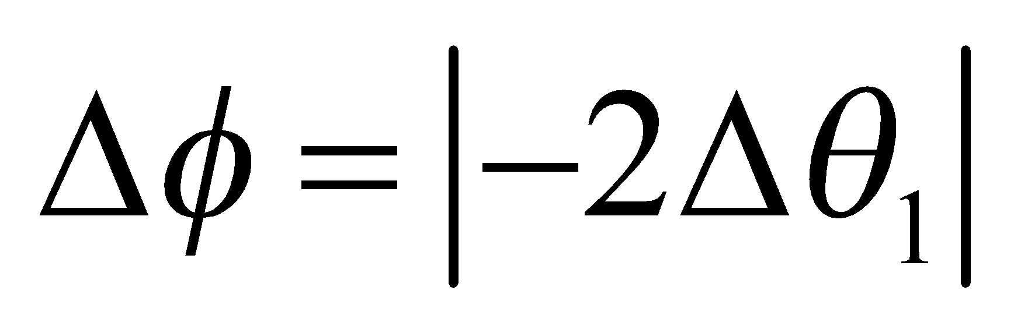 or twice this amount.

Evaluate Thus, if 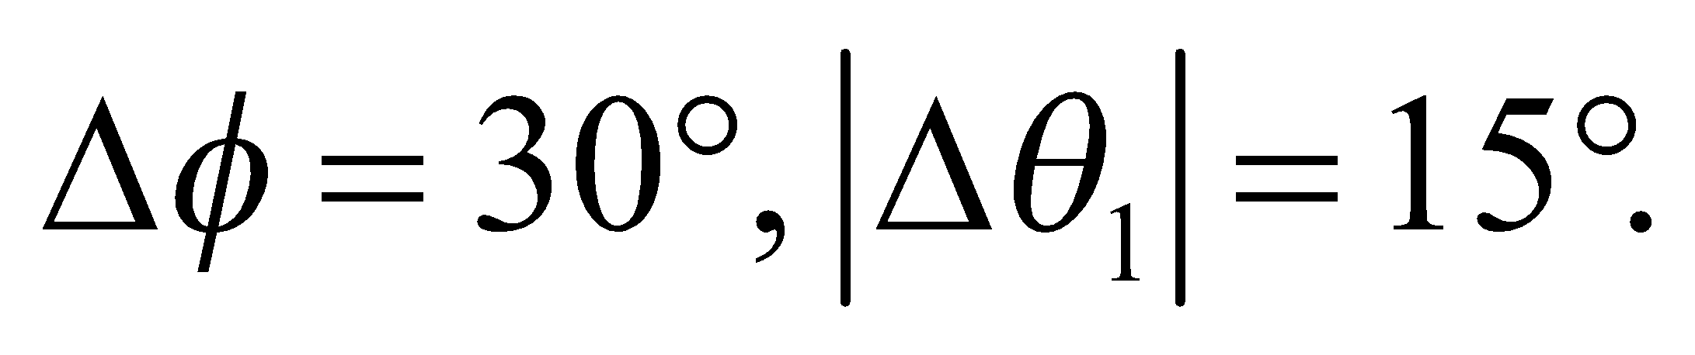
Assess This result can be easily verified with a small mirror.
12. Interpret This problem involves finding the path of an initially horizontal light ray reflected from the surfaces of two mirrors which are positioned as given in the problem statement.
Develop The path of the reflected ray can be constructed using the law of reflection which states that the angle of incidence equals the angle of reflection (Equation 30.1): 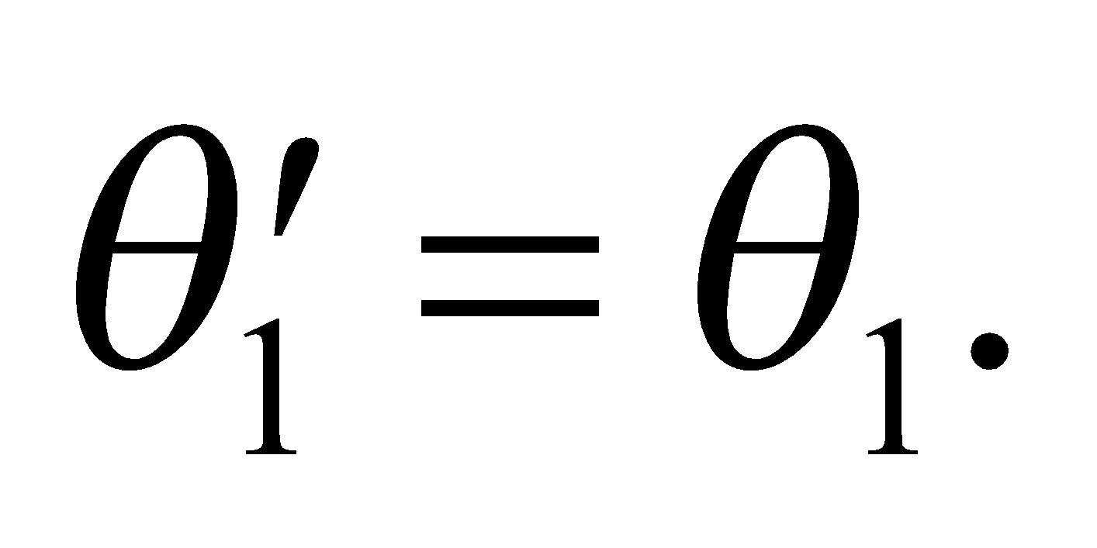
Evaluate (a) See figure below. The first reflected ray leaves the upper mirror at a grazing angle of 30°, and therefore strikes the lower mirror at normal incidence (i.e., perpendicular to the surface). It is then reflected twice more in retracing its path in the opposite direction, so the total number of reflections is 4.
(b) The resulting ray is antiparallel to the initial ray and goes through the same origin.

Assess Our double-mirror arrangement is a retroreflector that sends light rays back to their point of origin. Retroreflection has many practical applications (e.g., taillights, stop signs, etc.).
13. Interpret We are to find an expression for the angle of return of a light ray that is incident on a pair of perpendicularly aligned mirrors and use this expression to find the accuracy with which the mirrors must be aligned.
Develop A ray incident on the first mirror at a grazing angle α is deflected through an angle 2α (this follows from the law of reflection, see Problem 30.11). It strikes the second mirror at a grazing angle β and is deflected by an additional angle 2β. Let the total deflection be θ_{f}: 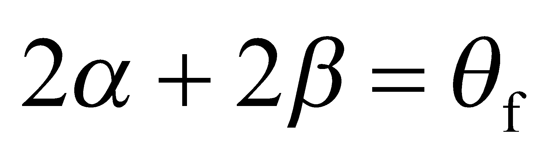. The alignment angle of the mirrors is θ = π/2 − α − β = π/2 − Δθ_{f} /2.
Evaluate Differentiating this expression gives
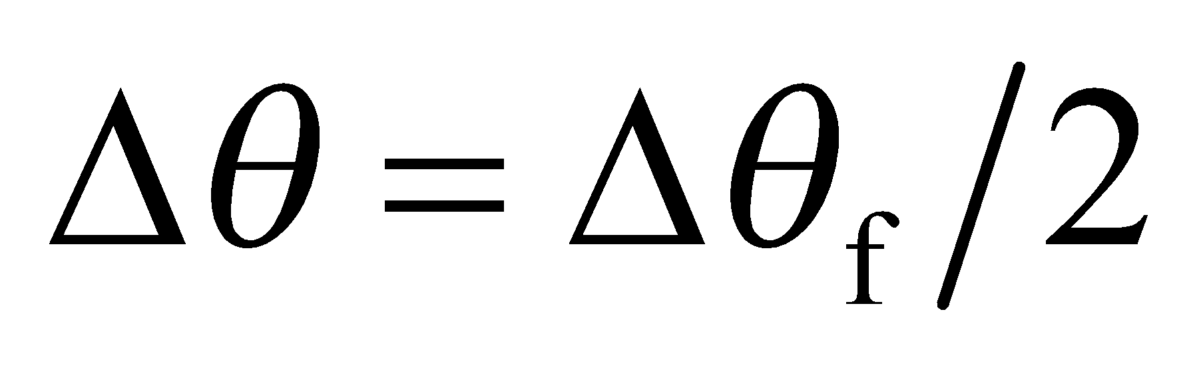
so for Δθ_{f} = 1°, Δθ = 0.5°.

Assess This is another retroreflector, but this time there is a displacement in the retro-reflected beam.
14. Interpret This problem involves finding the angle through which a light ray is rotated after undergoing reflection from the given two-mirror arrangement.
Develop See figure below. The path of the reflected ray can be constructed using the law of reflection (Equation 30.1). The angle of incidence equals the angle of reflection (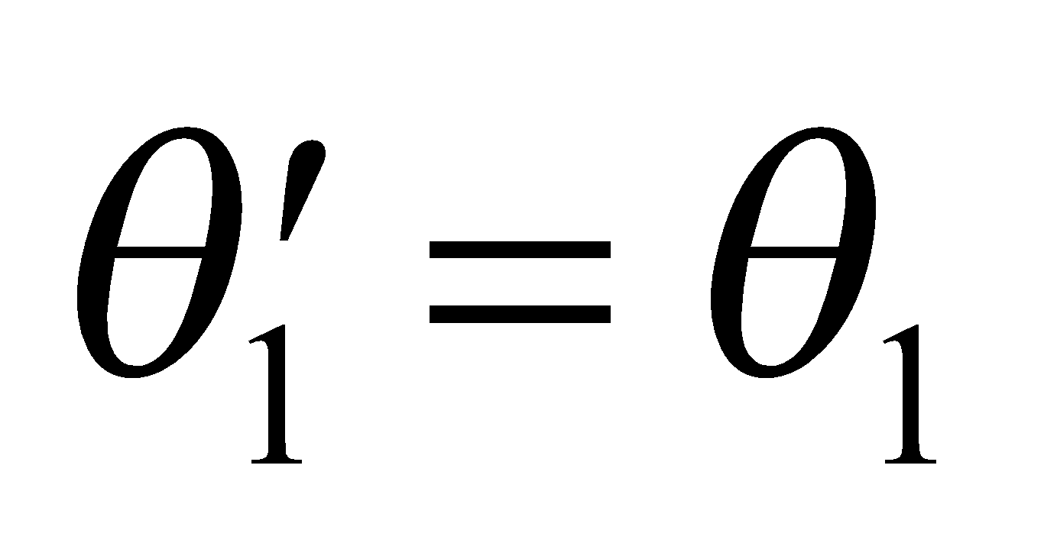). By simple geometry, we can find the angles α and β, and sum them to find the angle through which the incident ray is rotated.

Evaluate Entering parallel to the top mirror, a ray makes an angle of incidence of 30° with the bottom mirror. It then strikes the top mirror also at 30° incidence, and is reflected out of the system parallel to the bottom mirror (see the figure). The ray forms an isosceles triangle, which allows us to calculate the angles α and β. The total deflection is 2α + β = 240° counterclockwise (or 120° clockwise) from the incident direction.
Assess The reflected path follows from the law of reflection.
Section 30.2 Refraction
15. Interpret Given the speed of light in an unknown material, we are to find the index of refraction and thus identify the material.
Develop Apply Equation 30.2, n = c/v and use Table 30.1 to find the corresponding material.
Evaluate The index of refraction of the material is 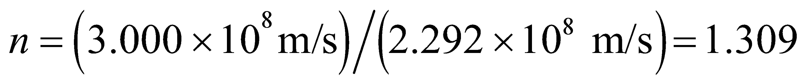, so the material is ice.
Assess This is a typical value for an index of refraction of a material that is transparent to visible light.
16. Interpret For this problem, we are to use the index of refraction of a CD to find the pit depth, given that it is one-quarter wavelength deep.
Develop From the discussion accompanying Equation 30.2, we know that 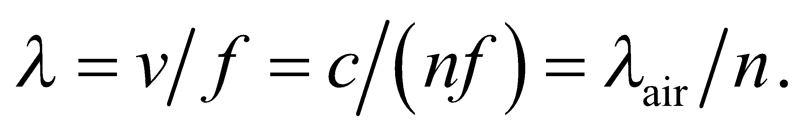 Given that the pit depth is λ/4, we can find the pit depth.
Evaluate Inserting the values given, the wavelength of the laser light is
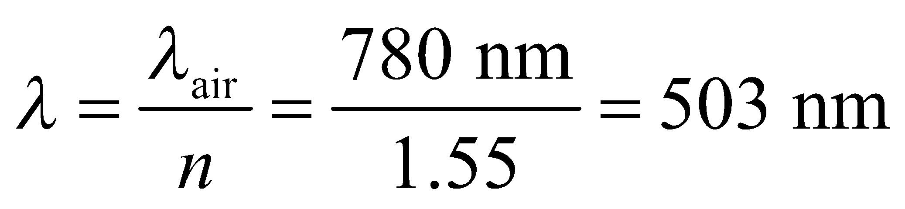
The pit depth is one quarter wavelength, or 126 nm.
Assess A typical pit on a CD is about 100 nm deep and 500 nm wide. Our result is within this range.
17. Interpret This problem involves Snell’s law, which we can use to find the incident angle of the light beam.
Develop Apply Snell’s law (Equation 30.3) to find the incident angle.
Evaluate Snell’s law (with 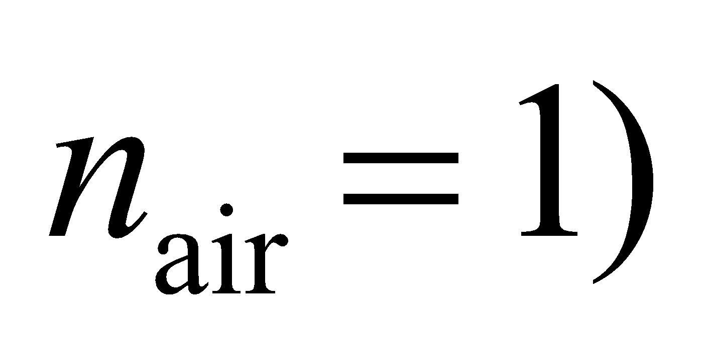 gives
Assess The angle is between 0° and 90°, as expected.
18. Interpret This problem is about refraction at an interface. We shall apply Snell’s law to find the index of refraction of the material.
Develop Snell’s law (Equation 30.3) states that 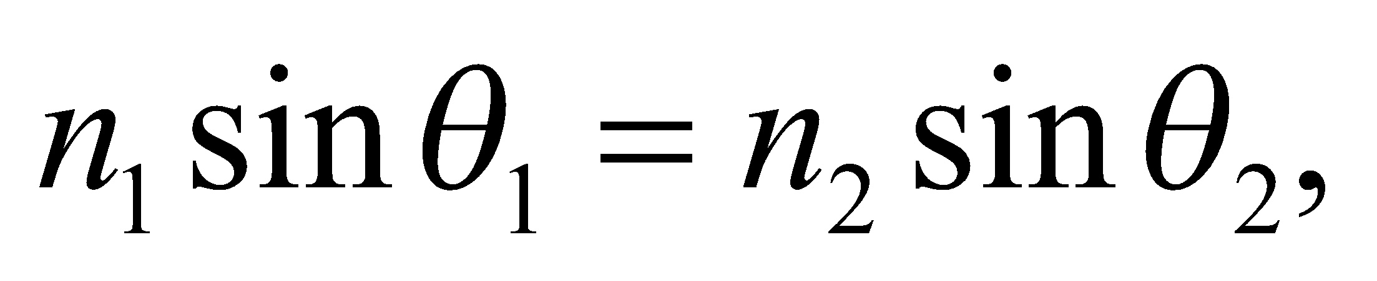 where 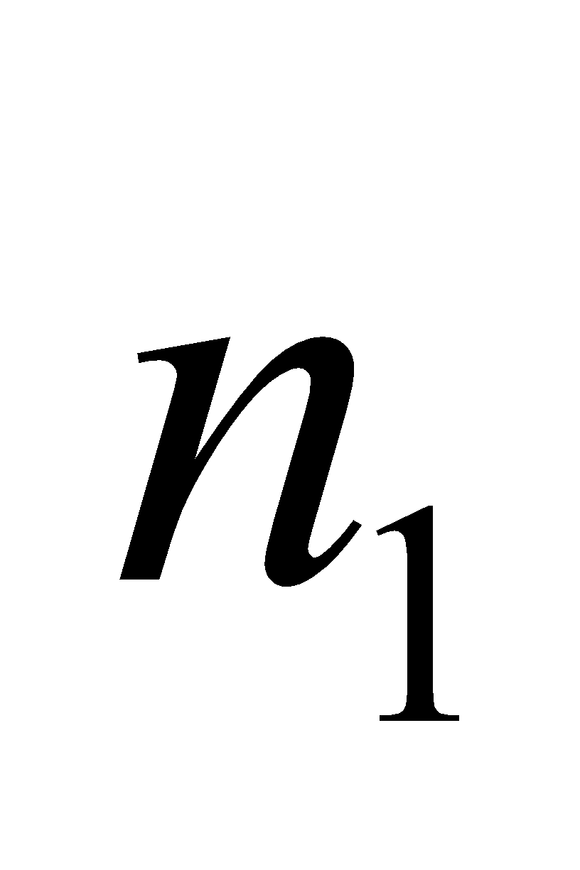 and 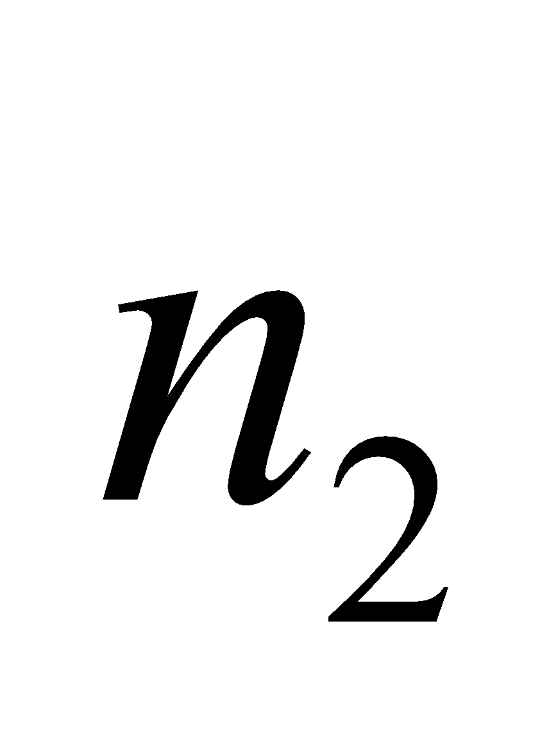 are the refractive indices of the two media, and and 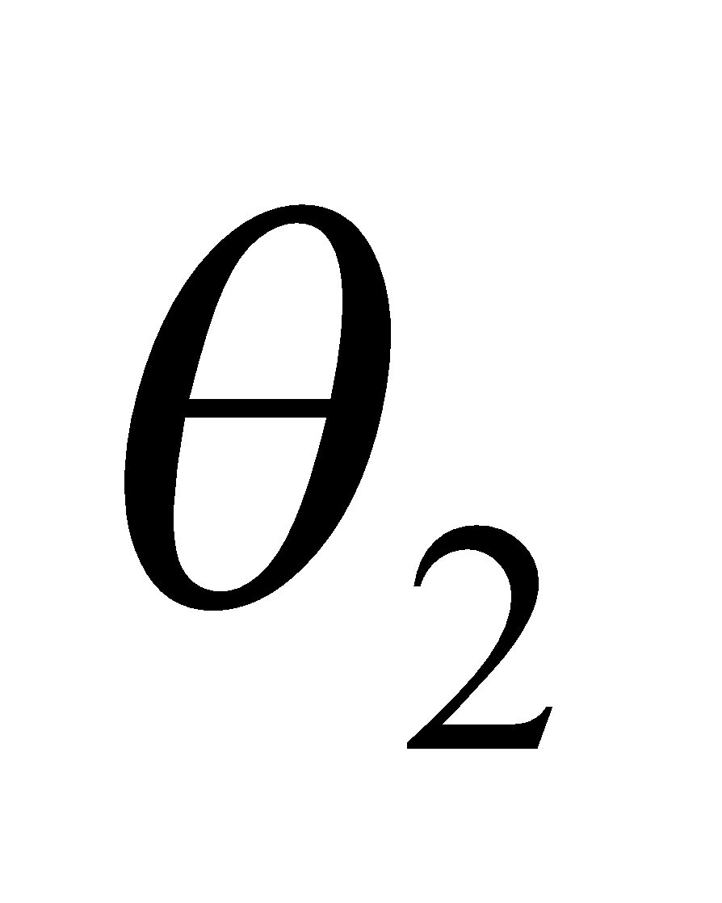 are the angles the light ray makes with the normal to the surface.
Evaluate With air as medium 1, the index of refraction of medium 2 is
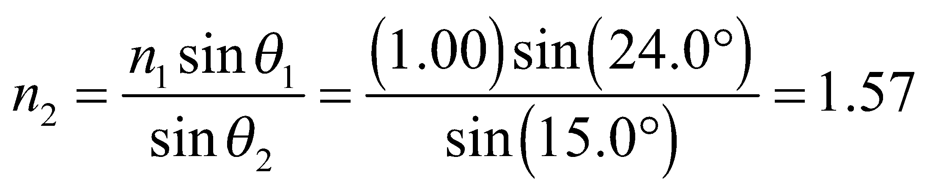
Assess Since 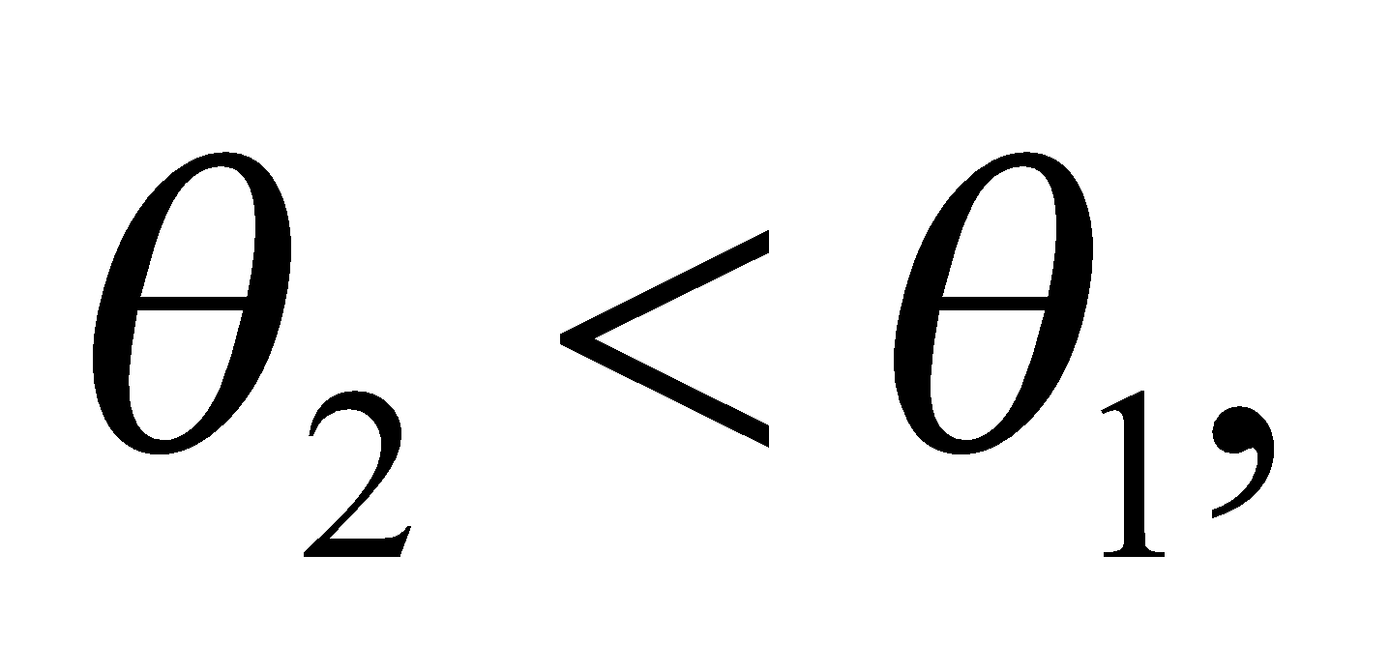 the light ray bends toward the normal and we expect 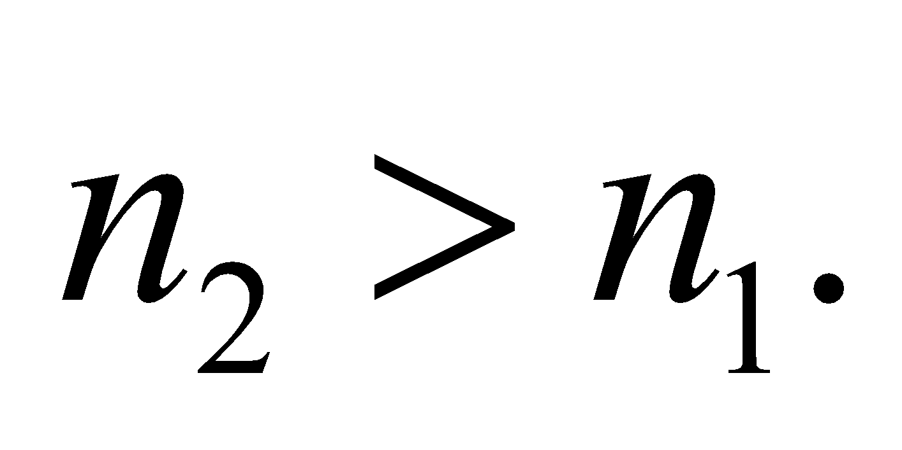
19. Interpret This problem involves Snell’s law, which we can use to find the angle of refraction of a light beam as it passes from glass into water.
Develop Apply Snell’s law (Equation 30.3) to find θ₂, which is the angle of refraction in the water. From Table 30.1, the index of refraction of water is n₂ = 1.333.
Evaluate Equation 30.3 gives
Assess This angle is greater than the incident angle (12.4°), as expected because the index of glass is larger than that of water.
20. Interpret This problem asks for the polarizing angle of the air-diamond interface, which is the angle at which the reflected light is linearly polarized perpendicular to the plane of incidence (i.e., the plane containing the incident and reflected rays).
Develop Using Equation 30.4, the polarizing angle for light in air reflected from diamond is
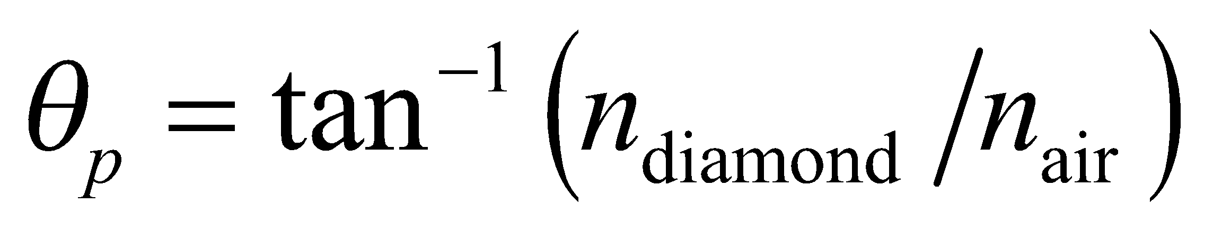
Evaluate From Table 30.1, 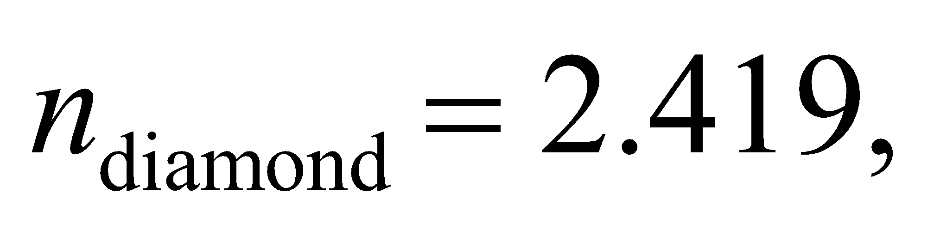and the polarizing angle is
Assess At this angle, the reflected light ray is perpendicular to the transmitted light ray, as illustrated in Figure 30.8.
21. Interpret We are to find the refractive index of a material given its polarizing angle in air.
Develop Apply Equation 30.4, with n₁ = 1.0 and θ_{p} = 62°.
Evaluate Solving Equation 30.4 for n₂ gives
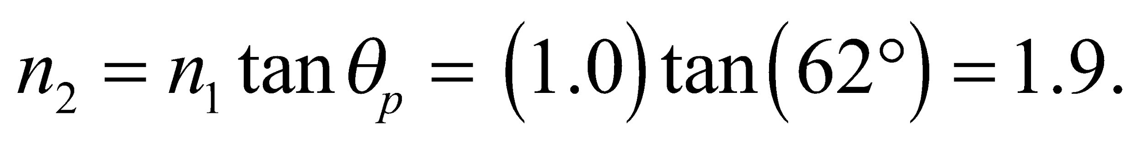
Assess From Table 30.1, this material could be a glass.
Section 30.3 Total Internal Reflection
22. Interpret We are to find the critical angle for total internal reflection in various media.
Develop For 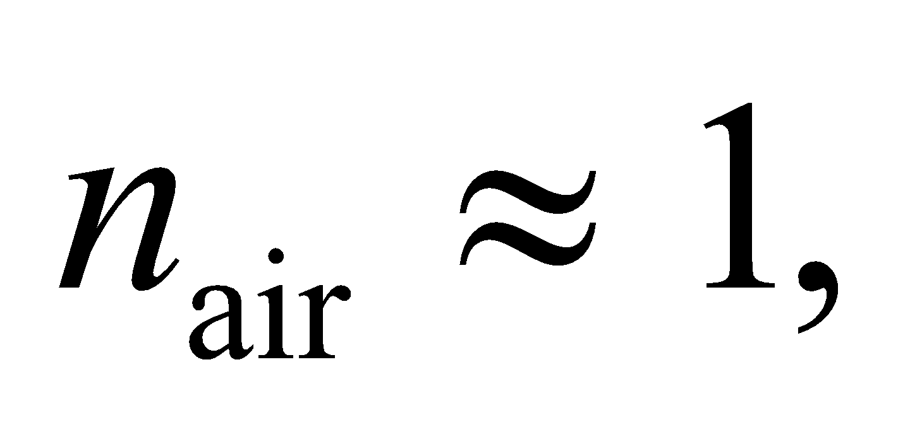 using Equation 30.5, the critical angle for total internal reflection in a medium of refractive index n is 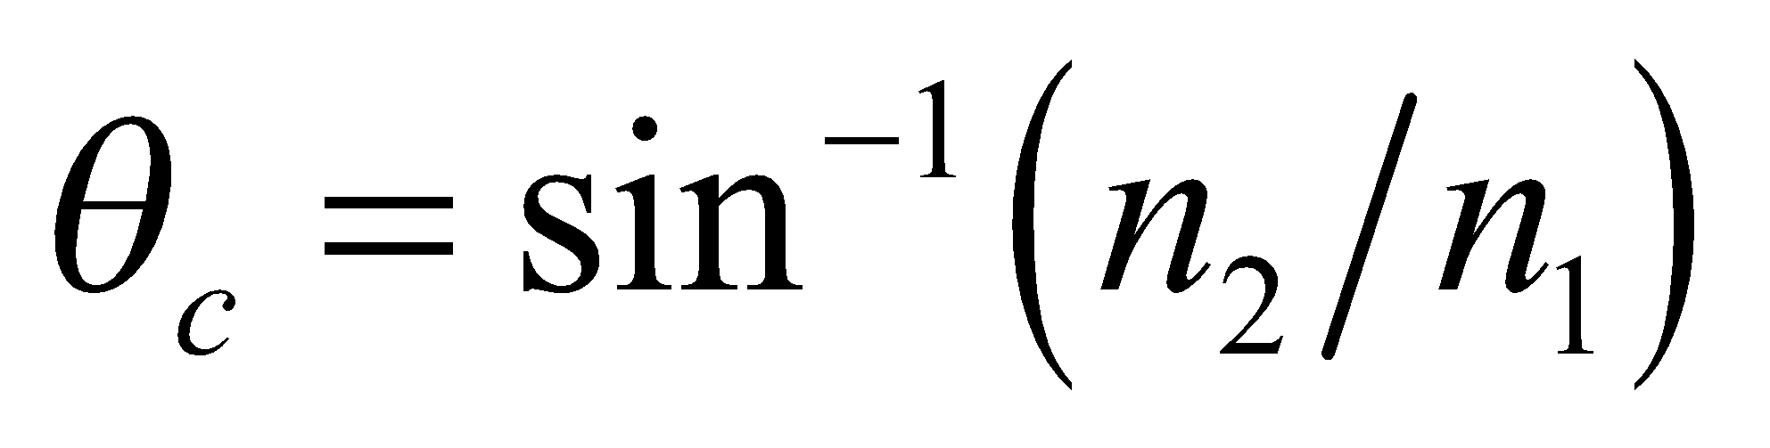 where air is medium 2. Use Table 30.1 to find the indices of the various materials.
Evaluate (a) From Table 30.1, we find n = 1.309 for ice, so 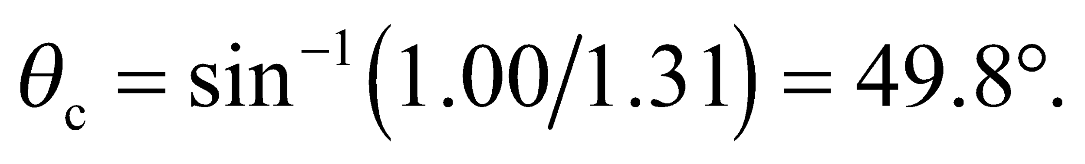
(b) With n = 1.49 for polystyrene, 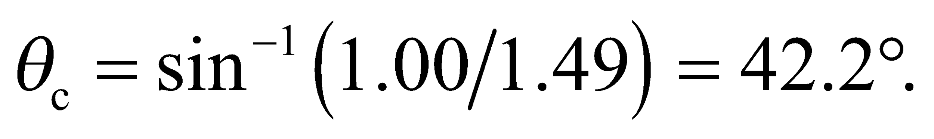
(c) Similarly for rutile, n = 2.62 and 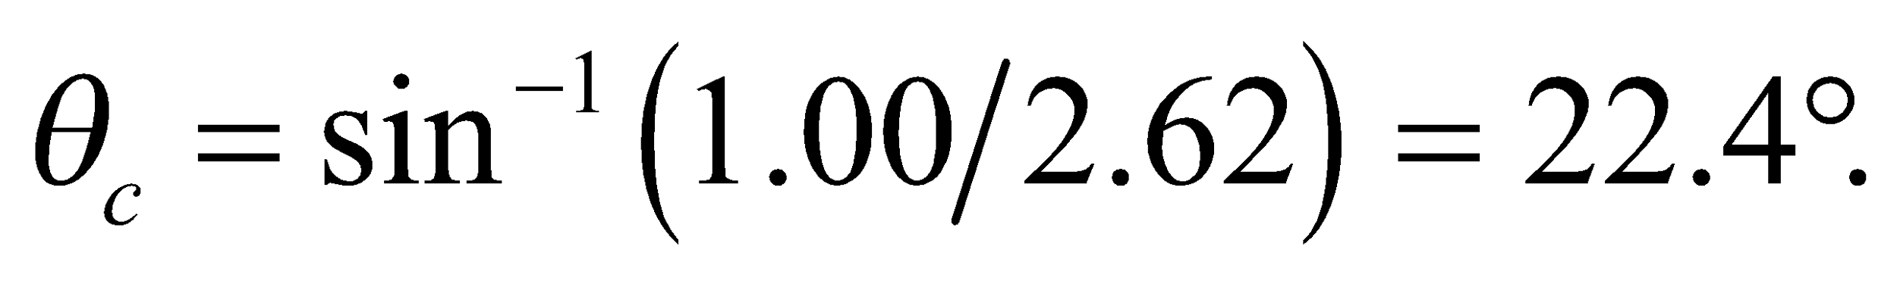
Assess The larger n, the smaller critical angle. Light incident at 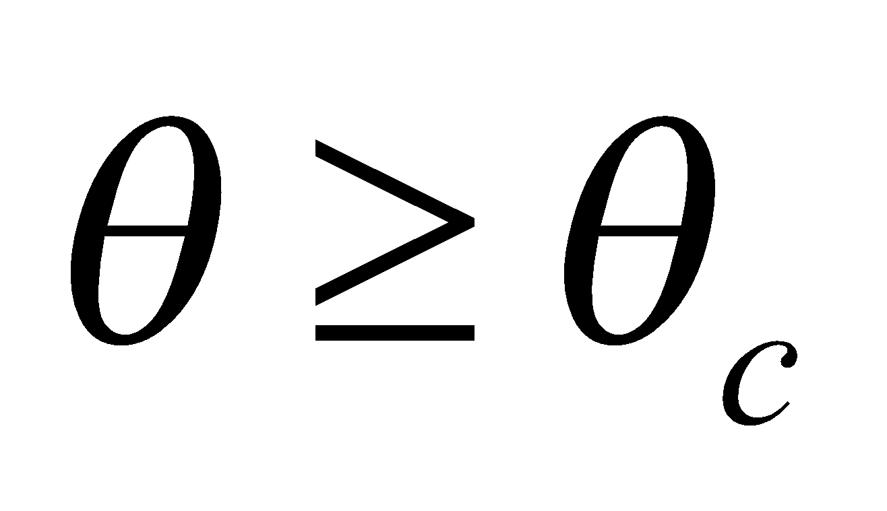 cannot escape from the medium.
23. Interpret We are to find the critical angle for light going from water to ice.
Develop Apply Equation 30.5, using Table 30.1 to find the indices of refraction of the media.
Evaluate The critical angle is
Assess This is a reasonable value for a critical angle between to similar media.
24. Interpret In this problem, we want to find the critical angle for total internal reflection at the interface between various media.
Develop The critical angle in medium-1, at an interface with medium-2, is given by Equation 30.5:
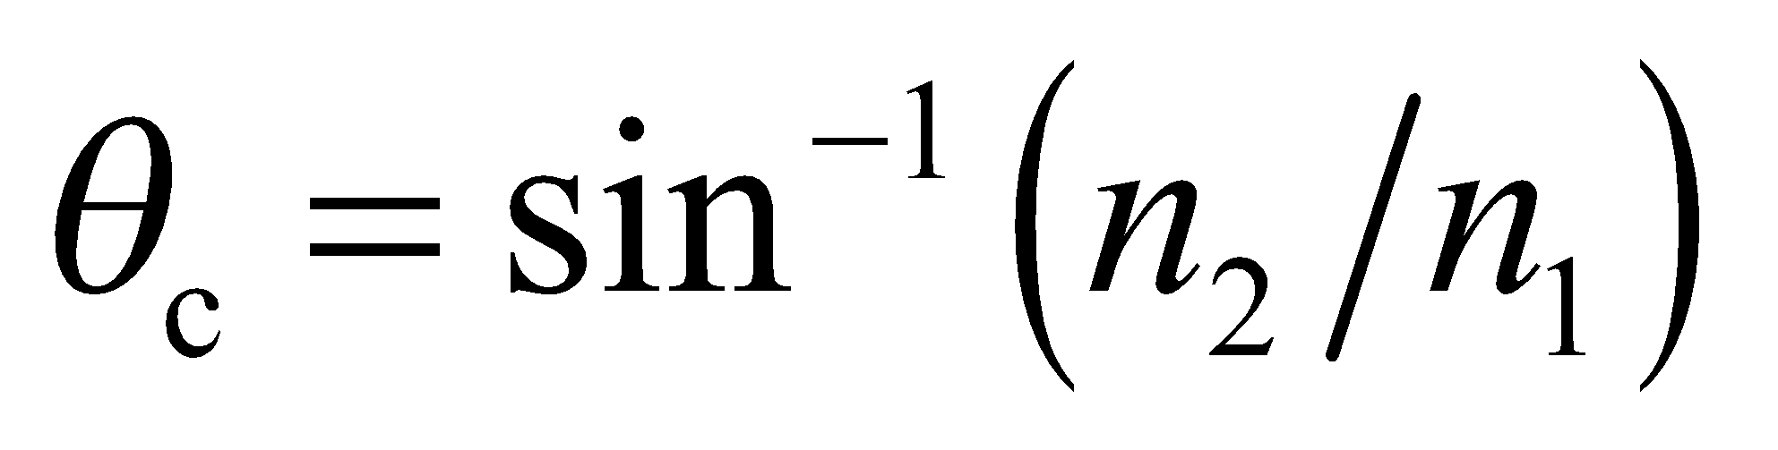 where 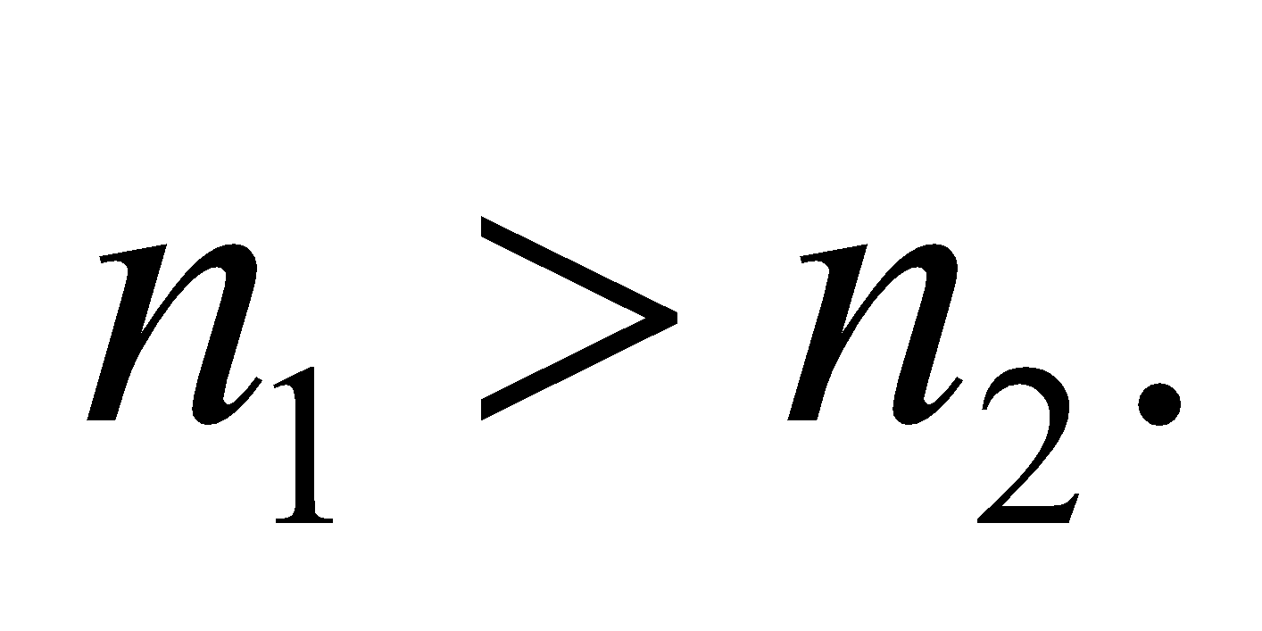
Evaluate (a) For glass (n1 = 1.52) immersed in water 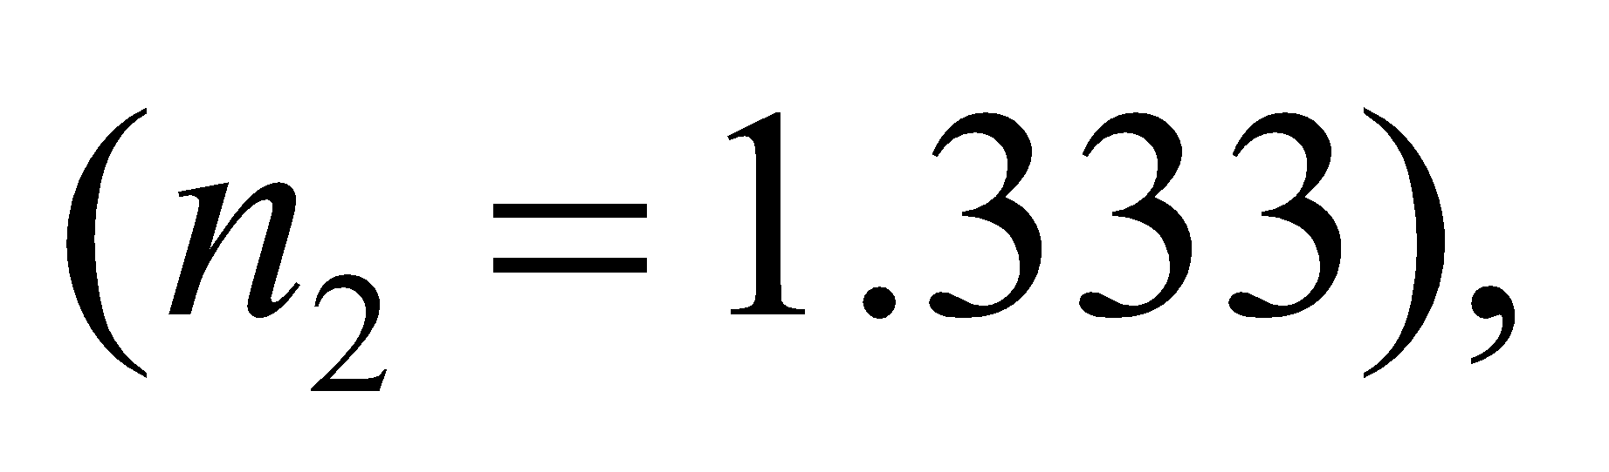 the critical angle is
(b) The same glass immersed in benzene has 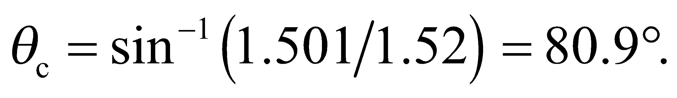
(c) Since the index of refraction of diiodomethane 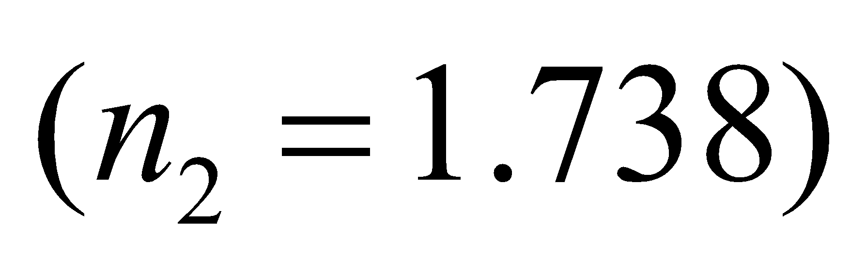 is not smaller than that for this glass, there is no total internal reflection for light propagating in the glass. However, for light originating in the liquid, the critical angle at the glass interface is 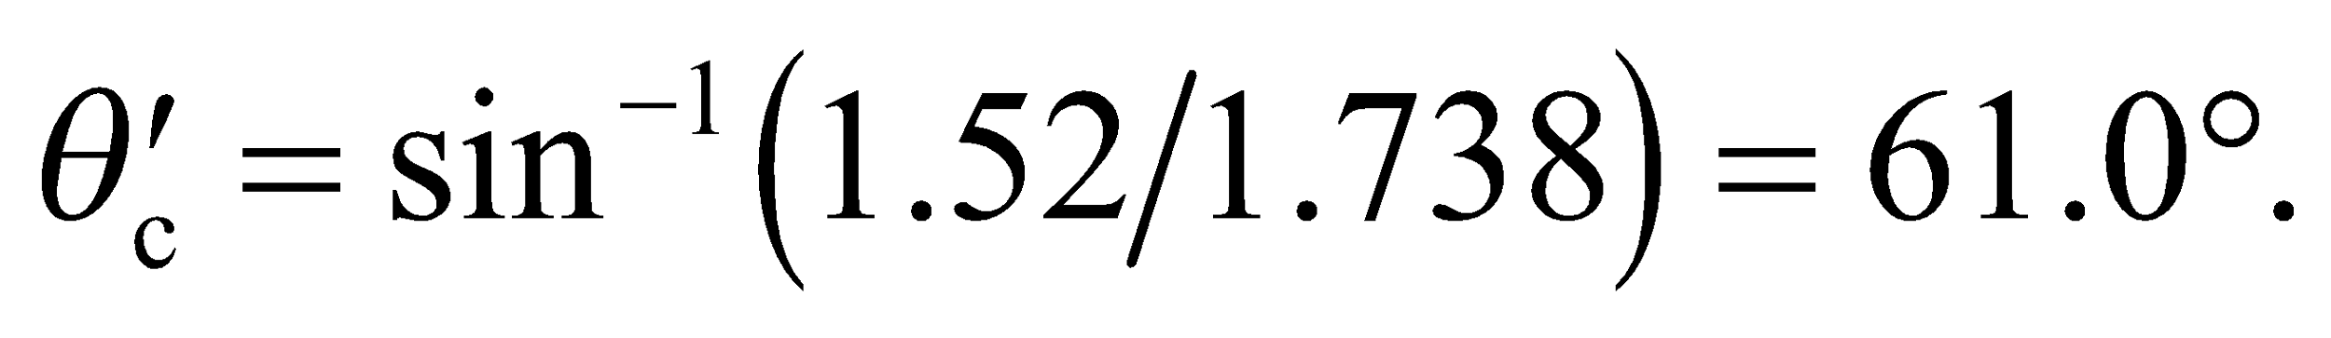
Assess This problem shows that for total internal reflection to take place as light propagates from medium 1 to medium 2, we must have
25. Interpret We are to find the refractive index of plastic given the critical angle for light propagation from air to plastic.
Develop Apply Equation 30.5, with n₁ = 1.00 θ_{c} = 37°.
Evaluate At the critical angle in plastic, 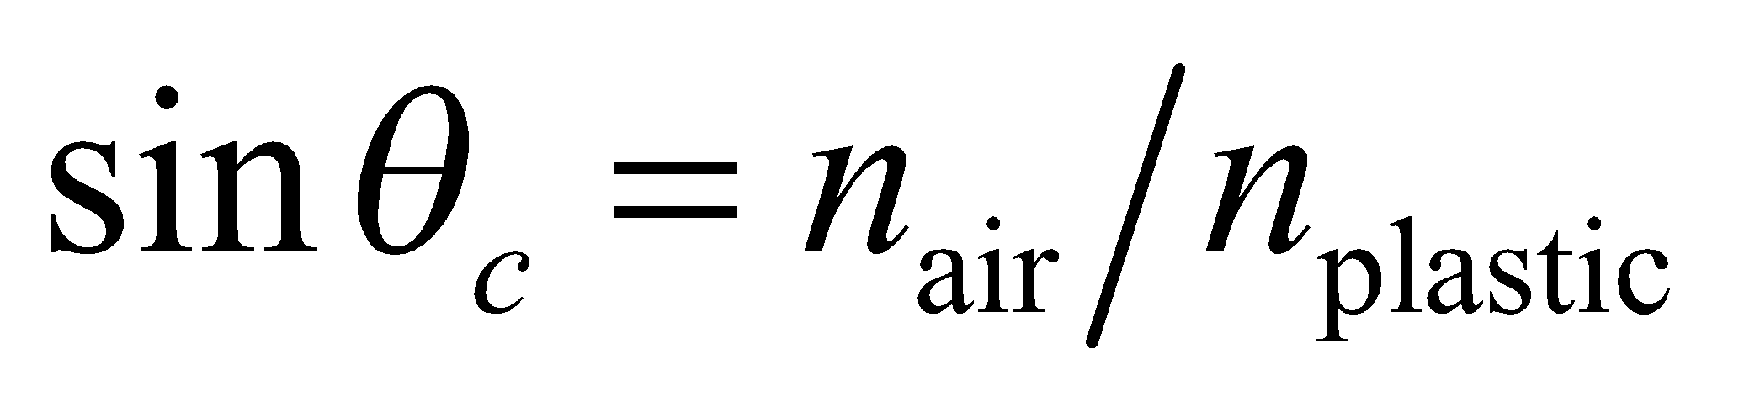 (Equation 30.5), so 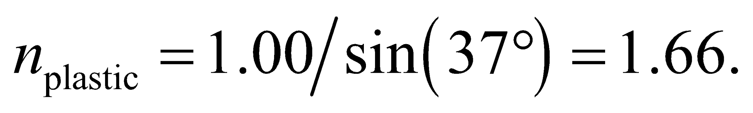
Assess This is a reasonable value for a refractive index for a plastic.
Section 30.4 Dispersion
26. Interpret This problem involves finding the angle between the red and the blue light that is created by dispersion in glass.
Develop Using Snell’s law (Equation 30.3), the angle of refraction for each wavelength is 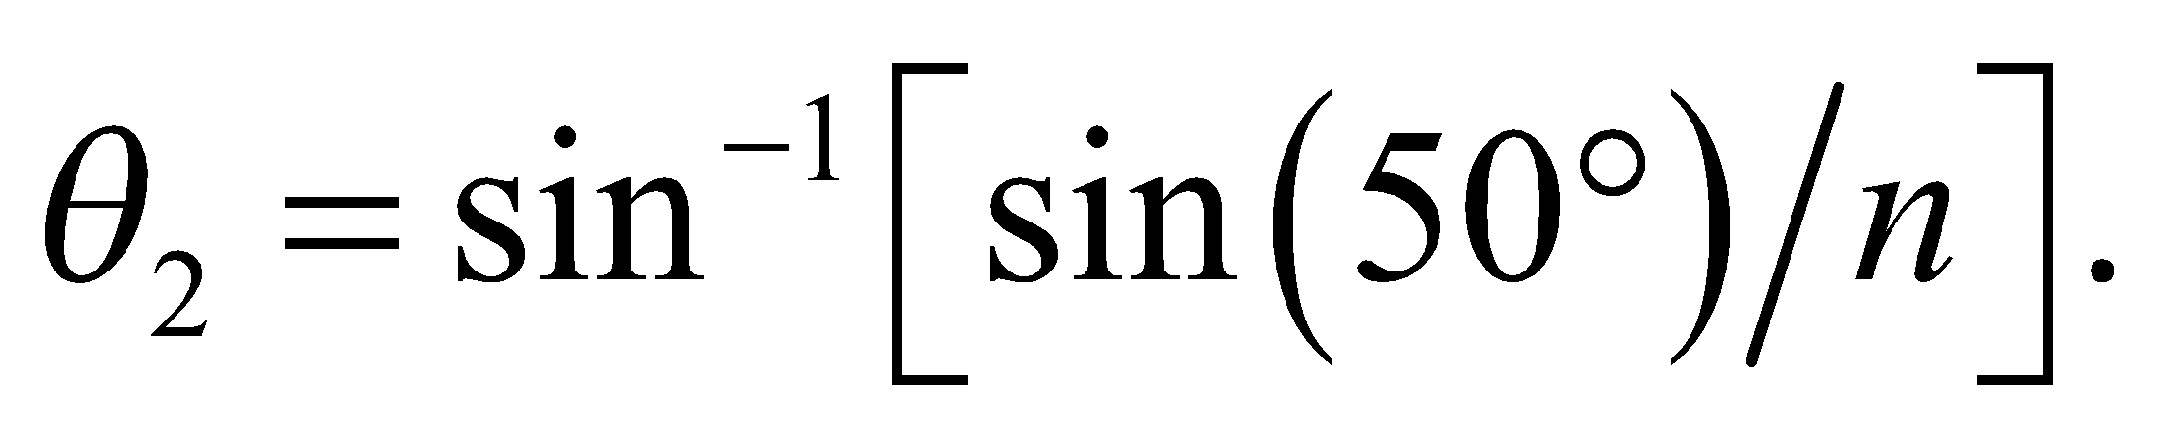 The angle between the two laser beams is 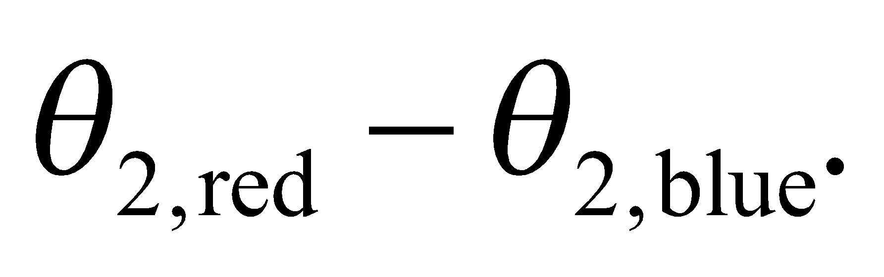
Evaluate Substituting the values given in the problem statement, we get
Assess The refractive index of a material is higher for blue light than the red light. So, from Equation 30.2, we expect red light to travel at a greater speed than the blue light.
27. Interpret We are to find the angular dispersion for a beam of white light that transits an equilateral prism.
Develop The geometry for refraction through a prism is shown in the figure below. Using Snell’s law (Equation 30.3) and the fact that 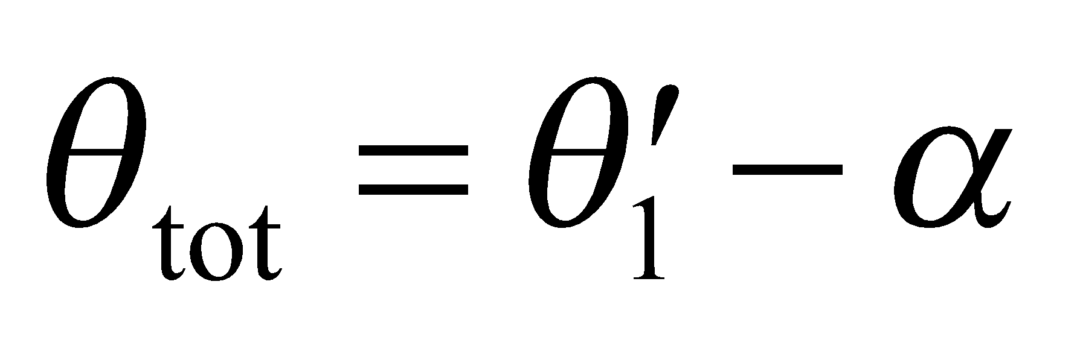 and 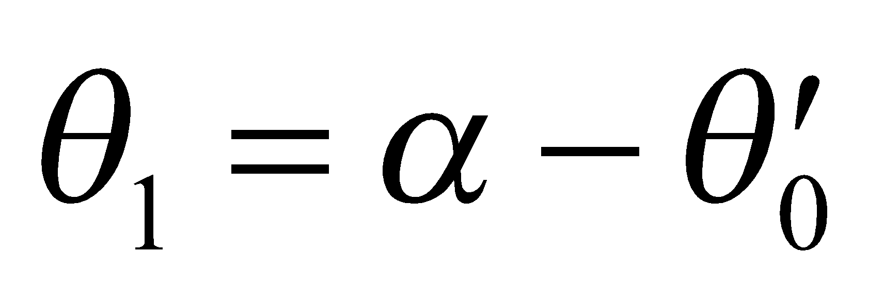, we find the following expression for θ_{tot}:
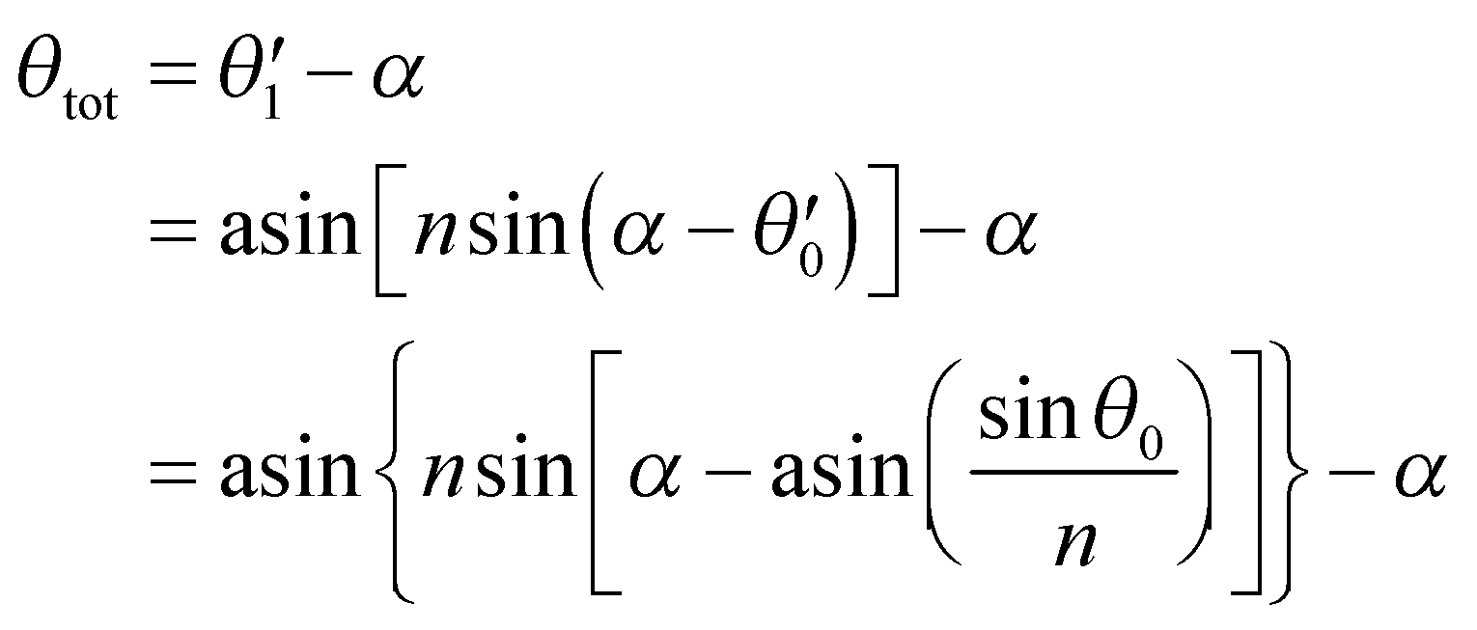
where α = 60°, n is the refractive index of the prism and we have used n = 1 for air. For red light, n = n_{red} = 1.582, whereas for violet light, n_{violet} = 1.633. The angular dispersion of the outgoing beam is the difference 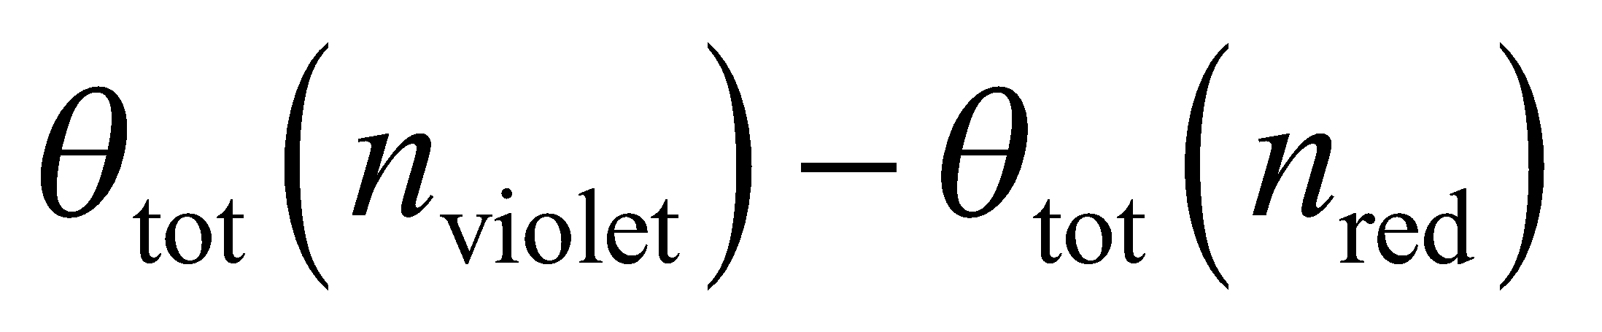.

Evaluate Using θ₀ = 45°, we find 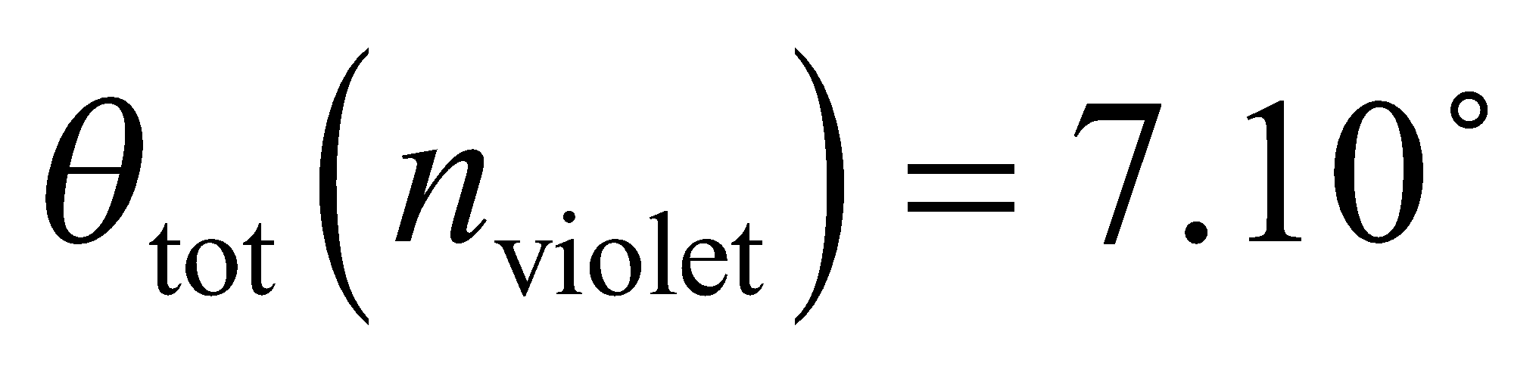 and 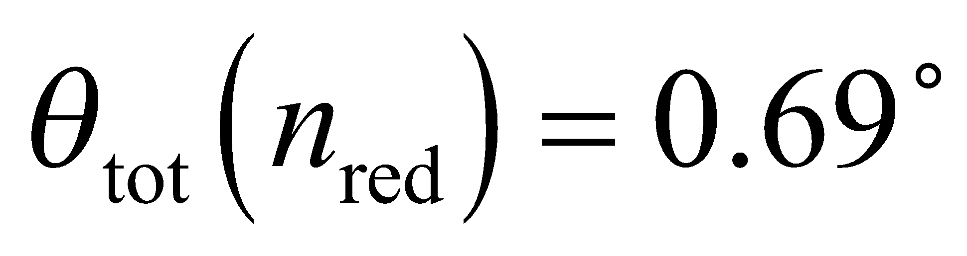, so the dispersion is 7.10° − 0.69° = 6.41°.
Assess We find that the violet light is deflected more than the red light, which is reasonable because the index of refraction for violet light is greater than for red light (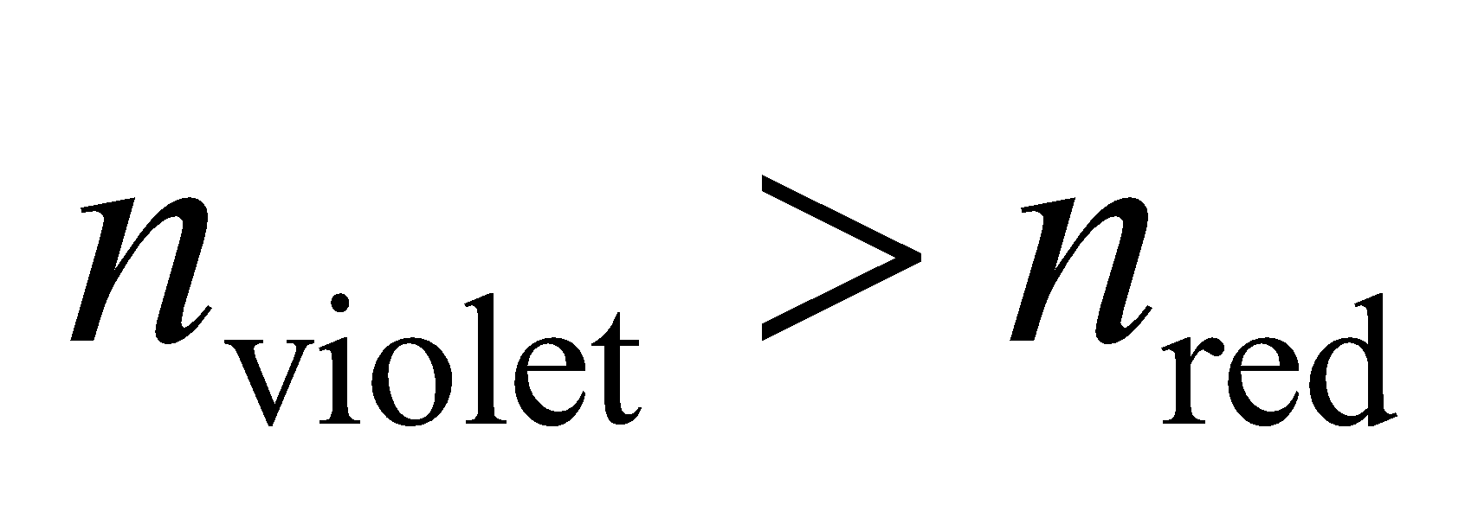).
Problems
28. Interpret This problem involves sketching the path of the light ray reflected from the surfaces of two mirrors.
Develop The path of the reflected ray can be constructed using the law of reflection (Equation 30.1), which says that the angle of incidence equals the angle of reflection (). In the following, refer to the sketch below of the mirror system.
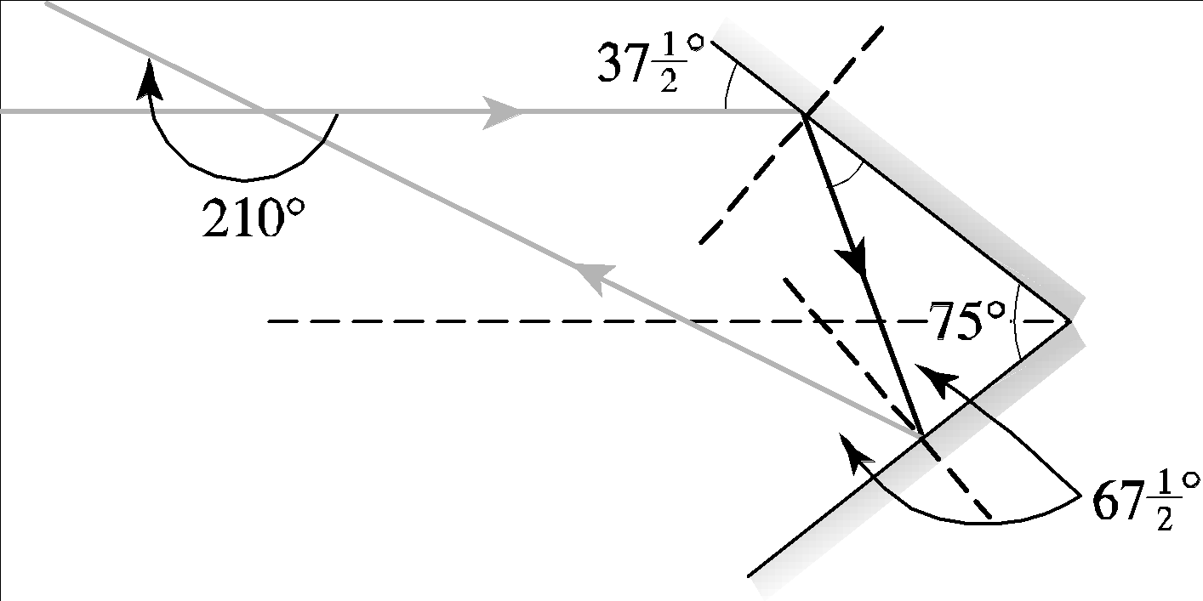
Evaluate After the first reflection, the ray leaves the top mirror at a grazing angle of 37.5° and so makes a grazing angle of 180° − 75° − 37.5° = 67.5° with the bottom mirror. It is therefore deflected through an angle of
2(37.5°) +2(67.5°) = 210° clockwise as it exits the system, after being reflected once from each mirror.
Assess The reflected path follows from the law of reflection.
29. Interpret We consider refraction in the human cornea.
Develop The angle of refraction, 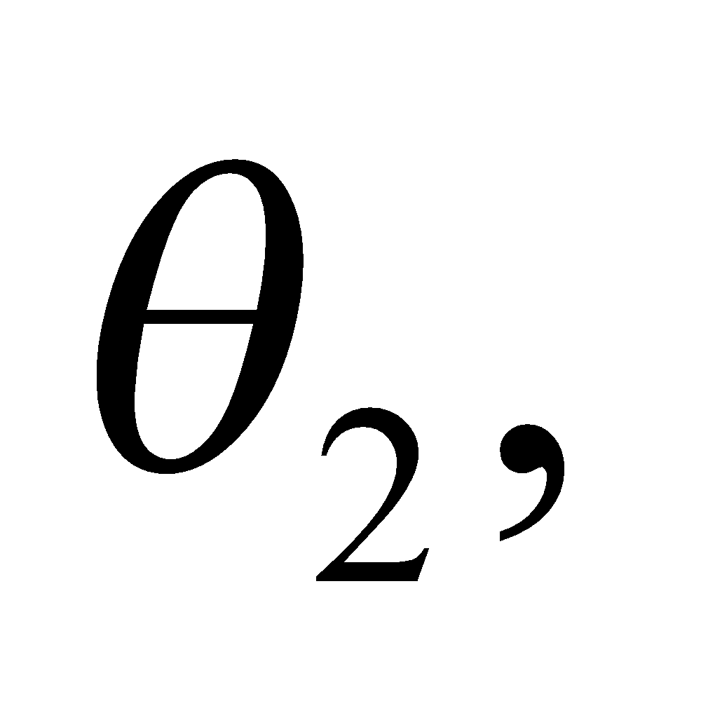 can be found from Equation 30.3: 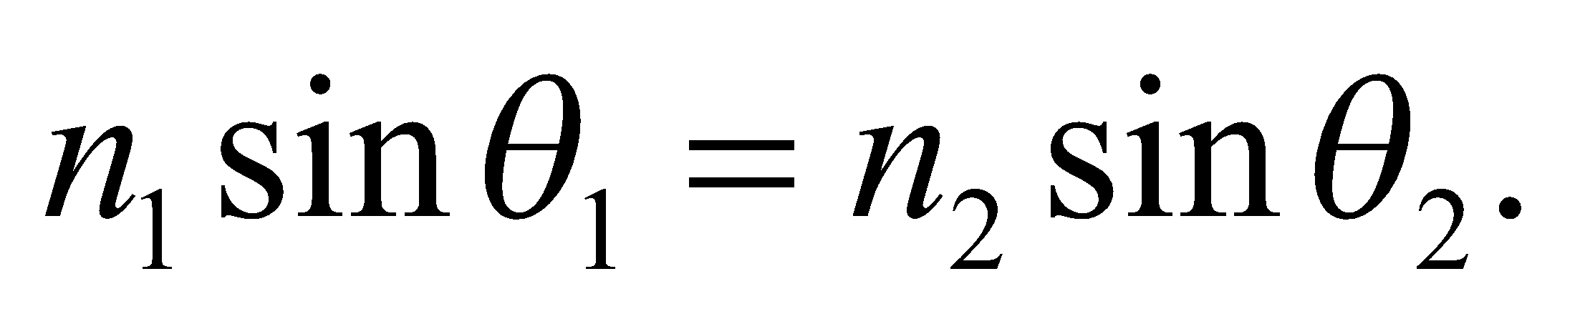 The light is coming from air 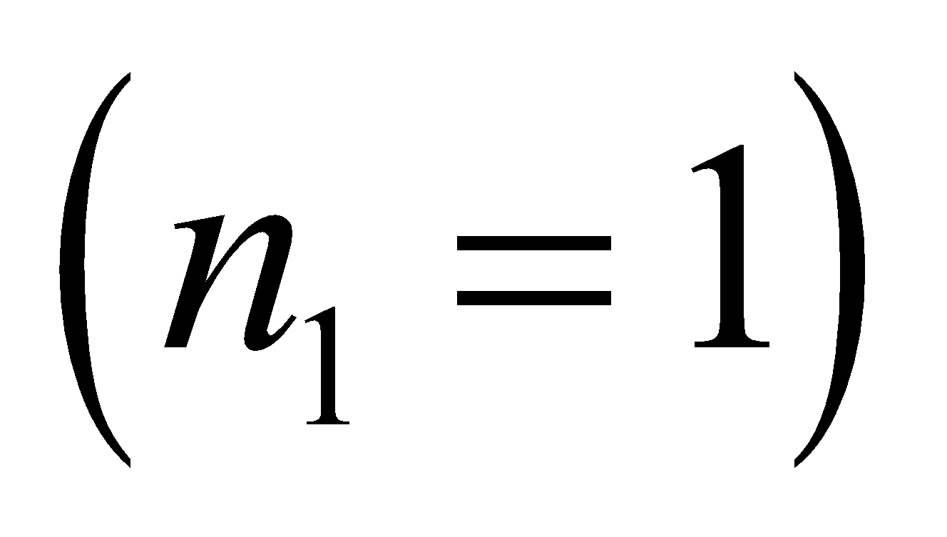, so the wavelength in the cornea is 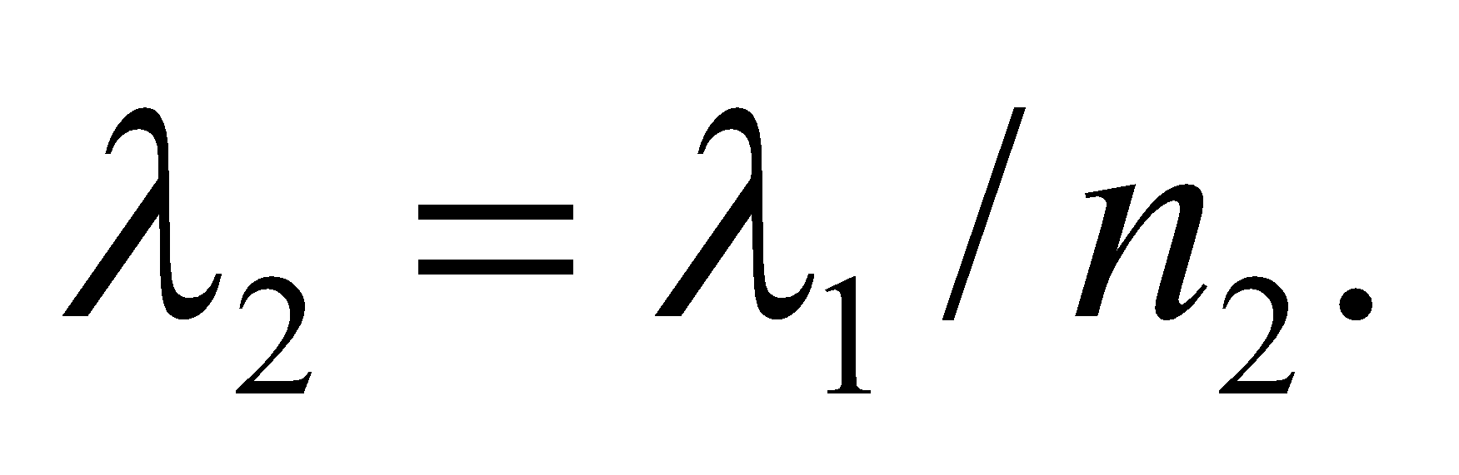
Evaluate (a) Solving for the angle of refraction gives
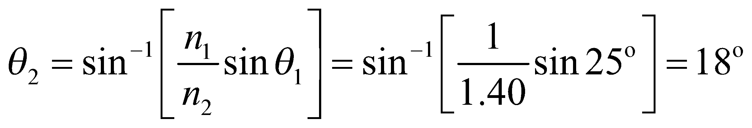
(b) The wavelength reduces to
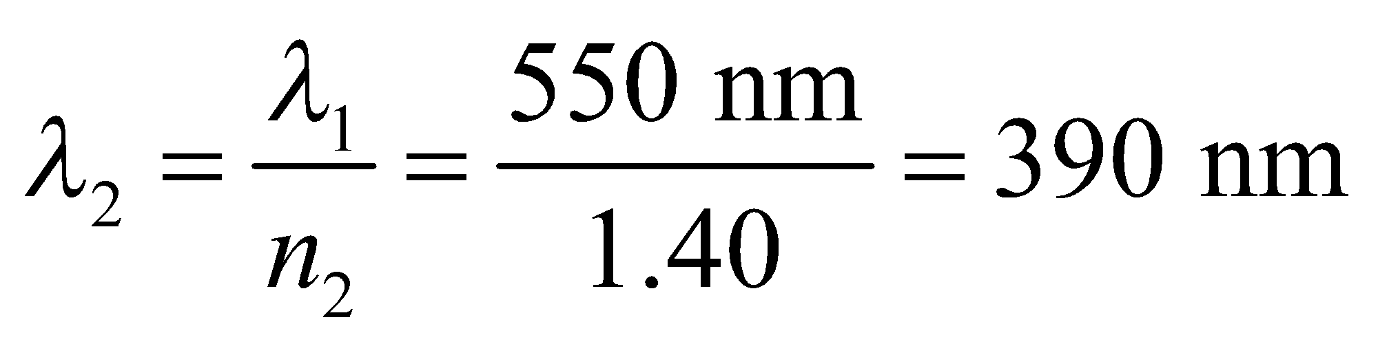
Assess The angle of refraction is less than the angle of incidence, which is what we would expect for light entering a material of higher index of refraction.
30. Interpret This problem is a generalization of the preceding problem. We are to find the angle through which a light ray is deviated if it is reflected once off each mirror of a two mirror system with an arbitrary angle between the mirrors.
Develop Using the sketch below, we see that 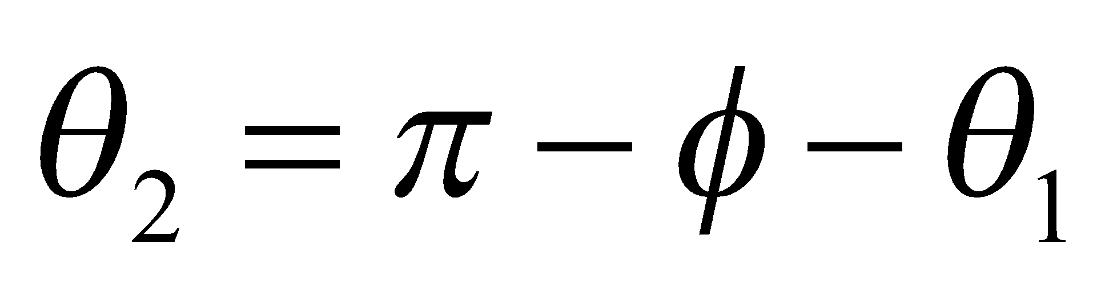. The total angle of deviation is 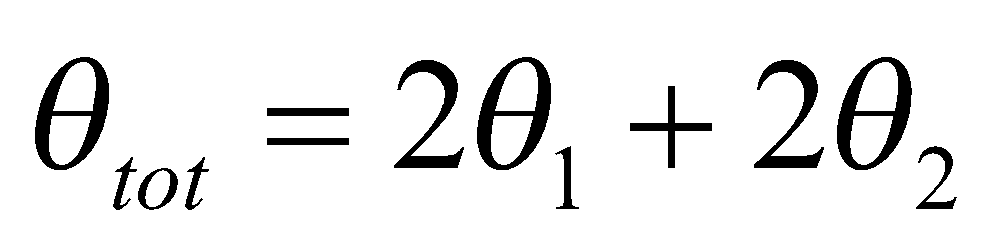.

Evaluate Substituting the expression for θ₂ into the expression for θ_{tot} gives
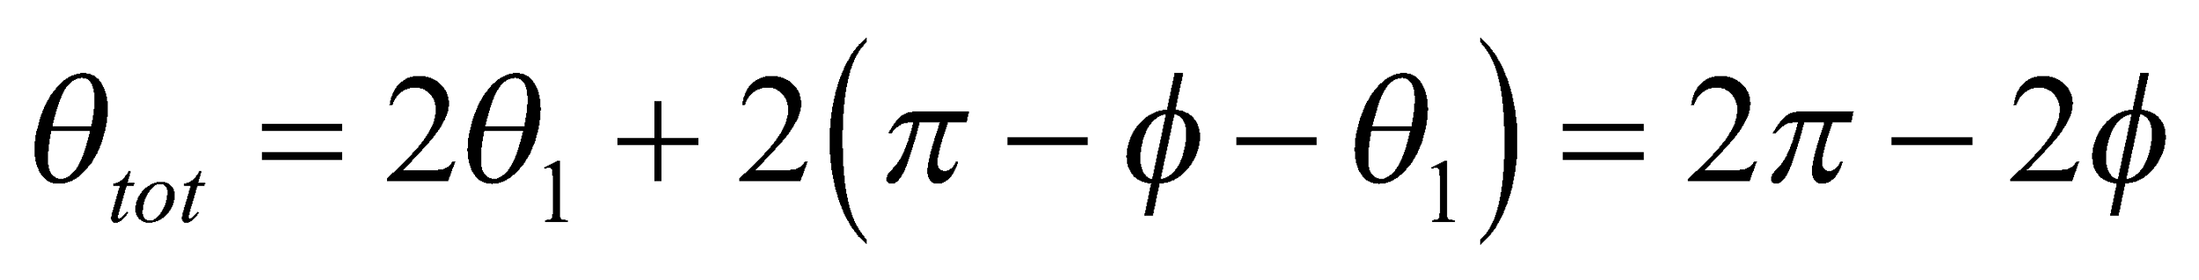
Assess This agrees with the expression in the problem statement, given that π = 180°.
31. Interpret You want to identify an unknown liquid by measuring the way that light refracts at the interface between the liquid and glass of known index of refraction.
Develop You shine the laser light so that it first passes through the unknown liquid before entering the glass 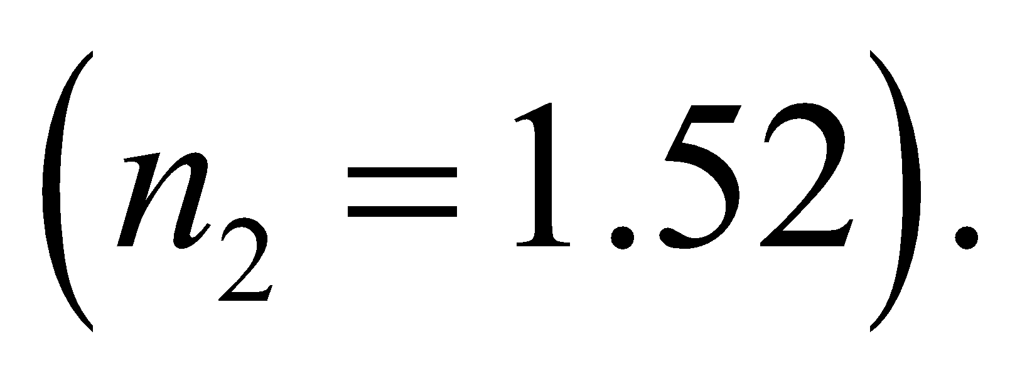 With the measured angles, you can determine the liquid's index of refraction from Equation 30.3:
Evaluate Solving for n₁ gives
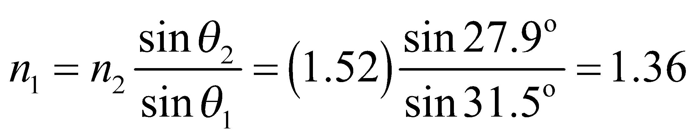
This agrees with the index of refraction for ethyl alcohol in Table 1.1.
Assess The ethyl alcohol has smaller index of refraction than glass, so the light should bend toward the normal, as it does here. If the liquid had been benzene, which has an index of refraction very close to that of glass, the change in angle would have been nearly imperceptible.
32. Interpret This problem is about refraction at the air-water interface. The mark you see is the point at the bottom of the tank along the refracted path.
Develop As shown in the diagram below, the mark seen on the meter stick is at position
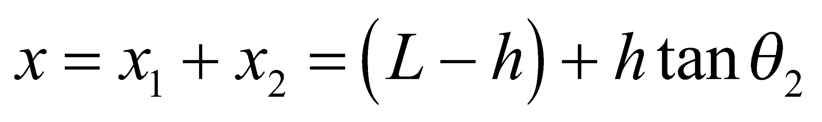
where 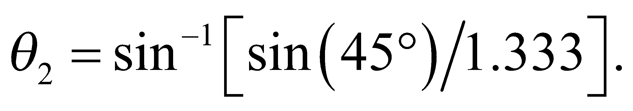 Thus, 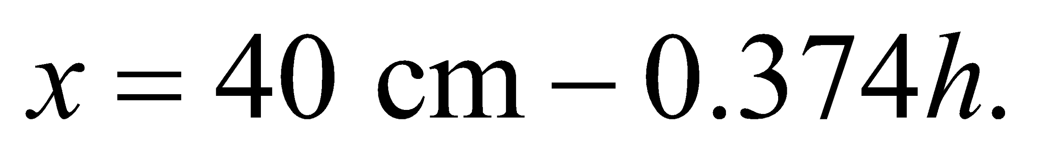

Evaluate (a) For h = 0 (empty), x = 40 cm.
(b) For h = 20 cm (half full), 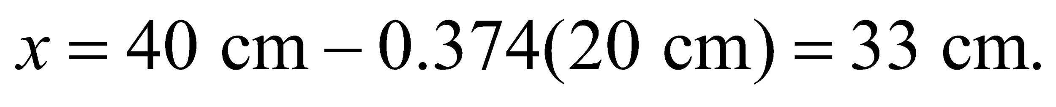
(c) Similarly, for h = 40 cm (full), 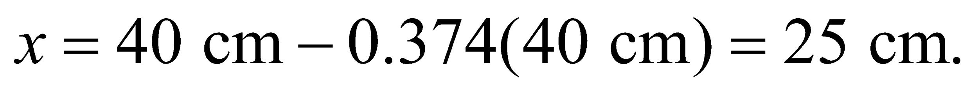
Assess The more water in the tank, the more the path “bends” the path, and hence the smaller mark on the meter stick you see. The results are given to two significant figures, as warranted by the data.
33. Interpret We are to find the refractive index such that a ray impinging on the center of a cube will transect the opposing vertex (see figure below).
Develop From the figure below, we see that the angle of refraction in the glass, given by 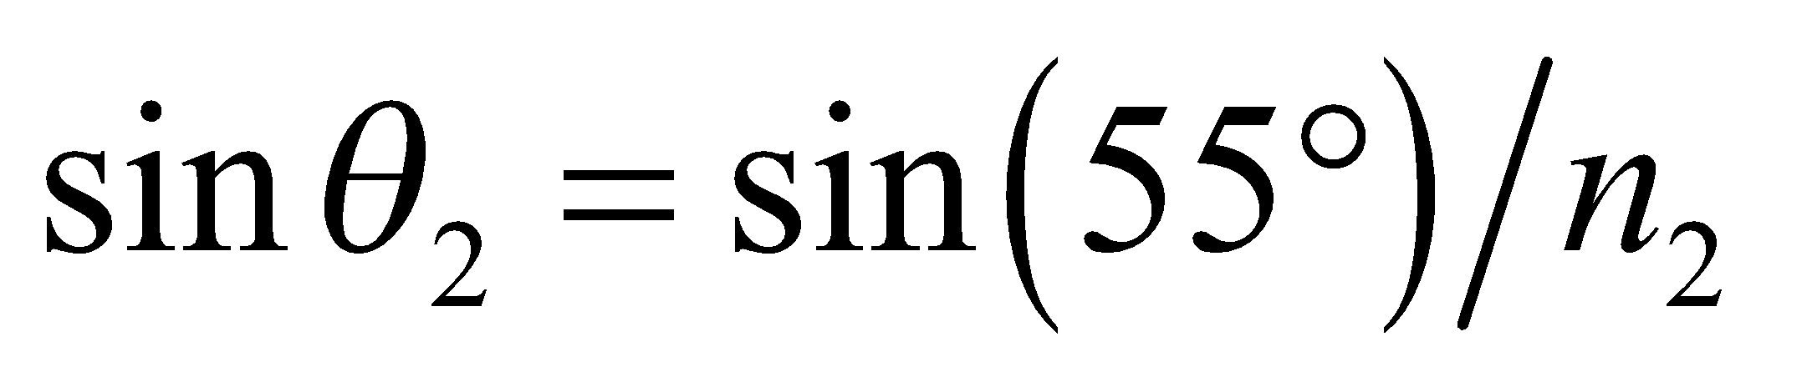must be less than 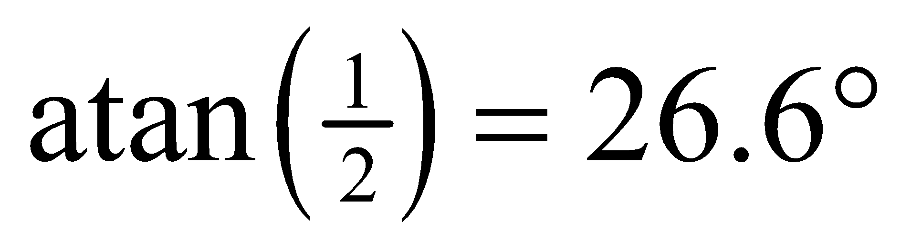 for the ray to emerge from the opposite face

Evaluate Therefore, 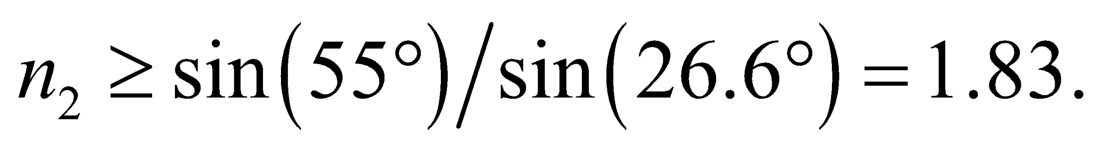
Assess The vertical face appears shorter than it really is, as is the case when one looks at legs in the 3-ft section of a swimming pool.
34. Interpret This problem involves refraction at an air-water interface. We are to find the minimum angle with the horizontal for which a beam of white light will illuminate the bottom of the tank.
Develop From the sketch below, we see that, if the beam enters at the rim of the tank, the maximum angle of refraction it can have and still reach the bottom is
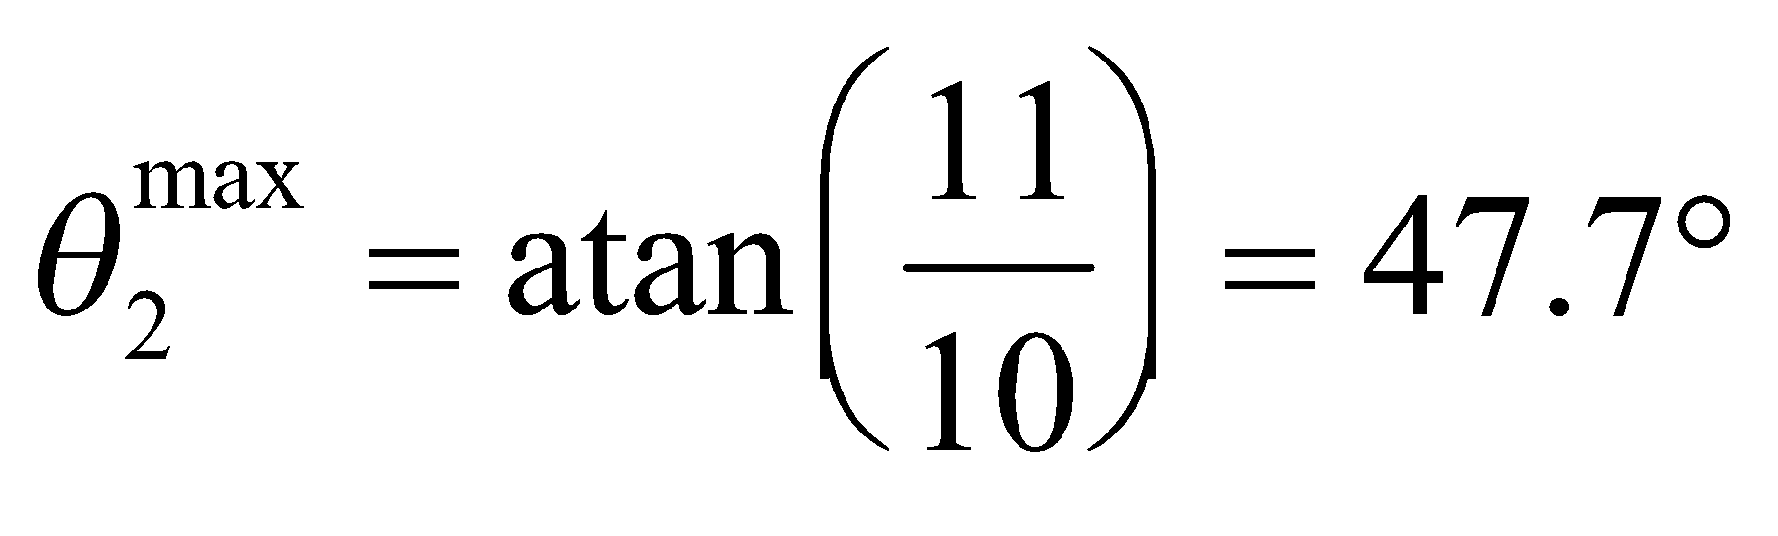
From Snell’s law, the maximum angle of incidence is given by 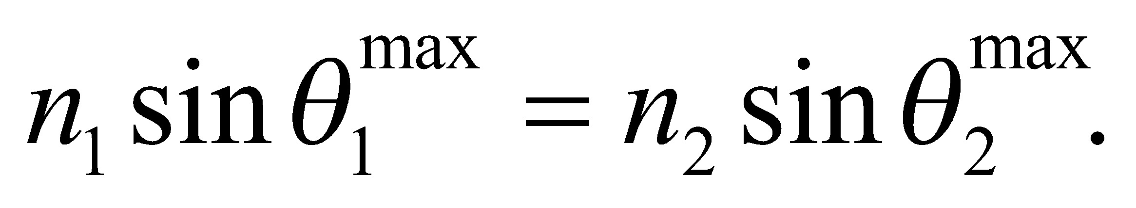

Evaluate Using the above equation, we see that the angle of incidence in air must be less than
In other words, the grazing angle α (the angle with the horizontal water surface) must be greater than
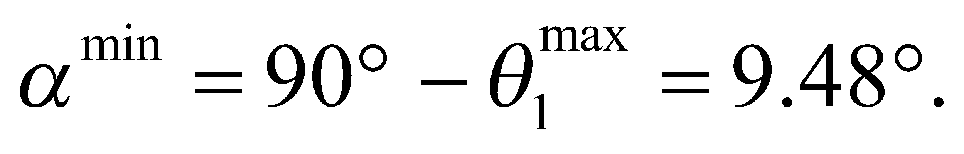
Assess Below 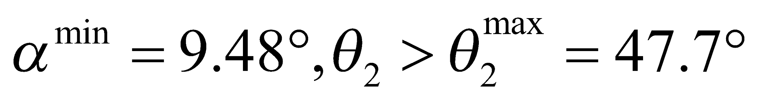, the refracted path will not reach the bottom of the tank.
35. Interpret This problem involves the refraction of light at an air-water interface, which we shall use to find the distance at which the diver is from the lake edge.
Develop Consider the sketch below, which describes the situation. Snell’s law gives the angle of refraction (θ₁) in terms of the angle of incidence (θ₂ = 42°) for the light path from the flashlight to your eye. These can be related to the other given distances by means of a carefully drawn diagram. Thus,
where we have used indices of refraction from Table 30.1, with n₁ = 1.00 for air. Given this angle, we can find the desired distance from geometry.

Evaluate The geometry of the diagram makes the horizontal distances apparent:
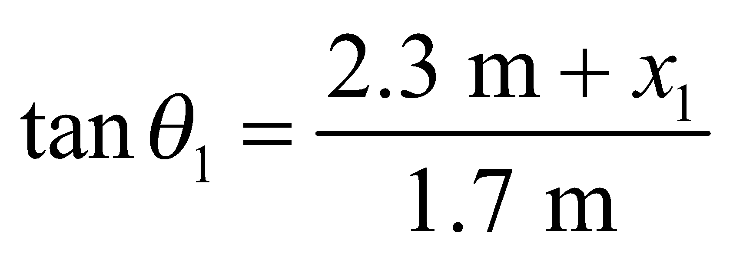 or 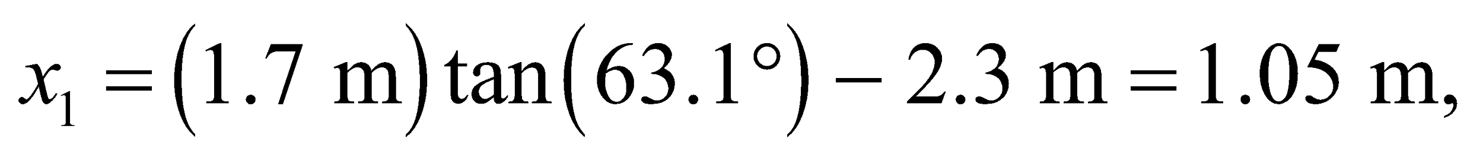
and
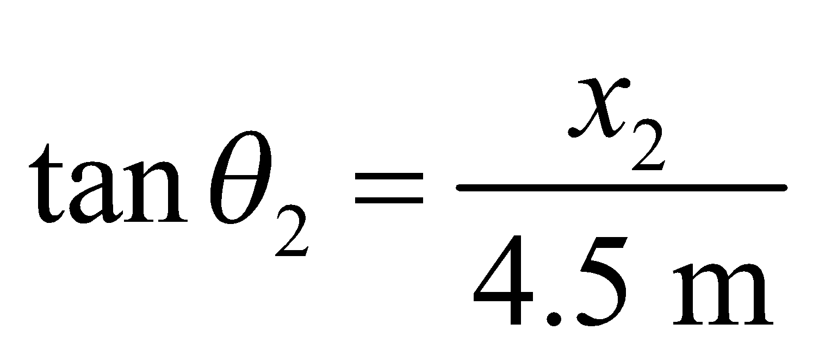 or 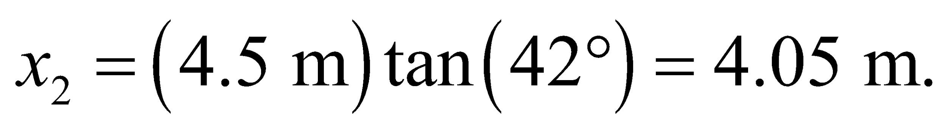
The total horizontal distance from the edge is 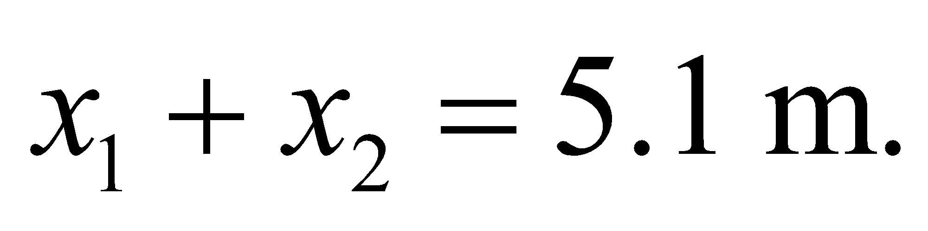
Assess The diver will appear to be farther from the edge of the lake, but in reality will be at the given distance.
36. Interpret This problem is about the refraction of light at an air-water interface.
Develop From the geometry shown in Figure 30.19, we have
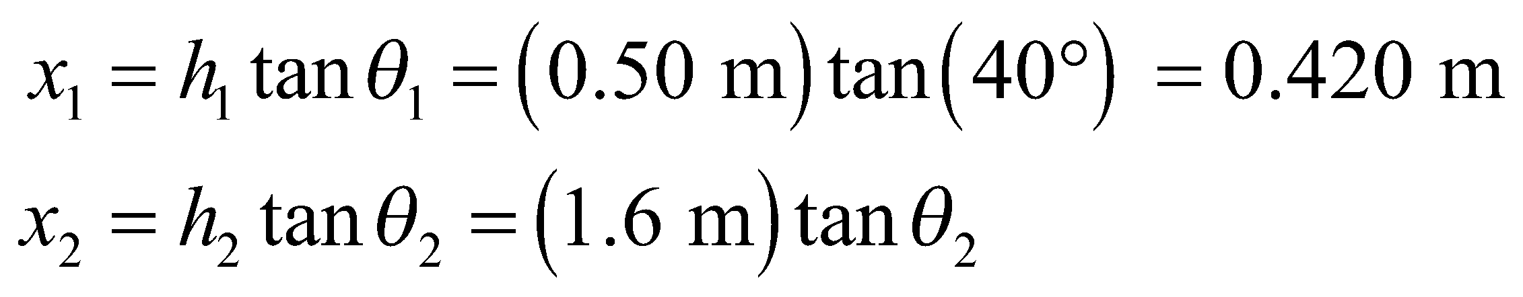
From Snell’s law, 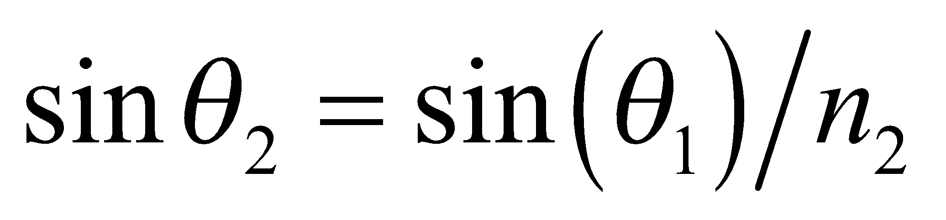 or 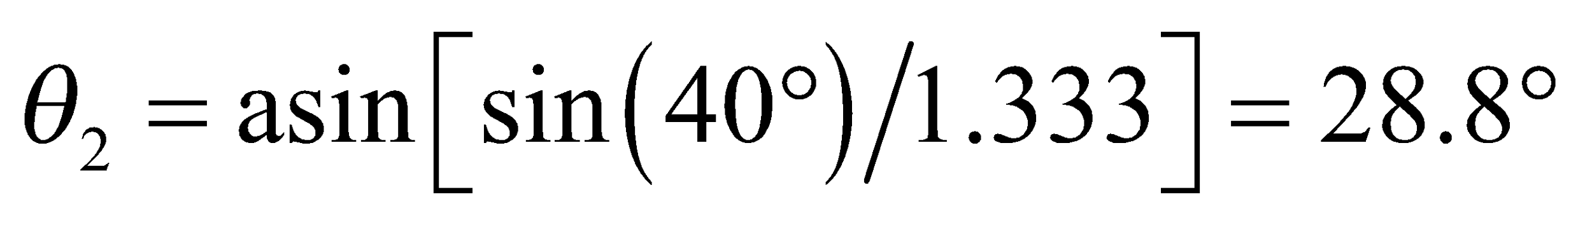 (n₁ = 1.00 for air). This gives 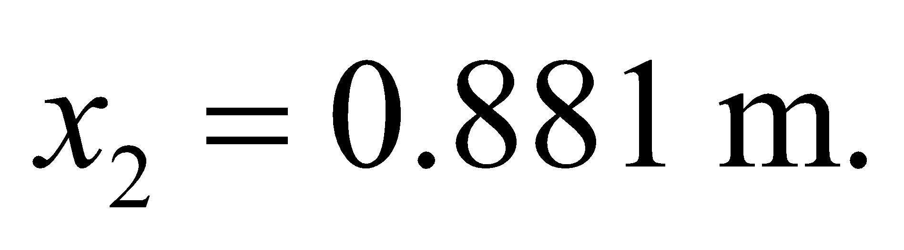
Evaluate The total horizontal distance from the dock is 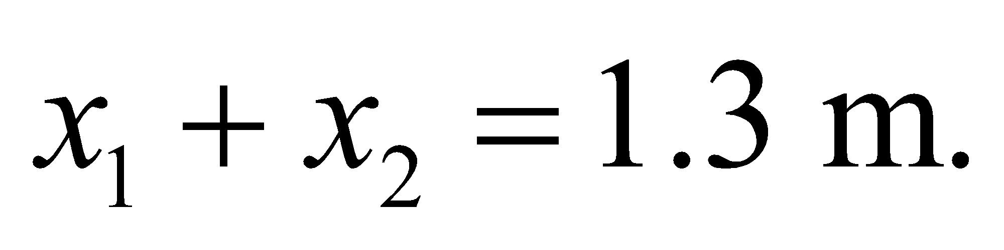
Assess The horizontal distance increases with θ₁, so the smaller the angle θ₁, the closer the keys are to the dock.
37. Interpret The problem concerns laser surgery and the wavelength of UV light when it passes into the eye.
Develop The light is coming from air , so the wavelength in the lens is
Evaluate Using the wavelength in air and the index of refraction of the lens, the wavelength becomes
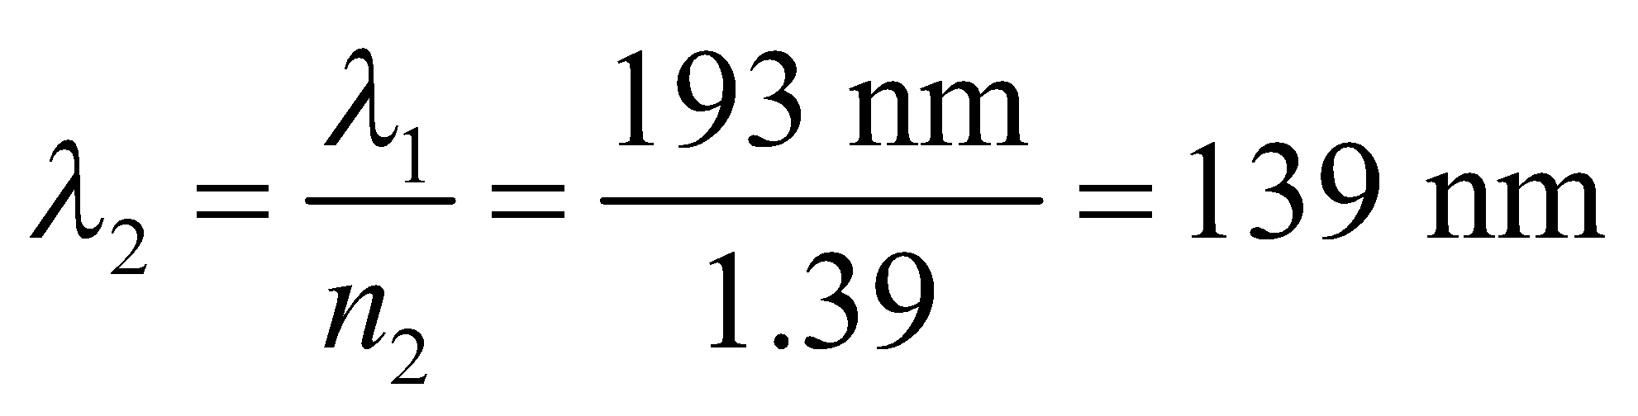
Assess The laser light isn't technically supposed to enter the lens. Instead it is used to sculpt the cornea in front of the lens. The procedure helps to redirect light into the eye (through refraction) to improve vision.
38. Interpret This problem is about light that is refracted at the entrance and exit air-prism interfaces. We are to find the angle through which the light beam is deflected when it exits the prism.
Develop From Snell’s law (Equation 30.3) and plane geometry, we have 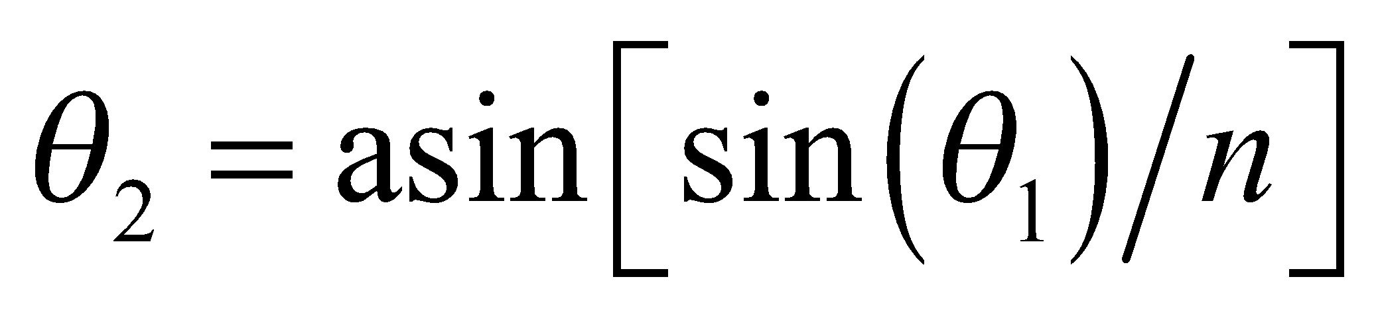 (Snell’s law for the first refraction, with n₁ = 1.00 and 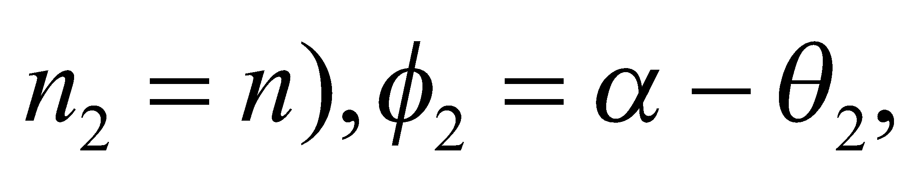 where α is the exterior angle to the triangle formed by the ray segment in the prism and the normals to the surfaces, 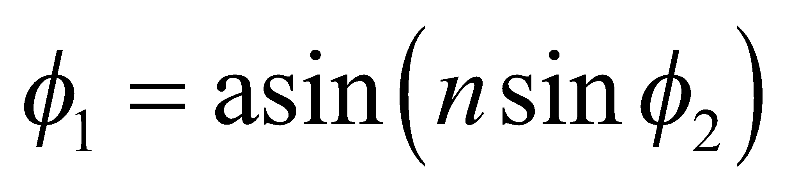 (Snell’s law for the second refraction). The total deflection is the sum of the deflections at each refraction, taking clockwise deflection to be positive in Fig. 30.23. Substituting the expressions obtained above, one gets (see Problem 27)
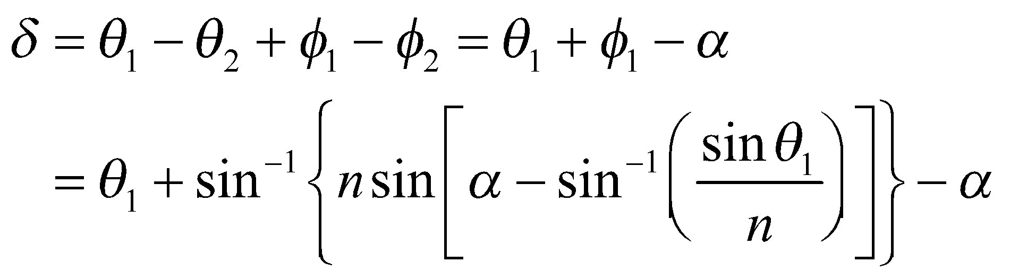

Evaluate For the data in this problem, the other angles and the deflection are:
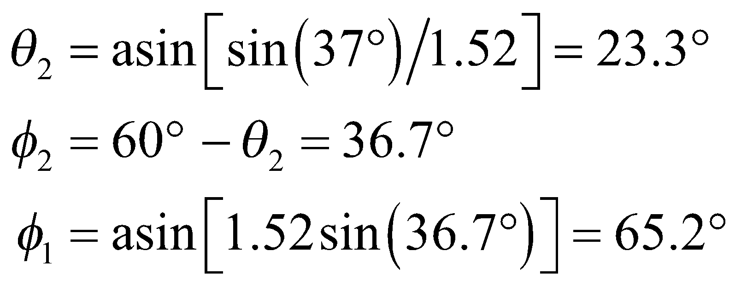
Therefore, the total deflection is
Assess The total deflection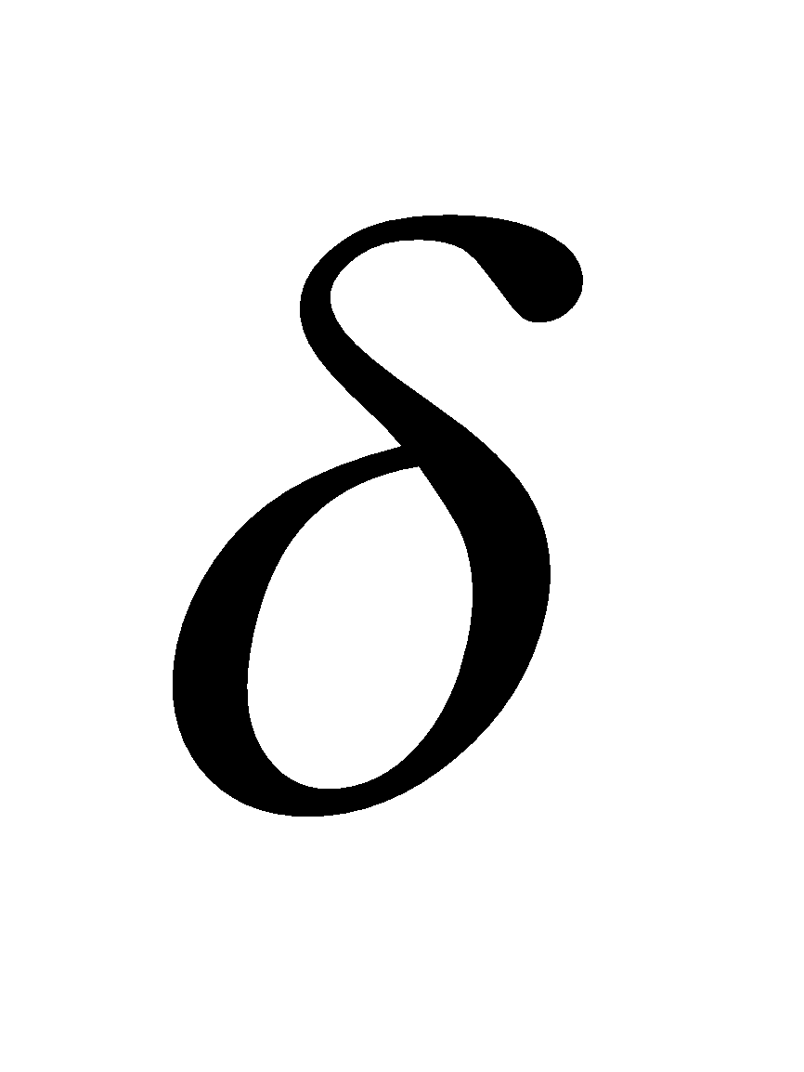is a complicated nonlinear function of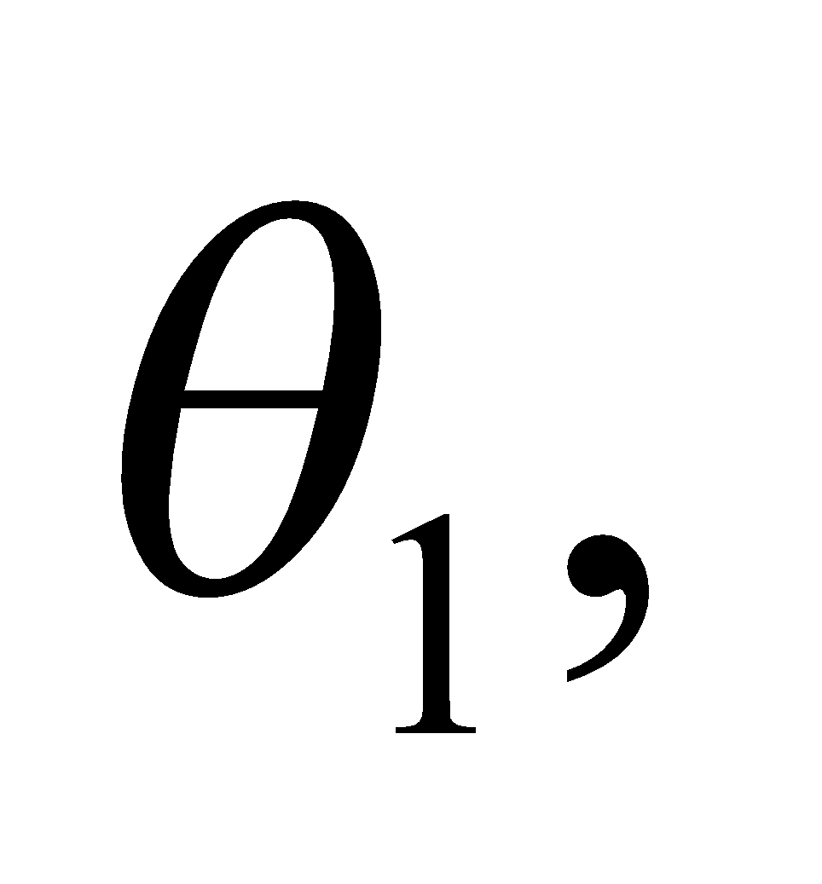as shown in the figure below.

39. Interpret We are to redo the preceding problem with different values for the refractive index of the prism, the incident angle, and the prism’s apex angle.
Develop A general treatment of refraction through a prism of index of refraction 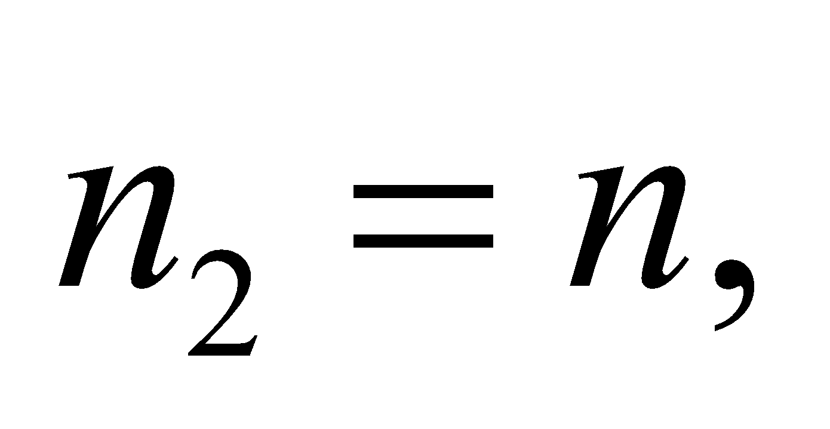 surrounded by air of index 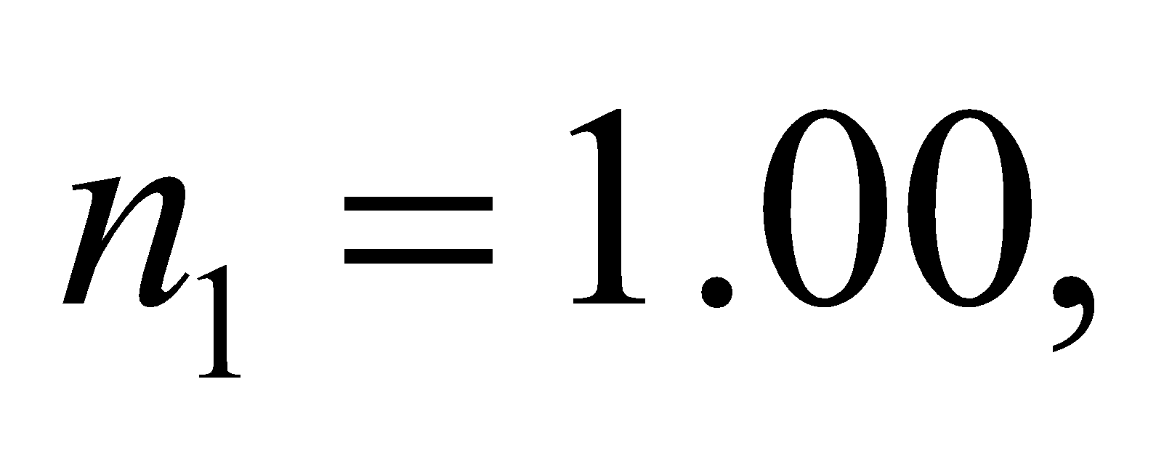 for the geometry of Figure 30.20, is given in the solution to Problem 27.
Evaluate For 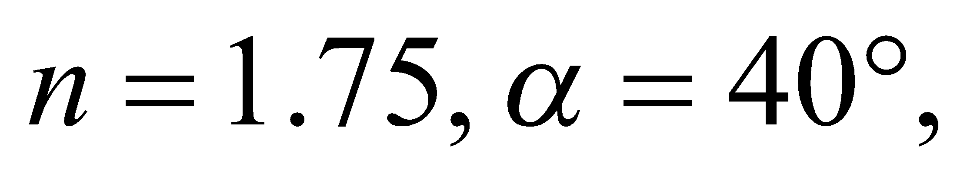 and 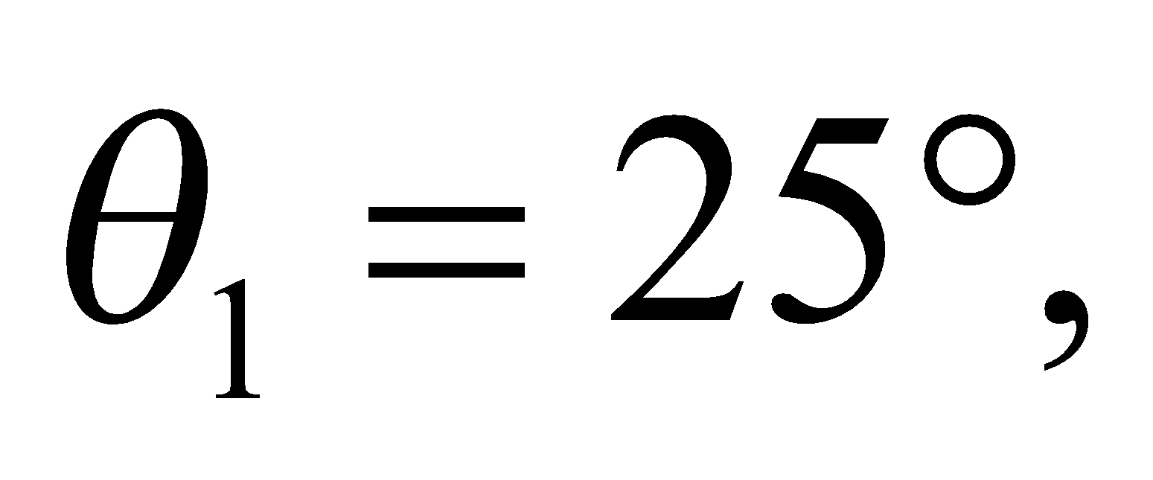 the other angles defined there are
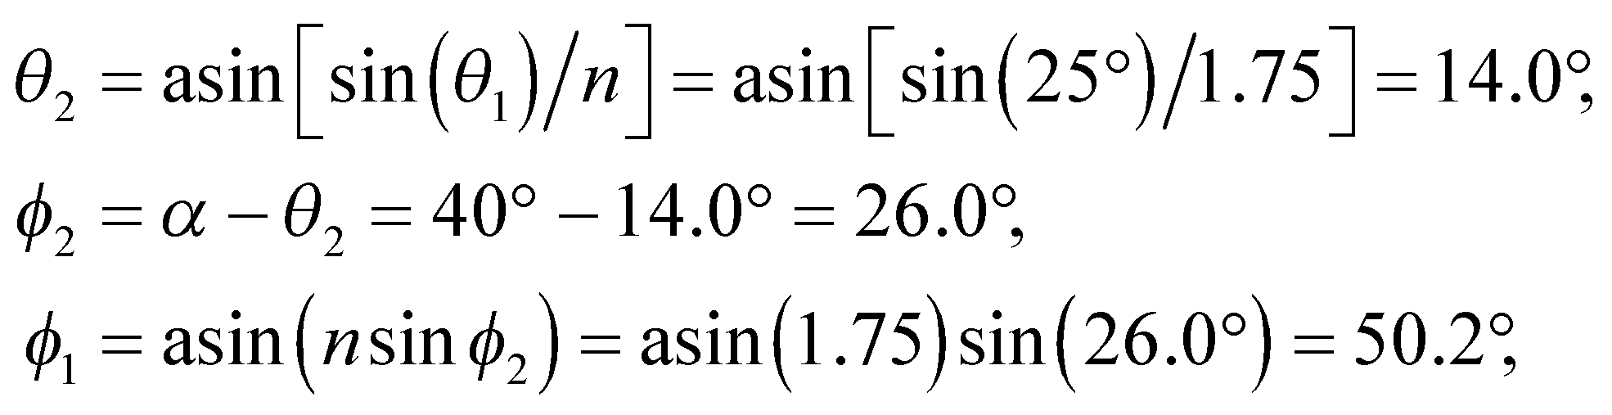
and 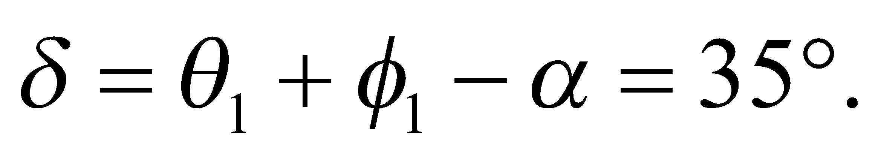
Assess Note that 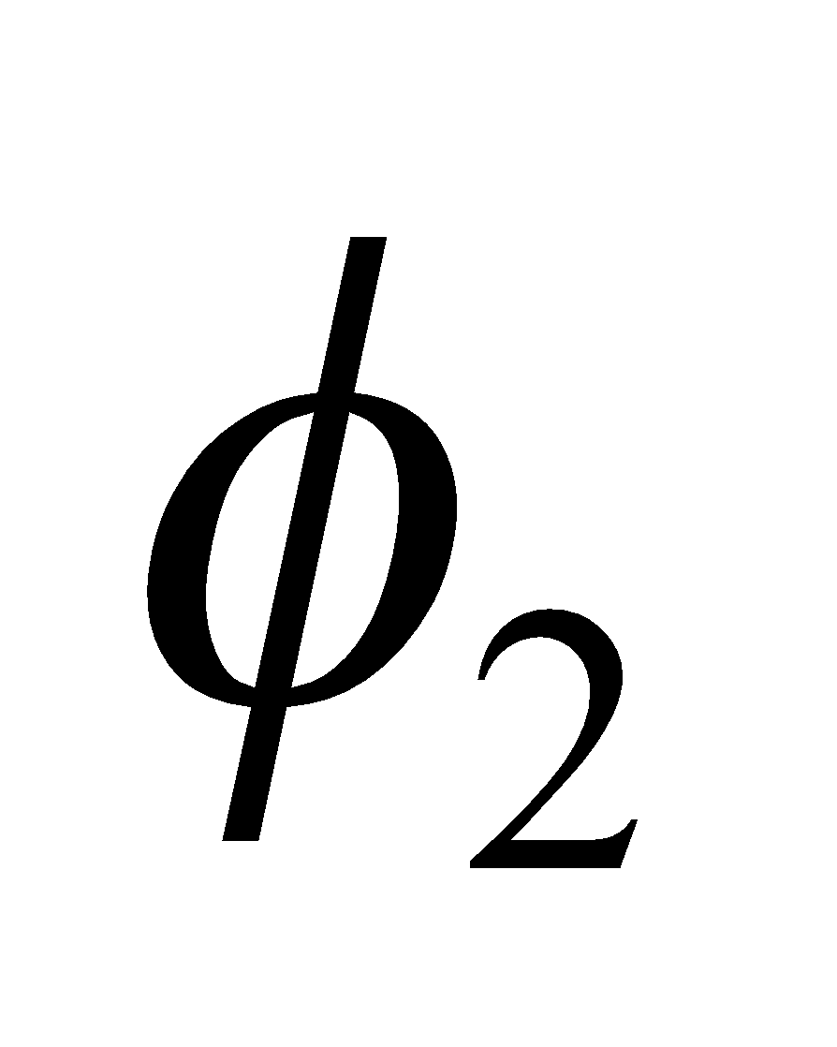 is less than the critical angle for this prism, which is 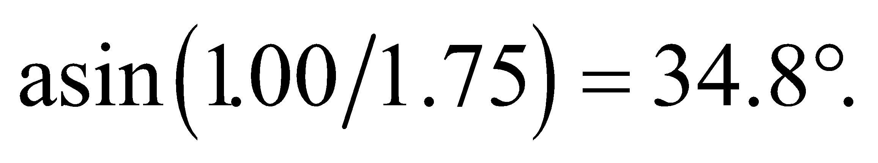
40. Interpret We are to find the minimum index of refraction for the prism shown in Figure 30.11 so that total internal reflection occurs. The prism is surrounded by air and we shall use Equation 30.5 for the critical angle.
Develop Equation 30.5 for critical angle is 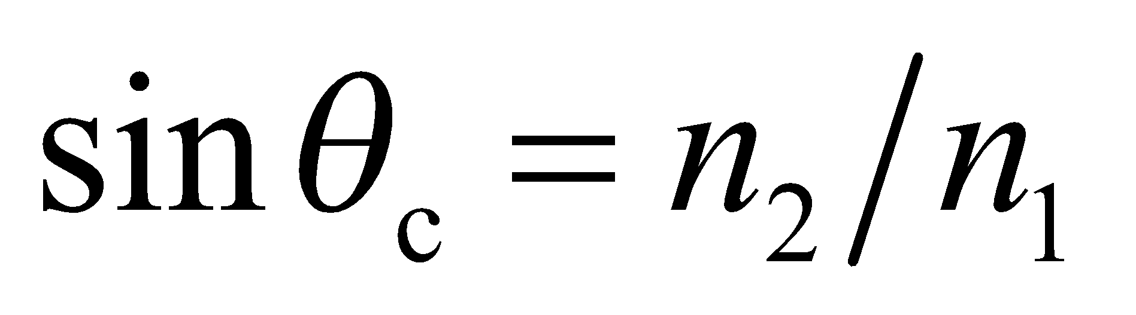, where 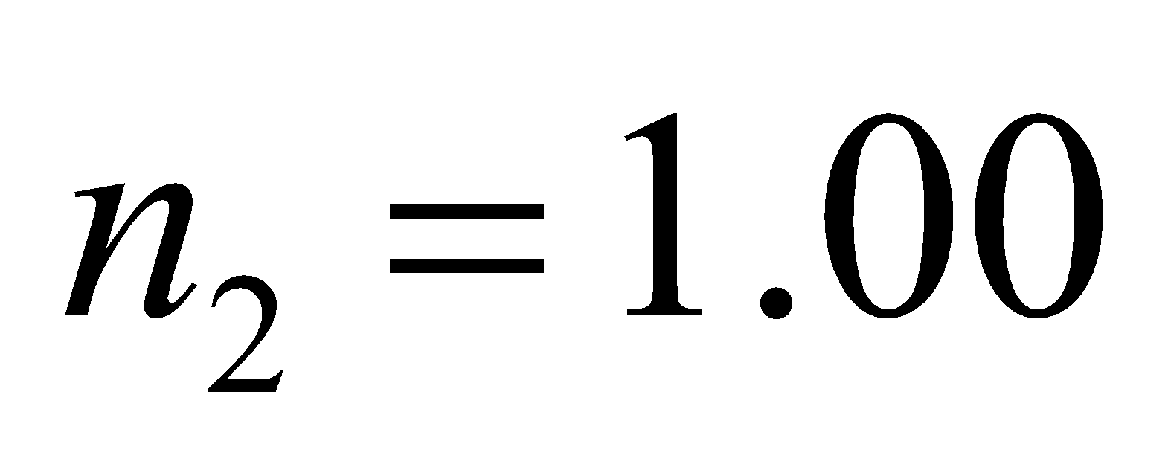 and, by inspection of the geometry of the figure, 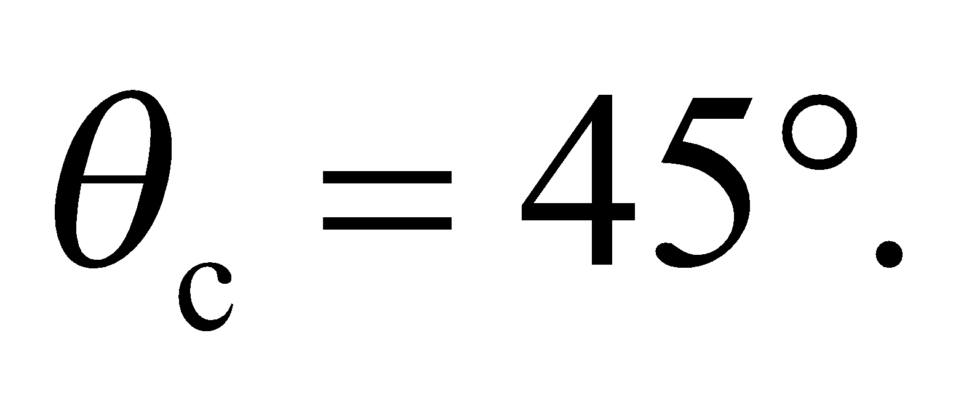 Solve for 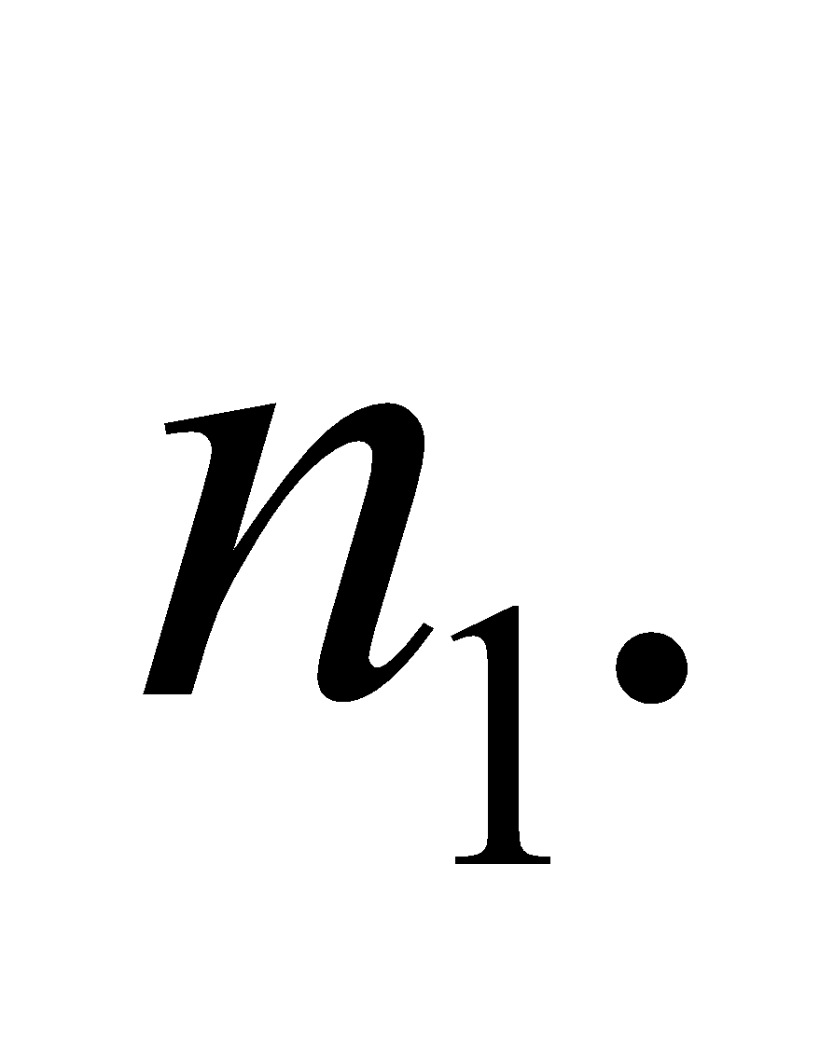
Evaluate The minimum refractive index for total internal reflection is
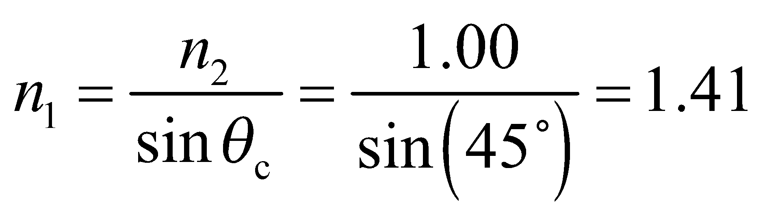
Assess Most types of glass and clear plastic have an index of refraction greater than 1.5, so this type of prism is not unusual. If you take apart a pair of binoculars, you’ll see several of these.
41. Interpret For this problem, we are to determine if the main beam emerges from the prism at the diagonal face or at the bottom face of the prism, and at what angle it emerges with respect to the exit face normal.
Develop The critical angle for an ice-air interface is 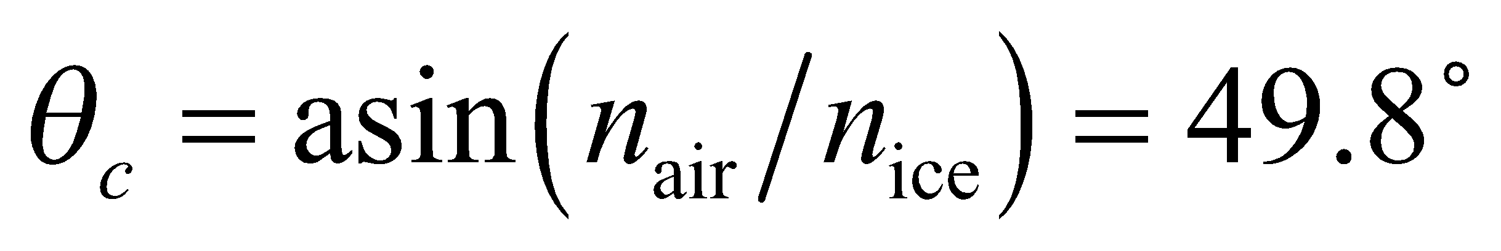, which is greater than the incident angle of 45° (see figure below). Thus, total internal reflection does not occur, and the beam emerges from the diagonal face of the prism at an angle with respect to the face normal determined by Snell’s law (Equation 30.3).

Evaluate From Snell’s law, the exit angle (θ₂ in the sketch above) is
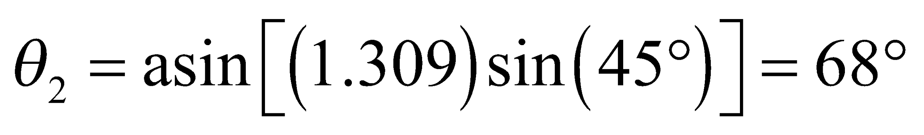
The deviation from the incident direction is 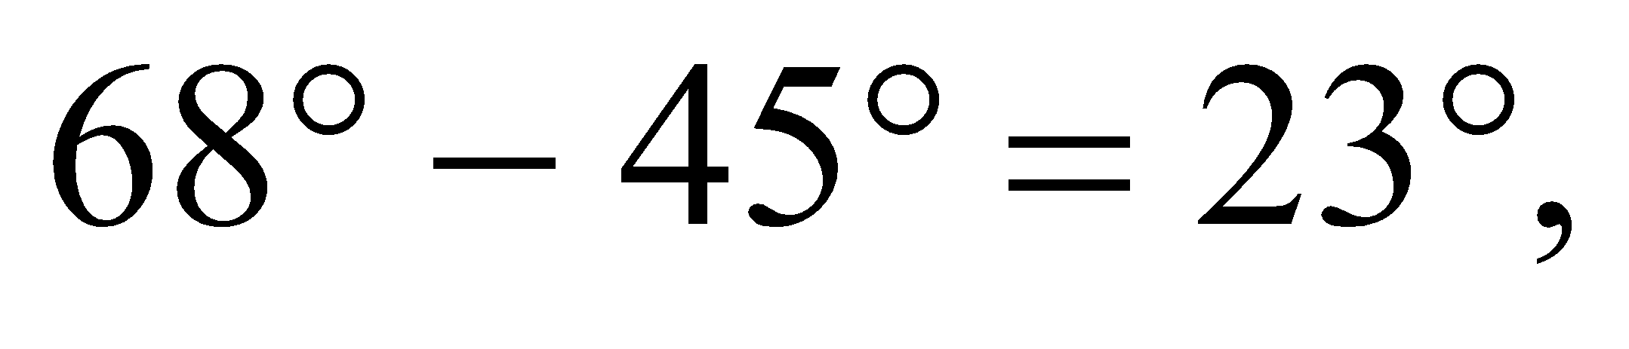 as shown in the sketch above.
Assess Because n₂ < n₁, θ₂ > θ₁ to compensate and satisfy Snell’s law.
42. Interpret This problem involves finding the speed of light in a medium. We are given its critical angle at an interface with air, which allows us to calculate the index of refraction.
Develop From Equations 30.2 and 30.5, the relationship between the critical angle and the speed of light in a material can be written as
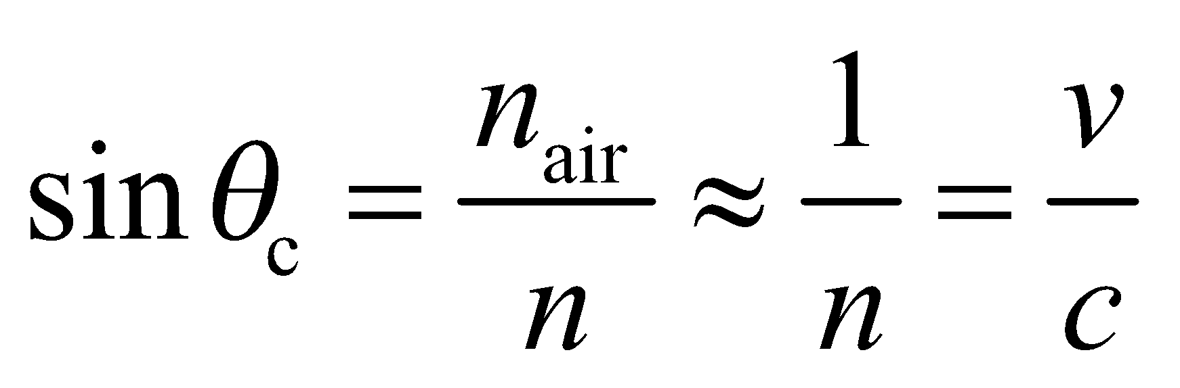
Evaluate With 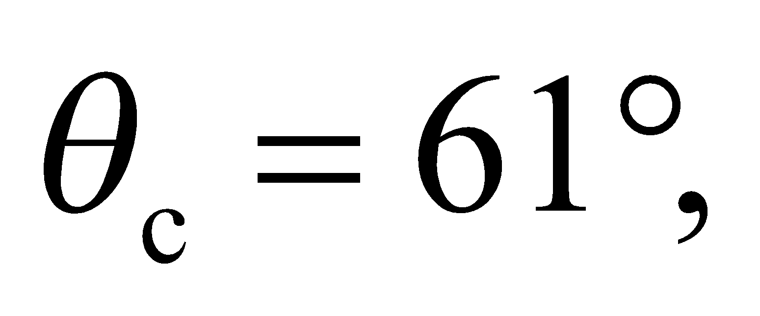 the speed of light in the medium is
Assess The critical angle and the speed of light in a material are both related to the index of refraction. When
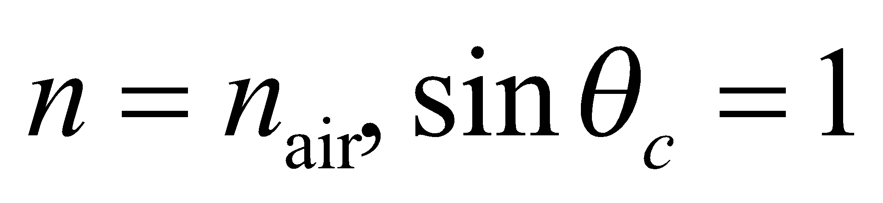 and v = c, as expected.
43. Interpret We are to find the minimum refractive index for the medium surrounding the prism in Figure 30.10 for which total internal reflection does not occur.
Develop When the prism is immersed in liquid, 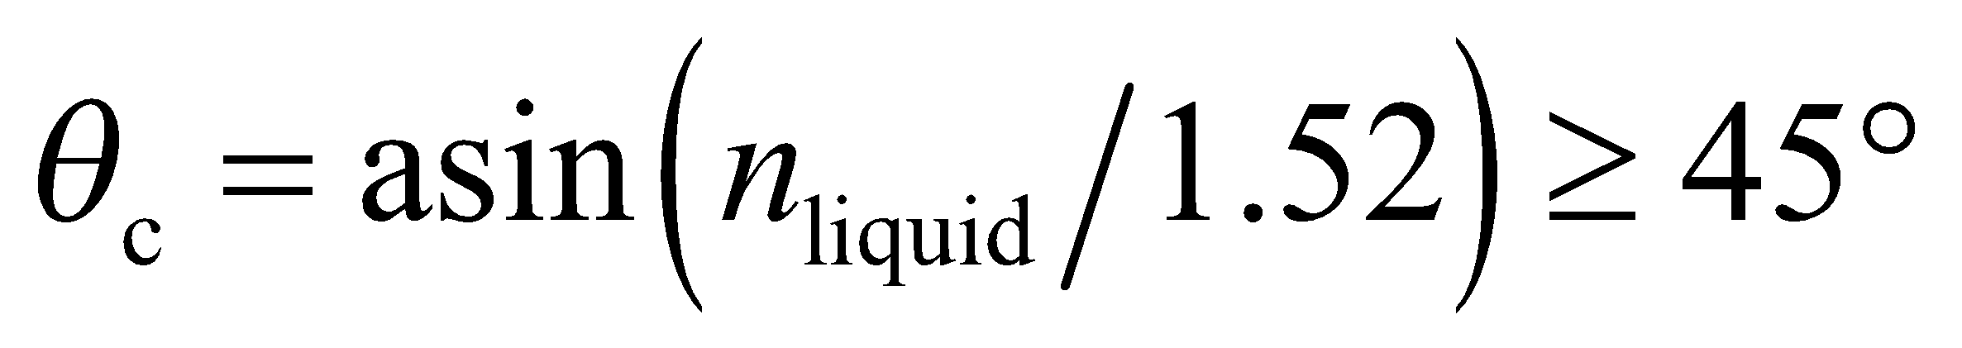 for total internal reflection to occur.
Evaluate Therefore, 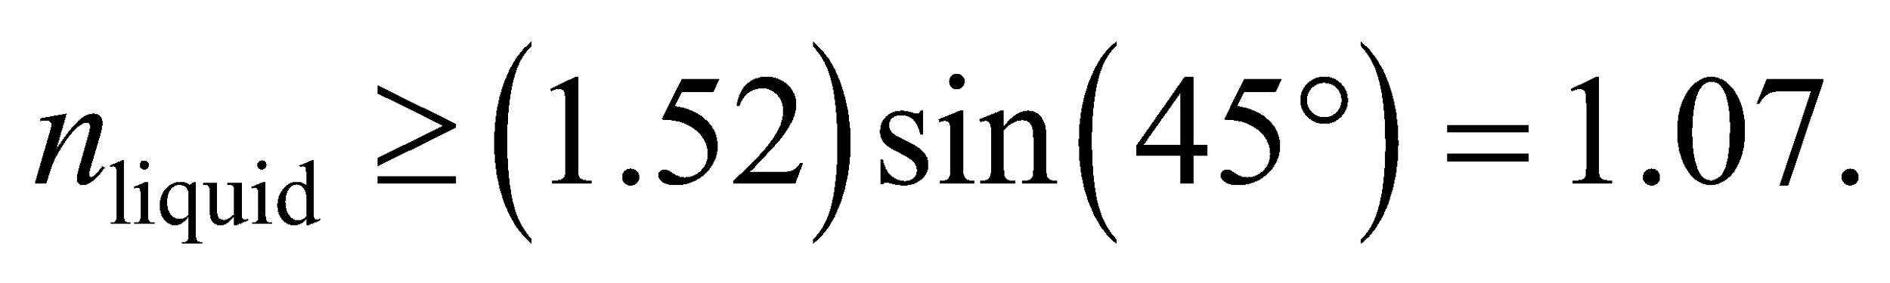
Assess Because the liquid constitutes the second medium (i.e., the light propagates from the prism into the liquid), its refractive index must be less than that of the prism for total internal reflection to occur.
44. Interpret We are to find the relationship between the critical angle and the polarizing angle at an interface between air and another medium.
Develop For an interface with air, the critical angle is usually specified for light propagating from the material into the air (as in Figure 30.9). Thus, n₁ is the index of the material and n₂ is the index of air. Equation 30.5 for the critical angle then takes the form
However, the polarizing angle for the same interface is usually specified for incident light propagating in the reverse direction (i.e., from air into the material), so in Equation 30.4, n₁ is the index of air and n₂ is the index of the material, which leads to
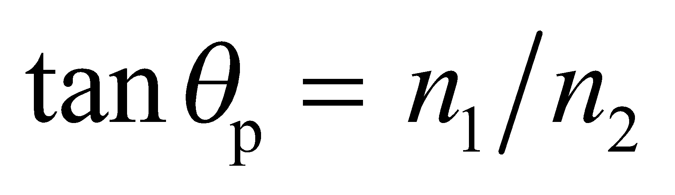
Evaluate Combining the two equations, we obtain
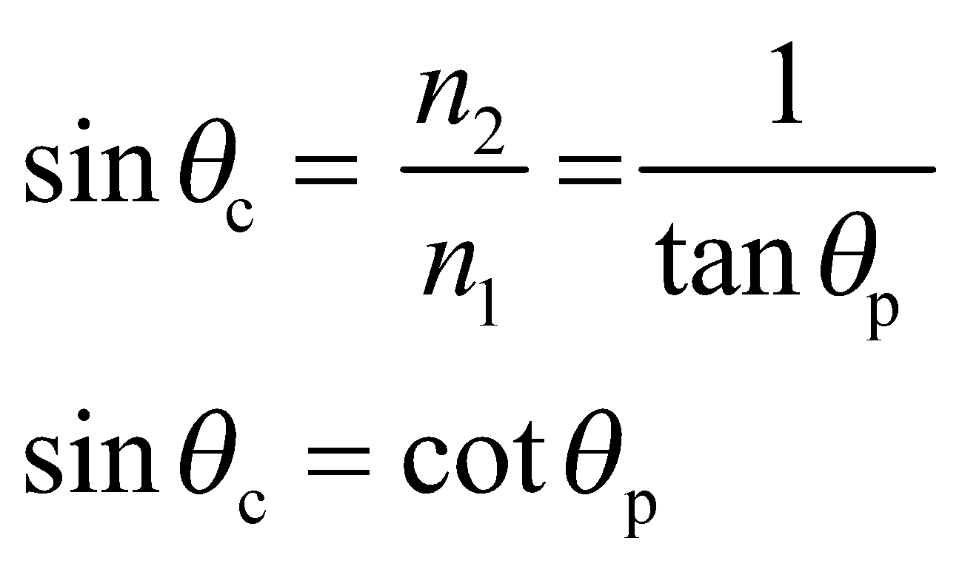
Assess This is not a fundamental relation; it merely reflects the fact that both angles depend on the ratio of the indices of refraction.
45. Interpret We are to show that light emanating from a point source in on material will enter a second medium in a circle with the given diameter. The critical angle at which the light is totally internally reflected will be useful for this problem.
Develop Consider the diagram below. Light from the flash will strike the water surface at the critical angle for a distance 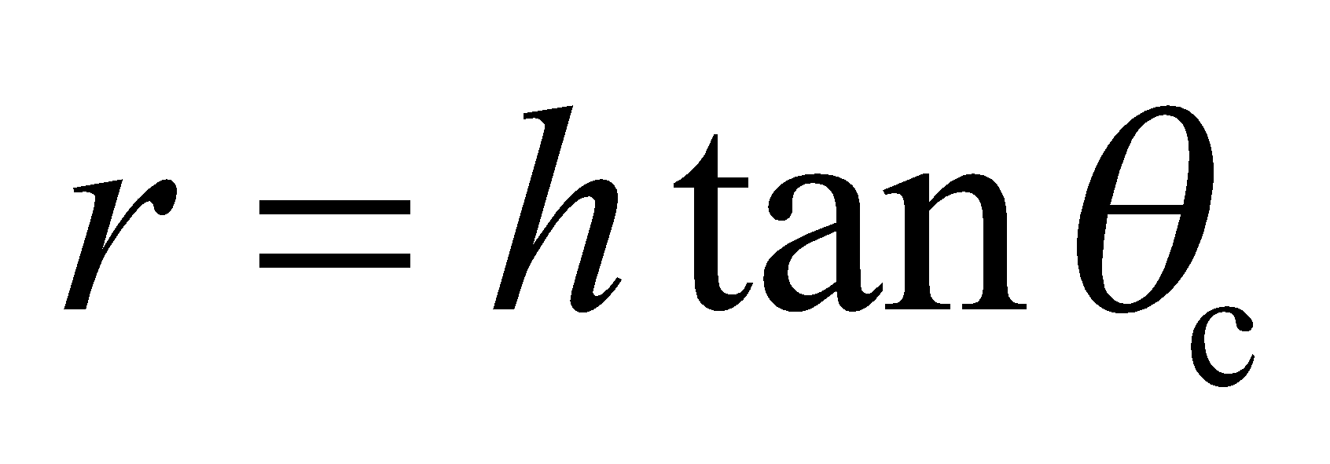 from a point directly over the flash. Therefore, the diameter d of the circle through which the light will emerge is 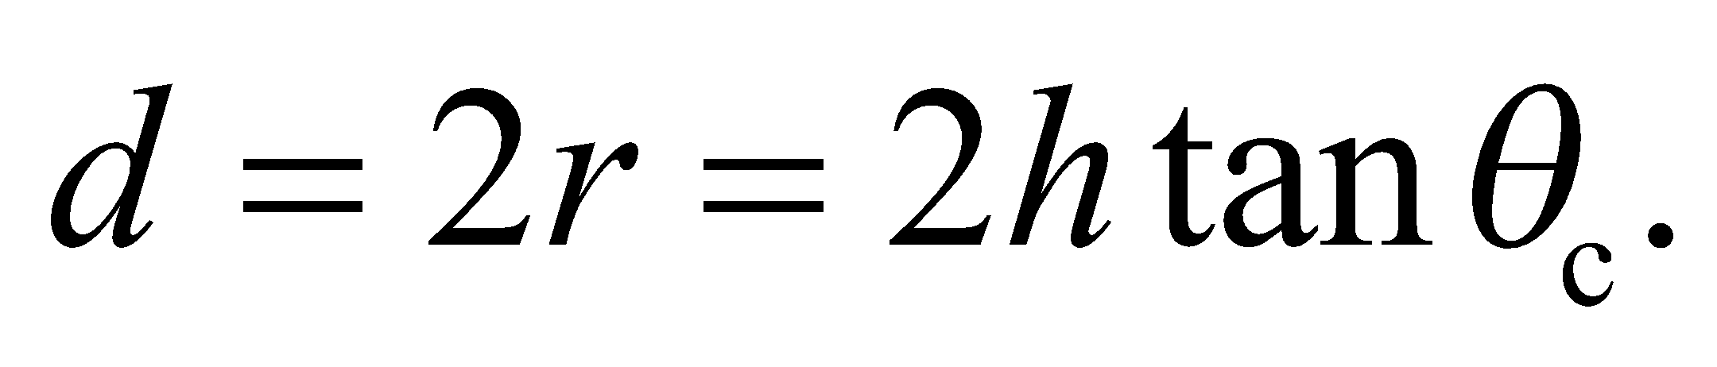 But 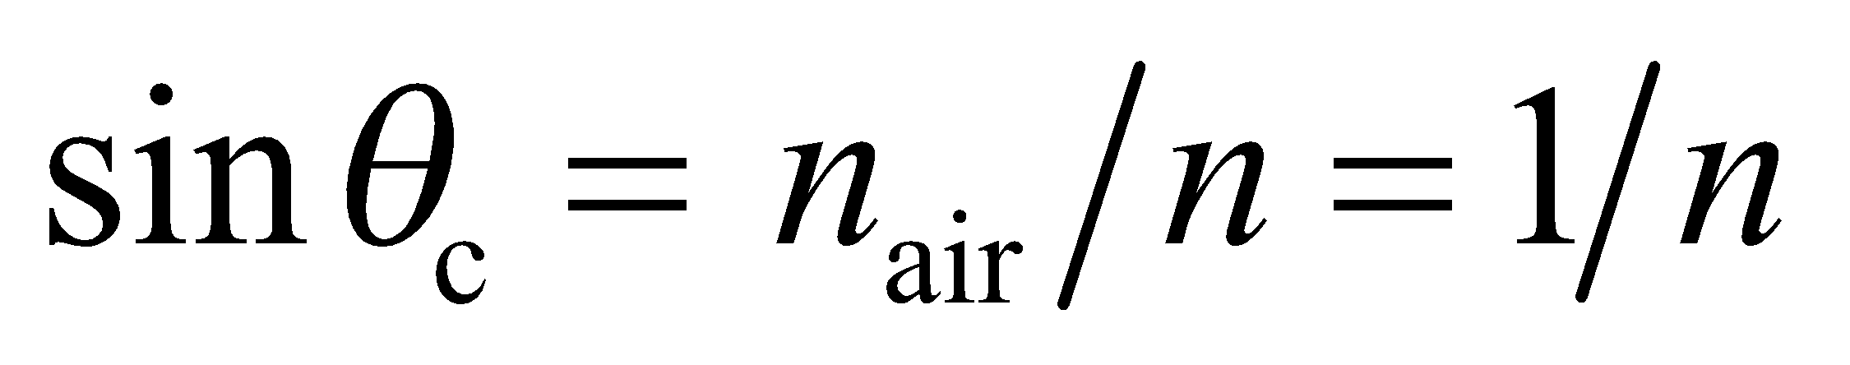 (Equation 30.5 at the water-air interface), and 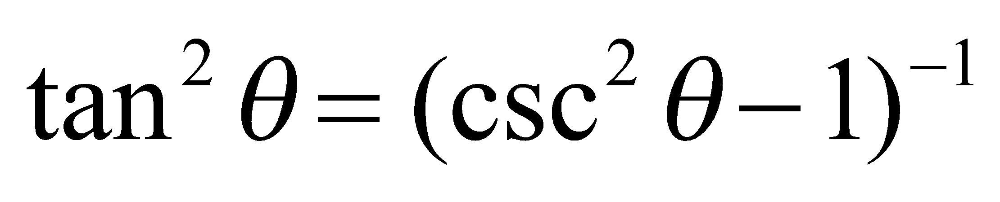 (a trigonometric identity), which we can use to show the desired relationship.

Evaluate The diameter of the circle through which the light emerges can therefore be expressed as
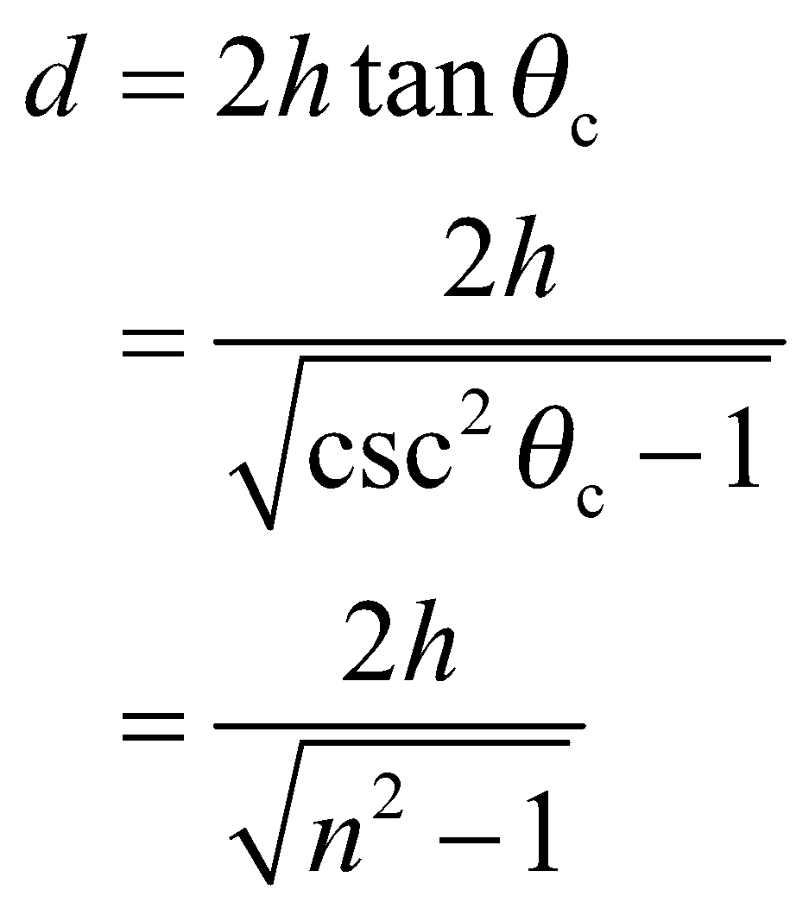
Assess The more general form of this relationship is
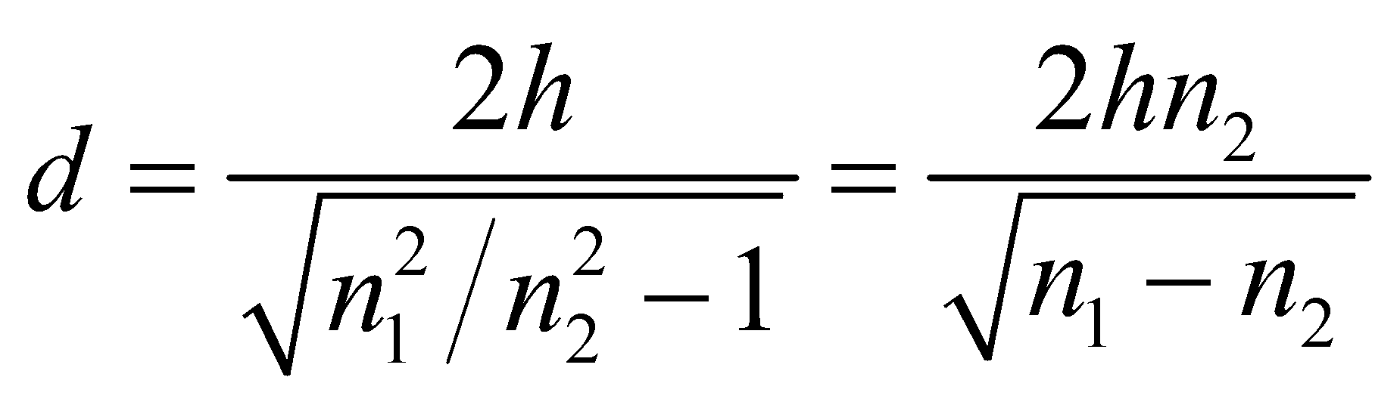
which shows that the critical angle is only relevant for n₁ > n₂, which is expected because sinθ_{c} = n₂/n₁ cannot be greater than unity.
46. Interpret This problem involves the critical angle for total internal reflection at the glass-air interface and dispersion (i.e., the index of refraction is wavelength dependent). We shall use to this find the range of angles for which blue light is totally internally reflected whereas red light is not.
Develop The critical angle for the blue light and the red light are
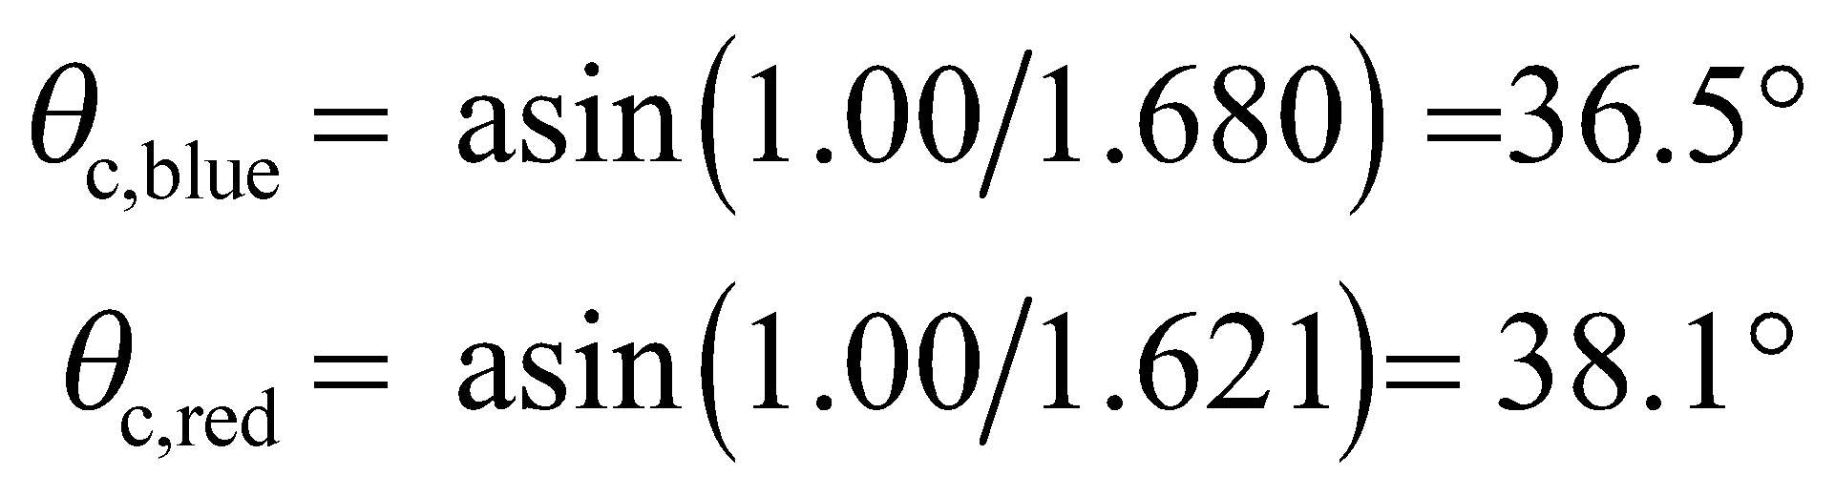
Evaluate For incidence angles between these values 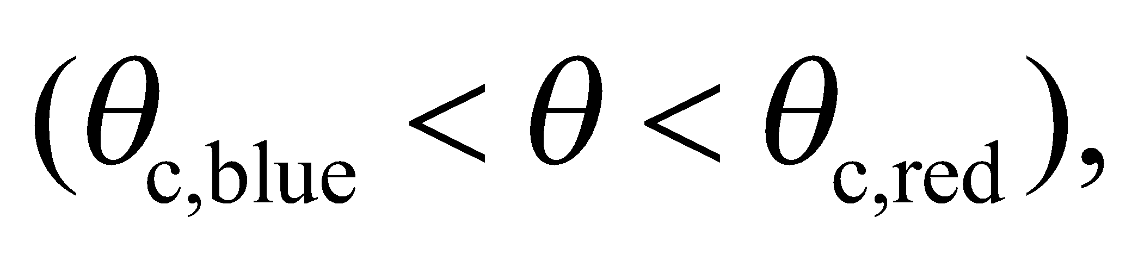 blue light will be totally reflected, while some red light is refracted at the glass-air interface. Therefore, the angular range of interest is 36.5° to 38.1°.
Assess Because the refractive index for the blue light is greater than that of the red light 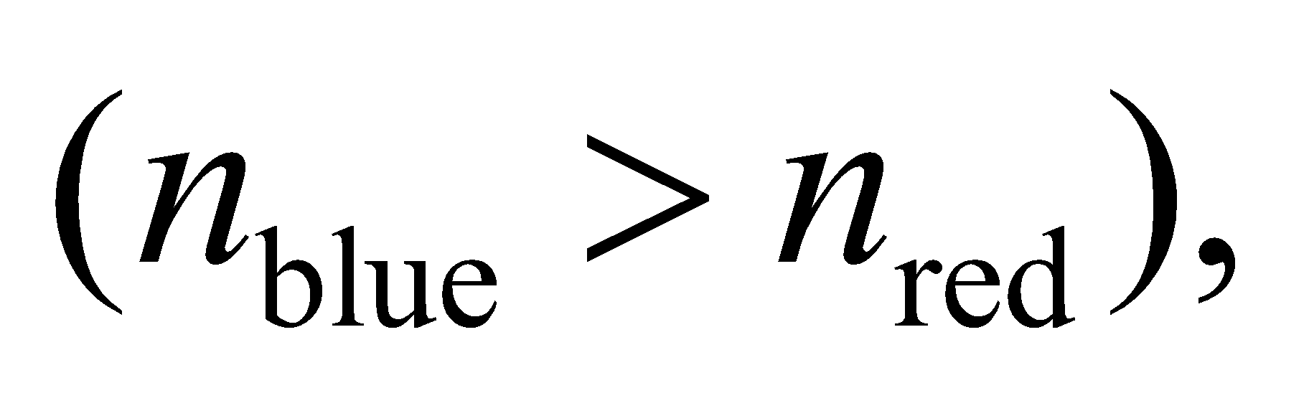 the critical angle for blue light is less than for red light.
47. Interpret This problem involves finding the critical angle at the interface between two given media.
Develop Apply Equation 30.5, sinθ_{c} = n₂/n₁ with n₂ = n_{glass} and n₁ = n_{flint}.
Evaluate The critical angle is
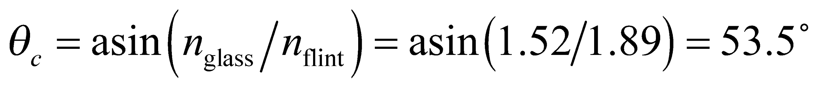
Assess In the reverse direction, there is no critical angle because n_{flint} > n_{glass}.
48. Interpret We are to find a “simple” relationship between the speed of light in a medium and its critical angle at an interface with air.
Develop The speed of light in a medium with refractive index n is (Equation 30.2) v = c/n. On the other hand, from Equation 30.5, the critical angle of the medium is 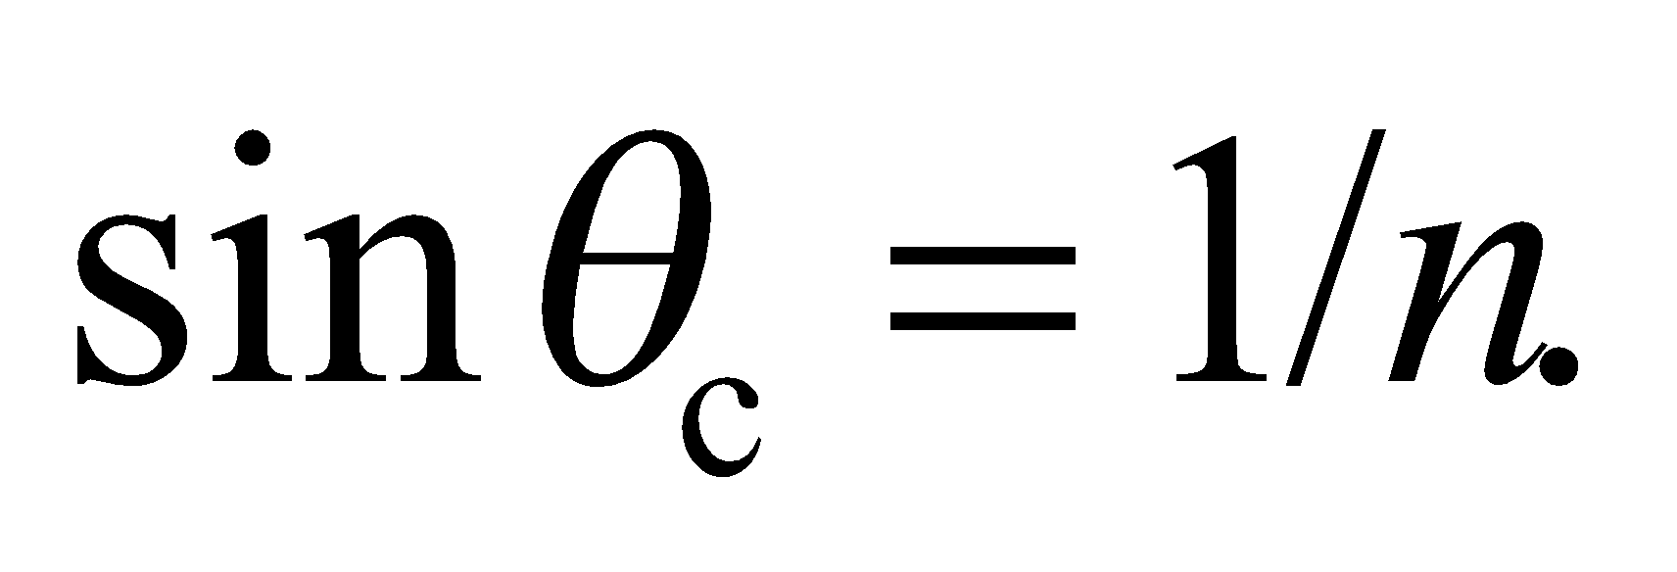 Thus, the relationship between the critical angle and the speed of light in a material can be written as
Evaluate From the above equation, the speed of light in the medium may be expressed as
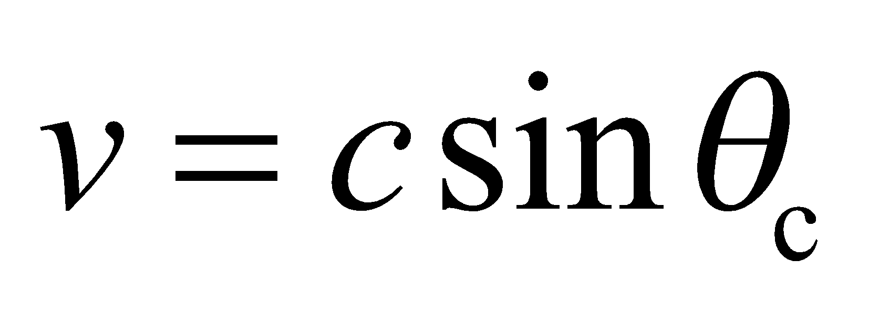
Assess The critical angle and the speed of light in a material are both related to the index of refraction of the medium. When 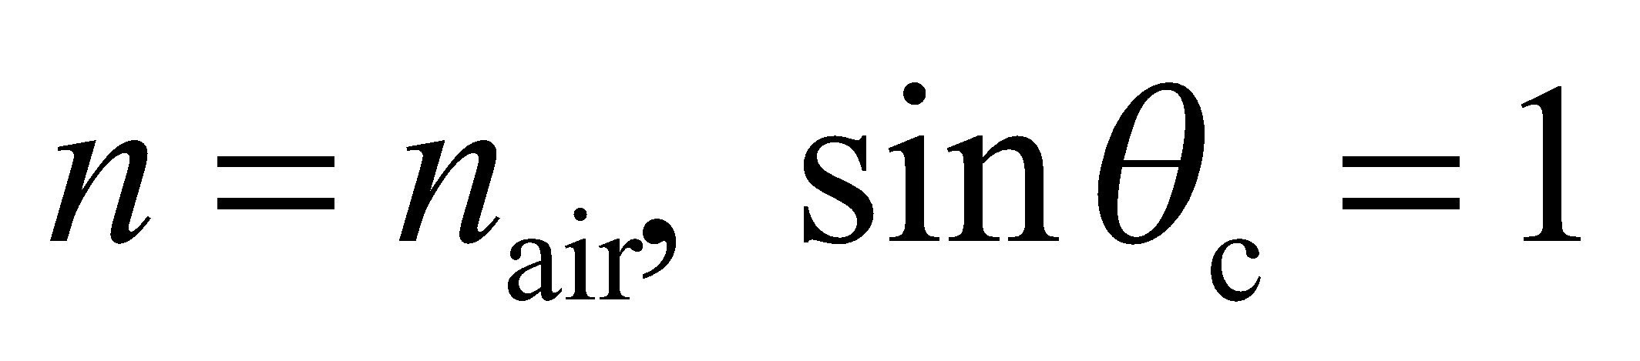 and v = c, as expected. Note that a more general form of this expression is
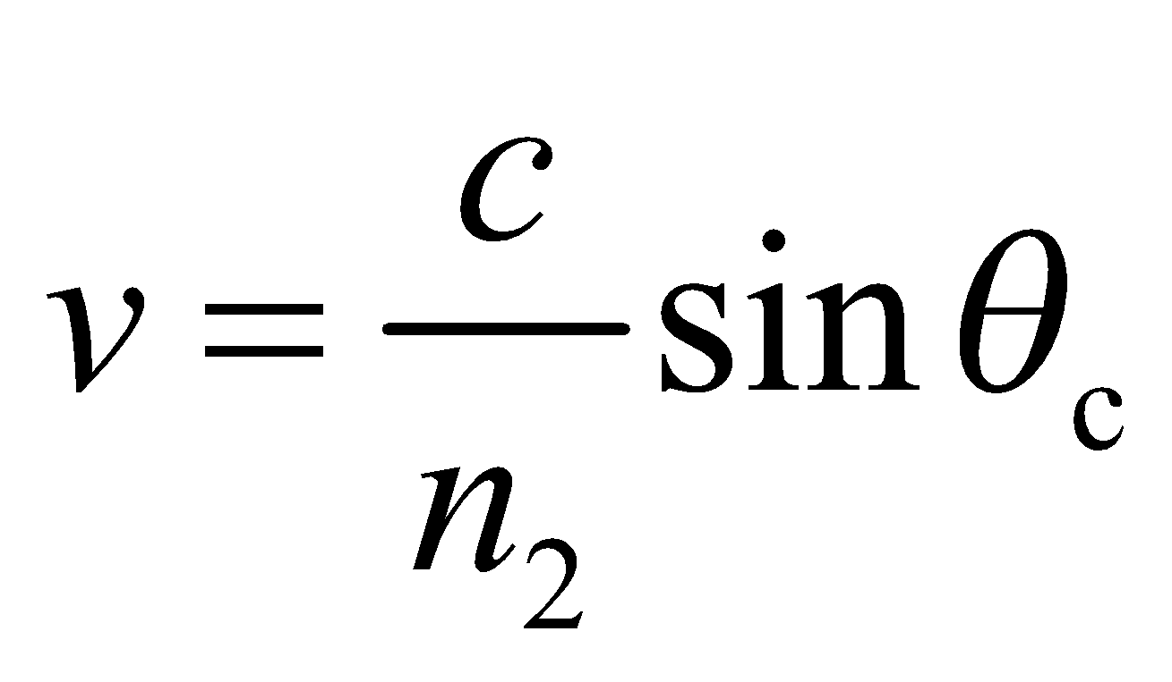
which reduces to v = c =for n₂ = 1.
49. Interpret We are to find the polarizing angle for a water-air interface.
Develop Apply Equation 30.4, with n₂ = n_{air} and n₁ = n_{water}.
Evaluate The critical angle is
Assess This may be qualitatively verified in your neighborhood swimming pool.
50. Interpret We are to find the diameter of a water tank given the incident angle at which light will traverse from the top right to the bottom left of the tank.
Develop Consider the sketch below. The diameter d and depth h of the tank are related to the angle of refraction θ₂ by
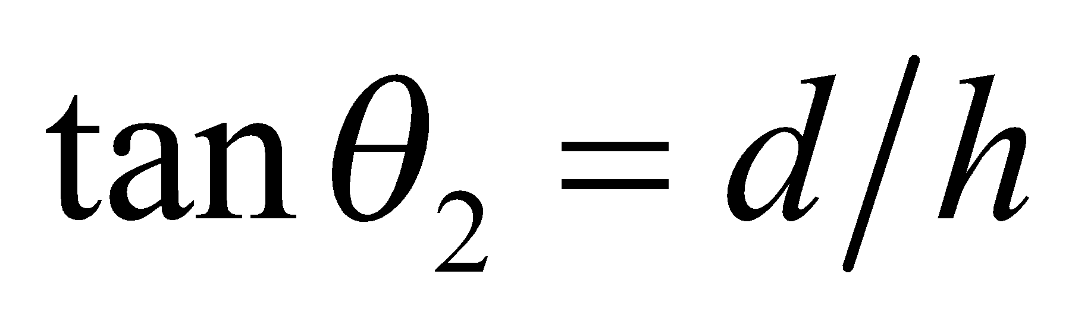
Combine this with Snell’s law (Equation 30.3) to find the diameter of the tank.

Evaluate Using n₁ = 1.00 for air and n₂ = 1.33 (see Table 30.1), we find the diameter of the tank to be
Assess The result is reported to two significant digits because we are given the incident angle and the tank depth to two significant digits.
51. Interpret This problem is about refraction of sunlight. We want to know the diameter of the tank such that sunlight can reach part of the tank bottom whenever the Sun is above the horizon.
Develop The rays of sunlight which first hit the bottom of the tank just skim the opposite edge of the rim. The diameter and depth of the tank (d and h) are related to the angle of refraction by . Combining this with Snell’s law (Equation 30.3), we find (with n₁ = 1.00 for air and n₂ = 1.333 for water)
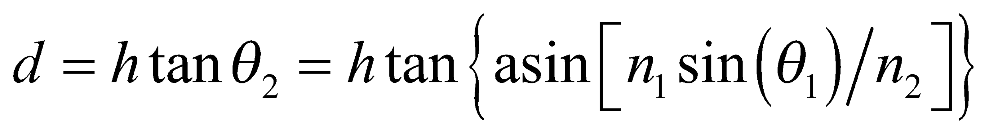
Evaluate If we let θ₁ approach 90° (Sun angle approaches 0°), then the tank diameter becomes
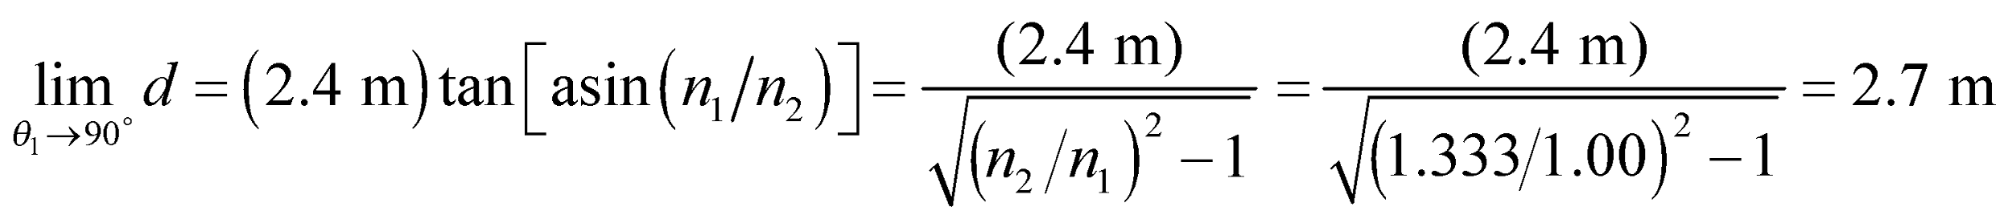
where we have used 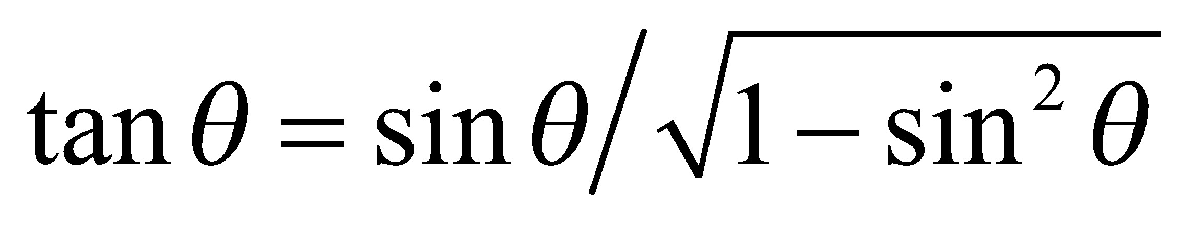.
Assess If the diameter is smaller than 2.7 m then, in order for the sunlight to reach the bottom of the tank, a smaller value of θ₁ would be required. The diameter of the tank as a function of θ₁ is depicted in the figure below.

52. Interpret This problem involves refraction at two interfaces: (1) air-polystyrene and (2) polystyrene-water. Given the incident angle at the air-polystyrene interface, we are to find the angle of refraction in the water.
Develop Consider the figure below. Appling Snell’s law to each interface gives
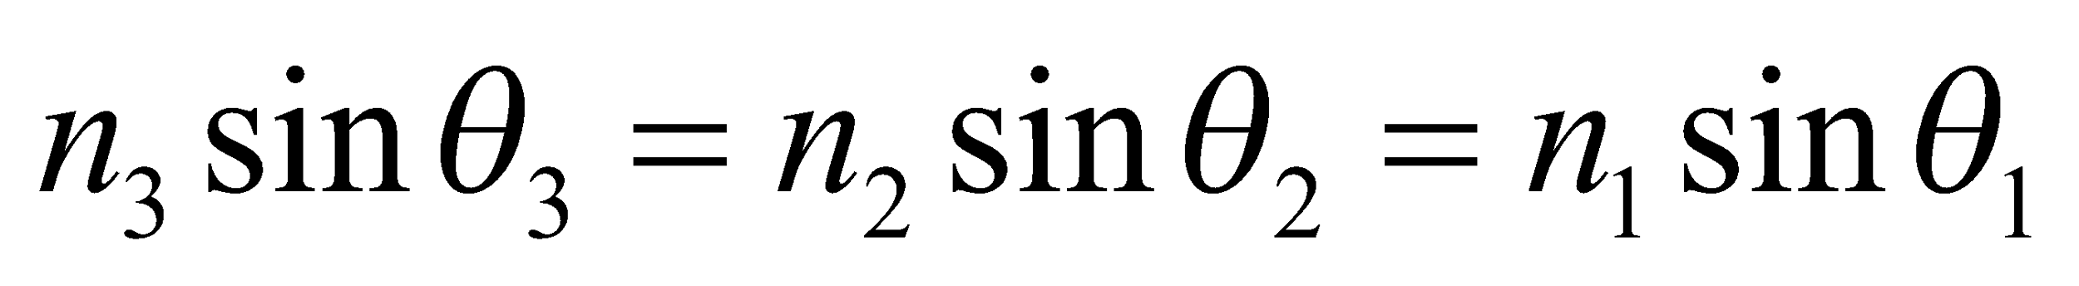
so the angle of refraction in the water (θ₃) can be found given the angle of incidence in air.
Evaluate The angle of refraction is
Assess This result is independent of the intermediate material (provided it is transparent).
53. Interpret You want to center the screen so the projector's light reflects straight back towards the patient's eyes.
Develop The figure below shows the path the light should take from the projector to the patient's eyes. The lengths 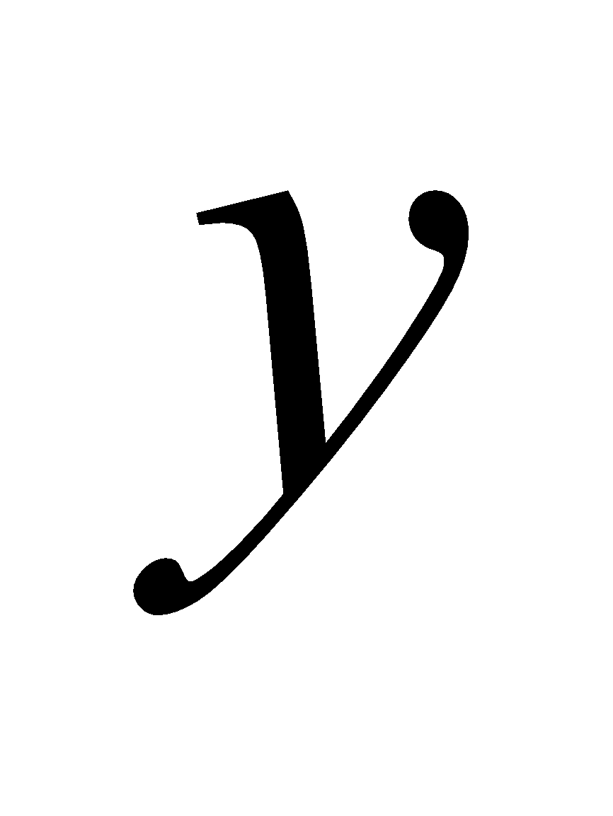 and 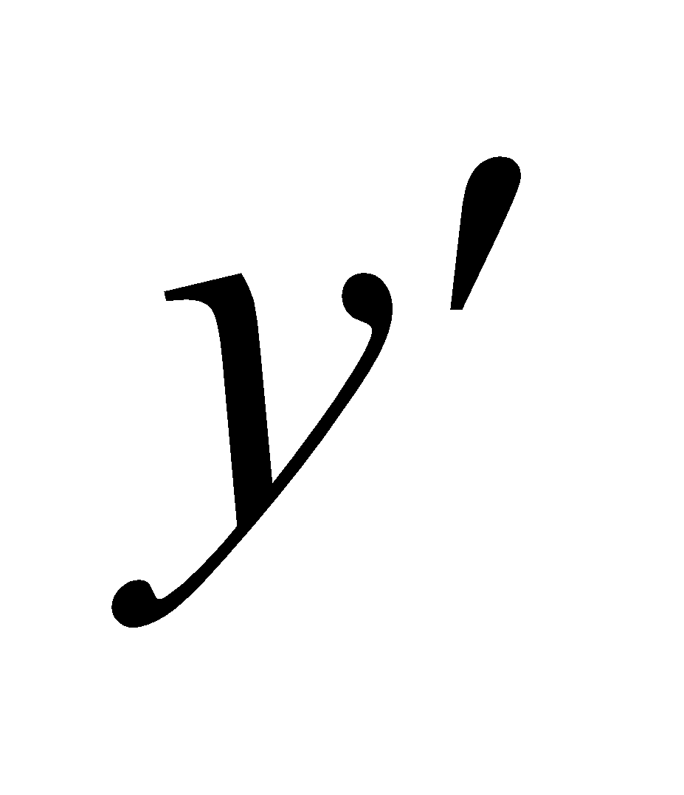 give the vertical distance from the center of the screen to the projector and the eyes, respectively. If you assume specular reflection, the angle of incidence, is equal to the angle of reflection, 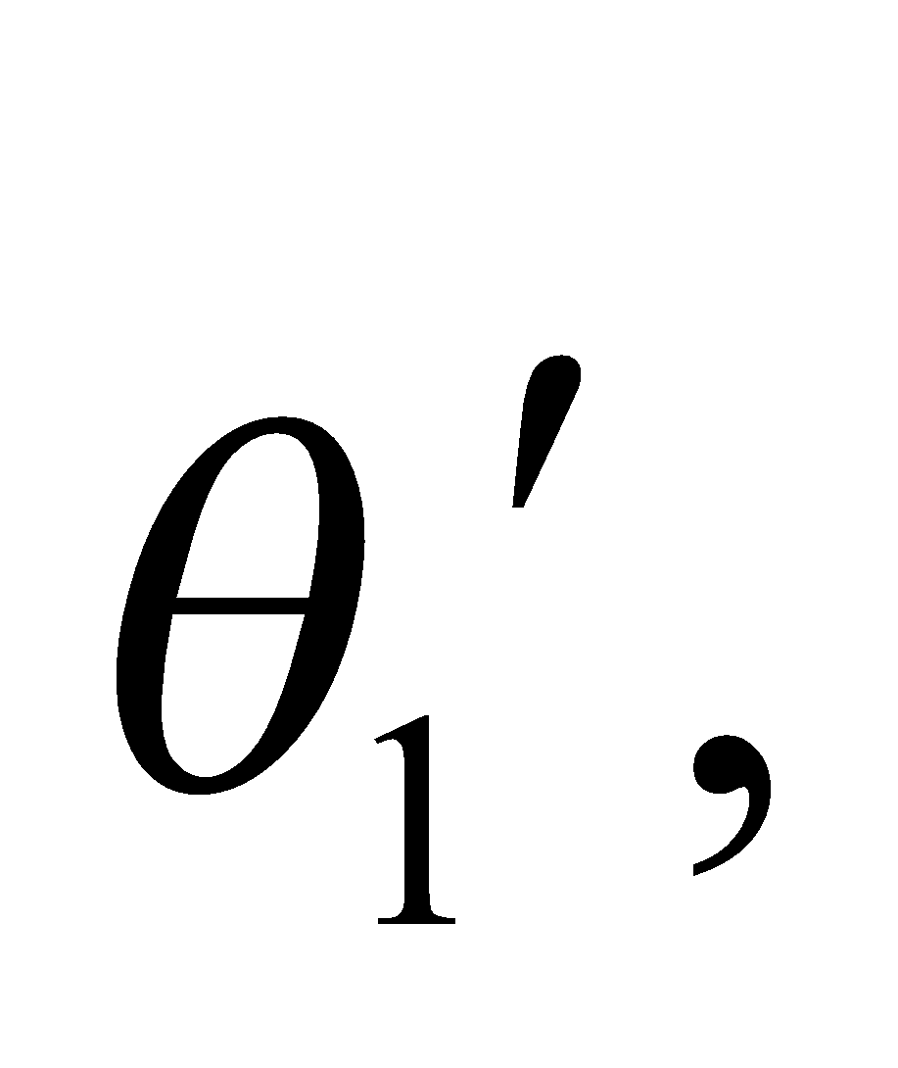 which means

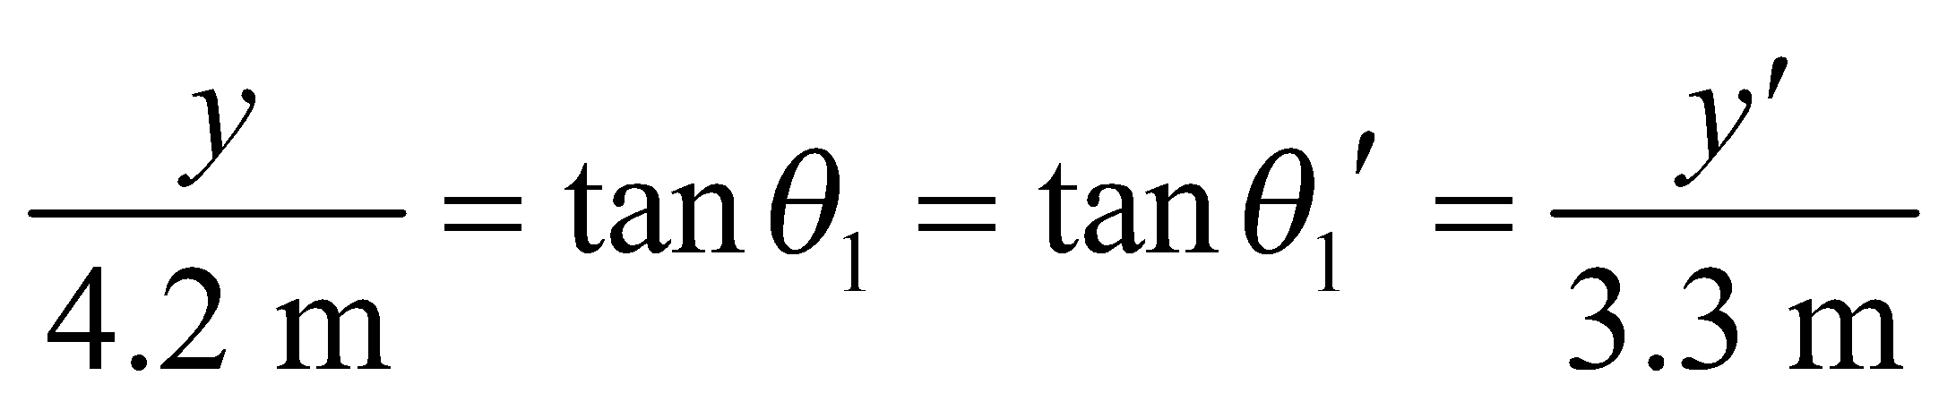

Evaluate From the figure, the unknown distances must satisfy: 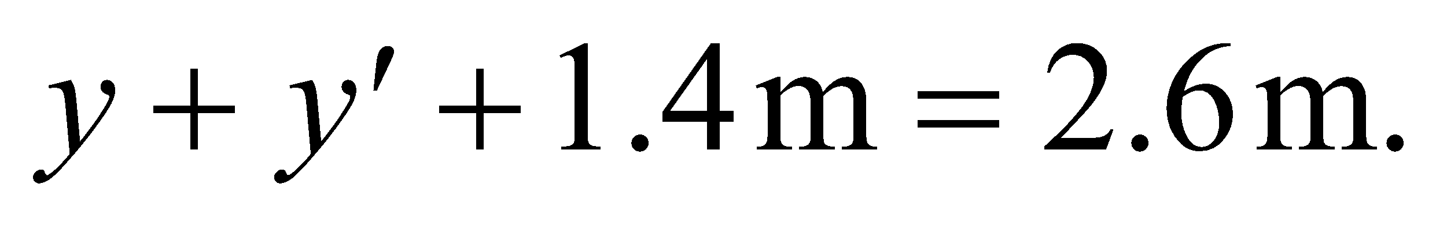 Combining this with the reflection criterion above, we find
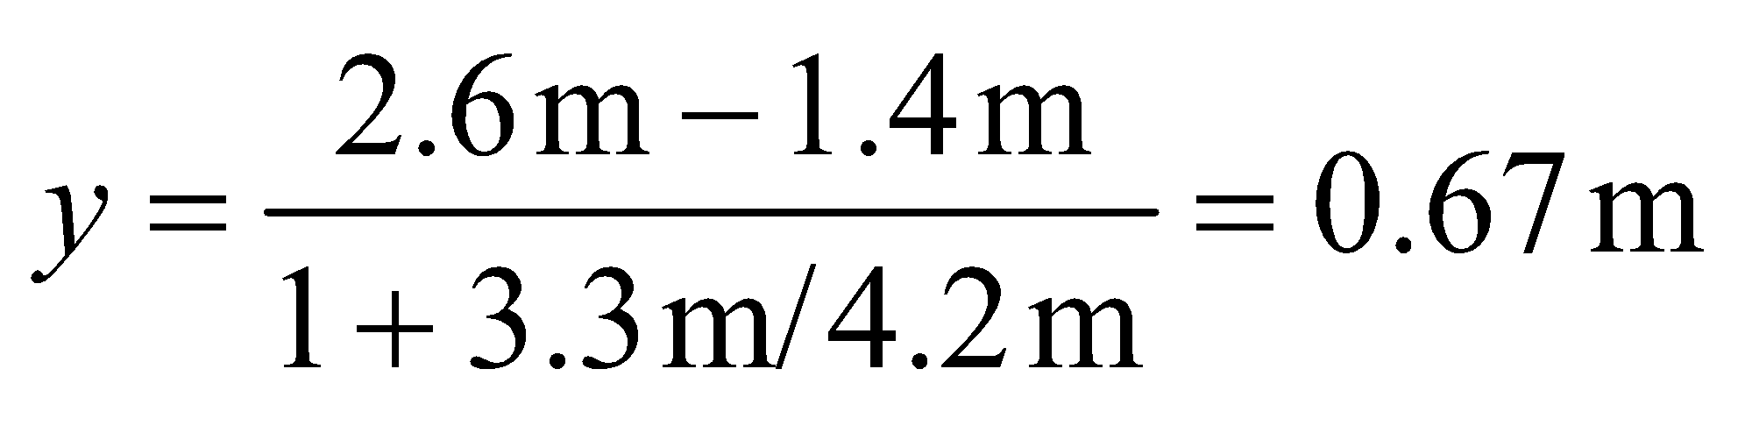
This means the center of the projector should be placed 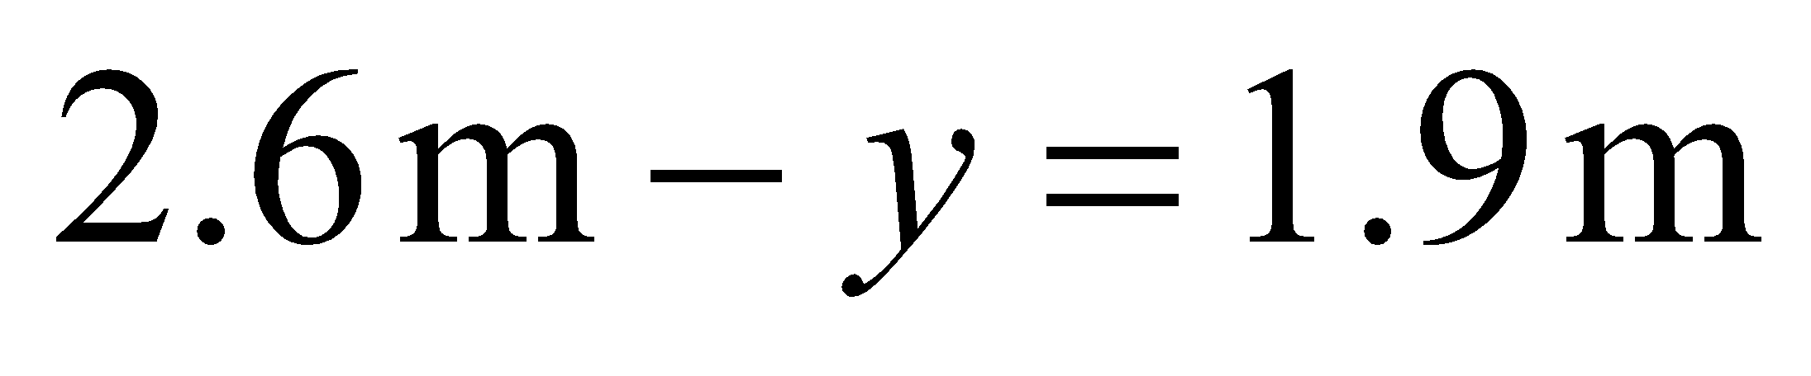from the floor.
Assess This is a little lower than the midpoint between the projector and the eyes, which makes sense since the eyes are closer to the screen than the projector.
54. Interpret We are to find an expression for the angle of refraction of a ray passing through a transparent slab in air.
Develop Consider the figure below. In Figure 30.6, 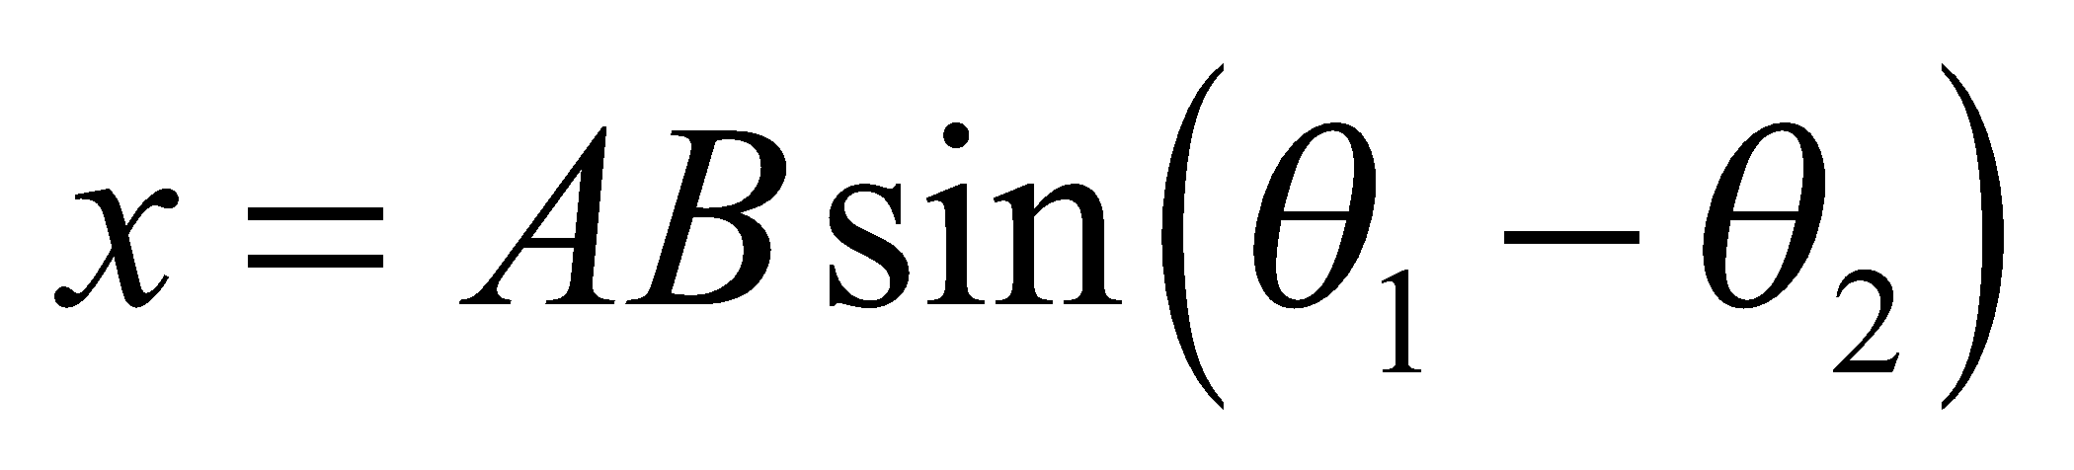 and 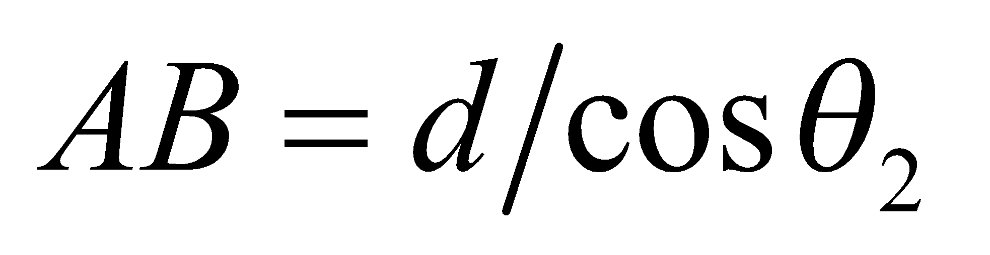.

Evaluate With the aid of trigonometric identities and Snell’s law (Equation 30.3,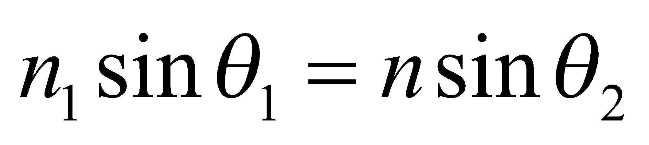), we find
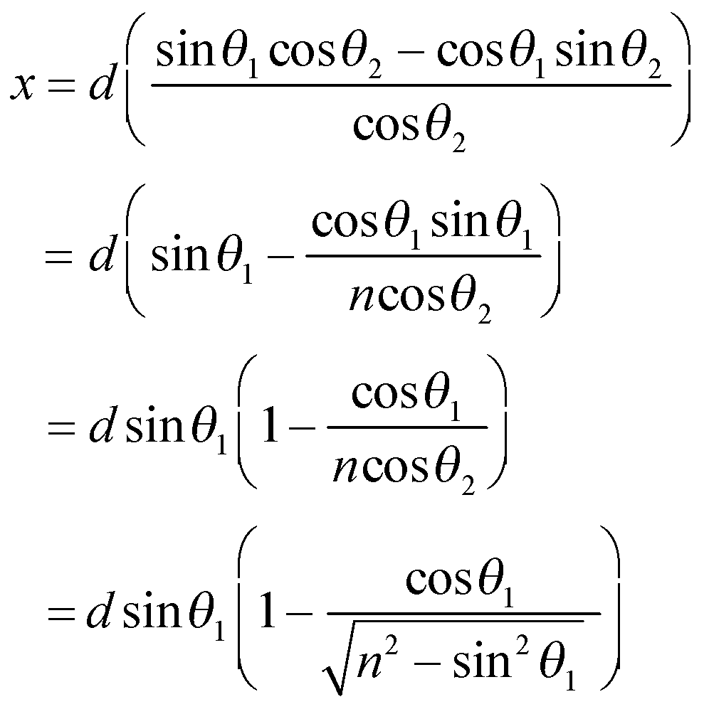
Assess For n = 1 (i.e., the slab is made of air), this reduces to x = 0, as expected.
55. Interpret This problem involves two refractions and a total internal reflection as the light ray passes through a spherical raindrop. Thus, we shall use Snell’s law and the relationship of total internal reflection to show that the complement of the angle between the incoming and outgoing rays is as given in the problem statement.
Develop Consider the figure below. The angle φ can be found by summing the deflections each time the ray in Figure 30.21 is refracted or reflected. The deflection at A is 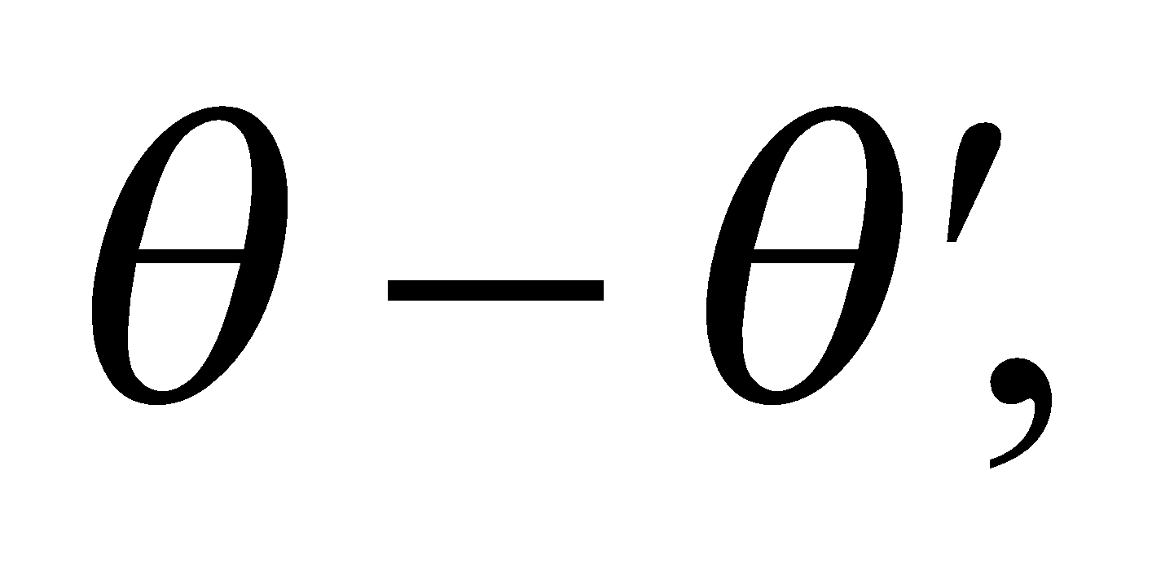 at B is 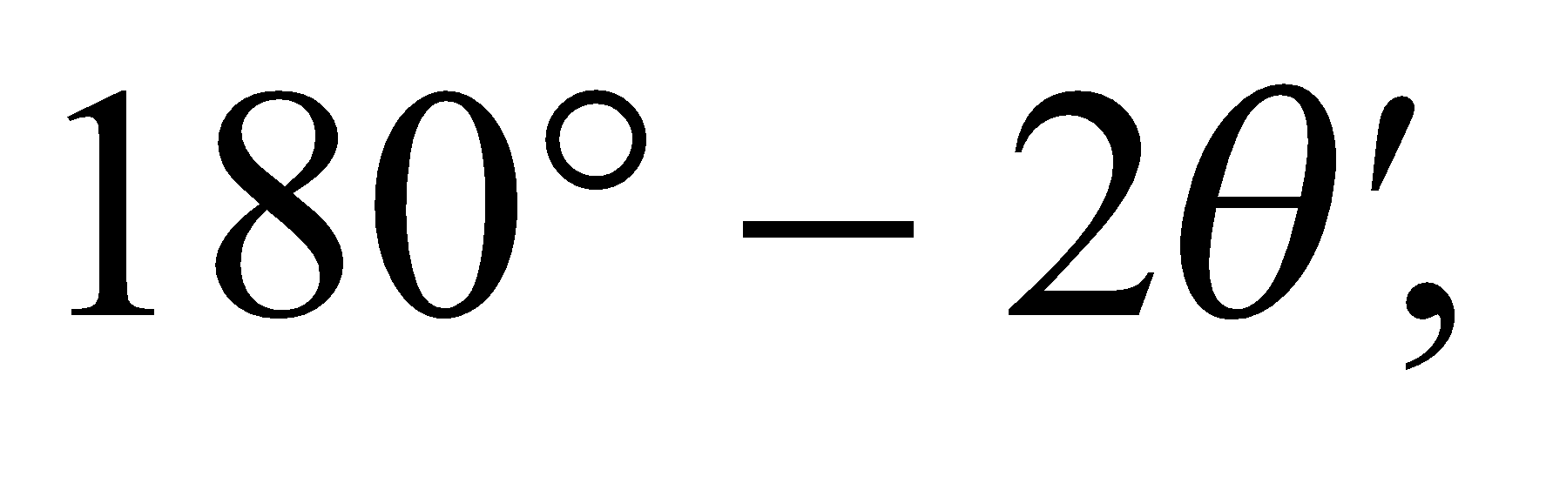 and at C is 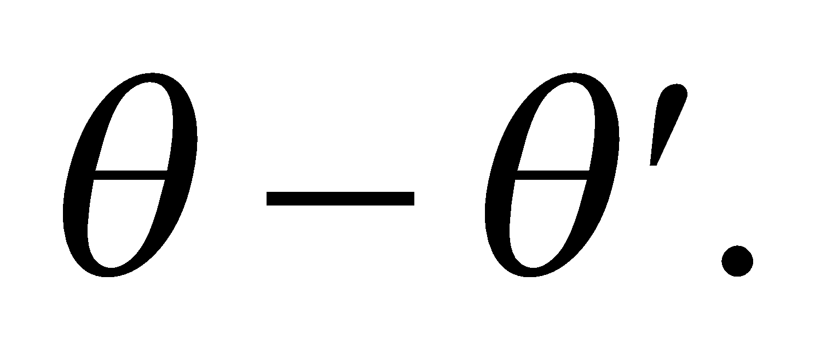 The sum is
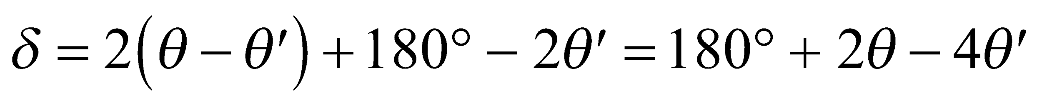
and is related to φ by 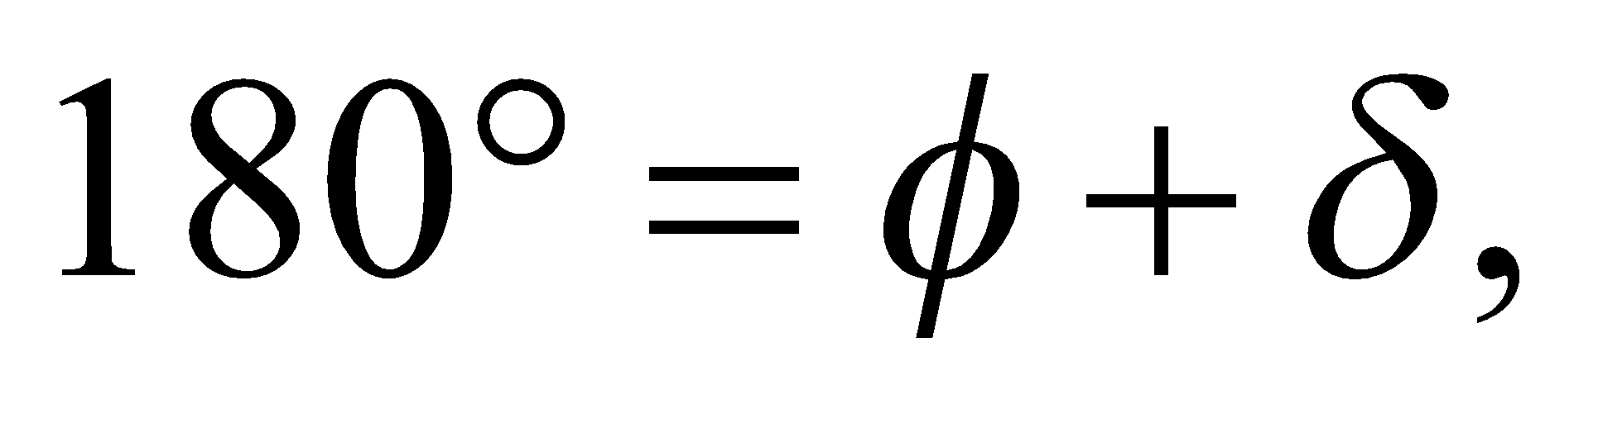 so 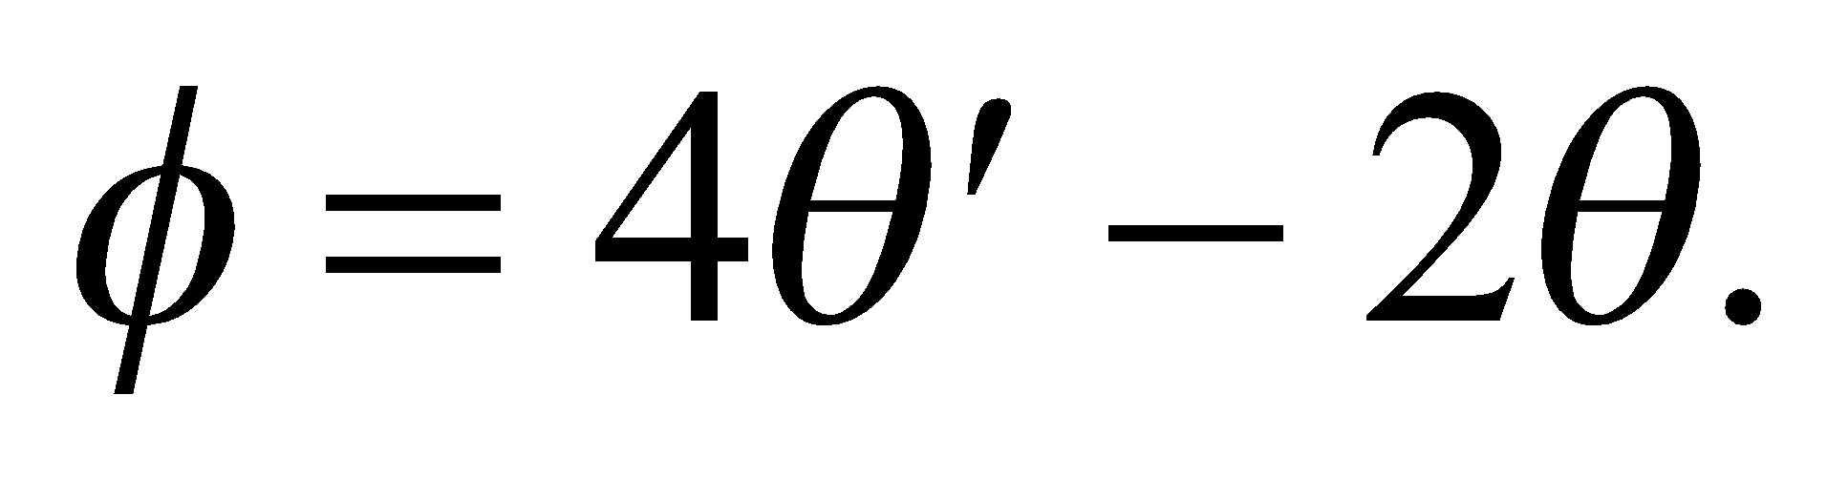

Evaluate By eliminating θ′ using Snell’s law [Equation 30.3, 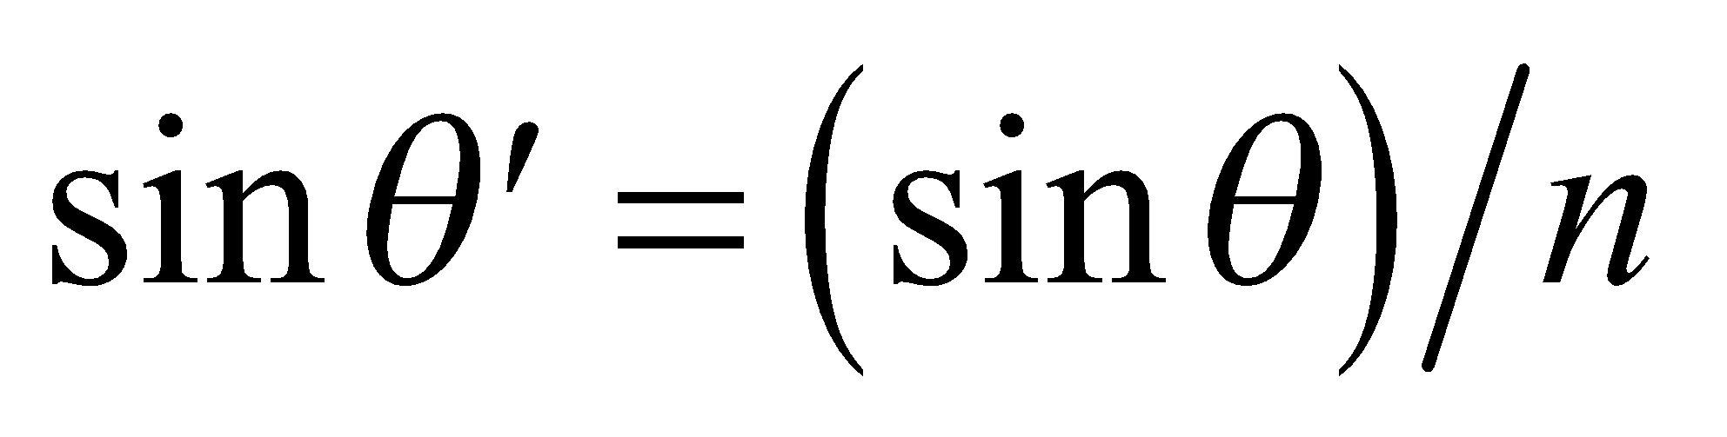], the desired expression
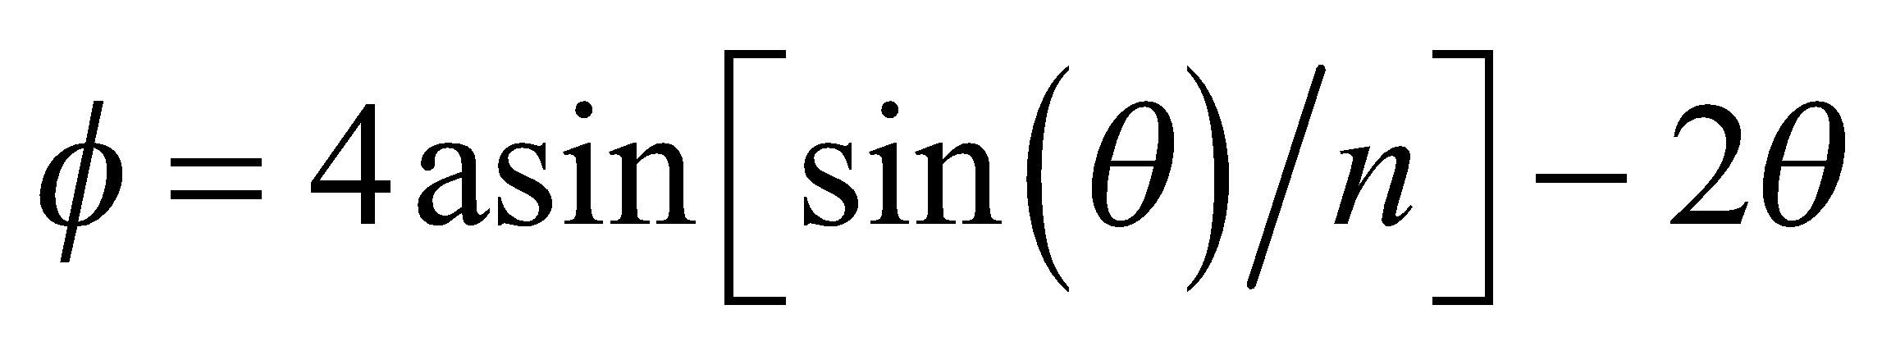
is obtained. Note that light incident at the boundaries of the drop, at A, B, and C, is partially reflected and partially refracted; we show only the rays relevant to the formation of a rainbow.
Assess The angle φ is a complicated nonlinear function of θ, as shown on the right (with n = 1.333).The maximum value of φ is approximately equal to 42.1°. This is the average angle above the anti-solar direction that an observer sees a rainbow, because n is the average index of refraction for visible wavelengths.

56. Interpret We are to maximum angle φ from the previous problem for which light striking a spherical water droplet is deviated.
Develop Differentiate the result of the previous problem, set the derivative equal to zero, and solve for φ.
Evaluate (a) The derivative is
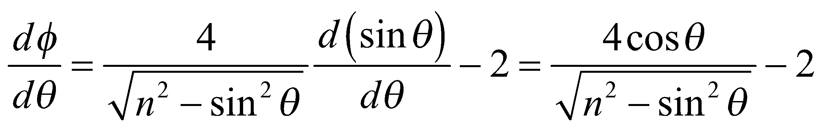
The condition for a maximum, 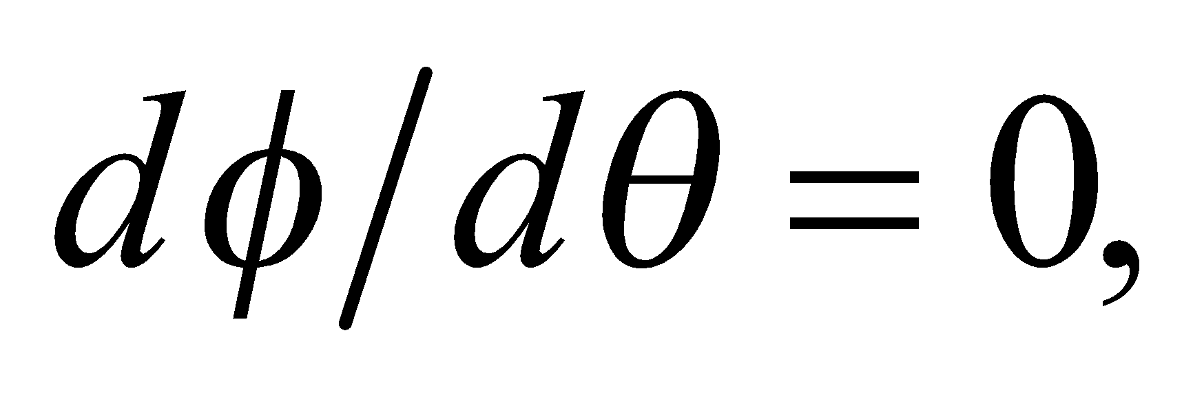 implies that 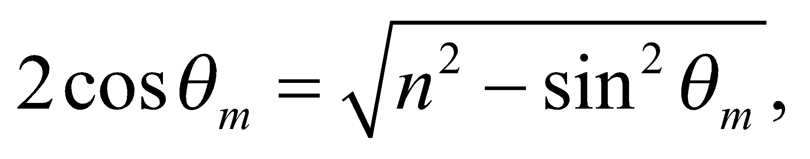 or 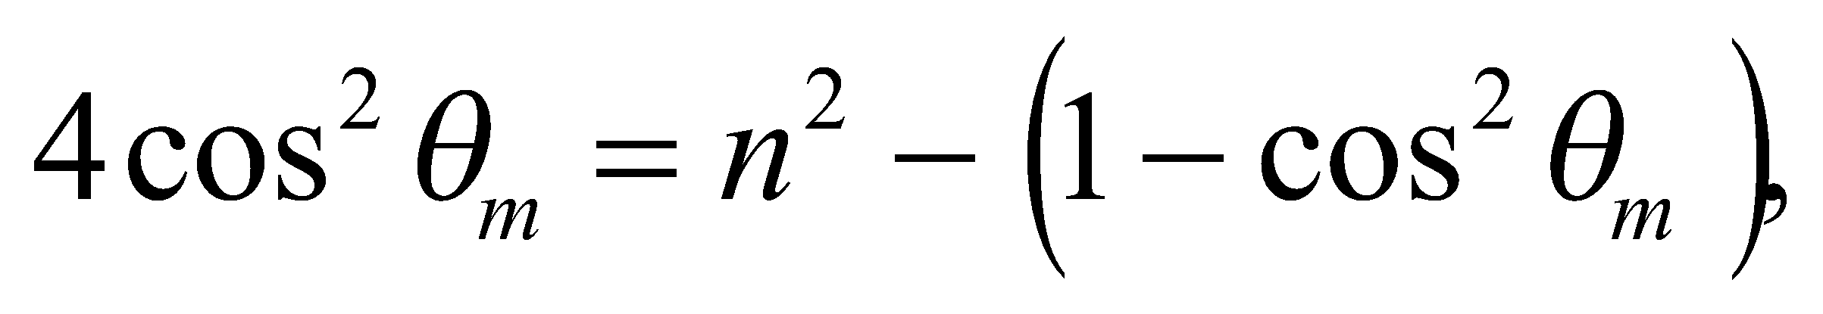 so
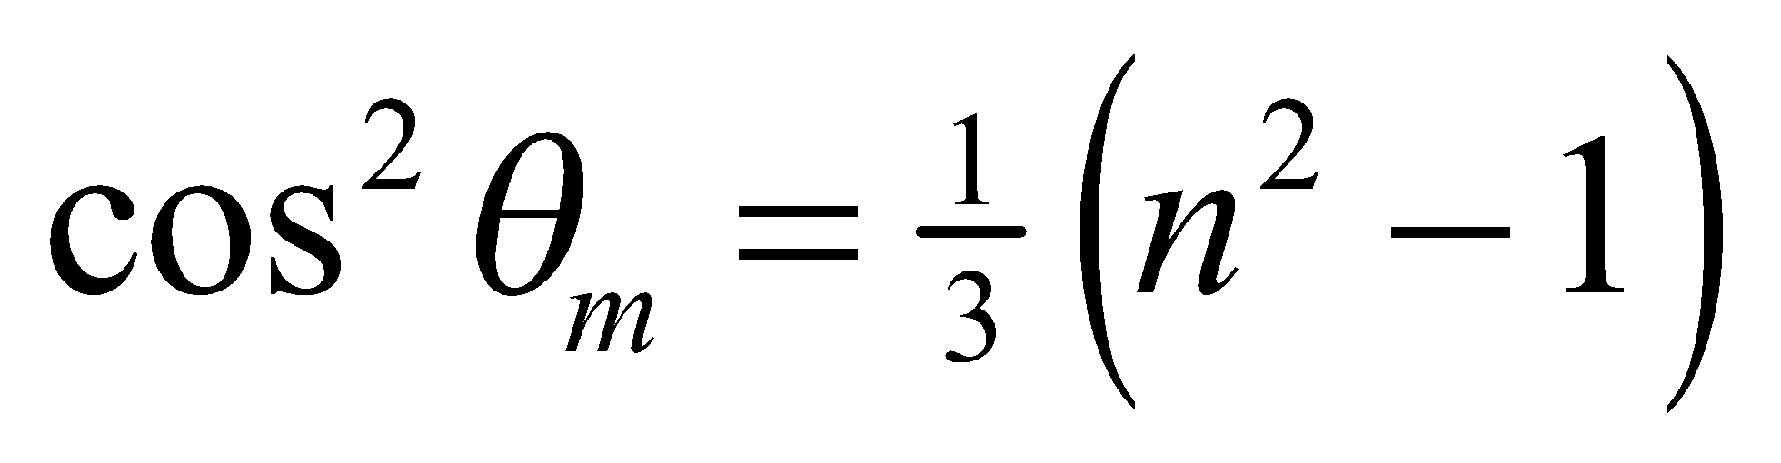
(b) If this value of θ is substituted into the expression for φ, after noting that 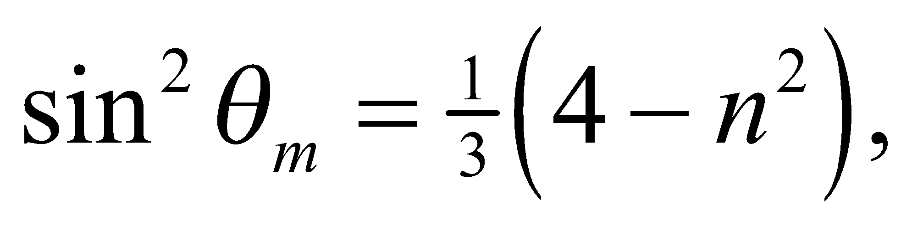 one gets
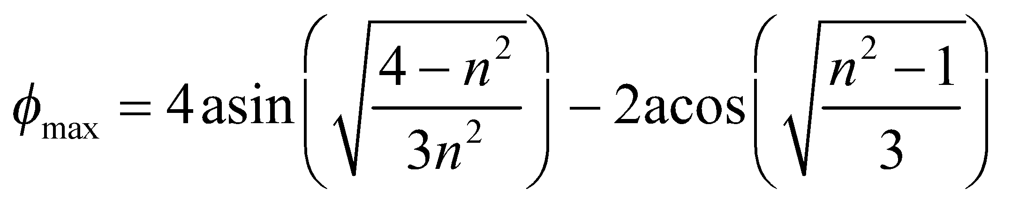
which equals 42.1° for 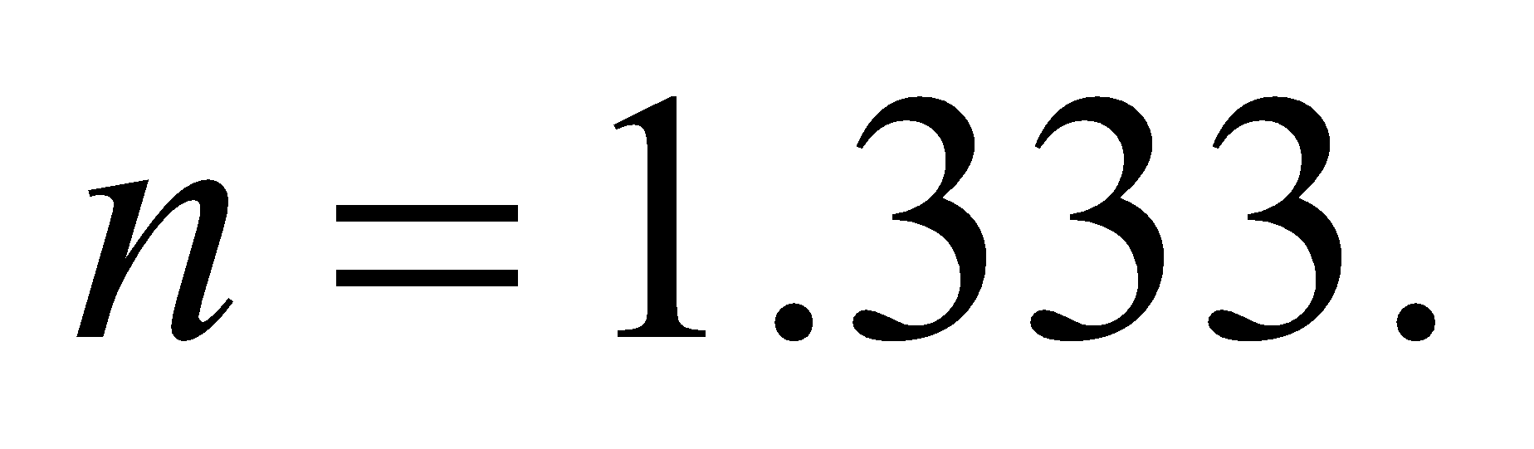
Assess This is the average angle, above the anti-solar direction, that an observer sees a rainbow, because n is the average index of refraction for visible wavelengths.
57. Interpret This problem involves two refractions and two total internal reflections as the light ray passes through a spherical raindrop. We are to use the results of the two previous problems for this problem.
Develop The analysis of the secondary rainbow is similar to that of the primary rainbow (see Problems 55 and 56). The angles for an incident ray, which experiences two internal reflections in a spherical drop of water, are shown in the figure below for the emergent ray traveling downward to an observer on the ground. The total deflection for two refractions and two internal reflections,
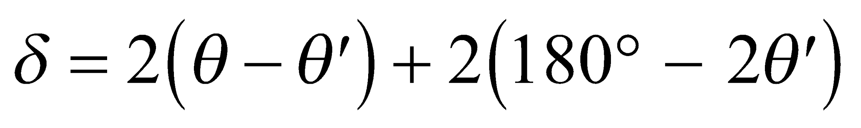
is related to the observation angle from the anti-solar direction φ by 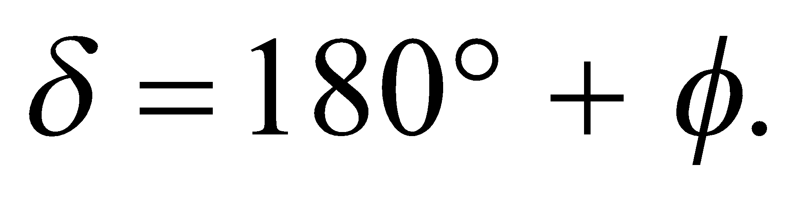

Evaluate Combining the two equations, we obtain
If we differentiate Snell’s law with respect to θ and substitute for θ in terms of φ and θ, we get
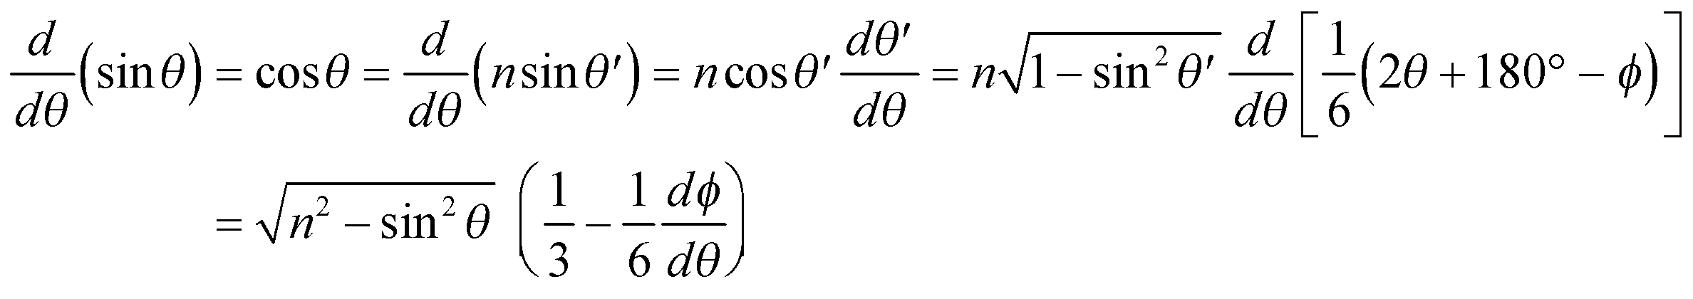
A concentrated beam is formed for the incident angle that satisfies the condition 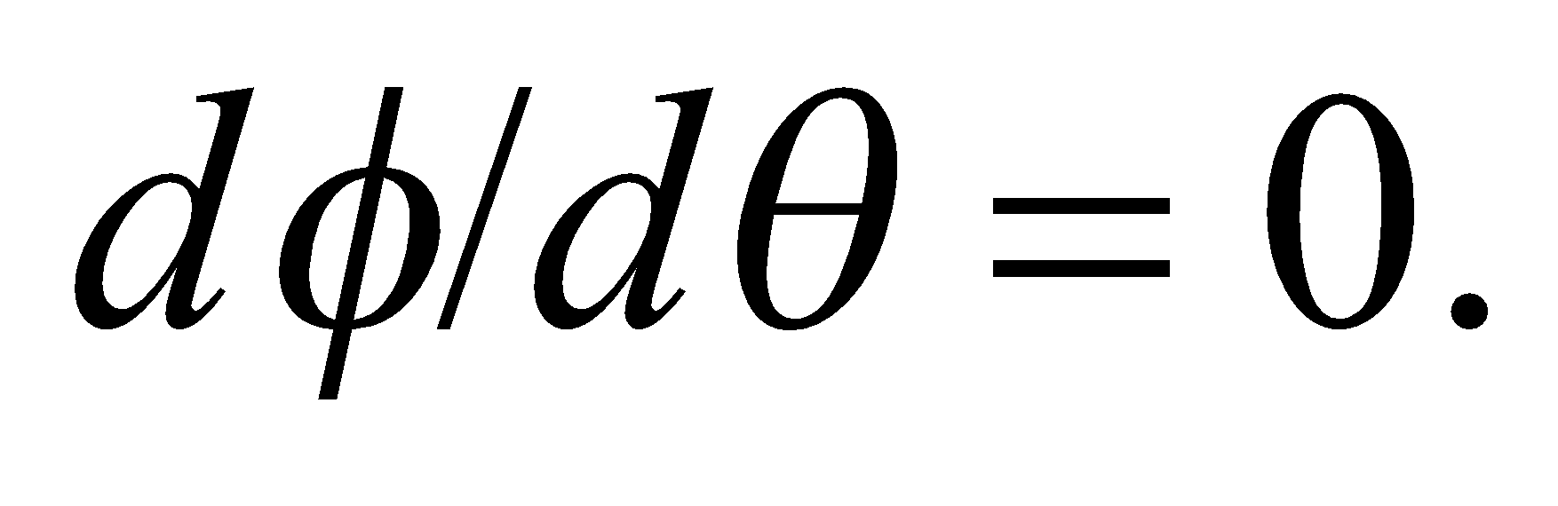 Thus,
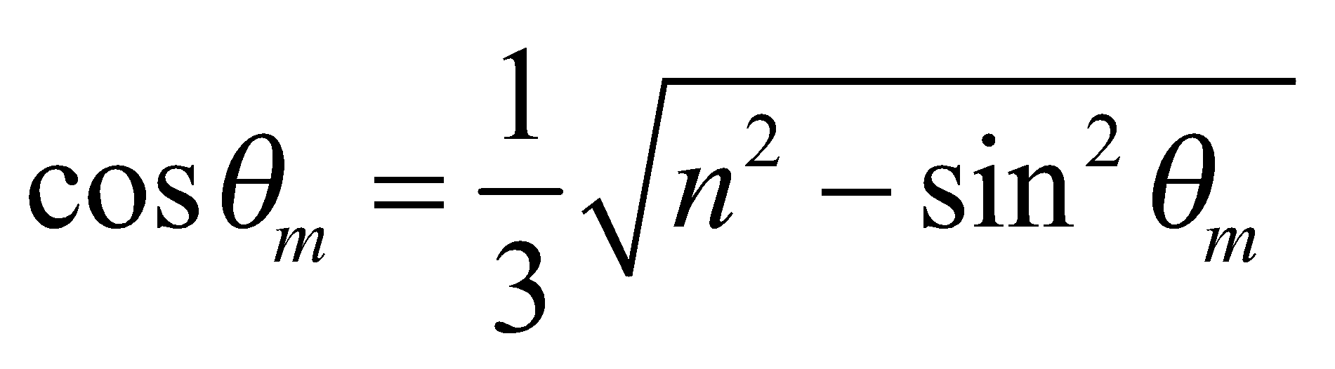
which implies 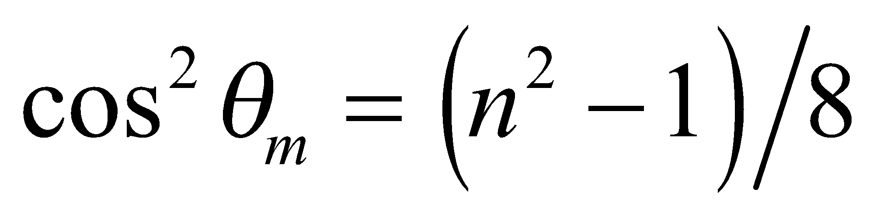 and 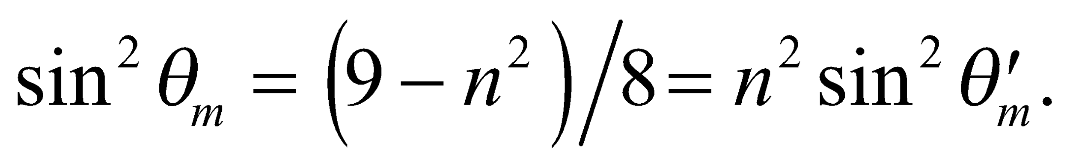 Finally, the maximum value of φ is
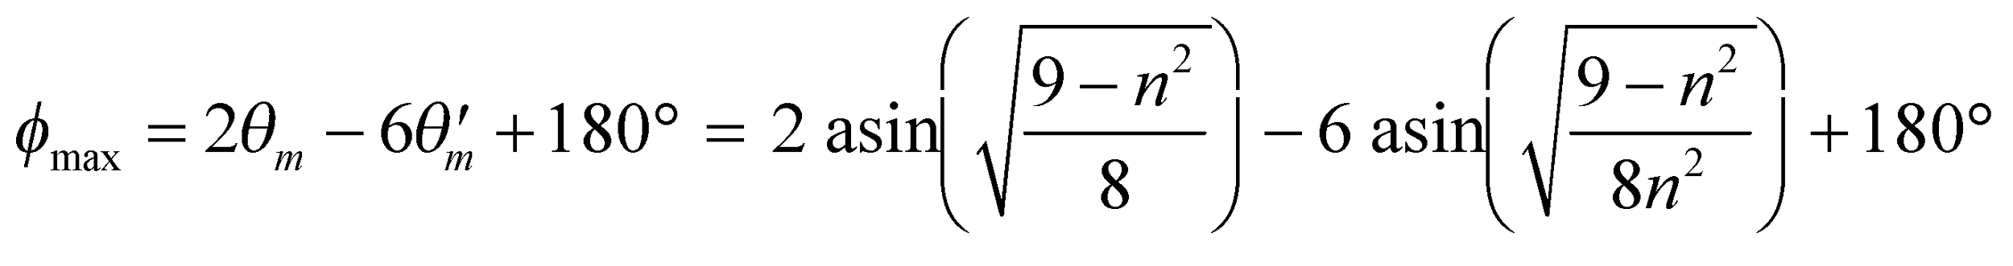
For n = 1.333, the average angle is 50.9°. However, substituting n_{red} = 1.330 and n_{violet} = 1.342, we obtain 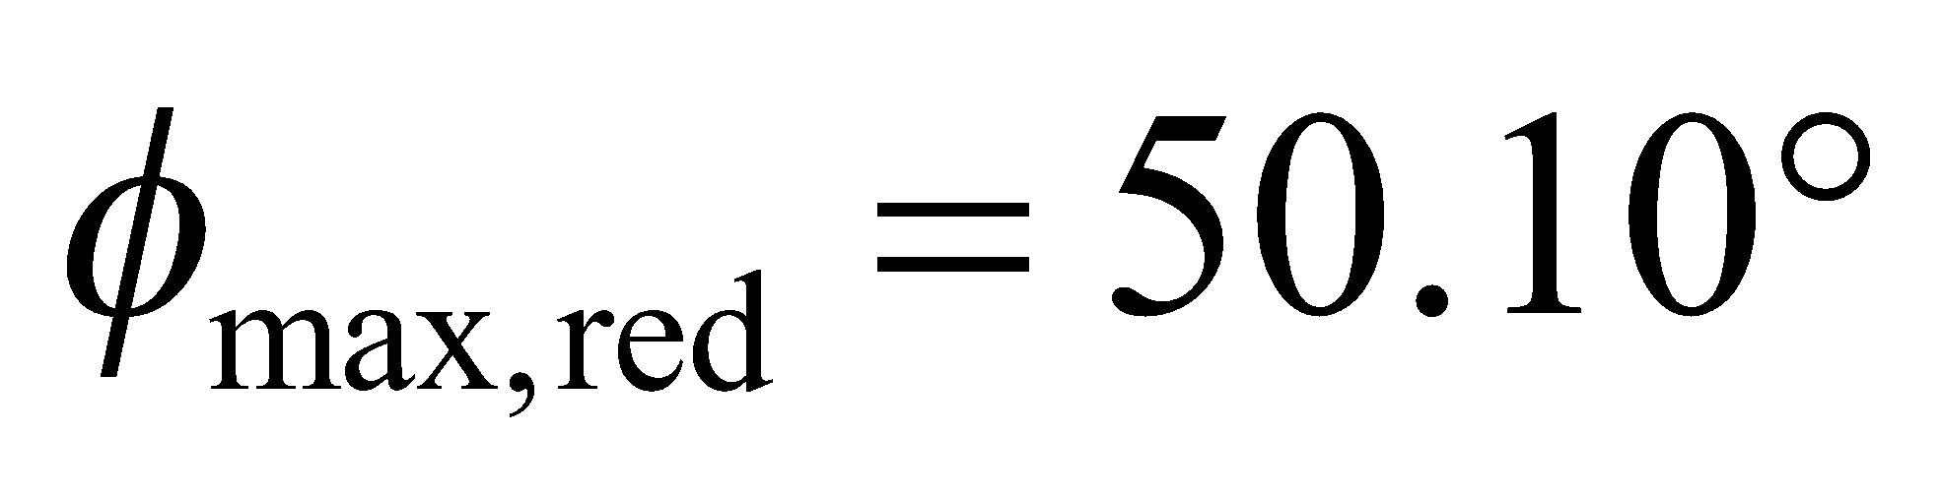 and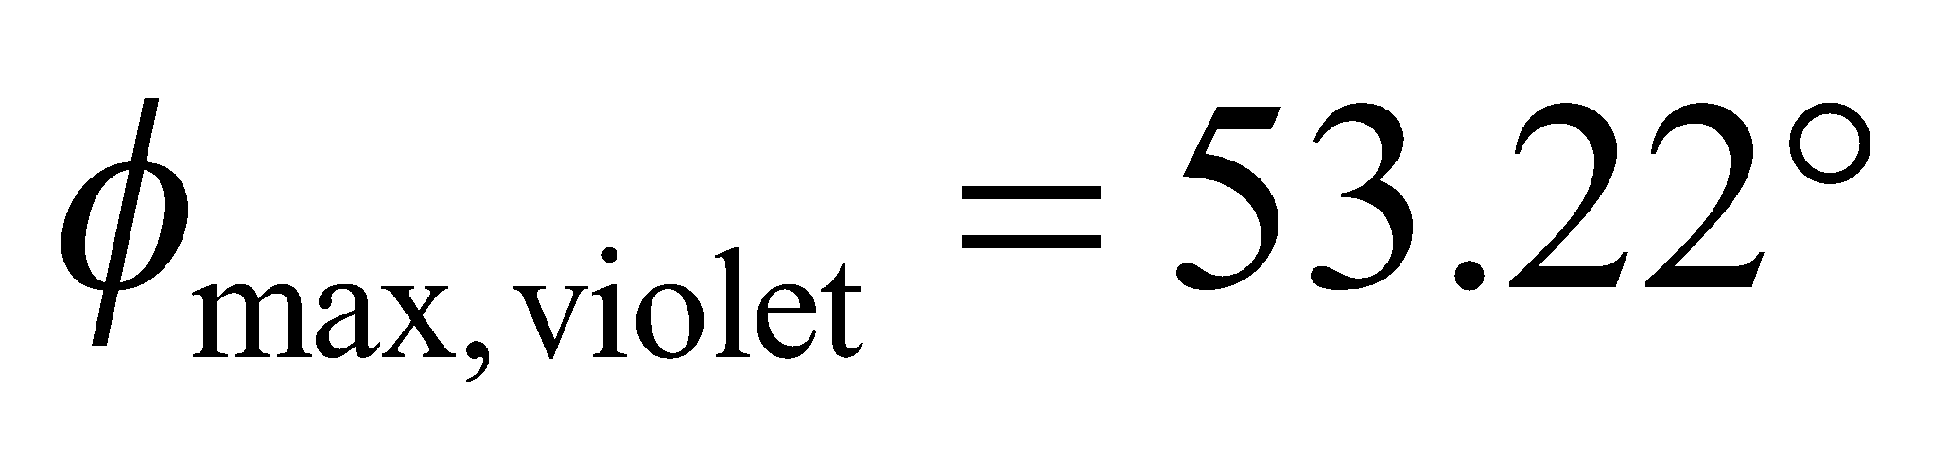 for the secondary rainbow.
Assess Since 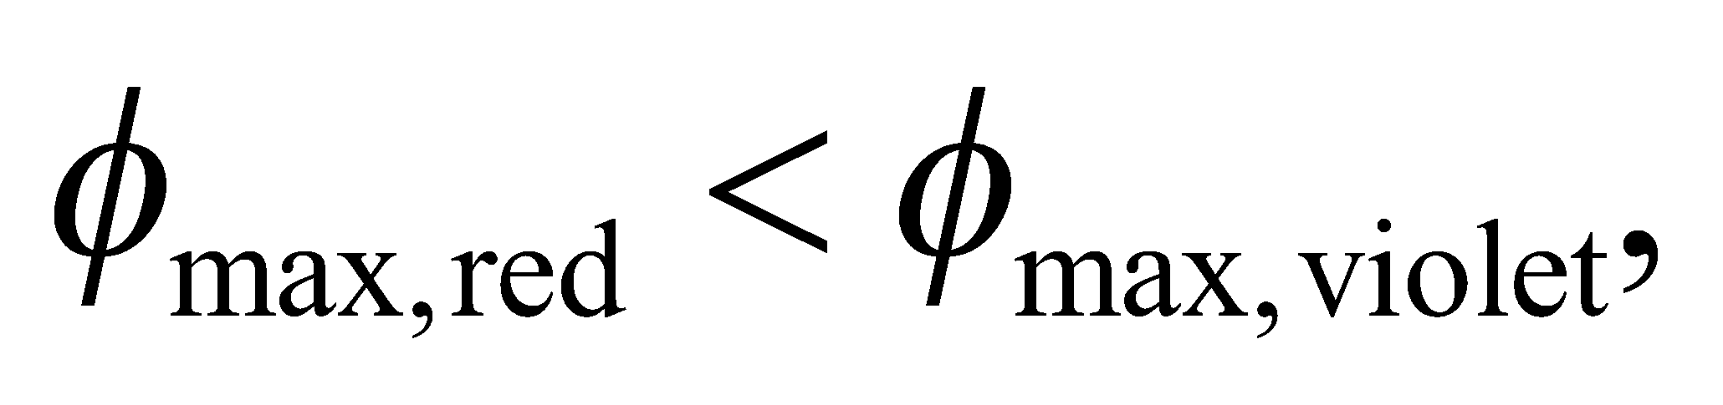 the colors appear in the reverse order from that in the primary rainbow. Although the deflection for violet rays is always larger than that for red rays (no matter how many internal reflections are considered), the relation between φ and δ depends on the quadrant of δ and is different for the primary and secondary rainbows.
58. Interpret We are to find the net reflection of a reflector that consists of three plane mirrors oriented to form the corner of a cube (i.e., three mutually perpendicular mirrors).
Develop A single plane mirror reverses the direction of just the normal component of a ray striking its surface. For example, a ray incident in the direction
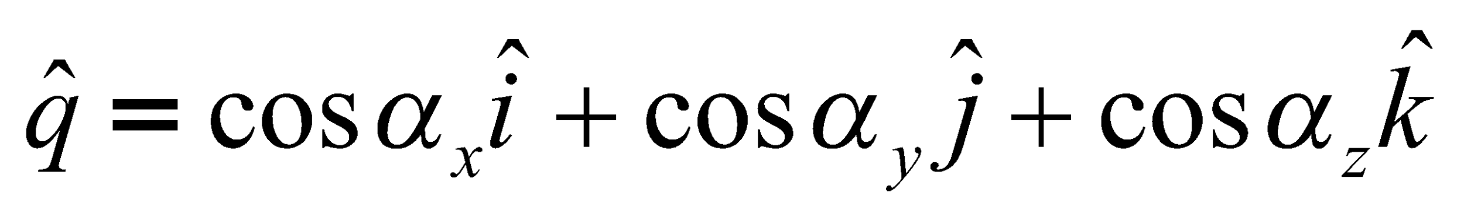
on a mirror normal to the x axis, is reflected into the direction
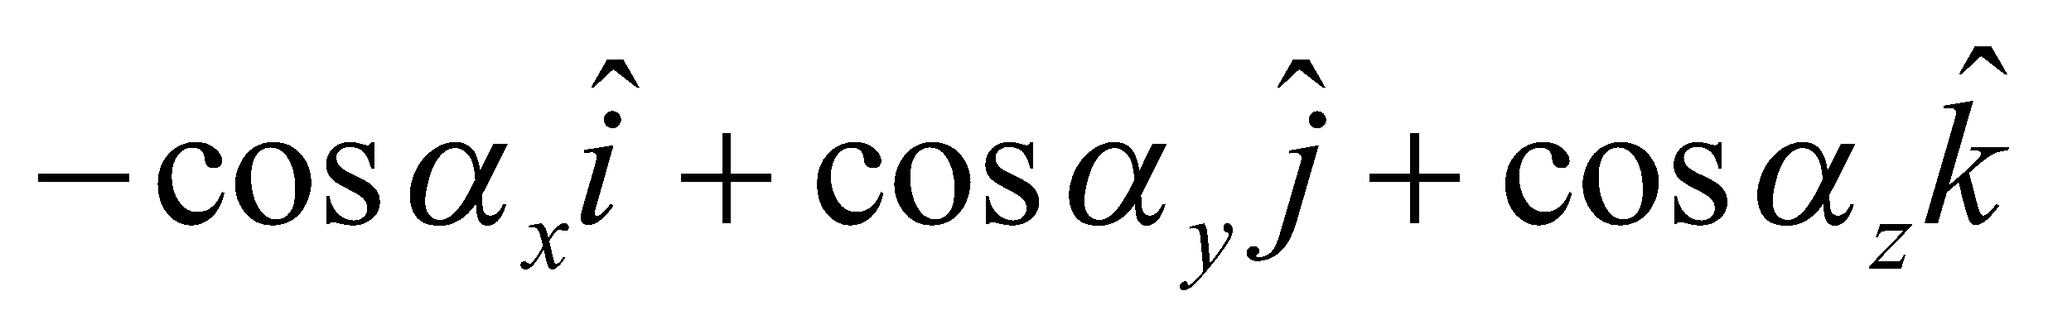
In our notation, 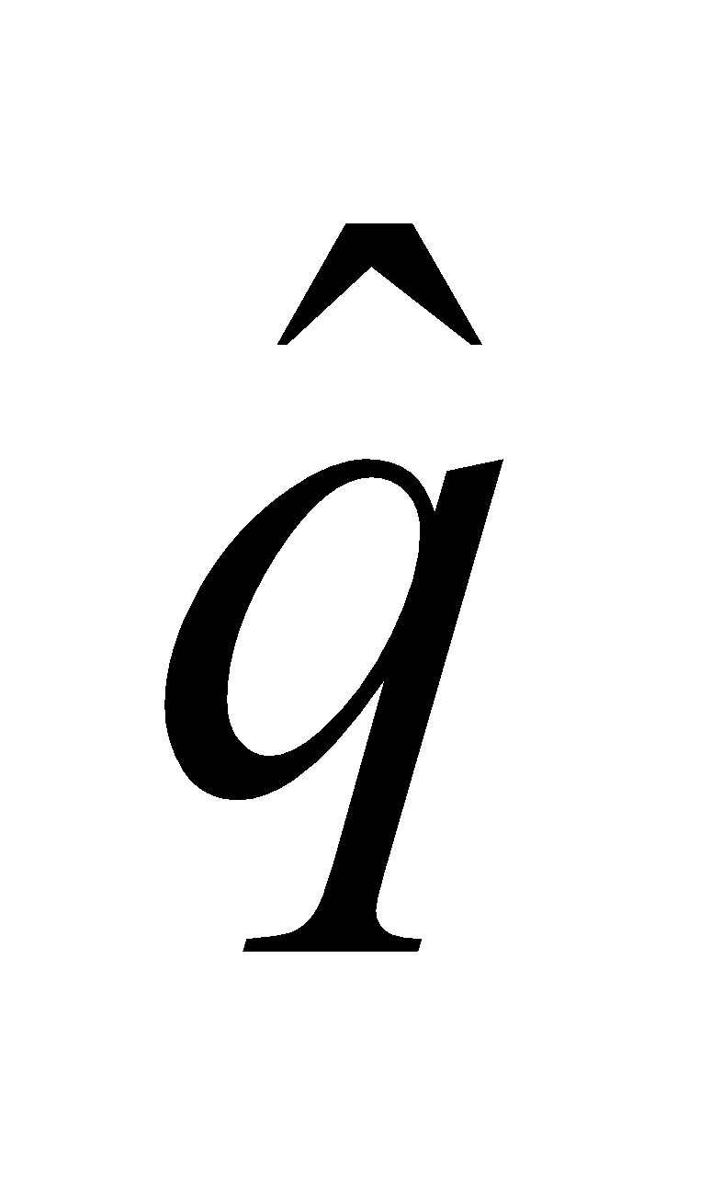is a unit vector, and 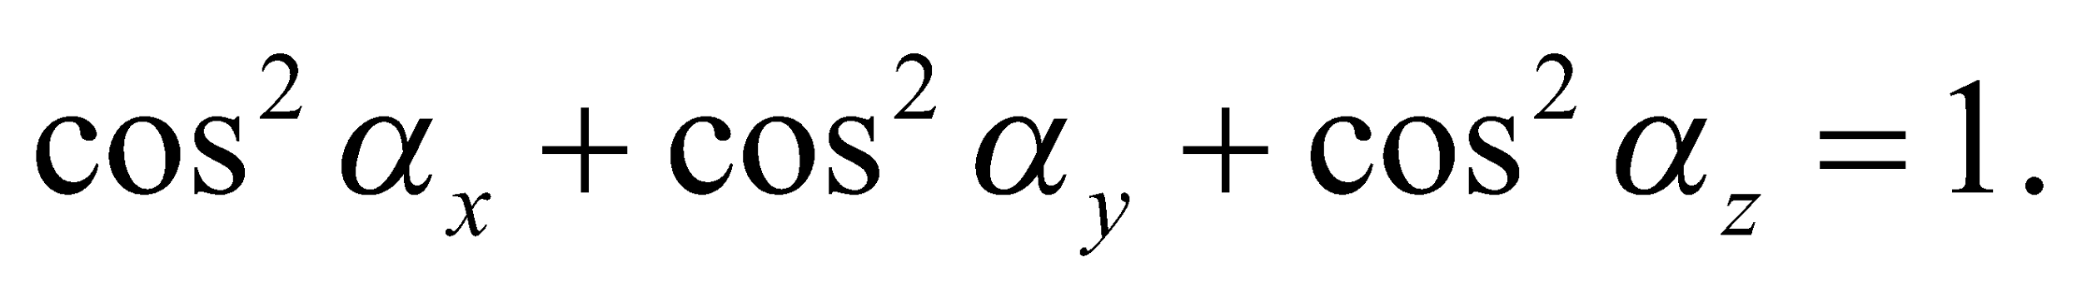
Evaluate If the ray also strikes mirrors which are normal to the y and z axes, as in a corner reflector, it emerges in the direction
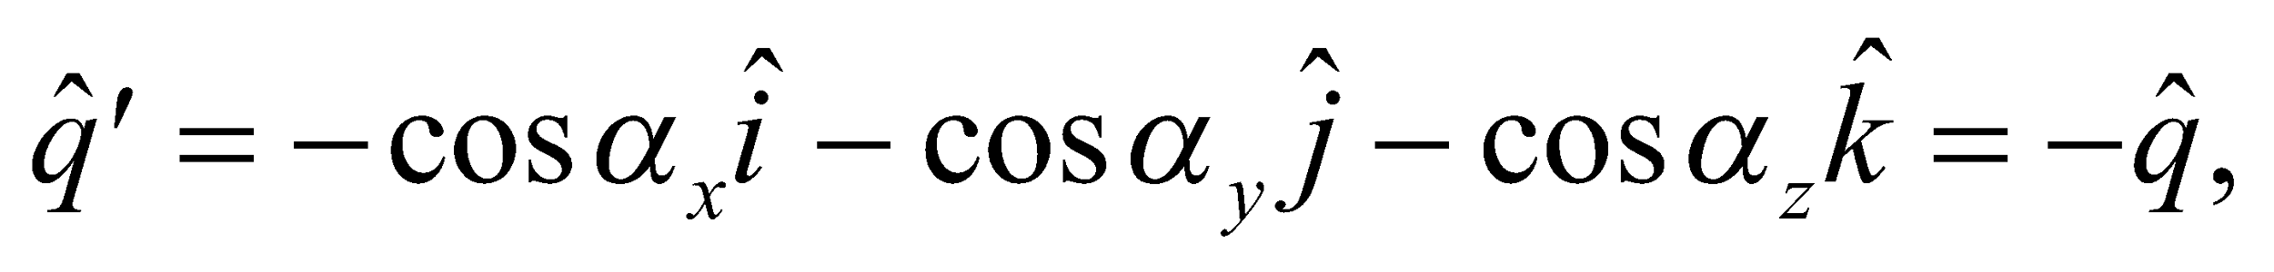
or opposite to the initial direction.
Assess In order to strike all three mirrors, the direction cosines of the incident ray must have magnitudes greater than some minimum nonzero value, depending on the size of the reflector.
59. Interpret We will prove Snell's law starting from Fermat's principle that says light takes the path of least (or most) time when traveling between two points.
Develop We'll assume the two mediums are separated by a flat horizontal interface. Let point A be in medium 1 at a vertical distance 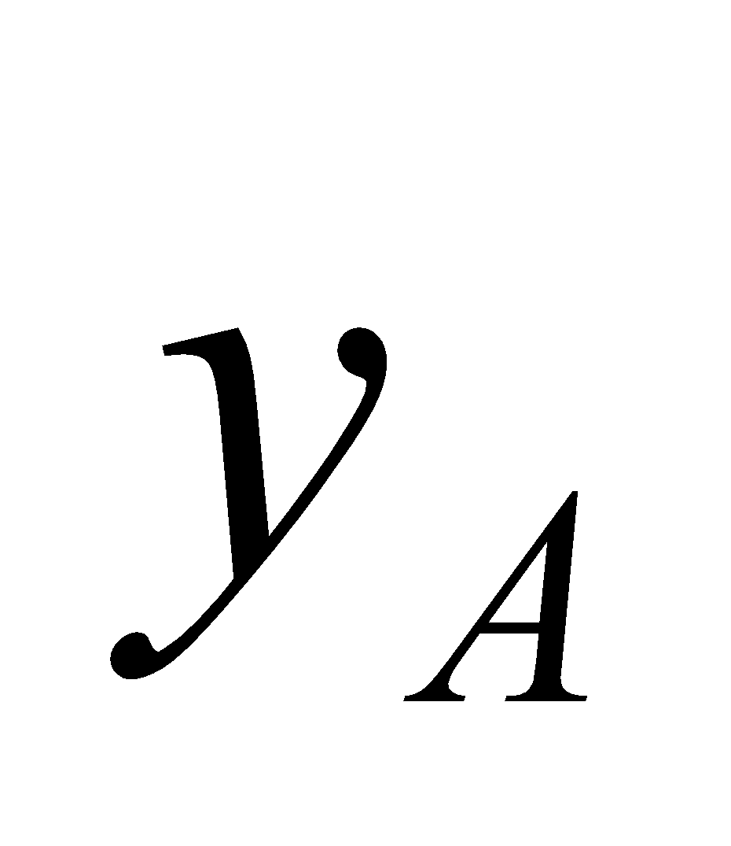 from the interface. Likewise, let point B be in medium 2 at a vertical distance 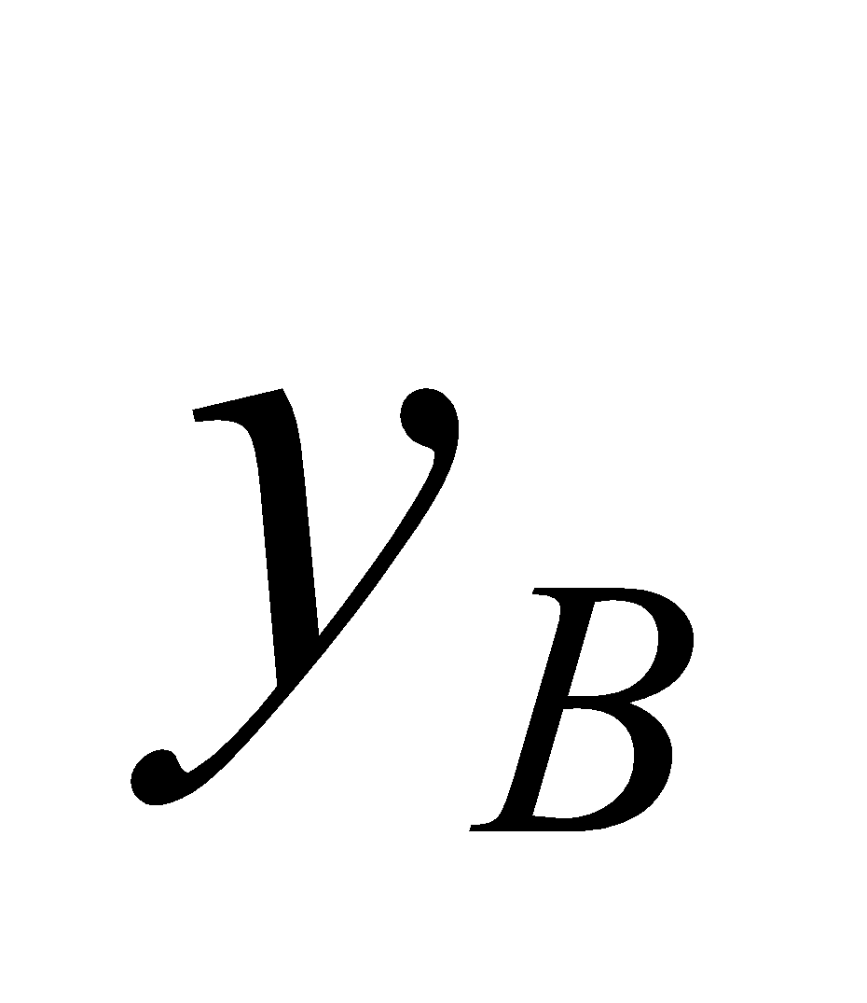 from the interface and a horizontal distance L from A. See the figure below.

We choose an arbitrary path from A to B, characterized by the horizontal distance x between point A and the point where the path crosses the interface. This leaves a horizontal distance of 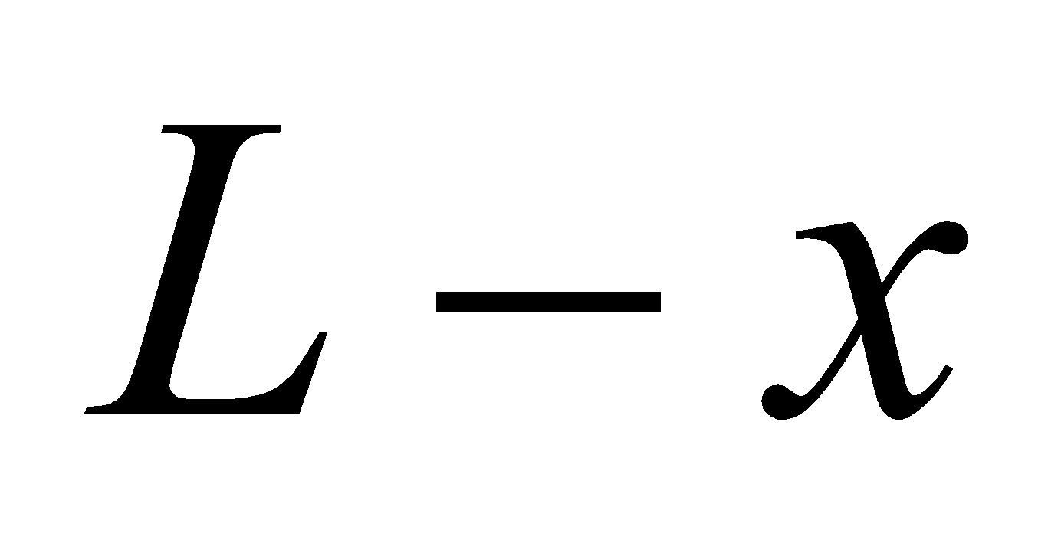from the crossing point to point B. As such, the time the light spends in medium 1 and medium 2 can be expressed as:
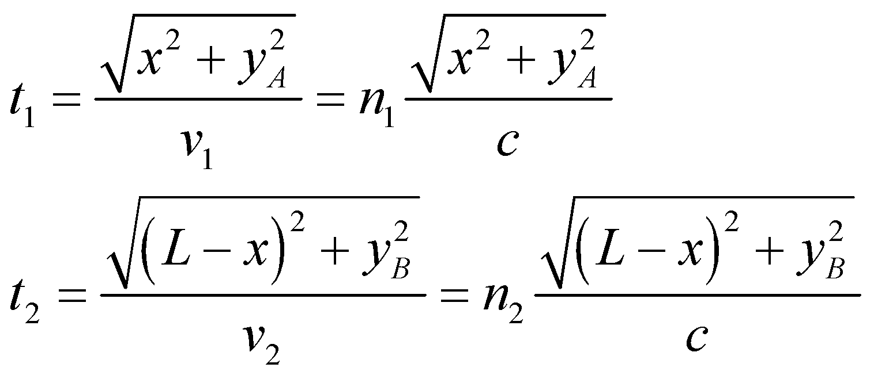
where we have used the speed of light in each medium: 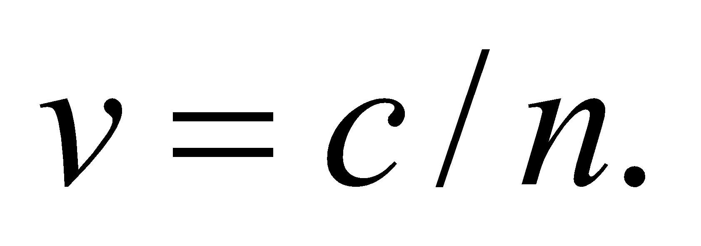 Notice that the only variable in these two equations is the distance x; the other parameters are constants. The total time for light to travel along this path is 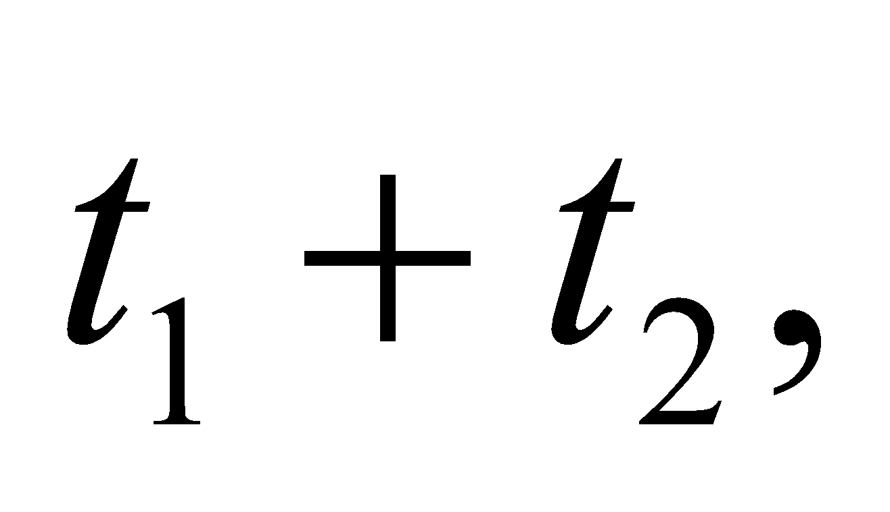which can be differentiated with respect to x to find the extremum.
Evaluate The derivative of the total time with respect to x is
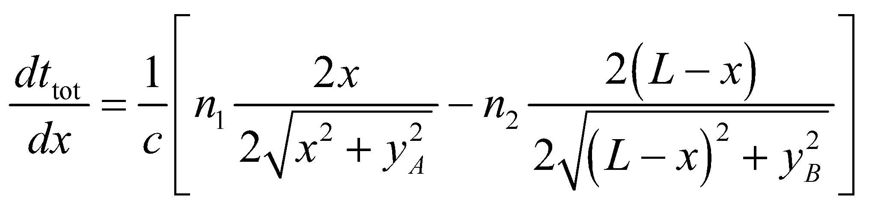
Setting this equal to zero, we find the path that is an extremum obeys Snell's law:
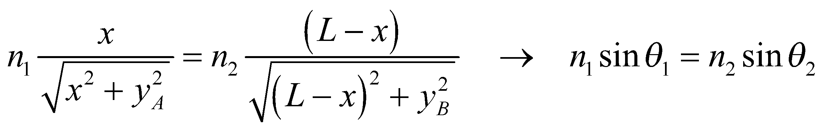
The last step of this derivation follows from the geometry in the figure.
Assess If we take the second derivative of the total time, we can show that it is always positive, which means the extremum we have found is a minimum. In other words, light chooses the fastest path from point A to point B. If light moves faster in medium 1 (i.e. 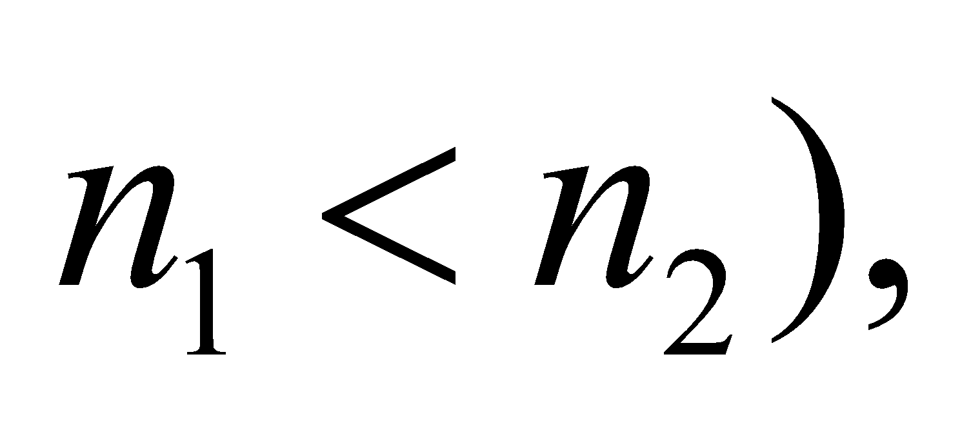 then the path of minimum time will extend the distance traveled in medium 1, in order to reduce the distance traveled in medium 2. An analogy would be a lifeguard rushing to reach a struggling swimmer in a lake. The fastest path may not be a straight line, but instead one in which the lifeguard runs along the shore before diving in. This is because the lifeguard moves slower through the medium of water than of air.
60. Interpret We are to determine if total internal reflection in a layer of plastic between two layers of glass in safety glass will pose a problem for the driver. We will investigate this by checking the critical angle at the glass-plastic interface, and then determining whether light from the air-glass interface can reach the plastic at this angle.
Develop See the figure below for the definition of the angles and materials. Total internal reflection occurs in materials with a higher index of refraction than the surrounding media, so it is not possible for light to be trapped in the plastic layer. The angle at which light is totally internally reflected at the glass-air interface is
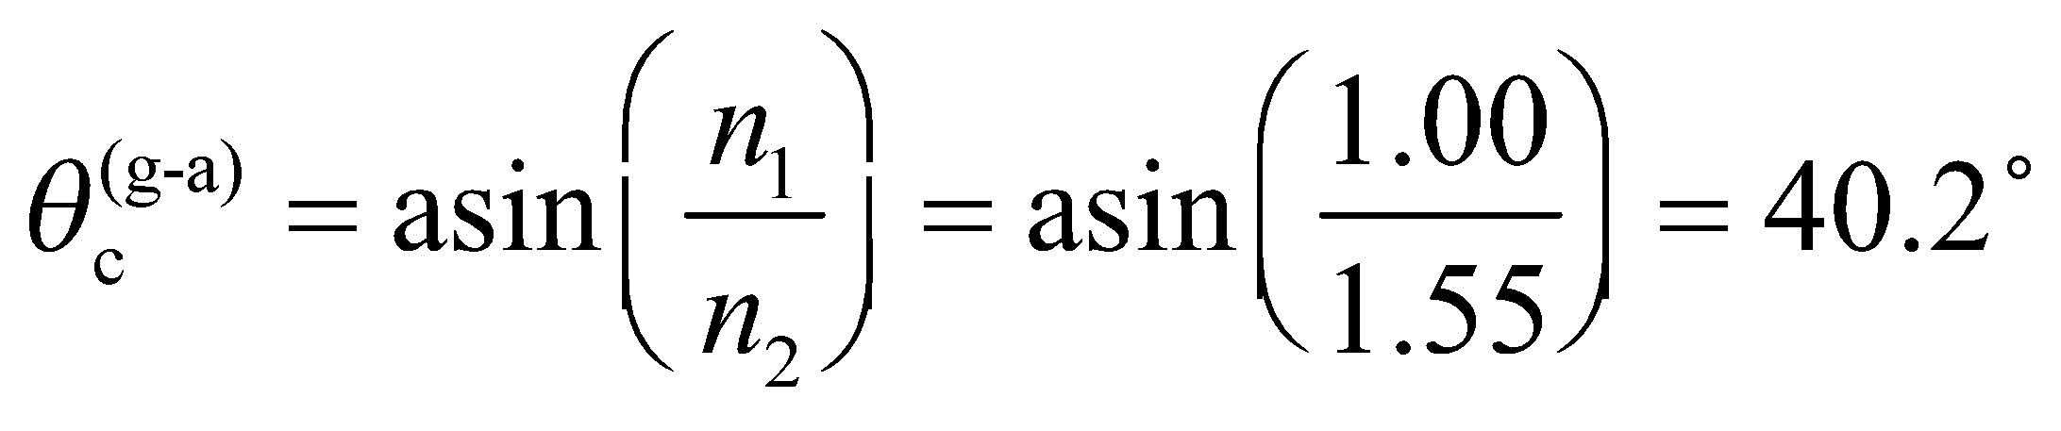
The angle at which light is totally internally reflected at the glass-plastic interface is
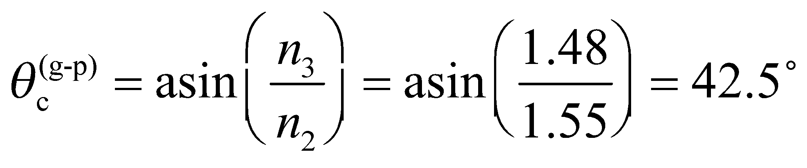
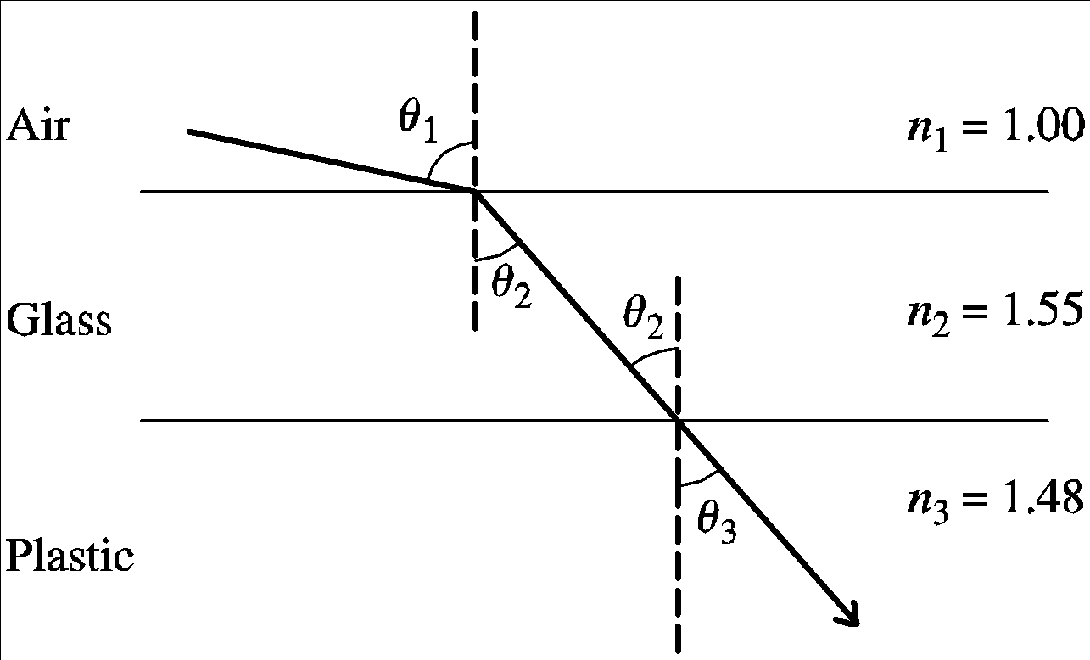
Evaluate Because 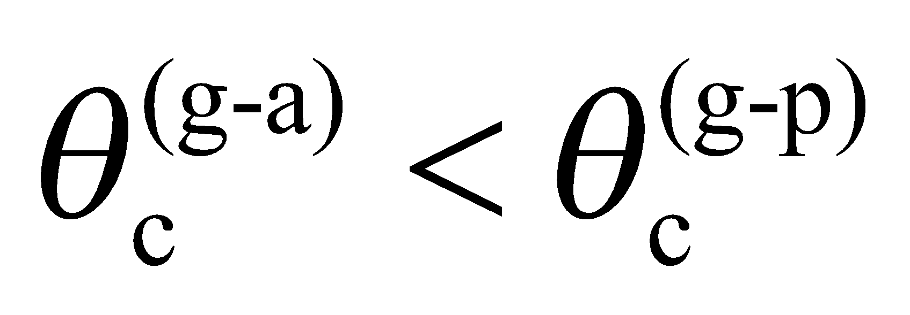, light will be totally internally reflected within the entire composite sheet before it will be trapped within the inner glass layers. Thus, the design is satisfactory.
Assess Note that unless n₃ < n₁, total internal reflections will never be a problem for this type of layered construction.
61. Interpret We want an expression for the time it takes light to traverse a slab of transparent material with an index of refraction that varies with depth. The light enters the material normal to the surface, so there's no angle of refraction to worry about.
Develop Inside the slab, the time it takes light to travel an infinitesimal distance, dx, is
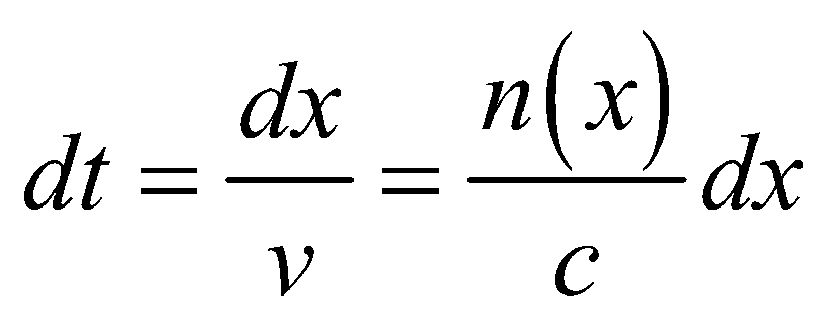
To find the total crossing time, we will integrate this over the slab's thickness, d.
Evaluate The time to traverse the slab is
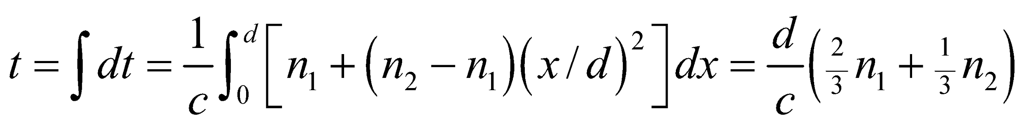
Assess Since and have to be greater or equal to one, our result implies that the presence of the slab lengthens the time light takes to travel the distance d, as we would expect. If 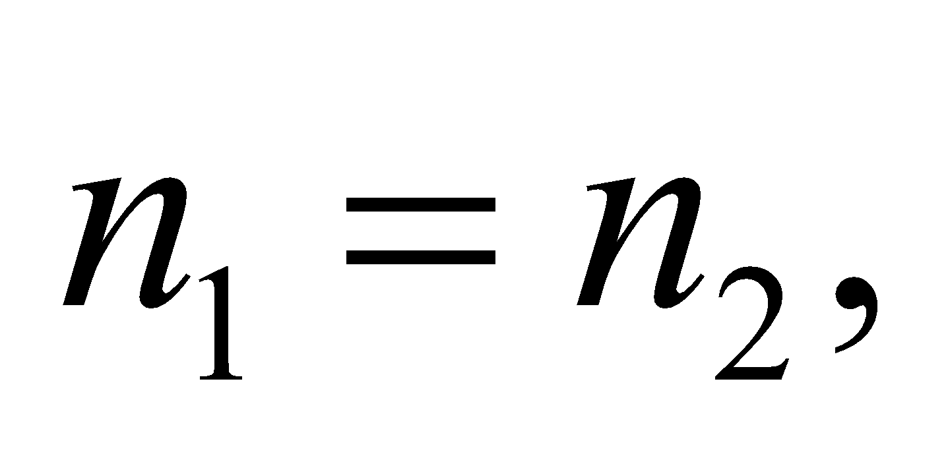then the slab has uniform index of refraction, and the time reduces to 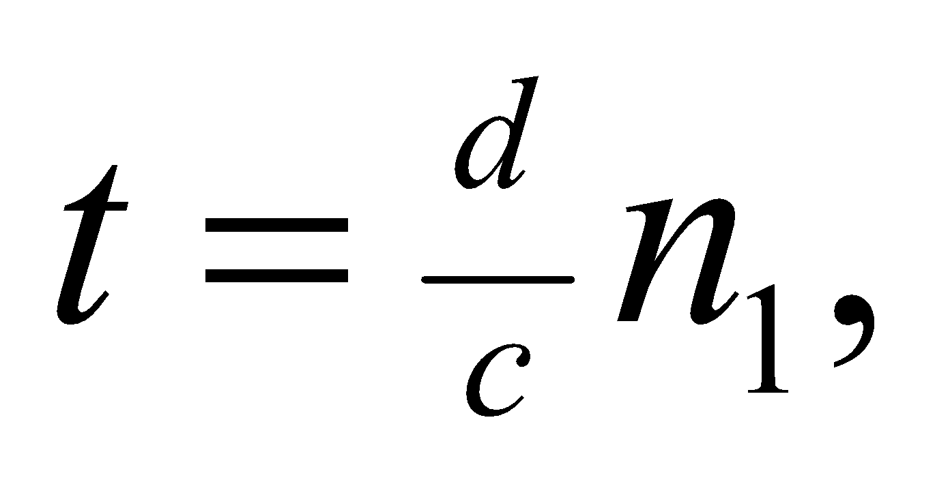again as we would expect.
62. Interpret We consider media with varying indices of refraction.
Develop In the mirage diagram, the light's vertical direction changes from initially pointing down to later pointing up. This implies that the index of refraction is changing in the vertical direction.
Evaluate To determine whether the index of refraction is increasing upward or downward, we imagine a particular point on the light's path where it is approaching the ground. We draw a horizontal line and assume the index of refraction is above this line and below the line. See figure below.

In this configuration, the tendency is for 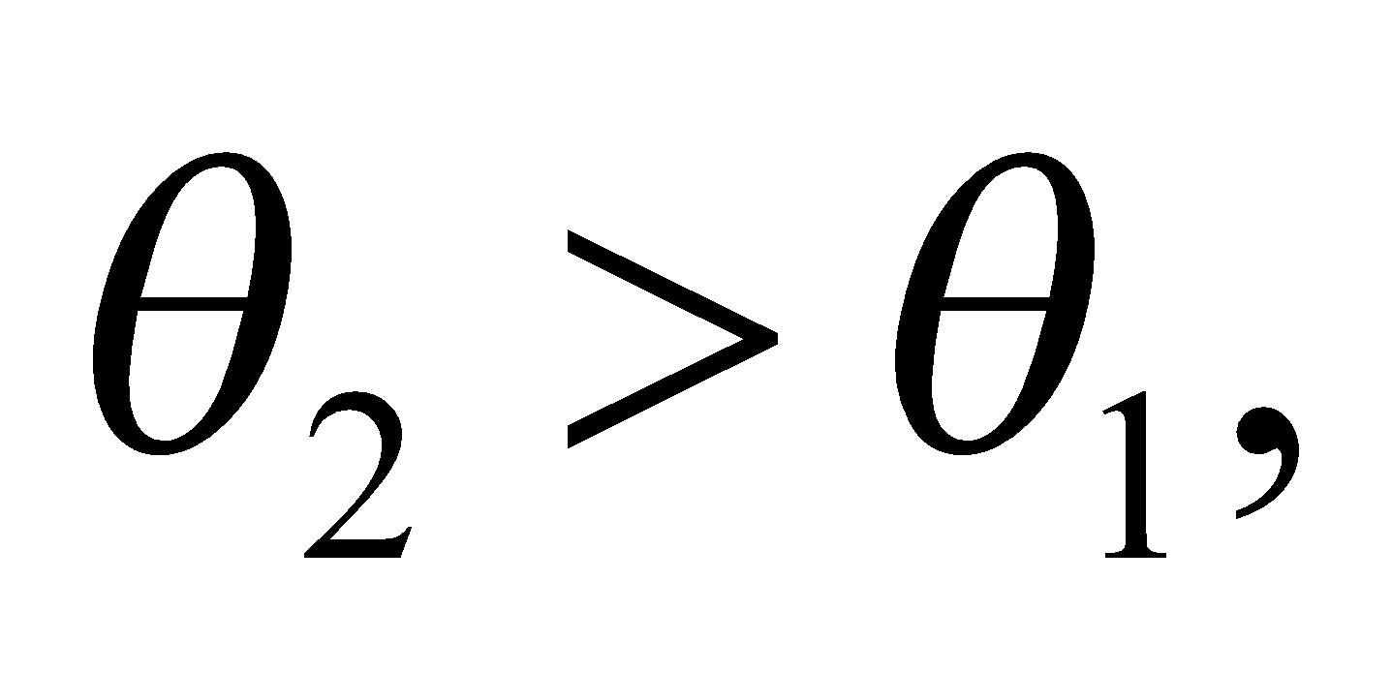 which means has to be less than in order to obey Snell's law. Therefore, the index of refraction is increasing upward.
The answer is (c).
Assess This variation in the index of refraction is due to a temperature gradient in the air. Warmer air is less dense and therefore has a lower index of refraction than cooler air. In a place where the ground is hot, the air near the surface may be several degrees warmer than the air just a few meters above. The corresponding change in the index of refraction can cause a mirage by bending downward moving light upwards.
63. Interpret We consider media with varying indices of refraction.
Develop The observer viewing the mirage is unaware of the light's curved path. He only perceives the angle at which the light enters his eye. He assumes what he sees is located in the direction implied by this angle.
Evaluate We redraw the figure below, extending a straight line from the observer's eye at the incident angle of the light. It's clear that the mirage will appear at the point A.

The answer is (a).
Assess This answer makes sense with our experience of mirages. We think we see water on the ground in the distance, but in fact we are seeing light from the sky that is being refracted from the air near the ground.
64. Interpret We consider media with varying indices of refraction.
Develop The ionosphere can be thought of as a mirror that only works for certain angles.
Evaluate Waves emitted at angles less steep than θ are essentially reflected to points farther than point B from point A. Likewise, we'd expect waves emitted at angles steeper than θ to be reflected to points between than points A and B, but they're not, so these points will not receive any ionosphere-mediated signal.
The answer is (b).
Assess The angle θ hre depends on frequency: i.e., the cutoff for reflection to occur is at a smaller angle for higher frequencies. This explains why ionospheric reflection typically works for lower frequencies, such as the AM radio band (535 to 1700 kHz). By contrast, waves in the FM radio band (88 to 108 MHz) are usually not bent enough by the ionosphere to return back to Earth.
65. Interpret We consider media with varying indices of refraction.
Develop If the refractive index of the ionosphere approaches 1 at high frequencies, that means it will have roughly the same index of refraction as the atmosphere below and above it. Thus, there will be relatively no bending of high frequency radio signals.
Evaluate Since higher frequencies will essentially pass through the ionosphere, an alternative method, such as satellite-based communication, will be needed to send them over long distances.
The answer is (c).
Assess Most satellite-based communication is in the GHz region of the electromagnetic spectrum.

