MAXWELL’S EQUATIONS AND
ELECTROMAGNETIC WAVES

29

Exercises
Section 29.2 Ambiguity in Ampère’s Law
13. Interpret In this problem, we are asked to find the displacement current through a surface.
Develop As shown in Equation 29.1, Maxwell’s displacement current is
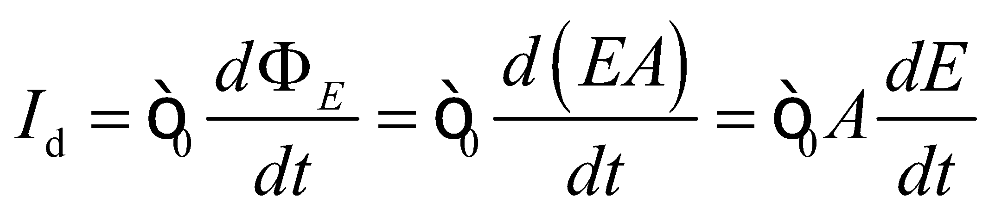
Evaluate The above equation gives
Assess Displacement current arises from changing electric flux and has units of amperes (A), just like ordinary current.
14. Interpret This problem involves finding the displacement current across a parallel-plate capacitor given the rate at which the voltage is changing.
Develop The electric field is approximately uniform in the capacitor, so 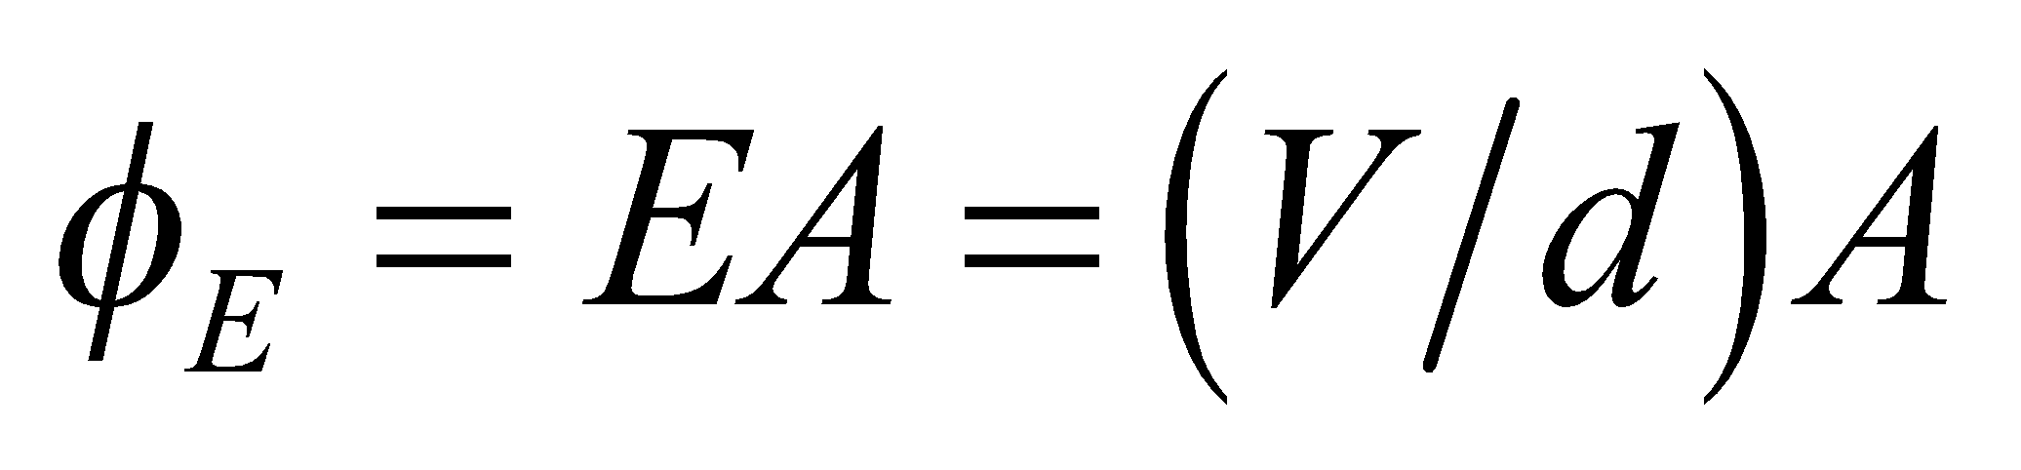. Differentiate this with respect to time to find the displacement current.
Evaluate The displacement current is
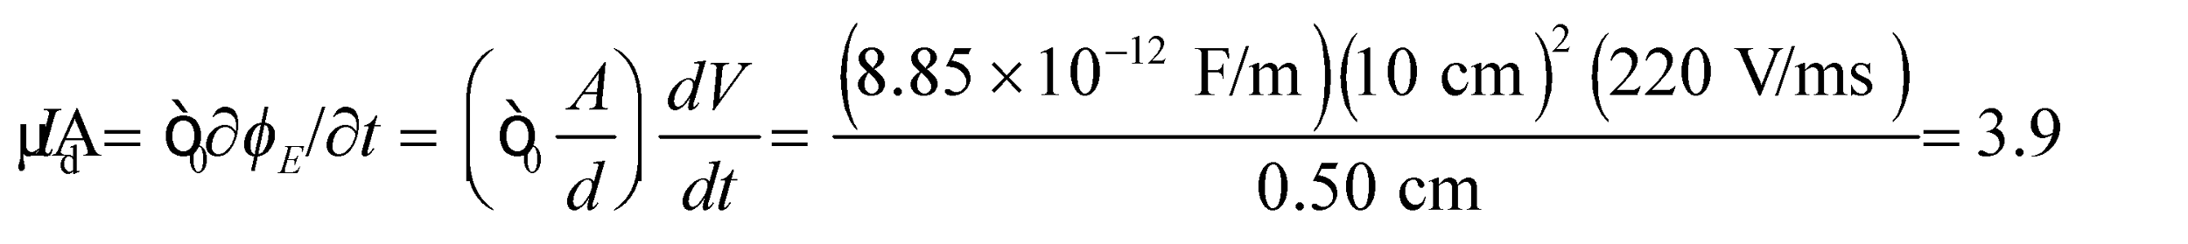
Assess The units of the displacement current work out to be (with the help of Appendix B)
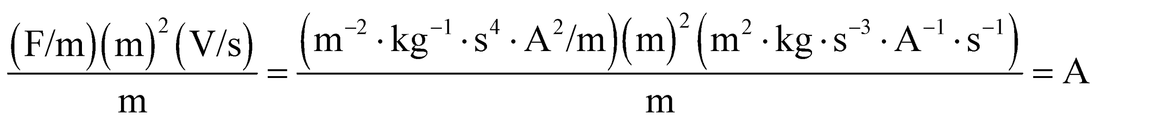
as expected.
Section 29.4 Electromagnetic Waves
15. Interpret We are given the electric and magnetic fields of an electromagnetic wave and asked to find the direction of propagation in terms of a unit vector.
Develop The direction of propagation of the electromagnetic wave is the same as the direction of the cross product 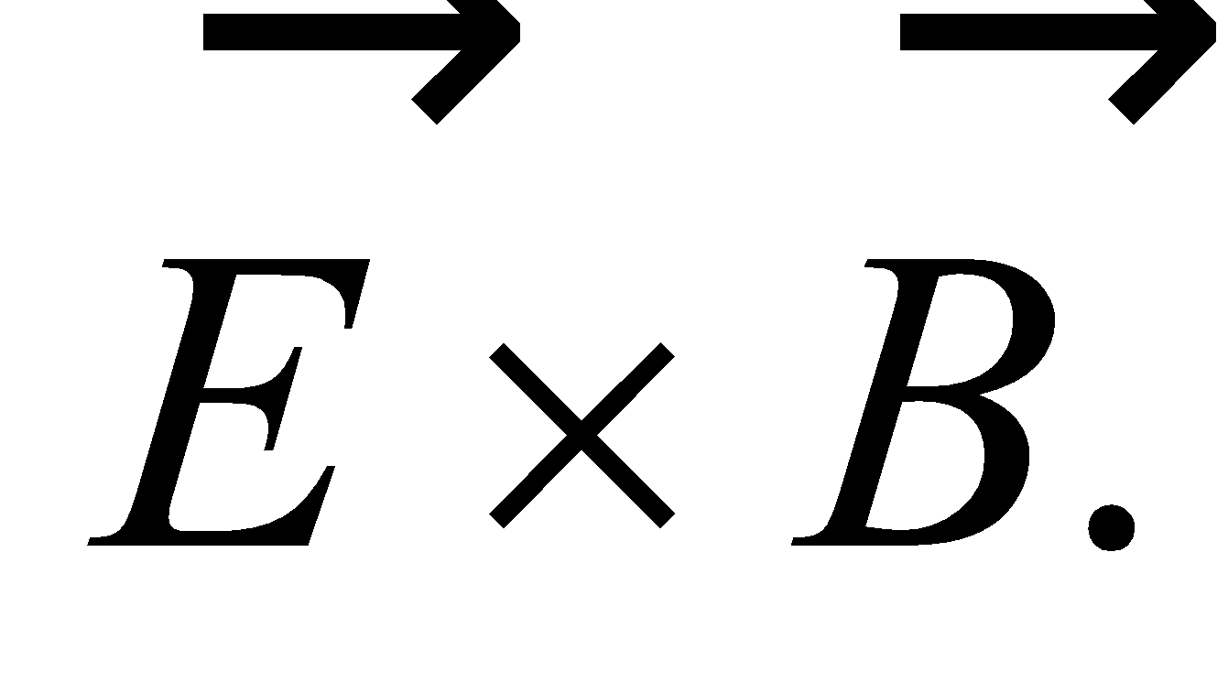
Evaluate When  is parallel to 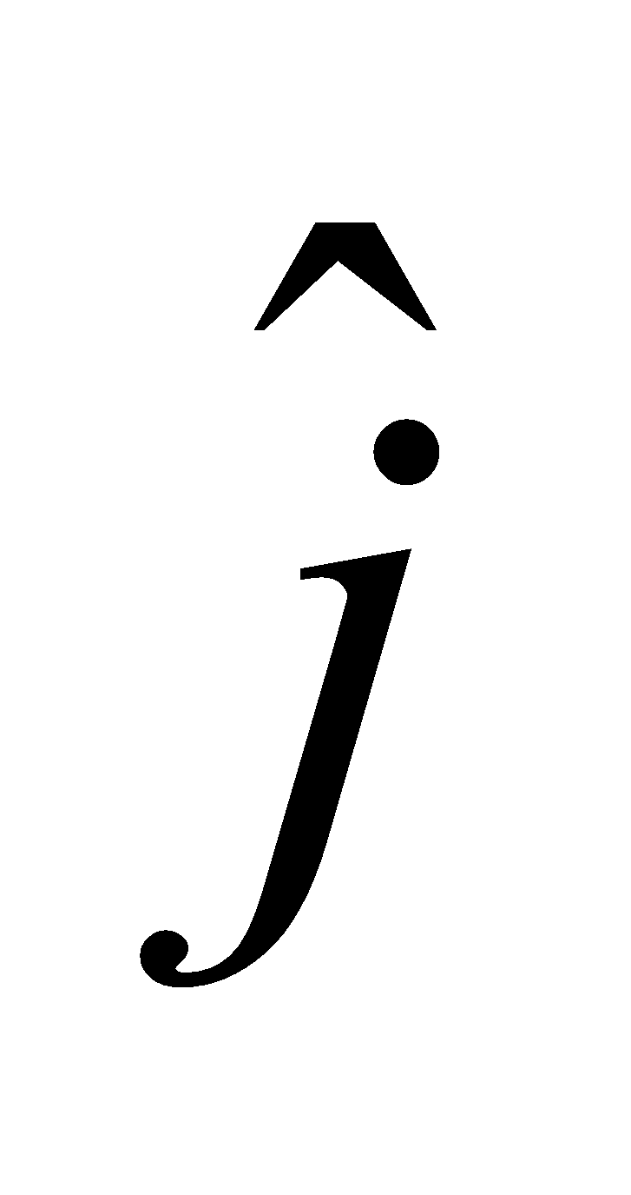 and  is parallel to 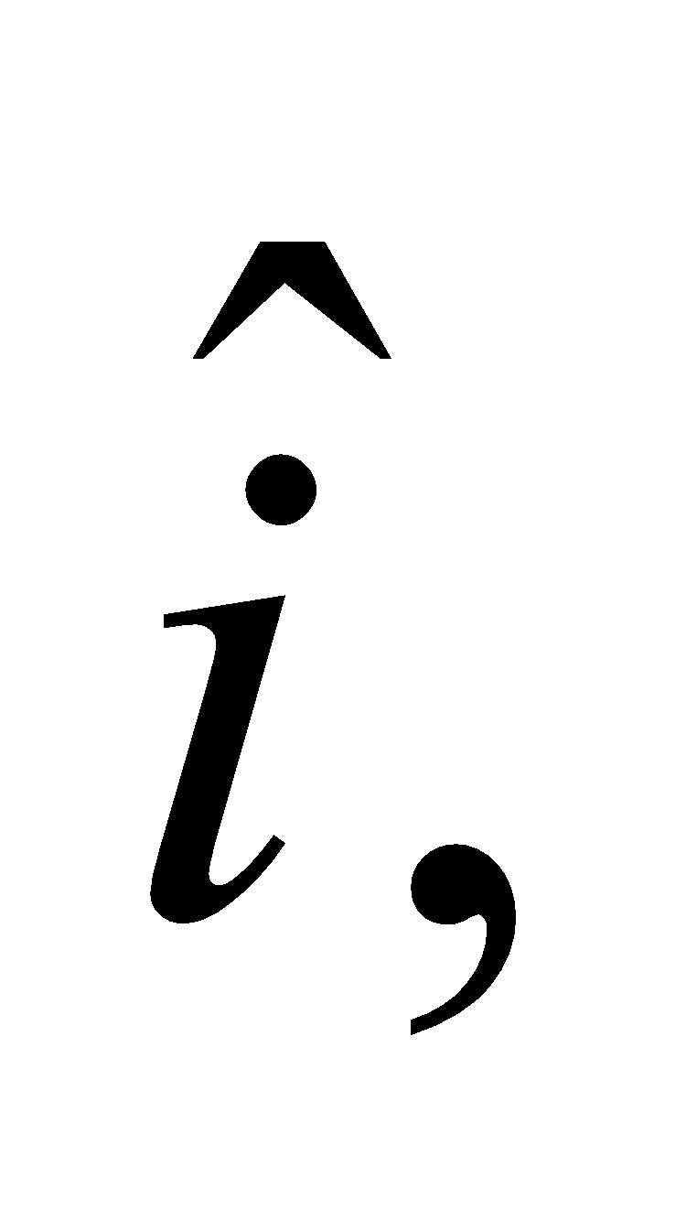 the direction of propagation is parallel to 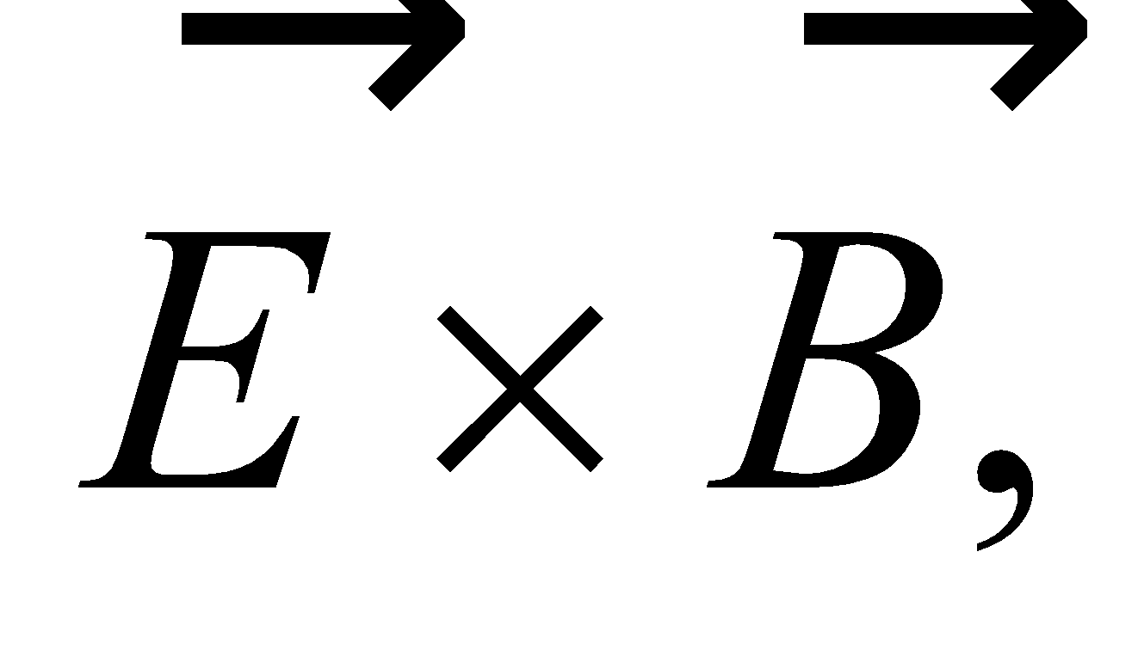 or
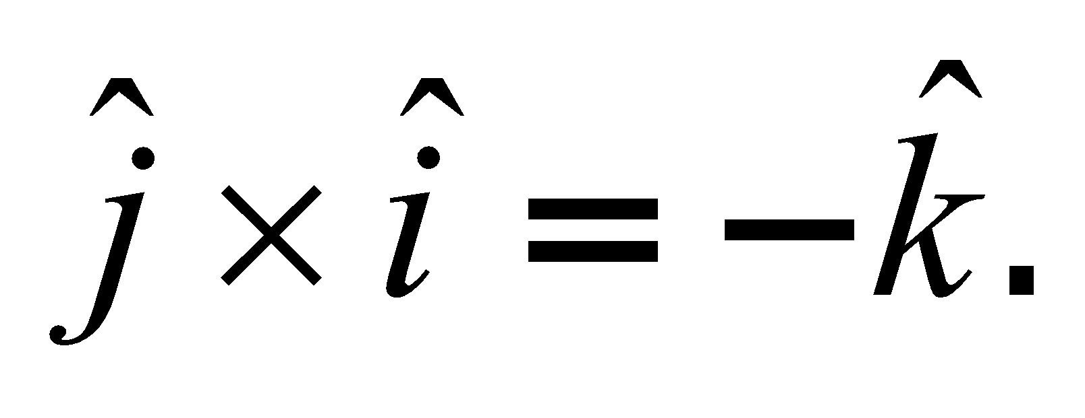
Assess For electromagnetic waves in vacuum, the directions of the electric and magnetic fields, and of wave propagation, form a right-handed coordinate system.
16. Interpret We are given the description of the electric field of a radio wave and are asked to characterize it by finding the peak electric field and the direction of propagation.
Develop The maximum of the sine function is unity, so the prefactor of the sine function gives the peak electric field. In vacuum, the magnetic field must be perpendicular to the electric field. The latter is oriented at 45° above the x-axis for 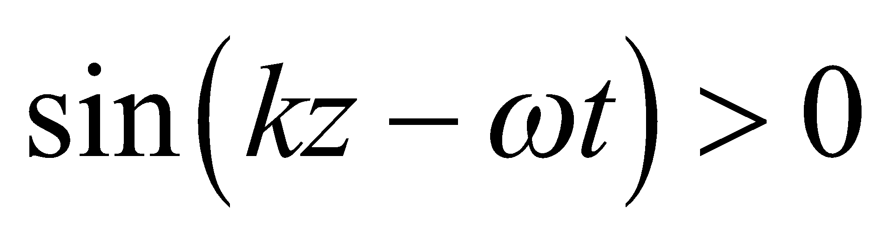, so we can find possible directions for the magnetic field.
Evaluate (a) When the sine function is unity, the electric field is 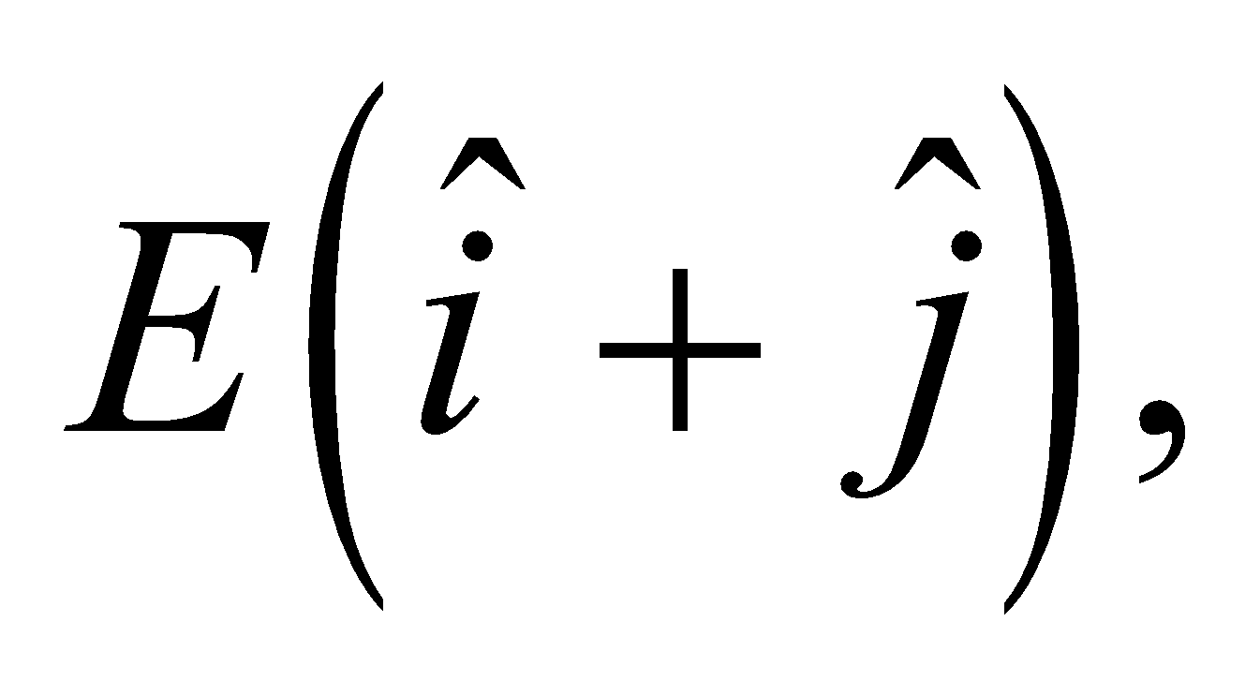 so its peak magnitude is 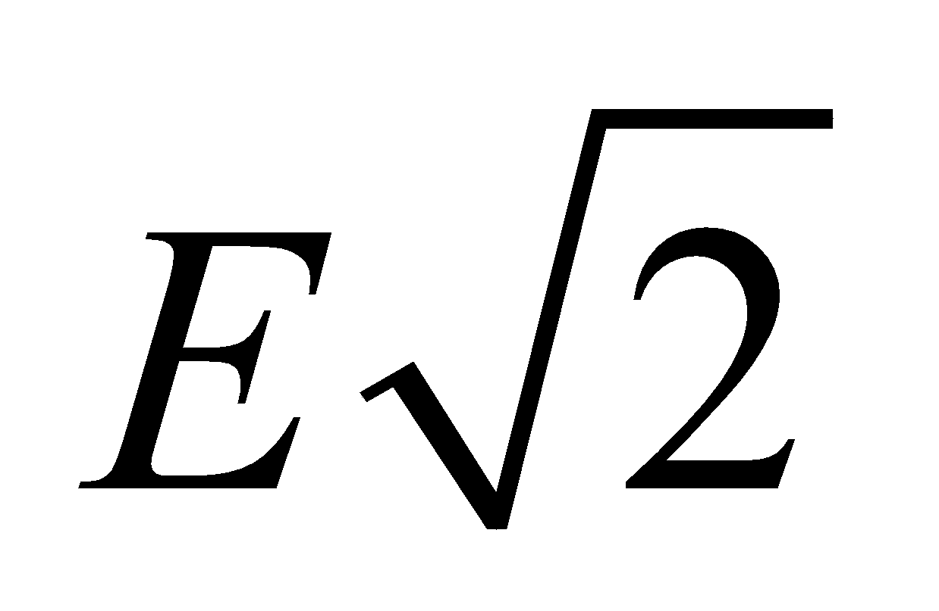 and it direction is 45° above the x-axis.
(b) To be perpendicular to the electric field, the magnetic field may either be in the +135° from the x-axis (i.e., second quadrant), or −45° from the x-axis (i.e., fourth quadrant). These fields would have unit vectors of 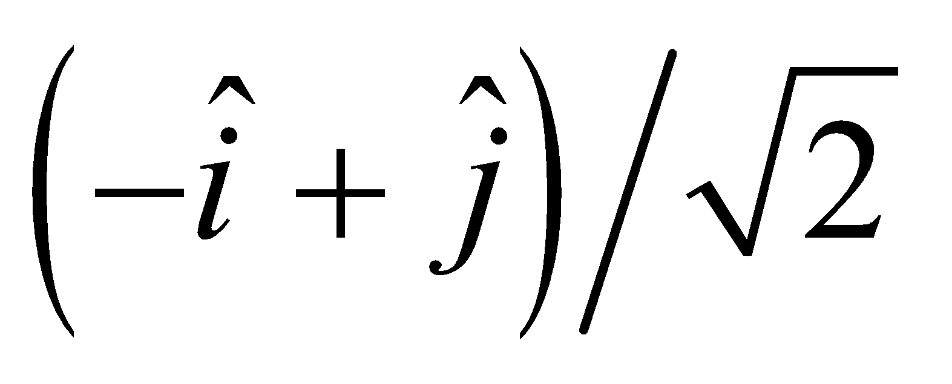 and 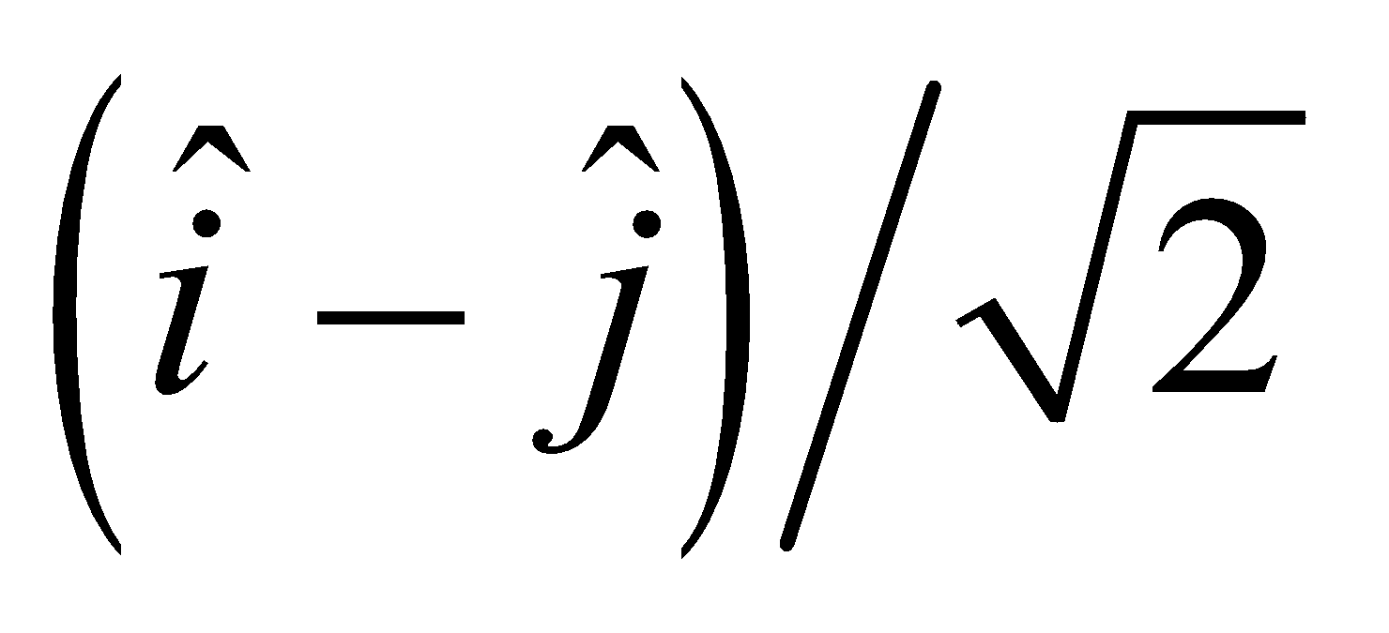, respectively.
Assess Without knowing the direction of propagation of the electromagnetic wave, we cannot determine absolutely the direction of the magnetic field. The direction of propagation of the electric field is in the direction of 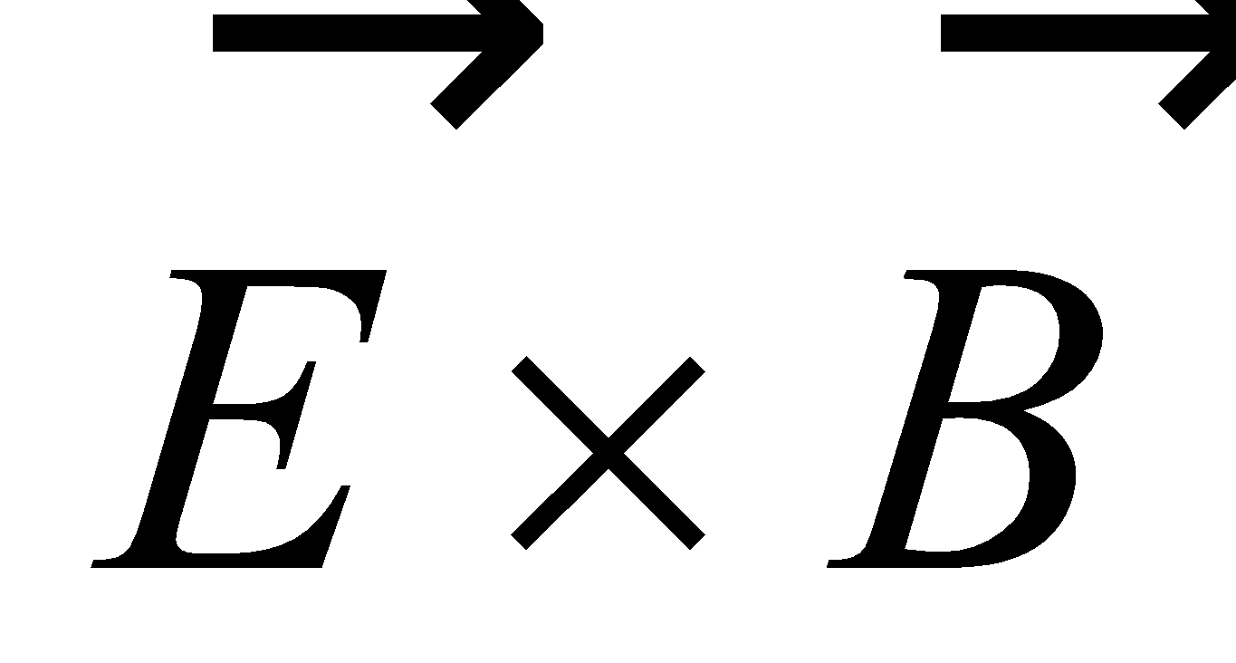, and so would be in either the 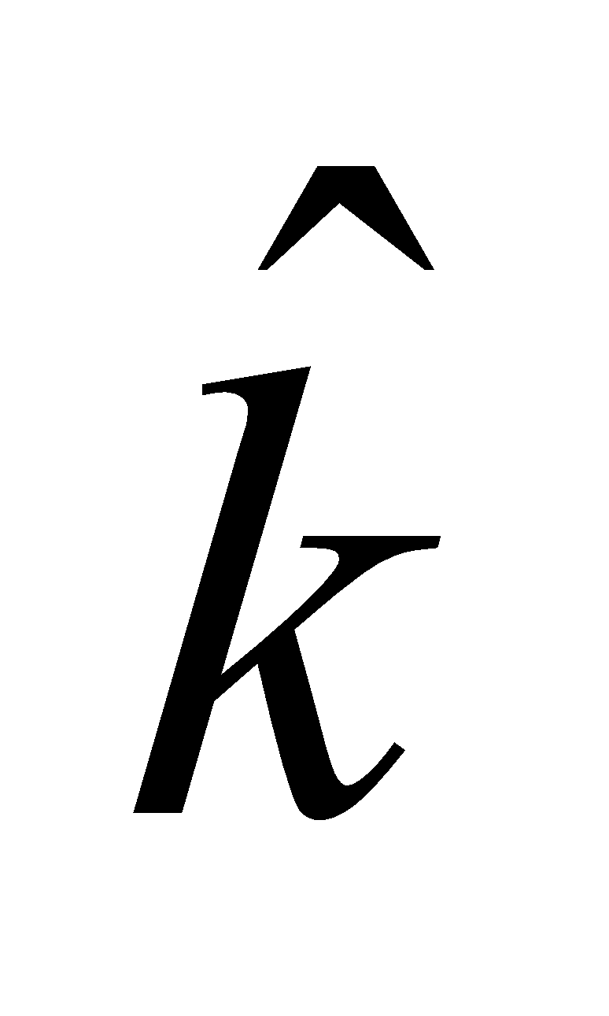 or 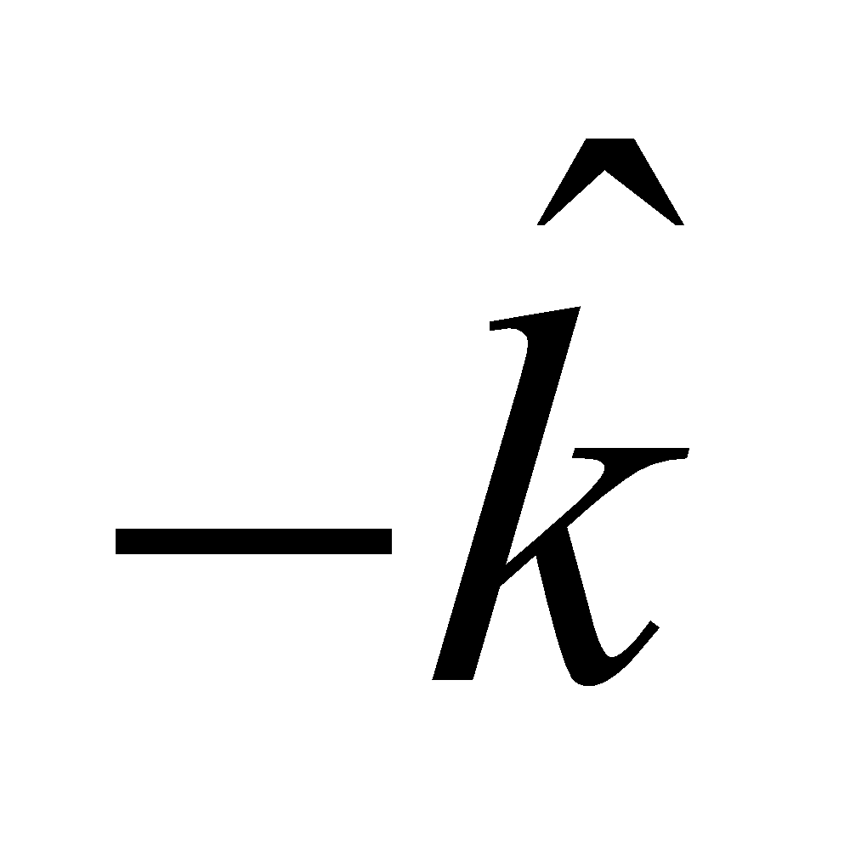 direction, respectively.
Section 29.5 Properties of Electromagnetic Waves
17. Interpret This problem involves expressing the distance between the Sun and the Earth in terms of light minutes.
Develop A light minute (abbreviated as c-min) is approximately equal to
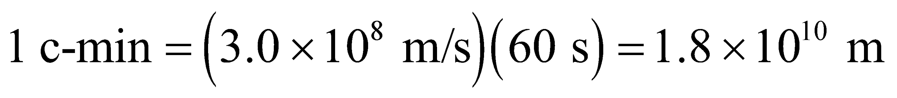
On the other hand, the mean distance of the Earth from the Sun (an astronomical unit) is about 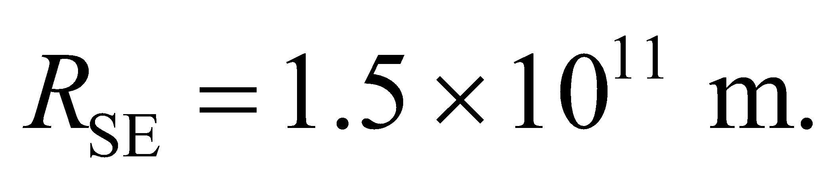
Evaluate In units of c-min,  can be rewritten as
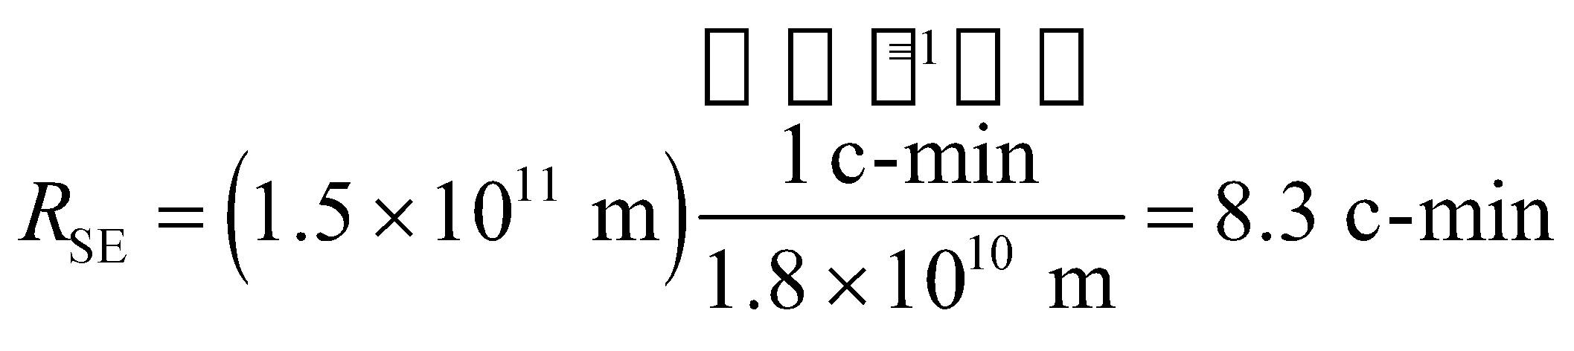
Assess The result implies that it takes about 8.3 minutes for the sunlight to reach the Earth.
18. Interpret This problem is to give you a “feel” for the speed of light. You are to find the approximate time it would take for an electromagnetic signal to travel to a satellite and back.
Develop Assuming the satellite is approximately overhead, we can estimate the round-trip travel time by 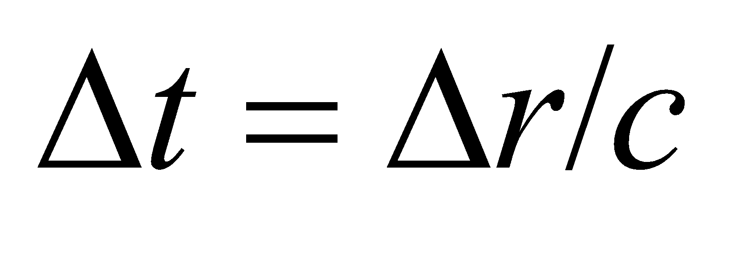, where c = 3.00 × 10⁸ m/s is the speed of light in vacuum.
Evaluate The approximate round-trip time is 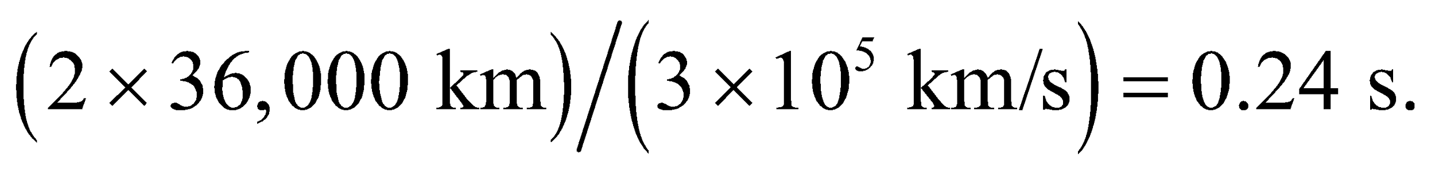
Assess This explains the very slight delay one may notice in intercontinental phone calls.
19. Interpret In this problem we want to deduce the airplane’s altitude by measuring the travel time of a radio wave signal it sends out. The logic of this method is the same as that of the preceding problem.
Develop The speed of light is 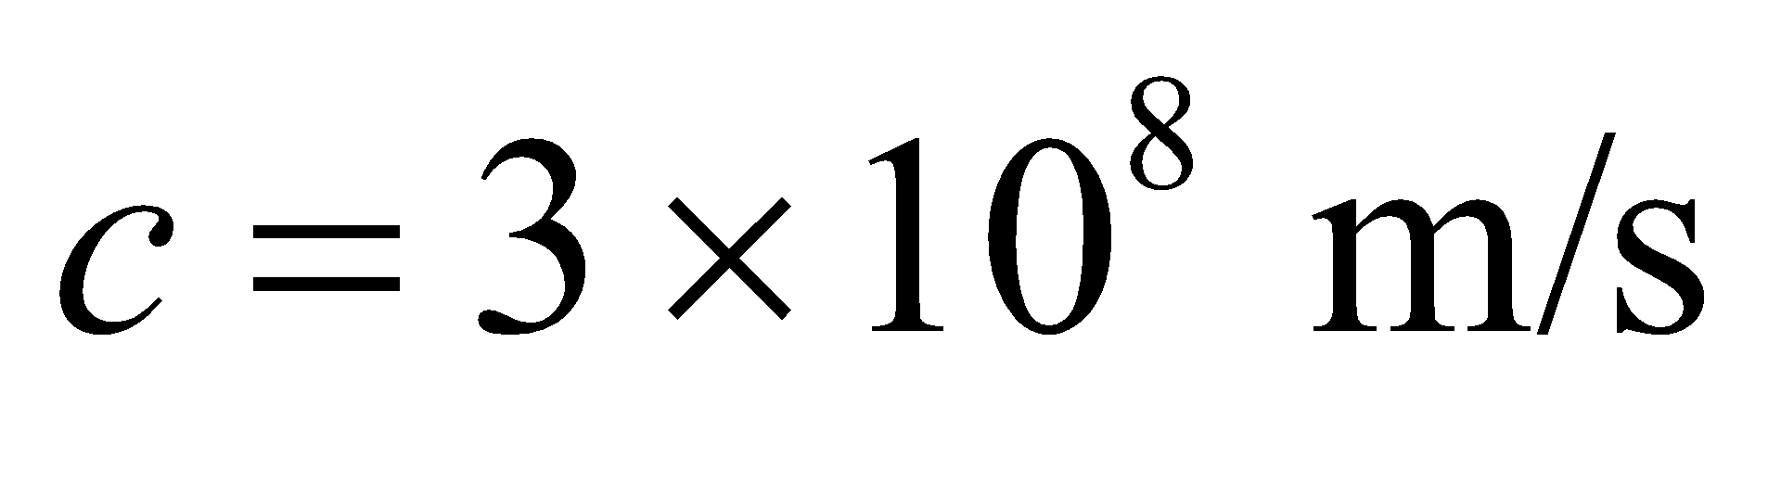 and the total distance traveled is 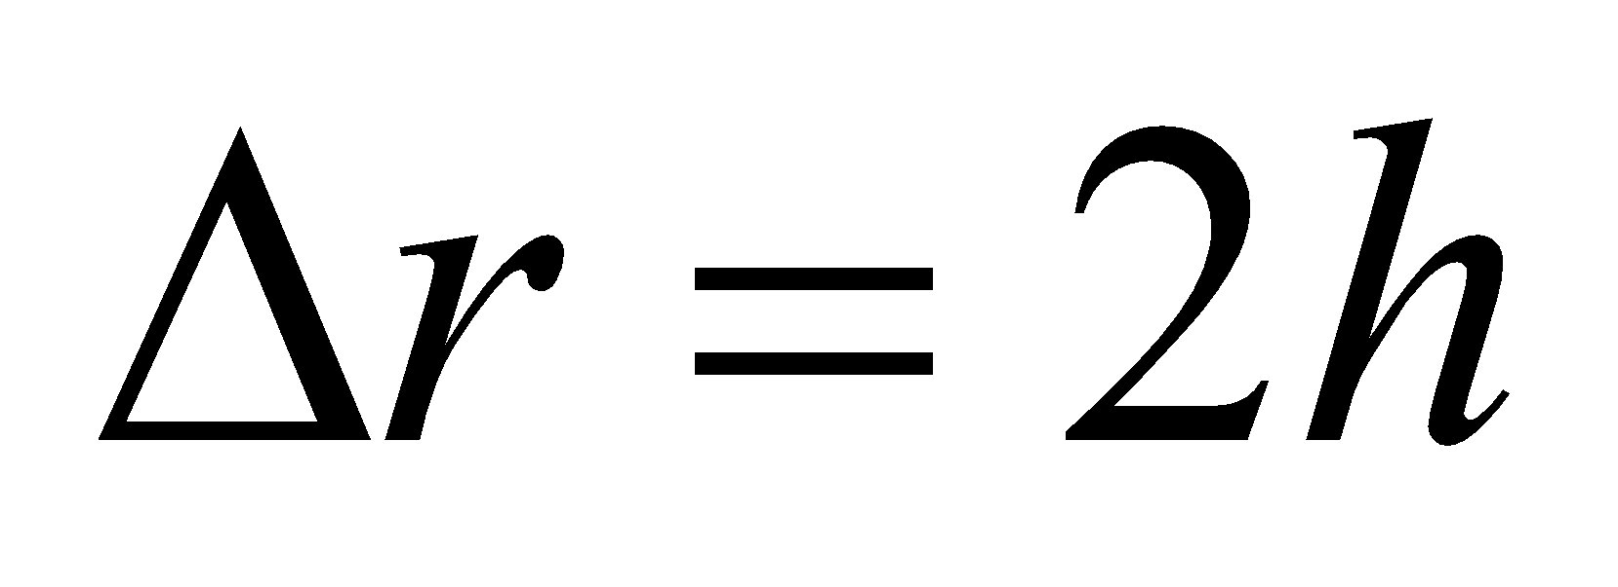 (neglecting the distance traveled by the plane during the transit time of the signal).
Evaluate Since 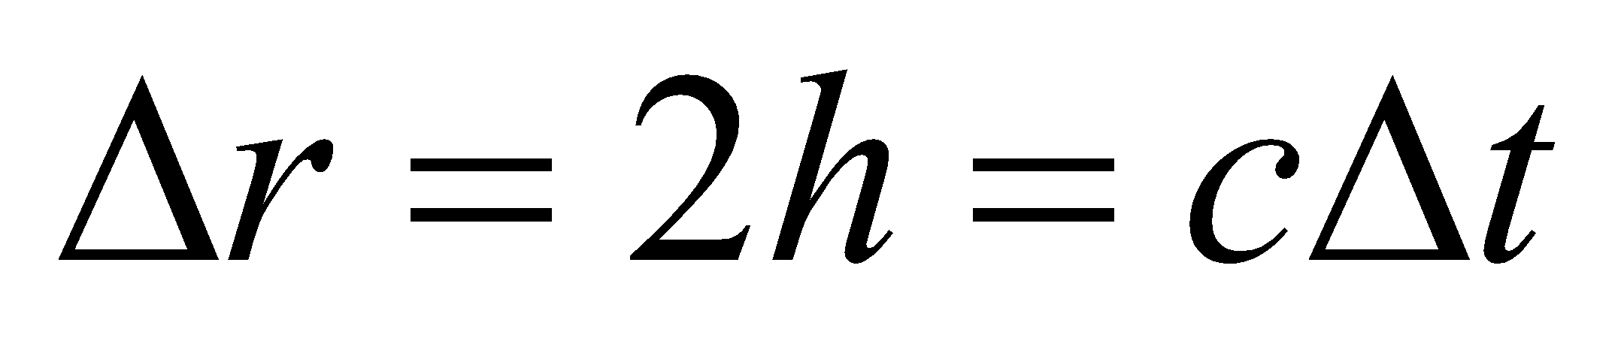 (for waves traveling with speed c), the altitude h is
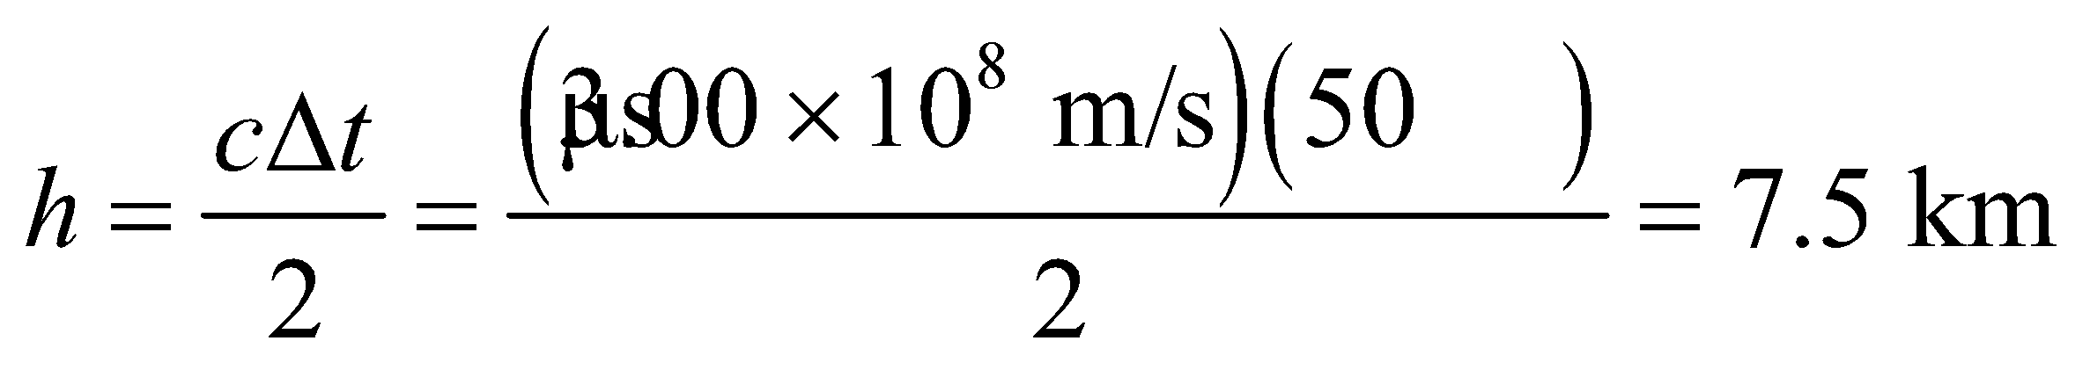
Assess The airplane is flying lower than the typical cruising altitude of 12,000 m (35,000 ft) for commercial jet airplanes.
20. Interpret This is another problem designed to give a “feel” for the speed of light. We are to find the time it takes for an electromagnetic wave to travel 1 foot (in vacuum).
Develop The speed of light in vacuum is c = 3.00 × 10⁸ m/s, so the time may be found by dividing the distance (1 foot ~ 0.30 m) by this speed.
Evaluate The time t for light to travel one foot in vacuum is approximately
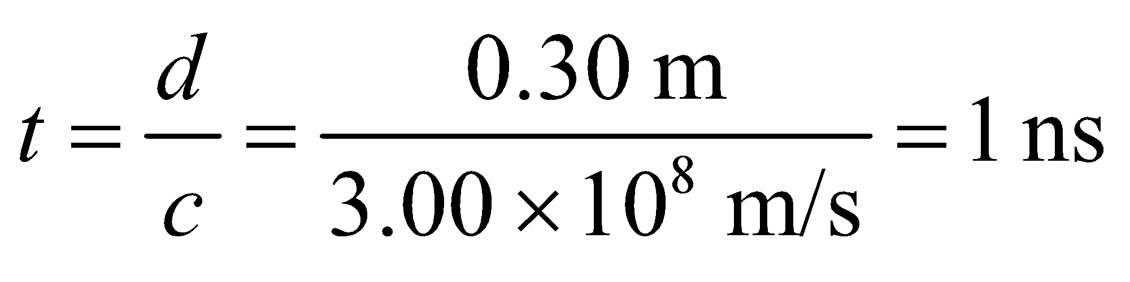
Assess This time delay may be measured by modern electronics. Faster times, however, are better measured using optical methods.
21. Interpret This problem involves finding the round-trip time delay for radio signals traveling between the Earth and the Moon.
Develop The time it takes to get a reply is twice the distance (out and back) divided by the speed of light, which is 3.00 × 10⁸ m/s in vacuum.
Evaluate From Appendix E, we find the distance between the Earth and the Moon to be 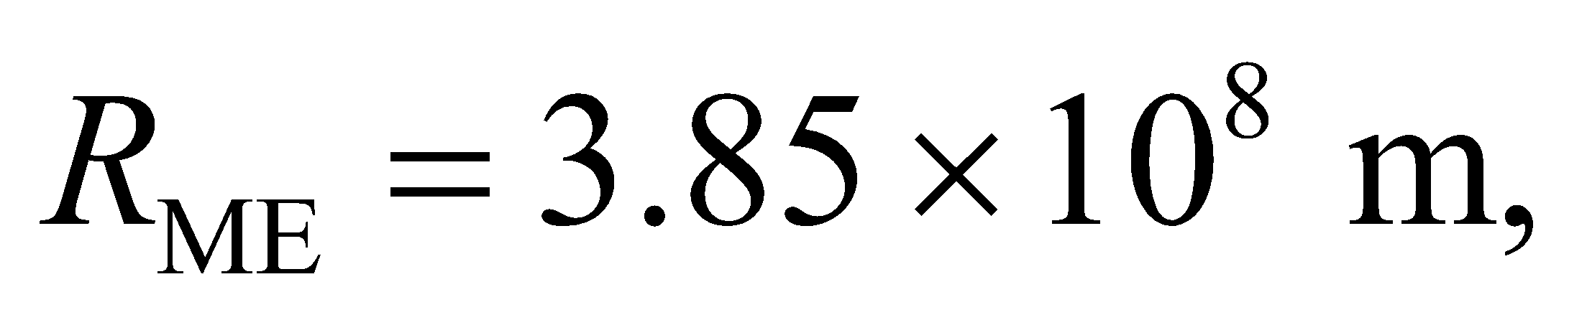 so the time required is
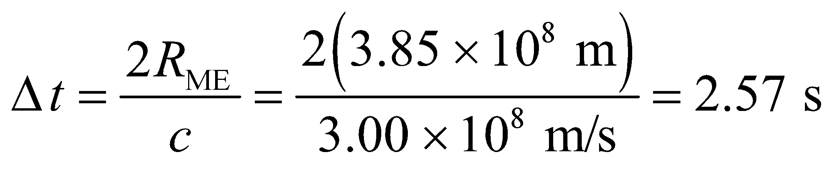
Assess The signal has to travel a very long distance, so a time delay of 2.57 seconds is not surprising. The time delay via geostationary satellite communication is typically between 240 ms and 280 ms (see Problem 29.18).
22. Interpret This problem involves converting frequency of light to wavelength.
Develop Equation 29.16c gives the relation between frequency and wavelength: 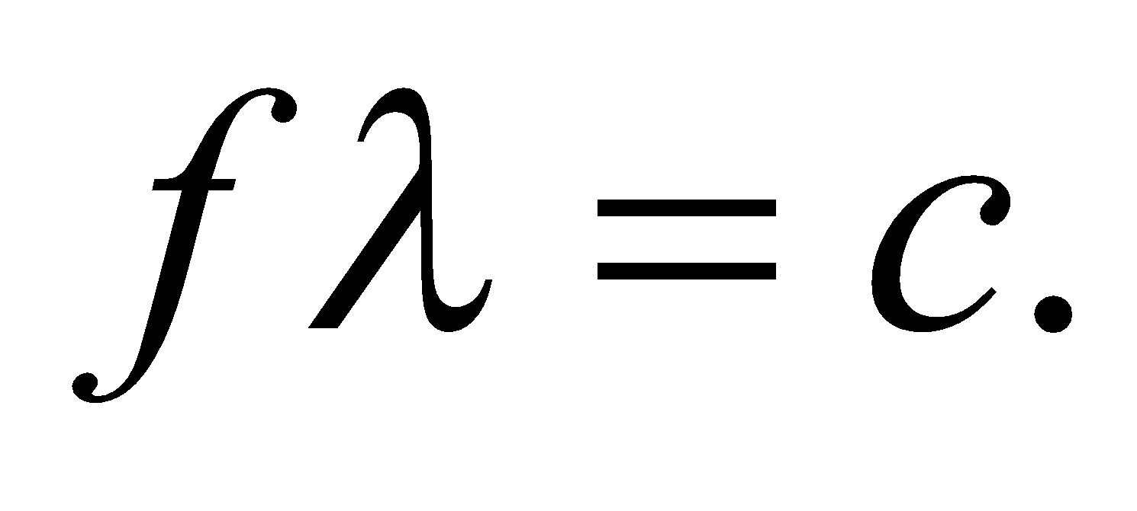
Evaluate (a) For an FM radio wave,
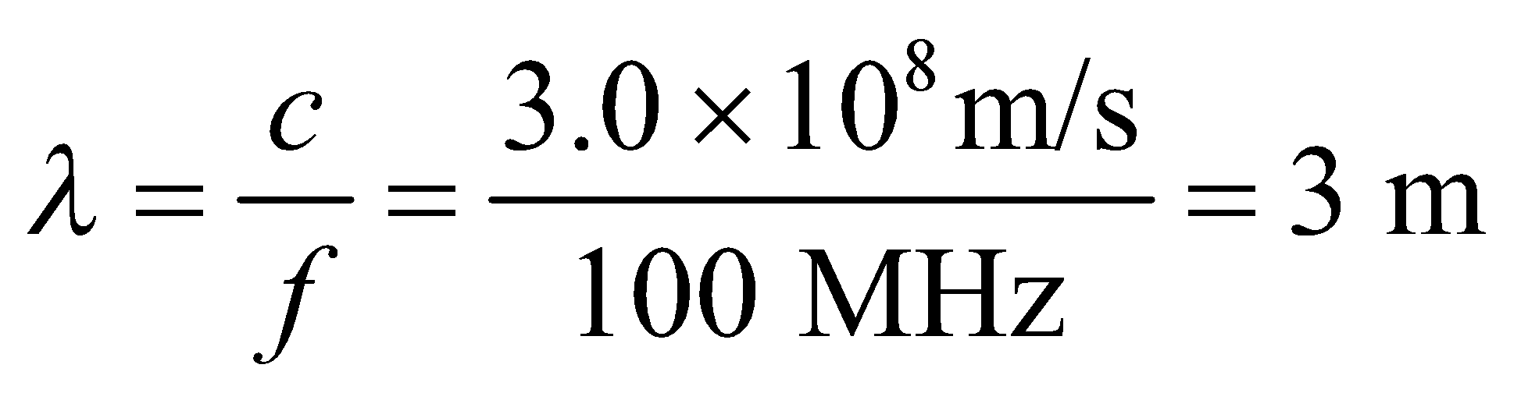
(b) For a WiFi signal,
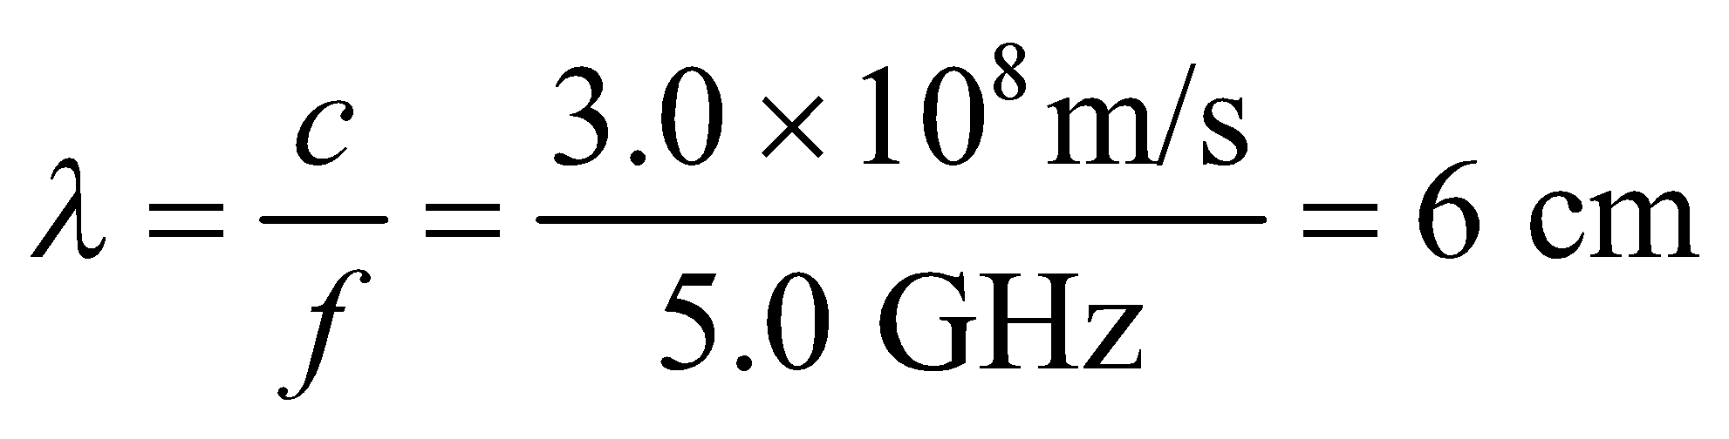
(c) For a visible light wave,
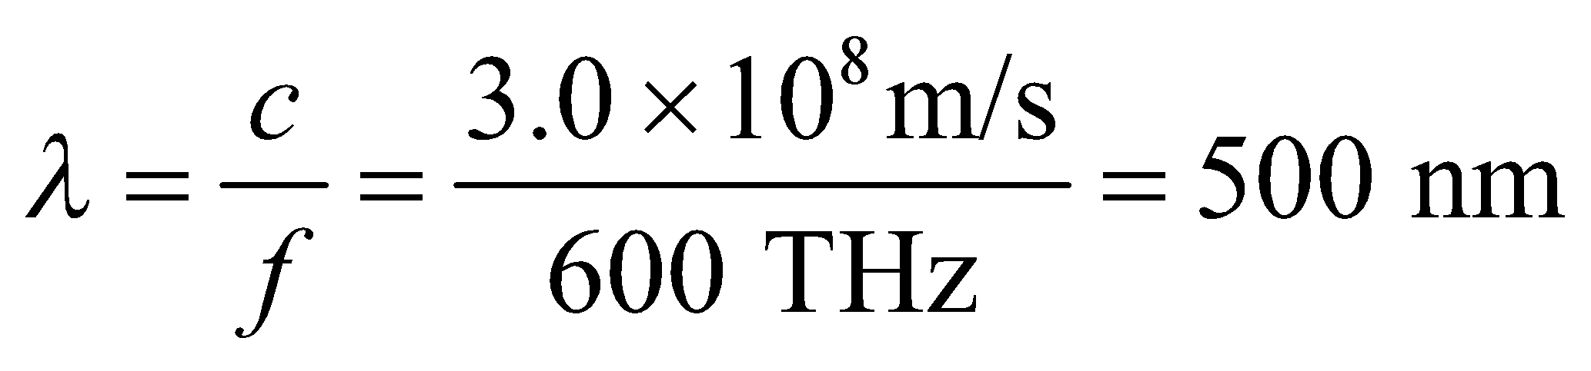
(d) For an X ray,
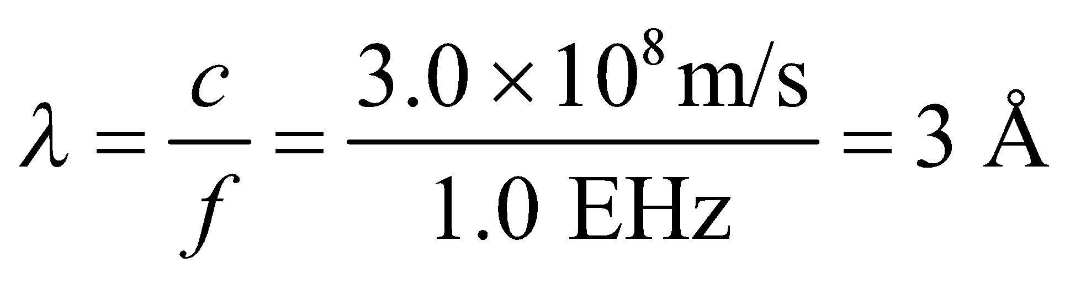
Assess From 3 m to the electromagnetic spectrum that we are most familiar with extends more than 10 orders of magnitude.
23. Interpret In this problem we are asked to find the wavelength of electromagnetic radiation that propagates through air, given its frequency.
Develop The wavelength of the electromagnetic wave can be calculated using Equation 29.16c: Because air is not optically dense, it may be taken to be a vacuum, so the speed of light is c = 3.00 × 10⁸ m/s.
Evaluate The wavelength in a vacuum (or air) is
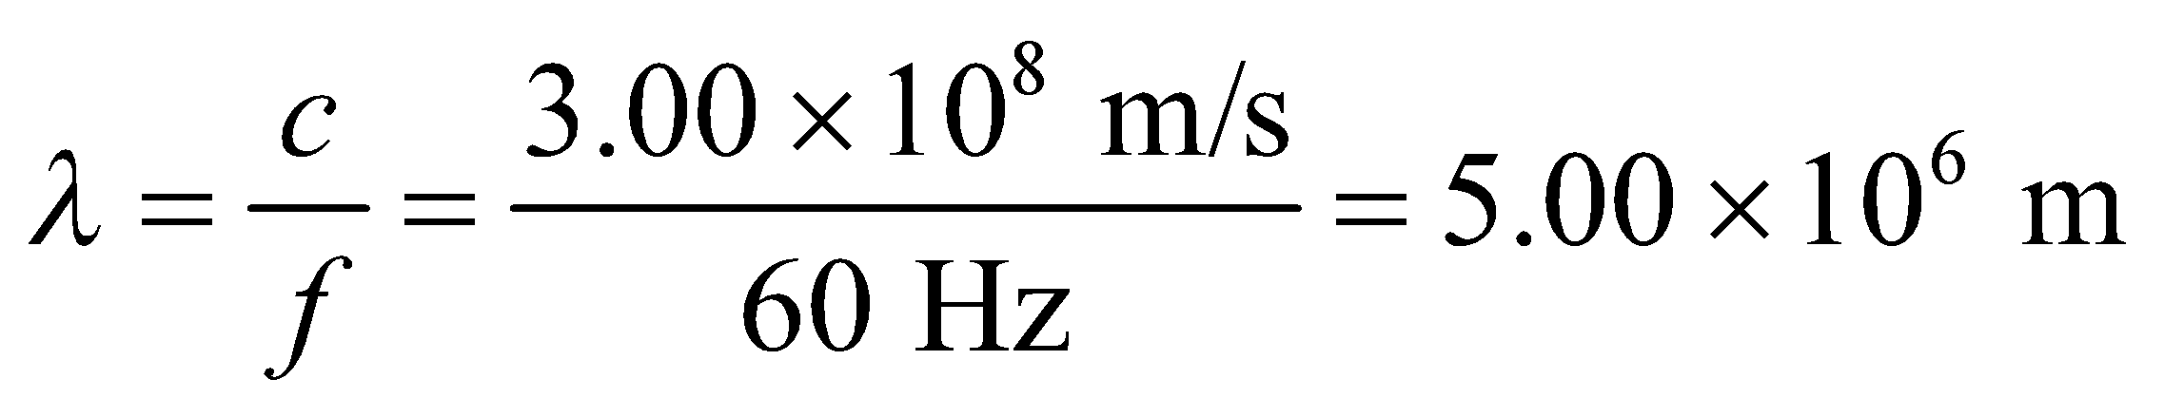
Assess The wavelength is almost as large as the radius of the Earth!
24. Interpret The distance between wave crests is the wavelength of the wave, which we are to find for an electromagnetic wave in vacuum given its frequency.
Develop Apply Equation 29.16c, λ = c/f, with c = 3.00 × 10⁸ m/s and f = 2.4 × 10⁹ s⁻¹.
Evaluate The distance between wave crests is
Assess The result is reported to two significant figures.
25. Interpret This problem involves finding the direction of polarization of an electromagnetic wave, which is the direction in which the electric field oscillates.
Develop The direction of propagation of the electromagnetic wave is the same as the direction of the cross product In our case, we have 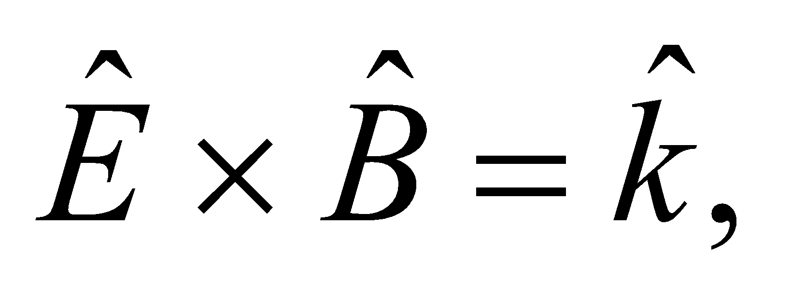 where is the unit vector in the + z direction.
Evaluate Since the magnetic field points in the +y direction, 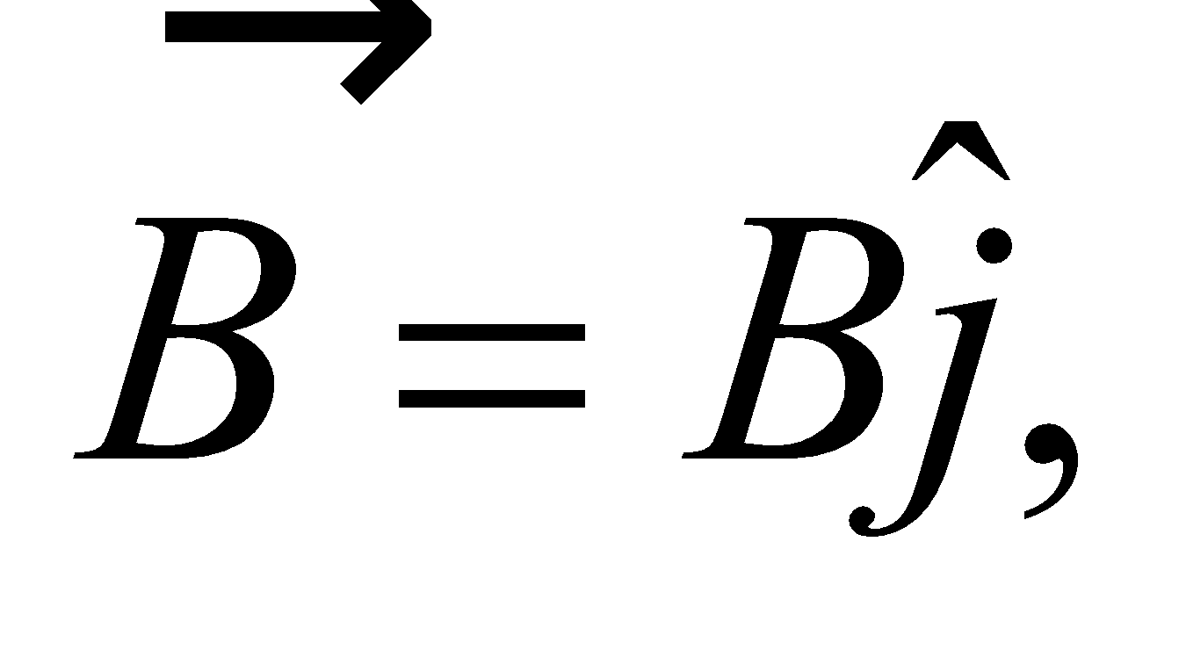 we must have 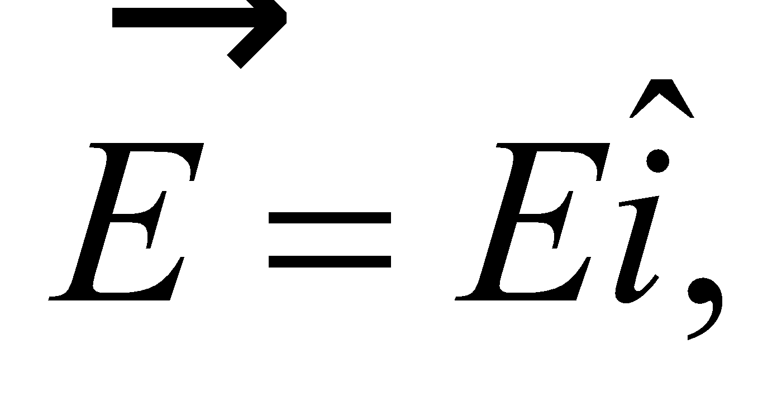 so that 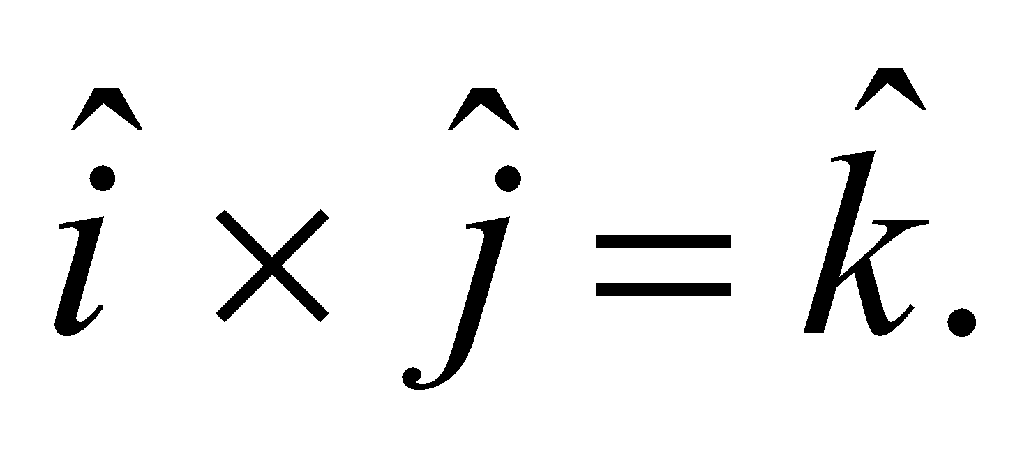 The wave is linearly polarized.
Assess For electromagnetic waves in vacuum, the directions of the electric and magnetic fields, and of wave propagation, form a right-handed coordinate system. One may write 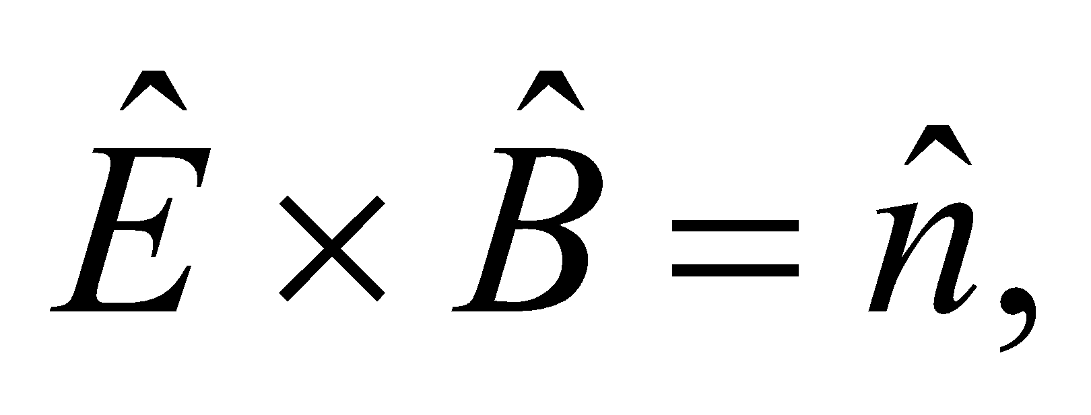 where 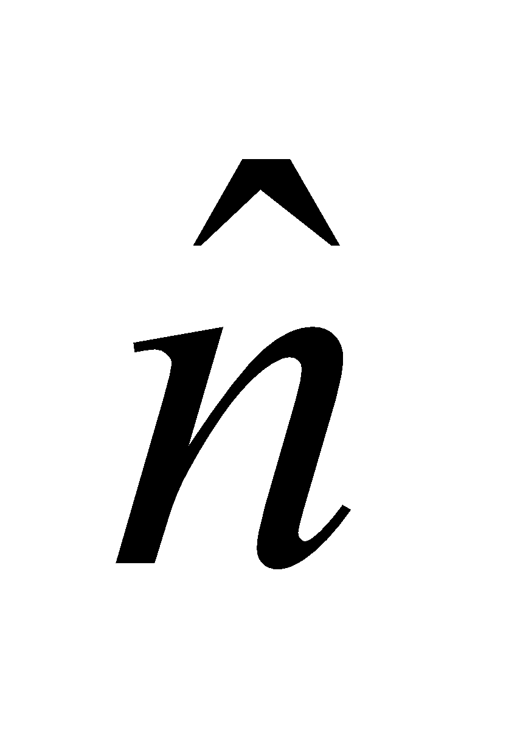 is the unit vector in the direction of propagation.
26. Interpret We are to find the angle between the polarization of the electromagnetic wave (i.e., the direction of its electric field) and the polarization direction of the polarizing material.
Develop Apply the Law of Malus, Equation 29.18.
Evaluate From the law of Malus, 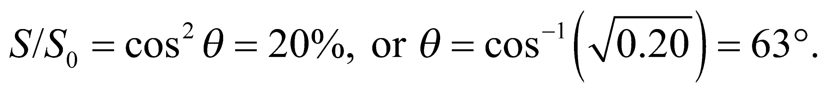
Assess By rotating the polarizer with respect to the incident electromagnetic field, the transmission can be adjusted from almost 100% to almost 0%.
27. Interpret This problem is about the intensity of a light beam that transits a polarizer. We are given the angle between the polarization of the light (i.e., its electric field) and the polarization direction of the material.
Develop The intensity of the light after emerging from a polarizer is given by the Law of Malus (Equation 29.18), 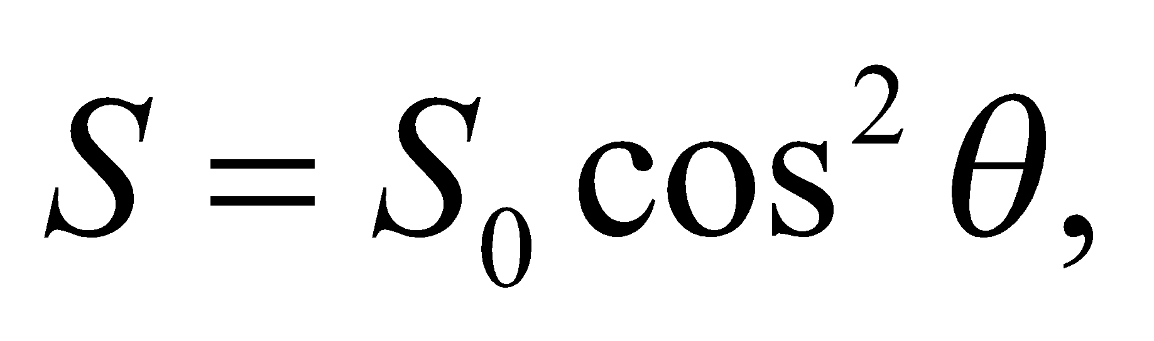 where θ is the angle between the field and the polarization direction of the material.
Evaluate The Law of Malus gives 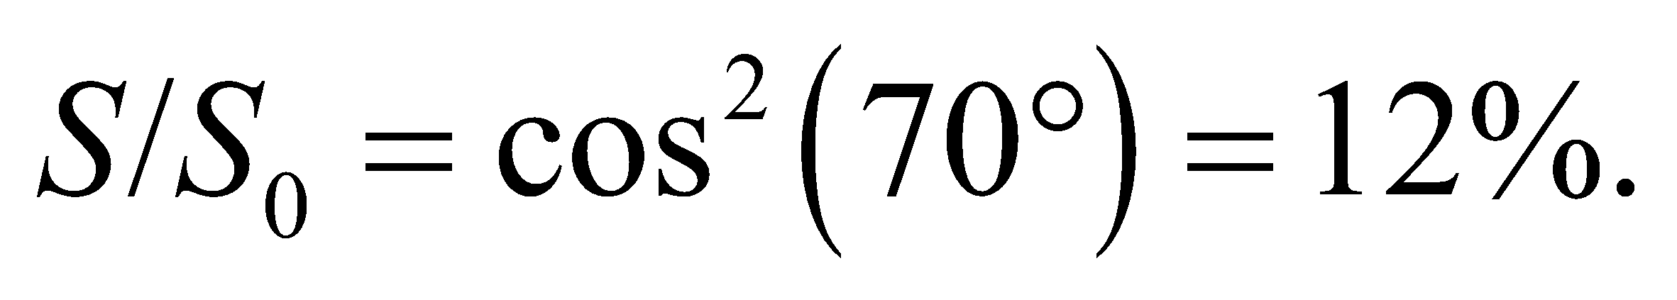
Assess The intensity depends on 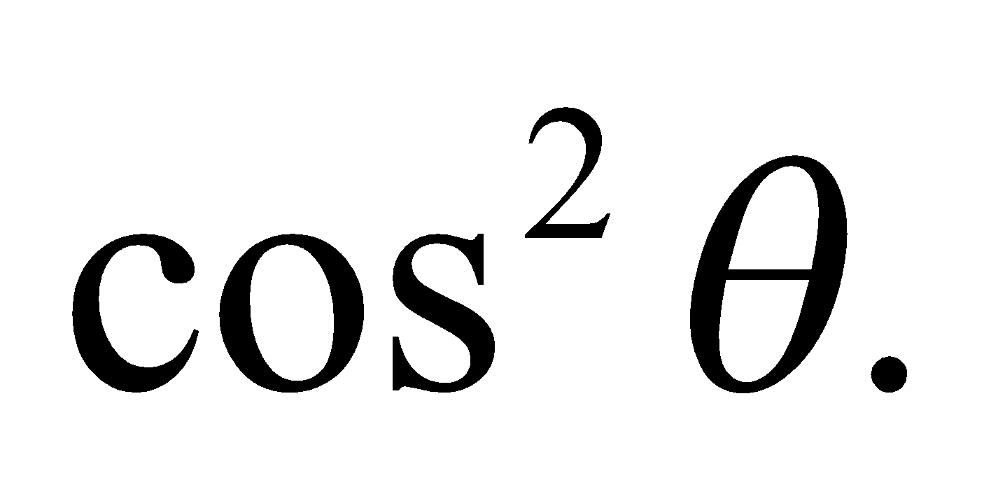 The limit θ = 0 corresponds to the situation where the direction of polarization of the incident light is the same as the preferred direction specified by the polarizer, and 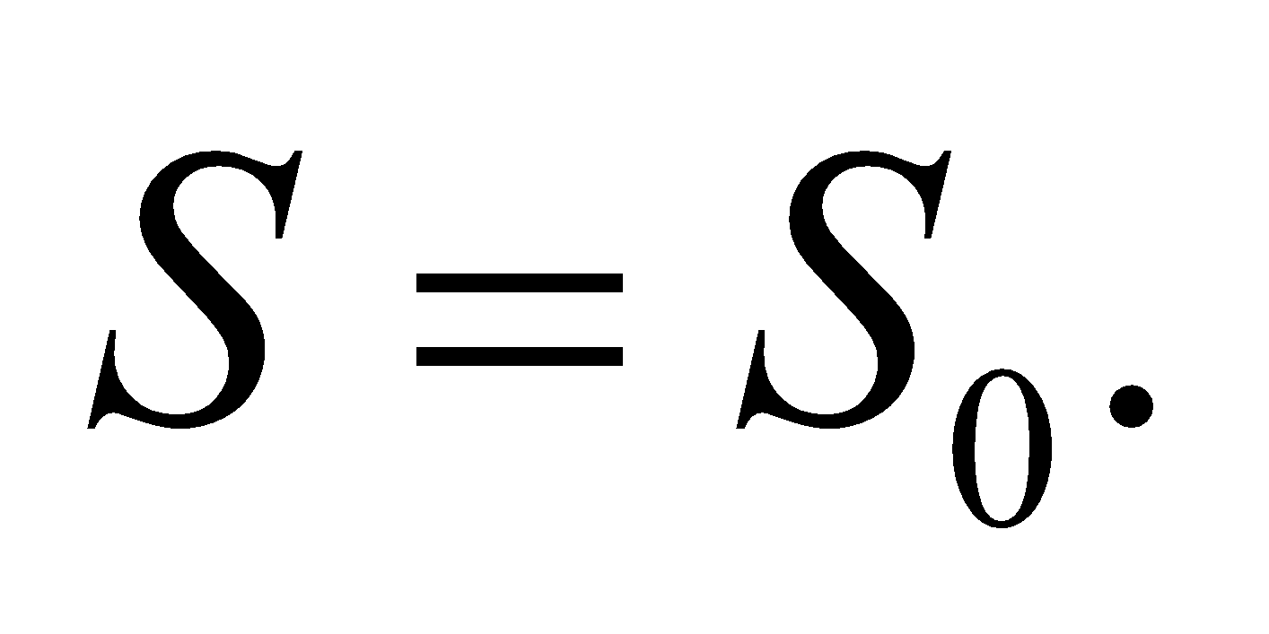 On the other hand, when θ = 90°, essentially no light passes through the polarizer.
Section 29.8 Energy and Momentum in Electromagnetic Waves
28. Interpret We are to find the intensity of an electromagnetic wave given the strength of its maximum electric field.
Develop Apply Equation 29.20b, 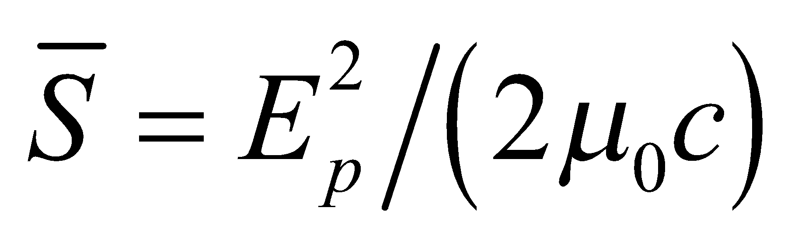.
Evaluate The intensity is
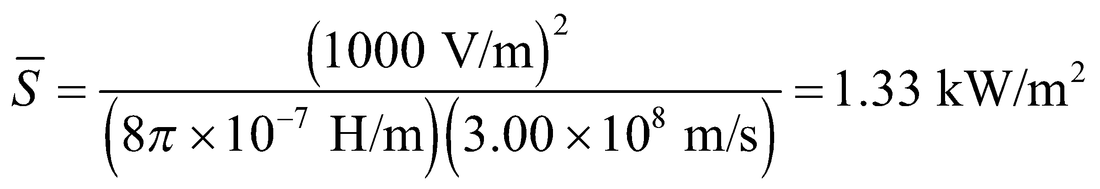
Assess This is comparable to the average solar intensity at the surface of the Earth, which is about 1370 W/m².
29. Interpret This problem explores the average intensity of a laser beam required for dielectric breakdown in air.
Develop The average intensity of an electromagnetic wave is given by Equation 29.20:
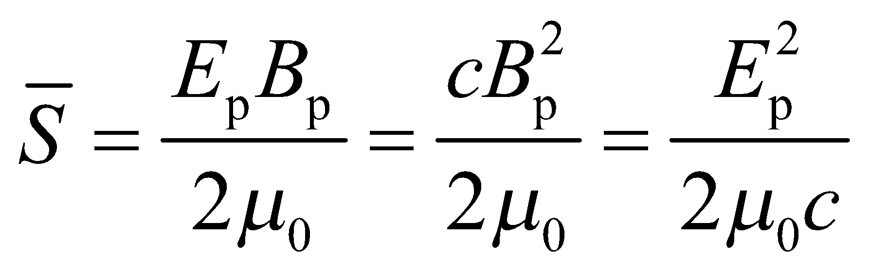
Evaluate With 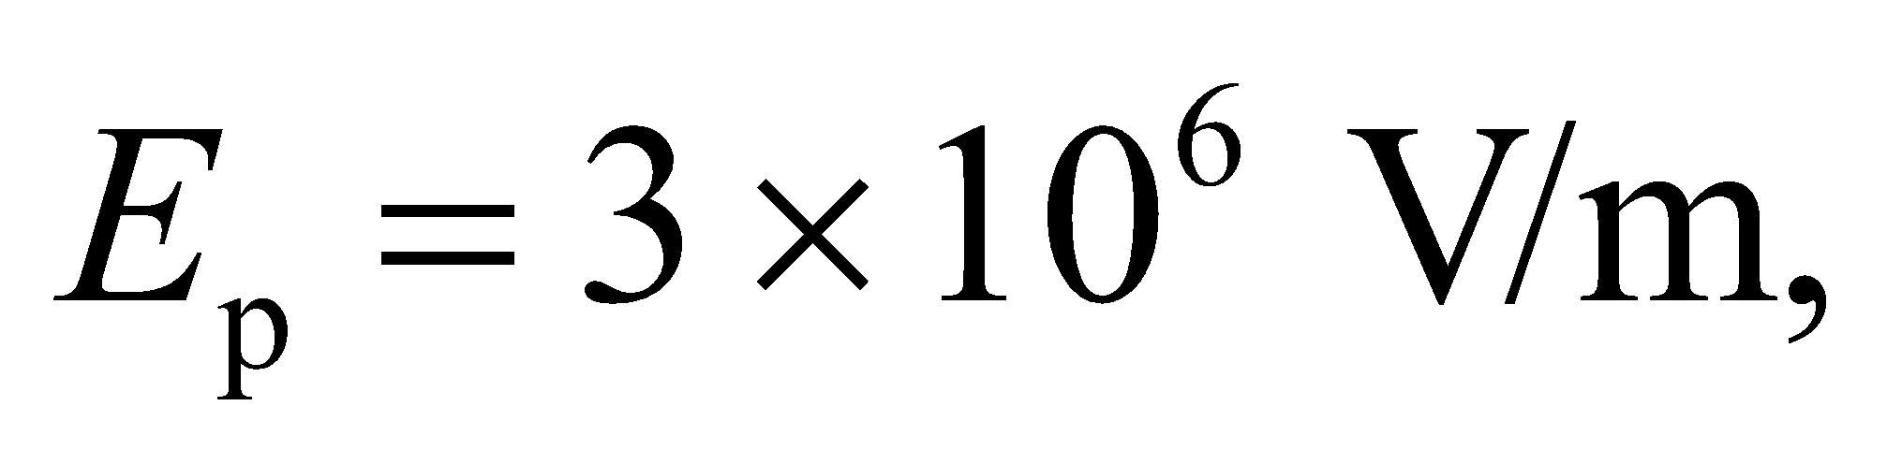 the average intensity is
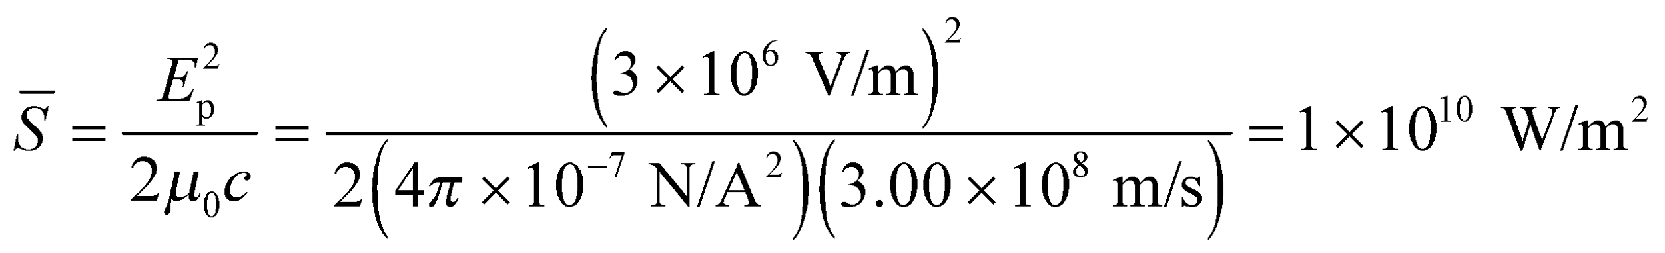
Assess We need a very powerful laser to produce the breakdown field strength. The laser intensity can be compared to the average solar intensity which is about 1370 W/m².
30. Interpret We’re asked to calculate the electric field inside a microwave oven of a given power.
Develop If we assume the microwaves travel through the oven as plane waves, then the average intensity is related to the power by 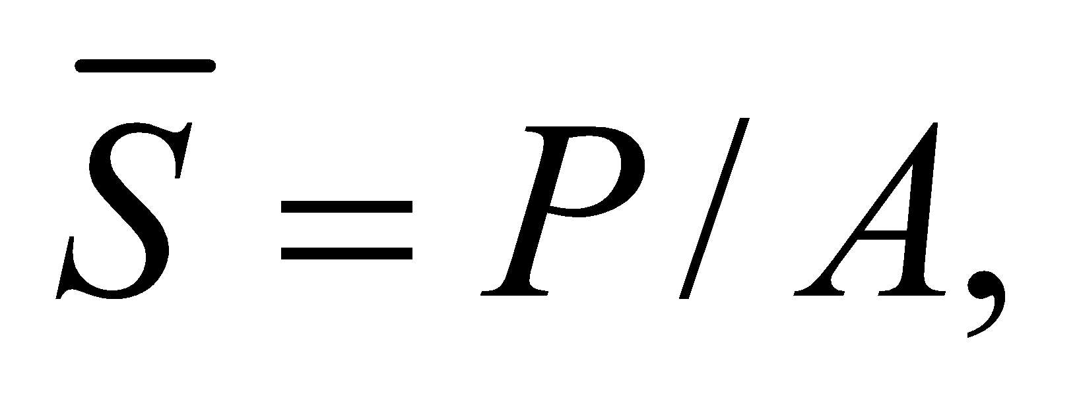 where A is the cross-sectional area of the oven. The average intensity is proportional to the square of the peak electric field in the light (Equation 29.20b): 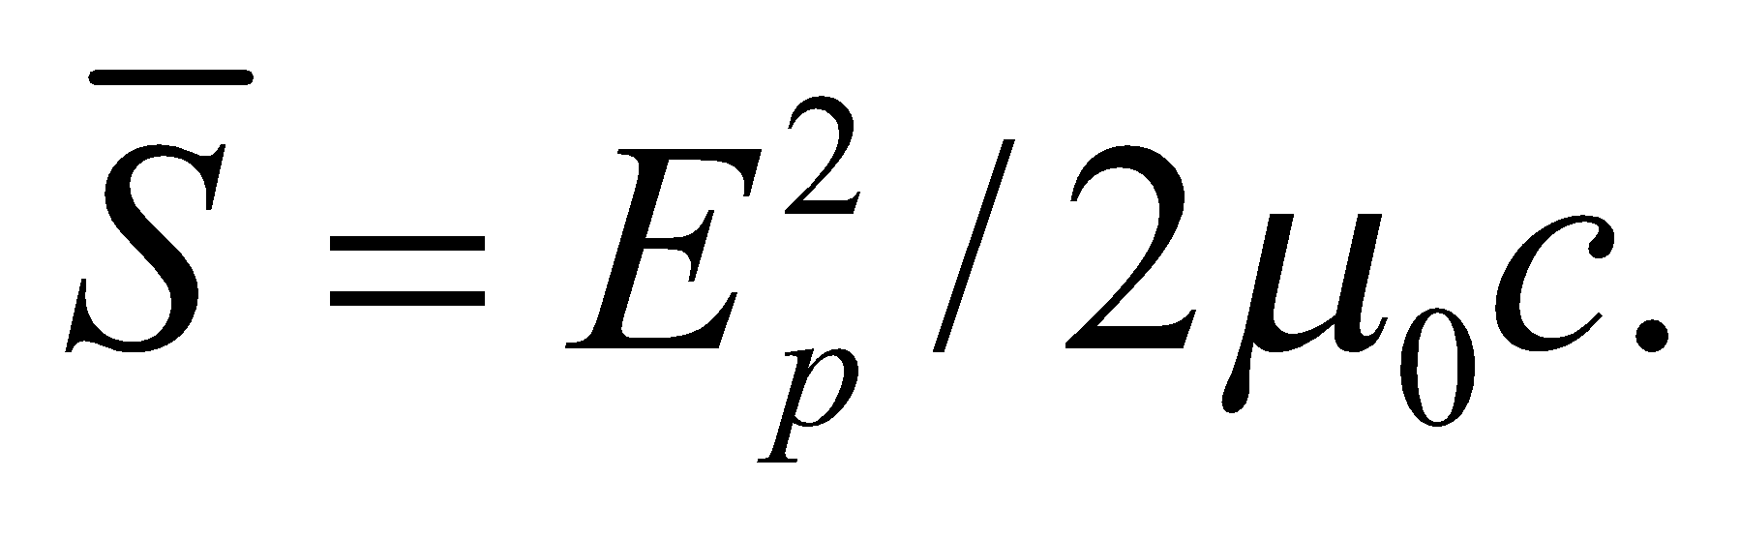
Evaluate Equating the two intensity equations from above, we can solve for the peak electric field:
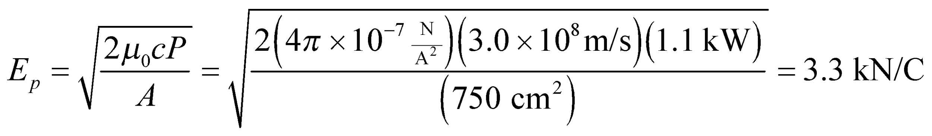
Assess The answer can also be written as 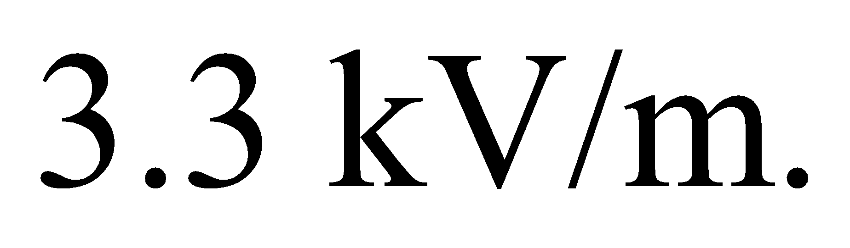This is almost 4 times the peak electric field of sunlight hitting the Earth’s surface (recall Example 29.3).
31. Interpret You want to know if your new radio can pick up a signal from a remote location.
Develop Given the minimum electric field that the radio can pick up, the minimum intensity is 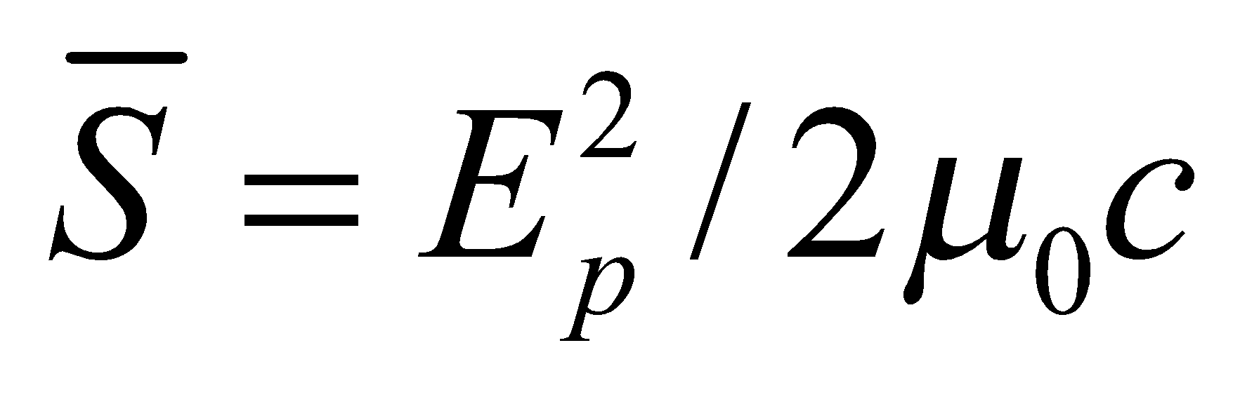 (Equation 29.20b).
Evaluate The radio’s intensity threshold is
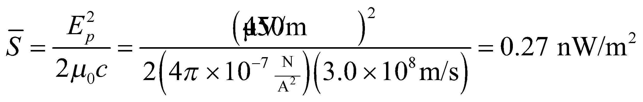
This means you will be able to hear your favorite station at your remote cabin.
Assess The minimum detectable signal for a radio or other receiver is usually set by the background noise. A radio station’s signal has to be significantly more powerful than stray electromagnetic waves that contribute to the "static" we hear between stations.
32. Interpret This problem involves finding the average intensity and the peak electric and magnetic field for the given laser pointer.
Develop The average intensity is the power per unit area, so we need only divide the given power by the given area. To find the electric and magnetic fields, apply Equations 29.20b and 29.17, respectively.
Evaluate (a) The average intensity is
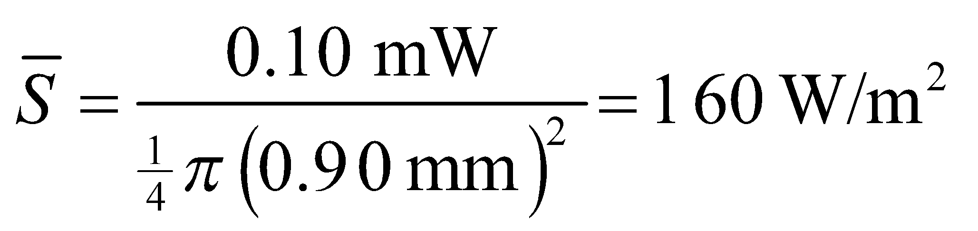
(b) Equation 29.20b gives and
(c) Equation 29.17 gives
Assess This average intensity is much less than that of the Sun’s radiation at the surface of the Earth.
33. Interpret You want to double the range of your radio station’s antenna.
Develop Listeners at a distance of 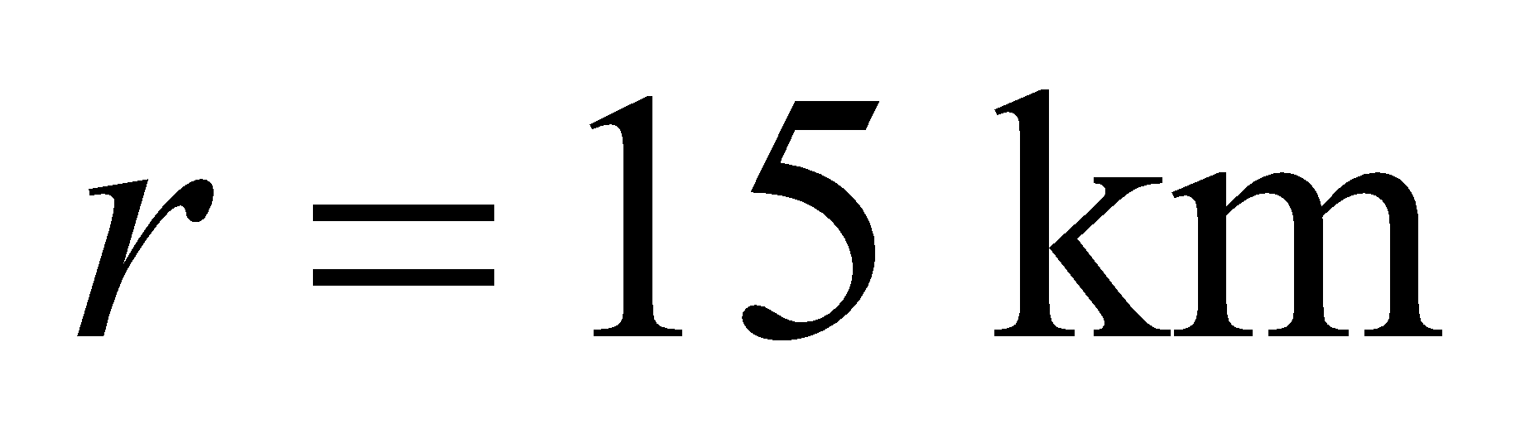 from the antenna can pick up your radio station because the intensity, S, inside this perimeter is above a typical radio receiver’s threshold. You want to increase the power so that the intensity at 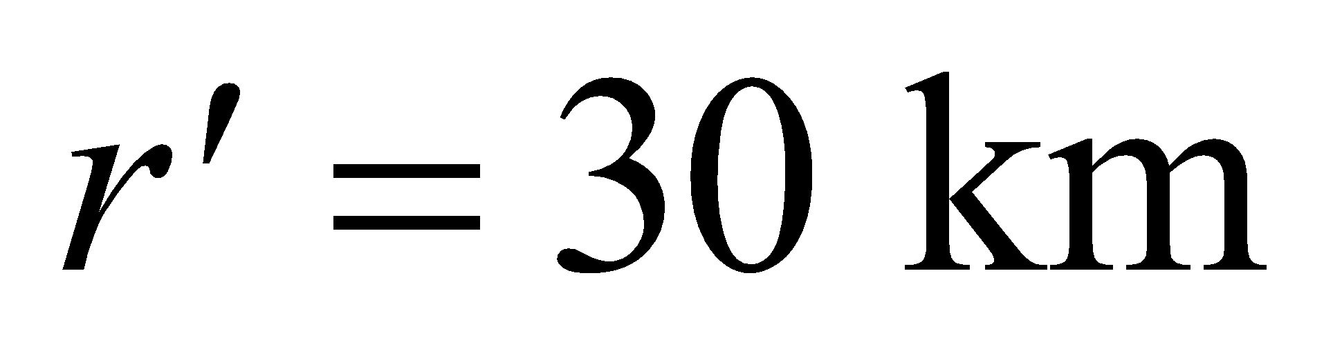is above threshold. The relation between intensity and power is given in Equation 29.21: 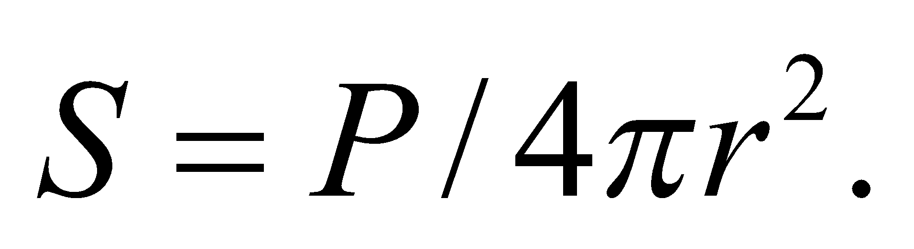
Evaluate The required power for doubling the range is
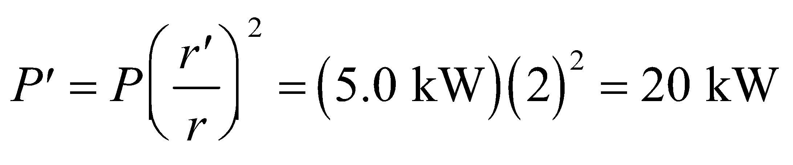
Assess We have assumed that the signal from the antenna radiates uniformly out in all directions, but that is not always the case. Some antennas focus their intensity in particular directions. However, no matter what the radiation pattern from the antenna, the power will have to be quadrupled to double the range in a given direction.
Problems
34. Interpret This problem involves applying Gauss’s law to find the magnetic field induced by a changing electric field in a circular parallel-plate capacitor. The symmetry involved is cylindrical symmetry, so the magnetic field will be constant at a given distance from the axis of the circular capacitor plates and in the plane of the plates.
Develop Cylindrical symmetry and Gauss’s law for magnetism require that the 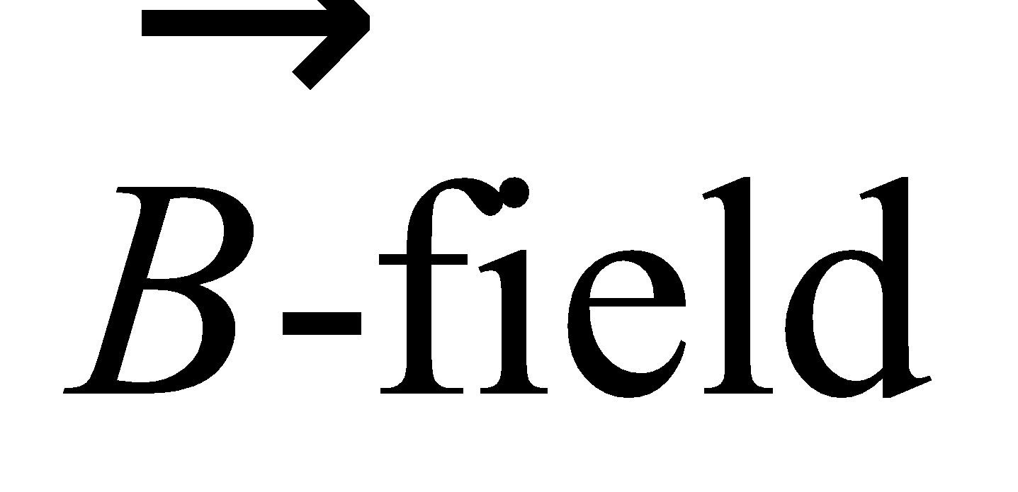 lines be circles around the symmetry axis. For a radius r less than the radius R of the plates, the displacement current is
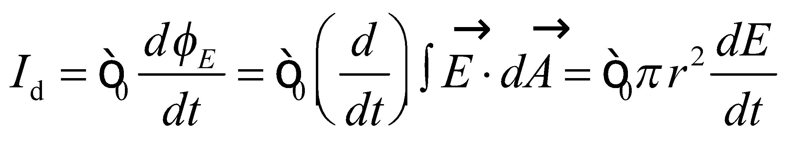
where the integral is over a disk of radius r centered between the plates. Maxwell’s form of Ampère’s law gives
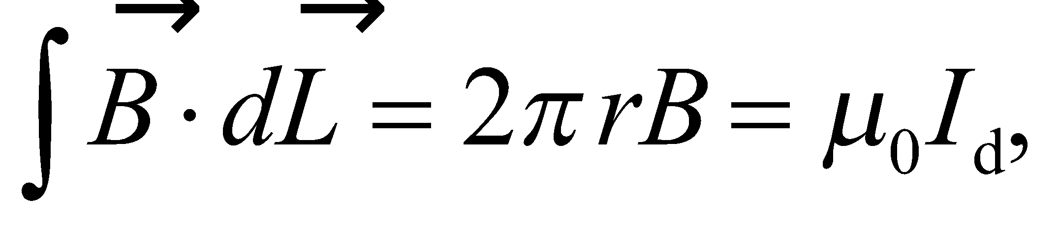
where the line integral is around the circumference of the disk. Thus,
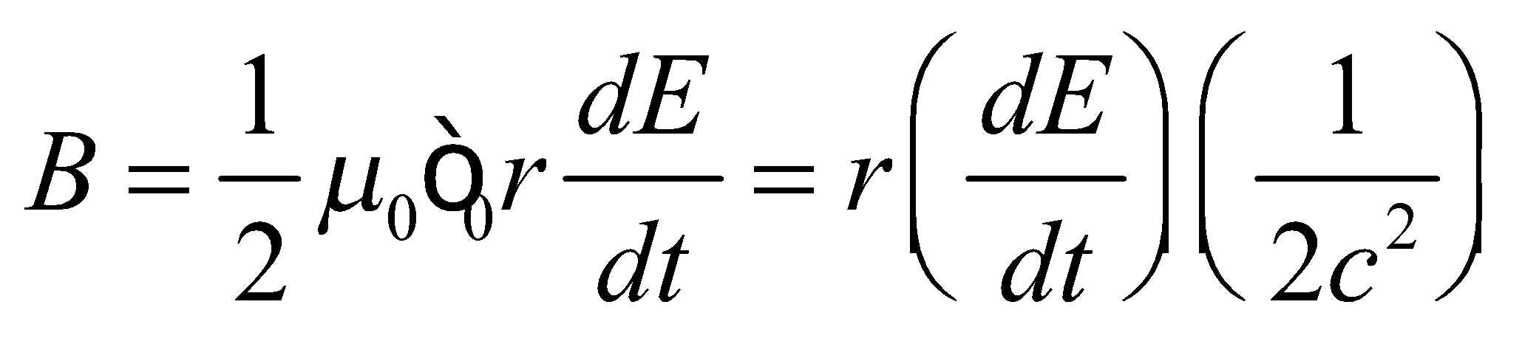
where c is the speed of light (Equation 29.16a).
Evaluate (a) On the symmetry axis, r = 0, so B = 0.
(b) For 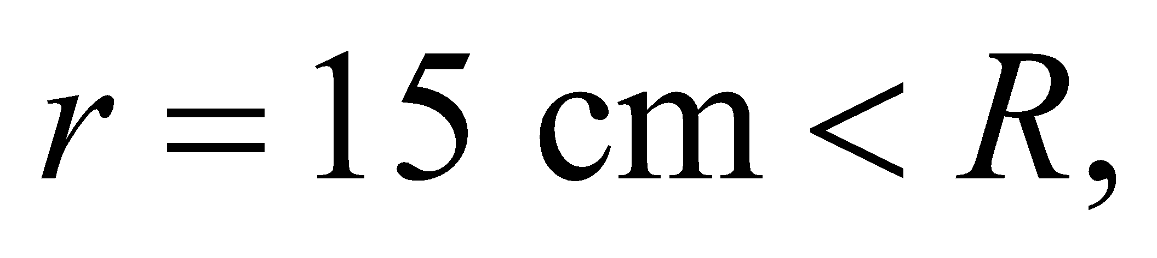
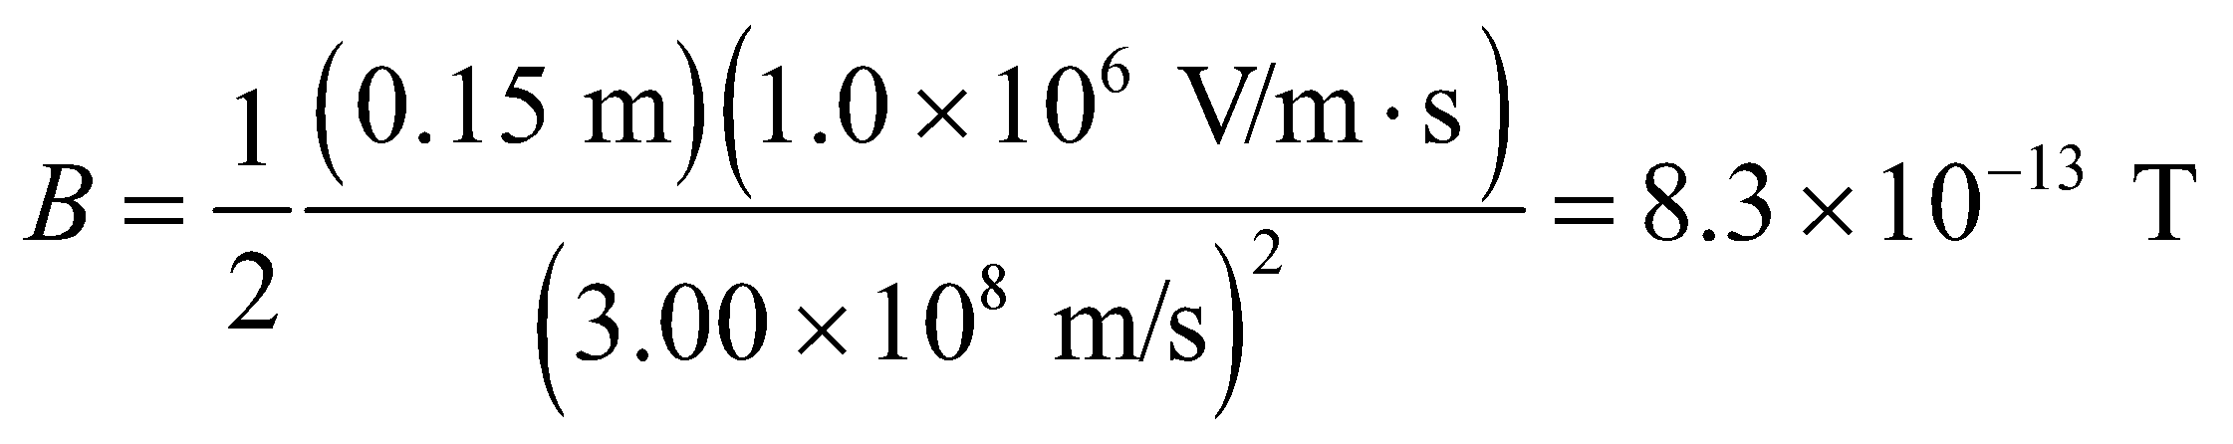
(c) For 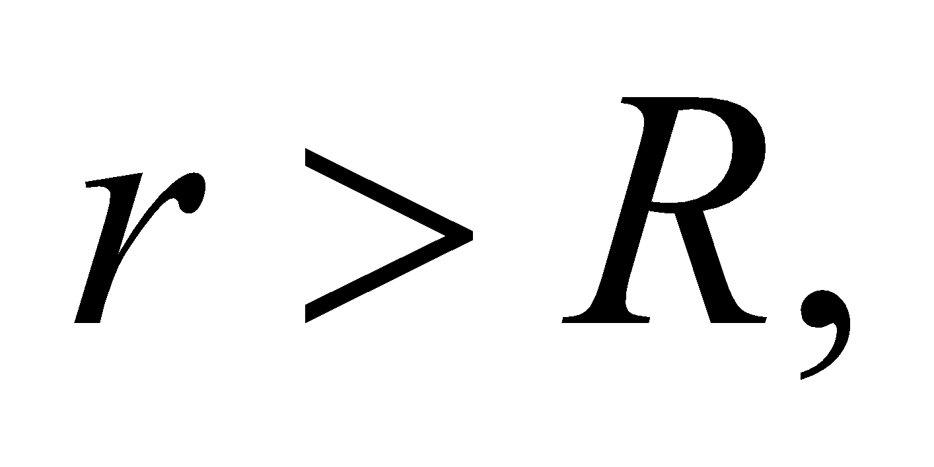 the displacement current is
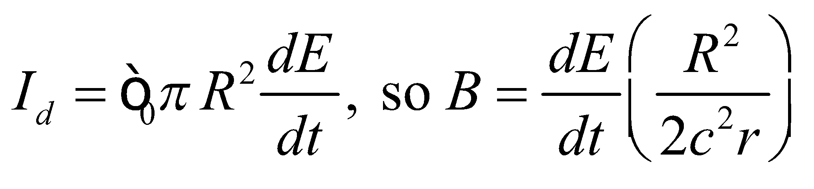
At r = 150 cm,
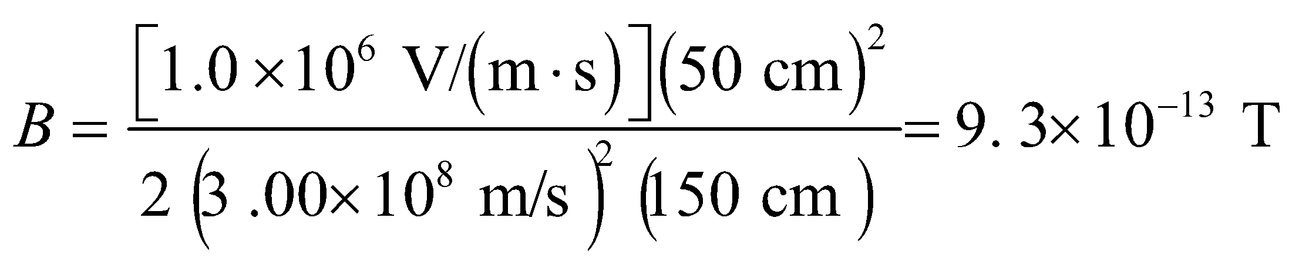
Assess The magnetic field strength increases from r = 0 to r = R, then decreases beyond r = R.
35. Interpret This problem is about the rate of change of electric field, which induces a magnetic field. Given the magnetic field strength at 50 cm from the center, we are to find the rate of change of the electric field and whether it is increasing or decreasing.
Develop The electric and magnetic fields are related by Equation 29.1. If we evaluate the integrals around the circular field line of radius r shown in Figure 29.15, and the plane area it bounds, we obtain:
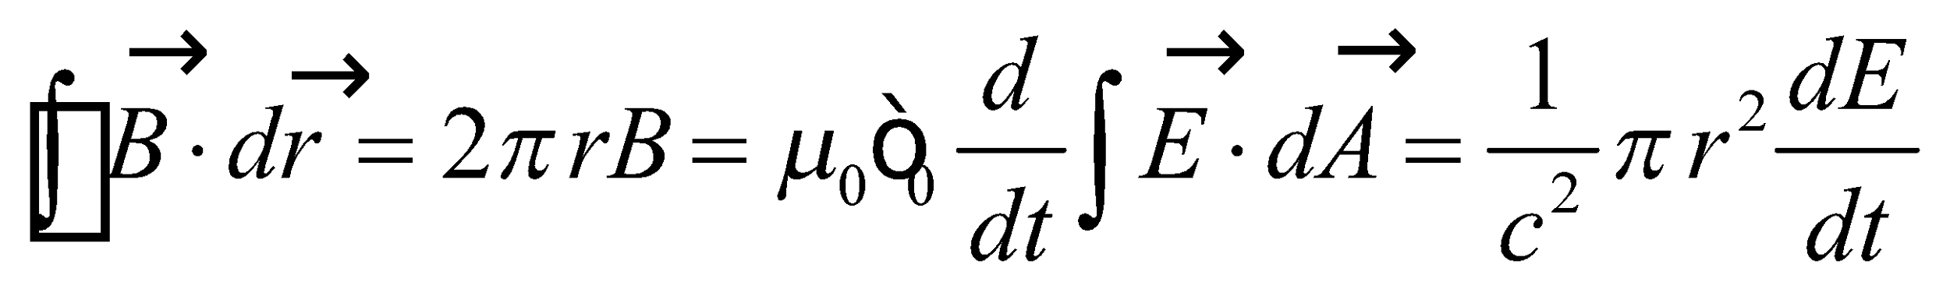
where we have used 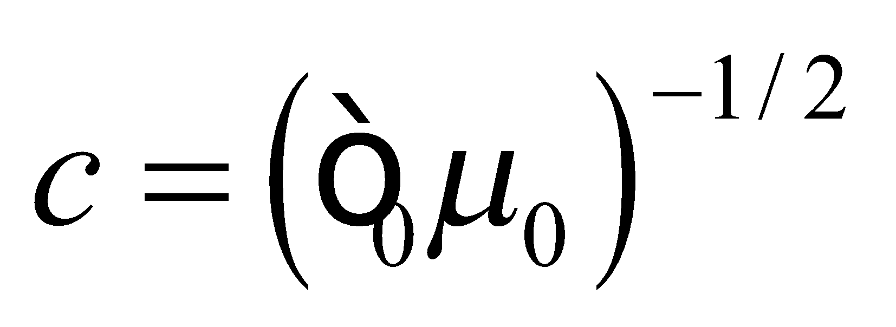
Evaluate (a) Thus, the rate of change of electric field is
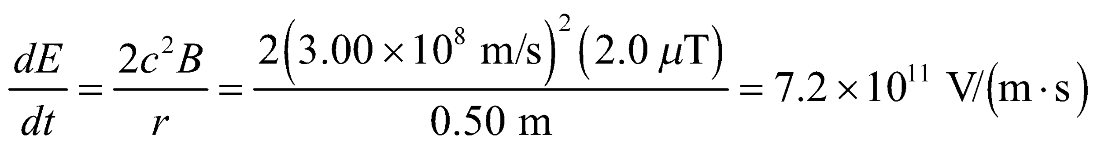
(b) A circulation of clockwise around the circle gives a positive displacement current into the page, so is increasing in this direction.
Assess Any change in electric flux results in a displacement current that produces a magnetic field. The displacement current encircled by the loop of radius r = 0.5 m is
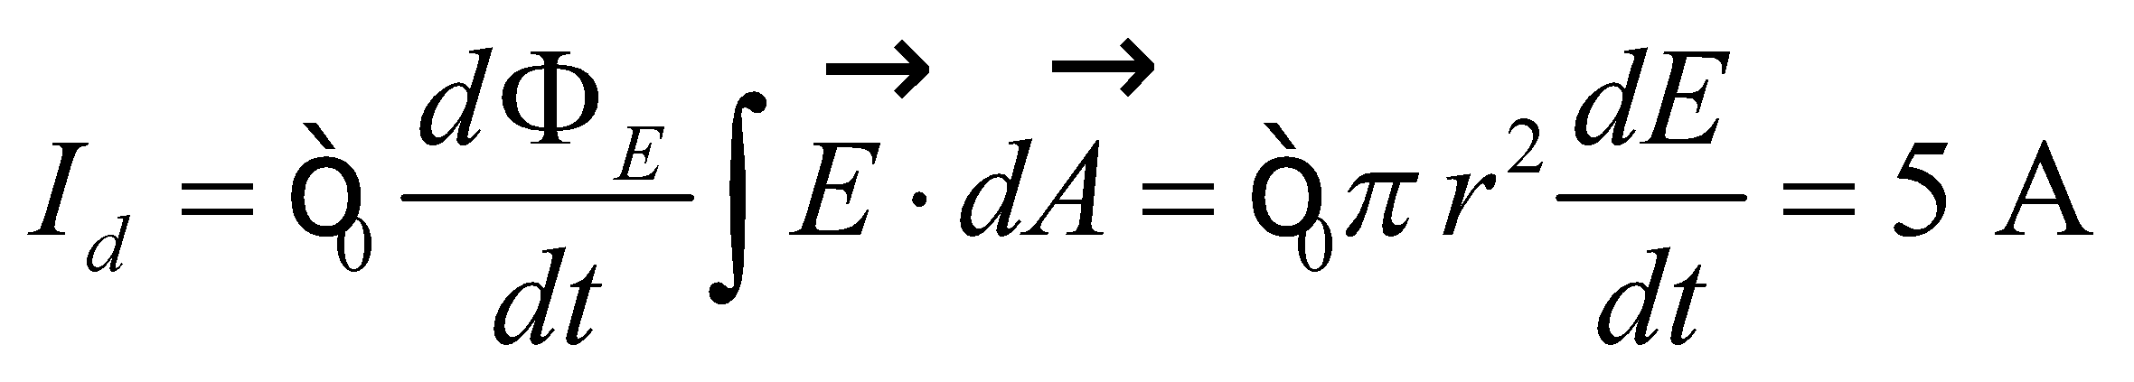
This is precisely the current a long wire must carry in order to produce the same magnetic field strength at a distance r = 0.5 m from its center.
36. Interpret You want to see if a new cell phone you are designing has enough room to incorporate all of its antenna.
Develop The proposed antenna will need a length of 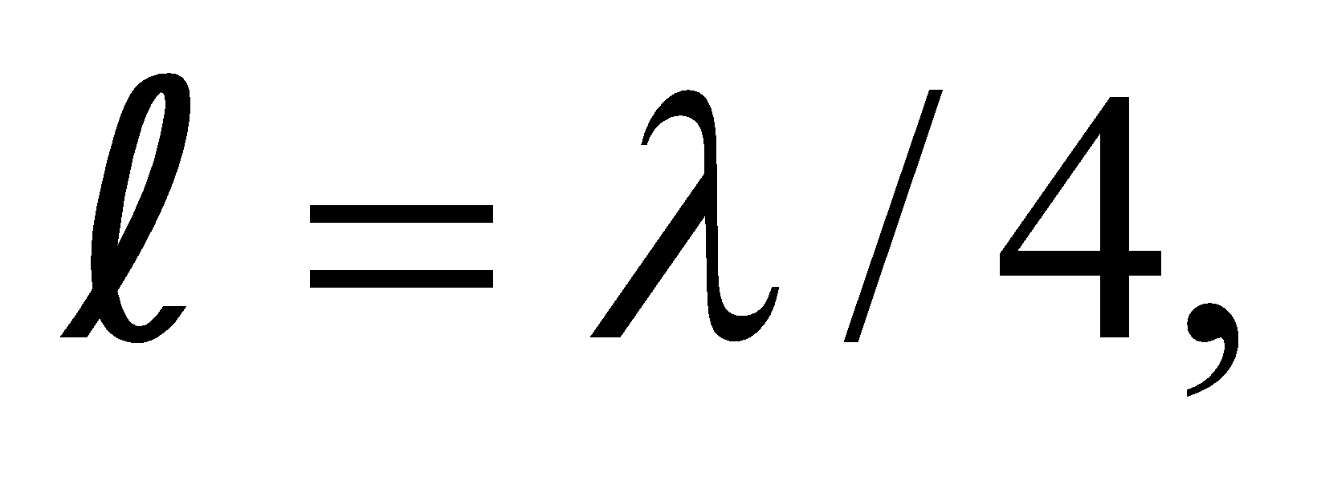where the wavelength corresponds to the signal frequency, 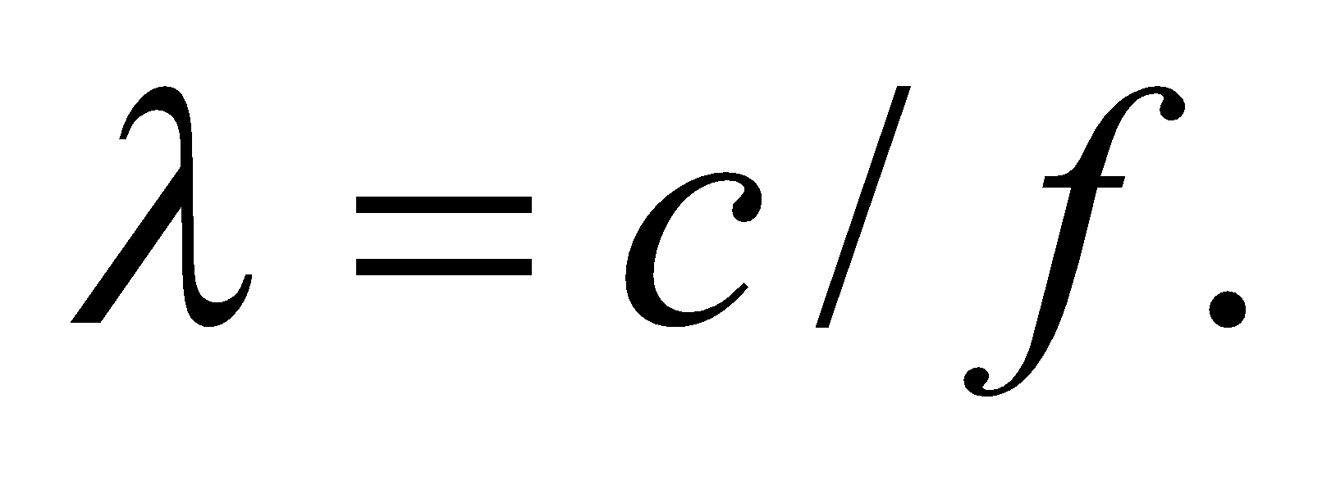
Evaluate The antenna’s length is
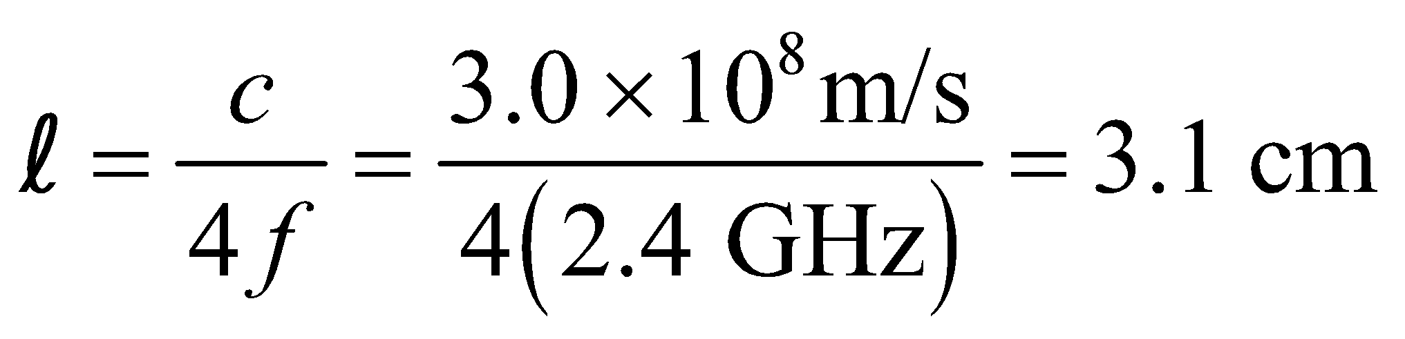
This means there’s plenty of room in the 9-cm cell phone for the quarter-wavelength antenna.
Assess There’s even enough room for an antenna that is half a wavelength long. Choosing quarter- or half-wavelength antennas makes tuning easier, since the resonant frequency of the antenna will be some integer fraction of the cell phone frequency.
37. Interpret The problem simply asks what frequencies correspond to the UVB wavelength range.
Develop The frequency is inversely proportional to the wavelength: 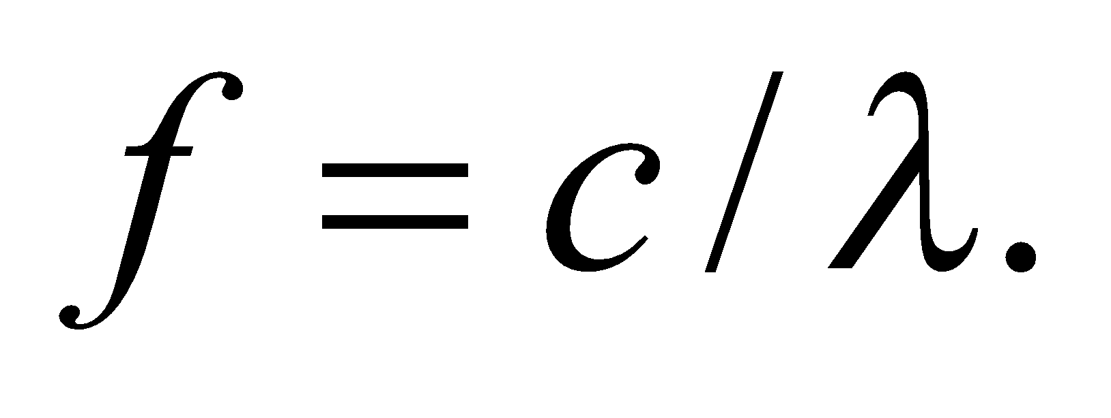
Evaluate The limits of the UVB band in frequency are
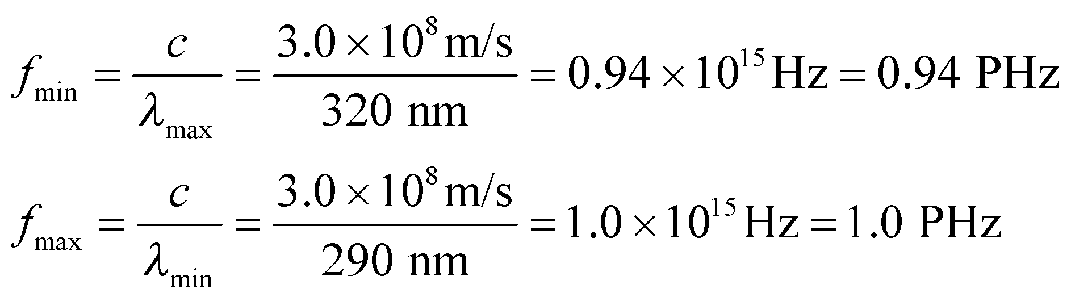
Assess Since most people are more familiar with nanometers than with petahertz, the wavelength limits for UV radiation are more often given than the frequency limits.
38. Interpret We are to find the magnetic field strength of an electromagnetic wave that produces dielectric breakdown in air.
Develop Treating electromagnetic waves in air approximately like those in vacuum, we can apply Equation 29.17, 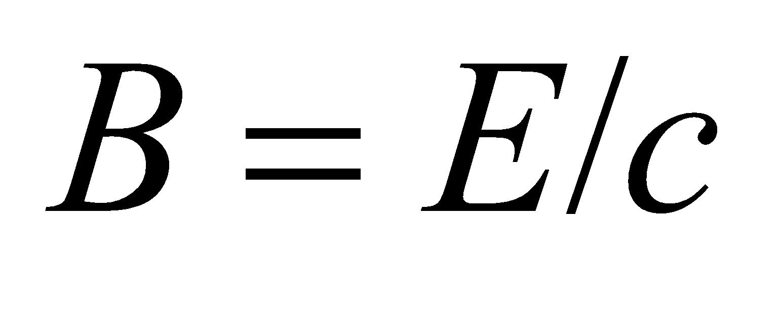 to find the magnetic field strength associated with an electric field strength of 3 MV/m.
Evaluate The magnetic field strength is approximately
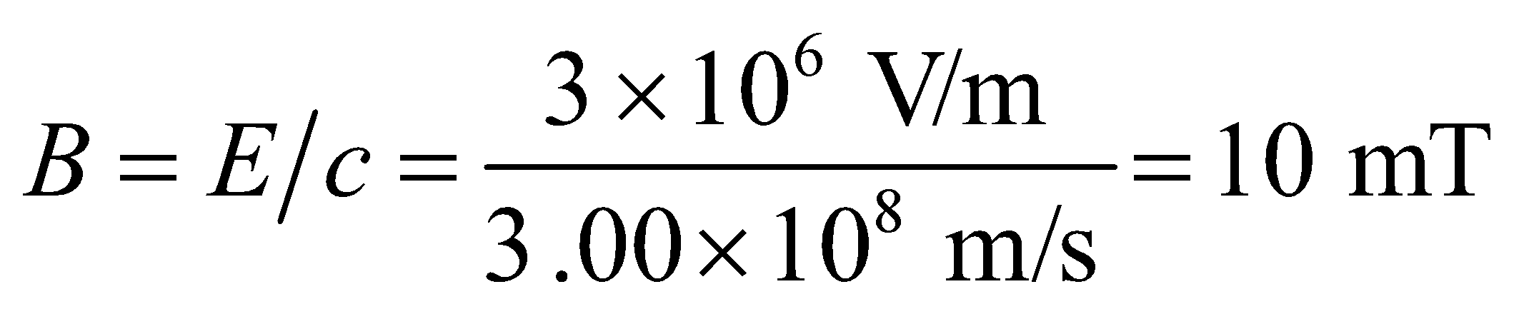
Assess This is some three orders of magnitude larger than the strength of the magnetic field at the surface of the Earth, which ranges from 30 to 60 μT.
39. Interpret Given the electric field strength, we are asked to find the corresponding magnetic field strength for an electromagnetic wave propagating in air, which we can treat as a vacuum.
Develop For an EM wave in free space, Equation 29.17 gives 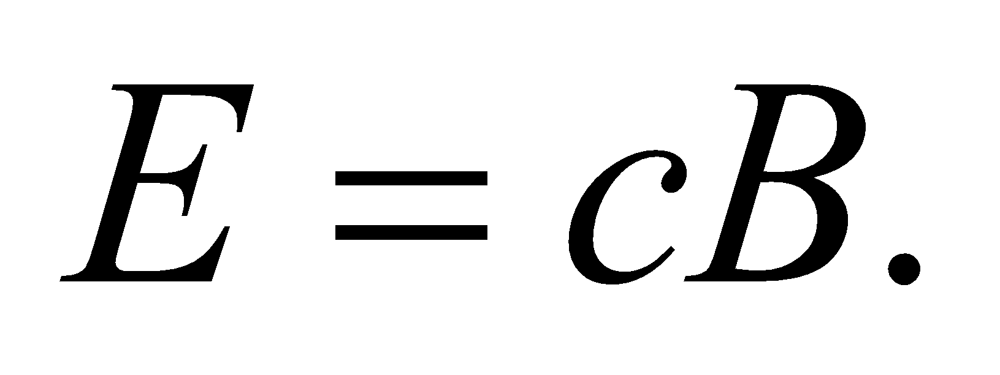
Evaluate Given that 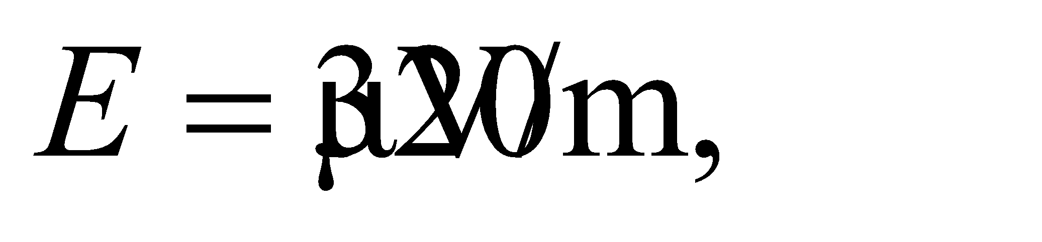 the corresponding magnetic field strength is
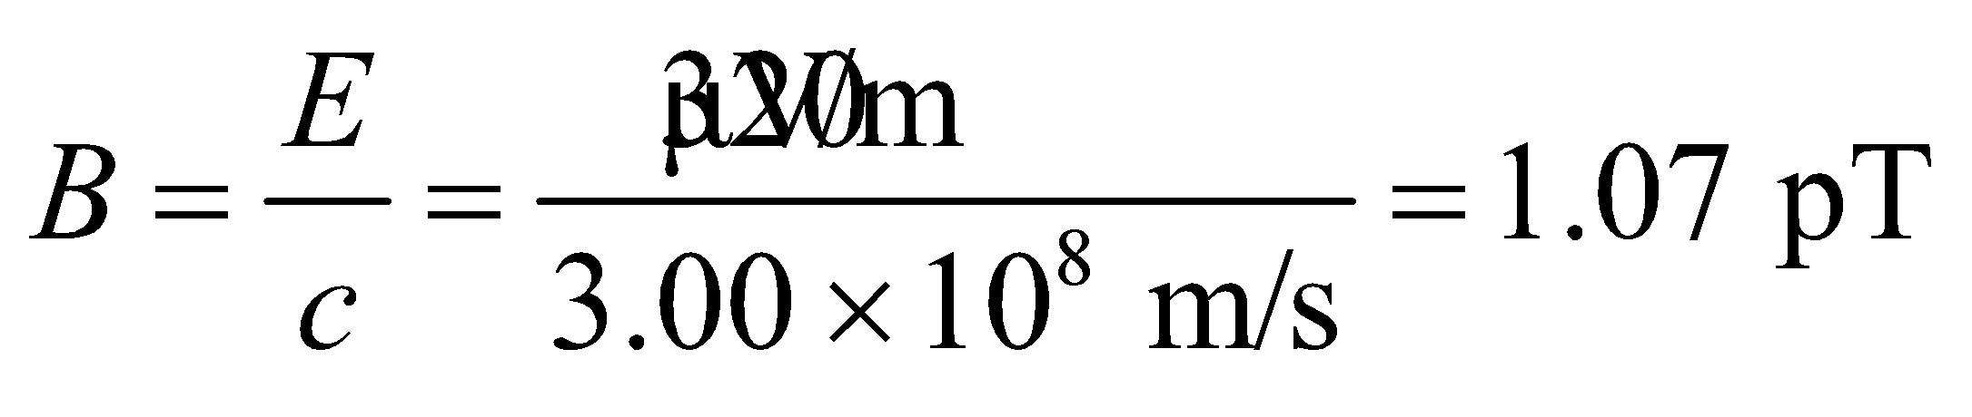
Assess This is a very small magnetic field. Note that in an EM wave, both the field strengths E and B are not independent; once one quantity is determined, the other can be found via the relation
40. Interpret We are to find the angle between a polarizer’s axis and the polarization direction of an electromagnetic wave given that the polarizer blocks 75% of the wave.
Develop Apply the Law of Malus (Equation 29.18).
Evaluate Equation 29.18 gives
Assess The angle must be between 0 and π/2.
41. Interpret This problem involves finding the fraction of light transmitted through a polarizer as the direction of the incident polarization changes.
Develop The fraction of light transmitted can be found by using the Law of Malus (Equation 29.18), where θ is the angle between the polarization direction (i.e. the direction of the electric field) in the electromagnetic wave and the polarization direction of the polarizer. Note that, with zero voltage applied, the laser beam polarization is perpendicular to the polarizer, so zero light is transmitted. During the brown out, the electro-optic modulator manages to rotate the polarization 72°, which is 18° short of the 90° rotation needed to pass 100% of the laser light through the polarizer. In the Law of Malus, the angle θ measures the angular departure from parallel alignment (i.e., when there is 100% transmission), so we must use θ = 18° in our calculation.
Evaluate From Equation 29.18, we find that 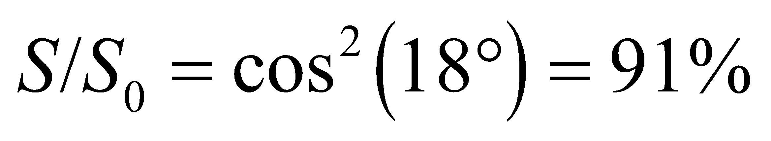 is transmitted.
Assess The intensity of the laser beam depends on The limit θ = 0 corresponds to the situation where the direction of polarization of the laser beam is the same as the preferred direction specified by the polarizer, and
42. Interpret We are to find the intensity of an initially unpolarized light beam after it passes through two linear polarizers oriented at the given angle.
Develop Only 50% (one half the intensity) of the unpolarized light is transmitted through the first polarizer, and the second cuts this down by 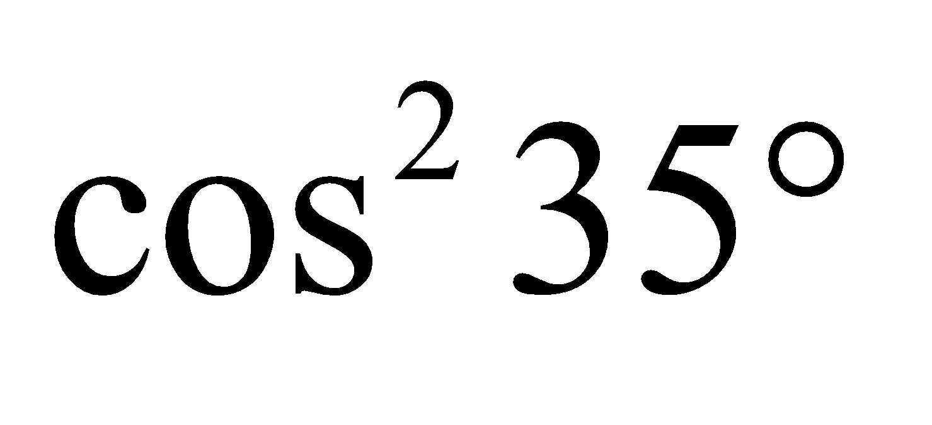 (Law of Malus, Equation 29.18).
Evaluate Therefore 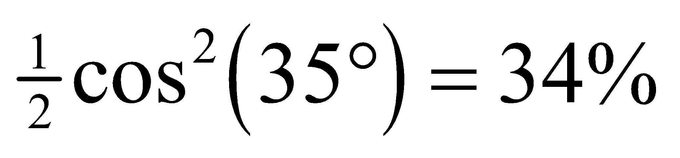 of the unpolarized intensity gets through both polarizers.
Assess Most of the intensity is lost transiting the first polarizer.
43. Interpret We are to find the intensity of a light beam after passing through two polarizers that are oriented at different angles to the polarization direction of the light. Note that the second polarizer is oriented perpendicular to the initial polarization, so we may expect that no light is trasmitted.
Develop The intensity of the light after emerging from the first polarizer is given by the Law of Malus (Equation 29.18), 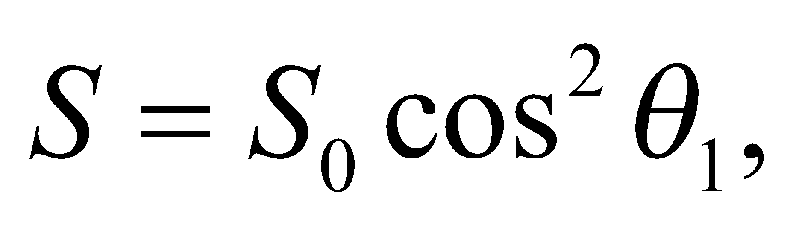 where θ₁ is the angle between the electric field and the first polarizer’s axis. After passing through the first polarizer, the electric field is rotated to the angle θ1 and so makes an angle θ₂ – θ₁ with the axis of the second polarizer. Thus, the intensity of the light transmitted through both polarizers is
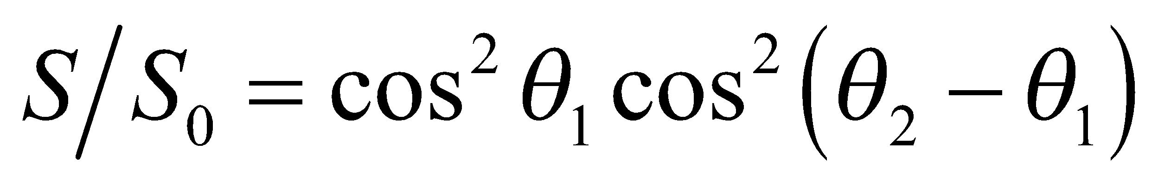
Evaluate Two successive applications of Equation 29.18 yield
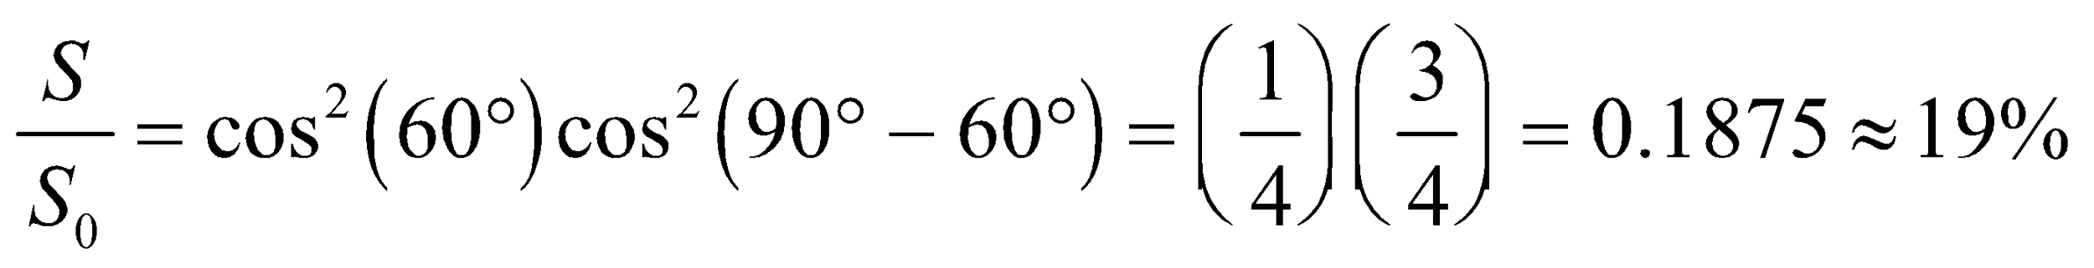
Assess To see that the result makes sense, let’s solve the problem in two steps. The intensity of the beam after passing the first polarizer with 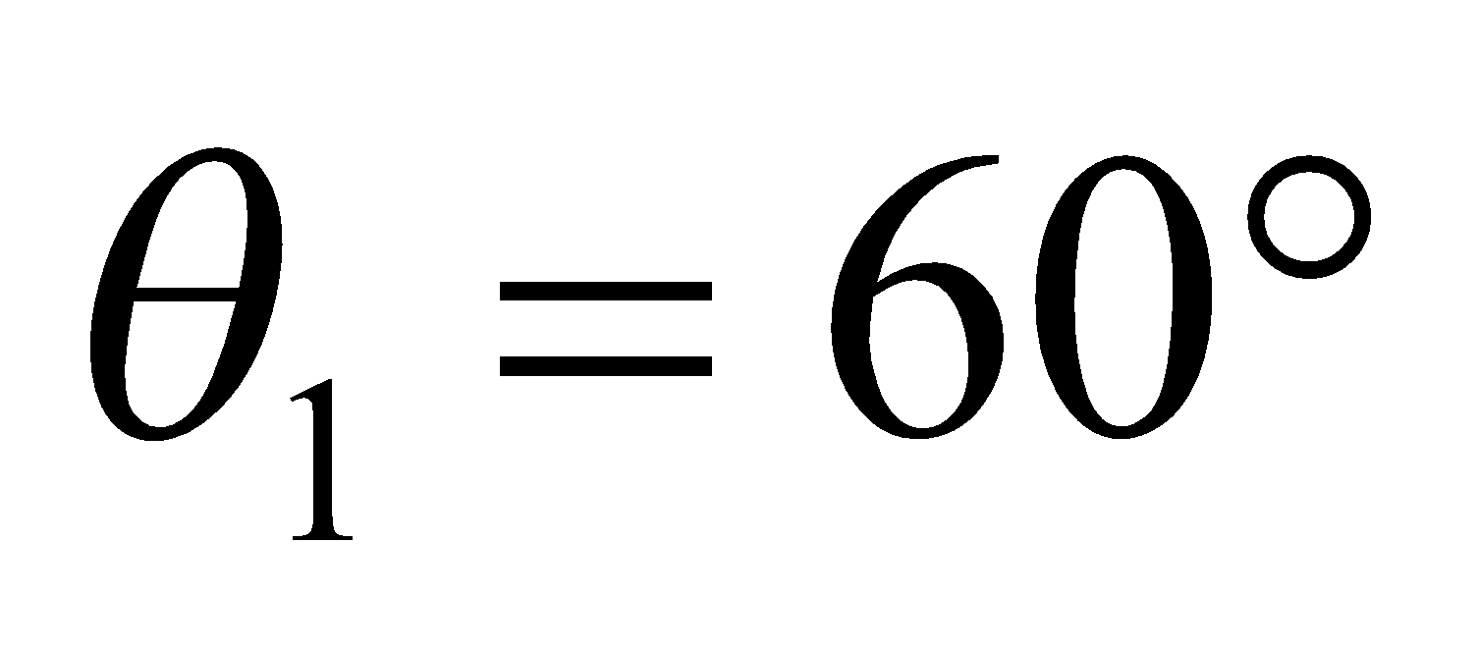 is 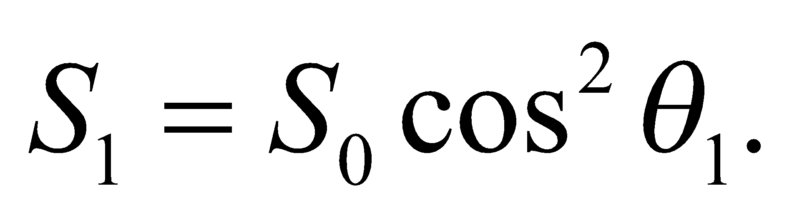 Since the angle between the first and the second polarizers is 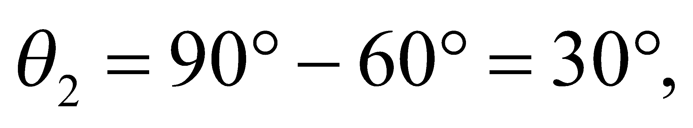 so upon emerging from the second polarizer, the intensity becomes
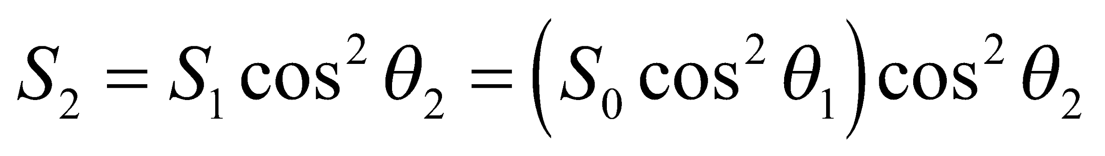
which is the same as above.
44. Interpret We are to use Gauss’s law and Faraday’s law to show that it is not possible for the electric field to have a time-varying component in the direction of the magnetic field.
Develop Consider a wave propagating in the x-direction through a vacuum (no charges or currents present), as illustrated in the figure below. Gauss’s laws for electricity and magnetism require the field lines to continue forever in the y-z plane (no E_{x} or B_{x}) because the integral on the right-hand side of Gauss’s laws (Equations 29.6 and 29.7) can be taken over any closed surface. We may choose the z-direction parallel to the magnetic field, 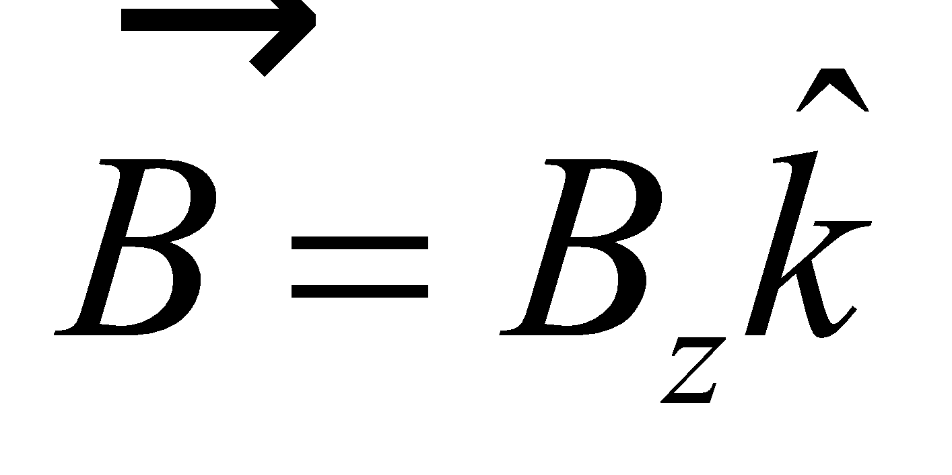. Suppose 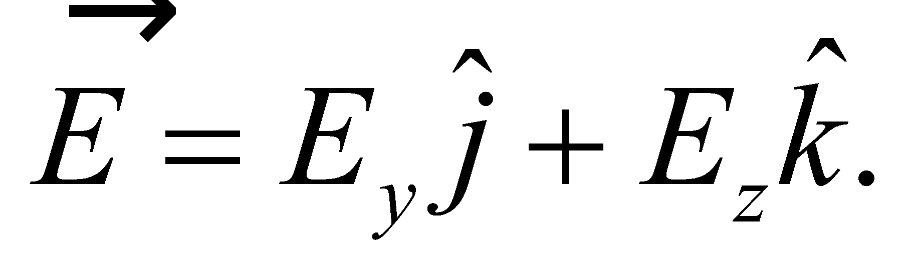 The discussion of Faraday’s law leading to Equation 29.12 shows that 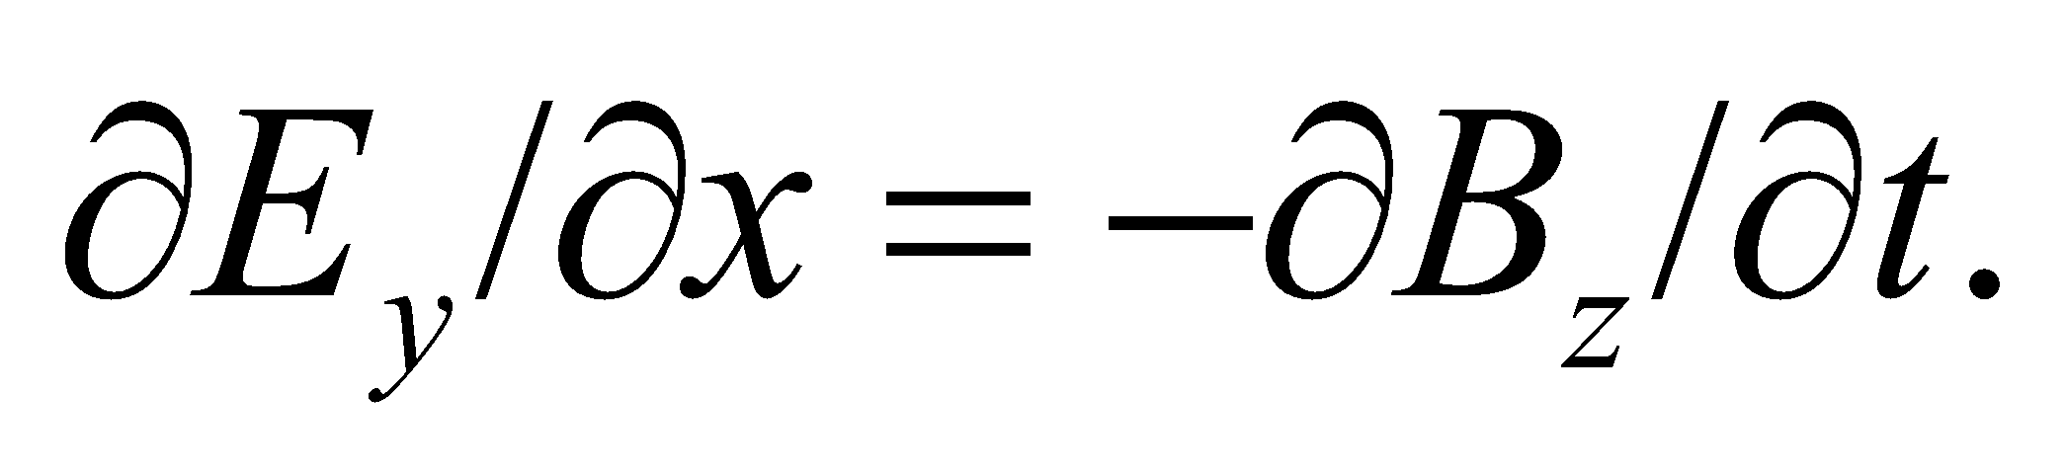

Evaluate Consider a corresponding loop in the x-z plane, as shown above. Then 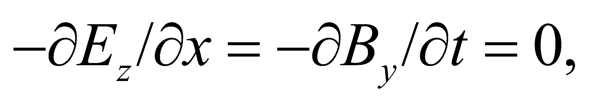 since there is no 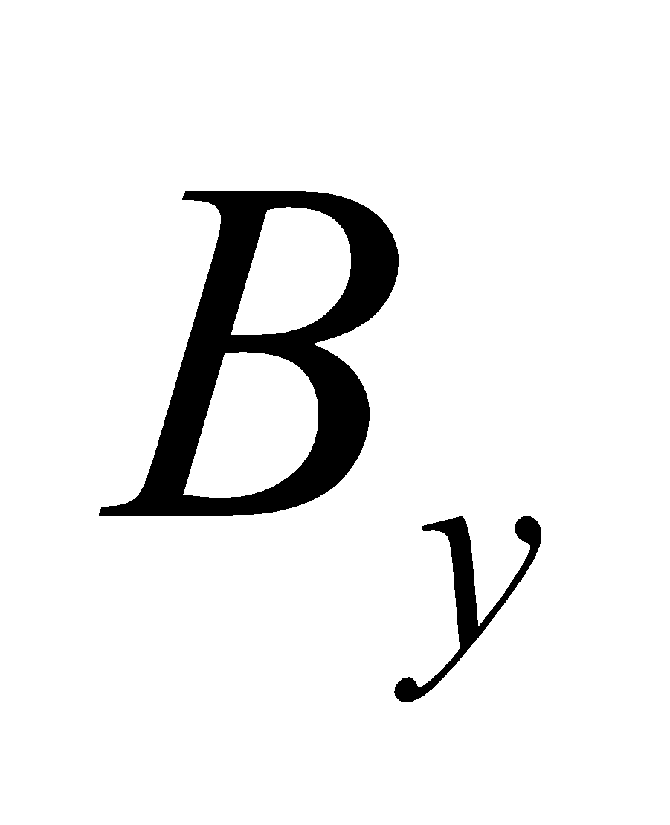 by assumption. Thus 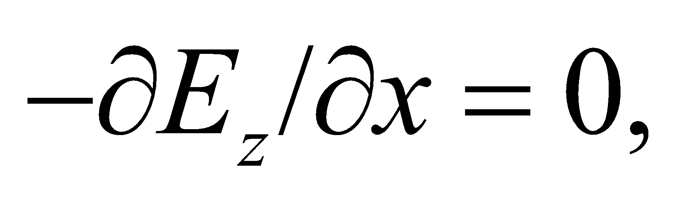 and E_{z} must be a constant, so it cannot be part of the wave.
Assess Similar consideration of Ampère’s law over the loop in the x-y plane gives 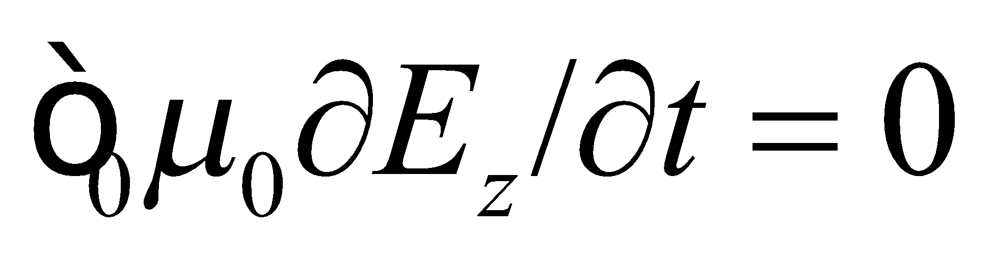 directly, with the same conclusion regarding 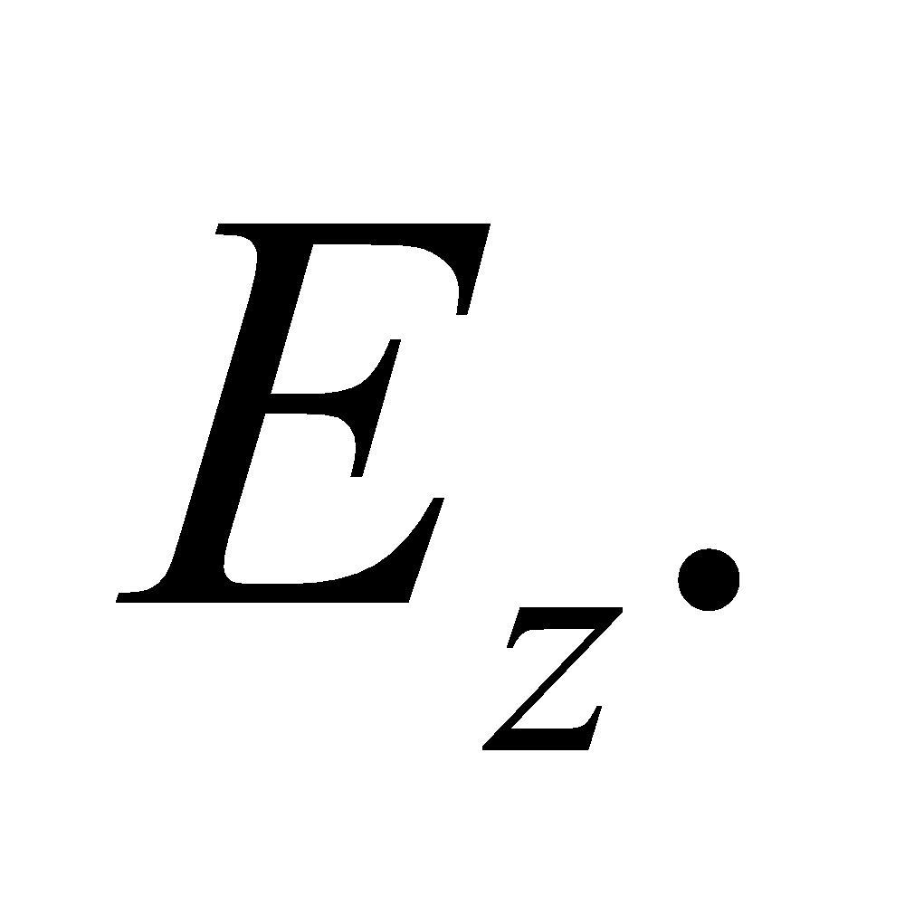
45. Interpret We want to determine how much of a microwave oven’s radiation can leak out its door and still be below regulation standards.
Develop If we assume power is leaking uniformly out the door, then the maximum power allowed is just the intensity limit multiplied by the area: 
Evaluate The fraction of power that is allowed to leak out the oven door is
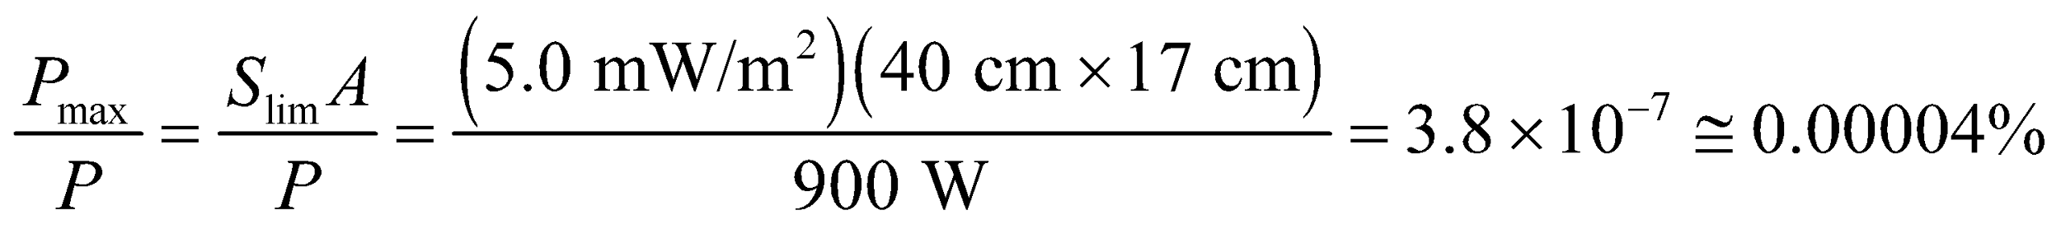
Assess This is less than one part in a million. It might be surprising, therefore, that a metal screen with holes in it could provide this good of protection. The holes in the metal are much smaller than the microwave wavelength 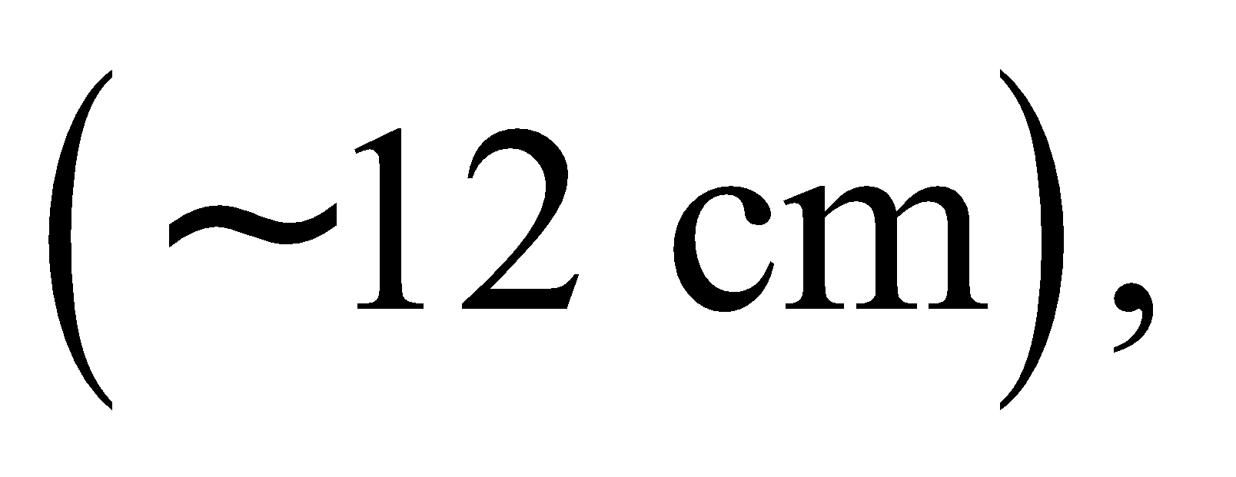 which means very little of the radiation can pass through.
46. Interpret From the astronomical data in Appendix E and the given intensity of the Sun’s radiation at the surface of the Earth, we are to estimate the Sun’s total power output.
Develop If the Sun emits isotropically, its power output is 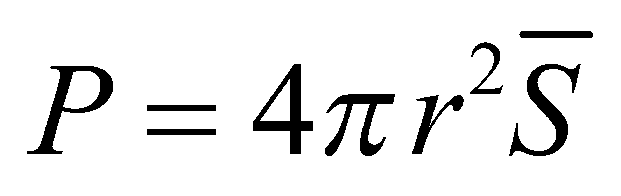 (from Equation 29.21). A sphere with a radius of one Earth orbit has a surface of 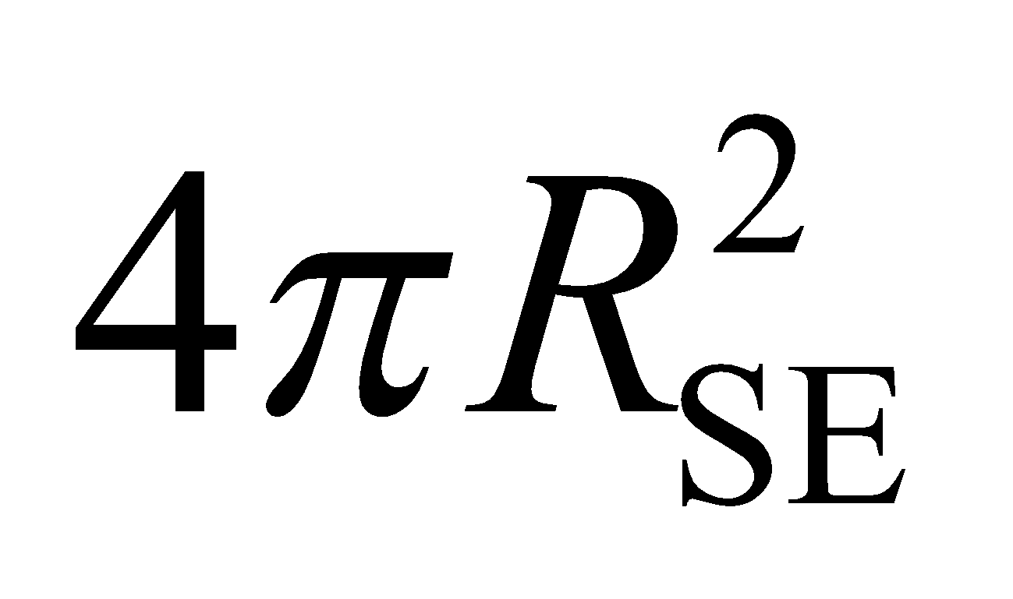, so the total power is the power P_{E} in one square meter multiplied by the total surface area of this sphere.
Evaluate The power output of the Sun is approximately
Assess This is a significant power output. Note that the condition that the Sun radiates isotropically becomes better for greater distances from the Sun (or from any source, for that matter).
47. Interpret The problem asks for a comparison of power output between a star and a quasar. The two objects have the same brightness but are at different distances from the Earth.
Develop The average intensity of radiation received determines the apparent brightness, so 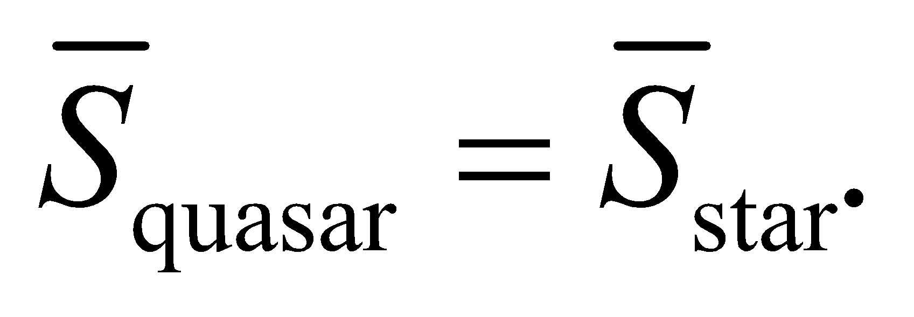 Apply Equation 29.21 to find the relative power from each source.
Evaluate From Equation 29.21, 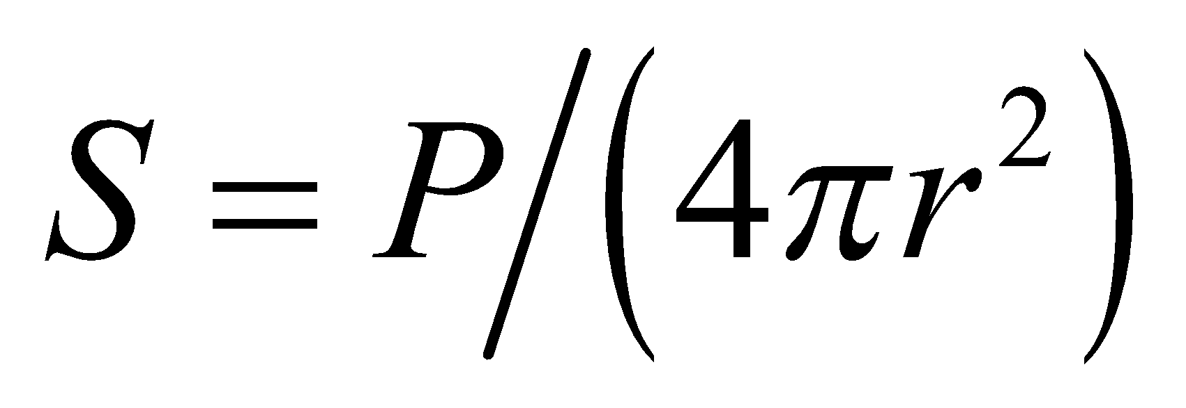 we see that the above condition implies that
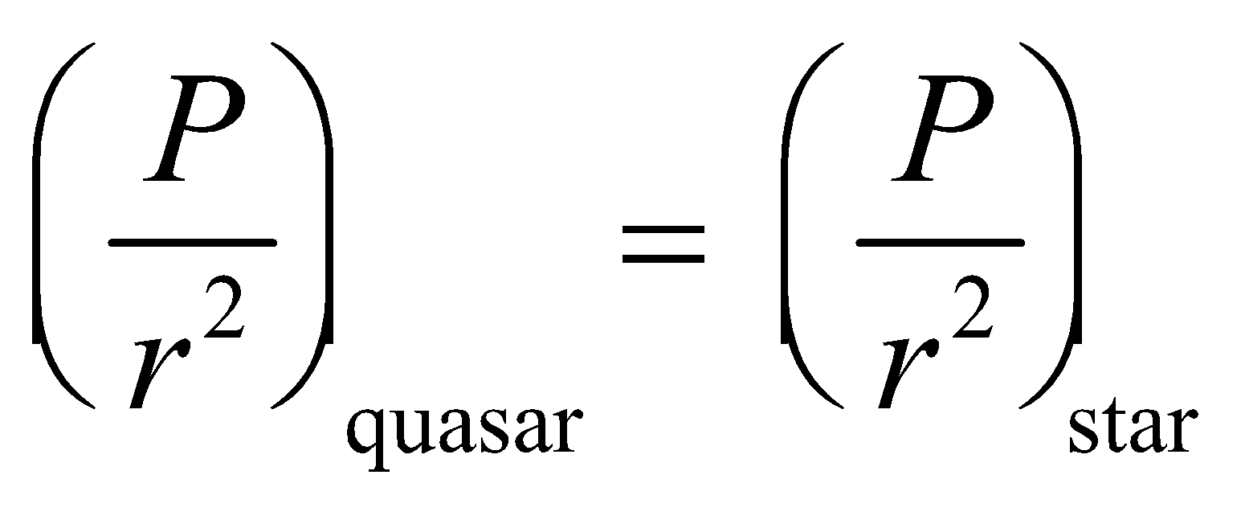
if both behave like isotropic sources (which should be a good approximation; see Problem 29.46). Thus,
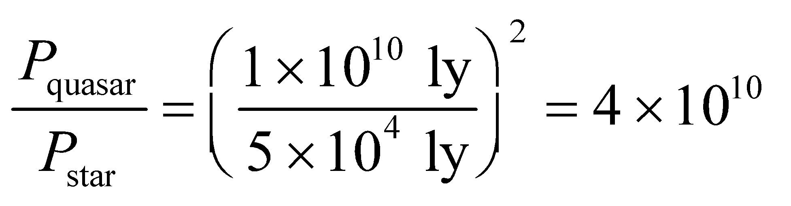
Assess The luminosity of a quasar is comparable to a galaxy of stars!
48. Interpret We’re asked to characterize the electromagnetic properties of a typical laser pointer.
Develop Assuming the laser’s power is distributed uniformly over the beam cross-section, then the intensity is just the power divided by the area: 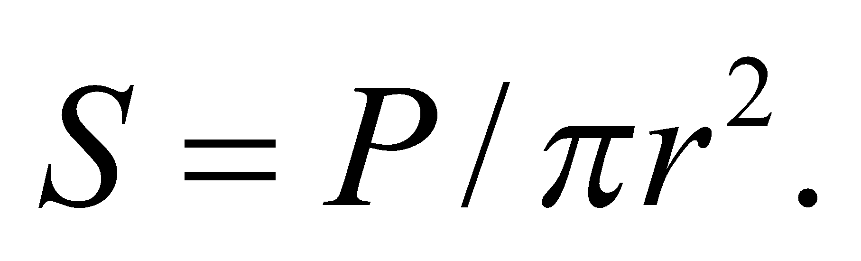 If the beam points directly into a person’s eye, the total energy delivered before the eye blinks will be 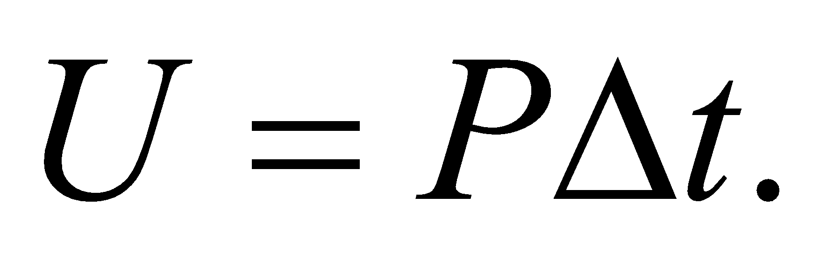 Finally, the peak electric field can be found with Equation 29.20b: 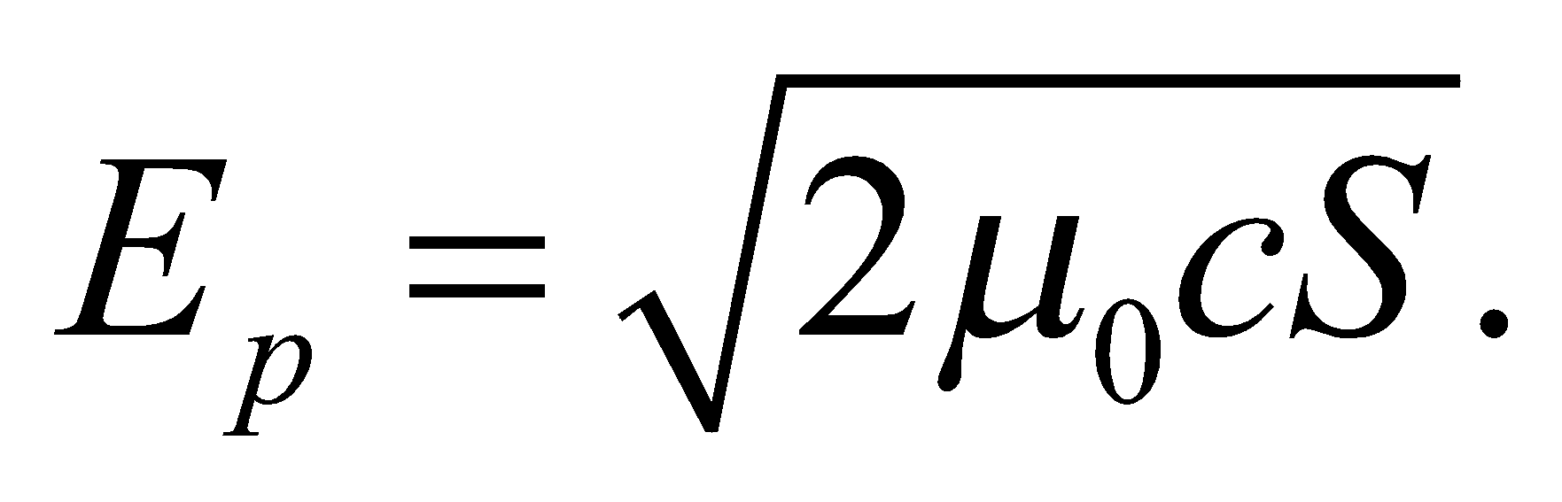
Evaluate (a) The laser beam intensity is
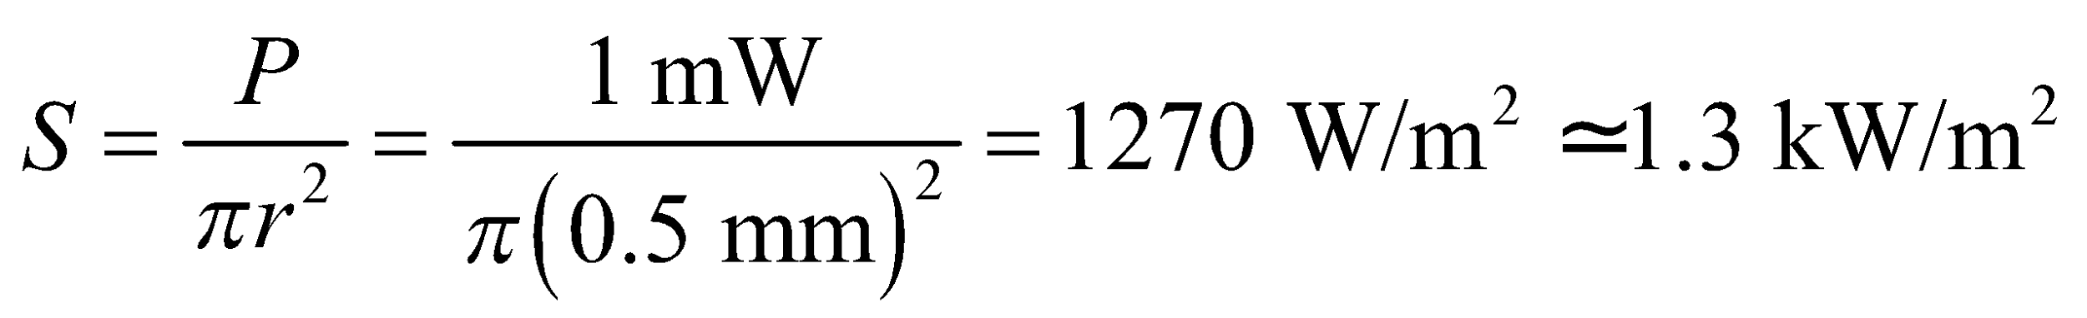
(b) The energy delivered before blinking is
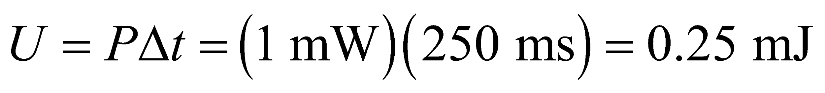
(c) The peak electric field in the laser is
Assess Notice that the laser pointer’s intensity is comparable to the intensity of noontime sunlight on a clear day (see Example 29.3). Both light sources can damage your eyes if you forced yourself to look at them long enough.
49. Interpret We are to find the transmitted power and the peak electric field in the given electromagnetic wave.
Develop Equations 29.21 and 29.20b can be combined to express the average power output of an isotropic transmitter in terms of the peak electric field at a distance r:
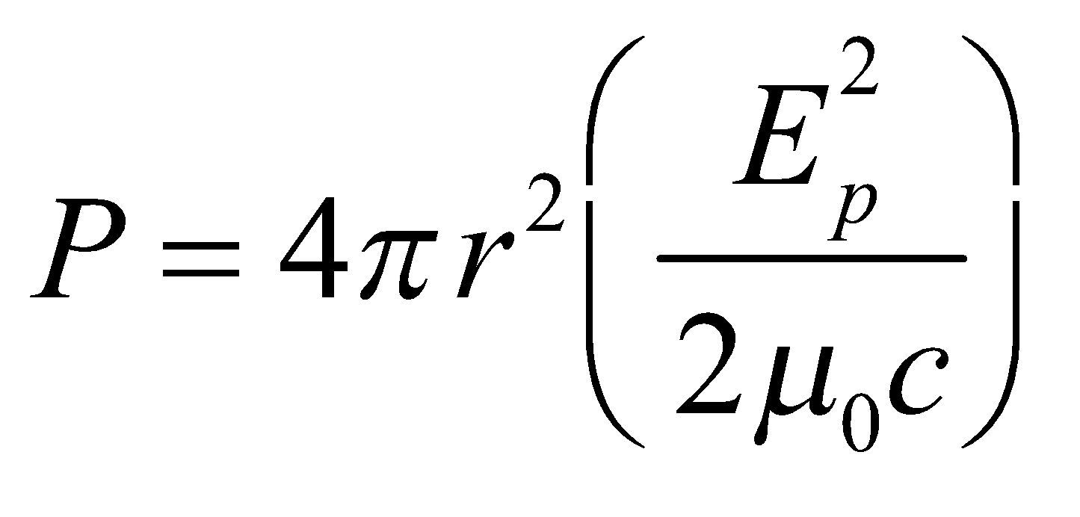
Evaluate (a) The transmitted power is
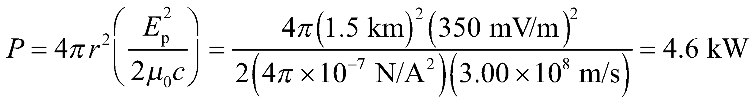
(b) Since 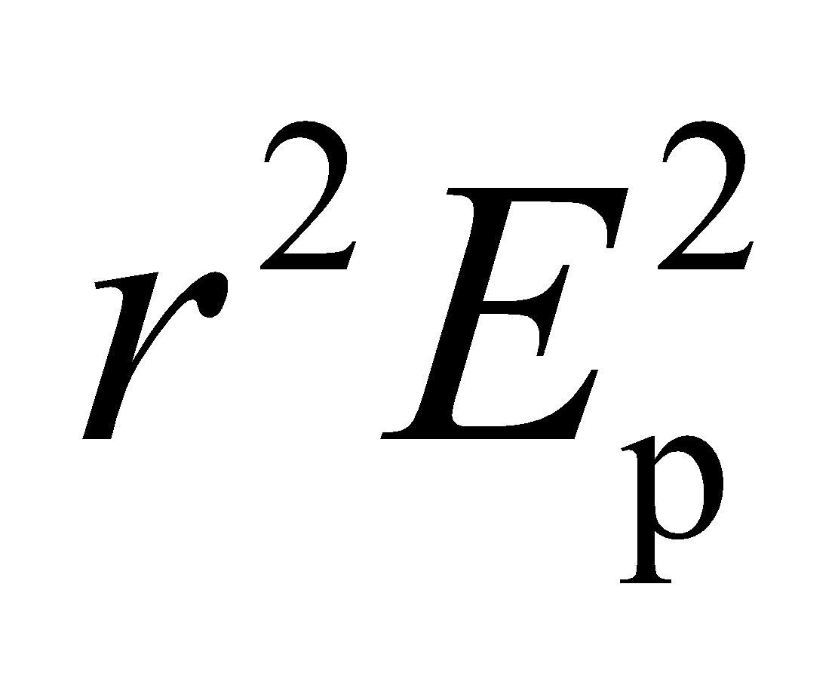 is a constant,
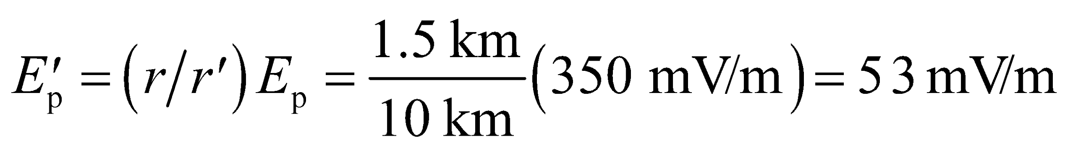
at a distance of
Assess This signal is still strong enough to be captured by modern radios. Checking the units for part (a), we find
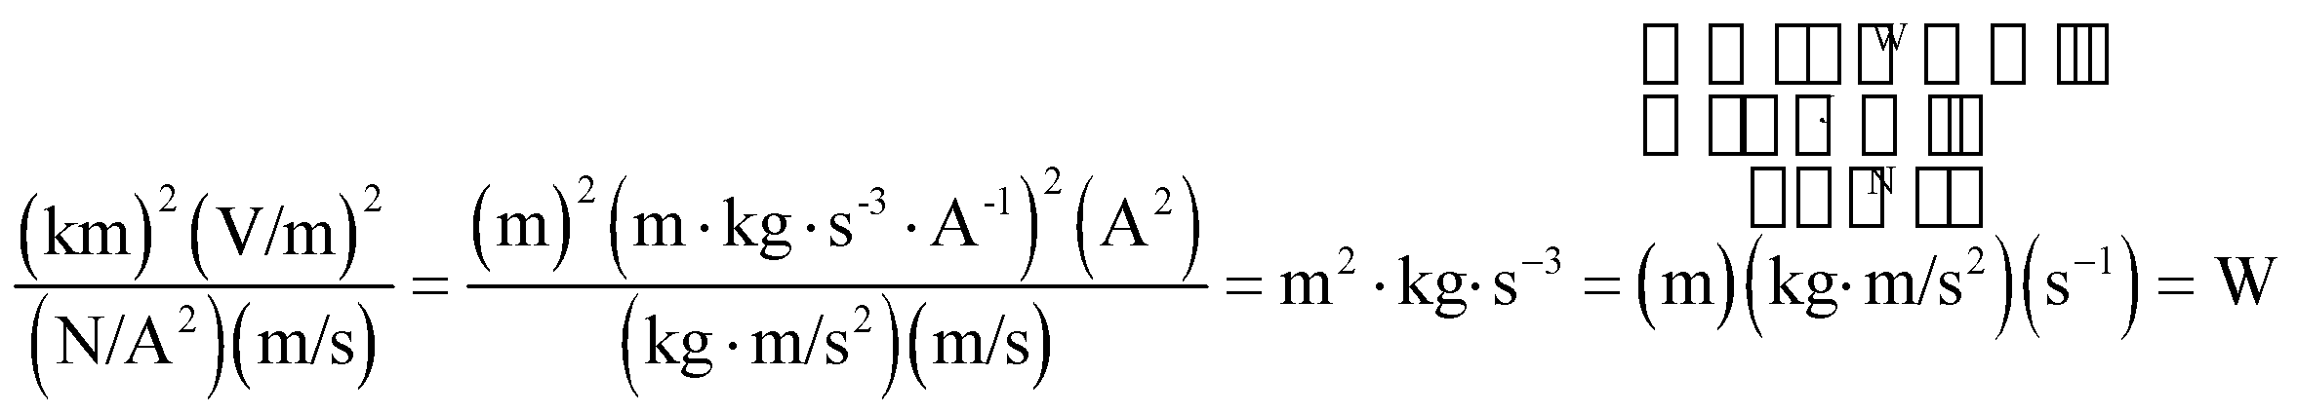
50. Interpret This problem involves finding the peak electric and magnetic field strengths of electromagnetic radiation, given the average power of the light source and the distance to the light source.
Develop For an isotropic source of electromagnetic waves (in a medium with vacuum permittivity and permeability), Equations 20.20 and 20.21 give
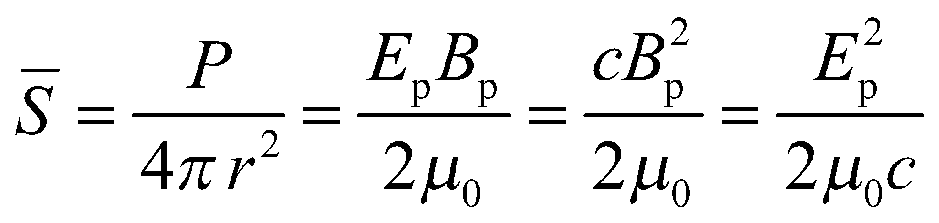
Evaluate The peak electric field strength is
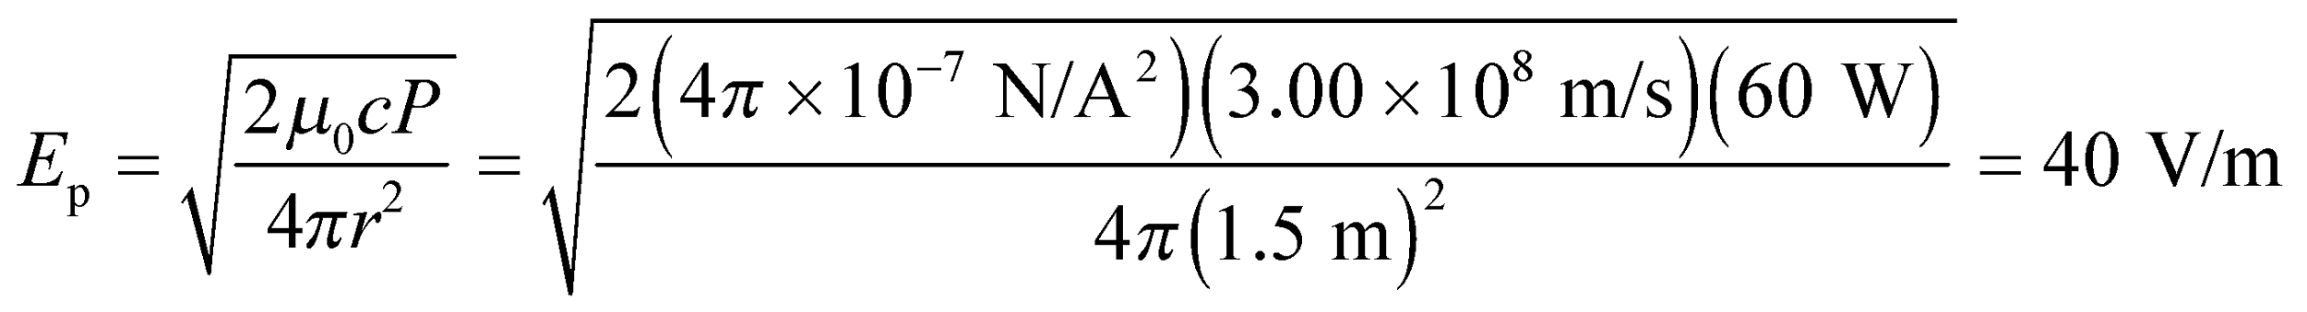
Using Equation 29.17, we find the peak magnetic field strength to be 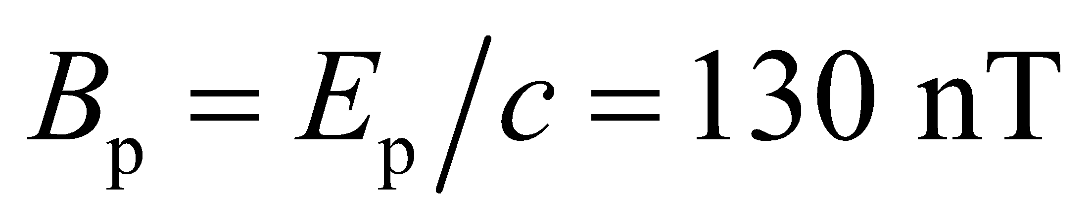, to two significant figures.
Assess The field strengths due to the light bulb are rather small.
51. Interpret This problem explores the influence of the symmetry of a line source of light in the distribution of intensity that it radiates. Specifically, we are to compare the variation of intensity with distance near a line source and far from the line source.
Develop Near the lamp (i.e., at distances  the length L of the lamp), but far from its ends, light waves travel approximately radially outwards from the tube axis. The power crossing two co-axial cylindrical patches is the same, but the area of each patch is proportional to the radius (see figure below). Very far away, the lamp appears as a point source.

Evaluate (a) Near the lamp, the intensity varies as 1/r because
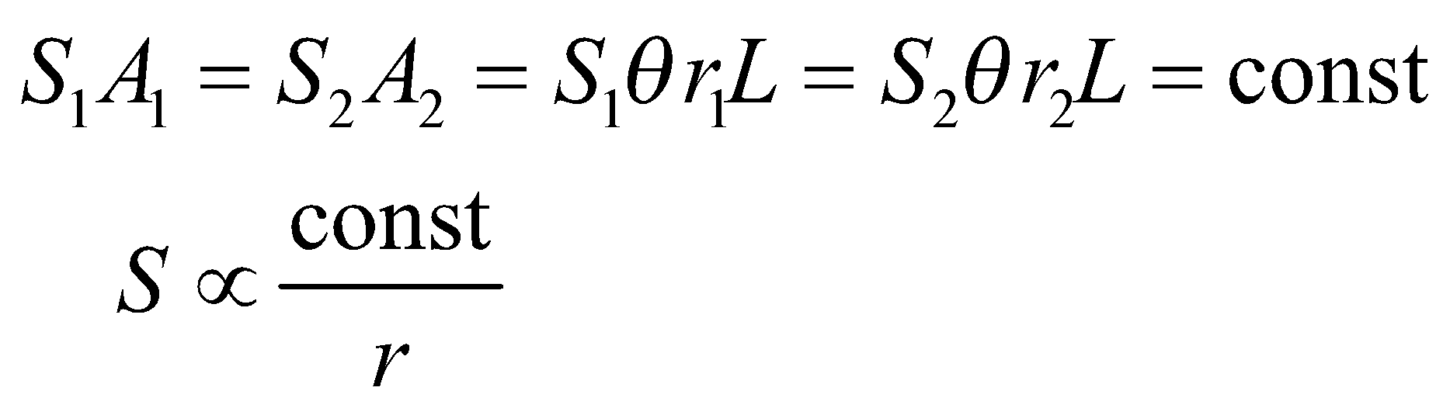
(b) Far from the lamp, Equation 29.21 holds, so the intensity varies like 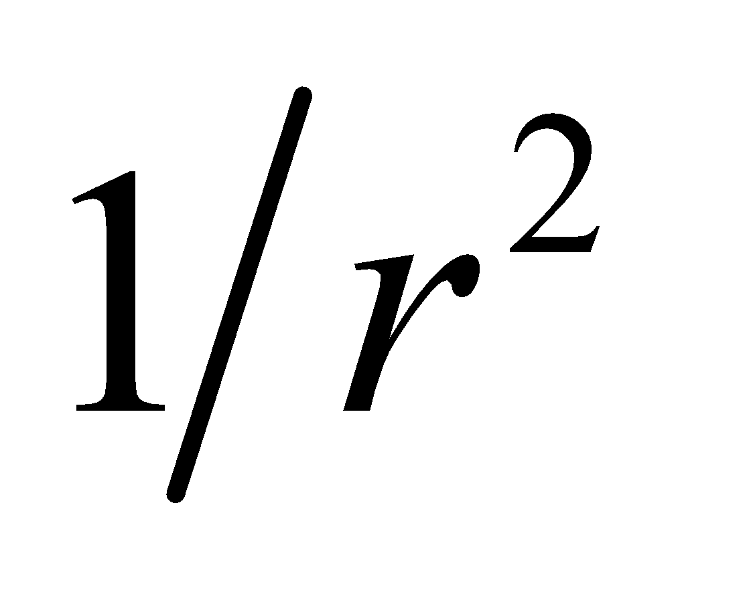
Assess Extending this reasoning, we would expect the intensity of a plane source of light to be independent of distance to the source for distances  the dimensions of the plane source, assuming we are not near the edges of the source.
52. Interpret This problem asks for the energy and momentum carried by the light from a camera flash.
Develop The energy U is the average power times the duration of the flash, and the momentum is simply given by 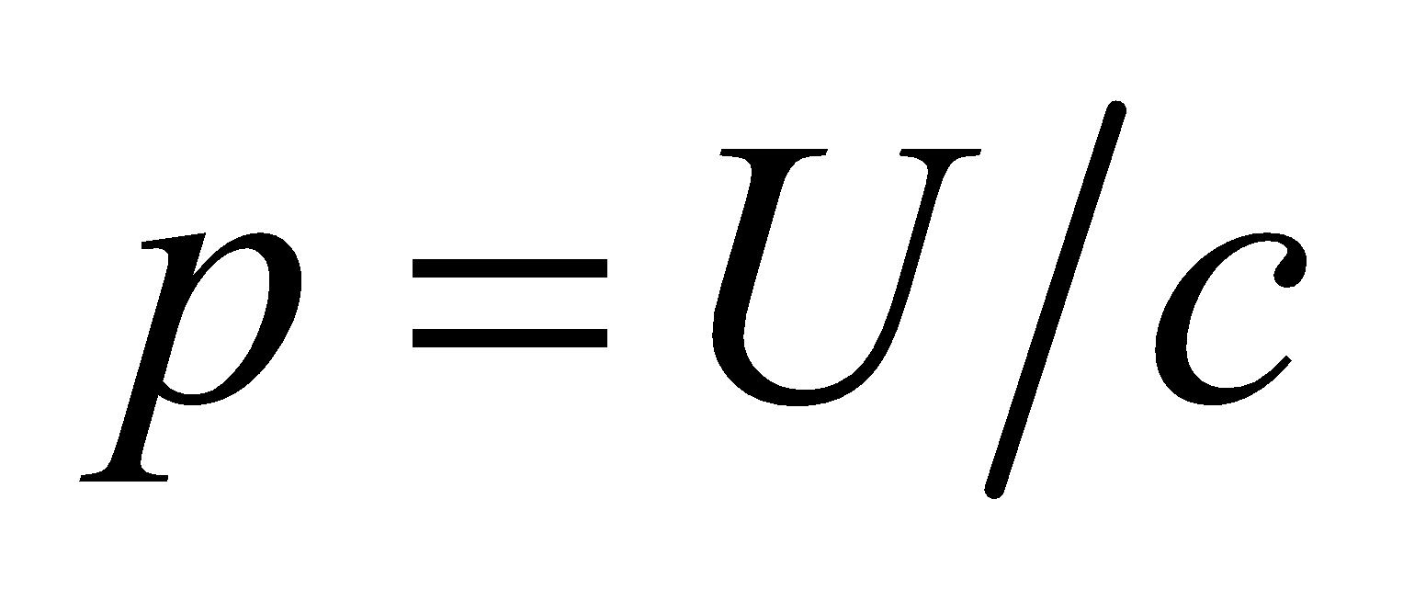 (see section on momentum and radiation pressure).
Evaluate (a) The total energy the flash carries is 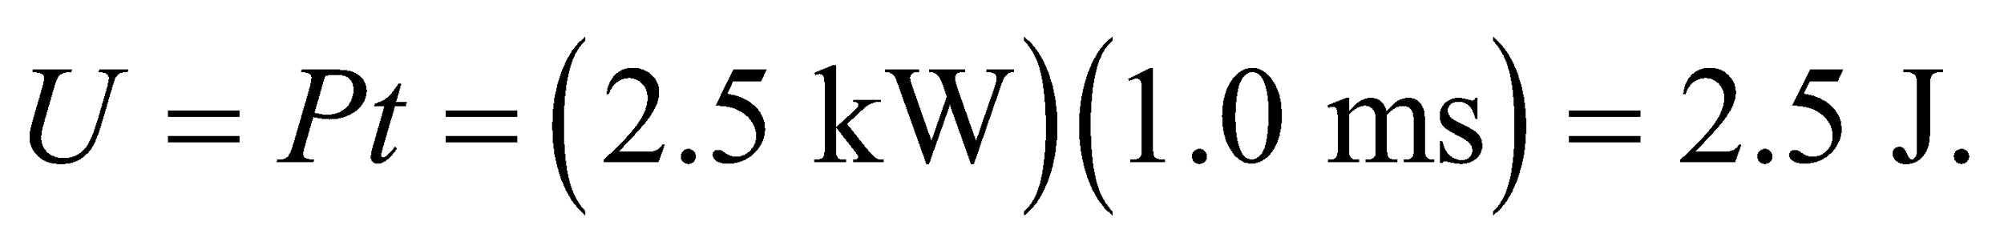
(b) The momentum is
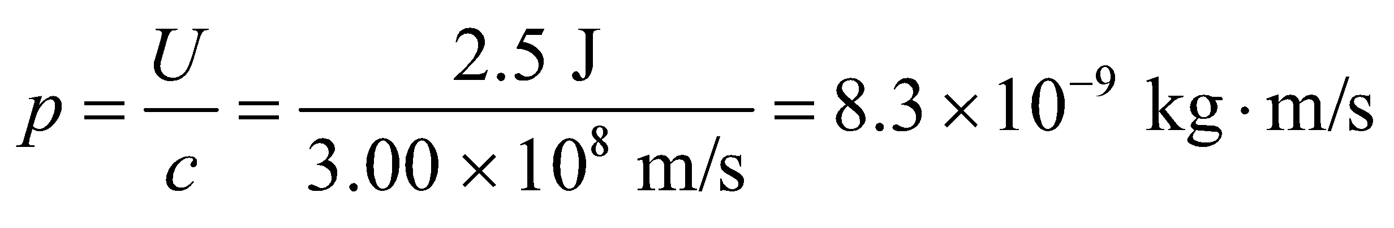
Assess A camera flash works by storing energy in a capacitor and then rapidly releasing the energy to cause a quick bright flash of light.
53. Interpret We are to find the average intensity and the peak electric field of the light from a laser, given its average power and its beam diameter.
Develop Intensity is defined as power per unit area. We know that the power of the beam is P = 7.0 W and the area is 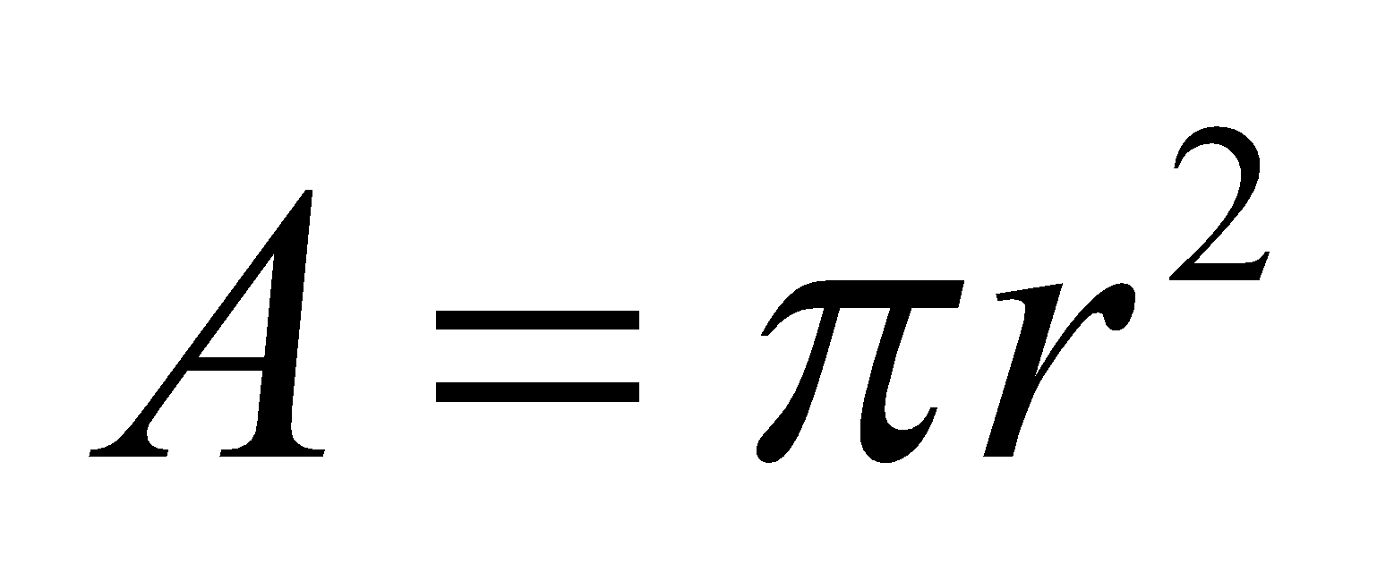 where 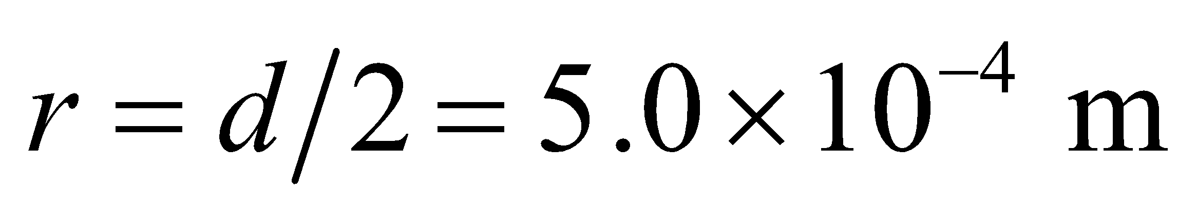, so we can find the intensity. Intensity is also given by the Poynting vector, 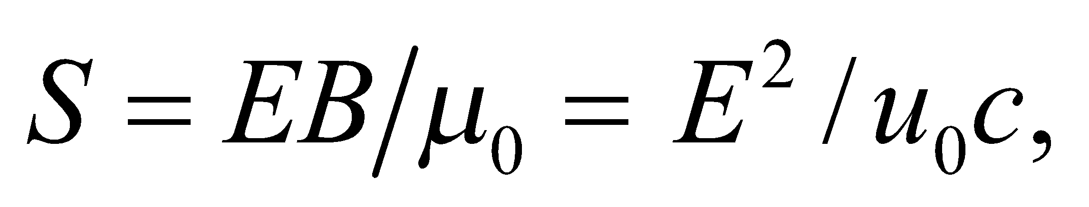 from which we can determine the peak electric field.
Evaluate (a) 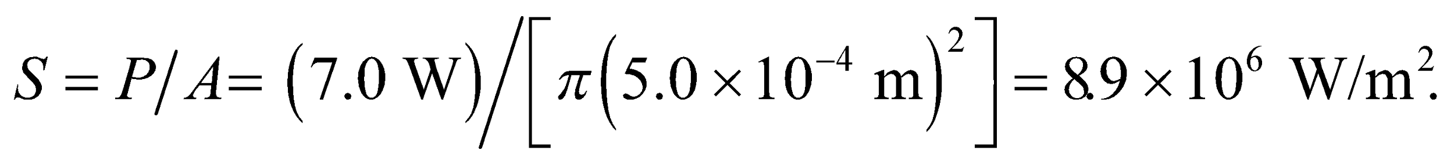
(b)
Assess This intensity is one factor in what makes a laser beam so dangerous. Seven watts is really not much power, but packed into such a small area it gives an enormous intensity.
54. Interpret Given the intensity of the laser beam, we are asked to find the corresponding radiation pressure it exerts on a light-absorbing surface.
Develop The radiation pressure generated by a totally absorbed electromagnetic wave of given average intensity can be calculated using Equation 29.22: 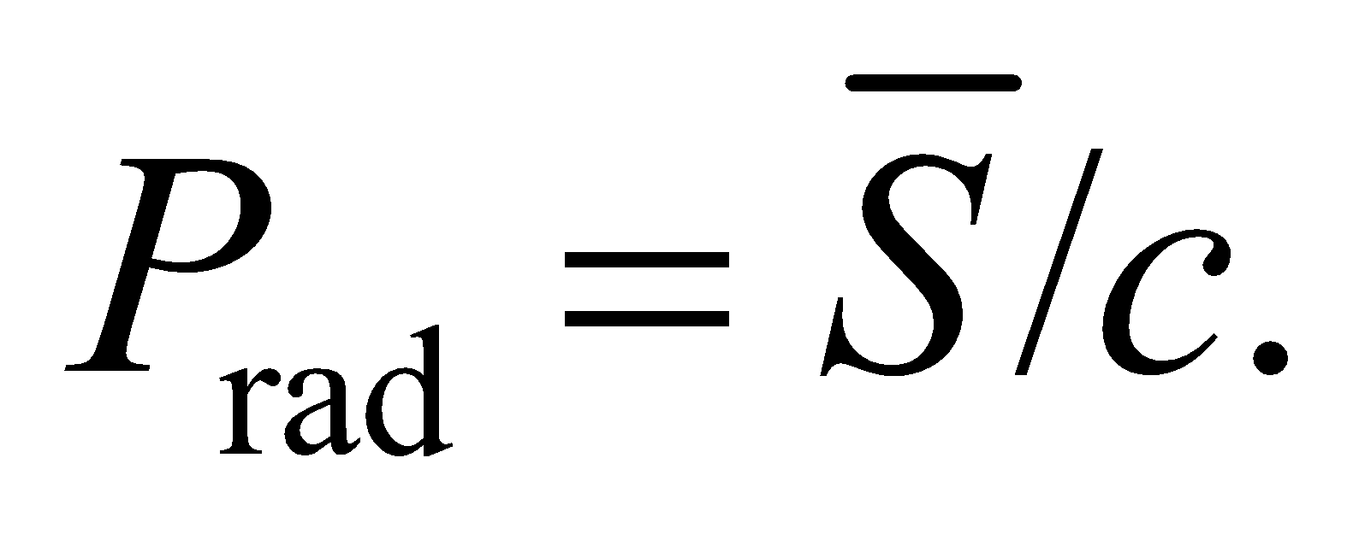
Evaluate Inserting the values given, the radiation pressure is
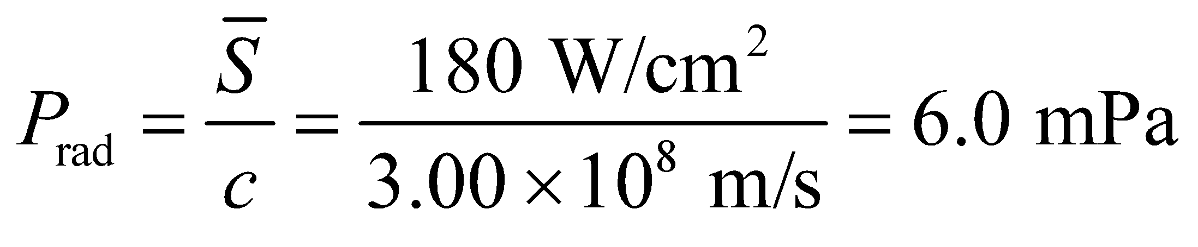
Assess The pressure is a lot smaller compared to the normal atmospheric pressure of 
55. Interpret We will use Newton’s third law (Chapter 4) and the radiation momentum generated by the given flashlight to find the time it takes the astronaut to accelerate from rest to 10 m/s.
Develop By Newton’s third law, the reaction force of the light emitted on the flashlight equals the rate at which momentum is carried away by the beam, or 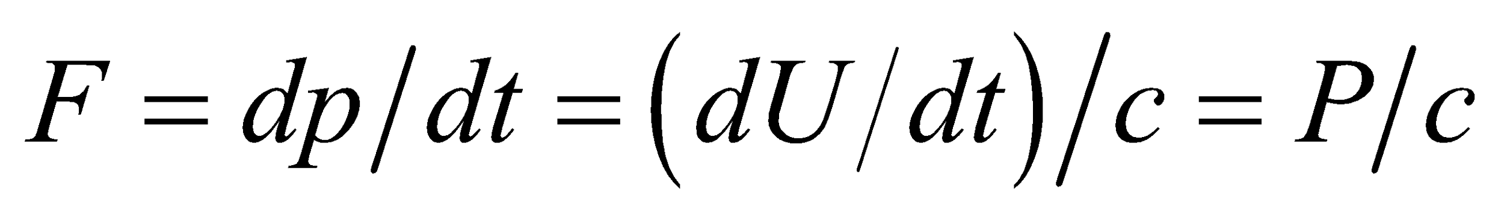. Such a force could accelerate a mass m from rest to a speed v in time 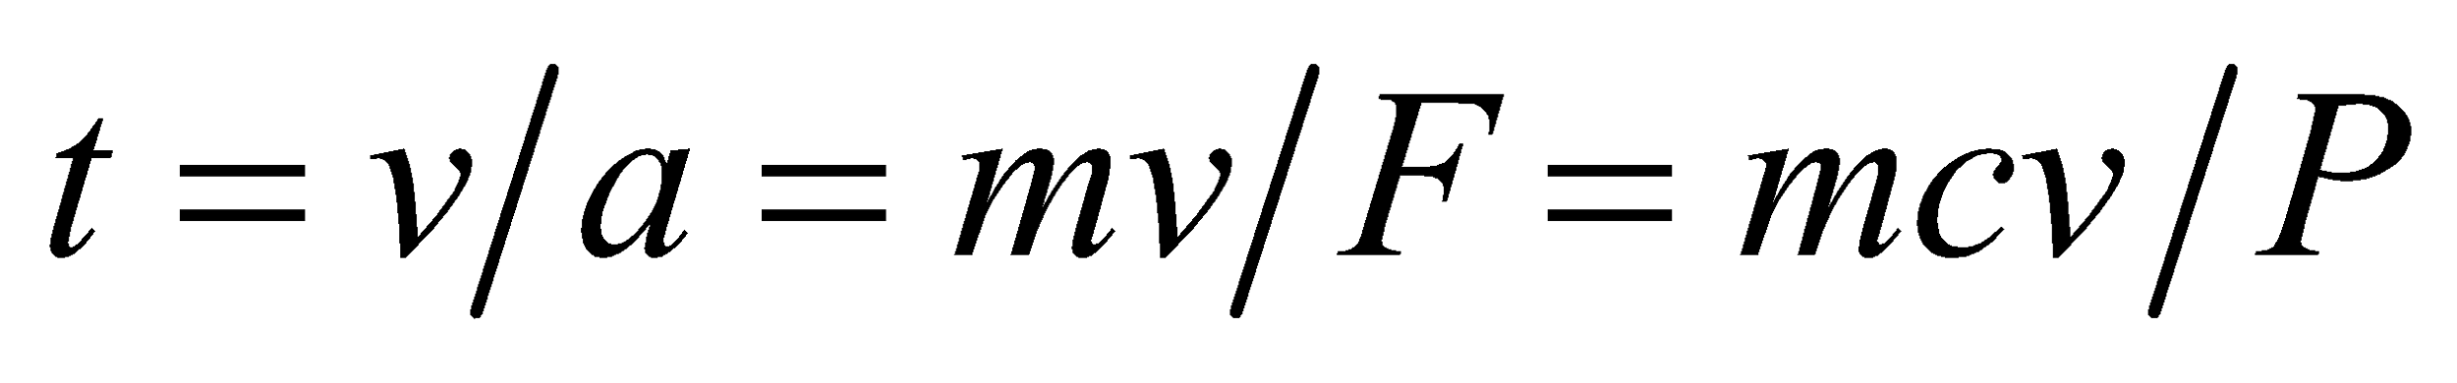.
Evaluate For the values given for the astronaut and flashlight,
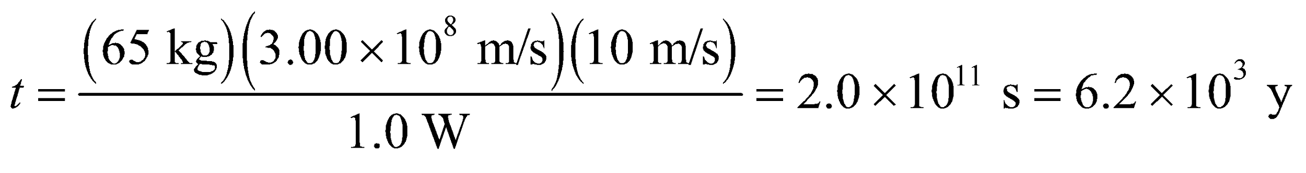
Assess This is impractically long, as one might expect.
56. Interpret This problem involves finding the power of a light source, given the thrust it yields.
Develop The thrust of a (photon) rocket is the rate that momentum is carried away by its electromagnetic exhaust beam:
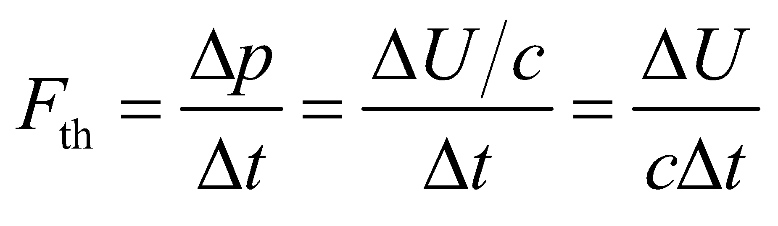
Evaluate To yield a thrust of 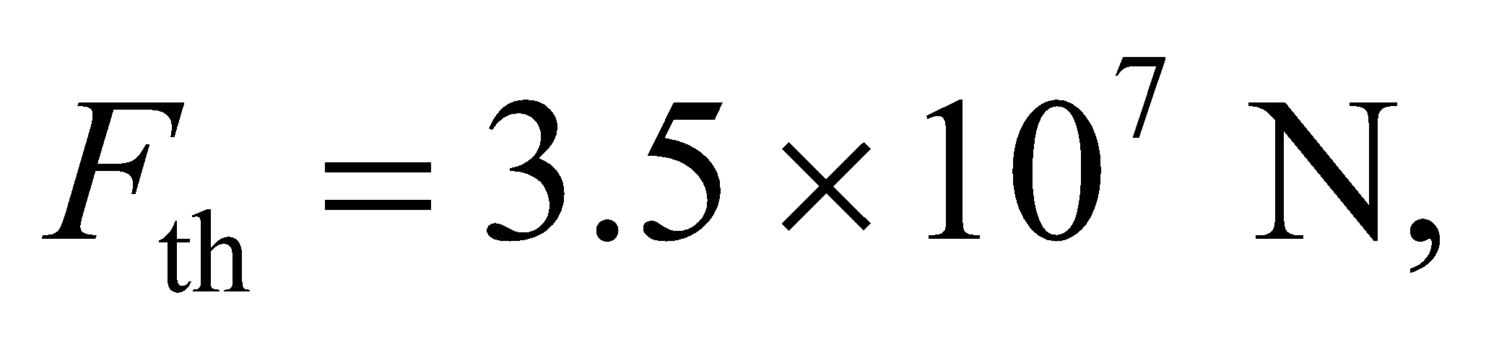 the beam power must be
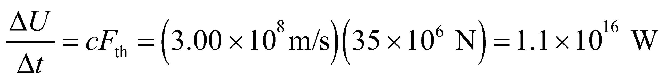
This is 10⁴ times the world’s electric-power generating capacity.
Assess This is not a practical means of launching payloads off the Earth. The momentum per unit energy of a light beam 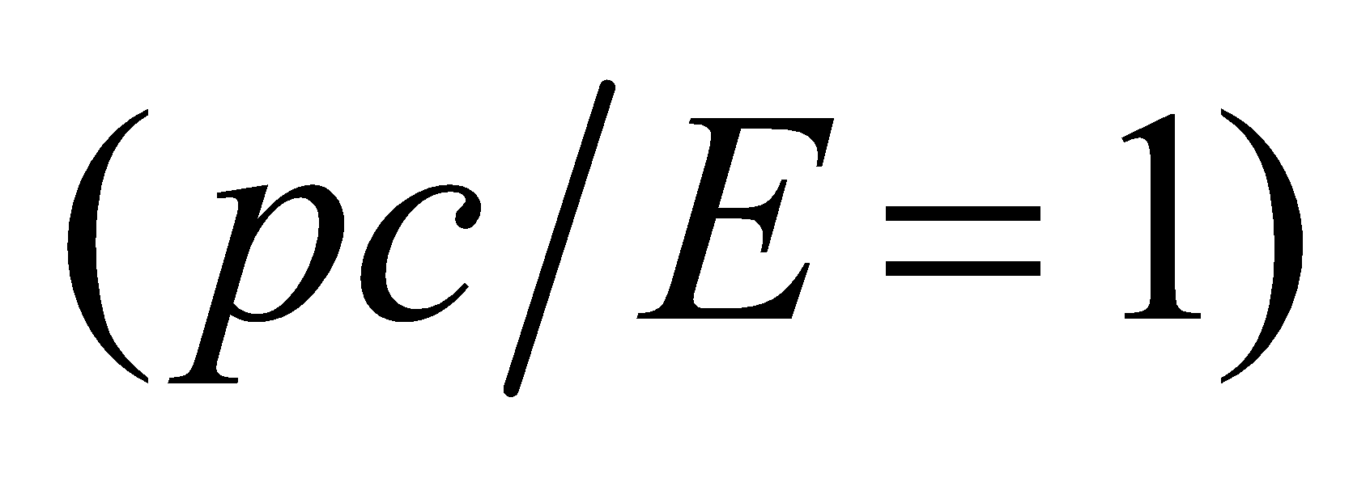 is greater than that of any particle beam 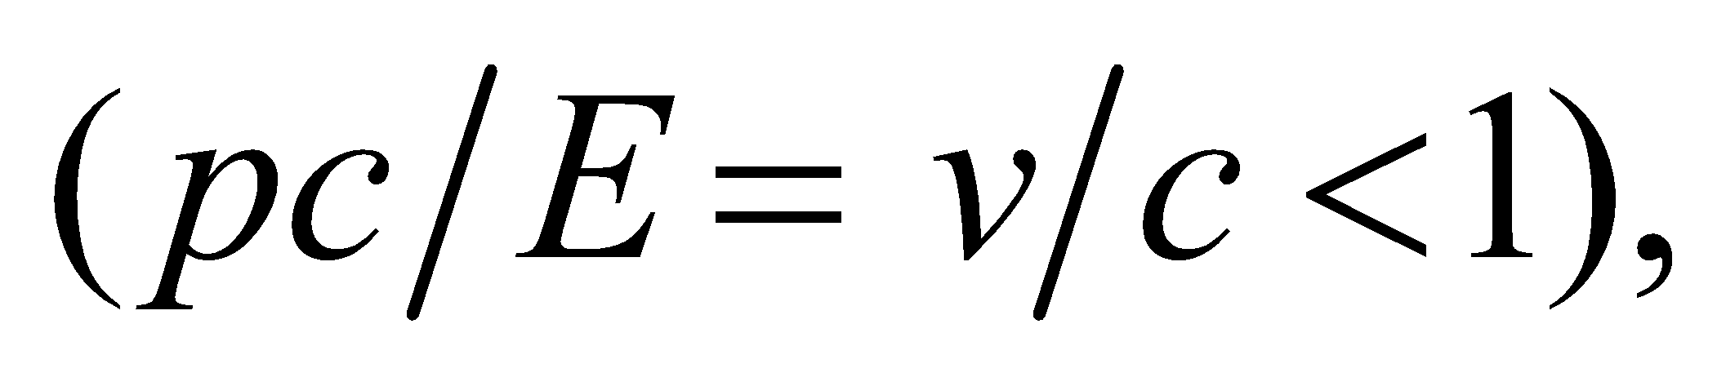 so a photon rocket could be more energy-efficient in long-distance, low-thrust space travel.
57. Interpret This problem involves finding the radiation pressure at the surface of a white dwarf, given its power and radius.
Develop From Problem 29.46, the Sun radiates 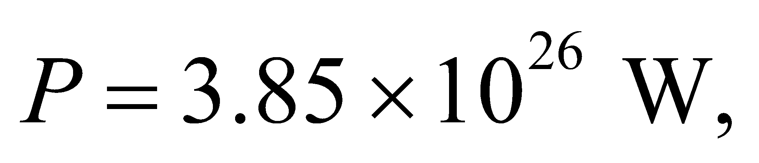 and the radius of the Earth is 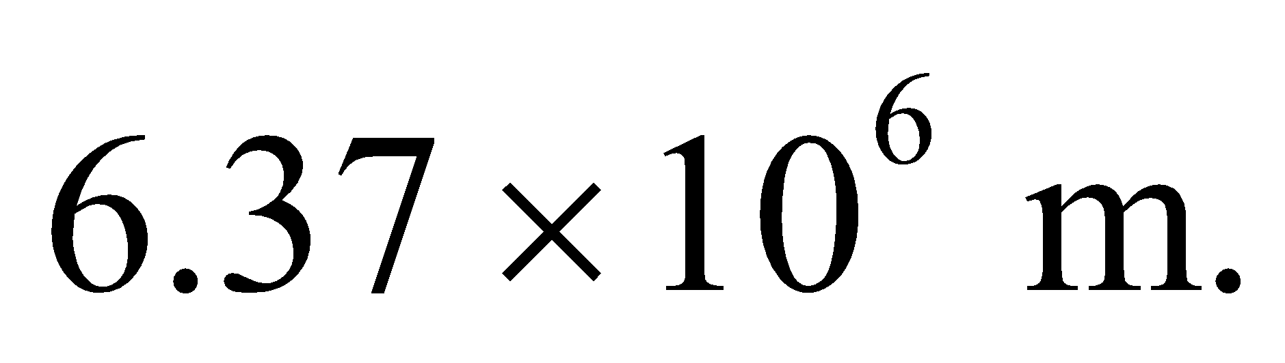 Equation 29.22 gives the radiation pressure on a perfect absorber as 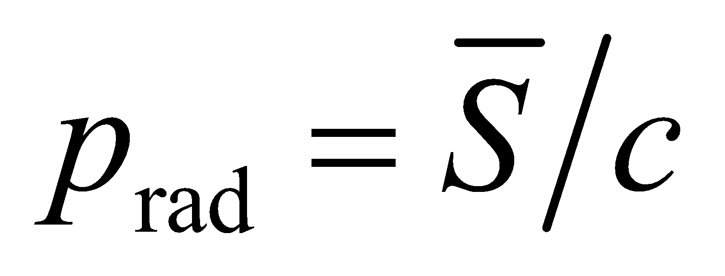 and the intensity may be found using Equation 29.21, 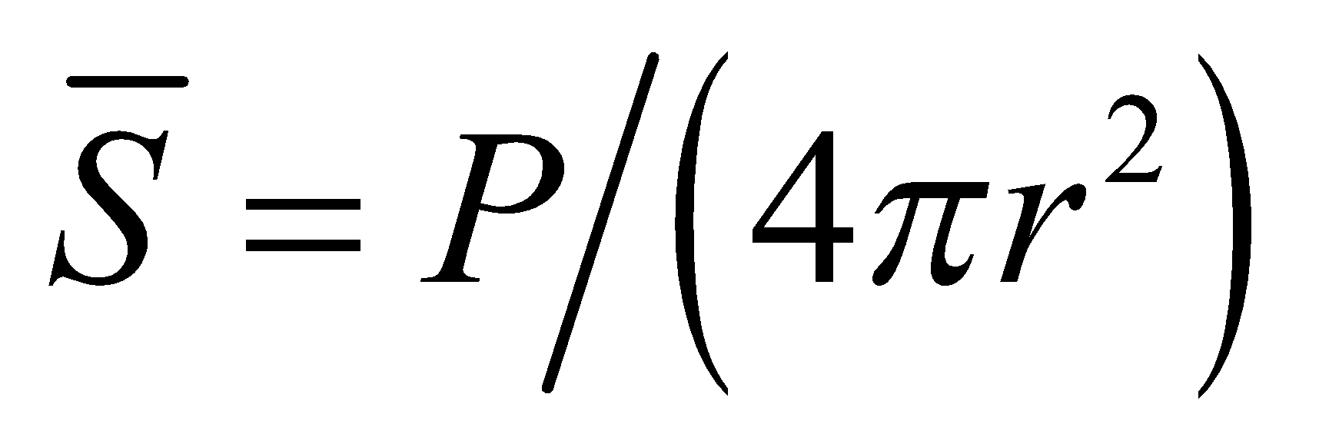.
Evaluate Combining the expressions above gives a radiation pressure of
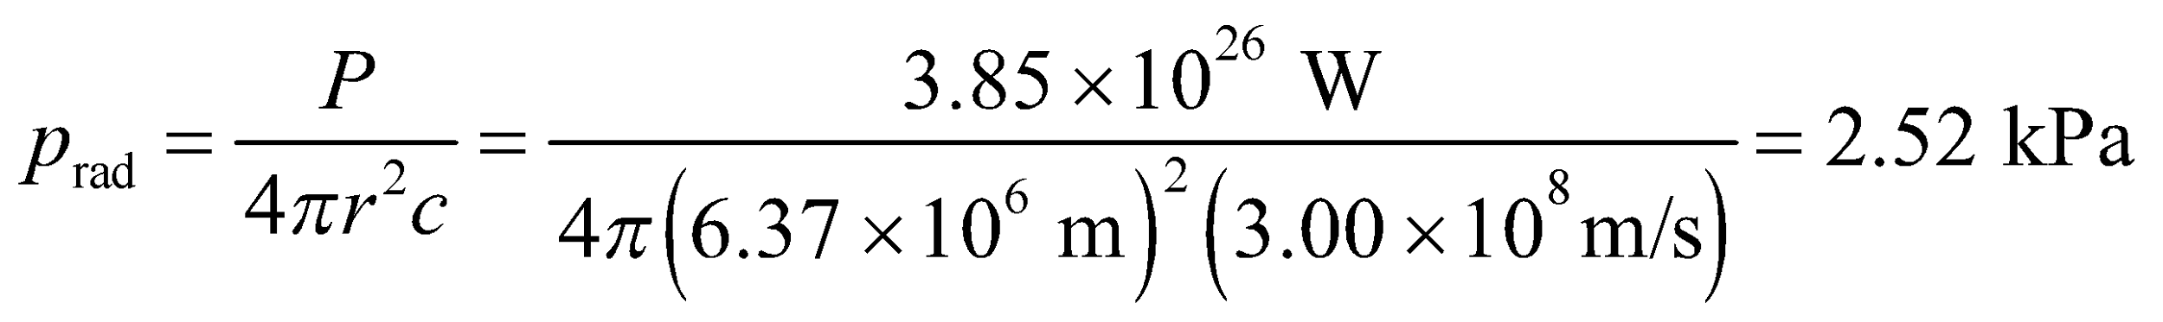
Assess This is some 100 times less than the atmospheric pressure at the surface of the Earth.
58. Interpret This problem is about radiation pressure on an absorbing object at the Sun’s surface.
Develop For an isotropic source, the radiation pressure on an opaque (perfectly absorbing) object is (Equation 29.22)
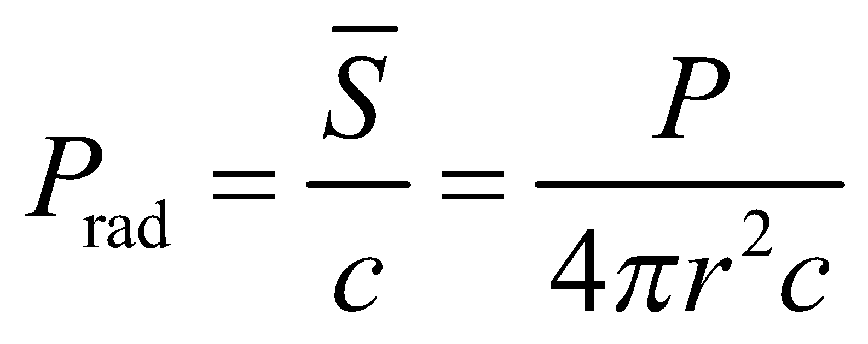
Evaluate The luminosity of the Sun (power radiated) is 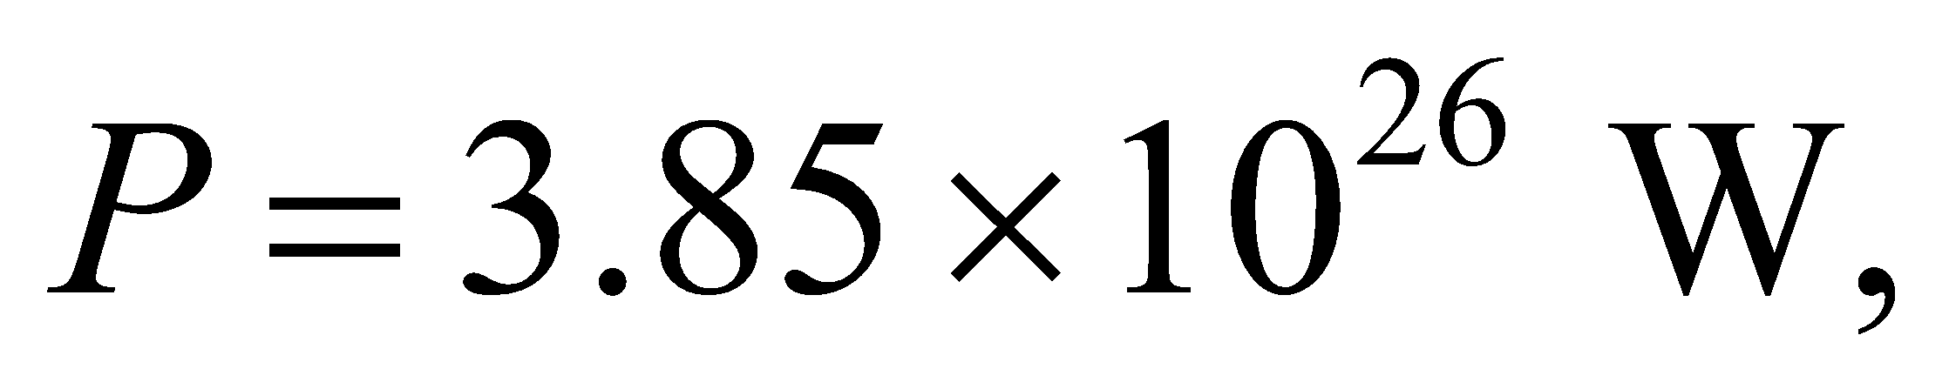 and the radius of the Sun is
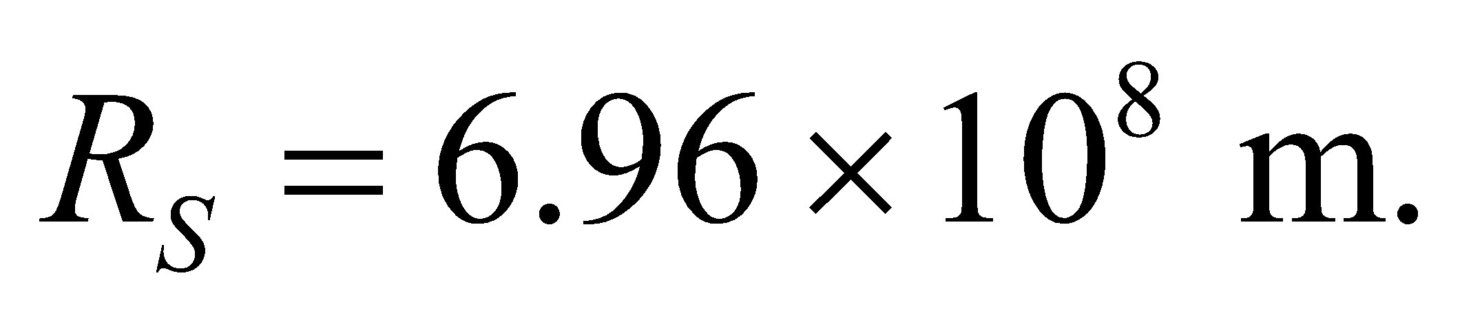 Thus, the radiation pressure is
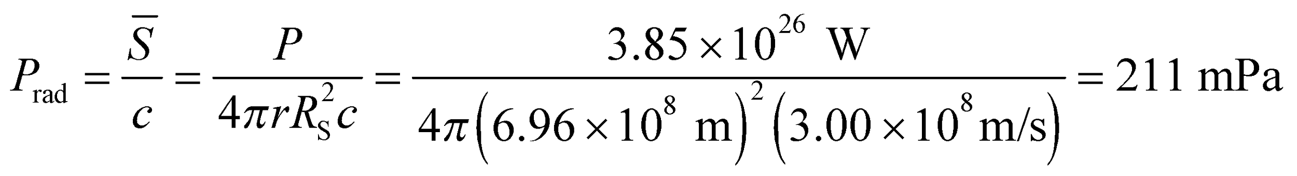
Assess This is much greater compared to  on the surface of the Earth.
59. Interpret This problem involves characterizing an electromagnetic wave given the relevant parameters.
Develop The average intensity of a pulse is the average power during a pulse divided by the beam area; 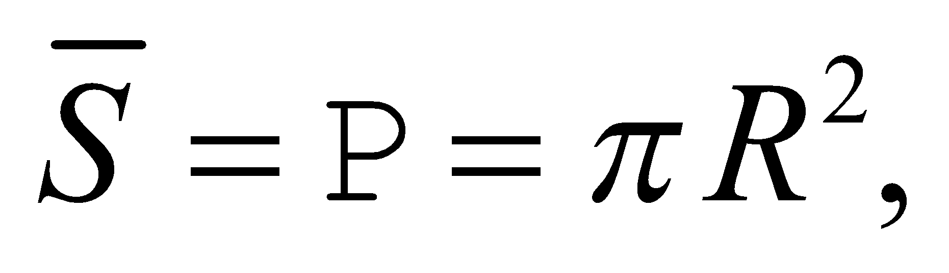 and (from Equation 29.20b) the peak electric field is 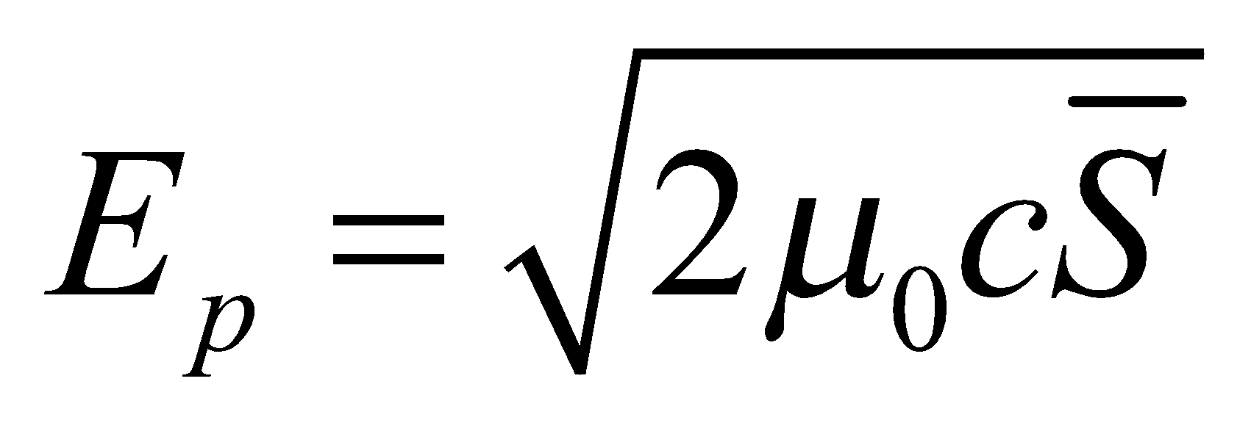. The wavelength may be found using Equation 29.16c, c = fλ.. To find the energy in a pulse, use 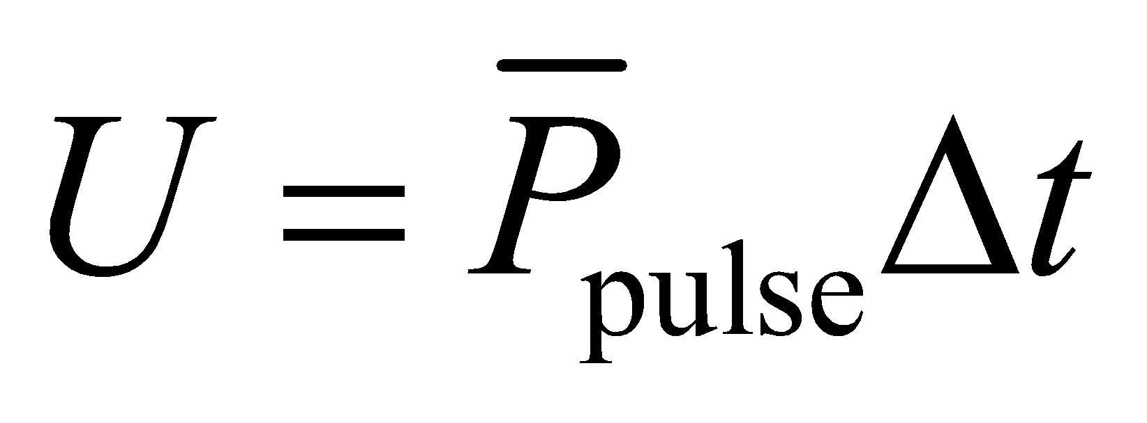, where Δt =NT = N/f, with N = 100 and f = 70 GHz. To find the average power output, calculate the power in a pulse, multiply by 1000 because there are 1000 pulses per second, and divide by 1 s to get the power (energy per unit time).
Evaluate (a) The peak electric field is
(b) The wavelength is 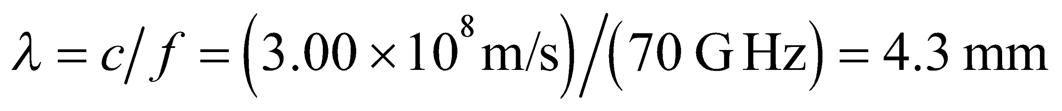.
(c) The total enegy in a pulse is
(d) The momentum per pulse is given by p = U/c = 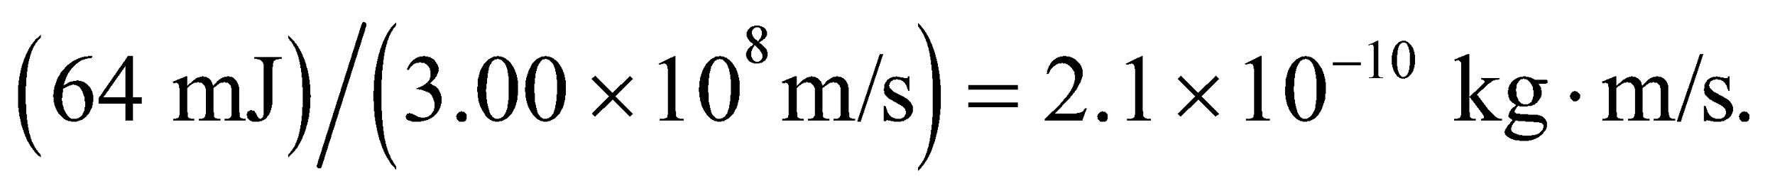
(e) Every pulse carries 64.3 mJ, and there are 1000 per second, so the average power is 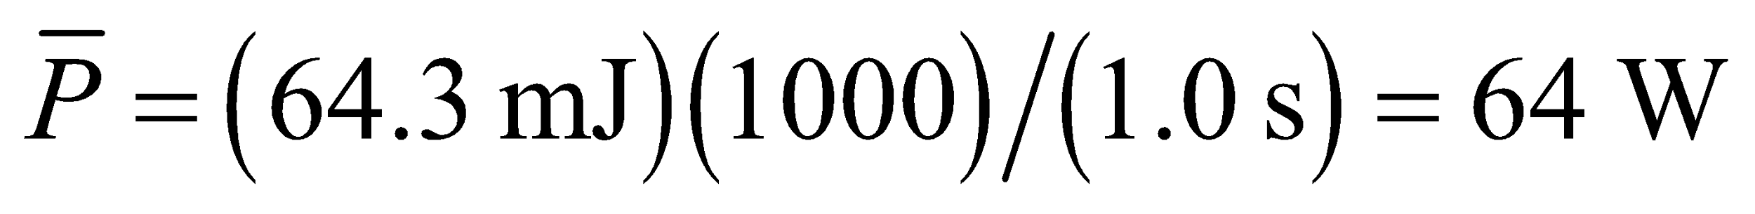.
Assess The average power in the beam is much less than the power per pulse because the duty cycle is
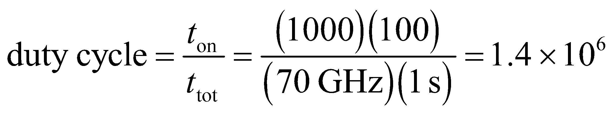
which explains the six-order-of-magnitude difference between 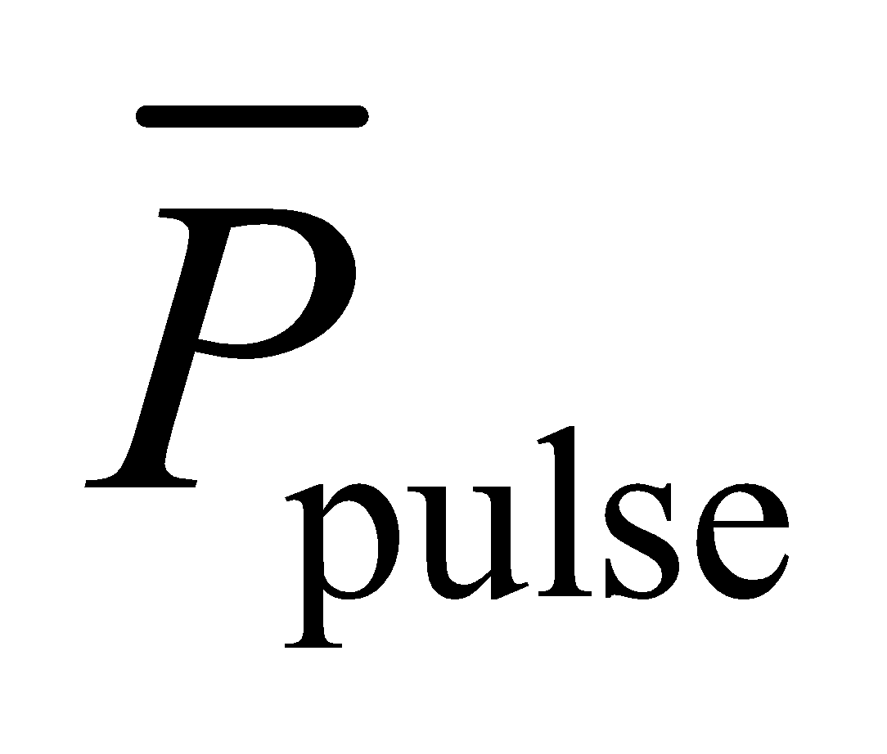 and 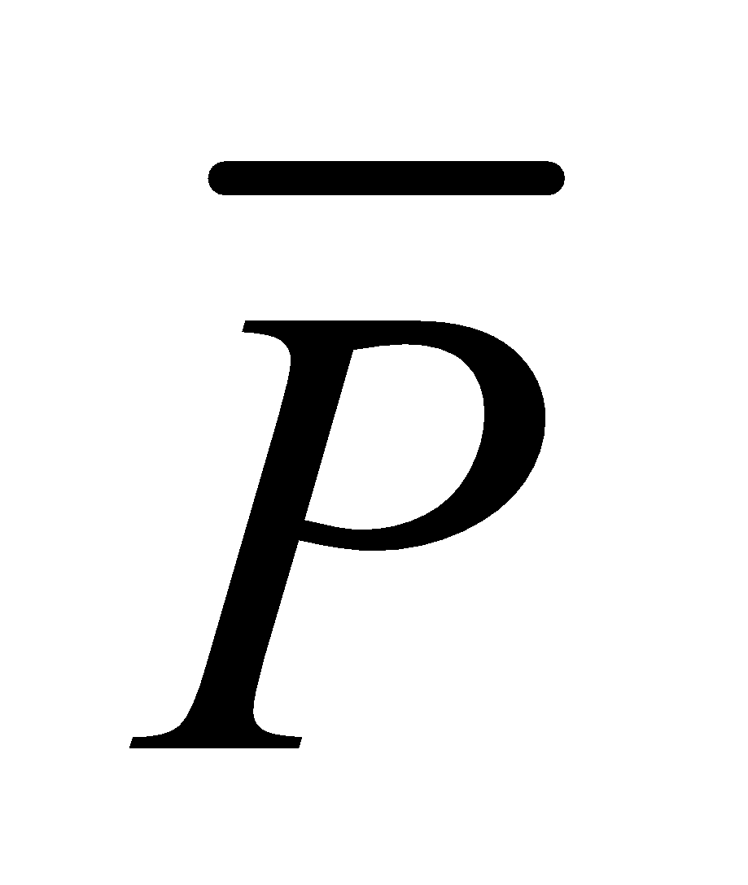.
60. Interpret In this problem, we explore the electric and magnetic fields in a cylindrical resistor and are to show that the Poynting vector averaged over the surface area is I²R.
Develop Consider the sketch below of the cylindrical resistor, where the hashed portion is the cross-section of the cylinder. Assume that the current is steady, and that the fields are independent of time. Ohm’s law gives 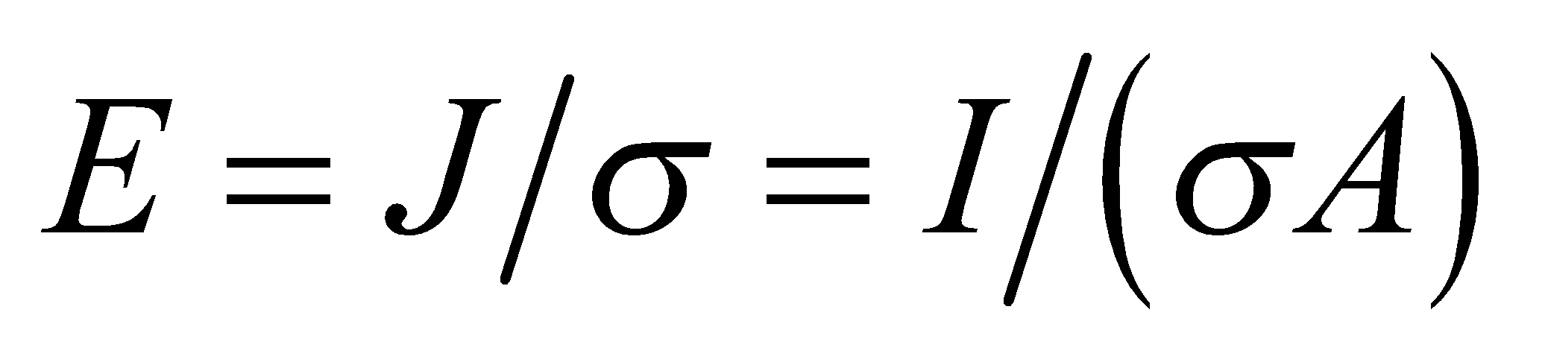 in the direction of the current (see Section 24.3). The magnetic field at the surface, 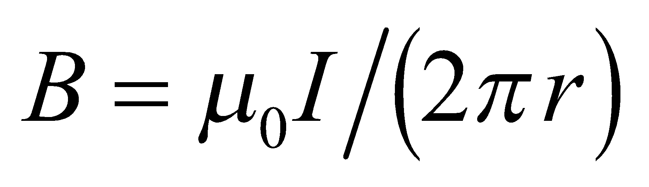, encircles the current in the direction of a right-hand screw. Thus is perpendicular to 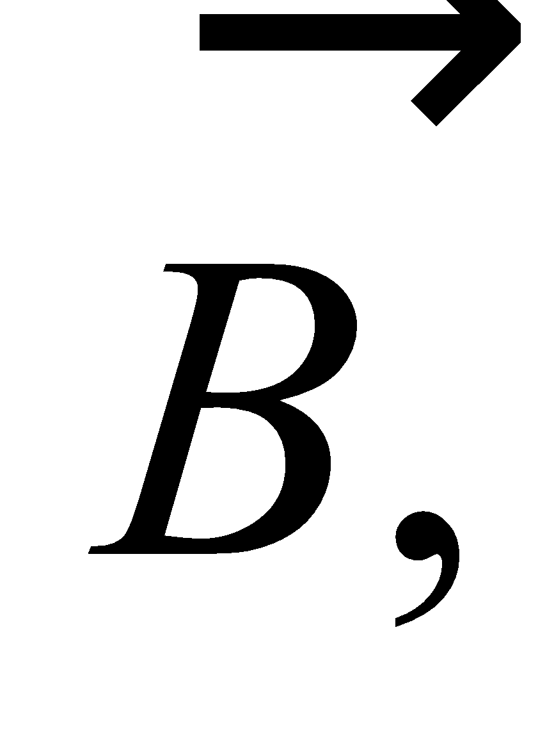 and 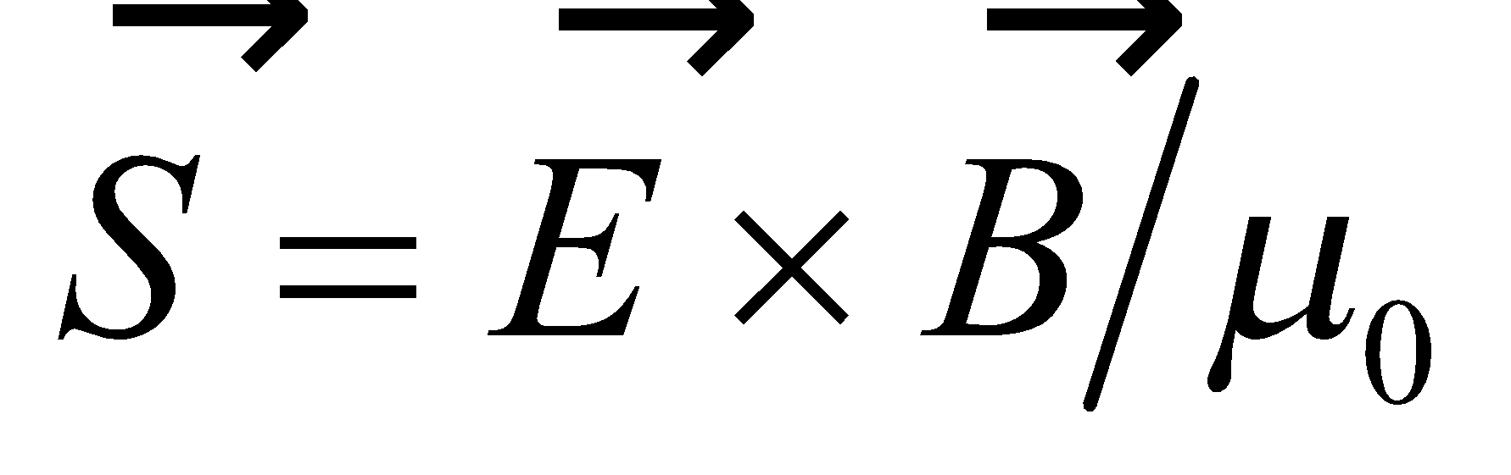 points radially into the resistor, as per the right-hand rule. Power flows from the fields into the resistor only through the curved portion of its cylindrical surface, so we can find the power by integrating the Poynting vector component parallel to the surface normal over the surface of the resistor.

Evaluate The power flowing into the resistor is
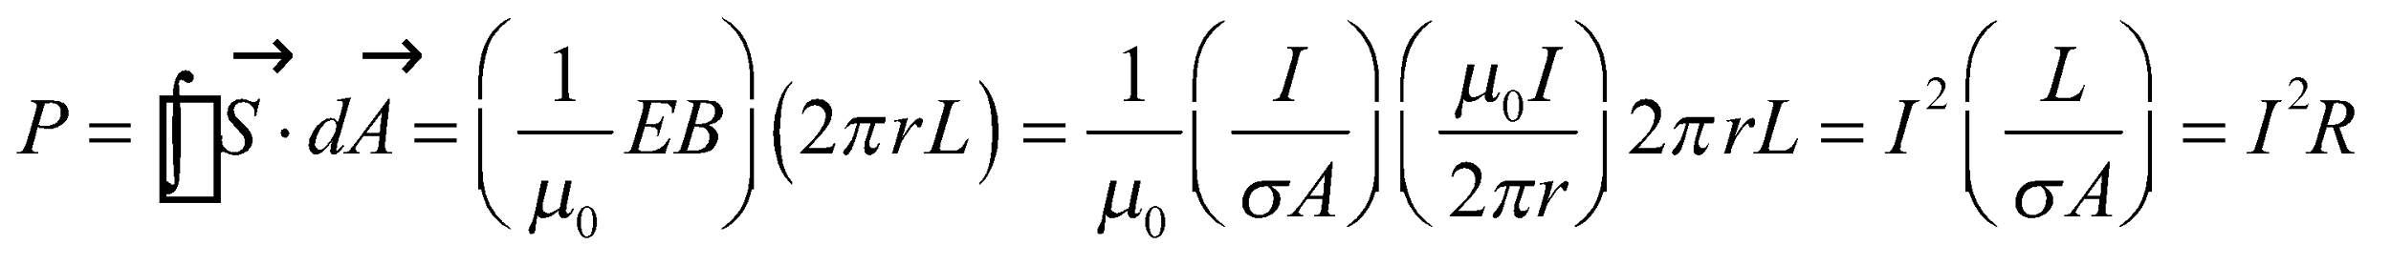
Assess This is a special case of Poynting’s theorem applied to steady fields.
61. Interpret From the transmission percentage of a stack of polarizers, we are to determine how many polarizers the stack contains. We shall use the Law of Malus.
Develop The Law of Malus (Equation 29.18) is where θ is the angle between the polarization of the impinging light beam and the polarization direction of the polarizer sheet. For this problem, θ = 14°. The first polarizer eliminates 50% of the initially unpolarized light, and each subsequent polarizer is equivalent to multiplying the amount of light remaining by 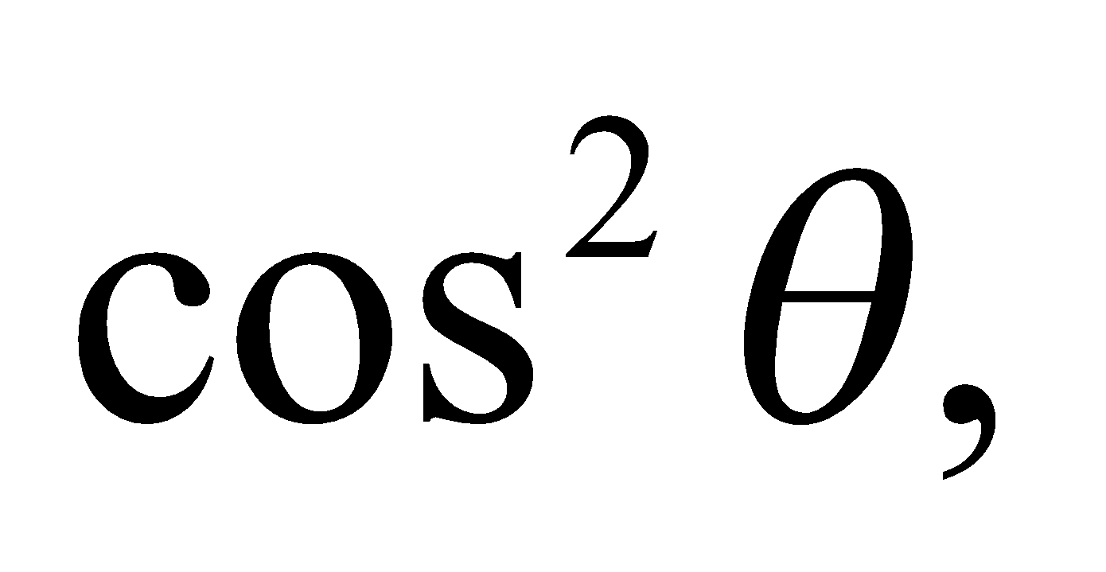 so the total percentage of the light that comes through the stack of n polarizers is 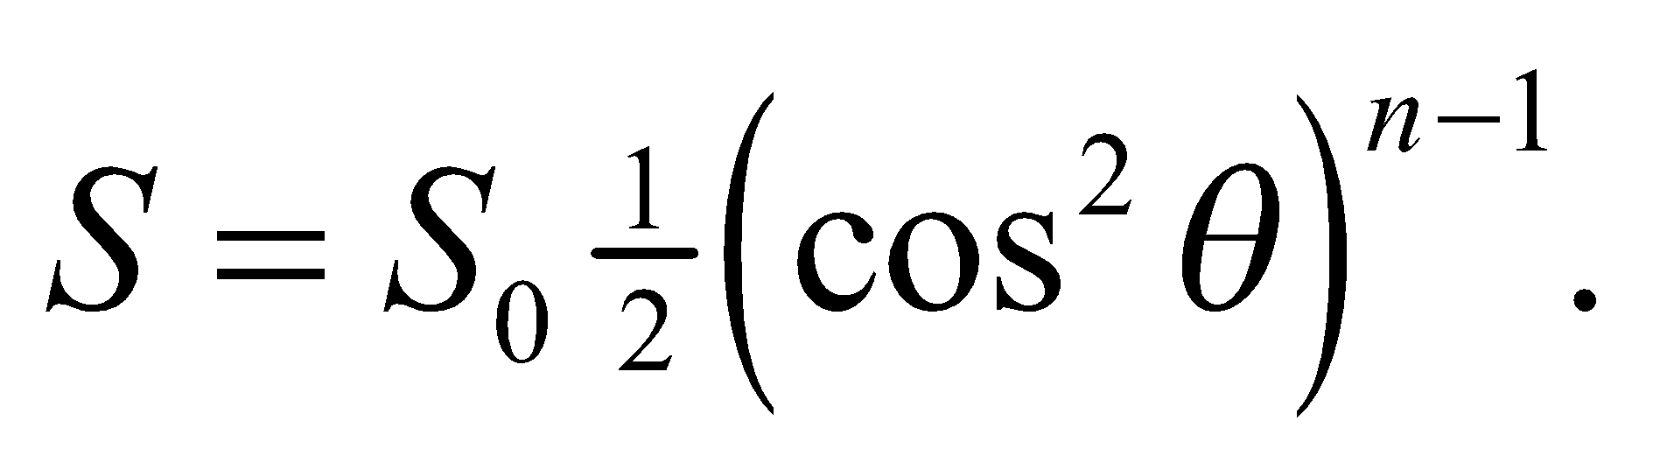 We are given that 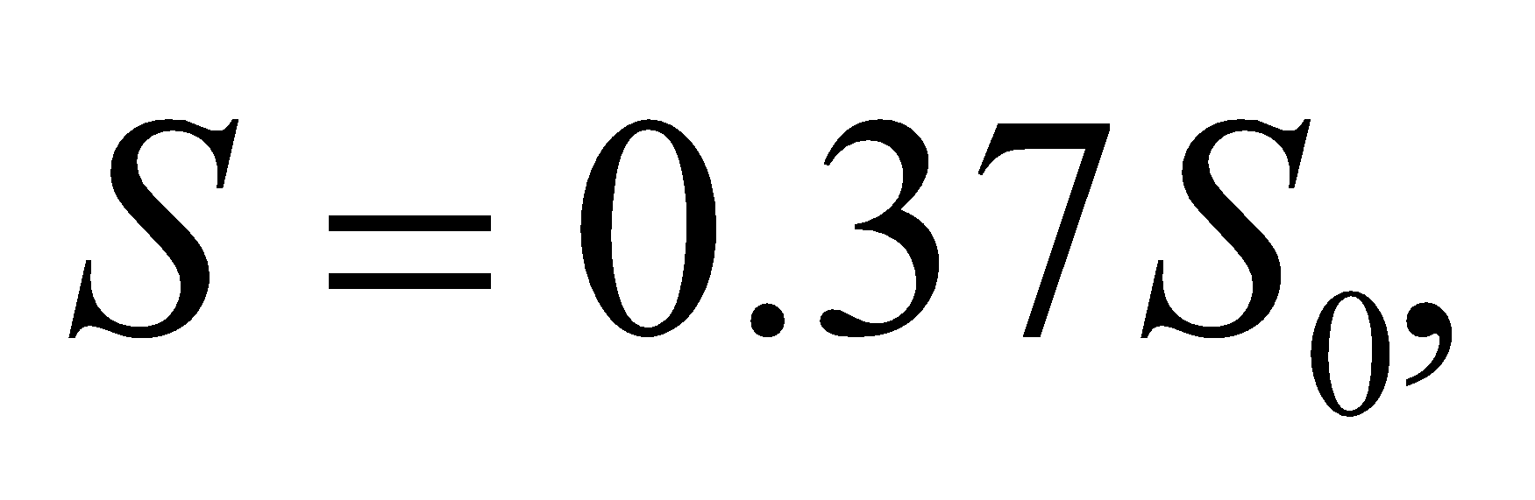 so we can solve for n.
Evaluate The number n of polarizer sheets is
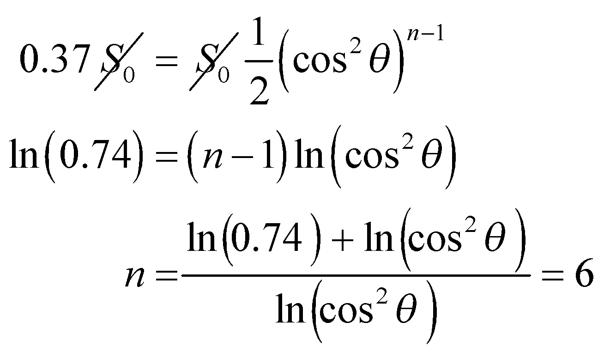
Assess The stack has six sheets. If you got 17.5 sheets, you probably forgot that the first sheet eliminates half the unpolarized incident light.
62. Interpret You want to evaluate an hypothesis that the sun’s radiation pressure cleared out small particles from the early solar system.
Develop The pressure applied by radiation is the intensity divided by the speed of light: 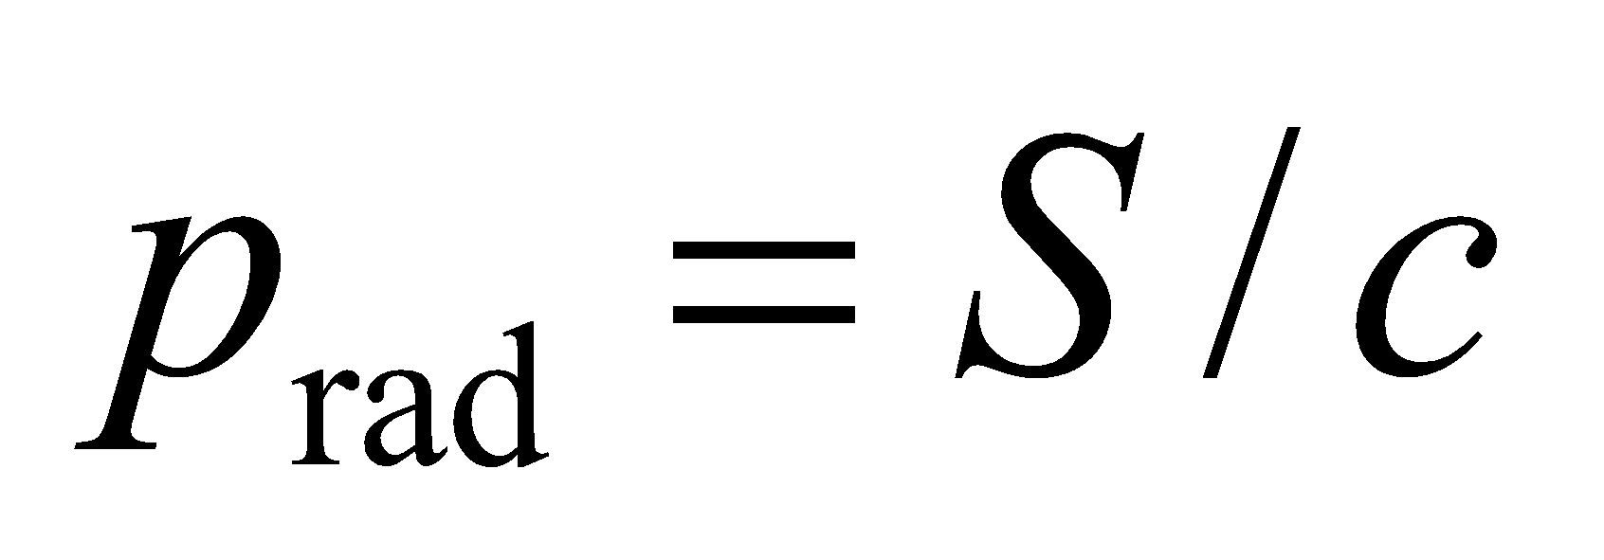 (Equation 29.22). The sun radiates uniformly in all directions (with 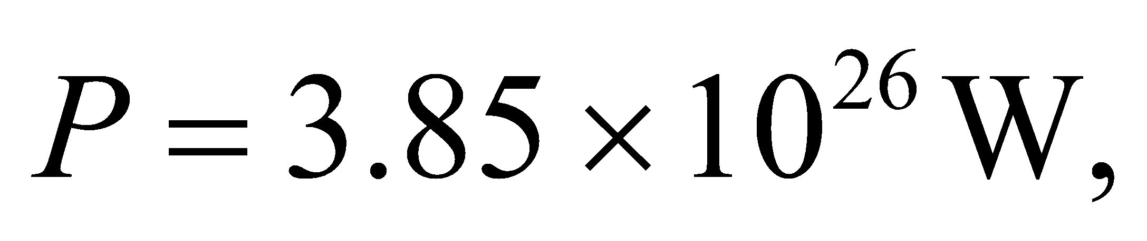from inside cover), so the radiation pressure decreases as one over the distance squared: 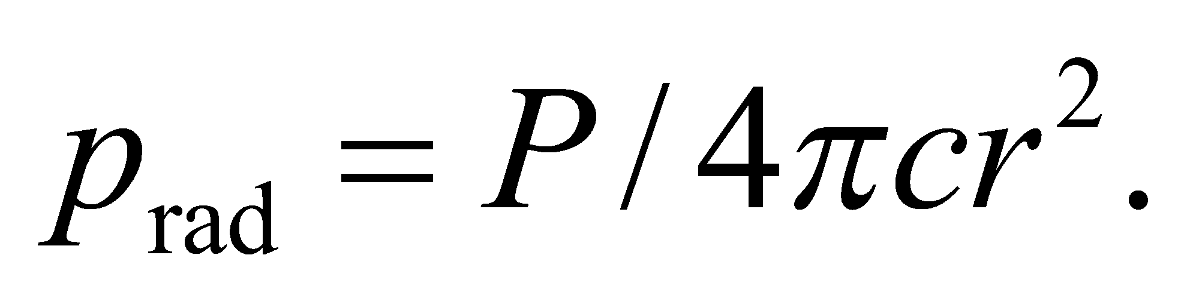 A small particle with radius R will have one face 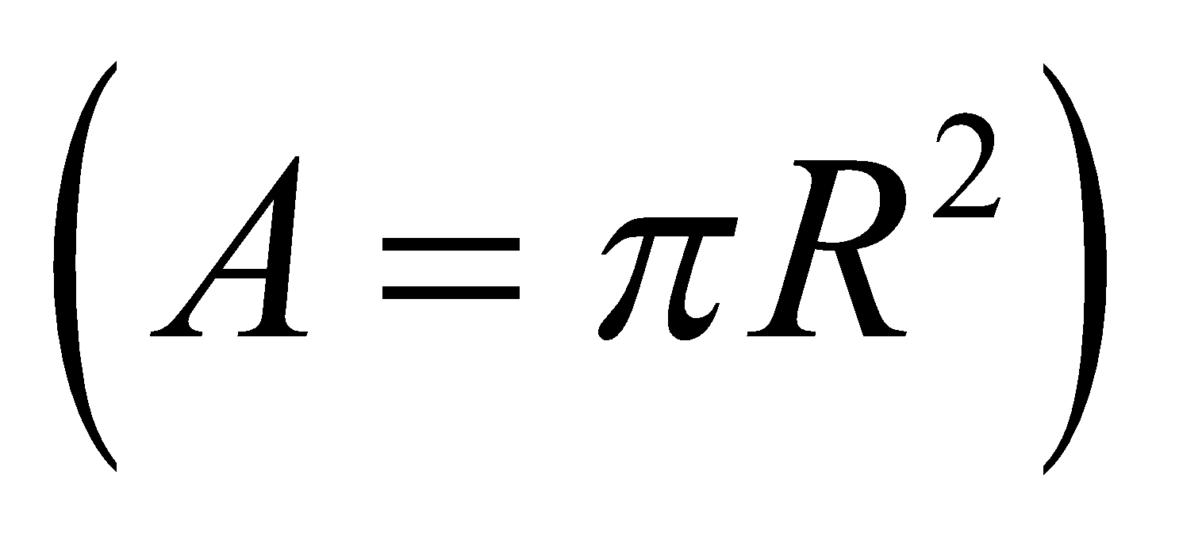exposed to this pressure. We assume that the particle absorbs the radiation, but does not reflect it, so it will absorb the momentum and thus experience a radiation force of
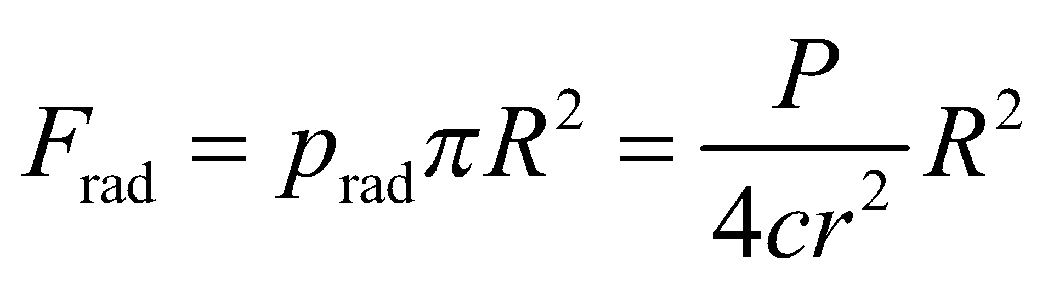
In comparison, the gravitational force on the same particle will be
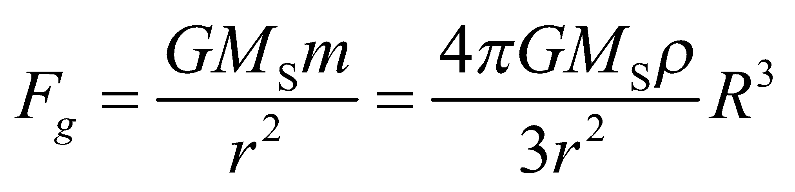
where we have used the density to write the mass as a function of the particle’s radius.
Evaluate The radiation force will point outwards, away from the sun, while the gravitational force will point inwards. You want to know at what particle radius will the two forces cancel each other:
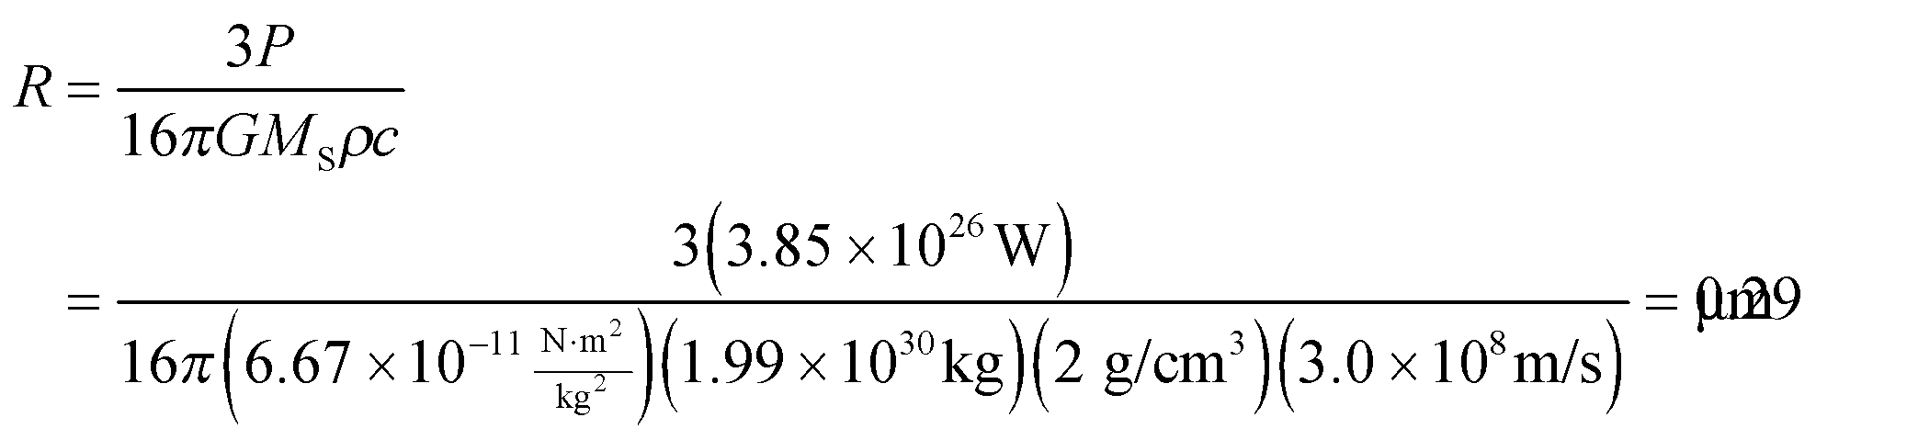
Assess Particles smaller than this radius would presumably have been blown out of the early solar system. Larger particles would have stuck around to form planets, comets and other solar system bodies. The particle size discrimination does not depend on the distance from the sun because both the radiation force and gravitational force are proportional to 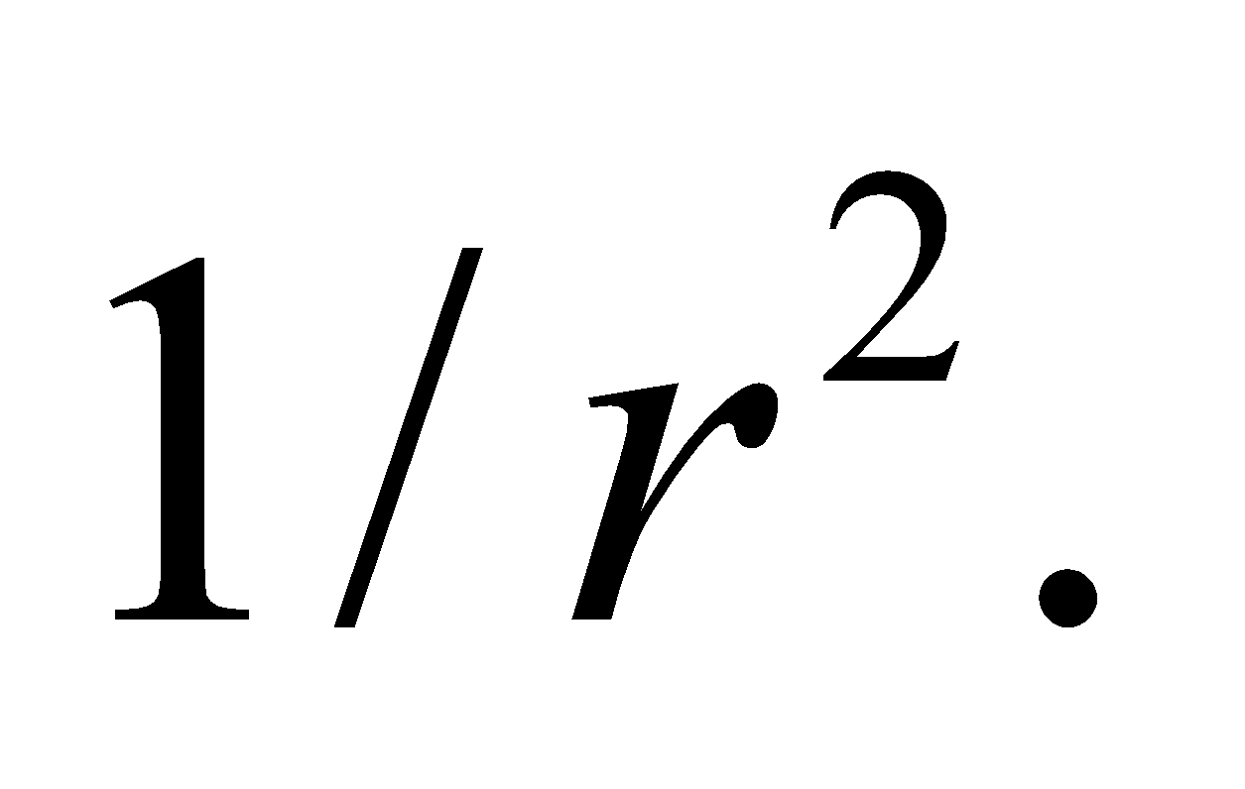
63. Interpret We will use Maxwell’s equations to derive the wave equation for electromagnetic radiation.
Develop We will start with the differential form of Faraday’s law: 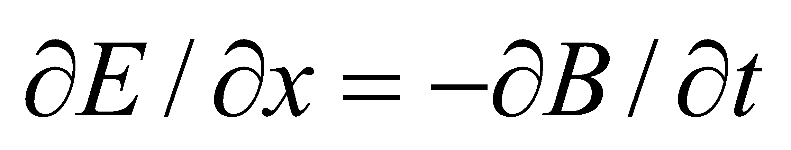 (Equation 29.12) and differentiate it with respect to x. Then we will take the differential form of Ampère’s law: 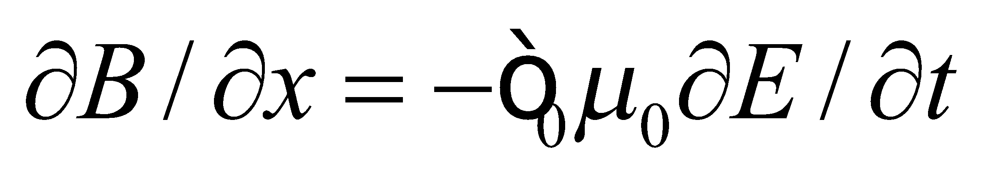 (Equation 29.13) and differentiate it with respect to t. The combination of these two equations should match that of the generic wave equation: 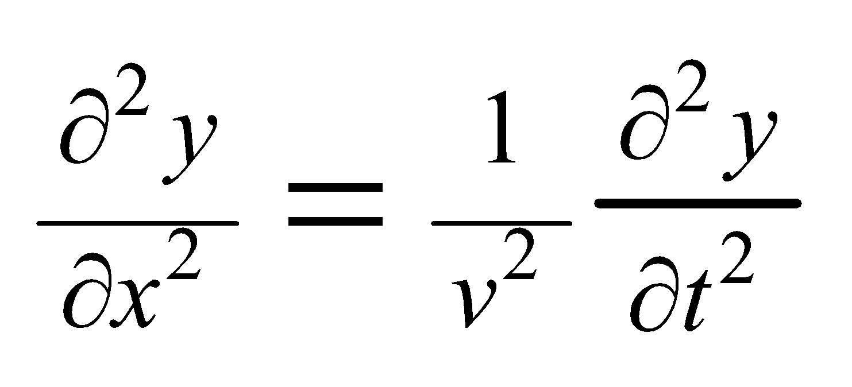 (Equation 14.5).
Evaluate Taking the derivatives specified above, we have
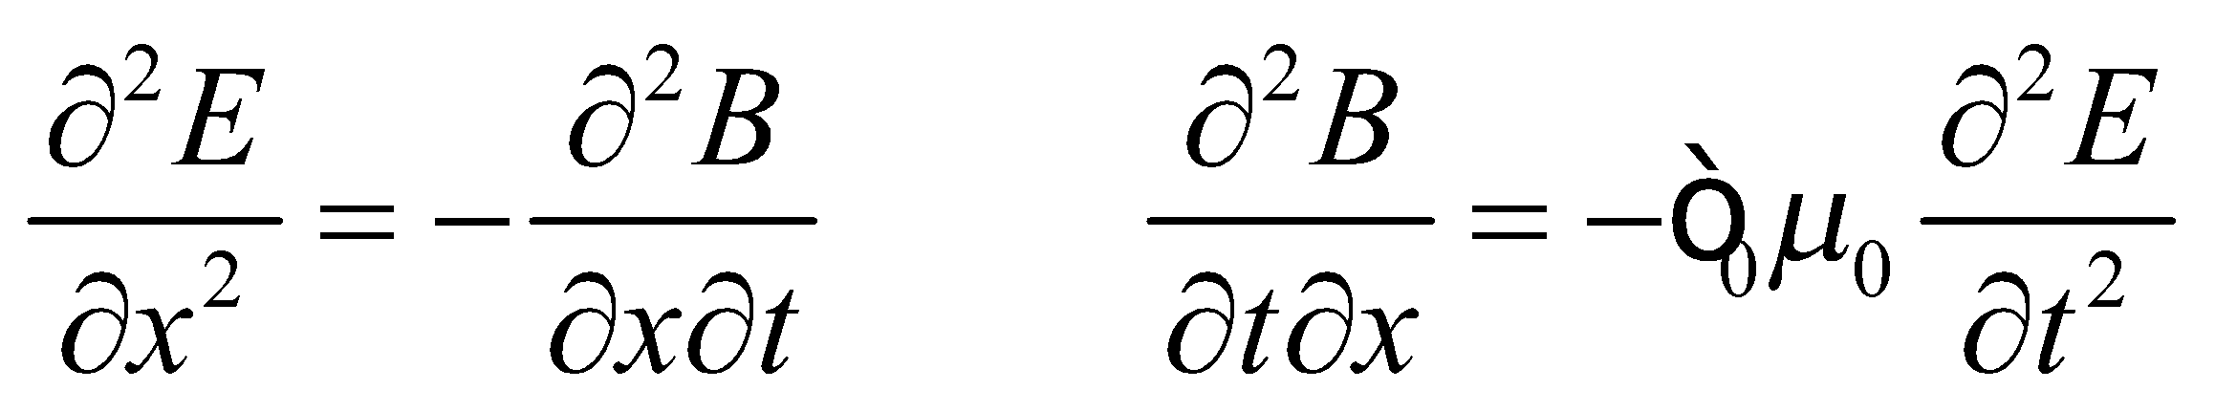
Since the order of the partial derivatives is irrelevant, the magnetic field derivatives in the two equations are equal, so we get
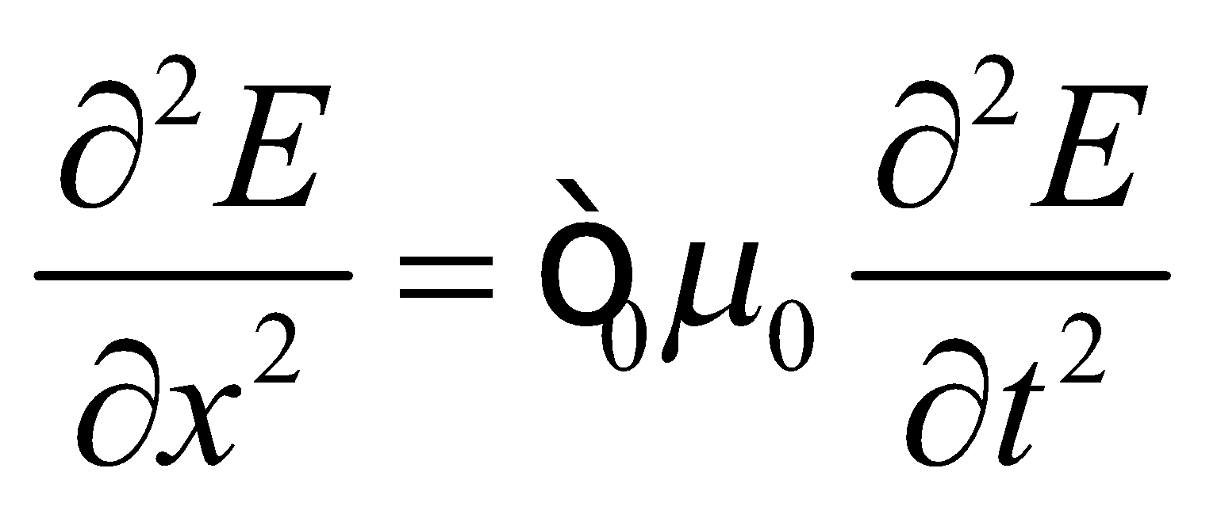
This has the same form as Equation 14.5, which implies the electric field behaves as a wave with speed 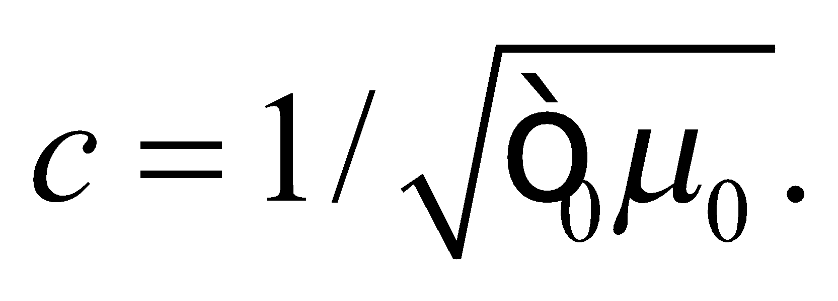By reversing the differentiations, we can show the exact same thing for the magnetic field.
Assess As described in Chapter 14, the solution to the wave equation is any function of the form 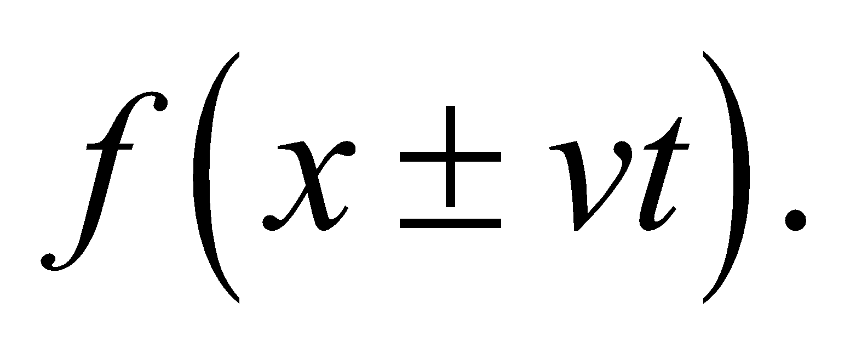 So electromagnetic waves do not necessarily have to be sine waves, but any shape of wave can be analyzed as the sum of individual sine waves (see Figure 14.18).
64. Interpret We are to find the speed of an electromagnetic wave in a medium of dielectric constant
Develop If we replace all instances of  with , then our result will be the same as before but with 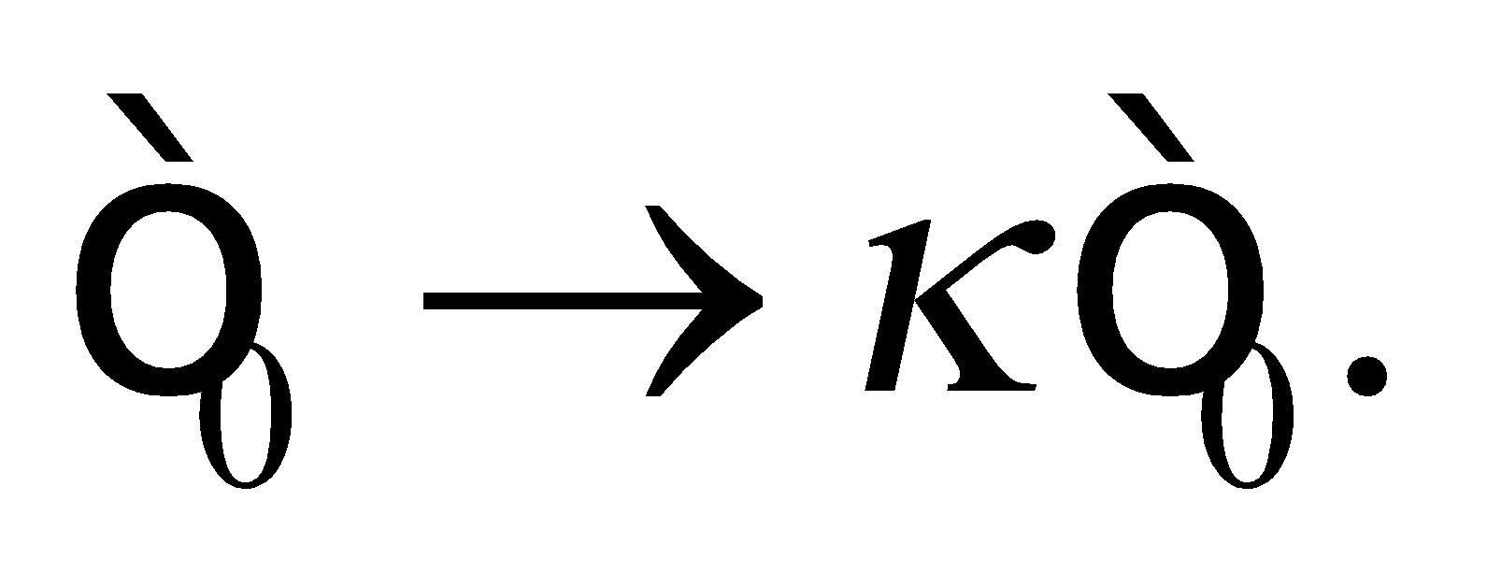
Evaluate The speed of light in a vacuum is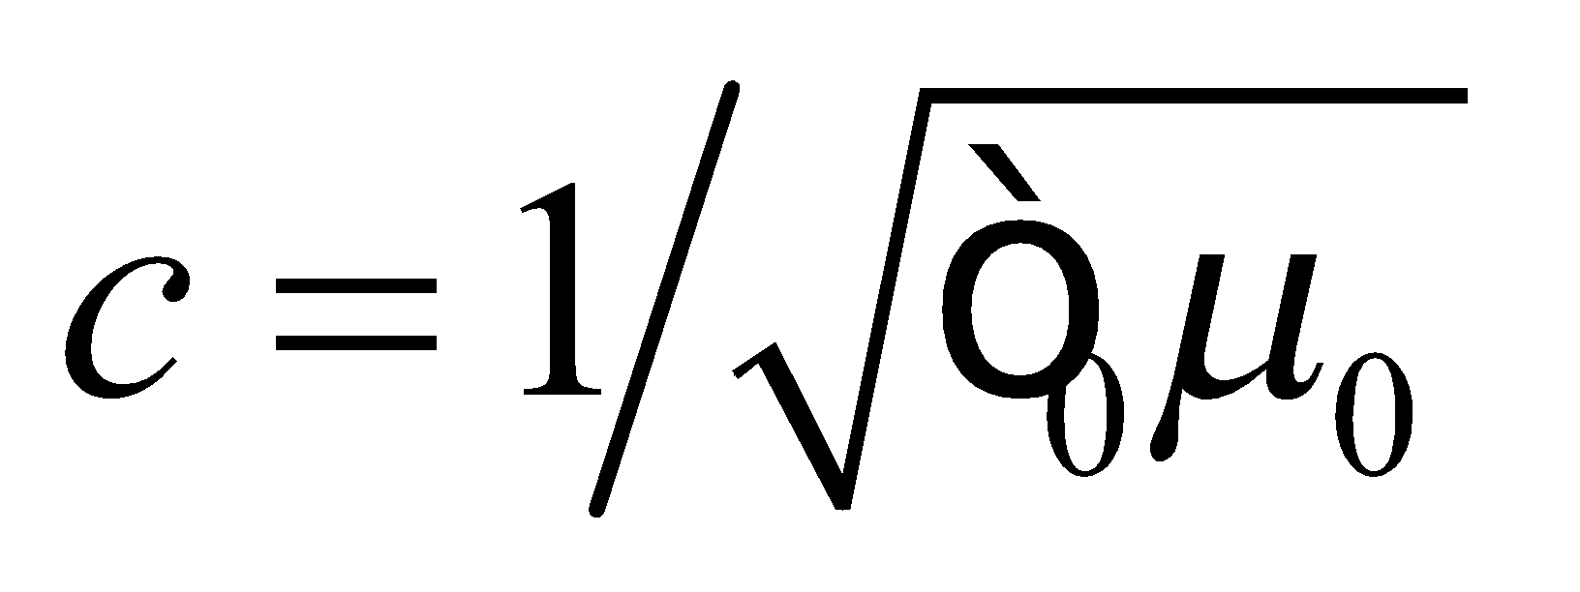. We make the substitution 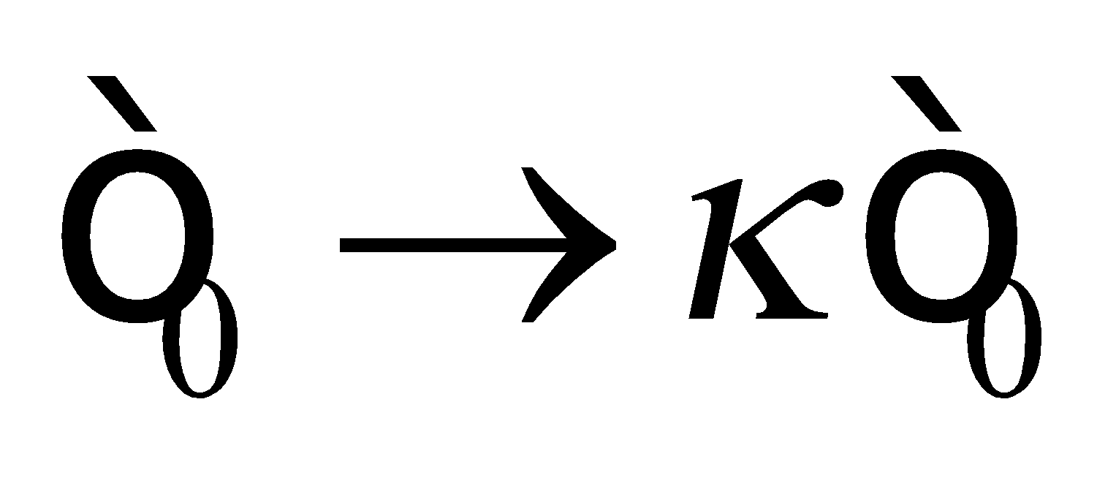 and obtain
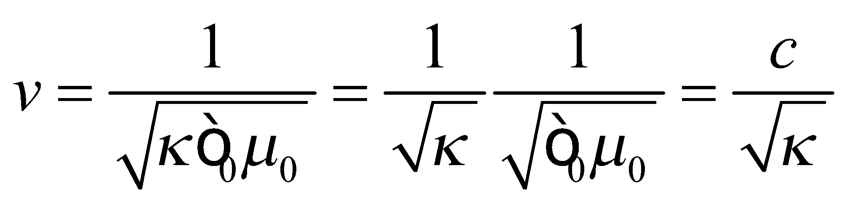
Assess We could obtain the same result with more effort by going through the whole derivation again, making the replacement at each step.
65. Interpret We are to find the quarter wavelength of the given electromagnetic radiation.
Develop We use the relationship between frequency and wavelength (Equation 29.16c) 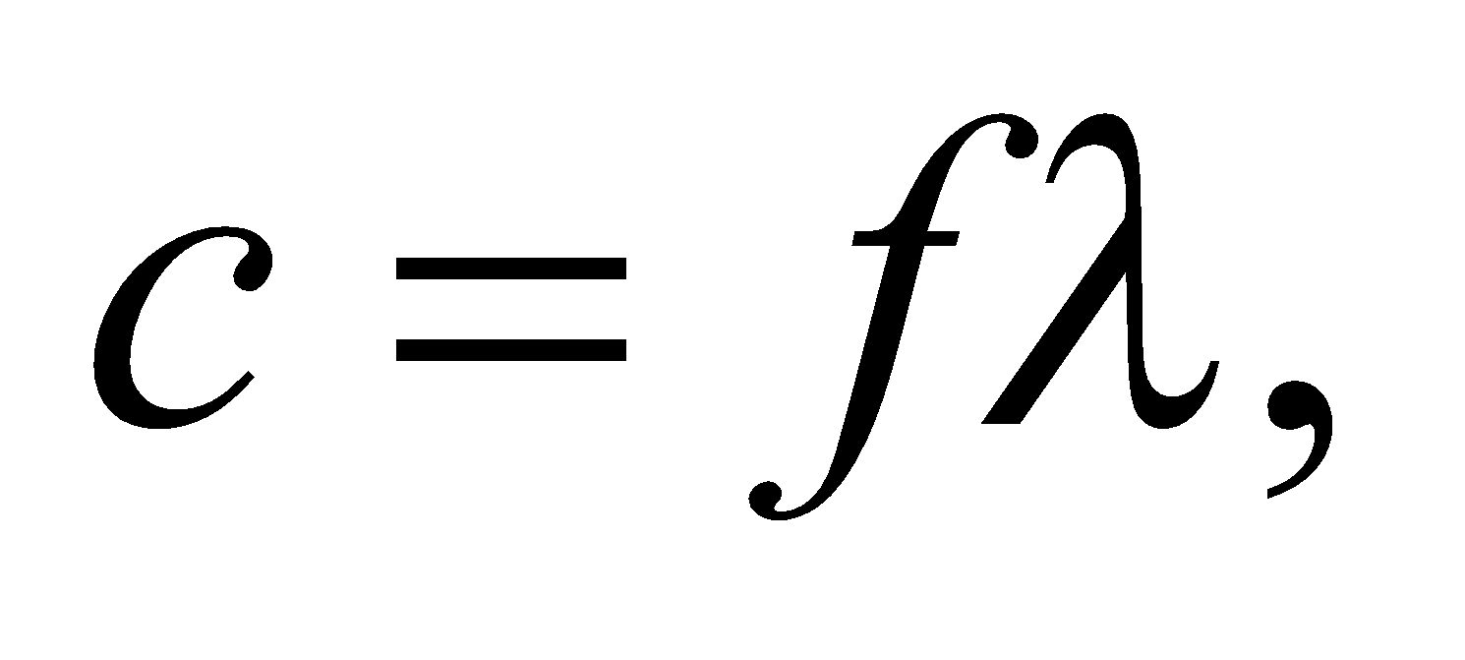 to find the wavelength of the signal, then divide by 4.
Evaluate The length of the antenna should be
Assess This seems reasonable—it’s about the length of the long antennas typically seen on pickup trucks.
66. Interpret You want to show that solar power could potentially meet our energy needs.
Develop The total sunlight reaching the Earth’s surface will depend on clouds and other atmospheric effects, but for simplicity you can assume that all of the sun’s intensity within the cross-sectional area of the Earth reaches the ground. That means the total power that could potentially be tapped is 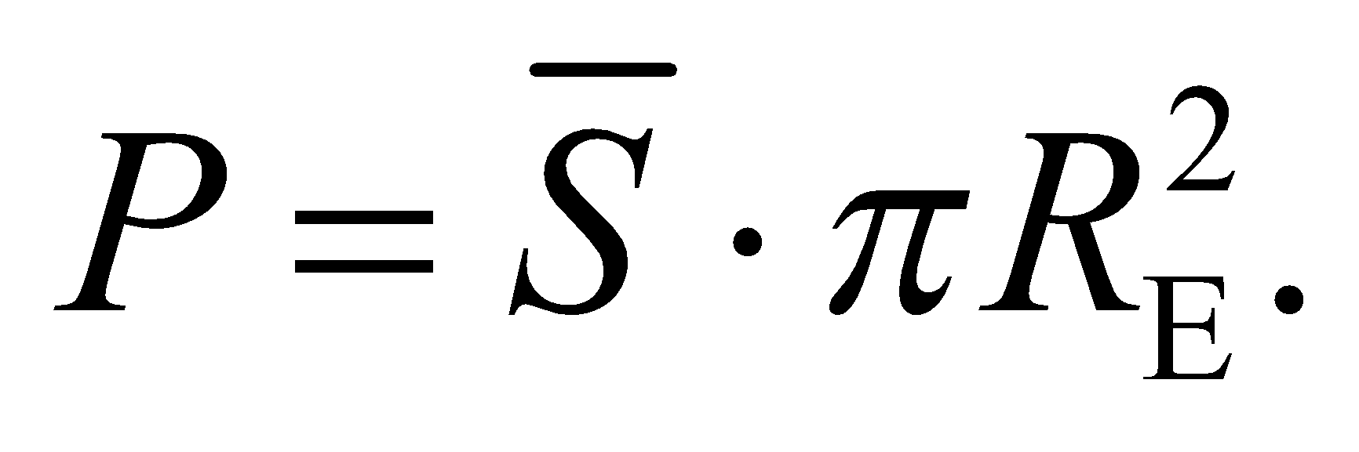
Evaluate The average solar intensity at Earth’s distance from the sun is
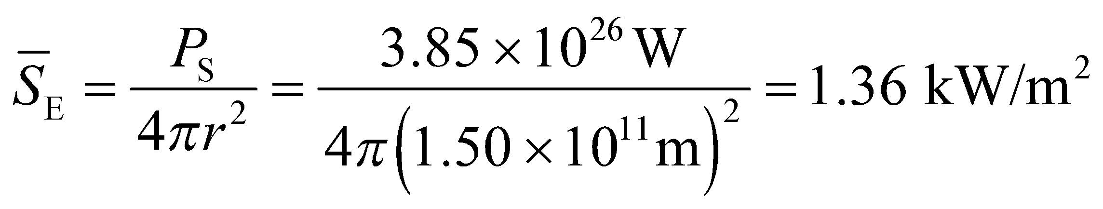
This quantity is called the "solar constant." Multiplying by the cross-sectional area of Earth, the total incident solar power is
This is over 10,000 times the current global power consumption of human beings. So there seems to be sufficient potential in solar power.
Assess If you take the total power and divide by the surface area of the Earth, you get a very rough estimate of the average solar intensity at a point on the Earth (i.e. accounting for day-night and seasonal effects):
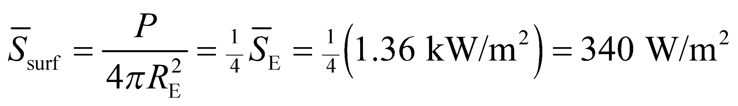
Let’s assume that current solar power collectors are about 10% efficient at converting solar radiation into electricity, in which case the amount of area you’d need to cover with solar collectors to meet global demand would be approximately
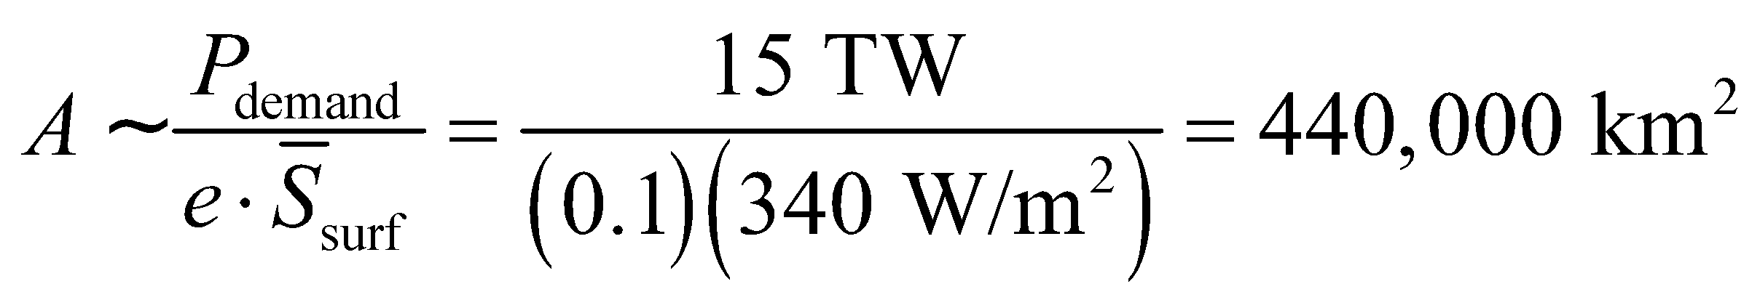
This is about the size of the state of California, although if such a grand project were realized, it would clearly be better to distribute the solar collectors evenly across the planet.
67. Interpret We’re asked what size of receiver dish will be needed to capture the Voyager 1 radio transmission in the future.
Develop If we assume that the spacecraft’s transmitter broadcasts its radio signal uniformly in all directions, then the intensity at Earth will be 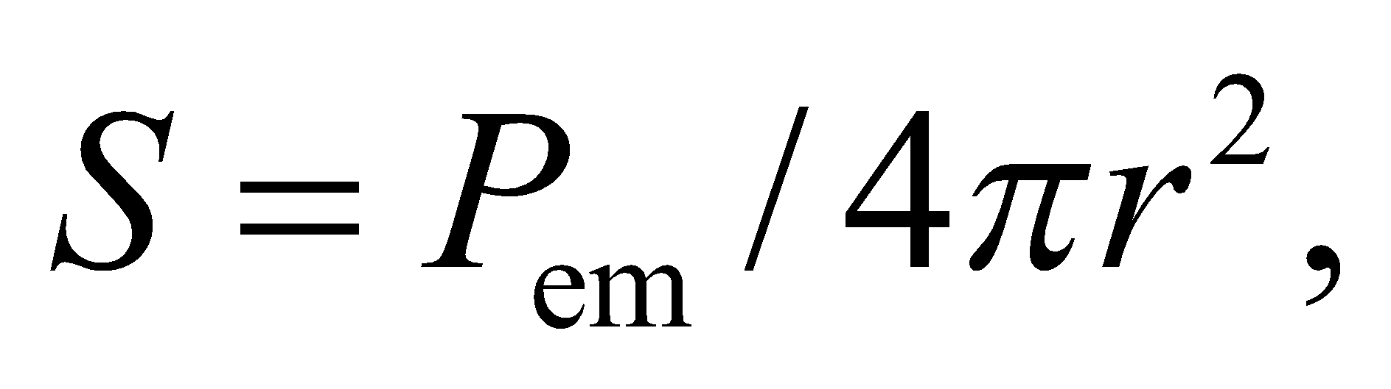where is the emitted power and r is the distance from Earth. An Earth-bound receiver of diameter, d, will be able to gather a signal with power 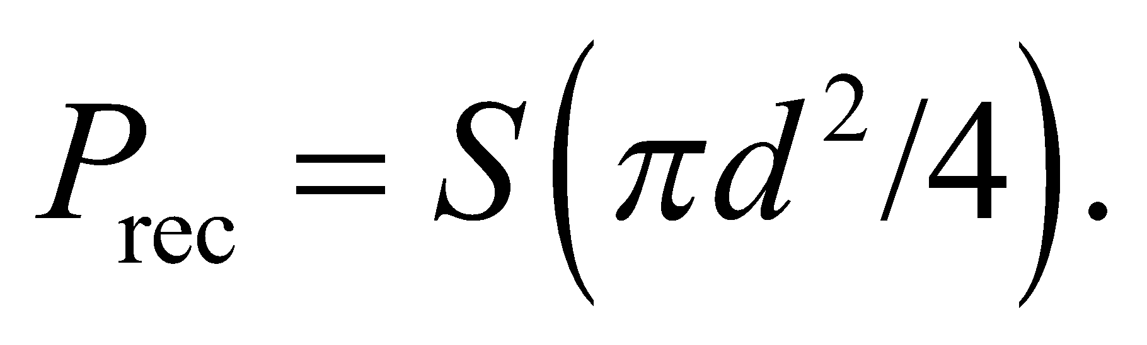
Evaluate Given the desired receiver signal, the receiver diameter will have to be
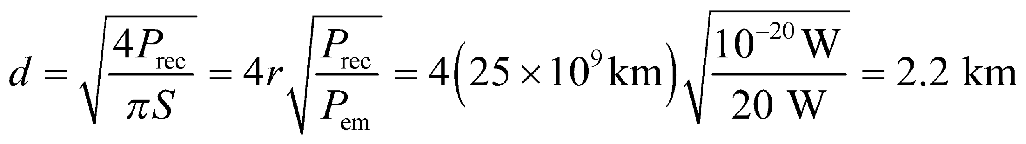
Assess There is no single dish of this size currently. The Arecibo observatory comes closest with its 305-m diameter dish. There are plans to build a 500-m diameter single dish telescope in China, but nothing spanning 2 kilometers is in the works. However, our assumption that Voyager 1 broadcasts in all directions is not correct. The transmitter is shaped like a parabola, and therefore beams its signal towards Earth, so a smaller receiver should be sufficient.
68. Interpret From a measurement of electric field at some distance from an antenna, we are to estimate the power radiated from the antenna. We will assume that the antenna radiates uniformly in all directions, and use the inverse-square law (see Equation 29.21).
Develop We are told that the electric field at a distance R = 4.6 km is E = 380 V/m. With the Poynting vector
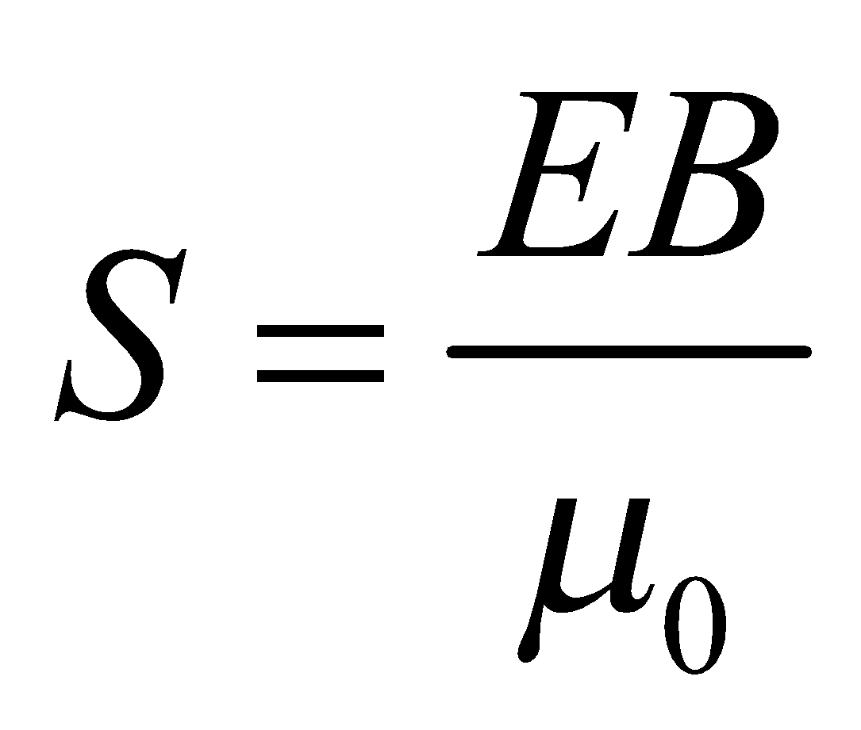 and E = cB
we can then find the intensity at this distance. From the area of the sphere at this distance and
the intensity, we can calculate the total power coming from the antenna.
Evaluate The total power coming from the antenna is
Assess One thing to consider is that the transmission antenna does not radiate uniformly in all directions, so the actual power may be somewhat different depending on the relative elevation difference between the measurement location and the antenna, assuming the antenna is vertical. However, this is probably a good estimate, and the actual power of the antenna is likely to be lower if the measurement point is at about the same elevation as the antenna. The station is broadcasting legally.
69. Interpret We’re asked to consider the potential of solar sail technology.
Develop The solar sail is accelerated by the radiation pressure from the sun: 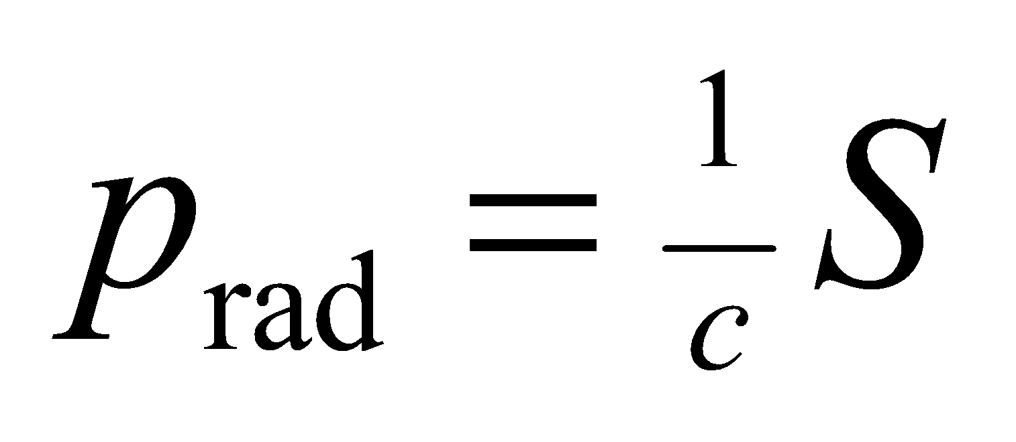 (Equation 29.22). We don’t know the area or the mass of the sail, but since the sun’s intensity decreases as one over the distance squared, so will the acceleration: 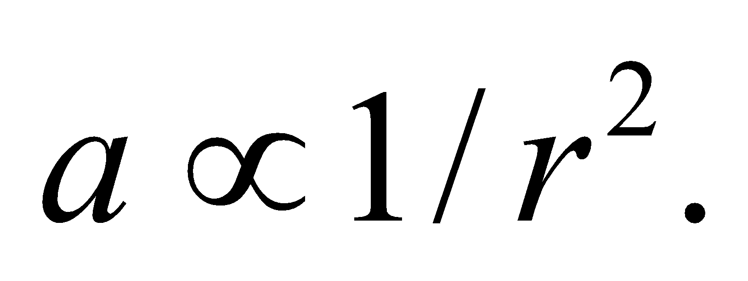
Evaluate The acceleration near Mars will be less than the acceleration near Earth. More specifically,
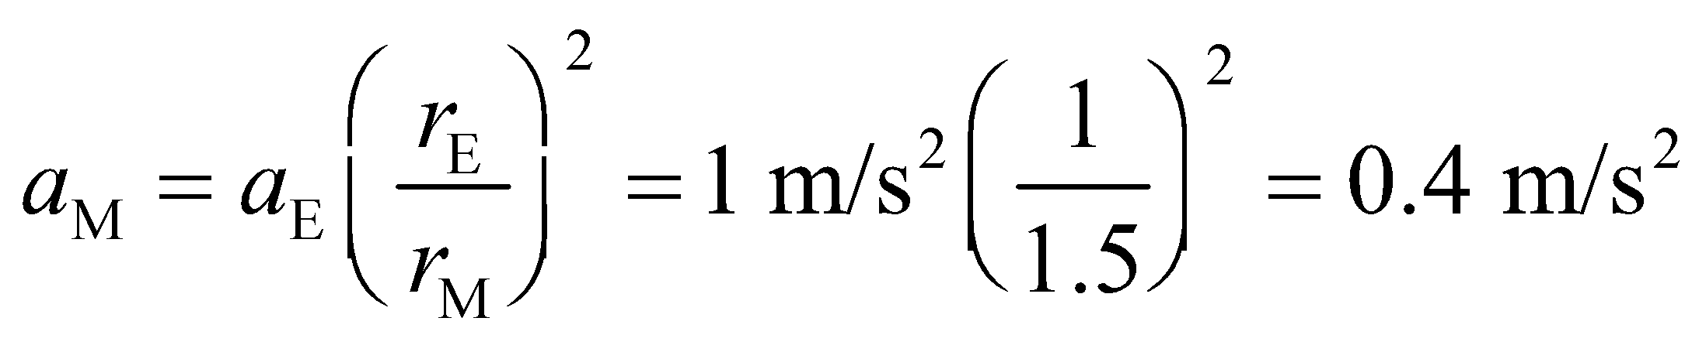
The answer is (b).
Assess The acceleration of the sail is not large, but it never "shuts off" like a rocket engine does, so the speed can build up over time. Using the fact that 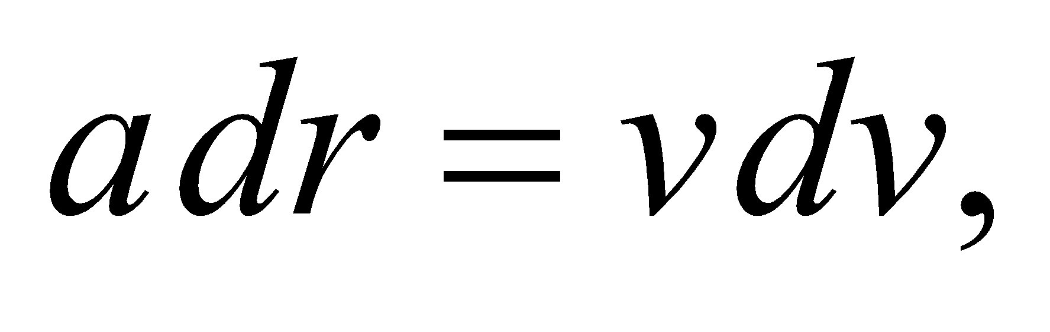we can integrate the sail’s acceleration from Earth’s orbital radius to that of Mars:
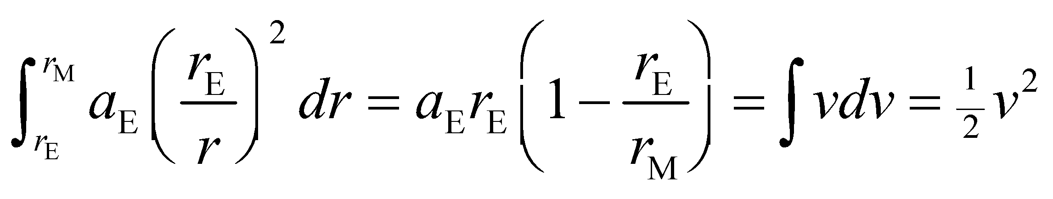
where we have assumed that the solar sail started at rest at Earth. Plugging in the values from above, the sail’s speed once it reaches Mars would be about 300 km/s.
70. Interpret We’re asked to consider the potential of solar sail technology.
Develop The rate at which light waves carry momentum per unit area is 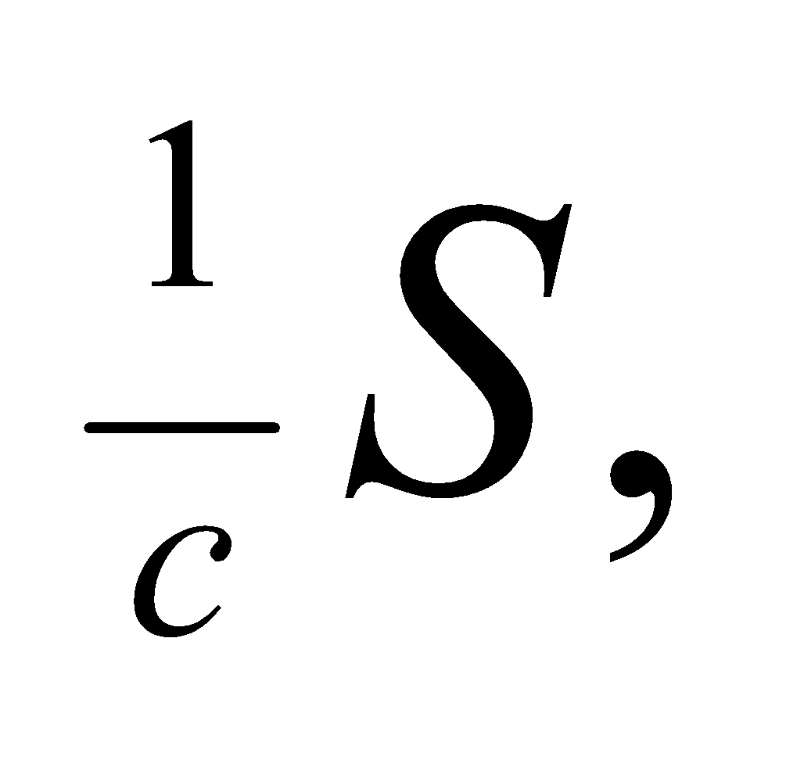 so an object that absorbs this light over an area A and during time  will gain in momentum by 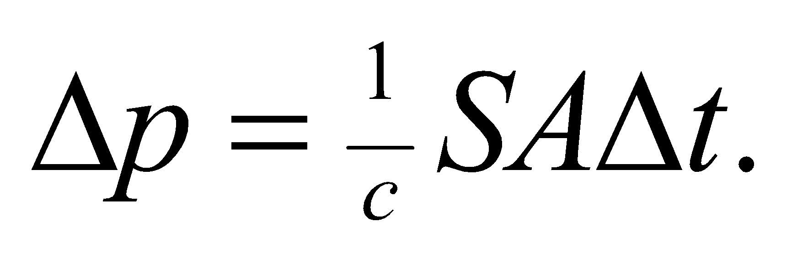However, if the light is reflected rather than absorbed, then the light’s momentum is reversed and the object’s gain in momentum will be double: 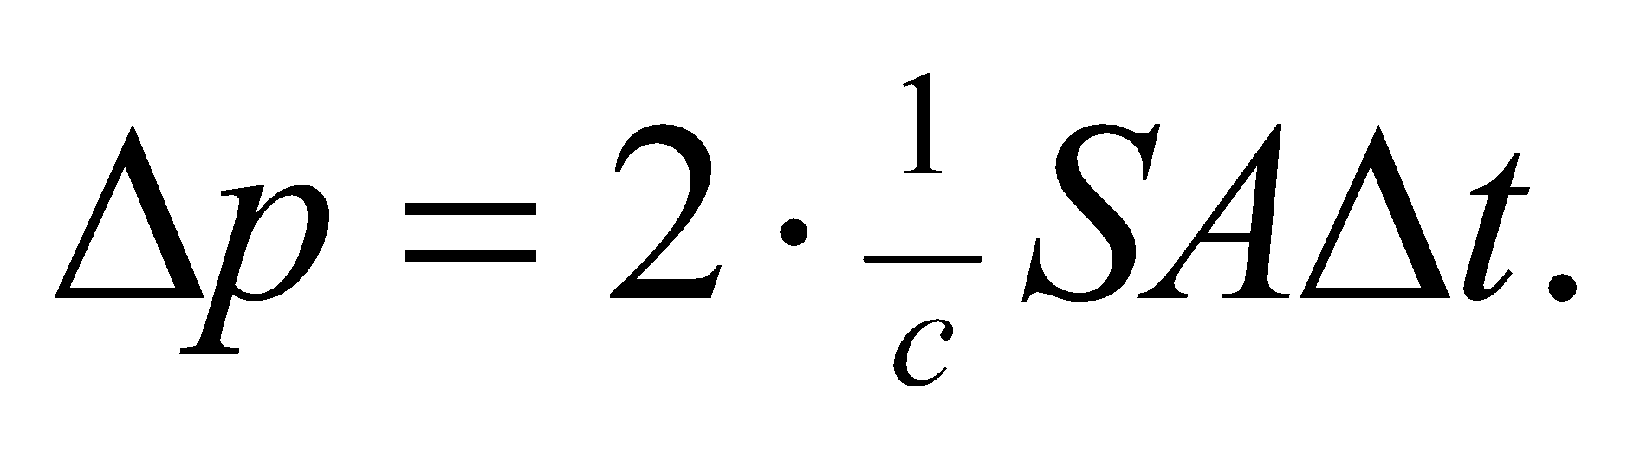
Evaluate Since the acceleration is proportional to the momentum change: 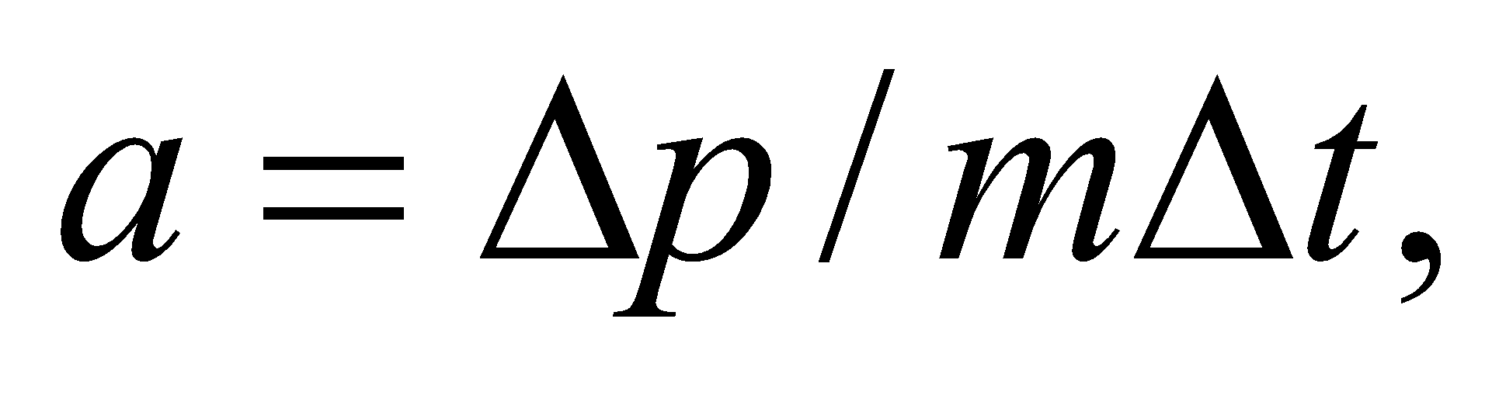 a reflective sail should have twice the acceleration of the absorptive sail.
The answer is (b).
Assess We’ve assumed here that the reflective sail is flat, and the incoming light is normal to its surface. If the sail happened to be curved or tilted, then the reflected light would not be directed back towards the sun, and the change in momentum would be less than twice that of the absorptive case.
71. Interpret We’re asked to consider the potential of solar sail technology.
Develop In the previous problems, we have argued that the radiation pressure and the force it applies to the sail are proportional to This is also true of the gravitational force.
Evaluate Since Jupiter is roughly 5 times further from the sun than Earth, the sail force at Jupiter’s position will be 25 times smaller. However, the gravitational force from the sun will also be 25 times smaller, so the sail force will still be 20 times solar gravity.
The answer is (d).
Assess For the sail force to dominate gravity, the sail must be light-weight with a large surface area. We can write the ratio of the forces in terms of the area and the mass:
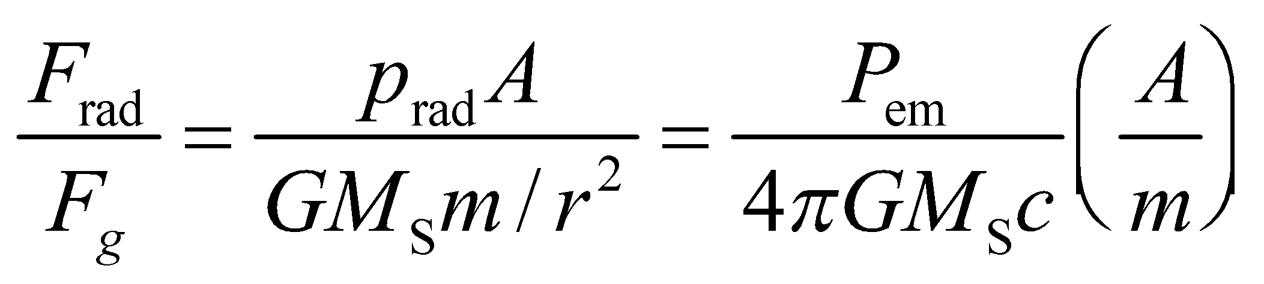
where we have written the sun’s intensity in terms of the emitted power: 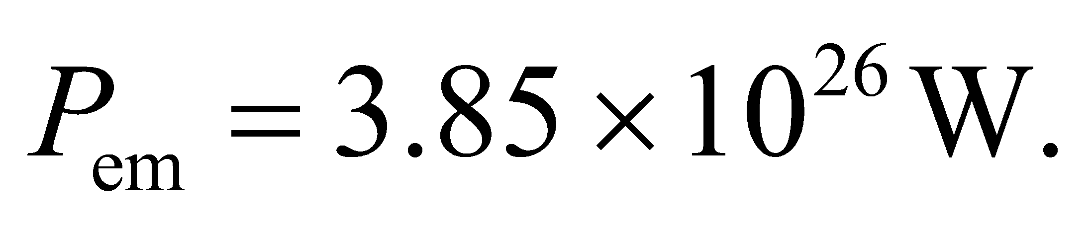 Plugging this in with the mass of the sun, 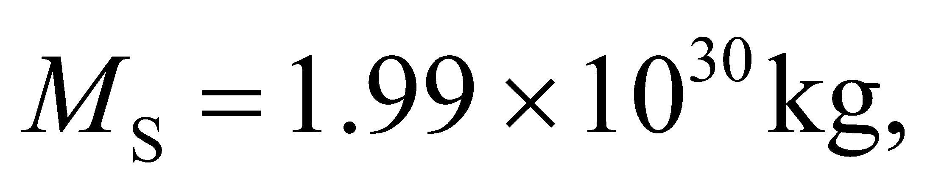we get
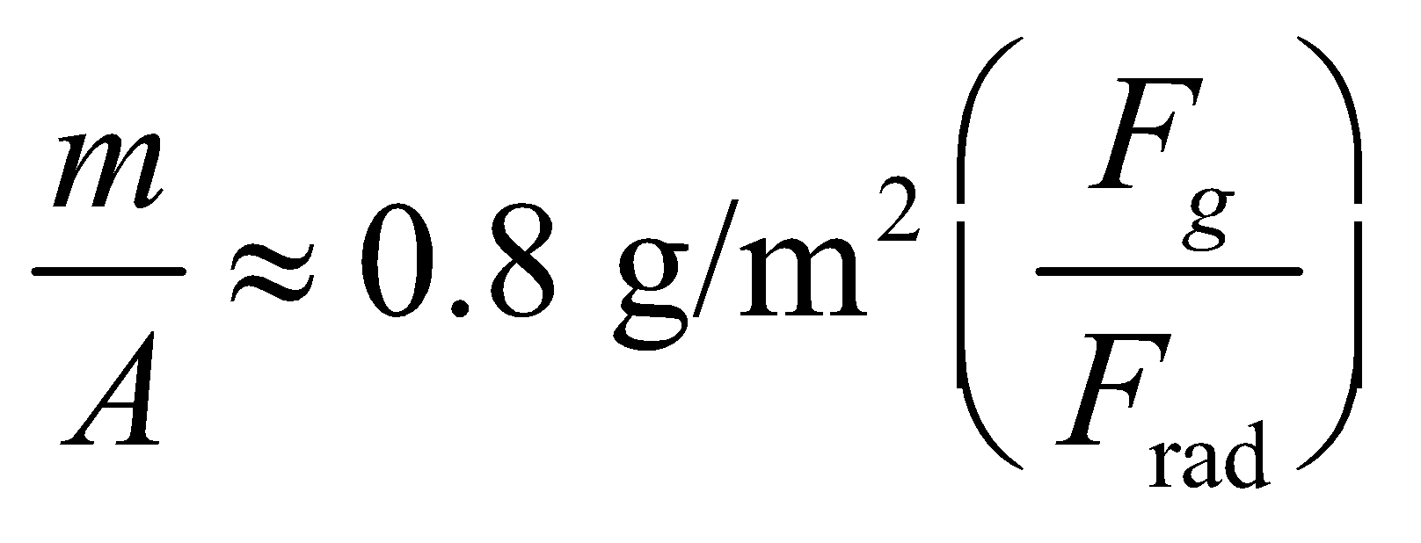
What this says is that each gram of spacecraft requires more than a square meter of sail if the radiation force is to overcome gravity.
72. Interpret We’re asked to consider the potential of solar sail technology.
Develop We’re given the sun’s intensity and the area of the sail, so the force from radiation is
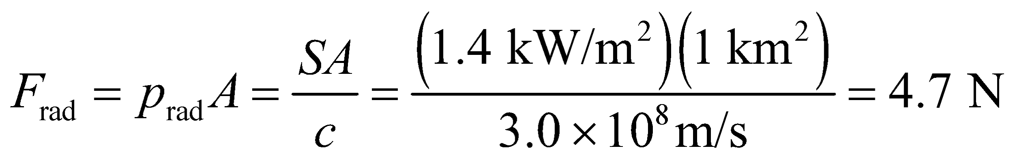
Evaluate For the given mass of 100 kg, the spacecraft should accelerate at about 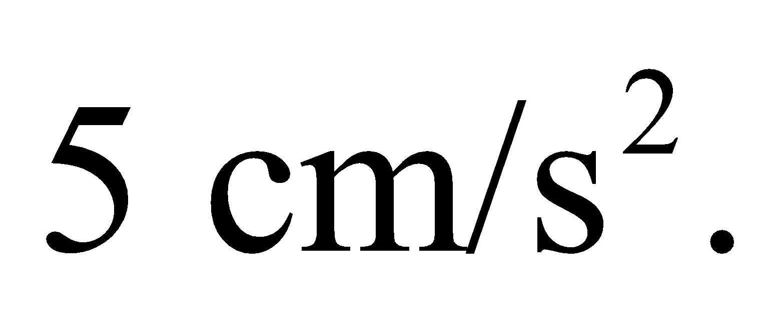
The answer is (b).
Assess The mass to area ratio of this sail is 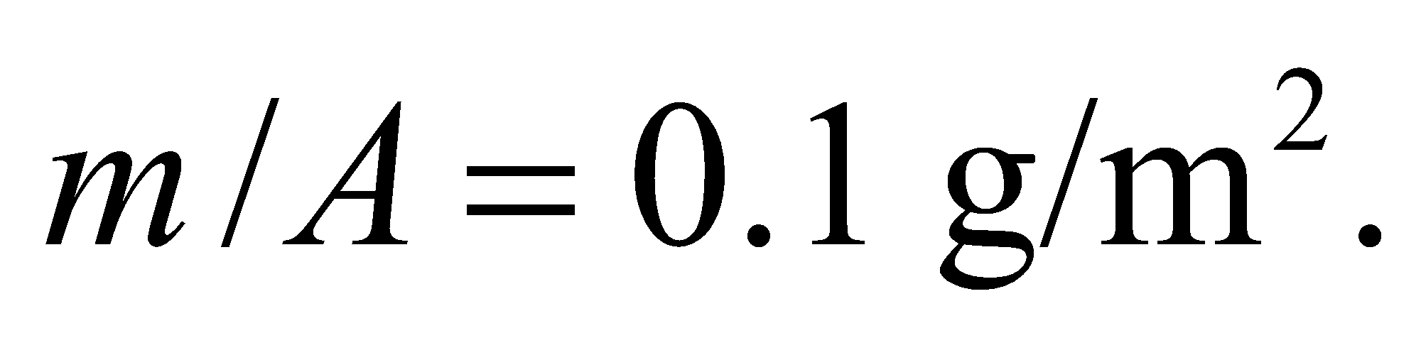 Plugging this into the equation we derived in the previous problem, we see that the gravitational force on the sail will be about 1/8th that of the radiation force.

