(E6.11) A system with a transfer function Y(s)/R(s) is

Determine the steady-state error to a unit step input. Is the system stable?

Ans.

Step input ,

Poles: 0, -5.67, -0.9, 0.280.714j

* The system is unstable due to right-half s-plane poles.

(E6.19) Determine whether the systems with the following characteristic equations are stable or unstable:

Ans.

1. Poles: 0.944.02j, -5.88 🡺 Unstable
2. Poles: -0.44, -4.56, -0.51.66j 🡺 Stable
3. Poles: -0.55, -5.5 🡺 Stable

(E6.23) A system is represented by Equation (6.22) where

, characteristic polynomial is .

Find the range of k where the system is stable.

Ans.

characteristic polynomial is .

The Routh array is

* 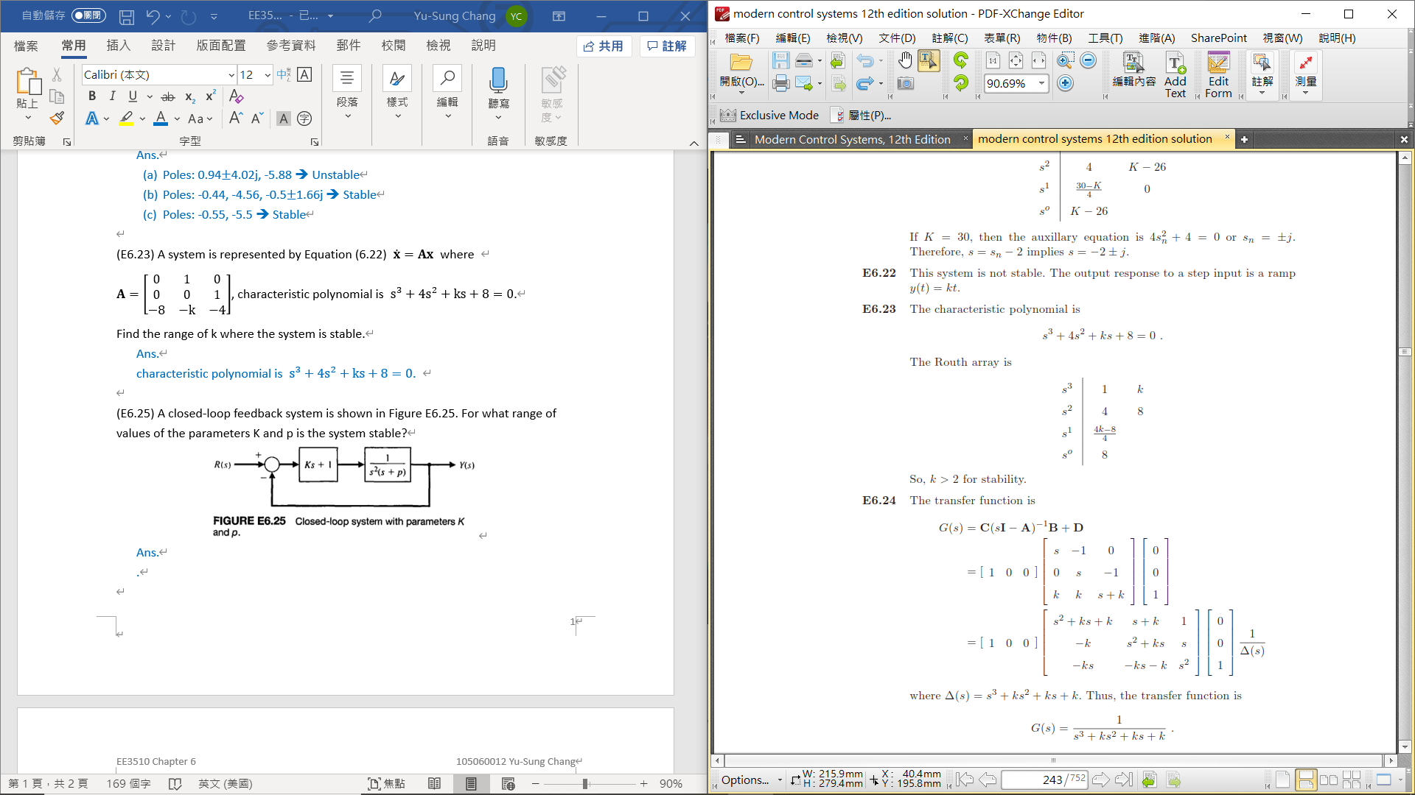
* For Stability,

(E6.25) A closed-loop feedback system is shown in Figure E6.25. For what range of values of the parameters K and p is the system stable?

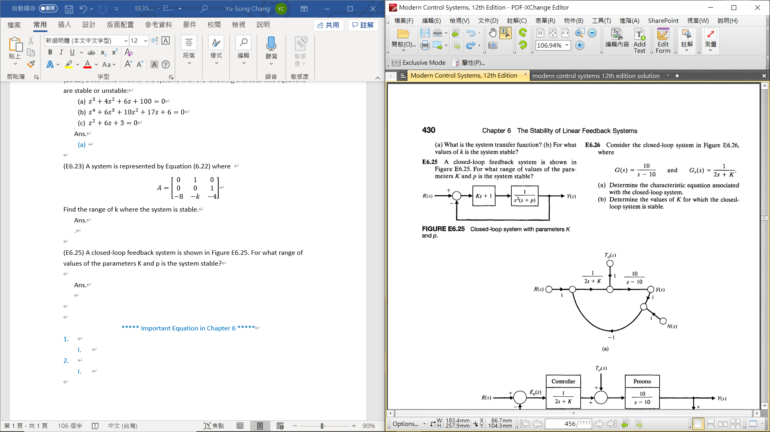

Ans.

🡪 the characteristic equation is

The Routh array is

* 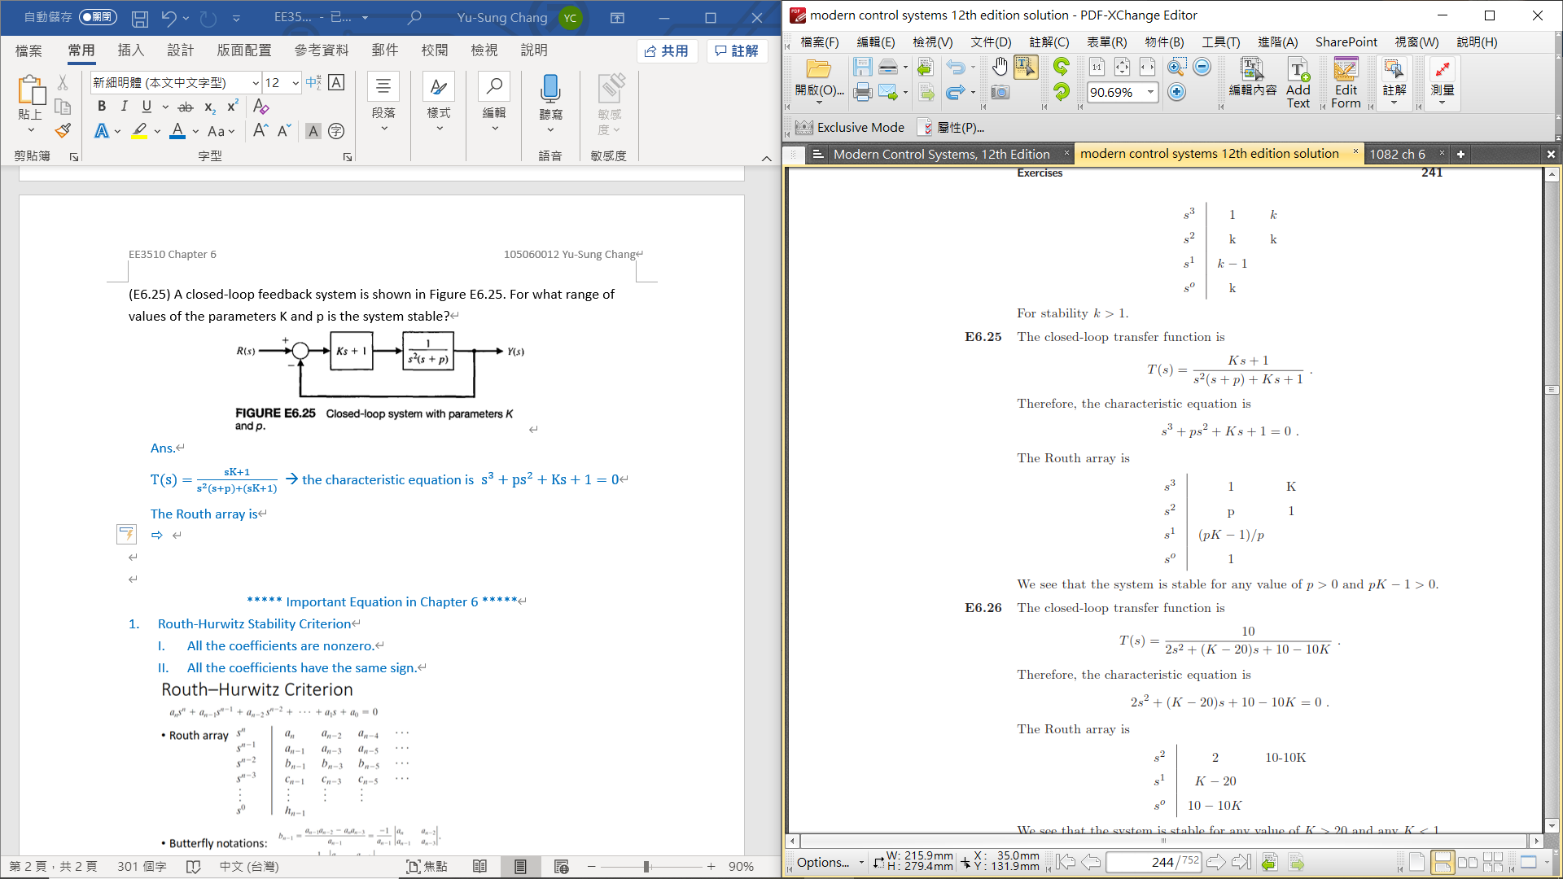
* For Stability,

\*\*\*\*\* Important Equation in Chapter 6 \*\*\*\*\*

1. Routh-Hurwitz Stability Criterion
   1. All the coefficients are nonzero.
   2. All the coefficients have the same sign.

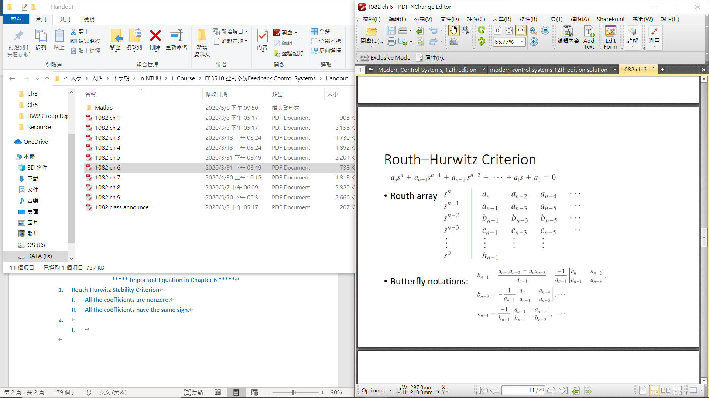

1. Four Distinct Cases for Routh Array Calculation Procedure
   1. Routh–Hurwitz criterion states that the number of roots with positive real parts is equal to the number of changes in sign of the first column of the  Routh array.
   2. Four cases: (1) No element in the first column is zero; (2) there is a zero in  the first column, but some other elements of the row containing the zero inthe first column are nonzero; (3) there is a zero in the first column, and the other elements of the row containing the zero are also zero; and (4) as in  the third case, but with repeated roots on the imaginary axis