Atlas MOSFET case

#Specifications:

1. Channel length = 0.18 μm.
2. Gate oxide thickness = 3 nm.
3. Adequate threshold voltage = 0.5 ± 0.2 V.

#Output:

1. Generate the device mesh for N-MOSFETs and P-MOSFETs.

* NMOS

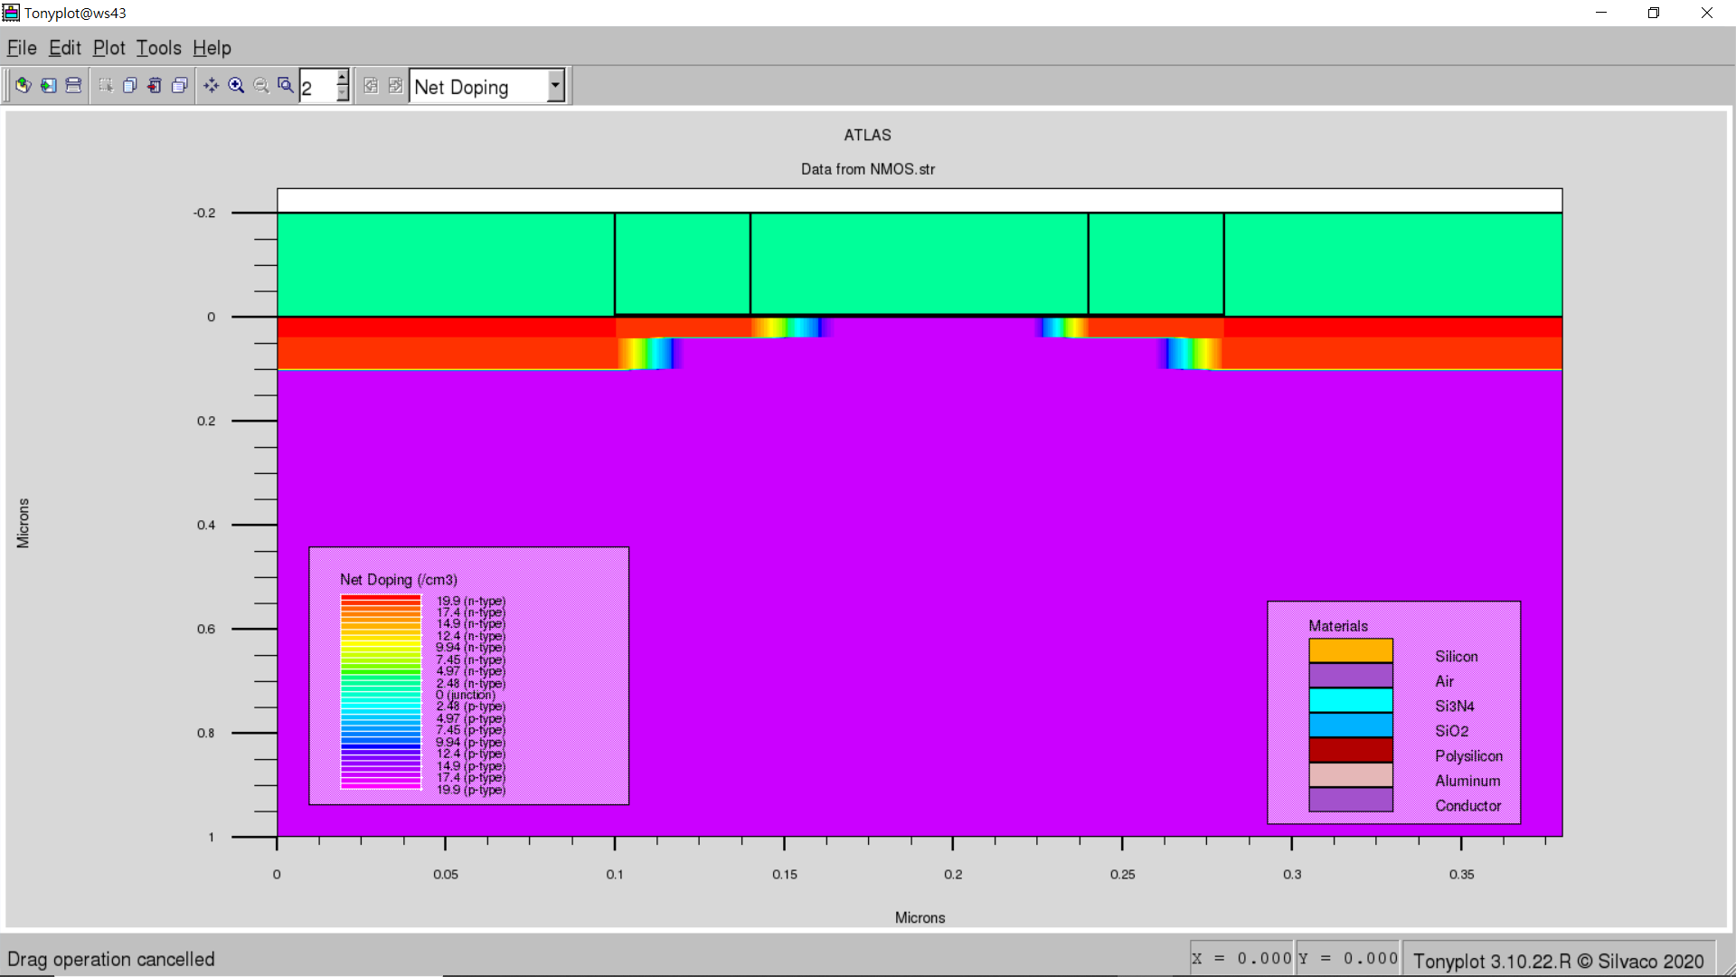

* PMOS

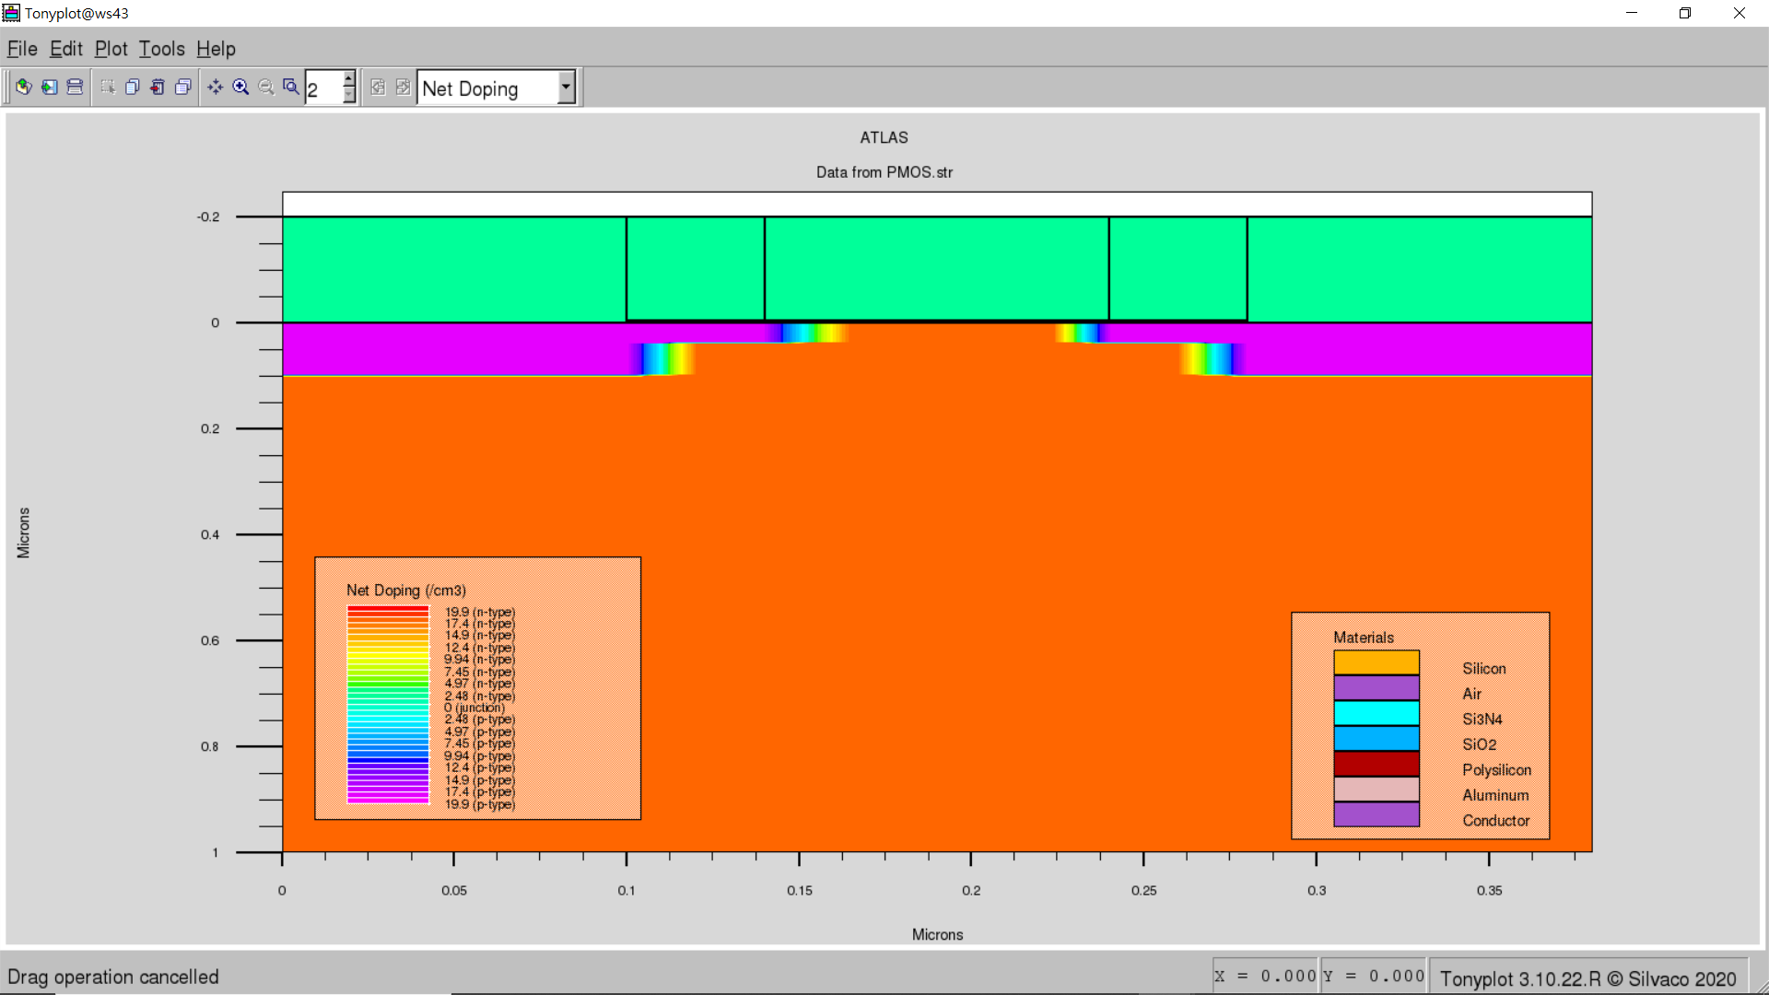

1. Plot Id-Vg at Vds= 1V for N-MOSFETs and P-MOSFETs.
   * NMOS

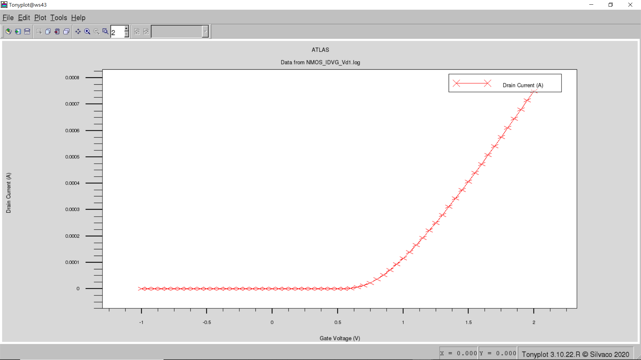

* + PMOS

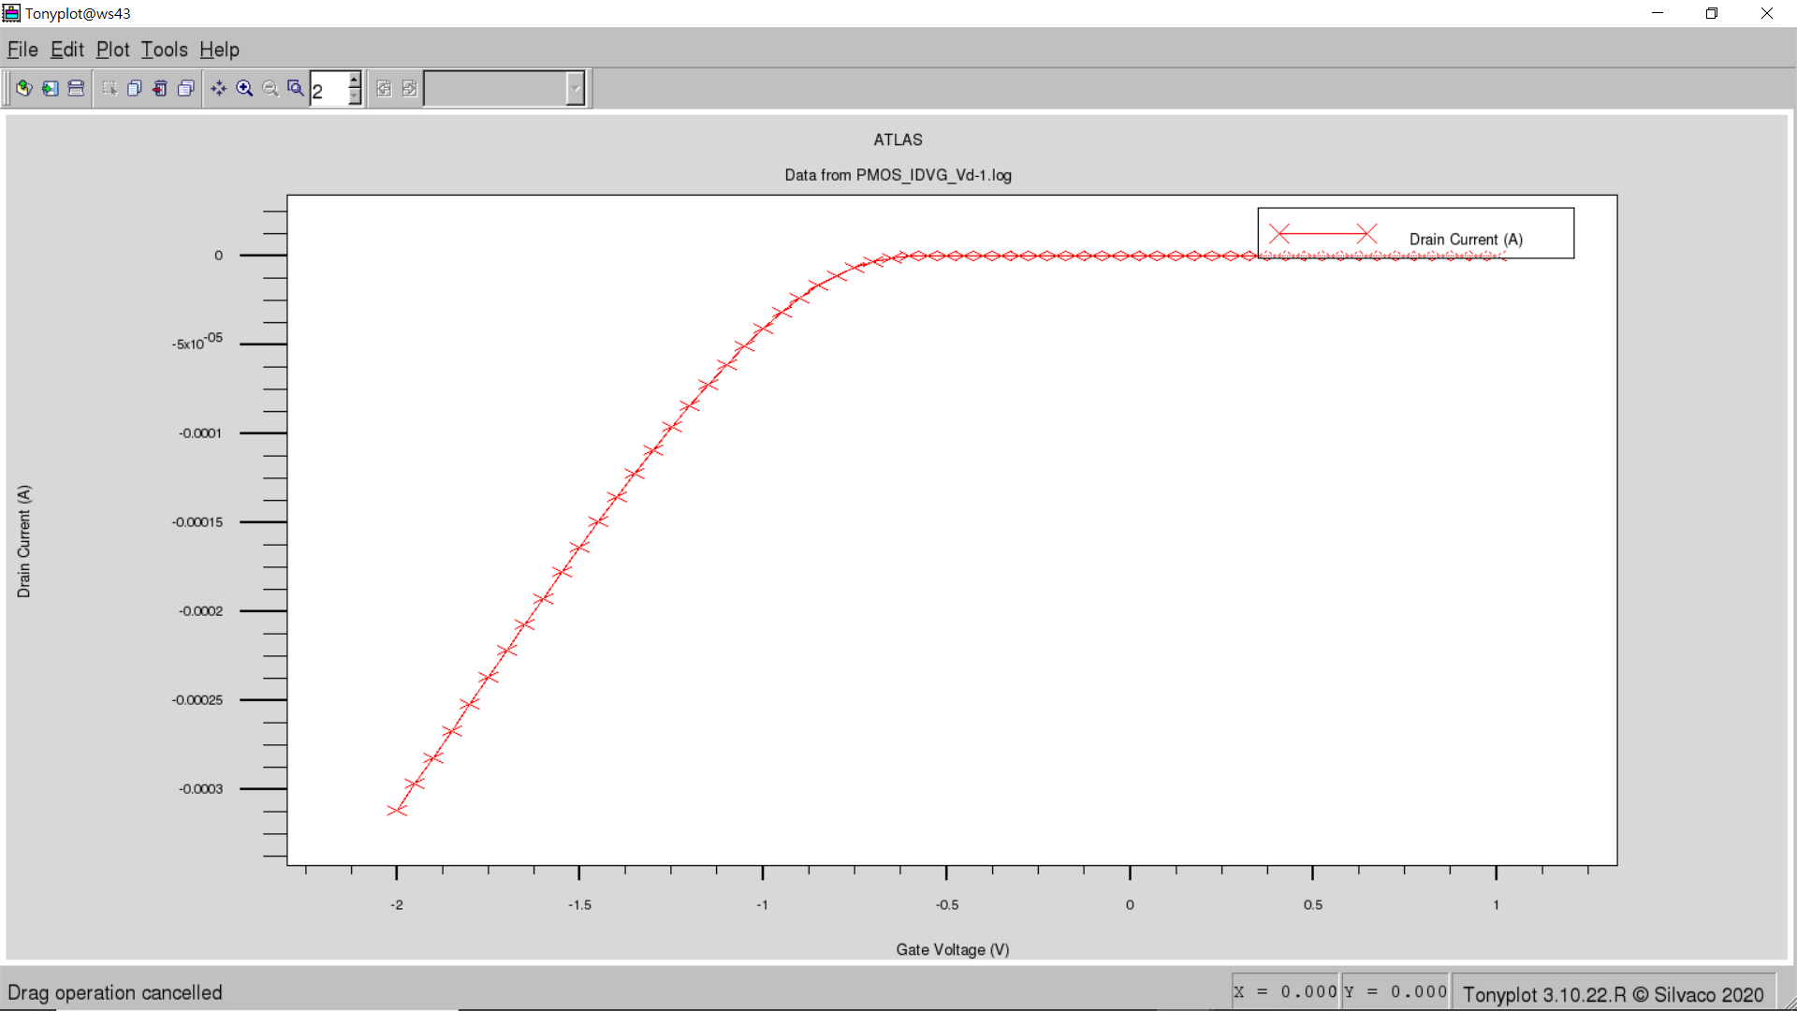

1. Plot Id-Vd at Vgs= 0.6, 0.8, 1V for N-MOSFETs and P-MOSFETs.
   * NMOS

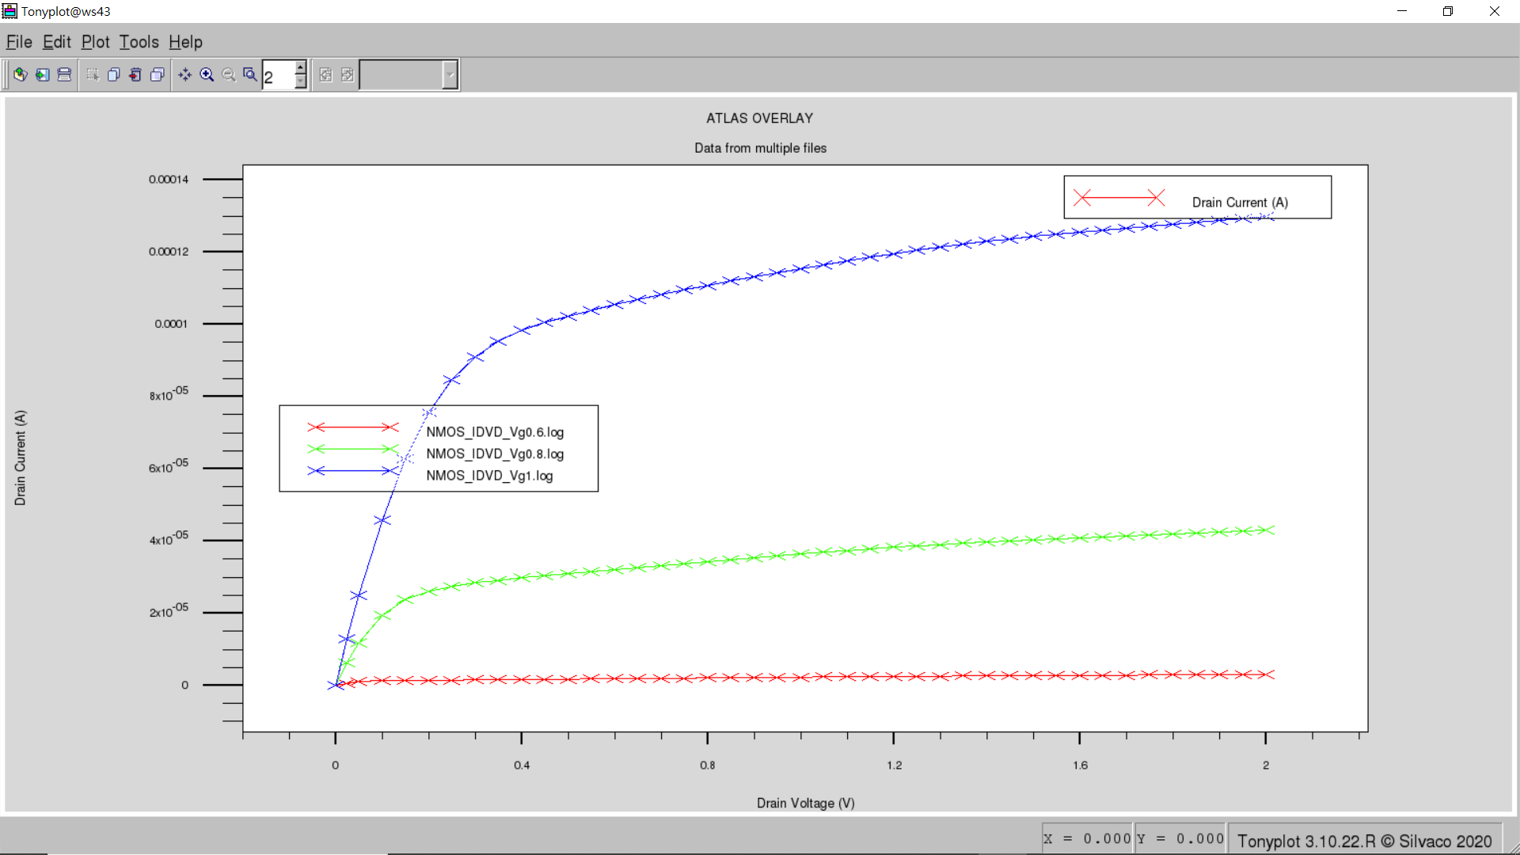

* + PMOS

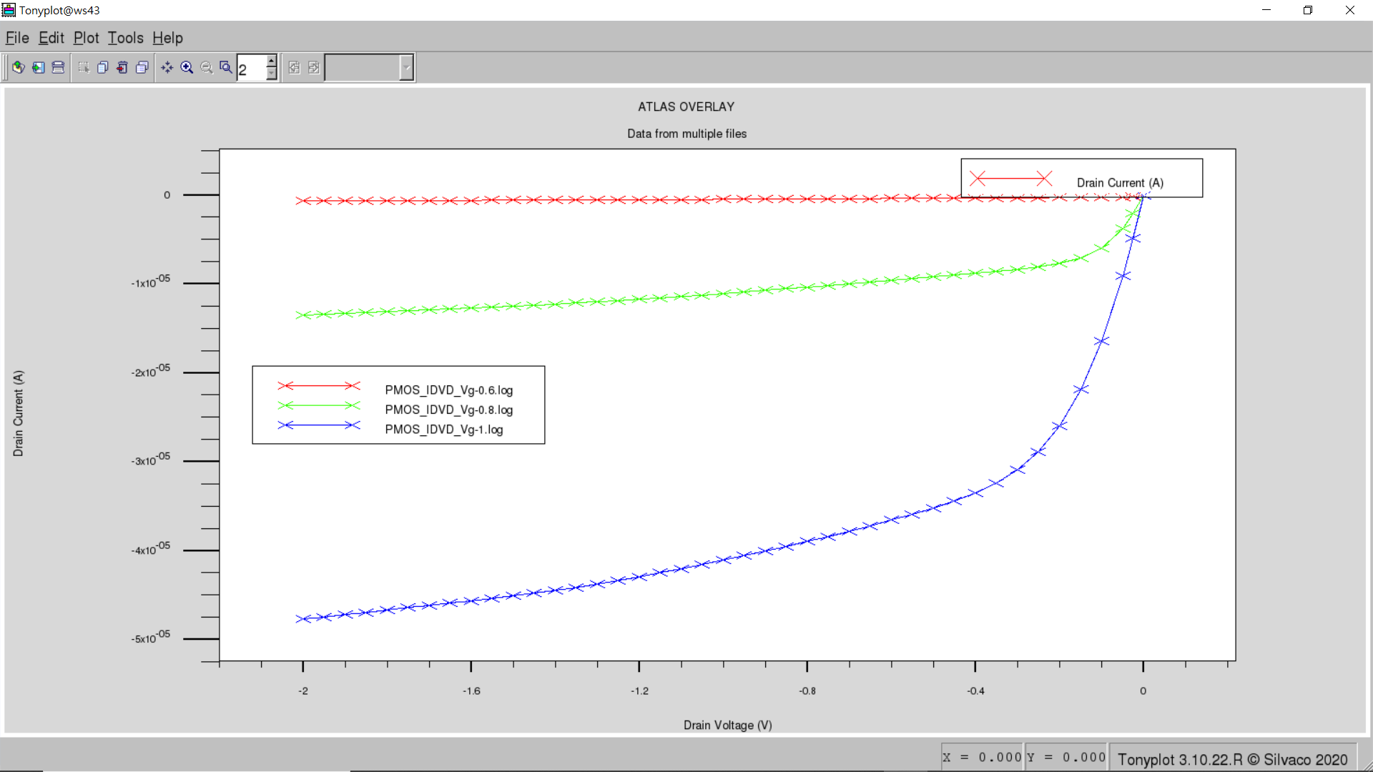

1. Shows the threshold voltage and subthreshold swing of your devices at Vds= 1V
   * NMOS

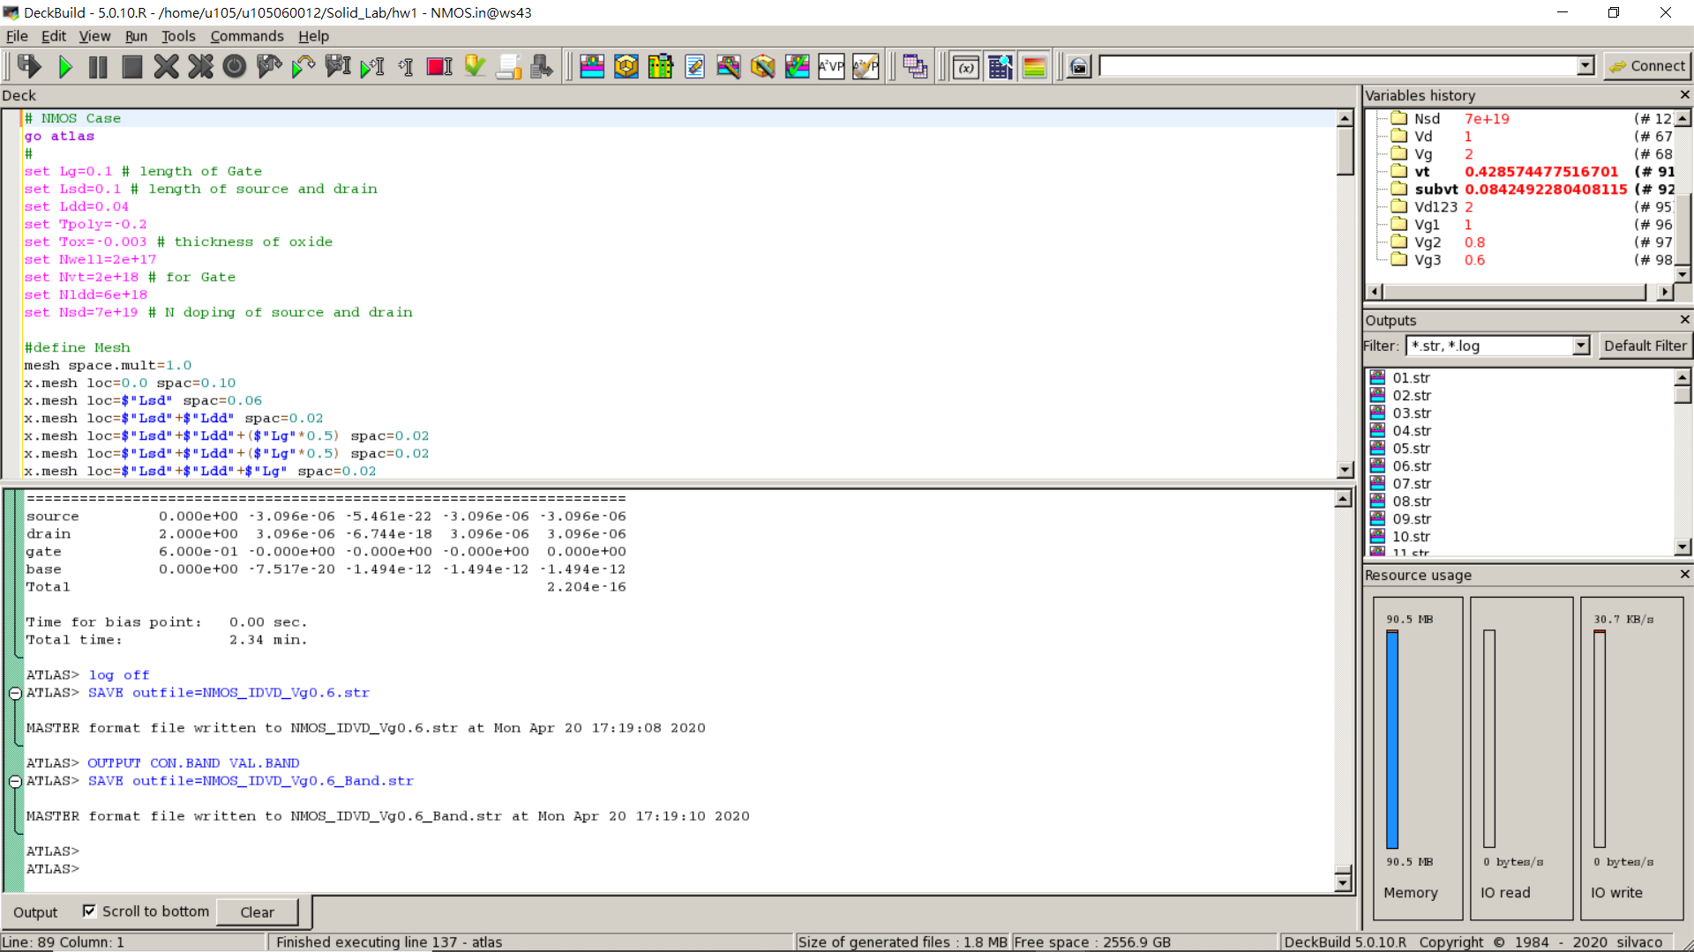

* + PMOS

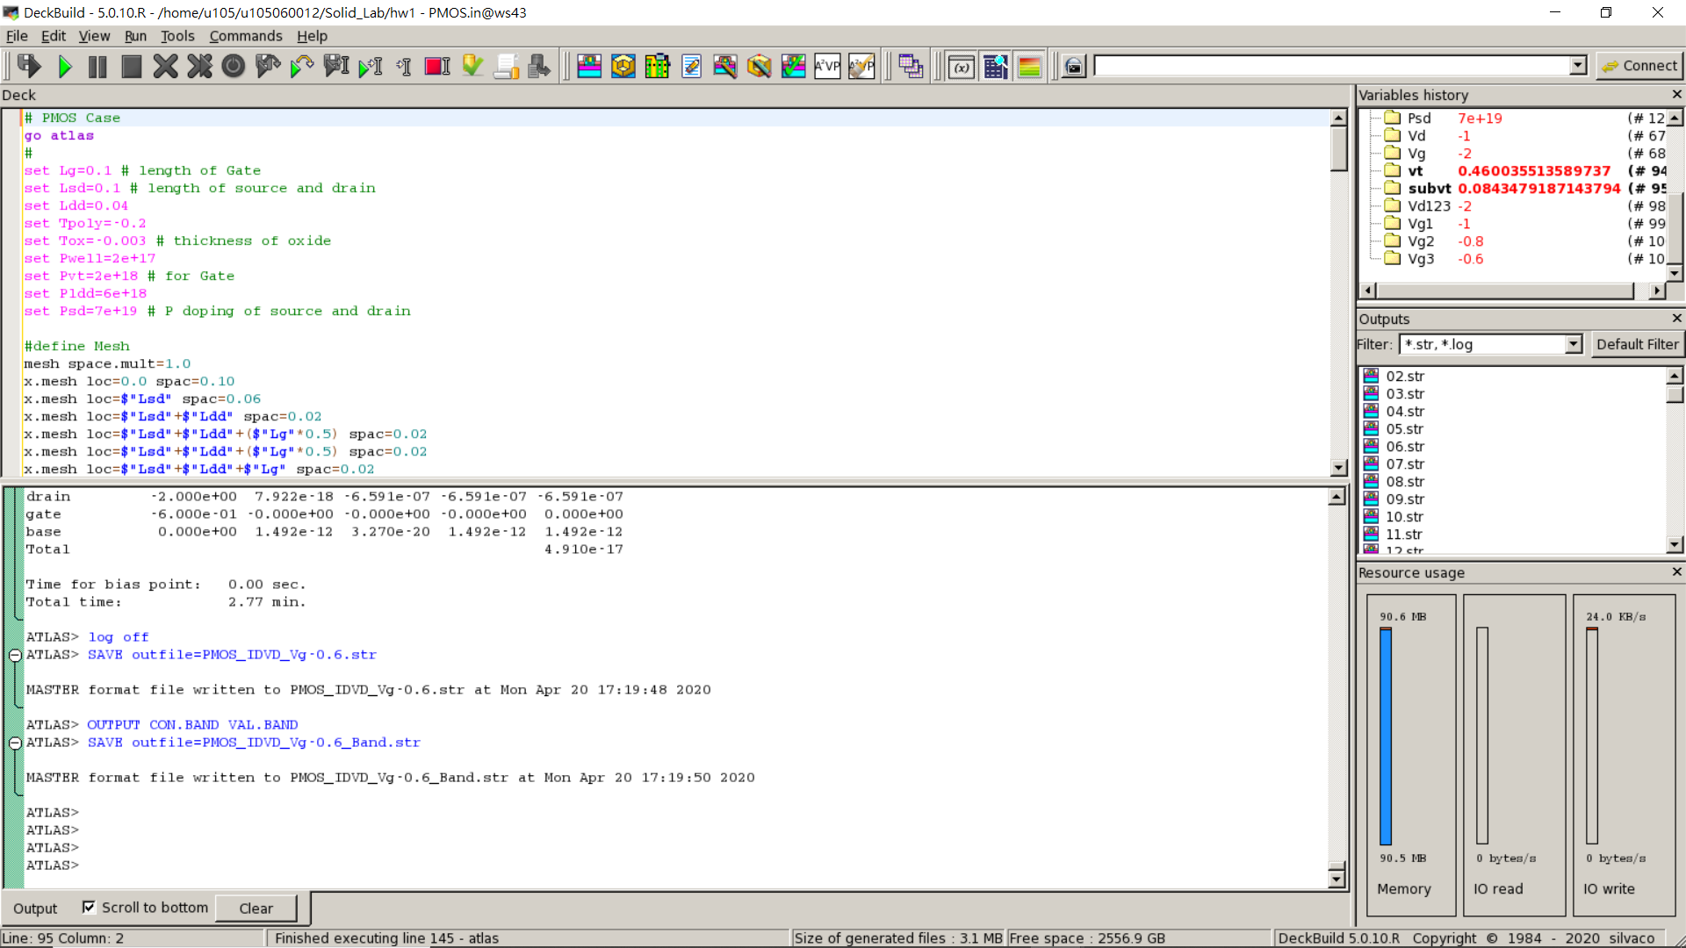

1. Upload all .in file.

Athena Inverter case

#Specifications:

1. Channel length = 0.18 μm.
2. STI isolation.

#Output:

1. Upload Inverter .in file.
2. Generate the device for Inverter.

